Introduction.

Mummification Is among the most popular areas of study in Egyptology, with a wide range of appearances in academic papers and seeping its way into popular culture with phenomena such as Egyptomania(Trafton, 2004). Over the course of 3 weeks there has been an experiment where the effects on salt-based moisture extraction on both fruit and meats which have been studied with the Egyptian style mummification as a model for the experiment. The mummification of human cadavers in ancient Egypt was a tradition that lasted thousands of years (Byard, 2025) and there have been attempts to replicate the process as best as possible. For example there was an experiment in 2011 that saw a modern man named Alan Bilis mummified in the 18th dynasty style(Buckley, 2011). The intent behind this experiment is to find show if tangerines and processed meat such as Frankfurters will react the same way that ancient mummification process caused the mummies of ancient Egypt would react to the salt contents. This experiment is on a much smaller scale than the Egyptian mummies and uses a different agent to extract the moisture with as this experiment uses a mixture of salts such whereas the ancient Egyptians used natron (Sandison, 1963).
The hypothesis of this experiment is that the Tangerine and the Frankfurter will mummify, and the moisture will extract from the Tangerine and frankfurter, and it will preserve itself in the same way the ancient Egyptians did. The primary goal of the experiment is to ascertain the results of this experiment, but it is also important to note that another function of this experiment was to teach undergraduate university students how to properly conduct a rudimentary experiment and write a corresponding report as a teaching exercise.

Methods.
The method used during the experiment was taking one half of the same tangerine and frankfurter and placing them in 4 separate plastic sealed bags. Two of these bags were control and we placed nothing in these bags and allowed them to naturally take their course over the next three weeks however the other two bags which had one tangerine in its own bag and one frankfurter in its own bag and was filled with a mixture of salts which contained table salt Epson salt and Himalayan in equal quantities this micture was chosn as it is the closest possible facsimile of natron that could have been made with limited tools and supplies(Sandison, 1963). a schedule of weekly check-ins on both the controls and the experimental and recording their weight, colour, height, width and length this would on the Thursday of each week from 10:00am until 13:00pm. The height, width and length were recorded using electronic callipers as to get the most precise measurements possible. The colour was measured using the pantone colours matching system to track how the tangerines and frankfurter changed over the course of the experiment. There was safety precautions taken as there is a reasonable possibility of illness or nauseas caused contact with the material especially at week 3 or even caused by the smells and scents given off by the controls and experimental batches at week two or three. There was a requirement to wear gloves when handling both the experiments and control and there was a required break in the halfway mark of the days we conducted the experiment. As a result of distinct cultural differences in regards to death and burial it is important to note that our skills and knowledge do not eclipse that of Egypt in the regard of mummification and using salt/natron based methods of mummification(Bianucci et al., 2015) It should also be noted that the dry based mummification that is being used in not the only methods as the 18th dynasty employed a natron based solution approach however due to inexperience and inability to safely handle and procure these materials this method was not put into usage(Buckley, 2011; Öhrström et al., 2020)

Results
Over the course of the experiment the hypothesis was successful as there was a significant amount of evidence that pointed towards the salt extracting the moisture from both the frankfurter and the tangerine. During the first week when each of the objects were placed in their sealed bags measurements of all of them were done and each of them were measured and colour tested as a base to compare to the changes as time went on
Week 1 | Tangerine C | Tangerine E | Frankfurter C | Frankfurter E
weight | 49.1 | 40.7g | 19.3g | 40.7g
height | 41.81mm | 46.74mm | 42.51mm | 42.31mm
width | 29.16mm | 29.16mm | 17.46mm | 17.46mm
length | 59.49mm | 59.45mm | 76.12mm | 73.65mm

As the table shows these are the baseline statistics that each of both the control and the experimental objects are using as their baseline and any changes from here will be noted down in separate tables and graphs during the next series of updates and check-ins in line with the methodology for this experiment there will also be images and colour pantones shown for the sake of tracking the visual changes that happen during the course of this experiment. Due to the fact that there are different sections of each object both experimental and control then to better track the change in colour an image and a description of each object will be given and using the corresponding pantones.

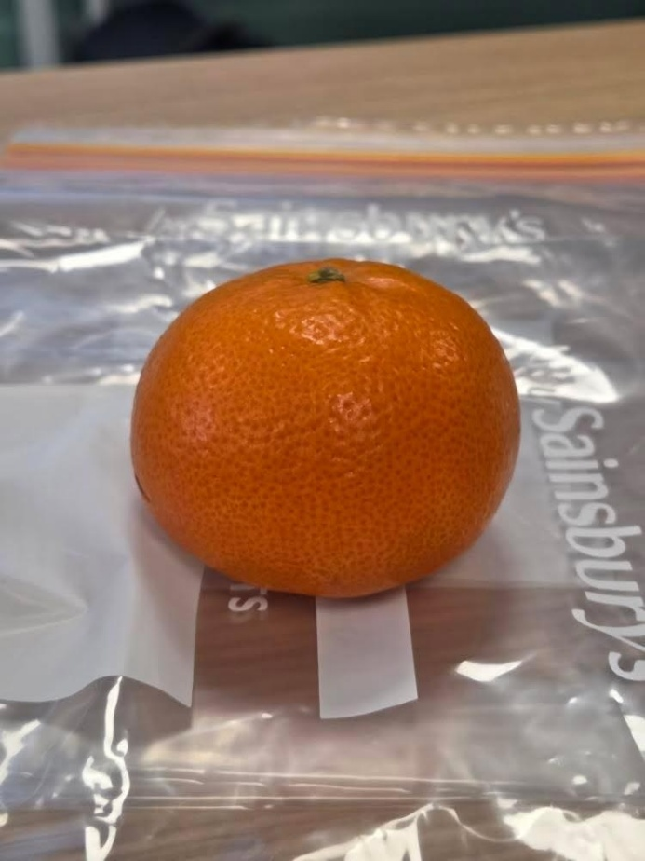peel 1575c#ff7f32
figure 1. whole tangerine week 1 Evan Davies
the tangerine here is whole as this was the beginning of the experiment and there were pictures taken through each stage of it this. The pith and the flesh of the tangerine was revealed to be 2013#ff9800 (flesh) and 4201#f0eeq (pith). These tangerines showed minimal damage to its outside flesh and was healthy and ripe. The tangerine was then cut in half, and each half was placed in separate bags and then designated control and experimental respectively. At this point in time the tangerines were firm and held a normal quantity of juice is relation to its size and held a thick but almost plush texture along the bumpy skin. When cut into the flesh was juicy and clearly held a large volume of liquid. The pith was also quite springy, and the texture of the whole tangerine was spongy
The frankfurters were also cut and both placed in the control and experimental bags respectively.as the methodology dictated there was a mixture of salts placed within each experimental bags and nothing paced in the control bags. The frankfurters were firm and cold to the touch but did not hold significant amounts of liquid but most of their water contents was based in solidified fat,
As week two arrived there were significant changes in both the control bags and the experimental bags. As the control bags were taking their natural course so they showed clear signs of rotting and decay while the experimental bags showed signs of moisture extraction and preservation it seems only to have slowed not to have halted the process in the same way the ancient Egyptians were capable of outputting. (Ikram, 2010)

Week 2 | Tangerine C | Tangerine E | Frankfurter C | Frankfurter E
weight | 40.0g | 38.0g | 18.3g | 10.7g
height | 40.16mm | 39.23mm | 16.54mm | 13.71mm
width | 28.53mm | 28..53mm | 17.29mm | 14.14mm
length | 60.05mm | 56.28mm | 75.66mm | 66.91mm

As the table states there was a significant reduction in all factors across the control and the experimental tangerine however, the tangerine had the greatest reduction in weight and height when compared to the rest of the table this may have been due to the salts water extraction and the fact that tangerines made up of significantly more water that a frankfurter. therefore, by having the liquid extracted it then causes a greater reduction in weight. There were also visual differences within the experiments and the controls as the control frankfurter started secreting a viscous white liquid and gave off a strong smell despite that fact that he experiments frankfurter was not and hadn’t displayed any visual changes. The tangerines had displayed a loss in mass and cohesion between the flesh, pith and skin, this was also coupled a loss in colour and significantly paler complexion as well as a sign of Mold on the control tangerine and not the experimental. A common themes of the results from week to be the unexpected conditions in each of the controls and the experiments.

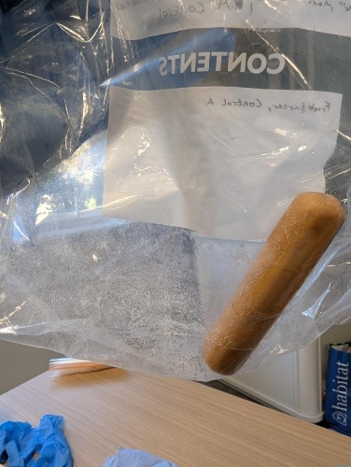
figure 2 frankfurter control week 2 katie howell
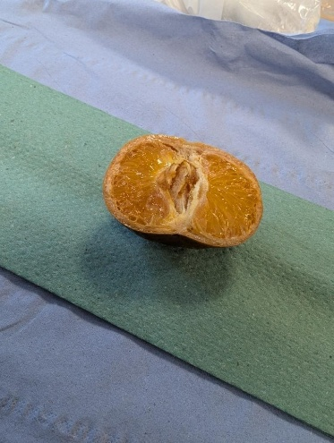
figure 3 tangerine experimantal week 2 Caleb Rees
week 3 was the final week of the experiment. Despite the ability to continue this experiment the desired outcome of the experiment in both of its goals had been accomplished so it was decided that the experiment would terminate after the third week of the experiment. However, the reason this was done was also due to time constraints and the condition of both the experiments and the control.
At thus point the contents of the experimental bags had become dry and almost calloused in texture as well as losing any sort of spongy texture due to the elimination of liquids however, the tangerine still held its shape considerably well and felt more like it had relaxed after stretching to its limit and becoming significantly looser. The frankfurter were relatively the same as the experimental had only shrunk down but the control seemed to eject even more of the liquidized fat from the sausage as it lost weight and even gained a moldy property

Week 3 | Tangerine C | Tangerine E | Frankfurter C | Frankfurter E
weight | 39.39g | 32.1g | 18.0g | 10.8g
height | 39.71mm | 37.37mm | 15.68mm | 13.7mm
width | 27.18mm | 25.60mm | 17.02mm | 14.44mm
length | 58.46mm | 57.0mm | 74.73mm | 67.16mm

Of the final tables results there is clearly still a process taking place as there in mass being extracted by the salts and therefore lowering the salt contents of the objects. While the control object is decaying at their standard rate but losing weight and size at a slightly faster rate. There is a clear significant difference between the object that included the salt mixture in the bags (experimental) and those that did not (controls) the colouration of these objects also quickly slowed down but are still producing new things to quantify as there are mouldy parts on the control objects there is also the white liquid that the control frankfurter, and only the control frankfurter was releasing.

conclusion
Over the course of this experiment a new understanding of the biological processes of mumification within an object. Of course, this topic has been studied quite significantly from when the first mummy was found(Öhrström et al., 2020) but the gal of this experiment was not to be the first to do this but to reinforces the findings that have already been in place as if an experiment is not able to be replicated then the experiment has issues with its validity using the scientific method. The evidence is clear that there is a significant effect on the tangerine and the frankfurter when it is placed in a large volume of salt for extended periods of time. Although it is unclear what would happen if these objects were placed in the salt filled bags for a month or even a year. The short-term data that has been collected does show that there is a large difference between using and not using salt to preserve objects such as tangerines and frankfurters. The extraction of the moisture is in line with the descriptions and theorization of previous Egyptologists and does give insight into the usage and importance of salt contents with natron(Sandison, 1963) (Baines and Lacovara, 2002).

Baines, J. and Lacovara, P. (2002) ‘Burial and the dead in ancient Egyptian society: Respect, formalism, neglect’, Journal of Social Archaeology, 2(1), pp. 5–36. Available at: https://doi.org/10.1177/1469605302002001595.
Bianucci, R. et al. (2015) ‘Shedding New Light on the 18th Dynasty Mummies of the Royal Architect Kha and His Spouse Merit’, PLOS ONE, 10(7), p. e0131916. Available at: https://doi.org/10.1371/journal.pone.0131916.
Buckley, S. (2011) View Record: Mummifying Alan: Egypt’s Last Secret · BoB. Available at: https://learningonscreen.ac.uk/ondemand/index.php/prog/0211F9B7?bcast=95124075# (Accessed: 29 March 2026).
Byard, R.W. (2025) ‘Mummification – An historical and cultural overview’, Journal of Forensic and Legal Medicine, 112, p. 102863. Available at: https://doi.org/10.1016/j.jflm.2025.102863.
Ikram, S. (2010) ‘Mummification’, UCLA Encyclopedia of Egyptology, 1(1). Available at: https://escholarship.org/uc/item/0gn7x3ff (Accessed: 21 March 2026).
Öhrström, L. et al. (2020) ‘Experimental mummification—In the tracks of the ancient Egyptians’, Clinical Anatomy, 33(6), pp. 860–871. Available at: https://doi.org/10.1002/ca.23568.
Sandison, A.T. (1963) ‘The Use of Natron in Mummification in Ancient Egypt’, Journal of Near Eastern Studies, 22(4), pp. 259–267. Available at: https://doi.org/10.1086/371747.
Trafton, S. (2004) Egypt Land: Race and Nineteenth-Century American Egyptomania. Duke University Press.

