Group Project
M5X00400
Chassis Group
2020
Contents
Introduction 3
Project Organisation 4
John Hopkins (P151371) 6
Overview 6
Suspension 6
Research 7
Analysis 8
Dampers 10
Research 10
Component Selection 10
Testing 12
Obstacles 13
Michael Heys 1702352 14
Research 14
CAD – SolidWorks 15
Rear Chassis 15
Rear Damper Mounts 17
Spoiler Bracket 19
Rear Hub/Upright 20
Rear Suspension Mounting Point(s) 21
Analysis 22
Joshua Lewis 1703080 (Brake and driver comfort engineer) 24
Research 24
Experiments 28
Design 29
Development 29
Analysis 30
LIU Zihao 1904590 31
Introduction 31
Personal Roles 31
Process of Researches 33
Analysis AND Conclusion 33
1.Fire extinguisher type selection 33
1.2Causes of lithium battery fire 34
1.3Fire extinguisher efficiency experiment 34
2.Car switch selection 36
2.1 Introduction 36
2.2 Summarize the priority of switch control 36
2.3 Confirm all switches 36
2.3.1 The Emergency Stop Switches 37
2.3.2 Confirmation of the circuit breaker 37
2.3.3 Driver Master Switch 38
2.3.4 Fire switch 39
3.Automotive switch system 39
4.Electric control safety system circuit setting 40
Self-analysis 41
Progress 42
Success & Failure 43
Bibliography 44

Introduction

The chassis of a race car is fundamentally important. More than just a frame on which to bolt auxiliary components, its design directly influences the way a car handles and transmits power and is the primary factor in its driveability and safety. The chassis group is tasked with taking the existing chassis of a TOMs 033f and modifying and updating it to make it suitable to house an all new electric motor conversion in order to become a competitive all-electric, open-wheel hill-climb racer.
Achieving this poses several challenges to the team; paramount is the immense increase in power. Where the base car produced around 300hp, the proposed design will have to cope with nearer to 700hp. This will require special consideration for transmitting the power through the rear wheels, braking capabilities, structural robustness and the new safety risks that come with the new powertrain. On top of this, the chassis must also be compatible with all the work carried out by the other teams. Provisions must be made in order to accommodate aerodynamic aids as well as safely fitting the power unit in an easily serviceable housing.
Hill-climb racing is a vastly different discipline to circuit racing. With only one car on the grid and with heats rarely exceeding 2 minutes it was clear that the discipline is about all out performance. As such, components such as brakes pads and tyres would be required to last minutes rather than hours. Despite this there is a great need for serviceability; a hill-climb event is often run over a series of heats, therefore requiring the car to be easy to work on between runs should any issues occur.
When considering safety several considerations had to be made. The new car would have to adhere to the differences in the regulations in 1990s Formula 3 racing and in modern hill-climb events. Furthermore, increased risk of electrical fires from the new powertrain configuration would have to be considered.

Project Organisation
Team Members | Roles | Responsibilities
Sam Williams | Suspension Geometry Engineer | - CAD for Suspension (wishbones, uprights, hubs)  - Measuring suspension pickup points  - Brakes
Richard Osborne | Team Leader & Co Chassis Engineer | - CAD for motor housing/packaging  - Battery Packaging  - Suspension pick up points for the rear  - Rear Damper mounting  - Subframe Material Selection
Josh Lewis | Brake & Driver Comfort Engineer | - Brakes (from disks to pedals)  - Steering wheel and harnesses  - Custom made seat  - Pedal box  - Prices of all the above including specialist tools and materials
John Hopkins | Damper Technician | - CAD for wheels and tyres  - CAD for Dampers  - Damper dyno for existing dampers
Lui Zihao | Safety & Regulations Engineer | - Regulations for F3 and Formula E  - Pedal box  - Fire Extinguisher  - Electrical cut off (isolator switch)
Michael Heys | Chassis Engineer | - Research into single seat race car chassis  - CAD for rear chassis frame  - Tyre selection  - Wheel selection  - Chassis Material Selection

Group Tasks | Start Date | End date
Research hillclimb events and vehicles | 30/09/2019 | 04/11/2019
Weigh existing components | 07/10/2019 | 08/10/2019
Measuring the mounting points for chassis frame | 09/10/2019 | 10/10/2019
Design a chassis structure | 11/10/2019 | 04/11/2019
Design Motor housing | 11/10/2019 | 06/11/2019
Front Suspension wishbones and uprights | 09/10/2019 | 31/10/2019
Rear wishbones and uprights | 20/11/2019 | 24/01/2020
Material Selection for chassis and suspension | 25/11/2019 | 07/02/2020
Wheelbase and track width | 23/10/2019 | 14/02/2020
Weight distribution | 05/11/2019 | 07/02/2020
Brakes – Disks, callipers, lines, servos | 21/10/2019 | 27/11/2019
Steering | 27/01/2020 | 10/02/2020
Tyres | 21/10/2019 | 06/11/2019
Wheels | 23/10/2019 | 06/11/2019
Controls | 28/10/2019 | 21/02/2020
Safety devices | 28/10/2019 | 28/02/2020
Measuring front suspension coordinates for WinGeo3 | 21/11/2019 | 22/11/2019
Group Project VIVA | 02/12/2019 | 06/12/2019
Group Project Report and VIVA | 23/03/2020 | 26/03/2020

John Hopkins (P151371)

Overview
Primary areas of work were within suspension design and kinematics as well as damper selection and analysis. CAD modelling was also a shared role within the group. Performing these tasks required extensive research, the use of software such as WinGeo3 and data acquisition software, and the use of measurement and testing equipment in the university workshop.

Suspension
Before committing to the production any suspension design, it is essential to ensure that it will perform as expected throughout its entire range of motion. This geometrical analysis is possible through the use of Mitchell WinGeo 3. This software was used extensively throughout the project both to analyse existing setups but also to help visualise new ideas.
During the early stages of the project it was decided that the existing front end of the base car would be suitable for the intended application and that it needn’t be changed. Despite this it was important to try and gain a better understanding of it, since little information was already available. Having placed the tub on a flat bed, with all the front-end suspension components fitted, it was possible measure its coordinates comprehensively and input them into WinGeo. This allowed us to alter various characteristics such as ride height and observe the effects of these changes on chassis roll and bump. The front configuration is a push-rod double a-arm setup with coil-overs mounted inboard and actuated via a 90-degree bell crank. This setup provides consistent movement through the full travel of the suspension and can easily be adjusted to alter toe and camber depending on the track. Having inboard suspension also comes with its benefits. In motorsport, less weight is always advantageous, particularly if it is unsprung weight. Reducing unsprung mass minimises disturbance to the sprung mass as well as allowing the dampers to cope better with any changes to the road service. These benefits improve the control and turn-in capabilities of the car. The dampers are also protected from the elements within their housing which should enhance their lifespan. Exposed springs and dampers are aerodynamically undesirable and keeping them inboard reduces disturbance to airflow. Other suspension components such as wishbones and track-rods can have their shape manipulated to suit the air flow.
The rear end needed to be totally redesigned. This was due in part to the lack of original rear suspension components but mainly due to the power unit conversion that presented new structural and packaging hurdles. It was decided that the rear chassis would also utilise a pushrod double-wishbone configuration with coilovers mounted vertically alongside the rear power unit frame. In order to configure the rear chassis on WinGeo, certain dimensions had to be decided. The chassis and simulation group settled on a wheelbase of 2675mm, a front track of 1810mm, a rear track of 1840mm and a 40mm ride height. It was also decided in a meeting that the vehicle would have a 40:60 weight distribution. Having inputted these figures and plotted the coordinates of the desired chassis layout, iterations of ride, roll and steer could be produced throughout the range of motion of the chassis.

Research
With a complete and working chassis model produced for the front and rear, it was possible to explore setup changes to the chassis. It was possible to alter characteristics such as camber, kingpin angle, toe and caster.
It was important to consider how the chassis would behave with geometry adjustments as they can provide a significant advantage depending on the course. The rear chassis setup is heavily dictated by the need to transmit power transmitted through the rear wheels. Being such a short event, hill climb is heavily dependant on a good start; as a result, modest camber and toe angles are necessary to maximise longitudinal launch grip in order to achieve maximum acceleration. The front, however, can be adjusted to enhance the ‘turn-in’ abilities of the car and to offer greater stability both on the straight and in the corners.
Any adjustment made to wheel alignment is a compromise and with camber it is no different. Things to consider include tyre wear, braking forces, aero forces generated and steering feel. While aggressive negative camber can enable higher cornering speeds, it also makes the car unstable in a straight line, impedes braking and is very unsuitable for wet weather conditions. With most pilots also preferring an understeering chassis, striking a balance between front and rear grip is crucial. Having considered these things, the standard setup chosen for front and rear are -3º and -0.5º respectively.
Changing the caster angle of a car allows us to manage characteristics such as stability, steering effort & response, understeer/oversteer and camber gain. The latter phenomenon is particularly utilised in motorsport. It allows the outside wheel to gain negative camber and the inside wheel to gain positive camber while cornering. This maximises the contact patch during corners while allowing more modest camber angles on the straight to aid braking capability and stability. The drawbacks for this the potential to increase tyre wear and heavier steering however this is complimented by the improved stability and the fact that race runs in hill-climb are short. It was decided that a 7º caster angle would provide the best combination of handling ability and drivability.

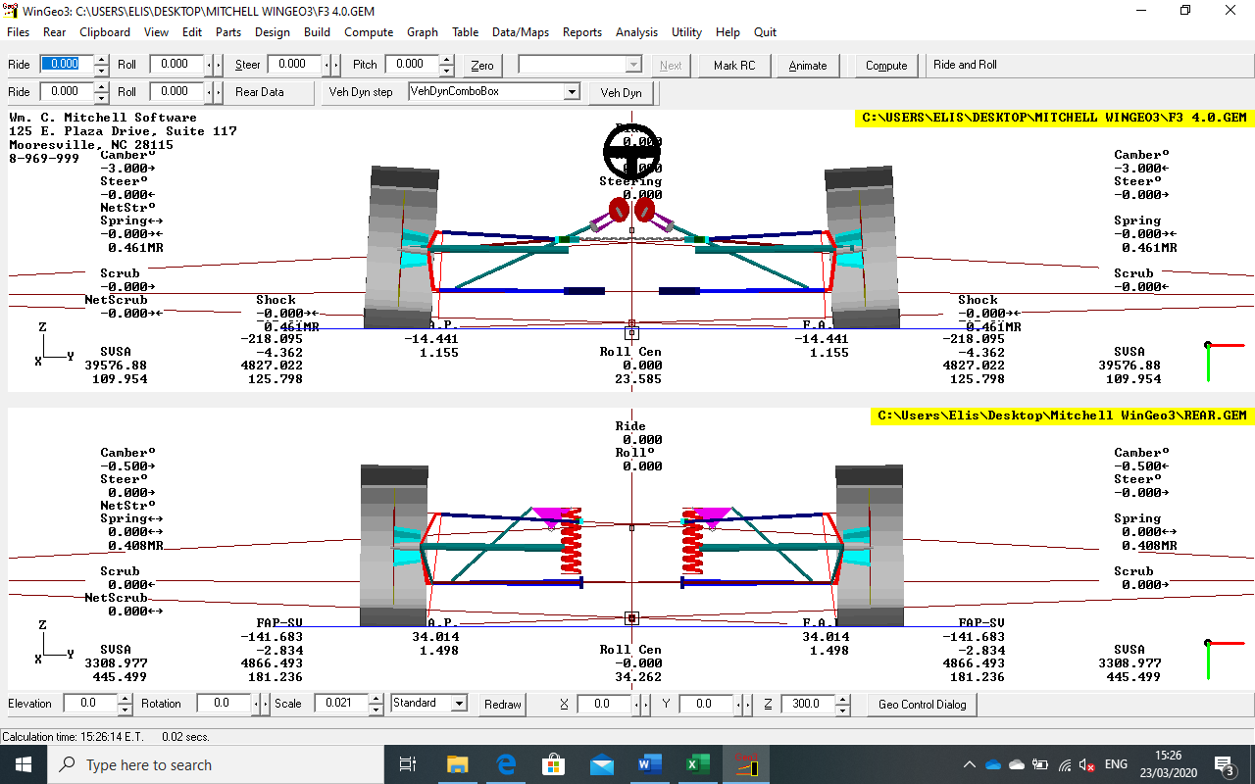
Analysis
Above are models produced on WinGeo3 for the front and rear of the car respectively. Having produced these models it was possible to run the iteration function within the program to observe the effects of bump, roll and steer on the chassis. The rear roll centre is higher than the front at 34.262 and 25.585 respectively.

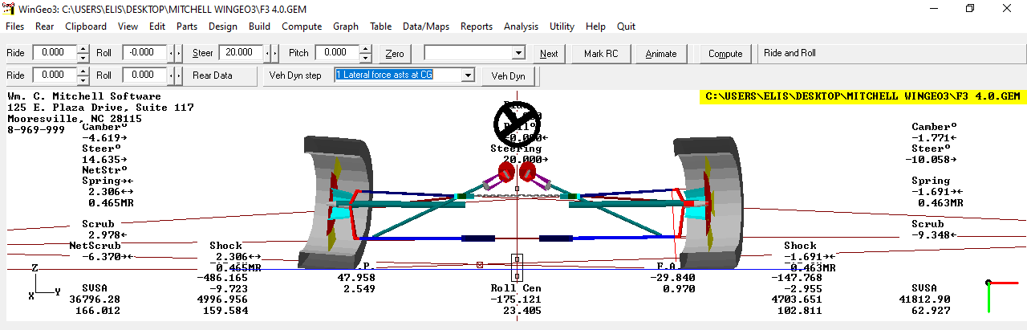
The screen-grab above shows the effect of steering on the chassis. As expected with the setup, with 20º of steer to the right, the left wheel camber goes from -3º to -4.6º while the right wheel goes from -3º to -1.8º. This should provide better front end grip in hard corners. Also visible is the front roll-centre shift; approximately 175mm to the left.

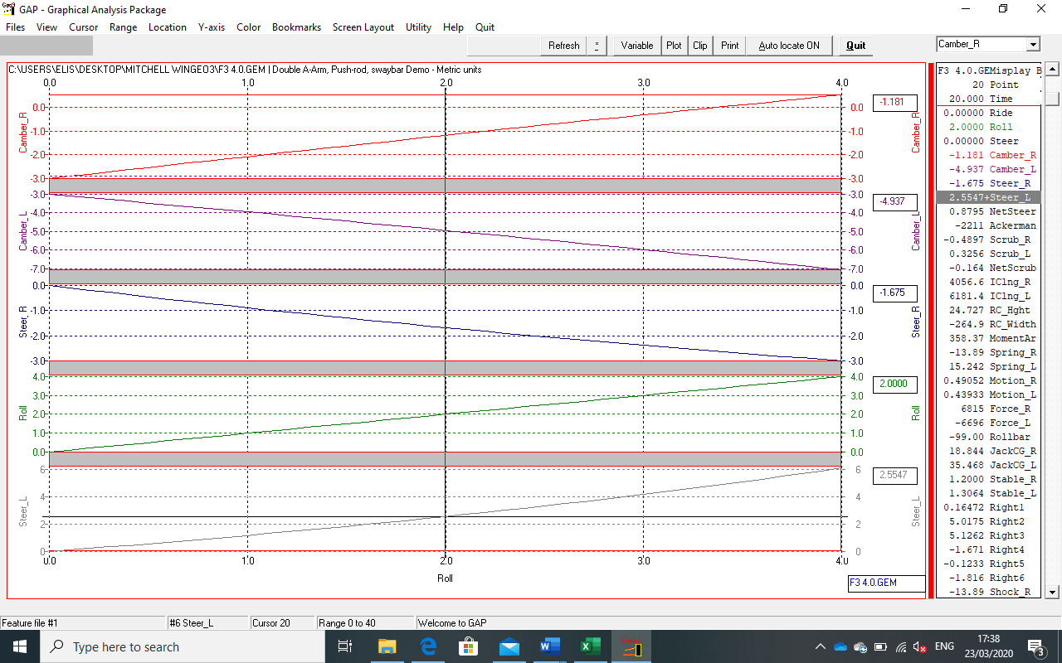
The screen-grab above shows the graphical analysis of camber against steer. Illustrating graphically the effects illustrated in the figure above.

Dampers

Research
While often an afterthought, dampers are a hugely important component on a race car. Poorly designed or unsuitable dampers can have catastrophic effects on vehicle handling and drivability. An effective damper limits excessive movement of the unsprung masses on a car, in turn helping to manage the sprung mass too. When working properly, they should ensure that the tyres remain in contact with the road as much as possible in order to produce maximum grip. By maintaining consistent contact with the road, dampers also help to keep the changes in frictional forces in the tyres as linear as possible. Sudden spikes and drops in available grip are difficult to react to for the driver and can unsettle the chassis, cause skidding and cause excessive wear on tyres.
Adjustable dampers are also one of the most effective ways of managing load transfer. During steady state cornering, dampers have very little effect, as they are acceleration sensitive, but during braking, turn in and acceleration they play a major role. If it becomes clear that a car is behaving a certain way on a certain track for example, losing time on winding sections, a possible solution would be worth stiffening bump and rebound to transfer load from one left to right more quickly. Having easily adjustable dampers then, allows us to toy with different setups during testing and on race days. This can be an invaluable asset to help improve times or to adapt to changing track & weather conditions. This fine tuning requires consideration of spring rates and load transfer.

Component Selection
Damper selection was crucial to ensuring that the vehicle handled as desired and provided safe drivability in its designated application. The base car was fitted with Penske front dampers which were tested to determine their effectiveness. This was done by removing the dampers from the chassis, removing the springs and fitting them to the damper dyno in the workshop with assistance from Paul Davies. One of the dampers failed to hold gas and, after trying to re-gas it, it was clear there was a fault with the seals. The other damper was tested on the dyno and it produced desirable bump and rebound characteristics, however, turning the adjustment dials between their minimum and maximum settings for high and low speed damping equated to very modest changes in the characteristics. Having considered the variety of faults between the dampers and the restricted time frame for the project, it was decided that new dampers front, and rear should be used. Several dampers were considered and by prioritising certain characteristics it was possible to choose the perfect product. The dampers would be used on smooth paved hill climbs circuits; as a result, a damper with good low-speed adjustability is preferable. Unlike most circuits and street courses, hill climb courses tend not to have aggressive curbs or apexes making high-speed adjustability less important. Where reliability is concerned, damper would also need to be easily serviceable between heats and be durable enough to last the entire season. While the front dampers would be enclosed the rear dampers would be exposed to the elements. This poses reliability issues and also the need to consider drag and airflow disturbance. It is also important to remember that dampers are highly sensitive to temperature. Due to hill climb events tending to be run on smooth courses and being short races in nature, we can assume that the temperature won’t climb too high such as can happen on an extended rally stage for example. On cold days however, with the lack of safety laps it can we worth manually warming the dampers before starting the event.
With these requirements in mind, Koni 2612 dampers were selected front and rear. These dampers are desirable for several reasons. They are a lightweight development of Koni’s competition dampers, and their narrower profile makes packaging easier and their frontal area smaller. Unlike the Penske dampers tested, their adjustment dials are packaged to minimise exposure to water and dirt and have better seals to the internals. They boast accurate low speed adjustment and low friction parts, which perfectly suits this application. They were also developed on formula 3 chassis, similar to the base chassis used for this project. The cost of the dampers is £180 each.

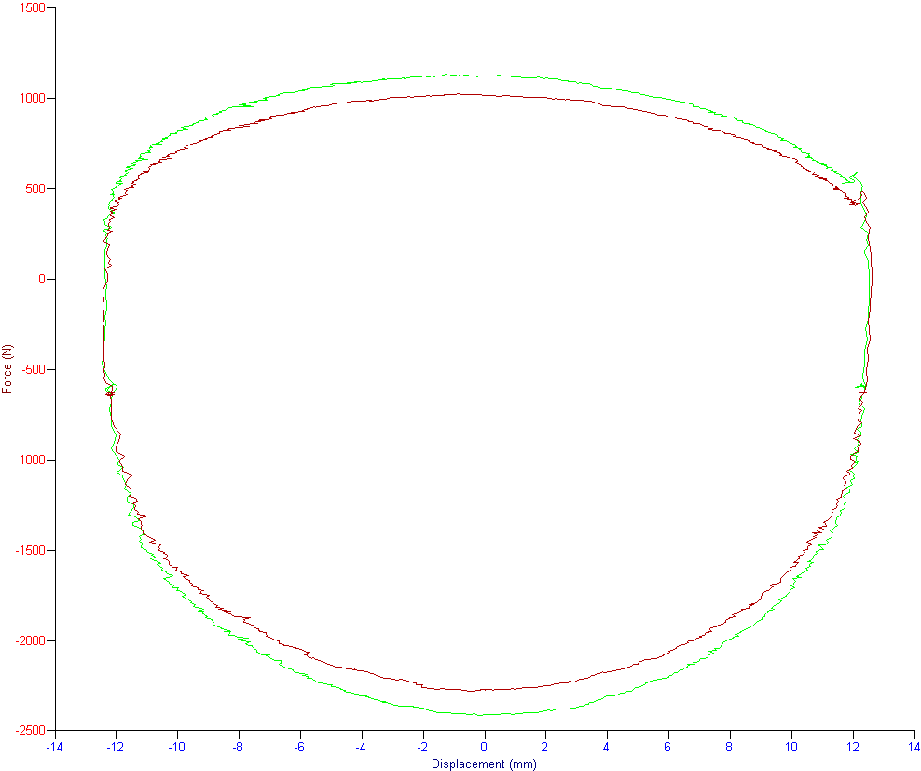
Testing
The above image shows the graph produced when testing one the original Penske dampers, this one being the damper that could still hold air. The red line shows the damper at its minimum setting for low-speed bump and rebound. The results were promising with the damper demonstrating fairly consistent damping and higher damping rate for rebound than bump which is suitable for the application. The absence of major anomalies also showed that the piston was able to move freely and that the valves were functional. Unfortunately, when adjusting the damper to its ‘stiffest’ setting it was clear that there was very little change in its characteristics; this is shown by the green line. Maximum rebound damping increased from 2280.92N to 2414.67N and maximum bump damping increased from 1028.41N to1133.72N. These factors contributed to the decision to pursue new dampers.

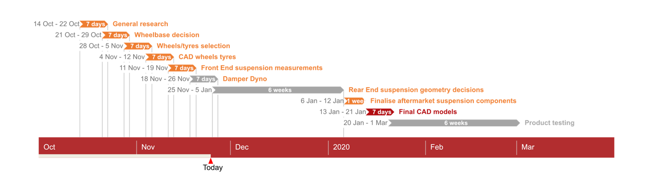
Progress

The Gant chart above highlights the developmental phases of the project and their timeframes. Fortunately I was able to stick to this plan and complete the tasks required.

Obstacles

In order to fulfil my role within this project there were large amounts of research that needed doing. Suspension kinematics is a complex area of automotive design and in order to properly understand their influence on chassis behaviour extensive research had to be done. Having built a good base understanding of the dynamics involved, familiarisation with the Mitchell WinGeo3 software was required. While the software is hugely capable and provided all the functions required, its interface is dated and unintuitive. Having spent ample time learning to use the software however, it was possible to fully utilise it.
Suspension damping was also a field with which I was very unfamiliar. In order to complete the task of selecting the dampers for the car, extensive reading into the topic was required. Damper workshops held by Paul Davies in the workshop also gave the opportunity to further my knowledge and to query an expert in the field.

Michael Heys 1702352
My tasks within the group as a Chassis Engineer were chassis and suspension oriented. I had to design a rear chassis that would mount onto the back of the tub and house the motors and batteries within. I had to define a wheelbase and track width, select wheels and tyres. I also had to design the rear suspension pickup points and the rear shock mounts to allow us use of inboard dampers.

Research
I began with research into rear chassis designs that have been run before and what was currently running in races. Obviously the first place to look is at the VW I.D. R, this gave us an idea of what we ought to be aiming for. I decided to base my research on single seater combustion engine race cars. This is because they are designed to be as light as possible because of engine size limitations in the regulations. The result of my research was that a spaceframe chassis would be the way forward. A strong, lightweight, versatile and customizable structure ideal for our application. However, the key difference between the our fully electric car and an ICE car is that we cannot use the motors as stress members as you would an engine. This therefore created the need for motor mounts or a bracket system to minimise strain on the moving parts.
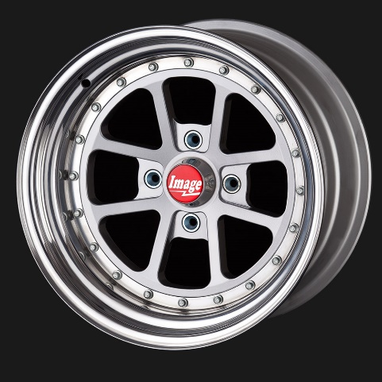
My research then moved on to wheels and tyres. We were very fortunate because at the time I was doing research there was a Dallara Formula 3 racing car in the workshop setup for Hillclimb racing. Being an opportunist, I based a few of my calculations/findings off this car. For example, the wheels and tyres. The wheels were 13inch diameter, 10 inches (250mm) wide at the front and 12 inches (300mm) wide at the back. I went online and found a supplier call ‘ (Billet 93, n.d.)￼. It is also available in centre lock so we can use them on our car. The manufacturers claim that a 6x13” wheel weighs 3.4kgs which will help us to reduce our unsprung mass. The wheels are also totally custom so we can decide what offset we want depending on if we need to adjust the track width.
(Billet 93, n.d.)
Figure 1 Billet 93 wheels
I also used the Dallara as a basis for our vehicle’s wheelbase. We used the Dallara because we did not have all the rear end parts of the Tomms Formula 3 tub, this is because we were presented with only a few boxes of parts. Therefore, we couldn’t make any accurate calculations using rear end parts from the tub in our possession. Subsequently we also used the same logic for the front and rear track.
The tyres on the Dallara were Pirelli P Zeros Ultra Soft slicks. We decided to use this tyre choice as a springboard, so we came up with three different tyre choices to suit as many track conditions as possible. We chose Pirelli P Zero Ultra Soft, Pirelli Cinturato, and Avon Radial Cut Wet. The Ultra soft tyres (purple) should give us instantaneous grip from the start line. This is important for us because the track is very short and not long enough to get sufficient heat into a firmer compound tyre. The Cinturato tyre is a treaded intermediate tyre, like those run in Formula E. this should provide the most grip in damp or moist conditions. And the Avon Radial cut wet tyres are for rain, they have a very blocky tread pattern ideal for moving water. The tyres cost on average about £200 a corner (£800 a set).
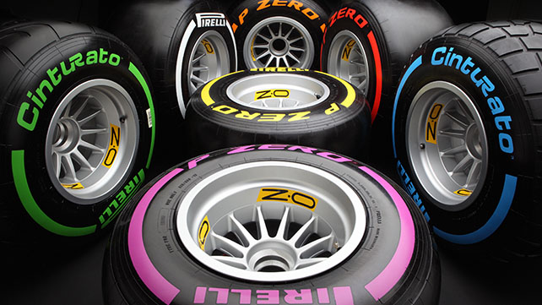

Figure 2 Pirelli Tyres
(Pirelli, 2016)

I also did some research into what suspension setup would be suitable for the rear end of the car, considering that the original setup was double wishbone suspension, but we are unsure whether the shocks were inboard or not. I think the best option for us is inboard shocks. My research proved valuable, I learnt that the calculations of forces are simpler if you keep everything 2 dimensional, i.e. the dampers in line with the axles. When you introduce a third plane by having the dampers mounted along the body it becomes more complex (SK8215, 2019).

CAD – SolidWorks

Rear Chassis
Once I had done enough research, I began to create some CAD models and see what would work. Unfortunately, my CAD skills weren’t as good as they could have been at the start of the project, so I was keen to expand and broaden my capabilities with the software.
This was the first cad model produced. It was designed to bolt onto a smaller cage which housed the motors in a modular system. Unfortunately, this was too heavy and massively over engineered. It also turned out that I had misdrawn the model and got two dimensions mixed up.

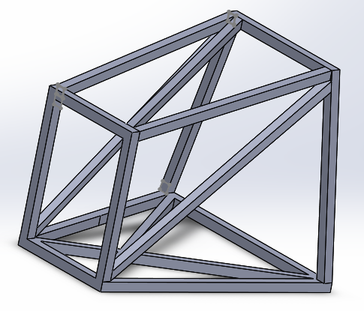

Figure 3 Rear Chassis Mk1

The following iterations were unsuccessful (I would get stuck and restart), mk2,3,4. Mk5 was the next finished after mk1. This model used 20mm tube instead of 25mm box for the main section, and 25x25mm box surrounding the motor mount. This model also had fewer supports than the mk1 because it was stressed to me that it was way too heavy. Subsequently it wasn’t strong enough, so I adjusted some dimensions and added two supports to the mk6 to take the loads from the motors.

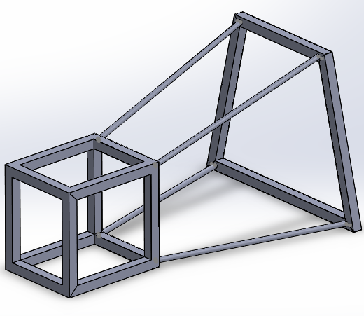
Figure 4 Rear Chassis Mk5

The sixth iteration was then accepted with the two additional supports and larger tubing. I had also progressed in my SolidWorks skills and used a more straightforward way of creating the model by using lots of sweeps and lofts.
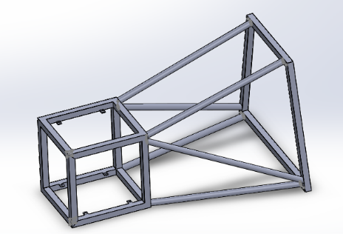

Figure 5 Rear Chassis Mk6

However, because we were working to a wheelbase of 2675mm the distance from the back of the tub to the motor housing was limited to 587.5mm. This proved a challenge to the powertrain group who struggled to find a way to fit the battery packs and control modules without changing the shape of the sixth generation of chassis. The final solution was to change the shape but keep the original length from the back of the tub to the axles. The new size requirements meant a redesign of how the chassis mounts onto the tub. The steel box section frame used in the mk6 became 10mm thick Aluminium plate with mounting holes aligned with the studs on the back of the tub. This allowed the top supports to go around the battery packs and down to the motor housing, enabling us to continue moving forward with the final variation of the battery pack.
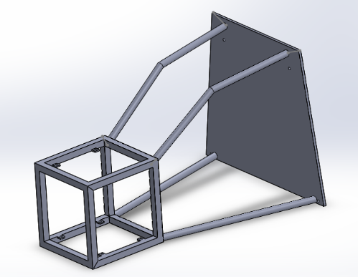

Figure 6 Rear Chassis Mk7

Rear Damper Mounts
I originally wanted to mount the rear dampers along the top chassis rail and have a pushrod activated system as this would mirror the setup utilised at the front; however, I watched a video on YouTube of a man creating his own ground effect vehicle with inboard suspension. This proved very useful as I learnt that when you introduce a third plane by having the dampers mounted along the body it becomes more complex. This made me rethink my idea (having already made two variations).
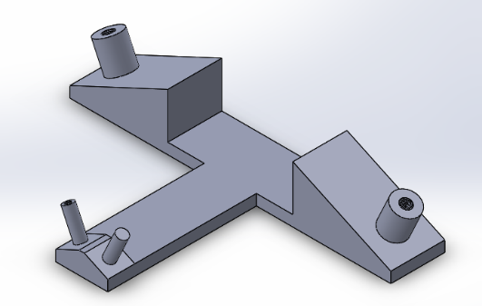

Figure 7 Rear Damper Mounts Mk1

The mk3 followed this idea but was larger, mounting to more of the top of the motor housing. Both the mk1 and mk3 kept both the bell crank pivot and the damper mount at the same angle.

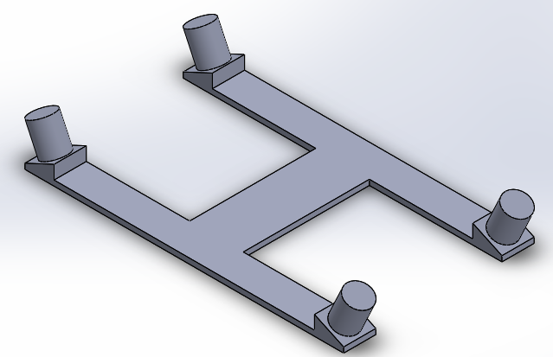

Figure 8 Rear Damper Mounts Mk3

The following designs stuck to the idea of keeping the dampers on the same plane as the pushrods and axles. This was beneficial to us because the simpler equations saved us time and allowed us to make our deadline. The Mk4 is too weak and thin but is a starting point.
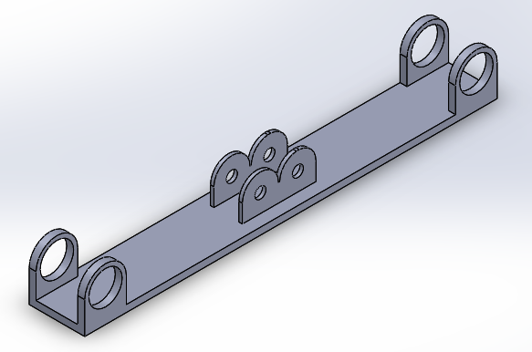

Figure 9 Rear Damper Mounts Mk4

The Mk4 had one main issue, the length between the bell crank and the damper mount wasn’t long enough to fit most dampers available. However, we realised that if we stepped the damper mounts down to in line with the top of the motor mount created by Reza, we could increase the distance between the bell crank and the damper mount (hypotenuse of a triangle).
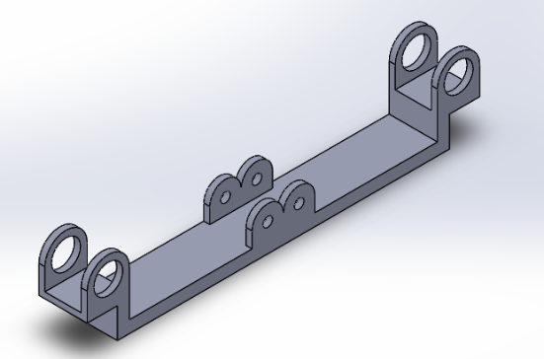

Figure 10 Rear Damper Mounts Mk5

The Mk6 was is very similar to the Mk5 with minor tweaks and slight adjustment to the damper pivot points.
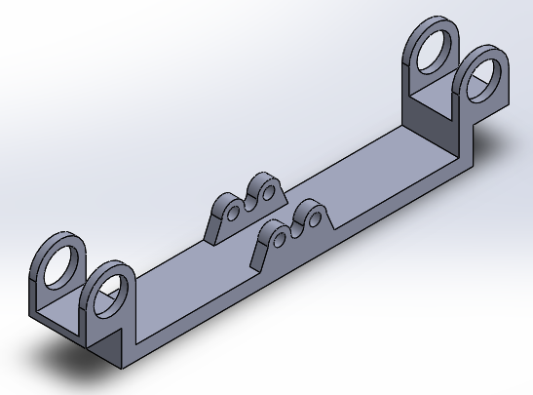

Figure 11 Rear Damper Mounts Mk6

The Mk7 used the same design as the Mk6 but has a larger thickness under the bell crank pivot to increase the length of the hypotenuse giving us more room to mount the dampers. This was the final design and shall potentially be used with motorcycle dampers.
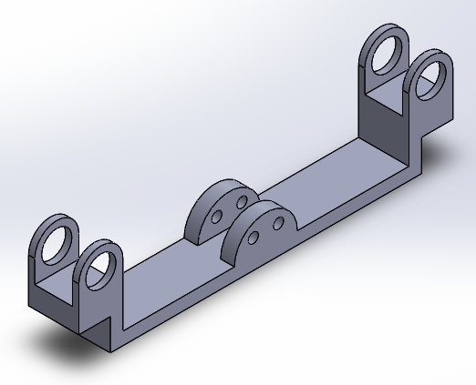

Figure 12 Rear Damper Mounts Mk7

Spoiler Bracket
I was approached by Duke Asamoah from the Aero group who asked me to make a spoiler bracket based off a design he drew. I created 5 variations in total, the first 3 didn’t get completed. The Mk4 was the first finished product but unfortunately due a miscommunication between myself and Duke, I made the spoiler bracket to the wrong size specifications, it had a size limit of no more than 0.9m. The Mk5 is just the scaled down version (640.65mm).
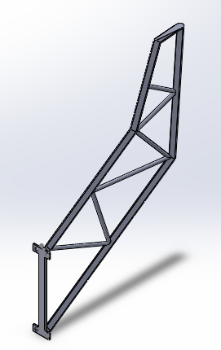

Figure 13 Spoiler Bracket Mk4

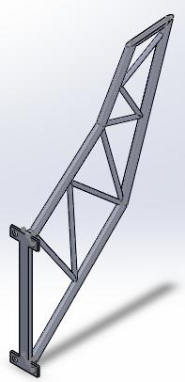

Figure 14 Spoiler Bracket Mk5

After I had finished designing the spoiler bracket, I decided to do a topology run using the maximum aero loads from Duke to see what the ideal bracket should look like. The result was surprising, but not unfamiliar. My design for a spoiler bracket isn’t too different from the topology results, so the bracket should be strong enough. If I had the time and the knowledge, I would also do an FEA study of it to make sure it doesn’t fail during a race.
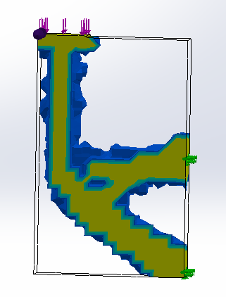

Figure 15 Spoiler Bracket Topology Run

Rear Hub/Upright
We needed a CAD model of the rear hub, and our Suspension Geometry Engineer was away so I measured the existing rear hub and created a rear hub that is slightly different to the existing one but with some key similarities. It uses the same diameter for the bearing and same sized mounting points/ fixings. Instead of it being hollow steel like the existing one, I drew up a design that would be made of aluminium and could be made lighter if needed. If I had a more in-depth knowledge of SolidWorks and more time, one could make it more sculpted. Perhaps create it with a more organic structure, like that generated from topology runs. I would also do a series of topology runs and a series of FEA studies to gain a greater understanding of the component’s strength and also limitations.
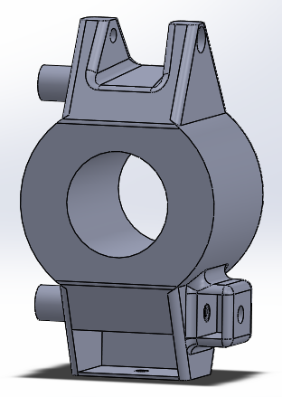

Figure 16 Rear Hub/Upright Mk1

Rear Suspension Mounting Point(s)
I also drew up on SolidWorks the suspension pick up points. These are just brackets which will be bolted or welded to the chassis frame around the motor housing. It is not a complex model because it does not need to be.
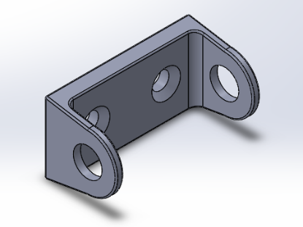

Figure 17 Rear Suspension Mounting Point(s)

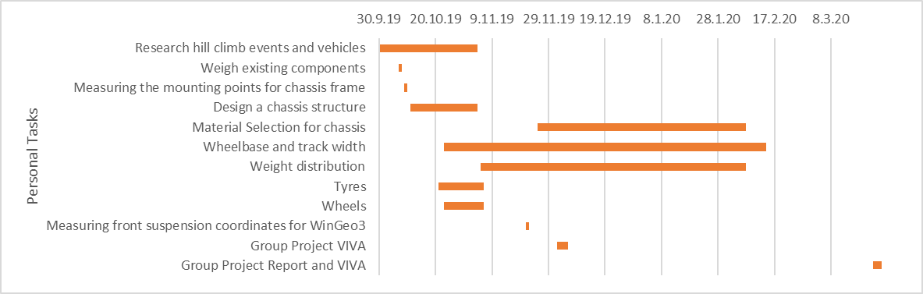
Analysis
Figure 18 Personal Gantt Chart from Initial VIVA
This is the Gantt chart I made to plan my time for the tasks allocated by the group. As one can see, there is a lot of time dedicated to weight distribution, wheelbase and track width, and material selection. Unfortunately, my time management skills are not as good as I had hoped, and I haven’t been able to totally stick to this time plan. The weight distribution is dependent on accurate cad models of parts to get a clear picture of part volume, part material, and thus the mass. Due to unforeseen circumstances, our group leader left shortly after our initial viva. This meant that we had to take on more work each and subsequently the weight distribution didn’t get finalised. This was also the case for material selection for the rear chassis and suspension components. However, I believe that we were working on the basis of which ever material would be most suitable and most cost effective, typically either aluminium or steel due to the time constraints we encountered towards the end of the project.
As we were all struggling with time (a period of complacency after Christmas), we all clubbed together in the final weeks of the deadline. We started to split the remaining tasks up to whomever could complete them. As such I helped with anything I could as part of the Chassis and Suspension group; this meant redesigning the chassis, making a rear spoiler bracket, rear upright, and the suspension pickup points for the wishbones and the mounts for the rear shock absorbers. However, this meant that I prioritised completion of other key components over the weight distribution, as one cannot be completed without the other.
Overall, I think the work that I have done is to a good standard. I believe that I have improved my skills with SolidWorks, however I still need more practice to gain an even better grasp. I would have liked to have run topology for everything that I designed in CAD, but I only learnt how to use it (the basics) after creating the spoiler bracket, by which point there wasn’t enough time. I feel I could have managed my time better if I had stuck to the Gantt chart and was less complacent after Christmas. This would have meant that we would not be rushing as much as we were towards the end of the group project, resulting in a better end product with fewer mistakes.
The most difficult part about this group project is that a lot of the time, one couldn’t make progress until someone from another group had made a decision or progress. This wasn’t helped by our group leader (chassis and suspension) leaving shortly after the first Viva. This resulted in a lot of confusion and lack of motivation, until George Dalton-Brown became the ‘Manager’ of the entire group project. After George became the manager, we would go around the whole group and vocalise any individual or group needs or requirements (such as mounting points for a wing, rear chassis length etc). This increased our productivity and motivation, but it was too late to make a lasting impact.

Joshua Lewis 1703080 (Brake and driver comfort engineer)
  - Work content
- Toms F3 hill climb car complete brake design
- Choice of steering wheel
- Choice or safety devices
- Design and manufacturing process of a custom F3 seat
- Pedal box design
- Bill of materials
- General team input and help with design and ideas such as helping to weigh all components and help with measurements for Wingeo.

Research
So my first task was too design and spec brakes for the toms F3 car since the new power plant has just over double the original output of the car the brakes evidently need updating. There were several elements I needed to consider when choosing the brakes such as, weight of the car or an estimate at least, what is the maximum size disk and calliper I can run with 13inch wheels, whether the brakes can adequately stop the vehicle in a safe and controlled manner. We were lucky enough to have an F3 hill climb car in the workshop during the first semester I used this to my advantage and was able to glance at what setup the dellara was using however after asking some questions it became apparent that this brake setup is for a car with around 230kw whereas the electric hill climb car has around 600kw so it wouldn’t provide enough braking force.

I investigated the biggest disk and calliper I could fit under a 13’’ wheel and found out that the best disk was a 278mm. I then took a look on AP Racings website at their options for f3 cars with 278mm disks and found their top of the range radial drop forged 4 piston calliper however these were fairly expensive at £749.99 per calliper, I decided to give them a call and see whether they were a popular choice for my specified application after explaining the project the sales person was able to point me in the direction of the billet 4 piston calliper as these were considerably cheaper at £440 per calliper thus giving more budget to spend elsewhere. the billet ones are also 1g lighter than the forged calliper giving a weight saving of 4g.

AP also do the correct rotors and pads for this setup which were 278mm vented and grooved floating disks these were £221 per disk. They are also lightweight coming in at 2.2kg per disk
Meaning a total of 16.72KG for disks and calipers.

I next had a look at the F3 tub to see what size and style steering wheel to go for I researched similar f3 cars to see what type of steering wheel would be adequate for our application. I settled with an OMP formula Quadro due to it being specifically designed for formula 3 cars the wheel features a flat bottom with the widest parts of the wheel at 250mm which I was then able to double check the fitment in the tub. The reason for the flat bottom was purely down to giving the driver more room between the wheel and drivers legs this wheel came in at £145 which keeps me within budget too.

As part of my role I was also tasked with the designing/planning how to make a custom F3 seat, I started off by questioning the university workshop technicians to see if they could point me In the right direction to efficiently complete the task In hand, I spoke to Paul who was able to shed some light as I had never looked into this before he explained that “what they do is put the driver in his full race suit including fire/heat retardant layer you would then line the tub with polyurethane sheeting spray expanding foam in with another layer of sheeting on top the driven then climbs in on top and waits for the foam to set, thus creating a foam mould you then make your choice on what material you want the seat made out of.’’ (Davies, 2019) So I went on to further my understanding of this specific process which is where I came along an interesting article in motorsport technology which has a very similar approach to Paul’s with some good pictures showing how its done in figure’s 1 and 2.
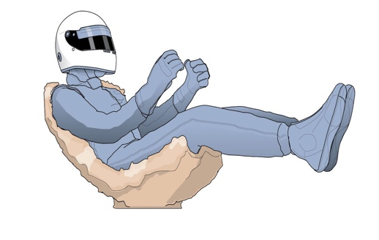
Figure 1 shows the driver sat in the expanding foam mould once the foam has set they will have a mould for the seat however you must ensure that the driver is in his full race suit. As when the foam hardens it causes a chemical reaction which radiates a lot of heat, therefore if the driver isn’t well insulated they could suffer burns.

(maisefield)
Figure 1
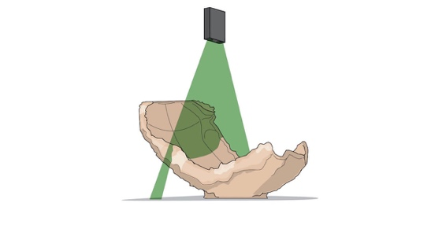
figure 2 shows the seat being 3D scanned to give a computer aided model of the seat. This can then let a CNC machine cut a mould out of a slightly more rigid foam which can be used to make the mould.

Figure 2

(maisefield)
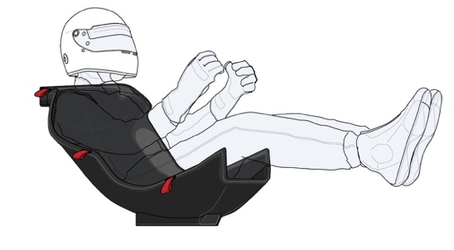
Figure 3 shows the finished carbon seat mould made from the foam template thus giving the driver maximum comfort and safety in the tub.

Figure 3

(maisefield)

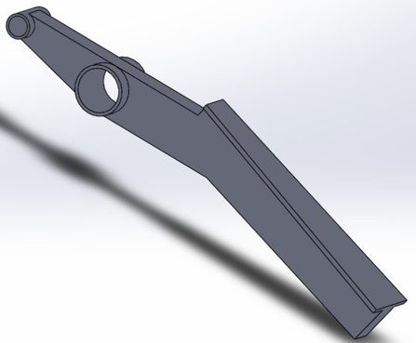
My next task was a joint task with Liu to design a pedal box we had the original pedal box so we were able to get the measure the original throttle pedal and create a 3D model using solid works (Figure 4) so there wasn’t a big amount of research to do for this task.
Figure 4

As part of my role I was also challenged with choosing what safety harnesses we were going to use. I chose the scroth formula student harness due to it being FIA approved and having great specification whilst keeping costs down.
Throughout all of my work content I needed to insure that I have full preliminary bill of materials so that I can give the whole group all of my costings for my involvement of the task at hand which can be seen in (Figure 5). Throughout the whole task I have tried to look at it from a management perspective using these equations.
$$\frac{£}{kg }$$
$$\frac{£}{seconds per lap}$$

part | quantity | Total price
Forged AP racing 4 pot calliper | 4 (20% student discount) | £1760
Brake pads | Front & rears | £161.20
Brake lines (inc fittings) | All four lines + fittings. | £132.46
Harnesses (fia approved) | 1 | £195
Steering wheel | 1 | £145
Expanding foam | 5 x 750ml | £24.90
Polyurethane sheet | 1 | £14.29
Brake bias/master cylinder | 1 | 94.99
Grand total |  | £2527.84
Figure 5

Experiments
For the brakes I was given power point presentations from Tim Tudor explaining how to work out the braking forces, As this is something I have never done before it was fairly challenging for me having minimal prior experience. But however with help from Sam Williams I we were able to create our own brake force calculator which enabled us to work out what braking force we would achieve using the selected brake parameters which can be seen in (Figure 6).
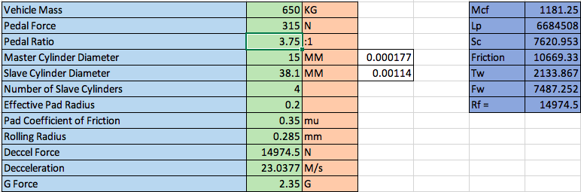
Figure 6
As you can see from figure 6 the car is stopping with around -2.35g. To work out how much G force the car can produce you use the formula.
$$g=gm/r^2$$
with G being Newton's gravitational constant, m is the vehicles mass divided by the radius squared. 2.35gs will be more than adequate to stop the car this is nearly half the braking force of a formula 1 car which can brake at up to 5gs, However they are using bigger wheels meaning they are able to have bigger disks and callipers not to mention the fact they are running carbon ceramic disks. But this wouldn’t work well in a hill climb car as we will be reaching half the speeds of an f1 car, another factor is carbon ceramic brakes are not very effective without heat so that rules them out of the equation for this particular application.
I gave this data to the simulation team to run the data on the simulator, I waited to hear back from them and I pleased to see that they performed tenfold over the original brakes that were on the F3 car. However in my first viva I hadn’t thought about brake biasing so this was something I needed to look at, having spoken to the simulation team they ran various different brake biasing options and they were able to inform me that 55:45 split was the best setup for the car.
In regards to the brake lines and fittings I looked at various suppliers such as Goodridge , HEL, and EBC to see what company could offer the best performance at a reasonable cost, I ended up choosing to go with HEL performance braided lines as they are competitively priced and offer respectable performance.

Design
Whilst working through my tasks I only really had three tasks that could come under the design phase, firstly you could say that I need to design the braking system after my research I knew what components I was using. However I needed to actually go into the workshop and physically design the braking system to see how it was going to work if we were to put the hill climb car into action. I started off by using wire to get all the correct lengths for the brake lines although it was a rough estimate as the rear end of the hill climb car is yet to be made, although I did know the vehicle’s track and wheel base so I’m sure the assumption will be correct. For the brakes this was as far as I could go in the design process.

Secondly I looked at designing the seat as you can see in figures 1-3 if I were actually able to design the seat then I would have looked deeper into the pros and cons of using carbon fibre over fibre glass obviously the first thing that comes to mind is price is it worth the weight saving? this obviously all depends on how big the budget is although we do have the equipment in the university to make the seat in house however it would be nice to do some destructive testing to ensure the seat would hold up in the event of the driver losing control.

Finally the last thing that needed to be designed is the accelerator pedal we did have one that was originally in the F3 car however it was fairly clunky and heavy so I thought we would draw it up on solid works and try to reduce the weight, my first thought was to make it out of aluminium instead of mild steel and the original was a lot chunkier than the new revised pedal. Once again anywhere we can save weight by making parts lighter in house we will. Thus reducing the total vehicle weight as low as possible to keep it competitive.

Development
There were two areas of concern after my first viva that I hadn’t picked up on. Firstly Mark Sanford asked me whether the 14974N of braking force had any brake bias now this is something that I hadn’t thought about, so therefore I asked the simulation team to run the numbers and see whether the brakes were adequate once I was told they were sufficient I was able to finalise my decision. I went on to look at brake biasing methods and found the most common method of two master cylinders with a balance bar this way I would be able to send 55% of the braking power to the front of the car and 44% of the braking power to the rear this seemed to be an effective way of overcoming the first concern.

The second concern which was picked up by Tim Tudor was the harnesses were the wrong type of harness for this particular car, I debated this with Michael Heys and we came up with a solution of drilling holes in the tub to support the eyelets for the harnesses, However we were concerned about this creating a weak point in the tub so we decided the logical thing to do is use some lightweight aluminium plates on either side of the eyelet thus meaning the load is forced on a wider area on the tub. This way we can stick to the original harnesses.

Analysis

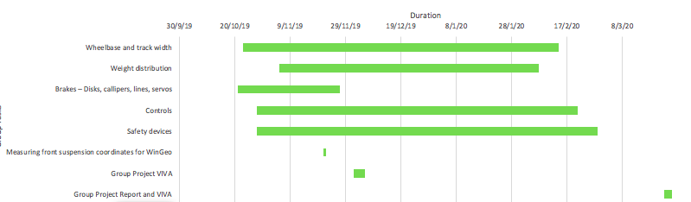
Gantt Chart 1
Firstly I would like to say that I have learnt a lot not just about my specific tasks but about how to work within a team and ensure that the task in hand is completed. As you can see from the Gantt chart above I was fairly generous with my time constraints. However the brakes didn’t go to plan straight away this was down to my bad time management. Which meant that I took along time to get my brakes up to spec, This did cause a slight issue with the simulation team as they were waiting for the braking forces. The reason it took so long is because maths isn’t my strong point so it took me a while to get up to speed. However I did manage to stick to timings for the safety devices and controls.

The wheelbase and track width I worked closely with Michael Heys and Sam Williams and I feel we worked well as a team to get the job done. We were unfortunate enough to lose our team leader Richard Osbourne who unfortunately had to leave university I feel this had a negative impact on the team as his workload was then spread between the group, However Abi did manage build up morale and get us back on track.

Overall everyone in all the different groups all pulled together to ensure we met the deadline I think that the weekly meetings were effective however I feel that if we had a another meeting during the week and set solid goals for the Monday session we could have progressed quicker, we did start meeting on Fridays at 8am which proved to be very productive I feel that if this was suggested at the start the project could have been done to a higher standard

LIU Zihao 1904590

Introduction
Personally, I am responsible for checking the regulations of Formula E and improving the safety system of electric sprint cars with shut-off devices and fire extinguishers. The cut-off points include fire extinguisher switches, neutral switches, emergency stop buttons and stop switches, and attempts to complete the design and upgrade of the car switch control system. Then try to complete the safety circuit design of the formula car independently

Personal Roles
For security systems, the first thing I do is to divide my tasks into checking rules, collect and summarize information, perform calculations, and check the horizontal comparison of websites to select components that meet the rules. Circuit diagrams have been modified with reference to actual designed vehicles in conjunction with literature and magazines to ensure that the new safety system is adequate for the race. After completing the personal tasks, I helped other members of the group to complete the confirmation of the pedal box and rear wishbones and completed the modeling on the software of solidworks.

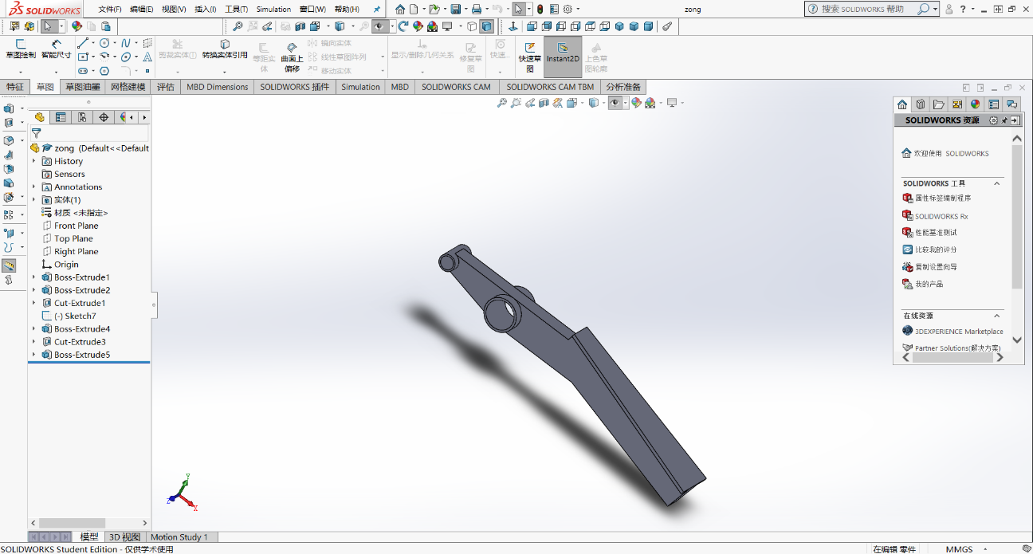
Figure1- single pedal

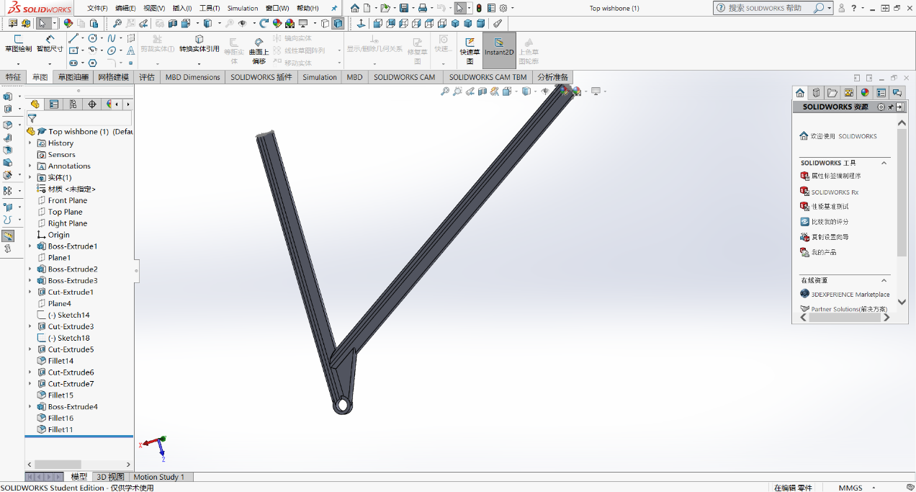
Figure2- Rear wishbones
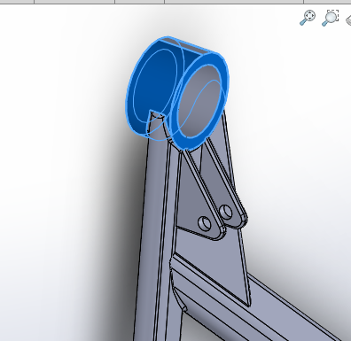
Figure3- Rear wishbones

Process of Researches
After completing the steps to divide a single task, the tasks to be done become clear. First, separate the entire security system. The first data available is the choice of fire extinguisher. Read a lot of regulations to determine the specifications of a fire extinguisher, and then read a lot of literature to determine the type, material and efficiency of a fire extinguisher. The specifications of all switches are then determined through exchange with members of the powertrain team to obtain the determined engine specifications.
After reading the literature extensively and combining discussions with classmates and teachers at weekly meetings to deepen my understanding of automotive safety systems and automotive safety circuit design, I found that circuit switches need to be selected through calculation and regulatory constraints. Therefore, by calculating and selecting the specifications of the correct parts required for the electric formula car, and then comparing the parts that meet the specifications horizontally, the most cost-effective parts were selected. Then replace the parts to optimize the feasibility of the car emergency power-off circuit. Evaluate and optimize your own plan, calculate the cost of implementing the plan, and verify the feasibility of the plan. Finally, the effectiveness and feasibility of the optimized upgrade scheme were verified.

Analysis AND Conclusion
There are two main difficulties in the analysis: the specific choice of fire extinguisher and how to control the switch.

1.Fire extinguisher type selection
1.1 Introduction to the types of fire extinguishers and their respective principles
Before choosing a fire extinguisher, consult the rules can know Only ABC extinguisher types usable for fuel extinction, but we are lithium batteries, so ABC fire extinguishers may not be applicable.
There are many types of fire extinguishers, and their uses are divided into many types. Blindly selecting a fire extinguisher can sometimes not only extinguish a fire, but it can also have an adverse effect. It can effectively destroy the combustion conditions, so that the substance that stops burning becomes a fire extinguishing agent. According to the existing form, the fire extinguishing agents are divided into three types, namely gas fire extinguishers (1. non-combustible gas fire extinguishers, mainly carbon dioxide fire extinguishers, nitrogen fire extinguishers, etc. 2. halogenated fire extinguishing agents) liquid fire extinguishers (1. water and water additives, 2. Foam fire extinguishing agent 3. Solid fire extinguisher (1. Dry powder fire extinguishing agent 2. Smoke fire extinguishing agent)
Its fire extinguishing principle is to use gaseous fire extinguishing agents such as carbon dioxide and inert fire extinguishing agents. When it is ejected from the fire extinguisher, a sudden decompression, part of the carbon dioxide adiabatically expands, evaporates, absorbs a large amount of heat, and quickly cools another part of the carbon dioxide into a solid snowflake. Carbon dioxide ("dry ice"). The temperature of "dry ice" is -78.5 ° C. When sprayed on a fire, it evaporates immediately to reduce the concentration of oxygen; it also cools because it absorbs heat through vaporization. And a large amount of carbon dioxide gas surrounds the combustion zone, which can also isolate the combustion material. There is air. The advantage is that it is not conductive and does not contain water. It can be used to extinguish fires of electrical equipment and certain hydrophobic substances. It does not leave any traces after fire extinguishing. It can be used to extinguish fires of precision instruments, mechanical equipment, books, archives, etc.; it is cheap. Its disadvantage is that the cooling effect is poor, and it cannot extinguish the smouldering fire. After extinguishing the fire, it may reignite the flame. Carbon dioxide and alkali metals (sodium, potassium) and alkaline earth metals (magnesium) undergo chemical reactions at high temperatures and cause explosions. 2Mg + CO2 ==== 2MgO + C When carbon dioxide expands, it generates static electricity and may cause combustion; carbon dioxide can suffocate firefighters.
Use water-based fire extinguishing agent: The principle is to fill the interior with foam generated by AFFF water film foam extinguishing agent and nitrogen, then spray it on the fuel surface, and separate the water film on the surface of the water fuel by foam chromatography to make it flammable. Objects are isolated from the air. It has the advantages of convenient operation, high fire extinguishing efficiency, no upside down when used, long validity period, anti-reignition, and double fire extinguishing. The state advocates the use of water-based fire extinguishers, which are environmentally friendly and can extinguish fires caused by ordinary household appliances. Its disadvantages are short shelf life and high price

1.2Causes of lithium battery fire
Before fully deciding the fire extinguisher I choose, we must first understand the main reasons for lithium battery fires. A mild short will only cause elevated self-discharge and the heat buildup is minimal because the discharging power is very low. If enough microscopic metallic particles converge on one spot, a sizable current begins to flow between the electrodes of the cell, and the spot heats up and weakens. As a small water leak in a faulty hydro dam can develop into a torrent and take a structure down, so too can heat buildup damage the insulation layer in a cell and cause an electrical short. The temperature can quickly reach 500C (932F), at which point the cell catches fire or it explodes. This thermal runaway that occurs is known as “venting with flame.”

1.3Fire extinguisher efficiency experiment
Because the fire test was too dangerous and I did not have a test site to conduct the experiment, I checked the fire test in various countries to obtain the conclusions. Such as the United States Fire Research Foundation (FPRF), the United States Federal Aviation Administration (FAA), NASA (NASA), German Motor Vehicle Supervision Association (DEKRA), Civil Aviation Authority (CAA).
Civil Aviation Authority (CAA).
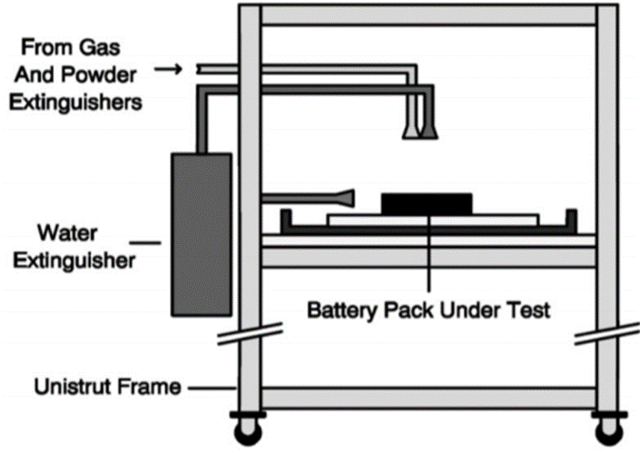
Figure4- Test Bench

The British CAA selected different types of fire extinguishers and studied the effects of water-based, halon, FE-36, dry powder fire extinguishing agents and fire blankets on fighting lithium battery fires. Through improved fire extinguisher nozzles and pipes, overcharged or heated There are two vents in the fire extinguishing room to simulate the air flow. The experimental setup is shown in Figure 2. Typical lithium batteries for CAA portable electronic equipment, including square lithium batteries, cylindrical lithium batteries, and nickel-metal hydride batteries, are used to build three types of fire models: group fires, electronic equipment fires, and electronic equipment fires in luggage. Find,
Fire model and type of extinguishing agent are important factors affecting the fire extinguishing effect of lithium batteries, and Halon and FE-36 have better fire extinguishing effects. Through this project research, the British Civil Aviation Authority (CAA) recommended Halon and FE-36 fire extinguishing agent to deal with the fire of portable lithium battery equipment on flights.
The experiment used a standard 18650 lithium battery with a battery capacity of 2600 mAh and a SOC of 50%. Five lithium batteries are connected side by side through a nickel-chromium wire, and a 2.56 million cubic data 8th galvanic couple is arranged between adjacent batteries and on both sides of the battery to monitor temperature changes during the fire extinguishing process. Using a 100 W tube furnace and hexane heating caused the battery to run out of control. The position of the heater is shown in Figure 1. First, turn on the tube furnace heater. When the first battery is heated to 100 ° C, turn on the hexane heater. After the first battery is out of control, spray the fire extinguishing agent. When extinguishing fire, liquid fire extinguishing agents such as water, AF-31, AF-21, A-B-D and Novec1230 fire extinguishing agents at normal temperature and pressure are poured by hand-held 500 mL water bottles; other fire extinguishing agents, such as Halon1211, HalotronⅠ , FM-200, FE-36, CO2 and Purple-K fire extinguishing agents are sprayed with a hand-held fire extinguisher. Turn off the heater after the fire.
The results show that without the fire extinguishing agent, all lithium batteries are out of control, and only 500 mL of liquid fire extinguishing agent can effectively suppress the spread of lithium battery fire, but non-liquid fire extinguishing agent does not work. The US Federal Aviation Administration (FAA) through the research of this project found that the evaluation results of the cooling effect of fire extinguishing agents are in good agreement with the results of lithium battery fire extinguishing experiments. Water-based fire extinguishing agents have the best effect on suppressing lithium battery fires, while gas and dry powder fire extinguishing agents have no effect on suppressing lithium battery fires.
To sum up, I chose the water-based fire extinguisher FE-36 as the fire extinguisher for the car.

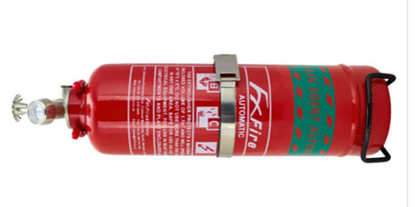
Figure5- FE-36 2KG Fire extinguisher
The price of a fire extinguisher is 153 pounds, its price is within a reasonable range

2.Car switch selection
The next step is the switch selection of the car. Before completing the selection, we must first review the rules to understand the switch requirements in the rules, then select the switch that meets the rules, and enable him to operate in the circuit system of the car. And design a switch circuit diagram that can control the overall circuit.

2.1 Introduction
Switch requirements: I learned from the regulations: ▪ The driver must have easy access to at least one emergency stop button and one stop switch. ▪ A second "Emergency Stop" button must be placed so that it can be operated when the vehicle is lying on its side or reversing. This button must be mechanically locked once it is operated and requires manual operation to reset. The emergency stops button and driver stop switch must act as circuit breakers, interrupting all electrical transmission circuit breakers between RESS and all other HV circuits through fire protection circuits. When the emergency stop, stop switch or normal stop is activated, the HV potential outside RESS must drop below 60V DC within 2 seconds. ▪ On vehicles without a 12v alternator, a DC / DC converter equipped with a suitable power must Ratings are provided to charge the auxiliary battery / power the 12v electrical system. ▪ All parts of high-voltage electrical equipment must be protected with an appropriate IP rating (minimum IP65).
All cars must be equipped with a driver master switch (DMS). • When the driver is seated and the steering wheel is in place, the driver must be able to operate the DMS while sitting in the driving position. • The DMS must be separate from the universal circuit breaker. • The Emergency Stop Switches control the General Circuit Breaker.

2.2 Summarize the priority of switch control

Table 1: Actuating (= contact opening = current interruption = off) the General Circuit Breaker by the Emergency Stop Switches and by the Driver Master Switch
：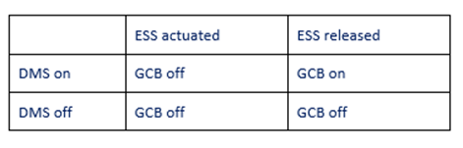
Table-1 Basic control chart

2.3 Confirm all switches
According to the power group, the maximum voltage of the power supply of the selected power system is 230v, and the maximum current is 300A.
Through the power calculation formula $P=U*I$, the maximum power of the power supply can be calculated as 69KW, and the maximum requirement in the rules is 250KW, so it meets the rules.

2.3.1 The Emergency Stop Switches
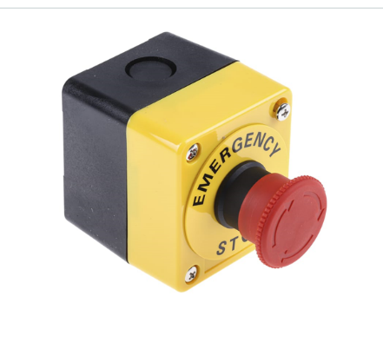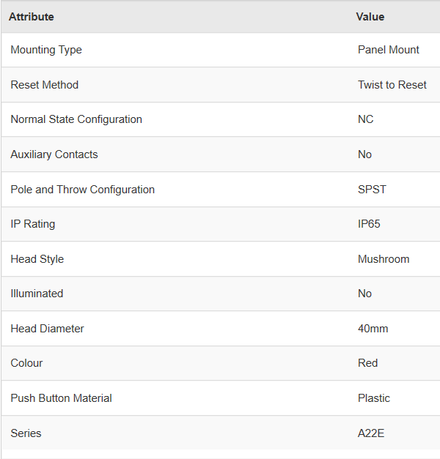
Figure6-Emergency Stop Switch

The Omron A22E series emergency stop pushbutton switch has a red round style head with the diameter of 40mm. It has a double pole single throw (DPST) contact configuration. This button is supplied as a complete or sub-assembled unit and can easily be mounted without using tools. A lock plate is provided as a standard feature to ensure that the control box and switch are not easily separated. The pushbutton is made from the plastic material. It has a current rating of 10A and voltage rating of 440VAC.
But the maximum current it allows far exceeds the current generated by the engine, so we need a circuit breaker as a resistor to connect the series current to the ESS.
Its price is 65 pounds

2.3.2 Confirmation of the circuit breaker
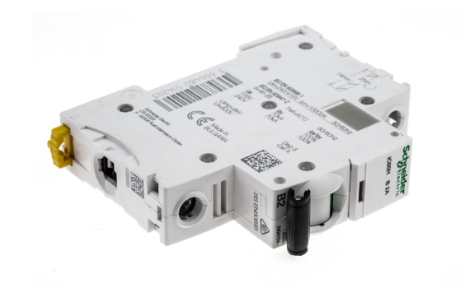 Figure7- circuit breaker

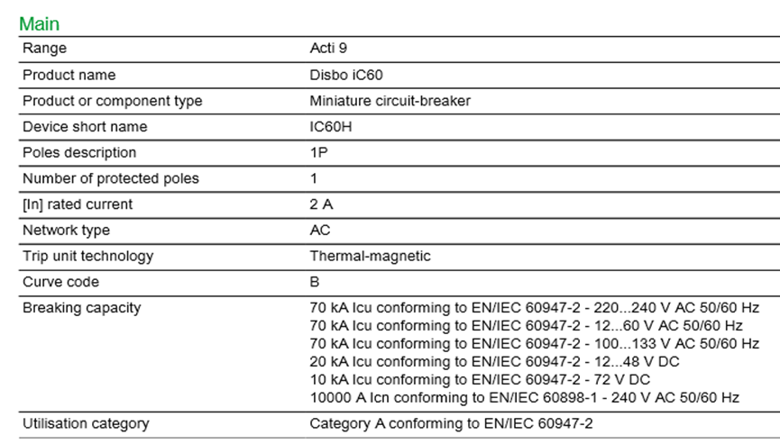
A9F53102 Schneider Electric MCB
This model has tripping curve type B that trips instantly at a rate of 3 to 5 times the rated current 1 pole breaker and a breaking capacity of 10 kA. And the current that can be passed is 2A, which meets the requirements
Its price is 58.23 pounds

2.3.3 Driver Master Switch
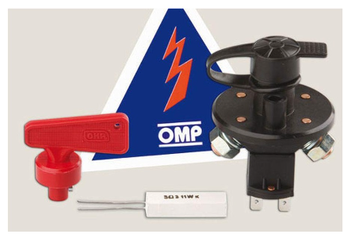
Figure8- Driver Master Switch

This is the DMS of the car, and the driver can use it to turn off the power system of the car. This is the DMS of the car, and the driver can use it to turn off the power system of the car. It can pass up to 3A and meets the requirements. Its price is 32.3 pounds

2.3.4 Fire switch
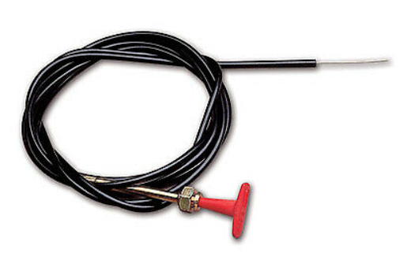
Figure9- Fire switch
This is the switch of the fire extinguisher. Pull the switch to turn off the ignition source. Its price is 13.25 pounds

3.Automotive switch system
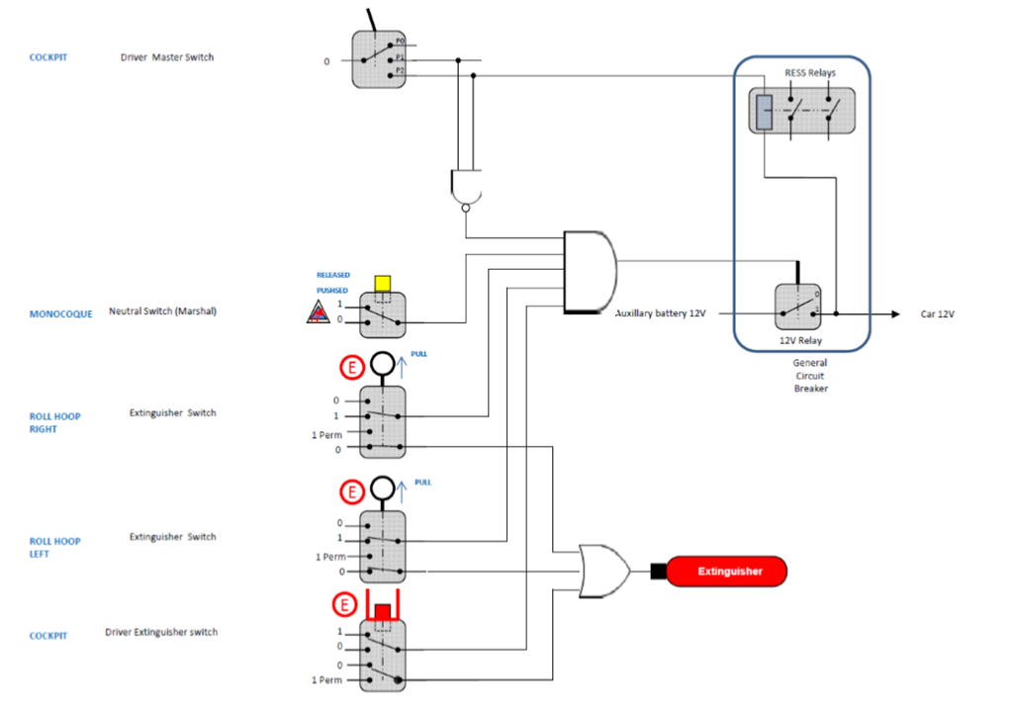
Figure10 switch system

This is a simple car switch control system that I designed at the beginning, which meets the safety requirements of general formula racing. The main switch is used to control the power on and off of the car. At the same time, there are two switches that can control the car's fire extinguisher and one fire extinguisher switch. It is placed on the driver's side, and a fire extinguisher switch is placed on the outside. At the same time, it can meet the need to extinguish the fire if the car is tilted or inverted. Driver Monster Switch cannot withstand such high currents and voltages, and it also lacks circuit protection devices. So I upgraded and improved the system, and chose to add a circuit breaker and an emergency switch system in front of the main switch. This can protect the circuit and meet the requirements in Table

4.Electric control safety system circuit setting
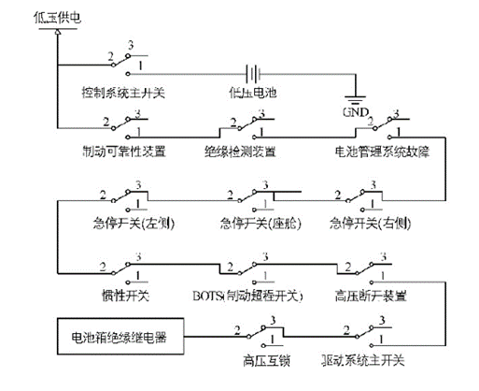
Figure11 Electric control safety system circuit setting

A schematic diagram of the overall circuit design of the electronically controlled safety system of the electric formula car is shown in the figure. This circuit sets brake reliability equipment, insulation detection equipment, and battery management system faults to normally open switches. When these important safety switches fail and lose power, they can return to a normally open state, disconnect safety circuits, and protect the safety of the driver. All safety circuit switching devices are controlled by hardware and use relays or switches, which is more reliable than software control. At the end of the safety circuit is a battery box insulated relay. After all safety circuit switches are closed, the battery box insulation relay controls the coil to energize to control the battery box to supply power to the vehicle's power system. When any part of the car fails, the corresponding part of the safety circuit will be disconnected, thereby disconnecting the vehicle's power output and ensuring safety.

Self-analysis
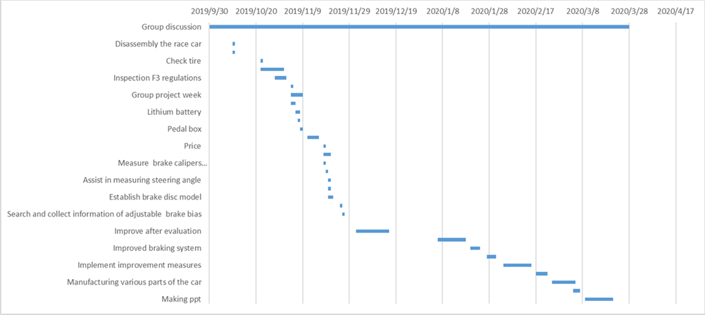

This is my personal Gantt chart. You can see that the timing of each step is very clear, there is enough time to complete my own security equipment selection and security system upgrade, and there is extra time to help the team complete the other parts. task. Unfortunately, my time management skills did not meet my expectations. And I can easily imagine my task, so much so that I always thought that I just chose two parts and failed to complete the task on time. Due to unforeseen circumstances, our team leader left shortly after the first meeting, which means that each of us must do more work. That's why I finished modelling the wishbone and pedals. Although more group tasks delayed my progress, it made me more proficient and understand SolidWorks software. Due to my personal complacency, I don't have enough time to design a car's safety circuit. I can't fully grasp the software matlab to calculate the voltage and current of the discharging process in a car safety circuit. Design, such as the design of the signal detection circuit and understanding of its principles.

As we are all struggling with time (self-completion time after Christmas), we all meet in the last few weeks of the deadline, but since the last few weeks of Friday, all the group members get together to complete the group task More efficient, which proves that group meetings and group meetings are effective and meaningful. If the plan can be implemented early, I believe the team can go further on the road to designing chassis and suspension.

Progress

John Hopkins successfully completed simulation and analysis of automotive suspension with wingeo3 and finalised selection of suspension components. Also completed CAD models of wheels & tyres.
Michael Hayes used solid work to complete the design of the rear hub of the car.
Research into single seat race car chassis, Tyre selection, Wheel selection, andChassis Material Selection was also completed.

Joshua Lewis completed Steering wheel and harnesses
Choice of Custom made seat
Design of Pedal box
Completed Prices of all the above including specialist tools and materials.

Liu Zihao completed the modeling of wishbone and pedal, completed the selection and upgrade of the fire extinguisher, completed the establishment and upgrade of the car switch system, completed the selection of various components of the car switch system, and designed the safety circuit of the car。

Success & Failure

Throughout this project there has been lots of success and a few failures let's start with the positive bits we have all managed to complete the tasks at hand and have designed what could be a very competitive hill climb car. There have been some setbacks such as losing a team member this seemed to have quite a negative effect on the group as this caused a knock-on effect of spreading his workload throughout the team members. Although the task wasn’t a failure had we all managed our time better the quality of the project could have been done to a higher standard.

Bibliography
John Hopkins
(n.d.). Retrieved from https://suspensionsecrets.co.uk/how-to-remove-oversteer-and-understeer/
Dixon, J. c. (1987). The Roll-Centre Concept in Vehicle Handling Dynamics:. Retrieved 3 23, 2020, from https://journals.sagepub.com/doi/abs/10.1243/pime_proc_1987_201_159_02
Richardson, R. M. (1984). Adaptive Suspension Damping. Publication of: Society of Automotive Engineers.
Sakai, H., & Satoh, Y. (1994). The impact of roll center height on vehicle dynamic behavior. Jsae Review, 15(4), 329-333. Retrieved 3 23, 2020, from https://sciencedirect.com/science/article/pii/0389430494902151
Sun, S., Deng, H., Du, H., Li, W., Yang, J., Liu, G., . . . Yan, T. (2015). A Compact Variable Stiffness and Damping Shock Absorber for Vehicle Suspension. IEEE-ASME Transactions on Mechatronics, 20(5), 2621-2629.
Tandy, D. F., Colborn, J., Bae, J. C., Coleman, C., & Pascarella, R. (2015). The True Definition and Measurement of Oversteer and Understeer. SAE International Journal of Commercial Vehicles, 8(1), 160-181. Retrieved 3 23, 2020, from https://sae.org/publications/technical-papers/content/2015-01-1592
Thompson, L. L., Soni, P. H., Raju, S., & Law, E. H. (1998). The Effects of Chassis Flexibility on Roll Stiffness of a Winston Cup Race Car. SAE transactions, 107(6), 2558-2570. Retrieved 3 23, 2020, from https://sae.org/publications/technical-papers/content/983051
Topping, R. W. (2012). Understeer Concepts with Extensions to Four-Wheel Steer, Active Steer, and Time Transients. SAE International Journal of Passenger Cars - Electronic and Electrical Systems, 5(1), 167-186. Retrieved 3 23, 2020, from https://sae.org/publications/technical-papers/content/2012-01-0245
Woods, D. E., & Jawad, B. (1999). Numerical Design of Racecar Suspension Parameters. SAE transactions, 108(6), 3156-3161. Retrieved 3 23, 2020, from https://sae.org/publications/technical-papers/content/1999-01-2257
Michael Heys
Billet 93. (n.d.). Retrieved from Image Wheels: https://www.imagewheels.co.uk/billet-93-alloy-wheel/
Pirelli. (2016, February 23). The Colour Purple. Retrieved from Pirelli: https://www.pirelli.com/global/en-ww/race/the-colour-purple
SK8215. (2019, 5 18). Making a Custom Push Rod Suspension - E55 ASL Part 7. Canada: YouTube.

Josh Lewis
Davies, P. (2019, 10 15). F3 car seat . (J. Lewis, Interviewer)
Motorsport technology, (2019), f1 seat build [ONLINE]. Available at: https://motorsport.tech/formula-1/f1-seat-fitting [Accessed 28 November 2019].
Liu Zihao
[1] FIA FORMULA E CHAMPIONSHIP. (2019/11/20).
: FIA: https://www.fia.com/regulation/category/109
[2] Lain M J，Teagle D A，Cullen J，et al. Dealing With InFlight Lithium Battery Fires In Portable Electronic Devices [J]. CAA PAPER，2003 (4)
[3] Summer S M. Flammability Assessment of Lithium- Ion and Lithium- Ion Polymer Battery Cells Designed for Air⁃ craft Power Usage[M]. US Department of Transportation, Federal Aviation Administration，2010.
[4] FIA Formula E Championship Technical Regulations ANNEXE J / APPENDIX J – ARTICLE 253 www.fia.com/regulation/category/109#
[5]陈凯琦,彭辉.大学生电动方程式赛车电控安全系统的设计[J].电工技术,2019(12)
[6] Lain M J，Teagle D A，Cullen J，et al. Dealing With InFlight Lithium Battery Fires In Portable Electronic Devices [J]. CAA PAPER，2003 (4).
[7] Egelhaaf M，Kress D，Wolpert D，et al. Fire Fighting of LiIon Traction Batteries[R]. SAE Technical Paper，2013.
[8] Rao H，Huang Z，Zhang H，et al. Study of fire tests and fire safety measures on lithium ion battery used on ships [C]// Transportation Information and Safety (ICTIS), 2015 International Conference on. IEEE，2015.
[9] Maloney T. Extinguishment of Lithium- Ion and LithiumMetal Battery Fires[M]. US Department of Transportation, Federal Aviation Administration，2014.

(Topping, 2012) (Tandy, Colborn, Bae, Coleman, & Pascarella, 2015) (Woods & Jawad, 1999) (Dixon, 1987) (Sakai & Satoh, 1994)

