Changemakers: Building your Personal Brand for
Sustainable Employment – Assignment 2



Sophie Tinson
2000410
Level 5
Introduction
It is important when a module or project is completed to reflect upon the skills and knowledge gained and developed, as this builds awareness of personal strengths and weaknesses. As well as this reflection is required when improvement and target setting is needed.
Within this assignment I will look at the skills and qualities that I have developed and improved upon during this module. The module is focused on building a personal brand for myself looking at what I skills and attributes I possess and ways in which they can help and be used within my desired future career. Reflecting on my own strengths and weaknesses is an important aspect of building my own brand as I will become self-aware and understand my capabilities.
When reflecting on this module I will use the Gibbs reflective cycle. The Gibbs reflective cycle will be used as it is a simple method of reflection and it provides structure and defined sections (Adeani, Febriani & Syafryadin, 2020). The Gibbs reflective cycle allows us to focus on different areas of ourselves and our work asking a variety of questions ensuring that successful reflection occurs.
Gibbs Reflective Cycle
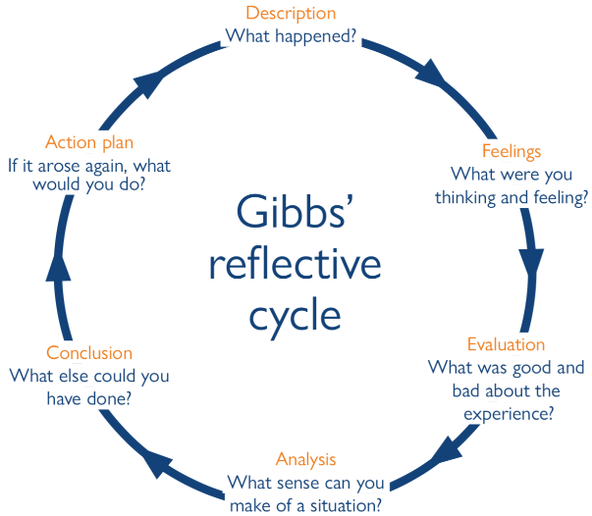
The Gibbs reflective cycle is made up of six different sections. These sections allow you to look at different aspects of yourself and your work. This helps us to reflect looking at a variety of different approaches.
The reflective cycle allows us to look simply at the project in question describing the process of it. However the cycle also allows us to do in depth reflection for example one section asks us to state what else we could have done to make us more successful.
I will use the reflective cycle appropriately providing my thoughts and opinions of myself and my performance throughout the module in question.
Description
To begin the Gibbs reflective cycle I am required to reflect on the task and assignment that was completed looking at each stage that was written and created. For this module I was given a choice of different methods to express myself and my skills. I decided to complete a personal development plan and write a CV. As well as this I wrote a zander letter to myself showing where I would like to be in the future.
Firstly I decided to develop a personal development plan as this process requires me to look at my own skill set focusing on how I can use these skills in the future and whether I need to improve on this skill. I believe it is important to acknowledge which skills require improvement as this enables me to thrive and be successful.
Throughout my life writing a CV cannot be avoided therefore I decided to create one for this module. A CV was a way of me showing my brand in a professional manner and doing so can help me improve when I create one for my future job role. I think that it is important to write and update my CV often as it enables me to produce them effectively.
Finally writing a zander letter can be a difficult process as it is hard to know exactly what you want to achieve in the future. However I wrote a zander letter explaining the achievements and experiences I have had gaining and carrying out my desired job role. I used my current targets and expectations of myself to create a passage showing what I wish to achieve and be involved with within my career. This included looking at my university achievements, the process of gaining the role and what I have undertaken within the role.
Feelings
The second section of Gibbs reflective cycle aims to look at the thoughts and feelings that were had during the process of the task. My initial thoughts of the process differed from the thoughts I had during and once I completed the module.
Prior to completing the module I did not feel confident to promote myself, my skills and my achievements. As this personally is something I have difficulty with, I understood that I had to promote my brand for employability and success therefore I felt I needed to improve on this aspect.
Despite this the completed module focused on the importance of promoting yourself and your success. Gaining knowledge of the importance of presenting myself and my achievements provided me understanding of it teaching me the purpose of ensuring this is done effectively. I began to understand how to promote myself which provided me with a great amount of confidence to do so.
Once I completed the module and the assignment I felt confident and feel able to promote myself and my brand in a positive and effective manner. I now understand that promoting yourself is necessary for employment and future opportunities therefore I believe the module is necessary.
Evaluation
It is important to assess the positives and the negatives of the experience looking at what we did not do well at and what we exceled at, this is the third step of Gibbs reflective cycle.
I was required to complete three tasks when evaluating my skills and achievements, therefore I feel I used different approaches to do so. Using different approaches to promote myself I feel was an effective way for me to develop and learn to use different materials of self-analysis. I had the opportunity to create a personal development plan, a CV and a zander letter all which are unique ways to present myself. I believe I did a great amount of research on each approach ensuring it is completed effectively.
Following on from this I understand that more emphasis on my skill set should have been given within my CV and zander letter. I am aware that this module focuses on skills and personal development therefore more focus on this should have occurred. Despite this I feel that within my personal development plan I provided a range of different skills which enabled me to look at my strengths and weaknesses within a variety of scenarios.
I think that the zander letter allowed me to think about my goals and career aspirations. This I felt was beneficial as I was able to assess what skills I need and what I need to do to achieve my goals. I felt that I put a great amount of thought in the zander letter and I created it setting out a detailed plan for me to become successful.
Each task was given a set word limit, sticking to the word limit was a difficult aspect of the module assignment. I felt that the limit caused difficulty when discussing all the skills and attributes that I acquire and how I could use them in my desired role. However I prioritised the important sections of the text and condensed my assignment to meet the criteria. I feel doing this will help me with future projects and assignments which is useful, I adapted upon many skills which I did not set out to which is important to state.
Analysis
The module has provided me both with knowledge and realisation of the importance of skills and self-development for the future and my gaols. It is important that I understand the reasoning behind this as well as the process for doing so. For the analysis section of Gibbs reflective cycle I have looked at why I need to have communication skills and how this skill helps me to be more employable.
Thompson (2018) highlights that communication skills are often not recognised as of great importance. However he further states that professionals need communication to carry out their role effectively as they will need to go beyond everyday situations that require will not just require basic communication skills. To be successful I need to be aware the different ways to communicate depending on the situation and task.
I understand that each one of the listed skills from assignment one will be required when not just working as an EWO but in most roles and life situations. I think that building upon these skills is vital and I will do so in every given opportunity. This will help me be successful in my professional and personal life.
Conclusion
There are many aspects of my work that I feel should have been improved and adapted upon. Looking at potential shortfalls within my work is an effective way to ensure improvements can be made if repeated.
Firstly I believe that research around my desired job role was a shortfall when assessing my skills in comparison to the role. I feel that it is vital to gain holistic and in depth research on the role to evaluate whether you have the skills and knowledge to undertake the position. I completed some research on the role but felt that this could have been completed more effectively.
Furthermore I think that I successfully looked at a variety of skills focusing on how they would be used as an EWO. It is important to evaluate which skills will be needed within the workplace and how they will be used. Within my personal development plan I discussed how the skill would be used which is important as it shows context within a work environment.
Within my zander letter I can conclude that I missed opportunities to place myself in scenarios. I think that an effective way to evaluate my skills and knowledge would be to consider scenarios that I may be a part of within my job role. Stating experiences that I have had within my role can enable me to show how I would use my skills within a difficult and real life situation.
Finally I can state that my CV needed more detail and focus. I used a great amount of my CV explaining and listing my qualifications, I feel that my CV would be more effective if I focuses on my skills and attributes as employers look at this to understand your character. Many employers favour skills and attributes as this makes a person unique and more employable.
Action plan
It is important to discuss and evaluate the changes and action that I will take now the module is completed and I have looked at my own skills and attributes in great detail.
If repeated I would make changes to my personal development plan as I feel that it would be useful for the future and I could use it for future reference. I think that it would be effective to look at the ways in which I will improve upon the selected skills. I stated a variety of skills that I feel I need to improve on however I did not state ways in which this can occur. To create a more successful development plan I need to provide way in which I can successfully improve on these selected skills.
In addition to this I feel that I need to put greater emphasis on my skills and attributes within my CV. My CV included a short paragraph stating my skills and attributes, in the future I will focus on specific skills stating how they are a strong point and how I have built upon the skill providing examples.
Finally if repeated I would change my zander letter also. I feel that I did not use the zander letter to present how I have used the skills I have to make me successful within my role. If repeated I would include scenarios that could typically occur within the environment of a EWO showing how I would undertake it and which of my skills I would use.
Summary
Overall this module has given me understanding and self-awareness of my acquired skills and what I can do to improve upon them. I have looked at a variety of skills in detail providing an evaluation of them.
I have developed resources which I may require to do later in life and understanding how to create them will be very beneficial. I have awareness of my brand and how I will be viewed by employers. I feel this module has successfully improved upon my view on personal development as I know what skills I posses and what skills I need to improve upon.
Reference List
Thompson, N. (2018) Effective communication: a guide for the people. 3rd edn. Palgrave: London.
Adeani, I.S, Febriani, R.B and Syafryadin. (2020) Using Gibbs’ reflective cycle in making reflections of literacy analysis. Indonesian EFL Journal.

