
UNIVERSITY OF WALES TRINITY SAINT DAVID

Module Name: Learning in the Digital Era
Module Code: ACCA 4025
Student Name: Cristiane Uhlmann Rodrigues
Student ID:2541760
Group:3
Lecturer’s Name: Anee
Assignment 2
Learning in the Digital Era

Table of Contents
Introduction 2
Conclusion 7
References 7

Introduction

Video Link: A presentation on Self-Evaluation, Professional Development Plan and Topic Summary.pptx

Slide 1

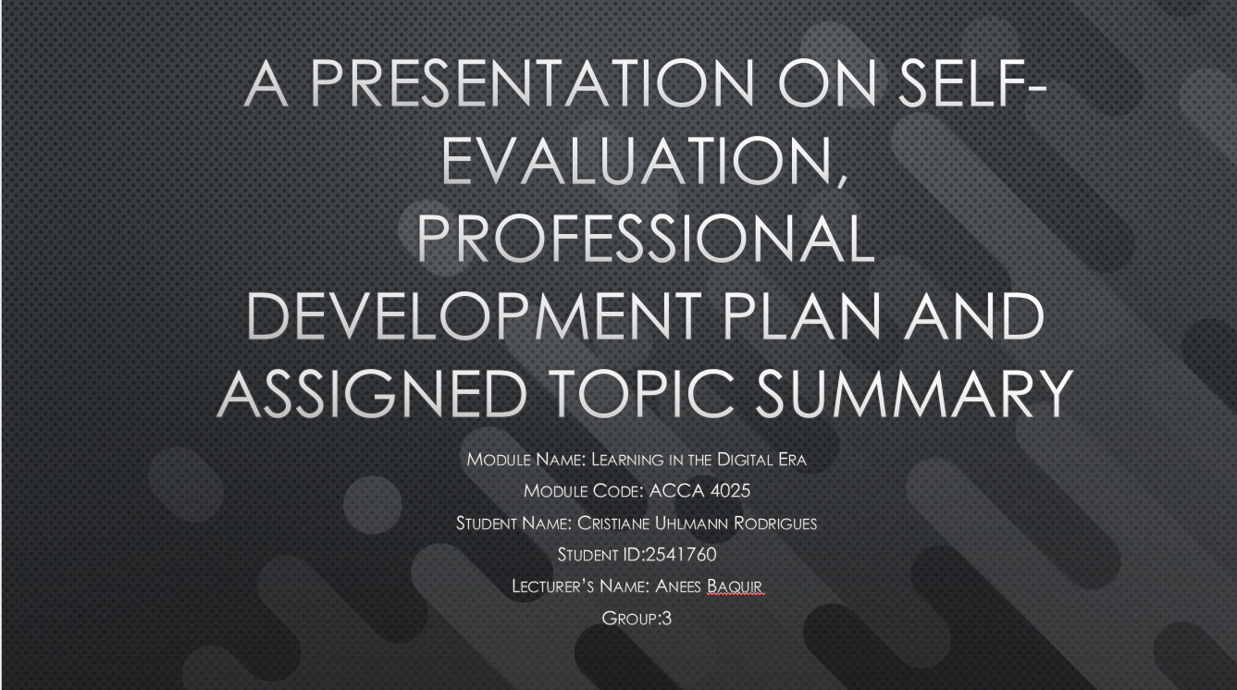

Slide 2

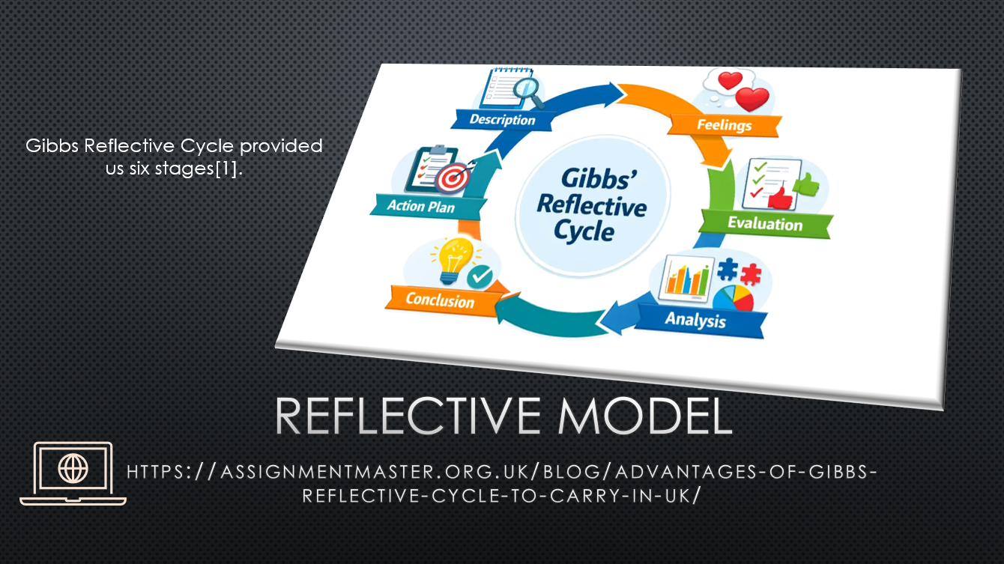
Gibbs Reflective Model has provided us six stages to understand emotions, Feeling, Evaluation, Analysis, Conclusion, Action Plan, Description

Slide 3

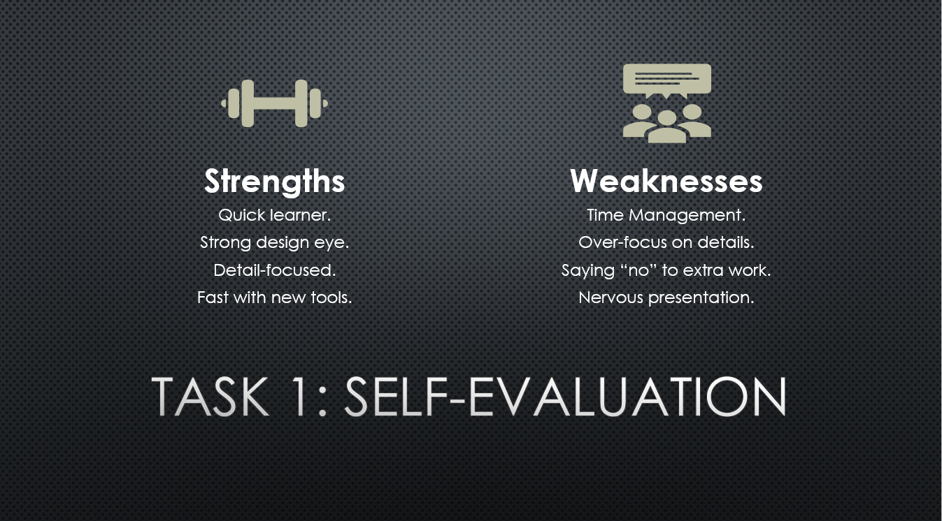
On my self-valuation I have reflected my strengths as Quick learner, strong design eyes, detail-focused and fast with new tools; my weaknesses with Time-management, over-focus on details, saying No for extra works and nervous to presentation.

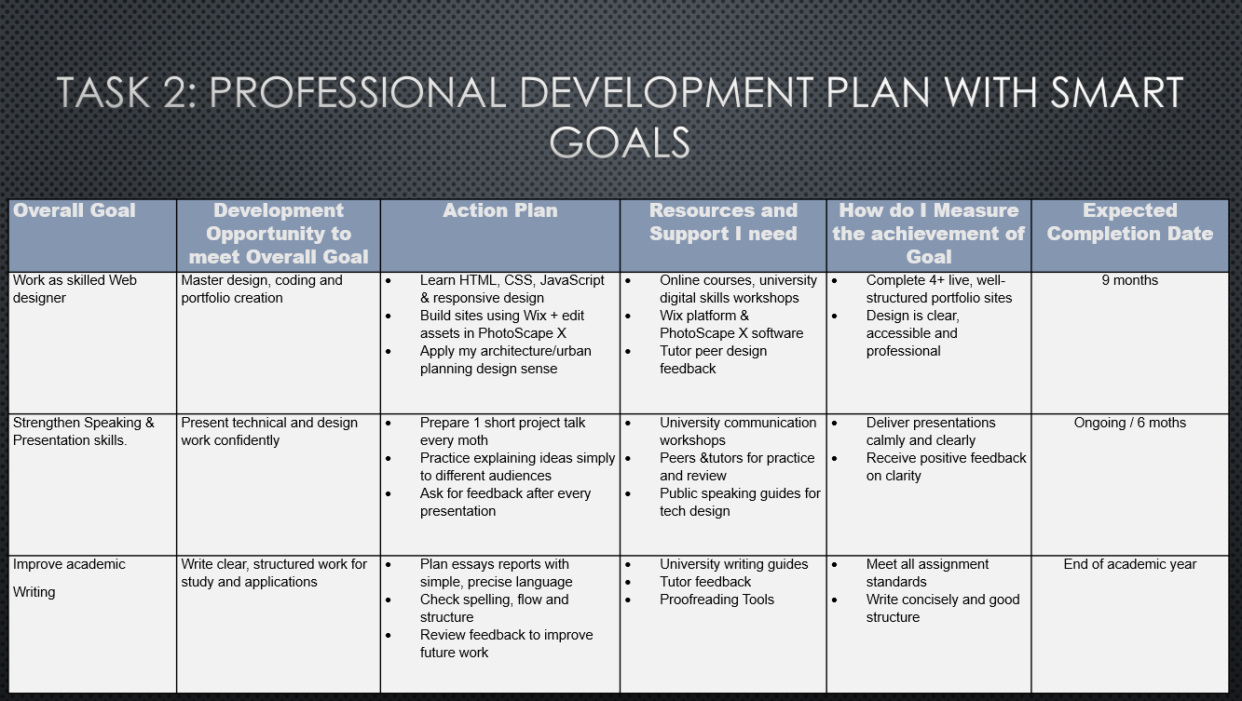
Slide 4
With my SMART goals plan, my overall goal is to become a skilled web designer, strength my speaking and presentation skills and to improve academic writing: master design, write clear to structure study applications. My action plan Learn various programming, Preparation and plan. I can use online and University resources. I will gain support from university workshops and online courses. I will get positive feedback and expect to complete by the end of academic year.

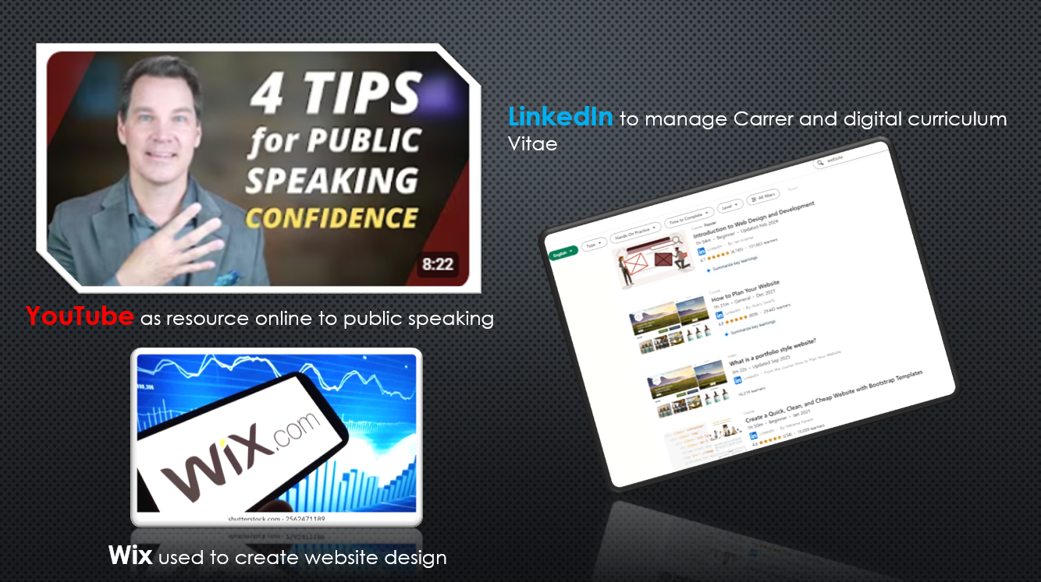
Slide 5

I can use WIX to help me create my website design. The YouTube for improve my public speaking and LinkedIn for my Digital career CV.

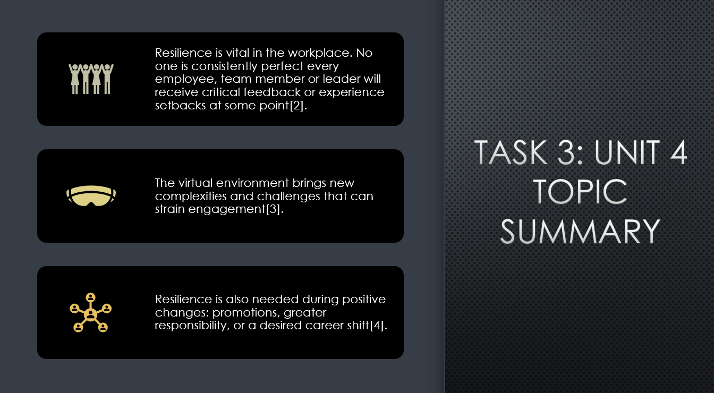
Slide 6
Resilience is vital for the workplace, the virtual environment with positive changes. It promotes great responsibility for a desired career.
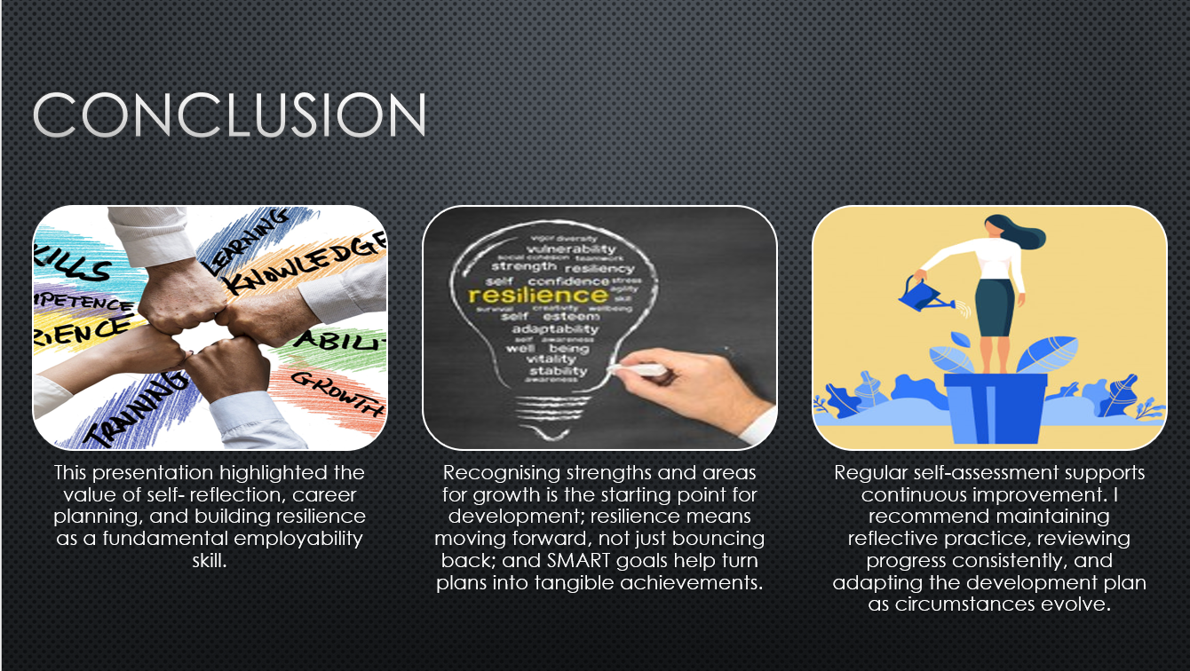
Slide 7
I have concluded my self-reflection in career planning is essential for employability skill. Smart goals help turns plans into achievements and regular assessment supports continues improvements.

Slide 8

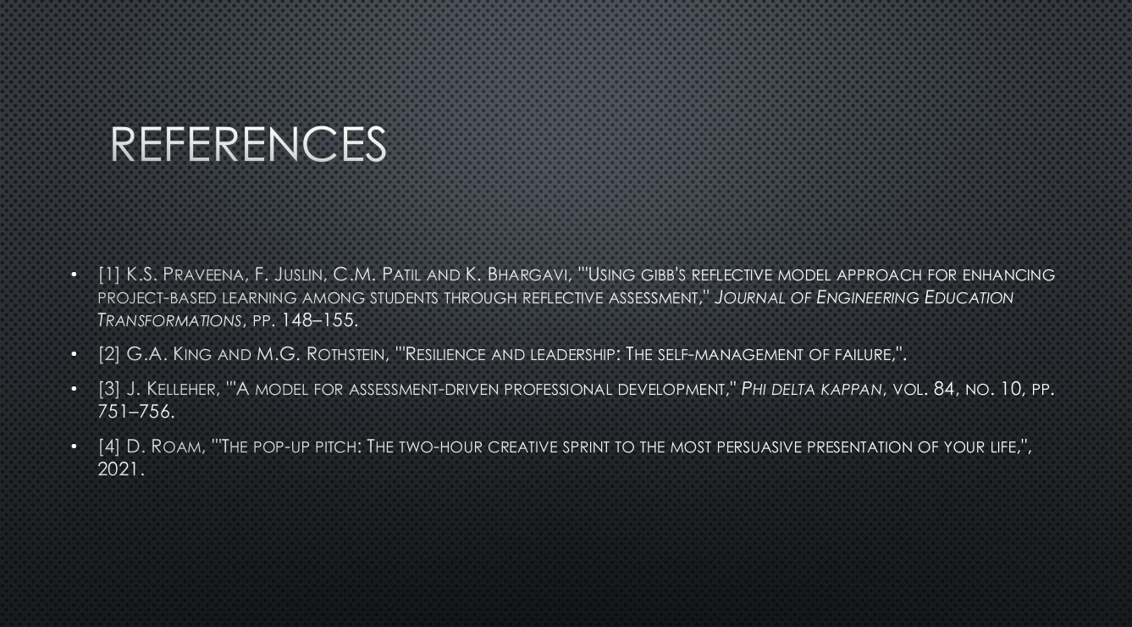It’s reference about Gibb’s reflective and task 3 Resilience

Conclusion
I have concluded my self-reflection in career planning is essential for employability skill. Smart goals help turns plans into achievements and regular assessment supports continues improvements.

References
[1] K.S. Praveena, F. Juslin, C.M. Patil and K. Bhargavi, '"Using gibb's reflective model approach for enhancing project-based learning among students through reflective assessment," Journal of Engineering Education Transformations, pp. 148–155.
[2] G.A. King and M.G. Rothstein, '"Resilience and leadership: The self-management of failure,".
[3] J. Kelleher, '"A model for assessment-driven professional development," Phi delta kappan, vol. 84, no. 10, pp. 751–756.
[4] D. Roam, '"The pop-up pitch: The two-hour creative sprint to the most persuasive presentation of your life,", 2021.

