Title: Changemakers: Creativity and Value Creation
Student Name: Shana Rankin
Student ID: 1912354
Module Code: BMHP5014_BIRM
Assignment Task 1& 2: E-portfolio evidence of Learning
Lecturer’s Name: Dr. Azora Hurd

19th February 2021

This assignment is the idea of Mindmap:

Mindmap is an online mapping tool that helps users’ access, communicate, and express their ideas across the cloud and structure their information and ideas. This application is another groundbreaking technology used internationally by all people.
1
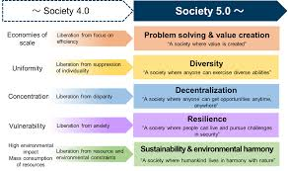
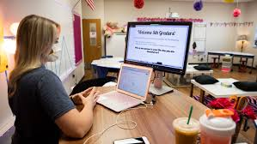
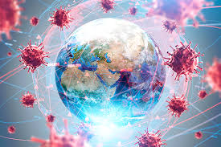
7
2
Pandemic and Society
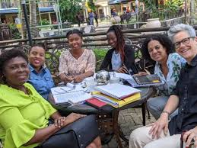
6
3
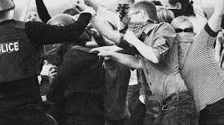
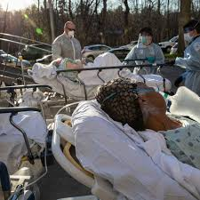
5

4

Hollauf and Voll (2007)
Introduction
The assignment for task 1 will discuss creativity in theory within the practice by using the Mindmap to provide information to correspond with the expectation and how the challenges, change-making, value and self-direct happen in the pandemic and society. Within task2, they will be a blog about pandemic and society and how we can provide for humanity during the pandemic. However, using creative and ethical leadership and using innovation and change with critical thinking to solve the problem and how decision-making comes in to provide my blog with the simple developing solution. Innovation is about developing and transmitting innovations to society, according to Abi Younes et al. (2020). The widespread distribution is especially significant in the present sense, as it represents explicitly saved lives and economic development. The dilemma of access to medicines for developed countries resonates with diffusion. While most industrialized countries manufacture medicinal remedies, they also have to be made accessible to the world. This foreign policy viewpoint poses a range of problems, of which this study deals in several ways.
The pandemic and society beneath the following fields are identified
- Pandemic infectious disease worldwide
- Education & student challenges in the pandemic
- Changemakers during the pandemic
- What is pandemic
- Society
- Society outbreak
- Society 4.0 and 5.0 in the fifth industrial revolution
Pandemic & Society
TASK 1
Pandemic
With the spread of infectious diseases all over the world, the pandemic has triggered an outbreak. This condition is like the effects of flu that contribute to the death of humanity. Creativity has been tested to limit in the pandemic. How to adapt to changes is so important that we have to thrive and prosper. It is like a defining influence for a healthier future. This is separate from anything that humanity ever sees.
1.) 1 2

3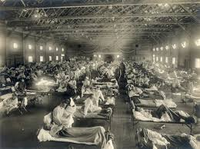 4 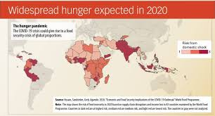 Abi Younes et al (2020).

These are challenges, creativity, self-direct, values and change-making in education and student life during the pandemic.
The complexities and demands we face in the pandemic have forced many educators to teach online on-demand. Most educators were required to teach online due to the challenges and difficulties. Students concerned with home education and online education system are confused about adaptation, and many people expect problems and cannot deal with pandemic and lockdown.
2.) 1 2 
Remote Learning with educators and students
3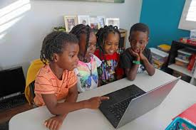 4  5 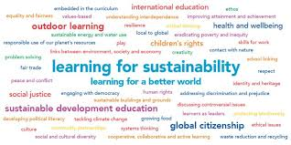
Tam and El-Azar, (2020)
Education is a drastic transition to online learning because of the pandemic and the risk of an increasing school system. Remote learning is often motivated by the pandemic that leads to internet connectivity and data are essential to process online learning in Microsoft teams and connect with educators. These are the drawbacks of pandemic learning.
According to Blume, Schmidt, Kramer, Schmiedek and Neubauer, (2020). From mid-March to the end of April 2020, schools have been suspended across Germany. Schooling was translated into the children's homes, and their teachers were to focus on learning assignments. Students should be believed to have self-regulation and attributes in teaching activities.
Changemakers during the pandemic
Changemakers are known by their talents and resources to do excellent work after the pandemic and collect funds to aid those devastated and make sure no one is left behind. The pandemic values of ideas in people's lives are conceived as free of fear and development. And environmental activity and autonomy during the pandemic will preserve freedom throughout the pandemic, stability, and wellbeing.
Discussion as a charity group to support and plan funding to society and donating food to poverty.
3.) 1 2 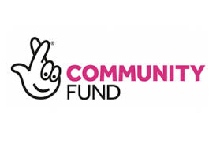
3 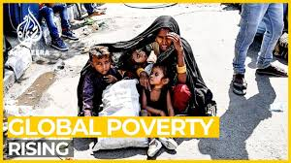 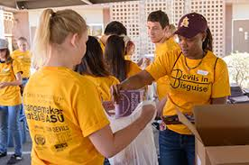 4
5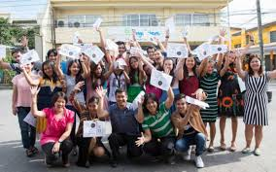 6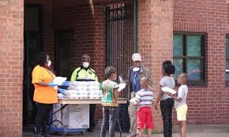 Valerio, (2020)
Changemakers support families and persons worldwide who are combating the pandemic; the staff acts with compassion to help people with disabilities in poverty.

What is a pandemic: There is a significant pandemic outbreak?
The unexpected development and widespread global dissemination of a new influenza virus occurred in early 2009, according to Morens, Folkers and Fauci (2009). They misunderstood the meaning of the term pandemic and how they should understand the pandemic as they arise. In general, a large area affects a substantial part of the population, distributed or widespread across the nation, area, the continent or worldwide.
The disease affects your immune system that is causing a worldwide pandemic
What Is a Pandemic, Anyway?,(2021)
4.) 1 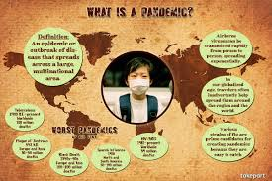 2 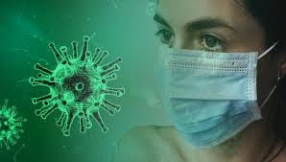
3 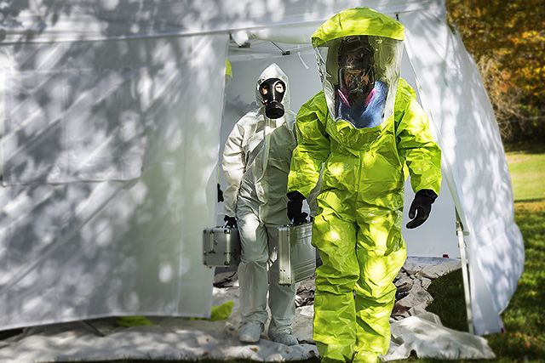 4 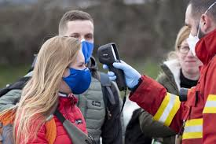
.
5 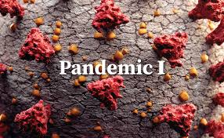 6 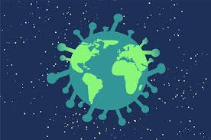Chrienova, (2020)
Society
A group of people engaging in social interaction and occupying the same geographical or social territory in the society, but due to the pandemic society is not what it used to be due to infectious disease that spread around the world.
Social interaction in the society before the pandemic happen.
5.) 1 2 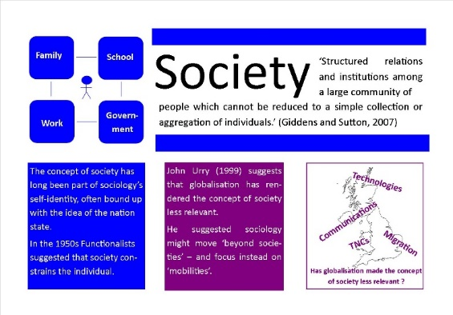

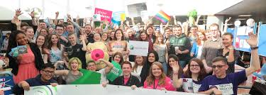 3
5 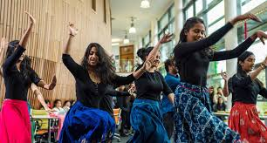 4 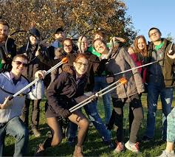Thompson, (2017)
Society Outbreak
This is the society around the world during a pandemic outbreak, the face of the families, peers, schools, and social divide between them. The pandemic disease's innovative life and time of invention have raised significant obstacles to the global economy and people, impacting culture every day. The dynamic environment of society will affect the value system of societies in terms of their heart and conduct that purchases the best and the worst of humanity. The society guides classroom practices and success and empowers students, not just students but also self-direct employees to evaluate their jobs and to lead themselves independently.
6.)1 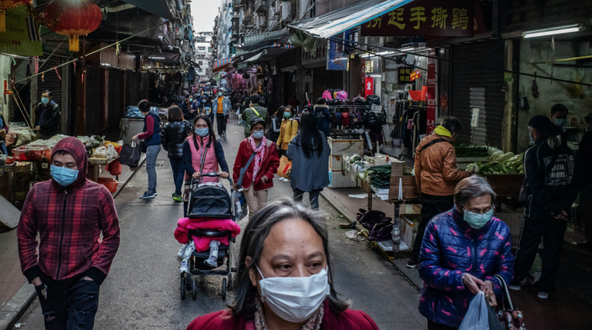 2 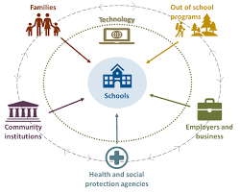 3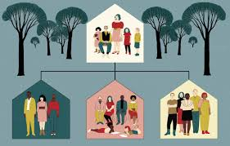
4 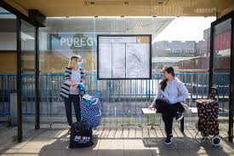
5 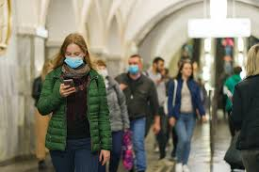 6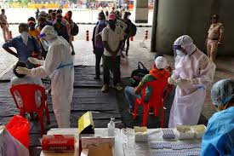
VOICE: The whole-of-society approach to the COVID-19 pandemic | Association for Progressive Communications, (2021)
View of society worldwide of what life used to be before the pandemic accrued, different aims to society and the expectation we have to adjust to, to make society what it is today.
1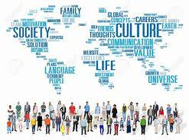 2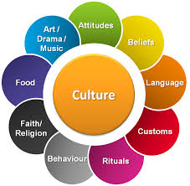
Sharma, (2018)
The society is broken during the pandemic, failure of
leadership and challenges to humanity.
3 Beaver and Gottfried, (2019)

Society shock: Due to the pandemic worldwide and the

cultural, creative, and socialisation humanity are in crisis.

Due to Society changes 4 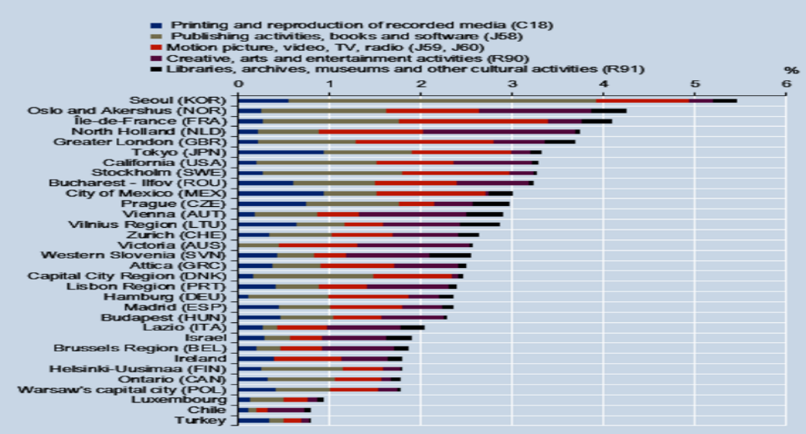
Beaver and Gottfried, (2019)
Society 4.0 and 5.0 – The Fifth Industrial Revolution
The pandemic will encourage Industry 4.0, which leads to the Fifth Industrial Revolution of the company,5.0 according to Sarfraz, Sarfraz, Iftikar and Akhund (2021). However, the correspondence analyses different technology from business 4.0 and company 5.0 and is inspected to internationally monitor the pandemic rate, including robots and (AI)artificial intelligence. Finally, in terms of the effect of the pandemic on application solutions being discussed and introduced, we discuss the transition in business 4.0 into society 5.0.
Society 4.0 and 5.0
7.) 1 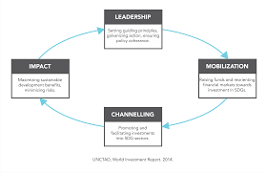 2 -
The fifth industrial revolution
4 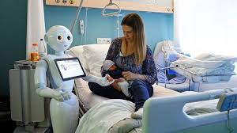 3 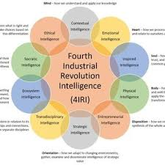
Sarfraz, Sarfraz, Iftikar and Akhund (2021)

Task 2- Blog Pandemic & Society
Username
Student No

1912354

PANDEMIC & SOCIETY BLOG
Innovation, Creativity, Changes, Changemaker, Challenges

Shana
I have learnt in unit 2 the value of creation and spotting competences and for me to re-create, my own competences story, scoping, identify new and attributes, and use my creative solution tool to make, my blog. The idea and creativity and values of what is happening globally due to the pandemic and how society tries to cope with changes have shared many sorrows and the same hopes and potential in problem-solving and decision-making. The pandemic has reminded all of us how independent we all can be. We all need to encourage and use our peace of mind to think about others, including those we never see. It is not a lovely feeling to feel worried, in fear when so many are suffering, trying to develop calmness and clear sight of how we can help others, and in so doing, even help ourselves. The most difficult challenges that have helped me gain strength in my own life, the current situation in our society, affect humanity globally, especially the health crisis and the environment's concern. We have remembered humanity is to thrive, and we must remember we are all one.
The pandemic in the world affected our cultures, stunned the world economy, and overburdened the struggles within the health system and other social bodies across the globe, according to Sovacool, Furszyfer Del Rio and Griffiths (2020). Although specific ramifications of global spread become more apparent, the pandemic's effects are becoming more prevalent on energy and climate policy. Ongoing socio-economic activities, technologies and changes to sustainability affect the disease Pandemic problems and perspectives. Tens of millions of people face. Underfed populations' quantity is officially measured to be severe poverty to reach close to 690 million and may increase to 132 million by the end of the year. The pandemic creates catastrophic economic and social damage to society.
According to Bossak and Welford report (2010), that pandemic can have a global effect on human mortality and address the virus attributes of an outbreak worldwide. Furthermore, they can compart summaries of macro-economic, social, and political transitions and migrations, ethnicity, and social disparities. Pandemic has dramatically impacted the population in psychological and social terms. The positive factor to the society and the pandemic is equity, fairness, environmental sustainability, and balance to humanity.

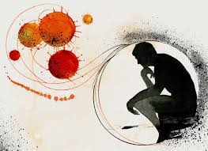

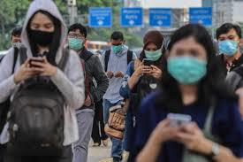

However, Amis and Greenwood (2020), enforce the pandemic changes in emptiness and a setting where the imbalance of care and opportunity is commonly recognised. These trends and the changes they have created highlighted how people should unite corporate members and others to align more closely with subordinate desires and values. The lack of awareness of this paradigm shift tends to be undoubtedly an obstacle to pandemic reform efforts. The mechanisms of benefit and disadvantage characterised by the Amis et al. (2020) organisations have been more marked in the sense of the pandemic in Bapuji et al. (2020).
Abi Younes et al (2020).

Tam and El-Azar, (2020)

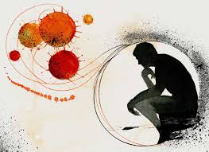
Bossak and Welford (2010)
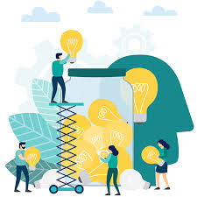

The pandemic that causes society to adapt.

Pandemic challenges in society worldwide.

The durability and the wealth of society.

Shining creativity and providing the alternative.

Conclusion
In conclusion, identify the pandemic and society's seven points by developing the mind map and blog to tie together to illustrate the changes, value, self-direct, ideas, problem-solving, critical thinking creativity, the challenges, and innovation. The pandemic triggered a worldwide outbreak that infected many individuals, including the human immune respiratory system, by this lethal virus. It has caused people to distance themselves from family and friends and make children and educators learning remotely online. Within the 4.0 and 5.0 society, and when we are in the changes today, this fifth revolution business comes in as we adapt to the society and the differences.
The financial recession is taking place within society; everyone is struggling to respond to society's changes. The optimistic results and coordination of the pandemic have led to establishing real relationships and seeking family time. Lifestyle changes lead to improved hygiene and better habits, inventions that remain linked and support each other and to find a new generation of tools and tech that operates and uses the general population on a remote basis. Training is digitalized and cost-effective. You are geographically far apart and linked emotionally. Be patient and stay safe.

References
Abi Younes, G., Ayoubi, C., Ballester, O., Cristelli, G., van den Heuvel, M., Zhou, L., Pellegrino, G., de Rassenfosse, G., Foray, D., Gaule, P. and Webster, E., (2020). COVID-19: Insights from Innovation Economists. SSRN Electronic Journal,.
Amis, J. and Greenwood, R., (2020). Organisational Change in a (Post‐) Pandemic World: Rediscovering Interests and Values. Journal of Management Studies,.
Bapuji, H., Patel, C., Ertug, G. and Allen, D. G. (2020). ‘Corona crisis and inequality: Why management research needs a societal turn’. Journal of Management, 46, 1205.
Apc.org., (2021). VOICE: The whole-of-society approach to the COVID-19 pandemic | Association for Progressive Communications. [online] Available at: <https://www.apc.org/en/news/voice-whole-society-approach-covid-19-pandemic> [Accessed 31 January 2021].
Beaver, K. and Gottfried, G., (2019). Majority worldwide say their society is broken - an increasing feeling among Britons. [online] Ipsos MORI. Available at: <https://www.ipsos.com/ipsos-mori/en-uk/global-study-nativist-populist-broken-society-britain> [Accessed 31 January 2021].
Blume, F., Schmidt, A., Kramer, A. C., Schmiedek, F., & Neubauer, A. B., (2020). Home schooling during the SARS-CoV-2 pandemic: The role of students’ trait self-regulation and task attributes of daily learning tasks for students’ daily self-regulation. https://doi.org/10.31234/osf.io/tnrdj> [Accessed 08 February 2021].
Bossak, B. and Welford, M., (2010). Spatio-Temporal Attributes of Pandemic and Epidemic Diseases. Geography Compass, 4(8), pp.1084-1096.
Chrienova, M., (2020). Call for Contributions: International law in pandemic times. [online] Voelkerrechtsblog.org. Available at: <https://voelkerrechtsblog.org/call-for-contributions-international-law-in-pandemic-times/> [Accessed 31 January 2021].
Hollauf, M. and Voll, T., (2007). Mindmeister | Online Tools for Teaching & Learning. [online] Blogs.umass.edu. Available at: <https://blogs.umass.edu/onlinetools/knowledge-centered-tools/mindmeister-2/>
Morens, D., Folkers, G. and Fauci, A., (2009). What Is a Pandemic?. 7th ed. https://doi.org/10.1086/644537: The Journal of Infectious Diseases, pp.1018–1021,. [Accessed 31 January 2021].
Sarfraz, Z., Sarfraz, A., Iftikar, H. and Akhund, R., (2021). Is COVID-19 pushing us to the Fifth Industrial Revolution (Society 5.0)?. Pakistan Journal of Medical Sciences, 37(2).
Sharma, H., (2018). Changing Times for Society, Culture and Technology. [online] Medium. Available at: <https://medium.com/new-media-dod/changing-times-for-society-culture-and-technology-22ae6a226459> [Accessed 31 January 2021].
Sovacool, B., Furszyfer Del Rio, D. and Griffiths, S., (2020). Contextualizing the Covid-19 pandemic for a carbon-constrained world: Insights for sustainability transitions, energy justice, and research methodology. Energy Research & Social Science, 68, p.101701.
TakePart., (2021). What Is a Pandemic, Anyway?. [online] Available at: <http://www.takepart.com/article/2015/04/02/what-is-a-pandemic> [Accessed 31 January 2021].
Tam, G. and El-Azar, D., (2020). 3 ways the coronavirus pandemic could reshape education. [online] World Economic Forum. Available at: <https://www.weforum.org/agenda/2020/03/3-ways-coronavirus-is-reshaping-education-and-what-changes-might-be-here-to-stay/> [Accessed 1 February 2021].
Thompson, K., (2017). What is society, and should sociologists study it?. Revise Sociology Social Theory (A2), Sociological concepts, pp.7191/1.
Valerio, C., (2020). Human Rights and Covid-19 pandemic. JBRA Assisted Reproduction,.

