

Tash Halley
2417049

Introduction 3
Literature Review 3
Research Problem Statement 5
Project Aim 5
Research Methodology, Strategy & Approach 5
Materials & Implementation Requirements 6
Project Design 7
Minimum Viable Project 8
Success Criteria 9
Project Plan 10
Resources & Budget 10
Industrial Impact, Limitations & Future Research 11
Personal Reflection 12
Bibliography 13

List of Figures
Figure 1 – Proposed data flow for the secure API-based MIS migration validation framework
Figure 2 – Proposed Project Implementation Timeline
List of Tables
Table 1 – Proposed Technical Stack and Implementation Resources
Table 2 – Proposed validation rules for the API-based validation framework.
Table 3 – Minimum Viable Project Requirements
Table 4 – Success Criteria & Measurement of Success
Table 5 – Resource & Budget Estimated Costs

Project Proposal
Introduction
Management Information Systems (MIS) play a central role in the daily operation of education settings, underpinning attendance monitoring, safeguarding workflows, assessment management, statutory reporting and communication with parents and local authorities. Adhikari et al [1] state that MIS play a transformative role in modern school administration by enhancing efficiency, decision-making and overall effectiveness.
Across Bridgend, 60 schools are transitioning from the legacy platform SIMS to the more flexible, cloud-based system Bromcom. However, migrating data between MIS platforms can introduce challenges relating to data integrity, compatibility and security, particularly where large volumes of sensitive data are involved.
Migration processes may involve manual data exports, CSV files and system-specific migration tools, creating a need for effective validation to ensure that transferred data remains complete and accurate. Azeroual and Meena [2] highlight that data migration is increasingly important for data-intensive applications as legacy storage systems struggle to accommodate evolving requirements. In an educational environment, migration errors could have operational, legal and safeguarding consequences, increasing the importance of accurate and secure data validation.
An API-driven validation framework could provide a controlled and automated mechanism for comparing data against predefined rules and identifying inconsistencies between source and target systems. This project therefore proposes the development of a secure API-based data validation framework tailored to the SIMS-to-Bromcom migration process. It will examine the architectural requirements, security considerations and validation logic required to support reliable migration and verify the integrity of transferred data. By addressing challenges surrounding automation, accuracy and security, the framework aims to reduce migration risk, improve data quality and provide a scalable approach that could support MIS transitions within the education sector.
Literature Review
Earlier database migration approaches focused on reading, converting and writing data from source to destination environments, with manual intervention remaining part of the migration process as described by Fahmi and Putra [3]. Azeroual and Meena [2] similarly highlight that legacy storage systems lacked the flexibility required to support evolving organisational needs. As migration activities developed, transferring data alone became insufficient, creating a need to validate whether destination data accurately represented the source. Fahmi and Putra [3] identify completeness, consistency and integrity as important measures when evaluating migration quality.
Sarabu [4] provides an early structured approach, arguing that fragmented or manual validation methods were inconsistent and difficult to scale. The framework incorporated predefined validation rules and automated reconciliation techniques including schema, completeness, referential-integrity, record-count and checksum-based validation. In contrast, Netinant et al [5] demonstrate a more contemporary approach in which validation and monitoring are incorporated across multiple stages of the migration lifecycle, demonstrating a progression towards more continuous and integrated validation.
Modern data migrations frequently involve systems with differing schemas, structures and data representations. Fedushko et al [6] demonstrate that schema evolution can introduce changes to field names, data types and representations, requiring data to be mapped or transformed during migration. This is particularly relevant to MIS migration, where equivalent information may not be represented using identical structures. Kundavaram [7] identifies migration failure modes including incomplete transfers, encoding inconsistencies and corruption during transmission. Critically, these risks demonstrate that successful completion of a migration does not necessarily establish that the resulting dataset is complete, consistent or accurate.
The challenge is compounded by scale. Netinant et al [5] describe a real-world migration involving 223 database tables and 4.65GB of data, with structural and data-type differences between source and target systems. Combining large datasets, heterogeneous schemas and multiple validation requirements can make manual verification increasingly impractical, strengthening the case for repeatable automated validation.
Manjunath et al [8] propose automated source-to-target validation using SQL-based comparisons to identify discrepancies in mapping, transformation rules and duplicate records. However, this relies on direct access to source and target database tables, creating scope to investigate how similar principles could operate where data is accessed through controlled APIs. Conversely, Ananthakrishnan [9] proposes a layered framework incorporating real-time checksum validation, data reconciliation, anomaly detection and post-migration integrity checks. While comprehensive, its use of technologies including AI, blockchain and continuous monitoring may introduce unnecessary complexity where validation must remain operationally feasible. Together, these approaches demonstrate a gap between direct database-level validation and more complex frameworks requiring specialised infrastructure.
The effectiveness of automated validation also depends on the selection of appropriate rules. Manjunath et al [8] discuss record-count, referential-integrity and business-rule validation, while Ananthakrishnan [9] incorporates checksum and post-migration integrity checks. Record counts can indicate completeness but cannot establish that individual values were transferred accurately, while referential-integrity checks assess relationships but require knowledge of the expected target structure. As individual techniques provide different forms of assurance, combining complementary validation rules could provide a more comprehensive assessment of migration integrity.
Zimmermann et al [10] describe remote APIs as integration interfaces through which system functionality can be exposed to applications, third-party systems and other distributed components. This demonstrates their potential to provide a structured mechanism for communication between otherwise separate systems. Within migration validation, such an approach could enable data to be retrieved programmatically from target systems without requiring the validation framework to rely exclusively on direct database access.
API-based integration introduces additional security considerations. Genfer et al [11] identify secure communication, identity management, access management and traffic control as key considerations, including TLS/HTTPS encryption alongside authentication and authorisation. OWASP [12] similarly identifies broken authentication, broken object-level authorisation and broken object-property-level authorisation among its principal API security risks. Consequently, an API used for validation becomes part of the potential attack surface, requiring security controls to be incorporated into the framework rather than treated as operational safeguards.
Overall, the literature demonstrates progression towards increasingly automated and integrated migration validation. Earlier techniques rely heavily on direct database access, while contemporary frameworks may introduce unnecessary technical complexity for some migration environments. This identifies an opportunity to investigate whether a secure API-based framework combining complementary validation rules and security controls could provide a scalable and operationally feasible approach to MIS migration validation.
Research Problem Statement
Data migration between educational MIS platforms presents challenges in maintaining the completeness, accuracy and integrity of transferred data, particularly where source and target systems use different structures. Existing validation approaches may rely on direct database access, while more advanced frameworks can introduce unnecessary technical complexity.
There is therefore a need to investigate a secure and operationally feasible approach that combines automated validation techniques with API-based data access and appropriate security controls to support reliable MIS migration.
Project Aim
AIM: To design, implement and evaluate a secure API-based data validation framework for verifying data integrity between School Management Information Systems (MIS).
Research Objectives
- To analyse existing data migration and validation techniques and identify limitations within school MIS migration.
- To define appropriate validation rules and security requirements for an API-based data validation framework.
- To design and implement a secure API-based framework capable of comparing source and target MIS data and identifying migration discrepancies.
- To evaluate the effectiveness of the proposed framework using controlled migration test scenarios.
Research Methodology, Strategy & Approach
A positivist research philosophy will underpin this project due to its focus on objective and measurable evaluation. Gamage [13] describes positivism as an empirical approach based on systematic observation, measurement and analysis. This is appropriate as the framework will be evaluated using measurable results obtained through controlled testing.
A deductive approach will be adopted by applying established data validation and API security principles identified within existing literature. Kumar [14] describes deductive research as progressing from general theory towards specific observations. Software development will form the primary research strategy, involving the design, implementation and evaluation of the proposed framework. Venable et al [15] identify building and evaluation as key activities within Design Science Research, supporting the development and subsequent evaluation of technical artifacts.
A quantitative mono-method approach will be used to generate numerical results from controlled technical testing. Taherdoost [16] identifies quantitative research as involving numerical values derived from observations and subsequent mathematical analysis. A cross-sectional time horizon will also be adopted, as testing will occur within a defined implementation period rather than examining changes over time as mentioned by Gamage [13].
Representative source and target datasets will be tested using predefined discrepancies to establish known conditions against which framework outputs can be compared. This applies the controlled-testing principle described by Salih et al [17]. Analysis will measure correctly detected discrepancies, missed discrepancies, incorrectly flagged records and overall detection rate, with descriptive analysis used to evaluate individual validation rules.
Materials & Implementation Requirements
The implementation of the proposed framework will require a combination of software, data and development resources to support data retrieval, validation, security and controlled testing. The proposed materials will provide an isolated environment in which the framework can be developed and evaluated without affecting live operational data or systems.
Material Technology | Proposed Use
Standalone Laptop | Provides an isolated environment for development, implementation and controlled testing without affecting live operational systems.
Local SIMS Test Environment | Acts as the source MIS environment and provides representative data for extraction and validation.
Microsoft SQL Server / SQL Server Management Studio | Used to access, inspect and query the local SIMs test database, verify source records and establish expected values for controlled validation testing.
Bromcom Test Environment / API Access | Acts as the intended target MIS environment, with available API functionality used to provide controlled programmatic access to selected target data.
Python | Used to develop the validation framework, including data retrieval, field mapping, execution of validation rules, discrepancy detection and results processing.
Postman | Used during development to test API endpoints, requests, responses and authentication before implementing API interactions programmatically within Python.
JSON | Used as the anticipated data-interchange format for API responses and subsequent processing by the validation framework.
API Authentication & HTTPS/TLS | Restricts API access to authorised requests and protects sensitive data during transmission. The specific authentication mechanism will depend on the capabilities of the available test environment.
Python “logging” Module | Records framework activity, validation events and errors to provide an audit trail during implementation and testing.
CSV Validation Reports | Stores validation outcomes and identified discrepancies in a structured format for review and subsequent quantitative analysis.
Table 1 – Proposed Technical Stack and Implementation Resources

Representative test data from the local SIMS environment will form the source dataset, with corresponding data within the Bromcom test environment representing the target datasets. These datasets are appropriate because they enable controlled source-to-target comparison within the MIS context addressed by the project. Data will be retrieved using the available database and API mechanisms before being processed by the Python validation framework. Controlled discrepancies will be introduced where required to provide known conditions against which validation results can be evaluated.
Project Design
This section presents the proposed design and workflow of the secure API-based data validation framework. The design illustrates how data will be accessed from the source and target MIS environments, processed through predefined validation rules and assessed for potential discrepancies. It also identifies where security controls will be incorporated to protect data throughout the validation process and how validation outcomes will be recorded and reported.
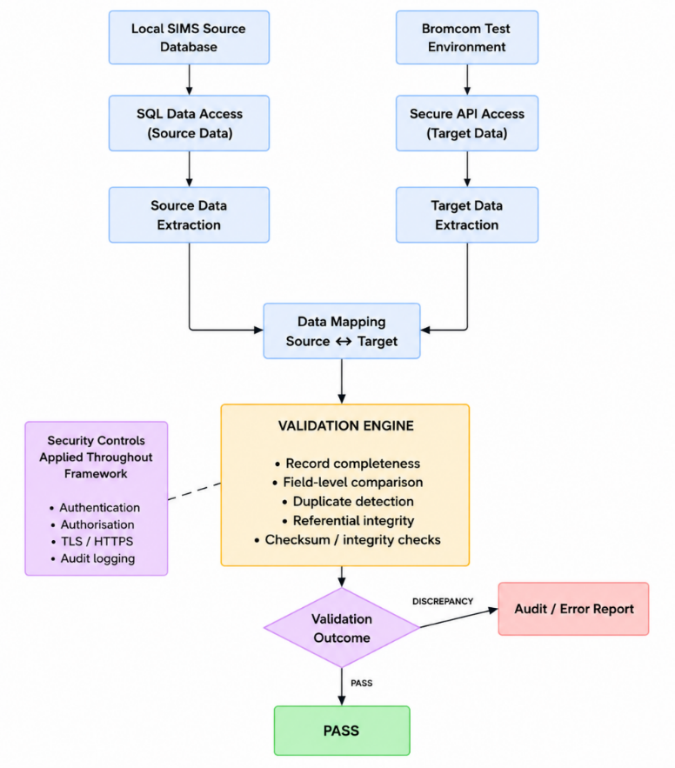

Figure 1 – Proposed data flow for the secure API-based MIS migration validation framework

Figure 1 illustrates the proposed workflow of the API-based validation framework. Source data from SIMS will be retrieved from the local database environment, while target data from Bromcom will be accessed using available API functionality. Data from both environments will be extracted independently before equivalent fields are mapped for comparison. The validation engine will then apply predefined rules related to record completeness, field-level consistency, duplicate detection, referential integrity and data integrity. Manjunath et al [8] identify techniques including record-count and referential integrity while Ananthakrishnan [9] incorporates checksum and post-migration integrity checks within a layered validation approach. Validation outcomes will distinguish between successfully validated data and identified discrepancies, with discrepancies recorded within an audit / error report. Genfer et al [11] identify authentication, authorisation and secure communication as important controls for API-based communication, while OWASP [12] highlights risks associated with weaknesses in API authentication and authorisation. These controls, alongside TLS / HTTPS and audit logging, will therefore be incorporated where appropriate to protect data access and support traceability throughout the validation process.
The proposed design separates data access from validation to ensure that the framework does not perform or modify the migration itself. Instead, source and target data are independently retrieved and mapped before being processed by the validation engine. This separation allows validation rules to operate consistently across equivalent fields while reducing dependence on the underlying structure of either MIS platform.
The validation engine will apply a series of predefined rules to assess different aspects of data integrity between the source and target datasets. As no single validation technique can provide assurance across all forms of migration discrepancy, complementary rules will be used to assess completeness, consistency and integrity. Table 2 outlines the proposed validation rules and their intended purpose within the framework.
Validation Rule | Purpose
Record Completeness | Verify that expected records present in the source dataset are also present in the target dataset and identify missing or unexpected records.
Field-Level Comparison | Compare mapped source and target fields to identify differences in individual values.
Duplicate Detection | Identify records that appear more than once where a unique record is expected.
Referential Integrity | Verify that relationships between related records remain valid following migration.
Checksum / Integrity Checks | Identify potential alteration or corruption of selected data between source and target datasets.
Table 2 – Proposed validation rules for the API-based validation framework.
Minimum Viable Project
The Minimum Viable Project will consist of a functional prototype capable of performing the core processes required to validate data between representative source and target datasets. Establishing an MVP will ensure that the principal project aim can still be achieved while allowing additional functionality and validation mechanisms to be incorporated where development time and system access permit.

MVP Component | Minimum Requirement | Purpose
Data Retrieval | Retrieve representative data from the source and target datasets through the available data-access mechanism. | Provides the data required for source-to-target validation.
Data Mapping | Map a selected set of equivalent fields between the source and target datasets. | Ensures corresponding data can be accurately compared despite structural differences.
Core Validation Rules | Implement record-completeness and field-level comparison checks as a minimum. | Enables the framework to identify missing records and differences in migrated values.
Discrepancy Detection | Identify and distinguish discrepancies between the source and target datasets. | Provides evidence of potential migration integrity issues.
Security Controls | Apply appropriate authentication, authorisation and secure communication controls where supported by the testing environment. | Protects access to data used by the validation framework.
Validation Output | Generate a clear record of validation results and identified discrepancies. | Supports review, testing and auditability of the validation process.
Table 3 – Minimum Viable Project Requirements
Additional validation mechanisms, including duplicate detection, referential-integrity checking and checksum-based validation, will be considered as extended functionality beyond the MVP where development time and system access permit.
Success Criteria
Project success will be assessed against measurable criteria aligned with the project aim and objectives. Venable et al [15] emphasise the importance of evaluating developed artifacts to demonstrate their utility, quality and success, with characteristics including functionality, completeness, consistency and accuracy forming potential aspects of evaluation. The success criteria for the proposed framework will therefore focus on whether it can securely access representative datasets, execute the core validation functions and accurately identify known discrepancies during controlled testing.
Success Criteria | Measure of Success
Data Access | Source and target test data can be retrieved successfully using the available data-access mechanism.
Field Mapping | Selected equivalent fields between source and target datasets are mapped correctly.
Validation Execution | The core validation rules run without failure against the selected test datasets.
Discrepancy Detection | Known missing records and field-level differences are correctly identified during controlled testing.
False Alerts | Controlled data is not unnecessarily flagged as a discrepancy.
Security Controls | Implemented authentication, authorisation and secure communication controls operate as intended within the test environment.
Reporting | Validation results clearly distinguish passed records from detected discrepancies and provide an auditable output.
Table 4 – Success Criteria & Measurement of Success
Project Plan
The project will be undertaken over a six-month implementation period, with development structured into a series of defined stages and milestones. The project plan has been designed to support the progressive development of the proposed validation framework, beginning with planning and environment preparation before progressing through data access, framework development, controlled testing and evaluation. Project documentation will be completed alongside implementation to ensure that development and testing activities are recorded throughout the project. Figure 2 presents the proposed project timeline and key milestones.
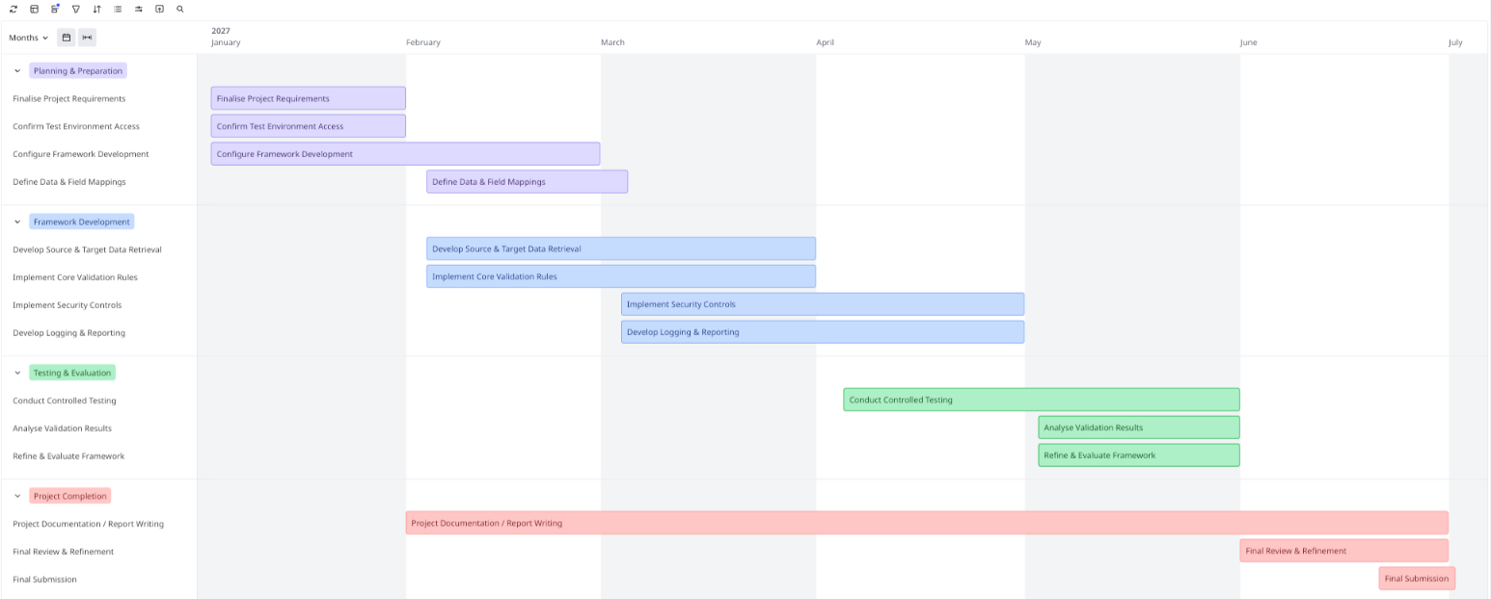
Figure 2 – Proposed Project Implementation Timeline
Resources & Budget
The proposed project has been designed to make use primarily of existing hardware, software and test environments, minimising the requirement for additional project funding. The principal resources include access to appropriate MIS test environments, development and database software, API functionality and suitable hardware for implementation and testing. Table 5 outlines the anticipated resources, their availability and any associated project costs.

Resource | Availability / Purpose | Estimated Cost
Standalone Laptop | Existing hardware provided by employer to host the development and local test environment. | £0
SIMS Test Environment | Required to provide representative source MIS data for development and validation testing. | £0
Bromcom Test Environment / API Access | Existing test environment intended to provide representative target data and available API functionality. | £0
Microsoft SQL Server / SSMS | Required to access and query the local SIMS database. | £0
Python | Used to develop and execute the validation framework. | £0
Postman | Used to test API requests, responses and authentication during development. | £0
Development Time | Undertaken as part of the final-year project within the allocated project period. | £0
Table 5 – Resource & Budget Estimated Costs
No direct project expenditure is therefore anticipated at the proposal stage, as the required development tools are either freely available or expected to be accessible through the existing test environments. The primary resource dependency will be obtaining the necessary level of access to the SIMS and Bromcom environments, particularly the availability of suitable Bromcom API permissions. Should the intended level of system access not be available, the project design may require adaptation using representative test datasets while retaining the proposed validation methodology.
Industrial Impact, Limitations & Future Research
The proposed framework has the potential to provide practical value within the education sector by supporting more consistent and auditable validation of data during MIS migration. Lai and Hsiao [18] highlight the importance of high-quality data within schools, noting that the quality of decision-making is dependent upon the quality of the underlying data. Schools rely on accurate information for operational activities including attendance, safeguarding, assessment and statutory reporting, meaning that discrepancies introduced during migration may have consequences beyond the technical migration process. By automating selected source-to-target validation checks, the proposed framework could reduce reliance on manual comparison while providing a structured record of identified discrepancies. Although the framework will be developed and evaluated within the context of a SIMS-to-Bromcom migration, the underlying approach of data extraction, mapping and rule-based validation could potentially be adapted to other MIS migration scenarios. This may provide a foundation for a more reusable validation approach where organisations are required to verify the completeness and integrity of data transferred between heterogeneous information systems.
Several limitations may affect the implementation and evaluation of the proposed framework. Access to the functionality of the SIMS and Bromcom test environments, particularly Bromcom API permissions, may restrict the range of data that can be retrieved programmatically. Bromcom [19] states that access for third-party applications requires the creation of a specific account by an administrator, demonstrating that API access is dependent upon appropriate system permissions. The functionality available within the project will therefore depend partly upon the level of access provided within the test environment. Testing will also be conducted using representative test data rather than live operational school data. Tan et al [20] highlight the importance of high-quality test data in providing assurance regarding software correctness and identify adequate representation of the input domain as an important consideration when generating test data. Although representative datasets will enable controlled evaluation of the proposed framework, they may not reproduce the full complexity and variety of data encountered during a live school MIS migration.
Future research could extend the framework by evaluating it across additional MIS platforms and larger, more diverse datasets to determine its wider applicability and scalability. Additional validation mechanisms could also be incorporated beyond those achieved within the MVP, including more extensive referential-integrity and checksum-based validation. Further development could investigate increased automation of field mapping and discrepancy classification, alongside integration with operational migration workflows. Evaluation within a controlled live migration environment could also provide further evidence of the framework’s effectiveness under realistic conditions, subject to appropriate data protection, organisational and ethical requirements.
Personal Reflection
Development of this project proposal has significantly increased understanding of the technical and research considerations involved in data migration validation. The initial project concept focused primarily on determining whether data had transferred correctly between two MIS platforms. However, the research and design process has demonstrated that effective validation requires consideration of data mapping, complementary validation techniques, API integration, security controls and measurable methods of evaluation. Developing the proposed architecture has also strengthened understanding of how technologies including Python, SQL and APIs can be combined within a secure validation framework. Tackling this topic as a final year major project is both challenging and motivating due to the practical implementation required and its relevance to a real-world MIS migration environment. Challenges may arise from test-system access, API permissions and the technical development of the framework. However, defining a realistic Minimum Viable Project, success criteria and structured development plan has increased confidence in the feasibility of the project. The opportunity to apply existing Cybersecurity and Networking knowledge while developing further technical skills makes the proposed project particularly valuable as a final-year undertaking.

Bibliography
[1] N. Adhikari, J. Budhathoki, and S. Adhikari, “Management Information Systems’ Role and Effects on School Administration: A Review ,” Perspectives on Higher Education , vol. 14, Dec. 2024.
[2] O. Azeroual and M. Jha, “Without Data Quality, There Is No Data Migration,” Big Data & Cognitive Computing, vol. 5, no. 24, May 2021.
[3] A. Fahmi and Y. Putra, “Database Migration Strategies and Techniques to Minimise Unexpected Dysfunctionality ,” in Materials Science & Engineering, Nov. 2019.
[4] V. Sarabu, “A Framework-Driven Approach to Data Validation and Reconciliation for Operational Accuracy ,” International Journal of Advanced Research in Electrical, Electronics and Instrumentation Engineering, vol. 5, no. 3, Mar. 2016.
[5] P. Netinant, N. Saengsuwan, M. Rukhiran, and S. Pukdesree, “Enhancing Data Management Strategies with a Hybrid Layering Framework in Assessing Data Validation & High Availability Sustainability,” Sustainability, Oct. 2023.
[6] S. Fedushko, R. Malyi, Y. Syerov, and P. Serdyuk, “NoSQL document data migration strategy in the context of schema evolution,” Data Knowl. Eng., vol. 154, Nov. 2024.
[7] V. Kundavaram, “Automated Data Migration in Cloud Environments: Challenges & Solutions,” International Journal of Computing Engineering & Technology, vol. 15, no. 6, Dec. 2024.
[8] N. Manjunath, H. Ravindra, and S. Mohan, “Automated Data Validation for Data Migration Security ,” Int. J. Comput. Appl., vol. 30, no. 6, Sep. 2011.
[9] V. Ananthakrishnan, “Enterprise Data Migration Strategies for High-Assurance Information Systems,” Frontiers in Computer Science & Artificial Intelligence , vol. 5, no. 5, Mar. 2026.
[10] O. Zimmermann, M. Stocker, D. Lubke, U. Zdun, and C. Pautasso, “Patterns for API Design: Simplifying Integration with Loosely Coupled Message Exchanges,” in Patterns for API Design, Addison-Wesley Professional, 2022, ch. 1, pp. 6–8.
[11] P. Genfer, S. Serbout, G. Simhandl, U. Zdun, and C. Pautasso, “Understanding Security Tactics in Microservice APIs using Annotated Software Architecture Decomposition Models - A Controlled Environment ,” Empir. Softw. Eng., vol. 30, no. 66, Feb. 2025.
[12] OWASP, “OWASP Top 10 Security Risks - 2023 ,” https://owasp.org/API-Security/editions/2023/en/0x11-t10/.
[13] A. Gamage, “Research Design, Philosophy, and Quantitative Approaches in Scientific Research Methodology ,” Scholars Journal of Engineering and Technology , vol. 1, no. 1, Feb. 2025.
[14] S. Kumar, “INDUCTIVE AND DEDUCTIVE APPROACHES TO QUALITATIVE RESEARCH ,” International Journal of Multi-Disciplinary Educational Research, vol. 13, no. 4, Jan. 2024.
[15] J. Venable, J. Heje-Pries, and R. Baskerville, “FEDS: a Framework for Evaluation in Design Science Research,” European Journal of Information Systems, vol. 25, no. 1, Nov. 2014.
[16] H. Taherdoost, “What are Different Research Approaches? Comprehensive Review of Qualitative, Quantitative, and Mixed Method Research, Their Applications, Types, and Limitations,” Journal of Management Science & Engineering Research, vol. 5, no. 1, 2022.
[17] S. Nadir, S. D, A. Abdullah, and G. R, “A Survey on Software/Hardware Fault Injection Tools and Techniques,” in Symposium on Industrial Electronics & Applications (ISIEA), IEEE, Sep. 2022.
[18] M. K. Lai and S. Hsiao, “Developing Data Collection & Management Systems for Decision Making: What Professional Development is Required?,” Studies in Educational Evaluation , vol. 42, Sep. 2014.
[19] Bromcom Documentation Centre, “Managing Third Party Integrations,” Bromcom.
[20] C. Tan, R. Behjati, and E. Arisholm, “Application of Deep Learning Models to Generate Rich, Dynamic and Production-Like Test Data,” Empir. Softw. Eng., vol. 30, no. 5, Oct. 2024.

