Assessment 2: Financial Management for the Hotel Industry
LECTURER NAME: Tristan Hawkins
STUDENT ID: 2126415
STUDENT NAME: Gianina AGHINITEI
Word Count: 2034

Table of Contents
Introduction 3
Market Analysis 3
Scope and Objectives 4
Identification of the Seaview Resort's Financial Performances over the Last Three Years 4
Identification of the Key Reasons Behind the Profitability Decline 5
Development of the Comprehensive Turnaround Strategy to Revitalise Seaview Resort Financial Health 6
Conclusion 8
References 10

Introduction
The concept of financial management implies controlling, monitoring, reporting, and protecting the organisational monetary/financial resources (Alabdullah, 2019). In general, different organisations adopt different financial accounting standards, with a view to remaining transparent in the auditing controlling process (Alvarez et al., 2021). This report is based on the theme of financial management in the context of the given case scenario for Seaview Resort. This report covers the analysis of the Seaview Resort's last three fiscal year’s financial performances with the identification of the possible reason for the profit decline in its business operations. In addition to these, this report also highlights the development of a holistic approach for Seaview Resort in terms of revitalising the turnaround strategy irrespective of the company's financial outcome.

Market Analysis
The Seaview Resort is confronting a complex trinity of challenges tightly entwined with its financial hardships. The highly competitive coastal resort market presents a formidable hurdle, with the emergence of sleeker, more contemporary alternatives in proximity applying immense pressure on the Seaview Resort's capacity to draw and retain guests. The appeal of these new choices, coupled with the resort's fiscal constraints, has resulted in diminishing occupancy rates, and slipping room rates, contributing to the decline in revenue and profitability. Moreover, the changing landscape of customer preferences holds paramount significance (Bandy, 2014). Present-day travellers exhibit a growing inclination toward eco-friendly and experiential tourism. Unfortunately, The Seaview Resort has lagged in adjusting to these evolving tastes, causing a disconnect that diminishes its appeal to potential visitors. To align with the surging demand for eco-conscious and experiential experiences, the resort must channel resources into sustainability initiatives and forge distinctive, memorable guest interactions (Brigham and Daves, 2019). With these market-related predicaments, the resort's financial reports expose the adverse effects of dwindling service quality and antiquated amenities, as disclosed in guest reviews. These issues not only undermine guest satisfaction, repeat patronage, and overall revenue but also serve as a financial demand to restore profitability (Bhimani, 2020).
In summation, the amalgamation of a fiercely competitive market, evolving customer inclinations, and service quality and amenity drawbacks, as reflected in the Seaview Resort's financial documents, emphasizes the pressing requirement for a comprehensive turnaround strategy. This strategy should seamlessly harmonize with the resort's financial recovery aspirations and its pursuit of reestablishing itself as a preeminent vacation haven that aligns with the contemporary proclivities of travellers.

Scope and Objectives

Identification of the Seaview Resort's Financial Performances over the Last Three Years
Over the preceding three years, the Seaview Resort witnessed a substantial downturn in its financial standing. The resort's total income diminished from £520,000 in 2020 to £430,000 in 2022, signifying a continuous loss of both customers and revenue. The operational expenses incurred by the resort exhibited an escalating trend, surpassing its revenue in 2022, indicating operational inefficiencies and fiscal challenges.
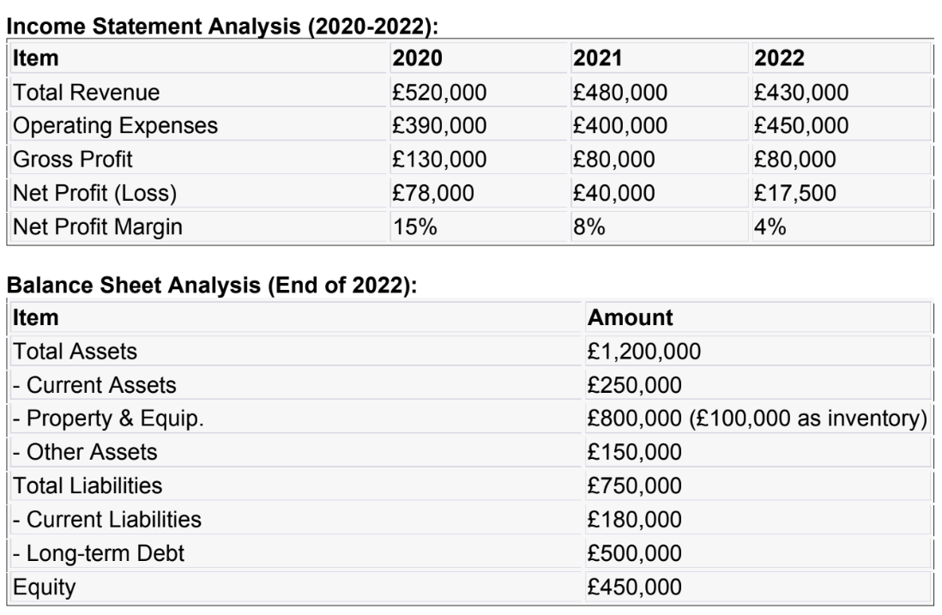
Consequently, this resulted in a noteworthy erosion of profitability, with the net profit margin dwindling from 15% in 2020 to a meagre 4% in 2022, culminating in a net loss of £17,500 in the latter year. The erosion in profitability can be ascribed to diminishing occupancy rates and the dwindling average room rates, manifesting a diminishing competitive edge and diminished appeal to customers. Furthermore, the resort grappled with a marked negative cash flow from operations in 2021, amounting to -£80,000, underscoring fiscal constraints. The resort's balance sheet exposes a substantial long-term debt of £500,000 alongside relatively modest equity of £450,000, signifying financial leverage and mounting pressure on its fiscal liquidity.
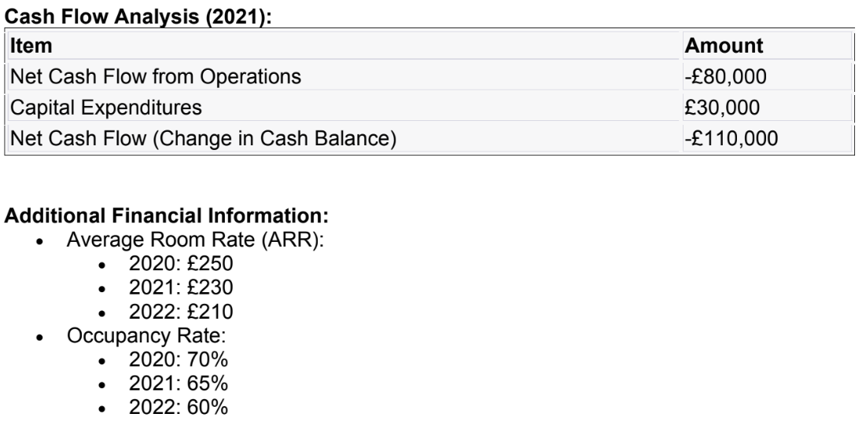
In summary, The Seaview Resort's financial performance experienced a decline over the past three years owing to heightened competition, evolving customer preferences, waning service quality, and fiscal mismanagement. The imperative now is to formulate a comprehensive strategy for revitalization, reinstating the resort's financial health and its repute as a premier holiday haven.

Identification of the Key Reasons Behind the Profitability Decline
The decline in the Seaview Resort's financial performance can be linked to several prominent factors, each contributing to its fiscal challenges.
- Elevated Competitive Landscape: The coastal resort sector has progressively become more cutthroat, with the emergence of contemporary, up-to-date resorts nearby (Campos et al., 2022). These rivals likely lured away a substantial portion of The Seaview Resort's potential clientele, resulting in diminished revenue and occupancy rates. The resort needs to carve a unique niche in the market to stand out from the competition.
- Evolving Client Tastes: Modern vacationers now favour eco-conscious and experiential tourism. The Seaview Resort may not have promptly adjusted to these evolving preferences. Present-day travellers seek exceptional, environmentally mindful experiences, and failure to align with these trends may be costing the resort potential patrons who opt for more innovative alternatives (Chibili, 2019).
- Service Excellence and Dated Amenities: Guest feedback highlights a dip in service quality and obsolete facilities at the resort. This adversely influences guest satisfaction and the likelihood of return visits (Finkler et al., 2022). Improving this necessitates investment in modernizing amenities and elevating service standards, ensuring an enjoyable and memorable guest experience.
- Dwindling Room Rates and Occupancy: The decrease in average room rates from £250 in 2020 to £210 in 2022, coupled with a fall in occupancy rates, indicates that the resort's value proposition may have lost its appeal. To reinvigorate profitability, a strategic review of pricing is imperative, possibly involving competitive rates, special packages, and off-peak discounts.
- Cash Flow Challenges: The resort grappled with a negative cash flow from operations in 2021, a signal of financial instability. Such cash flow constraints can lead to difficulties in covering operational expenses and servicing debt, intensifying the pressure on profitability (Eldenburg et al., 2020). A meticulously structured cash flow management strategy is essential to safeguard the resort's financial stability.
- Debt Burden and Limited Equity: The resort's considerable long-term debt of £500,000 and comparatively modest equity of £450,000 result in financial leverage, exacerbating cash flow constraints and hindering investments in enhancements. Investigating alternatives for debt restructuring or refinancing is a viable means to alleviate this financial encumbrance (Eun et al., 2021).
Hence, the Seaview Resort's dwindling profitability can be traced to heightened competition, evolving customer preferences, service quality concerns, dwindling room rates and occupancy, cash flow hurdles, and the weight of substantial debt. The path to recovery necessitates a comprehensive turnaround strategy, crucial for rekindling the resort's financial health and re-establishing its reputation as a top-tier vacation destination.

Development of the Comprehensive Turnaround Strategy to Revitalise Seaview Resort Financial Health
In order to develop a holistic turnaround strategy for the Seaview Resort the encompassing approach encompasses several key dimensions. Firstly, Market Positioning and Branding. The initial step is to reimagine the resort's image to harmonise with the evolving preferences of modern travellers (Hiromoto, 2019). Emphasizing eco-friendliness, sustainability, and one-of-a-kind experiences will differentiate the resort from its rivals. A rebranding endeavour should vividly convey the resort's dedication to the environment and its capacity to offer distinctive, unforgettable experiences. Effective marketing campaigns will be pivotal in conveying this renewed brand identity to prospective guests. Secondly, Operational Efficiency. Conducting a meticulous assessment of operations is critical to identifying inefficiencies and unearthing opportunities for cost savings (Hopwood, 2019). Rationalising staff schedules, renegotiating supplier contracts, and optimizing energy utilization can help pare down operational expenditures without compromising the calibre of service. Identifying and addressing these pockets of operational inefficiency is fundamental to bolstering the resort's fiscal health (Laine, 2021).
Thirdly, Service Quality and Amenities. To recapture its premier stature, The Seaview Resort must commit to enhancing its amenities. The revamp should encompass the modernization of rooms, restaurants, and recreational facilities, ensuring their ongoing appeal to guests. Additionally, the introduction of staff training programs is pivotal to substantially elevating service quality (Maheshwari et al., 2021). Empowering staff to transcend guest expectations and craft indelible guest experiences will play a pivotal role in restoring the resort's reputation. Fourthly, Pricing Strategy. A tactical reassessment of pricing is indispensable for recovering profitability. Offering competitive room rates that confer substantial value to guests is the linchpin. Contemplating dynamic pricing approaches, crafting special packages, extending discounts, and instituting loyalty programs should all be under consideration to allure and maintain patronage (Pakata, 2023). Transparency in pricing and the avoidance of concealed fees will reinforce trust and customer contentment, indispensable for prolonged success. Fifthly, Cash Flow Management. The establishment of a robust cash flow management blueprint is fundamental for fiscal stability. This plan should encompass judicious inventory management, expeditious collections, and stringent expense control to avert liquidity pitfalls. Maintaining a robust cash flow is crucial for underwriting operational expenses and servicing debt obligations (Pavone et al., 2023).
Sixthly, Customer Engagement and Feedback. Actively soliciting customer feedback is of utmost importance in the ongoing enhancement journey. Encouraging guests to contribute reviews and actively engaging with them in online realms can significantly elevate the resort's online standing. Pioneering a guest loyalty program will incentivize return visits and promote word-of-mouth endorsements, cultivating a dedicated customer base. Seventhly, Sustainability Initiatives. Incorporating environmentally responsible practices is pivotal to align with the inclinations of environmentally conscious travellers (Poretti et al., 2023). This encompasses the deployment of energy-efficient systems, waste curtailment, and the conscientious sourcing of materials. Promoting these initiatives will magnetize eco-conscious travellers and may lead to certification as an eco-friendly resort, intensifying the resort's authenticity and prominence in the market. Exploring alternatives for debt refinancing or restructuring is paramount to alleviate the burden of excessive debt. Slashing interest expenditures and enhancing financial adaptability will alleviate cash flow encumbrances, facilitating investments in enhancements and fresh initiatives. Amplifying the resort's digital presence is a priority (Rashid et al., 2020). This encompasses the development of an enticing and responsive website, optimizing it for search engines, and sustaining active engagement on social media channels. These endeavours are pivotal for effectively reaching potential customers in the digital era. Lastly, the factor of Collaboration and Partnerships with local businesses and tourism boards to extend unique guest experiences. These collaborations can enrich the resort's offerings and beckon a more extensive spectrum of visitors, endowing a competitive edge (Shapiro and Hanouna, 2019). Hosting seasonal events and promotional activities during low-traffic periods is a tried-and-true strategy for luring visitors throughout the year. Crafting theme-based packages and experiences will encourage reservations, warranting a steady influx of revenue.
In executing this comprehensive turnaround strategy, unwavering commitment, adequate resources, and an unwavering dedication to customer satisfaction are paramount. Vigilant monitoring and flexibility in adapting the strategy to changing market dynamics are critical for assessing its efficacy (Shim, 2022). Concentrating on sustainability, elevating service quality, and sustaining a competitive edge will pave the way for The Seaview Resort to reclaim its fiscal position and confirm its eminence as a premier vacation enclave.

Conclusion
This is to conclude that the Seaview Resort is currently at a pivotal crossroads in its journey towards financial recovery and the restoration of its esteemed position as a prime vacation destination. The resort has experienced a disconcerting decline in its financial performance over the past three years, primarily attributed to a confluence of factors. These include heightened competition within the coastal resort market, shifting customer preferences towards eco-friendliness and experiential tourism, and a noticeable deterioration in service quality and outdated amenities. These challenges are intricately interwoven, jointly contributing to a decline in both revenue and profitability, while also diminishing customer satisfaction. To navigate this intricate landscape, a comprehensive strategy for revitalization is not just a choice but a necessity. This strategy must encompass key elements such as redefining the resort's image to resonate with contemporary traveller preferences, optimizing operational efficiency, enhancing both amenities and service quality and reevaluating pricing strategies to offer enhanced value to guests.
Furthermore, sustainable practices and prudent debt management are vital components to ensure the resort's long-term financial well-being. Active engagement with customers, championing eco-friendly initiatives, and bolstering the resort's online presence are also critical steps in the quest to regain prominence in the market. The path ahead demands unwavering commitment, judicious resource allocation, and a resolute customer-centric approach. It is imperative to continuously monitor and adapt the strategy in response to the ever-evolving dynamics of the market. By confronting these challenges proactively and centring efforts on sustainability, service excellence, and competitive prowess, The Seaview Resort can strive to reestablish itself as a leading vacation destination with a flourishing financial outlook.

References
Alabdullah, T.T.Y., 2019. Management accounting and service companies' performance: Research in emerging economies. Australasian Accounting, Business and Finance Journal, 13(4), pp.100-118.
Alvarez, T., Sensini, L., Bello, C. and Vazquez, M., 2021. Management accounting practices and performance of SMEs in the Hotel industry: Evidence from an emerging economy. International Journal of Business and Social Science, 12(2), pp.24-35.
Bandy, G., 2014. Financial management and accounting in the public sector. Routledge.
Bhimani, A., 2020. Digital data and management accounting: why we need to rethink research methods. Journal of Management Control, 31(1-2), pp.9-23.
Brigham, E.F. and Daves, P.R., 2019. Intermediate financial management. Cengage Learning.
Campos, F., Lima Santos, L., Gomes, C. and Cardoso, L., 2022. Management Accounting Practices in the Hospitality Industry: A Systematic Review and Critical Approach. Tourism and Hospitality, 3(1), pp.243-264.
Chibili, M., 2019. Basic management accounting for the hospitality industry. Routledge.
Eldenburg, L.G., Brooks, A., Oliver, J., Vesty, G., Dormer, R., Murthy, V. and Pawsey, N., 2020. Management accounting. John Wiley & Sons.
Eun, C.S., Resnick, B.G. and Chuluun, T., 2021. International financial management. McGraw-Hill.
Finkler, S.A., Calabrese, T.D. and Smith, D.L., 2022. Financial management for public, health, and not-for-profit organizations. CQ Press.
Hiromoto, T., 2019. Restoring the relevance of management accounting. In Management Control Theory (pp. 273-288). Routledge.
Hopwood, A.G., 2019. Accounting and organisation change. In Management Control Theory (pp. 357-368). Routledge.
Laine, M., 2021. Methodological Openness, Theoretical Diversity and Societal Relevance. A Review of Jeffrey Unerman’s Contributions to the Corporate Sustainability Reporting Research. Social and Environmental Accountability Journal, 41(3), pp.208-218.
Maheshwari, S.N., Maheshwari, S.K. and Maheshwari, M.S.K., 2021. Principles of Management Accounting. Sultan Chand & Sons.
Pakata, R., 2023. Financial Statement Quality in the Hospitality Industry. Inisiatif: Jurnal Ekonomi, Akuntansi dan Manajemen, 2(2), pp.262-278.
Pavone, P., Migliaccio, G. and Simonetti, B., 2023. Investigating financial statements in hospitality: a quantitative approach. Quality & Quantity, 57(Suppl 3), pp.383-407.
Poretti, C., Jérôme, T. and Heo, C.Y., 2023. Business strategies and financial reporting complexity in hospitality firms. International Journal of Hospitality Management, 110, p.103429.
Rashid, M.M., Ali, M.M. and Hossain, D.M., 2020. Strategic management accounting practices: a literature review and opportunity for future research. Asian Journal of Accounting Research, 6(1), pp.109-132.
Shapiro, A.C. and Hanouna, P., 2019. Multinational financial management. John Wiley & Sons.
Shim, J.K., 2022. Financial management. Professor of Finance and Accounting Queens College City University of New York.

