

Postgraduate/Distance Learning
Assignment coversheet & feedback form

THIS SHEET MUST BE THE FIRST PAGE OF THE ASSIGNMENT YOU ARE SUBMITTING (DO NOT SEND AS A SEPARATE FILE)

For completion by the student:
Student Name:
Danielle Lisa Casling Alexander
Module code:  HPCA7019  Module title:  Sacred Skies | Student ID number:  1600109 |  |  | Educational support needs:  Yes/No
Module tutor:
Dr Bernadette Brady, Dr Darrelyn Gunzburg and Dr Nick Campion

Assignment due date: 14th May 2021 (Differentiated Deadline: 21st May 2021)
If your module has multiple submissions please indicate which piece of work this is.

1st 2nd 3rd 4th 5th 6th
I confirm that this is my original work and that I have adhered to the University policy on plagiarism.
Signed …………Danielle Alexander…………………………………………………
Email submission: if you are submitting this form via email, please tick this box
(as a substitute for your signature) to confirm that you agree to the above declaration.
Assignment Mark
Final Mark | WILL BE GIVEN ON TURNITIN

NB. All marks are provisional until confirmed by the Final Examination Board.

PLEASE NOTE: ALL COMMENTS WIL BE POSTED ON TURNITIN

For completion by Marker 1 :
Comments:

Marker’s signature: |  |  | Date:
For completion by Marker 2/Moderator:

Comments:

Marker’s Signature: |  | Date:
AGREED INTERNAL MARK (where necessary):

Comment on process of arriving at agreed mark:

External Examiner’s comments (if relevant)

External Examiner’s Signature: |  | Date:
Is there any evidence of celestial orientation at Samovodene, Bulgaria?

Introduction
This essay seeks to explore the possibility of celestial alignments at the prehistoric settlement of Samovodene, Bulgaria, the only Neolithic tell in the Veliko Tarnovo province. Prior archaeological evidence, published by Nedko Elenski, indicates that cultic activities were happening here. Sites contemporaneous with Samovodene have revealed that celestial observations were a key part of cultic activity. Furthermore, Neolithic solar alignments have been identified in southern Bulgaria so the practice is documented, albeit sparsely. Using archaeoastronomical methods, this paper seeks to answer whether the cultic architecture of Neolithic Samovodene, if there is any, had a celestial orientation and whether any significant celestial phenomenon aligned on the horizon during the dates of occupation. This is approached using archaeoastronomical methods, such as measuring the azimuth of the horizon using a clinometer and the transference of the horizon to the virtual planetarium software Stellarium. Evidence reveals several potential winter alignments and a curious pattern involving the constellations Orion and Centaurus.
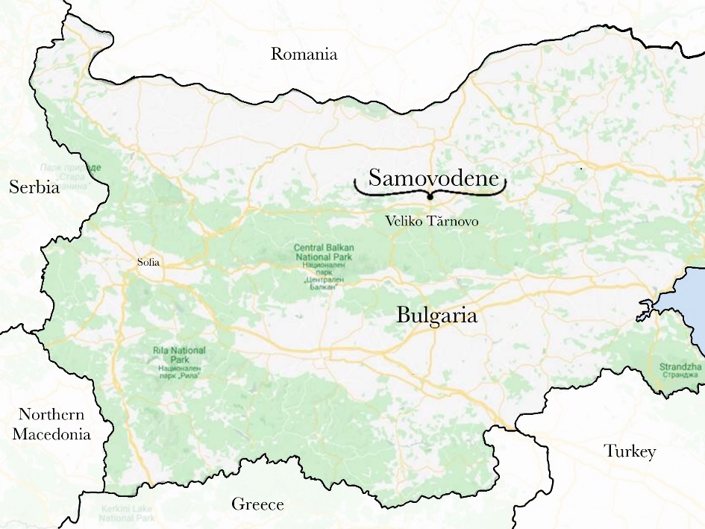
Figure 1 – Map of Bulgaria showing Samovodene, 10km north of Veliko Tarnovo. Image: Danielle Alexander
Samovodene
The modern town of Samovodene (Самоводене) rests on the bank of the river Yantra, 10km north of the old capital Veliko Tarnovo (Figure 1). The Neolithic site is situated behind a busy woodyard, between the modern town and the Yanta (Figure 2). The site was uncovered during road construction and excavations occurred over two periods; the initial excavations were undertaken by Peter Stanev, then Nedko Elesnki excavated during 1999-2000. The settlement, occupied from the early-middle Neolithic dates of 5970-5375 BC, housed eleven buildings over five continuous cultural layers, which have been categorised according to their stratification layers; Samovodene A-B1, Samovodene B1 and B2, Samovodene B2-C. This site is significant due to being the only Neolithic tell in the Veliko Tarnovo province and its connection to Ovcharovo, a culture that dominated north-eastern Bulgaria during the Eneolithic and is attributed with the ‘re-neolithization’ of the Balkans after decreasing temperatures had forced people to retreat south.
The material culture that has been unearthed at Samovodene is mostly unpublished, albeit accessible via Nedko Elenski at Veliko Tarnovo Museum. However, in a study conducted by Ivan Suvandzhiev, thirty-four ceramic lid pots were identified from Samovodene. They feature geometric designs and there is evidence of aesthetic preferences throughout the chronological layers; for example, the Late Neolithic (Layer B1) sees the introduction of an ‘H’ shaped motif onto the lids. Additional evidence of food-related activity is discussed in archaeobotanical studies, which reveal that the dominant food substance for this population was hulled barley, yet they also utilised the ‘mosaic landscapes with open forests and various wetlands’ to consume a diverse, nutritious diet. The evidence for agricultural activity is ‘impressive’, with many sickle inserts and sickle handles made of antler. The abundance of red deer antler at Samovodene was discussed by Hristina Markova, who proposed that antler was the dominant, specialist raw material for the inhabitants of Samovodene, who knew how to skilfully craft antler into tools from the earliest layers of the site. This shows the community had strong, long-standing traditions regarding red deer antler. Despite their preference for red deer (as no other deer species have been identified in the assemblage) the antlers were crafted into everyday items and were not specialised items or weaponry. The religious complex that was uncovered by Nedko Elenski featured an intentionally sealed cult shaft that had been used c.5970-5513 BC. He discovered that offerings were predominantly antler and river stones but other finds included a lamb sacrifice, pottery and pottery sherds, tripods, anthropomorphic and zoomorphic figurines, an amulet, loom weights, grinding stones, bone tools, river stones, flint artefacts, a large number of animal bones and horns (deer and aurochs). Furthermore, there is evidence of burning, which invites Elenski to propose the shaft was used for ritual praxis centred on fire, with the shaft representing the womb of Mother Earth and the offerings symbolising significant life-cycle stages. However, there is no discussion on the location or orientation of the shaft, nor further information regarding the religious complex. Therefore, while there is evidence of cultic activity at Samovodene, there is no discussion regarding the possibility of ‘sky’ based activities or alignments.
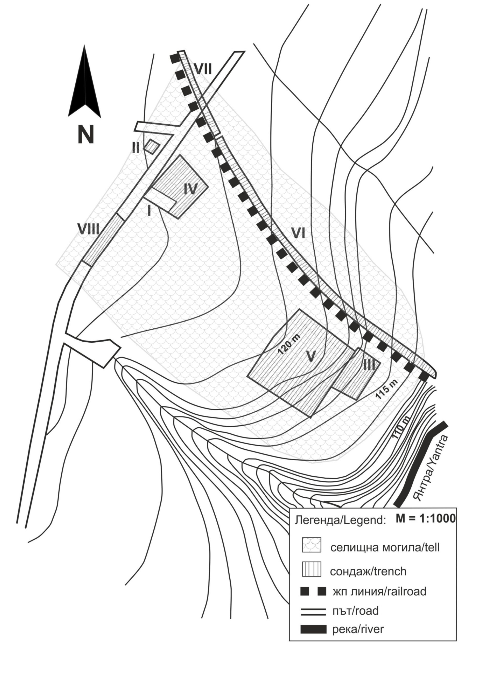
Figure 2 – Map of the Neolithic Site. Image: Hristina Markova.
Literature Review
According to Stanislaw Iwaniszewski, Eurasian archeoastronomy is 'not a well-established field of study'. This is curious considering the vital role the Balkans had in dispersing Neolithization across Europe from Anatolia and the attested archaeoastronomical evidence in both locations, such as solar time-keeping at Stonehenge and in Çatalhöyük houses. Nonetheless, the authors Alexey Stoev and Penka Maglova introduced Neolithic Bulgaria to the discipline in their contribution to Ruggles’ archaeoastronomy tome. Their chapter revealed how astronomy was an intrinsic part of Neolithic life via case studies of Karanovo (tell), Topchika (cave), Magura (cave), Bailovo (cave) and Tangarduk kaya (cave). They stated that the late Neolithic is the predominant epoch for astronomical-related architecture and iconography, with the population recording 'celestial events and the number of days between them’. Notably, 4 out of 5 of these sites are caves but the inclusion of a tell implies that evidence of celestial observation is not exclusive to cave sites.
Another paper by the same authors, albeit with the inclusion of a third author, Mina Spasova, explored two rock-cut structures in the Eastern Rhodopes, south of the Balkan mountain range, which are chronologically later than Samovodene. However, the authors argued that the caves are connected to the Mother Goddess and the winter solstice, evidenced by light penetrating the caves, allowing for accurate calendar keeping. The trio authored a second paper outlining the evolution of astronomical facilities and practices in ancient Thrace, highlighting the frequency of solar alignments on the summer and winter solstices and the equinoxes, proposing that these days were calculated through a symbol-filled calendar. This trio of authors dominate the English-language corpus of archeoastronomy in Bulgaria, but favour rock-cut monuments rather than investigating tells. Furthermore, their studies tend to be focused on slightly later dates than Samovodene.
Although the rock-cut monuments have been dated as later than the Neolithic, Stoev, Maglova and Spasova claimed that these locales are the ‘preserved representatives of monumental religious architecture of the ancient people from the Eneolithic.’ The authors stated that the people who used these monuments ‘created and continuously used’ the solar-chthonic cult of the Sun and Caves of the Great Mother Goddess, who birthed and married the Sun. Furthermore, alignments tend to be orientated towards sunrise or sunset of the solstice on ‘characteristic points of the local horizon’. Additionally, they highlight the typology of rock-cut monuments with archaeoastronomical meaning. For this project, the noteworthy characteristics include; landscape choice near rocks, caves or water; functions as a observatory, cult centre or calendar-keeping; the presence of topographical ‘sights’ such as pillars, trenches, grooves and finally, the presence of astronomically significant azimuths such as the solstices and equinoxes or the rising of constellations. Unfortunately, the authors fail to mention any constellations that could have been observed by the Thracians. Nonetheless, they concluded that these spaces reveal the ‘cyclicity and duration of existence’ and their connection to cult praxis. They also noted that the people of this time and region were able to observe the extreme sun culminations and measure them to the accuracy of +/- 1 day. Finally, Stoev and Maglova authoured another paper that employed a seven-site case study to show ‘how astronomy was woven into everyday and spiritual life’ and reveals the Neolithic, and later, perception of space and time.
An archeoastronomy paper by Aleksandra Bajić proposed that astronomical knowledge is evident at the West Serbian tumuli site of Atenica, attributed to the Thracian Triballian tribe who lived in the Central Balkans during the last millennium BC. Through measuring azimuths and using planetarium software, the authors conclude that the structures were aligned to the solstices, equinoxes and cross-quarter days that were associated with a ritual of passage, or sacrifice. Although chronologically and geographically distant, these Thracian tumuli are included in the Balkan prehistory and thusly, could be reflective of long-lasting, widespread Thracian traditions. Another Thracian tradition is the carving of dolmens, which are discussed by A. César González-García, Dimiter Kolev and Vesselina Koleva. Within their article, they state that these structures are always orientated towards mountains or the southwest. Through analysing a number of dolmens, they proposed that these ritual structures were orientated towards the Centaurus constellation and mountain peaks visible on the horizon, which are symbolic of the Sun God and Mother Goddess respectively.
The incorporation of ethnographic traditions into an archaeoastronomical study is demonstrated by Fabio Silvia, who provides a thought-provoking interpretation of the horizon alignments through the inclusion of oral tradition. Although his research focused on the Star Mountain in Portugal, this perspective can be applied to the Neolithic Balkans. This is because the folklore records of Bulgaria reveal characteristics that have been there since at least the Thracian times, and possibly before. Mercia MacDermot noted that Thracians, who believed in immortality, built tombs into cliff faces, 'in such a way that the sunlight entered all day', reflecting their solar-centred ideals. Furthermore, Pavel Şopov emphasised the significance of the cave as it symbolised an entrance to the womb of the Earth. This is reminiscent of the solar-chthonic structures discussed by Maglova, Stoev and Spasova, and the cult shaft uncovered by Elenski. According to Şopov, Thrace was the homeland to Dionysus and Orpheus, who were adopted by the Greeks, and had a strong cultural continuity throughout Greek and Roman contact, which continued well into the Thracian absorption into Slavic and Proto-Bulgarian populations. Both Şopov and MacDermot provide folklore knowledge from Bulgaria that can be traced to ancient Thrace and thusly, feature ethnographic knowledge that can be utilised when questioning whether the inhabitants of Samovodene were interested in celestial alignments.
Methodology
The queries of this project align with archeoastronomy, which uses material remains to infer how humans perceived and interacted with the sky. This is often identified through material culture artefacts such as architecture, settlements, landscape, tools, graves, and artwork. Frank Prendergast advises that the researcher be equipped with a field book, related literature, maps, measuring tape, stopwatch and a camera. Additionally, a Konus Konustar compass equipped with a clinometer was used; this is an instrument that enables the user to measure the altitude of objects on the horizon. These tools were portable but could have been affected by magnetic materials on site. This was overcome by taking multiple measurements from around the site to ensure calibration of the compass is accurate. An iPhone 8 was used for taking photographs and providing a GPS location; the app ‘GPS Diagnostic’ was used to calculate the accuracy of the signal, and the website-app What3Words was used for coordinates. Guilio Magli cautions that absolute precision is near-impossible to achieve but accuracy can be attained by repeating measurements. The use of multiple GPS tools was employed to reduce the levels of uncertainty through utilising multiple methods for measurement.
This site was chosen due to its proximity to the author’s family home, which allowed site visitation despite lockdown restrictions. This encouraged the incorporation of the phenomenological approach to the landscape, which is a theoretical perspective outlined by Christopher Tilley that encourages the researcher to acknowledge the agency of spaces and places. While it is a seemingly impossible task to envisage the prehistoric landscape, to have an experience of the place is to have a shared experience with prehistoric peoples. According to Tilley, a place is a contextualised, humanised space, of which there are five forms; somatic, perceptual, existential, architectural and cognitive. In regards to Samovodene, the Neolithic population would potentially have been experiencing all of the forms, whereas the 21st-century researcher experiences the place through, predominantly but not exclusively, somatic and cognitive mediums. Additionally, Tilley states that landscape is a stage for history and a mythopoesis. The archaeologist Tim Ingold similarly suggests that the landscape embodies the ‘biography’ of a place and its inhabitants. Ingold stresses that places and people are all connected through lines of interaction that permeate temporal and spatial experience. He further suggests that meaning can be gathered from a landscape, and being within one is itself an act of remembrance. Samovodene, with its extant agricultural-related archaeological record and evidenced cultic activity, is a place of many spaces in the landscape that is both a stage and embodiment of the history and myth of its prehistoric inhabitants. While the foliage of the landscape differs vastly, visiting the place is to gain knowledge concerning the feel and memories of the land, particularly of the horizon, allows a shared experience at Samovodene, one involved in a seven-millennia-long story of the land.
Furthermore, visiting the site is advised by Magli, who states it is an important step for the archaeoastronomer and required to compose an ‘accurate relief of the horizon.’ The horizon can be recognised as a ‘mediator between landscape and skyscape’ and is attributed high value to the astronomer, according to Fabio Silva, as architectural alignments are frequently aligned to a particular celestial phenomenon highlighted on the horizon. Special permissions were not required to access the site, but Tanya Dzhanfezova of Veliko Tarnovo University warned that the site may not be visitor friendly. Upon visiting the site, it became clear that viewing the horizon from the ground would not be possible due to the blossoming trees (Figure 3 and 4). This problem was overcome by attempting to find a nearby vantage point; a train bridge that goes over the Yantra and the site (Figure 5). However, even from this elevated position, only the south-eastern horizon was visible above the trees, and parts of the southern horizon could be glimpsed through the canopy. Therefore, a second location was chosen to guide virtual fieldwork methods and reduce the levels of uncertainty that accompanies virtual measurements. A small water fountain of unknown age was located amongst the undergrowth of the site and was chosen as a ground-level location to take measurements (Figure 6). It is unknown if this fountain was part of the Neolithic settlement, but it is located within the ‘tell’ section of the map provided by Markova (Figure 2).
The limited data that was gained from the site reinforced virtual fieldwork methods, such as the horizon freeware HeyWhatsThat. For gaining data regarding longitude and latitude, the app ‘What3Words’ (W3W) was used. This is because W3W has gridded the entire Earth using 3m squares and this proved to be more reliable than utilising the iPhone’s location data. Sketches of the site were compared to the Stellarium depiction of the imported HeyWhatsThat horizon, and the software was adjusted to match the data from the site. This consisted of altering the measurements from magnetic north to true north, of which there was a difference of -25°. This was only required for the railway bridge measurements as Stellarium and HeyWhatsThat automatically focus on true north. According to Daniel Brown, Stellarium has ‘immense potential’ for understanding skyscape experiences, despite its limitations regarding meteorological or phenomenological data. The horizons in Stellarium were set up to be viewied from -6000 to –5300 to accommodate for the 5970-5375 BC occupation dates for Samovodene. Measurements were taken for the solstices, equinoxes, and cross quarter days.
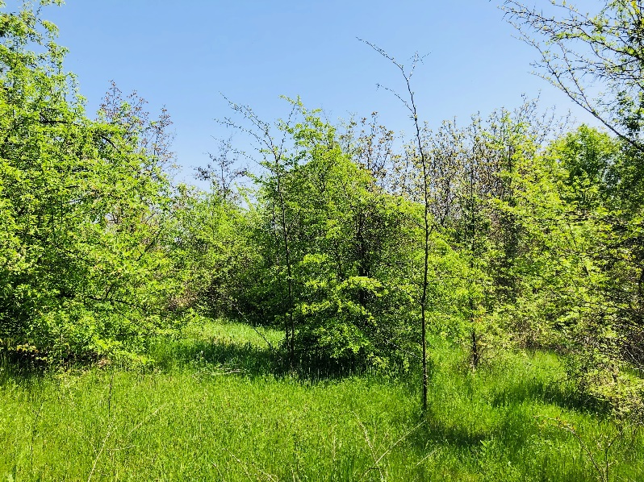
Figure 3 – The top of the tell at Samovodene had plenty of young trees that blocked the horizon from view. 28th April 2021, 13:24. Samovodene Neolithic Tell. Photo: Danielle Alexander.

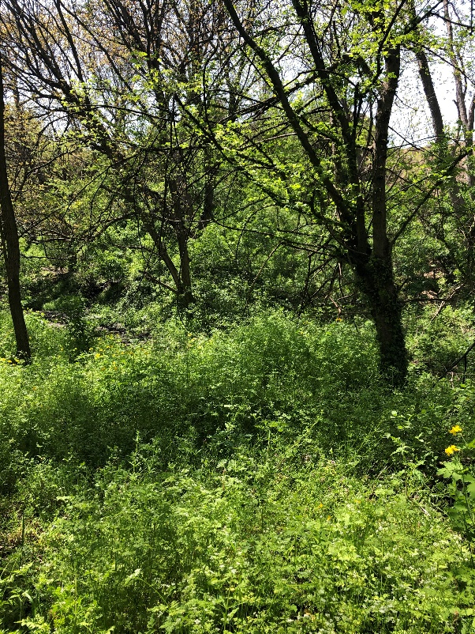
Figure 4 – The whole tell was covered in plants that restricted visibility. 28th April 2021, 13:48. Samovodene Neolithic Tell. Photo: Danielle Alexander.
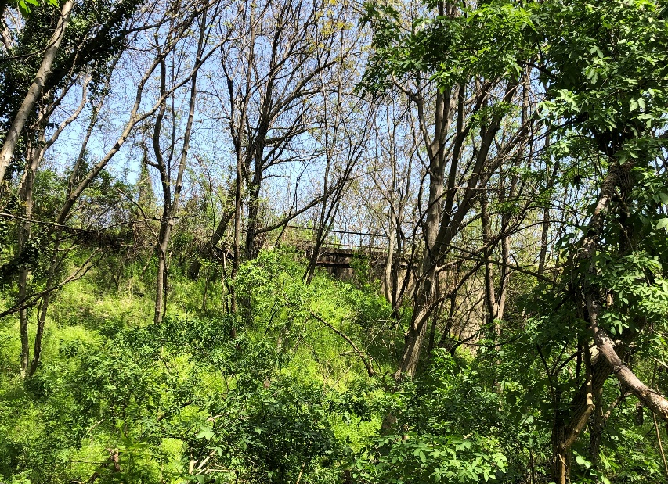
Figure 5 – The railway bridge runs over the site and is barely visible from the water fountain. 28th April 2021, 13:50. Samovodene Neolithic Tell. Photo: Danielle Alexander.

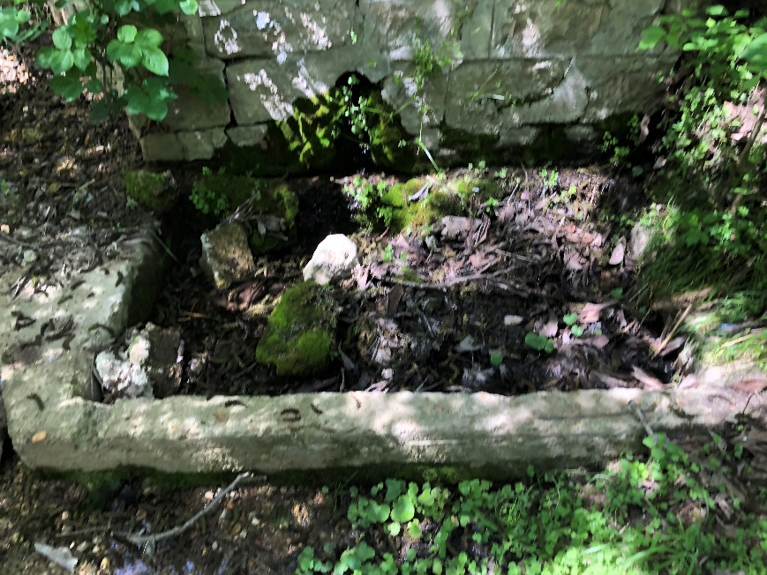
Figure 6 – The water fountain was buried beneath the undergrowth but was the only visible architecture at the site. 28th April 2021, 13:50. Samovodene Neolithic Tell. Photo: Danielle Alexander.

Results
The data revealed from the site itself is restricted to a phenomenological perspective (Appendix 2), photographs and two azimuth measurements. The azimuths that were recorded at the site focused on the ‘gorge’ visible above the treeline. This is because the gorge is a reliable point of reference. Furthermore, the gorge dominates the landscape and is almost magnet-like in its captivation of the viewer. Both horizons have been given alphabetical markers for ease of discussion. (Figures 10-11, 15-17).
The disused railway bridge ran directly over the Neolithic site and across the Yantra River. Measurements have been taken from the coordinates 43.142747 N, 25.614223 E (W3W: ///villain.platforms.arrangement) at an elevation of 60ft above ground level. The northern scape from the railway bridge is smoother than the southern horizon, which is defined by dips, mounds, and drastic gorges (Figure 7). The elevated land between south and south-west is a plateau that has sheer cliffs on either side (Figure 20). The decrease in elevation from the south-east to the east is steep but gradual, dotted with prominent ridges. The east-south-west horizon has captivating characteristics, whereas the north lacks anything of interest, which invites attention to be paid predominantly to the southern horizon. Both physical and virtual data was acquired for this location. The second location was a water fountain at the coordinates 43.143044 N, 25.61304 E (W3W: ///permanently.pelican.skirting). The structure had a waterspout protruding from its front, which faced east (136°). While stood beside it, it was not possible to see the sky or the horizon. The use of HeyWhatsThat allowed the reconstruction of the skyline. The bumps and ridges along the east-south horizon are slightly more defined compared to when viewed from the railway bridge (Figure 12). This is similar for the south-west horizon. However, the slope between point ‘N’ to ‘O’ is not as prominent when viewed from the water fountain. Furthermore, it is possible to see another bump (‘P’ and ‘Q’) that was not as prominent when seen from the railway bridge. Lastly, the points ‘R’, ‘S’ and ‘T’ are more defined from the water fountain, as they are a flat slope from the railway.
To compare the two provided horizons, the east to south segment is almost identical with the azimuths measured to be within 3° of each other (Appendix 1). However, the south to west section has a wider difference, with some points having a 10° difference. There are two potential reasons for this; the averages of the measurements or the sight line of the south-west horizon being drastically altered according to elevation. The former would be determined through further studies with more accurate equipment. The latter could aid in determining any potential alignments. The Google Earth image (Figure 17) and panoramic photograph (Figure 18) clarify the horizon provided by HeyWhatsThat. From these images, it is possible to see that the horizon is affected by the mountainous background; the gorge in the foreground has sharp outcrops opposite each other that are almost at a right angle (Figure 19). To quote from my field-diary; ‘it’s almost like someone cut a chunk out of the landscape’ (Appendix 2). The HeyWhatsThat horizon for the water fountain reveals that, at ground level, the ‘U’ shaped foreground of the gorge would have been as affected by the slope of marker ‘L’ too. This means any potential alignments related to the gorge should not be majorly affected by the locations that have been chosen; azimuths of rising/setting positions may vary within 1-2° due to the declination being affected by elevation and location.
By using Stellarium, it was possible to determine the azimuths of the solstices, equinoxes, and cross quarter days (Tables 2 and 3). These were consistent throughout the settlement’s history and did not differ drastically. However, the astronomical events are out of synch with the modern calendar. For example, the modern winter solstice would correlate to the prehistoric autumn-winter cross quarter day. By 5300 BC, the dates of these events were six days earlier, yet the azimuth remained within the same degree. Additionally, the path of the sun during the winter solstice passes above the gorge to be central over the ‘U’ shape at noon, whereas during the summer, the sun zenith is directly overhead and does not align to horizon features in either its rise or set. Notably, no alignments have been identified during the summer months for both locations. From the location of the railway bridge, the equinoxes have sunset alignments. However, the measurements from the ground level of the water fountain argue that the equinoxes did not have a noticeable alignment. Both locations have evidence that the winter cross-quarter days align to the sunrise and alignments can be identified for sunrise and sunset for the winter solstice.
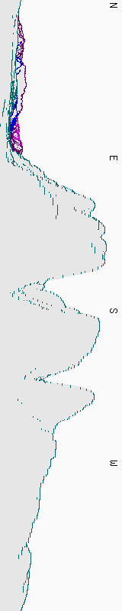
Figure 7 – The HeyWhatsThat skyline from the coordinates and elevation of the railway bridge.
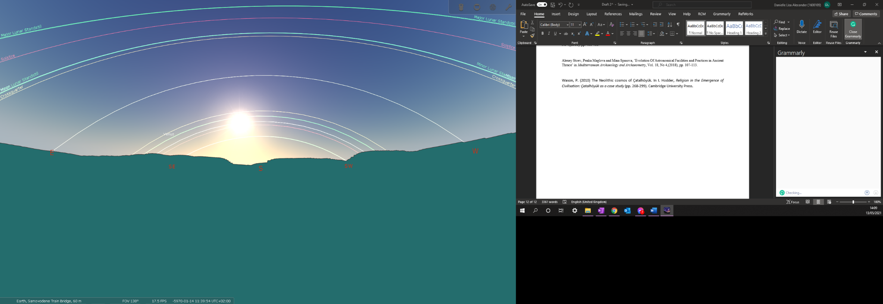
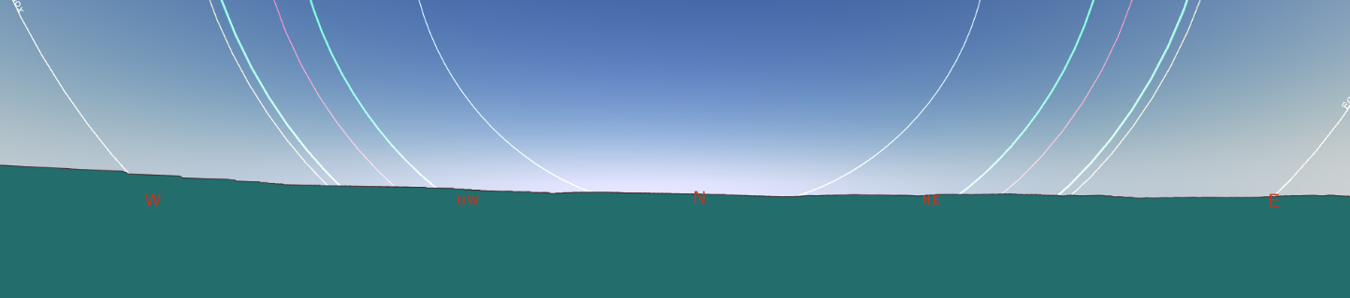
Figures 8 and 9 – the Railway bridge horizon imported into Stellarium.

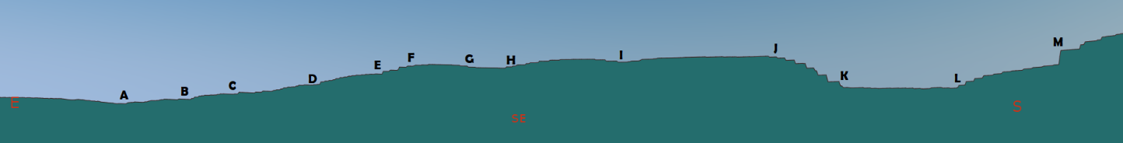
Figure 10 – Zoomed in East to South section of the horizon from the Railway Bridge with alphabetical markers (A-M) where azimuth measurements were recorded.

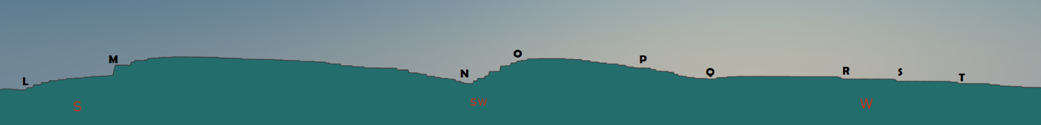
Figure 11 – Zoomed in South to West section of the horizon from the Railway Bridge with alphabetical markers (L-T) where azimuth measurements were recorded.

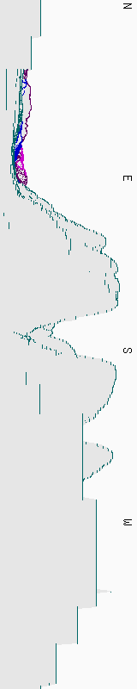
Figure 12 – The HeyWhatsThat horizon taken from the coordinates and elevation of the water fountain.

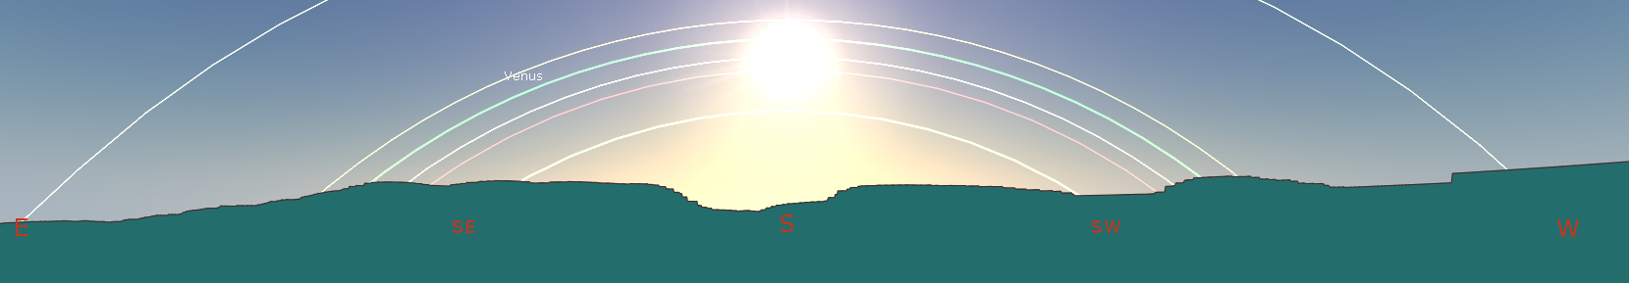
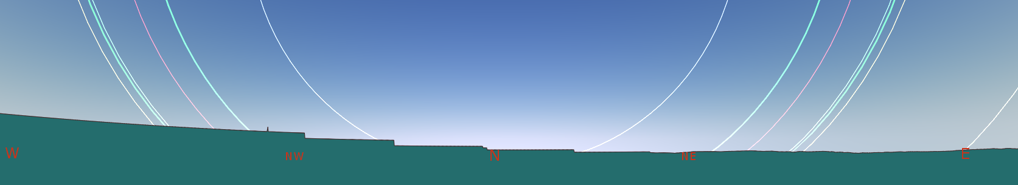
Figures 13 and 14 – the horizon from the water fountain imported into Stellarium.

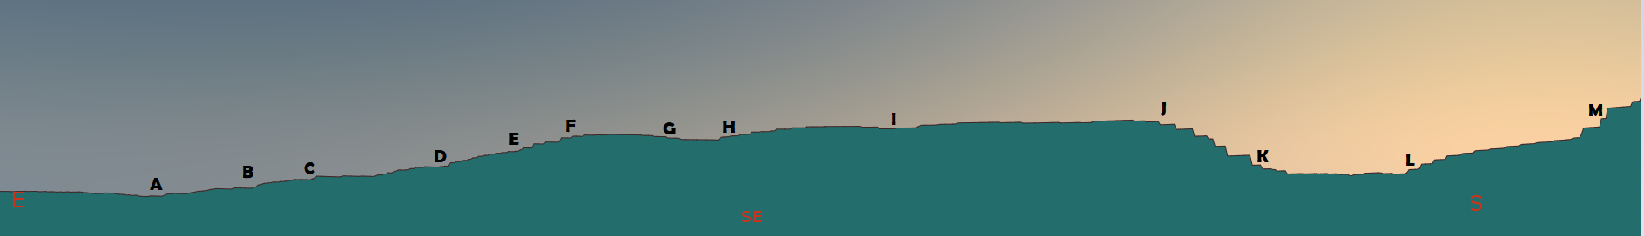
Figure 15 - Zoomed in East to South section of the horizon from the water fountain with alphabetical markers (A-M) where azimuth measurements were recorded.

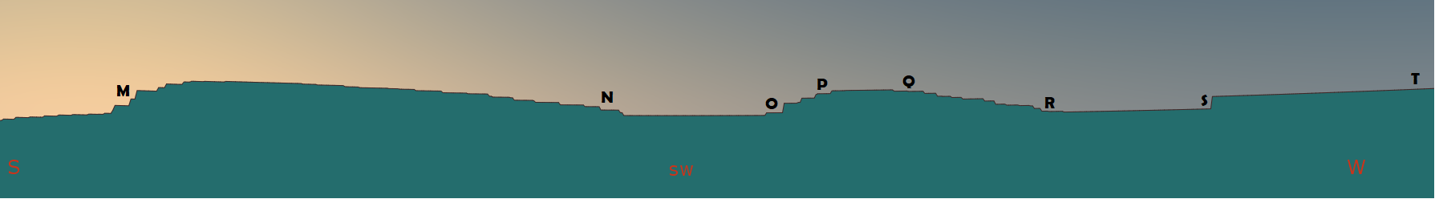
Figure 16 - Zoomed in South to West section of the horizon from the water fountain with alphabetical markers (M-T) where azimuth measurements were recorded.

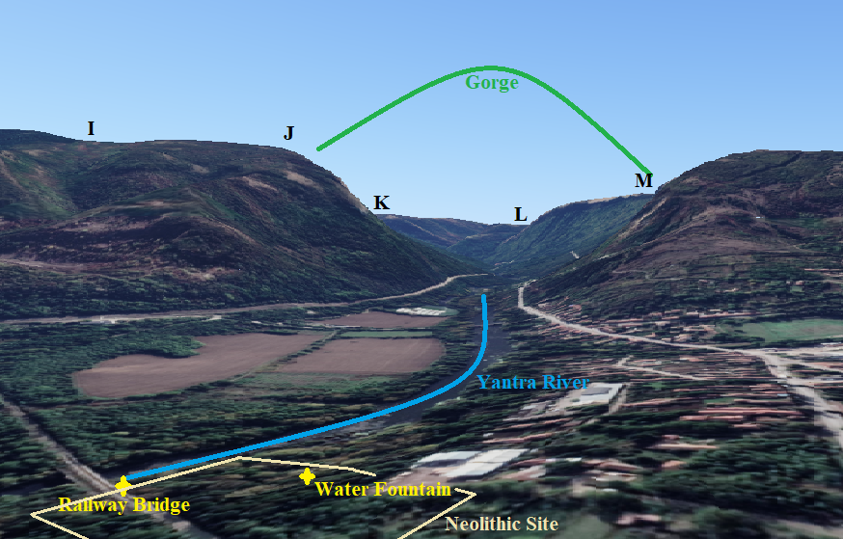
Figure 17 – The ‘gorge’ of Samovodene dominates the landscape. The two locations chosen for measurements are in bright yellow, whereas the site is outlined by the pale yellow. Alphabetical markers are included for ease of comparison with the HeyWhatsThat horizons.
Image: Google Earth, 2021.

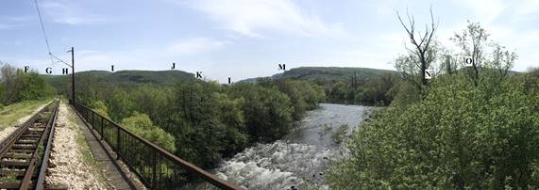
Figure 18 – Panoramic photograph taken from the railway bridge. Alphabetical markers included in order to compare to HeyWhatsThat data. 28th April 2021: 14:44. Samovodene Railway Bridge. Photo: Danielle Alexander.

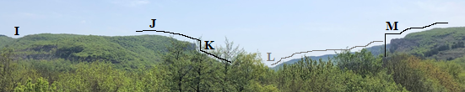
Figure 19 – The gorge has two sharp edges that are almost right angled, but the overall horizon is affected by the background mountains. The foreground is represented through black ink whereas the background is shown through grey ink. 28th April 2021, 13:40. Samovodene Railway Bridge. Photo: Danielle Alexander.

The star Betelgeuse of the constellation Orion has a particularly interesting path across the sky from the railway bridge point of view; from 6000 BC, it followed the path of the sun on the winter solstice. By 5300 BC, this star had shifted by 4° and was no longer aligned to the solstice path. Nonetheless, the constellation remained on the solstice path through the star Bellatrix. However, by 5200 BC, Bellatrix had also drifted towards the zenith and away from this alignment by 2°. This gave the impression that the constellation was ‘lifted’ from the gorge, as it had previously nestled within the ‘U’ rather than above it. This was not witnessed from the water fountain as Betelgeuse sat 3.5° above the solar solstice path from the start of the settlement.
Nevertheless, both locations view Orion as he ‘stands’ upright in the gorge from the summer solstice to the winter solstice, where this constellation is replaced by Centaurus, who dominated the gorge between the winter solstice to the summer (Table 1). This was evidenced at both locations with minimal (within 1°) difference in the azimuth of rising and setting. Furthermore, this pattern is not disrupted with the passage of time. It is also unaffected by the location and elevation differences between the railway bridge and the water fountain, with only minor differences in declination.

 | WS | WSX | SE | SSX | SS | SAX | AE | AWX
 | Orion follows sun set. | Centaurus only. | Centaurus follows sunset. | Neither visible. | Orion chased by sunrise. | Orion only. | Centaurus chased by sunrise. | Both rise and set in the night.
 | Table 1 – The pattern of the two constellations Orion and Centaurus on the dates of the winter solstice (WS), winter-summer cross-quarter (WSX), spring equinox (SE), spring-summer cross-quarter (SSX), summer solstice (SS), summer-autumn cross-quarter (SAX), autumn equinox (AE) and finally, the autumn-winter cross-quarter (AWX).
RB. | Rough Dates  (Julian Calendar) | Rise | Set | Alignment?
WS | 30th January to 11th February | 129°,  marker G | 230°, marker O | Yes, both.
WSX | 23rd March | 116°,  marker D | 241° between markers O and P | Yes, sunrise.  Maybe, set.
SE | 9th May | 90°,  no marker | 267°, marker R | Yes, sunset.
SSX | 26th July | 66°,  no marker | 292°,  no marker | No.
SS | 4th to 17th August | 56°, no marker | 302°, no marker | No.
SAX | 24th September | 66°, no marker | 292° no marker | No.
AE | 7th November | 90°, no marker | 267°, marker R | Yes, sunset.
AWX | 22nd December | 116°, marker D | 241°, between markers O and P | Yes, sunrise. Maybe set.

WF. | Rough Dates (Julian Calendar) | Rise | Set | Alignment?
WS | 30th January to 11th February | 130°,  marker D | 231°, marker O | Yes, both.
WSX | 23rd March | 117°,  marker E | 240°, marker Q | Yes, sunrise.  Maybe, set.
SE | 9th May | 90°,  no marker | 266°, marker R | No.
SSX | 26th July | 66°,  no marker | 289°,  no marker | No.
SS | 4th to 17th August | 56°, no marker | 299°, no marker | No.
SAX | 24th September | 66°, no marker | 289° no marker | No.
AE | 7th November | 90°, no marker | 266°, marker R | Yes, sunset.
AWX | 22nd December | 117°, marker D | 240°, between markers O and P | Yes, sunrise. Maybe set.

Tables 2 and 3 – Tables revealing the date, rising and setting azimuth and evidence of an alignment from the railway bridge (RB) and the water fountain (WF) for the winter solstice (WS), winter-summer cross-quarter (WSX), spring equinox (SE), spring-summer cross-quarter (SSX), summer solstice (SS), summer-autumn cross-quarter (SAX), autumn equinox (AE) and finally, the autumn-winter cross-quarter (AWX).

Discussion
According to the map provided by Markova, the settlement sat on the western bank of the Yantra, but no doorways were indicated, meaning it is not possible to determine the direction they faced. However, it was common for the streets of Neolithic settlements in Bulgaria to be ‘orientated according to the cardinal directions’. The present data shows that the settlement likely faced south-east and was orientated towards the gorge. This could be inferred by the site’s topography. The northern horizon of the landscape is more elevated and could have potentially provided shelter from the wind, whereas the southern scape is captivating, demanding of the viewers’ attention. This concurs with the work by Brown, who stated that the horizon is a ‘powerful magnet’ that draws the eye. Furthermore, it has been proposed that the Neolithic population of Thrace were drawn to spectacular topographical sites, such as the gorge, and these were frequent locations for alignments.
The horizon visible from Neolithic site of Samovodene is dominated by the gorge and the site seems small in its shadow. My attention kept being drawn back to the gorge, despite knowing there was more to see (Appendix 2). When I had finally left the vantage point to wander amongst the undergrowth, I noticed there were lines in the grass where something, or someone, had walked. It is possible this was evidence of the stray dogs that Dzhanfesova had warned about (Appendix 3). Nonetheless, Ingold discusses lines as ways to connect within the landscape spatially and temporally. The wandering through the lines transported my mind to the Neolithic and I pondered whether I was walking a similar track to the ancient inhabitants of the settlement; did they also brush their fingers along the tall grass while walking towards the roaring river or did they stand on this very spot and gaze up at the clouds above? The inability to view the gorge from the ground caused me to wonder whether the people of Samovodene would have encountered a similar issue during the summer months. The fieldwork data proposes that this could be a possibility, as all the alignments are connected to the more barren months of the year (Tables 2 and 3).
According to Stoev, Maglova and Spasova, prehistoric Thracians practiced rituals that were connected to specific positions of celestial objects in relation to the natural environment around them. Therefore, the gorge could serve as a ‘frame’ for a particular celestial phenomenon that the prehistoric inhabitants of Samovodene were interested in. The virtual data reveals that the constellations Orion and Centaurus had a potentially significant pattern; Orion sat over the gorge during the summer months and was eventually ‘chased off’ by Centaurus, who replaced Orion by the Winter Solstice. It is known through other related studies that the Neolithic Thracians did show an affiliation towards constellations. Additionally, the work of González-García, Kolev and Koleva proposed that Centaurus symbolises the Sun God. Therefore, if Centaurus is the Sun God, then his lone appearance above the gorge on the winter/spring cross quarter could be symbolic of his return as the days get longer. On the other hand, the lone appearance of Orion in the sky on the summer/autumn cross quarter could signal the return of winter. Nevertheless, the alignments that are revealed at Samovodene are not unusual; rather, the data of this project aligns with the work of Stoev, Maglova and Spasova.
It is unknown whether the prehistoric peoples of Samovodene acknowledged the constellation Orion. However, if they did, it is quite possible that the constellation was known by a different name. To borrow techniques employed by Silva, ethnographic material could potentially identify Orion as the Thracian Mother Goddess Bendis, or Bendida. Symbolised by the Moon and mountains, she was also associated with fertility, vegetation, animals, marriage and childbirth. Pious praxis for Bendis included 'dances, night ceremonies and offerings wrapped in wheat-straw'. The inclusion of straw is noteworthy because harvest time would have roughly coincided with the summer/autumn cross quarter alignment, which is when only Orion rests in the sky above the gorge (Table 1). Furthermore, depictions of Bendis often include spears, or a bow and arrow, whilst the goddess rides astride a doe. It could be speculated that the constellation of the hunter Orion was identified as the hunter goddess Bendis by the prehistoric Thracians. To expand on this idea, it is important to remember the work of Markova, which noted that the inhabitants of Samovodene frequently and skilfully utilised red deer antler in their daily lives, especially in agricultural tools. This could indicate that the people of Samovodene had a special relationship with red deer, potentially as a result to its connection to Bendis. It was proposed by Elenski that the cult shaft at the site was dedicated to the Great Mother goddess. Over time, the constellations rose higher in the sky and were no longer framed by the gorge. This could be why the shaft was sealed. Furthermore, Şopov argued that the Samodiva of Bulgarian folklore are reminiscent of the Thracian goddess Bendis. Often armed with a bow and arrow, these water nymphs reside near mountains, ride deer, and draw their power from the moon. The Samodiva share many attributes with Bendis and a name similar to Samovodene. The phenomenologist Christopher Tilley stated that places are often named and contextualised in accordance with their natural and cultural landscapes. This poses the question regarding a possible connection between the mythical creatures and the location of the Neolithic site, especially considering the present interpretation of Orion.
It has been argued previously that the Goddess was associated with the winter solstice due to light penetrating caves. However, this project presents an alternative method of this symbolic marriage that is not connected to sacred cave sites. The ‘chase’ across the sky of Centaurus and Orion, with their unified presence in the sky during the autumn/winter cross quarter could be a celestial depiction of the two deities and their sacred marriage. Their union could potentially be represented by the dual-alignment winter solstice. Therefore, this affirms Tilley’s statement that the landscape is a stage for myth. Regarding the work of Stoev, Maglova and Spasova, it would be interesting to discover what constellations were dominant in the skies for the alignments that they have presented.
Reflexive Considerations
For future studies, visiting the site in the winter may allow for a view of the horizon from the ground due to the lack of leaves. It would also be beneficial to have communication with Elenksi, who would be able to provide vital assistance due to the number of unpublished finds. Perhaps after discussing the research with Elenski, the location for archaeoastronomical measurements could be chosen according to the architecture of the Neolithic site, for example, the orientation of the cult shaft or a doorway of the cultic complex. The focus on one location would allow for a more detailed and accurate analysis. The increased attention to specific details would grant room to expand on potential alignments; the virtual fieldwork data would imply that the rising and setting positions lunar standstills could also have coincided to specific points on the horizon. This would further affirm the proposed theory regarding Bendis due to her association with the moon. This remained undiscussed within this project yet grants a topic for further study. Furthermore, the results and discussion of the site would benefit from an increased number of alphabetical markers on the recorded horizon, both photographs and on the virtual depictions, to gain a more accurate representation of the myriad of ridges.
Conclusion
Despite being buried under fresh undergrowth and the horizon blocked by blossoming trees, this project reveals that there is evidence for celestial orientation at Samovodene. While it is important to remember that the evidence does not confirm whether these alignments were intentional, this work corroborates with previous archaeoastronomical publications focused on prehistoric Bulgaria. Through utilising a mixed method approach of site visitation and virtual analysis, the data from Samovodene reveals that the rising or setting position of the sun corresponds to prominent ridges on the horizon from the autumn equinox to the spring equinox. It could be speculated that this could be due to the horizon being obstructed by trees during the warmer half of the year. However, it could also be related to the conjectured mythical world of these inhabitants and an affiliation with Bendis, the Thracian Mother Goddess. The constellation Centaurus has been identified as the Sun God by González-García, Kolev and Koleva and within this project, Orion is identified as Bendis. This is because these constellations are seen to ‘sit’ in the gorge at certain times of the year that appear to correspond with the proposed mythology; Bendis rules the winter and Moon whereas her husband and son, the Sun God, is linked to the summer and the Sun. The present data reveals that Orion, or Bendis, dominates the sky after the summer solstice and seemingly heralds the coming of winter. Similarly, Centaurus rests in the gorge after the winter solstice, portending the arrival of warmer days. The pair appear to ‘chase’ each other through the sky but fail to meet before the sun rises. However, during the autumn/winter cross quarter, both constellations are seen in the sky, which could reflect their sacred union. The connection to Bendis is further evidenced by the prevalence of red deer antler and the modern folkloric creatures, the Samodiva, who share many attributes with the goddess and a name similar to the settlement in question. It is also possible that this may be affirmed further through study of the lunar standstill alignments and more accurate recording of the horizon. Evidently, there is more to uncover regarding the skyscape archaeology of Samovodene. Therefore, this research serves as a preliminary feasibility inspection that confirms that there is evidence of celestial orientation at Samovodene.
References
Bajić, Aleksandra, ‘Possible Astronomical Lore Of The Ancient Triballians’, Sesiunea de
Comunicări a Societății Române pentru Astronomie Culturală: (15th-17th November 2019), 69-78.

Brown, Daniel, ‘Memories Unlocked And Places Unexplored: Stellarium, Temporality and Skyscapes’ in
Imagining Other Worlds, ed. by Nick Campion and Chris Impey (Ceredigion: Sophia Centre Press, 2018), 53-64.

Elenski, Nedko, ‘A Cult Shaft From A Cult Assemblage At Samovodene Neolithic Site’, Arheologiâ, 44.1
(2003), pp. 39-48. [Extended Abstract Only].

González-García, A. César, Dimiter Kolev and Vesselina Koleva, ‘Thracian Dolmens’, in Handbook of
Archaeoastronomy and Ethnoastronomy, ed. by Clive Ruggles. (New York: Springer Reference, 2015), 1395-1402.

Gurova, Mariah, 'Establishing The Identity Of Bulgaria's First Farmers - A New Perspective', Archaeologia
Bulgarica, 16. 2 (2012), 1-26.

Ingold, Tim, Lines, (London and New York: Routledge Classics, 2016).

Ingold, Tim, 'The Temporality of the Landscape', World Archaeology, 25.2 (Conceptions of Time and Ancient
Society, October 1993), 152-174.

Iwaniszewki, Stanislaw, ‘Cultural Interpretation of Archaeological Evidence Relating to Astronomy', in
Handbook of Archaeoastronomy and Ethnoastronomy, ed. by Clive Ruggles (New York: Springer Reference, 2015), 315-324.

Iwaniszewski, Stanislaw, ‘Archaeoastronomy In Traditional Areas Of Eurasia: A Review Paper’,
Archaeoastronomy, Vol 14, Issue 2 (Fall 1999), 87.

Kostadinova-Avramova, Maria, Mary Kovacheva and Yavor Boyadzhiev, 'Contribution Of Stratigraphic
Constraints Of Bulgarian Prehistoric Multilevel Tells And A Comparison With Archaeomagnetic Observations', Journal of Archaeological Science, 43 (2014), 227-238.

Lodestone Wireless, GPS Diagnostic (2016) <http://www.lodestonewireless.com/gps-diagnostic.html>
[accessed 19/05/2021].

MacDermot, Merica, Bulgarian Folk Customs, (London: Jessica Kingsley Publishers, 1998).

Magli, Guilo, Archaeoastronomy: Introduction To The Science Of Stars And Stones, (Milan: Springer, 2016).

Maglova, Penka, Alexey Stoev and Mina Spasova, ‘Late Chalcolithic Solar-Chthonic Rock-Cut Structures For
Time Measuring In The Eastern Rhodopes, Bulgaria’, Mediterranean Archaeology and Archaeometry, 16.4, (2016), 401-406.

Maglova, Penka, and Alexey Stoev, ‘Ancient Astronomical Observatories in Bulgaria’, Наследие и
современность , 3.3 (2020), 85-97.

Marinova, Elena, and Raiko Krauss, ‘Archaeobotanical Evidence On The Neolithisation Of Northeast
Bulgaria In The Balkan-Anatolian Context: Chronological Framework, Plant Economy And Landuse’, Bulgarian e-Journal of Archaeology, 4 (2014), 179-194.

Markova, Hristina, ‘Red Deer Antler As Raw Material At The Neolithic Site Of Samovodene, Veliko Tarnovo
District (Central Northern Bulgaria)’, Journal of Serbian Archaeological Society, Гласник Српског археолошког друштва, 36 (2020), 7-26.

Prendergast, Frank, 'Techniques of Field Survey', in Handbook of Archaeoastronomy and Ethnoastronomy,
ed. by Clive Ruggles (New York: Springer Reference, 2015), 389-410.

Ruggles, Clive, ‘Astronomy and Stonehenge’, Proceedings of the British Academy, 92 (1997), 203-229.

Ruggles, Clive, Ancient Astronomy: An Encyclopedia Of Cosmologies And Myth, (California, Denver and
Oxford: ABC CLIO, 2005).

Silva, Fabio, ‘Landscape And Astronomy In Megalithic Portugal: The Carregal Do Sal Nucleus And Star
Mountain Range’, Papers from the Institute of Archaeology, 20 (2012), 99-114.

Silva, Fabio, ‘The Role And Importance Of The Sky In Archaeology: An Introduction’, in Skyscapes: The
Role and Importance of the Sky in Archaeology, ed. by Fabio Silva and Nicholas Campion (Oxford: Oxbrow Books 2015), 1-7.

Şopov, Pavel, 'Historical Myths And Legends - Fundamentals Of Bulgarian Folk Culture', REVART, 2 (2015),
32-43.

Stoev, Alexey, and Penka Maglova, ‘Astronomy In The Bulgarian Neolithic’ in Handbook of
Archaeoastronomy and Ethnoastronomy, ed. by Clive Ruggles. (New York: Springer Reference, 2015), 1377–1384.

Stoev, Alexey, Penka Maglova and Mina Spasova, ‘Evolution Of Astronomical Facilities And Practices In
Ancient Thrace’, Mediterranean Archaeology and Archaeometry, 18.4 (2018), 107-113.

Suvandzhiev, Ivan, ‘Top of the pots. Late Neolithic ceramic lids from North Central Bulgaria’, In Bulgarian
e-Journal of Archaeology Supplements: Филови Четения. Балканска Археология | Filov Symposium. Balkan Archaeology, 7 (2019), 21-38.

Tilley, Christopher, Phenomenology of Landscape, (Michigan: Berg Publishers, 1994).

Todorva, Henrietta, ‘The Neolithic, Eneolithic And Transitional Period In Bulgarian Prehistory’, Prehistoric
Bulgaria, 22 (1995), 79-98.

Wason, Paul, ‘The Neolithic Cosmos Of Çatalhöyük’, in Religion In The Emergence Of Civilisation:
Çatalhöyük As A Case Study, ed. by Ian Hodder (Cambridge: Cambridge University Press, 2010), pp. 268-300.

What3Words, (2021) <http://www.what3words.com> [accessed 19/05/2021].

Appendix 1 – Table of azimuths for the alphabetical markers on the horizon images.

Alphabetical Marker | Railway Bridge Azimuths  (in degrees) | Water Fountain Azimuths  (in degrees)
A | 98 | 97
B | 107 | 103
C | 109 | 107
D | 117 | 115
E | 123 | 120
F | 125 | 123
G | 130 | 130
H | 134 | 133
I | 146 | 145
J | 158 | 160
K | 164 | 166
L | 175 | 177
M | 184 | 186
N | 223 | 218
O | 229 | 232
P | 244 | 235
Q | 254 | 241
R | 268 | 250
S | 274 | 261
T | 280 | 280

Appendix 2 – Field diary (541 words).
28th April 2021 – Sunny, no wind.
The workers of the woodyard were surprised to see us looking for the site and directed us to the path where we could climb down; ‘there’s nothing there’ the woodyard manager said with a sad, almost baffled smile.
I mean, the site is overgrown with rapid slopes and a gulley of green flora. I assume water went through there at one point, it looks like water erosion to me. Despite the trees, it’s definitely not a forest per say, just nature reclaiming it. Can’t see the horizon at all because of the blossoming trees… maybe it would’ve been better to come in winter?
Gosh, the trees and flowers smell lovely though. I’m thankful for their leafy protection from that sunshine though. It’s cool here.
As soon as you get to the bottom of the slope (which is definitely steeper than the Markova map stated), the sound of the river is all that you can hear. Trance-inducing. The road above is forgotten. There is not much twittering in the trees, I wonder if that is because of the woodyard at the top of the slope?
Water fountain; doesn’t look prehistoric but I am not a geologist. (Step Mum joked that this is why you befriend people in other disciplines – I mean, it would be helpful now.) Only other rocks visible are a pile. Just a pile, covered in leaves near the bridge. Neither of these ‘architectural’ features seem overly promising. The pile could be rubble from the bridges’ construction. Or even from the woodyard?
Wondered about the woods a bit, followed the lines in the undergrowth. Pondered what it was like to have lived here with the roaring river. Did they have the same trees?
Feeling a little sad that there is nothing here for me to gawk at. I wandered under the railway bridge and big (!!) rocks were under there. Probably from construction though. I tried to cross the little, fast-flowing subsidiary of the Yantra, feeling that maybe something might have been on the bank that separated it from the main river, but my Step Mum veto’d it with a firm ‘no, let’s go up instead’ and pointed to the presumably disused railway bridge. Wanting to see something, I agreed. I didn’t bring wading shoes anyway.
We clambered up this steep section to get to the track that had vines and such creeping over it. Very dystopian-esque, but a cheery dystopia with green everywhere. Still couldn’t see the horizon so we walked out across the river for a little… and the horizon blossomed in front of us.
WOW!!! It looks like someone cut a chunk out of the landscape! It’s incredible!! I can’t look away, but I must look at the rest of the horizon. A quick glance behind me confirms that the northern scape is kind of bland and boring, there’s no rises or mounds, and if there is, they’re hidden above the slope. To be fair, not much of the horizon is even visible above these trees. Thinking about winter again… Hang on, would the people of Samovodene also had their view restricted in the summer? Hm. Something to consider.
Hotter up here, but the view is just… inspiring. I could gaze at this gorge all day.

Appendix 2 – Copy of email communications with Tanya Dzhanfesova (503 words).
Specialist in prehistory and archaeometry at Veliko Tarnovo University, who contacted me after I reached out to the Veliko Tarnovo Archaeology Department.

26 April 2021 11:11
RE: Veliko Tarnovo
Dear Tanya,
Thank you for getting back to me and I greatly appreciate your guidance and for taking the time to share knowledge with me.
I will contact Mr. Elenski now, and check out the Facebook group! I did not realise there was a museum in Pleven – thank you for letting me know!
Kindest regards,
Danielle

26 April 2021 09:21
Re: Veliko Tarnovo
Dear Danielle,

Sincere apologies that it has taken some time to reply. Mr Nedko Elenski was not in town because of fieldwork projects. However, he's back now and knows about your interests. Please feel free to contact him using his email address: removed for privacy.
I am sorry to tell you that I was not able to track any translations of that book. However, there is a Facebook group called 'Archaeolit exchange' that might be useful, as many Bulgarian archaeologists discus similar issues there.
Also, given that you are not based far away from Pleven (if I am not wrong), perhaps it would be possible to also contact colleagues and archaeologists from the Regional Historical Museum there.
I hope this helps and wish you all the best with your project!
Tanya

April 8, 2021 11:43 AM
RE: Veliko Tarnovo
Dear Tanya,
Many thanks for getting back to me, and I am grateful for your assistance.
I eagerly await a response regarding permissions from Mr Nedko Elenski and the possible translation of Prof. Todorova’s book. Thank you for the warning regarding the safety of the site.
For this project, I think I will focus on Samovodene because it is the Neolithic that interests me the most. I have recently found a report that mentions a site near the village Gradishte (Pleven), which is currently where I am staying but there seems to be very limited information on it. It seems this area is abundant with prehistoric sites!
Thank you again,
Danielle

07 April 2021 19:37
Veliko Tarnovo
Dear Danielle,
Thank you very much for your interest in the sites.
As Assoc. Prof. Kostova pointed out, the right person to talk to should be Mr Nedko Elenski from the Regional Museum of Veliko Tarnovo. I can ask him whether you need permission to visit the sites, although there haven't been excavations at Samovodene for quite some time and there shouldn't be a problem.
Please bear in mind that the place may not be visitor friendly (stray dogs, etc.).
Regarding the other site, Hotnitsa, it is Assoc. Prof. Stefan Chohadzhiev who conducted the excavations there. Please do let me know if you would like to contact him and I will help.
As for the English version of Prof. Todorova's book, I should admit that I do not recall seeing that book translated in English. Would you please give me a day or two and I'll get back to you?

Sending my best regards,
Tanya

Henrietta Todorova, "The Neolithic, Eneolithic And Transitional Period In Bulgarian Prehistory." Prehistoric Bulgaria, 22 (1995), p. 81.
Nedko Elenski, ‘A Cult Shaft From A Cult Assemblage At Samovodene Neolithic Site’, Arheologiâ, 44.1 (2003), pp. 39-48. [Extended Abstract Only].
Alexey Stoev, and Penka Maglova, ‘Astronomy In The Bulgarian Neolithic’ in Handbook of Archaeoastronomy and Ethnoastronomy, ed. by Clive Ruggles. (New York: Springer Reference, 2015), pp. 1377–1384.
Penka Maglova, Alexey Stoev and Mina Spasova, ‘Late Chalcolithic Solar-Chthonic Rock-Cut Structures For Time Measuring In The Eastern Rhodopes, Bulgaria’, Mediterranean Archaeology and Archaeometry, 16.4, (2016), pp. 401-406.
Hristina Markova, ‘Red Deer Antler As Raw Material At The Neolithic Site Of Samovodene, Veliko Tarnovo District (Central Northern Bulgaria)’, Journal of Serbian Archaeological Society, Гласник Српског археолошког друштва, 36 (2020), p. 9.
Markova, ‘Red Deer Antler’, p. 8.
Markova, ‘Red Deer Antler’, pp. 8-10.
Maria Kostadinova-Avramova, Mary Kovacheva and Yavor Boyadzhiev, 'Contribution Of Stratigraphic Constraints Of Bulgarian Prehistoric Multilevel Tells And A Comparison With Archaeomagnetic Observations', Journal of Archaeological Science, 43 (2014), 227-238; Markova, ‘Red Deer Antler’, p. 10; Douglas Bailey, Balkan Prehistory, (New York and London: Routledge, 2002), p. 62; Henrietta Todorova, ‘The Neolithic, Eneolithic And Transitional Period In Bulgarian Prehistory’, Prehistoric Bulgaria, 22 (1995) , pp. 81, 86-87.
Ivan Suvandzhiev, ‘Top Of The Pots. Late Neolithic Ceramic Lids From North Central Bulgaria’, Bulgarian e-Journal of Archaeology Supplements: Филови Четения. Балканска Археология | Filov Symposium. Balkan Archaeology, 7 (2019), p. 36.
Suvandzhiev, ‘Top Of The Pots’, pp. 21-22.
Suvandzhiev, ‘Top Of The Pots’, pp. 23-28.
Elena Marinova and Raiko Krauss, ‘Archaeobotanical Evidence On The Neolithisation Of Northeast Bulgaria In The Balkan-Anatolian Context: Chronological Framework, Plant Economy And Landuse’, Bulgarian e-Journal of Archaeology, 4 (2014), p. 191.
Mariah Gurova, 'Establishing The Identity Of Bulgaria's First Farmers - A New Perspective', Archaeologia Bulgarica, 16. 2 (2012), p. 8.
Markova, ‘Red Deer Antler’, pp. 20-21.
Markova, ‘Red Deer Antler’, p. 19.
Markova, ‘Red Deer Antler’, p. 19.
Elenski, ‘A Cult Shaft at Samovodene’ [Extended Abstract Only].
Elenski, ‘A Cult Shaft at Samovodene’ [Extended Abstract Only].
Elenski, ‘A Cult Shaft at Samovodene’ [Extended Abstract Only].
Stanislaw Iwaniszewski, ‘Archaeoastronomy In Traditional Areas Of Eurasia: A Review Paper’, Archaeoastronomy, 14.2 (Fall 1999), p. 87.
Clive Ruggles, ‘Astronomy and Stonehenge’, Proceedings of the British Academy, 92 (1997), pp. 203-229; Paul Wason, ‘The Neolithic Cosmos Of Çatalhöyük’, in Religion In The Emergence Of Civilisation: Çatalhöyük As A Case Study, ed. by Ian Hodder (Cambridge: Cambridge University Press, 2010), pp. 285-6.
Alexey Stoev and Penka Maglova, ‘Astronomy in the Bulgarian Neolithic’, in Handbook Of Archaeoastronomy And Ethnoastronomy, ed. by Clive Ruggles (New York: Springer, 2014), pp. 1377-1384.
Stoev and Maglova, ‘Astronomy in the Bulgarian Neolithic’, pp. 1377–1384.
Stoev and Maglova, ‘Astronomy in the Bulgarian Neolithic’, p. 1378.
Penka Maglova, Alexey Stoev and Mina Spasova, ‘Late Chalcolithic Solar-Chthonic Rock-Cut Structures For Time Measuring In The Eastern Rhodopes, Bulgaria’, Mediterranean Archaeology and Archaeometry, 16.4 (2016), pp. 401-406.
Maglova, Stoev and Spasova,‘Solar-Chthonic Rock-Cut Structures’, pp. 405-6.
Alexey Stoev, Penka Maglova and Mina Spasova, ‘Evolution Of Astronomical Facilities And Practices In Ancient Thrace’, Mediterranean Archaeology and Archaeometry, 18.4 (2018), pp. 109-111.
Stoev, Maglova and Spasova, ‘Astronomical Facilities And Practices’, p. 108.
Stoev, Maglova and Spasova, ‘Astronomical Facilities And Practices’, p. 111.
Stoev, Maglova and Spasova, ‘Astronomical Facilities And Practices’, p. 111.
Stoev, Maglova and Spasova, ‘Astronomical Facilities And Practices’, p. 111.
Stoev, Maglova and Spasova, ‘Astronomical Facilities And Practices’, p. 111.
Stoev, Maglova and Spasova, ‘Astronomical Facilities And Practices’, p. 111.
Penka Maglova and Alexey Stoev, ‘Ancient Astronomical Observatories In Bulgaria’, Наследие и современность , 3.3 (2020), p. 85.
Aleksandra Bajić, ‘Possible Astronomical Lore Of The Ancient Triballians’, Sesiunea de Comunicări a Societății Române pentru Astronomie Culturală: (15th-17th November 2019), pp. 69.
Bajić, ‘Possible Astronomical Lore’, p. 78.
A. César González-García, Dimiter Kolev and Vesselina Koleva, ‘Thracian Dolmens’, in Handbook of Archaeoastronomy and Ethnoastronomy, ed. by Clive Ruggles. (New York: Springer Reference, 2015), pp. 1395-1402.
González-García, Kolev and Koleva, ‘Thracian Dolmens’, p. 1400.
González-García, Kolev and Koleva, ‘Thracian Dolmens’, p. 1401.
Fabio Silva, ‘Landscape And Astronomy In Megalithic Portugal: The Carregal Do Sal Nucleus And Star Mountain Range’, Papers from the Institute of Archaeology, 20 (2012), p. 109.
Pavel Şopov, 'Historical Myths and Legends - Fundamentals of Bulgarian Folk Culture', REVART, 2 (2015), p. 34.
Mercia MacDermot, Bulgarian Folk Customs, (London: Jessica Kingsley Publishers, 1998), p. 17.
Şopov, ‘Fundamentals Of Bulgarian Folk’, p. 36.
Şopov, ‘Fundamentals Of Bulgarian Folk’, p. 37.
Stanislaw Iwaniszewki, ‘Cultural Interpretation Of Archaeological Evidence Relating To Astronomy', in Handbook of Archaeoastronomy and Ethnoastronomy, ed. by Clive Ruggles (New York: Springer Reference, 2015), p. 316.
Frank Prendergast, 'Techniques of Field Survey', in Handbook of Archaeoastronomy and Ethnoastronomy, ed. by Clive Ruggles (New York: Springer Reference, 2015), p. 397.
Clive Ruggles, Ancient Astronomy: An Encyclopedia Of Cosmologies And Myth, (California, Denver and Oxford: ABC CLIO, 2005), p. 112.
Ruggles, Ancient Astronomy, p. 113.
Lodestone Wireless, GPS Diagnostic (2016) <http://www.lodestonewireless.com/gps-diagnostic.html> [accessed 19/05/2021]; What3Words, (2021) <http://www.what3words.com> [accessed 19/05/2021].
Guilo Magli, Archaeoastronomy: Introduction To The Science Of Stars And Stones, (Milan: Springer, 2016), p. 33.
Christopher Tilley, Phenomenology Of Landscape, (Michigan: Berg Publishers, 1994), p. 11.
Tilley, Phen. Of Landscape, pp. 73-74.
Tilley, Phen. Of Landscape, pp. 11, 15, 28.
Tilley, Phen. Of Landscape, pp. 16-17.
Tilley, Phen. Of Landscape, pp. 67.
Tim Ingold, 'The Temporality Of The Landscape', World Archaeology, 25.2 (Conceptions of Time and Ancient Society, October 1993), pp. 152-153.
Ingold, Tim, Lines, (London and New York: Routledge Classics, 2016), p. 172.
Ingold, ‘Temporality Of The Landscape, pp. 152, 155.
Magli, Archaeoastronomy, p. 31.
Favio Silva, ‘The Role And Importance Of The Sky In Archaeology: An Introduction’, in Skyscapes: The Role and Importance of the Sky in Archaeology, ed. by Fabio Silva and Nicholas Campion (Oxford: Oxbrow Books 2015), p. 3.
Personal communication through email. See Appendix 3.
Daniel Brown, ‘Memories Unlocked And Places Unexplored: Stellarium, Temporality And Skyscapes’ in Imagining Other Worlds, ed. by Nick Campion and Chris Impey (Ceredigion: Sophia Centre Press, 2018), pp. 61.
Stoev, Maglova and Spasova, ‘Astronomical Facilities And Practices’, pp. 108; Maglova and Stoev, ‘Ancient Astronomical Observatories’, p. 85.
Brown, ‘Stellarium, Temporality And Skyscapes’, p. 61.
Stoev, Maglova and Spasova, ‘Astronomical Facilities and Practices’, p. 111.
Ingold, Lines, p. 172.
Stoev, Maglova and Spasova, ‘Astronomical Facilities and Practices’, p. 108
Stoev, Maglova and Spasova, ‘Astronomical Facilities and Practices’, p. 111.
González-García, Kolev and Koleva, ‘Thracian Dolmens’, p. 1401.
Stoev, Maglova and Spasova, ‘Astronomical Facilities and Practices’, p. 111.
MacDermot, ‘Bulgarian Folk Customs', p. 17; Şopov, ‘Historical Myths and Legends’, p. 37.
MacDermot, ‘Bulgarian Folk Customs', p. 17.
MacDermot, ‘Bulgarian Folk Customs', p. 17.
Markova, ‘Red Deer Antler’, pp. 20-21.
Elenski ‘A Cult Shaft at Samovodene’ [Extended Abstract Only].
Şopov, ‘Historical Myths and Legends’, p. 34.
Şopov, ‘Historical Myths and Legends’, pp. 39-40.
Tilley, Phen. Of Landscape, p. 18.
Maglova, Stoev and Spasova, ‘Solar-Chthonic Rock-Cut Structures’, pp. 405-6.
Tilley, Phen. Of Landscape, pp. 67.
Stoev, Maglova and Spasova, ‘Astronomical Facilities and Practices’, p. 111.
Unfortunately, Prof. Nedko Elenski did not respond.

