Lighting Layout and Sound Index Calculation Assignment

Task A

Question 1.1

Calculate the Room Index:

A = 60 x 24 = 1440m2
ht = 8m – 1 = 7lm (Hm)

Room Index Formula = L x W
Hm(L + W)

Room Index = 60 x 24 = 2.45
7(60+24)

Question 1.2

Utilisation Factor = 0.46

In order to acquire the Utilisation Factor, I needed to use the Utilisation Factor table, through the Utilisation Factor table we needed to work out the reflectance of the bulbs, ceiling, and walls. With the bulb having a reflectance of 50% we needed to look at that row, with the walls and ceilings having a resistance of 0.5 this allowed us to look at them rows on the table and determine a volume of 0.46 for the Utilisation Factor.

Question 1.3

Formula to work out the number of lamps required =

N = E x A
F x UF x LLF

E = 200
A = 1440
F = 18000
UF = 0.46
LLF = 0.75

Number of lamps required = N = 200 x 1440 = 46.38
18000 x 0.46 x 0.75

= 48 Lamps

In order to be rounded up from 46.38 you would need to require 48 lamps as 46 Lamps would not be enough lamps required. Also, in order to design and create the best fit design for the luminaire insulation 48 lamps would be more suitable than 47 lamps.

Question 1.4

Maximum Value of S = 1.5 X Hm
Hm = 7
=1.5 x 7 = 10.5m

Question 2.0

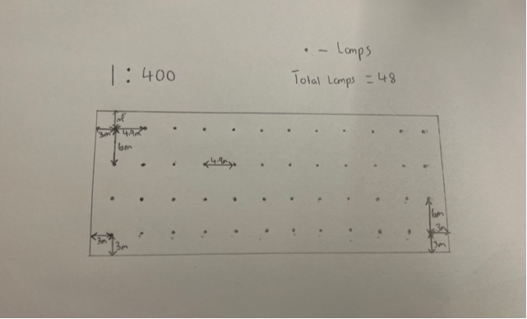

Task B

Question 1.0

Formulas needed to work out sound reduction index =

T0 = (T1 x A1) + (T2 x A2) + (T3 x A3)
A1 + A2 + A3

SRI = 10x (Log10 (1/T))

T0 = Overall Transmission coefficient
T1 = Transmission coefficient of one component
A1 = Area of that specific component

Brickwork =

T1 = ?
A1 = 20m2 – 2m2 = 18m2
SRI = 50dB

Window =

T2 = ?
A2 = 2m2
SRI = 10dB

Brick

SRI = 10 x (Log10 (1/T))
50 = 10 x (Log10 (1/T1))
5 = (Log10 (1/T1)
1/T1 = 10⁵
T1 = 10⁻⁵
= 0.000010

Window

SRI = 10 x (Log10 (1/T))
10 = 10 x (Log10 (1/T2))
1 = (Log10 (1/T2)
1/T2 = 10¹
T2 = 10⁻¹
= 0. 10

T0 = (T1 x A1) + (T2 x A2)
A1 + A2

= (10⁻⁵ x 18) + (10⁻¹ x 2)
18 + 2

= 0.000018 + 0.2
20

Average Transmission Coefficient = 0.0200018

SRI = 10x (Log10 (1/T))
= 10x (Log10 (1/0.0200018))
= 10 x (Log10 (49.9955004))
= 10 x 1.698
= 16.98

Overall SRI = 17dB

Question 2.1

There are various implications within the frequency and wavelength in building fabric resonance due to every object having a natural frequency which is the characteristic frequency at which it tends to vibrate when disturbed. An example is the sound of a metal bar dropped on the floor can be very distinguished compared to a block of wood dropped in the exact same way. A natural frequency depends on various factors such as the shape, density, and stiffness of the object, the implications this then leads too is the frequency in terms of how frequent it happens and also the wave length in terms of how long the sound lasts for. The materials used in the structure of a building will tend to have a high amplitude and at a specific frequency with the wave lengths being various sizes, also the frequency and the wavelengths size in a structure or material that have an equal or vey nearly equal frequency will result in the structure or material vibrating strongly and is the classical resonance state. This resonance state can often lead to unexpected behaviour of the structure or material.

Question 2.2

The implication factors in which affect the frequency and wavelength of partition walls is very reliant on the materials used as this is a big factor, such as at low frequencies with big wavelengths will lead to big transmission loss although this depends on the modal behaviour of the partition wall. For example, an 18mm plasterboard partition wall the elastic parameters of the partition wall including the mass density and boundary conditions at the junctions with the floor and roof will determine the real behaviour of the partition as the higher the amplitude of the partition vibration the lower the transmission loss. Also, as the transmission loss increases this therefore leads to the vibrations of the partition to have smaller amplitudes.

Question 2.3

In terms of the determining material choice used is a big factor in terms of the size of the wavelengths and also how frequent the vibrations and sounds are, as for an example a very good sound proof insulation is the Knauf Soffit insulation which is used within walls and ceilings for its insulation but also due to reducing space within walls as this will reduce the amplitude of wavelengths and also the frequency of vibrations and sound. The differing insulation used impacts the frequency and wavelength as if the insulation used isn’t very strong or sound proof then this will result in high amount of frequencies and also can result in long wavelengths where as on the other side if the material used for insulation is sound proof, very dense and very good for thermal conductivity then this will result in low amount of frequencies and also short wavelengths.

