Does the drama tool ‘Conscience Alley’ enhance the children’s oracy skills in a lower key stage two classroom?
0800986
TET
Contents
Page

Purpose of research…………………………. 3
Literature review……………………………….5
Methodology……………………………………7
Ethical considerations………………………..10
Lesson 1 & 2 analysis………………………11
Discussion……………………………………14
Conclusion……………………………………15
Recommendations……………………………17
Appendix………………………………………18
References………………………………..38

Purpose of research

‘Reading and writing float on a sea of talk’ Britton (1970)
The topic that I chose to focus on within my research on is Oracy. Specifically, within a lower Key Stage 2 classroom. Oracy has been a contentious issue in the UK over previous years with past governments and educators not giving it the priority it deserves. Alexander (2012) has wrote in depth about the misconceptions of oracy within the British education system. He has highlighted that in the past talk has often been seen within a social respect rather than an articulation of ideas and confidence in communicating.
Whilst on teaching practise I developed my own understanding of oracy. There has long been discussion about what we mean by the term ‘oracy’. Wilkinson (1968) introduced the term oracy to encompass speaking and listening although others refer to it as language across the curriculum. I personally believe that oracy underpins all aspects of children’s learning within school and this view is supported by Alexander (2012) whom wrote ‘Talk is essential to children's thinking and learning’. The ability to talk confidently is integral within today’s society. Donaldson (2015) refers to children being ‘healthy, confident individuals’ whom are able to share and communicate their own thoughts and feelings confidently across all contexts.
The school that I was based in for my professional teaching experience has recently started to implement changes across their lessons to improve levels oracy throughout the school. They had worked closely with Voice 21 which is a national campaign to raise the status of oracy in schools across the UK.
Although there were opportunities for collaborative discussion within lessons I didn’t see any aspects of drama being used and this prompted my discussion with my research partner. After much conversation with my research partner, we believed that using drama techniques would enhance the oracy skills of children within a KS2 classroom. We decided to research further the different types of drama strategies that are used.
Conscience Alley was a strategy that both myself and RF were familiar with. I was first introduced to the technique within a university lecture where we were introduced to it and also part of a practical activity showing how it could be used within a classroom. It supported the fact that Conscience alley can be used in any situation where there are different choices of action and enables the children to examine conflicting interest or dilemmas. It is useful to examine the pros and cons of a decision. Two lines of children face each other, and one child in role as a character walks slowly down the alley between them. As the character progresses down the alley, their thoughts are voiced aloud by the rest of the class. After this research we both decided that this would be an engaging practical strategy to use and this stimulated our research question ‘Does the drama tool ‘Conscience Alley’ enhance the children’s oracy skills in a lower key stage two classroom?’.
As I have previously mentioned the aim of this research project is to explore the relationship between the drama tool ‘Conscience Alley’ and oracy. Throughout my research I will explore whether ‘Conscience alley’ can develop and enhance children’s oracy within a lower key stage 2 classroom. Oracy encompasses many different skills and aspects which I shall focus on in more depth within this assignment. Another reason why I chose this question was because I am interested in developing children’s voice within school as this is a lifelong tool that they need throughout their lives. It is suggested that good levels of oracy support progress in other areas such as reading and writing, and this view is supported by ESTYN (2008). The school I was based in had started to introduce techniques that School 21 use. School 21(www.school21.org.uk) is a pioneering school in London that has developed a series of pedagogies and approaches that give children the ability to find their voice with a large focus on oracy throughout the school. They have worked with the University of Cambridge and Neil Mercer to develop an oracy framework.
Current research from Neil Mercer (2008) discusses how to enhance different types of talk within the classroom and this has led to my focus on drama tools; specifically, ‘Conscience Alley’ and its effect directly on children’s oracy. My research will add to this current research, which highlights the importance of oracy for children within school. I will explore the different approaches used when increasing children’s oracy within the classroom and link this to more recent research which has discussed the use of drama pedagogy to enhance oral communication.

Literature Review
There is a breadth of research on literacy and I shall cover these throughout my literature review.
As mentioned within my introduction, Wilkinson highlighted the term ‘oracy’ in the 1960’s and he argued that the oral skills of speaking and listening should be merged into the curriculum. However not as a specific subject but a ‘condition of learning’ across the breadth of the curriculum. This highlights the priority that he believed oracy should have within education. Wilkinson wrote this in response to what he believed had happened to oracy previously. He believed that the verbal skills of speaking and listening were being side-lined to focus on reading and writing.
It is highlighted through literature that oracy is the foundation for the development of children’s literacy skills (Britton, 1970). Estyn (2008) also supports this view as they report that progress in reading and writing are dependent on children’s language.
Wales in particular have highlighted issues in oracy and earlier this year the Welsh Assembly Government (2018) introduced the ‘Take time’ campaign as part of a wider government approach to oracy.
Kirsty Williams (2018) said “Oracy is essential for developing life skills and we are keen to support parents, carers and guardians as they pass these valuable skills on to their children”
This alludes to the responsibility that WAG give to parents and guardians in respect of children’s oracy. She also explained that this approach to oracy includes £700,000 of extra funding and support to schools in 2018-19 through regional consortia to help improve the language skills of learners.
However, Gorden (2011) has highlighted that there are many hurdles to oracy within the classroom. Examples of these barriers are the learners state of mind and personality differences (Grigg 2015).
Equally important Estyn (2008) wrote that when children have limited oral skills it has a negative effect on their reading and writing skills. and whilst on teaching practice I was able to see this link clearly.
There is a wealth of research that supports the use of drama to develop literacy skills. There is a natural link and Somers (2013) describes drama as a means of communication. HMI (1990) published a report that identified the value of drama clearly. It wrote ‘The teaching of drama has a strong influence upon the development of language and literacy’ although it noted that drama techniques rarely receive the attention it deserves as a tool not only in developing literacy but also across the curriculum’. In addition, Freebody (2013) believes that drama is created through interaction and talk. However, Carroll (1978) suggests that talk that occurs within drama situations is different to that of typical classroom talk. He argued that using drama techniques allows children to be more aware of their own language use and it also gives them more time for considered language choices.
In contrast, Kalidas (2014) reported that teachers are wary of using drama techniques as they feel like they may lose control of their classroom (as behaviour may turn boisterous and the inability to manage the active lessons). Many teachers are reported to feel intimidated by the idea of leading students in dramatic activities; however, most dramatic activities do not require teachers to have direct theatre experience (Beehner, 1990). In addition to this, research by Bolton (1985) suggests that both students and teachers saw drama as “doing a play” which negatively impacts the engagement and enthusiasm that they will have when approaching the lessons.
Another interesting point that has been introduced is that most primary teacher education programs do not offer courses related to drama and teachers mention feeling unfamiliar with facilitating dramatic activities (Furman, 2000). As dramatic activities can be playful and active teachers may be afraid that children will not take learning seriously. As McMaster (1998) has advocated, drama can be an invaluable teaching method, since it supports every aspect of literacy development. It develops children’s comprehension, knowledge, confidence and oracy as a whole. Drama activities off children a free and flexible place to grow and learn.

Methodology
Within my research I will use the Lesson study approach, originating in Japan, ‘Lesson Study is an investigation of classroom pedagogy conducted cooperatively by a group of teachers with the aim of improving the quality of teaching and learning’ (Tsui and Law, 2007). Dudley (2011) introduced this detailed form of classroom action research which focuses on the development of teacher practice knowledge. The lesson study approach encourages collaboration and reflection. Which is well suited to this research project as I shall be working alongside Rachel Fisher (RF) my research partner. This approach will allow us to take ownership of our own practice. It will also use pupil voice to develop the quality of teaching. Calderhead & Shorrock (1997) suggest that student and teacher learning is facilitated through Lesson Study as it connects experiences and observations. There are however barriers to the lesson study approach such as an apprehension from teachers to teach in front of their research partner. Alongside this is the fact that as neither research partner has taken part in this approach before and this could could mean that it is not successfully implanted properly. To ensure that the research is successful both myself and my partner must be open to change and new ideas (Wood and Cajkler 2013).
There have also been criticisms of Action research. It has been criticised for promoting a rigid approach to research (Carter and Halsall, 1998). It has also been argued that new researchers may find they deviate off the action research cycle and worry that they are not following the approach properly, when actually McNiff (2002) writes that research will always deviate from the plan. A damning criticism by Godfrey, 2004 is that action research was described as ‘all action and no research’.
Elliot (1991) It will involve an element of collaborative enquiry between myself and my research partner RF whom are trying to improve our research approach. The lesson study design will involve me teaching the first lesson whilst my research partner RF is a non-participating observer. However, for the second lesson RF will teach the lesson whilst I am the non-participating observer. After each lesson we shall hold a focus group interview with three children (a mixed ability group). Roberts (2008) writes that children are most knowledgeable about their own lives and finding a way to involve them within research is important. However, she points out that ensuring children are listened too as their voice is important within the research. The children’s feedback and reflection on the lesson will feed into our next lesson allowing us to improve through the children’s opinions. The children will have been chosen for the focus group as a mixed group with differing current levels of oracy within the classroom. The three children will be chosen before the day of the observation although if they are absent on the day then another child from the class can be asked if they are happy to be observed. There is no pressure at all for the children to be part of the research at all and they can withdraw at any time. The research activities will take place in two large English medium schools based in South Wales. The schools are within Yr Athrofa’s partnership with UWTSD.
There are three main ways that I shall collect data from this research; Entrance & exit cards, non-participant observation and a focus group interview with the 3 focus children after the lesson. We chose to use entrance tickets to gather a general feeling from the participants on how they felt about sharing ideas within a small group, the class and how well they felt they listened to others. We then repeated the same set of questions at the end of the lesson and could see what this suggested about their feelings towards the questions. It was anonymous and thus we felt that this would allow children to be more honest with their answers.
After both lessons we shall have an interview with the focus group. Dockett and Perry (2003) believed that including children in the discussion of their experience gave adults the ability to understand their opinions of the lesson. It was important within my research that children were listened to Rinaldi (2001). As Taber (2002) has noted research interviews can feel intense for both the interviewees and the interviewer and it is integral that as researcher we limit the chances of distress for participants. We will of course be very careful as not to lead the children or steer their responses. The fact that the interviews are taking place after the lesson may mean that children’s memory or opinions of the lesson may change. Hitchcock and Hughes (1995) suggested that the most natural interactions between researcher and participant during the observation rather than after.
Throughout the observation the observer will be non-participant within the lesson. This has advantages and disadvantages. Advantages are that it allows me to see what goes on with their own eyes - can make judgements and observe body language used. I can also be more open minded as I’m an outsider looking in - less likely to feel sympathy and therefore produce bias data. Although there are also many disadvantages to this approach; such as can lead to Hawthorne effect - people act differently as they know they are being observed. It may be hard to gain accurate results as watching from a distance however and so the positioning of the observer will be integral. As a research partnership we practised observing practice videos on YouTube to try and ensure our observations were consistent. We also agreed that our observations would be best fit as from the practice we noticed that many of the children moved between level descriptors. We discussed using participant observation, but I did not think it was suitable as it may be difficult to manage (Devereux and Miller, 2008). Balancing observing with writing notes on three children may be hard to keep on top of. To become a skilful observer Palaiologu (2008) suggests that observers need to ‘develop objectivity and absence of emotional bias’. As RF is observing my class and I am observing her class I feel that we will observe without bias. However, this is something I will be aware of.
After discussion with my research partner we decided to use the university ARC for reflection after each lesson. We decided this as we felt it would provide consistency as we were already familiar with the format. It is easy to slip into simply describe events (Nolan and Sim, 2011) So it is important that we both reflect well using high order skills as this will allow us to properly evaluate and refine the lessons in depth.
As a research partnership we looked at both the English curriculum and the School 21 oracy checklist. We looked for crossovers and this is how we produced the Observation schedule and level descriptors (Appendix M).

Ethical considerations
There are many ethical considerations that I was aware of before I started my research. I ensured that I followed all of the University procedures and ensured that I read the UWTSD Ethics code of practice (2017). It was imperative for the duration of the study to adhere to British Educational Research Association guidelines (BERA, 2011) and I ensured that I was thinking of the best interests of the participants at all times.
To ensure that my research question was suitable and ethically sound, I submitted an Ethics form to the university ethics committee to gain permission to start my research. I was also aware that the participants in my research were children of primary school age. I ensured that the participants were fully informed of the research and that their agreement to participate was essential. I also ensured that they understood that their assent was not a one off and that they had the right to withdraw at any time without prejudice form the researchers (Valentine, 1999). We gathered assent by asking the children to do an anonymous thumbs up/down technique. After gathering assent from the participants, I made sure that we also had written consent from their parents. We also ensured that the class teacher witnessed the children giving their assent and asked them to sign to agree they had witnessed this (see appendix I and J). All participants were all given anonymity, there was no names on any of the entry and exit cards. I also used School A and School B to identify the schools so that the identity of the schools could not be found out, it was important to do this so that I limited the risk of participants being identified. At all time our priority was to keep the possible risk to the participants low, both psychologically and physically. We ensured this by making sure that we were not alone with the children at any time, we also made sure we followed all of the school’s safety policies.

Lesson study and Lesson 2 analysis
You can see from the lesson plan (See Appendix A and B) it was agreed that both lessons were fully practical, allowing children to use as many of their oracy skills as possible. We decided to base the activities around Goldilocks and the three bears as we felt this was a topic that the children would be familiar with; enabling us to focus on the research evidence rather than introducing the children to a completely new topic. The learning objective was ‘To make an informed decision’. It was agreed that the lesson would take place in School A first and then both researchers would reflect and discuss any changes that the participants has mentioned and make them before the next lesson was delivered (the following day) in School B. It was agreed that we would also swap positions in school B so that children were familiar with the teacher.
School A
All the focus participants were engaged throughout the session. I predicted that conscience alley would enhance their oracy and from Appendix K you can see from RF observations both Child 1 and Child 3 either attained their year level descriptor or above. However, you can also see that Child 2 fell below their year level descriptor for the social aspect of their oracy which includes, listening, working with others and responding.
The focus group interview also suggested that Child 2 did not think Conscience Alley encouraged them to talk more responding ‘no’. It is interesting to mention that Child 2 said they felt ‘half and half’ when asked how they felt about sharing their ideas in a group. When asked how they felt about sharing their ideas by their self in front of others they replied, ‘not that good’. This proposes that Child 2’s oracy skills were not enhanced during Conscience Alley and they did not enjoy the drama activity. The focus group interview did show however the fact that Child 2 was engaged in the lesson.
In our reflection on the lesson both myself and RF felt that Conscience alley didn’t seem as effective as it could have been within the lesson. We had organised it as a whole class activity and it was unmanageable which led to a lack of effectiveness. This is evidenced within the focus group interview. When asked how we could change the lesson to make it better Child 3 said “One team should share ideas at a time so that we are not all speaking at the same.” And Child 1 said to put hands up to speak”. After much deliberation we decided to split the class in half for Lesson 2, so that we would in effect have two Conscience alleys for the next lesson.
I shall now briefly discuss the entry and exit card results. They
To conclude the changes going into Lesson 2 were as follows- reducing the size of the ‘Conscience alley’, ensuring that there was clearer explanation for the entrance and exit cards (as RF had mentioned she would need to scaffold the understanding of the question. We also added another box onto the observation schedule to include their end vote and the conversation.
After lesson 1 myself and my research partner both completed ARC forms for reflect on the lesson. Through the ARC we identified what we thought had gone well and what could be improved for the next lesson the following day.
Through this reflection we identified that we needed to structure the ‘conscience alley’ more for the second session. Due to the amount children in the activity we felt that the quality of interaction wasn’t manageable. So for lesson 2 we decided that we would split the class into two groups.
It is evident from the focus group interview (see Appendix N) that the participants did not think ‘Conscience Alley’ encouraged them to talk more. However, they did then mention that it made them think of other ideas. This could be because of the large size and they should have more opportunities for greater debating tomorrow.

School B
This lesson was a longer session that the lesson in School A.
As you can see by the observation schedule (see appendix K) the non-participant observer watched the three focus children throughout the lesson but focused on the areas within the schedule. She used the level descriptors (see appendix M)
To begin the lesson children were introduced to the topic and asked to give their assent. They gave this by a thumb up and down technique. They then filled in the entrance card (see appendix D). The teacher then used the PowerPoint to allow children to recap the story of Goldilocks and the three bears using images to stimulate their conversation. After this the PP was interrupted by a ‘Newsflash’, within which a ‘Morfo’ newsreader (video) informed the children that Goldilocks had been arrested. Within lesson 1 the ‘Morfo’ seemed to ignite conversation between the children; whereas in Lesson 2 the children didn’t seem as enthused by it. Within this part of the session all three focus children were seen to be responding with others well. Child 2 in fact was observed listening well to their partner and coped well when challenged. The class was then split into two halves, one side ‘Team Goldilocks’ and the other ‘Team Three Bears’. The children were then asked to discuss their ideas with a partner or group of three; this then snowballed to two groups together and then to the team discussion. It is interesting to notice however that contrary to my predictions, Child 2 starts to lose attention within the group. They were observed to be below their year level descriptor for both their cognitive and social aspects of oracy.
It is clear from the observation schedule that Child 1 developed their oracy skills as they went through the different parts of the lesson. When Child 1 started the conscience alley activity they were observed ‘needing prompting’ and ‘unsure when challenged’ although they grew more confident as they went through the activity. This is in comparison to both Child 2 and Child 3 who were observed reasoning their argument in depth,
I shall now discuss the results of the entrance and exit cards which you can see from appendix…… show that throughout the lesson the children feel more confident sharing their ideas within a group and as a class.

Discussion
It is clear to suggest from research findings suggest that conscience alley can enhance oracy skills. Although as was evident in my findings this is not true for all children, this is visible in Appendix N. Within lesson 1 it was evident that although all focus children were engaged and involved within the lesson, when it came to the interview you could see that it was not enjoyable for them all. This shows that in fact Conscience alley may not enhance all children’s oracy skills. In this case it would be interesting to see if other drama strategies had the same effect on the class or whether this would draw different results.

In relation to my own class (Lesson 1) it would be interesting to repeat the lesson with the improvements made and see what effect this had on the children. As I had this class for my teaching practice I had made assumptions and supported the teacher when levelling their oracy skills. However, working with another practitioner and viewing their results has improved my own objectiveness.
I will recommend that exploration of an array of activities would enhance oracy skills for ALL children. The focus group interview from Lesson 2 (see Appendix O) also suggests that the theme used for the drama technique must be well thought of, as mentioned; the focus children already knew the story (whereas we believed this would help them so that the focus was on oracy) in fact, it meant they thought it was “boring”.

Conclusion
To conclude, it is possible to suggest that ‘Conscience Alley’ does enhance the oracy skills of most of the focus participants within our study. However, it is imperative to point out that this is not a statement that can be represented in all classes. All children are different, and this can be seen in their opinions of the activities. As a small-scale study, I can only make suggestions we would need to repeat and refine the study further.
Key to point out that Lesson 2 was in fact longer (due to afternoon time constrictions in School A.
I have found it a really rewarding experience working alongside the participants. I fully believe that the focus group interview was invaluable as it allowed us to really grasp how the children felt about the aspects of the lesson. As non-participant observers we made judgements on observations that we saw; although it was interesting to see what the children actually thought. Grover (2004) noted the importance of a having a trusting relationship with the participating children to overcome the disposition that they may have to give the ‘right answer’.
Across both focus group interviews in School A and School B I felt also that because the children were familiar with us both they provided us with frank and honest answers.
In regard of the Lesson study approach I would like to use this approach throughout my career to improve my own practise. As an educational practitioner I feel that it is important to work alongside other teachers to improve out practice whilst taking advice off others.
In retrospect I believe that the method of collecting data although reliable was too broad to enable us to grasp a true judgement on whether conscience alley does in enhance the children’s oracy skills. Throughout the methodology and in discussions with RF we did not discuss fully what we meant by ‘enhance the children’s oracy skills’. This is evident again when observing the children throughout the lesson; the judgements are to broad and not specific enough to show clear evidence.
The judgements can be generalised and suggests can begin to be made from what we found through our research however at this stage I would prefer to consult again along with another professional to improve our approach and ensure limitations are at a minimum.
If I did this lesson again I would ensure that the observations made were more consistent. Coe (2009) stated that observations can be subjective and although both myself and RF used the same observation schedule it is of course true that we will have both observed different things and thus obtained different results (This can be seen in Appendix K and L). As we created the observation schedule it would be unfair to base our judgements on its success on just one small scale research project. It would be possible for fellow education professionals to use this objectively within their research to and see if it is useful.
Finally, the lesson study approach has been a positive and enjoyable experience for me and as recommended by Dudley (2011) I shall use this within my ongoing development. As a trainee teacher I am always looking for new approaches and different ways of supporting the children. Through this research using the lesson study approach I have been able to develop my own professional development and ongoing, continual learning (Hiebert, Morris and Glass, 2003).

Recommendations
Unfortunately, as I’ve already mentioned this has been a small-scale research project and before making definite judgements from my research I would like to share it with other education professionals to develop it further. However, I do think that it provides an insight into how practical activities can enthuse and encourage children to develop their oracy skills. As Alexander (2012) has documented, the balance between reading and writing and speaking and listening has been questioned and the spotlight with other research like mine will develop this further.
Further research with more time would develop the research I’ve started here. I would also recommend that the observation schedule be refined with the ideas of fellow researchers as I believe this would develop the quality of the research that is gathered. I decided this due to the breadth of information to collect within a short period of time.
To conclude, I feel that with greater time allowed to observe the children I believe that I would be able to gather a greater breadth of evidence. The evidence would also be more reliable if taken over a few sessions rather than just one.
Overall this research project I have developed my confidence in my own practice and it has also encouraged me to develop a positive approach to ongoing development. In turn this has allowed me to work with a research partner to improve my own practice and has been an invaluable experience to add to my ongoing professional development.
To finish, research supports the fact that the most effective teachers are those who use research to develop their teaching (Musset, 2010) and this is something I shall continue to do throughout my teaching career.

Appendix
Appendix A- Lesson plan 1 (School A)
Appendix B- Lesson plan 2 (School B)
Appendix C- Entrance and exit card 1
Appendix D- Entrance and exit card 2
Appendix E- ARC 1 Teacher
Appendix F- ARC 1 Observer
Appendix G- ARC 2 Teacher
Appendix H- ARC 2 Observer
Appendix I- Lesson 1 Assent
Appendix J- Lesson 2 Assent
Appendix K- Observation schedule 1
Appendix L- Observation schedule 2
Appendix M- Observation schedule level descriptors
Appendix N- Focus group interview for Lesson 1
Appendix O- Focus group interview for Lesson 2

Appendix A- Lesson plan 1 (School A)

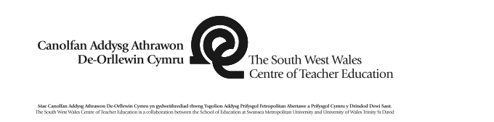 |  |  |  |  |  |  |  |  |  |  | 1B

Session Plan – Key Stage 2
Name of trainee: |  | Lucy Neale |  |  |  | Session ref: |  |  | TET Lesson 1
Personal target(s) in relation to QTS: |  |  |  | S3.2.2 They monitor and assess as they teach, giving immediate and constructive feedback to support learners as they progress. They involve learners in reflecting on, evaluating and improving their own performance.
Year group: | 3/4 |  | No. of learners: |  |  |  | ALN:
Additional Adults:
Learning objective(s): To make an informed decision. |  |  |  |  |  |  | Success criteria: - Share their opinion  - Listen to others  - Support their opinions with ideas.
Links to previous learning:
Curriculum coverage (range, skills)

Literacy(LNF)  Explain Information and ideas using relevant vocabulary.  Organise what they say so others can understand.  Speak clearly, varying expression to help listeners. |  |  |  |  |  | Numeracy (LNF)
DCF |  |  | Thinking  Begin to experiment with own ideas and those of others.  Generate imaginative ideas and responses. |  |  | ESDGC |  |  |  | YCC
Key vocabulary(English/Welsh):

Time | Session activities, organisation and management | Key questions & Assessment for Learning opportunities
15 mins | Introduction
15 mins | Introduce children to ourselves and explain what we are doing today. [Explain the process/assent etc]  Entrance card.  Recap over Goldilocks and the Three Bears using key images from the story on PowerPoint.  NEWSFLASH [Goldilocks arrested]
15mins  15mins | Main activities
15mins  15mins | Explain that the children are going to be split into: -  #Team Bears  #Team Goldilocks  - In 3’s (one 2) children to discuss ideas and arguments.  - 2 groups to join and discuss as a 6.  - As a full group discuss.  ‘CONSCIENCE ALLEY’  Nominate a ‘JUDGE’ to walk down alley.  Do they think Goldilocks was innocent or guilty? |  | Did Goldilocks apologise?
15mins  15mins |  |  | Did she have permission to go
15mins  15mins |  |  | Into the house?
15mins  15mins |  |  | What would her mother say?
15mins  15mins |  |  | Why was Goldilocks in the
15mins  15mins |  |  | Woods?
15mins  15mins |  |  | Was she being kind?
15mins  15mins |  |  | What did she do to solve things?
10 | Plenary |  | Did Goldilocks know she was
10 | Post it note vote…… Guilty or Innocent?  Exit card. |  | Breaking the law?
10 |  |  | Is goldilocks too young to be
10 |  |  | Charged?
10 |  |  | Was the door wide open?
10 |  |  | Was she scared?
10 |  |  | Did she see their house as a safe
10 |  |  | Place?
10 |  |  | Could she have gone anywhere
10 |  |  | else?

Appendix B- Lesson Plan 2 (School B)
 |  |  |  |  |  |  |  |  |  |  | 1B

Session Plan – Key Stage 2
Name of trainee: |  | Rachel Fisher |  |  |  | Session ref: |  |  | TET lesson 2 28.03.18
Personal target(s) in relation to QTS: |  |  |  | S3.2.2 They monitor and assess as they teach, giving immediate and constructive feedback to support learners as they progress. They involve learners in reflecting on, evaluating and improving their own performance.
Year group: | 3/4 |  | No. of learners: |  |  |  | ALN:
Additional Adults:
Learning objective(s): To make an informed decision.  Social Target: Everyone must be respectful of others. |  |  |  |  |  |  | Success criteria: - Share their opinion  - Listen to others  - Support their opinions with ideas.
Links to previous learning:
Curriculum coverage (range, skills)

Literacy(LNF)  Explain Information and ideas using relevant vocabulary.  Organise what they say so others can understand.  Speak clearly, varying expression to help listeners. |  |  |  |  |  | Numeracy (LNF)
DCF |  |  | Thinking  Begin to experiment with own ideas and those of others.  Generate imaginative ideas and responses. |  |  | ESDGC |  |  |  | YCC
Key vocabulary(English/Welsh):

Time | Session activities, organisation and management | Key questions & Assessment for Learning opportunities
15 mins | Introduction
15 mins | Introduce children to ourselves and explain what we are doing today. [Explain the process/assent etc]  Entrance card.  Recap over Goldilocks and the Three Bears using key images from the story on PowerPoint.  NEWSFLASH [Goldilocks arrested]
15mins  15mins | Main activities
15mins  15mins | Explain that the children are going to be split into: -  #Team Bears  #Team Goldilocks  - In 3’s (one 2) children to discuss ideas and arguments.  - 2 groups to join and discuss as a 6.  - As a full group discuss.  ‘CONSCIENCE ALLEY’ [Two alleys- one monitored by teacher and other by observer]  Nominate a ‘JUDGE’ to walk down alley. |  | Did Goldilocks apologise?
15mins  15mins |  |  | Did she have permission to go
15mins  15mins |  |  | Into the house?
15mins  15mins |  |  | What would her mother say?
15mins  15mins |  |  | Why was Goldilocks in the
15mins  15mins |  |  | Woods?
15mins  15mins |  |  | Was she being kind?
15mins  15mins |  |  | What did she do to solve things?
10 | Plenary |  | Did Goldilocks know she was
10 | Post it note vote…… Guilty or Innocent?  Exit card. |  | Breaking the law?
10 |  |  | Is goldilocks too young to be
10 |  |  | Charged?
10 |  |  | Was the door wide open?
10 |  |  | Was she scared?
10 |  |  | Did she see their house as a safe
10 |  |  | Place?
10 |  |  | Could she have gone anywhere
10 |  |  | else?

Appendix C- Entrance and exit cards 1 (School A)
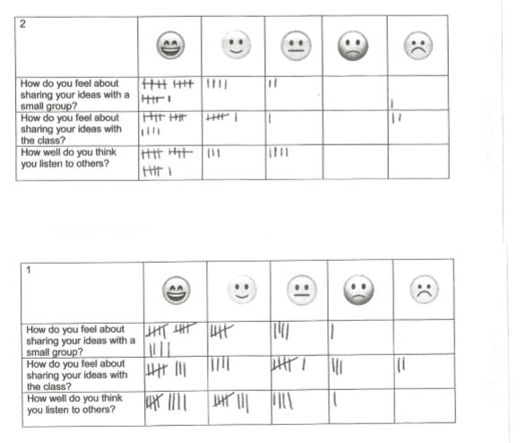
- Entrance card results
- Exit card results

Appendix D- Entrance and exit cards 2 (School B)
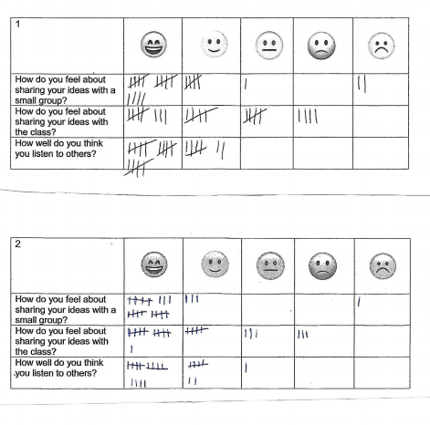
- Entrance card results
- Exit card results

Appendix E- Lesson 1 Teacher ARC
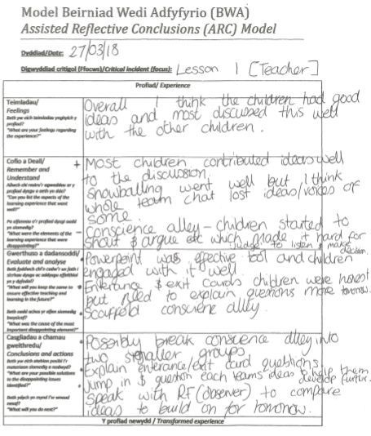

Appendix F- Lesson 1 Observer ARC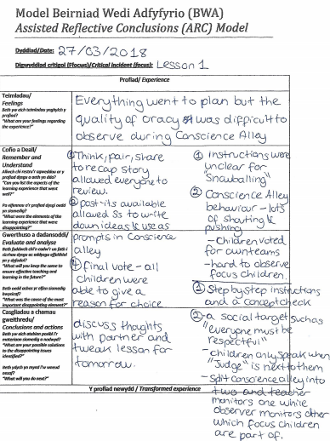

Appendix G- Lesson 2 Teacher ARC
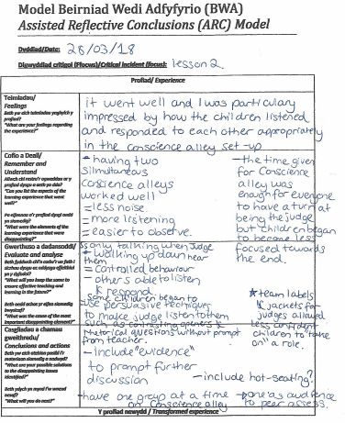

Appendix H- Lesson 2 Observer ARC
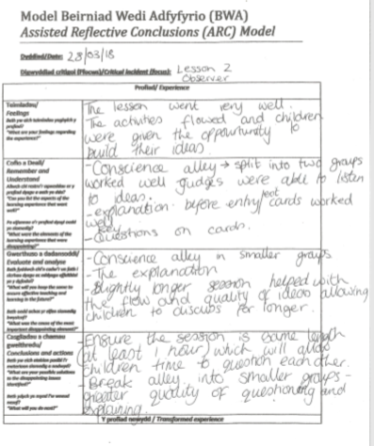

Appendix I- Lesson 1 assent
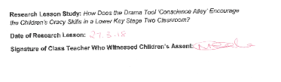
Appendix J- Lesson 2 assent
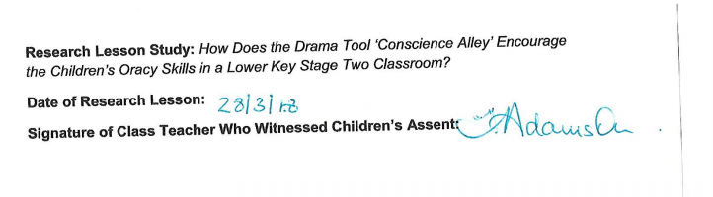

Appendix K- Lesson 1 Observation schedule

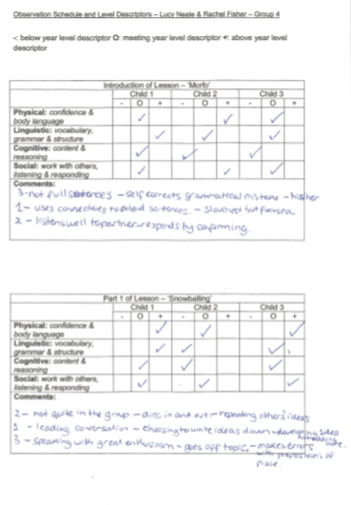

Appendix K- Continued
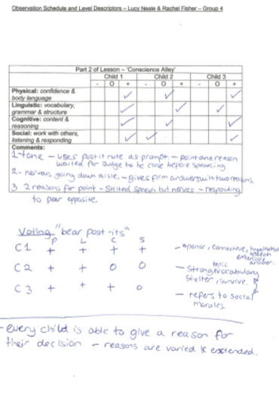
Appendix L- Lesson 2 Observation schedule
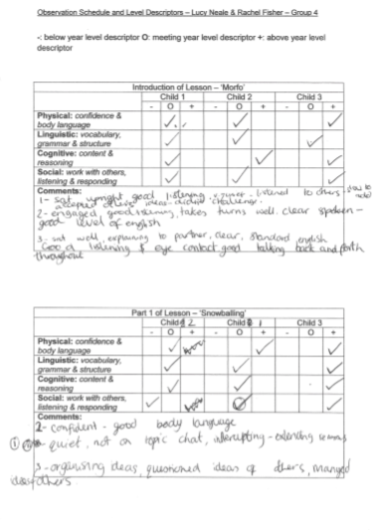

Appendix L- Continued
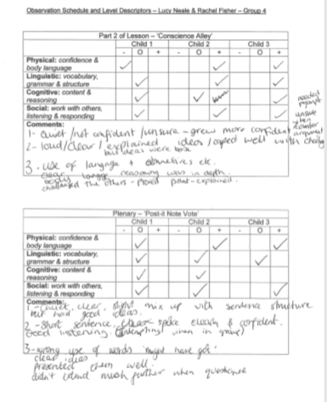

Appendix M- Observation schedule level descriptors

Physical: Confidence & Body Language
- | O | +
- Limited body movement; arms crossed, closed body language.  - Slouched posture  - Apprehensive, unable to manage feelings, unable to cope when asked questions  - Unable to make eye contact with audience | - Some body movement; arms opening and closing, leaning forward when speaking.  - Elements of good posture but not held throughout  - Elements of apprehension, able to manage feelings.  - Fleeting eye contact, unable to maintain for length of speech. | - Varied body language; uses hand gestures to support worded language, relaxed  - Upright posture, open to audience  - Confident when speaking, unchanged when asked questions  - Maintains eye contact when speaking and listening.

Linguistic: Vocabulary, Grammar & Structure
- | O | +
- Doesn’t use Standard English – uses slang.  - Confused organisation of speech  - Speech does not flow. | - Uses Standard English at times but not consistent with use.  - Often organises content well but not consistent  - Speech flows but needs prompts for extension. | - Uses Standard English appropriately for situations.  - Selects and organises content well  - Speech flows and is extended.

Cognitive: Content & Reasoning
- | O | +
- Unable to build on views of others  - Cannot clearly support their arguments  - Content is unclear for listening and further clarification is needed. | - Sometimes builds on views of others  - Gives basic reasons for supporting their arguments.  - Content is clear for listening and apprehensible. | - Builds on views of others  - Gives extended reasons and evidence to support their arguments.  - Content is clear for listen and emotive.

Social:
- | O | +
- Unable to take turns  - Does not allow time for others to challenge their ideas.  - Affected when ideas are challenged unable to manage emotions.  - Does not actively listen  - Does not respond to others  - Does not question nor challenge others | - Sometimes takes turns but interrupts others.  - Sometimes allows time for others to challenge their ideas.  - Is affected when ideas are challenged but manages emotions.  - Actively listening on occasions  - Responds to others but not always appropriately  - Questions or challenges others occasionally | - Able to take turns and manage the interaction of others.  - Allows time for others for others to challenge their ideas.  - Is unaffected when ideas are challenged.  - Actively listening throughout.  - Responds to others appropriately and constructively.  - Questions and challenges others in a constructive and clear way.

Appendix N- Focus group interview for Lesson 1
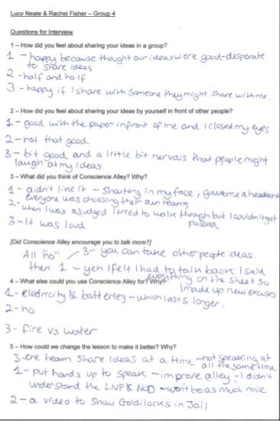

Appendix O- Focus group interview for Lesson 2
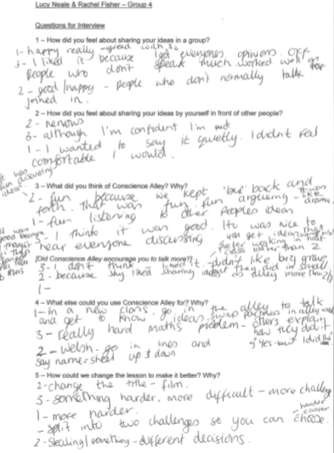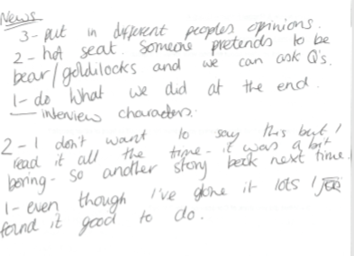

References
Alexander, R. (2012) Improving Oracy and Classroom Talk in English Schools: Achievements and Challenges. Extended and referenced version of a presentation given at a Department for Education seminar on Oracy, the National Curriculum and Educational Standards
British Educational Research Association (2011) Ethical guidelines for educational research. London: BERA
Beehner, M. B. (1990). Creating a dramatic script for dynamic classroom learning. "Education", 110(3), 283-288.
Bolton, G (1985) Changes in thinking about drama in education. Theory into practice. 24 p151-157.
Britton, J. (1970) Language and Learning, London: Penguin
Calderhead, J., and Shorrock, S. (1997) Understanding Teacher Education, London, Falmer Press.
Carroll, J. (1978) A language functions approach to areas in drama in education. National association for drama in education, 3: 19-27
Carter K and Halsall R (1998) ‘Teacher research for school improvement’ In R Halsall (ed) Teacher research and school improvement: Opening doors from the inside. Buckingham: open university press.
Collins, J (1994) ‘The silent Minority: Developing talk in the primary classroom’
Dockett, S and Perry, B (2003) ‘Children’s views and children’s voices in starting school’ Australian journal of early childhood, 28 (1) p12-17
Donaldson, G. (2015). Successful Futures. Available: http://gov.wales/docs/dcells/publications/150225-successful-futures-en.pdf. Last accessed 9th April 2018.
Dudley, P (2011) "Lesson Study development in England: from school networks to national policy", International Journal for Lesson and Learning Studies, Vol. 1 Issue: 1, pp.85-100
ESTYN. (2008). Best practice in the reading and writing of pupils aged 7 to 14 years. Available: https://www.estyn.gov.wales/thematic-reports/best-practice-reading-and-writing-pupils-aged-7-14-years-may-2008. Last accessed 9th April 2018.
Godfrey, R (2004) ‘Can everyone be a researcher?’ in Hayes, D (ed) The Routledge Guides to Key Debates in Education, Abington: Routledge, p207-210.
Grover, S (2004) ‘Why won’t they listen to us? On giving power and voice to children participating in social research’, Childhood, 11(1) p81-91.
Furman, L. (2000). In support of drama in early childhood education, again. "Early Childhood Education Journal", 27(3), 173-178. [EJ 610 229]
Freebody, K. (2013) Discourse in drama: talk, role and learning in drama education. NJ- drama Australia National Journal, 37: 65-76
Hiebert, J., Morris, A., & Glass, B. (2003). ‘Learning to Learn to Teach: An “Experiment” Model for Teaching and Teacher Preparation in Mathematics’. Journal of Mathematics Teacher Education, 6(2), pp. 201–222.
Lewis, C., Perry, R., & Hurd, J. (2003, November 19‐21). How do teachers learn
during lesson study? Paper presented at the meeting of the Global
Education Resources, Greenwich Japanese Schools, Regional Alliance @TERC, and Research for Better Schools 2003 conference, Toward a
common understanding: Implementing lesson study effectively, Stamford, CT.
McMaster, J. C. (1998). "Doing" literature: Using drama to build literacy. The reading teacher, 51(7), 574-584. [EJ 562 451]
McNaughton, M. J. (1997). Drama and children's writing: A study of the influence of drama on the imaginative writing of primary school children. Research in Drama Education, 2(1), 55-86.
McNiff, J (2002) Action research: Principles and practice (second edition) London Macmillan
Musset, P (2010) Initial Teacher Education and continuing training policies in a comparative perspective: current practices in OECD countries and a literature review on potential effects. OECD Education working papers. No 48 Paris OECD publishing.
Palaiologu, I (2008) Childhood Observation, Exeter: Learning Matters
Rinaldi, C (2001) ‘A pedagogy of listening: A perspective of listening from Reggio Emilia’ Children in Europe 1: p2-5
Somers, J. (2013). Drama in the curriculum. London: Cassell
Tsui, A., and Law, D. (2007). ‘Learning as boundary-crossing in a school-university partnership. Teaching and Teacher Education’. 23(8), pp.1289–1301.
University of Wales Trinity Saint David (2017) Research Ethics and Integrity code of practice
Valentine, G (1999) ‘Being seen and heard? The ethical complexities of working with children and young people at home and school’ Ethics, Place and Environment. 2 (2), p37-71
Welsh Assembly Government. (2018). Take Time to Talk, Listen and Play. Available: http://gov.wales/newsroom/educationandskills/2018/take-time-to-talk-listen-and-play/?lang=en. Last accessed 12th April 2018
Wood, P., and Cajkler, W. (2013) Beyond Communities of Practice: investigating and developing the professional learning of trainee teachers through lesson study. University of Leicester.
Wilkinson, A. (1968). Oracy in English Teaching. Elementary English. 45 (6), p743-747.

