
MBA STRATEGIC MANAGEMENT ASSIGNMENT
ALIBABA

GE ZENG
STUDENT NUMBER: 1805160

CONTENTS

Executive Summary 3
1. Introduction 4
1.1 Background of Alibaba 5
1.2 Alibaba's Main Business 5
1.3 Alibaba's Main Competitors 5
2. The Strategic Position 4
2.1 PESTEL Analysis 5
2.2 Porter’s Five Forces Analysis 5
2.3 VRIO Analysis 5
2.4 Main Findings 5
2.5 Strategic Drift 5
3. Strategic Choices 4
3.1 Business Strategy 5
3.2 Corporate Strategy 5
4. Strategy in Action 4
4.1 Types of Change 5
4.2 Implementing strategy 5
5. Conclusions 4

References 29

Executive Summary
This report is the assignment of Strategic Management, and chooses Alibaba as a case for analysis. Based on the actual situation of Alibaba and combining relevant strategic management knowledge, this report analyzed Alibaba's strategic position, strategic choices and strategy implementation.
This report used the relevant knowledge of strategic management to conduct a strategic analysis of Alibaba and obtained its strategic position. After that, according to Alibaba's strategic position, Alibaba's strategic choice was analyzed. Finally, recommendations for implementing strategies are proposed for Alibaba's weaknesses and threats.

1. Introduction
1.1 Background of Alibaba
Alibaba Group is an e-commerce giant that markets, sells and operates different businesses globally. It was founded in 1999 and is headquartered in Hangzhou, China (Alibaba, 2019). It supports merchants, brands and other businesses with its technology and helps them leverage their operations through internet as it engages more users. It offers online shopping platform through Tmall.com and Taobao (for non-branded products sold by smaller-unknown merchants), cloud computing and data management services through Alibaba Cloud Computing, digital media and entertainment, online wholesale market on Alibaba.com, online and mobile payment solutions through Alipay and partnership with Ant Financial Services (Mcclay, 2019).
Today's Alibaba has formed a complete business ecosystem centered on its own e-commerce platform, related to financial business, supporting local living services, pan-entertainment services and smart terminal services (Baker, 2014). The core of this business ecosystem is data and traffic sharing. The foundation is marketing services and cloud services.
On September 19, 2014, Alibaba Group was officially listed on the New York Stock Exchange under the ticker symbol “BABA” (Mcclay, 2019). The founder and chairman of the board of directors was Jack Ma. On July 19, 2018, the global simultaneous Fortune Global 500 list was released, and Alibaba Group ranked 300. In December 2018, Alibaba was nominated for the World’s Top 500 brands in 2018 (Alibaba, 2019).
As of 2018, the company had 576 million active users, exceeding the total US population. Strong earnings, a promising growth story and possibility of a stock listing in China in the near future has driven Alibaba stock to all time high in 2018.
1.2 Alibaba's Main Business
1.2.1 Taobao
Founded in 2003, Taobao is a business-oriented social platform that provides consumers with a sense of engagement and personalization through big data analytics (Alibaba, 2019). On Taobao, consumers can get highly relevant, engaging content and real-time updates from sellers to capture product and trend information and interact with other consumers or favorite businesses and brands (Baker, 2014). The businesses on the platform are mainly self-employed and small businesses.
1.2.2 Tmall
Established in 2008, Tmall is committed to providing consumers with a quality shopping experience with branded products (Mcclay, 2019). A number of international and Chinese local brands and retailers have opened stores on the Tmall website.
1.2.3 Alibaba Cloud Computing
Alibaba Cloud was founded in 2009 as a cloud computing business under the Alibaba Group (Baker, 2014). According to Gartner and IDC, Alibaba Cloud is one of the top three infrastructure and service providers in the world and the largest public cloud service provider in China. Alibaba Cloud provides a full range of cloud computing services to businesses on the Alibaba Group e-commerce platform as well as global users such as start-ups, enterprises and government agencies (Anwar, 2017).
1.2.4 Ant Financial Services Group
Ant Financial Services Group focuses on serving small and micro enterprises and ordinary consumers. It is building an open ecosystem that works with financial institutions to support the finances of the future society. The business of Ant Financial Services Group includes Alipay, Ant Jubao, Sesame Credit (Mcclay, 2019).
1.3 Alibaba's Main Competitors
While many people understand that Alibaba is an online retailer similar to Amazon or eBay, the company's business model is surprisingly different from the leading e-commerce businesses in the United States. Whereas Amazon is housed under one roof, Alibaba is divided into three core businesses: Alibaba, Taobao, and Tmall (Anwar, 2017). All three of these e-commerce websites serve to connect various types of buyers and sellers, allowing Alibaba to act as a middleman in China's emerging e-commerce industry.

2. The Strategic Position
Today, with the rapid development of the Internet, e-commerce is increasingly sought after, and there is also a great risk in the context of this prosperity (Anwar, 2017). In this section, PESTEL analysis was used to analyze the macro environment faced by Alibaba, and Porter’s Five Forces analysis and VRIO analysis were used for internal analysis of Alibaba. Finally, the SWOT analysis is used to summarize the strategic position of Alibaba.
2.1 PESTEL Analysis
The environment creates both opportunities and threats for organizations. The macro-environment consists of broad environmental factors that impact to a greater or lesser extent many organizations, industries and sectors (Dess, 2016). PESTEL analysis is a key tool for analyzing the macro-environment of an organization to provide a wide overview. It not only analyzes the external environment, but also identifies all the forces that have an impact on the organization(Johnson, 2017). PESTEL analysis is a method to investigate the external factors of the organization and can be divided into six major factors: political factors (P), economic factors (E), social factors (S), technical factors (T), ecological factors (E) and legal factors (L) (Dess, 2016). The following is the PESTEL analysis of Alibaba.
2.1.1 Political
Chinese Government pushes for artificial intelligence (AI) and digitalization. The growing protectionism in Chinese economy is helping Alibaba in increasing its penetration in the second fastest economy. The Chinese government is offering support for expansion for AI by sharing personal information such as ID photos for surveillance (Baker, 2014).
Alibaba has launched an e-hub for trade clearance and logistics in Malaysia for facilitating cross-border trade between China and Southeast Asia and among Southeast Asian countries through partnership with government entities. It will reduce the trade barriers for Alibaba in new markets and get government endorsement, which will allow it to offer its digital services to merchants through easy financing and end customers by using AI (Tem, 2018).
2.1.2 Economic
Under the leadership of Chinese President Xi Jinping, the Chinese government is promoting e-commerce as an important area for future economic growth (Kudasov, 2015). This has brought the company's development to a new level. Also, the sweeping political and economic reform campaign narrowed Ma’s activities in the country. There was noticeable that the company’s revenues fell by 10 percent in that period of time.
A combination of cultural, linguistic and government policy factors kept Western internet companies at arm’s length in the Chinese market. Based on this Alibaba created its own online shopping platform Taobao and Tmall, and quickly seized the Chinese market (Tem, 2018).
Slower economic growth in China overall is being matched by some slowing in the rate of growth of the Chinese e-commerce market .
Alibaba had seen off an attack by American rival eBay in the Chinese market with a fierce price-war.
2.1.3 Social
People's acceptance of the Internet and smart devices has increased, making Alibaba's mobile payment and online shopping services popular. Consumers have welcomed this convenient consumption method, and Alibaba's target markets are expanding (Baker, 2014).
One of the main problems of China is population aging. The family planning policy that began in the 1980s caused a breakdown in the labor structure of today's China. On account of an ageing population and the drying up of the traditional supply of young labor from rural villages (Kudasov, 2015). One child per family rule leads to the destructive decline of the able-bodied employees of company.
2.1.4 Technological
AI and big data are the big trends in today's society. Enterprises can provide users with fast and efficient services and enhance user experience through AI and big data analysis. Alibaba has leading data analysis technology and personnel, and has a good position in data competition (Mcclay, 2019).
The popularity of smartphones and the Internet has provided conditions for the development and popularization of mobile payment and online shopping.
2.1.5 Ecological
Faced with rising domestic concern about the environment, Chinese Government was happy to restrain the expansion of high polluting industries such as cement, coal and steel.
Alibaba's mobile payment and online shopping business can reduce the consumer's traffic demand by reducing the purchase behavior from offline transactions to online, helping to reduce carbon emissions and protect the environment (Tem, 2018).
2.1.6 Legal
A lawsuit in US appeals court has accused Alibaba of defrauding shareholders (Baker, 2014). As per the lawsuit, it has concealed the counterfeiters’ regulatory warning which it received before initial public offering (IPO). The 3-0 judgment by lower court has dismissed claims by holders of Alibaba’s American Depositary Shares and ADS call options against Alibaba. Though the judgment has not proven breach of the US securities yet, it has cost Alibaba a significant amount in legal proceedings. Unfavorable judgment might damage the brand reputation and also lead to heavy fines (Kudasov, 2015). The group has not been able to weed out fakes from its portals especially in premium segment. This might call for legal actions against it.
2.2 Porter’s Five Forces Analysis
Porter’s Five Forces helps to analysis an industry and identify the attractiveness of it in terms of five competitive forces: extent of rivalry between competitors, threat of entry, threat of substitutes, power of buyers and power of suppliers (Johnson, 2017). Porter refers to these forces as the micro-environment and contrasts it with a more general macro environment. They include those close to the company that affect their ability to serve customers and make a profit. Due to the overall change in industry information, any change in power often requires the business unit to reassess the market (Zheng, 2015).
Following is a detailed Porter’s Five Forces analysis of Alibaba.
2.2.1 Competitive Rivalry
Competitive rivals are organizations aiming at the same customer groups and with similar products and services (Dess, 2016).
Alibaba faces severe competition from its rivals. They include a variety of online sites within and outside China. For example, Amazon and eBay are its competitors. The success of these other alternate markets has led to the loss of profits for Alibaba. However, a variety of products offered and connecting buyers directly with manufacturers give Alibaba a competitive advantage as no other platform provides this facility. Also, the rates offered by Alibaba are less than the competitors. A drawback is the lack of trust many customers have on Chinese products that put Alibaba in a tough spot. Therefore, the competitive rivalry is high for Alibaba.
2.2.2 The Power of Suppliers
The suppliers of Alibaba are in fact the manufactures that are members of its selling pages (Mcclay, 2019). For every category of products, there are a large number of suppliers available to Alibaba. Due to its strong reputation, suppliers are required to pay a membership fee to have their products listed on the website. There are always new suppliers from China that are willing to register with Alibaba. Therefore, any supplier that attempts to increase the market rate will not be successful as Alibaba will bring in more suppliers that are willing to sell at market rates. Overall, the bargaining power of suppliers against Alibaba is low (Zheng, 2015).
2.2.3 The Power of Buyers
The buyers of products from Alibaba are both individual customers as well as businesses across the globe. Due to the low prices, wide variety, and a strong distribution network that Alibaba offers, most buyers do not have a choice to switch to (Kudasov, 2015). The number of buyers is very large for Alibaba, making it tougher for the buyers to be able to influence the market. But recently, specialized online marketplaces have started emerging that are focusing on particular segments and being successful in grabbing market share. These can be the choices for the buyers. Thus, the bargaining power of buyers is medium against Alibaba.
2.2.4 The Threat of Entry
Setting up a smaller and more focused e-commerce is not difficult in China. However, setting up an online market as large as Alibaba requires initial large investments and strong distribution channels worldwide. Also getting manufacturers to register themselves with you for a fee requires their trust. Alibaba has earned a strong reputation in the market. In another aspect, a new entrant will not be able to achieve the economies of scale that the existing players are at making their operating costs higher and profit slower (Zheng, 2015). Thus, the threat of new entrants is low for Alibaba.
2.2.5 The Threat of Substitutes
There are a number of substitutes for Alibaba. The largest is the physical retail stores that are offering low price goods. Secondly, a number of suppliers are also selling through social websites (Kudasov, 2015). Many companies have also set up their own retail websites offering the same prices as Alibaba, saving the supplier the membership costs. Thus, the threat of substitution is high for Alibaba.
2.3 VRIO Analysis
A VRIO analysis helps to evaluate if, how and to what extent an organization or company has resources and capabilities that are valuable, rare, inimitable and supports by the organization (Johnson, 2017). VRIO is a resource focused strategic analysis tool. Leaders at Alibaba can use VRIO to build sustainable competitive advantage by better understanding the role of resources in Alibaba’s overall business model (Su, 2019).
Resources of an organization can be categorized into two categories - tangible resources and intangible Resources. Tangible resources of Alibaba include physical entities, such as land, buildings, plant, equipment, inventory, and money (Kudasov, 2015). Intangible resources of Alibaba are skilled and administrative level of managers, brand names and goodwill of the company, intellectual property rights, copyrights, trademarks, and special relationship with supply chain partners.
Some representative resources were selected from these resources for the VRIO analysis of Alibaba (see Table 1). From Table 1, it can be concluded that brand awareness，company goodwill, skilled and administrative level of managers, synergy among various products, these resources give Alibaba sustainable competitive advantages (Su, 2019). Customer network and loyalty, supply chain network flexibility and technical talent give Alibaba temporary competitive advantage (Hayes, 2014) .

Table 1 VRIO Analysis of Alibaba
Resources | Valuable | Rare | Inimitable | Supported by the Organization | Competitive Implications
Brand awareness | Yes | Yes | Yes | Yes | Sustained competitive advantage
Company goodwill | Yes | Yes | Yes | Yes | Sustained competitive advantage
Skilled and administrative level of managers | Yes | Yes | Yes | Yes | Sustained competitive advantage
Synergy among various products | Yes | Yes | Yes | Yes | Sustained competitive advantage
Customer network and loyalty | Yes | Yes | No | Yes | Temporary competitive advantage
Supply chain network flexibility | Yes | Yes | No | No | Temporary competitive advantage
Technical talent | Yes | Yes | No | Yes | Temporary competitive advantage

2.4 Main Findings
SWOT provides a general summary of the Strengths and Weakness explored in the analysis of resources and capabilities and the Opportunities and Threats explored in the analysis of the environment (Johnson, 2017). The following is using the SWOT analysis to make a summary of the main findings to gain an overall picture of Alibaba’s strategic position.
2.4.1 Strengths
- The company is large in scale and has strong market competitiveness.
- Large and growing customer base of the company.
- Strategic Partnerships to create value propositions globally (Tem, 2018).
- Well-segmented product portfolio.
- Excellent corporate culture.
- The company has a wealth of funding sources.
2.4.2 Weaknesses
- Over dependence on Chinese market.
- The online shopping platform is full of fakes.
- Business growth of the company slows down (Zheng, 2015.
- E-commerce model is easy to be imitated.
2.4.3 Opportunities
- Potential of becoming market leader in cloud computing
- Consumers are increasingly dependent on online shopping.
- The e-commerce legal system is getting better and better.
- The Chinese government is paying more and more attention to e-commerce and big data platforms (Zheng, 2015.
2.4.4 Threats
- Increasing number of fakes may affect core competency
- Domestic and foreign competitors are increasing.
- The slowdown in China’s economic growth has an impact on people’s spending power (Tem, 2018).
- The development of overseas direct mail has divided some markets.
2.5 Strategic Drift
Strategic drift is the tendency for strategies to develop incrementally on the basis of historical and cultural influences, but fail to keep pace with a changing environment (Johnson, 2017). The influence of an organization’s history and culture on its strategic direction is evident in the pattern of strategy development depicted in Figure 1 (Hayes, 2014).
Alibaba is in the first phase of strategic drift, which is incremental change. This phase involve small changes. In successful businesses, there are usually quite long periods of continuity where strategies are largely unchanged or change incrementally.
At present, e-commerce and big data analytics industry are still in the stage of continuous development and belong to emerging industries. Since there is no need for huge changes, Alibaba can follow the previous strategy and adjust it locally to adapt to environmental changes.

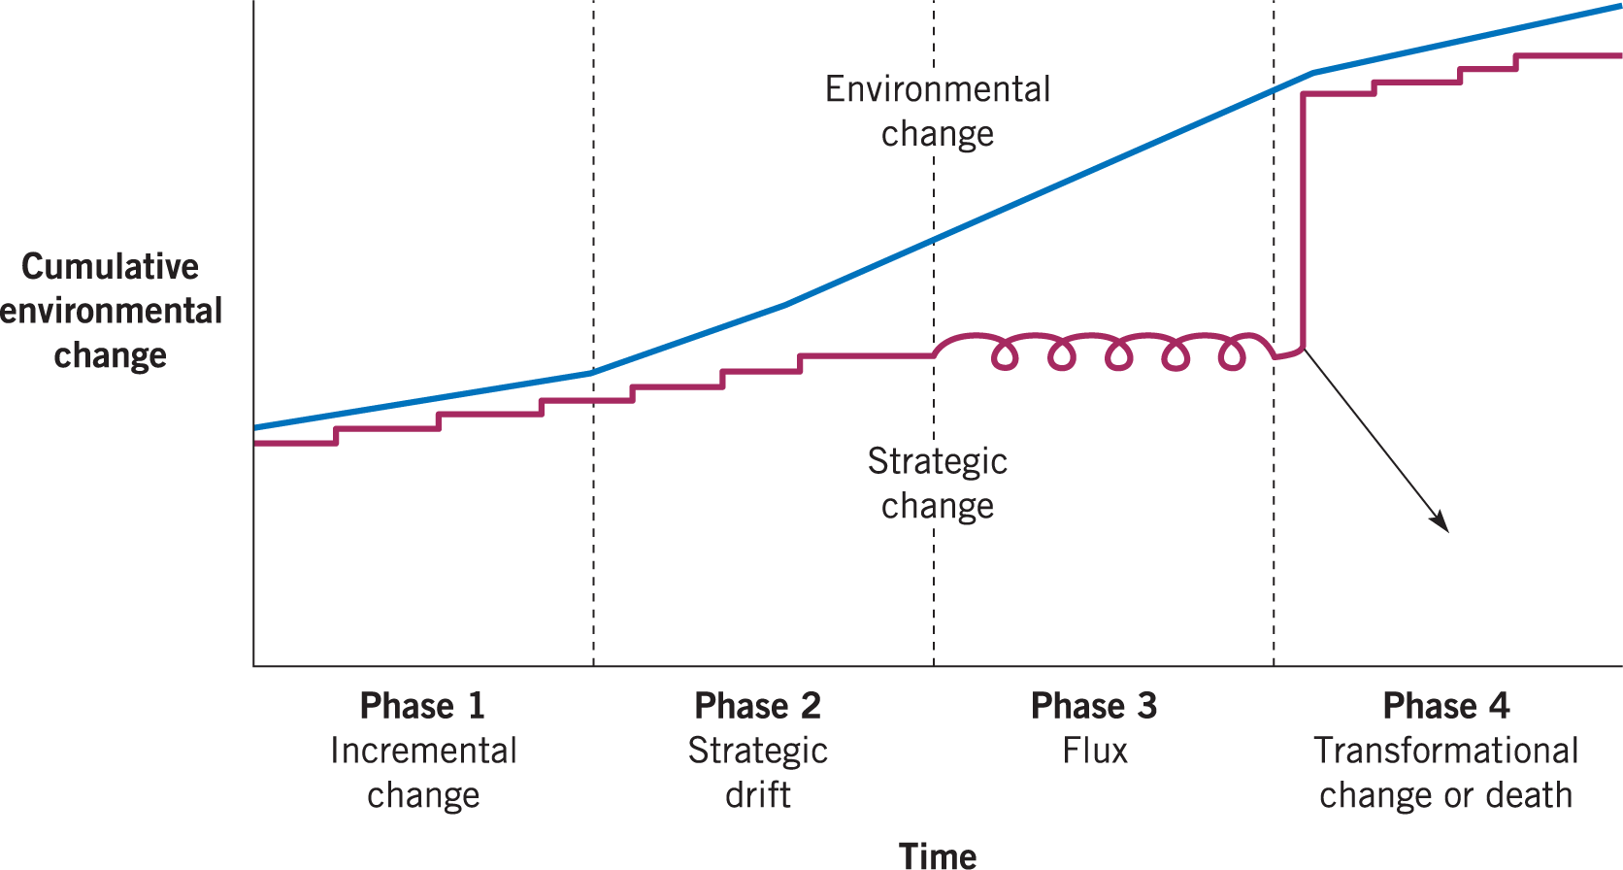
Figure 1 Strategic Drift

3. Strategic Choices
The previous section is an analysis of Alibaba's strategic position. In this section, Alibaba's strategic choices will be analyzed from both business level and corporate level.
3.1 Business Strategy
Porter’s distinctions between cost, differentiation and scope defined a set of basic types of strategy that hold across many kinds of business situations (Poter, 1985). These three generic strategies are cost-leadership strategy, differentiation strategy and focus strategy. A hybrid strategy combines different generic strategies (Grant, 2016).
3.1.2 The Strategy Clock
The Strategic Clock Model (see Figure 2) was proposed by Cliff Bowman, as a tool for analyzing the choice of competitive strategies. This model provides corporate managers and consultants with a way to think about competitive strategies and gain competitive advantage (Grant, 2016).
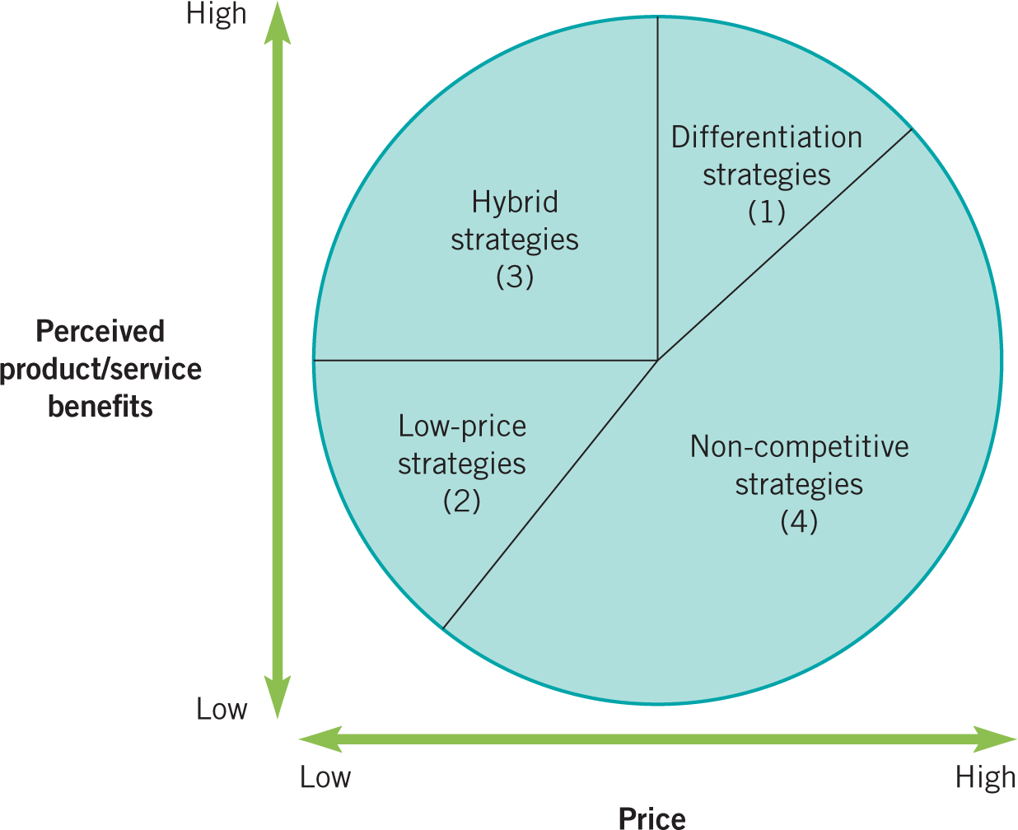
Figure 2 The Strategy Clock

The Strategy Clock is focus on price, and its scope for incremental adjustments in strategy, provides a more dynamic view on strategy than Porter’s generic strategies (Johnson, 2017). Instead of organizations being fairly fixed in terms of either a cost or a differentiation strategy, they can move around the clock.
The strategic clock model considers the price and the added value of the product/service together, and the company actually completes the business operation along one of the following four ways: differentiation strategy, low-price strategy, hybrid strategy, non-competitive strategy (Hayes, 2014). Some of these routes may be successful routes, while the non-competitive strategy may lead to corporate failure.
3.1.1 Differentiation
Due to the characteristics of Alibaba's e-commerce industry and the main findings in the previous section, the differentiation strategy is a suitable choice for Alibaba.
Differentiation strategy involves uniqueness along some dimension that is sufficiently valued by customers to allow a price premium (Johnson, 2017). Differentiation allows higher prices, but usually this comes at a cost. The differentiator can expect that its costs will be higher than those of the average competitor. An important condition for a successful differentiation strategy is to ensure the additional costs of differentiation do not exceed the gains in price (Hayes, 2014). The key drivers of differentiation are:
(1) Product and service attributes – providing better or unique features.
(2) Customer relationships – customer service and responsiveness; customization or marketing and reputation.
(3) Complements – building on linkages with other products/services.
Alibaba can also pursue differentiation strategy based on the Retail industry forces. In a differentiation strategy Alibaba can seek to be unique in the Retail industry by providing a value proposition that is cherished by customers (Price, 2009). Alibaba can select one or more attributes in terms of products and services that customers in the Retail values most. The goal is to seek premium price because of differentiation and uniqueness of the offerings.
Companies using differentiation strategy provide customers with a perceived added value at the same or slightly higher price than the competitor. The goal is to gain more market share by offering better products and services, or to increase revenues at slightly higher prices (Hayes, 2014).
As shown in Figure 2, differentiation strategy is zone 1. There is a range of alternative strategies (Grant, 2016):
- Differentiation without price premium (12 o’clock) – used to increase market share.
- Differentiation with price premium (1 o’clock) – used to increase profit margins.
- Focused differentiation (2 o’clock) – used for customers that demand top quality and will pay a big premium.
Alibaba is currently between 12 o’clock and 1 o’clock in the Strategy Clock. Alibaba has developed a mobile payment platform (Alipay), data analysis (Alibaba Cloud Computing) and other services through the differentiation without price premium strategy, and basically completed the preemption of market share (Price, 2009).
Alibaba also tried to implement the differentiation with price premium strategy by developing businesses such as Tmall, to increase profit margins. The differentiation with price premium strategy is also the next development strategy of Alibaba. After completing the market share, Alibaba has already had good reputation and customer support, which can support it to implement further differentiation strategy.
3.2 Corporate Strategy
Corporate strategy is about what business areas to be active in, and this will determine which business units to buy, the direction an organization might pursue and how resources may be allocated efficiently across multiple business activities (Johnson, 2017).
3.2.1 Ansoff’s Growth Matrix
A central corporate strategy choice is about in which area a company should grow (Johnson, 2017). The Ansoff’s Matrix represents the four choices that companies attempt to make revenue or profit growth. The main logic is that companies can choose four different growth strategies to achieve the goal of increasing revenue. The four strategies are market penetration, market development, product development, and conglomerate diversification (Grant, 2016).
The Ansoff’s Matrix can help companies scientifically choose a strategic model. However, they must master the core steps when using the tool (Hayes, 2014). First consider whether existing products can still gain more market share (market penetration strategy) in existing markets; Consider whether the company can develop some new markets for the existing products (market development strategy); Consider whether it is possible to develop a number of new products with potential benefits (product development strategy) for their existing markets; Consider whether the company can take advantage of its products, technology, market, etc., and adopt an integrated strategy that enables enterprises to continue to develop in depth according to the direction of material flow (Jelassi, 2014),.
Alibaba is a large-scale company that operates a wide range of businesses. The following is the Ansoff’s Matrix based on the actual situation of Alibaba (see Figure 3).

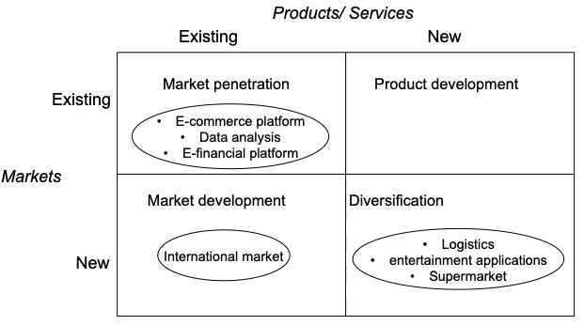
Figure 3 The Ansoff’s Matrix of Alibaba

3.2.2 Corporate Strategy of Alibaba
For existing products/ services in existing markets, such as e-commerce platforms, big data analysis, and online financial platforms, Alibaba needs to implement a market penetration strategy (Price, 2009). Alibaba can face existing customers with existing products/services, and focus on its current product market portfolio, and strive to increase the market share of products/services. Adopt a market penetration strategy to convince consumers to choose its own products by promoting or improving service quality, or to persuade consumers to change their usage habits and increase purchases.
For the development of existing products in new markets, such as Taobao platform to sell goods to overseas consumers, and Alipay to enter the overseas mobile payment market, Alibaba needs to implement market development strategies. Providing existing products to open up new markets, companies must find users with the same product needs in different markets. Often, product positioning and sales methods will be adjusted, but the core technology of the product itself does not have to be changed (Price, 2009).
For the development of new products/services in new markets, such as logistics, entertainment applications, supermarkets, travel booking services, etc., Alibaba can implement the conglomerate diversification strategy. Providing new products to new markets, where the company's existing expertise can not be used, it is the most risky diversification strategy. Alibaba can achieve some kind of synergy from sales, access and product technology in different products from different markets (Jelassi, 2014).
In summary, market development and conglomerate diversification should be the main corporate strategic choices for the current stage of Alibaba.

4. Strategy in Action
4.1 Types of Change
The Change Kaleidoscope model developed by Hope-Hailey and Balogun is a framework for identifying key contextual features to take into account when designing change programs (Swanson, 2014). It highlights how a set of contextual features can take various forms supporting or resisting change. Mainly the following eight contextual features: time, scope, preservation, diversity, capability, capacity, readiness and power (Price, 2009).
According to the Change Kaleidoscope, Hope-Hailey and Balogun identify four generic types of strategic changes base on nature (speed) and result (extent) of change, which are Evolution, Adaptation, Revolution, and Reconstruction (see Figure 4). Adaptation – can be accommodated with the existing culture and can occur incrementally; Reconstruction (or turnaround) – rapid change but without fundamentally changing the culture; Revolution – fundamental changes in both strategy and culture; Evolution – cultural change is required but this can be accomplished over time (Swanson, 2014).
As Alibaba is currently operating in good condition, the industry in which it operates has a large space for development (Basiouni, 2018).. Therefore, there is no hard requirement in the speed of Alibaba's strategic change, which can be seen as “incremental”. In terms of the degree of strategic change, Alibaba only needs to make strategic adjustments according to environmental changes, which can be seen as “realignment”. According to Figure 4, Alibaba's strategic change type is adaptation.

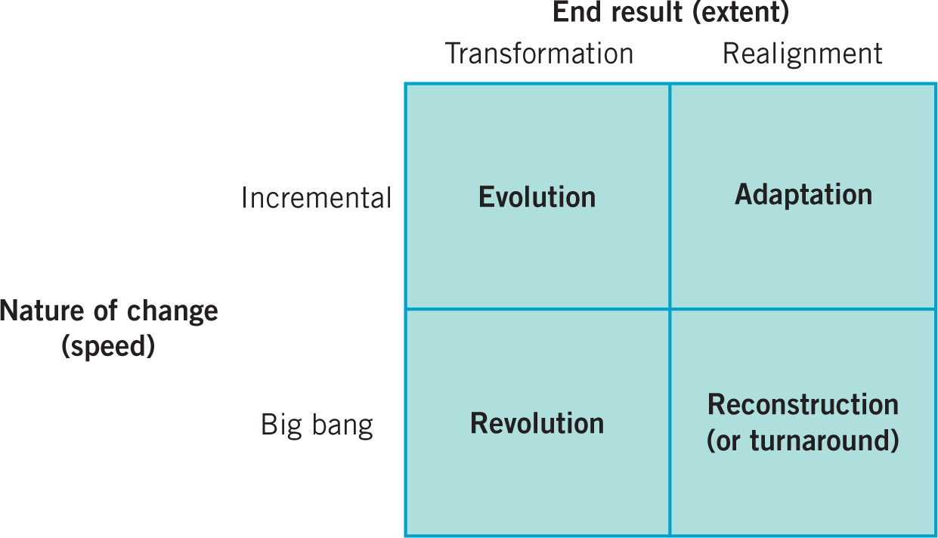
Figure 4 Types of Change

4.2 Implementing strategy
Based on the strategic position analysis and strategic choice analysis of Alibaba, this section proposes feasible suggestions for Alibaba's strategic adjustment based on Alibaba's weaknesses and threats.
4.2.1 Innovate the platform business
Innovate the platform business and maintain its advantages in major business.
Alibaba Group relies on e-commerce services to attract users' attention. Therefore, the Group must pay attention to the innovation platform business and change the service model in the development of diversification strategy (Price, 2009). Alibaba needs to gradually improve and improve the service level in the process of continuous business development and service model exploration, and provide users with systematic e-commerce services (Jelassi, 2014). In the future development, Alibaba Group should constantly improve the platform functions, such as establishing an equal communication platform for users and sharing website resources, so that users can gain more experience and communication while realizing shopping.
4.2.2 Exploring the international market
Changing Alibaba's main dependence on the Chinese market requires expanding its business to overseas markets(Jelassi, 2014). Alibaba can use its platform and influence advantages to actively explore new markets under the current economic slowdown in China, and expand its mobile payment business and e-commerce platform business to the international market (Basiouni, 2018). In light of the actual situation in the overseas market, adjustments should be made to suit local conditions when expanding the international market to cater to local culture and actual needs. The familiarity and dependence of overseas Chinese on the business of Alibaba, such as Taobao and Alipay, has provided customer support for Alibaba to open the international market.
4.2.3 Remediation of counterfeit and shoddy products
Alibaba needs to formulate relevant policies and punitive measures to combat counterfeit and shoddy products on the e-commerce platform (Jelassi, 2014). Previous legal disputes over fakes have greatly damaged Alibaba's corporate image and reduced customer satisfaction and loyalty. Although the fight against counterfeit goods will cause Alibaba to lose some of its trading volume, active anti-counterfeiting measures will enhance consumer confidence and will also help Alibaba's expansion in overseas markets (Hayes, 2014).
4.2.4 Continue to expand the types of business operations
In the future diversified strategy development, Alibaba should expand its business of “mobile media and entertainment” and form a mobile media and entertainment product portfolio centered on Ali Music, Ali Sports and Youku Video. Make it the new main business and core income source of Alibaba. Alibaba Group promotes the development and upgrading of all its businesses through technology upgrades, and promotes the transformation and upgrading of commercial Internet in various industries through the integration of capital ecosystem (Price, 2009).

5. Conclusions
Based on the actual situation of Alibaba and combining relevant strategic management knowledge, this report analyzed Alibaba's strategic position, strategic choices and strategy implementation.
In the Introduction section, a brief introduction to Alibaba's development background and main business was given.
In the Strategic Position section, PESTEL, Porter's five-force model and VRIO analysis were used to analyze the internal and external environment of Alibaba. SWOT summarized the main findings in the strategy analysis, and then obtained the strategic position of Alibaba according to the strategy drift.
In the Strategic Choices section, Alibaba's strategic choices were divided into two parts, business and corporate. Through the Strategy Clock model, Alibaba's business strategic choice is differentiation strategy. Ansoff's growth matrix was used to analyze its corporate strategy.
In the Strategy in Action section, Alibaba's strategic change is classified as adaptation, and according to the previous analysis of Alibaba's strategy, the strategy implementation recommendations are proposed for its weaknesses and threats.

Refferences
Alibaba (2019) Alibaba Group, Available at: https://www.alibabagroup.com/cn/global/home (Accessed: 18th April 2019)
Anwar, S. (2017) 'Alibaba: Entrepreneurial growth and global expansion in B2B/B2C markets', ournal of International Entrepreneurship, 15(4), pp. 366-390.
Arslan, A. (2015) 'Acquisition Entry Strategy of Nordic Multinational Enterprises in China: An Analysis of Key Determinants', Journal of Global Marketing, 28(1), pp. 1-20 [Online]. Available at: https://web-b-ebscohost-com.ezproxy.uwtsd.ac.uk/ehost/detail/detail?vid=0&sid=8c20e625-c1cd-4465-91d6-21565ec0d380%40pdc-v-sessmgr02&bdata=JnNpdGU9ZWhvc3QtbGl2ZQ%3d%3d#AN=100825803&db=bth (Accessed: 19th April 2019).
Baker, L.B. (2014) Alibaba surges 38 percent on massive demand in market debut, Available at: https://www.reuters.com/article/us-alibaba-ipo/alibaba-surges-38-percent-on-massive-demand-in-market-debut-idUSKBN0HD2CO20140919 (Accessed: 19th April 2019).
Basiouni, A.F. (2018) 'A Multi-Group Analysis of Innovation in Online Business Models', Pertanika Journal of Social Sciences & Humanities, 26(2), pp. 51-62 [Online]. Available at: https://openurl-ebscohost-com.ezproxy.uwtsd.ac.uk/linksvc/linking.aspx?sid=HUS&volume=&atitle=a+multi-group+analysis+of+innovation+in+online+business+models&date=20180302&spage=51&issn=0128-7702&stitle=&genre=article&issue=&title=Pertanika+journal+of+social+science+%26+humanities.&epage=62 (Accessed: 19th April 2019).
Burnes, B. and Cooke, B. (2013) 'Kurt Lewin's Field Theory: A Review and Re-evaluation', International Journal of Management Reviews, 15(4), pp. 408–425 [Online]. Available at: https://openurl-ebscohost-com.ezproxy.uwtsd.ac.uk/linksvc/linking.aspx?sid=bth&volume=15&date=2012-09&spage=n%2Fa&issn=1460-8545&stitle=&genre=article&issue=4&title=International+journal+of+management+reviews.&epage=n%2Fa(Accessed: 5th March 2019).
Dess, G.G., Eisner, A., McNamara, G. (2016) Strategic Management: Texts and Cases, 8th edn., New York: McGraw-Hill.
Garner, J., Stead, W., Stead, E. (2014) Sustainable Strategic Management, 2nd edn., London: Greenleaf Pub.
Grant, R.M. (2016) Contemporary Strategy Analysis: Texts and Cases, 9th edn., United Kingdom: Wiley.
Hayes, J. (2014) The Theory and Practice of Change Management, 4th edn., Basingstoke: Palgrave Macmillan.
Jelassi, T., Enders, A. & MartiÌnezpez, F.J. (2014) Strategies for e-business : creating value through electronic and mobile commerce ; concept and cases, 3rd edn., Pearson: Harlow.
Johnson, G., Whittington, R., Scholes, K., Angwin, D., Regner, P. (2017) Exploring Strategy Text and Cases, 11th edn., Harlow: Pearson.
Kudasov, A. (2015) Alibaba Global Strategy, Available at: https://www.slideshare.net/akudasov/alibaba-global-strategy (Accessed: 18th April 2019).
Lin, C. (2017) 'Strategy analysis for cloud storage reliability management based on game theory', Journal of Computer Security, 25(2), pp. 153â€“172 [Online]. Available at: https://web-b-ebscohost-com.ezproxy.uwtsd.ac.uk/ehost/detail/detail?vid=0&sid=40954bab-1abe-4efa-8445-bbab609cb1d3%40pdc-v-sessmgr05&bdata=JnNpdGU9ZWhvc3QtbGl2ZQ%3d%3d#AN=122835425&db=bth (Accessed: 19th April 2019).
Lynch, R. (2015) Strategic Management, 7th edn., Pearson: Harlow.
Mcclay, R. (2019) 10 Companies Owned by Alibaba, Available at: https://www.investopedia.com/insights/10-companies-owned-alibaba/ (Accessed: 19th April 2019).
Poter, M.E. (1985) Competitive advantage: creating and sustaining superior performance, New York: Collier Macmillan.
Price, D. (2009) The principles and practice of change, Basingstoke: Palgrave Macmillan.
Su, N. (2019) Alibaba Group: Technology, Strategy, and Sustainability VRIO Analysis & Solution, Available at: http://blueoceanuniversity.com/frontpage/vriocase/3977-alibaba-ma (Accessed: 18th April 2019).
Swanson, D.J. (2014) 'Sharpening the Focus of Force Field Analysis', Journal of Change Management, 14(1), pp. 28–48 [Online]. Available at: https://web-b-ebscohost-com.ezproxy.uwtsd.ac.uk/ehost/detail/detail?vid=0&sid=5e14ab25-dc71-4d4f-97fd-75ffa762922d%40pdc-v-sessmgr05&bdata=JnNpdGU9ZWhvc3QtbGl2ZQ%3d%3d#AN=95211296&db=bth(Accessed: 5th March 2019).
SWOT & PEATEL.com (2019) Alibaba SWOT & PESTEL analysis, Available at: https://www.swotandpestle.com/alibaba/ (Accessed: 19th April 2019).
Tem, I. (2018) PESTEL analysis of Alibaba at the time of the case, Available at: https://prezi.com/p/wgzxekx758vx/pestel-analysis-of-alibaba-at-the-time-of-the-case/ (Accessed: 19th April 2019).
Zeng, M. (2018) 'Alibaba and the Future of Business', Harvard Business Review, 96(5), pp. 88-97.
Zheng, J. (2015) Porter's Five Forces analysis on Alibaba, Available at: https://mgmt7160jz.wordpress.com/2015/02/10/porters-five-force-analysis-on-alibaba/ (Accessed: 20th April 2019).

