Water Supply and Waste Drainage

Bethan Stroud
1702210

Module Tutor:

Allan Nantel
Contents Page

1.0 - Introduction

2.0 - The London ‘Super Sewer’

2.1 - Sir Joseph Bazalgette

2.2 - Projected Cost of the Project

3.0 - Sewage Issues in London

3.1 - Climate Change

3.2 - Damage to the System

4.0 - Attitudes to the Project

4.1 - Environmental Attitudes

4.2 - Media Attitudes

5.0 - Conclusion

6.0 - References

1.0 - Introduction

With the increasing population, climate change and tourism, London is in need of a refurbished sewage system. The drainage is struggling to cope with capacity of the waste, as well as keeping the systems enclosed to stop the spread of gases, faeces and pollutants. A sustainable and effective system must be created to cope with an increasing supply, as well as becoming sustainable with today’s environmental regulations. London has necessarily outgrown its sewers, built over 150 years ago, now at the point of potentially flooding.

2.0 - The London ‘Super Sewer’

Tideway, the creators of The Thames Tideway Tunnel, a 25km tunnel below the ground of London’s River Thames. London’s new ‘super sewer’. This expansion is required to prevent “the tens of millions of tonnes of pollution that currently pollute the River Thames every year.” (Tideway, 2019). This will be the biggest water infrastructure project in the UK; the sewer will be more than 7m wide and 66m deep. This large project will be replacing the old Victorian sewage system, although still working and in good condition, it simply cannot cope with the capacity of waste flowing through the system and resulting in waste being transported in to the River Thames. The ‘super sewer’ will take the combined waste below ground and taken to appropriate facilities around London. This is where the waste can be treated and separated, to be used for other alternatives. Resulting in a more ecological route rather than dumping in to the Thames.

2.1 - Sir Joseph Bazalgette

The current London sewerage system was engineered by Sir Joseph Bazalgette, over 150 years ago. The systems have been efficient and well-constructed to last over the years, however cannot cope with the rising capacity of the current population of London. The system, by Bazalgette, “was designed for a smaller, more permeable city. The combined challenges of London’s growing population, changing land uses and changing climate mean that if we continue to rely on our current drains and sewers, we face an increasing and potentially unacceptable risk of flooding.” (Greater London Authority, 2015). The system was only built for approximately four million people after the Great Stink 1858, rather than over eight million which currently live there, not counting the millions which visit the city for tourism.

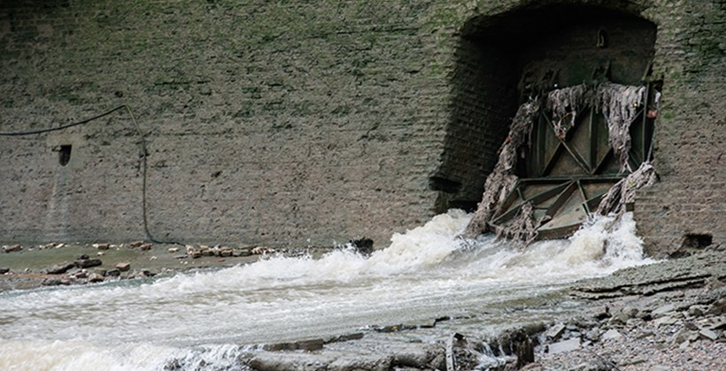
*Image 1 - Tideway, 2019*

2.2 - Projected Cost of the Project

At the start of the project planning, the ‘super sewer’ was aimed to cost £1.4 billion in 2004. “The 25km tunnel, which is expected to be completed by 2023, is budgeted to cost £4.2bn overall.” (Clark, 2018). The cost of the tunnel continues to rise, as well as pushing the expected completion date away from the projected date. This has been worrying for the London Taxpayers, resulting in questions asked over the years and worries about the final cost. Jenny Jones ask The Major “Given that the estimate has risen by almost £500 million from £3.6 billion to £4.1 billion what representations have you made to Ofwat and Thames Water to protect Londoners from bearing any additional costs?” Which The Major responded with “I have written to Government ministers expressing my concern about the overall costs and the procurement mechanism for this project. I remain concerned about these matters and will continue to raise them on behalf of all Londoners.” (London Assembly, 2013). This places doubt within the population due to the lack of stability within a set budget. Over the years this cost has creeped up, costing the taxpayers more money.

3.0 - Sewage Issues in London

As London has a constantly increasing footfall in the city, the sewage cannot withstand the capacity of waste being moved throughout the systems. One example of this issue is a ‘fatberg’ “weighing the same as 11 double decker buses and stretching the length of two football pitches is blocking a section of London’s ageing sewage network.” (Taylor, 2017). This ‘fatberg’ measured 250m in length, the biggest ever found and approximately weighing 130 tons, says Taylor. This disruption would be due to the insignificant size of the sewers in London, with the masses of waste being flushed and down sinks. Cooking fats, nappies and wet wipes cause issues like this within the sewers, followed by missing drainage inspections and lack of access to the sewers. Taylor also says that, “Thames Water says it spends about £1m a month clearing blockages from its sewers in London and the Thames Valley – an average of three fat-related blockages every hour.”, amounting up to £12m a year solely on recovering blockages.

3.1 - Climate Change

The issue of climate change means more water and rain, changes in weather conditions and storms. There is storm damage seen in 2013, causing damage to The Thames River Valley costing over £1 billion. “The researchers warned that global warming would change the risk of extreme weather and suggested politicians should bear this in mind when planning to protect the public, businesses and infrastructure. A series of storms in the winter of 2013-14 caused widespread flooding and about £1bn-worth of damage in the Thames river valley.” (Johnston, 2017). The area of London is not very green with natural spaces, covered nearly in concrete, resulting in difficulties with natural drainage in to the ground. Global warming and climate change also results in more moisture within the atmosphere, contributing to the moisture within the London sewage system, whether it be extreme weather or even precipitation and condensation; seeing the worse of it during winter.

3.2 - Damage to the System

Accumulating all the ongoing issues it is clear for the necessity to refurbish or replace the London sewage system. The amount of flooding and blockages is a regular occurrence. Some blockages could be missed, e.g. ‘fatberg’. These issues could further result in burst pipes, drainage issues in buildings in the surrounding areas and contamination in to the water supply. Damage is also seen in The River Thames, due to any over flow in the sewage system being emptied in to the River. Raw sewage, waste and rubbish gets emptied directly to The Thames as the old Victorian system cannot keep up with the capacity. Damage is also caused by ‘unflushables’ being flushed, “The popularity of wet wipes and other pre-moistened disposable wipes in the last few decades has led to messy questions about what it means to be “flushable” and what those products are doing to our wastewater infrastructure” (Mole, 2017). These items not accounted for when the original sewers being built due to the age of the Victorian structure.

4.0 - Attitudes to the Project

There is a lot of controversy surrounding the London ‘super sewer’. This is due to the amount of money that it is costing which could be spent elsewhere in the country. Many believe that there could be cheaper alternatives to fix the sewage problems, saving money and not creating damage to the environment and surrounding areas.

4.1 - Environmental Attitudes

The ‘super sewer’ can be seen as a positive environmentally as it will prevent raw sewage being flushed in to the River Thames and used to be filtered, resulting in being used for bio-diesels and other recyclables. “The ultimate goal of the project is to reduce the amount of overflow water and sewage being pumped into the Thames by 94 per cent” (Varghese, 2018). This will allow the fish species to grow throughout London, which currently cannot breed during wet winter months. However, there can be negative environmental effect with polluting effects of construction, “more than 840,000 tonnes of concrete will be used in the construction of the tunnels”, says Varghese. Tideway also says that approximately two million tons of waste will still be dumped in to the River Thames each year, still not successfully ridding the main reason for the expensive tunnel in the first place.

4.2 - Media Attitudes

The media has mixed attitudes about the London ‘super sewer’. Some believe that “Investors reap rewards of London super sewer long before it is built” (Plimmer, 2018). This clearly benefitting investors involved in the project, but not yet the taxpayers of London as it will still take six years until they see a cleaner Thames River, says Plimmer. Many articles also believe that the sewer is a large waste of money. “Engineering crews have already begun damming sections of the Thames to sink shafts to the required depth” (Gayle and Taylor, 2016). They say also that “it is unnecessary and that the government ought to have looked at alternative solutions.”, rather than spending the significant amount of money budgeted for. It is also likely that London’s taxpayers can expect to pay an increase in water bills. “The Thames Tideway Tunnel will add between £20 and £25 to the average bill for Thames Water customers as work on the new sewer ramps up in the next decade. Previous estimates had pencilled in a rise of up to £80 a year to fund the 15-mile long tunneling project.” (Dakers, 2015). This portrayed a negative media effect upon the new system.

5.0 - Conclusion

Overall, the London ‘super sewer’ is not seen as a very positive and effective solution to upgrade the current system. The media and environmental attitudes are not backing up the project as it will not benefit as much as it’s damaging and costing. The extortionate bill is growing and the completion is not to yet clear, while still negatively impacting the environment with the construction of the tunnels. Although it will be saving 18 ton of waste being dumped in the Thames, it does not rid of all flushed waste, still leaving the raw sewage entering the River.
6.0 - References

- Beth Mole, 2017. www.arstechnica.com/science/2017/09/putrid-130-ton-mass-clogging-london-sewer-highlights-worldwide-sewer-strife/ (Last Visited 15/01/19).
- Damien Gayle and Matthew Taylor, 2016. www.theguardian.com/uk-news/2016/nov/14/london-super-sewer-is-waste-of-4bn-says-assessor (15/01/19).
- Gill Primmer, 2018. www.ft.com/content/32f0a802-d6bc-11e8-ab8e-6be0dcf18713 (Last Visited 15/01/19).
- Greater London Authority, 2015. www.london.gov.uk/sites/default/files/lsdap_final.pdf (Last Visited 13/01/19).
- Ian Johnston, 2017. www.independent.co.uk/environment/climate-change-met-office-rainfall-record-third-global-warming-weather-extreme-flooding-a7856656.html (Last Visited 15/01/19).
- Jessica Clark, 2018. www.cityam.com/269640/londons-super-sewer-thames-tideway-tunnel-facing-cost (Last Visited 13/01/19).
- London Assembly, 2013. www.london.gov.uk/questions/2013/0141 (Last Visited 14/01/19).
- Matthew Taylor, 2017. www.theguardian.com/environment/2017/sep/12/total-monster-concrete-fatberg-blocks-london-sewage-system (Last Visited 14/01/19).
- Marion Dakers, 2015. www.telegraph.co.uk/finance/newsbysector/supportservices/11820602/Water-companies-say-super-sewer-will-add-25-a-year-to-Londoners-bills.html (15/01/19).
- Sanjana Varghese, 2018. www.wired.co.uk/article/sewage-environment-climate-change-london (Last Visited 15/01/19).
- Tideway, 2019. www.tideway.london/the-tunnel/ (Last Visited 13/01/19).

Direct and Indirect Water Supply

Contents

1.0 - Direct Water Supply

2.0 - Indirect Water Supply

3.0 - References

- Direct Water Supply

“This is the system that more modern houses are usually equipped with” (Chard, 2019). A water system which is directly supplied, has cold water directly sent to all cold water taps within a building. The hot water is supplied by a hot water cylinder fed from a 150 litre cistern within the building, heated and distributed when required. Usually heated in to a combination boiler in more modern or refitted homes. Toilets will also be directly flushed by the cold water. The water will be fed to the cistern, often located in a cupboard or in a loft, which will store and feed the water to hot water cylinder.

The benefits of having direct water supply is that you can instantly access good quality cold drinking water from any tap within the building. They also need less pipework to connect, resulting in a cheaper installment. It is also benefitting from instant hot water for showers and less structural support to hold a large cistern. However “they are also affected by burst pipes, mains repairs and leaks in the system which may result in a lack of water to your property.” (Smith, 2012). This is due to the higher pressure which could damage the fittings. If one pipe becomes damaged, then the entire supply of water will need to be put on hold until repaired.

This direct supply is seen more predominantly in newer properties, this is due to the foreseen money saving with reduced piping and less risk of contamination. In Wales, due to the majority of the housing stock being pre 1930’s, the majority of Wales’ homes would have been installed with the indirect water supply, unless refitted at a later date. This can be seen on the below image from the Consumer Data Research Centre, showing the age of houses within South Wales.
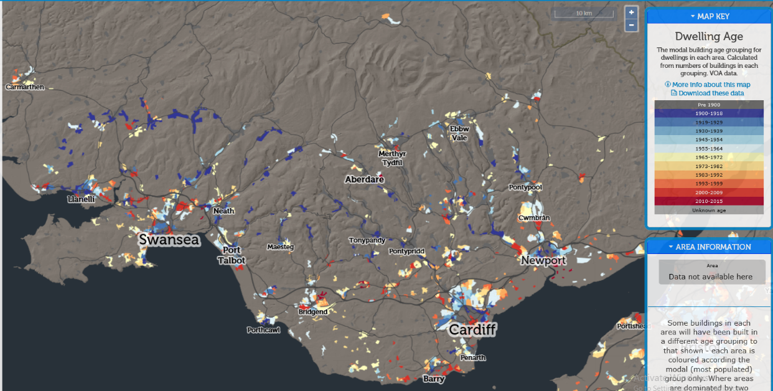
Image 1 – Consumer Data Research Centre, 2019.

- – Indirect Water Supply

Indirect water supplies are more likely to be found within older homes, this is due to the unreliable mains systems pre 1900’s. The main water supply would feed to the kitchen sink tap and the water storage cistern of around 250 litres, then being fed to a water cylinder to heat the water and indirectly to the other fittings.

The indirect water supply is not as effective as the direct due to the need of gravity to create enough pressure in the taps. This is why a shower and a toilet flush would become an issue at the same time. There can also be damage due to leaks in the storage tank, causing issues for the structure of the property, which would also need to be fitted with stronger structure to hold the cistern. It is also not as cost effective due to the extra pipe work needed and maintenance. A positive of this system is that if one fixture is damaged, then the rest of the building will still be able to be used, unlike the direct system. As well as the extra storage of water if the building was ever cut off from the main water supply.

The indirect water supply is still the most common used water supply due to the age of the UK housing stock. “The most common type of water system in the UK, the indirect system sends fresh water into your property through to the household stopcock valve” (Chard, 2019). Due to the population increase during the Victorian times, house building needed to increase, which could be afforded as a result of the industrial revolution and supply of more jobs. “From 1800 to 1900 the UK population grew from about 11 million to 32 million. The urban population increased from around 2 million to over 20 million.” (NHBC, 2015). This period also improved household functions by introducing the toilet flush during the 1890’s, using the indirect water supply.
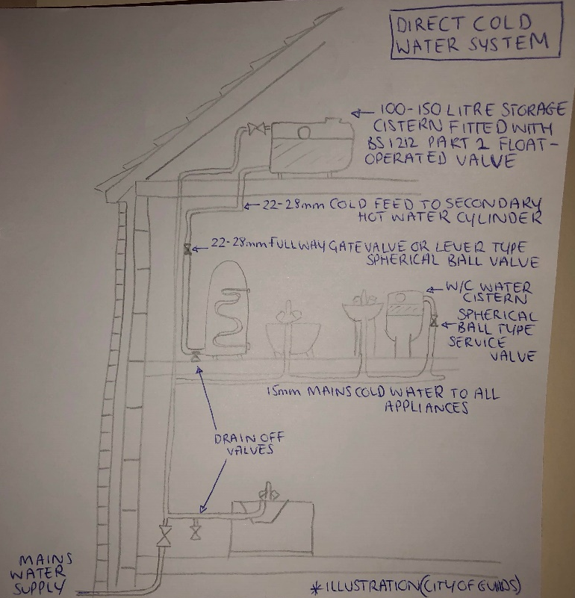
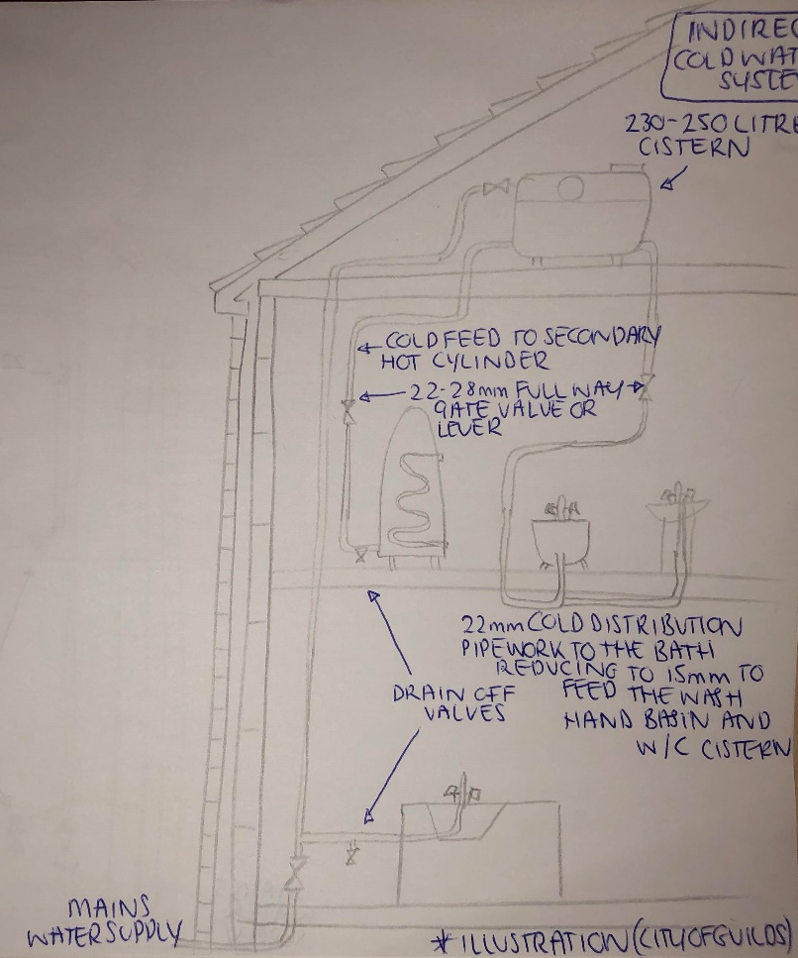
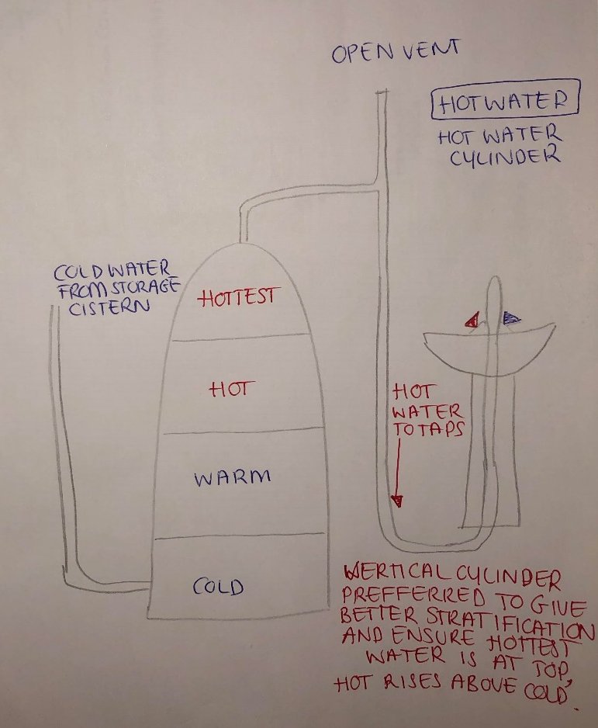
Illustrations showing, direct cold water supply, indirect water supply and hot water stratification.

3.0 – References

- Adam Chard, 2019. www.victoriaplum.com/blog/posts/understanding-home-water-systems (Last Visited 16/01/19).
- Consumer Data Research Centre, 2019. www.maps.cdrc.ac.uk/#/metrics/dwellingage/default/BTTTFFT/10/-3.5481/51.6553/ (Last Visited 12/01/19).
- Martin Smith, 2012. www.plumber24hours.co.uk (Last Visited 12/01/19).
- NHBC, 2015. www.nhbc.co.uk/cms/publish/consumer/NewsandComment/HomesThroughTheDecades.pdf (Last Visited 15/01/19).

