Assignment 2 Title:
Configure and manage the Virtualised Enterprise network

2427102@student.uwtsd.ac.uk
university of wales saint david
Module: Network Operating Systems and Services

Module code: ACCA5023

Lecturer Name : Dr. Sadeque Imam Shaikh
Student Name: Elaine Rodovalho
Student Number: 2427102
Group:1

Table of Contents
Introduction 2
1.Routing in Birmingham Network 3
1.2. Routing in London Network 5
2. Domain Server in Birmingham 8
3. Encrypted Connection (VPN) 11
4 .Users 12
5.Domain Membership 13
6. DHCP Server 14
7. Test and Troubleshoot 17
8.Disk Drive 19
9. IIS Server 22
10. Remote Desktop Services 24
Task _2 Linux Configuration IP a 26
Conclusion 27
References 28

Introduction

The network infrastructure is what keeps a firm operating every day. I built a virtual multi-site network from the ground up for this project using Windows Server 2019 and Active Directory. I created two locations that can communicate even if they're on different subnets to make the setup more realistic. The Domain Controller is set up in Birmingham, which is where the main office is located. The second office is in London, where a client machine is situated. The major goal of this project was to link the two places so they could safely share data and resources. I set up and installed a few critical roles on the server. These include giving the London office IP addresses, using IIS to host a company website, and using Remote Desktop Services to let people operate from home. In this report, I will explain what I did and demonstrate images to prove that the Birmingham and London systems are both connected and working together.

Task_1

1.Routing in Birmingham Network
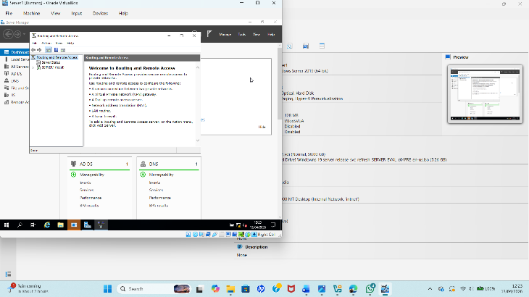
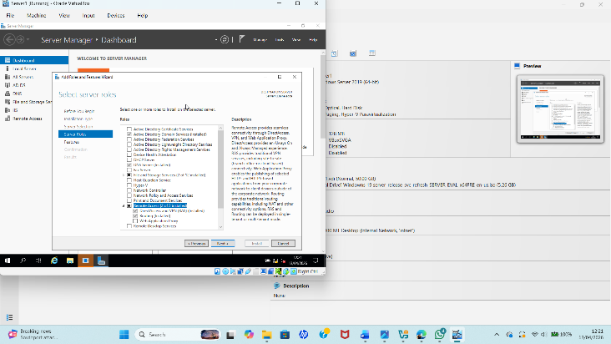
Install Routing and Remote Access Service (RRAS)
Figure 1: Installation of the Routing and Remote Access Service (RRAS) on the Birmingham server.
First, the Routing and Remote Access Service (RRAS) role was installed on the Birmingham server using Server Manager. This service was required to allow the server to act as a router between networks and support remote access features needed for the project [1].
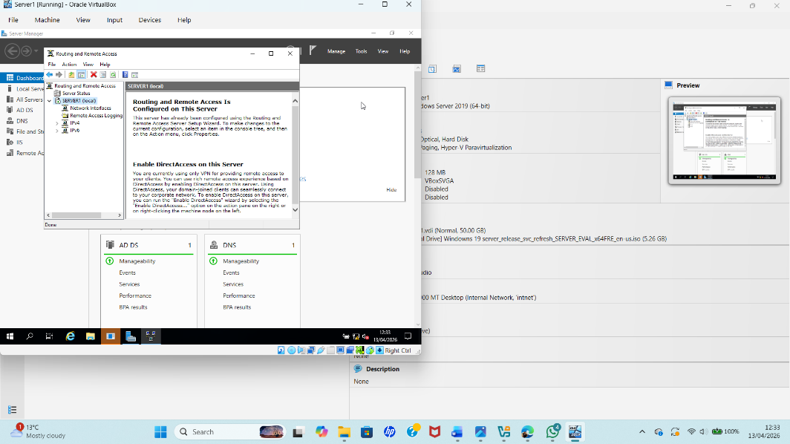
Enable RRAS on Server1 (Birmingham)

Figure 2: Enabling RRAS on the Birmingham server to provide routing functionality.
After installation, RRAS was enabled from the Tools menu in Server Manager. The configuration wizard was used to activate the routing functionality so that the server could begin forwarding traffic between connected networks.

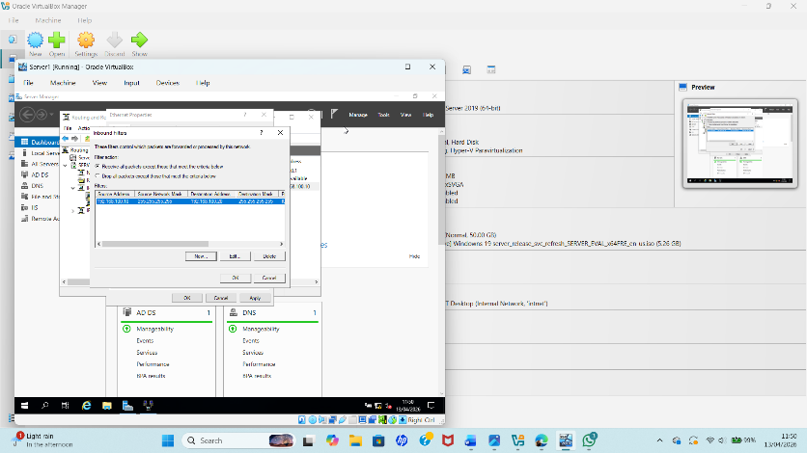
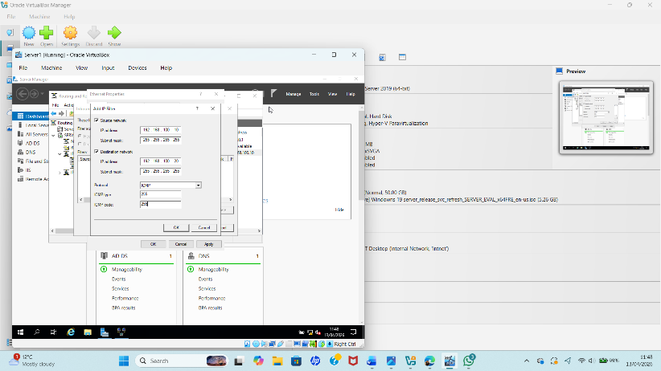
Modify Firewall Rules to Allow ICMP Traffic

Figure 3: Firewall Configuration (ICMP Allowed)
The Windows Defender Firewall settings were then updated to allow ICMP traffic. This was necessary because ICMP is used by the ping command, which helped verify connectivity between virtual machines and confirm that the routing configuration was working correctly [2].

1.2. Routing in London Network
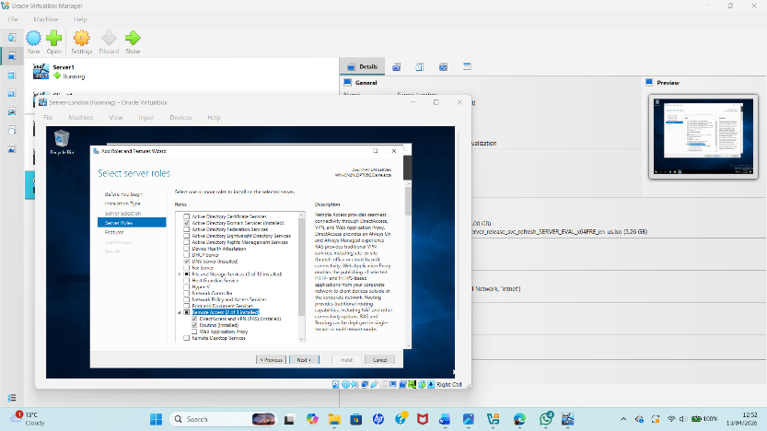
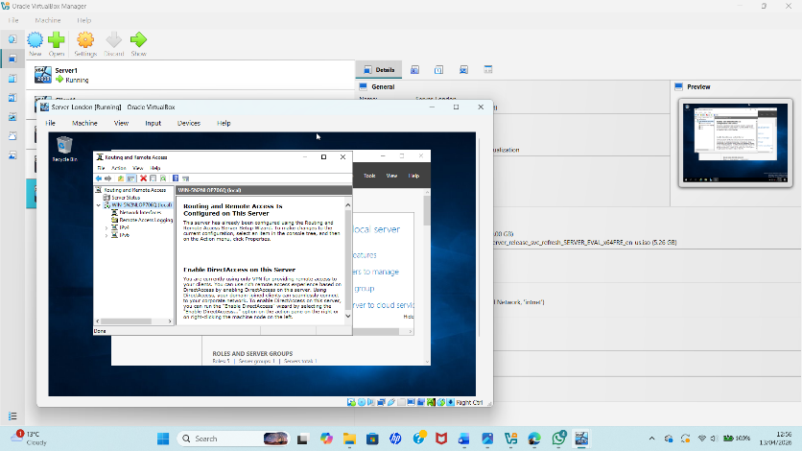
Configure routing in London

Figure 4: Courting configuration on the London network for inter-network communication.
Routing settings were then configured on the London network interface so that traffic destined for external or remote subnets could be forwarded correctly. This allowed the London network to communicate with Birmingham through the configured route.

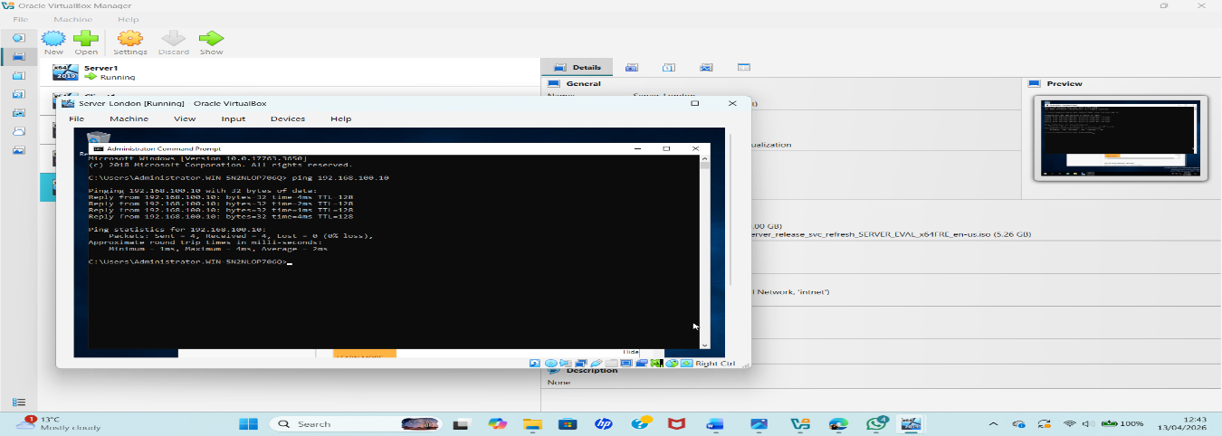
Configure persistent IP Forwarding and Routing

Figure 5: Configure persistent IP Forwarding and Routing
On the London server, persistent IP forwarding was configured so that packet forwarding remained enabled even after system restart. This ensured that the server could continue routing traffic between the London and Birmingham networks without needing to reapply the configuration manually [3].

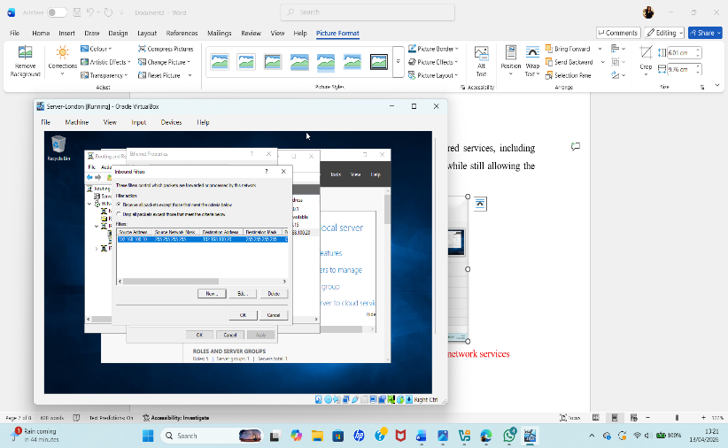
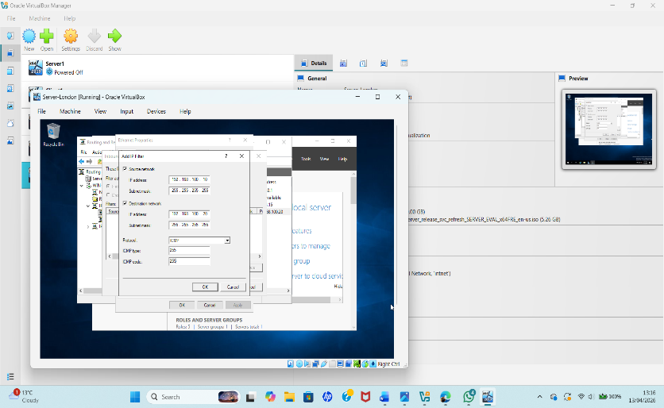
Customise firewall rules for required services

Figure 6. Firewall rules customised on the London server for required network services

Firewall rules in London were customised to allow only the required services, including routing-related traffic and testing protocols. This improved security while still allowing the services necessary for domain communication and VPN connectivity.

2. Domain Server in Birmingham
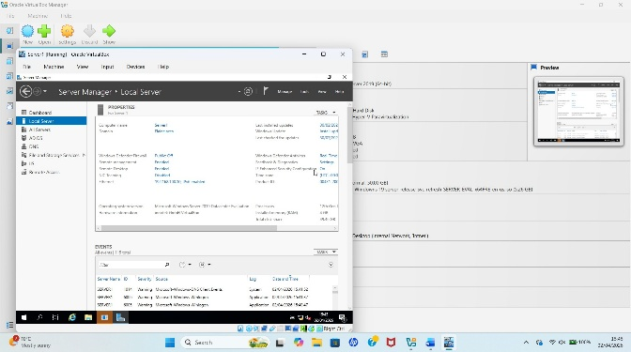
Create a forest named yourname. acca
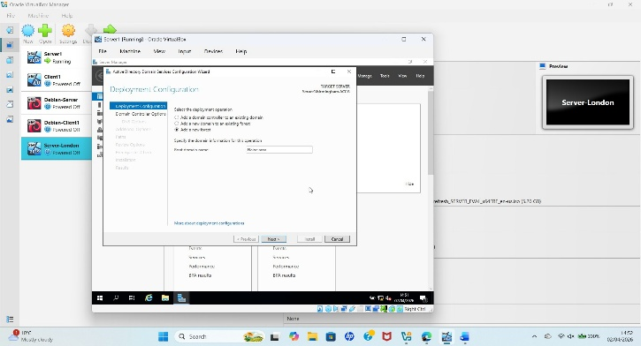

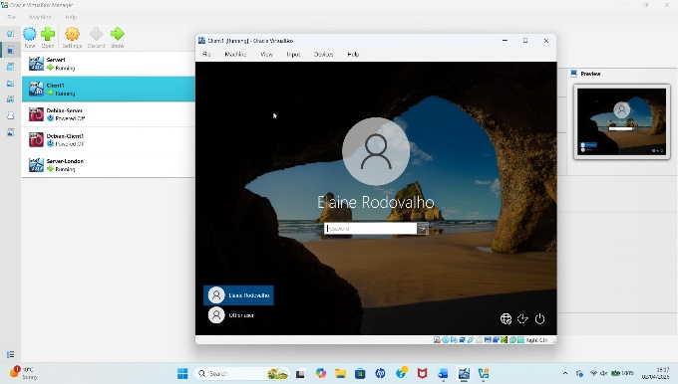

Figure 7. Creation of the new forest domain Elaine.acca on the Birmingham server.

The Birmingham server was promoted to a Domain Controller by installing Active Directory Domain Services (AD DS) and creating a new forest named Elaine.acca. This created the main domain structure for the network and provided centralised authentication and management[3] .

Create all appropriate a records for all servers on Birmingham and London network 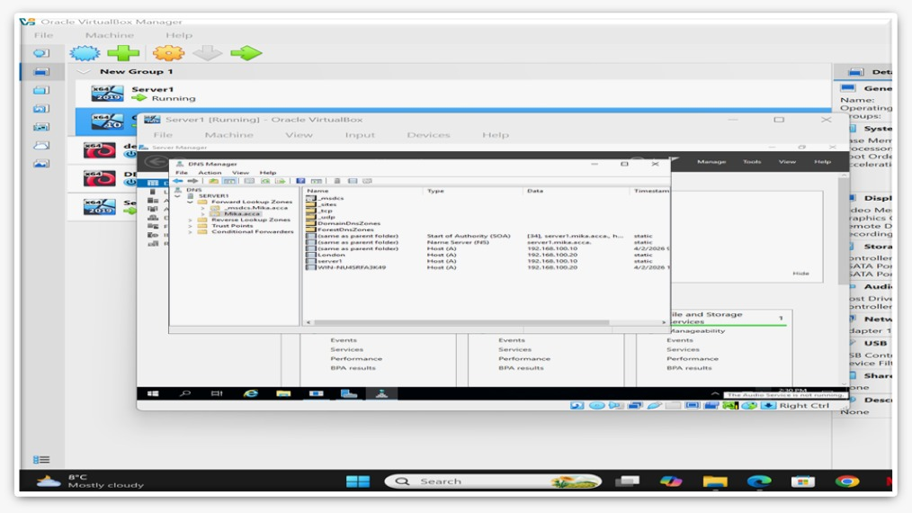
Figure 8: Creation of DNS A records for servers in Birmingham and London.
This figure shows the DNS Manager with the Forward Lookup Zone for Elaine.acca. Records are configured for key devices, allowing name resolution so devices can communicate using domain names instead of IP addresses.

Reverse Lookup Zone (PTR records)
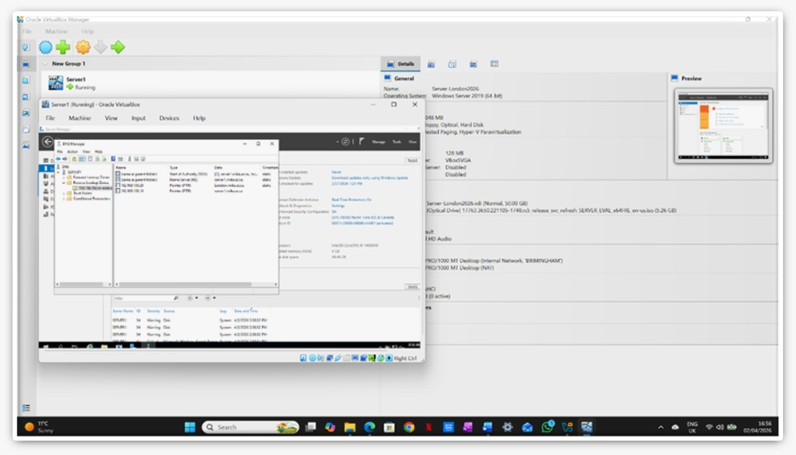

Figure 9: Reverse Lookup Zone Configuration
This figure shows the Reverse Lookup Zone with PTR records that map IP addresses to hostnames, enabling reverse DNS resolution and easier network management.

3. Encrypted Connection (VPN)
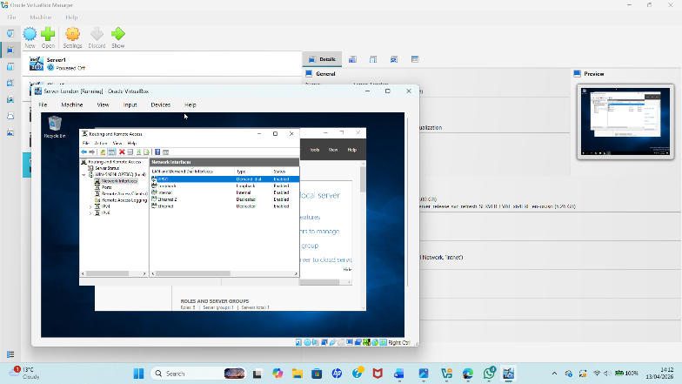

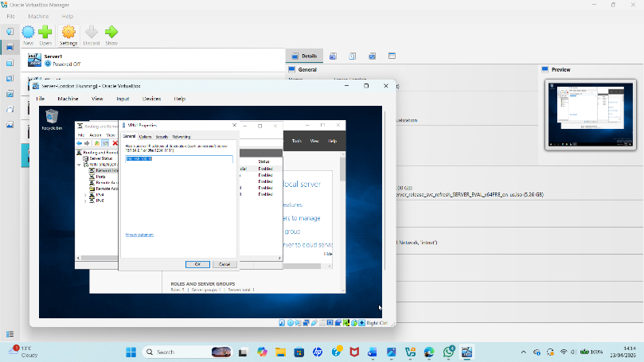

Figure 10: VPN Setup for Remote Connectivity
This image shows VPN setup to allow secure connection between London and Birmingham.

4 .Users
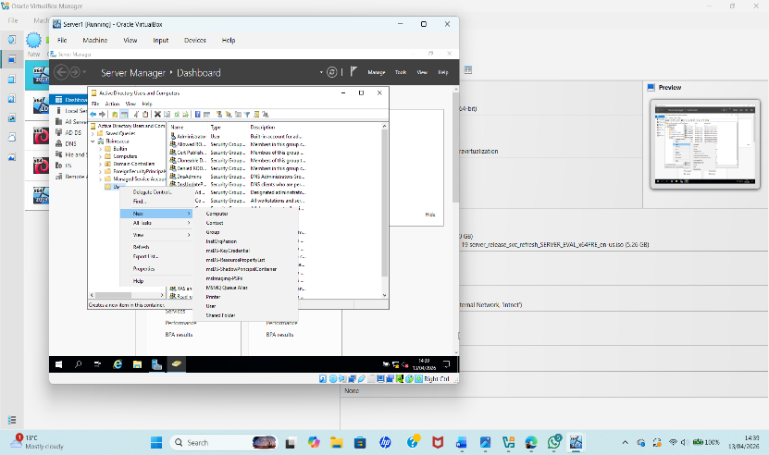
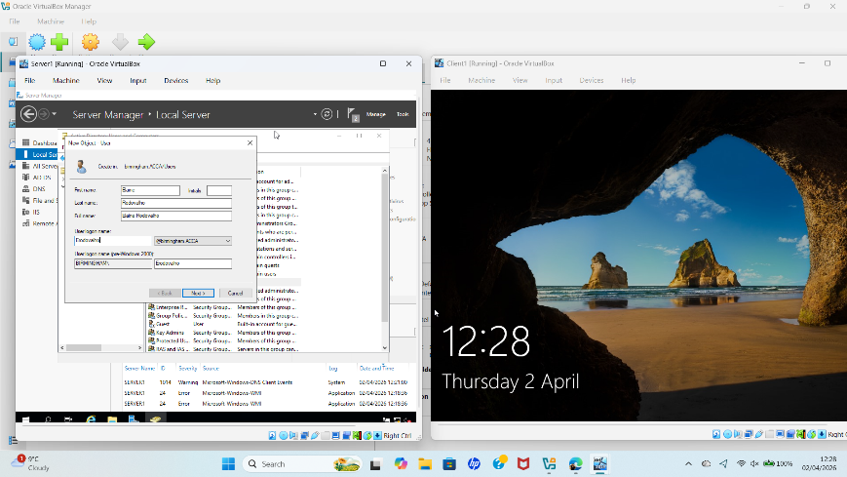

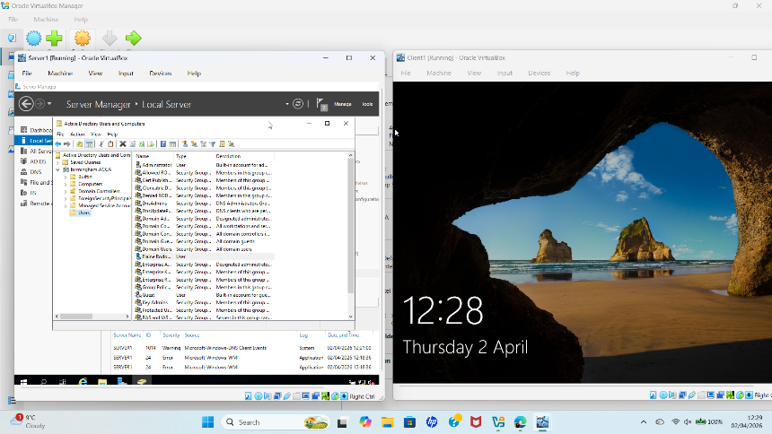

Figure 11: User Account Creation in Active Directory (ADUC)
User accounts were created in the domain using Active Directory, allowing secure access to network resources

5.Domain Membership
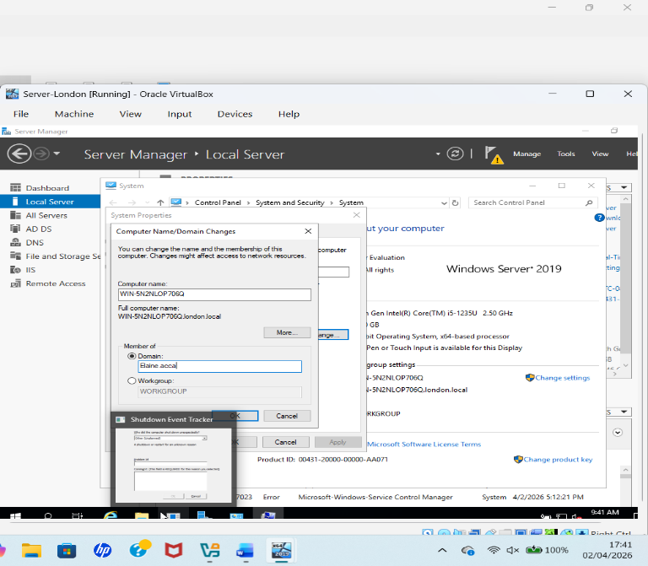
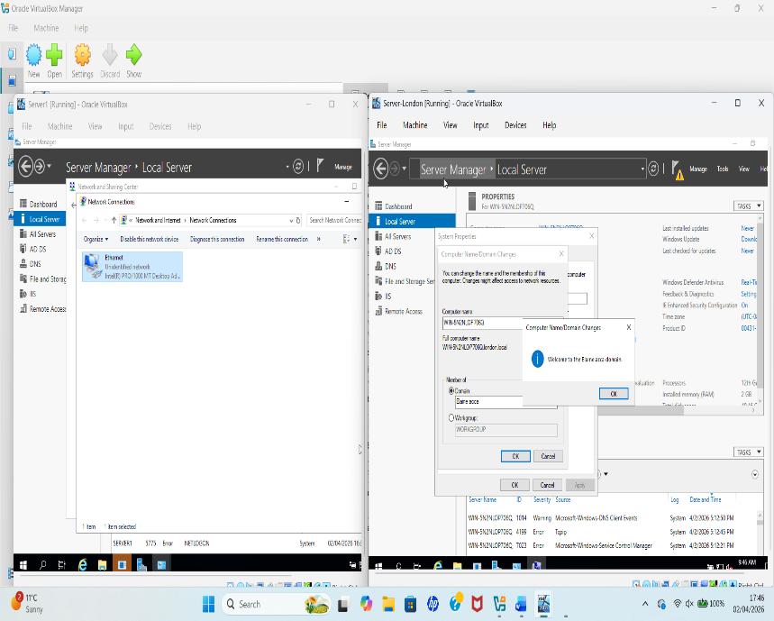

Figure 12: Joining a computer to the domain
This figure shows a computer being added to the domain yourname. acca the system name and domain settings are configured so the machine can join the network and communicate with the domain controller.

6. DHCP Server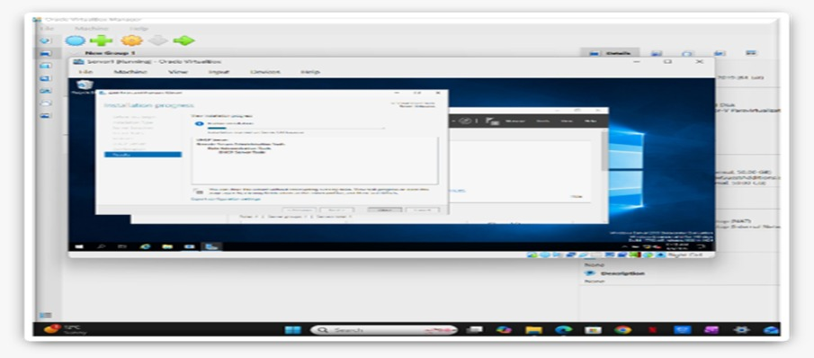Figure 13: DHCP Installation on Server
This figure shows the installation of the DHCP role on the server. DHCP is used to automatically assign IP addresses to devices on the network.
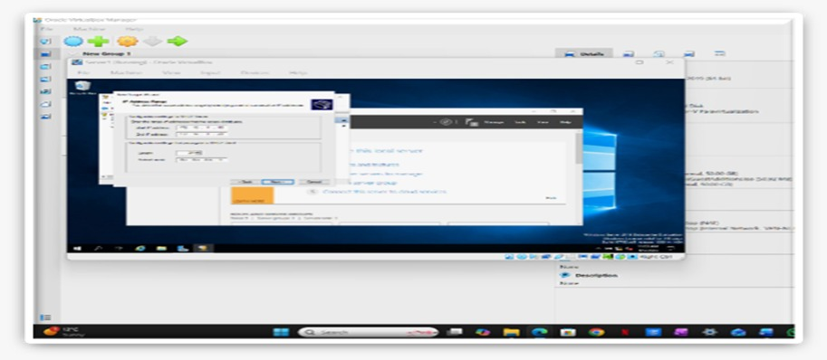
DHCP Scope Configuration

Figure 14: DHCP Scope Configuration

This figure shows the configuration of a DHCP scope on the server. The IP address range, subnet mask, and other settings are defined so that devices on the network can automatically receive valid IP addresses.

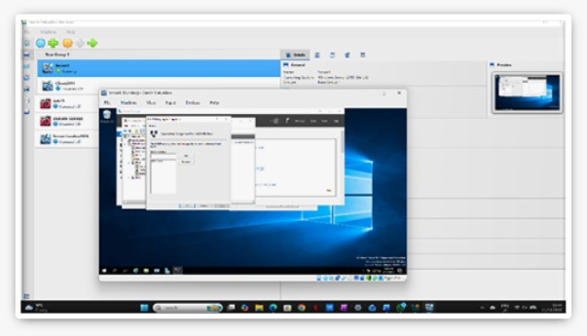
DHCP Relay Server

Figure 15: DHCP Relay Agent Server Configuration

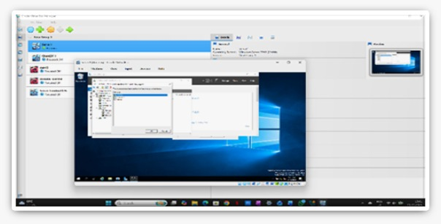

Figure 16: Adding Network Interface to DHCP Relay Agent

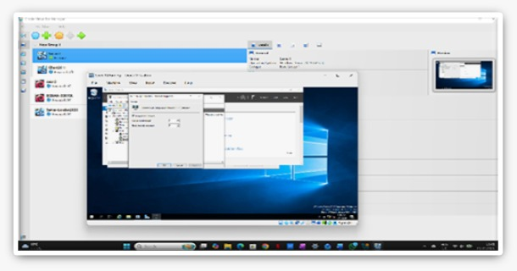

Figure 17: DHCP Relay Agent with Active Interface Configuration

We utilised RRAS to set up the DHCP Relay Agent on the London Server so that different areas of the network could talk to each other. It was selected which DHCP server and network link to utilise so that DHCP requests from the London network travel to the main server in Birmingham. This solution gives client computers their IP address settings right away, which makes sure that network management is always the same and works well [4].
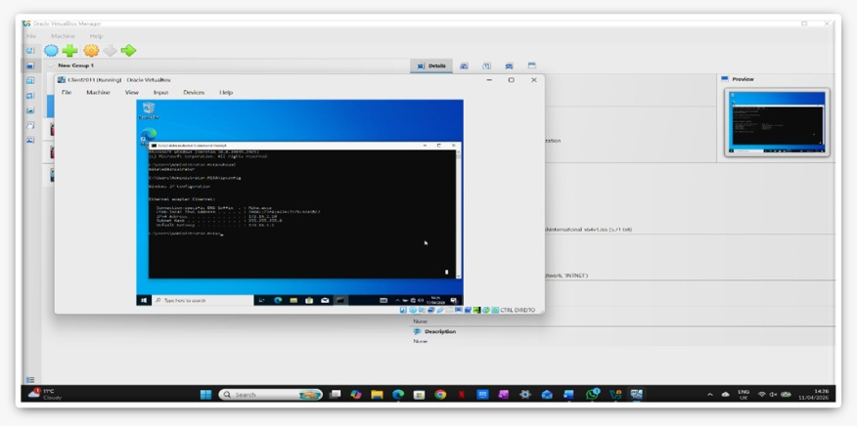
DHCP Client Verification
Figure 18: Client Network Configuration and DHCP Verification
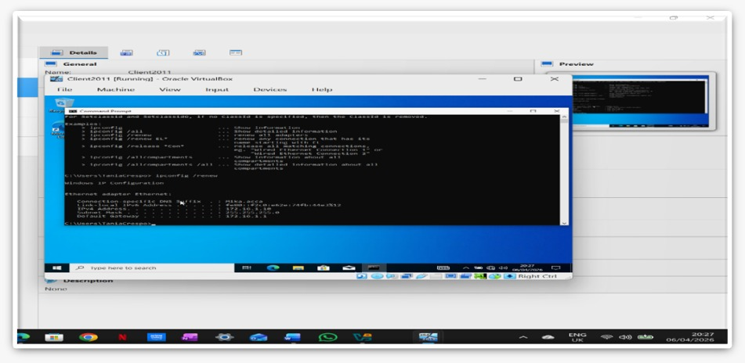
The client system was tested using Command Prompt to verify DHCP functionality and domain integration. The ipconfig command confirmed that the device received valid network configuration automatically, including IP address and DNS settings. The presence of the domain DNS suffix indicates successful connection to the domain environment. Additionally, the whoami command confirmed that the user is authenticated within the domain, demonstrating that DHCP, DNS, and Active Directory services are functioning correctly.
Figure 19: Initial DHCP Address Allocation on Client Machine
The client machine successfully obtained an IP address automatically from the DHCP server. This confirms that the DHCP service is functioning correctly and that dynamic IP address allocation is working as expected within the network environment.

7. Test and Troubleshoot
This step involved configuring DNS settings to enable proper communication between network devices. Initially, the domain name could not be resolved due to incorrect configuration. After correcting the IPv4 and DNS settings, the issue was resolved and successfully verified using the lookup command, confirming that domain name resolution is functioning correctly.
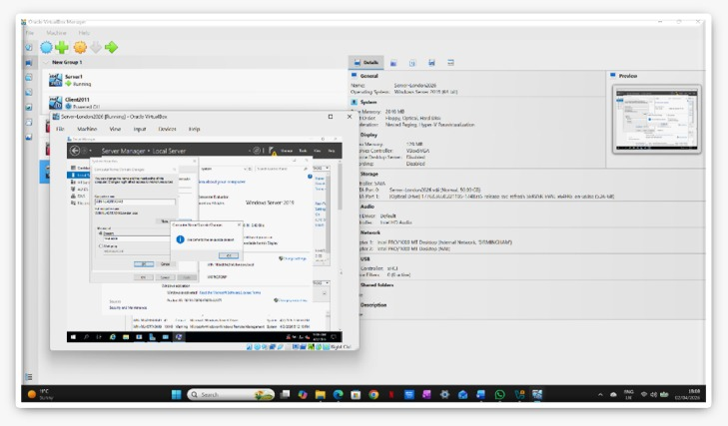
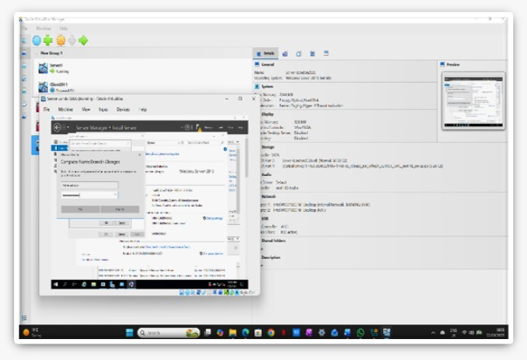
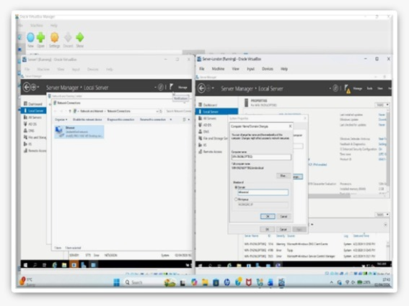

Figure 20: DNS Configuration and Domain Resolution Verification
This figure illustrates the verification of DNS configuration and domain connectivity within the network. The results confirm that domain name resolution is functioning correctly, allowing systems to communicate efficiently using hostnames rather than IP addresses.

Network Connectivity Testing (Ping Test) 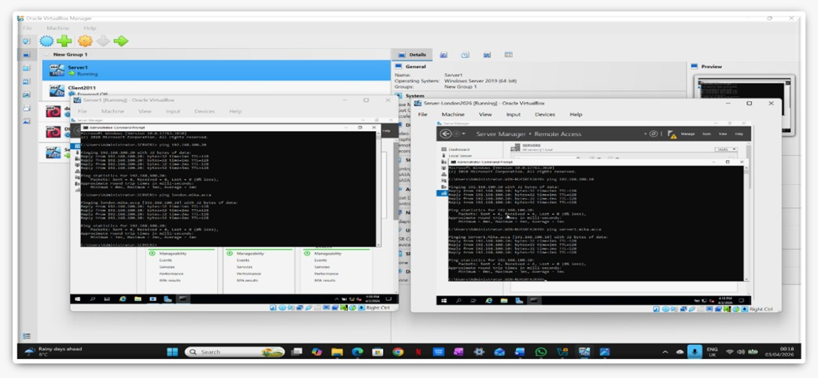
Figure 21: Network Connectivity Verification Using Ping
Ping tests were performed to verify communication between devices across the Birmingham and London networks. The results show successful replies with 0% packet loss, confirming that network connectivity is fully operational and that routing has been correctly configured.

Troubleshooting
During the configuration process, connectivity issues were identified due to incorrect DNS settings and restrictive firewall rules. These problems were resolved by correcting the DNS configuration and enabling ICMP traffic to allow network testing. After applying these fixes, successful communication between the Birmingham and London networks was achieved, confirming that the network is fully operational.

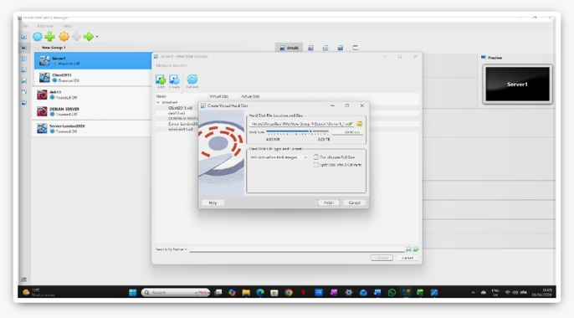
8.Disk Drive

Figure 22: Creation of Secondary Virtual Hard Disk in VirtualBox

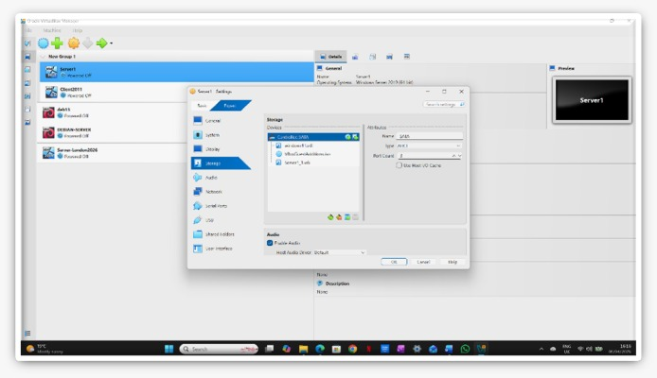

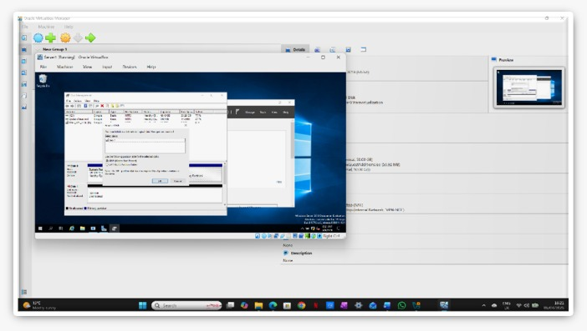
Figure 23: Secondary Virtual Disk Attached via SATA Controller

Figure 24: Detection of New Disk in Disk Management

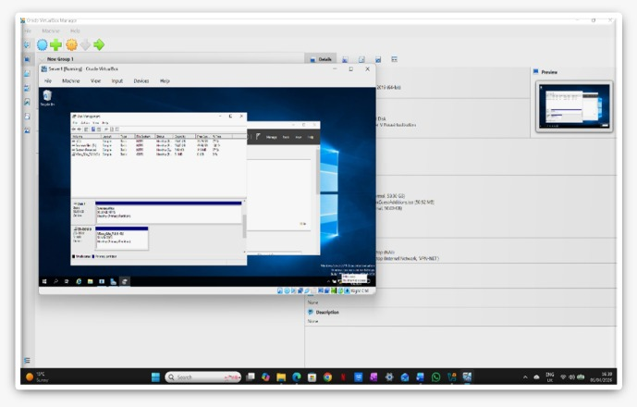

Figure 25: Disk Initialization, Formatting and Drive Configuration

A secondary disk was created in VirtualBox and attached to the virtual machine to provide additional storage capacity. The disk was configured in Disk Management by initializing it using the GPT partition style and formatting it with the NTFS file system. A new volume was then created, assigned the drive letter E: and labelled “Birmingham Files”. The folder was shared using Advanced Sharing settings, allowing network users to access and manage files efficiently. This configuration improves data organisation, storage management, and accessibility within the network environment.

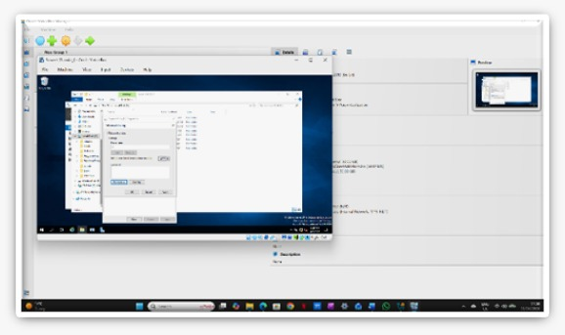
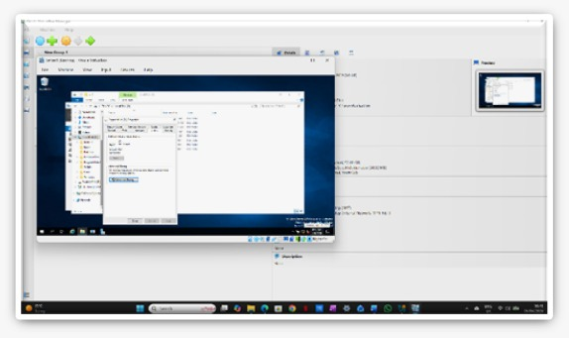
Disk Sharing and Permissions

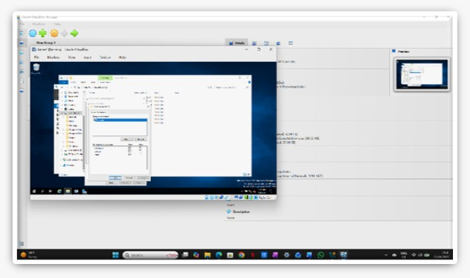

Figure 34: Shared Folder Permissions Configuration for Birmingham Files
A secondary disk was configured and assigned the drive letter E: labelled “Birmingham Files” to provide shared storage within the network. The folder was shared using Advanced Sharing settings, and permissions were configured to ensure that Domain Users have Full Control, while other users are granted Read-Only access. This setup ensures secure and controlled file sharing across the network environment.

9. IIS Server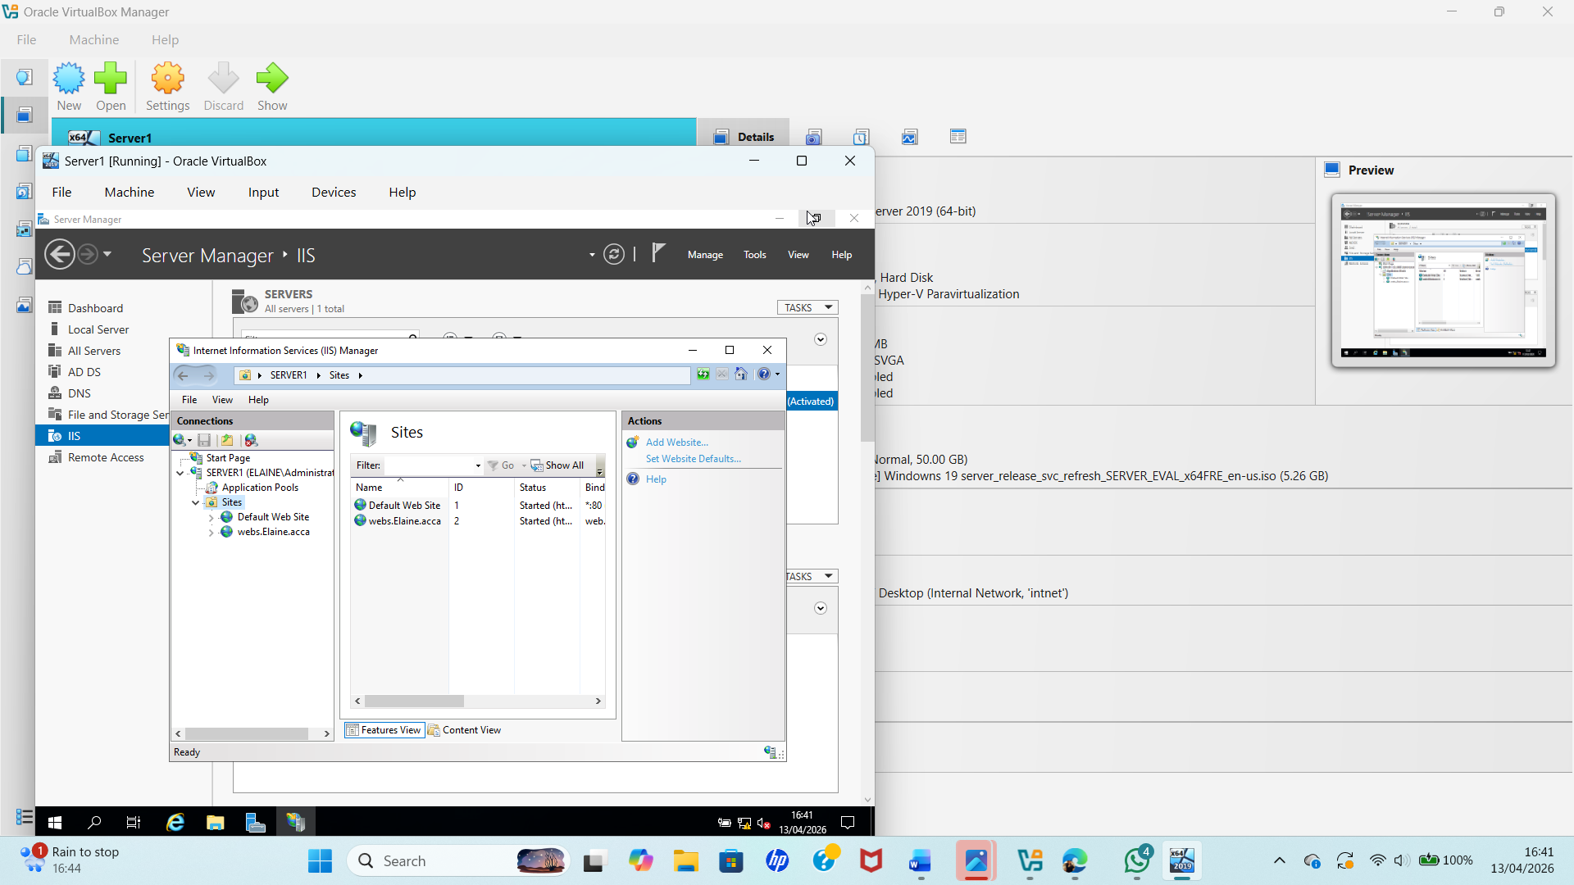
Figure 35: IIS Website Configuration on Server
This figure shows the Internet Information Services (IIS) Manager on the server. A website has been created and is running, allowing the server to host web content that can be accessed by users on the network.
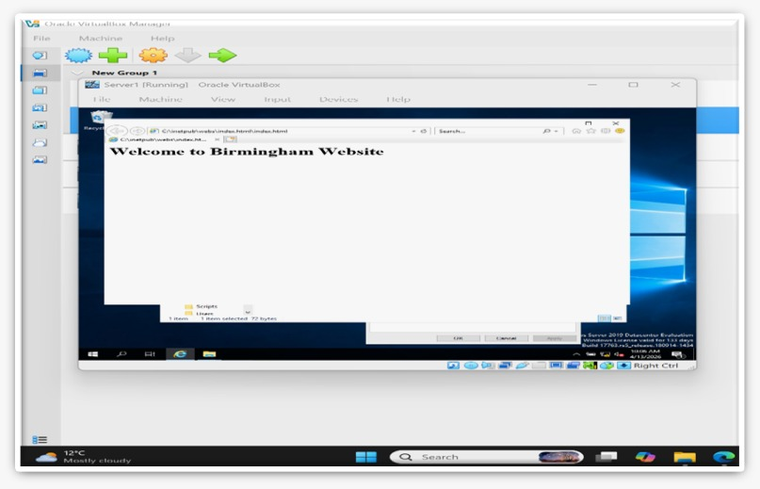
Figure 36: IIS Website Running Successfully

This figure shows the website being accessed through a web browser on the server. The page “Welcome to Birmingham Website” confirms that the IIS web server is working correctly and hosting the site success

10. Remote Desktop Services
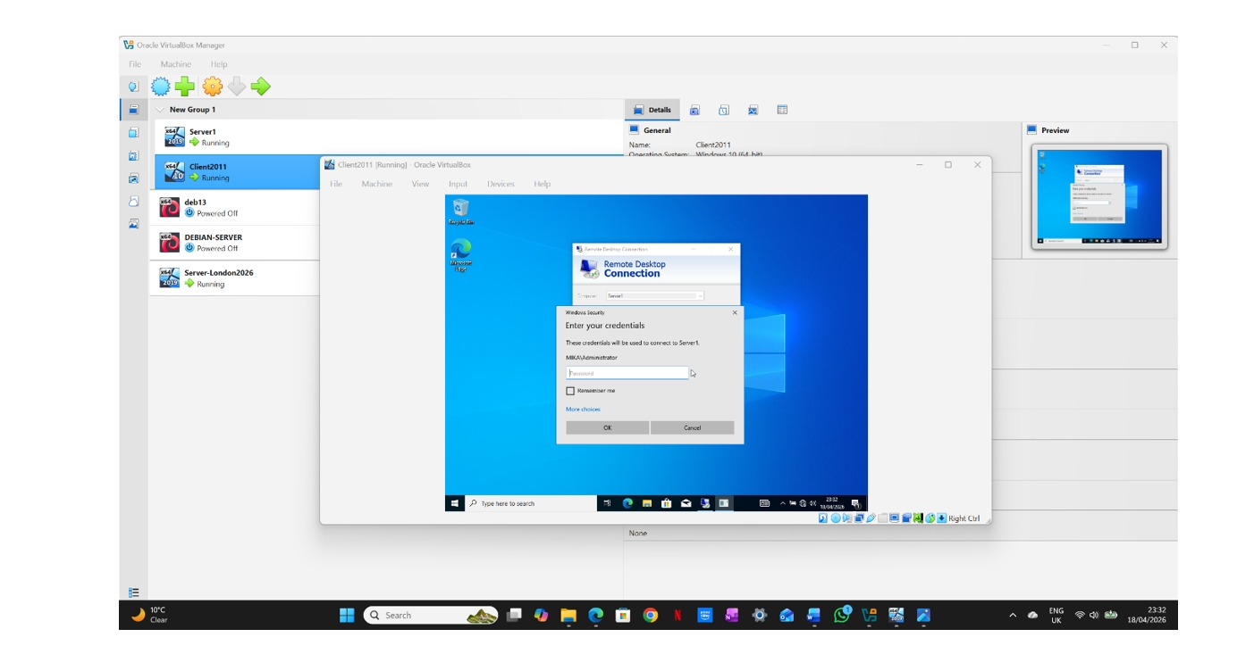
10.1 Configuring Secure Remote Access
Figure 37: Client Machine's Remote Desktop Connection.
Remote Desktop Connection was set up on the client PC so that it could connect to Server1 from a distance.

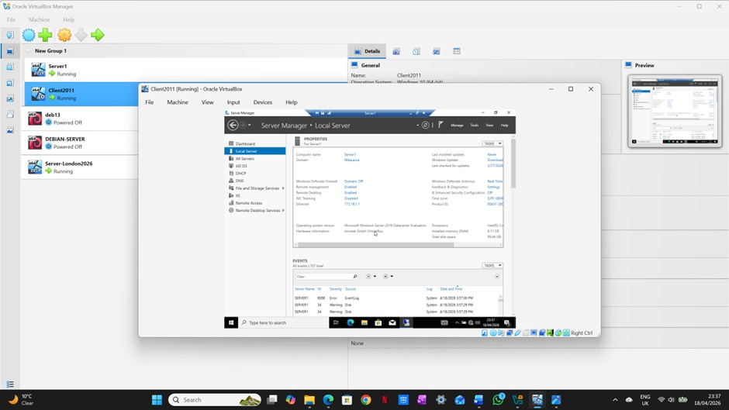

Figure 38: Configuration of the Local Server1

This picture shows the Local Server settings in Server Manager. It indicates that Server1 is set up correctly in the domain and is ready to have remote access set up.

Task _2 Linux Configuration IP a
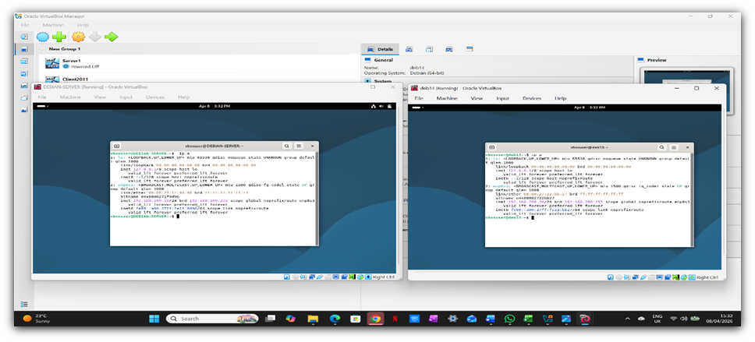
Figure 39: Linux Network Configuration Display (Ip a Command)

Conclusion
In conclusion, this project successfully built and configured a fully working virtual enterprise network for the Yousaf. acca domain. By setting up the main server in Birmingham (B-DC) and the remote client in London (L-CD), I proved that a multi-site network can be connected securely. Throughout the assignment, I installed Active Directory to manage the domain users and computers centrally. I also successfully deployed a DHCP server and a DHCP Relay agent so the London network could receive IP addresses automatically from the Birmingham pool. Furthermore, the network now hosts a secure internal company website using the IIS Web Server with Windows authentication. Finally, users can safely access the main server from other machines using Remote Desktop Services (RDS).All the connectivity tests, like pinging between the two subnets, passed without any issues. By completing all these tasks, this project resulted in a secure, fully operational network environment.

References

[1] R. Droms, "No title," 1997,
[2] E. Durmaz and M. SOYTURK, "The Role and Benefits of IPv6 in Modern Server Applications: A Survey with Simulation-Based Case Study,"
[3] J. Postel, "No title," 1981,
[4] J. Balen, K. Vdovjak and G. Martinović, "Performance evaluation of windows virtual machines on a Linux host," vol. 61, no. 3, pp.425–435, 2020,

