Adidas Blog Posts

Name of the Student
Student number
Module title
Lecturer name
Name of the University

Table of Contents
Introduction 2
Blog 1: Anthem featuring Siya Kolisi 2
Blog 2: Princess Nokia ft. Ready for Sports 4
Blog 3: What’s One More? 5
Blog 4: SuperNova 6
Blog 5: 60,000 employees of Adidas says ‘Ready for Sport’ 7
Blog 6: Adidas reaccelerates through ‘Read for Sport’ 8
Conclusion 9
References 10

Introduction
Adidas has recently launched ‘Ready for Sport' campaign that uses stories in the first person for vulnerability and resilience for inspiring others. The campaign follows a global athlete reflection. The 'What's One More' film is released under 'Ready for Sport' campaign for inspiring athletes that prepare to return to the field by 2021. The campaign aims to connect community as they wait for returning to active sport. The campaign critically explores how such cancellations have mentally and physically affected the individuals and how they used such experience for positively preparing to get back in the game. The current assignment has created six blog posts related to Adidas's 'Ready for Sport' campaign project, for increasing and creating awareness of the project, enhancing the dialogue between Adidas and its audience. The campaign is targeted for a global audience of the versatile and vertical athlete and both consumers and non-consumers of Adidas.

Blog 1: Anthem featuring Siya Kolisi
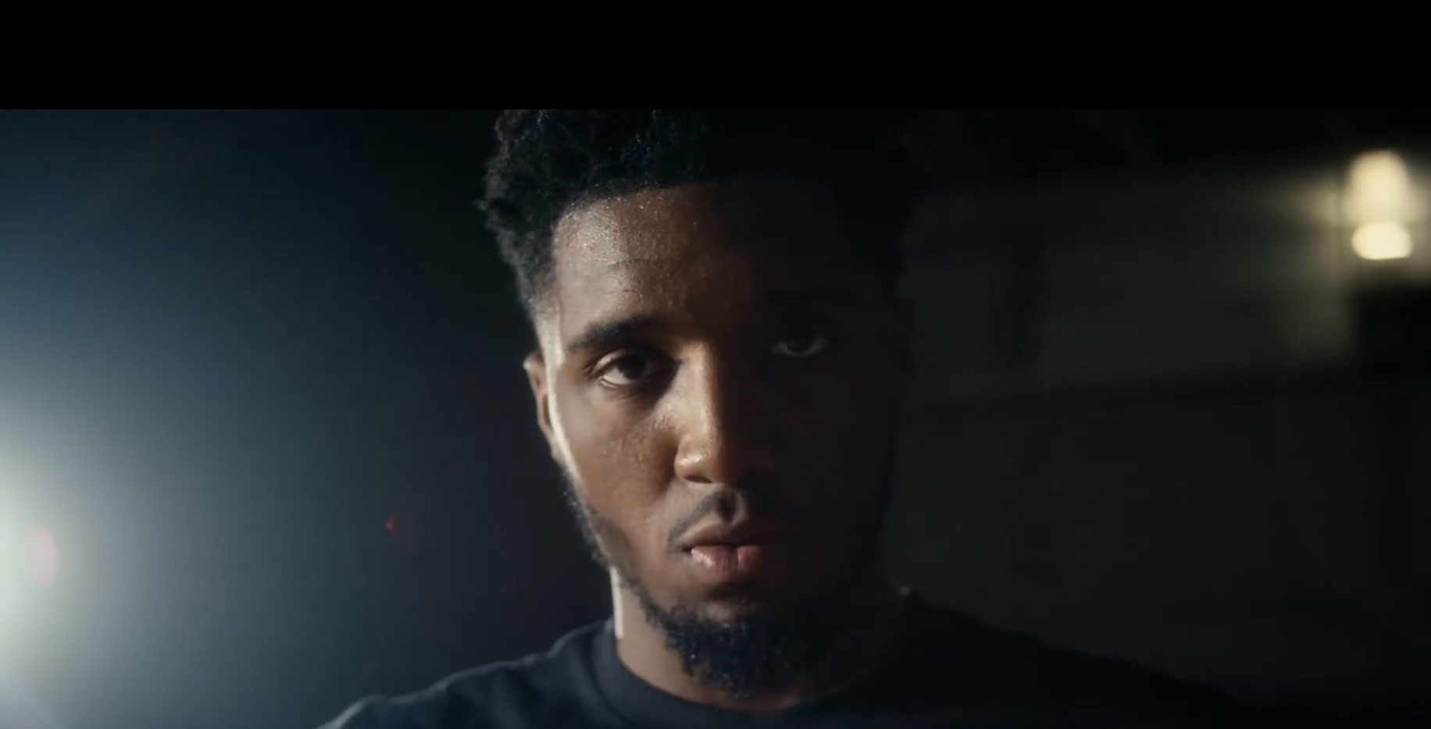
Figure 1: Anthem featuring Siya Kolisi
(Source: Adidas "Ready for sport: the anthem" by Iris, 2020)
Adidas has launched ‘Ready for Sport: The Anthem’ which is a film reflecting on the recent history of sporting for celebrating the true magnitude of what it had brought to this world. As per Crasto et al. (2020), the film has bold opening lines that help in exploring how it might bring together different communities as seen in a montage of dedication, raw emotion and exhilaration throughout the leading athletes globally. The film depicts the challenges which are unprecedented and is of 60-seconds in length (Adidas "Ready for sport: the anthem" by Iris, 2020). The film is narrated by Siya Kolisi who is a South African rugby legend, making history as the first Black man for being appointed as the Test captain of the 129 years of South African rugby. It is done with true determination led by the team of South Africa growing up in the town of impoverished Zwide for captaining the national team. The team also embodies the belief of Adidas that sport has the revolutionary power for transforming life. Sports might not be a solution to the issue however, it teaches that the challenges which are impossible needs to be overcome and faced. As per Kolisi, sportsperson needs to play with fire in the heart as the future is unknown to everyone. Hence, opportunities come and everyone needs to be prepared for it. According to Yang (2019), the poignant message of Kolisi is transformed to athletes in the short film against a film backdrop that includes Paul Pogba scoring the penalty of wining with few seconds to go. Noah Lyles is also found to finish the race going for gold and Caroline Dubois practices the boxing ring knockout. Candace Parker is also found to focus while practising for shooting that highlights optimism and sports excitement. For further information contact Adidas at 1-800-120-3300 or email at care@adidas.com.

Blog 2: Princess Nokia ft. Ready for Sports
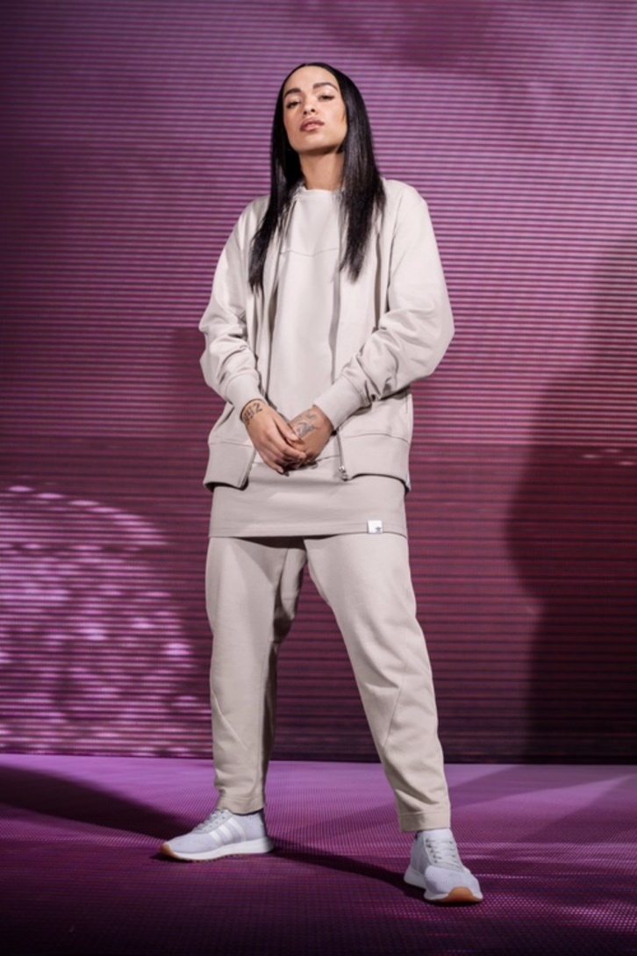
Figure 2: Princess Nokia ft. Ready for Sports
(Source: Adidas "Ready for sport: the anthem" by Iris, 2020)
Adidas has created stock footage a well as imagery campaign that has scripts read by NYC based rapper Princess Nokia. It delivers the powerful "We will ___ again" device. The stickers of Adidas Instagram have also been inviting and creating people for posting online about the sport or activity which they have been experiencing again. The product aims to rally the global audience of versatile and vertical athletes which reminds them how sport has been incredible for the feeling when it might return and hence everyone needs to be ready. As per Yang (2019), the Princess Nokia campaign for ‘Ready for Sport’ aims for being optimistic and inspiring rallying call for individuals everywhere for imagining and looking forward how sports has been incredible (Adidas "Ready for sport: the anthem" by Iris, 2020). The entire script is recorded through zoom and the brief was to compose an original piece of music with an essential message of optimism and hope. The team also needs to create something essential which is rousing and inspiring, building tension throughout the beautiful narration of Princess Nokia that helps individuals to feel the power of sports. FOGARTY (2017) stated that it is all about the anticipation feeling that although sports stopped due to Covid-19, something new is coming and everyone would be ready for it. To know further about this campaign, contact Adidas at 1-800-120-3300 or email at care@adidas.com.

Blog 3: What’s One More?
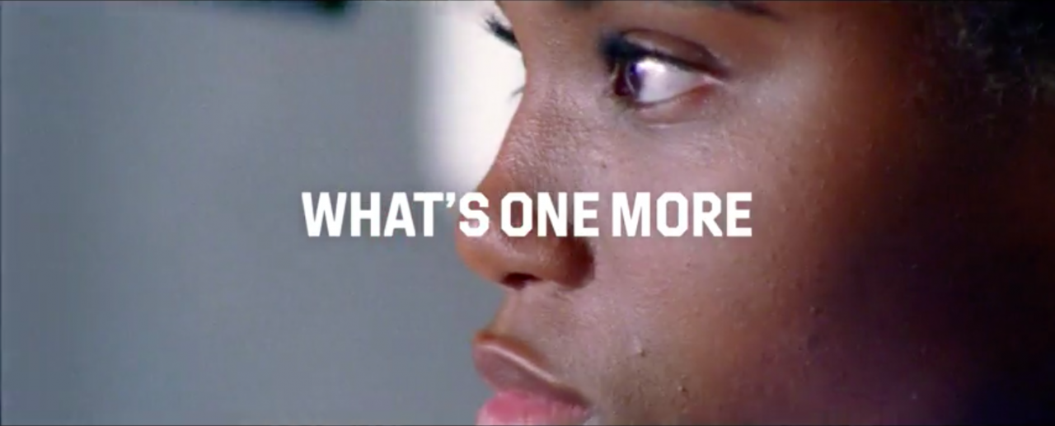
Figure 3: What’s One More?
(Source: Adidas "Ready for sport: the anthem" by Iris, 2020)
Under the ambit of 'Ready for Sports' Adidas released another film 'What's One More' that aims for inspiring athletes who have been preparing to return to the field in 2021. It depicts sporting events from matches at the grassroots level to global tournaments that are cancelled due to Covid-19 pandemic. The film also aims for connecting the community which awaits their return to active sports. The film also explores how such cancellations might have mentally and physically affected the individual wellness and how they might be used for preparing positively for getting back into the game. As per Nuseir (2020), it depicts Mirabai Chanu who is a competitive weightlifter and Padma Shri awardee stating that postponement of world's largest sports competition provides them an additional year for preparation and they have been working hard for improving the performance and doing well in the upcoming year. They firmly believe that sports are a symbol of joy and optimism that inspires and looks forward to bringing positivity into the lives of sportsperson (Adidas "Ready for sport: the anthem" by Iris, 2020). Hence, everyone needs to stay positive, keeping working hard and hence when the time comes, everyone needs to be ready even for the Tokyo Olympics that is delayed. According to Luczak et al. (2020), the captain of Indian Hockey team is also depicted in the film who stated that there is a sense of unity prevailing the community of sports and it is the sense of togetherness that is required to be focused at a moment. It also inspires and reminds all the athletes for keeping to work hard, emerging for the upcoming years. To become a part of ‘What’s One More?’, contact Adidas at 1-800-120-3300 or email at care@adidas.com.

Blog 4: SuperNova
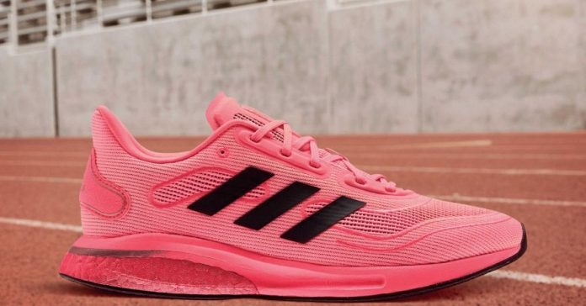
Figure 4: SuperNova
(Source: Adidas "Ready for sport: the anthem" by Iris, 2020)
As per Mehra (2017), under the ‘Ready for Sports’ campaign, Adidas has released responsive running shoes the ‘SuperNova’ from the Tokyo Collection for the athletes counting down for one more year. It aims for inspiring athletes for preparing for 2021 return. The shoe was originally designed for being worn in Tokyo 2020 Olympics (Adidas "Ready for sport: the anthem" by Iris, 2020). The unisex shoe is designed with materials that are recycled and designed with a mesh upper having additional airflow where one might sweat a little bit more. According to Murray (2018), it is a neutral running shoe made with 50% fabrics that are recycled. It is sustainable providing a clean conscience on the sports. To get a pair of SuperNova, visit Adidas store or contact Adidas at 1-800-120-3300 or email at care@adidas.com.

Blog 5: 60,000 employees of Adidas says ‘Ready for Sport’
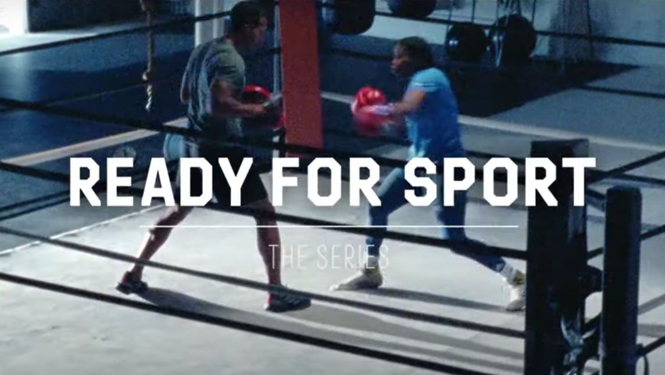
Figure 5: 60,000 employees of Adidas says ‘Ready for Sport’
(Source: Adidas "Ready for sport: the anthem" by Iris, 2020)
Adidas has mobilised the internal community entirely for inspiring optimism and hope for a return to the sport through the campaign Ready for Sport. Turner (2019) stated that the firm was exclusively released by employees of Adidas for using the spirit of unifying the sport for motivating the world as it looks for re-entering the physical sport of space at stores, streets and stadium. The Ready for Sport campaign aims for optimistic and inspiring rallying for calling people everywhere looking forward and imagining how the sport is incredible that is currently going to feel with the current situation of Covid19 (Adidas "Ready for sport: the anthem" by Iris, 2020). It helps the nation for keeping to move forward. Indian athletes have also joined this campaign that helps in motivating and inspiring people all around the world. As per Terskikh (2018), Adidas has also extended free access to the workout applications for 90 days additionally that provides the community with access to more than 260 exercises in 15 languages that helps them to keep motivated. To get ready for sports, contact Adidas at 1-800-120-3300 or email at care@adidas.com.

Blog 6: Adidas reaccelerates through ‘Read for Sport’
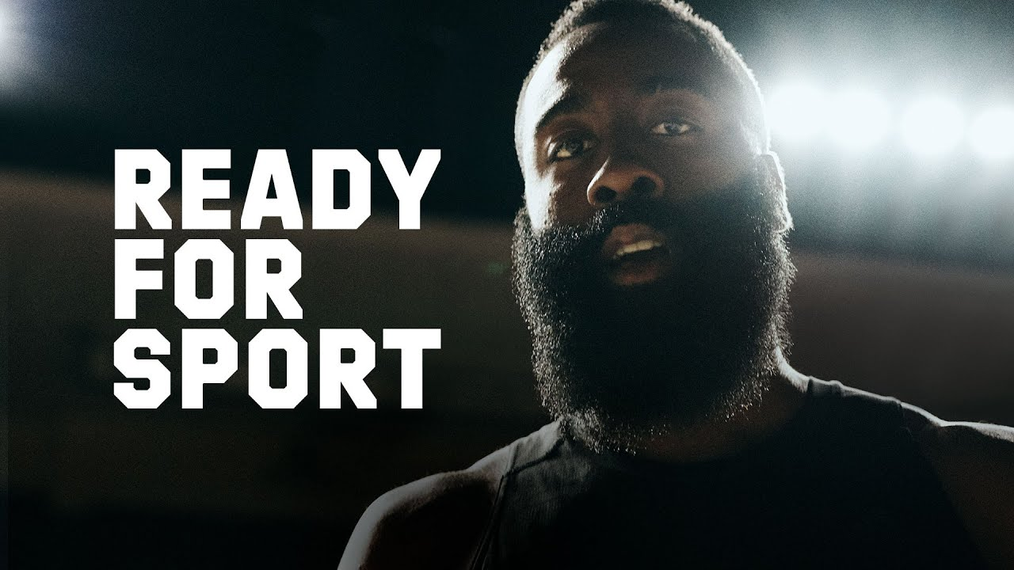
Figure 6: Adidas reaccelerates through ‘Read for Sport’
(Source: Adidas "Ready for sport: the anthem" by Iris, 2020)
Adidas has cut its budget for marketing by around 25% during the Covid-19 ongoing pandemic. As per Terskikh (2018), the company claims a 35% fall in the revenues and the majority of its stores are closed. The company also saw a postponement of major sports events such as the European Championship in football and Tokyo Olympics. Ecommerce is a bright spot where Adidas has found that consumers are shifting online rapidly. More than a third of the sales across the partner of business was digital and hence the sales increased by around 93% in the second quarter. According to Luczak et al. (2020), research has shown that 50% of the 18-34-year-old consumers have planned for exercising more. Hence the fashion shift that is pronounced towards leisure is in demand. The workplace flexibility increases also helped with the majority of plans of companies and more permanent working remotely (Adidas "Ready for sport: the anthem" by Iris, 2020). Adidas also helps in returning profitability as it helps in believing in ‘Ready for Sport’. For further details, contact Adidas at 1-800-120-3300 or email at care@adidas.com.

Conclusion
It can be concluded that Adidas has been rallying the global community of sporting for playing more with heart and harnessing the power of the game. The powerful campaign helps in reflecting the recent history of sporting for celebrating the true magnitude of what has brought in the world. The main film is narrated by rugby icon of South Africa Siya Kolisi. Sports might not be the correct focus right now, however, it inspires people for achieving a challenge that is impossible and needs to be overcome and faced.

References
Campaignlive.co.uk. 2020. Adidas "Ready For Sport: The Anthem" By Iris. [online] Available at: <https://www.campaignlive.co.uk/article/adidas-ready-sport-anthem-iris/1692312> [Accessed 10 November 2020].
Crasto, S.G., Kee, D.M.H., Xin, C.W., Juin, H.X., Man, L.K. and Pandey, D., 2020. Product innovation by Adidas Group through Sustainability. Journal of the community development in Asia, 3(1), pp.1-7.
FOGARTY, S., 2017. 10 How Adidas attracts and retains talent. Branding Inside Out: Internal Branding in Theory and Practice, p.157.
Luczak, T., Burch, R., Lewis, E., Chander, H. and Ball, J., 2020. State-of-the-art review of athletic wearable technology: What 113 strength and conditioning coaches and athletic trainers from the USA said about technology in sports. International Journal of Sports Science & Coaching, 15(1), pp.26-40.
Mehra, P., 2017. Factors Influencing Purchase Behaviour of Branded Sports Shoes. SCMS Journal of Indian Management, 14(4), pp.54-63.
Murray, S., 2018. Sports diplomacy: Origins, theory and practice. Routledge.
Nuseir, M.T., 2020. The effects of sponsorship on the promotion of sports events. International Journal of Business Innovation and Research, 22(2), pp.191-207.
Terskikh, M.V., 2018, April. Specific features of the communication strategy of sports brands promotion in social networks. In 2018 IEEE Communication Strategies in Digital Society Workshop (ComSDS) (pp. 63-65). IEEE.
Turner, T., 2019. The sports shoe: a history from field to fashion. Bloomsbury Publishing.
Yang, J., 2019. Cheap Adidas Gazelle Argentina Blue-apmkingstrack. com. American Journal of Industrial and Business Management, 9(3), pp.720-726.
Yang, J., 2019. Wholesale Adidas F50 Tunit 100% Discount Free Shipping-apmkingstrack. com. American Journal of Industrial and Business Management, 9(3), pp.720-726.

