
BYOD – Web Browser Access

Summary

The document will summarise what a user may experience when accessing university owned data and Cloud services such as O365 Email, Teams from a personal BYOD device using a Web Browser interface such as Microsoft Edge.

Web Browser Access
UWTSD recommend that wherever possible users access University owned data and Cloud services such as O365 Email, Teams from a university provided device.
Accessing University owned data and Cloud services such as O365 Email, Teams from a personal BYOD device using a Web Browser interface will be possible but with reduced functionality.
Users will be warned that the connection is monitored for security purposes as below
• Click Continue to Microsoft Exchange Online
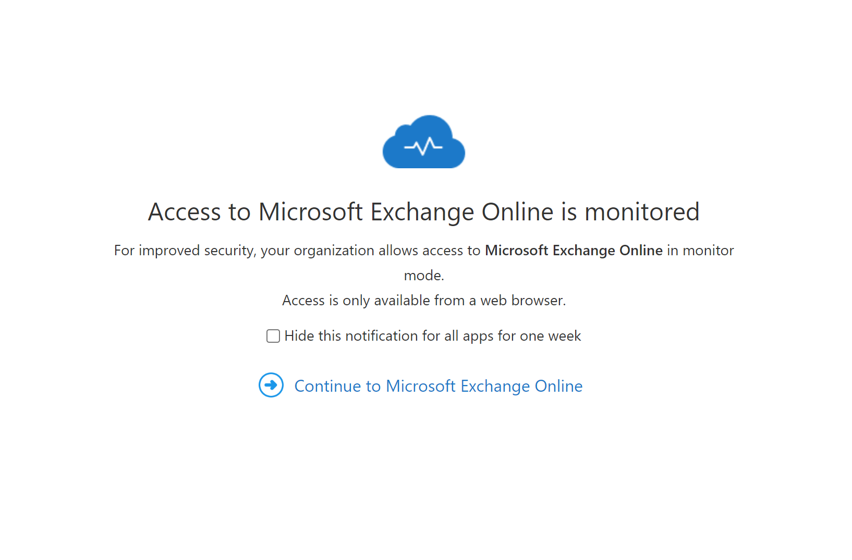

Users will have full access to all Microsoft Cloud services such as O365 Email, Teams but the following actions will be blocked when access is via a web browser:
- Downloading attachments from Outlook Web Mail
- Downloading files from Teams Online, OneDrive Online, SharePoint Online
- Copying/Printing the contents of files etc

Users will receive the following messages should they attempt any of the above actions.
Downloading attachments
Copying/Printing



