E-Portfolio: Learning in the digital era

Ria Glover-Harding

Table of Contents
E-Portfolio: Learning in the digital era 1
Task 1: Generate visual branding and create an online portal for publishing creative work. 3
Task 2: Creative group composition 4
Task 3: virtual group collaboration 5
Task 4: bibliography and pitch proposal. 5

Task 1: Generate visual branding and create an online portal for publishing creative work.

For task 1 I created a visual branding using my churches logo and then putting a video background to it. For this I sued adobe express importing the logo and then putting different effects on to it. After this I downloaded the logo created as a transparent logo and then I got a video or picture of Pexels and then put the two together again using adobe express. Here is some of my examples of what I did.
This is the final logo that I created using the audio and video from the actual service with the church’s logo.

Here is also the link to my YouTube channel

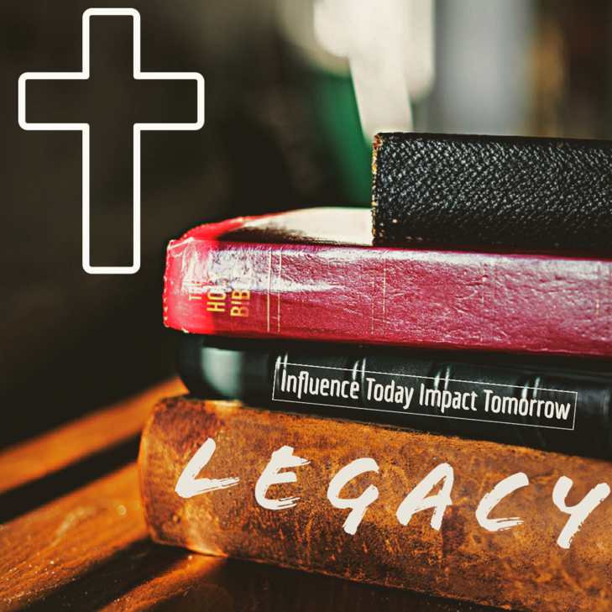

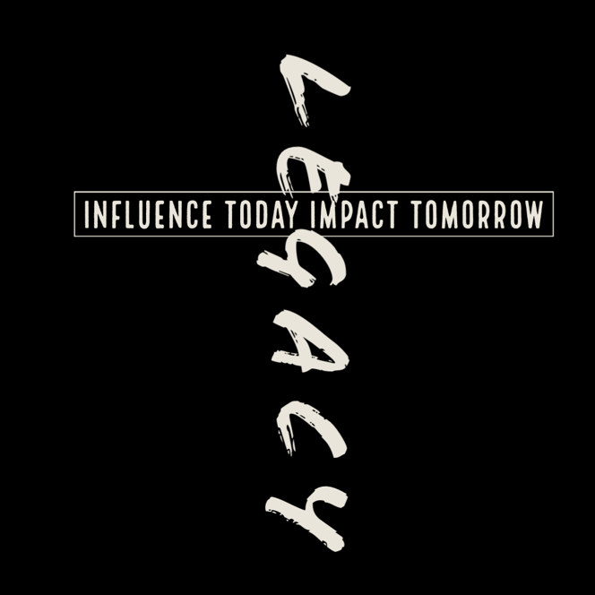
Here are the other logos that I had a play around with two of these are transparent logos that I have added still backgrounds too so they are visible for this assignment.

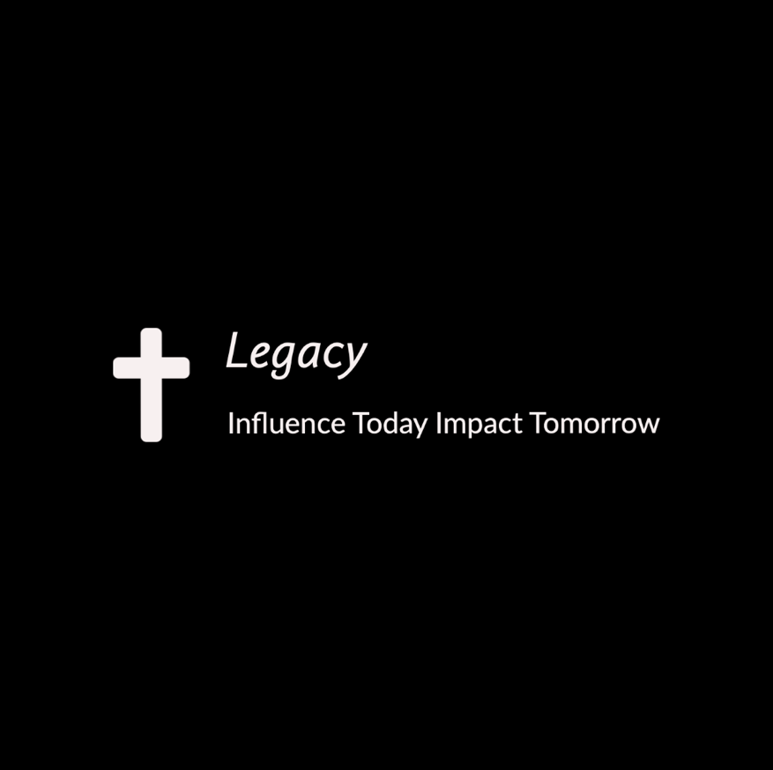

This is the one that I used throughout my tasks

Task 2: Creative group composition

For this task me and Steph worked together, and we recorded a spoken word version of a rap.
On the first week me and Steph spent time talking about what we might want to do as none of us play any instruments and Steph was also calling in online so at first we were using teams and then we moved on to FaceTime. After we spent some time deciding on what we were going to do and brainstorming different ideas it was quite clear that we were going to do a spoken word composition. We looked at some of Dylan Thomas’s work and we couldn’t’t really find anything the both of us wanted to do. I then spoke about a poem I did a while ago from Alice in wonderland- through the looking glass called the jabberwocky but we decided that it was a bit complicated for this piece of work. Steph then said about a song/rap she had been listening to that week and so we decided to have a listen to it. The song is called creation to salvation by Drakeford. When we had decided that we were going to do that but as a spoken word and not a rap we set up clean feed which is an audio recording service which has good voice quality and logic. We did a few takes each of the whole song through clean feed and saved them.

The second week we the decided that although the recordings were good, they were very quiet and the room dynamics were the same and so we decided to set up a mic in the studio and again we both did a few takes of the full song and recorded into logic and when we were both happy with the takes we had done we sat together to listen to them and pick out the best parts of each of our recordings. We chopped them all up and we recreated the song using the different recordings. We then saved this, and I sent a copy of this to Steph so that then she could add some different effects to it and so that the both of us could make it our own.

I have spent some time on this rap adding different defects and loops and reverbs and this is my final project.

Ria’s final Project
ria and steph rias mix.wav

Creation to salvation- Drakeford this is the song that we were inspired by.
https://youtu.be/xJqSZzmsYaA
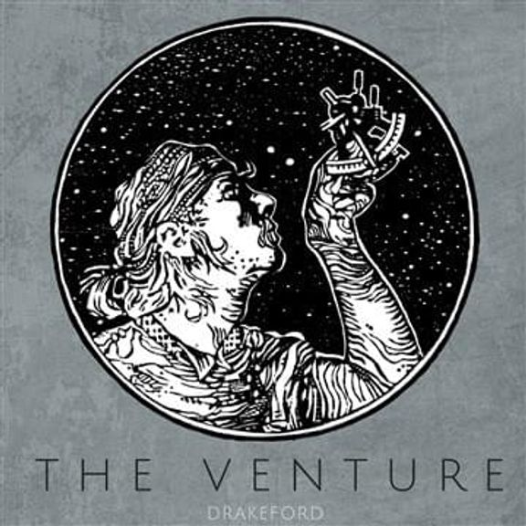

Task 3: virtual group collaboration

For this task we were put into groups, and I was with Steph and Thomas. We collectively worked together over teams to devise a plan of what we were going to do for this task.
In the teams meeting we discussed what each of our strengths are and what each of us would like to do for this task. Thomas was very keen to write the instrumental component and Steph wrote the lyrics. I was very happy to watch this all take place. We set up a team’s page where we could all put ideas into the folder. I didn’t really contribute much at this point but when it came to putting it all together, I was very keen in using my skills to bring Steph’s voice and Thomas’s music together to create our unique composition which we have named ‘The Dream Team’ this was done in logic at the studios after we had done everything.

This is our final piece which I have added reverb and compression.

the dream team rias mix.wav

Task 4: bibliography and pitch proposal.

My name is ria glover-Harding. I am currently studying in university of trinity saint David in Swansea doing a degree in creative music technology. I am currently in my first year. I have chosen to study this as I have recently found a great love in being an engineer in the studio and putting together music on the computer. I don’t play any instruments or sing but that hasn’t stopped me from composing music collaboratively. I currently do some studio engineer work at my church and I’m also creating different stems of our worship sets and the preaches ready to set up a podcast of our church. I am looking forward to learning more skills to equip me for all the things I wish to do in the future. I have a lot of ideas I wish to express and experience with in my next 2 and 1/2 years in university.

Pitch proposal

For the creative music technology festival, I have decided to do a live recording of my church worship team. I recorded this at Christmas time, so it is a Christmas Carol. My overall vision for this piece of work would be to get my work out there and to have people enjoy listening to what I create. Due to the nature of the recording this could be performed live in the music festival, and I would then engineer that from the setting. The video I have but together for this is a mixture of still photography and video based on the Christmas nativity and the feeling of Christmas. I have also included the logo I created for my church.

