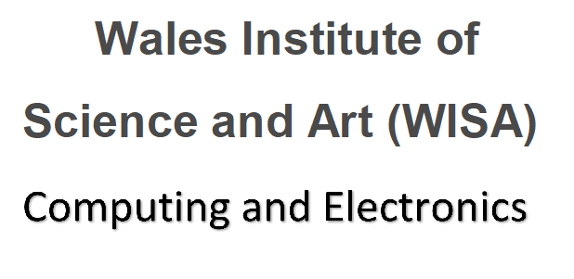
Online Welcome for returning level 5 (Sept 2019 intake) DDA Students Thursday 23rd September 2021 1pm
Microsoft Teams: Click here or https://bit.ly/38YRew1

1pm – 1.30 pm | Meeting with the team Kapilan, Beverley, Gaynor and Bridget. | - Welcome back  - Exam board results and feedback  - Overview of course structure
1.30pm – 2 pm | Liaison officer team feedback. | - Feedback session from ALOs.
2pm – 2.30 pm | Beverley and Gaynor Course overview. Q and A | - Introduction to the course structure and overview of the modules.  - Moodle and where to find information on Moodle.  - Student services and procedures to follow  - Hwb what’s new  - Opportunity to ask any question
2.30 pm – 3 pm | Professor Ian Wells Director of the Wales Institute of Digital Information (WIDI) | Discussions on:  - Potential health related projects  - Industry and Police related projects  - Suitable topics / areas of study for Industrial Research Module and Major Project
3pm – 3.30 | Team Q and A session | - Opportunity to ask any question about enrolment.  - ID Cards  - IT requirements where to find software
3.30pm | Self-guided:  Welcome videos and Campus safety presentations link.  Pre-recorded videos please see links. Please take some time to watch the videos if you have any questions please email the team. | Including  • Welcome from the VC  • Welcome from Provost  • Your Campus: COVID Safety on Campus  • Campus Virtual Tour  • Parking  • Enrolment  Link to resources on Hwb:  https://uwtsd.myday.cloud/pages/student/resources_welcomeandinduction


