Aled Phillips
2507188

Operating Systems
ACCA4022: Computer Architecture and Operating Systems

Table of Contents

Introduction 2
Key functions of general Operating Systems 3
Use of Windows OS CLI commands 11
Use of Linux OS CLI commands 14
Use of Windows OS scripts 18
Use of Linux OS scripts 21
Conclusion 26
References 27
Appendices 30

Introduction

As computing and networking systems have become increasingly complex, they have taken a far more central role in both our personal lives and in the structure of large, often highly regulated organisations. Whilst keeping up with the ever-changing landscape of software development and emerging technologies can be a challenge, it is often beneficial to strip back these layers of complexity and gain a solid understanding of how computer systems work at a more fundamental level.
The following report aims to provide an overview of the functions and uses of two of the most ubiquitous Operating Systems used on modern machines, Windows OS and Linux. We will highlight some useful Command Line Interface (CLI) commands in both PowerShell (Windows) and Bash (Linux), as well as demonstrating their functions in the form of an example script for each language.
By outlining some of these basic concepts, we hope to provide a foundational context for how Operating Systems function and give the reader some useful tools for navigating command-line environments.

Key Functions of General Operating Systems

Operating Systems are a type of software that manages hardware and system-level software resources, acting as an interface between the user and their device [1].
General-purpose Operating Systems, such as Windows, Linux or MacOS, can run a multitude of applications simultaneously and are commonly used in Personal Computers (PCs) and laptops due to their versatility in dealing with a wide range of hardware and software applications [2]. The key functions of general-purpose OS’s can be broken down into the following categories:

- Memory & Process Management
- Device Management
- File & Directory Management
- Performance Monitoring
- System Security

Memory & Process Management
The memory of a system is a key resource which needs to be closely monitored and managed [3]. As most systems have high-speed main memory (RAM) capacities of 16 GB, 32 GB or 64 GB, running multiple memory-intensive programs can cause the system to slow down or even crash. As a result, Operating Systems need to allocate memory to specific processes efficiently whilst allowing the user to track memory usage in real time for troubleshooting purposes. Fig. 1 shows Windows Task Manager, which allows the user to do just this, providing a quick overview that tracks memory usage as well as CPU usage, among other factors. If the user requires more information for detailed diagnostics, they can also utilise Windows Resource Monitor (Fig. 2).

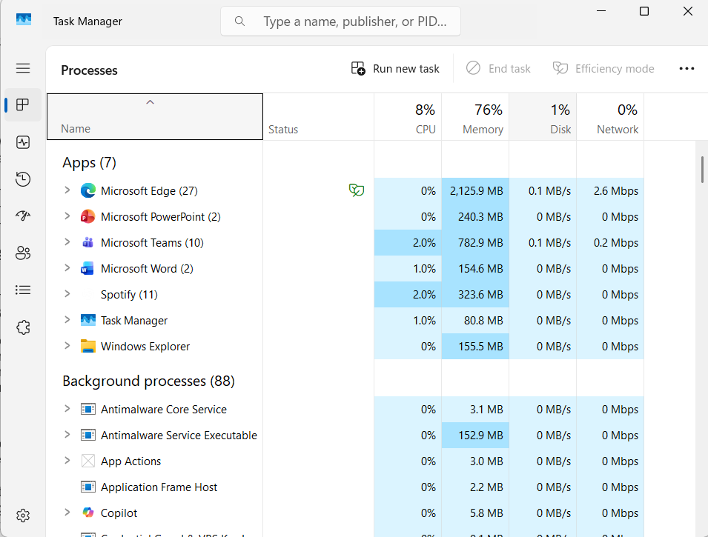
Fig. 1 Windows Task Manager, highlighting memory and CPU usage of running processes.

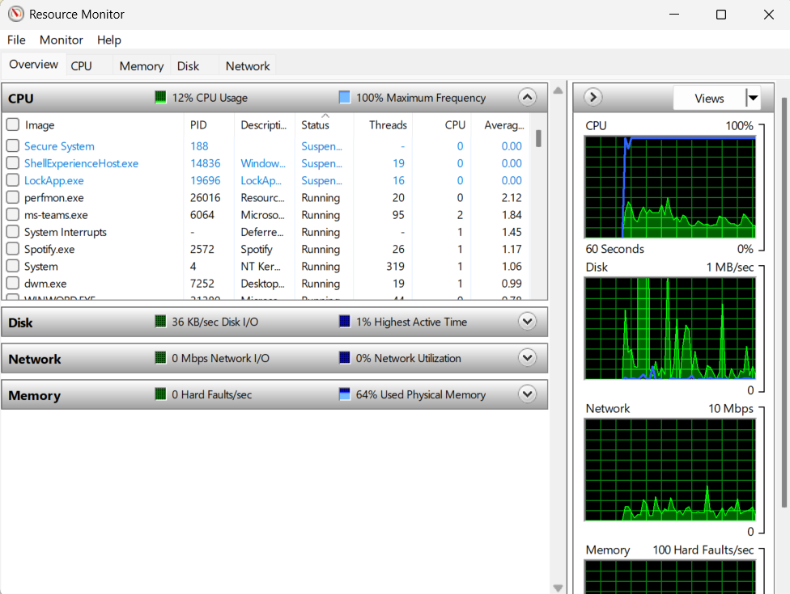
Fig. 2 Windows Resource Monitor.

Device Management
In order for the user to interact with the computer, input and output (I/O) devices are required such as a mouse, keyboard and screen. In order to process communication to and from I/O devices, the Operating System requires a program called a device driver [4]. These drivers act as a translator between the hardware and operating system and can be easily updated. The operating system uses two programs, the I/O Traffic Controller and the I/O scheduler to monitor the device’s status and prioritize between devices accordingly. In Windows, information regarding I/O devices and drivers can be found in the Device Manager (see Fig. 3).

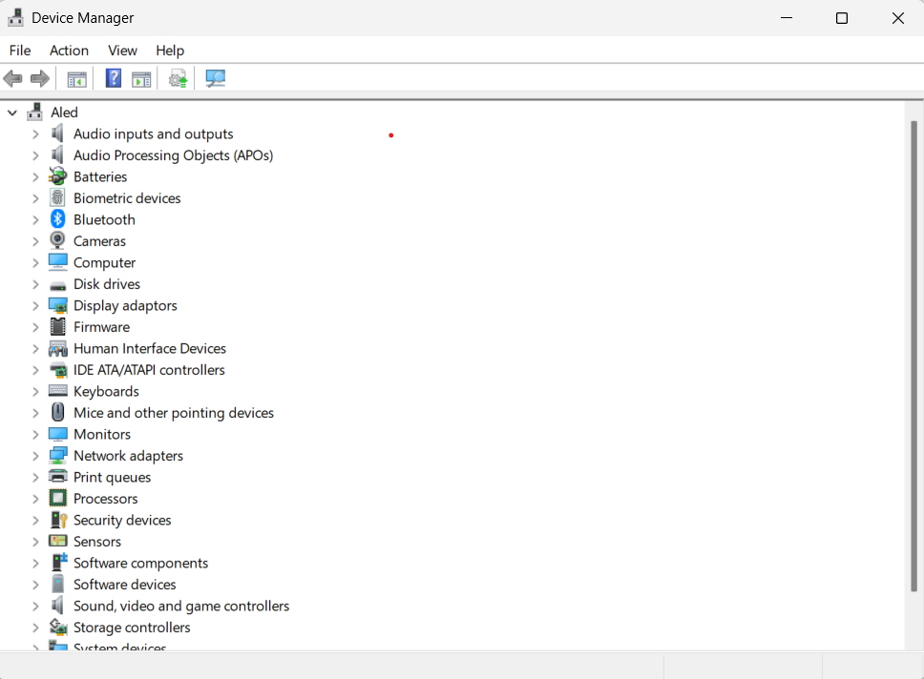
Fig. 3 Windows Device Manager.

File & Directory Management
Modern systems are required to maintain an ever-increasing number of files, any of which may be required to be accessed almost instantaneously. The Operating System is responsible for creating, storing and organising all of this data in directories [3]. Starting at the root directory, files are stored in a hierarchical tree of directories and can be accessed through their specific directory path using either the Operations System’s GUI or CLI. Each operating system uses it’s own management protocols for this purpose, for example, Windows NFTS or Linux EXT4. To further facilitate the user’s ability to troubleshoot issues, Fig. 7 shows the Reliability Monitor from Windows which provides the time and date of any errors, categorising them into critical and non-critical events and providing an ongoing reliability score which can help to identify if a system is operating significantly below it’s expected level of performance.
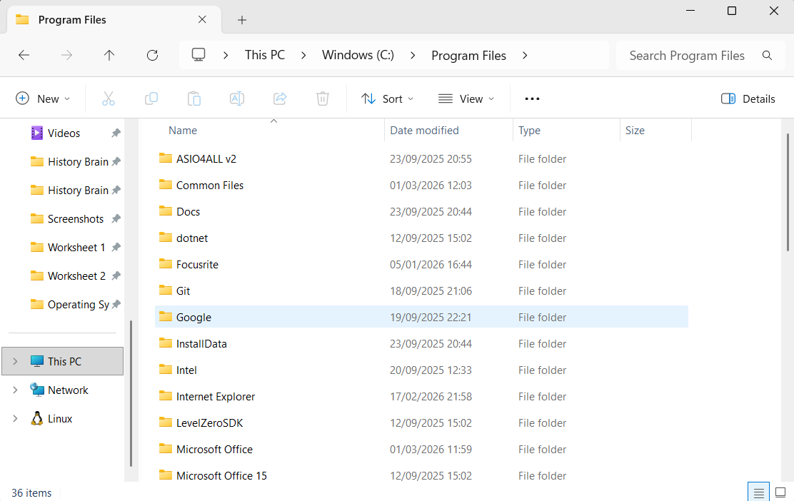
Fig. 4 Windows GUI representation of file directories.

Performance Monitoring
Operating systems are required to constantly monitor hardware and software elements to ensure that the overall system runs smoothly and that any issues can be identified by a user/ administrator. As can be seen in Fig. 5 and Fig. 6, operating systems like Windows and Linux maintain a record of any errors or faulty processes which may be affecting a systems performance, as well as providing tools for the user to run diagnostic reports and analyse the system for any underlying issues.
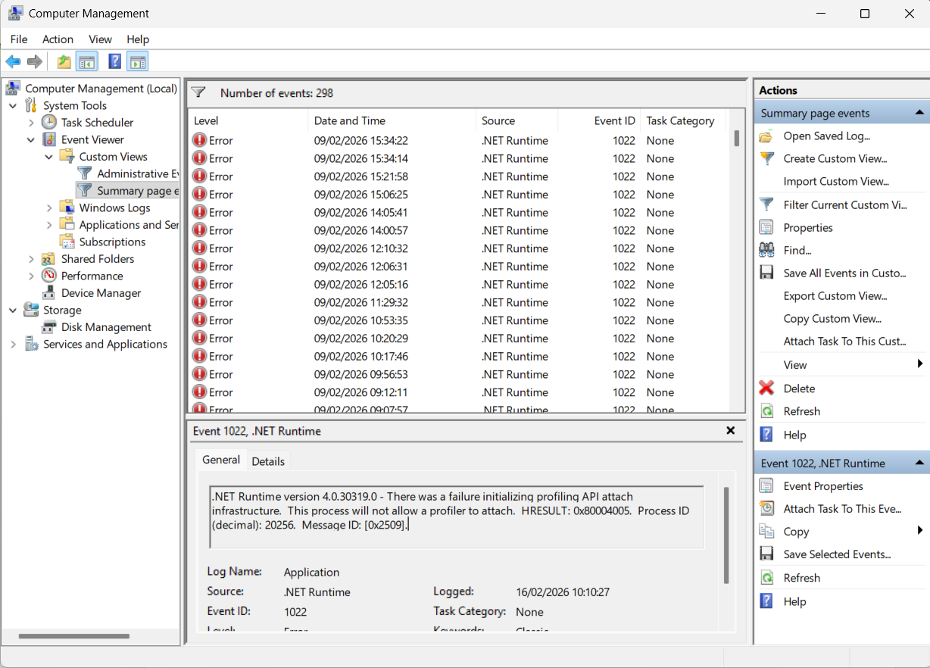
Fig. 5 Event Viewer in Windows Computer Management.
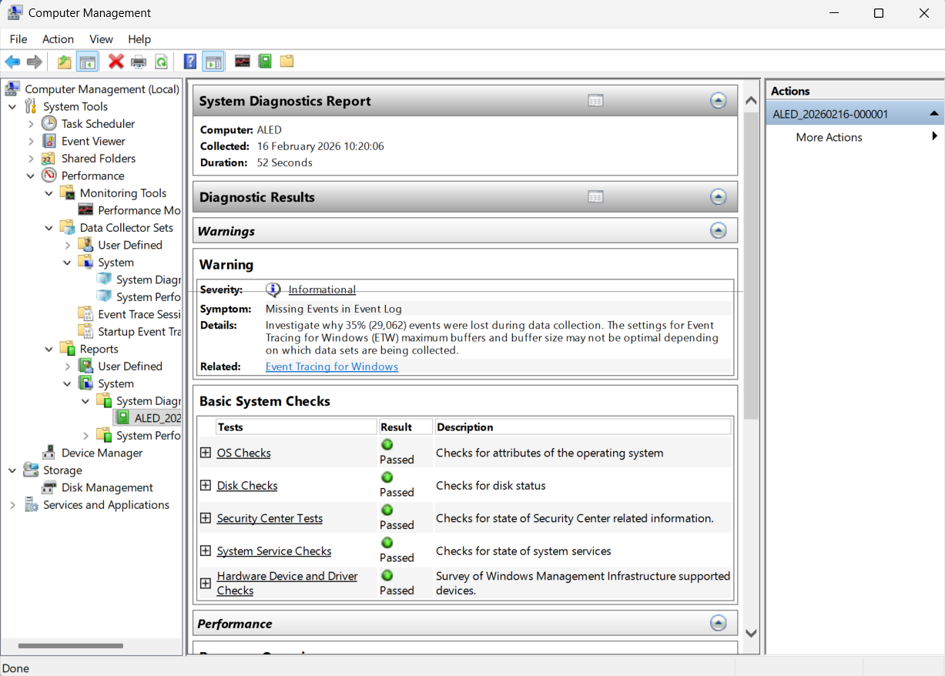
Fig. 6 System Diagnostics Report in Windows Computer Management.

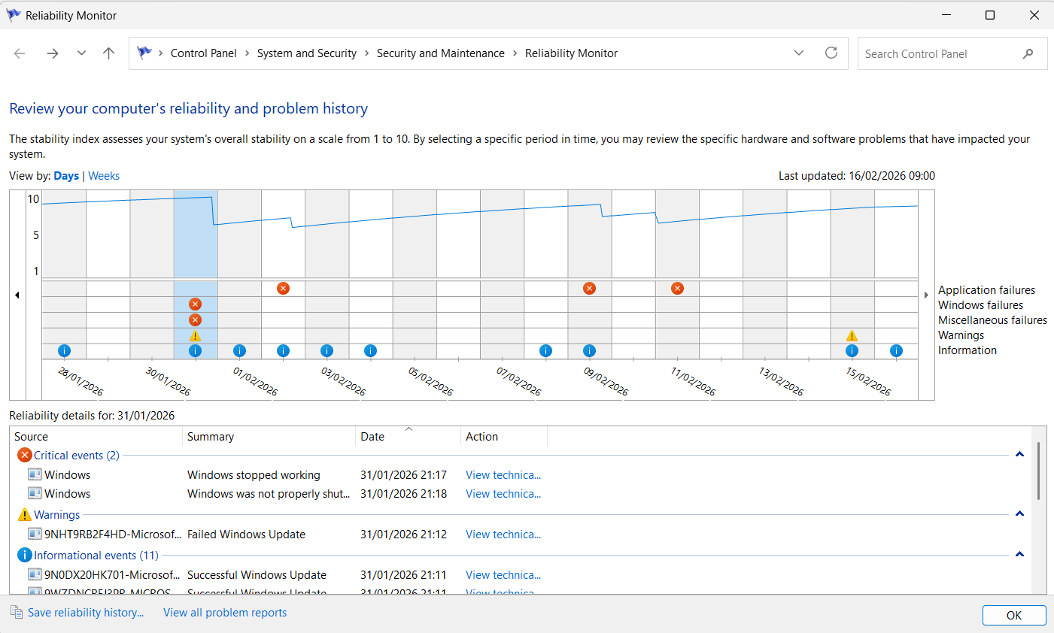
Fig. 7 Windows Reliability Monitor.
System Security
Finally, Operating Systems need to manage system security. This is vital to ensure that resources are protected and can only be used by authorized users [5]. Modern Operating Systems are designed in a hierarchical system known as ‘protection rings’, ranging from Ring 0 (aka the kernel) which has direct access to the RAM and CPU, to Ring 3 which operates surface-level applications. The purpose is to restrict access to the critical processes and hardware, requiring a higher level of permissions to make any changes at the more fundamental levels of the system.
Along with ensuring that only authorized users are able to access lower levels of the system, Operating Systems also monitor and protect against malware. Fig. 8 shows Windows Security, the built-in antivirus, firewall and network protection tool on Windows systems. Using this tool, the user can scan for any potential threats and customise the firewall to allow certain trusted sites or processes to run unimpeded.

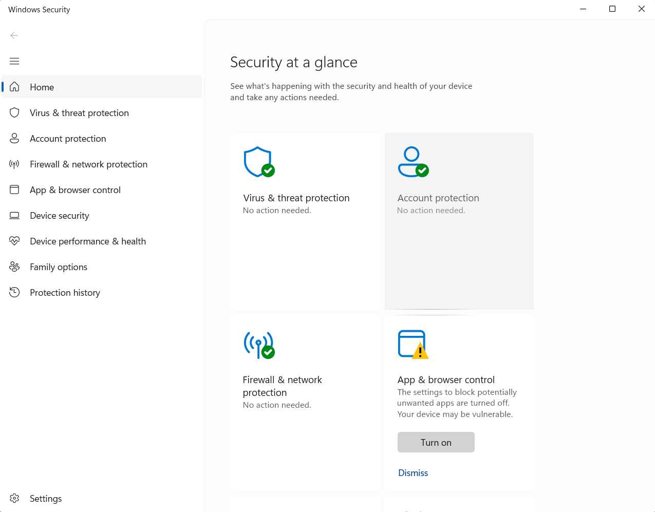
Fig. 8 Windows Security.

Use of Windows OS CLI commands

Area | Example | Description
Process Management | 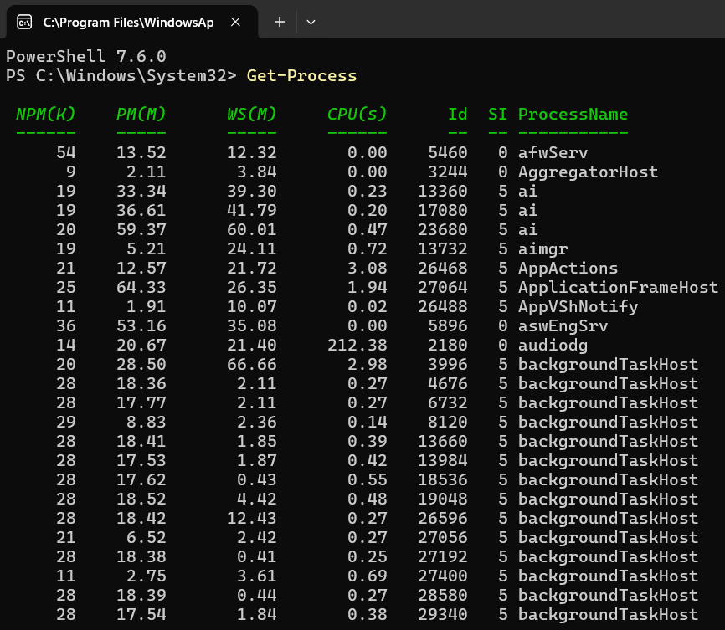  Fig. 9 Get-Process. | Using the “Get-Process” cmdlet in PowerShell shows all current processes that are running on the system. This can be used to monitor system performance, and results can be filtered further by the name of a specific process or by attributes like RAM usage or priority [6].
Process Management | 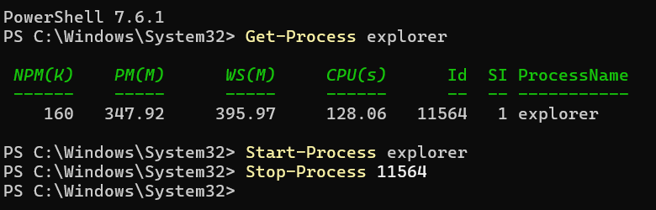  Fig. 10 Start-Process and Stop-Process. | “Start-Process” allows the user to open an application or process from the terminal, bypassing the GUI. Similarly, “Stop-Process” can be used to terminate an application. This can be useful both for automation and for ending unresponsive or problematic processes [7].
File & Directory Management | 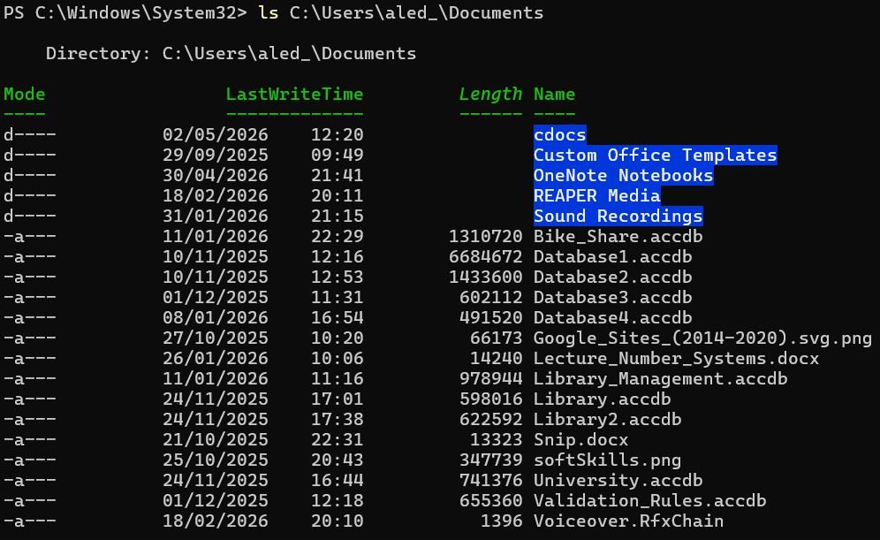  Fig. 11 ls (an alias for Get-ChildItem). | The “ls” cmdlet retrieves all of the contents of a given directory and displays information like file size and file name. “ls” is actually an alias for the cmdlet “Get-ChildItem” which supports switches like [8]:  -Recurse  -Filter  -File
File & Directory Management | 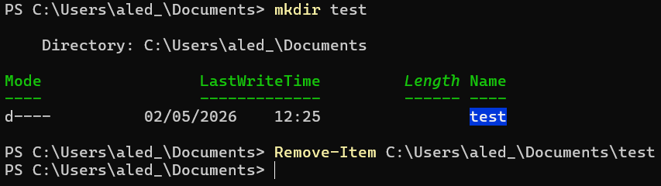  Fig. 12 mkdir (alias for New-Item) and Remove-Item. | “mkdir” is an alias for the “New-Item” cmdlet in PowerShell. It allows the user to create a new directory from the terminal and can be used to created multiple nested directories with a single command [9]. Similarly, “Remove-Item” can be used to delete a specified directory.
Network Testing/ Monitoring | 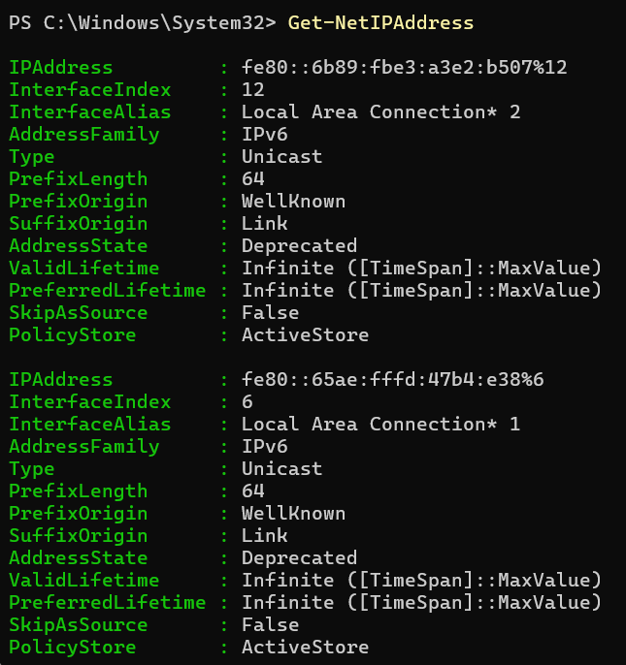  Fig. 13 Get-NetIPAddress. | The “Get-NetIPAddress” cmdlet displays useful information about the IP Address configured on the system. With the use of an additional “-AddressFamily” parameter, the user can specify whether they wish to retrieve an IPv4 or IPv6 address [10].
Network Testing/ Monitoring | 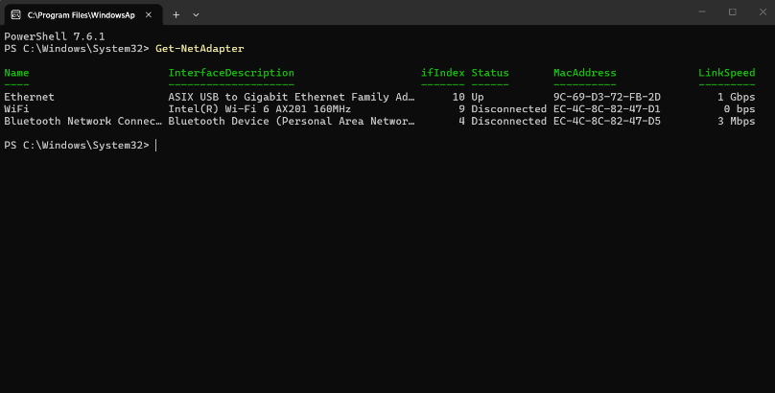  Fig. 14 Get-NetAdapter. | “Get-NetAdapter” retrieves information about the system’s network adapters, including the interface description and Mac address. This is useful in troubleshooting network connectivity issues [11].
User Management | 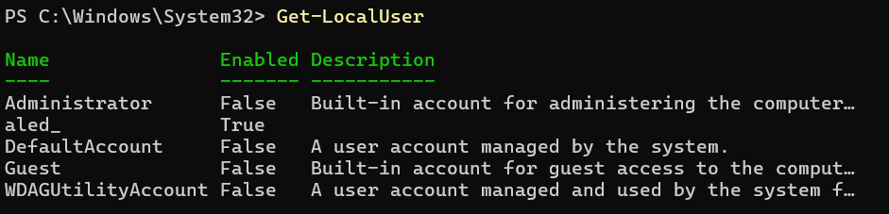  Fig. 15 Get-LocalUser. | The “Get-LocalUser” cmdlet retrieves basic information about user accounts configured on the system. This can assist in system auditing and security, especially for regulated organisations [12].
User Management | 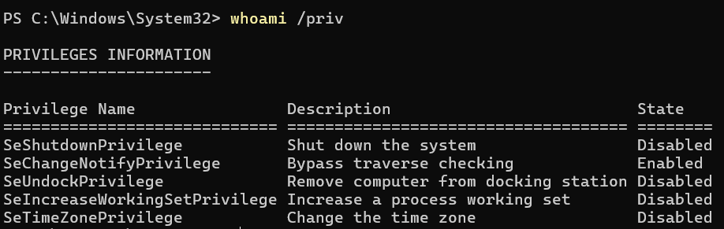  Fig. 16 whoami / priv. | “whoami / priv” displays the security privileges assigned to the current user’s session, showing what the user can and cannot alter at the Operating System’s level. This is vital in assessing permission related issues on a system [13].
Task Scheduling | 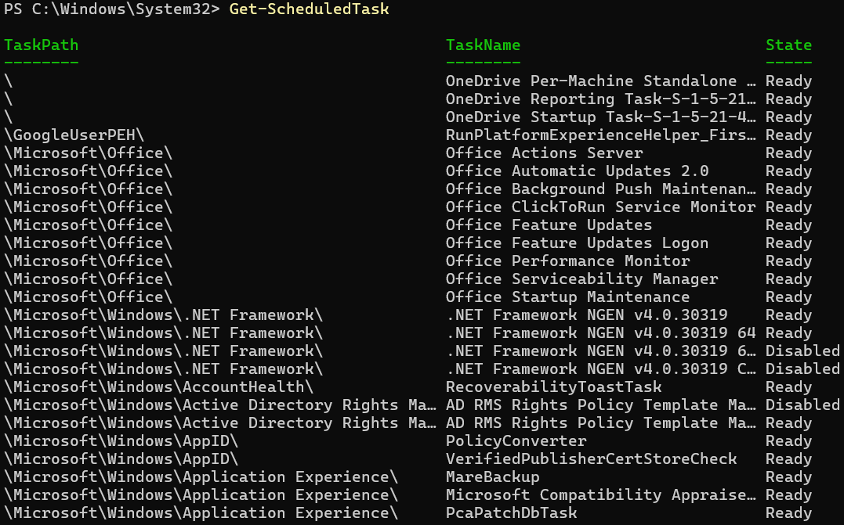  Fig. 17 Get-ScheduledTask. | “Get-ScheduledTask” retrieves all scheduled tasks on the system and can be used to further filter the information to display tasks that are currently running or tasks that are disabled. This can be particularly useful in system performance auditing, where the results can be exported to a CSV file for further analysis [14].
Task Scheduling | 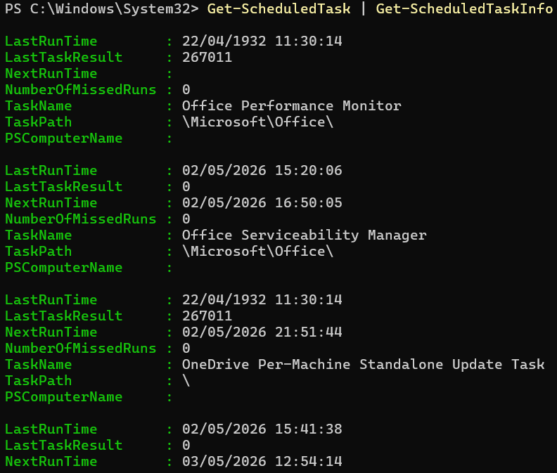  Fig. 18 Get-ScheduleTaskInfo. | The “Get-ScheduledTaskInfo” cmdlet can be used to gain additional information about scheduled tasks, such as the last time the task was run and when it is next scheduled to trigger. This is often used in conjunction with “Get-ScheduledTask” for the purpose of compliance, as organisations need to demonstrate that scheduled tasks like antivirus scans and backups are being completed on schedule [15].

Use of Linux OS CLI commands

Area | Example | Description
Process Management | 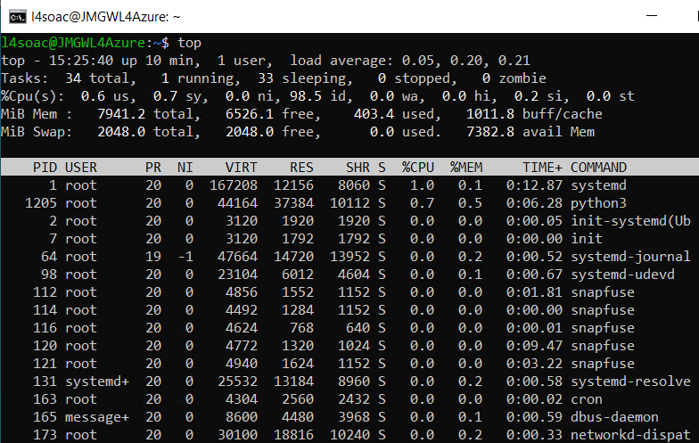  Fig. 19 top. | The “top” command retrieves a list of the current processes running on a system, updating in real-time. This can show how many processes are running, as well as each process’ CPU usage and RAM usage which is useful for system administration and identifying performance issues [16].
Process Management | 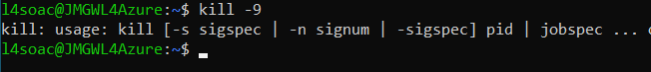  Fig. 20 kill. | The “kill” command sends a signal for a process to be terminated. On a deeper level, the command can send different signals, depending on the circumstances. For example, the signal SIGTERM attempts to terminate the process gracefully, however, this can be ignored. Alternatively, the SIGKILL signal will forcefully terminate the process immediately [17].
File & Directory Management | 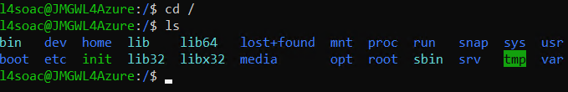  Fig. 21 ls. | The “ls” command in Linux is used to list the contents of any directory. This is key for basic navigation, as well as for monitoring storage usage [18].
File & Directory Management | 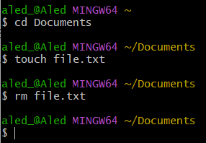  Fig. 22 touch and rm. | In order to create a file from the terminal in Linux the “touch” command can be used. The “rm” command can also be used to delete a file. This is not only efficient but can also be used to modify timestamp information relating to the file [19].
Network Testing/ Monitoring | 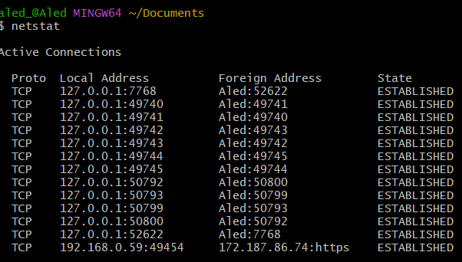  Fig. 23 netstat. | The “netstat” command can be used to retrieve basic information about the system’s network connections, as well as network interface statistics. This provides a solid overview of how a system is communicating over a network [20].
Network Testing/ Monitoring | 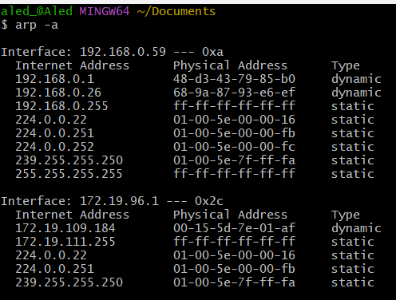  Fig. 24 arp -a. | The command “arp -a” can retrieve information about active devices on the system’s network, such as IP and Mac addresses. The ARP (Address Resolution Protocol) cache can be a useful tool in troubleshooting connectivity issues over a network [21].
User Management | 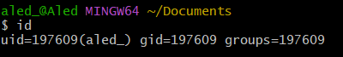  Fig. 25 id. | The “id” command retrieves information about the current user: User ID, Group ID and the groups the user belongs to. This is helpful in troubleshooting permission or access related issues [22].
User Management | 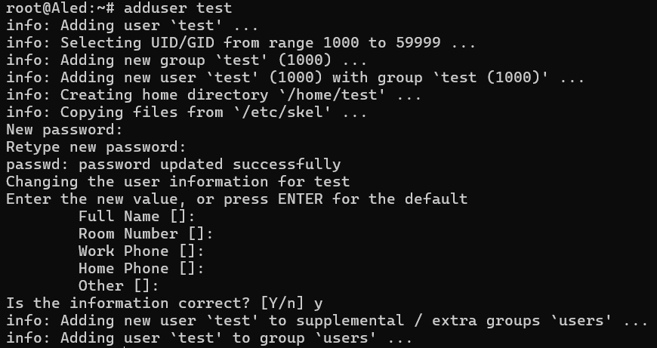  Fig. 26 adduser. | The “adduser” command allows you to enter a new user profile from the terminal. This particular command is a user-friendly version of the “useradd” command, providing a step-by-step guide for setting up a new user [23].
Task Scheduling | 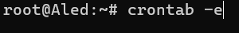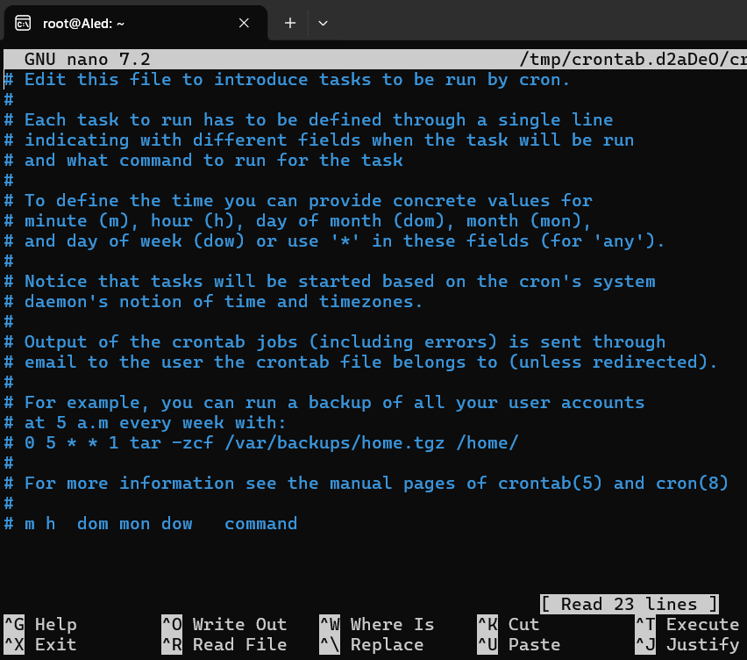  Fig. 27 crontab -e. | By using the “crontab -e” command in Linux, the user can enter a text editor like nano to create or edit scheduled events and processes. This is a fundamental tool used for general task scheduling and automation in Linux [24].
Task Scheduling | 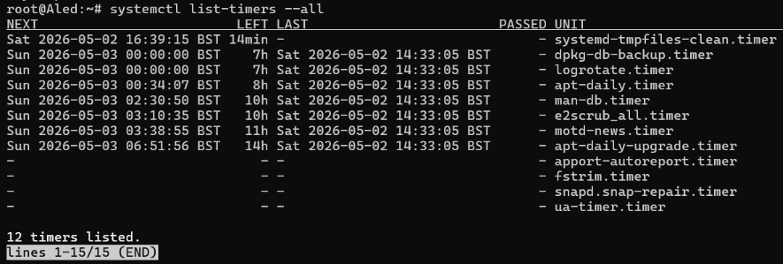  Fig. 28 systemctl list-timers – all. | The command “systemctl list-timers – all” retrieves both active and inactive timers, showing when each scheduled task will run and when the last instance was performed. This is vital for monitoring that key scheduled tasks are running as expected [25].

Use of Windows OS scripts

As a scripting language, PowerShell is an incredibly useful tool for automating repetitive administrative tasks, monitoring/ managing system resources and creating interactive programs directly from the command line in the Windows Operating System [26]. Several of the special features of the PowerShell language are demonstrated below, in the form of a simple, interactive number guessing game.
To begin, the program provides the user with a menu to input the level of difficulty for their game, expanding the target number range as the settings get harder. This introduces a key feature of the PowerShell scripting language, the switch statement. As you can see on lines 8-25 in Fig. 29, a switch statement can be used to check one value against multiple options. In more real-world applications, this can be used in network administration to perform certain actions depending on the specific server or in user administration when writing scripts that run different code depending on the user’s permission level [27].
The usefulness of switch statements would be greatly diminished without the fundamental ability to store and retrieve information in the form of variables [28]. As can be seen in Fig. 29 and Fig. 30, the following information is stored in variables, preceded by the “$” symbol, and are utilised at later points in the script:
- Difficulty
- Maximum number
- Answer
- Guess
- Number of guesses
To expand on the usefulness of variables, PowerShell allows the use of arrays, storing multiple values in one list, as can be seen on line 33 of Fig. 29. This means that a script can iterate over multiple points of data, such as usernames or file paths, without needing to manually check each variable one-by-one [29].
In order to allow the user to guess multiple times until they reach the correct answer, a while loop has been implemented on lines 37-51 of Fig. 30. This is a feature that is heavily utilised in task automation, as the script can evaluate the condition of the statement to determine whether the code in the loop will continue to run or needs to be terminated, without the need for further manual input [30].
Whilst this simple game does not include an exhaustive set of PowerShell’s tools, it outlines some of the key features of the Windows scripting language that are widely applicable to real-world scenarios in areas such as system administration, task automation and user management.
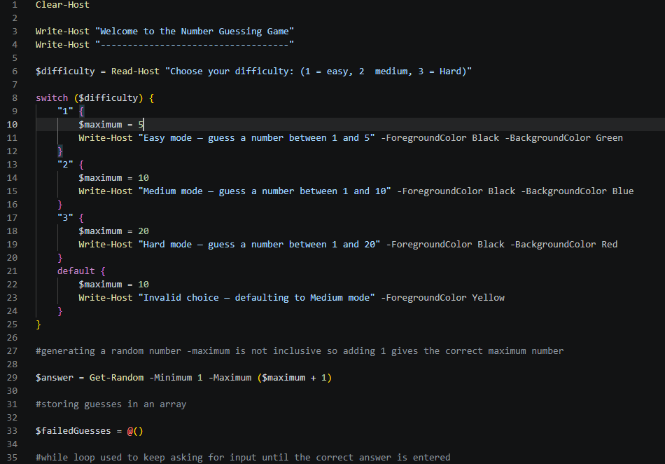
Fig. 29 PowerShell script for a simple number guessing game (part 1).

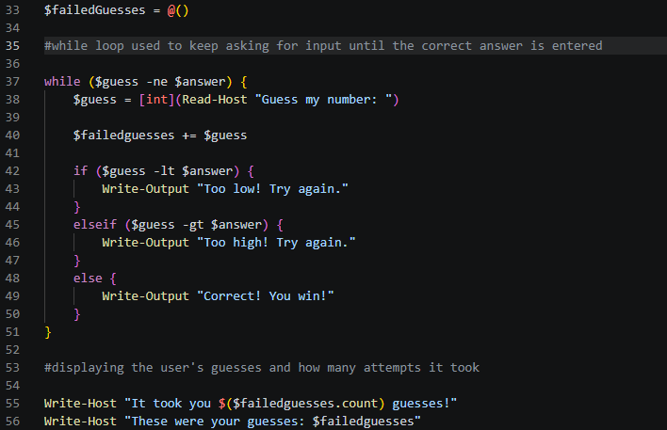
Fig. 30 PowerShell script for a simple number guessing game (part 2).

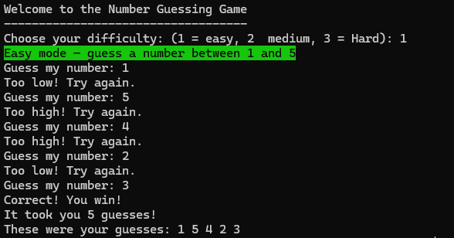
Fig. 31 Output of PowerShell script on Easy Mode.
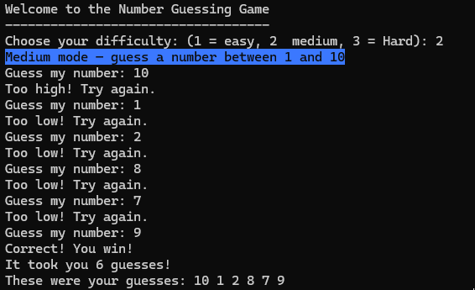
Fig. 32 Output of PowerShell script on Medium Mode.
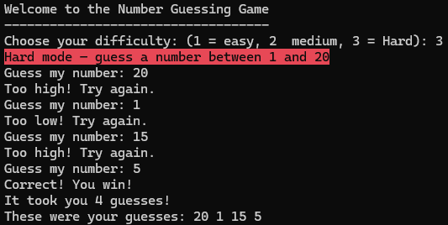
Fig. 33 Output of PowerShell script on Hard Mode.

Use of Linux OS scripts

Similar to PowerShell for Windows, Bash scripting is the most popular and language used on Linux-based machines. Bash scripts are often used for system and network administration, as well as automation. Therefore, to demonstrate some of the features of this language, the simple bash script below presents the user with a “System Administration” menu, allowing the user to monitor basic information from the terminal.
The first line of the script reads “#!/bin/bash”, as can be seen in Fig. 34. This line is essential for all Bash scripts, as it specifies the which interpreter should be used when the Operating System attempts to run the file [31]. The script then moves on to retrieve the current user and the date through a process called command substitution (Fig. 34 lines 8-9). This means that, rather than hardcoding a set of variables, the variables themselves can adapt to the machine’s environment in real-time, which can be useful in reducing the amount of manual re-configuration necessary in system, user or network administration contexts [32].
The bulk of the script consists of separate functions like disk(), memory() and processes(). Separating the various parts of the script into distinct functions improves reusability, as updating the information in the function will automatically change the other instances where the function is called later in the script [33]. In some instances (such as the “-h” on Fig. 4 line 18), additional flags have been used to present the output of the function in a more readable format.
In Fig. 36, the menu is presented to the user, and an input is requested, read and actioned via a case statement. Similar to the switch statement in PowerShell (Fig. 29 lines 8-25), this evaluates the user’s input ($choice) against the set of predetermined options, which then triggers the relevant function to run. The wildcard (*) is also included as an option to catch any invalid inputs. This is a clean and concise alternative to using a stack of if/elif statements to check the value of the input [34].
To further demonstrate some of the more useful aspects of Bash scripting, an array and for loop have been included (Fig. 35 line 54 and lines 62-64). This further highlights what was mentioned in the PowerShell section where, by storing the options for the user menu in an array, the script can print each line out by iterating over the elements, rather than having to manually print each option with “echo”.

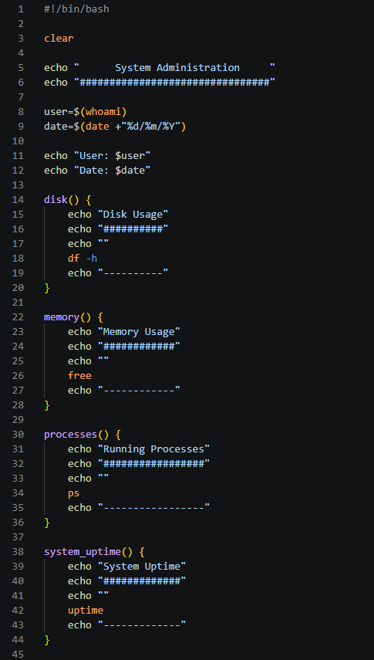
Fig. 34 Bash script for a system administration menu in Linux (part 1).
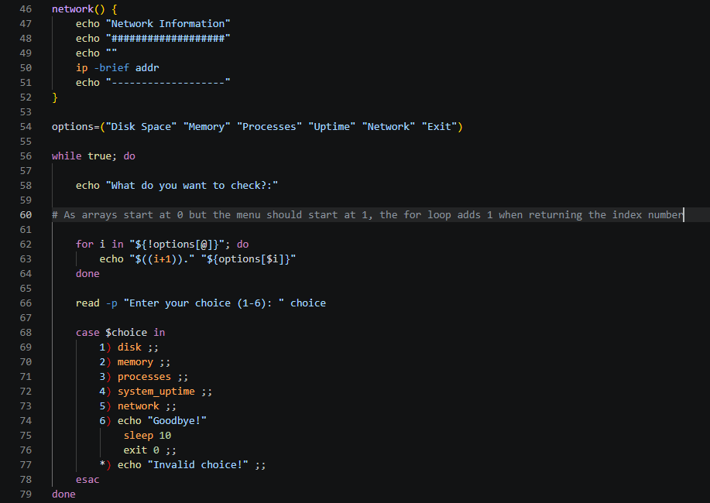
Fig. 35 Bash script for a system administration menu in Linux (part 2).

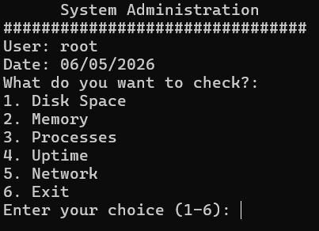
Fig. 36 System administration menu created by Bash script
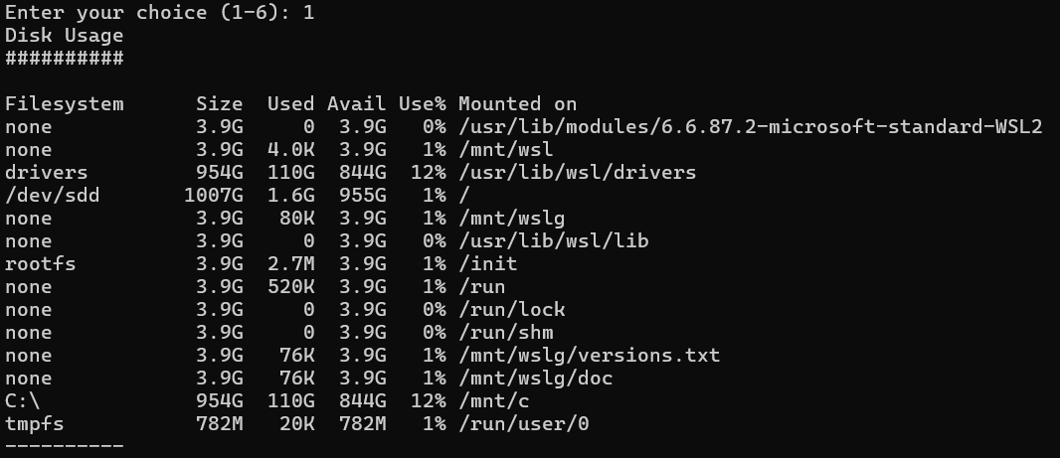
Fig. 37 Bash script – Output 1: Disk usage.
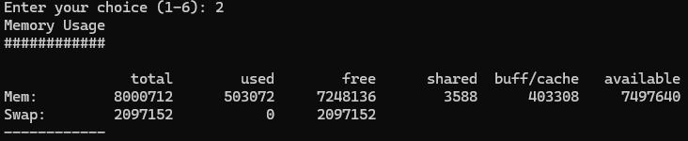
Fig. 38 Bash script – Output 2: Memory usage.
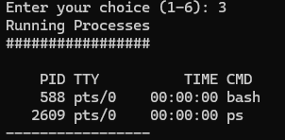
Fig. 39 Bash script – Output 3: Running Processes.
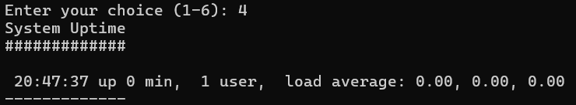
Fig. 40 Bash script – Output 4: System Uptime.

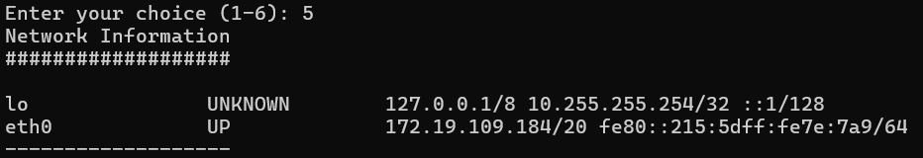
Fig. 41 Bash script – Output 5: Network Information.
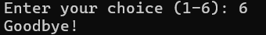
Fig 42. Bash script – Output 6: Exit.

Conclusion

Throughout this report, we have provided a brief overview of the main functions of modern Operating Systems. We have broken these down into five key areas: process management, file and directory management, network testing/ monitoring, user management and task scheduling. Whilst this report is not exhaustive, an understanding of these key areas may form the foundation of understanding that allows for further research into more complex areas of system and network management.
For those previously unfamiliar with the Command Line Interface, the report’s sections on PowerShell and Bash commands provides a great starting point for utilising simple but effective tools to gain a deeper insight into Operating Systems. These commands, with accompanying examples, allow the user to efficiently access critical system information like disk usage, IP or Mac address information and scheduled tasks. With this information, monitoring and troubleshooting issues on any particular machine or network becomes much easier. This is especially important in the context of a regulated business or organisation, where regular auditing is necessary to ensure compliance.
Finally, this report applies the introductory information outlined in previous sections and combines it in the form of example scripts for both PowerShell and Bash. Whilst these scripts are simple in nature, the concepts that they contain, such as modular functions, switch/ case statements and while/ for loops, are widely used to automate repetitive or time-intensive administration tasks.
By grasping the basic concepts in this report, the user is empowered to explore more advanced CLI commands and scripting to further enhance their understanding of Operating Systems and the tools that are available to navigate, manage and automate tasks within these environments.

References
[1] Geeksforgeeks, "Operating System Tutorial." Geeksforgeeks. Accessed: Feb 2 2026. [Online]. Available: https://www.geeksforgeeks.org/operating-systems/operating-systems/
[2] Shacklett, Mary E. & Bigelow, Stephen J. "What is an Operating System (OS)? | Definition from TechTarget." Techtarget. Accessed: Feb 2 2026. [Online]. Available: https://www.techtarget.com/whatis/definition/operating-system-OS
[3] A. S. Tanenbaum and H. Bos, Modern operating systems, Global edition, Fourth edition. Harlow, England: Pearson, 2014.
[4] P. Singh. "Device Management in Operating System." Scaler. Accessed: Mar 2 2026. [Online]. Available: https://www.scaler.com/topics/device-management-in-operating-system/
[5] Geeksforgeeks, "Operating System Security." Geeksforgeeks. Accessed: Mar 2 2026. [Online]. Available: https://www.geeksforgeeks.org/operating-systems/operating-system-security/
[6] Microsoft, “Get-Process (Microsoft.PowerShell.Management) - PowerShell,” Microsoft Learn. [Online]. Available: https://learn.microsoft.com/powershell/module/microsoft.powershell.management/get-process. [Accessed: 3-May-2026].
[7] shelladmin. "PowerShell Stop-Process - How to Kill Process If Running." ShellGeek. Accessed: May 3 2026. [Online]. Available: https://shellgeek.com/stop-process-in-powershell/
[8] Microsoft, "Get-ChildItem (Microsoft.PowerShell.Management)," Microsoft Learn, [Online]. Available: https://learn.microsoft.com/en-us/powershell/module/microsoft.powershell.management/get-childitem. [Accessed: 04 May 2026].
[9] SS64, "New-Item," SS64, [Online]. Available: https://ss64.com/ps/new-item.html. [Accessed: 04 May 2026].
[10] S. Rajack. "How to Get the IP Address Using PowerShell?" SharePoint Diary. Accessed: May 4 2026. [Online]. Available: https://www.sharepointdiary.com/2020/11/get-ip-address-using-powershell.html
[11] J. Bodnar. "PowerShell Get-NetAdapter." https://zetcode.com/powershell/get-netadapter/. Accessed: May 4 2026. [Online]. Available: https://zetcode.com/powershell/get-netadapter/
[12] D. Murphy. "How to List All User Accounts on a Windows System Using PowerShell." Lepide. Accessed: May 4 2026. [Online]. Available: https://www.lepide.com/how-to/list-all-user-accounts-on-a-windows-system-using-powershell.html
[13] LearnMandu, "WHOAMI Command – Display Current User and Security Info in Windows," LearnMandu, Mar. 14, 2026. [Online]. Available: https://learnmandu.com/blog/whoami. [Accessed: 04 May 2026].
[14] NinjaOne, "How to Use PowerShell to Audit Scheduled Tasks," NinjaOne Blog, Feb. 12, 2026. [Online]. Available: https://www.ninjaone.com/blog/use-powershell-to-audit-scheduled-tasks/. [Accessed: 04 May 2026].
[15] Splunk, "Monitoring Scheduled Tasks with PowerShell," Splunk Blog, [Online]. Available: https://www.splunk.com/en_us/blog/tips-and-tricks/monitoring-scheduled-tasks-with-powershell.html. [Accessed: 04 May 2026].
[16] Site24x7, "Top 7 Linux Performance Commands for System Administrators," Site24x7, [Online]. Available: https://www.site24x7.com/learn/linux/top-commands-for-sysadmins.html. [Accessed: 04 May 2026].
[17] Liquid Web, "How to Use Kill Commands in Linux," Liquid Web Blog, Jan. 15, 2026. [Online]. Available: https://www.liquidweb.com/blog/linux-kill-commands/. [Accessed: 04 May 2026].
[18] University of Cambridge, “The ls command,” Cambridge Computing Group. [Online]. Available: https://www.maths.cam.ac.uk/computing/linux/unixinfo/ls. [Accessed: 4-May-2026].
[19] PhoenixNAP, “How to use the touch command in Linux,” PhoenixNAP Knowledge Base. [Online]. Available: https://phoenixnap.com/kb/touch-command-in-linux. [Accessed: 4-May-2026].
[20] YouStable, “Netstat Command in Linux Explained With Examples in 2026,” YouStable Blog, 2026. [Online]. Available: https://www.youstable.com/blog/netstat-command-in-linux. [Accessed: 4-May-2026].
[21] Linux Wiki, “arp - Display and manipulate ARP cache,” Linux Command Reference. [Online]. Available: https://linux.wiki/docs/commands/system-info/arp. [Accessed: 4-May-2026]
[22] GeeksforGeeks, “id command in Linux with examples,” GeeksforGeeks, 2026. [Online]. Available: https://www.geeksforgeeks.org/linux-unix/id-command-in-linux-with-examples/. [Accessed: 4-May-2026].
[23] LinuxOpsys, “adduser command in Linux,” LinuxOpsys. [Online]. Available: https://linuxopsys.com/adduser-command-in-linux. [Accessed: 4-May-2026].
[24] GeeksforGeeks, “Crontab in Linux with examples,” GeeksforGeeks, 2026. [Online]. Available: https://www.geeksforgeeks.org/linux-unix/crontab-in-linux-with-examples/. [Accessed: 4-May-2026].
[25] Simplified Guide, “How to list systemd timers,” simplified.guide. [Online]. Available: https://www.simplified.guide/systemd/timer-list. [Accessed: 4-May-2026].
[26] Microsoft, "What is PowerShell?," Microsoft Learn, [Online]. Available: https://learn.microsoft.com/en-us/powershell/scripting/overview. [Accessed: 04 May 2026].
[27] PsCustomObject, "PowerShell Switch Statement," Hitchhiker's GUID(e) to Automation, Jul. 30, 2020. [Online]. Available: https://pscustomobject.github.io/powershell/howto/PowerShell-Switch-Statement/. [Accessed: 04 May 2026].
[28] R. de Jong, "How to Use PowerShell Variables," LazyAdmin, Jan. 18, 2024. [Online]. Available: https://lazyadmin.nl/powershell/powershell-variables/. [Accessed: 04 May 2026].
[29] Microsoft, "About Arrays," Microsoft Learn, [Online]. Available: https://learn.microsoft.com/en-us/powershell/module/microsoft.powershell.core/about/about_arrays. [Accessed: 04 May 2026].
[30] Microsoft, "About While," Microsoft Learn, [Online]. Available: https://learn.microsoft.com/en-us/powershell/module/microsoft.powershell.core/about/about_while. [Accessed: 04 May 2026].
[31] Linuxize, "Bash Shebang," Linuxize, Jul. 23, 2019. [Online]. Available: https://linuxize.com/post/bash-shebang/. [Accessed: 07 May 2026].
[32] GNU Project, "Command Substitution," Bash Reference Manual, [Online]. Available: https://www.gnu.org/software/bash/manual/bash.html#Command-Substitution. [Accessed: 07 May 2026].
[33] GNU Project, "Shell Functions," Bash Reference Manual, [Online]. Available: https://www.gnu.org/software/bash/manual/bash.html#Shell-Functions. [Accessed: 07 May 2026].
[34] SS64, "case," SS64 Bash Reference, [Online]. Available: https://ss64.com/bash/case.html. [Accessed: 07 May 2026].

Appendix A – Lecture Activities

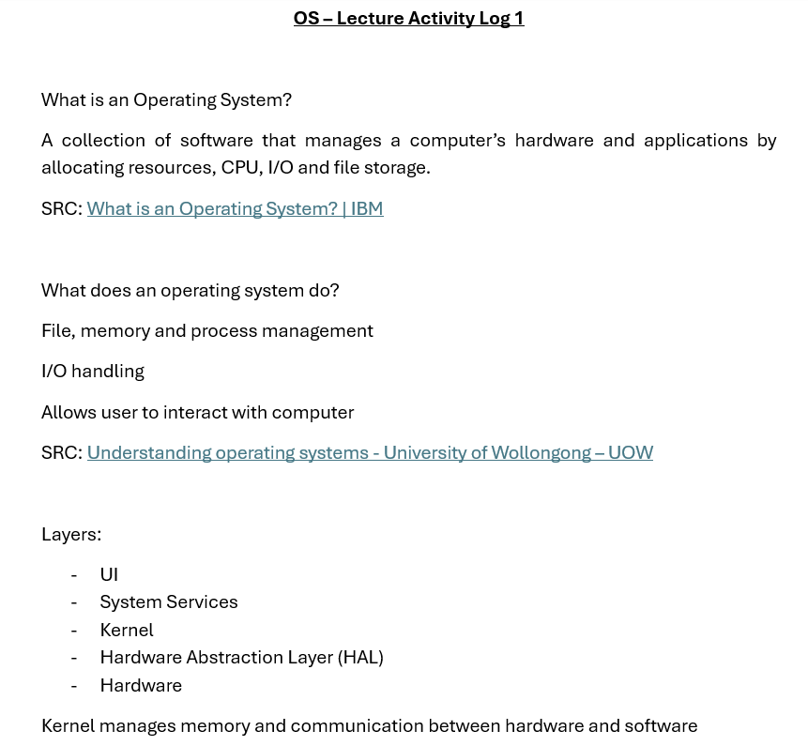

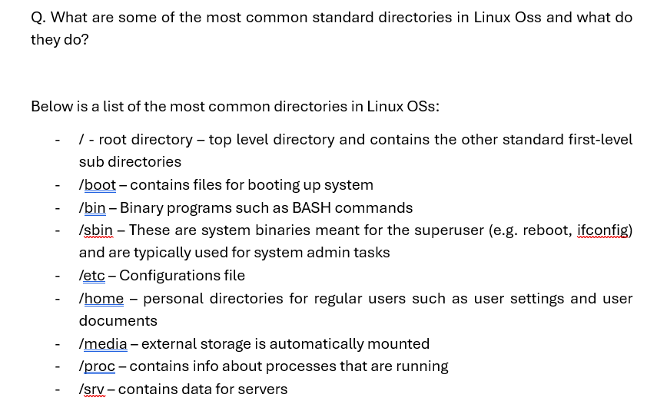

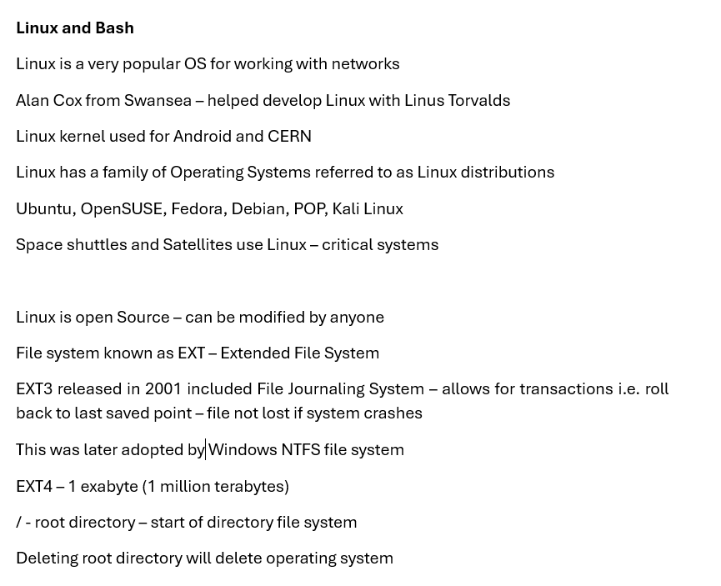

Appendix B – Online Course Evidence

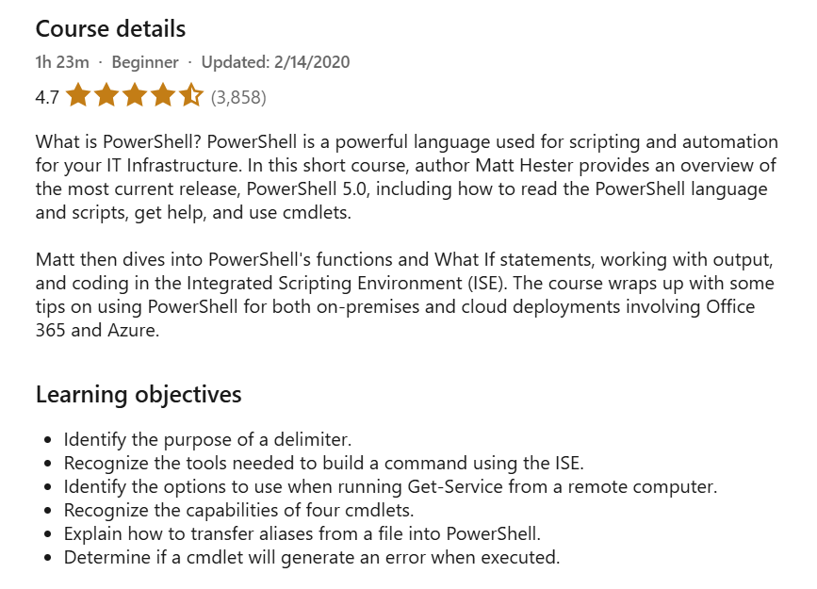
LinkedIn Learning - “Learning PowerShell” Course Overview

Quiz results - Section 1 “PowerShell Overview”

Quiz results – Section 2 “Using PowerShell”

Quiz results – Section 3 “Taking PowerShell on Premises and Online”

