PG1 - FULL RESEARCH PROPOSAL

This form is to be completed by both the student and supervisory team within THREE months for full-time students and SIX months for part time students, after the commencement of the research degree or following progression to Part Two of your course.

Once complete, submit this form via the MyTSD Doctoral College Portal at (https://mytsd.uwtsd.ac.uk).

This document is also available in Welsh.

Student Details
Student Family / Surname: |  | GENG
Student Given / First name: |  | HUAN
Student Number |  | 2000319
Start Date | 1/10/2024 | End Date | 30/09/2027

PhD  by Research | PhD  Practice Based | PhD by  Published Works | Professional Doctorate  (including DBA, DProf, Ed D) | MPhil by Research | MPhil  Practice Based
☐ | ☐ | ☐ | ☒ | ☐ | ☐
MA by Research | MSc by Research | MRes
☐ | ☐ | ☐

Proposed Research

Current Proposed Title (20 / 30 words):
Evaluating the Adoption and Impact of Smart Farming Technologies on Family Farms in Wuchang
Background & Context (approx. 500 words)

The contemporary agricultural industry is confronted with a plethora of challenges, encompassing limited resources and the pressing need to ensure sustenance for an expanding global population. Traditional farming methods are increasingly struggling to meet these demands, prompting a search for more efficient and sustainable alternatives. One potential resolution lies in the implementation of intelligent agriculture, commonly known as precision farming(Wolfert et al., 2017).

Smart farming technologies involves a variety of practices that leverage technology to more effectively monitor and manage crops and livestock. This approach, based on data analysis, empowers farmers to make well-informed choices, resulting in improved resource efficiency, increased yields, and minimized ecological footprint (Zhang et al., 2020). The early adoption of smart farming technologies has already demonstrated considerable benefits in several agricultural sectors, offering a potential blueprint for modernizing farming practices on a global scale.

Within this context, the concept of the family farm is particularly important. Family farms are typically managed and operated by family members, who provide the majority of the labor and decision-making. These farms can vary in size, but they are often small to medium-sized operations. They play a crucial role in rural economies and contribute significantly to food security, making them a key focus for the adoption of smart farming technologies (Lowder, Skoet, and Raney, 2016).

Wuchang City, known for its extensive rice cultivation, serves as an insightful case study for examining the adoption of smart farming technologies. Agriculture in Wuchang faces several challenges, including fluctuating market prices, labor shortages, and the impacts of climate change. However, despite these obstacles, there is growing interest among local farmers in adopting intelligent agricultural technologies, spurred by the potential for greater efficiency and productivity.

Currently, smart farming adoption in Wuchang remains in its early stages. While some innovative farmers have started using IoT sensors and drones for crop monitoring, overall adoption rates remain low due to barriers such as high costs, limited technical expertise, and insufficient access to information (Klerkx, Jakku, and Labarthe, 2019). Understanding these barriers and the motivations behind adoption is crucial for developing strategies to promote the uptake of smart farming practices in the region.

This research offers substantial contributions to both academic knowledge and practical applications. By expanding the current understanding of smart farming technologies beyond AI-driven precision agriculture, it provides a broader view of advanced agricultural practices. Focusing specifically on rice farming in Wuchang, the study delivers detailed insights into the technologies being adopted and the factors influencing their uptake. This localized investigation fills a crucial gap in the literature, providing empirical data on smart farming's usage and impact in a specific agricultural setting. Moreover, the mixed methods approach enhances the research by integrating both quantitative and qualitative data, offering a comprehensive perspective on technology adoption and its broader economic and social impacts (Brewster et al., 2017; Klerkx, Jakku, and Labarthe, 2019).

This study provides valuable practical insights for agricultural practitioners to overcome common obstacles in adopting new practices, such as financial constraints and limited awareness, thereby enhancing the professional and academic quality of their work. It outlines key strategies for overcoming these obstacles and highlights the potential economic and social benefits, thereby enabling farmers to make well-informed choices regarding the adoption of intelligent agricultural techniques (Rose and Chilvers, 2018). Technology providers can also benefit from this research by acquiring an extensive comprehension of the distinct needs and expectations of agricultural workers in Wuchang, thereby facilitating the development of more user-friendly and customized solutions (Bryman, 2016). From a policy standpoint, the research generates valuable data that can guide the formulation of supportive programs, such as subsidies and training initiatives, to encourage the wider adoption of smart farming technologies. Ultimately, this contributes to the modernization of the agricultural sector and strengthens food security (Klerkx, Jakku, and Labarthe, 2019; Israel, 2015).

This research aims to identify the specific smart farming technologies employed in rice farming in Wuchang, determine the key factors that influence their adoption, and assess the economic and social benefits they provide. By addressing these objectives, the study will offer valuable insights into how smart farming can be effectively integrated into local agricultural practices, while also highlighting the challenges that need to be overcome.
Aims and Objectives (approx.. 250 – 500 words)
This study aims to comprehensively examine the adoption, impact, and practical implications of intelligent agricultural technologies on family-owned farms in Wuchang. It will employ a combination of research methods to identify key factors influencing technology adoption, evaluate the economic and social benefits, and provide practical recommendations for farmers, technology providers, and policymakers.

Research Objectives:
- To catalog the specific smart farming technologies currently being utilized by family farms in Wuchang.
- To measure the adoption rates and patterns of smart farming technologies among rice farmers in Wuchang.
- To identify and analyze the macro-level factors (economic, social, and technological) that influence the adoption of smart farming technologies.
- To evaluate the economic and social impacts of smart farming technology adoption on family farms in Wuchang.
- To develop practical recommendations for enhancing the adoption and impact of smart farming technologies for farmers, technology providers, and policymakers in Wuchang.
Proposed plan of work including timetable
Planned Development (e.g. submission of form, completion of chapter, submission of thesis) | Target Date
Submission of Research Proposal (including literature review) | December 2024
PG2 and Ethical Approval Application | January 2025
Completion of Literature Review | February - March 2025
Pilot Survey & Refinement of Instruments (Survey and Interview Guide) | April - May 2025
Fieldwork and Data Collection (Spring Observation in Wuchang) | June - August 2025
Data collection, Data Cleaning and Preliminary Data Analysis( data collection in Wuchang) | September - October 2025
Fieldwork and Data Collection (Autumn Observation in Wuchang) | October - November 2025
Full Data Analysis (Quantitative & Qualitative) | December 2025 - February 2026
Draft of Methodology Chapter | March 2026
Draft of Findings and Analysis Chapters | April - June 2026
Submission of Draft Thesis | July 2026
Review and Feedback from Supervisors | August 2026
Revision of Thesis | September - December 2026
Final Data Collection (if necessary) | January - February 2027
Final Thesis Revisions and Editing | March - June 2027
Submission of Final Thesis | July 2027
Thesis Defense and Final Review | August - September 2027

Proposed methodology (approx. 500 words):
The present study will employ a pragmatic framework, with a specific focus on addressing real-world challenges and generating actionable outcomes. It is particularly well-suited for investigating the implementation of intelligent agricultural technologies. To address practical research inquiries, researcher will adopt an integrated approach that combines quantitative and qualitative methods.

Disciplinary Orientation/Approach
The study is grounded in agricultural technology and rural development, drawing upon theories from Diffusion of Innovations (DOI) Theory by Everett Rogers (2003), the Technology Acceptance Model (TAM) (Davis, 1989), and Social Constructivism (Berger and Luckmann, 1966). These frameworks are essential for explaining how new technologies, such as smart farming tools, are perceived and adopted within specific communities. The research aims to generate both academic knowledge and practical solutions for farmers, technology providers, and policymakers, addressing the primary determinants that impact the acceptance of and successful implementation of smart farming technologies.

Methods
1. Quantitative Methods:
To capture adoption rates and patterns, structured surveys will be conducted with a representative sample of rice farmers in Wuchang. The survey will gather data on the types of smart farming technologies being used, their frequency of use, perceived benefits, barriers to adoption, and demographic characteristics such as age, education, and farm size. Surveys will be distributed through online platforms and in-person visits to ensure broad participation. This data will enable statistical analysis of adoption trends and provide insights into the economic, social, and technological factors driving these patterns.

2. Qualitative Methods:
In-depth interviews will complement the quantitative data by offering a deeper exploration of the motivations, challenges, and perceptions that influence technology adoption. A purposive sample of both adopters and non-adopters will be selected to participate in these interviews, allowing for an in-depth examination of their experiences with smart farming technologies. The interviews will provide qualitative insights into the barriers to adoption, such as high costs or lack of technical knowledge, as well as the perceived benefits that drive adoption among early users.

3. Secondary Data Collection:
Secondary data from government reports, agricultural institutions, and industry publications will be used to provide contextual background on the agricultural sector in Wuchang. This will help frame the research findings within the broader economic, social, and policy environment that affects the adoption of smart farming technologies (Klerkx, Jakku, and Labarthe, 2019).

4. Data Analysis:
The statistical analysis will involve the utilization of quantitative data obtained from surveys, employing techniques such as descriptive statistics and regression analysis. This approach will enable us to identify patterns in technology adoption and key factors that influence it (Davis, 1989). Additionally, qualitative data gathered through interviews will be subjected to thematic analysis to identify recurring themes associated with barriers to and adoption of technology. By adopting this mixed methods approach, we can achieve a comprehensive understanding of the topic by capturing both overarching trends and individual experiences.

The research follows a pragmatic paradigm, which prioritizes solutions to real-world problems over abstract theoretical considerations. By employing a mixed methods approach, this research balances quantitative data on technology adoption rates with qualitative insights into farmers' personal experiences. This approach aligns with the pragmatic emphasis on actionable outcomes, as it ensures that both macro-level trends (e.g., economic and technological factors) and micro-level factors (e.g., individual motivations and barriers) are addressed. Ultimately, this methodology is well-suited to the study's goal of generating practical recommendations for improving the adoption and impact of smart farming technologies in Wuchang (Morgan, 2014).

Conclusion
By utilizing a mixed methods approach informed by the pragmatic paradigm, this research provides a holistic view of the adoption of smart farming technologies in Wuchang. The combination of quantitative and qualitative data allows for a thorough analysis of both measurable adoption rates and the contextual factors influencing farmers' decisions. This methodology not only addresses the research objectives but also ensures that the study delivers practical, data-driven recommendations for stakeholders looking to enhance smart farming adoption in the region.
Introductory bibliography:
Baxter, G. and Sommerville, I., (2011). Socio-technical systems: From design methods to systems engineering. Interacting with Computers, 23(1), pp.4-17.

Blackmore, S., (2018). Bridging the Knowledge Gap in Precision Agriculture. Precision Farming Times. Available at: [Precision Farming Times].

Brewster, C., Roussaki, I., Kalatzis, N., Doolin, K. and Ellis, K., (2017). IoT in agriculture: Designing a Europe-wide large-scale pilot. IEEE Communications Magazine, 55(9), pp.26-33.

Bryman, A., (2016). Social Research Methods. 5th ed. Oxford: Oxford University Press.

Creswell, J.W. and Plano Clark, V.L., (2018). Designing and Conducting Mixed Methods Research. 3rd ed. Thousand Oaks, CA: Sage.

Davis, F.D., (1989). Perceived usefulness, perceived ease of use, and user acceptance of information technology. MIS Quarterly, 13(3), pp.319-340.

Eastwood, C., Klerkx, L. and Nettle, R., (2017). Dynamics and distribution of public and private research and extension roles for technological innovation and diffusion: Case studies of the implementation and adaptation of precision farming technologies. Journal of Rural Studies, 49, pp.1-12.

Etikan, I., Musa, S.A. and Alkassim, R.S., (2016). Comparison of convenience sampling and purposive sampling. American Journal of Theoretical and Applied Statistics, 5(1), pp.1-4.

FAO, (2019). Smart Farming for Sustainable Agriculture. FAO Essays. Available at: [FAO Essays].

Frontiers in Agriculture, (2023). Mobile robotics in smart farming: Current trends and applications. Frontiers in Agriculture. Available at: www.frontiersin.org [Accessed 14 October 2024].

Israel, M., (2015). Research Ethics and Integrity for Social Scientists: Beyond Regulatory Compliance. 2nd ed. Thousand Oaks, CA: Sage.

John Deere, (2020). The Future of Farming: Embracing Smart Technologies. John Deere Insights. Available at: [John Deere Insights].

Johnson, R.B., Onwuegbuzie, A.J. and Turner, L.A., (2007). Toward a definition of mixed methods research. Journal of Mixed Methods Research, 1(2), pp.112-133.

Klerkx, L., Jakku, E. and Labarthe, P., (2019). A review of social science on digital agriculture, smart farming and agriculture 4.0: New contributions and a future research agenda. NJAS-Wageningen Journal of Life Sciences, 90, p.100315.

Lowder, S.K., Skoet, J. and Raney, T., (2016). The number, size, and distribution of farms, smallholder farms, and family farms worldwide. World Development, 87, pp.16-29.

Lundvall, B.A., (2010). National Systems of Innovation: Toward a Theory of Innovation and Interactive Learning. London: Anthem Press.

MIT Technology Review, (2020). The Future of Smart Farming: Emerging Trends and Technologies. MIT Technology Review. Available at: [MIT Technology Review].

Mock, S., (2019). The Next Big Thing in Smart Farming. Agri-Tech Blog. Available at: [Agri-Tech Blog].

Morgan, D.L., (2014). Integrating Qualitative and Quantitative Methods: A Pragmatic Approach. Thousand Oaks, CA: Sage.

Morgan, D.L., (2007). Paradigms lost and pragmatism regained: Methodological implications of combining qualitative and quantitative methods. Journal of Mixed Methods Research, 1(1), pp.48-76.

Paustian, M. and Theuvsen, L., (2017). Adoption of precision agriculture technologies by German crop farmers. Precision Agriculture, 18(5), pp.701-716.

Rogers, E.M., (2003). Diffusion of Innovations. 5th ed. New York: Free Press.

Rose, D.C. and Chilvers, J., (2018). Agriculture 4.0: Broadening responsible innovation in an era of smart farming. Frontiers in Sustainable Food Systems, 2, p.87.

Saik, R., (2017). The Social Revolution in Smart Farming. Agri-Futures Journal. Available at: [Agri-Futures Journal].

Schimmelpfennig, D. and Ebel, R., (2016). On the doorstep of the information age: Recent adoption of precision agriculture. Agricultural Economics, 47(5), pp.185-191.

Springer, (2023). Enhancing resilience in agricultural production systems with AI-based technologies. Environment, Development and Sustainability. Available at: link.springer.com [Accessed 14 October 2024].

Springer, (2023). Smart agriculture and agricultural robotics: Review and perspective. SpringerLink. Available at: link.springer.com [Accessed 14 October 2024].

Vygotsky, L.S., (1978). Mind in Society: The Development of Higher Psychological Processes. Cambridge, MA: Harvard University Press.

Wang, X., (2021). Internet of Things for the future of smart agriculture: A comprehensive survey of emerging technologies. IEEE Journal of Agricultural Sciences, 142, pp.283-297. Available at: ieee-jas.net [Accessed 14 October 2024].

Wolfert, S., Ge, L., Verdouw, C. and Bogaardt, M.J., (2017). Big Data in Smart Farming – A review. Agricultural Systems, 153, pp.69-80.

Zhang, Y., Wang, C., Zhang, H. and Hu, R., (2020). The impact of agricultural extension on farmer nutrient management behavior in Chinese wheat-corn production. Journal of Integrative Agriculture, 19(12), pp.2992-3004.

Facilities and resources available for the investigation: please indicate if you expect to need any special resources
This research into the adoption of smart farming technologies requires several key facilities and resources to ensure thorough data collection and analysis. Below is an overview of the necessary resources and access plans.

1. Libraries and Archives
Access to both physical and digital libraries will be critical:

University Library Resources: The university library will be a central resource for accessing academic journals, books, and research databases, including SCI-Space, EBSCO, and ScienceDirect. These platforms are essential for obtaining peer-reviewed literature on smart farming technologies and AI in agriculture. I already have institutional access to these resources, ensuring comprehensive support for the research.

Online Databases: The university's online library also offers access to a range of the latest research publications. My institutional subscription ensures that I can utilize these databases effectively for the literature review and analysis.

2. Specialist IT Facilities
Data Analysis Software: The research will require advanced data analysis tools. For quantitative data, I will use SPSS for statistical analysis, while ggplot and R will be employed for creating visualizations. NVivo will be used for coding and analyzing qualitative data. All these tools are available through the university’s IT facilities, with access permissions already confirmed.

Survey and Interview Tools: For survey distribution, I will use Google Forms and Questionnaire Star to reach participating farmers. These tools are fully accessible, and I have already secured the necessary permissions to use them for data collection purposes.

3. Fieldwork and Interviews
Fieldwork Location: The fieldwork will take place in Wuchang City, where interviews with local farmers will be conducted. Given the seasonal nature of farming activities, I anticipate spending several months (primarily in the spring and autumn) in the region, observing farming practices and conducting interviews. I will seek permission from the university to support my travel to Wuchang during these periods.

Ethical Clearance and Permissions: Ethical approval has been granted for conducting interviews and field research, with all relevant ethical considerations addressed. In line with the principles of Axiology, the research design emphasizes ethical responsibility and the value of participant engagement. Consent forms will be used to ensure all participants are fully informed about the research, their rights, and the use of the data collected.

Travel and Finance: The funding for travel and fieldwork has not yet been fully secured. I am exploring whether the university or external sources can provide financial support for travel and accommodation. In the event that external funding is unavailable, I will manage the research budget carefully to ensure that the project progresses as planned.

4. Permissions for Access
Governmental and Institutional Access: I have obtained permission from the local agricultural department to conduct research within Wuchang City. No additional permits are required for gathering data in public areas.

Access to Private Facilities: Some of the farms that have adopted smart technologies are privately owned. I have established contacts with several farmers who have granted me permission to interview them and observe their farm operations, ensuring comprehensive access to the necessary data.

By leveraging these facilities and resources, I am confident that this research will be conducted efficiently, leading to meaningful insights into the adoption and use of smart farming technologies in Wuchang.

Intellectual Property IP
It is anticipated that Intellectual Property (IP) will be produced as a result of this research.
Tick √
 | YES | NO
Is the IP already subject to a separate agreement with a third party (e.g. employer, sponsor or external funder)? If so please provide details below | ☐ | ☒
Is the research dependent upon background IP owned by:  If so, please provide details below | UWTSD  ☐ | A third party  ☐
Text box will expand

Tick √
I understand that: | YES | NO
If any party other than the student is likely to be involved in the development of IP a separate IP agreement will be needed and it may be necessary for the student to assign the IP rights to the University. | ☒ | ☐
If there are no third parties involved in the creation of the IP the student is deemed to own the IP, however should the student wish to commercially exploit their IP and require the assistance of the University to do so, they will be required to assign their IP to the University. https://www.uwtsd.ac.uk/iiced/protecting-innovation-and-creativity---intellectual-property/ | ☒ | ☐

Student Signature

Signature or Print Name: | 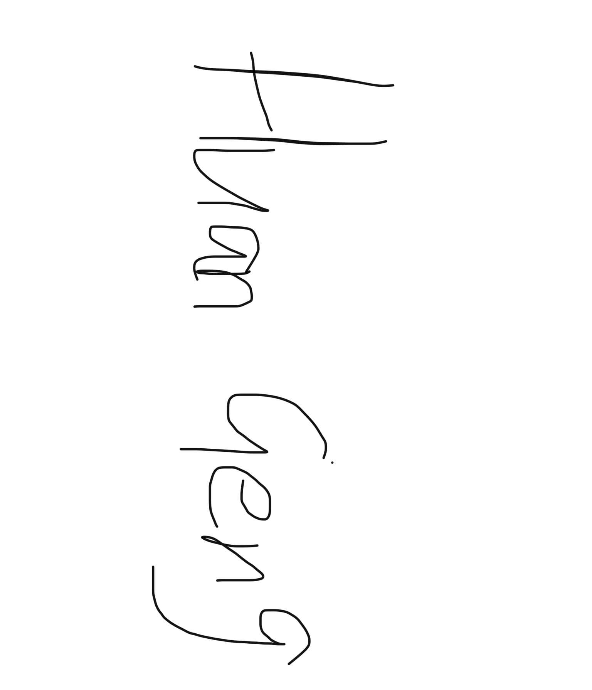 | Date: 14/10/2024

Supervisory Team

Has the student proposed a viable research project that is appropriate for this programme that should be supported by the Institute?
Supported: ☐ Not Supported: ☐

Authorisation

Director of Studies | Signature or Print Name: | Date:
Institute Manager of Research Degrees | Signature or Print Name: | Date:

Once complete, submit this form via the MyTSD Doctoral College Portal at (https://mytsd.uwtsd.ac.uk).

