Fundamentals of Construction Technology
Module: ACBA4001
Student: 1910146

Contents
Introduction……………………………………………………………………………………………………………………pg. 4
Suspended Timber Ground Floor…………………………………………………………………………………….pg. 5
First Floor Framing Structure…………………………………………………………………………………………..pg. 6
Partition Walls………………………………………………………………………………………………………………..pg. 6
Internal Load Bearing/Partition Walls……………………………………………………………………………..pg. 6
Internal Load Bearing/Partition Walls continued…………………………………………………….pg. 7
Openings, Doors and Windows……………………………………………………………………………………….pg. 7
Eaves and Roof……………………………………………………………………………………………………………….pg. 7
Warm Roof……………………………………………………………………………………………………………………..pg. 7
Warm Roof Continued……………………………………………………………………………………………pg. 8
Cold Roof………………………………………………………………………………………………………………………..pg. 8
Main Roof Structure……………………………………………………………………………………………………….pg. 8
Conclusion………………………………………………………………………………………………………………………pg. 8
Conclusion Continued…………………………………………………………………………………………….pg. 9
References……………………………………………………………………………………………………………………pg. 10
References Continued………………………………………………………………………………………….pg. 11
References Continued………………………………………………………………………………………….pg. 12
Appendices……………………………………………………………………………………………………………………pg. 13
Appendix 1…………………………………………………………………………………………………………..pg. 13
Appendix 2…………………………………………………………………………………………………………..pg. 14
Appendix 3…………………………………………………………………………………………………………..pg. 15
Appendix 4…………………………………………………………………………………………………………..pg. 16
Contents
Appendix 5…………………………………………………………………………………………………………..pg. 17
Appendix 6…………………………………………………………………………………………………………..pg. 17
Appendix 7…………………………………………………………………………………………………………..pg. 18
Appendix 8…………………………………………………………………………………………………………..pg. 19
Appendix 9…………………………………………………………………………………………………………..pg. 20
Appendix 10…………………………………………………………………………………………………………pg. 21

Introduction
The purpose of the following assignment is to research and discuss how certain elements of a house is constructed. The proposed house is to be a two story, detached domestic house with a loft room. The assignment will detail the main components of the building such as the roof and ground floor construction. As part of the research in to how these specific elements are constructed, the assignment will also look at what Regulations and British Standards need to be adhered to in order for the house to be built correctly and safely. Along with the written report on the construction of each element will be a detailed drawing to further support the findings.

Suspended Timber Ground Floor
Before the Suspended timber floor can be built, firstly there will need to be a full site investigation carried out. This will determine what type of foundation would be suitable for the build. As it has been advised that the Greenfield site has 450mm of topsoil, with a firm subsoil below with a low clay content that is above the water table, there are a number of recommended foundations available for this site. These are:
- Wide strip footing
- Raft foundation
- Piling
Due to the size of this build and estimated costs, the most affordable option would be a traditional strip foundation with reinforcement as advised by an engineer. The suspended timber floor is to be built in accordance with Approved Document C.

Upon the concrete base for this build the ideal design for the suspended timber floor will be sleeper walls built using the honeycomb style in order to allow for ventilation under the finished floor level, the depth required for the sub base ventilation is usually a minimum of 150mm as standard, in some circumstances a deeper ventilation void may be required this would be determined after a site investigation. This will prevent a build-up of moisture thus protecting the timbers. On the top brick of the sleeper walls will then have a Damp proof course followed by a wall plate, the joists will then sit in joist hangers. To achieve the natural air flow through the gaps under the floor there will be an airbrick to the external blockwork with a telescopic floor vent running to the opening under the floor. The joist to be used are the WS250 Easi-joists, joist depth 254mm by 147×47. In-between each joist there is to be king span insulation board. The insulation board is needed to cut down on draughts and to minimise thermal bypass therefore creating greater energy efficiency. According to Pelsmakers et al (2016), reducing space heating energy demands supports the UK’s legislated carbon emission targets. Once the construction of the joists are complete, for the sub floor the use of 22mm tongue and groove chipboard. (See Appendix 1)
First Floor Framing Structure
The first floor, floor structure will be constructed using the WS200 Easi-joists, joist depth 219mm by 127×47. The joists are to meet the standards set by B3 of the building regulations. They are to be secured using m9 joist hangers with noggins and parallel restraint straps along the direction of the joist with no more than 2m centres. They are to be laid over the shortest span available wall to wall. Where there is a supporting wall to be sat above the joists, the joist are to be doubled up to support the extra load. Joist hangers should meet with the requirements of BS EN 845-1. The use of Easi-joist will allow for plumbing and electrical services to easily be installed without drilling and/or cutting. This will save on time and labour. The underside of the joists (ground floor ceiling) is to be finished with 12.5mm plasterboard and skim finish. The sub-floor is to be constructed of 22mm tongue and groove chipboard. (See Appendix 2).

Partition Walls
Partition walls are to be made using 89mm timbers, with 600mm centres, the sole plate will be fixed securely to sub floor. There are to be noggins between each vertical timber, these can be staggered for easier fixing. Walls to be suitably insulated where necessary to comply with Building Regulations Part E. There needs to be double (King) studs either side of the door opening, and a header for the door fitted. Correct sized door linings to be supplied. If the stud wall is to be used for heavy fixtures such as radiators, bathrooms and kitchen fittings, then a Patrice is to be fitted. The studwork is to then be finished with 12.5mm plasterboard with a plastered finish. (See Appendix 3)

Internal Load Bearing/Partition Walls
For the internal walls that are acting as both a load bearing wall and a partition, single skin blockwork is required. The Structural design of the masonry walls should be in accordance with BS EN 1996-1-1. The blocks need to be tied into the external blockwork using cavity wall ties. The wall is to be finished using the dry lining method and then plastered. If there is to be a door in the wall a suitable Steel lintel is to be fitted in order to distribute the supported weight correctly and the steel is to be fire resistant for a minimum of 30minutes. (See Appendix 4)

Openings, Doors and Windows
When considering options for lintels cills and jambs it is necessary to take into consideration thermal bridging, this is due to that heat transfer is much easier through steel that is connected to outside. According to Sierraa (2014) the heat loss through the head of the opening’s changes depending on the cavity wall, its corresponding allocated lintel and the configuration of the construction detail. It is therefore important to make sure the construction of the cavity wall and the steel lintel have been constructed correctly to minimise the thermal bridging. For the cills and Jambs, the ideal solution to use would be cavity wall Closers. According to Pargeter (2017), cavity wall closers will not only improve overall thermal efficiency of the building envelope but can also include an integral damp proof barrier, effectively preventing the problems frequently associated with traditional methods of closing cavities and thermal bridging. (See Appendices 5, 6, 7)

Eaves and Roof
The main roof and the two smaller roofs are to be all pitched, using both cold and warm roof construction methods, the main roof is to be constructed using the warm roof construction method and the two smaller roofs using the cold roof construction method. The Eaves are to be closed.

Warm Roof
To ensure the warm room works correctly, the thermal insulation is to be fitted above the rafters. Before the insulation is fitted it is important that a vapour membrane is fitted first, this is to prevent water vapour. The vapour membrane can be fitted over the rafters in order to protect them for better sustainability. In order to achieve the greatest chance of a fully sealed roof, laps and junctions must be sealed using a sealing tape. The warm pitch roof gives greater energy efficiency and minimises the thermal bridge at the eaves and reduces the risk of condensation. This style roof adheres to Approved Document L Building Regulations 2006. (See Appendix 8)

Cold Roof
A cold roof differs from a warm roof in that the insulation sits between the rafters instead of above. With this style of roof ventilation in accordance with BS 5534 (BS 5250: 2002) should be provided, this will prevent the build-up of condensation. It is ventilated through the eaves using an eaves ventilator and then through the ridge through a ridge vent. Using the cold roof method to the single story sections is done as the storage space is not to be inhabited therefore no need for the warm roof construction also using the cold roof construction decreases the height of the roof required compared to a warm roof construction. It is however important to ensure the ceilings below the cold roof are sealed correctly. (See Appendix 9)

Main Roof Structure
From reviewing the proposed plans of the house, the roof structure required is a queen post truss style. A queen post truss is suitable because it allows the roof to be adequately supported for its size and weight. According to Del Senno (2003), Queen post truss allow to cover important spans by raising the top. It also allows the space for the 2 rooms to be situated. There are to be 2 Queen post trusses to be constructed, sat on the relevant supporting walls. The whole house structure is to comply with Building Regulations 2010: Document A – Structure. BS 5534:2014

Conclusion
This assignment set out to research how certain parts of a house are made up and for what purpose they are designed in that way. It is clear to see from the paper that building a house is not as simple as just bricks and mortar. If this was the case than anyone could do it, it is far more complicated and precise than that. The need to understand how different weather conditions can effect a house is essential in order for the house to be built correctly for the climate it is in. e.g. The amount of detail and elements needed to construct an external wall correctly for it to be able to complete its job is surprising. It has to support the rest of the house such as floors and roof. Be able to protect the house from the different weather conditions as well as define the shape of the house. The British Standards and Building Regulations are there not to just ensure that all houses are built to the correct standard but also to help the construction industry. Without these standards and regulations who knows how the buildings and houses would turn out.

References
BS 5250:2011 Code of practice for control of condensation in buildings (+A1:2016). Available at: https://www.thenbs.com/PublicationIndex/documents/details?Pub=BSI&DocID=314968. (Accessed on 28 April 2020)

BS EN 1996-1-1:2005 Eurocode 6: Design of masonry structures. General rules for reinforced and unreinforced masonry structures (+A1:2012) (incorporating corrigenda February 2006 and July 2009). Available at: https://www.thenbs.com/PublicationIndex/documents/details?Pub=HSA&DocID=303605. (Accessed on 28 April 2020)

BS 5534:2014 Slating and tiling for pitched roofs and vertical cladding – code of practice (+A2:2018). Available at: https://www.thenbs.com/PublicationIndex/documents/details?Pub=BSI&DocID=320916. (Accessed on 28 April 2020)

BS EN 845-1:2013 Specification for ancillary components for masonry. Wall ties, tension straps, hangers and brackets (+A1:2016) (incorporating corrigendum September 2013). Available at: https://www.thenbs.com/PublicationIndex/documents/details?Pub=BSI&DocID=315354. (Accessed on 28 April 2020)

DEL SENNO, M. and PIAZZA, M., 2003. Behaviour and Rehabilitation of Queen Post Timber Trusses: A Case Study. Southampton: W I T Press.

Easi-Joist, Engineered Metal Web System. Available at: https://www.wolfsystem.co.uk/media/114954/easi-joist-tech-guide-v8-6th-edition.pdf. (Accessed on 20 April 2020).

Easi – Joist Span Tables. Available at: https://www.merronbrook.co.uk/easi-joist/. (Accessed on 17 April 2020).

Francisco Sierraa, Jiping Baia, and Talal Maksouda. 2014 Impact of current steel lintels on the thermal performance of cavity wall buildings under the elemental recipe of Part L1A 2013. Energy Procedia, Volume 62, 2014, Pages 299-308

Pargeted Adrian (2017) CPD: Cavity closers and thermal bridging Available at:
http://www.constructionmanagermagazine.com/cpd-articles/cpd-cavi8ty-clos7ers-and-therm6al-bridging/. (Accessed on 17 April 2020)

Pelsmakers, S., Fitton, R., Biddulph, P., Swan, W., Croxford, B., Stamp, S., Calboli, F.C.F., Shipworth, D., Lowe, R. and Elwell, C.A. 2016. Heat-flow variability of suspended timber ground floors: Implications for in-situ heat-flux measuring. Journal of Energy and Buildings, Volume 138, 1 March 2017, Pages 396-405

Site preparation and resistance to contaminates and moisture: Approved Document C. Available at: https://www.gov.uk/government/publications/site-preparation-and-resistance-to-contaminates-and-moisture-approved-document-c. (Accessed on 17 April 2020)

The Building (Amendment) (Wales) Regulations 2018. Available at: https://www.legislation.gov.uk/wsi/2018/552/note/made (Accessed on 15 April 2020).

The Building Regulations 2010. Available at: http://www.legislation.gov.uk/uksi/2010/2214/contents/made. (Accessed on 16 April 2020).
The Building Regulations 2000, Schedule 1 Requirements. Available at: http://www.legislation.gov.uk/uksi/2000/2531/made. (Accessed on 18 April 2020).

Wales Part L: Conservation of fuel and power. Available at: https://www.labc.co.uk/professionals/building-regulations-guidance-documents/approved-documents-and-technical-guidance-wales/wales-approved-document-l-conservation-fuel-and-power. (Accessed 16 April 2020)

Appendices
Appendix 1
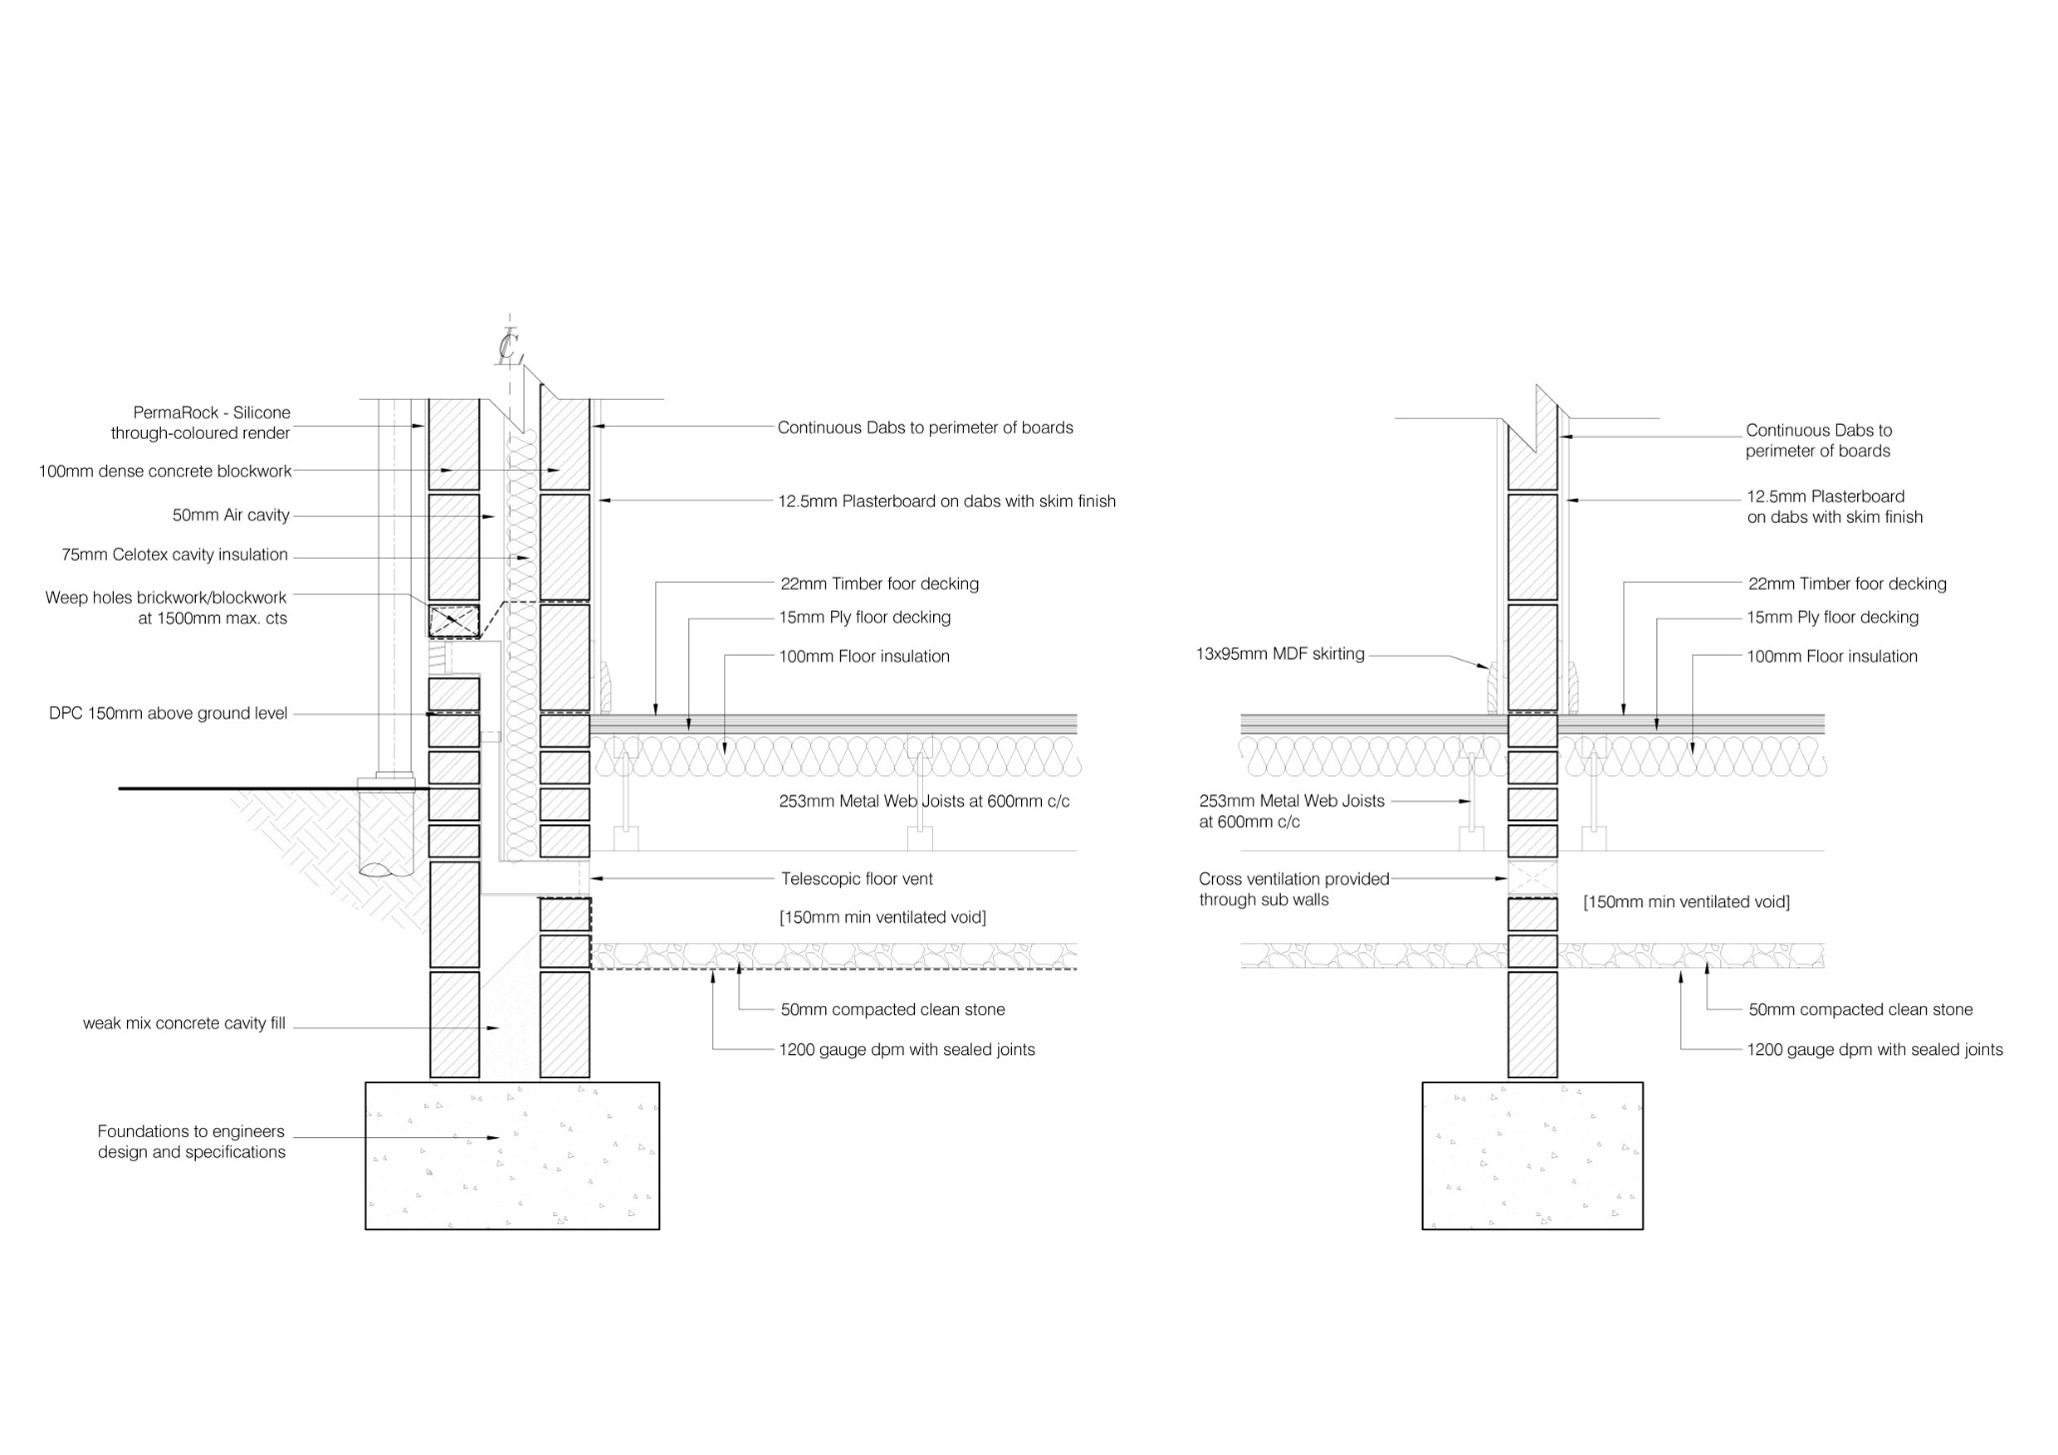

Appendix 2
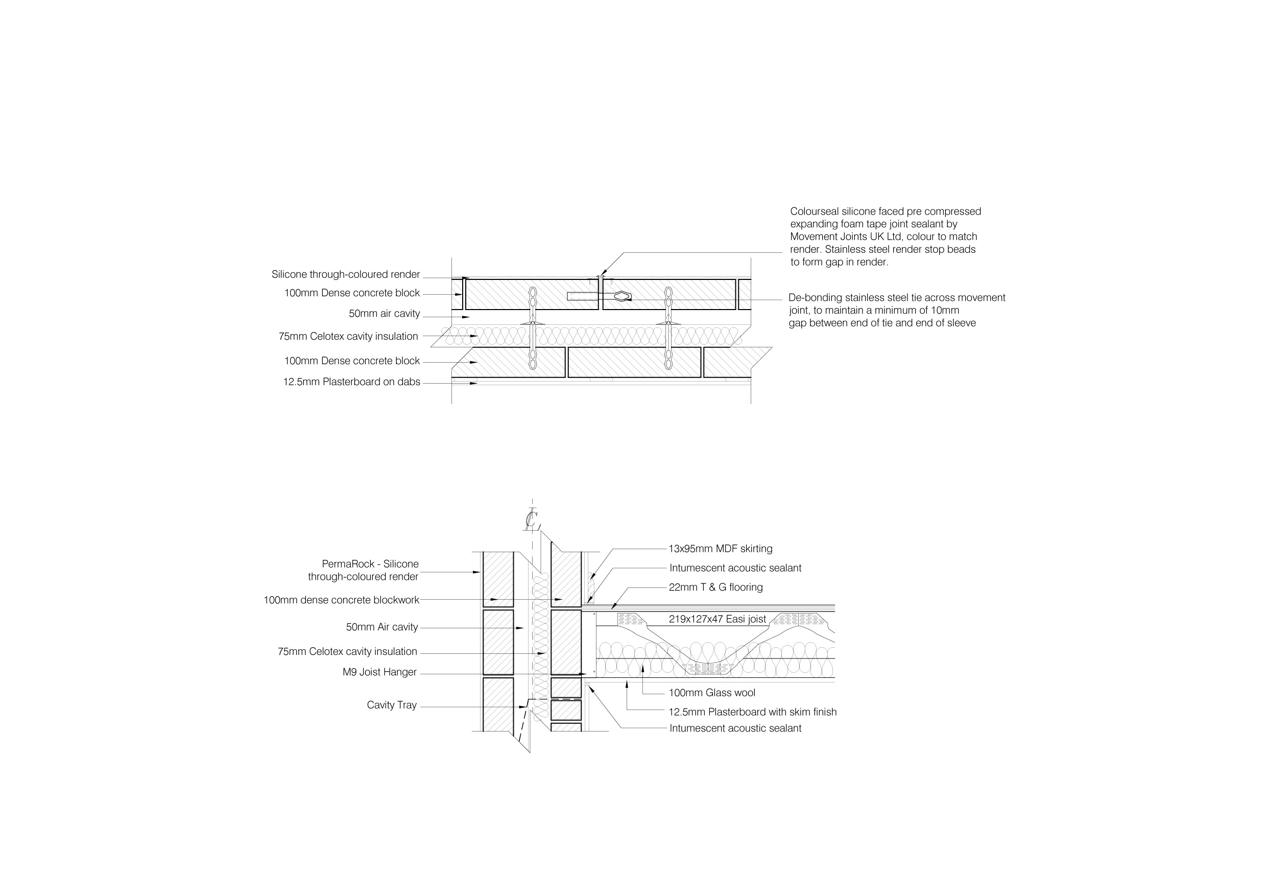

Appendix3

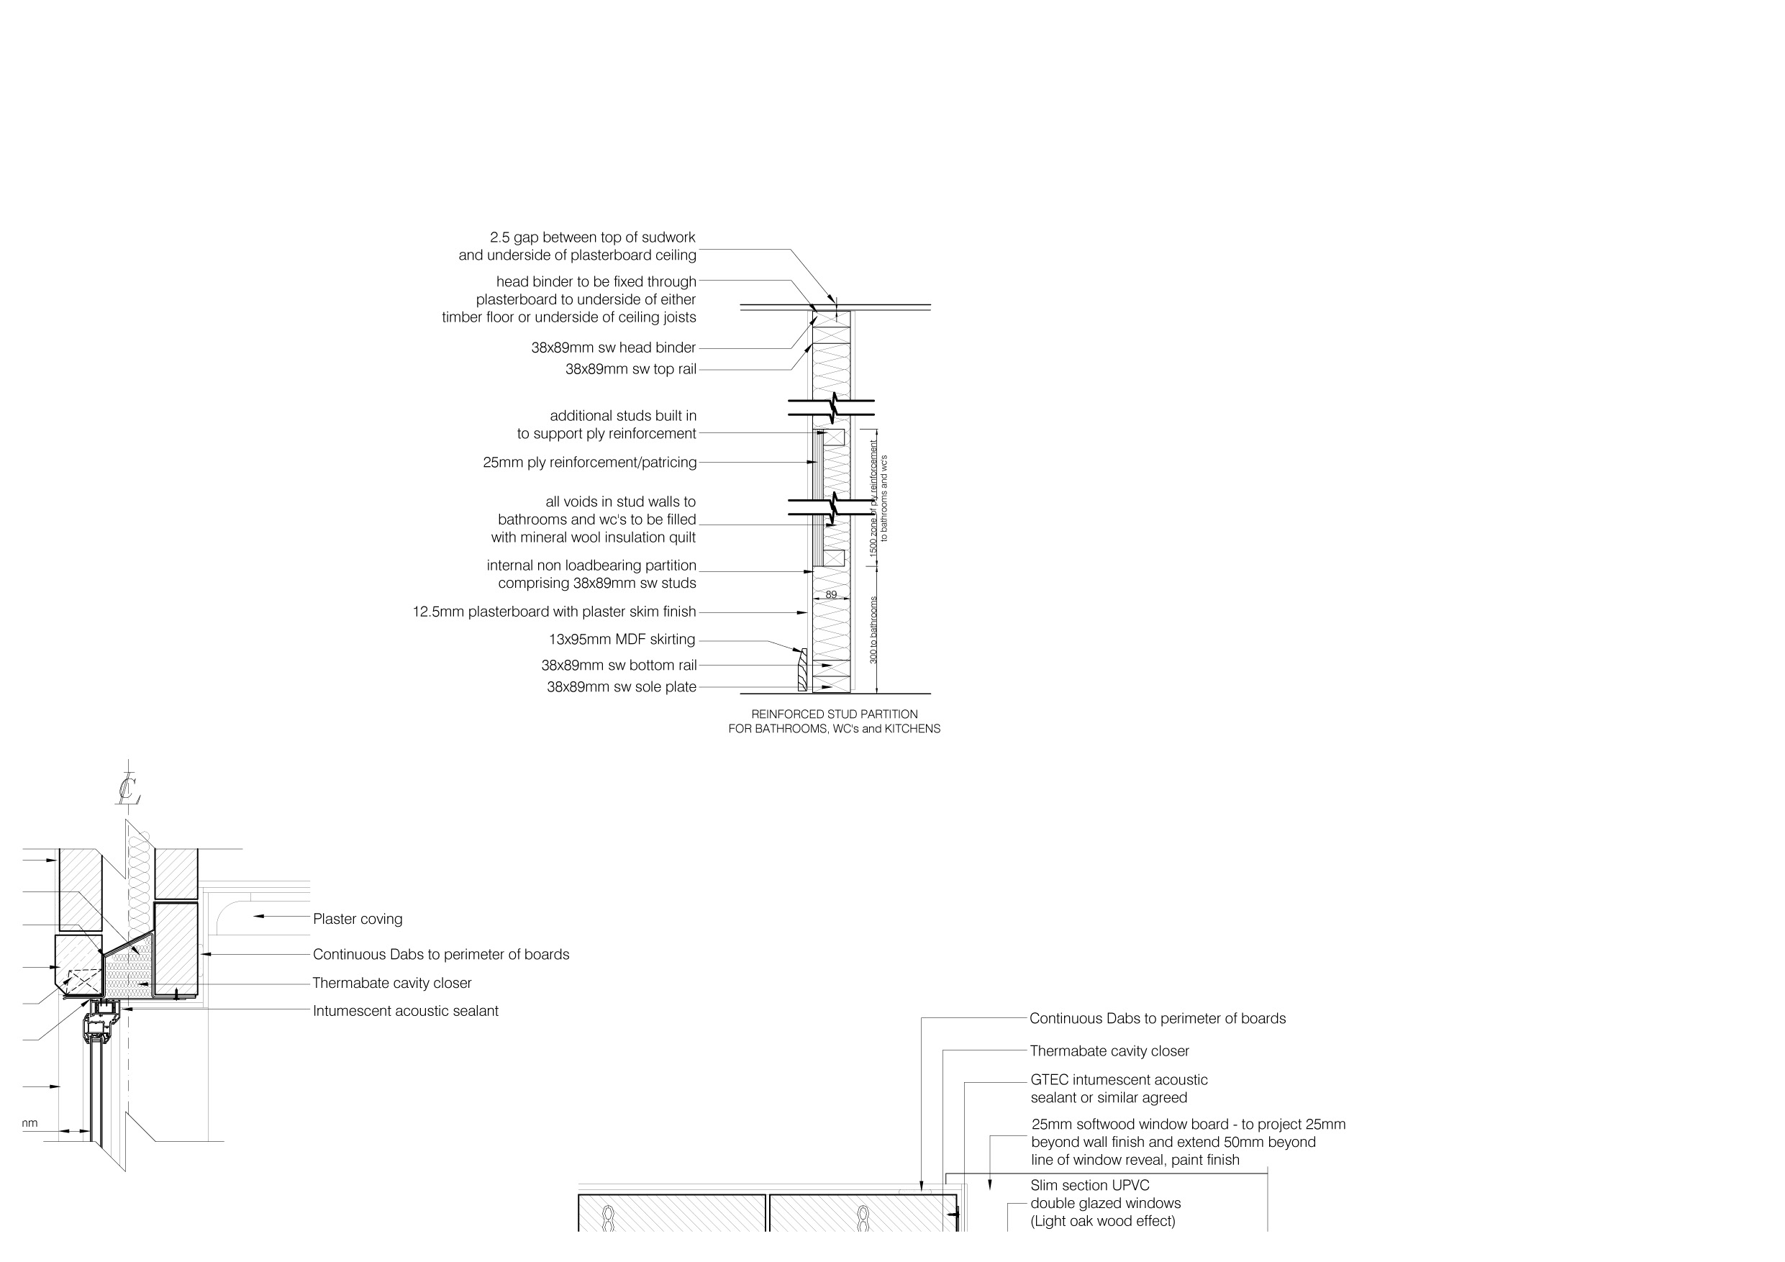

Appendix 4

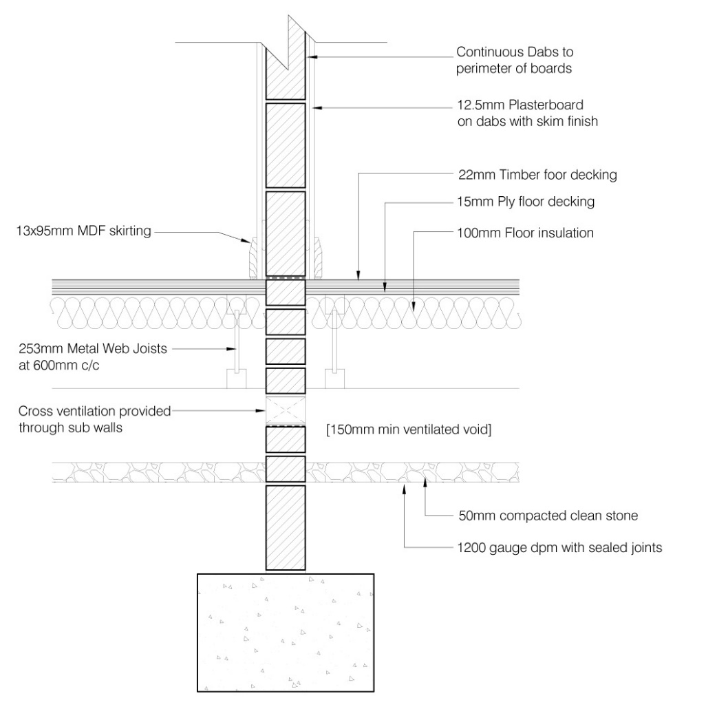

Appendix 5, Head Detail.
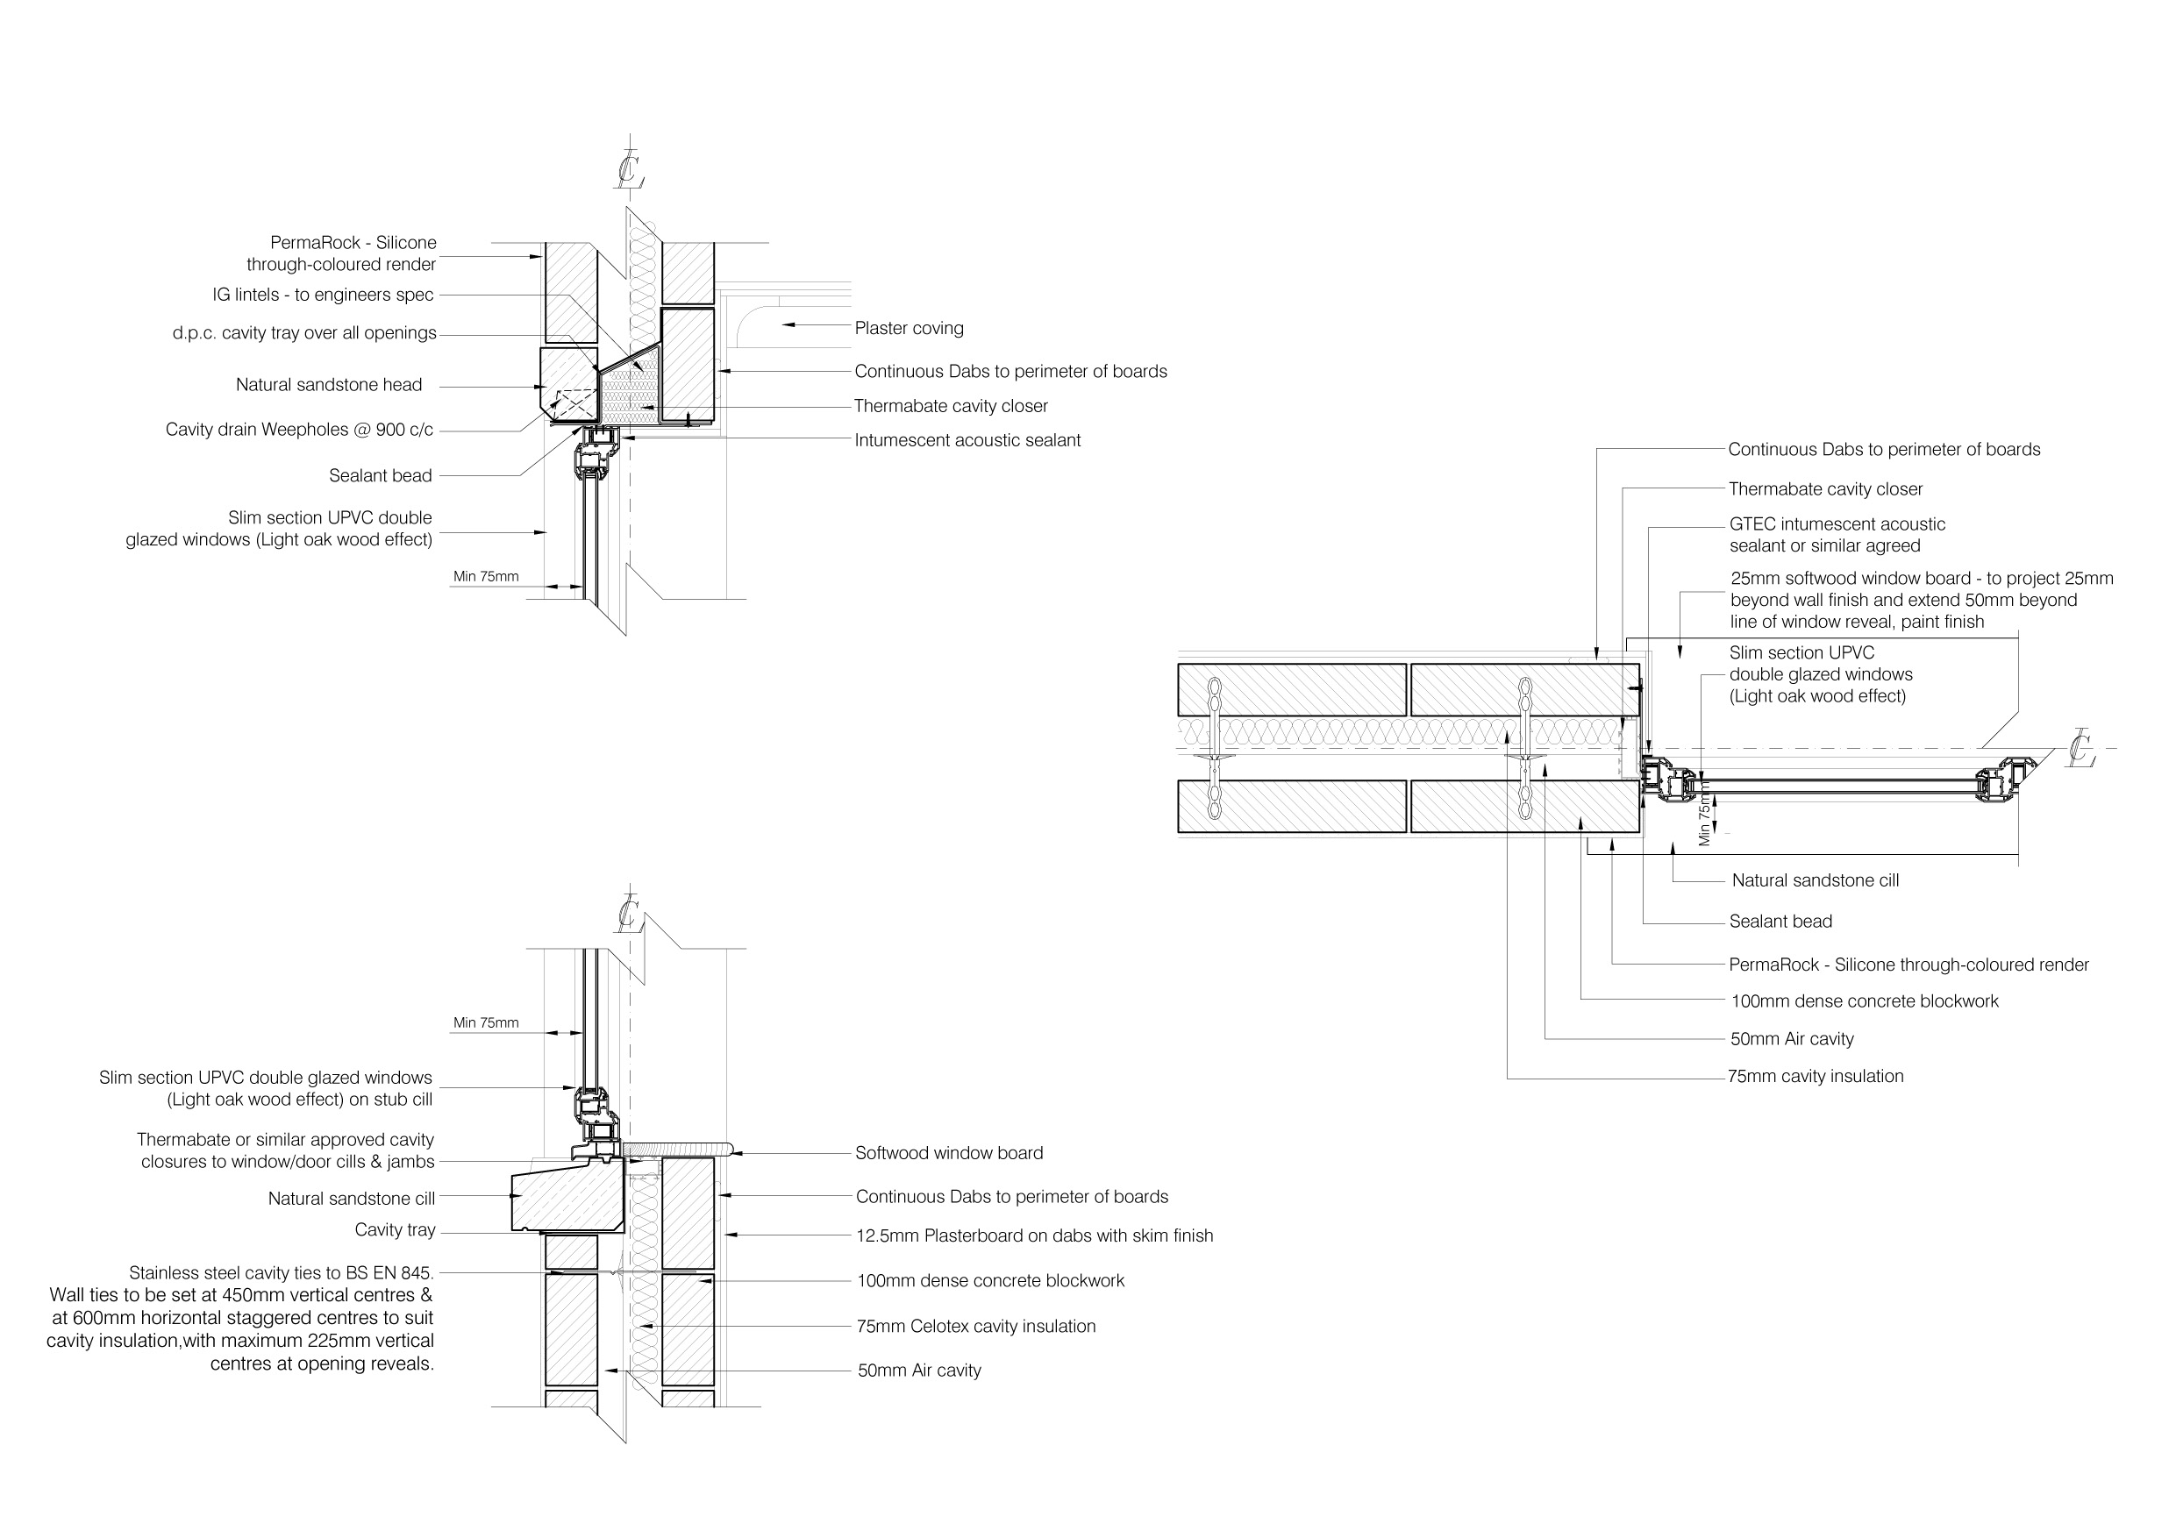

Appendix 6, Sill Detail
Appendix 7, Jamb Detail

Appendix 8, Warm Roof.
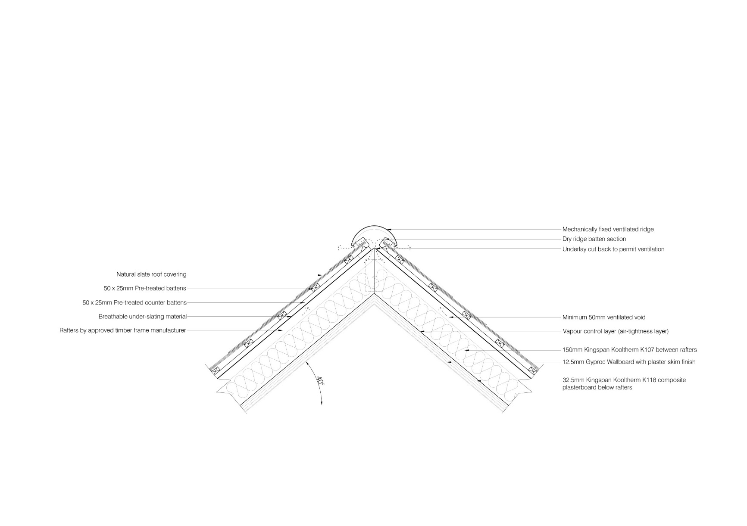

Appendix 9, Cold Roof and Eaves

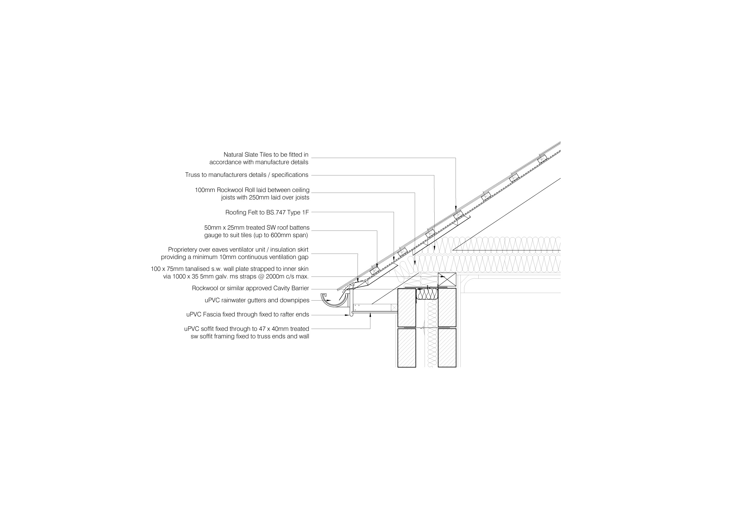

Appendix 10, Queen Post Truss



