UNIVERSITY OF WALES TRINITY SAINT DAVID

STUDENT NAME: STELA GEORGIEVA STUDENT ID NUMBER: 2118350
PROGRAM: BA BUSINESS MANAGEMENT
MODULE: DATA HANDLING AND BUSINESS INTELLIGENCE
MODULE CODE: LCBB5000
LECTURER: KHAZA AHMED
ASSIGNMENT TITLE: COURSEWORK (WRITTEN REPORT) 2

Table of Contents
Introduction: 1
Part 1: 1
Part 2 12
Advantages and disadvantages of data analysis software 12
Data mining cycle: 14
Conclusion 15
References: 1

Introduction:
Data handling is essential for businesses to research data that is properly stored and channeled sect surely. It includes the s development of data management policies. Most data are handled electronically by businesses now a day. There are several data processing software available which can be used to get a better grip on scattered data. The systematic approach to analyze data by using statistical or mathematical tools to derive inherent characteristics of the data set is data analysis. It is important to derive useful information to be used in decision-making from vast data sets. The following report consists of 2 parts. The first part is concerned with data summarizing and analysis. This shows data visualization using tools such as excel. The second part has a description of using data analytical tools and data mining.

Part 1:
The first part concludes with data sets that are driven from a supermarket. A data set is given which represents the historical sales of three supermarket branches for 3 months in 2019. A new business analyst has to help the company analyze the given data.
- The data set includes 17 rows with the following titles.
- Invoice id
- Branch
- City
- Customer
- Gender
- Product Line
- Unit Price
- Quantity
- Tax
- Total
- Date
- Time
- Payment
- COGS
- % Gross Margin
- Gross Income
- Rating
It can be seen that this is a large sample of data about supermarket sales of FY 2019 involving one thousand rows. A data visualization board can be constructed using the Pivot table option from the data set. The board is the representation of data and information in a meaningful and simplistic approach (Witte, 2019). The below board shows a Pivot table including the following variables:
- Invoice ID per Sales,
- Gross Margin % per Product
- Date per Gross Sales
- COGS per product line
- Product per Customer Ratings.
To create the Pivot table, I clicked Insert from the menu bar and then Pivot table. In the Pivot table, I chose ROW; Invoice ID, and Date, after that in Values I insert the Sum of gross margin percentage Sum of cogs and Sum of Rating. In Columns, I insert Value. The working with full screenshot is shown below:
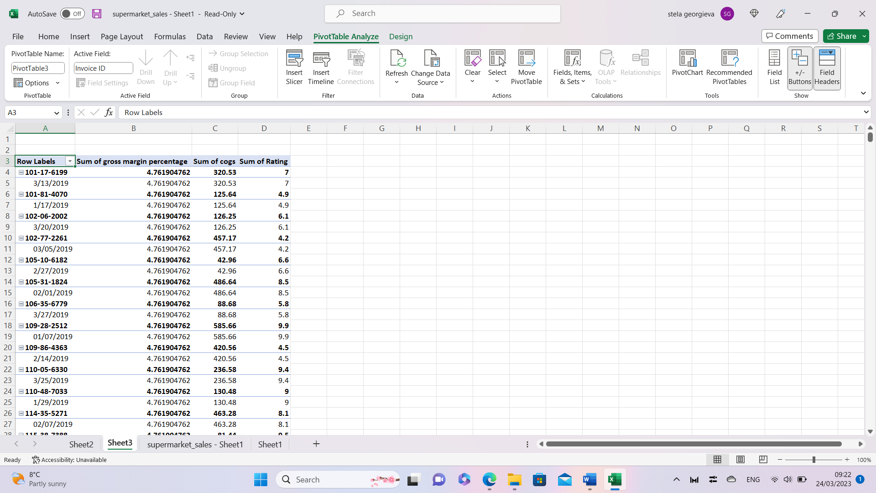
Table 1: Pivot Table for Supermarket Sales

The full table includes 2004 rows.
The work is given below:
- The full data set is selected.
- From the Insert option of excel, the Pivot table was selected. In the data range, the full worksheet range is given. Excel has been instructed to put the Pivot table on another worksheet.
- The Pivot table is prepared. In the row level, there are 3 variables, Invoice ID, Date, and product line. The column level shows 3 variables, the Sum of gross Profit Percentage, the Sum of COGS, Sum of Rating.
The below findings can be derived from the Pivot table.
In terms of Gross income, the top 5 product lines are Sports and travel, electronic accessories, Health and beauty, Food and beverages, and Fashion accessories. The chart is shown in the chart below:
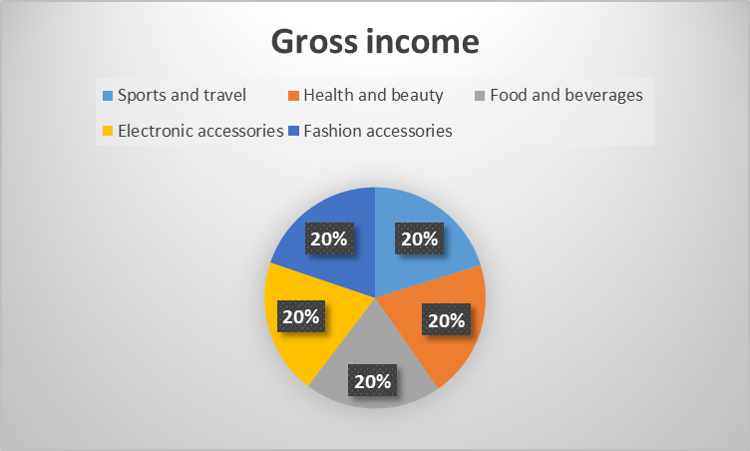
Figure 1: Contribution of major product lines
In terms of the Cost of goods sold the top items are Fashion accessories. Food and beverages and home and lifestyles.
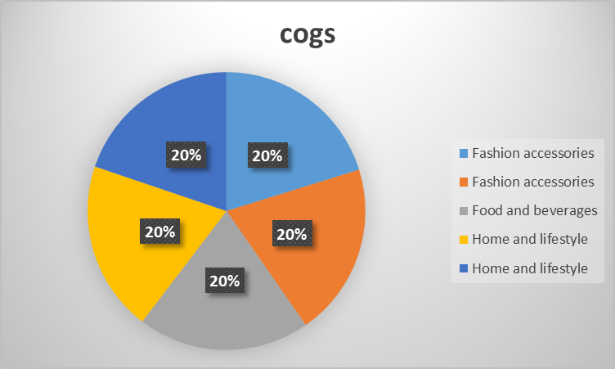
Figure 2: Cost of Goods sold.
b) The answers using the Pivot table filter option are given below:
(i) The most profitable product line will be the one with the highest Gross Income or the highest number of units sold. Using the filter option, the item with the highest gross income can be found as Fashion Accessories.
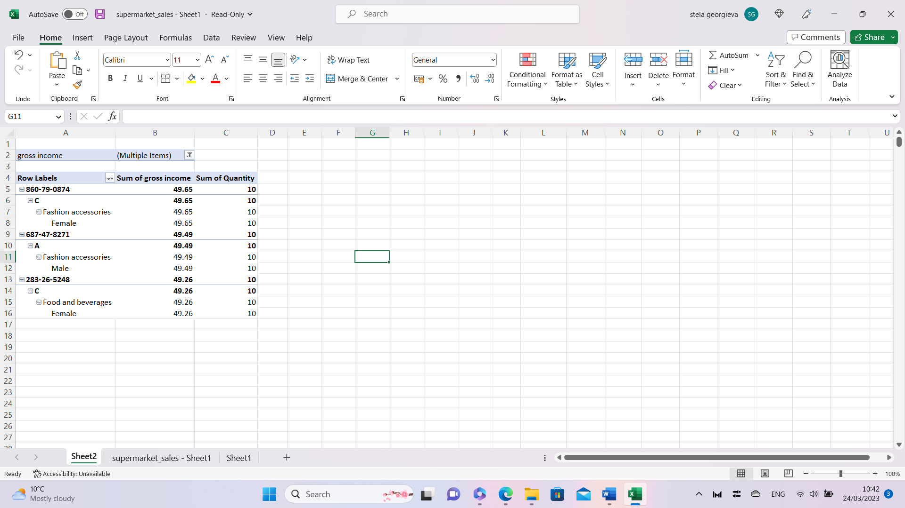
Table 2: Pivot table showing the most profitable product line
To create the Pivot table I clicked Insert from the menu bar and then Pivot table. In the Pivot table, I chose in ROW; Invoice ID, Branch, Product line, and Gender after that in Values I insert the Sum of gross income and the Sum of Quantity. In Columns, I insert Value and into Filter, Gross income. To finalise the Pivot table, I go to the filter and choose the highest Gross income. From Branch C, Female customers have bought 10 units of Fashion accessories. This amounted to GBP 49.65 of the gross income. the second largest profitable product line was fashion accessories too, only this time it has been bought by male customers. This amounted to GBP 49.49 of gross income. The number of units sold is 10 units. The thirst for the most profitable line of products is food and beverages. This product line is bought by female customers which contributed GBP 49.26 to the gross income of Branch C. 10 units of food and beverages are sold. For better inventory management, the business has to pile up the most popular fashion accessories in both male and female categories.
(ii) To create the Pivot table, I clicked Insert from the menu bar and then Pivot table. In the Pivot table, I chose ROW, Branch, and after that in Values, I insert Sum of Quantity and Sum of gross income. The performance of Branches A, B, and C can be calculated by taking into number of units sold per branch and the gross income earned by them. The branch with the highest number of units sold or the one with the highest amount of gross income could be considered the most successful branch. There are 3 branches of the given supermarket. A pivot table constructing the performance while considering their unit sales quantity, and a sum of gross income are given below:
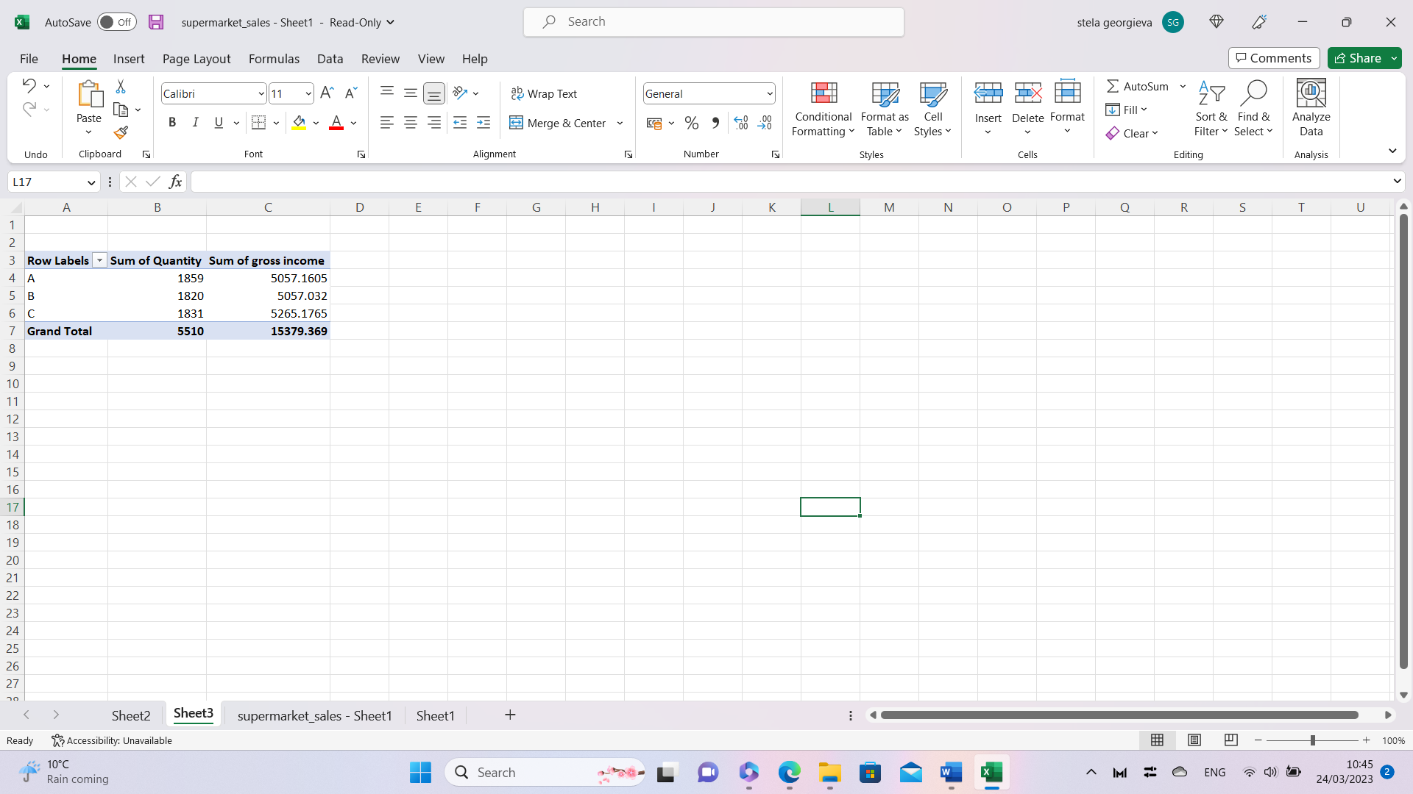
Table 3: Pivot table showing branch performance.
Their performance of them is discussed below:
- From the given Pivot table, it can be observed that branch A has sold 1859 units of products, Branch B has sold 1820 units of products, and Branch C has sold 1831 units of products. The total number of products sold by the branches is 5,510 units of product. So,
- in terms of the Quantity of products sold, Branch A has been able to sell the highest amount of products.
- The gross incomes of the branches are Brach A- 5057.16, Branch B- 5057.032, and Branch C- 5265.1765. The Branch with the highest amount of gross income is Branch C. It has contributed 32.88% of the total gross income of GBP 15379.369 for the supermarket. On the other hand, Branch B has contributed has somewhat similar to the total gross income of 32.88%. Brach C has contributed 34.23% of the supermarket`s gross income.
(iii) To create the Pivot table I clicked Insert from the menu bar and then Pivot table. In the Pivot table, I chose ROW, Branch, and Gender after that in Values I insert the Sum of Quantity and Sum of gross income. In Columns, I insert Value. The sales performance by gender is shown in the pivot table below:
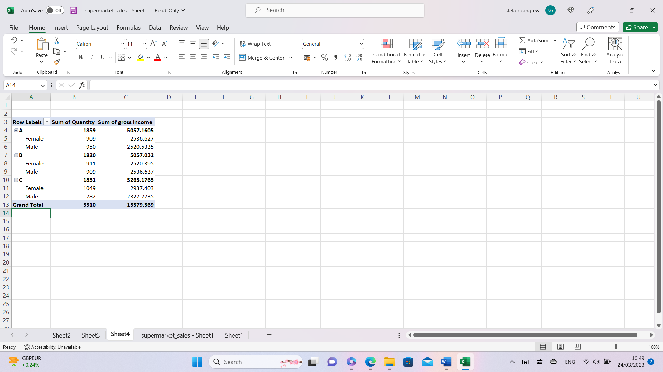
Table 4: Pivot table showing a performance by gender.
It can be seen from the table how many units of products are bought by people based on gender from the 3 different branches. From Branch A, 909 units have been bought by female customers which are 48.89% of its total sales unit of 1859. The gross income derived from female customers was GBP 2536.627. The male customers have bought 950 units of product with is 51.1% of total sales. The gross income earned from male customers is GBP 2520.5335. So, in Branch A, make customers are concluded by buying more products compared to that female customers.
In branch B, Female customers have bought 911 units of products. This is 50.05% of the total number of units sold by that branch. The male customers have bought 909 units of product which are 49.95% of the branches’ total sale of 1820 units. The female customers have bought more products from Branch B. The gross income derived from female customers is GBP 2520.395. On the other hand, the gross income derived from male customers is GBP 2536.637. it means, even if the female customers have bought a larger number of products, the male customers have spent more than the female customers.
In Branch C, female customers have bought 1049 units of products which is 57.29% of the branch’s total sales of 1831 units. Male customers have bought 42.71% of products which amounts to 782 units. In Branch C, it can be said that female customer has bought more products compared to male customers. In terms of income, the female customers have contributed GBP 2937.403 to the total income of branch C. the male customers have contributed GBP 2327.77. the female customers have contributed more to the gross income of the particular branch.
C) The descriptive statistics of the data including Mode, Median, Mean, Range, and Standard deviation for Customer ratings and the results are discussed below:
- The first step is to select the Rating Column
- Then from the Excel data tab, the data analysis tab has to be selected
- From the given dialogue box, descriptive statistics have to be chosen.
- The results are shown in another worksheet.
The table is shown below with a discussion:
Table 5: Descriptive Statistics of Data Analysis
- Mode: A mode is a particular number in the data set that has the highest frequency of occurring (Hays, 2018). That is, the number that has happened the most times in the selected sample is known as the mode. The customer rating data set has a mode of 6, which means most people have rated the supermarket buying experience as 6 out of 10. It is above average. The business should work on giving customers a better experience through excellent offerings and after-sales service.
- Median: The median is the middle value of the data set. While calculating the median, the data are arranged from smallest to largest. Then the value just in the middle of the data set is the median (Kendall, Stuart, and Ord, 2015). In the given problem, the median has been calculated using excels descriptive statistics function. The data set has a median of 7.
- Mean: The mean is the number exerted from diving the sum of numbers with the number of values in a given set (Freedman, 2018). It is also known as the average number of a particular data set. In the given business data set, the mean is 6.97. It means the customer average rating for the supermarket is 6.97, which is fair.
- Range: Range can be calculated as the subtraction of the smallest value from the largest value of the business. The range in the given data set is 6.
- Standard deviation: The standard deviation of a data set measures how dispersed the data are about the set`s mean. If the standard deviation is low, it means more data close to the mean value and the values are more predictable. On the contrary, if the standard deviation is high, it would mean that data are more distant from the mean value and unpredictable. In a given distribution, 95% of values stay within two standard deviations of the mean. The given data set has a standard deviation of 1.71. there is no benchmark for standard deviation (Harper, 2016).
Analysis Conclusion:
The business has been able to earn GBP 15379.369 during the 3 months of the operation. To create the Pivot table, I clicked Insert from the menu bar and then Pivot table. In the Pivot table, I chose ROW, Branch, and Product line after that in Values I insert the Sum of gross income. The following table shows the gross income of the business categorized into 3 branches along with product lines:
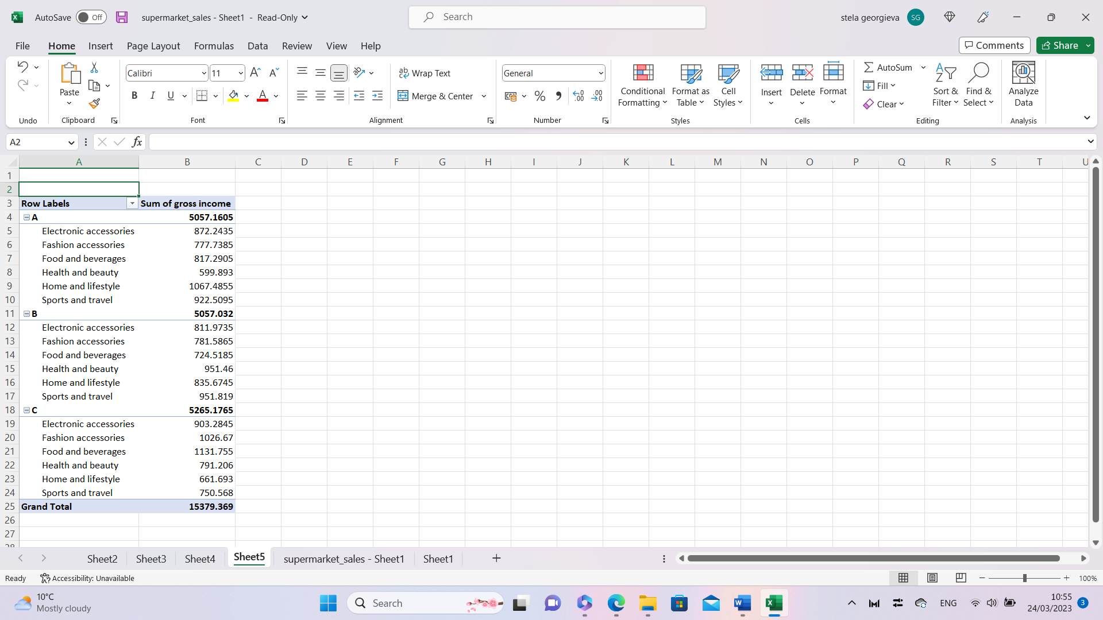
Table 6: Gross income along with Product line
It can be seen that the supermarket is currently selling products from six different categories these are:
- Electronic Accessories
- Fashion accessories
- Food and beverages
- Health and Beauty
- Home and lifestyle
- Sports and travel
In the given time, the business has been able to earn the highest amount of gross income, GBP 5265.17, from its branch C, the most profitable product being fashion accessories. However, the product bearing the g highest gross income in branch c was Food and beverages which amounted to GBP 1131.75. For Branch B, the items contributing the highest amount of gross income were home and lifestyle, which amounted to GBP 1067.485. For Branch A, the item is Sports and travel. The amount of gross income from this category of product is GBP 951.819. the items that need to be paid special attention to in the three different branches are:
- For branch A, Health and beauty scores the lowest gross income.
- For Branch B, Food and beverages made the lowest gross income.
- For Branch C, Home and lifestyle made the least amount of gross income.
To make higher and more sustainable performance, the supermarket seems to need to pay attention to the respective product lines in the given branches. Better product differentiations and competitive pricing have to be induced so that sales in the respective categories may increase satisfactorily. For further performance analysis, sales data from different periods could be added here. that would be a time series analysis drawing valuable insights regarding customers’ buying patterns. The business should focus on customer segmentation as per their choice and buying pattern. The product offering should come accordingly.

Part 2

Advantages and disadvantages of data analysis software

a) The advantages and disadvantages of using SPSS, Excel, and Tableau using relevant examples are discussed below:
SPSS: SPSS is an advanced software for statistical analysis. It is rigorous and complicated software for data mining. The advantages of using SPSS are.
- Comprehensive, including all basic and advanced functions of mathematical and statistical analysis.
- Interpretation of results is particularly easy.
- Can be changed with additional features.
- It has the most extensive statistical tool pack.
The disadvantages are:
- Very expensive for students
- May require training before running the software.
- Complicated user interface
- SPSS models require advanced statistical skills to operate.
Excel: Excel is a calculation tool provided by Microsoft. It applies spreadsheets to put data and organize them. Excel has numerous functions and formulas and has undergone a significant number of modifications to date. The advantages of using excel are:
- Supplies a user-friendly interface.
- Excellent means of storing data
- It provides simplified tools for data analysis.
- There are multiple templates used in excel.
- Deriving charts and graphs is easier.
The disadvantages of Excel are.
- Does not offer advanced and sophisticated tools for data analysis.
- Struggle to analyze unstructured, structured, and semi-structured data on a real-time basis.
- Learning the syntax in excel may require training.
- Since Excel allows multiple users, the security of data may be compromised.
- Excel offers limited statistical tools. However, Numbly, an extended statistical feature of excel can be added to the built-in excel. It is an expensive add-in.
Table au: It is a platform for visual analytics of data. The software can collaborate with data visualization to better organize work. Visualization of data makes data presentation interesting and useful.
The advantages are:
- It has high performance.
- It can be used on smartphones.
- The software can handle millions of data rows.
- Different types of visuals can cooperate with a very large amount of data.
The disadvantages are:
- It was very expensive.
- The company offers poor after-sales service.
- There are security issues related to the visuals.
- There is no case-by-case solution for customers.

Data mining cycle:
- The data mining cycle is a process that involves human, and computer resources, in the application of data mining operations (Owen, 2016). It supplies a framework to separate crucial and trivial information from data. A conventional data mining cycle would typically include 6 steps. The importance of these steps is discussed below:
Step 1: Business Understanding
According to Plemon (2011), mining starts with an understanding of the information set available. There are certain questions that need to be answered while working on a data set, for example, a businessperson intends to find the relationship between chosen variables. To do so, the managers have to determine the necessary data to select relevant variables.
Step 2: Data Selection
After a well-defined plan has been objectified the selection of data plays a vital role in the required findings. Data that is being considered has to be right and relevant for better output.
Step 3: Data preparation
The data can be summarized in the data analysis software. The data should be placed fairly and transparently (Aczel, 2012). The better the preparation, the quicker will be the modeling and execution.
Step 4: Modelling
Data modeling depends on fixed Once the data mining process is chosen, the next step will be to enter, extract, assimilate, and fix the proper data set for necessary data mining (Schmerling, 2014). The input data has to be provided with the right amount, construction, and format suitable for the modeling algorithm. A proper statistical model can assist in sorting out important details and concluding necessary findings. For example, a business looking out for deriving correlation between variables should run unbiased statistical models over the variables such as Person correlation, Dicky fuller test, etc.
Step 5: Evaluation
The evaluation stage states the necessity of data modeling to receive correction if so requires. There might be an error in the selection and modeling process. Sometimes, the researcher gets biased while running models since the human mind tends to find out patterns in numbers subconsciously and believe in them religiously despite having adequate evidence.
Step 6: Deployment
The final stage contains the reflection of the data presented with rational visualization. This stage is particularly important since it involves channeling output to users.

Conclusion
Due to the advancement of computational analysis, various tools have become particularly useful in statistical analysis for both business and research purposes. These tools can be used with scattered data to be presented in a meaningful and simple format. The full approach to data processing and analysis is crucial for business decision-making. The goal is to derive important insights into costs, income, profit, etc. Data analysis helps businesses reach their goals. The report shows evidence of how various data can be organized and later used to make useful decisions for the business.

References:
Aczel, A., 2012. Complete Business Statistics. Morristown, NJ.
Freedman, D., Pisani, R. and Purves, R. (2018) Statistics. New Delhi etc.: Viva Books.
Harper, W., 2016. Statistics. London: Financial Times Pitman Pub.
Hays, W., 2018. Statistics. Belmont, Calif.: Wadsworth/Thomson Learning.
Kendall, M., Stuart, A. and Ord, J., 2015. The Advanced Theory of Statistics. London: Griffin.
Owen, F. and Jones, R. (2016) Statistics. London: Pitman.
Plemon (2011). “Analysis of frequencies: Quantitative Analysis”, pp. 238–261; Available at: https://doi.org/10.1002/9781444390155.ch13.
Schmerling, S., 2014. Computer-intensive methods in statistics. Series statistics and computing. Computational Statistics & Data Analysis, 17(5), pp.602-603.
Witte, R.S. and Witte, J.S. (2019) Statistics. Hoboken, NJ: Wiley.

