

An Interactive Holographic Game

by
Erdong Mao

Supervisor: Dr Nik Whitehead
Second Marker:

Project submitted as part of the requirements for the award of MSc Applied Computing

September 2017

DECLARATION

I, ............................................(FULL NAME)………………………………… declare that I am the sole author of this Project; that all references cited have been consulted; that I have conducted all work of which this is a record, and that the finished work lies within the prescribed word limits.

This has not previously been accepted as part of any other Masters' submission.

Signed : .............................................

Date : .............................................

FORM OF CONSENT

I ____________________________ hereby consent that my Project, submitted in candidature for the M.Sc. Applied Computing , if successful, may be made available for inter-library loan or photocopying (subject to the law of copyright), and that the title and abstract may be made available to outside organisations.

Signed __________________________

Date ____________________________

Catalog
1 Introduction & Literature Review 5
1.1 Introduction 5
1.2 Virtual Reality 6
1.2.1 VR Introduction and History 6
1.2.2 VR principle 6
1.2.3 VR Application 7
1.3 Augmented Reality 7
1.3.1 AR Introduction and History 7
1.3.2 AR Principle 8
1.3.3 AR Application 8
1.4 Pepper’s Ghost 9
1.4.1 Pepper’s Ghost Introduction and History 9
1.4.2 Pepper’s Ghost Principle 9
1.4.3 Pepper’s Ghost Application 10
1.5 Unity 12
1.5.1 Unity Introduction and History 12
1.5.2 Unity Application 13
1.6 Leap Motion 13
1.6.1 Leap Motion Introduction 13
1.6.2 Leap Motion Principle 14
1.6.3 Leap Motion Application 15
2 Methodology & Requirements 16
2.1 Research Methodology 16
2.2 Requirements 18
2.3 Risks 20
2.4 Validity & Generalisability 21
3 Development & Experiment 22
3.1 Time Box 1: Ball Moves 22
3.1.1 Features 22
3.1.2 Design and Implementation 22
3.1.3 Test 24
3.1.4 Evaluation 24
3.2 Time Box 2: Player Moves 25
3.2.1 Features 25
3.2.2 Design and Implementation 25
3.2.3 Test 27
3.2.4 Evaluation 27
3.3 Time Box 3: Score Calculation & Display 28
3.3.1 Features 28
3.3.2 Design and Implementation 28
3.3.3 Test 30
3.3.4 Evaluation 30
3.4 Time box 4: Gesture Control 30
3.4.1 Features 31
3.4.2 Design and Implementation 31
3.4.3 Test 34
3.4.4 Evaluation 34
3.5 Time Box 5: Change Play Mode & Smooth movemnet 34
3.5.1 Features 35
3.5.2 Design and Implementation 35
3.5.3 Test 38
3.5.4 Evaluation 38
3.6 Time Box 6: Hologram Processing 38
3.6.1 Features 39
3.6.2 Design and Implementation 39
3.6.3 Test 41
3.6.4 Evaluation 41
3.7 Time Box 6: 3D Boom Ball Game 41
3.7.1 Features 42
3.7.2 Design and Implementation 42
3.7.3 Test 43
3.7.4 Evaluation 44
4 Evaluation 45
5 Conclusion 50
References: 51
Appendix: 53

1 Introduction & Literature Review

1.1 Introduction
Video games play a more and more important role in people’s life. The ISFE Video Games in Europe Consumer Study [1] shows that a surprisingly wide range of ages play games: 40% of the UK population in fact, of which 24% play at least weekly. How Healthy Behaviors Supports Children’s Wellbeing states that in England, video games were played for two hours or more a day by 55% of boys and 20% of girls in 2013 [2]. In this environment, most of the research about the effect of the computer games focus on its negative effect such as violence, addiction and potential harm to people’s health. However, in order to understand the effect of computer games comprehensively, a more balanced evaluation is necessary. Research dating right back to the early 1980s has consistently shown that playing computer games (irrespective of genre) produces reductions in reaction times, improved hand-eye co-ordination and raises players’ self-esteem [3]. Isabela Granic and his colleague find that [4]: video games have positive influence on four main domains: cognitive, motivational, emotional, and social. They think playing video games may foster real-world psychosocial benefits. Besides, some new games have already broken the traditional definition of games. These games can be quiet useful in education, medicine and so on. Therefore, try to develop some new and innovative is meaningful. However, most traditional videos games just can be played by keyboards and mouse in a two dimensional screen. Compared with the rapid development of computer graphics technology, the visual and entertainment experiences of computer games are urgently needed to be improved.

Holographic projection has been widely used in stage performances, film and it works very well, as shown in Fig 1.1 and Fig 1.2. But it is still a new technique for computer games. In order to change the traditional game mode, the game developed in this paper combine the popular visual techniques named “Pepper’s Ghost” with itself to present a stereoscopic 3D image. An interactive holographic game will be built in Unity 3D originally. Then a hollow pyramid shaped prism made by four plexiglass would be used to create a 3D stereo image. The game built in Unity 3D has four cameras which means it has four scenes in the game window, if put the prism in the middle of the four scenes, a 3D stereo image will show up in the middle of the hollow pyramid shaped prism. Furthermore, a gesture input device Leap Motion make the game can be played by hands by importing Leap Motion assets in to Unity 3D.
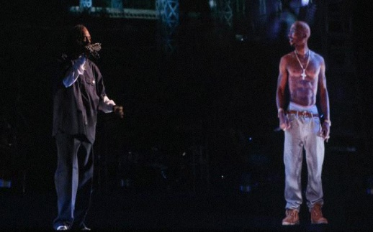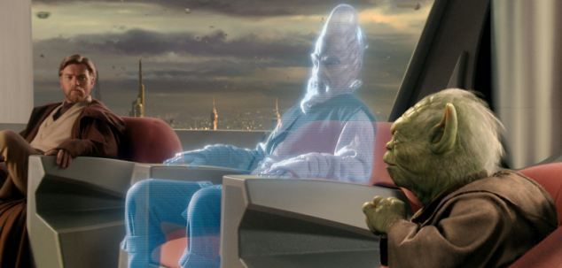
Fig 1.1 Holographic Application in Concert Fig 1.2 Holographic Application in Film
One of the innovations of this game is its display method. The traditional display method is show the graphic in a two dimensional flat screen. From the initial flat panel monitor to the modern liquid crystal display, the screen is getting clearer and thinner. But it is steal two dimensional and with the development of the technology, people are no longer satisfied with two-dimensional display, they want a more realistic visual effect. Then holographic projection, virtual reality (VR), augmented reality (AR) becomes more and more popular.

1.2 Virtual Reality

1.2.1 VR Introduction and History
Virtual Reality (VR) is characterized by the illusion of participation in a synthetic environment rather than external observation of an environment [5]. VR has received a great number of publicity in recent years and maybe it is still mysterious to many people, but its idea is not new. The first appearance of VR dates back to 1960. The ‘father’ of computer graphic, Ivan Sutherland, first postulated the use of stereographic head-mounted displays in the 1960s [6]. Then in 1962, the most famous and earliest example of immersive and multisensory technique named Sensorama was built by Morton Heilig, the machine can display 3D images of New York. Users can also feel the noise, the wind of the city. The difference between VR and Sensorama is Sensorama’s route was fixed, it was not interactive. In 1984, NASA Ames’s engineer Dr Mike McGreevy and Jim Humphries developed the Virtual Visual Environment Display (VIVED) (Fig 1.3). They designed the system for astronauts to control the robot outside the space station. The resolution of the system is 320*240px. Astronauts can see 360 degree environment. Later, Virtual Interactive Environment Station (VIEW), a head-mounted stereoscopic display system, was invented by NASA Ames Research Center. It can track head and hand movements. Now, the most famous VR device is Sony PlayStation VR, it is a virtual reality headset designed by Sony launched on Oct 2016 (Fig 1.4). This system can display an image to the headset and television at the same time. There are 9 positional LEDs on the headset to track head movement and the tracking are reach 2.4*1.8m².
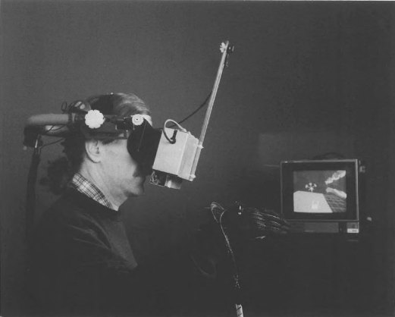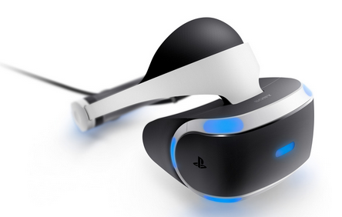
Fig 1.3 the VIVED System Fig 1.4 the PlayStation VR

1.2.2 VR principle
The most important components of the headset is the two convex lens. They will show different images to user’s different eyes which give the user a sense of depth which is a special feature of cave automatic virtual environment (CAVE). To be specific, different visual fields and different picture depths form a virtual field of view in the user's brain vision system (see Fig 1.5). One thing to note, the volume and weight of the headset need to be considered when design a VR device. With thinner lenses, the distance between the lens and the display will be larger and the size of the headset will increase. A thick lens will shorten the distance between the lens and the screen but it is easy to have geometric distortion and chromatic aberration (Fig 1.6). When people move their eyes or head, the headset can track people’s physical movements and send these information to computer. The computer will redraw the pictures to reflect these changes in the virtual world.
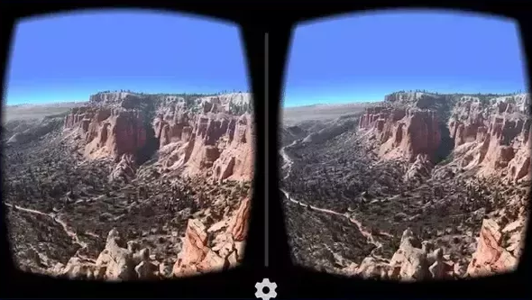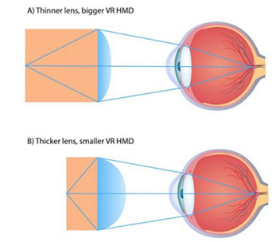
Fig 1.5 VR Principle I Fig 1.6 VR Principle II

1.2.3 VR Application
VR becomes more and more popular not only because it has a shock performance in game, but also it provides many benefits for other application areas:
- Cinema and entertainment: Some film companies such as Fox Searchlight Pictures and Skybound applied VR to their films [7].
- Architectural visualization: Today many architects use computer software like CAD ect to finish their design. But these software cannot provide the degree of realism. So, architects begin to use VR to get a sense of space.
- High-risk industry: Workers can use VR mediated teleoperation to protect them from the real danger just like NASA Ames’ VIVED and VIEW system. For example, pilot can use VR for flight training.
- Medicine: Because of VR’s distinctive attributes that provide ecologically realistic and motivating opportunities for active learning, these technologies have been used in pediatric rehabilitation over the past 15 years, the ability of VR to create opportunities for active repetitive motor/sensory practice adds to their potential for neuroplasticity and learning in individuals with neurologic disorders. [8]. Harris and Reid reported that children with cerebral palsy can improve their volition by playing VR games [9]. Though VR game is difficult for them but they are motivated rather than frustrated.

1.3 Augmented Reality

1.3.1 AR Introduction and History
Augmented Reality (AR) was defined as a real-time direct or indirect view of a physical real world environment that has been enhanced/augmented by adding virtual computer-generated information to it [10]. AR was recognized as an emerging technique in recent years, but its origins can be traced back to 1900s. L. Frank Baum, an author, first mentions the idea of an electronic display/spectacles that overlays data onto real life (in this case 'people'), it is named a 'character marker' [11]. In 1975, L.B Rosenberg developed one of the first functioning AR systems, called Virtual Fixtures and demonstrated its benefit on human performance while Steven Feiner, Blair MacIntyre and Doree Seligmann presented the first major paper on an AR system prototype named KARMA [12]. In 2000, the first mobile AR game named ARQuake was demonstrated International Symposium on Wearable Computers. After that, more and more AR applications are developed such as spyglass, Transparent Earth and so on.

1.3.2 AR Principle
Usually, both AR and VR are designed to be used by single players and the audience also need special equipment to see the 3D effect. The difference between AR and VR is that AR superimpose virtual images on real world. AR also need a head mount display or just a glass to implement function. Small cameras installed in the headset or glass will recognize and collect the real world information and send it to the processing unit, a computer or a phone. Then these information will be analyzed and restructured. The process will also combine the data with head tracking device to get the relative position of virtual scene and real scene and align the two different coordinate system. Finally, the integrated information will be displayed in the headset or glass simultaneously. Fig 1.7 show the basic structure of an AR system. Firstly, infrastructure tracker unit collect the data from sensors, then processing Unit will translate the data and combine it with real world video. Finally, users can see the AR effect through the head mount display.
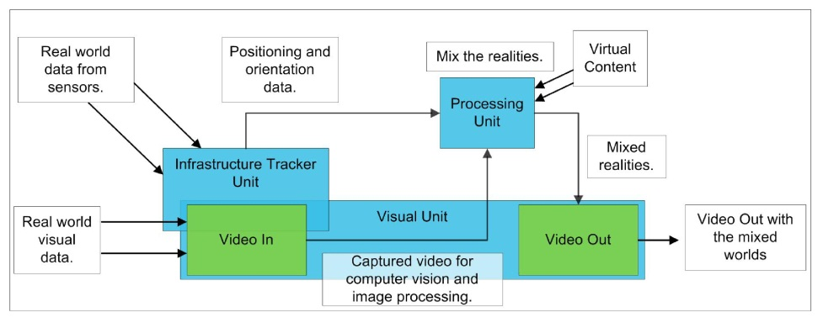
Fig 1.7 AR System Structure

1.3.3 AR Application
1) Advertisement: Businesses are able to show a 3D graphic in front of the customers when they open the web by using AR. In 2008, the famous car company, MINI ran an augmented reality advertisement in several German automotive magazine. If a customer go to the company’s web and show the ad to the camera, a 3D MINI car will display on the screen (Fig 1.8).
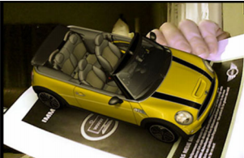 1.8 MINI AR Advertisement
2) Culture: In China, there are some AR systems for historian to rebuilt ancient ruins [13]. Beside, some museums begin to use AR device as their guidance system instead of words and record [14] [15].
3) Medicine: It is very convenient for nurses or doctors to get patient’s information directly from the AR glasses. Bichlmeier et al. introduced an AR system for viewing through the “real” skin onto virtual anatomy using polygonal surface models to allow for real time visualization [16].

1.4 Pepper’s Ghost

1.4.1 Pepper’s Ghost Introduction and History
Pepper’s Ghost has already been widely used in theater productions that allows a holographic display on the stage like Fig 1.1. Though we are seeing such a display more and more frequent, many people still do not know about Pepper’s Ghost even never heard of. Actually, it is an ancient technology with a long history. Pepper’s Ghost was first described in a book named Natural Magic, written by Giambattista della Porta in 1584. In 1862, Henry Dircks invented Victorian illusion, the prototype of Pepper’s Ghost, this invention was used to create a ghost on the stage. But it is quite difficult for theatres to apply this technique to stage performance because they need to completely rebuild the whole stage which limits its application. But John Henry Pepper saw the technique, he modified it and made it easier to be applied to the theater at that time by using a sheet of glass. John showed this illusion trick during a scene of Charles Dickens's The Haunted Man, it allows a semi-transparent ghost appears on the stage along with the human actors and other real objects [17]. Because of this success, “Pepper’s Ghost” was tied to this technology permanently. Now it is a well know technology in theater, concert and many other fields.

1.4.2 Pepper’s Ghost Principle
Compared with VR/AR, Pepper’s Ghost is much easier to achieve. It doesn’t has any complicated mathematical calculations or program and users also don’t need to wear a head mount display to see 3D images. Actually, it is not the real holographic display, but people get used to call it holographic display now. According to Cambridge Dictionary’s definition of hologram: A special type of photograph or image made with a laser in which the objects shown look solid, as if they are real, rather than flat. So a real holographic display involves the use of laser interference, diffraction, light intensity recording and suitable illumination of the recording. The basic principle of Pepper’s Ghost is ray optics including refraction and reflection of light. Generally speaking, this technique uses a semi-transparent glass or foil placed at an angle to reflect the thing onto the main stage so audience can see a semi-transparent 3D virtual object. Fig 1.9 shows the main process and details of Pepper’s Ghost principle:
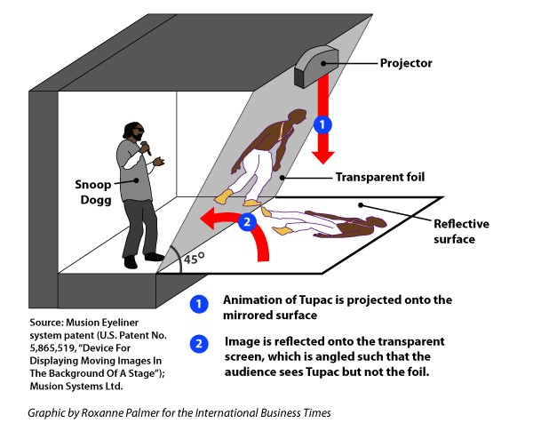
Fig 1.9 Pepper’s Ghost Principle Diagram
It was a show in the 2012 Coachella Valley Music and Arts Festival performed by Dr. Dre and Snoop Dogg. They just used a reflective surface and a transparent foil to have Pepper’s Ghost effect. The foil was placed at an angle with the reflective surface, 45 is the most common degree because it will be simple to hide the source hologram video. In order to show what audience want to see on the stage, they prepared a video of the deceased singer in advance, taken from past live performances. The advantage of using a projector is that it is easy to get a large display effect. The first step is projector project the video onto reflective surface, then when the reflected light reaches the boundary between transparent foil and air, some of the light is reflected and the rest is refracted according to the common sense in physics, light will propagates at a different speed in different media and the foil and air have different refractive index. As a result, audience will see a semi-transparent or ghost 3D image on the stage which consist of the lights from both normal and refracted ray. Considering that a concert only have the audience in front of the stage, the transparent foil can work well. But as a holographic computer game, we want users can see the 3D image from every side of the object. So, a pyramid shaped prism with four sides will be used in this project to show a 360 degree hologram (Fig 1.10). As mentioned above, the game also have four cameras, so four symmetrically projection of the same object are projected on to the four sides of the prism. In theory, four projections will fall on to the center of the prism where they work in unison to form a 3D illusion (Fig 1.11).
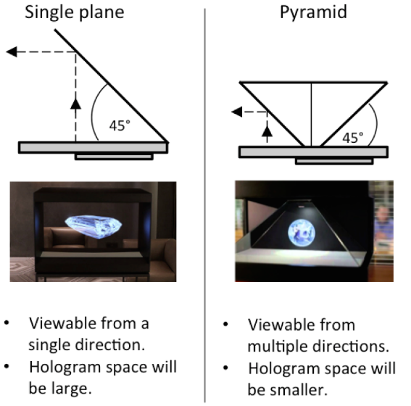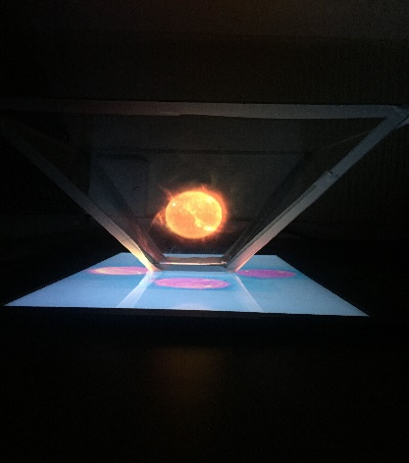
Fig 1.10 Single Plane vs Pyramid Fig 1.11 3D Illusion Using Pepper’s Ghost

1.4.3 Pepper’s Ghost Application
For now, Pepper’s Ghost has been applied in many areas:
- Concerts: The typically usage of Pepper’s Ghost in a concert always involve a special transparent film and projection media server. It is not very difficult to achieve. So more and more concert use it to commemorate some deceased singers and give a shock to the audience. The most famous one among these is 2014 Billboard Music Awards, an illusion of deceased pop star Michael Jackson, other dancers, and the entire stage set was projected onto the stage for a performance of the song "Slave to the Rhythm" from the posthumous Xscape album [18]. Apart from this, in 2006 Grammy Awards, Madonna use this technique to project the English virtual band Gorillaz onto the stage for a performance of two songs: Feel Good Inc. & Hung Up.
- Amusement Parks: Although Pepper’s Ghost has a nearly 150 years’ history, it still can delight audience today because it creates ethereal image which is suitable to display all sorts of otherworldly spirits. The most famous and also the largest example of its application in amusement parks is Disneyland’s Haunted Mansion, opened in 1969 (See Fig 1.12). The Ballroom scene uses this trick to bring multiple reveling ghouls together in one scene. They use a big glass as the refracting plane. But the size of the glass is amazing, it is about 30-feet tall and 90-feet long. Visitors stand on an elevated mezzanine and they can see the ‘ghost’ through the glass because the ghost animation is displayed in a hidden black room under the mezzanine. In addition to Disneyland, the Hogwarts Express tourist spot in Universal Orlando Studio use this technique to create an illusion that visitors will disappear into the brick after they enter Platform 9 3/4 if watched from further behind (Fig 1.13).
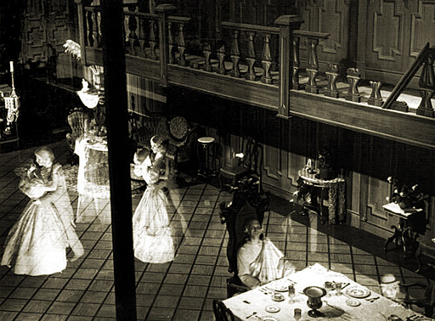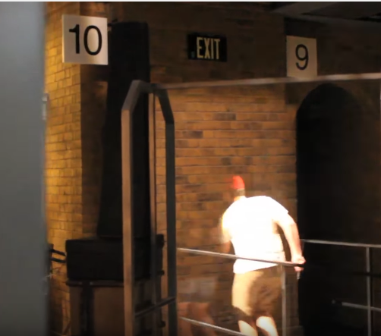
Fig 1.12 Haunted Mansion in Disneyland Fig 1.13 Hogwarts Express in Orlando
- Museums: Using Pepper’s Ghost in museums can improve its attraction to appeal more visitors. The changing office in London Science Museum can show the transformation from 1970s to 1980s happened in this office by using Pepper’s Ghost. There are more examples about Pepper’s Ghost around all over the world. Wimbledon Lawn Tennis Museum use it to make a hologram video of John Patrick McEnroe so ‘he’ can introduce the history to visitors. In October 2008, a life-sized Pepper's ghost of Shane Warne was opened at the National Sports Museum in Melbourne, Australia [19]. In the South African Jewish Museum in Cape Town, they use it in their permanent exhibition. Visitors climb over each other to catch a glimpse of the Pepper’s ghost video installation.
- Film and Television Works: In the 1990 movie Home Alone, the technique is used to show Harry with his head in flames, as result of a blow torch from a home invasion gone bad. CGI was not available at the time of filming [20]. On 1 June 2013, ITV broadcast Les Dawson: An Audience With That Never Was. The program featured a Pepper's ghost projection of Les Dawson, presenting content for a 1993 edition of An Audience With That Never Was to be hosted by Dawson but unused due to his death two weeks before recording [21].
- Mixed Reality: Nowadays, with the development of digital display, Pepper’s Ghost has already been used with these leading-edge computer graphic technology to create a Mixed Reality (MR) system where static information and dynamic virtual objects are displayed together in the scene. For example, Ronald Sidharta et al. [17] developed a Pepper’s Ghost MR system that was able to display in varying z locations with different depths. They used a Polymer Dispersed Liquid Crystal (PDLC) with six layers as their projection screen which allows the appearance of the object at different depth by turning PDLC on/off [Fig 1.14]. Mariza Dima et al. proposed a new interaction technique that creates the illusion of tactile exploration of museum artefacts by using Pepper’s Ghost [22]. They made a replica for each exhibits and put it into a black box facing the original object at an equal distance from display glass. When visitors try to touch the replica, they can see their hands are trying to touch the original exhibit in the window by using Pepper’s Ghost which can improve their touch feeling. Another interesting invention about MR in recent years is Meta 2 which is released in 2016 (Fig 1.15). Based on traditional AR glasses, they change the angel between the glass and the headset to have a 3D stereo effect. So, the basic principle is as same as Pepper’s Ghost. But it is more attractive and interesting than just using AR. Therefore, Mixed Reality is an important future development direction for both Pepper’s Ghost and VR/AR where they can play their respective strengths.
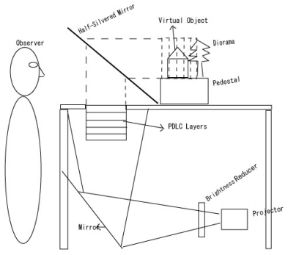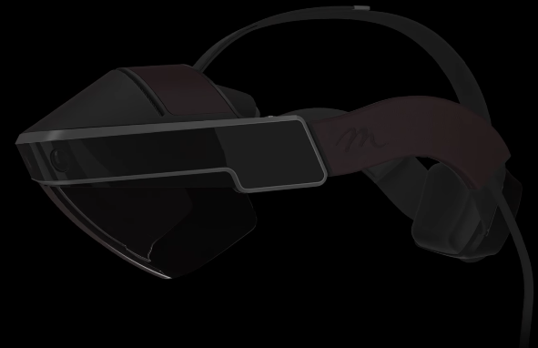
Fig 1.14 MR System Example I Fig 1.15 MR System Example II

1.5 Unity
There are many computer three-dimensional modeling software such as SketchUp [23], Solidworks [24], CATIA [25] and so on. In this paper, we choose Unity to build the game because Unity is easy to import resources and it is convenient to connect with Leap Motion. Besides, Unity is famous for its ability to release game on different platforms.

1.5.1 Unity Introduction and History
Unity is one of the key platforms of the era of digital games, it is a cross-platform game engine developed by Unity Technologies which make it easy for creative developers to build video games can run on different platforms including computer, mobile phone or webpage [26]. There are five main versions of Unity have already been released. The first version of Unity (1.0.0) was created by colleagues: David Helgason, Joachim Ante and Nicholas Francis in Denmark, the initial product was released on June 6, 2005 [27]. It was only available for Mac operation system and the game created by it just can be played in a few platforms. But version 1.1 began to support exporting to Windows and webpages. Immediately after the release of Unity (1.0.0), Unity 2.0 was being developed on the side. Unity 2.0 launched in the Unite Developer Conference, 2007. It has been regarded as a milestone in Unity’s history. The development team added Microsoft DirectX support so this release strengthened Windows support and webpage compatibility across platforms. Besides, web streaming, networking ect. These new features are also impressive. The next important version is Unity 3.0 which was released in 2010. There were many new but important features in this version, such as editor unification, Beast lightmapping, deferred rendering, Umbra occlusion culling, low level debugging, and FMOD audio filters [28]. The fourth generation of Unity came out on June, 2012. David Helgason, the CEO of Unity Technologies said [29], “The revolutionary animation system and add-on deployments to Adobe Flash and Linux are some of the critical features introduced in Unity 4, which together maintain Unity as the strongest, fastest evolving modern games development platform available.” The newest version of Unity is Unity 5.6 which launched on 1 April, 2017. The following list is about some new key features about Unity 5.6:
- Improvements in lighting: Compared with Enlighten, Progressive Lightmapper can provides immediate feedback and it is faster.
- Support for Vulkan: Vulkan is a new generation of graphics and computing API. It can implement some efficient and cross-platform modern GPU functions on both desktops and mobile platforms. Unity use it to lower CPU’s workload and save battery life.
- TextMesh Pro: TextMesh Pro allows advanced text rendering, styling which will greatly improves the control of text formatting and layout.
- New platforms: In Unity 5.6, developers can release the game on Facebook Gameroom, Goolge DayDream, CardBoard and Nintendo Swich.
- Graphics performance improvements: The improvements of Particle System and GPU Instancing give this version a better graphics performance.
The latest version of Unity 5.6 became available for users to download on 11 May 2017.

1.5.2 Unity Application
Unity is a very popular game development engine in recent years because of its cross-platform ability. Dozens of games created in Unity, many of them are very popular around the world:
- Temple Run Trilogy [30]: It was one of the most popular mobile game few years ago. First published by Imangi Studios in 2011. In this game, player needs to keep running to not caught by the “demonic monkeys”. The game is endless unless players make a mistake and eaten by the monkey. The farther you run, the higher you score.
- Sunless Sea [31]: It is an immersive 2d experience game in Steam with over eighty percent positive reviews. Sunless Sea raised about 100,000 dollars on Kickstarter. It is so successful that some players may forget that this is one of the popular games built in Unity.
- Hearthstone [32]: Heroes of Warcraft: Hearthstone is a card game based on Warcraft, a classic RPG game in the world. Blizzard released the game in 2014. Unlike other Blizzard games, this game is totally free to play. This game has an effective but easy gameplay which can hook players into it in just a few minutes. Hearthstone won the “Best App” award among numerous apps in Google’s Play store.
More and more developers choose Unity as their game development engine because of its unique advantages. The holographic game will be created in Unity 5.6.1.

1.6 Leap Motion

1.6.1 Leap Motion Introduction
In order to improve the entertainment and give the interactive feature to the game, a gesture input device is necessary. There are three main popular gesture input device, one is Leap Motion [33], another is Kinect [34], the last one is Intel RealSense. Table I shows their own pros and cons:
 | Pros | Cons
Leap Motion | ▪ Within the range of recognition, the accuracy is very high, and it can directly provide the precise information about the position and speed of fingers  ▪ It was first published in 2013, so there are a great number of related resources  ▪ It is small and portable, may be the wearable device in the future | ▪ The recognition area is a little small  ▪ Leap Motion suppose users’ hands face to the device all the time, so it cannot recognize if users turn over their hands
Kinect | ▪ Kinect can track more than one user’s whole body  ▪ The recognition area is wider than Leap Motion  ▪ It has the perfect supporting software | ▪ The smallest unit is the whole palm so it cannot track fingers  ▪ The interface should be USB 3.0
RealSense | ▪ Accuracy is good  ▪ Official SDK can track fingers | ▪ RealSense is still new, so resources is not enough  ▪ It doesn’t have the independent camera  ▪ Its requirement for machine is also very critical
Table I Pros & Cons Contrast
In summary, in order to control a holographic game developed in Unity, Leap motion is the right choice.

1.6.2 Leap Motion Principle
In general, the Leap sensor can reconstruct the motion information of the palm in the three-dimensional space of the real world according to the pictures captured from two built-in cameras in different angles (Fig 1.16). The basic principle is triangulation (Fig 1.18). After the calibration, the distance between two cameras (b) is a constant, when the two cameras ‘watch’ object P at the same time, it is easy to get P position coordinate value. There are three main steps. Firstly, each camera needs to do the calibration to eliminate distortion. Secondly, the two cameras need to calibrate to identify the distance between the two cameras. At last, the right and left visual images are collected from the binocular camera, and the depth image is generated by stereo vision algorithm. The detection range is roughly 25 millimeters to 600 millimeters above the sensor, and the detection space is roughly an inverted four pyramid. Firstly, the Leap Motion sensor will creates a rectangular coordinate, the origin of the coordinate is the center of the sensor, the X axis is parallel to the sensor and points to the right of the screen, the Y axis points upwards, the Z axis points to the direction of the screen (Fig 1.17).
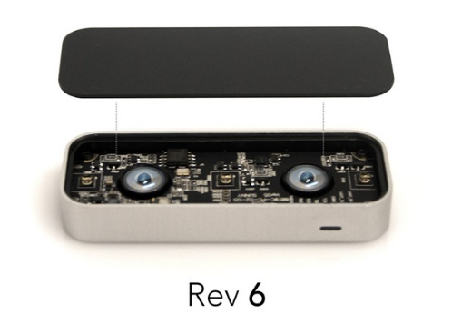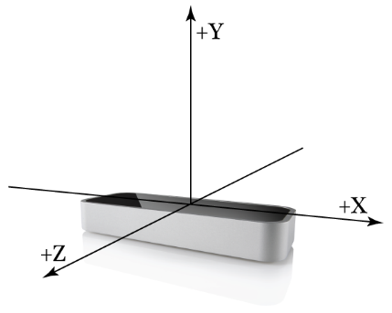
Fig 1.16 Leap Motion Structure Fig 1.17 Leap Motion Coordinate
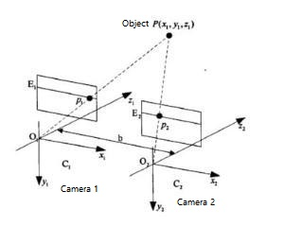
Fig 1.18 Triangulation
When using Leap Motion, its sensor will transmits motion information about the hand periodically and every single information including palm, finger will be allocated a unique ID, developers can query these information by using Frame::hand( ) , Frame::finger( ) function. Leap can generate motion information based on the data detected by each frame and former frame. For example, if two hands are detected move to one direction, Leap Motion will consider hands’ move is translation. Except the hands, Leap Motion can also detect some tools hold by hand like a pen.

1.6.3 Leap Motion Application
1) Education: There are some educational apps using Leap Motion. Molecules [35] is a Mac app which allows users observe and operate molecules in the form of 3D. Exoplanet is another Mac app use Leap Motion to provide an interactive navigation in the whole space.
2) Game: Boom Ball [36] is a classic and easy game combines brick and squash. Players can break the brick by using Leap Motion. Dropchord is a music game which is full of powerful pictures, rhythmic and dynamic electronic music. The user uses two fingers to avoid obstacles and score by sensing the rhythm of the music.
3) Productivity Tools: Corel Painter Freestyle [37] is a drawing software. Users can choose draw a picture by fingers or an instrument. Touchless allows users control Windows or Mac through Leap Motion. And Google Earth also provides a gesture manipulation option.

2 Methodology & Requirements

2.1 Research Methodology
The purpose of the paper is to develop an interactive holographic game, it is kind of an emerging technology. In order to complete the project in a systematic and efficient way, choosing a proper research methodology is a very important step. Research methodology refers to the step-by-step research process; the selection of the most efficient ways to collect, analyse and present data whilst maintaining academic rigour. There are three main parts researchers need to take into consideration: Philosophy, Approach and Strategies. The first one is philosophy. It depends on the way that researchers think about the development of knowledge. There are two main research philosophies: Positivism and Phenomenology. Positivism adheres to the view that knowledge is based on the observation or experience of real phenomena in an objective and real world. Correspondingly, phenomena means knowledge is a social phenomenon that can only be understood subjectively. Module in Diagram 2.1 illustrates the process to choose a research philosophy:
The Research Question
Theory

Philosophical Perspective

Positivism
Single, Objective Reality
Phenomenology
Multiple Realities
Research Purpose

Explain, Interpret, Describe (Phenomenon)
Test, Verify, Describe (discrete variables)

Experimental, Quasl-Experimental Descriptive
Qualitative Case Study Ethnography Grounded Theory
Research Design

Observation, Interview, Review of Artifacts
Controlled Intervention, Sequential Clinical Trials, Survey, Software Development

Research Methods

Qualitative Constant Comparative
Quantitative Statistical Analysis

Confirm or Revised Theory

Diagram 2.1 Philosophical Approaches to Research
The first step is to identify research question, then find out some relative theories. From the diagram we can see there are lots of differences between positivism and phenomenology. So researchers can choose the appropriate philosophy according to research data, research methods and so on. Sometimes, not all research fall into only one perspective or another, they may contain some elements could be considered belong to either philosophical perspective. In this project, our goal is to develop an interactive holographic game, the research methods is software development and experiment and it tends to produce quantitative data instead of qualitative data. Based on this, positivism is a better choice for this project.
The second part is approach. Usually, a positivist philosophy often leads to a deductive approach and a phenomenological philosophy normally leads to an inductive approach. Deductive involves developing a theory and hypothesis, and designing a research strategy to test that hypothesis while inductive involves collecting data, analysing it, then developing theory. Deductive works from general to specific, so it is also called ‘top-down’ approach. It often begin with a theory, then narrow that down to a specific hypothesis and test it. Conversely, inductive works from specific observations to general theories. It is also called ‘bottom up’ approach. In general, inductive approach will finally develop some general theories from specific observations. So, the main difference between deductive and inductive is that the former is aimed and testing theory while inductive is about the generation of a new theory. In this project, we want to use ‘Pepper’s Ghost’ to develop a new display system, so deductive is the proper approach.
The last one part is strategies. There are five main strategies which are commonly used within applied computing: Experiment, Software Development, Document Review, Case Study, and Survey.
- Experiment: The purpose of the experimental research strategy is to establish the existence of a case-and-effect relationship between two variables. In order to examine the relationship, an experiment manipulates one variable while a second variable is measured and other variables are controlled. The final goal is to find out if the alteration of one variable ‘causes’ a change in another.
- Software Development: This strategy involves developing novel software and testing that it works effectively.
- Document Review: Also called ‘Literature Review’ is a very common and popular research strategy. It can help researchers to know pioneer’s prominent work in this filed and get some inspiration from it. Besides, it can also provide some results can be compared with.
- Case study: Case study aims to help researchers to understand a complex phenomenon of interest and can extend experience to what is already know in this filed. It emphasize detailed contextual analysis of different events and their relationships. It is effective but may be very time-consuming and requires good access to the phenomenon of interest.
- Survey: Survey is about an investigation into opinions through questionnaires or interviews. All questions should be designed properly before use. The benefits of survey is that it is relatively inexpensive and survey is useful to describe the characteristics of a large population.
Except for these five strategies, other strategies also exist, but they are difficult to apply to a short applied computing project. So, in this project, experiment, software development and document review are useful strategies. Software development is necessary because this project aims to develop a game. The game should be properly designed and tested in Unity. Besides, Leap Motion should be integrated with Unity to allow interaction. Document Review can help us to know more about holographic projection including VR/AR and Pepper’s Ghost. So, we know their history, principle, applications and advantages or disadvantages which can help us to make a better choice. And instructions for Leap Motion is necessary because we need the document to tell us how to use Leap Motion in Unity. Experiment can be helpful to improve our design. For example, the prism’s original design has four sides and the angle between glass and screen is 45 degree. But more experiments with different number of sides and angle may provide a better display plan.

2.2 Requirements
One important part in this project is the development of the holographic game in Unity. In order to achieve the final goal, a detailed function requirements table should be listed before start developing the game. Actually, the list is about all the possible features we want the game to have, it is an important part of FDD (Feature Driven Development). FDD is one of the agile methodologies developed empirically in the late 1990’s [38]. The idea is to develop the high-level features, scope and domain object model and then use that to plan, design, develop and test the specific requirements and tasks based on the overarching feature that they belong to. There are five main activities in FDD. The basic process step is shown as below:
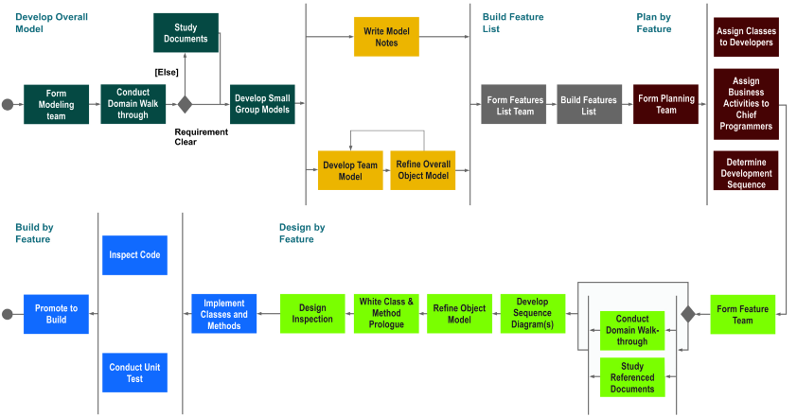
Fig 2.1 FDD Process Diagram
The first step is develop an overall model. In a large size project team, they will have a modeling team to refine overall model. But it is not very specific, it has just enough detail to form a conceptual framework for the project. The model is more shape than content. The second step is build a feature list. As FDD’s name implies, features are the most important part of FDD. After finish the list, the plan should be driven by features, so the third step is plan by feature. The next step is design by feature, each feature will have a design package which includes the referenced requirements, design alternatives and so on. The final step is build by feature, it contains some tasks like detailed modeling, programming and testing of the system. The advantages of using FDD to develop a software is obvious. The simple five steps help to finish the work in a short time and make the project easy to manner. Besides, FDD helps to reduce risks by using shorter iterations of design and can provides a better understanding of the requirements in a clear way. Therefore, apply FDD into this project, the most important thing is build the feature list. In order to write the list in a thoughtful way, MoSCoW method is used here. It is a prioritization technique widely used in software development. MoSCoW is an abbreviation comes from the first letter of each of four prioritization categories (Must have, Should have, Could have, and Won't have). All requirements are important. But they have different priority. MoSCoW can make the choice easier when the time is not enough. The system term will provide two games including ping pang and boom ball. Table 2.1 and Table 2.2 is their respective feature list using MoSCoW:
Ping Pang Feature list
Must Have | Score board
Must Have | A ping pang ball can be played by player, it can bounce when meet table or racket
Must Have | A table can provides boundaries
Must Have | Two rackets controlled by players
Must Have | Can be played by hands by using Leap Motion
Must Have | If one player miss the ball, the opponent score
Must Have | Anyone get 21 points will win the game
Should Have | Light and four cameras
Should Have | Rendering materials
Could Have | Background
Could Have | Music
Could Have | Game option: Single mode and Double mode
Won’t have | Referee
Won’t have | Complete character model
Won’t have | Different batting strength
Table 2.1 Ping Pang Feature List
Boom Ball Feature List
Must Have | Score board and time board
Must Have | A wall consist of many bricks which can be destroyed by the ball
Must Have | Two hands can throw the ball
Must Have | Two hands module can be controlled by player’s hands
Must Have | Boundary
Must Have | A ball can hit the wall and destroy bricks and it will bounce when reach the boundary
Should Have | Light and four cameras
Should Have | Rendering materials
Could Have | Some floating bricks
Could Have | Game option: Single mode and Double mode
Could Have | Background
Could Have | Music
Won’t Have | Different strength to throw the ball
Won’t Have | Complete character model
Table 2.2 Boom Ball Feature List

2.3 Risks
Risks are an inevitability within any project of any size. But most of the time, many risks are easy to identify and overcome if they are analyzed properly before the start of the project. Therefore, risk analysis is necessary to make a project efficient and low-cost. There are four main steps need to take place when doing a risk analysis [39]:
- Risk Identification: It is the process of determining risks that could potentially cause a risk to the program including things that can directly or indirectly have an effect on the project.
- Risk Projection: Also known as risk estimation. All the risks identified in stage one will be given a level label based on likelihood the predicted influence on the project. The higher level a risk get the higher impact it may have on the project.
- Risk Assessment: A risk register (see table 2.3) will be built to assess all the risks. The register includes the information about the probability of occurring of risks, their potential influence rating, a rating based on probability and impact and mitigation to minimize the impact.
- Risk Management & Monitoring: During the whole process, strict risk monitoring can ensure the best solution is properly applied and working correctly. If a new risk which is not listed in the risk register come out during the project, it should be added to the register and monitored.

Risk # | Risk Summary | Probability | Impact | Rating (P*I) | Mitigation
1 | Hardware unavailable | 1 | 3 | 3 | Make a copy of all the important data including game module, code and documents and upload these to cloud.
2 | Delays in development of the system | 4 | 4 | 16 | Make a schedule at first and keep touch with supervisor regularly.
3 | Skills deficiency | 2 | 3 | 6 | Keep learning knowledge needed in this project. Look up relative resources or ask teacher for help when meet some difficulties that cannot be solved independently.
4 | Bugs | 4 | 4 | 16 | Try all the functions we have in this project to identify all the bugs and fix it as soon as possible.
Table 2.3 Risk Register
From the risk register we can see, there are two main risks may have the highest effect on the project. The first one is delays. This could be caused by other risks in the table. Use timeboxing, a time management method, to arrange the game building process reasonably. Progress at each stage should follow the schedule and any issues may cause a delay should be rectified quickly. Besides, regular meeting with supervisor is an effective way to promote the progress. Another main risk is bugs. Bugs is inevitable when build a complex game. So many different tests should be done on the game to eliminate bugs.

2.4 Validity & Generalisability
Validity is the extent to which a concept [40], conclusion or measurement is well-founded and corresponds accurately to the real world. There are three main threats to validity:
- Chance: All tests and results may be influenced by random variation while doing the project. It is important to prove that the success of the system is not due to a chance. The best way to avoid this is repeat all the tests. Adequate sample size can alleviate the influence of random variation.
- Bias: Differ from chance, bias is influenced by systematic variation. Systematic error exists in measuring instruments and theoretical approximation. But in this project, we just need to make sure that all the functions can work properly and we can see a 3D holographic effect, it do not need to be very precise. So, bias is not a big problem here.
- Confounding: Confounding is similar to bias so it is a little confusing. Specifically, bias is about the error found during the measurement of a variation, confounding involves error in the interpretation of an accurate measurement. A famous instance of confounding is to interpret the finding that people who carry matches are more likely to develop lung cancer as evidence of an association between carrying matches and lung cancer. Smoking is the confounding factor in this relationship- smokers are more likely to carry matches and they are also more likely to develop lung cancer. So in this project, when we try to analyze the potential reason for a problem, we need to the real reason.
Generalisability describes the extent to which research findings can be applied to settings other than that in which they were originally tested. When build the game in Unity, it can be released to many platforms including Windows, OS X, Android and so on. So the problem for generalizability is different display device like screen, prism and projector. These change depends on specific circumstances. A small 3D holographic image may do not need the projector, but a big one will needs it as well as a reflective surface. In general, it is quiet easy to extent this game system to other places.

3 Development & Experiment
One of the most important part of this project is to build the game in Unity. This part will describe all the key steps in the whole process in detail. As mentioned above, the method we use to build the game is FDD. As the name implies, the whole process of creating the game based on those features listed in table 2.1 & 2.2. In order to build the game in an efficient and reasonable way, time box will be used to allocate a fixed time period to each feature. A time box is a defined period of time during which a person or a team works steadily towards completion of some goal. Usually, people are used to continue to work unless a goal is reached no matter how long does it takes. Time box is different as it encourages you to focus on deadline rather than task. It is very popular in many successful software development projects, especially smaller ones because it can helps developers focus on the work for the specific period of time and increase productivity. Each time box has its own features, duration, design, test and evaluation. In this project, there are seven time boxes in total.

3.1 Time Box 1: Ball Moves
Date – 09th July 2017
Duration – 3 Days
Completion Date – 12th July 2017

3.1.1 Features
- Ball Moves and bounces

3.1.2 Design and Implementation
Use Case Description
Use Case Name: Ball moves
Brief description: The ball moves from one point (x1, y1,z1) to another (x2, y2,z2)
Trigger: Initial pulse acting on the ball
Normal flow of events:
- System calculates path of the ball
- System displays ball as is moves
- Ball change the route after a bounce
Sub-flows:
S-2
- If ball is not at (x2,y2,z2) then the ball keeps moving

Alternative/Exceptional flow of events:
S-1a: If the ball is going to hit a wall
- Calculate the new path of the ball after the bounce
- Display ball as it moves.
At the beginning of this step, an arena should be created to provide the ground and the boundary. Fig 3.1 shows the basic module of the arena built in Unity:
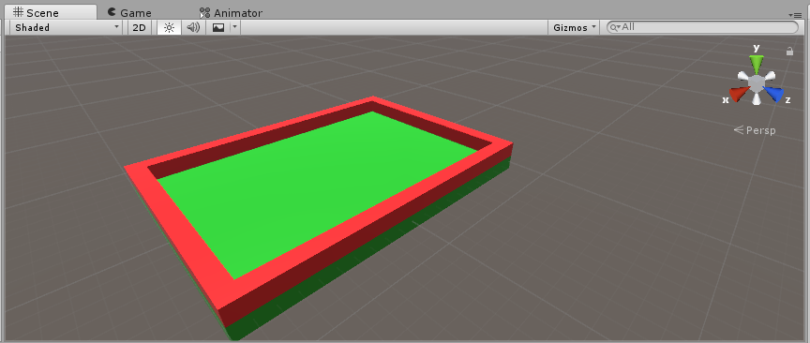
Fig 3.1 Arena Module
The center coordinates of the arena is (0, 0, 0) because it is easy for developers to handle the position relation among various objects. The next step will be create a ball. In order to move the ball around, a rigidbody component should be added to the ball and set the interpolate to interpolate, set the collision detection to continues dynamic that means if the ball is moving really fast, the system still can detect the collision otherwise it won’t. This takes some more computing but more precisely. Besides, Y position should be frozen to prevent the ball from flying out the scene. In the long term, we want to be able to use the y direction as well. But limiting it is a good start. The following step is to create a script to move the ball by using VS 2017. In the main body of the script, we can program behavior for the game objects. All the scripts are inherited from MonaBehaviour and MonaBehaviour is inherited from a component. To move the ball, an impulse is added by creating a public Vector3 variable initialImpulse that developers can set in the editor. The details are shown as below:
public class Ball : MonoBehaviour
{
public Vector3 initialImpulse;
public Rigidbody rb;

// Use this for initialization
void Start()
{
rb = GetComponent<Rigidbody>();
rb.AddForce (initialImpulse, ForceMode.Impulse);
}

// Update is called once per frame
void Update()
{
}
}
What it basically is when start the game, the ball will receive one impulse that can be set in inspector. The last step is about bounce. The ball won’t bounce from the border if it doesn’t have the physic material. So, a physic material is attached to the ball and the parameters are set as Fig 3.2:
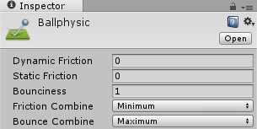
Fig 3.2 Physical Material Parameters
These parameters describe how the object should behave if it collides with another object. Friction means movement is slowed down and we don’t hope the ball slow down so the value is 0, bounciness describe how bouncy object and the ball should be absolutely bouncy so the value is 1. Correspondingly, change the friction combine mode to minimum and bounce combine to maximum. After these steps, the ball can move and bounce properly.

3.1.3 Test
Task ID | Task Name | Days Expected | Actual Days | Planned Results | Actual Result
1 | Make the plan and build arena, boundary and ball | 1 day | 1 day | Build a size-suitable arena with four boundaries | Arena built successfully
2 | Ball moves | 1 day | 1 day | The ball can moves in the expected direction under the action of initial pulse | Finished as expected
3 | Ball bounce | 1 day | 1 day | The ball will change the route after collide with boundary | Finished as expected

3.1.4 Evaluation
All tasks were finished within the given time period. The evaluation method is run the game directly in Unity and see what happen. Here are some screenshots for the ball move and bounce test:
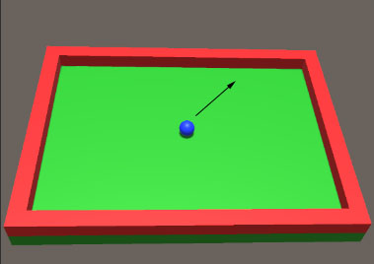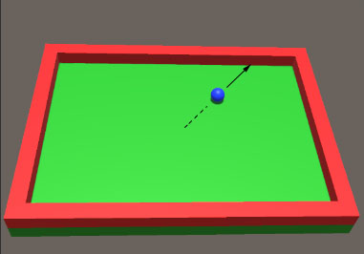
Fig 3.3 Initial Position Fig 3.4 Movement Process
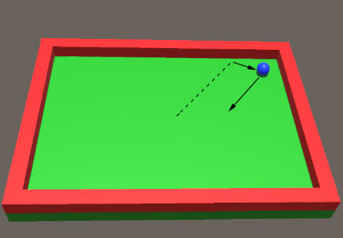
Fig 3.5 After bounce the border
From the pictures we can see all the functions we expect work properly. During the building of the program, arena and ball were built in a right way.

3.2 Time Box 2: Player Moves
Date – 13th July 2017
Duration – 2 Days
Completion Date – 14th July 2017

3.2.1 Features
- Bat moves

3.2.2 Design and Implementation
Use Case Description
Use Case Name: Player moves
Brief description: The bat moves from one point (x1, y1,z1) to another (x2, y2,z2)
Trigger: Player manipulate the bat
Normal flow of events:
- Player manipulates and moves the bat
- System calculates path of the ball based on player’s input
- System displays ball as is moves
Sub-flows:
S-2
- If bat is not at (x2,y2,z2) then the bat keeps moving

Alternative/Exceptional flow of events:
S-1a: If the bat is going to hit a wall
- It will stops moving
- Player can move it to another direction.
Except the ball, another important element in this game is player’s bat. Therefore, the second part is about the movement of the bat. Just like a real ping pang game, people can use the bat to hit the ball to attack or defend so it also has a rigidbody component which can also guarantee the bat will stop when hit a wall. In principle, the initial position of the bat should be on the one side of the table and it can move in x and z axis direction. Besides, considering that this game can be played by two players at the same time and we want to just have one script that can be used in two bats because of space saving concern, an enum variation should be defined in the script. It has two values: Left and Right. So system will distinguish which bat should move based on player’s input. Speaking of input, the next step is to reset the input manager. There are two bats in the game and each bat can move in two axis directions, and each axis direction has two directions (negative and positive), so there are 8 directions in total. The basic setup for one bat is shown as below:
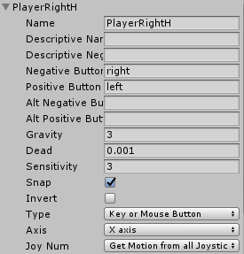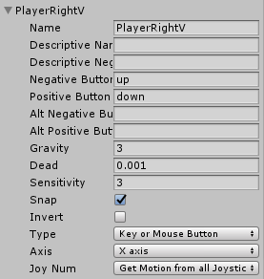
Fig 3.6 Input Setup
The bat in the right of the arena named PlayerRight, and use PlayerRightH and PlayerRightV to distinguish vertical and horizontal. Player can control it by pressing up, down, left and right. Based on these requirements, the main code is:
public enum ePlayer
{
Left,
Right
}

public class Player : MonoBehaviour {

public float speed1 = 15f;
public float speed2 = 10f;
public ePlayer player;

// Update is called once per frame
void Update () {
float inputSpeedV = 0f;
float inputSpeedH = 0f;
if(player == ePlayer.Left)
{
inputSpeedV = Input.GetAxisRaw("PlayerLeftV");
inputSpeedH = Input.GetAxisRaw("PlayerLeftH");
}
else if(player == ePlayer.Right)
{
inputSpeedV = Input.GetAxisRaw("PlayerRightV");
inputSpeedH = Input.GetAxisRaw("PlayerRightH");
}

transform.position += new Vector3(inputSpeedH * speed2 * Time.deltaTime, 0f, inputSpeedV * speed1 * Time.deltaTime);
}
}
The system will determine which bat move to which direction based on ePlayer’s information.

3.2.3 Test
Task ID | Task Name | Days Expected | Actual Days | Planned Results | Actual Result
1 | Preparation | 1 day | 1 day | Make the plan and build the module | Finished as expected
2 | Programming and test | 1 day | 1 day | Make the module move as expected | One bug exit in this system

3.2.4 Evaluation
All tasks were finished within the given time period except one bug. The bug is both the right and left player’s bat can move out of the arena. These two bats have the same component and script. So the reason has not been found, it supposed to be solved in the future. Some screenshots for player moves are shown as below:
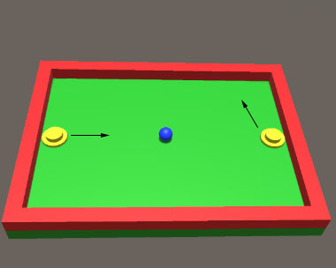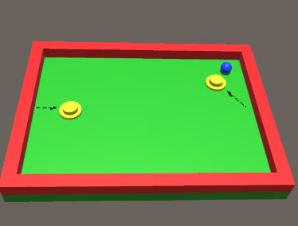
Fig 3.7 Initial Position of Two Bats Fig 3.8 Movement Process

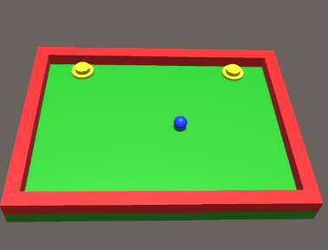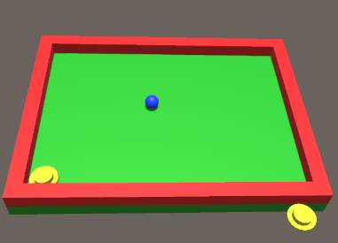
Fig 3.9 The Bats Stop When Hit The Wall Fig 3.10 Bug in the system
All the functions we expect work properly during the test process except the bug. That proved the project is basically progressing well so far.

3.3 Time Box 3: Score Calculation & Display
Date – 17th July 2017
Duration – 3 Days
Completion Date – 20th July 2017

3.3.1 Features
- Restart the game
- Score calculation and display

3.3.2 Design and Implementation
Use Case Description
Use Case Name: Score calculation and display
Brief description: Restart the game when player miss the ball. And the scoring system calculate each player’s score automatically and show it on the scoreboard.
Trigger: One player miss the ball and the ball hits the border behind the bat
Normal flow of events:
- Player miss the ball
- Ball hits the arena border behind the player
- The other player get one point and the scoreboard displays updated scores
- The game restart
Sub-flows:
S-2
- If one player scores, the ball will go back to the original position in the arena and move again under the initial impulse
Alternative/Exceptional flow of events:
S-1a: If nobody miss the ball
- The score stays the same and game keep going until one player miss batting the ball
All the important basic components including arena, ball, bats, impulse and their movement have already been built in this project and they can work as we expected. So the next step is to build a score & restart system. The system should be able to judge when to restart the game and which player get the point. According to the rules of ping pang game, when the player miss batting, the ball will hit the border behind the player, his/her opponents get one point. When do the program, rather than add the score script to the ball, the best way to do this is build an empty game object and attach the score script to it and then add it to the border script which is used to restart the game and add score to the winner. In addition, once the ball hit the border behind player, the game should stop and restart. Based on these requirements, main body of the border script is shown below:
public class PlayerBorder1 : MonoBehaviour {

public ePlayer player;
public ScoreUI score;

void OnCollisionEnter (Collision col)
{
Ball ball = col.gameObject.GetComponent<Ball>();
if(ball != null)
{
ball.transform.position = new Vector3 (0f, 1f, 0f);
if (player == ePlayer.Right) score.scorePlayerLeft++;
else if (player == ePlayer.Left) score.scorePlayerRight++;
}
}
}
In this code, OnCollisionEnter function was used to restart and determine which side score. ScoreUI was built in another script ScoreUI attached to the empty object. ScoreUI defines the size and position of the score area by using OnGUI (shown below). ePlayer was created in time box 2.

public class ScoreUI : MonoBehaviour {

public int scorePlayerRight;
public int scorePlayerLeft;
public GUIStyle style;

private void OnGUI()
{
// the center of the screen
float x = Screen.width/2f;
float y = 30f;
float width = 300f;
float height = 20f;
// scoreboard content
string text = scorePlayerLeft + " / " + scorePlayerRight;

GUI.Label (new Rect (x - (width / 2f), y, width, height), text, style);
}
}
There is a public variable named style. So in the editor panel, developers can change the font, font size, alignment and so on.

3.3.3 Test
Task ID | Task Name | Days Expected | Actual Days | Planned Results | Actual Result
1 | Create a script to restart the game | 1 day | 1 day | Make the plan and create a script to set the trigger to restart the game | Finished as expected
2 | Add the UI to display the score | 1 day | 1 day | Make the plan and create a script called ScoreUI | Finished as expected
3 | Increase the score and fix the bug left last week | 1 day | 1 day | The scoreboard will increase automatically when player miss the ball | Finished as expected except the bug

3.3.4 Evaluation
All tasks were finished within the given time period except the bug. Some efforts were put into the bug including change the interpolate method and collision detection, it doesn’t work. But there are two parts in each bat, one bigger circular base and a smaller circular handle. The bigger one is parent and the smaller one is child. Experiments prove that if remove the handle individually which means the bat is just the big circular base, then the bat won’t move out of the arena. So the problem is identified, it supposed to be solved in the next time box. Some screenshots for score and restart are shown as below:
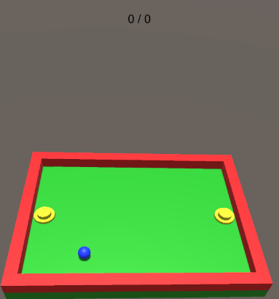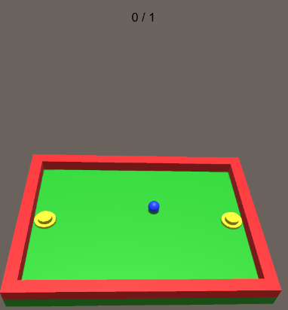
Fig 3.11 Game Start Fig 3.12 Left Player Miss the Ball
All the functions we expect work properly during the test process except the bug. So the basic structure of this game is completed, but there is still plenty of room for improvement in this game like 3D arena and so on. More functions will be added to the game in the future.

3.4 Time box 4: Gesture Control
Date – 21th July 2017
Duration – 7 Days
Completion Date – 31th July 2017

3.4.1 Features
- Use Leap Motion to control the bats

3.4.2 Design and Implementation
Use Case Description
Use Case Name: Gesture control
Brief description: Instead of the keyboard, use Leap Motion to build the hand model to control player’s bat
Trigger: The player puts his hands into the scan area of Leap Motion
Normal flow of events:
- Leap Motion get player’s hands information (position, rotation, etc…)
- Leap Motion translate these information and send it to the hand model in Unity
- The hand model interact with objects in Unity through interaction engine
- The bat move with hands after player “grab” it
Sub-flows:
S-2
- Player’s hand move in the real world casually, the bat can only move in the arena
Alternative/Exceptional flow of events:
S-1a: If player’s hand move out of the scan area of Leap Motion
- The hand model in Unity will disappear until it gets back to the scan area
According to the “Must Have” feature: Can be played by hands by using Leap Motion. This step aims to add the interaction function to the game. There are two ways to meet this requirement. Method I use rigidbody and collider component to trigger the interaction engine to control the hands. On the other hand, Method II detect the distance between hands and bats and replace the bats position with hands coordinate. Two methods are all tested in this step:
- Method I:
- The first step in both two methods is connect Leap Motion with computer and Unity so Unity can get hands information and display the hands. Leap Motion official website [33] provides LeapDeveloperKitand many Unity assests for all developers. In this project, LeapDeveloperKit, LeapMotion_CoreAssets, LeapMotion_HandsModule and Leap_Motion_Interaction_Engine are needed. All the Unity resources should be imported to our project;
- The following step is build the hands model by using a prefab in core asset in CoreAsset named LeapHandController. The hand pool script in LeapHandController can help developer to control hand model. The specific settings are shown in Fig 3.13:
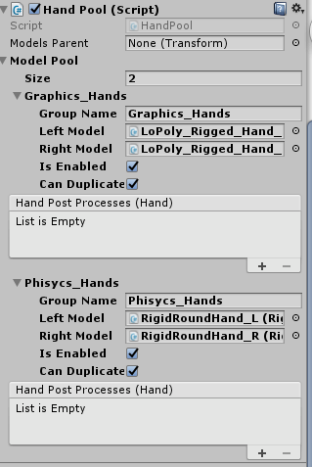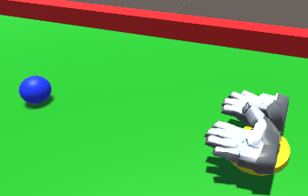
Fig 3.13 Hand Pool Setting Fig 3.14 Hand Model in Scene
So there are two main parts of the hand model: Graphic hands and physics hands. The final model we can see in scene is shown in Fig 3.14;
- Now we can already see the hand when we start the game when player put their hands in the scan area. But it can just move and cannot move the bat. This step is build the interaction between hand model and Unity object. In order to realize it, interaction manager, a prefab in interaction engine, is added to the scene. Besides, bat also need to have an interaction behavior script to communicate with hand model. In this step, physics hands will be removed and interaction hands will be added to interaction manager. In addition, the bat movement in Y axis should be limited to avoid flying out of the scene.
After these three steps, player can use their hand to move the bat as they want.
- Method II:
- The first and second steps are as same as Method I;
- Instead of interaction engine, try to use script to control the movement of the bat. The main idea is detect the distance between bat and LeapHandController, if the distance is less than a constant, the bat position value will be replaced by hands position value. Some main codes are shown as below:
using System.Collections;
using System.Collections.Generic;
using UnityEngine;
using Leap;
using Leap.Unity;

public class PickandMove : MonoBehaviour
{
LeapProvider provider;
public Transform player;
public Transform playerCam;
bool hasPlayer = false;

void Start()
{
provider = FindObjectOfType<LeapProvider>() as LeapProvider;
}

void FixedUpdate()
{
Controller controller = new Controller();
Frame frame = controller.Frame();
List<Hand> hands = frame.Hands;
Hand firstHand = hands[0];
Hand secondHand = hands[1];
Hand hand = frame.Hands[0];
Leap.Vector position = hand.PalmPosition;

Vector3 vec = new Vector3();
vec = playerCam.transform.TransformPoint(position.ToVector3());
Debug.Log(hasPlayer);
//Debug.Log(playerCam.transform);
//Debug.Log("palmworldpostion:" + hand.sss);

float dist = Vector3.Distance(gameObject.transform.position, player.position);
//Debug.Log(dist);
if (dist < 3f)
{
hasPlayer = true;
}
else
{
hasPlayer = false;
}
if (hasPlayer)
{
GetComponent<Rigidbody>().isKinematic = true;
transform.position = vec;
}
Debug.Log(vec);
In this test code, use a bool variable to judge whether the bat is suitable to control. Then use Leap.Vector position to get the hand’s position coordinate. And the playerCam can be defined in the inspector which is player’s hand in this case. The difficulty is the hand’s coordinate is not the world coordinate. So hand’s position value cannot be used directly before coordinate transformation. In this code, TransformPoint function was used to transform the hands position value from the local coordinate to world coordinate. And use Debug.Log(vec) display the value. But unfortunately, it fails. The coordinate value is still the local coordinate value. Once give this coordinate value to the bat, it will go out of the scene.

3.4.3 Test
Task ID | Task Name | Days Expected | Actual Days | Planned Results | Actual Result
1 | Connect Leap Motion with computer and Unity | 2 day | 2 day | Can see the hand model in Unity and it will follow the real hand | Finished as expected
2 | Add all the necessary asset to Unity and use Mehod I to control bat | 2 day | 2 day | Player can use their hand to control the bat | Finished as expected
3 | Use Method II to control the bat | 3 day | 3 day | Player can use their hand to control the bat | Finished as expected except the coordinate transformation problem

3.4.4 Evaluation
Almost all tasks were finished within the given time period except the coordinate transformation problem. Though this part is quiet difficult, the main goals are basically achieved. There are two things need to pay attention to. The edition of Unity used in this project is 5.6.1, it is the newest one and the interaction engine provided by Leap Motion is 1.0.1. They doesn’t match very well. When import this asset to Unity, there will be some errors. Therefore, the asset used here is provided by other developers online [41]. Another thing is due to the new edition, brush hand, which used to be find in prefab in interaction engine cannot be found anymore. Remove the physic hands can add the interaction hand (left & right) to interaction manager can fix the problem. In addition, the bug left in last two weeks have already been fixed in this time box by adding a rigidbody component to the smaller part of the bat. Before the bug fixed, when the bat hit the boundary, the bigger part will be a little out of the boundary and the smaller cannot prevent the movement for lack of physical characteristics.

3.5 Time Box 5: Change Play Mode & Smooth movement
Date – 1st August 2017
Duration – 4 Days
Completion Date – 4th August 2017

3.5.1 Features
- Change the paly mode from two players to one player
- Smooth and rationalize bat movement

3.5.2 Design and Implementation
Use Case Description I
Use Case Name: Change play mode
Brief description: Instead of having two players, new game mode will only allow one player to play the game, and computer will be the other player
Trigger: Start of the game
Normal flow of events:
- When the game start, player use Leap Motion to control the right bat
- Meanwhile, the computer ‘controls’ the left bat automatically
- Other functions including score, restart game will work as before
Sub-flows:
S-2
- The left bat will change its position according to the ball’s movement
Alternative/Exceptional flow of events:
S-1a:
- If the left bat cannot find ball, the screen will display “PlayerAI cannot find Ball”
- If the left bat lag behind the ball, the system will prevent the lagging by clamping the z-position to the ball position
Originally, this step is about how two players use their hands to control two bats. But, Leap Motion doesn’t support two device on one computer. And it is too difficult to use one Leap Motion device to track two or four hands to control multiple objects in different position at one time, at least I haven’t found any demo or solution to this problem. Therefore, another way to build the game is change the play mode from two player to one player. So the following step is create a new script to make the bat can move automatically. The easiest way to do this is give the bat a cyclical movement then it will move like a robot. But the ideal situation is the bat can change the route according to the ball’s movement. Based on this idea, the main code is shown as below:
public class PlayerAI : MonoBehaviour
{
public float speed = 2.5f;

private Transform ballTransform;

void Start()
{
GameObject ballGameObject = GameObject.Find("Ball");
if (ballGameObject == null)
{
Debug.LogWarning("PlayerAI cannot find Ball.");
enabled = false;
}
else
{
ballTransform = ballGameObject.transform;
}
}

/// Updates the player position.
void FixedUpdate()
{
// input speed of the AI from -1 to 1
float inputSpeed = 0f;

if (ballTransform.position.z > transform.position.z)
{
inputSpeed = 1f;
}
else if (ballTransform.position.z < transform.position.z)
{
inputSpeed = -1f;
}

// move player along the z axis
Vector3 position = transform.position + new Vector3(0f, 0f, inputSpeed * speed * Time.deltaTime);
transform.position = position;
}
}
From the code, we can find that the trick is inputSpeed, it will be -1 if the bat movement direction is opposite to the ball. Otherwise, it will be 1. So this variable can helps bat to follow the movement direction of the ball. And the variable speed controls how fast the bat moves with the ball, it can be changed in the editor panel. This code works properly, but if the bat speed along the z-axis is smaller than the ball’s, the player will lag. We can prevent the lagging by clamping the z-position to the ball position:
if (inputSpeed > 1f)
{
if (position.z > ballTransform.position.z)
{
position.z = ballTransform.position.z;
}
}
else if (inputSpeed < 1f)
{
if (position.z < ballTransform.position.z)
{
position.z = ballTransform.position.z;
}
}

Use Case Description II
Use Case Name: Smooth and rationalize bat movement
Brief description: In last step, the bat is difficult to grab and sometimes, it will move too far so that the hand need to move out of the Leap Motion’s scan area to control the bat which is impossible. This part try to fix this problem
Trigger: Move the bat
Normal flow of events:
- Smooth the movement of the bat
- Set a limitation to the position of the bat

Sub-flows:
S-2
- The bat stop following hands movement

Alternative/Exceptional flow of events:
S-1a:
- If the bat is going to move out of the control area, it will stop moving
Though in last time box, player can control the bat through Leap Motion, the bat is quiet difficult to grab and move. And sometimes, it will suddenly moves a long distance after the contact of hands. In order to fix these problems, the model of bat was changed to a capsule which is much easier to grab (Fig 3.15). And change all the objects scale into a smaller value which have a similar size with our hand model. Besides, the interaction behavior code attached to rightplayer was also changed, the modified part is marked with Italic type:
public void StayGrasped(List<InteractionController> controllers) {
if (moveObjectWhenGrasped) {
Vector3 origPosition = rigidbody.position;
Quaternion origRotation = rigidbody.rotation;
Vector3 newPosition;
Quaternion newRotation;

graspedPoseHandler.GetGraspedPosition(out newPosition, out newRotation);

IGraspedMovementHandler graspedMovementHandler = rigidbody.isKinematic ?
(IGraspedMovementHandler)_kinematicGraspedMovement
: (IGraspedMovementHandler)_nonKinematicGraspedMovement;
if (origPosition.x>0.65) { graspedMovementHandler.MoveTo(newPosition, newRotation, this, _justGrasped); }

OnGraspedMovement(origPosition, origRotation, newPosition, newRotation, controllers);
So only when the bat is in the control area, it will follow the hand movement.

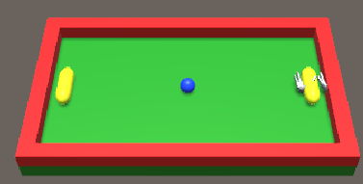
Fig 3.15 New Bat Model

3.5.3 Test
Task ID | Task Name | Days Expected | Actual Days | Planned Results | Actual Result
1 | Create the computer player | 2 day | 2 day | The bat can move automatically according to ball’s movement | Finished as expected
2 | Change bat model and Interaction Behavior script | 2 day | 2 day | Smooth the bat movement and fix the ‘out of control’ problem | Finished as expected

3.5.4 Evaluation
The process is quiet painful, but almost all tasks were finished within the given time period. Many methods had been tried to fix problem in this step. For example, I tried to change the hand model position in inspector or changed the code in LeapHandController in order to have more than one hand model in different position to control two bats but it failed. And also tried to use mathf.clamp to constrain the movement of the bat, it also failed. So some changes were made in this step, but basically they are acceptable and only have little effect. In general, the project is going well so far, the next step is to build four cameras in Unity, so players can see the 3D image finally.

3.6 Time Box 6: Hologram Processing
Date – 7st August 2017
Duration – 2 Days
Completion Date – 8th August 2017

3.6.1 Features
- Create four cameras in Unity
- Player can see the 3D holographic game through a hollow pyramid shaped prism made by four plexiglass

3.6.2 Design and Implementation
Use Case Description
Use Case Name: Hologram processing
Brief description: The final result is player can see the 3D holographic game through the prism
Trigger: Start of the game
Normal flow of events:
- When the game start, four cameras in different position display four images of the game scene
- Put the hollow pyramid shaped prism in the middle of the four cameras views
- Four projections fall on to the center of the prism where they work in unison to form a 3D illusion
Sub-flows:
S-2
- Adjust the prism to find the best performance position
Alternative/Exceptional flow of events:
S-1a:
- If the system display four views at the wrong position or rotation, change it to a reasonable value
In this time box, “Pepper’s Ghost” was used to create a holographic image of the game. As mentioned in Chapter 1.4, there are two main common refraction tools we can chose: single plane and pyramid. In this project, we use pyramid to show a 360 degree holographic image. Therefore, the first step is to create four cameras in unity, each camera will show the different side of the game which gives a different image if people watch the game in different position. And according to the refraction principle, the point is put the camera in the right rotation and position. Besides, in order to show the four views in one scene, camera’s viewport rect value should be rectified in advance. And the last thing is change the cameras background to black. The final result is shown in Fig 3.16:
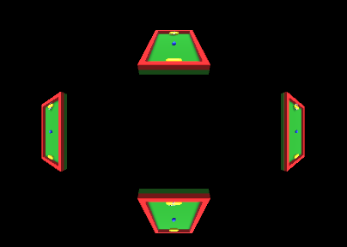
Fig 3.16 Four cameras preview
But there is a problem, the original scoreUI cannot show the score very well. Because it use GUI.Label function to define the score position which is difficult to find out and test now. So the last step is use UI text plug-ins to display the score. So developers can change the position of score in inspector, it is convenient and intuitive. And add these codes to the PlayerBorder script:
public Text scoreText;
void Start()
{
SetScoreText();
}

if (player == ePlayer.Right)
{
scorePlayerLeft = scorePlayerLeft +1; SetScoreText();
}
else if (player == ePlayer.Left)
{
scorePlayerRight = scorePlayerRight + 1;
SetScoreText();
}

void SetScoreText()
{
scoreText.text = "Com:Player" + " " + scorePlayerLeft.ToString()+ ":" + scorePlayerRight.ToString();
}
Compared with the original ScoreUI script, we can input the position value in UI text plug-ins inspector rather than define the position of the text in script. Until now, all the preparations have been completed.

3.6.3 Test
Task ID | Task Name | Days Expected | Actual Days | Planned Results | Actual Result
1 | Create four cameras in Unity and put them in the right position | 1 day | 1 day | The four camera views can show the different sides of the game reasonably | Finished as expected
2 | Change the display method of score to have a better display mode | 1 day | 1 day | Player can see the score above the arena | Finished as expected

After all these steps, the final image that the player is really facing is:
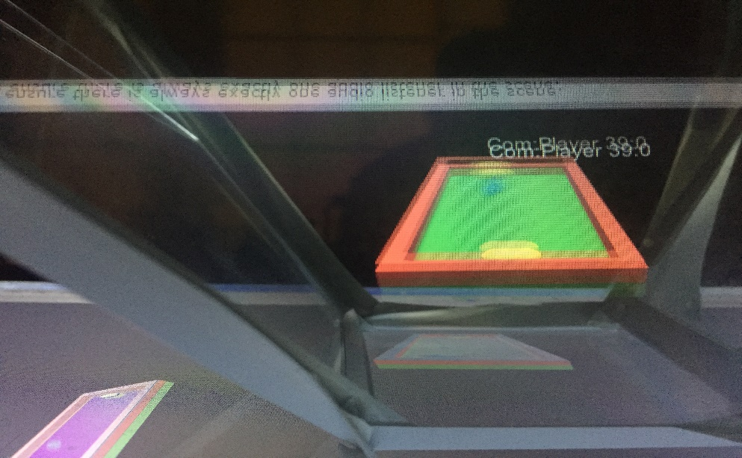
Fig 3.17 Final display

3.6.4 Evaluation
In this step, UI text change would have been omitted if I was familiar with Unity. UI text should be used in time box three at first actually. But in general, we finally have the holographic game and everything seems to work well. And there is also one thing needs to pay attention. Now, the camera view position and scale looks good in my laptop. But if show this game in a big screen, these parameters may need to change to fit the bigger screen. So basically, different screen have different viewport rect.

3.7 Time Box 6: 3D Boom Ball Game
Date – 9st August 2017
Duration – 3 Days
Completion Date – 11th August 2017

3.7.1 Features
- Create a boom ball game in Unity
- Player can use the bat to hit the ball
- If the ball hit the brick, the brick will disappear and player score
- When all bricks are destroyed, it will show “You Win”
- When player miss the ball, the game will stop and provide restart selection

3.7.2 Design and Implementation
Use Case Description
Use Case Name: 3D Boom ball game
Brief description: A casual 3D game where player can use a bat to hit the ball to destroy bricks in a 3D room
Trigger: Start of the game
Normal flow of events:
- When the game start, the ball will move automatically under the action of initial pulse
- When player hit the ball, the ball will bounce back
- When the ball hit the brick, the brick will disappear and player score
Sub-flows:
S-2
- If all the bricks are destroyed, the system will show win text
Alternative/Exceptional flow of events:
S-1a:
- If player miss the ball, the ball will get out of the room and game will stop
As mentioned in chapter 2, another game named boom ball will be built in this project. Thanks to the experience of the ping pang game, this game did not take too much time. The first step is build the game room, there are six walls in this room. The wall behind the ball and bat is transparent, when player miss the ball and hit this wall, the system will destroy the ball and game stop. Attach border script to the wall, the main purpose of this script is trigger destroy function and enable restart button. The main code is shown as below:
void OnCollisionEnter(Collision col)
{
BallMove ball = col.gameObject.GetComponent<BallMove>();
if (ball != null)
{
ground = GameObject.Find("Ground");
ground.gameObject.GetComponent<menu>().enabled = true;
Destroy(col.gameObject);
}
}
In this code, ballmove is another script attached to the ball. And menu script is used to create a new button and reload the scene:
void OnGUI()
{
if (GUI.Button(new Rect(280, 100, 60, 30), "Restart"))
SceneManager.LoadScene("boom ball", LoadSceneMode.Single);

}
The second step is create a ball which can move and bounce in the room. The model is simple and the point is the script. The script have three functions: Give the ball an initial impulse, plus one point when the ball hit the brick and show “You Win!” text when score is greater than the number of bricks. All these functions were achieved in ping pang game, so just need to combine them into one script.
The last step is build the bricks, add start button and hand control system. In this prat, UI plugin button was used to start the game, the specific settings for button are shown below:
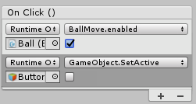
Fig 3.17 Button setting
As for the hand model and score system, the detailed description has been already made in the ping pang game, so no more details here. The final game just like fig 3.18 and 3.19:
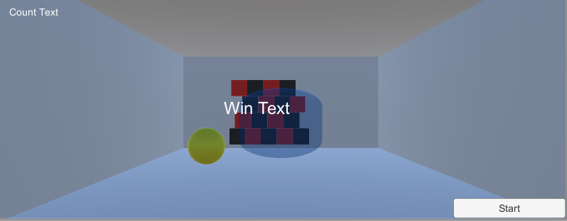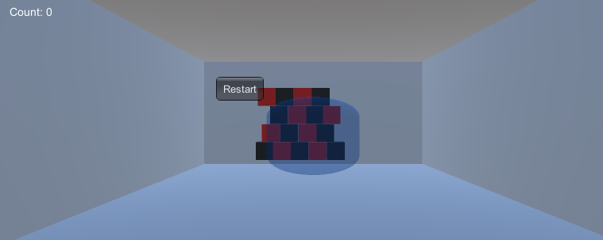
Fig 3.18 Boom Ball Screenshot I Fig 3.19 Boom Ball Screenshot II

3.7.3 Test
Task ID | Task Name | Days Expected | Actual Days | Planned Results | Actual Result
1 | Room build | 1 day | 1 day | Create a certain confined space and if the ball hit the front wall, the ball will be destroyed and game stop | Finished as expected
2 | Create the ball | 1 day | 1 day | The ball will move under the action of initial impulse if player click start button | Finished as expected
3 | Create a semi-transparent bat and use hand to control it | 1 day | 1 day | Import Leap Motion resource package successfully and player can use hand to move the bat | Finished, but the effect is not very good

3.7.4 Evaluation
In this step, a new 3D game was built eventually. Almost all the main functions are work properly so far. But due to the shape of the bat, it is still difficult for hand model to grab and control. By comparison, the bat in ping pang game is easy to control and the accuracy is higher.

4 Evaluation
In chapter 3, ping pang and boom ball game have already been built in Unity. In order to improve program design and implementation in the future, evaluation part is an ideal way to achieve it. Evaluation is a process that critically examines a program. It involves collecting and analyzing information about a program’s activities, characteristics, and outcomes. So a good evaluation can helps developers to obtain new ideas and improve the program. There are three main evaluation methods, quantitative methods, qualitative methods and mixed methods. Quantitative methods provide numerical results while qualitative approaches give narrative or descriptive data instead of numbers. Mixed methods involves both qualitative and quantitative approaches. In this chapter, a questionnaire with both qualitative and quantitative questions will be used to do the evaluation. Because questionnaire is one of the most convenient and affordable way to collect information. The most important part in this chapter is design a proper questionnaire. These questions should help developers know testers’ idea and feeling about the control and display experience of the game. Considering the control problem of boom ball, this questionnaire is only for ping pang games. Here is the question list:
- How difficult were the games to play?
- How clear was the display?
- How much did you enjoy playing?
- The most attractive thing in this game?
- What's your suggestion to this game?
- What other games do you think this could be used for?
- What other things do you think this type of control would work for?
- What other things do you think this type of display would work for?
It was expected that testers can provide an objective and novel idea about the game. They are from different majors and different countries so the result can help developers have a more comprehensive understanding of the game and get some inspirations. The survey results are arranged as follows:

Question 1: How difficult were the games to play? It was expected that the game is quiet easy to play, because players just need to move their hand to play it though sometime there will be some delay. The actual result is shown as Chart 4.1:

Number
Score
Chart 4.1 Question 1
Three people choose 3 and 2 people choose 4 but nobody choose 5. It is a little different from expected. People think it is a little difficult to control compared with the traditional mouse. Especially the bat is hard to grab or move occasionally. Due to the precision of Leap Motion, it is not as convenient and accurate as mouse now. But in the future, we believe that hand control will be more and more popular.

Question 2: How clear was the display? It was expected that the game is not very clear, because the resolution of the screen is not very good and the prism will have a negative effect on the display. The actual result is shown as Chart 4.2:
Number
Chart 4.2 Question 2
From the chart we can see many testers’ feeling about the clarity is not bad. It is a quiet new technique and the application use “Pepper’s Ghost” like some concerts also don’t have a high definition. So testers think this one is acceptable. A higher screen resolution and a project may improve clarity. And with the development of the screen material and projection technique, the clarity will be better in the future.

Question 3: How much did you enjoy playing? It was expected that people are quiet interested with this game, because it is different from tradition game. It should be their first time to play an interactive holographic game. The actual result is shown as Chart 4.3:
Score
Number
Chart 4.3 Question 3
The result is consistent with expectations. Testers think this game is very novel and interesting. They are impressed by the 3D hologram and hand control function. These characters are quiet attractive.

Question 4: The most attractive thing in this game? It was expected that people think “Pepper’s Ghost” is the most attractive thing. The actual result is shown as Chart 4.4:
Number
Score
Chart 4.4 Question 4
The result is consistent with expectations. The most attractive thing is the 3D hologram. And the second one is hand control function. Most games just can be played by mouse and keyboard and only show in the 2D screen. Two most attractive innovation can gives a game new life.

Question 5: What's your suggestion to this game? It was expected that people from different countries and different major can provide some interesting ideas about the game. The actual result is shown as below:
- Add some sounds;
- Improve the control system;
- Connect it to internet so players can play it with friends online;
- Set different levels of difficulty;
- Beautify the game scene;
These suggestions are useful to improve the quality of the game. Sounds can i the player's game experience. Better control system makes the game easier to play. And connect to internet or set different levels of difficult or beautify the game scene are all practical ways to give more attractive things to this game other than optimizes the code.

Question 6: What other games do you think this could be used for? It was expected that there many games is suitable for this. The actual result is shown as below:
- Shooting games (Bubble shooter, Counter-strike…)
- Racing game (Need for Speed, Dirt Rally…)
- Sports game (table tennis, tennis…)
There are quiet lots of games tester think this could be used for and they belong to three main categories: shooting, racing and sports. In general, if there is a hand module in the game, it could be suitable.

Question 7: What other things do you think this type of control would work for? It also was expected that this type of control could work for many things. This question can help researchers get more ideas. The actual result is shown as below:
- Design job;
- Teaching;
- Robot control;
- Combine with VR/AR;
- UAV (unmanned aerial vehicle);
- Mobile applications;
Testers did provide many interesting ideas. For example, when an artist or an engineer want to design a product, they can use this type of control instead of just using a mouse or a keyboard. They do not need to compromise with software, they can use their hands to paint or build the module they want. And we can not only combine it with “Pepper’s Ghost”, but also AR or VR. It will be also fantastic.

Question 8: What other things do you think this type of display would work for? It was also expected that this type of display would work for many things. This question can help researchers get more ideas. The actual result is shown as below:
- Data analysis;
- Movie, Speech, concert;
- Teaching or training;
- Advertising;
- Mobile applications;
Testers did provide many interesting ideas. For example, if we could use our mobile phone to watch a holographic video, it will be a milestone in the history of mobile phone.

From the result we can find that there are lots of things we can do to this game in the future. And these ideas about the techniques used in this project can be expanded into many other areas which gives more meaning to this project.

5 Conclusion
In this project, an interactive holographic game was built by using “Pepper’s Ghost” and Leap Motion. In the first part of this paper, VR, AR, “Pepper’s Ghost”, Unity and Leap Motion are introduced in detail including their history, principle and application which lays a theoretical foundation for later work. Chapter two is about research method, project requirements, risk and validity & generalisability. FDD (Feature Driven Development) and MosCow was used to build the feature list which can help developers develop the game in a methodical way. And risk analysis can effectively prevent some accidents before it happens. In chapter three: Development & Experiment, time box is an effective method to manage time and the speed of progress. Both FDD and time box have already proved that they can help developers to make the plan and supervise the process. At last, a well-designed questionnaire can benefit both writer and readers a lot. The game can be improved according to testers’ opinion and their ideas about the technique used in this project may come true in the future. During the whole process, I learned how to search literature, how to manage a project and the most important thing is how to code. I know how to use Unity, Leap Motion and combine them with each other. Though there are some problems when import the Leap Motion asset to Unity and use interaction manager, these problems help me to learn how to solve problem and finally I learn more things than I expected. When writing the literature review, it surprise me that “Pepper’s Ghost” have already been used in many places and I even doesn’t know it before I do this project. Besides, little things such as bugs or the differences between old version and new version may cost lots of time. The final game is a little different from I thought at beginning. Because some functions such as use script to control the move of hand are difficult to achieve. If I were to do it again, I want to try more functions like sound and render because these factors are also important part of a good game. At last, if I had more time to do this project, I want to try different kinds of prism, maybe five or more sides with different angel. And I will also try to release the game to different platform including Windows, IOS and Android. So future students can build a more complex network game based on this.
At the end of this paper, I want to express my gratitude to my supervisor Doctor Nik for her help and advice. I also want to thank all the testers for their patience and valuable opinion.

References:
[1] Videogames in Europe: Consumer Study; Retrieved from:
http://www.isfe.eu/sites/isfe.eu/files/attachments/euro_summary_-_isfe_consumer_study.pdf
[2] How Healthy Behavior Supports Children’s Wellbeing; Retrieved from:
https://www.gov.uk/government/uploads/system/uploads/attachment_data/file/232978/Smart_Restart_280813_web.pdf
[3] Mark Griffiths. The educational benefits of videogames. Education and Health, 2002.
[4] Isabela Granic, Adam Lobel, Rutger C. M. E. Engels. ” The Benefits of Playing Video Games”. American Psychologist, 2014.
[5] Rae Earnshaw, M.A Gigante, H Jones. Virtual Reality Systems. Academic Press, 28 Jun 2014.
[6] Sutherland, I.E. 1968. A head-mounted three dimensional display. Proceedings Fall Joint Computer Conference, Thompson Books, Washington, DC, 757-764.
[7] Cieply, Michael. "Virtual Reality 'Wild' Trek, With Reese Witherspoon". 2016, New York Times.
[8] Patrice L. (Tamar) Weiss, Emanuel Tirosh, Darcy Fehlings. Role of Virtual Reality for Cerebral
Palsy Management. Journal of Child Neurology, 2014, Vol.29(8), pp.1119-1124.
[9] Harris K, Reid D. The influence of virtual reality play on children’s motivation. Can J Occup Ther. 2005;72:21-29.
[10] Julie Carmignian, Borko Furht, Marco Anisetti ect. Augmented reality technologies, systems and applications. Multimedia Tools and Applications January 2011, Volume 51, Issue 1, pp 341–377.
[11] Johnson, Joel. "The Master Key": L. Frank Baum envisions augmented reality glasses in 1901. Mote & Beam, September 2012.
[12] Borko Furht. Handbook of Augmented Reality. Springer Science & Business Media, 31 Aug 2011.
[13] Huang Y, Liu Y, Wang Y. AR-View: and Augmented Reality Device for Digital Reconstruction of Yuangmingyuan, IEEE International Symposium on Mixed and Augmented Reality, 2009.
[14] Bruns E, Brombach B, Zeidler T, Bimber O. Enabling mobile phones to support large-scale museum guidance. IEEE MultiMedia, April-June 2007, Vol.14(2).
[15] Miyashita T, Meier P, Tachikawa T, Orlic S etc. An augmented reality museum guide. 2008 7th IEEE/ACM International Symposium on Mixed and Augmented Reality, Sept. 2008, pp.103-106.
[16] Bichlmeier C, Wimmer F, Heining SM etc. Contextual anatomic mimesis: hybrid in-situ visualization method for improving multi-sensory depth perception in medical augmented reality. 2007 6th IEEE and ACM International Symposium on Mixed and Augmented Reality, Nov. 2007, pp.129-138.
[17] Ronald Sidharta, Atsushi Hiyama, Tomohiro Tanikawa, etc. The Development of Multi-Depth Pepper’s Ghost Display for Mixed Reality System. 16th International Conference on Artificial Reality and Telexistence--Workshops, Nov. 2006, pp.115-118.
[18] Carolyn Giardina. "Why Billboard Music Awards' Michael Jackson Can't Be Called a 'Hologram'". 22 May 2014. Retrieved from:
http://www.billboard.com/biz/articles/news/touring/6099053/michael-jackson-hologram-not-a-hologram-billboard-music-awards.
[19] Shane Warne. ‘Cricket Found Me’. National Sports Museum. August 2015. Retrieved from:
http://www.nsm.org.au/Exhibitions/Shane%20Warne%20Hologram.aspx.
[20] Alan Siegel. Home Alone Hit Theaters 25 Years Ago. Here’s How They Filmed Its Bonkers Finale. Retrieved from:
http://www.slate.com/blogs/browbeat/2015/11/16/home_alone_hit_theaters_25_years_ago_here_s_how_they_filmed_its_bonkers.html.
[21] Brian Logan. Can a hologram Les Dawson tell 'em like he used to? September 2013. Retrieved from: https://www.theguardian.com/tv-and-radio/les-dawson/2013/may/31/all.
[22] Mariza Dima1, Linda Hurcombe2, Mark Wright. Touching the Past: Haptic Augmented Reality
for Museum Artefacts. Designing and Developing Virtual and Augmented Environments: 6th International Conference, 2014, p3-p14.
[23] Sketchup. Retrieved from: http://www.sketchup.com/.
[24] Solidworks. Retrieved from: http://www.solidworks.co.uk/.
[25] CATIA. Retrieved from: https://www.3ds.com/products-services/catia/.
[26] John Riccitiello. John Riccitiello sets out to identify the engine of growth for Unity Technologies (interview). Interview with Dean Takahashi. Retrieved January 18, 2015. Retrieved from:
https://venturebeat.com/2014/10/23/john-riccitiello-sets-out-to-identify-the-engine-of-growth-for-unity-technologies-interview/.
[27] John Haas. A History of the Unity Game Engine: An Interactive Qualifying Project. Worcester Polytechnic Institute, 2014, p1.
[28] Unity Technologies. Unity Technologies Delivers Unity 3. 19 Jan. 2014. Retrieved from:
http://www.marketwired.com/press-release/Unity-Technologies-DeliversUnity-3-1325564.htm.
[29] Unity Technologies. The Next Generation of the Unity Game Engine Unveiled. 18 June, 2012. Retrieved from: http://www.marketwired.com/press-release/the-next-generation-of-the-unity-game-engine-unveiled-1670512.htm.
[30] Temple Run Trilogy. Retrieved from:
https://play.google.com/store/apps/details?id=com.imangi.templerun&hl=en.
[31] Sunless Sea. Retrieved from: http://www.failbettergames.com/sunless/.
[32] Hearthstone. Retrieved from: http://us.battle.net/hearthstone/en/.
[33] Leap Motion. Retrieved from: https://www.leapmotion.com/.
[34] Kinect. Retrieved from: https://developer.microsoft.com/en-us/windows/kinect/develop.
[35] Molecules. Retrieved from:
https://itunes.apple.com/gb/app/molecules/id444014972?mt=12.
[36] Boom Ball. Retrieved from: http://www.boomballgame.com/.
[37] Corel Painter Freestyle. Retrieved from:
http://www.painterartist.com/en/pages/14500169.html.
[38] Feature Driven Design. A whitepaper by John C Goodpasture, PMP. November, 2009.
[39] Vose, David. Risk Analysis: A Quantitative Guide, 3rd Edition. Wiley, 2007.
[40] JB Manheim, RC Rich, L Willnat el. Empirical Political Analysis 8th edition. Boston, MA: Longman p. 105.
[41] Leap Motion Asset, Retrieved from:
https://github.com/leapmotion/UnityModules/tree/master/Assets.

Appendix:
All codes are collected in appendix:
- Ping pang game:
- Ball.cs
using System.Collections;
using System.Collections.Generic;
using UnityEngine;

public class Ball : MonoBehaviour {

public Vector3 initialImpulse;

// Use this for initialization
void Start () {
GetComponent<Rigidbody>().AddForce(initialImpulse, ForceMode.Impulse);
// GetComponent<Rigidbody>().velocity = new Vector3(0.3f, 0, 0.3f);

}

// Update is called once per frame
void Update () {

}
}

- NewBehaviourScript.cs
using System.Collections;
using System.Collections.Generic;
using UnityEngine;

[System.Serializable]
public class Boundary
{
public float xmin, xmax, zmin, zmax;
}

public class NewBehaviourScript : MonoBehaviour {

public Boundary boundary;
void FixedUpdate()
{
GetComponent<Rigidbody>().position = new Vector3
(
Mathf.Clamp(GetComponent<Rigidbody>().position.x, boundary.xmin, boundary.xmax),
0.0f,
Mathf.Clamp(GetComponent<Rigidbody>().position.z, boundary.zmin, boundary.zmax)
);
}

- PlayerAI.cs
using UnityEngine;
using System.Collections;

/// The variable speed controls how fast the player moves with the ball.

public class PlayerAI : MonoBehaviour
{
public float speed = 2.5f;

private Transform ballTransform;

void Start()
{
GameObject ballGameObject = GameObject.Find("Ball");
if (ballGameObject == null)
{
Debug.LogWarning("PlayerAI cannot find Ball.");
enabled = false;
}
else
{
ballTransform = ballGameObject.transform;
}
}

/// Updates the player position.
void FixedUpdate()
{
// input speed of the AI from -1 to 1
float inputSpeed = 0f;

if (ballTransform.position.z > transform.position.z)
{
inputSpeed = 1f;
}
else if (ballTransform.position.z < transform.position.z)
{
inputSpeed = -1f;
}

// move player along the z axis
Vector3 position = transform.position + new Vector3(0f, 0f, inputSpeed * speed * Time.deltaTime);

// If the ball speed along the z-axis is smaller than the ball speed, the player will lag.
// We can prevent the lagging by clamping the z-position to the ball position.
if (inputSpeed > 1f)
{
if (position.z > ballTransform.position.z)
{
position.z = ballTransform.position.z;
}
}
else if (inputSpeed < 1f)
{
if (position.z < ballTransform.position.z)
{
position.z = ballTransform.position.z;
}
}

transform.position = position;
}
}

- PlayerBorder.cs
using System.Collections;
using System.Collections.Generic;
using UnityEngine;
using UnityEngine.UI;

public class PlayerBorder : MonoBehaviour {

public enum ePlayer
{
Left,
Right
}
public ePlayer player;
public Text scoreText;
private int scorePlayerRight;
private int scorePlayerLeft;

void Start()
{
SetScoreText();
}

void OnCollisionEnter(Collision col)
{
Ball ball = col.gameObject.GetComponent<Ball>();
if (ball != null)
{
ball.transform.position = new Vector3(0f, 0.1f, 0f);

if (player == ePlayer.Right) { scorePlayerLeft = scorePlayerLeft + 1; SetScoreText(); }
else if (player == ePlayer.Left)
{
scorePlayerRight = scorePlayerRight + 1;
SetScoreText();
}
}
}

void SetScoreText()
{
scoreText.text = "Com:Player" + " " + scorePlayerLeft+ ":" + scorePlayerRight;
}
}

- Boom ball game:
- BallMove.cs
using System.Collections;
using System.Collections.Generic;
using UnityEngine;
using UnityEngine.UI;

public class BallMove : MonoBehaviour {
public Vector3 initialImpulse;
public Text countText;
public Text winText;

private Rigidbody rb;
private int count;

// Use this for initialization
void Start()
{
GetComponent<Rigidbody>().AddForce(initialImpulse, ForceMode.Impulse);
// GetComponent<Rigidbody>().velocity = new Vector3(0.3f, 0, 0.3f);

rb = GetComponent<Rigidbody>();
count = 0;
SetCountText();
winText.text = "";

}
// Update is called once per frame

void OnTriggerEnter(Collider other)
{
if (other.gameObject.CompareTag("Pick Up"))
{
other.gameObject.SetActive(false);
count = count + 1;
SetCountText();
}
}

void SetCountText()
{
countText.text = "Count: " + count.ToString();
if (count >= 30)
{
winText.text = "You Win!";
}
}
}
- Border.cs
using System.Collections;
using System.Collections.Generic;
using UnityEngine;

public class Border : MonoBehaviour {
public GameObject ground;

// Use this for initialization
void Start () {

}

void OnCollisionEnter(Collision col)
{
BallMove ball = col.gameObject.GetComponent<BallMove>();
if (ball != null)
{
//ball.transform.position = new Vector3(-0.2f, 0.16f, -1.16f);
ground = GameObject.Find("Ground");
//ground.gameObject.GetComponent<menu>().enabled = true;
Destroy(col.gameObject);
}
}

// Update is called once per frame
void Update () {

}
}

