Narrative is something which I have found to be a really valuable and formative part of how I produce my work. Often the narrative might not be so clear in the prints which I produce, however I like for them to be supported and inspired by all of the whimsical stories which I have dreamed up or been inspired by. I find that the level of depth which stories hold allows for a level of richness in my designs and even in my colours that would be somewhat withdrawn in their absence. The use of stories prompts me to think more in depth about the objects which I choose to include within my designs and the relationship which they have with each other. Sometimes the connection might be quite farfetched and creative, others are more obvious in their simple forms.

Within my fourth-year experience, I am keen to start developing my portfolio in new ways. Not so much in a sense of trying new things and new styles, as this is something which I am limited to in terms of how much I can explore and am very happy with the design style which I have developed for myself. I just hope to start expanding my portfolio in a more professional way, to communicate and learn to present myself in a much more concise and clear manner. Graduation is something which I think about often in terms of what my next step might be, and therefore I realise this is the prime time to be building the foundations in order to be able to stand on my own two feet beyond my degree.

Colour is something which I find really important in my work as well as in my day-to-day life with regards to how I can communicate. Emotions relating to colour is a well-documented concept, however I have noticed that I tend to go further than this and also relate colour to places and faces. This ability is one which I have found to be especially important to me when it comes to choosing a colour palette for a collection as it is very often decided from the moment I have visited a location and I have never found myself stuck for what colours I might use. I find that I use the emotions that I have within a certain location to assist me in making decisions about which colours I choose to pull out of it. Sometimes I will feel really good about a colour, and other times I feel that colours or colour palettes have bad connotations attached to them and therefore I choose to avoid them.

When I started this year, I began researching into the stars and the zodiac as part of my thought experiment project. I became enthralled by the vast breadth of stories, myths and legends which surround the zodiac, and the whimsical nature of the topic was one which I felt connected to in regard to how I build and formulate my designs. However, when a story is not your own, it is difficult to feel as connected to it as one which you have dreamt up in your own head. I was finding myself confused and overwhelmed by the sheer amount of tales, opinions, colours, gemstones and animals that are all represented by the zodiac which dimmed my spark a little bit and made it harder for me to feel connected to the stories I was trying to tell. I felt lost in this huge vast space and found it impossible to focus on one story when there were so many things that seemed to be overlapping and winding in and out of each other and so eventually I decided to move on from this.

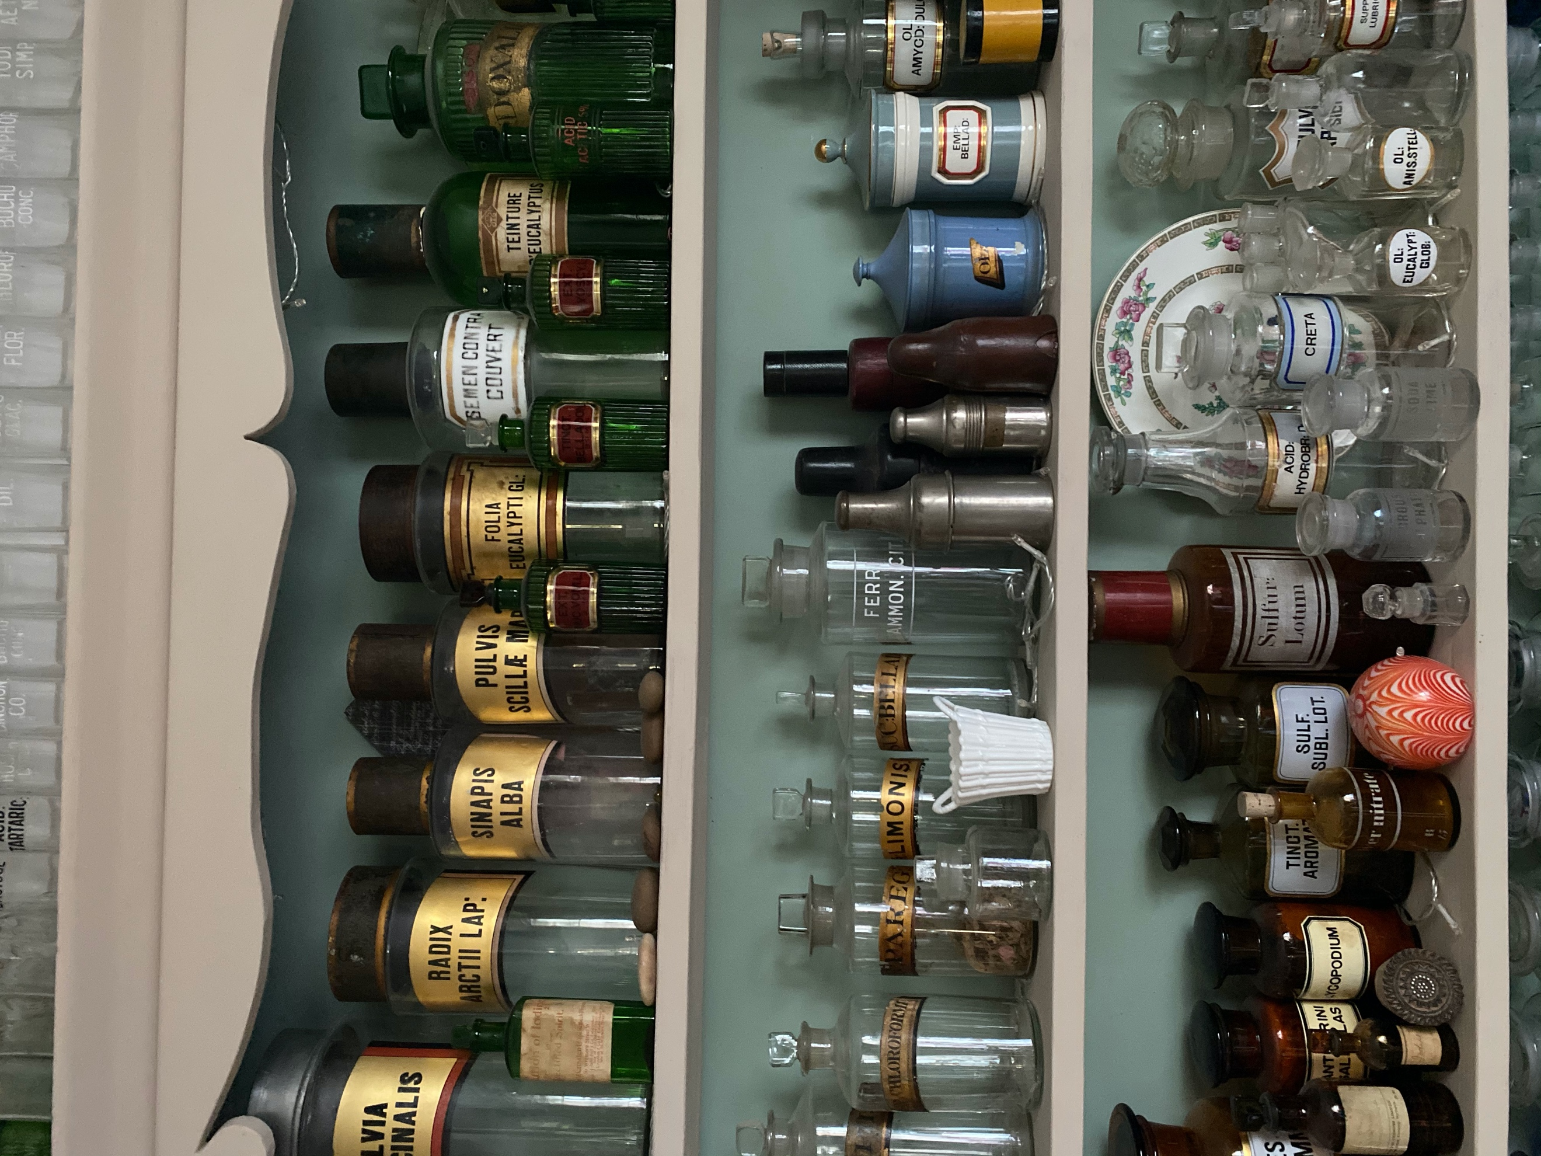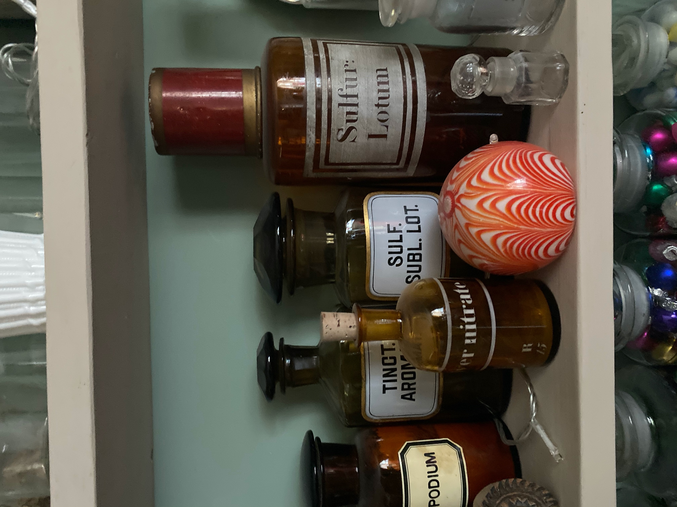
Figure 1. and Figure 2.

Home is something which now more than ever I have familiarised myself with. I am so used to coming and going from home, leaving for school every day or moving out to university every term, it made life feel like such a whirlwind that I never focused on the tiny details which I knew so well right within the four walls of my house. I am fascinated by the various treasures and trinkets which my mother loves to collect and decorate the house with, pots, vases, marbles, glasses, old, new and everything in between. Especially at this time of year when everything looks so twinkly and magical, I found inspiration here and knew that this would be something I would love to create a collection from, it is personal but hopefully resonates with a lot of other people.

I have spent a lot of time at home over the course of the year and so now more than ever I am familiarising myself with all the weird little nooks and cranny’s and treasures which I had never noticed previously right under my nose. I knew I wanted to use this in some way to elevate my work as it is something which I have had to absorb so much of, and all the different elements are ones which I know so well. I feel I would be able to portray this with so many rich layers and allow it to really be a personal journey of discovery and a labour of love. I have never been particularly interested in the works of others in terms of how they impact the work which I go on to produce, I can appreciate and love what other people do, but it takes a lot for me to feel so personally connected to it that it influences my own work. I have never found the spark of excitement and inspiration that others tend to find when sitting in a gallery. However, I do feel it when wondering around a museum of gems and trinkets or I take in the organic life around me. I love the challenge of taking an object, plant or animal and transporting it to my own world of exploration, turning it into something which means something to me or displaying it in a way which sympathises with how that object or experience made me feel.

One of the small treasures which my mother has dotted around the house is a tiny tin plane hanging from a dresser shelf. Although it has hung here for years, I’d never given much thought to its existence, where it came from, or what its story is. Perhaps I don’t want to know what its real story is, just in case it alters the one that I have imagined for it. Even the playful way in which the plane swings from the shelf and hovers over all the gems and trinkets below is enough to offer me the strongest narrative and set the imagination off on a wild tangent of discovery. Because these items are so loved by my mother, it instinctively makes them far more personal and valuable to me.

Emotional attachment is something which I knew I wanted to explore within this project. It is something which I want to use in order to allow me to celebrate the small things which surround me in everyday life. Things which perhaps serve no purpose or aid my life in any way, but that would negatively affect me if they were to be removed. ‘To understand what people are and what they might become, one must understand what goes on between people and things. What things are cherished, and why, should become part of our knowledge as human beings’ (2012, p.1). This quote has been taken from Mihaly Csikszentmihalyi in his book ‘The meaning of Things’ and is one which I looked into whilst I was writing my dissertation. In that piece of writing, I touched on the meaning of home, and what that word can mean to different people. I discussed the notion of home in relation to the objects we fill our homes with and what these things might mean to us. This wasn’t a concept I had previously given any thought to and yet during this year in which I have found myself confined to the 4 walls of my own home; I have been wondering about this very idea without even realising it. The quote which I have drawn from ‘The Meaning of Things’ is one which I think is really essential in summarising what I would like to explore within my project in terms of this being a journey of self-exploration and solidifying what it means for me to be a designer, and predominantly, a human. By identifying the things which I ‘cherish’ and why I cherish them, I might be able to understand not just myself but others around me better too.

As a keen illustrator and a lover of fine detail, I know that I want my project to exude a rich array of delicate drawing, as this is my way of communicating my thoughts and visions. I have been drawn to digital design and illustration over the past year and have worked to develop my skills in this area heavily. I love the versatility of a digital drawing and how easily this way of working can be transferred across a whole variety of mediums and methods of working from screen print to laser engraving. The high level of detail which I can achieve and maintain when implementing my drawings across different mediums is one which is unrivalled by a paintbrush or pencil. However, I feel I have become complacent with my skills, satisfied with their appearance and churning illustrations out like a robot had become taxing for my creative mind. The way I draw when I do so digitally slightly removes the relationship between head, heart and hand, the physicality of what I am drawing feels lost in a mass of pixels and in a way, I feel a bond has broken. My passions and design handwriting still remain firmly in the realms of digital design, these are skills which I have spent years perfecting, and above all else, I love spending my time doing. I know that other skills which I have gained and enjoyed have come and passed but these have all been fundamental building blocks to arrive at the destination which I have currently reached. Therefore, it is necessary to reunite with pen, pencil and paintbrush in order to enable myself to really feel what it is I am drawing. The texture of the paper, the heaviness of my pencil and the size and scale which I am no longer restricted to will all play fundamental roles in reuniting me with my work.

The relationship between head, heart and hand is one which I am really interested in understanding more about. I previously stated that I felt there had been a slight disconnect of my hand in the loss of my physical drawing. Malcom McCullough writes ‘Hands show life most when at work. They don’t just hold: they grasp, they pinch, they press, they guide.’ (1998, p.2) This summarises perfectly what I think I have been lacking when it comes to how I have been drawing and creating. The way I control a physical pencil, or a paintbrush is something which I would really like to re-familiarise myself with. In order to create different tones, textures, shades, and marks, you find yourself altering your grip, moving the paper, looking closer or further away, and I find that this process allows you to truly immerse yourself in what it is that you are drawing.

I do not wish to remove or diminish my use of digital design as this is something which I find a lot of enjoyment in and is definitely a defining part of who I feel I am as a designer. This journey is more about a discovery of how I can marry digital and hand crafted. My mission is to find a way to combine these two very different ways of working in order to create a hybrid medium which allows me to express versatility and allow me to continue to create using my signature handprint.

Perspective
It has been difficult not visiting real life locations throughout the past year in order to help source inspiration or spark ideas. It’s not unknown that sitting in the same room, staring at the same things all the time can be dulling for a creative mindset. Unfortunately, this is the situation we ultimately find ourselves in this year. A global pandemic has been the perfect opportunity for me to step back and reflect on my life and ultimately then, my creative output too. I am painfully precious about all aspects of my life, a perfectionist to the highest degree. It is one of my greatest assets, but also one of my biggest downfalls. I know that if I think something might not end up the way I had hoped, I prevent myself from creating at all. Beverly R. Down promotes the idea of ‘being the star in your life’ (2005, p.143) which encourages the idea of being indulgent for yourself, treating yourself with the highest respect and being your own biggest cheerleader. ‘Being the star in your life means being your own ultimate authority. Did you notice how I just quoted myself above, right next to Shakespeare? Why not? Why not feel confident enough to take risks, respect your own thinking, and put your creativity out into the world?’ (2005, p.143) My project will be one of extreme personal value to me, one which reflects the inner conversation which I have been able to have with myself throughout the duration of the year. Not so much a theme of flora and fauna, or a particular museum, or a specific garden, but one which truly celebrates everything which I draw enjoyment from, things with light my spark and drive my passion. There are so many things right under my nose with contribute to the wild and wonderful stories which I dream up in my head, and so when the rest of the world is closed off, why not celebrate the one which is very much alive all around me?

As previously mentioned, scouring a museum for beautiful objects is something which I do really value and enjoy in my practice. Thankfully, I have been able to find new ways to source and dream up the inspiration and narratives that I crave. Wondering around the natural history museum may be off the cards, but online museums have been a new source of wonder and curiosity for me instead.

Project proposal

My project will be of an interior context. This is one which I feel passionately about, and I want to aim this project at a luxury interior market as this is where I hope I will one day find myself. My imagery and designs lend themselves to this context so perfectly. I am definitely most drawn to the rich velvets and heavy cottons as these seem like the perfect theatre for my designs to perform on.

My work will flow seamlessly between the realms of digital and physical forms of creating as I navigate the challenging and unpredictable world that unfolds around me. It is impossible for me to find a clear pathway in a world that is so uncertain and therefore I want to allow myself the flexibility and creative licence to find any pathway or alleyway which might lead me to a place which satisfies my mission as a designer and presents me with a result which I am not only proud of, but that celebrates my world.

The way which a design sits on a surface is something which is essential to my creative mission. The tactility and physicality of a real fabric which I can touch, move, see and even smell, is what really allows my work to sing. The way that light and shadow present itself on a printed cloth absolutely becomes part of the design and makes me feel as though my work has come full circle. From a physical object, to a dream like narrative, and back into a physical object again which tells the stories of its travels through my mind and the stories and life which I have imagined for each object.

Originally, I wanted to explore the possibility of taking my work to new mediums such as screen printing or lino printing. I have chosen to be mindful of the current circumstances which we find ourselves in and the ever-changing way in which we are forced to work. Therefore, I will not be putting pressure on this being the premise of my project and alleviating some of the pressure which comes with that. I am most drawn to wallcovering and soft furnishing and having been introduced to a wonderful seamstress in west Wales during lockdown, I would love to work alongside her to create some beautifully finished, professional looking products as a final collection. I have created collections in the past but these have always stopped at the point of a fabric sample as I have always felt limited by my sewing capabilities as this is not something which I am particularly good at and also have never set aside the time to learn properly about or been able to perfect. Having a connection with someone who is able to sew at a professional level will mean that I am able to take my designs to new ground and be able to elevate them in a way which I haven’t been able to do so previously. This in particular is something which I am quite excited to develop as I know this will be valuable to me in terms of developing my own brand beyond my creative venture.

Bibliography
Csikszentmihalyi, M. and Halton, E., 2012. The Meaning Of Things. Cambridge [England]: Cambridge University Press, p.1.

Down, B., 2005. Inspiring Creativity. 1st ed. California: Creativity Coaching Association Press, p.143.

McCullough, M., 1998. Abstracting Craft. Cambridge: MIT Press, p.2.

Images
Figure 1 – 2021, Authors own photo
Figure 2 – 2021, Authors own photo

