Cert. HE S4BA Assignment
TURNITIN Submission Template

Use the following Template structure in Microsoft Word to create the word document to submit to the ‘TURNITIN ASSIGNMENT SUBMISSION LINK – FINAL’ link on Moodle. Include the details below and submit to the TURNITIN ASSIGNMENT SUBMISSION LINK – FINAL’ link on Moodle.
Title page.
Module Name:Software and apps for business
Assignment Title: Software and apps for business
Student Name: Hewad Rustom
Student number:2233338
Course name: digital skills
Task 1: e-Portfolio.
- Include here: A link to the e-portfolio homepage.
https://sites.google.com/view/hewad-rustom/home
- Include here: A screenshot of task 1a and 1b answer.
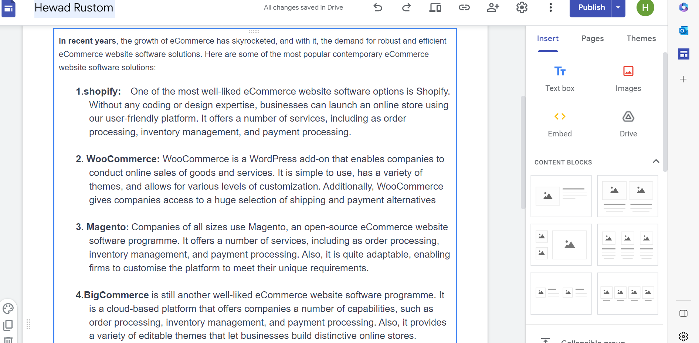

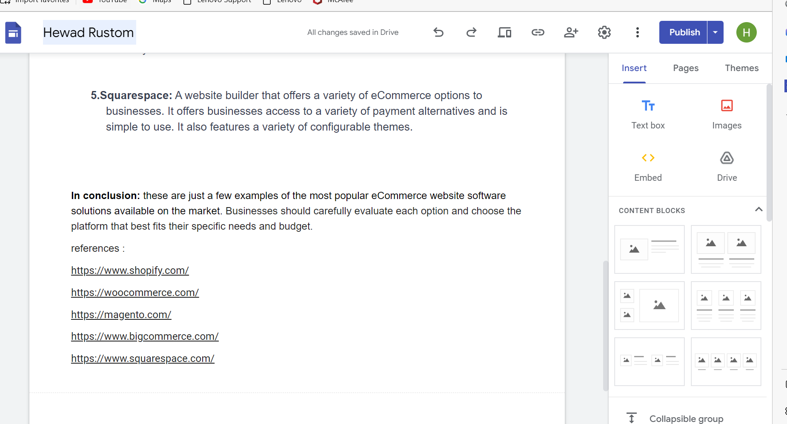

Task 2 – Mind-map.
Include here:
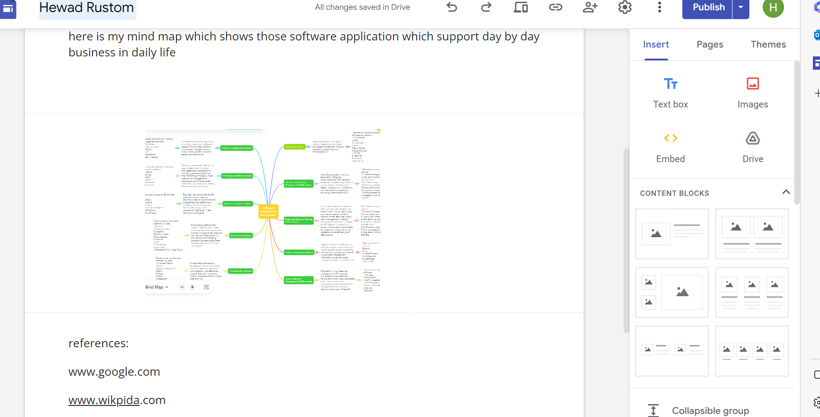

Task 3 – Office Applications.
- Include here: A screenshot of task 3a and 3b task answer.
Here is the screenshot of Task 3 part A

- 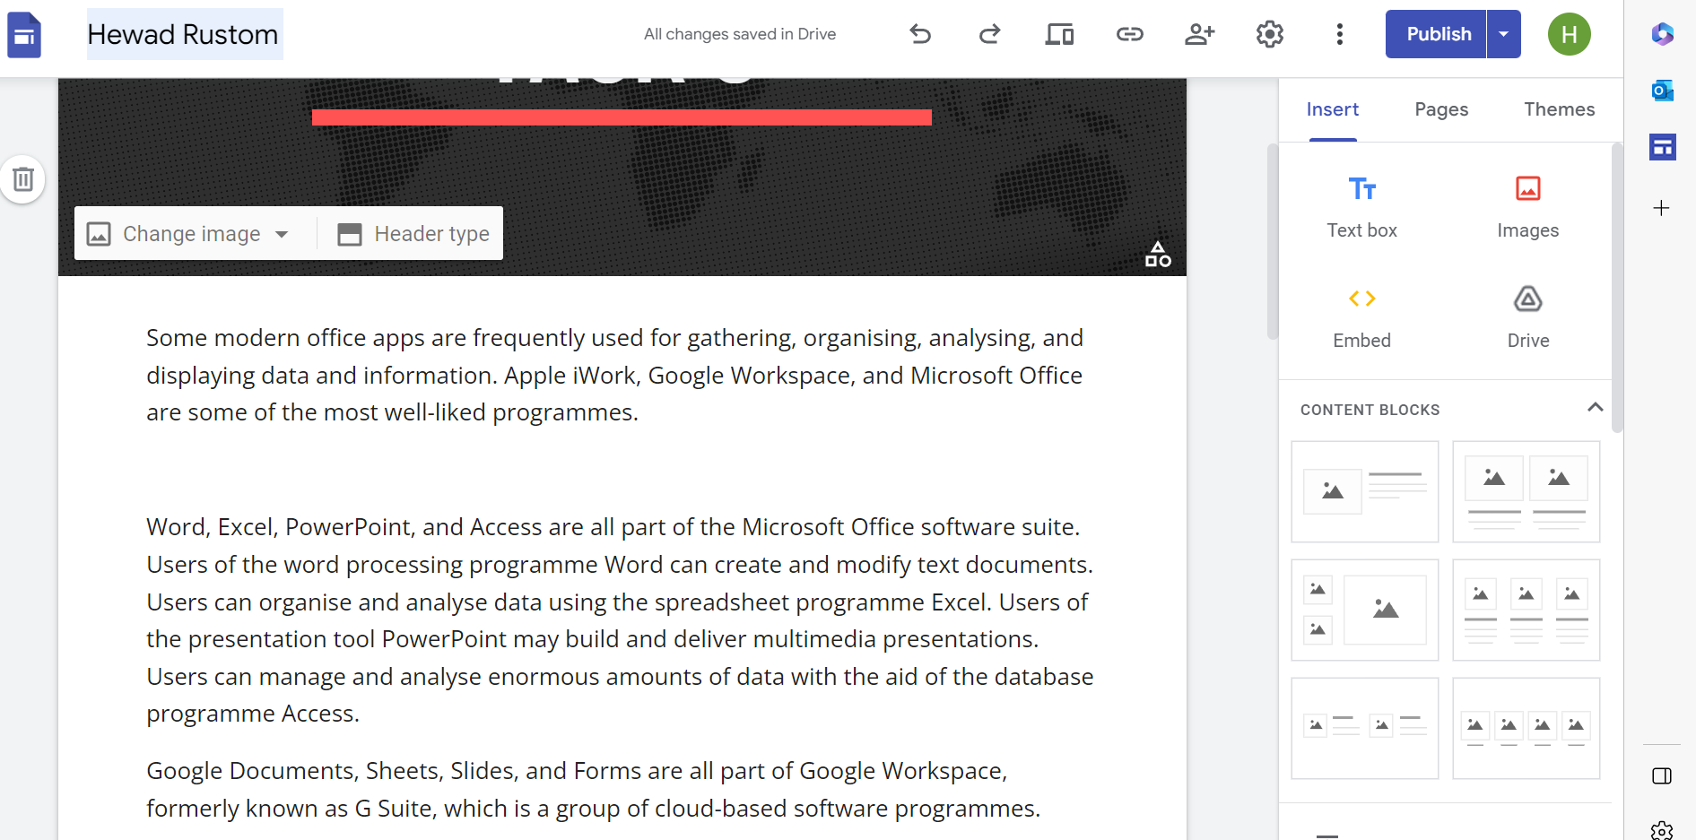
- Here is the screenshots of task 3 part B
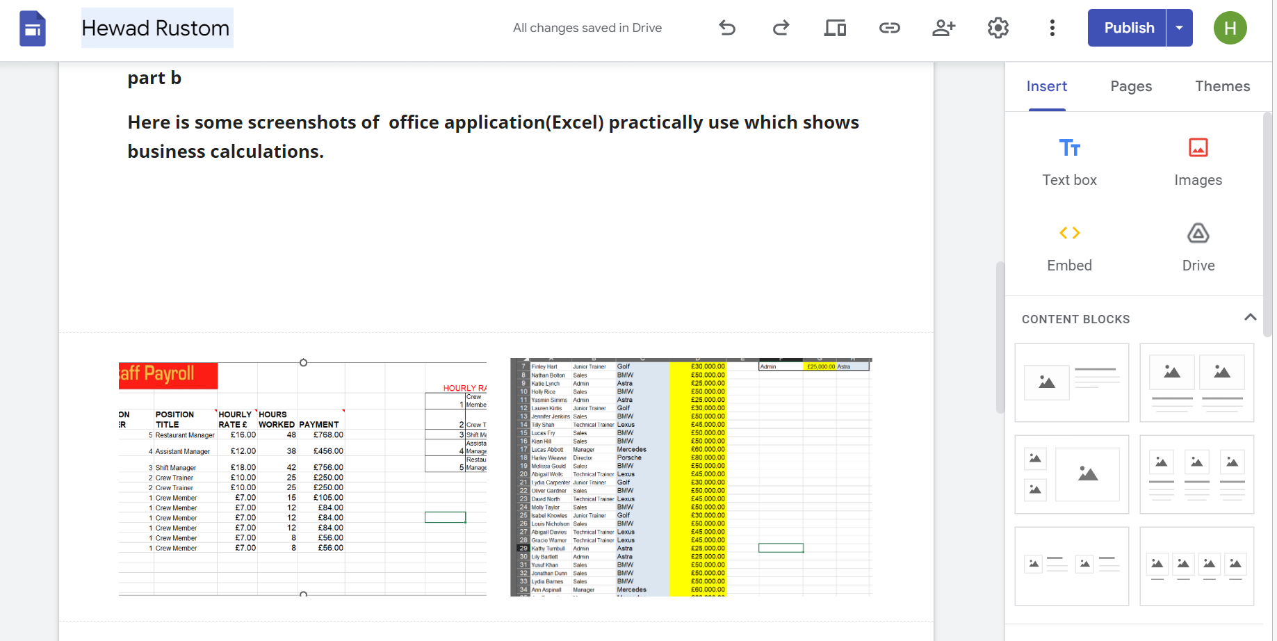
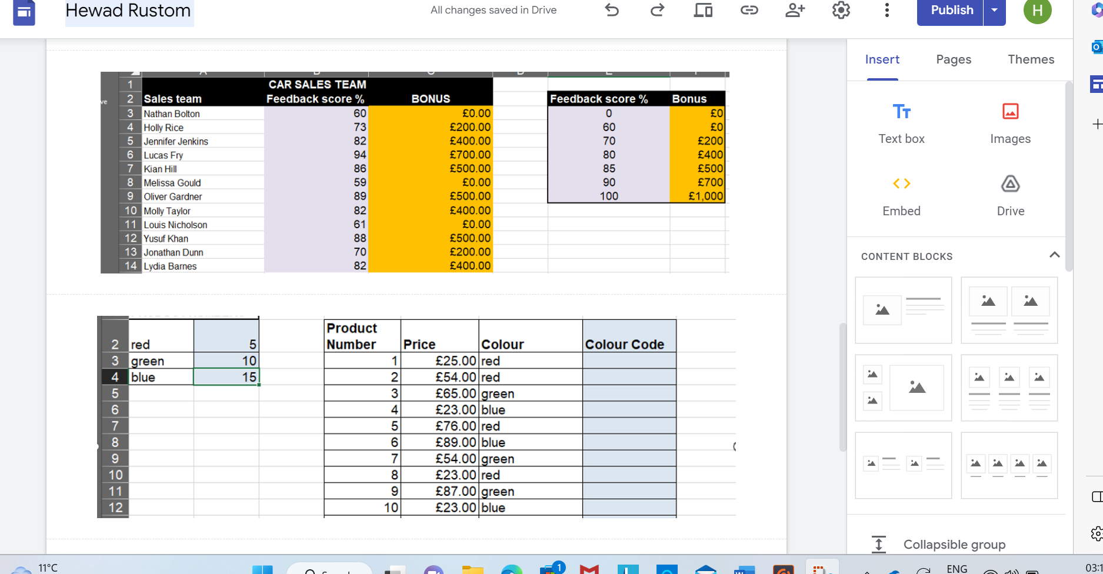
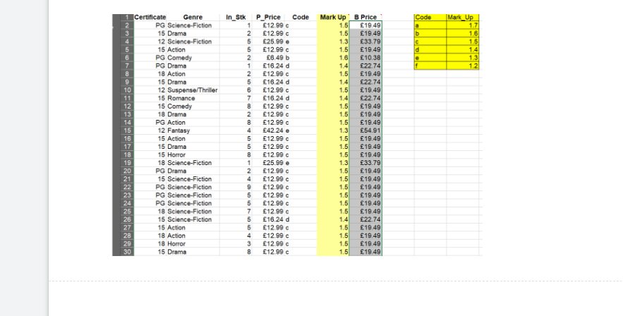

Task 4 – Digital Dashboard and Data Analytics software.
- Include here: A screenshot of task 4a or 4b task answer.

The following are the screenshots of task 4-part A.
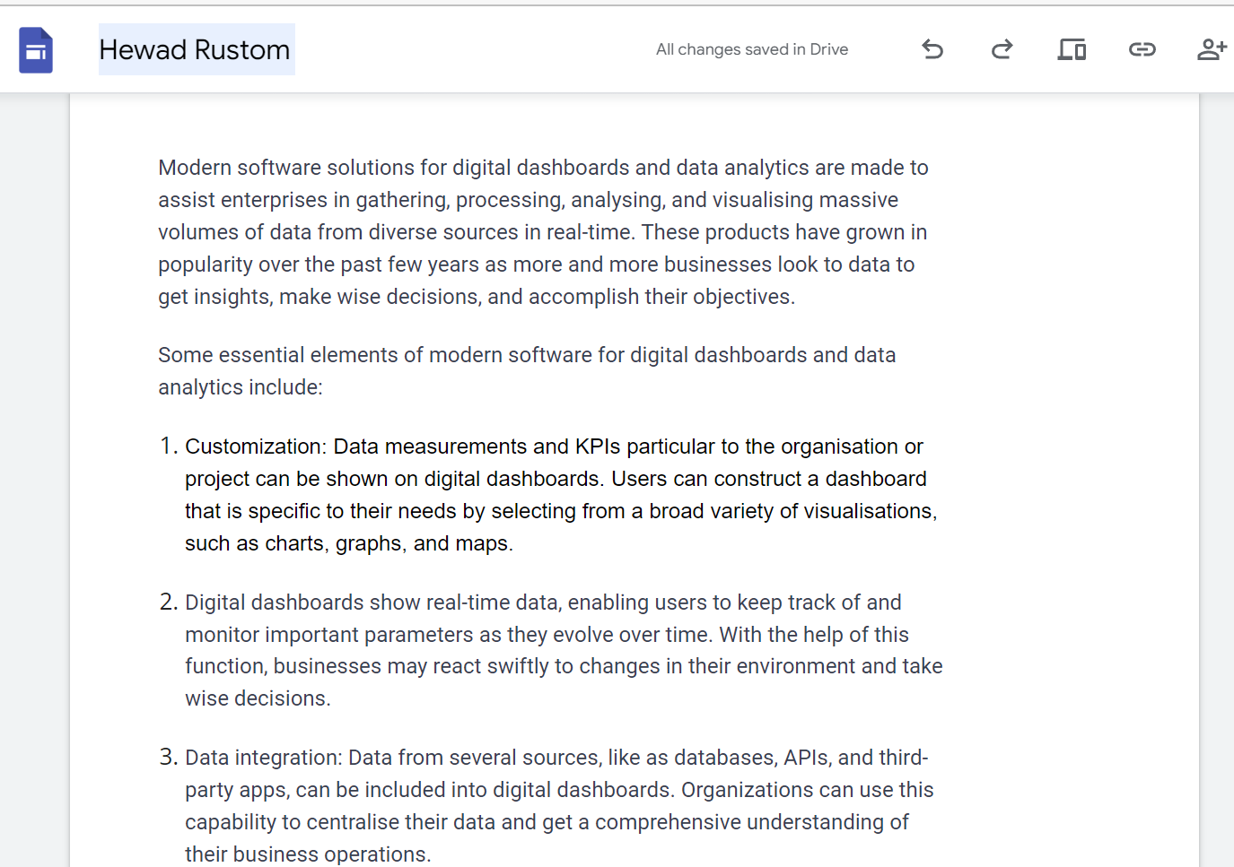
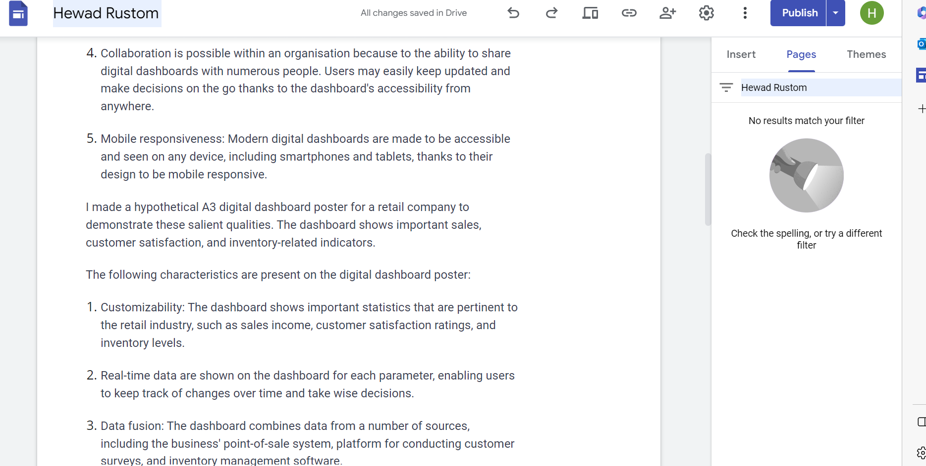

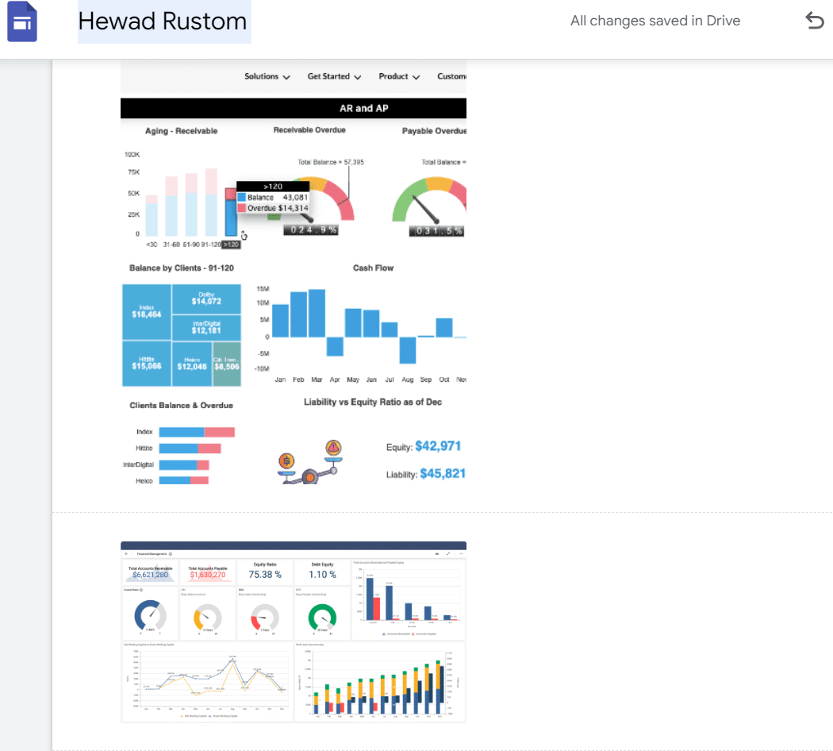

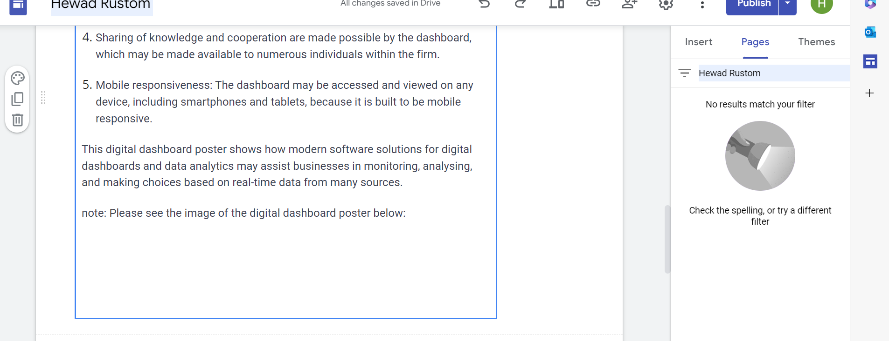

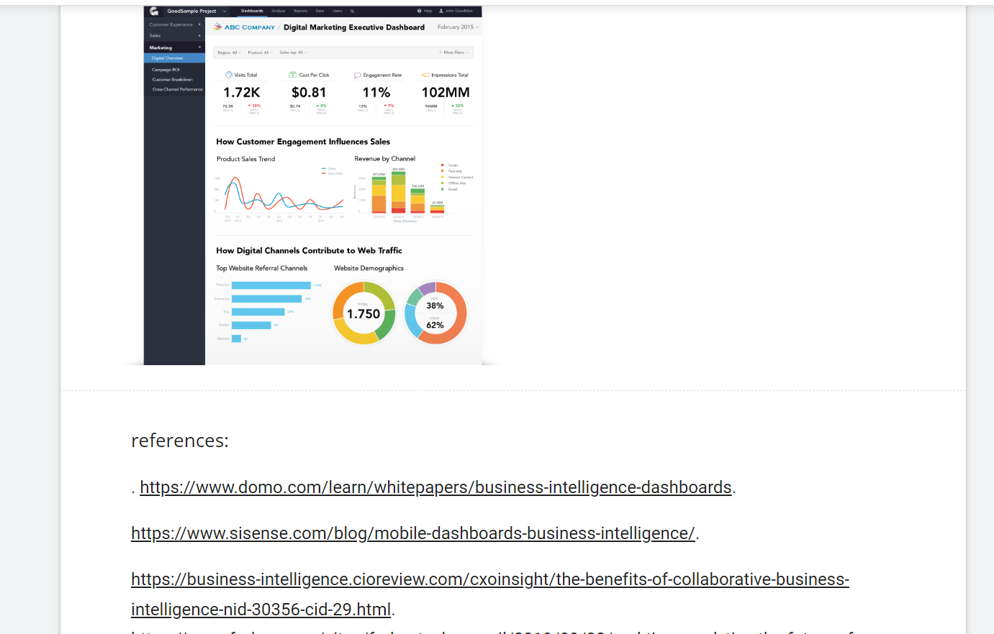
Task 5 - Communication, Collaboration & Project Management
- Include here: A screenshot of task 5a and 5b task answer.
Task 5-part A screenshots

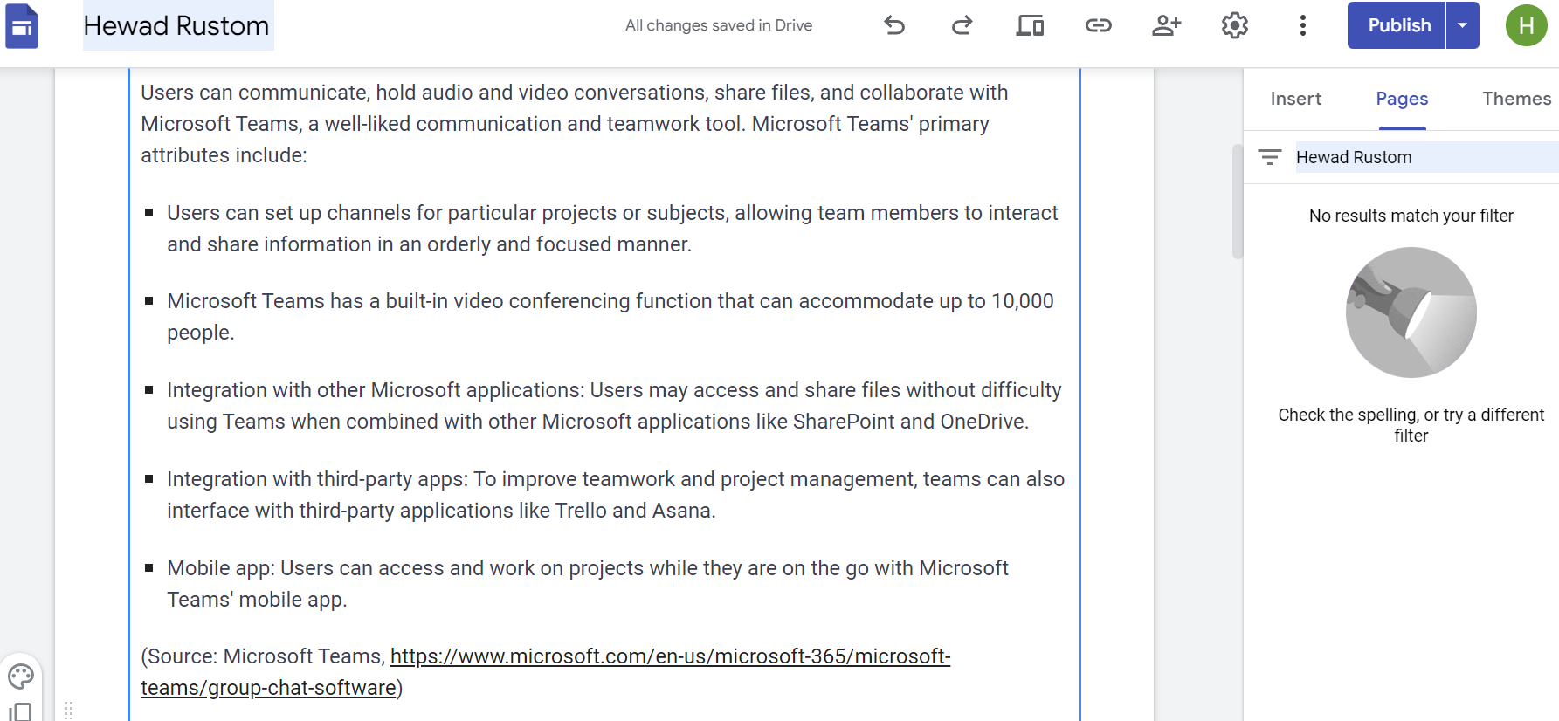

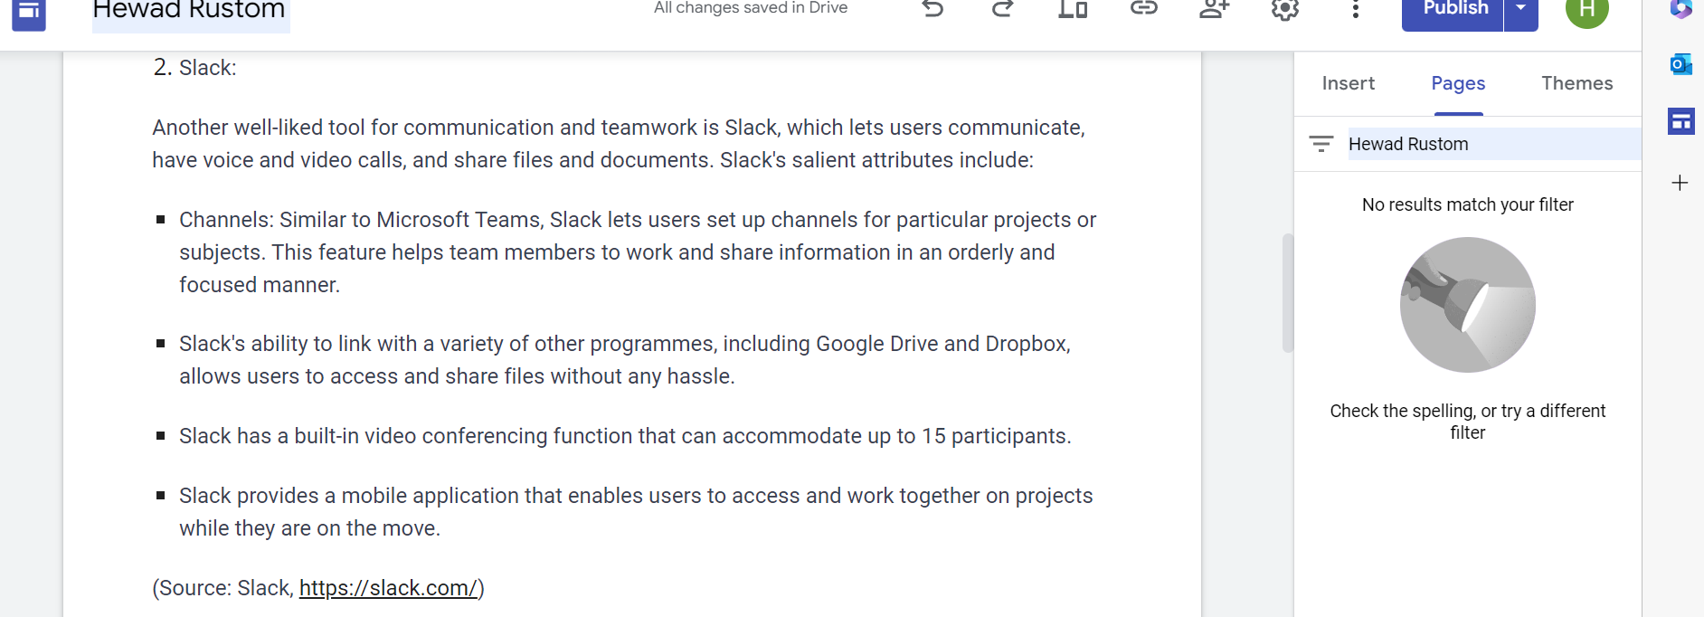
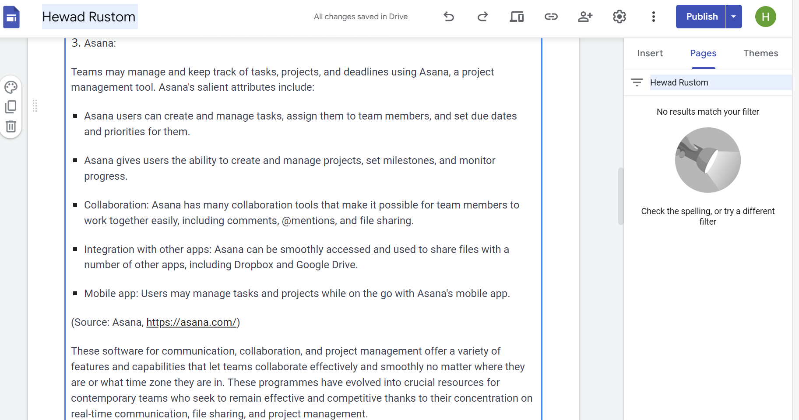
Task 5-part B screenshots
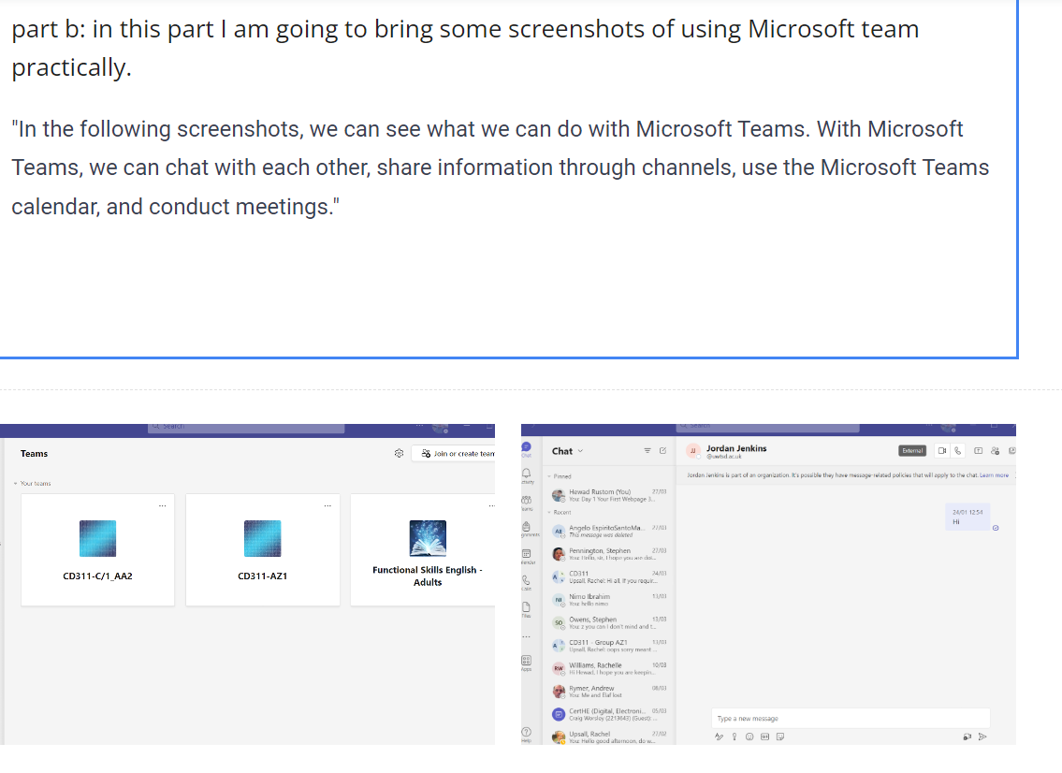
"In the above two screenshots from Teams, we can create channels to communicate with people. Additionally, we can see the chat page in the screenshots where we can communicate with each other one-on-one."

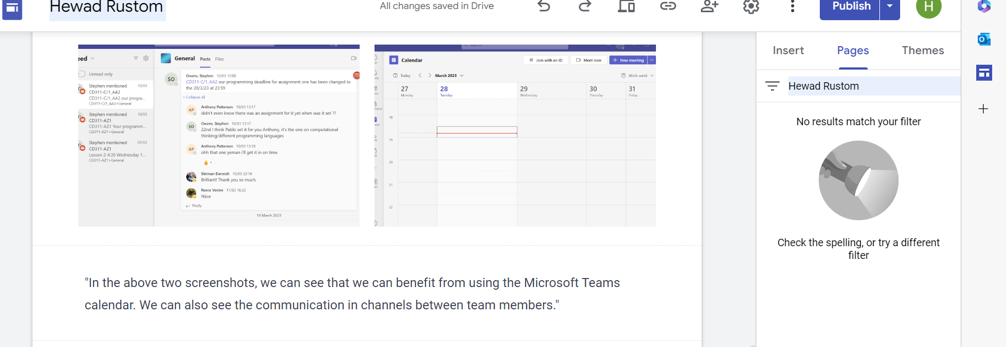
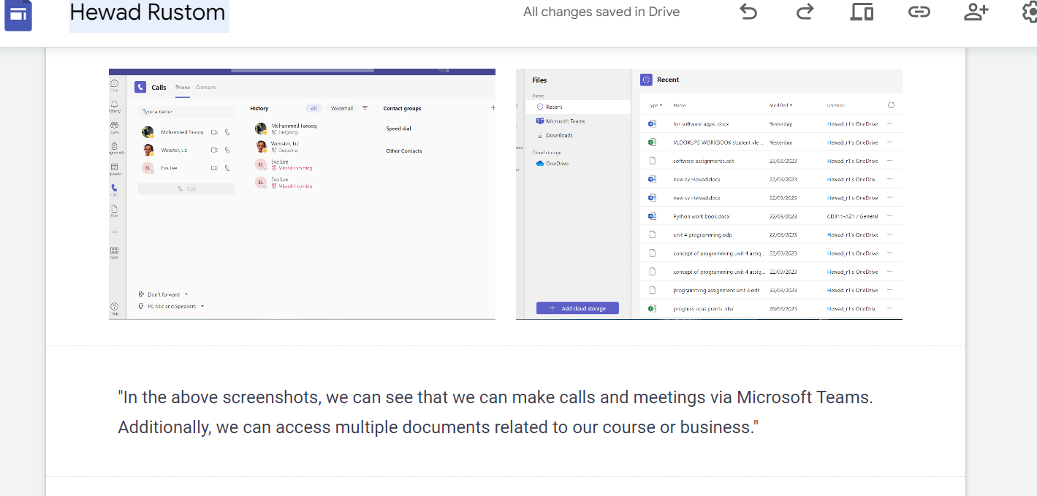

IMPORTANT LINK TEST REMINDER: to ensure your work is accessible for marking it is important to test your work can be accessed by the tutors. To do this either try opening the e-portfolio link in a private/incognito tan in a web browser or sign out of the e-portfolio and to try to open it in a web browser with the link you are providing in this document.

