BA (Hons) Leadership and Management
Strategic Management for SMEs
Module Code: BMSW6104
Assignment title: Strategic Management for SMEs
Student Name: Elena Banica
Student Number:2126381
Lecturer Name: Abdallah Naser

Contents
Introduction 3
A Critical Appraise Zindiya Streatery & Bar’s Current Strategy using Porter’s 5 Forces 3
Competition 3
Potential for new entrants 4
Negotiating power of suppliers 4
Negotiating power of customers 5
Ability of customers to find substitutes 5
A critical environmental analysis 5
PESTLE Analysis 6
SWOT Analysis 7
Stakeholder Analysis using the power/interest grid 9
Possible strategic growth options for Zindiya Streatery & Bar restaurant using the BCG model 12
The BCG model 12
Chosen strategy 13
Key strategic recommendations 15
Open new outlets outside Birmingham 15
Invest in e-commerce website 16
Research on new menu items and services that can join the star products 16
Conclusion 17
References 18
Poster 21

Introduction
The management of SMEs is skill that business managers should have as the majority of the businesses registered in the UK are categorized as SMEs. As small businesses, SMEs require effective management as they have limited internal resources such as financial resources and skills as opposed to big businesses that have more finances and can afford highly skilled labor (Moeuf et al., 2018). This report discusses the process of managing an SME business in the restaurant industry. The report focuses on the management of Zindiya Streatery & Bar. The business is located at 21 Woodbridge Rd, Birmingham and provides its customers with a variety of menu items including foods, vegan menu, cocktails, festive menu, kids’ menu, and different non-beverages such as tea. The business also runs event a catering business where it provides individuals and organisations hosting events with catering services. The restaurant has an Indian theme as the founders’ mission was to create an immersive experience of India to its customers (Zindiya Streatery & Bar, 2023).

A Critical Appraise Zindiya Streatery & Bar’s Current Strategy using Porter’s 5 Forces

Competition
According to the Porter’s 5 Forces tool, the degree of competition between organisations in an industry impacts the ability of a business to compete. A business should understand the competition in its industry in order to create strategies that can enable it to compete (Isabelle et al., 2020). One of the competitive strategies that Zindiya Streatery & Bar applies to remain competitive is its differentiation strategy. The restaurant has an Indian theme, which is unique in its locality. The strategy sets the restaurant apart from its competitive rivals as it offers a unique Indian experience that the rivals do not offer.

Potential for new entrants
The ability of a business to compete in an industry is also affected by the potential for new businesses entering the industry. In cases where a new business can start and immediately provide similar services, competition is stiff and it reduces the competitive advantage of the existing businesses (Gerard and Bruijl, 2019). One of the ways in which a business can make it difficult for new entrants to replace its services is by making itself unique through product differentiation. In addition to providing a unique Indian experience, the current strategy for product differentiation that Zindiya Streatery & Bar uses involves providing unique menu offerings to customers such as the festive menu, the kids’ menu, and vegan menu. The different types of menu offerings make it hard for a new restaurant to offer similar services thus increasing the competitive advantage that Zindiya Streatery & Bar has by reducing the potential for new entrants.

Negotiating power of suppliers
The negotiating power of suppliers increases when the suppliers in a market are the source of an important factor of production. A market where the suppliers have a high negotiation power makes it difficult for SME businesses to compete effectively as the suppliers can increase their cost of operation (Mazikana, 2023). The strategy that Zindiya Streatery & Bar employs to mitigate a possible increase in supplier power is diversification. In this strategy, the restaurant provides more than one services, which enables the business to diversify its sources of income and reduce the impact of the bargaining power of suppliers in any one of its channels of income.

Negotiating power of customers
The negotiating power of customers is caused by a high number of competing businesses that give customers choices. Alternatively, customers can have a high negotiating power if they there are few in the market (Holmes et al., 2017). In an industry where customers have high negotiating power, the businesses are forced to reduce their prices. The Zindiya Streatery & Bar strategy for encouraging customers to pay the prices for its services is based on providing high quality services. The restaurant has invested in skilled workers that prepare quality meals and maintain the Indian experience.

Ability of customers to find substitutes
The ability of customers to find goods and services that are not similar but can satisfy the same need increases competition among businesses (Mazikana, 2023). The Zindiya Streatery & Bar restaurant has distinguished itself through product differentiation as it is the only restaurant in the neighborhood that provides the Indian experience. Therefore, while customers can find other restaurants and pubs, there are no substitute services for customers looking for a unique Indian experience. The strategy is effective as it enables the restaurant to maintain competitiveness.

A critical environmental analysis
Managers at SME businesses should understand their environment as their businesses are impacted more by changes in their external and internal environments compared to big businesses (Durst and Runar Edvardsson, 2021). The two main tools available for business managers to examine their external and internal business environments are the PESTLE and the SWOT tools respectively.

PESTLE Analysis
Political
Brexit – the immigration policies that were implemented after the Brexit decision impact the ability of restaurants to secure skilled labor as the policies made it difficult for EU immigrants to access the UK labor market (Sargent, 2023). The political decision has affected Zindiya Streatery & Bar restaurant external environment by increasing the cost of labor.
Government fiscal policies - different government regimes practice different fiscal policies that affect the external environment of restaurants. The policies affect the business operations at Zindiya Streatery & Bar restaurant because they affect the prices of supplies.
Economic
High cost of living – the UK has been experiencing a high cost of living due to uncertainty in its economy that has individuals and businesses to cut down on their spending (Hewlett et al., 2024). The high cost of living causes people spends on important payments such as food and fuel thus reducing the amount they spend in restaurants.
Social
Healthy dietary trends – the social trend where people have become more aware of the importance of healthy diets has impacted the business of restaurants orders. The trend has caused an increase in demand for healthy foods and a reduction in demand for unhealthy fast foods (Sievenpiper et al., 2019).
Technological
E-commerce – the growth of e-commerce websites has enabled restaurants to increase their sales by serving customers through online orders. The technology has also reduced the number of visits that customers make to restaurants (Joseph, 2019).
Targeted social media marketing – social media marketing has enabled the ability of businesses to target their customers with marketing. The technology has enabled restaurants to target individual customers who are likely to need its services and in their neighborhoods.
Legal
Employment laws – the UK has employment laws that all employers have to observe when dealing with their employees. Restaurants in the UK, including Zindiya Streatery & Bar restaurant, have to obey the laws and other laws that will be made in future.
Environmental
Environmental regulations – there environmental regulations in the UK are designed to make businesses reduce their carbon emission in order to reduce the human contribution to global warming. The regulations have impacted the service industry as all businesses have to adhere to the regulations by adjusting their operations to reduce their carbon footprint.

SWOT Analysis
Strengths
Diverse services – the restaurant offers more services than just the dining services. For example, the restaurant offers catering services and food deliveries, which is a strength as it enables the business to have multiple streams of business (Zindiya Streatery & Bar, 2023).
Indian experience – the Indian experience that the restaurant provides to customers is unique as it enables them to be immersed into an Indian culture while dinning at the restaurant. The unique selling point is a strength as it offers an experience that competitors cannot offer.
Diverse menu designs – the restaurant has a kids’ menu, festive menu, vegan menu, and the normal food menu (Zindiya Streatery & Bar, 2023). The diverse menus enable the restaurant to attract different types of customers, which is a strength from a competition point of view.
Weaknesses
Geographical limitation – the restaurant is limited to Birmingham only and this limits the revenue it can collect. The limitation is a weakness as competitors in the UK restaurant have outlets in multiple cities that enable them to collect more revenues than Zindiya Streatery & Bar restaurant.
Opportunities
Technological advancements – the restaurant has an opportunity to use the current advanced technologies such as social media and e-commerce to advance its brand awareness and increase its sales.
Recovering economy – the economy of the UK has been recovering since the beginning of this year as the recent inflation rates have been reducing according to The Office for National Statistics (Office for National Statistics, 2024). This represents a good opportunity for the restaurant to increase its sales as people are likely to have more disposal income.
Threats
Competition – the restaurant faces competition from other restaurants in Birmingham. The competition from other restaurants is a threat to Zindiya Streatery & Bar restaurant because competitors can win market share from it if they implement more effective strategies.

Stakeholder Analysis using the power/interest grid
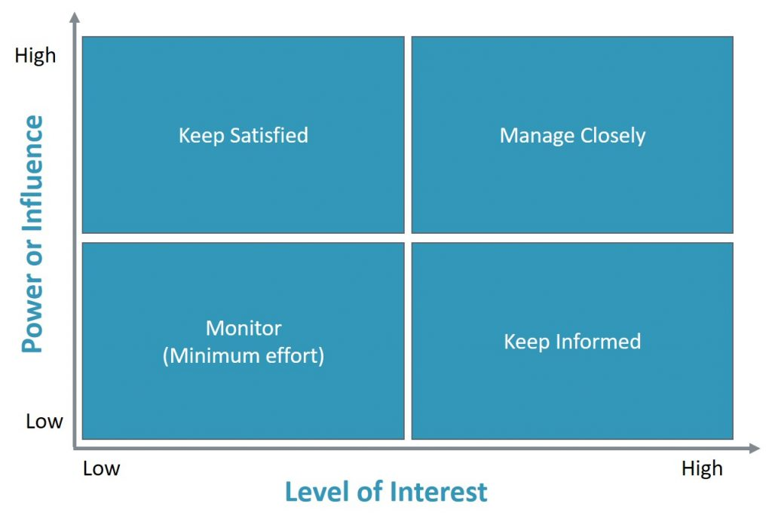
The above figure shows a power/interest grid that depicts the four categories of stakeholders in an organisation namely high power/low interest, high power/ high interest, low interest/low power, and high interest/low power (Slabá, 2014). Based on the four categories, the stakeholders at Zindiya Streatery & Bar restaurant.
High power/Low interest
Government agencies – government agencies have high power as they have the legal capacity to interfere with the operations at the restaurant if the restaurant does not according to the law. However, the government agencies do not have an economic interest in the performance of the restaurant hence their low interest.
Community – the community has high power over the restaurant because community members have the capacity to jeopardise the operations of the business through negative sentiments about the restaurant (Silberberg and Martinez-Bianchi, 2019).
The two stakeholders should be managed through communications and actions that keep them close in terms of information. For example, when dealing with government agencies, the restaurant should manage their expectations the legal requirements such as licensing. On the other hand, the restaurant should manage the community’s expectations by acting in its interests.
High power/ High interest
Customers – the customers have high power because they consume the services that the restaurant provides, which means that they determine the revenues collected. The customers have high interest in the operations at the restaurant because they are emotionally invested in the services due to its unique experience it provides (Ferrell, 2014).
Management - the management at the restaurant has high power because they make the decisions that that enable the business to operate. The management also has high interest because they are employed by the restaurant hence the economic interest attached to the business.
High power/high interest stakeholders should be managed by keeping them satisfied throughout their relationships with the restaurant (Ackermann and Eden, 2021). Customers can be kept satisfied by providing quality foods, drinks, and services. The management can be kept satisfied by informing them on all the processes that involve managing the business.
Low interest/Low power
Delivery drivers – the drivers who do deliveries from the restaurant to customers who order food are stakeholder as they help in its operations. The delivery drivers have low interest in the success of the restaurant because they also work for other restaurants. Similarly, they have low power because they do not have the influence on the operations of the restaurant.
Non-targeted customers – the non-targeted customers are not repeat customers and they visit the restaurant in isolated occasions. Such customers have low power as they do not contribute to the majority of the revenues generated by the restaurant. They also have low interest as they are not emotionally invested in the restaurant’s services.
The restaurant should manage the low interest/ low power stakeholders such as delivery drivers and non-targeted customers by monitoring their interests (Ackermann and Eden, 2021). Monitoring the interests of such stakeholders is an important method of managing them as it informs the restaurant in cases when their power or interest changes.
High interest/w power
Utility suppliers – utility suppliers like the partners who supply the restaurant with ingredients are stakeholders who have high interest and low power at the restaurant. Utility suppliers have low power because the restaurant can acquire the same suppliers from other suppliers. However, the suppliers have high interest as they benefit from the business they conduct with the restaurant.
The restaurant can manage the high interest/ low power stakeholders by keeping them informed of the aspects that involve them. For instance, the restaurant can manage the produce suppliers by informing them on its stock needs.

Possible strategic growth options for Zindiya Streatery & Bar restaurant using the BCG model

The BCG model
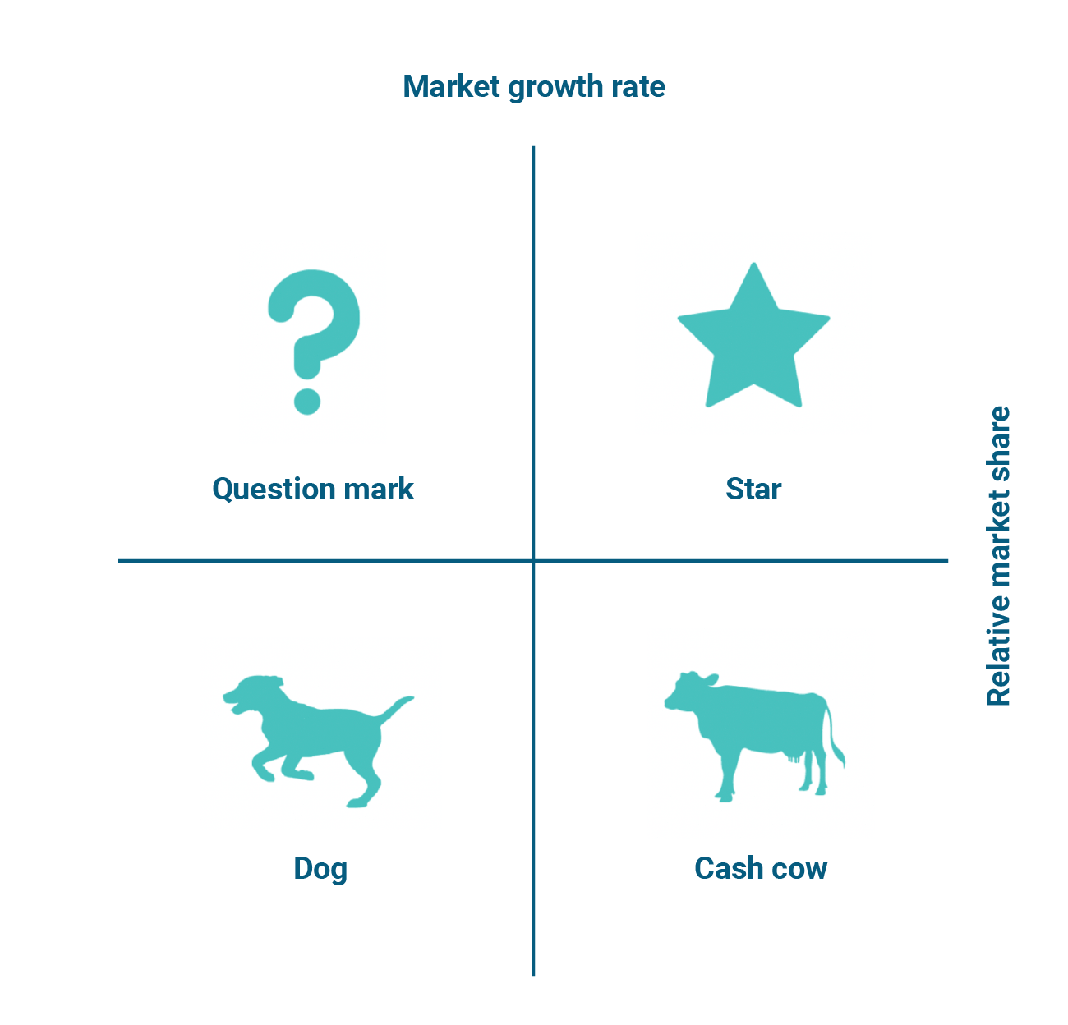
The BCG growth share matrix model depicted in the figure above categorizes the products in a company into four categories namely cash cow, dog, star, and question mark. The model helps businesses determine a growth strategy by understanding how they can increase their revenues using their existing products (Mohajan, 2017). Using the BCG model, the following are the three possible growth strategies that the restaurant can apply to grow its operations.
Stars - Stars are products that perform the best in a company. Stars generate the most revenue as they have the largest market share. The model states that stars serve a market that grows at a fast rate hence the potential for generating more revenues in the future (Mohajan, 2017). At Zindiya Streatery & Bar restaurant, the star products are the services that are in a growing market and generate the restaurant substantial income. They include the catering services, the healthy foods on its normal menu, and the vegan menu. The restaurant can enhance its growth by focusing the stars where it invests in producing more of the same services to serve the growing market.
Dog - According to the BCG matrix model, the dog represents the products that are in a market that grows slowly and the products have a small market share. The products in this category are able to provide cash flow but do not improve on their financial performance. The model advises that companies with such products can phase them out and use the funds to finance other well-performing products in order to enhance growth (Mohajan, 2017). The strategy can be used at Zindiya Streatery & Bar restaurant to enhance growth by identifying the services or products that fit the description of dogs as defined in the model and phasing them out in order to generate funds that can be channeled to improving other performing products.
Cash cow
The cash cow according to the model represents the products with a high market share but serve a market that is glowing slowly. The products in this category make the company a leader in the market as they perform better than all other products from competing company. A company can enhance its growth by focusing on cash cows and improving their market leadership position and make more money from the products (Mohajan, 2017). At Zindiya Streatery & Bar restaurant, the products that fit in the description of a cash cow include the kids’ menu and the festive menu. The restaurant can use the products to enhance its growth by investing in such products in order to improve its position as a market leader thus generating more revenues from the products.

Chosen strategy
Focusing on the stars
The chosen strategy that will help the business grow both in the short-term and long-term. The restaurant can identify its star products by looking into its best performing products and services and the markets they serve. Having identified the stars, the restaurant should focus on improving their performances and increase its revenues and grow.
Why the strategy chosen will help to secure the long-term future of Zindiya Streatery & Bar restaurant
It will increase the number of customers
Focusing on stars enables a business to increase the number of customers it recieves as the strategy enables the business to create and produce more of the star products and services (Hossain and Kader, 2020). Similarly, focusing on the stars at the restaurant will help the business secure its long-term future by increasing the number of customers seeking the stars. By focusing on the stars, the business will be able to improve their quality. As a result, the products will attract more customers than the one it currently attracts. In the long run, the restaurant will experience an increase in the number of customers visiting its premises to get its star products and services.
It will generate more revenues
When a business focuses on its stars, it increases the revenues it generates because it avails more products that have an increasing market share (Hossain and Kader, 2020). Implementing the strategy will enable Zindiya Streatery & Bar restaurant to improve its revenue as more customers from the increasing market share will translate into revenue from the payments for the products and services. Increased revenues will secure the long-term future as it will increase the business’s financial sustainability.
It will increase brand preference
Brand preference is achieved when a business builds a reputation that makes customers to prefer its products and services as opposed to those offered by competitors (Dam, 2020). The chosen strategy will help the restaurant secure its long-term future by improving its brand preference. Focusing on the star products and services will make the customers know the restaurant for the quality star products hence improving brand preference. In the long-term, the brand preference that the restaurant will achieve will make customers prefer its services, which will enable the business to continue making sales in the long-run.

Key strategic recommendations

Open new outlets outside Birmingham
The report recommends that the restaurant opens new outlets outside Birmingham. The recommendation will help the restaurant increase the number of customers it serves as new outlets will attract new customers from the areas where the new outlets will be located. When implementing the recommendation, the new outlets should be designed to be identical to the main outlet in Birmingham in order to create a consistent brand. In addition, when opening the new restaurants outside Birmingham, the business should ensure it conducts research on the best locations where its star products have a ready market.
The competitors might reach to this strategy by increasing their geographical coverage as well and open new outlets. The reaction can help the competitors maintain their market share by responding to an increase in market share for increasing Zindiya Streatery & Bar restaurant by increasing their market shares. Zindiya Streatery & Bar restaurant can deal with such a reaction by focusing on its strengths as these will enable the restaurant to maintain its competitive advantage.

Invest in e-commerce website
The report recommends that Zindiya Streatery & Bar restaurant should invest in an e-commerce website where it can enable its customers to shop for its products and book its services online. The restaurant should design the website to include the latest e-commerce features that attract customers and provide them with updates on their order processing process. The e-commerce website will provide strategic advantage to the restaurant as it will enable customers to see the available menu items and book services on their devices thus making it convenient to buy from the restaurant.
The competitors in the market might react to this strategy by creating their e-commerce websites in order to gain the same benefits of e-commerce. The restaurant can deal with this reaction by marketing its e-commerce website effectively and reach as many potential customers as possible.

Research on new menu items and services that can join the star products
The restaurant should research to find new menu items and services that can join the star products that have high sales volume in growing markets. Finding menu items or services with such potential can help the business to grow by increasing the number of star products and services. When conducting the recommended research, the business should focus on long-term social trends in the restaurant industry and identify the products and services that customers prefer.
Competitors in the industry can react to this strategy by offering the products and services that the restaurant has introduced to its menu and list of services. The competitors might reach in such a manner as a means of ensuring they also get part of the market share that Zindiya Streatery & Bar restaurant will acquire by selling the identified products and services. The restaurant can deal with such reactions by making its products and services unique through strategies such as pricing.

Conclusion
Zindiya Streatery & Bar restaurant can succeed as an SME in Birmingham through effective and strategic management practices. The restaurant’s strategic management includes understanding its external and internal business environment as this will enable the business to make informed decisions. In addition, the business should understand its stakeholders using the stakeholder analysis conducted in the report and manage them effectively. Finally, the business should adopt the strategy of focusing on its star products as this will enable it to increase brand preference and revenues, which will secure its long-term future.

References
Ackermann, F. and Eden, C., 2021. Strategic management of stakeholders: Theory and practice. Long range planning, 44(3), pp.179-196.
Dam, T.C., 2020. Influence of brand trust, perceived value on brand preference and purchase intention. The Journal of Asian Finance, Economics and Business, 7(10), pp.939-947.
Durst, S. and Runar Edvardsson, I., 2021. Knowledge management in SMEs: a literature review. Journal of knowledge management, 16(6), pp.879-903.
Ferrell, O.C., 2014. Business ethics and customer stakeholders. Academy of Management Perspectives, 18(2), pp.126-129.
Gerard, H. and Bruijl, T., 2019. The relevance of Porter's five forces in today's innovative and changing business environment. SSRN.
Hewlett, K., Dacombe, R., Haggar, T., Piggott, H., Wojciechowska, M. and Hall, S., 2024. Practising Resilience: Lived Experience, Agency and Responses to the Cost‐of‐Living Crisis. Social Policy & Administration.
Holmes, Y.M., Beitelspacher, L.S., Hochstein, B. and Bolander, W., 2017. “Let's make a deal:” Price outcomes and the interaction of customer persuasion knowledge and salesperson negotiation strategies. Journal of Business Research, 78, pp.81-92.
Hossain, H. and Kader, M.A., 2020. An analysis on BCG growth sharing matrix. International Journal of Contemporary Research and Review, 11(10), pp.21899-21905.
Isabelle, D., Horak, K., McKinnon, S. and Palumbo, C., 2020. Is Porter's Five Forces Framework Still Relevant? A study of the capital/labour intensity continuum via mining and IT industries. Technology innovation management review, 10(6).
Joseph, E., 2019. Mall performance: Corporate, retail, restaurants and e-commerce effects. International Journal of Financial Research, 10(2), pp.1-15.
Mazikana, A.T., 2023. Application of Porter 5 Forces to the Banking Industry. Available at SSRN 4380793.
Moeuf, A., Pellerin, R., Lamouri, S., Tamayo-Giraldo, S. and Barbaray, R., 2018. The industrial management of SMEs in the era of Industry 4.0. International journal of production research, 56(3), pp.1118-1136.
Mohajan, H., 2017. An analysis on BCG growth sharing matrix.
Sargent, K., 2023. The labor market impacts of Brexit: Migration and the European union. Economic Modelling, 121, p.106196.
Sievenpiper, J.L., Riccardi, G., Ricordi, C. and Dembska, K., 2019. Nutrition, health and dietary trends. Achieving the Sustainable Development Goals Through Sustainable Food Systems, pp.63-82.
Silberberg, M. and Martinez-Bianchi, V., 2019. Community and stakeholder engagement. Primary Care: Clinics in Office Practice, 46(4), pp.587-594.
Slabá, M., 2014. Stakeholder power-interest matrix and stakeholder-responsibility matrix in corporate social responsibility. Proceeding of 8th International Days of Statistics and Economics, pp.1366-1374.
Zindiya Streatery & Bar. (2023). Food menu. Retrieved November 13, 2024, from https://www.zindiya.co.uk/pages/food-menu

Poster



