THE IMPACT OF INTEGRATED MARKETING COMMUNICATION AND DIGITAL MARKETING ON THE FAST FOOD INDUSTRY OF THE UK
Abstract
The first chapter of the dissertation highlights the background of the research related to digital marketing and integrated communication marketing strategy. It also sheds light on the problems, rationale and importance of the research. It also covers the aims and objectives of the dissertation.
The literature review chapter mainly highlights the importance of digital marketing within the fast food industry. On the other hand, it also sheds its light upon the impact of the implementation of integrated marketing communication and Digital Marketing to ensure fast-food companies expansion. In addition, it also illustrates the discussion based on Major issues related to integrate marketing communication strategy and effective initiatives within fast-food companies. It also discusses the main characteristics of digital marketing activities. The issues have been discussed and solutions have been provided. This chapter also discusses important theories and models related to digital marketing and IMC. Moreover, this chapter sheds light on the gap in the literature.
The methodological chapter has included data collection, sampling and data analysis methods and such other techniques that help the research to grab successful outcomes. On the other hand, in this chapter the study has discussed about the ethical consideration that is extremely needed for successful research.
The findings and analysis chapter has entailed the thematic analysis as well as the quantitative analysis through covering survey with eight questions. With the help of the analysis and findings, the study grabs fast-hand result about the chosen topic. This particular report sheds light on representing the results derived from the primary qualitative data. Focus has also been laid on representing the results of the secondary data as well. This chapter also highlights the major findings based on the survey responses and the secondary data.
The conclusion chapter sheds light on the overall findings of the research. On the other hand, the chapter has includes linking with objectives that helps the study to meeting with research objectives. This chapter also highlights essential recommendation for the fast-food business to ensure business growth along with a discussion based on future scope for this study.

Table of Contents
Chapter 1: Introduction 4
1.0 Introduction 4
1.1 Background of the research 4
1.2 Problem of the research 5
1.3 Purpose of the research/Research rationale 6
1.4 Aim and Objectives of the dissertation 7
1.4.1 Aim 7
1.4.2 Objectives 7
1.5 Questions related to the analysis 8
1.6 Importance of the research 8
1.7 Synopsis of the dissertation 9
1.8 Chapter summary 9
Chapter 2: Literature review 10
2.0 Introduction 10
2.1 Importance of Digital Marketingrelated to the fast-food company 10
2.2 Impact of the implementation of integrated marketing communication and Digital Marketing to ensure fast-food companies expansion 11
2.3 Major issues related to integrated marketing communication strategy and effective initiatives within fast-food companies 13
2.4 Recognising the feasible solutions for improvising digital marketing in the fast-food companies 15
2.5 Discussing relevant theories, models and frameworks 16
2.5.1 Integrated marketing communication model 16
2.5.2 Communication strategy framework 17
2.5.3 AIDA marketing model 18
2.5.4 Theory of Planned Behaviour 19
2.5.5 Critically analysing and comparing the models and theories 20
2.6 Literature gap 21
2.7 Conceptual Framework 21
2.8 Chapter summary 23
3. Overview of research methodology 24
3.0 Introduction 24
3.1 Research onion 24
3.2 Research philosophy 25
3.3 Research design 25
3.4 Research approach 25
3.5 Data collection method 26
3.5.1 Secondary data collection 26
3.5.2 Primary data collection 26
3.6 Sample size and sampling technique 27
3.7 Data analysis method 28
3.8 Ethical consideration 28
3.9 Summary of the chapter 29
Chapter 4: Analysis of the data and discussion on findings 30
4.0 Introduction 30
4.1 Findings /Results 30
4.1.1 Results derived from primary quantitative data 30
4.1.2 Results derived from primary qualitative data 38
4.1.3 Results derived from secondary qualitative data 42
4.2 Discussion of the Results or Findings 49
4.2.1 Discussion of the interview results or Primary qualitative data 49
4.2.2 Discussion of the survey responses or Primary quantitative data 51
4.2.3 Discussion of the secondary qualitative data 54
4.3 Chapter Summary 56
Chapter 5: Conclusion and recommendations 57
5.0 Conclusion/summarising the findings of the research 57
5.1 Linking with objectives 59
5.2 Recommendations 60
5.3 Future Scope 62
Reference List 64
Appendix 1: Survey Questionnaire 73
Appendix 2: Interview Questionnaire 76

Chapter 1: Introduction

1.0 Introduction
Communication through integrated marketing is basically based on an approach that creates a unified experience for the customers so that the customers can interact with the brand seamlessly. Along with that, digital marketing is likely to be one of the most important techniques for any food industry to promote their food brands and expand their business in a significant manner. Many fast-food brands in the UK have taken initiatives through integrated communication as well as digital marketing to grow their business by meeting customers' demands accordingly.
Chapter one of this research has focused on the impact of integrated marketing communication and digital marketing on the world-famous fast foodjoint, “KFC” in the UK.

1.1 Background of the research
Any organization can analyse customer behaviour, expand its business with proper integrated communicative skills. Famous food joint, “KFC” has successfully accomplished its goal by communicating with customers through integrated marketing and taking advantage of digital marketing. “KFC UK” has been focused on the customers' needs by commuting directly through integrated marketing. According to Uddin (2020), “KFC UK” is one of the famous fast food joints after McDonald's. The company has accomplished its aim to increase its productivity in order to maintain nation demand. “KFC UK” uses a strategy based on demographic segmentation for meeting the market demand. The recent report says “KFC UK” has kept their promise to improve welfare within the industry by improving the company’s poultry supply chain (Global.kfc.com, 2020). The company trails over almost 348 chicken farms among around 33 suppliers. “KFC UK” has overcome their losses that happened due to lack of poultry supplies resulting in closing around 300 outlets including UK outlets with the help of newspaper and television advertisements. The company compensated for the losses within around three months by generating a profit of almost one billion (Campaignlive.co.uk, 2021) Based on this information it can be obtained that the company needs to improvise their integrated marketing communication skill and promote their brand through digital advertisements to ensure the company’s long term sustainability. Along with that, the company needs to implement effective methodologies as well as technical intervention in order to progress globally and get ahead in the market competition. “KFC UK” must monitor the reasons behind the odds that are the obstacle in the growth of their business along with feasible solutions to mitigate the issues to sustain in the global market.

1.2 Problem of the research
Globalization has pushed today's contemporary business sector to embrace and implement new and innovative service provisions. In the era of globalization, renowned fast food companies such as “KFC UK” have been subjected to a wide plethora of problems such as supply chain disruption (bbc.com, 2021). This in return creates hindrance while “KFC UK” tries to fend off the other potential market rivals. “KFC UK” faced several service inconveniences which led to adverse impacts on their supply chain. In the financial year of 2018, the company has been compelled to close around 300 outlets in the UK (Thebci.org, 2018). The problem occurred due to engaging a new delivery partner who was unable to supply poultry ingredients such as fresh chicken to the outlets. In order to maintain the supply chain and meet the demand of the customers “KFC UK” appointed a new delivery partner which also led to delays in supplies. The company also witnessed a case of customer dissatisfaction in the UKon the basis of a complaint about discovering a worm in his "half-eaten" KFC snack. A recent report says that this food chain needs to encounter several customer complaints in the UK market such as customers have been complaining about a worm in their ordered food from KFC which led to an impact on their health as well (Bedfordshirelive.co.uk, 2021).
Based on these customer conveniences," KFC UK" needs to improve their supply chain by creating compatible delivery partners to prevent the company's outlets from closing down. The food joint must take care of the quality of food they are serving to the customers by maintaining proper hygiene. According to Jocelyn (2018), in order to maintain their position in the market and have a vast approach with abundant availability of their poultry supplies “KFC UK” needs to promote more via social media, television and newspaper advertisements. Implementation of proper integrated marketing communication is considered to be helpful for the company to sustain itself in the global market.

1.3 Purpose of the research/Research rationale
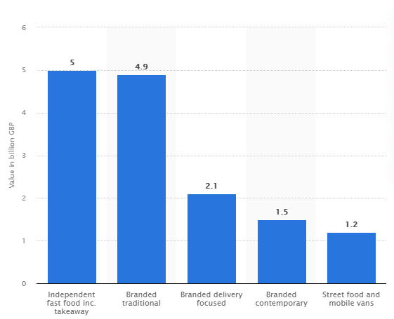
Figure 1: Share generated by fast-food market players in the UK
(Source: Statista.com, 2018)
The above graph provides an illustrative view regarding the share generated by key players or business entities of the fast-food business sector of the UK. Consequently, the requirement of embracing digital communication strategy has also been highlighted through this statistical representation, since by embracing this technique, market share in the UK market can be maximised.
The implementation of “integrated marketing communication” helps any business to improve efficiency in their relationship with customers in order to maintain the consumer’s trust in the company. Based on the views of Berne-Manero (2020), digital advertisements ensure the company’s sustainability in the international market by promoting the brand globally.
The purpose of the research is to analyse the importance of the marketing strategy based on integrated communication and digital advertisements in enhancing the company’s growth. Enforcement of “integrated marketing communication” assists organizations to develop the advantages of market competition, increase the company's sales and profit gains, reduce time and stress and help to save money as well. In the views of Gamageet al. (2021), a communication strategy based on integrated marketing adjoins customers with better communication and helps in shaping the customer purchasing process through various stages. “Integrated marketing communication” is considered to be an effective tool in business management of “KFC UK” which not only helps to draw the attention of the consumers but also serves information of customer's needs. This strategy facilitates consumer knowledge and competency in products and their utilisation. In order to meet customers' needs and fulfil their demands, the implementation of “integrated marketing communication” is omnipotent for any company like KFC to enhance their business in the global market. Based on the opinions of Alalwan (2018), social media advertisements help companies to forecast the customers and build significant relationships with them. Digital marketing can assist organizations to have a universal approach that can help the organizations to enhance their business and to grow in a proficient manner.
Thus, the rationale of conducting this research is to provide meaningful suggestions regarding deploying “integrated as well as effective marketing communication” interventions for the sake of maximizing the profit of KFC while conducting business in the global and domestic markets.

1.4 Aim and Objectives of the dissertation

1.4.1 Aim
The ultimate research of the study is to manage in-depth examinations regarding the fast-food company in the UK in order to understand the importance of the implementation of “integrated marketing communication” and advertising via social media.

1.4.2 Objectives
- To recognize the importance of “Digital Marketing” related to the fast-food company in the UK such as KFC
- To analyse the impact of the implementation of the “integrated marketing communication” and uses of “Digital Marketing” in order to accelerate the expansion of fast food companies like KFC
- To identify the issues related to the strategy of “integrated marketing communication” and effective initiatives that encounter the problems must be taken by the fast-food companies in the UK such as KFC
- To recognize the feasible solutions and help to enlighten the food companies like KFC about effective measures for improvising the digital marketing communication with the customers to meet their demands

1.5 Questions related to the analysis
- What is the importance of digital marketing strategies regarding integrated communication on the food companies like KFC in the UK?
- How do digital marketing and marketing communication help UK food industries to accelerate their growth in the global market?
- What are the disruptions that need to be taken under control by the food companies in the UK such as KFC?
- How do the food companies in the UK like KFC bring technological innovation in order to improve the process of digital marketing?

1.6 Importance of the research
The importance or the significance of a scientific research study can only be analysed by measuring its capability in terms of filling gaps in the existing knowledge. In this context, this research provides feasible information about the impact of the implementation of marketing communication in an integrated way and strategy of digital marketing on “KFC UK”. Along with that, this study also highlights many issues in the service and marketing of “KFC UK” that affected their business sustainability. In order to fix the issues, this research also elucidates effective recommendations that can help the food company, “KFC UK” to expand their business and get ahead in the high competition in the international market. The research also assists to recognize the importance of intervention of innovative technologies in order to improvise the strategy of digital marketing.

1.7 Synopsis of the dissertation
The entire dissertation has been discussed and it is divided into five chapters. The first chapter discussed the company background, rationale, the organization's aims and objectives. The second chapter of the report will be based on the reviews related to literature focusing on all information regarding the fast-food company “KFC UK”. The third chapter will elaborate on the technological methods and initiatives that will help “KFC UK” to prevent the organization from facing consequences. On the other hand, the fourth chapter of the research will be based on analysing the significant company's research findings linked with the literature review. The sixth chapter will highlight the limitations, conclusions and recommendations for “KFC UK” to expand their business in a proficient manner.

1.8 Chapter summary
The first chapter sheds light on the importance of the implementation of digital marketing and integrating marketing communication strategy. The study also highlights the issues that need to be taken care of by the company to ensure sustainability by adopting effective initiatives. The study also covers the aim, objectives, purpose, and rationale of the research.Thus, the first chapter sheds light on background of the research that helps the fast-food industry in the United Kingdom to reshape their business as well as utilize the new technology in the workplace. Similarly, the chapter has covered a rationale that covers all the issues that faced by fast food industry like KFC, UK while implementing technology in workplace. Simultaneously, the chapter has entailed some aim as well as objectives to flourish the research in future. On the other hand, with the help of research question in this chapter, the whole study can maximise the level of the research on fast food retail industry while implementing technology in workplace. Thus, this chapter has provided main as well as in-depth knowledge about the chosen topic and helps the study to accomplish its core objectives.

Chapter 2: Literature review

2.0 Introduction
The discussion of existing literature is one of the most important parts of a research process as it helps to extract effective knowledge regarding the encountered topic. Identifying the major impacts of digital marketing as well as integrated marketing communication within the fast food industry of the UK is the main motive of this research. This chapter will provide focus on discussing the importance as well as the impact of digital marketing characteristics on the fast-food industry. The issues within integrated marketing as well as digital marketing will also be identified. Different theories will be applied based on the characteristics of the marketing activities.

2.1 Importance of Digital Marketingrelated to the fast-food company
Ensure business growth
Digital marketing can bring lots of opportunities for any business by ensuring growth in larger markets. As per the view of Kauppila (2019), digital marketing in recent times has become the norm of any successful business, more effective within fast-good companies. On the other hand, it can help the company to efficiently lead towards increased sales and exposure among the market. This helps the company, mainly the fast food companies to develop its online presence for efficiently ensuring business growth. In addition, it is also essential for the food companies to reach broader audiences and to effectively expand the market among global markets.
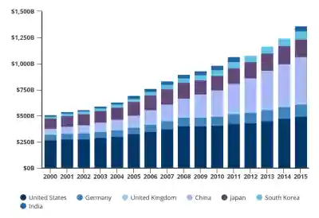
2.1.1 Figure: Growth of business concerning digital marketing strategies
(Source: Shkarletet al. 2020)
Attract more traffic
As per current statistics, it can be utilized that about 70% of the companies in recent times uses digital marketing strategy to develop their business (Forbes.com, (2021). Moreover, digital marketing provides the company ability to interact with a broader audience to know their expectations and to serve better for the valuable customers. On the other hand, 20% of the total units related to fast food among the world utilize digital marketing strategies to attract more traffic and gain competitive advantages. In addition, an adaptation of digital marketing strategies also provides fast food companies advantages to ensure their growth rate of about 4.6% in recent times (Statista.com, 2021). Therefore, digital marketing in recent times plays a significant role in ensuring business growth and more traffic for business expansion.
Faster and cost-effective
Digital marketing for the concern of fast food Company’s growth is an affordable approach than the traditional marketing to expand globally. It has been highlighted by Shkarletet al. (2020), digital marketing helps the fast-food business worldwide by obtaining more leads and saving money. In addition, this helps the company to become a more visible brand among a wider range of audiences by investing in cost-effective strategies. On the other hand, this is also a very fast approach that actively helps the business to gain a competitive advantage in a larger market. More to this context, it helps the company to ensure faster conversation with the targeted traffic for reflecting the business's online presence among wider markets. This also helps the company to establish a too high brand reputation among its competitors.

2.2 Impact of the implementation of integrated marketing communication and Digital Marketing to ensure fast-food companies expansion
Improved efficiency
The effective implementation of integrated marketing communication (IMC) or digital marketing in the business context of fast food companies helps inimproving the efficiency of their operations. On the other hand, this provides the entire business streamlined process that is carried across different channels and ensures effective internal communication. This helps the business to maintain efficiency among the business operations to increase profit margin and to gain competitive advantages. It has been highlighted by Low et al.(2020), implementation of digital marketing strategies helped the company to develop the business through improving its brand’s presence and efficiency among the market.
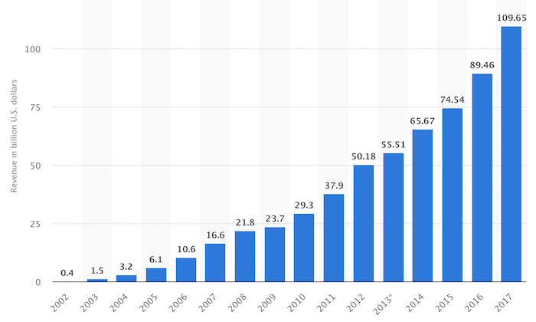
2.2.2 Figure: Changing growth of the business through the application of digital marketing
(Source: Glucksman2017)
Builds trust and high brand awareness
Integrated marketing communication and digital marketing in recent times ensure the growth rate of food business about 2.4% per year worldwide (Ibisworld.com, 2021). It can be utilized that implementation of essential digital marketing and IMC strategies helps to ensure fast food business to build trust and high grand awareness among larger audiences. As per the view of Glucksman(2017), this allows the company to use a wide range of communication and social media channels to effectively reach the targeted audience. On the other hand, the business of fast food present worldwide generally invests about GBP 15.57 billion to develop their digital media presence (Statista.com, 2021). This reflects that investment of the fast-food companies among IMC and digital marketing strategies also helps in ensuring high profitability and brand awareness.
Ensure accessibility towards a broader audience
In recent times, the changing nature of customers allows the company to invest in developing essential IMC and digital marketing strategies to increase accessibility towards broader audiences. It has been highlighted by Henninger et al.(2017), application of IMC helps the business to collaborate with the marketing team to effectively form essential marketing strategies to ensure broader audiences among both local and international markets. On the other hand, this also helps the fast food industry to arrange social media campaigns to connect and attract more customers based on the aspect of attractive advertising. In addition, the implementation of crucial digital marketing and IMC strategies helps in increasing business morale to manage accessibility for increasing traffic. Therefore, it can be utilized based on the aspect of the above discussion that in recent times, the fast-food business effectively uses IMC and digital marketing strategies to ensure business growth among a wider audience and market.

2.3 Major issues related to integrated marketing communication strategy and effective initiatives within fast-food companies
Functional silos
Most of the time the business in implementing effective integrated marketing communication strategies faces issues with their functional silos. As per the view of Laurie and Mortimer (2019), successful arrangement and development of IMC strategies require proper guidance from the company's upper management. In the context of the fast-food industry, they face issues communicating with the company's upper management for ensuring successful outcomes. On the other hand, this resulted in transferring the overall control of upper management towards team leaders (Lacerenzaet al. 2017). Besides, these ensure the occurrence of functional silos among the activities related to IMC strategies and for its implementation to ensure business growth and profitability. The issues can be reduced by ensuring proper planning for the implementation of IMC strategies to reduce the functional silos among fast-food businesses.

2.3.1 Figure: Issues related to the implementation of IMC strategies
(Source: Turner and Endres, 2017)
Restricts creativity
Integrated marketing communication also works for restricting creativity in the workplace of fast food industries to ensure successful outcomes. It has been highlighted by Ots and Nyilasy(2017) when a variety of departments within the fast-food industry are involved to develop an essential IMC campaign that fetches impact upon reflecting creative ideas. On the other hand, a variety of teams is not capable of implementing creative strategies and planning on business to ensure growth and increase profitability (Turner and Endres, 2017). Therefore, this restricts for ensuring creativity among businesses and to follow any unified strategy for conveying towards target customers. Furthermore, to reduce the issue of restricting creativity; the fast-food industry can utilize planning for ensuring the involvement of creative teams.
Lacking resources
This is another issue that the business of fast food faces while ensuring the implementation of essential integrated marketing communication strategies. It can be stated that effective implementation of IMC strategies generally requires the participation of all the business members’ to gain successful outcomes. As per the view of Cromhout(2020), while planning for integrated marketing communication campaigns the lack of team's participation ensures failure and miscommunication to execute the strategic plan. Therefore, miscommunication and lack of resources became major issues for fast food companies while setting up their integrated marketing communication strategies. Therefore, to reduce the impact of the issue, the breakfast food industry can develop and maintain the individual participation of each team for getting a competitive advantage (Gunasekaran et al. 2017). On the other hand, maintaining the basic principles of IMC can also be beneficial for the fast-food industry to collaborate teams in executing effective planning.

2.4 Recognising the feasible solutions for improvising digital marketing in the fast-food companies
The concept of integrated marketing is dependent on the knowledge of the marketers regarding the appropriate utilisation of multiple marketing channels as well as tools. As stated by Laurie and Mortimer (2019), the main motive of integrated marketing communication is to introduce a particular theme through different marketing channels and mediums. It is very important to identify the actual expectations of the target market through different market analyses. This method is effective to overcome the issues regarding inappropriate marketing campaigns. It is also essential to hire local PR agencies for developing integrated marketing communication plans as well as digital marketing strategies. Local agencies are familiar with the basic characteristics and expectations of the local target market. International PR agencies might have comparatively higher experiences as well as higher resources but inadequate knowledge regarding the encountered business market can hamper the overall sustainability of the marketing activities. It has been highlighted by Šķiltere and Bormane (2018), identification of the most suitable social media platform for promoting digital marketing activities at the initial stage might be helpful to reduce the issues regarding poor reachability. For instance, it is essential for marketers to properly compare and contrast the popularity of different social media channels. This method is effective to identify the appropriate social media channels based on the expectations of the target market (Porcuet al. 2017). On the other hand, ethical issues faced by business organisations can be a major reason for the decreased rate of the brand reputation of a business entity. It is the responsibility of marketers to maintain ethical guidelines while developing marketing strategies. Providing misguided information through their marketing activities and marketing channels can hamper the overall sustainability of the business organisation. Different countries have started to provide comparatively higher attention towards identifying the appropriate ethical guidelines for a particular topic. Digital marketers can follow ethical guidelines and legal guidelines to overcome the issues regarding unethical marketing activities. Customers are the most important part of a business organisation and marketing activities are crucial to gain the attraction of the customers. The introduction of a social media marketing strategy plays a crucial role to make an impact on the decision-making activities of the customers (Bartosik-Purgat, 2019). It is the responsibility of the marketers to utilise digital marketing tools for improving the overall brand loyalty of the business entities. However, a lack of knowledge regarding different marketing channels can hamper the overall sustainability of integrated marketing communication activities. Business organisations can develop separate teams for different marketing channels and establishing effective communication between different teams might be helpful to establish sustainability within the strategy development process. As per the view of Iqbal (2021), the implementation of an open communication form can act as an important tool to increase communication between different departments. The queries of one department can be solved quickly by posting the query on the open communication forum. The application of this strategy is effective to increase the overall productivity of the marketing department.

2.5 Discussing relevant theories, models and frameworks

2.5.1 Integrated marketing communication model
Integrated Marketing Communication (IMC) is important for the fast-food industry in terms of facilitating multi-channel communications with the target customers. Some of the common IMC objectives encompass increasing brand awareness, influencing customer behaviour and increasing sales as well as market share in the relevant industry. As per the view of Camilleri (2018), the IMC model is very helpful for maximizing the effectiveness of digital marketing strategies by understanding marketing trends and customer behaviour. In this context, the focus can be given to the functions of the IMC model in order to determine how it is applied in the marketing communication strategy. Fast-food companies need to consider the behavioural and demographic data of the customers to identify the purchasing behaviour of the customers. In addition, decision making related to the marketing strategies is being assessed for their investment purposes through the IMC model. In turn, it can help the companies to determine their financial capacities and values for marketing investment. Apart from that, IMC creates and delivers content regarding the marketing communication based on the business prospects as well as customers (Wibisurya, 2018). Moreover, the IMC contributes to determining the marketing goals so that the companies can allocate the required budget and develop the right marketing approach to attract potential customers effectively.
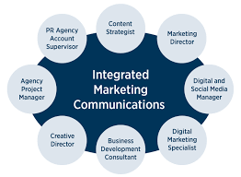
Figure 2.5.1: Integrated Marketing Communications
(Source: Camilleri, 2018)

2.5.2 Communication strategy framework
The communication strategy framework (CSF) helps the food business companies to determine how they can make effective communication with the external and internal stakeholders. As per the opinion of Osman et al. (2021), the CSF is important for aligning the values, goals and objectives of the company that can contribute to long-term success. Therefore, fast food companies need to make clear statements regarding the development and implementation of the communication strategy. At present, most companies are focusing on social media marketing for reaching more customers easily and quickly. The CSF helps the company to understand the background and outcomes of the initiatives by aligning the communication strategy with the objectives. Moreover, it is essential to align the company's objectives with the company's communication strategy to ensure that the company can satisfy the needs of the targeted customers effectively. The companies can measure customer engagement and retention rates to determine whether the strategies are aligned with the objectives or not. As commented by Linåkeret al. (2019), the CSF also includes the target audience that helps the companies to create the strategy considering the needs of individual customers. This clearly shows the changes within target areas of interest of the business entity and ensures the time relevance of their strategies at the same time. Henceforth, this is being incorporated into their marketing as well as promotional strategies.In turn, the fast-food companies can incorporate interesting narratives, attractive and colourful food images with a view to increasing the interest of the customers. Besides, proper implementation of the CSF can help the business companies to influence specific needs and attitudes among the targeted customers.
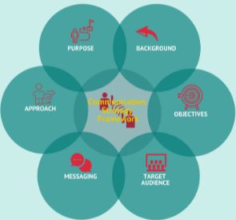
Figure 2.5.2: Communication strategy framework
(Source: Linåkeret al. 2019)

2.5.3 AIDA marketing model
The main aim of considering the AIDA marketing model is to identify the cognitive stages of the customers during the purchasing process. Thus, by implementing the AIDA model the fast-food companies can understand the buying pattern of the customers and develop effective marketing strategies to influence the buying decisions of the customers. As commented by Budimansyahet al. (2019), the AIDA model primarily focuses on four key aspects of customers' behaviour such as attention, interest, desire and action. Thus, fast food companies can focus on increasing their social media presence and promote online communication such as e-mail marketing for drawing the attention of the customers. Moreover, the companies need to understand the interest of the customers to increase customer engagement with the business. The companies are more likely to collect feedback from the customers to understand their area of interest. The "interest" part of the AIDA model is closely related to the "desire" part (Fortenberry, J.L. and McGoldrick, 2020). Most of the fast-food companies are likely to explain the benefits of the products to make a proper appeal to the personal needs of the customers. The final stage is to determine the right actions and connect with the target audience effectively. Thus, by using central idea of this model, KFCUKcollectsfeedback from the customersto take actions to enhance customer satisfaction level.Attention of the customers has been grabbed by using promotion using online media and print media. Implementing the core concept of this model in turn helps KFC UK to make improvement the interest of the customers towards the products of the company. The desires of the customers results in purchase of the products.
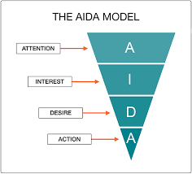
Figure 2.5.3: AIDA marketing model
(Source: Budimansyahet al. 2019)

2.5.4 Theory of Planned Behaviour
The theory of planned behaviour (TPB) has the main focus on explaining the behaviour of individuals at a particular time and place. As highlighted by Pejic Bach et al. (2018), TPB is helpful for understanding the behavioural intent of the customers effectively. Based on the theory it can be said that an individual's behaviour can be influenced by subjective norms, social norms, attention, behavioural intention and perceived behavioural control. All these factors can contribute to the increasing behavioural achievements of the customers. Thus, fast food companies can focus on the personal attitudes of individual customers regarding the foods and services. On the other hand, people are more likely to have a healthy diet that determines the subjective norms for the targeted customers in the fast-food industry. Moreover, perceived behaviour control plays a significant role in determining the purchasing behaviour of the customers (Elseidi, 2018). For instance, a large number of customers are focusing on avoiding fast foods and junk foods for improving their health and well-being. Therefore, fast food companies need to determine how the customers can perform their behaviour of interest and develop the marketing communication strategies accordingly. According to the theory of planned behaviour, KFC has influence the customers by implementing lubricating offers on the food of the company. Purchasing behaviour of the customers has been influenced by the promotion strategy of the company. Avoidance of fast food has been further impacted on the promotion strategy determination.
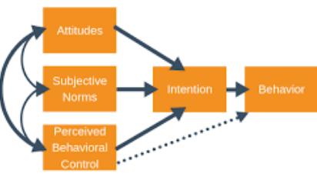
Figure 2.5.4: Theory of planned behaviour
(Source: Bach et al. 2018)

2.5.5 Critically analysing and comparing the models and theories
As per the above discussion, it is easy to understand that the integrated communication model is effective for accelerating the marketing communication process. However, this particular model focuses more on marketing activities than business goals and objectives. Henceforth, the fast-food companies can consider the CSF to design the marketing communication strategy in line with the business goals and objectives (Budimansyahet al. 2019). On the other hand, both the AIDA model and TPB can help the fast-food companies to understand the behavioural intentions of the customers. However, the TPB does not focus on the actual control over individuals' behaviour. It can create confusion while designing the marketing communication strategies for the customers. On the other hand, the AIDA model does not focus on the conversational atmosphere that can have a negative impact on the long-term working relationships of the fast-food companies.
Pay-per-click model of digital marketing
Search engine optimisation has been done by paying to the service providers in implementation of PPC. KFC has implemented PPC in the process of marketing the products online. Demographic segmentation has been done by KFC to implement digital strategies in product and service promotion. Key advantage of the model has been the enhanced reach of the contents. It has been helpful for KFC to reach the targeted customer base in shorter duration (Liu et al. 2019). PPC requires time investment which has been the key disadvantage of the model.

2.6 Literature gap
This chapter primarily focuses on the importance of integrated marketing communication and digital marketing in fast food companies. However, the discussed literature does not focus on the implementation process of IMC and digital marketing strategies. Moreover, this chapter does not consider the issues related to the application of IMC and digital marketing in the fast-food industries.

2.7 Conceptual Framework

THE IMPACT OF INTEGRATED MARKETING COMMUNICATION AND DIGITAL MARKETING ON THE FAST-FOOD INDUSTRY OF THEUK
Relevant theories, models and frameworks
- Integrated marketing communication model
- Communication strategy framework
- AIDA marketing model
- Theory of Planned Behaviour
Importance of Digital Marketing
- Ensure business growth
- Attract more traffic
- Faster and cost-effective

Impact of the implementation
- Improved efficiency
- Builds trust and high brand awareness
- Ensure accessibility towards a broader audience

Major issues related to integrated marketing communication strategy
- Functional silos
- Restricts creativity
- Lacking resources

Recognizing the feasible solutions
It is very important to identify the actual expectations of the target market through different market analyses. This methodis effective to overcome the issues regardinginappropriate marketing campaigns.
Figure 2.7: Conceptual framework
(Created by author)

2.8 Chapter summary
This literature review chapter highlights the importance of digital marketing in fast food industries in the UK. Moreover, this chapter discusses the impact of IMC and digital marketing for enhancing the marketing communication process. In addition, the issues and solutions regarding the implementation of digital marketing and IMC have been described in this chapter followed by the discussion of relevant models and theories.

3. Overview of research methodology

3.0 Introduction
Research methodology is a systematic process that helps a study to conduct research as well as solve the research problem and enquiry. This chapter sheds light on the methodological part of the research. Similarly, this chapter has discussed and illustrated the research philosophy, research design; research approach that helps the research to grab the maximum knowledge about the significance of marketing communication as well as digital technology in the UK based fast food industry. On the other hand, this chapter has discussed the data collection as well as sample size and sampling techniques that are beneficial for this research to find successful outcomes. Similarly, the methodology chapter includes the data analysis technique and ethical implications that help the study to gather the maximum current knowledge about the relevant topic and ways to maintain ethics during conducting this research.

3.1 Research onion
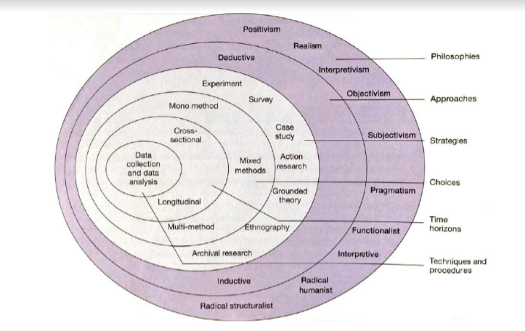
Figure 1: Research onion
(Source: Khar et al. 2019)

3.2 Research philosophy
Positivism is the concept of positivism philosophy that has been taken in this research that helps the current research to evaluate the importance of marketing communication as well as digital technology in the fast-food industry of the United Kingdom. Positivism philosophy is a unique philosophical approach that provides guidelines to research to hold all genuine knowledge (Ryan, 2018). On the other hand, positivism philosophy helps the research to collect relevant and in-depth knowledge or data from various resources. Through utilising the positivism philosophy, the research has grabbed the importance or significance of digital marketing and marketing communication in the fast-food industry in the UK. Utilising the positivism philosophy the study has analysed the major issues encountered by KFC, UK while handling integrated marketing communication and can provide feasible solutions that help KFC, UK to maximise their business and earn maximum revenue.

3.3 Research design
Descriptive research design is one of the most important as well as relevant research designs that help a study or research to find a successful outcome (Sovacoolet al. 2018). Descriptive research design has been used to describe or analyse the characteristics of a particular research phenomenon (Bradshaw et al. 2017). Thus, by using the descriptive research design process, the study is able to determine the importance of digital technology on the fast-food industry of the UK. Similarly, by utilising the above research design, the study is also able to know the significance of marketing communication as well as the issues while including the marketing communication and technology to enhance the business.

3.4 Research approach
A deductive approach is one of the well known as well as most used research techniques that help the study to aid the process of scientific investigation (Rashid et al. 2019). The deductive approach helps a researcher to find successful as well as effective outcomes. Thus, by utilising the deductive research approach, the present study has collected an in-depth understanding of the importance of marketing communication that helps a business to enhance the business. On the other hand, this research approach is very relevant while the research has tried to grab the knowledge about the significance or impact of digital technology in the UK based fast food industry that helps the business to grab the maximum number of people from the UK.

3.5 Data collection method
The data collection method is one of the important parts while trying to make a research successful (Theofanidis and Fountouki, 2018). While doing the current research, the study has used both primary qualitative and quantitative data collection methods. Utilising mixed-method data collection including secondary qualitative methods, the study has opened the pathways to find the significance of marketing communication as well as digital technology in the UK based fast food business by gaining real-time and unbiased information.

3.5.1 Secondary data collection
The secondary data collection method helps a study to grab in-depth knowledge about the topic (Mohajan, 2018). While researching the importance of digital technology as well as marketing communication on the business of the fast-food industry in the UK, the study has used the secondary data collection technique. While using the secondary data collection method, the study was able to collect significant knowledge from the journal articles and other Government business reports (Such as Government reports and articles regarding Food Industry performance of UK) (Nosratabadiet al. 2019). Thus, by utilising the secondary data collection method, the research has found the relevant data on the impact of digital technology and marketing communication to enhance customer behaviour as well as enhance the overall business. Similarly, by utilising the secondary data, the research has been able to find the appropriate mitigation strategy that helps KFC to reshape the business and maximise the customer number.

3.5.2 Primary data collection
Primary data collection is one of the most relevant data collection processes that help the research to grab the hand to hand and most relevant data for the research (Stieglitz et al. 2018). In the current research, the study has utilised the primary data collection method that helps the research to evaluate the significance of digital technology as well as marketing communication to enhance the beauty of the UK based fast food industry. Thus, in order to collect the primary data, the study conducted a survey among 121 customers of the KFC, UK and an interview of 3 KFC managers of this organisation. By utilising the primary data, the research has analysed or emphasised the necessity of communication and digital techniques in the KFC, UK to enhance their business outcome.

3.6 Sample size and sampling technique
The sample size is one of the important parts of research since it ensures systematic data collection from the selected sample population (Vasileiouet al. 2018). This present study has used the primary and secondary data collection methods to grab the maximum knowledge about the significance of digital marketing on the KFC, UK. In essence, the research has surveyed customers of KFC, UK by taking a sample size of 121 customers, who have been selected randomly from different paths of the UK. Thus, by conducting a survey, the research can grab the primary quantitative data that not only enhances the value of the research but also helps the research to collect one to one responses from the 121 KFC customers in the United Kingdom. On the other hand, the study has arranged an interview and taken a sample size of 3 managers of the best retail fast food industry KFC, UK to grab the relevant and proper information about the business and the impact of digital marketing techniques as well as grab the primary qualitative data. Thus, this ideal and desired sample size has helped the present research to analyse the role of digital technology as well as the significance of marketing communication that enhance the business of the KFC, UK. On the other hand, the study has utilised the 8 peer-reviewed journals that helps the study to grab the maximum secondary qualitative data from the journal articles about the role and significance of digital technology on the fast-food industry. Similarly, by using the secondary data collection technique, the research is able to analyse the maximum in-depth underpinning about the digitalization and the marketing communication that may maximise the business of the KFC, UK.
While doing the research, the study has utilised the "self-selection non-probability sampling technique" that helps the study to gather the effective knowledge about the recommended business strategy from the peer reviewed journal articles. On the other hand, the study also used the above sampling technique for grabbing the data from interviews of the KFC managers. Similarly, while the research has conducted the survey for the 121 KFC customers, the study has used the random sampling technique that helps the research to grab the one-to-one data from the respondents.

3.7 Data analysis method
While conducting research, the data analysis method has played a pivotal role to find successful research outcomes (Erlingsson and Brysiewicz, 2017). This present research has used the content analysis, statistical analysis, thematic analysis method to analyse the acquired data from first-hand sources and secondary literary sources. While the research conducts the survey, the research has utilised the statistical data analysis technique to analyse the primary quantitative data. On the other hand, the content analysis method has been utilised while analysing or evaluating the primary qualitative data from the interview. Similarly, in time of analysing the data from the chosen peer-reviewed journals, it has used the thematic analysis technique that helps the study to grab the relevant and effective findings of the research. Thus, these above three data analysis techniques help the study to collect the relevant data about the significance of marketing communication and the necessity of utilisation of digital technology in the KFC, UK.

3.8 Ethical consideration
While collecting data from various sources, the study ensures that the research has followed all the necessary protocols to handle the data that are collected from various sources (Shu et al. 2020). On the other hand, by maintaining data confidentiality or data privacy, the research has followed some code of conduct or ethical guidelines provided by the University. While collecting information from various different resources, the present study has used some ethical code of conduct. Similarly, the study also follows the guidelines of Data Protection Act UK, 1998 to maintain the data confidentiality of the current research (Legislation.gov.uk, 2021). During the interview session the study has taken Informed consent from the participants and ensures no participants were forced to join the interview. All the details of interview and survey were priory provided to the respective participants to ensure no ethical dilemma. The authors whose writing has been used as secondary information were acknowledged properly. Information obtained from various sources was safeguarded in an encrypted or passwords protected database to ensure no third party access. The study has also confirmed that the research information has been used for this research only. Thus, the ethical consideration has helped the research make the collected data private and increase the value of the research.

3.9 Summary of the chapter
Thus, it can be concluded that the chapter has shed light on the methodological part of the research. By utilising the chapter, the research has grabbed the more relevant as well as unbiased data that enhance the research on importance of communication and digital techniques to maximise the business of the KFC, UK. On the other hand, the survey and interviews are going to be very helpful for the research that helps the study to enhance the value of the research as well as helps the company to maximise their business.

Chapter 4: Analysis of the data and discussion on findings

4.0 Introduction
Integrated marketing plays an important role in the fast food industry as it helps in enhancing communication and also develops the multi pronged marketing campaign. For instance, Digital marketing helps in connecting business with the consumers through online mediums. As a result, audiences can buy food through social media and by using different applications. The fourth chapter focuses on the analysis of findings and data obtained through primary quantitative data as well as secondary quantitative data and provides feasible information for the research purpose. The chapter provides detailed description about results derived from primary quantitative data along with the results derived from secondary quantitative data. Detailed illustration and discussion of all the information of the results or findings are also included in this chapter.

4.1 Findings /Results

4.1.1 Results derived from primary quantitative data
Survey Question 1: Survey based on demographic characteristics of Customers
Based on age
Age group | Frequency | Percentage | Total number of participants
Below 15 | 20 | 16.52 | 121
18-35 | 70 | 57.85 | 121
36-50 | 26 | 21.48 | 121
51-65 | 5 | 4.13 | 121
Table 1: Demographic characterised customers
(Source: Created by author)
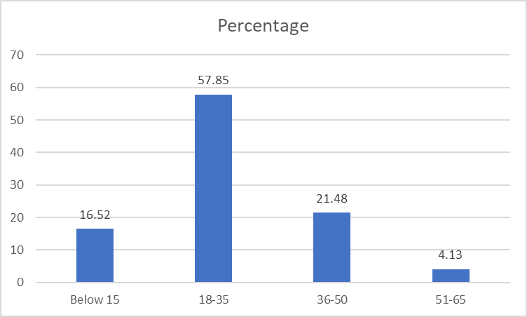
Figure 1: Demographic characterised customers
(Source: Created by author)
Comment/Analysis
Based on the above statistical evidence, 16.52% of people who are below the age of 15 attend this survey. Similarly, 57.85% of people who are aged between 18-35 have participated in the programme and entailed the impact of social media in the fast-food industry. In contrast, only 4.13% of people who are above 60 groups attended the survey and 21.48% of people aged between 35-50 have found the support of social media while ordering or purchasing food.
Survey Question 2: Do you believe e-services social media or other attributes of digital marketing have increased the business of the fast-food industry?
Responses | Participants | Percentage | Total
Yes | 75 | 61.98 | 121
No | 5 | 4.13 | 121
Neutral | 31 | 25.61 | 121

Table 2: Improvement of the efficiencies of social platforms as an ordering way
(Source: Created by author)
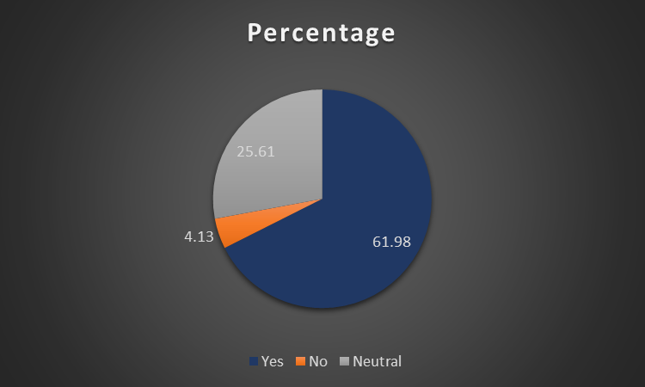
Figure 2: Improvement of the efficiencies of social platforms as an ordering way
(Source: Created by author)
Comment/Analysis
The above chart entails that 61.98% of participants who participated in the survey have shared the fact that e-service and digital marketing help the fast-food industry to achieve the goal. On the other hand, 25.61% of people in the survey remain neutral and only 4.13% of people do not believe in the impact of social media in the food industry.
Survey Question 3: Do you think that digital marketing, as well as integrated marketing strategies, create a positive impact on the fast-food business in the UK?
Responses | Participants | Percentage | Total
Yes | 80 | 66.11 | 121
Neutral | 20 | 16.52 | 121
No | 21 | 17.35 | 121
Table 3: Positive impact of social media marketing on the fast-food industry
(Source: Created by author)
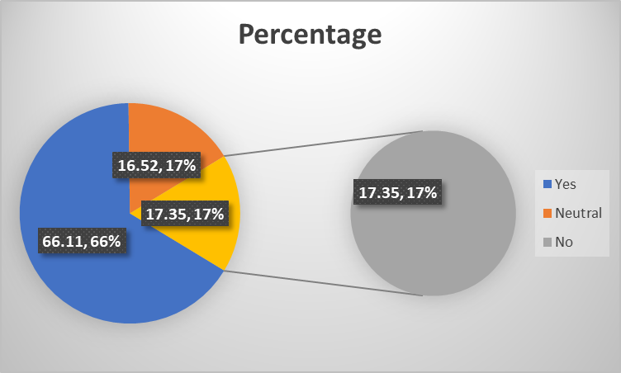
Figure 3: Positive impact of social media marketing on the fast-food industry
(Source: Created by author)
Comment/Analysis
As per the above graph, more than half of the participants, that is 66.11% of people, say that social media creates a positive impact on the business of the fast-food industry. Similarly, 17.35% did not believe in technological impact on the food industry. On the other hand, 16.52% of people have given preference in providing no response to this particular survey question.
Survey Question 4: Would you like to talk about your gender category?
Gender Group | Responses | Percentage (%) | Total
Male | 67 | 55% | 121
Female | 40 | 33% | 121
Others | 14 | 12% | 121
Table 4: Demographic characterised customers
(Source: Created by author)
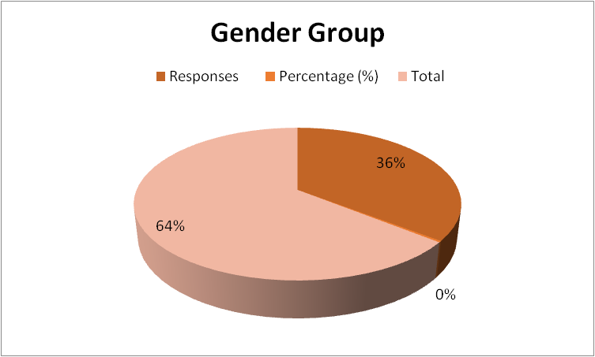
Figure 4: Demographic characterised customers
(Source: Created by author)
Comment/Analysis
Based on the statistical evidence, it can be stated that about 55% of customers are male who is attending this survey. Additionally, 33% of the cutters are female along 12% are identified as others. It can be stated that the participants in the programme and to entail the major impact of the integrating marketing strategies within the food industry of the UK is performed through their important responses and by their opinion.
Survey Question 5: Do you agree that extensive website marketing of your favourite fast-food brand is often irritating to you specifically in the UK?
 | Strongly agree | Agree | Neutral | Disagree | Strongly disagree
Responses | 14 | 10 | 2 | 46 | 51
Percentage | 12% | 8% | 2% | 38% | 42%
Total | 121 | 121 | 121 | 121 | 121
Table 5: extensive website marketing of your favourite fast-food brand is often irritating specifically in the UK
(Source: Created by author)

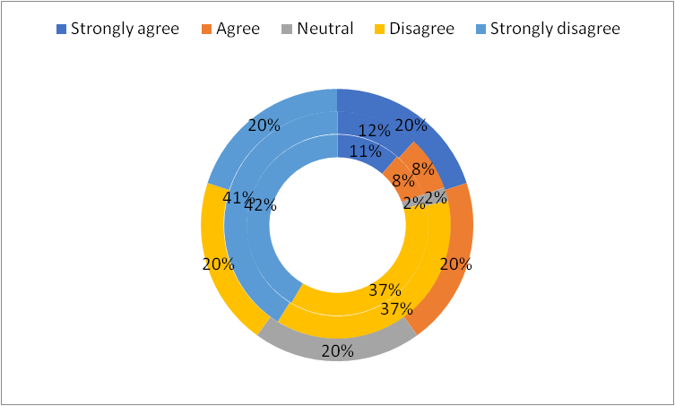
Figure 5: extensive website marketing of your favourite fast-food brand is often irritating specifically in the UK
(Source: Created by author)
Comment/Analysis
The above table and the chart mainly entail that about 12% of the participants generally strongly agree with the concern that extensive website marketing of favourite fast food brands is often irritating. On the other hand, about 42% of the participants strongly disagree with the consideration as they find the extensive website marketing is useful for them to get their food from the favourite fast-food brand and not irritating.
Survey Question 6: How far do you agree that ordering from any location is promising for customers like you to meet your demands and satisfy your appetite within 30 minutes of ordering food?
 | Strongly agree | Agree | Neutral | Disagree | Strongly disagree
Responses | 46 | 51 | 2 | 14 | 10
Percentage | 38% | 42% | 2% | 12% | 8%
Total | 121 | 121 | 121 | 121 | 121
Table 6: Ordering from any location is promising for customers and to satisfy their appetite
(Source: Created by author)

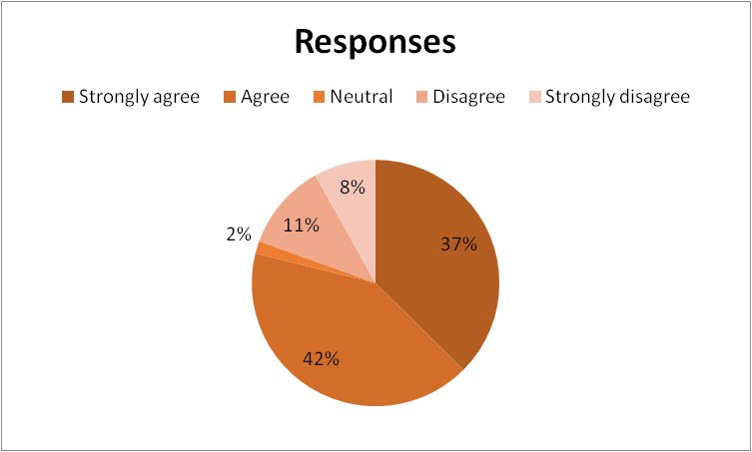
Figure 6: Ordering from any location is promising for customers and to satisfy their appetite
(Source: Created by author)
Comment/Analysis
As per the above chart, it can be stated that about 42% of the participants generally agrees that ordering from any location is promising for customers to meet the demands and satisfy the appetite within 30 minutes of ordering food. Besides, about 12% disagree and 8% of the participants strongly disagree with this as they are finding that their foods are not delivered timely to them to satisfy their demands and needs within 30 minutes.
Survey Question 7: Do you agree that Fast food companies are competing based on their mobile platform presences?
 | Strongly agree | Agree | Neutral | Disagree | Strongly disagree
Responses | 51 | 46 | 2 | 10 | 14
Percentage | 42% | 38% | 2% | 8% | 12%
Total | 121 | 121 | 121 | 121 | 121
Table 7: Fast food companies are competing based on their mobile platform presences
(Source: Created by author)
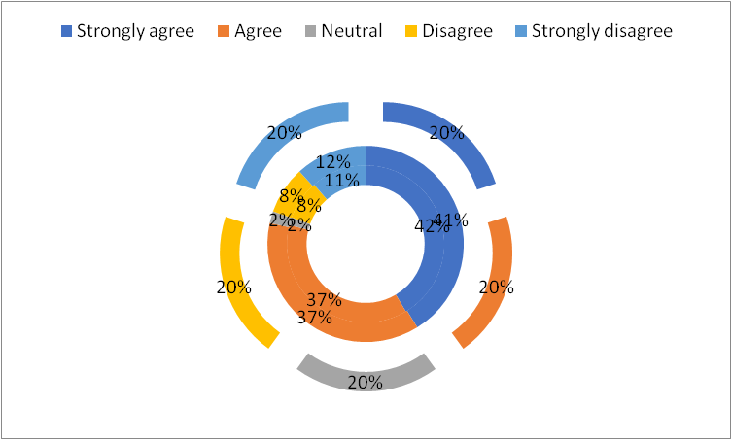
Figure 7: Fast food companies are competing based on their mobile platform presences
(Source: Created by author)
Comment/Analysis
The above graph entails that about 42% of the participants strongly agree with the consideration as fast food companies are competing based on their mobile platform presences. In addition, it reflects that the mobile platforms provide the business advantage to attract more customers easily. On the other hand, 12% of the participants strongly disagree with this as they are not finding the presence of the mobile platform is effective for the companies to compete.
Survey Question 8: How far do you find it useful when the fast-food companies have delivered delicate food items with easy to use and pay options for customers that enable to taste your favourite food items?
 | Strongly agree | Agree | Neutral | Disagree | Strongly disagree
Responses | 55 | 40 | 5 | 12 | 13
Percentage | 45% | 33% | 4% | 10% | 11%
Total | 121 | 121 | 121 | 121 | 121
Table 8: Fast food companies have delivered delicate food items with easy to use and pay options for customers
(Source: Created by author)

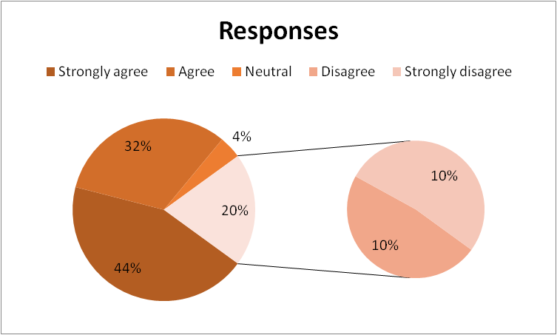
Figure 8: Fast food companies have delivered delicate food items with easy to use and pay options for customers
(Source: Created by author)
Comment/Analysis
Based on the above table, it can be reflected that about 45%c of the participants strongly agree with the concern as it is useful when the fast-food companies have delivered delicate food items with easy to use and pay options for customers to taste their favourite food items. On the other hand, 11% of the participants strongly disagree with this because they might be not fond of using the easy to use payment options technologies to pay the food charges.

4.1.2 Results derived from primary qualitative data
Question 1: How digital marketing strategies in context to integrated communication have played an enormous role in your best retail fast food industry, KFC?
Manager 1 | Manager 2 | Manager 3
Being a general manager of such a renowned fast food company in the UK, I strongly think that digital marketing has identically reduced the cost of marketing and promotion for the existing fast food industry of the UK | As a senior manager of an established fast food company in the UK, I would say that integrated communication has effectively enabled the retail fast food industry of the UK to spread the brand promotion through multiple numbers of digital media platforms such as Facebook, Youtube and so on. | As a sales manager of the fast food industry in the UK, I think that both digital marketing and integrated communication have facilitated the fast food companies in the UK such as KFC to share their brand and business information in a quicker way
Analysis
The above stated table contains the individual responses of the 3 selected managers in context to the impacts of digital and integrated marketing communication on the retail fast food industry of the UK. It can be seen that Manager 1 thinks that digital marketing has effectively cut down the marketing and promotional costs. On the other hand, Manager 2 thinks that digital integrated communication has enabled the retail fast food companies of the UK such as KFC to successfully expand their brand promotion through online platforms such as Facebook. However, Manager 3 thinks that the fast food organisations of the UK can share information quickly through digital marketing.
Question 2: What are your thoughts regarding the usefulness of digital marketing communication that helps UK’S food industries to accelerate into the global market?
Manager 1 | Manager 2 | Manager 3
Being associated with the fast food industry of the UK for such a long time, I would say that digital marketing communication has enabled the fast food companies of the UK to expand the development and publicity of their brand into the international market | As a senior manager, my point of view is that digital and integrated marketing communication have assisted the fast food companies of the UK such as KFC to have a long-term exposure of their business performances which has strengthened their positions within the global food market | Knowing the retail fast food industry of the UK for such a long time has enabled me to say that digital marketing communication has effectively enabled the relevant fast food organisations of the UK to successfully communicate with the stakeholders of the targeted countries in which they wanted to expand their businesses internationally
Analysis
This particular table holds the individual responses of the interviewed managers of the retail fast food industry in the UK regarding the usefulness of digital and integrated marketing communication. It can be identified that Manager 1 thinks that digital marketing has enabled the fast food companies of the UK to expand their brand publicity into the global market. Besides this, Manager 2 opines that integrated and digital marketing communication has facilitated the fast food organisations of the UK to maintain a sustainable long-term exposure of their business activities. Manager 3 depicts that digital marketing has enabled the retail fast food companies of the UK such as KFC to successfully communicate with the stakeholders of the targeted countries.
Question 3: How can the identified issues of digital marketing be overcome by the fast food industry of the UK such as KFC?
Manager 1 | Manager 2 | Manager 3
Staying connected with the existing retail fast food industry of the UK for quite a long time, I identically feel that the identified issues of digital marketing can be solved by developing an attractive and responsive website which will contain accurate informative contents about the relevant fast food companies and provide scopes to the customers for registering their valuable feedback | Being engaged with the internal business operations of the existing retail fast food industry of the UK, I strongly think that adopting and implementing email marketing can remarkably facilitate the fast food companies of the UK to eliminate the identified issues of digital and integrated marketing | As a sales manager, I would like to say that approving and implicating mobile optimisation can deliberately help the retail fast food industry of the UK to successfully overcome the identified issues of digital marketing and strengthen their positions in the existing food market of the UK
Analysis
The above stated table informs the audience about the recommended ways by the selected managers of the UK fast food industry in terms of overcoming digital marketing issues. Manager 1 recommends developing an attractive and responsive website by the retail fast food companies of the UK such as KFC in order to acquire more customers. This might also help the mentioned food company to easily collect the consumer feedback and take necessary actions for bridging any identified gaps. Furthermore, Manager 2 thinks that the implementation of email marketing can effectively eliminate the digital marketing issues. Lastly, Manager 3 stated that implementing mobile optimization can remarkably exclude the identified issues of digital marketing within the retail fast food industry of the UK.
Question 4: How can you bring technological innovations in food companies like KFC in order to improve its digital marketing process?
Manager 1 | Manager 2 | Manager 3
According to my personal point of view, I might adopt and apply authentic content marketing through digital platforms in order to enhance technological innovations within the fast food companies of the UK such as KFC. I also think that this particular innovation might enable the relevant retail fast food companies to interact with their consumers at an increased rate | Staying connected with the retail fast food industry of the UK for such a long tenure, I might definitely implement chatbots in order to develop and improve the customer experience. I believe that this particular technological innovation can remarkably help the retail fast food companies of the UK to provide quicker solutions to their customer queries. | As per my personal concern, I definitely think that introducing and including the facility of voice search in the official websites of the retail fast food companies of the UK such as KFC can identically enable them to acquire and retain the traditional customers
Analysis
This specific table represents the respective answers of the 3 selected managers of the retail fast food industry of the UK in relevance to technological innovations in digital marketing of food companies such as KFC. It can be seen that Manager 1 thinks that authentic online content marketing can enable the fast food companies of the UK to interact with their consumers at a rapid rate. In addition to this, Manager 2 depicts that implementing chatbots can provide quicker and accurate solutions to the consumer queries. Furthermore, according to Manager 3, including the facility of voice search within the websites of the fast food companies of the UK can enable them to acquire and retain the customers.

4.1.3 Results derived from secondary qualitative data
Theme 1- 2 articles | Articles | Author | Title | The methodology used by authors | Overall findings highlighted in each article | Justification
Theme 1- 2 articles | Article 1 | Suharto et al. (2019) |  | Primary quantitative through survey | In this present research article, the author has entailed the importance of e-service in the fast-food retail industry in Bandung, Indonesia | With the help of the research journal, the present study is able to know the significance of social platforms or e-services while people try to purchase fast food from any food retail organisation.
Theme 1- 2 articles | Article 2 | Smith et al. (2019) |  | Qualitative and psychological methodology | In the present article, the authors say that due to the use of social media apps and other technology in food orders, children are enhancing their eating preferences | Using the article, the study grabs the importance of social platforms in the fast-food industry.
Theme 2- 2 articles | Article 1 | Potvin et al. (2019) |  | Survey among 101 children | In this research article, the author has entailed the issues faced by the children like obesity and others due to using e-service while ordering food | Utilising the article, the study is able to grab knowledge about threats that are faced by the people while utilising social media for ordering foods in a maximum way.
Theme 2- 2 articles | Article 2 | Whalen et al. (2018) |  | Quantitative | In this article, the authors have entailed the positive as well as the negative impact of promoting food on television and other online ways. | This helps the study to grab the impact as well as the negative side of technology in the food industry in the UK.
Theme 3- 2 articles | Article 1 | Sabbagh et al. (2020) | “Analysing Credibility of UK Social Media Influencers’ Weight-Management Blogs: A Pilot Study” | Thirteen indicators and four themes (Secondary qualitative) | The authors of this particular article have focused on pointing out and evaluating the spread of dietary misinformation by the social media influencers | The study has given relevant information about the malpractices of the social media influencers
Theme 3- 2 articles | Article 2 | Zhang et al. (2019) | “The Impact of Adding Online-to-Offline Service Platform Channels on Firms' Offline and Total Sales and Profits” | Two surveys and one scenario-based experiment and the dummy approach (Primary quantitative and secondary qualitative) | The authors of this specific article clearly demonstrates the innovation injected by the online-to-offline process into the digital marketing | This particular article has been able to successfully gather the information about the impact of online methods of marketing through this selected article
Theme 4- 2 articles | Article 1 | Vieira et al. (2019) | “In pursuit of an effective B2B digital marketing strategy in an emerging market” | Development of a vector autoregressive model (Secondary qualitative) | The authors of this particular article has stated the importance of the B2B strategy in eliminating digital marketing issues | This definite study has included relevant information that has further helped to examine the ways of overcoming the digital marketing issues
Theme 4- 2 articles | Article 2 | Thabit and Raewf (2018) | “The Evaluation of Marketing Mix Elements” | Secondary qualitative | The respective authors of this specific article demonstrated the role of the mix-marketing elements in eliminating the identified issues of digital marketing | This study has successfully provided the ways of mitigating the identified digital marketing issues through the implementation of the mix strategies

Table 4.1.3: Information drawn from Secondary sources
(Source: Created by author)
Thematic analysis
Theme 1: social media as well as other e-service or digital marketing attributes help people to enhance their food habit and helps the fast food industry in the UK to maximise their profit
Social media plays a pivotal role in the current era. Based on the views of Suhartanto et al. (2019), e-service helps the food industry to enhance its food quality by collecting customers' ratings. Similarly, these e-services help a customer and the company to know about the needs of individuals and after that fulfil their needs. On the other hand, according to the views of Smith et al. (2019), social media not only provides entertainment and fun to the people but also helps children to enhance their food habits. The article by Smith et al. (2019), highlighted that in a survey among children aged fewer than 15, social platforms and eye-catching content influence the customers to buy food as well as eat those food supplements. Thus, based on the above scenario, it can be depicted that social media has provided positive support for the UK fast food industry to attract a vast number of people and enhance profit level as well. Henceforth, by driving attention to a vast number of people digital marketing has become an inseparable part of fast-food company promotion.
Theme 2: Challenges of digital marketing in context to food industry and its effects on children and teenagers in the UK
Unhealthy food marketing is a powerful determinant of improper diets and obesity among children (Potvin Kent et al. 2019). It can be seen that the use of Smartphone and internet have identically increased among children and teenagers which is deliberately hampering their education. The fast food companies of the UK seem to have made it easier for their customers to receive the desired platter by staying at their homes. This is eventually leading to emergence of adverse effects on children such as obesity. Uncontrolled food habits and excessive food promotion of the food companies through digital advertisements also leads to the excessive exposure of the children and adolescents to unhealthy diets. However, on the other hand, the UK food advertising viewed by children is being used by the food companies for promoting unhealthy foods (Whalen et al. 2018). The attractive food advertisements remarkably grab the attention of the children and adolescents of the UK and involve them in unhealthy diets. As per the views of Sletten et al. (2018), excessive obesity leads to severe heart disease that can turn out to be fatal. Furthermore, unhealthy food habits and obesity prevent the children and teenagers of the UK from getting engaged into physical activities and sports practices.
Theme 3: Identification and evaluation of the impacts of digital marketing and integrated marketing communication in context to the fast food industry of the UK
There are various identical concerns about the spread of dietary misinformation by the social media influencers (SMI) that is having a negative impact on public health (Sabbagh et al. 2020). The use of internet and social media platforms such as Facebook, and Twitter have increased the scope of the SMIs to misguide people about improper food diets that can effectively hamper the weight management process. The adverse digital blogs of the SMIs are eventually leading the people of the UK to consume extreme calories which is destroying their personal health. However, on the other hand, the online-to-offline service platform enables people to order their daily foods through innovative digital marketing platforms such as omnichannels, apps and so on (Zhang et al. 2019). E-commerce has made it easier and convenient for the people of the UK to order and receive food quickly and instantly without paying a physical visit to the food outlets. This is eventually resulting in the increase in the number of customers for food companies in the UK such as KFC.
Theme 4: Investigation of the recommended ways by which the identified issues of digital and integrated marketing can be mitigated successfully
The B2B marketing process has rapidly increased the fluency and effectiveness of the communication between the sellers and the buyers (Vieira et al. 2019). Besides this, B2B e-commerce is scalable which enables the food companies of the UK to measure their business progress accurately. Furthermore, the digital B2B marketing strategymakes it easy and convenient for the consumers to interact with the relevant brands which successfully enable the companies to inherit the customers. This particular digital marketing strategy also improves the brand promotion of the food companies of the UK through the online advertisements and campaigns. On the other hand, the promotion of the products through the mix-marketing strategies increases the chance of maximising the sales of the product (Thabit and Raewf, 2018). Furthermore this particular digital marketing strategy enables the consumers to understand the nature of the product. It also enables the sellers to capture an overall idea about the nature of the market in which the online promotion is to be made.

4.2 Discussion of the Results or Findings

4.2.1 Discussion of the interview results or Primary qualitative data
Digital marketing strategies play a vital role in integrating the communication as well as handling the retailing business activities of the fast food company KFC. Critically analysing the first interview session, it has been found that digital platforms are very much important as UK based food firm KFC’s brand promotion can be done through social media sites such as YouTube, Facebook and so on. As per the views of Kauppila (2019), digital along with integrated marketing concepts help in increasing the sales and exposure of an organisation in an efficient manner. Therefore, from performing digital marketing, a brand can include more customers existing in a digital platform. Moreover, digital platforms provide a chance for companies like KFC to grow more. Another benefit which the food industry can get by Digital marketing is less investments and high profit. In this context, from the first interview session, it can be analysed that the food business includes digital marketing for reducing the cost of marketing. For instance, digital marketing is a cost effective strategy and far better than the traditional strategy of marketing as it helps to connect with a greater number of customers at an affordable price (Shkarlet et al. 2020). Moreover, since it is not like the traditional way of marketing as it can be performed in a fast manner. Therefore, comparing and contrasting the above concepts, digital marketing saves time for the Brand in marketing. Thus, fast food companies like KFC UK, need to engage them for digital marketing for a low cost in marketing.
Digital marketing plays a pivotal role for enhancing communication which in turn helps the UK based food company such as KFC UK in accelerating into the global market. Based on the second interview session, it can be derived that Digital marketing not only provides exposure of the brand but also holds the brand exposure for a long period of time. In this context, brands can elongate their company furthermore. Moreover, brands like KFC in the UK can create communication and bonding with other countries' stakeholders and interns can expand the company internationally. In recent statistics, it can be found that over 70% of the businesses use the strategies of Digital marketing for making expansion of their businesses more vivid (Forbes.com, 2021). Along with that about 20% of the food industry uses the Digital medium for attracting more customers and gaining advantages. In this context, in recent times it has been found that over 4.6% of the fast food industries have gained comparative advantage through the process of marketing digitally (Statista.com, 2021). Along with the help of Digital marketing a company can establish their reputation intact among the audience. Thus, it can be concluded that with enhancement of the acceptance of the digital platform for getting in contact with a greater number of audiences and for making bonds with the stakeholders, a company like KFC UK can earn a significant amount of profitability. In this way the brands could reach several people and make the company successful. Thus, Digital marketing plays a significant part for engaging more traffic into the business environment and expanding it in an effective manner.
There are several issues related to digital marketing which are faced by the KFC Food industry of the UK. From analysing the third interview session it can be found that for overcoming the issues regarding digital marketing the KFC Company had tried by developing responsive and accurate food websites which will contain information associated with food. In this context, the customers can make registration on those websites along with sharing their comments and feedback which in turn help the companies to develop more. According to the views of Laurie and Mortimer (2019), issues of digital marketing can be solved by creating different food channels for solving the issues of digital marketing more appropriately. Thus, by comparing and illustrating the above views as well as by initiating mobile optimization along with email marketing the brands could drive more people to engage into the KFC Company. For instance, these are the procedures by which KFC companies can sort out the issues related to integrated and digital marketing. Thus, by the help of digital marketing a food industry like KFC can make their company strong and build a position among the other food companies.
Technological innovation plays a vital role in developing the Digital marketing procedure. Based on the fourth interview session, the technology in the digital marketing would help the brand to answer the queries of their customers quickly and easily. Moreover innovation in digital marketing helps the company in interacting with the different consumers. In this context, technological innovation also helps the KFC food industry for retaining and acquiring the traditional customers. According to the views of Lacerenzaet al.(2017) technical innovation in digital marketing helps a company to manage the company in an efficient way and access the audience seamlessly. Thus, a market like KFC can increase the functional capabilities through implementing technical innovation in digital marketing.

4.2.2 Discussion of the survey responses or Primary quantitative data
The digital marketing strategies are significant in effectively integrating marketing communication as well as proper handling of the food business in the UK market UK. As per the view of Nemeth (2019), concerning the survey responses of the participants, it can be stated that nowadays the young age group are mainly fond of using social media platforms for purchasing their favourite food. In addition, e-services, social media or other attributes of digital marketing have increased the business of the fast-food industry in recent times as it helps the business to attract more traffic (Zhuang et al. 2020). On the other hand, it also provides the food business opportunity to increase their sales and to gain high competitive advantages.
It has been highlighted by Othman et al. (2020), that essential digital marketing as well as integrated marketing strategies, create a positive impact on the fast-food business in the UK as it is cost-effective to ensure business growth. Moreover, in accordance with survey responses, it can be utilised that the survey is performed upon both males and females and others to understand their perspective regarding the usage of extensive website marketing in recent times (Gazzola et al. 2020). Additionally, regarding the concern of extensive website marketing of the favourite fast-food brand is often irritating, specifically in the UK is getting disagreed by the people and ensures that it is crucial for the customers to quickly purchase the favourite food.
Furthermore, ordering from any location is promising for customers who like to meet the demands and satisfy the appetite of the customers within a particular time. According to Li et al. (2020), fast-food companies like KFC are competing with the competitors by developing and enhancing mobile platform presences in order to ensure high business growth and profitability. In addition, the extensive use of websites and digital marketing can bring within the fast-food business several opportunities by increasing the sales and number of traffic. More to this context, the fast-food companies have delivered delicate food items with easy to use and pay options for the customers for getting and testing the favourite food items.
The effective implementation of “integrated marketing communication” and the use of “Digital Marketing” help to accelerate the expansion of fast food companies like KFC. As per the opinion of Minculete and Olar (2018) the development of essential integration marketing approaches like IMC and digital marketing strategies can improve business efficiency. In reference to the findings, this can be stated that the fast food companies have recognised the importance of integrated communication to enhance the impact of their marketing activities for attracting more customers. More to this context, integrating marketing as well as digital marketing ensured the growth rate of the fast-food business in the UK effectively. The implementation of essential IMC strategies mainly helps to ensure trust-building among the larger audiences. On the other hand, the communication and effective social media channels developed by the fast-food business ensure high traffic within both national and international markets (Koufie and Kesa, 2020). The provision of the essential easy to use payment options is crucial for the audiences to rapidly purchase their favourite foods from their favourite fast-food brands.
In accordance with the survey responses, it can be stated that in recent times, social media platforms play a significant role as by collecting the views and responses of the customers, fast-food businesses make changes to enhance the quality of the food. It has been highlighted by Lu et al. (2019), the crucial e-services also help the customers by fulfilling their needs and requirements of the customers to attract more traffic effectively. More to this context, the social media channels and marketing approaches also provide the customers beneficial paying options to easily and quickly pay for the purchased fast foods. However, Ricart et al. (2020) stated that several social media platforms like Twitter, Facebook work to increase the scope for the business to attract more traffic and to understand the product's detailing and its quality aspect. Additionally, it can be depicted that the digital marketing platform has provided the fast-food business positive support to attract a vast range of people. In addition, it is also crucial to enhance the profit margin of the business by driving high sales within the companies.
Furthermore, by developing and performing digital marketing, fast food business brands like KFC works to attract more customers from both the national and international markets. The rise of digital media platform users is higher in international markets and companies can recognise and implement their strategies (Bala and Verma, 2018). Accordingly, for example, Domino's home delivery option has reduced the costs for business setups such as costs related to store locations that have previously been reported. Hence, this can be stated that the fast food companies are on the edge of using digital media platforms effectively to ensure business growth. Many arguments have been observed that digital media are exploiting their customers and also impacts the buying habits of consumers and manipulating the choices at the same time. As per the view of Aghara et al. (2018), fast food companies have recognised the major importance of integrated marketing communication to enhance the impact of their marketing activities and to increase the overall sales of the business. In addition, this can be stated by keeping in mind that digital marketing is one of the major tools for supporting and enhancing business activities in cross border situations that play multifaceted roles for businesses. On the other hand, this also helps the business for evaluating customer needs such as food preferences and also plays a medium for communicating with potential customers (Yi et al. 2018). The communication channels that are used by the fast-food companies in the UK such as Facebook, Twitter and others are crucial to attracting potential customers.
Additionally, in the case of implementation of essential digital marketing strategies, these are majorly used for integrating marketing communication which is now clear in various forms of online marketing stances by the fast-food companies. Moreover, these are also crucial for fast-food businesses like KFC to effectively engage with the customers and to fulfil their needs as well. It has been highlighted by Chen et al. (2021), social media marketing strategies are crucial to enhance the communication level among the customers which in turn helps the fast-food business of the UK to accelerate with the global market effectively. More to this context, by considering the survey responses, it can be stated that digital marketing strategies and approaches provide effective exposure of the overall brand to hold for a long-time among the existing and the new customers. Therefore, fast-food companies like KFC can effectively use digital marketing strategies to enhance their functional capabilities and to ensure business growth as well.

4.2.3 Discussion of the secondary qualitative data
Discussion based on Theme 1:
Social media marketing or the digital marketing strategies in the current era helps the fast-food business to build trust among the existing and new customers in an efficient manner. In addition, the use of essential digital mediums is helpful for fast-food companies like KFC to attract more customers and to gain high competitive advantages. As per the view of Xiao et al. (2019), the fast-food industries of the UK by implementing essential integrating marketing strategies establish a high brand reputation among the target audiences. On the other hand, the digital marketing strategies not only provide the business with a better communicative aspect with the customers but ensure the vivid expansion of the business worldwide. In addition, social media as well as other e-service or digital marketing attributes help the business by influencing the food habits of the customers (Pollák and Markovič, 2021). Additionally, it also helps the fast-food industry in the UK such as KFC to maximise their profit margin and to build trust among the targeted audiences from both national and international markets.
Discussion based on Theme 2:
The major introduction of the digital, as well as the social media marketing strategies, plays an essential role by impacting the decision-making activities of each of the customers. It has been highlighted by Cooper (2019), the business organisation manages the development of the separate teams for managing the communication and marketing channels to satisfy the needs of the target audiences. In addition, in recent times, the occurrence of unhealthy food habits is performed as a powerful determinant related to improper diets as well as obesity among children. More to this context, it can be stated by concerning the secondary findings that the use of the internet and smartphones has identically enhanced several negative impacts upon teenagers and children as well. The challenges of social media or digital marketing also affect the food promotion for the fast-food business of the UK like KFC. However, Backholer et al. (2021) stated that the promotional tool used by the fast-food business through the development of digital advertisements leads the business towards the excessive exposure of unhealthy diets among teenagers and children in the UK. The food advertising performed by the fast-food business of the UK such as KFC helps in grabbing the attention of the adolescents as well as the children to effectively engage within unhealthy food habits. Therefore, it can be stated that integrating marketing strategies and digital marketing performed by the food business are effective to ensure unhealthy food habits among children and teenagers in the UK.
Discussion based on Theme 3:
A variety of identical concerns are presently related to the head of major dietary information by the influencers of social media. This mainly harms the health of the people regarding the fast-food business present in the UK market. It has been highlighted by Moghimi and Wiktorowicz (2019), the excessive use of social media platforms and the internet such as Twitter, Facebook have worked to increase the scope for the fast-food business in the UK. This can provide an advantage to misguide the customers or people about considering improper diets. On the other hand, the adverse effects of the attractive digital blogs of the social media influencers are working for leading the customers of the UK. The consumption of extreme levels of calories is also destroying the personal health of the people living in the UK as impacted by the digital marketing approaches (Lu et al. 2020). In addition, the online-to-offline related service platforms mainly enable the people in the UK to order their foods by using essential digital or social media platforms like mobile applications, Omni channels and so on.
Discussion based on Theme 4:
The development of e-commerce services in the fast-food industry of the UK has made it convenient and easier for people to receive and order food instantly without paying any physical visit to the food outlets like KFC. In addition, this eventually increases the number of traffic for the food company present in the UK to gain high competitive advantages. As per the view of Boyd and Koles (2019), the development of the B2B marketing strategies has rapidly enhanced the effectiveness and fluency of communication among the buyers and the sellers. B2B e-commerce services are mainly scalable, which helps the business of the fast-food companies in the UK like KFC to measure the business growth accurately. However, digital marketing through B2B strategies makes it convenient and easy for the customers to effectively interact with the essential beads to inherit the target audiences. More to this context, the particular B2B digital marketing strategy also helps by improving the promotion of the brand of the food companies like KFC in the UK (Nyadzayo et al. 2018). Additionally, the online advertisements, as well as the social media campaigns performed by the fast-food companies, enables the customers to properly understand the nature of the associated products. On the other hand, it also helps in enabling the sellers to effectively capture the overall idea of the market;’s nature within which the online promotion will be performed thoroughly.
In reference to the secondary findings, this can be stated by the fact that digital marketing is one of the major tools for supporting and enhancing business activities in cross border situations. This plays an essential role for the fast-food business in the UK to effectively multifaceted the major roles for businesses and to gain high competitive advantages (Lee et al. 2019). In addition, this also helps fast-food companies such as KFC to efficiently evaluate customer needs related to food preferences. More to this context, it also plays a medium for communicating with prospective customers within the business that increases high sales. The digital media or the social media platforms used by the fast-food business in the UK like KFC are mainly included with Face Book, Twitter and others help in effectively promoting the business (Alrawabdeh et al. 2020). Thus, it can be developed through the consideration of secondary findings that social media and digital marketing strategies through IMC increases overall productivity and number of traffic for the business.

4.3 Chapter Summary
This chapter highlights the discussion based on the interview, survey responses as well as the major secondary findings related to the major impact of integrated marketing communication and digital marketing upon the fast-food industry of the UK. It also effectively sheds its light upon the effectiveness of digital and social media marketing for the customers in purchasing their favourite foods. On the other hand, this chapter also covers the consideration based on the issues of digital marketing to be overcome by the fast-food business like KFC in recent times. Similarly, this chapter has also covered the main findings regarding the effectiveness of technological innovation for the development of the business and to improve the process of digital marketing.
This chapter also concludes the findings related to the issues faced by the teenagers and children of the UK regarding the promotional activities performed by the fast-food business and its impact upon unhealthy diets. Simultaneously, it also entailed the findings by concerning social media as well as other e-service or digital marketing attributes to help the fast-food industry in the UK such as KFC for maximising their profit margin.

Chapter 5: Conclusion and recommendations

5.0 Conclusion/summarising the findings of the research
Integrated marketing communication as well as utilisation of digital marketing tools has become the most common term in corporate culture. The utilisation of the new initiatives on marketing helps in delivering desired operational satisfaction by keeping ahead of an organisation than their potential competitors. This entire research sheds light on the impact of integrated marketing as well as digital technology in the fast-food industry of the United Kingdom. With the help of the present study, the research has found the effectiveness of digital marketing technology in the workplace that helps the business of KFC UK to maximise the number of customers from the competitive market and allows them to fulfil the customer desires. Similarly, in this study, the loophole of digital technology has also been discussed in greater depth. Utilising the aim as well as objectives of the study, the research may achieve the main goal of the research as well as analyse the chosen topic in a more fruitful way. The rationale of the research may help the study to detect the loopholes or issues that the UK based fast food retail organisation as KFC has faced due to not implementing proper technology in the workplace. In this context, by detecting all the issues or threats, the organisation may implement proper technology that helps them to maximise the number of KFC customers by accomplishing organisational desires and keeping customers satisfied.
Utilising the present study, the future researcher on the chosen topic has found support and maximised knowledge about the significance of digital marketing in the United Kingdom. On the other hand, this study is also able to detect the positive as well as the negative impact of using technology in the food retailing market. For instance, due to excessive use of technology such as tools of digital marketing and advertising, people are not impressed by homemaking foods, which eventually enhances the money spent on purchasing fast food. Critical analysis of contemporary literature has also revealed the fact that this bad habit creates a serious health burden among the people who are purchasing fast food in a random fashion. On the other hand, due to using eye-catching content for promoting and advertising foods, children and teenagers are found to develop a growing tendency to consume fast food and thus, by citing this relevance, the study has once again revealed the negative impact of digital technology and technology-driven tools. Thus, with the help of the study, the research has grabbed in-depth knowledge about the negative as well as the positive impact of digital technology in the fast-food industry in the UK. Similarly, with the help of the study, the research may detect the issues that KFC, UK may encounter while trying to implement technology in the workplace or business. Simultaneously, the study has also entailed a series of actions or feasible solutions that helps organisation like KFC, the UK to mitigate or resolve business-related as well as technical issues and ensure the long-term sustainability of the venture.
In this context, with the help of the theoretical framework of the study or analysing the feasibility of theories like, “AIDA marketing model”, “Planned behaviour theory”, “Integrated marketing communication theory”, KFC, UK can enhance the marketing communication. In this context, by highlighting the concept of these theories, the research has intended to discuss the real-time application of these frameworks, through which KFC UK can obtain a series of benefits in their Business. Summarising the facts highlighted in these theories, it can be stated that the organisation and the fast-food industry of the UK have resolved the business issues while they implement technology in their workplace.
On the other hand, the methodological tools and techniques that have been used in the present research have helped the study to grab successful results or outcomes from the research. By utilising positivism philosophy and the descriptive research design, the study has grabbed the most successful outcomes and is able to know the actual importance of digital marketing and marketing communication in the fast-food industry in the UK. Similarly, with the help of the deductive research approach and the primary qualitative as well as quantitative data collection process, the study is able to grab the best possible information as well as fast-hand data surrounding the topic of interest. Due to utilising these data collection tools and techniques, the study may grab the maximum fast hand information as well as find the best results of the research on the chosen topic. With the help of the interview results which were conducted through three managers of KFC UK, the research may grab hand-to-hand as well as one-on-one data or information for the research. Similarly, by conducting surveys among 121 customers of KFC, UK, the research has grabbed a vast number of valuable and relevant information of KFC UK while trying to maximise business communication and implementing technology in the workplace. Due to utilising the above methodological techniques, the study is able to acquire both factual understandings as well as numerical responses from the selected sample size, which eventually help to address each and every crucial piece of information associated with the topic of interest. On the other hand, by maintaining proper ethical guidelines while researching the above-mentioned topic, the study may enhance the value of the research. Due to maintaining a proper code of conduct and maintaining data protection act and guidelines the study has collected more reliable data as well as enhances the beauty of the present research on KFC, UK and the importance of digital technology in the workplace that helps them to maximise the marketing communication.
Similarly, with the help of results and findings, the research has discussed thematic analysis as well as entailed the exact result of a survey that has been conducted among 121 customers of KFC, UK. With the valuable data of customers, the organisation may be able to know the effectiveness as well as the loophole of the venture. On the other hand, after detecting all the negativity, KFC, UK may take the proper strategy that helps them to implement proper technology or techniques in their workplace. On the other hand, the interview results that have been obtained from 3 KFC Managers, is going to be extremely important to detect the internal issues that are faced by the management or managers while they are facing any loophole of a tech background. Simultaneously, doing thematic analysis, the study has met with the main objectives of the research as well as comparing and contrasting various viewpoints of reliable data sources. In this context, by discussing the qualitative and quantitative data, the study grabs maximum reliable data from the research as well as critically evaluates the acquired data in a more innovative way.
Thus, it can be concluded that, with the help of the study, the research has found reliable as well as valuable information that may enhance the value of the research. On the other hand, by detecting the loophole of the present research, the study also helps the future researcher to mitigate the research related issue while they are trying to research on the present topic. Thus, the study has made a Broadway fulfil research objectives by evaluating the importance of marketing integrated communication as well as implementing technology in the workplace of the fast-food industry in the UK.

5.1 Linking with objectives
Objective 1: To evaluate the importance of digital marketing technology in the workplace of KFC, UK
The study has tried to meet the research objective in both the literature review as well as the results and findings section. In the literature part, the part highlighting “Importance of Digital Marketing related to the fast-food company” has a meeting with the above-mentioned objective. On the other hand, in the analysis section, the objective is to have a meeting in theme one of the research projects and in the first research interview session.
Objective 2: To analyse the impact of digital marketing and technology while KFC, UK has trying to implement technology in the workplace
This particular objectivehas been discussed in the “Impact of the implementation of integrated marketing communication and Digital Marketing to ensure fast-food companies’ expansion” of the present literature review of the research. Similarly, the third theme in the thematic analysis objective has been highlighted. On the other hand, in the second interview session, the objective has been discussed and met to enhance the value of the research.
Objective 3: To analyse the issues or threats faced by fast-food retail organisation like KFC, UK to take integrated marketing communication strategy
The above-mentioned particular objective has been highlighted in the “Major issues related to integrated marketing communication strategy and effective initiatives within fast-food companies” of the literature review. Simultaneously, in the second theme in the thematic analysis section, the objective has been discussed. On the other hand, in the third interview session, the study has a meeting with the above-mentioned objective.
Objective 4: To recognise the feasible solutions or cores of actions that help the UK based fast food industry to overcome the issues while utilising digital marketing strategy
This study has highlighted the particular objective in the “Recognising the feasible solutions for improvising digital marketing in the fast-food companies” part of the literature review. Similarly, in the fourth theme in the thematic analysis in the analysis chapter, the research objective has been discussed. On the other hand, in the fourth interview session, the study has a meeting with the mentioned objective.

5.2 Recommendations
5.2.1 Recommendation 1: Focusing upon the major conversion and not only the leads can help to satisfy the needs of the customers.
Focusing on major conversion is one of the most essential pillars to easily win the digital marketing strategy is to gather the relevant data. The fast-food companies in the UK such as KFC can gain knowledge by appraising the metrics and data to influence the action and decision within the marketing team. As per the view of Yost et al. (2021), in the current marketing era, digging through the essential metrics and data helps the business to effectively understand the potential consumer’s spending money and time consideration in purchasing their favourite food. In addition, focusing upon the major consideration of the digital marketing strategies by implementing essential technologies like machine learning and big data to effectively dig deeper as well as impact the high conversion rates of the customers (Kibria et al. 2018). More to this context, by targeting the particular audience segments and demographics the markets of the fast-food business can push the decision of the consumers towards food purchasing.
5.2.2 Recommendation 2: Adding essential and attractive video content rejected with food preparation can enhance customers' trust level towards the brand.
Nowadays, people are not fond of reading long blogs and articles, therefore the utilization of video content related to food preparation easily catch the eye of the customers. As per the view of Souiden et al. (2019), the worldwide based fast-food business in recent times taking a major turn towards the development of video content marketing. In addition, working on the videos by displaying the food preparation, fantastic delicacies, menus, chatting with the chef and the overall coverage of ambience can be effective to influence the purchasing behaviour of the customers. More to this context, these kinds of interactive videos can help the business of KFC to get easily engaged with the customers by building up the trust level towards the brand. For instance, most of the fast-food businesses present worldwide are utilizing video content marketing to attract more potential customers (Al Muala, 2018). Therefore, adding video content to the social media platforms can be crucial for KFC to attract more traffic and to gain high competitive advantages.
5.2.3 Recommendation 3: Taking advantage by classifying the online reviews of the customers
Nowadays, people are mostly purchasing the products and services as well as the foods by considering the reviews of the other people for satisfying their major needs. Therefore, based on this aspect, this is crucial for the fast-food business present in the UK to take advantage by classifying the online reviews of the customers. This also helps the markers to analyze the credence of the customer’s level that they put in while purchasing foods from their favourite fast-food company. As per the view of Ahmad et al. (2018), the companies can encourage the potential customers to post their reviews upon various social media platforms and upon the website of the company to ensure the changes as per the requirement of the customers. This can offer the business opportunity to enhance the quality of the foods and to easily attract more potential customers for business growth. In addition, the review of the customers can effectively influence the other customers' trust level as well as impact their purchasing behaviour of them. For instance, other fast-food companies like Domino's also take high advantage by classifying the online review of the customers to serve better for new traffic (Chi et al. 2020). Therefore, this can be crucial for the business of KFC to improve their food quality and to offer value to the customers in gaining high competitive advantages.

5.3 Limitation of primary data and analysis
The major limitation of the primary data and the associated analysis of this study as it do not allow the researcher to research the impact of integrated marketing as well as digital marketing in the fast food industry of the UK. On the other hand, based on the conduction of the primary research this research is limited to gather secondary information about the other fast food industry presents in the other countries. More to this context, this research is also effectively limited to ensure the analysis based on the perception of the associated participants not entailed through the other available sources related with impact of digital and integrated marketing.

5.4 Future Scope
This current research provides a wider overview related to the major impact of integrated marketing communication (IMC) and digital marketing on the fast-food industry of the UK by covering KFC. This research majorly highlights the discussion upon the importance of digital marketing strategies to ensure business growth and to influence the purchasing behaviour of the customers (Qureshi and Rehman, 2018). This paper also covers the discussion related to the key issues faced by the company in implementing essential digital marketing strategies. Therefore, this research provides future scope to analyse major digitalization strategies that are effective for the fast-food business by the researchers in future. This research can help the fast-food companies in the UK as well as the KFC Company to develop the integrating marketing strategies and other digital market strategies for ensuring business growth (Zhong and Moon, 2020). In future research, the researcher can perform the analysis based on the digital marketing strategies used by the fast-food business worldwide to cover a wide range of discussions.

Reference List
Aghara, V.N., Nwaizugbo, I.C., Oparah, P.C. and Ifeanyichukwu, C.D., (2018). Sales promotion as a leverage strategy for improving sales and profitability in alcohol beverage industry. International research journal of management, IT and social sciences, 5(4), pp.18-25.
Ahmad, S. Z., Ahmad, N., and Bakar, A. R. A. (2018). Reflections of entrepreneurs of small and medium-sized enterprises concerning the adoption of social media and its impact on performance outcomes: Evidence from the UAE. Telematics and Informatics, 35(1), 6-17.
Al Muala, A. (2018). Influence of viral marketing dimensions on customer satisfaction in fast food restaurants in Jordan. J. Mgmt. & Sustainability, 8, 149.
Alalwan, A.A., (2018). Investigating the impact of social media advertising features on customer purchase intention. International Journal of Information Management, 42, pp.65-77.
Alrawabdeh, W., Alheet, A.F., Al-Dwiry, M. and Hamand, A.Y.F.B., (2020). Crisis Communication as Trust Repair Strategy in the Fast Food Industry Comparison of Case Studies. International Journal of Business and Social Science, 11(11).
Backholer, K., Gupta, A., Zorbas, C., Bennett, R., Huse, O., Chung, A., Isaacs, A., Golds, G., Kelly, B. and Peeters, A., (2021). Differential exposure to, and potential impact of, unhealthy advertising to children by socio‐economic and ethnic groups: A systematic review of the evidence. Obesity Reviews, 22(3), p.e13144.
Bala, M. and Verma, D., (2018). A critical review of digital marketing. M. Bala, D. Verma (2018). A Critical Review of Digital Marketing. International Journal of Management, IT & Engineering, 8(10), pp.321-339.
Bartosik-Purgat, M., (2019). Digital marketing communication from the perspective of individual consumers: A cross-country comparison. Entrepreneurial Business and Economics Review, 7(3), pp.205-220.
Bbc.com, (2021).KFC warns menu items missing due to supply issues.Availableat:https://www.bbc.com/news/business-58180308[Accessed on:09.11.2021]
Bedfordshirelive.co.uk, (2021).Dunstable man felt 'very sick' after finding worm in half-eaten KFC order.Available at:https://www.bedfordshirelive.co.uk/whats-on/food-drink/dunstable-man-felt-very-sick-5853980
Berne-Manero, C. and Marzo-Navarro, M., 2020. Exploring how influencer and relationship marketing serve corporate sustainability. Sustainability, 12(11), p.4392.
Boyd, D.E. and Koles, B., (2019). Virtual reality and its impact on B2B marketing: A value-in-use perspective. Journal of Business Research, 100, pp.590-598.
Bradshaw, C., Atkinson, S. and Doody, O., (2017). Employing a qualitative description approach in health care research. Global qualitative nursing research, 4, p.2333393617742282.
Budimansyah, D., Fitriasari, S., Iswandi, D., Muthaqin, D.I. and Yudistira, R., (2019), February. AIDA Model PC Extension (Attention, Interest, Desire, Action, Based Projectcitizen) to Address the Practice of Bullying among Students in the Regency of Pangandaran. In 5th UPI International Conference on Technical and Vocational Education and Training (ICTVET 2018) (pp. 527-534). Atlantis Press.
Camilleri, M.A., (2018). Integrated marketing communications. In Travel marketing, tourism economics and the airline product (pp. 85-103). Springer, Cham.
Campaignlive.co.uk, (2021).KFC: A very fcking clever campaign.Available at:https://www.campaignlive.co.uk/article/kfc-fcking-clever-campaign/1498912[Accessed on:08.11.2021]
Chen, W.K., Riantama, D. and Chen, L.S., (2021). Using a text mining approach to hear voices of customers from social media toward the fast-food restaurant industry. Sustainability, 13(1), p.268.
Chi, O. H., Denton, G., and Gursoy, D. (2020). Artificially intelligent device use in service delivery: a systematic review, synthesis, and research agenda. Journal of Hospitality Marketing & Management, 29(7), 757-786.
Cooper, R.G., (2019). The drivers of success in new-product development. Industrial Marketing Management, 76, pp.36-47.
Cromhout, D.H., (2020). The impact of an integrated marketing communication service learning project on participating client organisations (Doctoral dissertation, Cape Peninsula University of Technology).
Elseidi, R.I., (2018). Determinants of halal purchasing intentions: evidences from UK. Journal of Islamic Marketing.
Erlingsson, C. and Brysiewicz, P., (2017). A hands-on guide to doing content analysis. African Journal of Emergency Medicine, 7(3), pp.93-99.
Forbes.com, (2021), 100 Stats On Digital Transformation And Customer Experience. Available at:https://www.forbes.com/sites/blakemorgan/2019/12/16/100-stats-on-digital-transformation-and-customer-experience/
Fortenberry, J.L. and McGoldrick, P.J., (2020). Do Billboard Advertisements Drive Customer Retention?: Expanding the “AIDA” Model to “AIDAR”. Journal of Advertising Research, 60(2), pp.135-147.
Gamage, T.C., Gnanapala, A. and Ashill, N.J., 2021. Understanding social customer relationship management adoption: qualitative insights. Journal of Strategic Marketing, pp.1-25.
Gazzola, P., Pavione, E., Pezzetti, R. and Grechi, D., (2020). Trends in the fashion industry. The perception of sustainability and circular economy: A gender/generation quantitative approach. Sustainability, 12(7), p.2809.
Global.kfc.com, (2020).THE ULTIMATE CHICKEN CHECK-IN: KFC UK & IRELAND LAUNCHES FIRST ANNUAL CHICKEN WELFARE PROGRESS REPORT.Available at:https://global.kfc.com/press-releases/the-ultimate-chicken-check-in-kfc-uk-and-ireland-launches-first-annual[Accessed on: 08.11.2021]
Glucksman, M., (2017). The rise of social media influencer marketing on lifestyle branding: A case study of Lucie Fink. Elon Journal of undergraduate research in communications, 8(2), pp.77-87.
Gunasekaran, A., Subramanian, N. and Papadopoulos, T., (2017). Information technology for competitive advantage within logistics and supply chains: A review. Transportation Research Part E: Logistics and Transportation Review, 99, pp.14-33.
Henninger, C.E., Alevizou, P.J. and Oates, C.J., (2017). IMC, social media and UK fashion micro-organisations. European Journal of Marketing.
Ibisworld.com, (2021), Fast Food Restaurants in the US - Market Size 2002–2027.Available at:https://www.ibisworld.com/industry-statistics/market-size/fast-food-restaurants-united-states/
Iqbal, M.D., (2021). How Digital Marketing impacts in Advertising Agency over regular marketing: A perspective on SkyWalk Solutions Advertising Agency.pp.2-8
Jocelyn, M.A.S., (2018).An Analysis of The Impact of Public Relations on Consumer Buying Behaviour: The Case of KFC (Pick ‘N’Eat Ltd).
Kauppila, E., (2019). Audience Engagement on Social Media: A Study on how Wendy's Use Different Forms of Audience Engagement in their Social Media Posts.
Khar, A.N.I.L., Islam, S., Kalia, P.R.I.T.A.M., Bhatia, R. and Kumar, A., (2019). Present status of haploidy research in onion (Allium cepa)—a review. Ind J Agric Sci, 89, pp.396-405.
Kibria, M.G., Nguyen, K., Villardi, G.P., Zhao, O., Ishizu, K. and Kojima, F., (2018). Big data analytics, machine learning, and artificial intelligence in next-generation wireless networks. IEEE access, 6, pp.32328-32338.
Koufie, M.G.E. and Kesa, H., (2020). Millennials motivation for sharing restaurant dining experiences on social media. African Journal of Hospitality, Tourism and Leisure, 9(1), pp.1-25.
Lacerenza, C.N., Reyes, D.L., Marlow, S.L., Joseph, D.L. and Salas, E., (2017). Leadership training design, delivery, and implementation: A meta-analysis. Journal of Applied Psychology, 102(12), p.1686.
Laurie, S. and Mortimer, K., (2019). How to achieve true integration: the impact of integrated marketing communication on the client/agency relationship. Journal of Marketing Management, 35(3-4), pp.231-252.
Laurie, S. and Mortimer, K., (2019). How to achieve true integration: the impact of integrated marketing communication on the client/agency relationship. Journal of Marketing Management, 35(3-4), pp.231-252.
Lee, J., Suh, T., Roy, D. and Baucus, M., (2019). Emerging technology and business model innovation: the case of artificial intelligence. Journal of Open Innovation: Technology, Market, and Complexity, 5(3), p.44.
Legislation.gov.uk (2021), Contents.Availableat:https://www.legislation.gov.uk/ukpga/1998/29/contents[Acessed on: 21.12.2021]
Li, C., Mirosa, M. and Bremer, P., (2020). Review of online food delivery platforms and their impacts on sustainability. Sustainability, 12(14), p.5528.
Linåker, J., Regnell, B. and Damian, D., (2019). A Community Strategy Framework–How to obtain influence on requirements in meritocratic open source software communities?. Information and Software Technology, 112, pp.102-114.
Liu, H., Tang, Q., Yang, Z., Ran, X., Geng, C., Chen, B., Feng, L. and Yao, M., (2019). A comparative study on partially premixed combustion (PPC) and reactivity controlled compression ignition (RCCI) in an optical engine. Proceedings of the Combustion institute, 37(4), pp.4759-4766.
Low, S., Ullah, F., Shirowzhan, S., Sepasgozar, S.M. and Lin Lee, C., (2020). Smart digital marketing capabilities for sustainable property development: A case of Malaysia. Sustainability, 12(13), p.5402.
Lu, D., Lai, I.K.W. and Liu, Y., (2019). The consumer acceptance of smart product-service systems in sharing economy: the effects of perceived interactivity and particularity. Sustainability, 11(3), p.928.
Lu, V.N., Wirtz, J., Kunz, W.H., Paluch, S., Gruber, T., Martins, A. and Patterson, P.G., (2020). Service robots, customers and service employees: what can we learn from the academic literature and where are the gaps?. Journal of Service Theory and Practice.
Minculete, G. and Olar, P., (2018), June. Approaches to the modern concept of digital marketing. In International conference Knowledge-based organization (Vol. 24, No. 2, pp. 63-69).
Moghimi, E. and Wiktorowicz, M.E., (2019). Regulating the fast-food landscape: Canadian news media representation of the Healthy Menu Choices Act. International journal of environmental research and public health, 16(24), p.4939.
Mohajan, H.K., (2018). Qualitative research methodology in social sciences and related subjects. Journal of Economic Development, Environment and People, 7(1), pp.23-48.
Nemeth, N., Rudnak, I., Ymeri, P. and Fogarassy, C., (2019). The role of cultural factors in sustainable food consumption—An investigation of the consumption habits among international students in Hungary. Sustainability, 11(11), p.3052.
Nosratabadi, S., Mosavi, A., Shamshirband, S., KazimierasZavadskas, E., Rakotonirainy, A. and Chau, K.W., (2019). Sustainable business models: A review. Sustainability, 11(6), p.1663.
Nyadzayo, M.W., Matanda, M.J. and Rajaguru, R., (2018). The determinants of franchise brand loyalty in B2B markets: An emerging market perspective. Journal of Business Research, 86, pp.435-445.
Osman, M.I., Mohammad, R. and Chelliapan, S., (2021). Development of an operational excellence framework for organisational performance improvement in the Sudanese aviation industry. Journal of Industrial Engineering and Management, 14(4), pp.681-700.
Othman, B.A., Harun, A., De Almeida, N.M. and Sadq, Z.M., (2020). The effects on customer satisfaction and customer loyalty by integrating marketing communication and after sale service into the traditional marketing mix model of Umrah travel services in Malaysia. Journal of islamic marketing.
Ots, M. and Nyilasy, G., (2017). Just doing it: theorising integrated marketing communications (IMC) practices. European Journal of Marketing.
Pejic Bach, M., Aleksic, A. and Merkac-Skok, M., (2018). Examining determinants of entrepreneurial intentions in Slovenia: Applying the theory of planned behaviour and an innovative cognitive style. Economic research-Ekonomskaistraživanja, 31(1), pp.1453-1471.
Pollák, F. and Markovič, P., (2021). Size of Business Unit as a Factor Influencing Adoption of Digital Marketing: Empirical Analysis of SMEs Operating in the Central European Market. Administrative Sciences, 11(3), p.71.
Porcu, L., Del Barrio-Garcia, S. and Kitchen, P.J., (2017). Measuring integrated marketing communication by taking a broad organisational approach: The firm-wide IMC scale. European Journal of Marketing.pp.5-10
Potvin Kent, M., Pauzé, E., Roy, E.A., de Billy, N. and Czoli, C., (2019). Children and adolescents' exposure to food and beverage marketing in social media apps. Pediatric obesity, 14(6), p.e12508.
Qureshi, F. N., and Rehman, A. (2018). Role of Digital Marketing as a Platform for Promoting Consumer Products/Brands. Journal of Business Administration and Management Sciences (JOBAMS), 2(2), 268-283.
Rashid, Y., Rashid, A., Warraich, M.A., Sabir, S.S. and Waseem, A., (2019). Case study method: A step-by-step guide for business researchers. International Journal of Qualitative Methods, 18, p.1609406919862424.
Ricart, J.E., Snihur, Y., Carrasco-Farré, C. and Berrone, P., (2020). Grassroots resistance to digital platforms and relational business model design to overcome it: A conceptual framework. Strategy Science, 5(3), pp.271-291.
Ryan, G., (2018). Introduction to positivism, interpretivism and critical theory. Nurse researcher, 25(4), pp.41-49.
Sabbagh, C., Boyland, E., Hankey, C. and Parrett, A., (2020). Analysing credibility of UK social media influencers’ weight-management blogs: a pilot study. International journal of environmental research and public health, 17(23), p.9022.
Shkarlet, S., Dubyna, M., Shtyrkhun, K. and Verbivska, L.,(2020). Transformation of the Paradigm of the Economic Entities Development in Digital Economy. WSEAS transactions on environment and development, 16, pp.413-422.
Shu, K., Mahudeswaran, D., Wang, S., Lee, D. and Liu, H., (2020). Fakenewsnet: A data repository with news content, social context, and spatiotemporal information for studying fake news on social media. Big data, 8(3), pp.171-188.
Šķiltere, D. and Bormane, S., (2018). Integrated marketing communication as a business management tool in the context of sustainable development. Open Economics, 1(1), pp.115-123.
Sletten, A.C., Peterson, L.R. and Schaffer, J.E., (2018). Manifestations and mechanisms of myocardial lipotoxicity in obesity. Journal of internal medicine, 284(5), pp.478-491.
Smith, R., Kelly, B., Yeatman, H. and Boyland, E., (2019). Food marketing influences children’s attitudes, preferences and consumption: A systematic critical review. Nutrients, 11(4), p.875.
Souiden, N., Chaouali, W. and Baccouche, M., (2019). Consumers’ attitude and adoption of location-based coupons: The case of the retail fast food sector. Journal of Retailing and Consumer Services, 47, pp.116-132.
Sovacool, B.K., Axsen, J. and Sorrell, S., (2018). Promoting novelty, rigor, and style in energy social science: towards codes of practice for appropriate methods and research design. Energy Research & Social Science, 45, pp.12-42.
Statista.com, (2018).Available at:https://www.statista.com/statistics/711976/fast-food-market-value-united-kingdom-uk-by-type/[Accessed on:09.11.2021]
Statista.com, (2021), Digital marketing in the United Kingdom (UK) - statistics &facts.Available at:https://www.statista.com/topics/4019/digital-marketing-in-the-uk/
Statista.com, (2021), Market size of the quick service restaurant industry worldwide from 2011 to 2020, with a forecast for 2021.Available at:https://www.statista.com/statistics/1186194/fast-food-restaurant-industry-market-size-global/
Stieglitz, S., Mirbabaie, M., Ross, B. and Neuberger, C., (2018). Social media analytics–Challenges in topic discovery, data collection, and data preparation. International journal of information management, 39, pp.156-168.
Suhartanto, D., Helmi Ali, M., Tan, K.H., Sjahroeddin, F. and Kusdibyo, L., (2019). Loyalty toward online food delivery service: the role of e-service quality and food quality. Journal of foodservice business research, 22(1), pp.81-97.
Thabit, T. and Raewf, M., (2018). The evaluation of marketing mix elements: A case study. International Journal of Social Sciences & Educational Studies, 4(4).
Thebci.org, (2018).Supply chain failure closes more than half of KFC fast-food outlets.Available at:https://www.thebci.org/news/supply-chain-failure-closes-more-than-half-of-kfc-fast-food-outlets.html[Accessed on:08.11.2021]
Theofanidis, D. and Fountouki, A., (2018). Limitations and delimitations in the research process. Perioperative nursing, 7(3), pp.155-163.
Turner, S. and Endres, A., (2017). Strategies for enhancing small business owners' success rates. International Journal of Applied Management and Technology, 16(1), p.3.
Uddin, S.M., (2020). Operational strategies and management of KFC: An enquiry. EPRA International Journal of Research and Development (IJRD), 5(4), pp.172-179.
Vasileiou, K., Barnett, J., Thorpe, S. and Young, T., (2018). Characterising and justifying sample size sufficiency in interview-based studies: systematic analysis of qualitative health research over a 15-year period. BMC medical research methodology, 18(1), pp.1-18.
Vieira, V.A., de Almeida, M.I.S., Agnihotri, R. and Arunachalam, S., (2019). In pursuit of an effective B2B digital marketing strategy in an emerging market. Journal of the Academy of Marketing Science, 47(6), pp.1085-1108.
Whalen, R., Harrold, J., Child, S., Halford, J. and Boyland, E., (2018). The health halo trend in UK television food advertising viewed by children: the rise of implicit and explicit health messaging in the promotion of unhealthy foods. International journal of environmental research and public health, 15(3), p.560.
Wibisurya, I., (2018). The effect of digital marketing implementation through location based advertising on customer’s purchase intention. Binus Business Review, 9(2), pp.153-161.
Xiao, A., Yang, S. and Iqbal, Q., (2019). Factors affecting purchase intentions in generation Y: an empirical evidence from fast food industry in Malaysia. Administrative Sciences, 9(1), p.4.
Yi, S., Zhao, J. and Joung, H.W., (2018). Influence of price and brand image on restaurant customers’ restaurant selection attribute. Journal of foodservice business research, 21(2), pp.200-217.
Yost, E., Zhang, T. and Qi, R., (2021). The power of engagement: Understanding active social media engagement and the impact on sales in the hospitality industry. Journal of Hospitality and Tourism Management, 46, pp.83-95.
Zhang, S., Pauwels, K. and Peng, C., (2019). The impact of adding online-to-offline service platform channels on firms' offline and total sales and profits. Journal of Interactive Marketing, 47, pp.115-128.
Zhong, Y., and Moon, H. C. (2020). What drives customer satisfaction, loyalty, and happiness in fast-food restaurants in China? Perceived price, service quality, food quality, physical environment quality, and the moderating role of gender. Foods, 9(4), 460.
Zhuang, M., Fang, E. and Cai, F., (2020). How does omnichannel marketing enable businesses to cope with COVID-19? Evidence from a large-scale field experiment. Evidence from a Large-Scale Field Experiment (July 1, 2020).

Appendix 1: Survey Questionnaire
Survey Question 1: Survey based on demographic characteristics of Customers
Based on age
Age group | Frequency | Percentage | Total number of participants
Survey Question 2: Do you believe e-services social media or other attributes of digital marketing have increased the business of the fast-food industry?
Responses | Participants | Percentage | Total
Survey Question 3: Do you think that digital marketing, as well as integrated marketing strategies, create a positive impact on the fast-food business in the UK?
Responses | Participants | Percentage | Total
Survey Question 4: Would you like to talk about your gender category?
Gender Group | Responses | Percentage (%) | Total
Survey Question 5: Do you agree that extensive website marketing of your favourite fast-food brand is often irritating to you specifically in the UK?
 | Strongly agree | Agree | Neutral | Disagree | Strongly disagree
Responses
Percentage
Total
Survey Question 6: How far do you agree that ordering from any location is promising for customers like you to meet your demands and satisfy your appetite within 30 minutes of ordering food?
 | Strongly agree | Agree | Neutral | Disagree | Strongly disagree
Responses
Percentage
Total

Survey Question 7: Do you agree that Fast food companies are competing based on their mobile platform presences?
 | Strongly agree | Agree | Neutral | Disagree | Strongly disagree
Responses
Percentage
Total

Survey Question 8: How far do you find it useful when the fast-food companies have delivered delicate food items with easy to use and pay options for customers that enable to taste your favourite food items?
 | Strongly agree | Agree | Neutral | Disagree | Strongly disagree
Responses
Percentage
Total

Appendix 2: Interview Questionnaire
Question 1: How digital marketing strategies in context to integrated communication have played an enormous role in your best retail fast food industry, KFC?
Manager 1 | Manager 2 | Manager 3

Question 2: What are your thoughts regarding the usefulness of digital marketing communication that helps UK’S food industries to accelerate into the global market?
Manager 1 | Manager 2 | Manager 3

Question 3: How can the identified issues of digital marketing be overcome by the fast food industry of the UK such as KFC?
Manager 1 | Manager 2 | Manager 3

Question 4: How can you bring technological innovations in food companies like KFC in order to improve its digital marketing process?
Manager 1 | Manager 2 | Manager 3



