LCLM6002 BIRM
Student number: 2322331
Student: Karen Hart
Subject: Design Thinking and Innovation
Tutor: Dr Semih Yumusak
Contents
Introduction 3
Key Innovations and Technological Milestones 3
Innovation Ambition Matrix 5
Core 5
Adjacent 5
Transformational 7
Cadbury BCG Matrix Breakdown 7
Cash Cows (High Share, Low Growth): 8
Stars (High Share, High Growth): 8
Question Marks (Low Share, High Growth): 8
Dogs (Low Share, Low Growth): 8
Strategic Implications 8
Customer journey map 9
Fig 1 9
Proposed 9
Cadbury has been a top-selling confectionery brand for over a century 10
Expected impact on sales: 12
Significant Boost in Sales and Brand Loyalty 12
Increased Social Media Engagement 12
Potential Risks and Considerations 13
Impact on Sales: 13
Porter’s Five Forces Analysis of the Initiative: 13
Updated customer journey map 14
fig 2. 15
Conclusion 15
Reference list 16

Part 1

Introduction
In my report, I aimed to demonstrate that Cadbury's has consistently been a leader in adopting cutting-edge technology since its inception. However, my findings revealed that their commitment to innovation goes beyond just their manufacturing processes. Cadbury's history further solidifies its position as a pioneering brand in technology and employee welfare. Overall, my research shows how Cadbury's has consistently been at the forefront of progress, not only in technology but also in creating a better workplace for their employees.
For more than 200 years, they have been a dominant player in the chocolate business since its establishment in 1824. Through consistent improvements in manufacturing methods, product innovation, and environmentally-friendly packaging, Cadbury has significantly influenced the evolution of the chocolate industry. Its unwavering commitment to enhancing the taste and accessibility of chocolate has cemented its position as a renowned brand and a top choice for consumers worldwide. Cottrell, S. (2023) Lopes, T. Da S. (2016)

Key Innovations and Technological Milestones
- In 1866, a major advancement was made in the cocoa industry when Cadbury introduced their cocoa pressing technology. With the help of a Dutch invention, Cadbury refined their own cocoa pressing process and extracted some of the less desirable cocoa butter from the bean. This groundbreaking technology not only enhanced the flavour of cocoa but also improved the overall drinking experience. The implementation of cocoa pressing not only revolutionised the taste and quality of cocoa but also the growth and success of the chocolate industry. (Cadbury, 2026), Bryson, J.R. and Lowe, P.A. (2002) Kimberley, J. (2019)

- In the late 19th and early 20th centuries, Cadbury changed the chocolate industry with their innovation of the "crumb process" and large-scale production. This method, developed by the company, involved adding powdered milk to chocolate to create a smoother, creamier texture. As a result, Dairy Milk was launched in 1905 and became a beloved and iconic product in Britain. (Cadbury, 2026)

- The time frame of 1879-1900 was also a significant period for Cadbury, as the company underwent a major transition by relocating from Birmingham city centre to Bournville. The concept of a "factory in a garden" was both visually appealing and helped with working conditions for employees. The introduction of improved transportation options, such as canals and rail, facilitated large-scale production and efficient distribution of goods. This modernisation of their production methods was crucial to establishing Cadbury as a prominent chocolate producer. The move to Bournville not only revolutionised Cadbury's manufacturing approach but also had positive effects on the local community through job creation and better infrastructure. (Cadbury, 2026), Bryson, J.R. and Lowe, P.A. (2002) Kimberley, J. (2019)

- Since its establishment in 1875, Modern Moulding & Packaging has transformed the chocolate market through pioneering methods and techniques. By creating a pure cocoa butter that could be easily moulded into smooth shapes, Modern Moulding & Packaging continued to advance and adapt to emerging technologies, incorporating advanced robotic techniques to wrap millions of products each year. These advancements have not only increased production efficiency and speed but also enhanced accuracy and consistency in the final product's quality. TV Choice Productions, production company (2010)

- The food industry has been greatly impacted by the introduction of scientific methods in product development, specifically in the creation of popular items like the Flake bar. Launched in the 1920s, the Flake bar underwent thorough observation and experimentation. Recent examples include 30% less sugar for Dairy Milk, which required three years of research and development. This innovative product maintains its texture and flavour without resorting to artificial sweeteners. From its modest beginnings to present-day endeavours, scientific product development has continuously transformed and enhanced the food industry, resulting in delectable and healthier options for consumers. Hammond, A., Mustafa, M.H. and TV Choice Productions, production company (2005)

- In recent years, the issue of plastic waste and its impact on the environment has become a crucial concern. As a result, companies have been searching for sustainable packaging solutions. With the introduction of a new packaging method in the 2020s. By doing so, Cadbury contributes to a more sustainable future while providing quality products to customers. The company's adoption of this approach sets an example and showcases its dedication to sustainability. bbc.co.uk (2026) TV Choice Productions, production company (2010), Zampori, L. And Dotelli, G. (2014)

The advancement of digital and smart technologies has completely transformed the methods used to produce goods in the food industry. This not only ensures consistent quality but also reduces waste by detecting problems or deviations. bbc.co.uk (2026) Zampori, L. And Dotelli, G. (2014)

Innovation Ambition Matrix
Cadbury's approach exemplifies the Innovation Ambition Matrix, which categorises initiatives into three distinct groups: Core, Adjacent, and Transformational.
Cadbury's aims to balance incremental improvements to its core products with opportunities to expand into new sectors. This guarantees that the company retains its market dominance and loyal customer base through its core offerings while also venturing into new markets and growing. This method enables Cadbury to retain its competitive advantage and address evolving consumer needs, while upholding its well-established brand identity and reputation.
The initial 70% of the process focuses on improving the core aspects of the business, such as packaging and recipes, while minimising risk. The following 20% focuses on leveraging current capabilities to expand into new areas, such as introducing new chocolate bar formats under the "Cadbury Silk" label. The remaining 10% is dedicated to transformative innovation, which entails taking significant risks and exploring ideas that may not currently be part of Cadbury's product line, such as developing new healthy or functional snacks.

Core
For decades, Dairy Milk has been a popular choice in the chocolate industry due to its smooth texture and delicious flavour. To maintain its appeal and stay current, the company frequently introduces limited-time or alternative flavours of its signature Dairy Milk bar. These line extensions have proven successful for the brand, with flavours such as Dime, Biscoff and Fruit & Nut gaining a loyal fan base. This not only helps keep the brand relevant but also boosts sales as customers are eager to try new varieties. By prioritising innovation and consistently offering fresh flavours, Dairy Milk is sure to continue satisfying chocolate enthusiasts with exciting new renditions of its classic bar. (Cadbury, 2026)

Adjacent
In today's competitive market, product packaging plays a crucial role in determining a product's success. As companies strive to stand out and connect with their target audience, they have introduced innovative packaging techniques such as the "sign with Fingers" campaign and QR codes. These interactive and refreshed packaging strategies enable a more personalised and creative customer experience. For example, the "sign with Fingers" campaign encourages customers to use their fingers as a signature to show support for eco-friendly products, fostering a sense of community and showcasing the brand's values. Similarly, QR codes provide a convenient way for customers to access additional information or participate in promotions and contests. Companies are adapting their products into different formats to cater to new occasions and consumer needs. This is evident in the introduction of smaller, portion-controlled snack bags as an alternative to larger single-serving packages. These smaller portions cater to health-conscious consumers and those who prefer to control their portions. This approach not only offers more options for consumers but also lets companies tap into new markets and expand their customer base. Adapting products to different formats is a strategic move that helps companies remain competitive and meet evolving consumer demands. (Cadbury, 2026)
Cadbury is taking measures to enhance manufacturing efficiency by incorporating 3D printing and other advanced technologies at its technical centres. This not only accelerates production but also enables the faster development of new products for consumers. With 3D printing, Cadbury can create innovative product designs and experiment with new packaging options that appeal to customers' desire for customisation and personalisation. By leveraging advanced technology, companies can gain a competitive advantage by efficiently creating and testing new product designs.
This move not only aims to expedite production but also facilitates the rapid development of new products for their customers. By using 3D printing, Cadbury is innovating designs and experimenting with new packaging options, appealing to customers who want greater customisation and personalisation.
These innovations involve expanding the brand into new markets or introducing new products to target different consumer segments. By exploring new markets or developing new products, companies can tap into untapped potential and reach a wider audience. Adjacent innovations also help companies stay competitive and adapt to changing consumer needs and preferences. However, careful planning and research are required to ensure that these innovations align with the brand's core values and image. Overall, adjacent innovations play a crucial role in a successful business strategy by providing opportunities for growth and expansion while minimising risk and staying relevant in an ever-changing market.
The market for high-quality chocolate has seen a rise in popularity and profitability, and Cadbury is taking advantage of this trend. This move also justifies a higher price point, potentially increasing Cadbury's profit margins. It sets them apart from other mass-market brands and positions them as a competitor to upscale chocolate companies. This shift into the premium chocolate sector presents an opportunity for Cadbury not only to expand its market share but also to enhance its brand image and appeal to a more discerning audience. In society, there is a growing emphasis on health and wellness, leading consumers to prioritise healthier options in their food and drink choices. As a result, products specifically designed for health-conscious individuals, such as sugar-free and low-calorie alternatives, have been introduced. (Cadbury, 2026) Lopes, T. Da S. (2016)

Transformational
In today's digital era, technology and the rise of online shopping have become essential for businesses. They are utilising digital marketing strategies and online sales platforms to reach consumers. By embracing digital transformation, Cadbury is not only adapting to the changing market but also catering to consumer preferences for online shopping. This approach not only helps retain their current customer base but also attracts new customers who rely on e-commerce for their everyday needs. The combination of digital transformation and e-commerce has enabled businesses to compete in today's digital landscape by directly targeting consumers. TV Choice Productions, production company (2010)
Cadbury has set its sights on expanding globally in emerging markets like India. With its recognisable packaging, Cadbury has a strong presence worldwide, making it a significant player in the international market. By entering new markets, Cadbury can increase its market share and establish itself as a top brand in the confectionery industry. The brand's consistent quality and well-known image make it easily recognisable to consumers from diverse cultural backgrounds. With its reputation and established brand, Cadbury is well-positioned for success in its global expansion. Cadbury (2026) Lopes, T. Da S. (2016)

Cadbury BCG Matrix Breakdown
The BCG Matrix is a widely used strategic tool that helps companies like Cadbury classify their product portfolio to maximise profitability and growth. In this matrix, products are divided into four categories: Cash Cows, Stars, Question Marks, and Dogs. Cadbury's Cash Cows include popular products like Dairy Milk, which provide a stable source of revenue for the company. The Stars in their product portfolio are high-growth, high-share items such as Oreo-based products and Bournville, which require continuous investment to maintain their growth and market share. On the other hand, the Question Marks are newer products or rebranded. Crème Eggs have the potential for high growth but also carry uncertainty. Lastly, the Dogs in Cadbury's product portfolio include underperforming products with low market share and growth potential. Categorising products this way, Cadbury can make informed decisions and focus on maximising profitability and growing its product portfolio. IE University Publishing (2021) Lynch, R.L. (2021)

Cash Cows (High Share, Low Growth):
Cadbury Dairy Milk: A flagship product that has matured but still brings in substantial, stable cash flow with a high market share.
Bournville: Established brands with strong, consistent market presence.
Bournvita: a high-performing brand, contributing significantly to stable financial growth for the company, Cadbury (2026)

Stars (High Share, High Growth):
Oreo Collaborations: frequently features high-growth products, such as Dairy Milk, Biscoff or Oreo, which dominate a growing niche market. bbc.co.uk (2026)
Premium/Dark Chocolate: As health-conscious trends increase, premium ranges act as star products in growing segments, Cadbury (2026), bbc.co.uk (2026)

Question Marks (Low Share, High Growth):
Cadbury Crème Eggs: Despite high recognition, recipe changes have made their market share uncertain. These require investment to determine if they can become "Stars."
New Functional Snacks: Innovative, healthier options that have high growth potential but have not yet achieved a dominant market share,

Dogs (Low Share, Low Growth):
Niche Ice Cream: Products with lower ROI that consume resources, resulting in limited profit.
Legacy Products: Older, declining product lines such as Temptations ranges that have lost market share to newer alternatives.

Strategic Implications
- Invest: Direct cash from Cash Cows (Dairy Milk) into Stars (Oreo variations) to maintain market share.
- Divest/Reposition: Withdraw investment from Dogs or rebrand them,
- Growth Focus: Capitalise on growing trends by shifting focus toward premium and healthier options
Customer journey map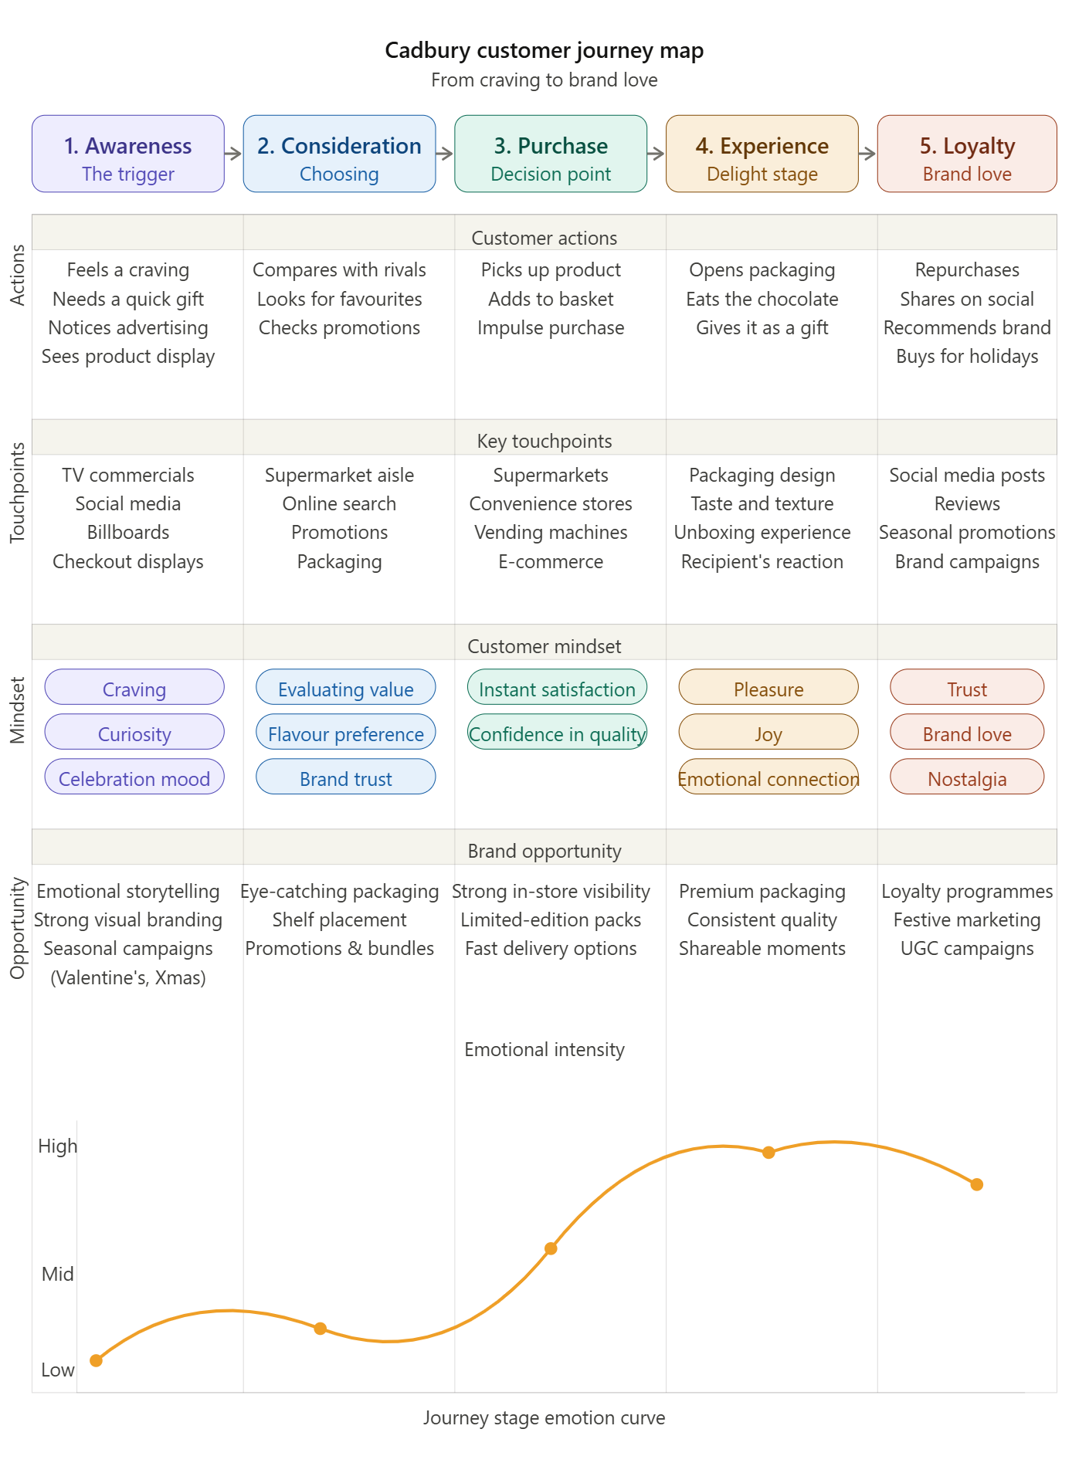
Fig 1. IE University Publishing (2021) Sneed, C. et al. (2025)

Part 2

Proposed
This campaign aims to bring back nostalgia and recreate the fond memories associated with the brand. In today's fast-paced digital age, it's easy to forget about the simple pleasures of the past. Cadbury's has launched an exciting new digital campaign that takes us on a journey through its rich history and its iconic chocolate bars. With this campaign, people of all ages can reminisce about their fondest memories of Cadbury's chocolate bars, some of which may have long been forgotten. This campaign also aims to evoke memories of working for Cadbury, featuring stories and anecdotes from past employees. As a result, some of the old Cadbury bars are in dedicated decade tins, giving people the chance to relive their childhood memories and remember why they fell in love with Cadburys in the first place. This campaign not only celebrates the heritage and legacy of Cadburys but also creates a sense of connection and shared experiences among families, making it a perfect opportunity for people to come together and bond over their love for chocolate.
Just the thought of those sweet treats can transport us back in time and bring a smile to our faces. With this in mind, I believe that offering decade boxes on our website, featuring the top-selling bars from each era, would be a popular and profitable idea. We can also personalise tins for this using our technological centre to make it a one-of-a-kind gift. This would not only allow people to relive their childhood through taste, but also give them a personalised touch by letting them choose the specific bars they want in their box. These boxes could be marketed for special occasions. As the recipes for these bars are already in our arsenal, minimal research would be needed to bring this project to life. I am confident this idea would be a valuable addition to our product line. Cottrell, S. (2023)

Cadbury has been a top-selling confectionery brand for over a century
- Cadbury Dairy Milk (launched in 1905) is its #1 bestseller, selling 350 million bars annually
- In the 1900s-1920s, Dairy Milk quickly became a market favourite and flagship product
- Milk Tray (1915) launched in the 1930s-1950s and grew in popularity while Dairy Milk remained dominant
- In the 1960s, Buttons were introduced and appealed heavily to families
- Cadbury Creme Eggs: Launched in 1963, becoming a staple confectionery item.
- Cadbury Eclairs: Introduced in 1965.
- Cadbury Mini Eggs: Introduced in 1967.
- Bar Six: A six-piece chocolate-covered wafer bar launched in the 1960s as a competitor to Rowntree's KitKat.
- Contrast: A mixed box of milk and plain chocolates was popular during this era.
- Caramilk: A specialised bar sold during this period.
- Bournville: Remained a staple, leading seller in the plain chocolate market
- The 1970s-1980s saw the rise of Curly Wurly (1970) and Wispa (1981) as cult favourites
- Golden Cup: A popular 1960s-70s favourite that was eventually discontinued in the 1980s following the rise of competition like Cadbury's Caramel.
- Star Bar (1976): Launched with a "peanut power" theme in 1976, this bar featured milk chocolate, peanuts, and caramel.
- Old Jamaica (1970): Launched in 1970, this rum-flavoured chocolate bar became a staple "classic" that has seen numerous re-releases due to popularity. Wispa (1981): Launched in the UK, it became a massive seller during the decade.
- Twirl (1986): Following its Irish launch, it was released in the UK in 1986.
- Spira: Introduced in the late 1980s in the North East, it rapidly became a firm favourite.
- Drifter (1980): Another key launch in the early 80s.
- Milk Tray Egg (1985): A consistent best-seller for Easter.
- The 1990s were known as the "Top Deck" era, with the launch of Top Deck in 1993
- In the early 2000s, Dream Bar (2001) was launched, but some products were short-lived
- Wispa was re-released in 2007 to high demand after being discontinued
- Twirl has become a best-selling bar in the modern era and sometimes challenges Dairy Milk's popularity
Cadbury (2026), bbc.co.uk (2026) www.lovefood.com (2026)
By tapping into all these bars of the past, we have the opportunity to create a money-making future. With access to bars from past decades, you can customise your tin or box with a selection of bars that hold special significance to the recipient. Whether it's a bar from the 60s, 70s, or any other decade, this gift will not only be a nostalgic trip down memory lane but also a potential investment in the future. So why settle for a generic gift when you can choose from a variety of bars and create a one-of-a-kind present that will leave a lasting impression on your loved ones, a perfect tin or box filled with bars from past decades? bbc.co.uk (2026)
A box of Cadbury bars representing different decades would be a highly successful product, capitalising on the nostalgia, premium gifting, and social media appeal. With a majority of UK consumers drawn to sweets that evoke childhood memories, this box of classic Cadbury bars would surely resonate with many. This type of marketing is particularly effective in the confectionery industry, where indulgent treats are often associated with fond recollections and comforting experiences. The potential for social media exposure is also significant, as people enjoy sharing nostalgic content and reliving happy moments with friends and followers. By tapping into these strong emotions and desires, a Cadbury "bars through the decades" box has the potential to drive sales and strengthen the brand's connection with consumers.

Expected impact on sales:

Significant Boost in Sales and Brand Loyalty
- High Demand for Nostalgia: In the UK, confectionery consumers prefer brands they grew up with, making retro-themed boxes could be in high demand.
- Spending: Nostalgia marketing can increase brand preference and loyalty, often prompting consumers to buy one product over another. Research suggests consumers are willing to pay 10–15% more for products that rekindle positive memories.

Boosted Premium Gifting and Sharing
- Gifting: A "decades" box aligns with the growing demand for experiential, premium-looking gifts in the confectionery sector.
- Occasions: A product that would likely boost sales during the festive season or as special-occasion gifts, as Cadbury already sees strong performance in giftable, premium formats.

Increased Social Media Engagement
- Viral: Retro products bring social media engagement, as consumers share photos and memories. Cadbury could use this to drive organic viral marketing to boost engagement.
- Digital Nostalgia: "Digital Nostalgia Marketing," using throwback stories to engage users on platforms like TikTok and Instagram.

Potential Risks and Considerations
- Product Consistency: The success depends on the authenticity of the "retro" experience. If the taste or packaging is not perceived as authentic, it may upset customers.
- Shrinkage: If the box is sold at a high premium price but contains smaller versions of the classic bars, it may result in negative customer feedback.
A through-the-decades box has the potential to be a highly effective nostalgia marketing tool. With its selection of popular bars from different eras, this box will evoke feelings of nostalgia. This emotional connection to the past can be a powerful motivator, leading to short-term spikes in sales and increasing long-term brand loyalty. These products align with comfort and familiar products during economic uncertainty. By creating a product that bridges generations, Cadbury can successfully target a wide range of consumers and establish a strong brand presence across multiple age groups. A "Cadbury Bars Through the Decades" has the potential to be a highly successful and impactful marketing tool for the brand, Lopes, T. Da S. (2016)

Impact on Sales:
- High Volume "Drop" Sales: a product that would create immediate sales through social media buzz and collector appeal.
- Increased Gift ability: A decade box increases the product's value as a gift,
- Boosted Premium Pricing: would allow the brand to charge a premium, with consumers often willing to pay more for products that rekindle positive memories.
- Cross-Generational Appeal: It appeals to all ages, but more so to older people who remember them from their youth.

Porter’s Five Forces Analysis of the Initiative:
- Threat of New Entrants (Low to Moderate): Although it may be challenging to break into the confectionery industry because of strong brand loyalty, the introduction of a "decades" box serves to solidify Cadbury's 200-year legacy and make it even more difficult for new competitors to imitate this rich history.
- Bargaining Power of Suppliers (Moderate): The use of essential components, such as cocoa, can contribute to fluctuations in pricing. A box set with a higher value is likely to have larger profit margins, TV Choice Productions, production company (2010)
- Bargaining Power of Buyers (High): Cadbury has significant influence in the retail market, but their exceptional and desirable nostalgic product gives it an advantage in negotiating for prime shelf placement.
- Threat of Substitute Products (Moderate): Due to the increasing popularity of health-conscious lifestyles, a box with a nostalgic feel is seen as a special indulgence rather than a regular snack, setting it apart from more nutritious and contemporary options.
- Competitive Rivalry (High): This move directly battles major rivals like Nestle and Mars by emphasising unique brand history, forcing competitors to respond with their own nostalgia campaigns. Kock, C.J. and IE Universidad, publisher (2021) Lynch, R.L. (2021)

Updated customer journey map
To put it simply, the "Through the Decades" collection from Cadbury's "Made to Share" approach prioritises creating emotional connections to boost profitable sales.
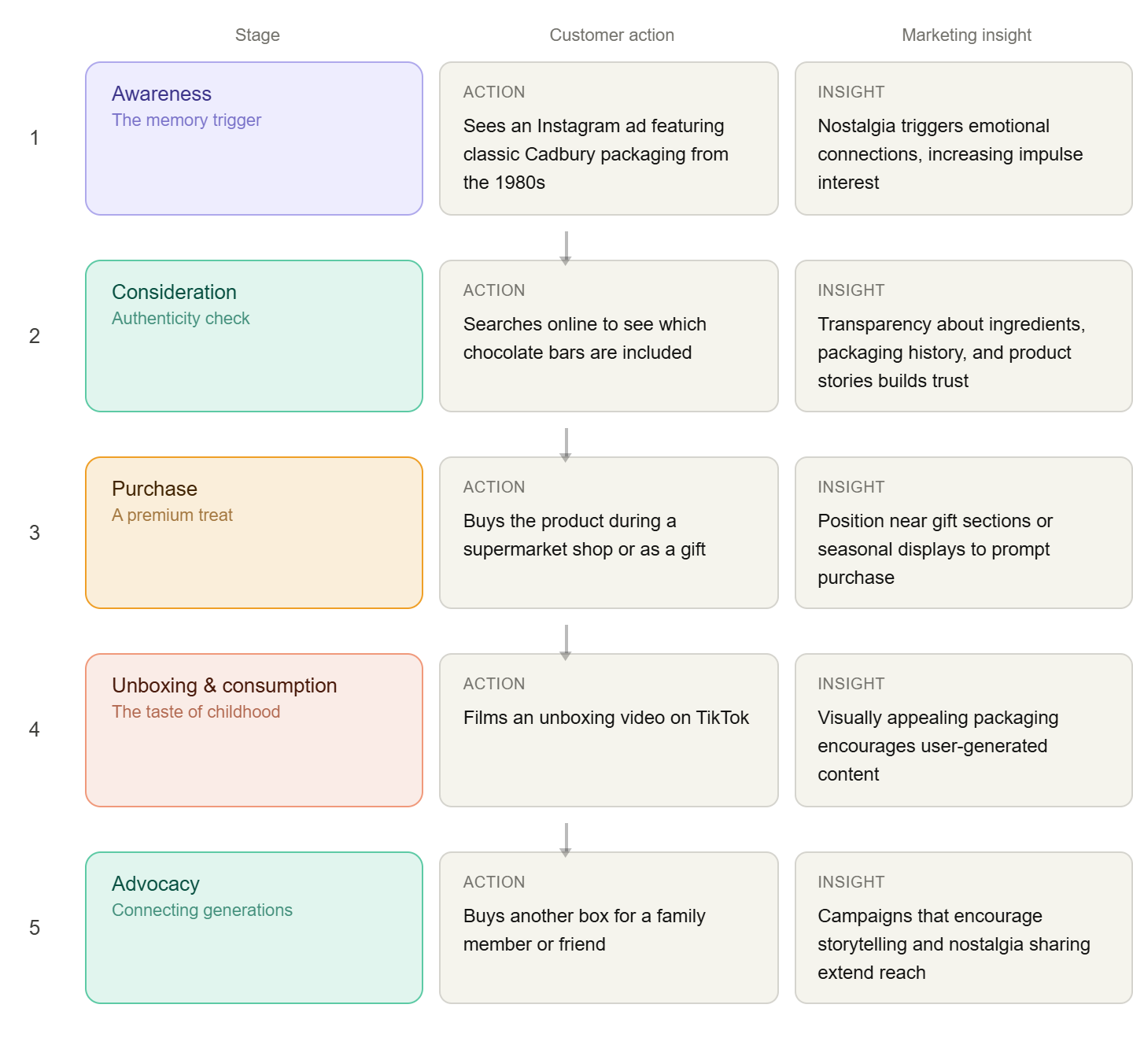
fig 2. IE University Publishing (2021) Sneed, C. et al. (2025)

Conclusion
All indications suggest that the campaign highlighting the company and its iconic bars from different decades has great potential to generate buzz on social media and ultimately boost sales. By showcasing the evolution of the company and its products over time, this campaign creates a sense of connection and familiarity. This can lead to increased engagement and conversation on social media, as people share their own memories and experiences with the brand. Highlighting the unique characteristics of each bar from different decades can pique the interest of both loyal customers and new audiences, driving them to try out these limited-edition products. The combination of emotional appeal and the potential to create a powerful marketing buzz ultimately increases sales. Social media is a powerful tool for sharing information and generating interest. The campaign aims to reach a wide audience and create a lasting impact on the brand's image. This campaign has the potential to be highly successful in sparking conversation and driving sales for the company. Cottrell, S. (2023) www.lovefood.com (2026)

Reference list

https://www.bbc.co.uk/news/articles/ck79gygry3lo (Accessed: 5th March 2026).
Bryson, J.R. and Lowe, P.A. (2002) “Story-telling and history construction: rereading George Cadbury’s Bournville Model Village,” Journal of historical geography, 28(1), pp. 21–41. Available at: https://doi.org/10.1006/jhge.2001.0372.
https://www.cadbury.co.uk/about/history/our-story/(Accessed: 7th March 2026).
Cottrell, S. (2023) Critical thinking skills : effective analysis, argument and reflection. 4th edition. London: Bloomsbury Academic.
Hammond, A., Mustafa, M.H. and TV Choice Productions, production company (2005) Inside a factory. 2, Cadbury’s. London, England: TV Choice
IE University Publishing publisher (2021) BCG Matrix. Place of publication not identified: IE University Publishing
IE University Publishing publisher (2021) Customer Journey Mapping. Place of publication not identified: IE University Publishing.
Kimberley, J. (2019) “Employee Relations and the Quaker Employers Conference of 1918: The Cadbury Company,” Quaker Studies, 24(2), pp. 229–248. Available at: https://doi.org/10.38
Kock, C.J. and IE Universidad, publisher (2021) Five forces. Place of publication not identified: IE University Publishing.
Lopes, T. Da S. (2016) “Building Brand Reputation through Third-Party Endorsement: Fair Trade in British Chocolate,” Business history review, 90(3), pp. 457–482. Available at: https://doi.org/10.101
https://www.lovefood.com/gallerylist/422746/the-worlds-best-cadbury-products-of-all-time-ranked(Accessed: 15th March 2026).
Lynch, R.L. (2021) . Strategic management. Ninth edition. London ; SAGE
Sneed, C. et al. (2025) “Customer Journey Mapping: A New Tool in the Extension Educator’s Toolbelt,” Journal of extension, 63(1), pp. 1–8. Available at: https://doi.org/10.3406
TV Choice Productions, production company (2010) Fair trade chocolate : the Divine story. London, England: TV Choice
Zampori, L. And Dotelli, G. (2014) “Design of a sustainable packaging in the food sector by applying LCA,” The international journal of life cycle assessment, 19(1), pp. 206–217. Available at: https://doi.org/10.1007/s11367-013-0618-9.

