Targed/Target 1 | Ceir tystiolaeth dy fod wedi ymgysylltu gydag ystod gyfyngedig o lenyddiaeth a gwelir gorddibynniaeth ar destunau.
Targed/Target 2 | Gwelir rhywfaint o werthuso a dadansoddi cysyniadau ac egwyddorion yn ymwneud ag asesu ar gyfer dysgu mewn modd beirniadol yn y Gwaith.
Targed/Target 3 | Brawfddarllen yn ofalus cyn ei gyflwyno er mwyn gallu adnabod a chywiro camgymeriadau ieithyddol niferus.

Design and conduct a small-scale research study, and critically evaluate the chosen research tools and the impact of finding on the learner and on your professional practice.

A systematic review on the power of feedback in assessment on learners’ progression.

A systematic research study, providing a conceptual analysis of the power of feedback in assessment, supporting students’ learning and progression within an educational setting. Black and Wiliam (1998) argues that feedback is one of the five key components of formative assessment, stating learners’ progression is evident from ‘the provision of effective feedback.’ The issue focused in this study will aim to comply with preceding studies influenced by the work of Wiliam and Black (1998). The importance of this study is to guide teaching practitioners in the development of knowledge in the system in contemplation of learners’ progression when formative assessment is applied in daily practice.

Subsequently, the study highlights the connection between teachers constructing feedback and how students deconstructs feedback given in order to obtain academic achievement, expanding desirable changes in classroom learning. To elaborate, the research evidence will propose a small-scale of the effectiveness of feedback on students among the ages of seven to eleven, at Key Stage 2 attending mainstream education. The Welsh Government (2020) reports set how pupils should be formally assessed by their teacher, stating ‘assessment should focus on identifying each individual learner’s strengths and achievements’, as well as, ‘areas of any barriers to learning’ (Welsh Government, 2020). In this essay, feedback interventions are researched by collecting data using three key research tools; summative interviews, standardized questionnaires and naturalistic observations. By conducting professional and pedagogic research strategies in current practice it will attempt to identify the analysis that supports the use of feedback, that debatably makes a significant and positive difference to both pupil and professional learning outcomes (Black et al. 2003). Additionally, the analysis and evaluation of the data from the research will gain an insight into aspects of teaching and learning, providing professional practice perspectives in complying to ethical principles over research.

Formative assessment can be used by the teacher to qualitatively evaluate pupils understanding and learning needs. Enabling students to process and evidently engross feedback to support their learning, allowing attainment and progress to be assessed more frequently (National Foundation for Educational Research, 2018). In the same way, the impact of integrated self- and peer-assessments can be summarised as an opportunity for pupils to be given feedback on their work (Clarke,2008). Purpose of a formative assessment task is to provide feedback to both the teacher and learner the learner’s progress towards achieving the learning objectives. This feedback may be used by the teacher to revise and develop further instruction. Prior research exemplifies that ‘clarifying learning objectives and establishing pupil-generated (and therefore pupil-owned) success criteria’ can be an effective task to encourage awareness and engagement in learners’ individual progression (Clarke,2008). Learning objectives and a success-criteria are evidently planned as part of a formative assessment which alternatively encourages learners to be active in their own learning. Clarke (2008) states that ‘active learners need to be engaged and reflective’, therefore, teachers must encourage awareness of expectations and identification of high potential learning outcomes. On the contrary, in an article from The Guardian (2018) contradicts Black and Wiliams theory by stating ‘Teachers should ditch reflections sheets and give instructions for actions that more directly reflect a specific situation’ suggesting that formative assessment strategies refrain enhancement in learners’ progression, instead, adds ‘workload for teachers’.

The primary purpose of conducting this systematic review is to assess the significant impact of the power of feedback and to provide a deeper understanding of personal teaching practice. The second aim of this research is to improve certain aspects of pupils’ learning outcomes and progression through practice on the basis of research evidence. In order to conduct this study, three research tools were selected in order to obtain information and in-sight of current formative assessments enforced in an educational setting. According to Scott and Usher (1996) data in the context of educational research adopts the values of discovering essential ‘research enterprise if we conceive of the purpose of this being the development of understandings about social relations and activities’ to accommodate further practice. Griffiths (2009) agrees with Scott and Usher, stating that measurable practices are used ‘to understand rather than to transform practice’ findings will be analysed and linked with current practice instead of modifying practice to reflect on the research data collected.
The research was operated at a small-scale, research was carried out using three different research tools. The author conducted methodical interviews, detailed questionnaires and reliable observations, that are standardized to minimize the control of being a biased research report. To illustrate, participants were selected to provide applicable information to obtain substantial evidence which will evidently have their responses taken into active consideration whilst evaluating the completion of this research. Teachers were selected to participate in the interview as part of researching professional experiences, supporting learners’ progression and if they apply formative assessments into their practice. Participants were questioned on relevant topics relating to the main objectives and aims to provide measurable as well as clear responses to develop further understanding. It is considered in qualitative research that interviewing methods are used to understand the experience of others (Seidman,1998).

Customarily, the author chose to extend their knowledge by distributing questionnaires, to both teachers and learners to gain more respondents and a variation of experiences. Learners were chosen at random, from the ages of seven to eleven to participate in the anonymous questionnaire. Participants were chosen by a primary school year category, identifying the target audience to share their own learning provisions based on the principle of feedback. It is noticeable that learners could potentially have a more diverse judgments, comparing with teacher’s views, therefore, it is comprehensive to extend its approaches of participants for this research. According to O’Leary (2004) credibility must be adhered when alternating a research study stating, ‘credibility can come from that which is… realistic’, this supports the authors chosen participants, as rationalized to be involved in the feedback process. This advocates the possibility for the participants to be active in planning relevant and current feedback frameworks in their educational setting, allowing a credible response. Questionnaires were analysed through variation of questions to conduct an overall response.

Lastly, concluding the authors methods used in the research, observations were carried out in an educational setting over one day period in Key Stage 2, Year 5 class with twenty-seven pupils present. The author was able to trial the observation tool to observe how feedback proposes specifically on tasks relating to learning, as well as, how particular formative assessment strategies are implemented within everyday lessons. The noticeable strategies appear to be considerably active in the teachers’ daily planning of lessons, structure of teaching and overall students’ progression assessment strategies. As shown in (Appendix C: Figure 2) the evidence presents three valuable formative assessment strategies; learning objectives, peer-assessment and traffic lights entirely on one reflective sheet after a day-to-day activity. In this instance, the piece of work shown is distributed at the end of the lesson to enable all students to assess their peers’ work. Clare (2008) implies that when pupils are exposed to learning objectives or success criteria it creates a sense of requirement of the level of pupils’ work and are capable to ‘define quality for themselves’.

On completion to the research tools used in an educational environment, ethnic practice must consistently be adhered to. (Appendix A) shows the application form required for ethical approval, in order for research activity to be studied it must be conducted ethically. The approach is necessary to provide information or obtain informed consent. As the research was conducted in an educational setting, the author gained consent from the Headteacher of the primary, shown in (Appendix B: Figure 1). The British Educational Research Association (2018) believes that ‘educational researcher should operate within an ethic of respect for any persons- including themselves’. The author aimed for participants to give voluntary informed consent to part take in any of the research implications. Equally, participants will be informed continuously of their consent and participation within the research (BERA, 2018). The sensitive information given for research purposes only, will be kept confidential on a password memory stick in which names are kept in private.

Outcomes:

The author received sixteen responses from pupils when distributing questionnaires in a Welsh mainstream Primary School. The evaluation shows that pupils in Key Stage 2 were the respondents. All participants were fully aware of their participation in the research and the author gained consent by each pupil in implying information to their best knowledge. The United Conversion on the Rights of the Child (1989) states that ‘children between the ages of birth to eighteen to have their wishes known, listened to and respected’, therefore, the author followed the guidelines set out by UNICEF(Article 12) which states’ every child has the right to express their views, feelings and wish in all matters effecting them, and to have their views considered and taken seriously.’ This illustrates the importance of children’s voice and all potential participants have been consented by an adult on their behalf (UNICEF,1989).

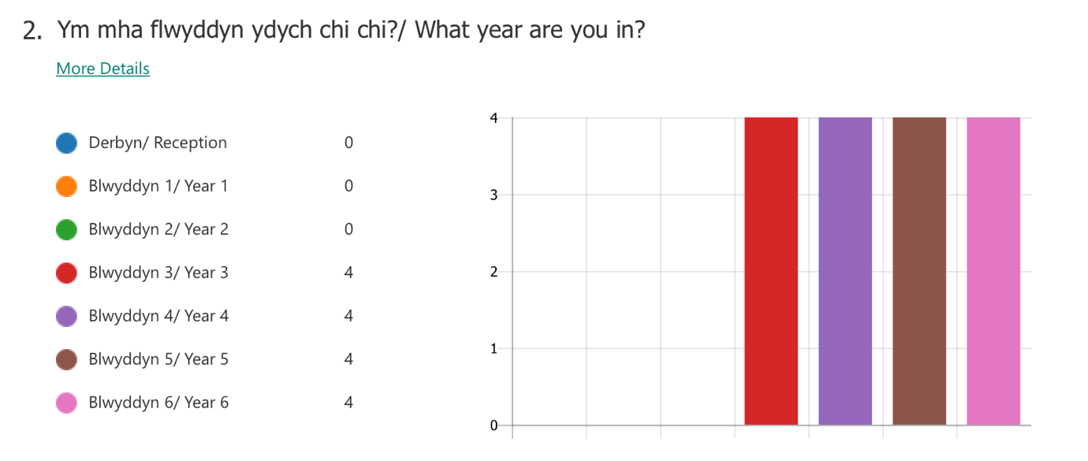
Table 1.5: Data analysing the pupils’ responses from question 1 of the pupils’ questionnaire.

The graph above represents the pupils that participated in each year group. The author asked, ’what year are you in?’ overall there were sixteen responses, four pupils from each year group in Key Stage 2 (Year 3 to Year 6) answered anonymously. The purpose of collecting a variety of different age group varies on the type of learning and teaching being implemented, therefore, responses should be diverse. This possibility may result in the author receiving a wide range of variation in responses and experiences.

Table 1.6: Data analysing the response from Question. 3 of the pupils’ questionnaire (Appendix D).

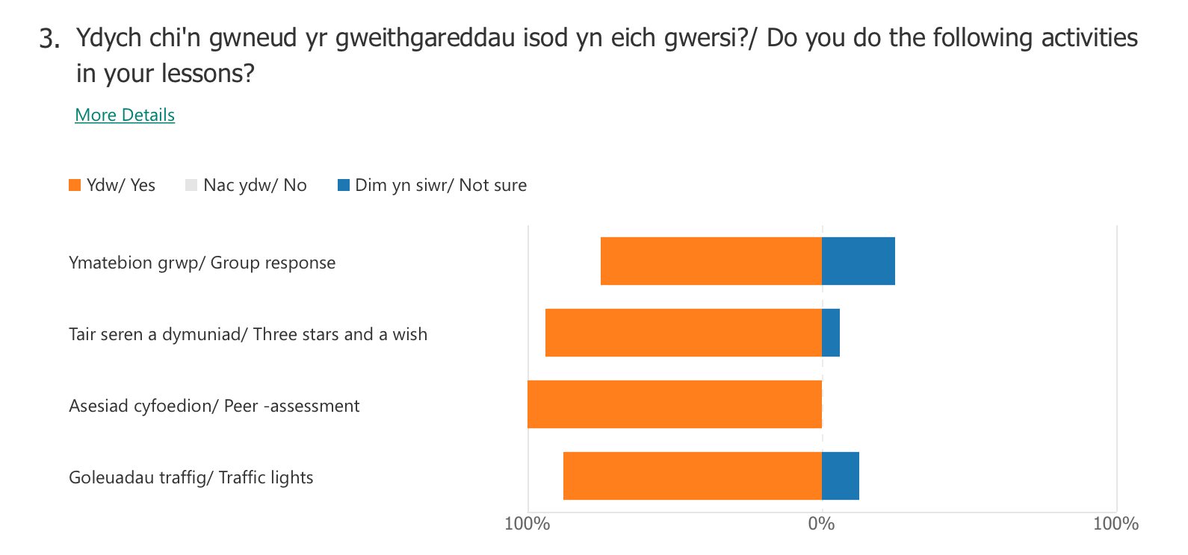

Purpose of the graph is to analysis the response given by pupils in answering Question 3 of the pupils’ questionnaire. The author asked, ‘Do you take part in the following activities in your lessons?’ as seen above, 75% pupils answered that ‘group responses’ take place in their learning, leaving 25% unsure. To clarify, the authors use of language presented in the questionnaire may have needed to be written to suit the appropriate target audience, overcoming any uncertainty of questions or answers provided. Secondly, 98.3% of participants recall three stars and a wish being present in their lessons, leaving 6.3% remain unsure of the activity. Thirdly, 100% of participants answered to peer- assessments being an activity in their lessons. Lastly, 87.5% of participants responded to traffic lights activities being an activity in their lesson, leaving 12.5% unsure. Overall, there is a high percentage of pupils are aware of formative assessment strategies in their lessons. However, when comparing the results with the teachers’ response it was pointed out that all of the activities stated in the answer are active in lessons. For future research, the author will need to be aware of appropriate terminology to suit pupils’ language to avoid any confusion or a lack of understanding or illustrate a picture of the activity for students to identify. Estyn (2015) reports states that pupils should be part of their own marking, stating that pupils should have an awareness of the ‘effectiveness of the marking’ and have a good understanding of the assessment policy, in order to engage in their own progression. In referring to the authors personal practice, regulating from research methodology and curriculum standards, pupils must be encouraged to be part of their learning in accordance to curriculum guidelines. By reviewing the responses from the pupils shown in (Appendix D: Table 1.7) 81% of pupils believe that feedback improves their learning and 62.5% of pupils responded to the feedback given in teacher assessment being extremely useful and 37.5% responded to feedback being useful towards their progression of learning.

Following the questionnaire responses (Appendix E) seems to show that the author received three anonymous responses from teachers that teach in Key Stage 2. Each participant responded with various responses in accordance to the questions given. As shown in Table. participants responded to the question, ‘Are Assessment for Learning strategies present in your teaching?’ 100% of teachers confirming that Assessment for Learning (formally known as, Formative Assessment) strategies are present in their teaching. Emphasising on Black and Wiliam (1998) belief that Assessment for Learning should be embedded within their teaching, stating ‘The ultimate user of assessment information that is elicited in order to improve learning is the pupil’ to which the teachers hold responsibility to give opportunities for pupils to extend their engagement with their own learning progression (Black and Wiliam, 1998, pp.6). On further research, when questioned, ‘Explain why Assessment for Learning strategies are used in your teaching?’ participants responded with various explanations clarifying the use of formative assessment strategies, however all correlates to the same value of promoting opportunity for pupils to be active within their own learning process by acquiring feedback:
- Relevant to all pupils marking their own work.
- To assess comprehension so that learners understand how to improve. It also provides feedback and peer-assessment.
- To promote pupils to take responsibilities for their personal development by knowing what the target is and how to reach that target’

Table 2.5: Data analysing the response from Question.7 of the teachers’ questionnaires.
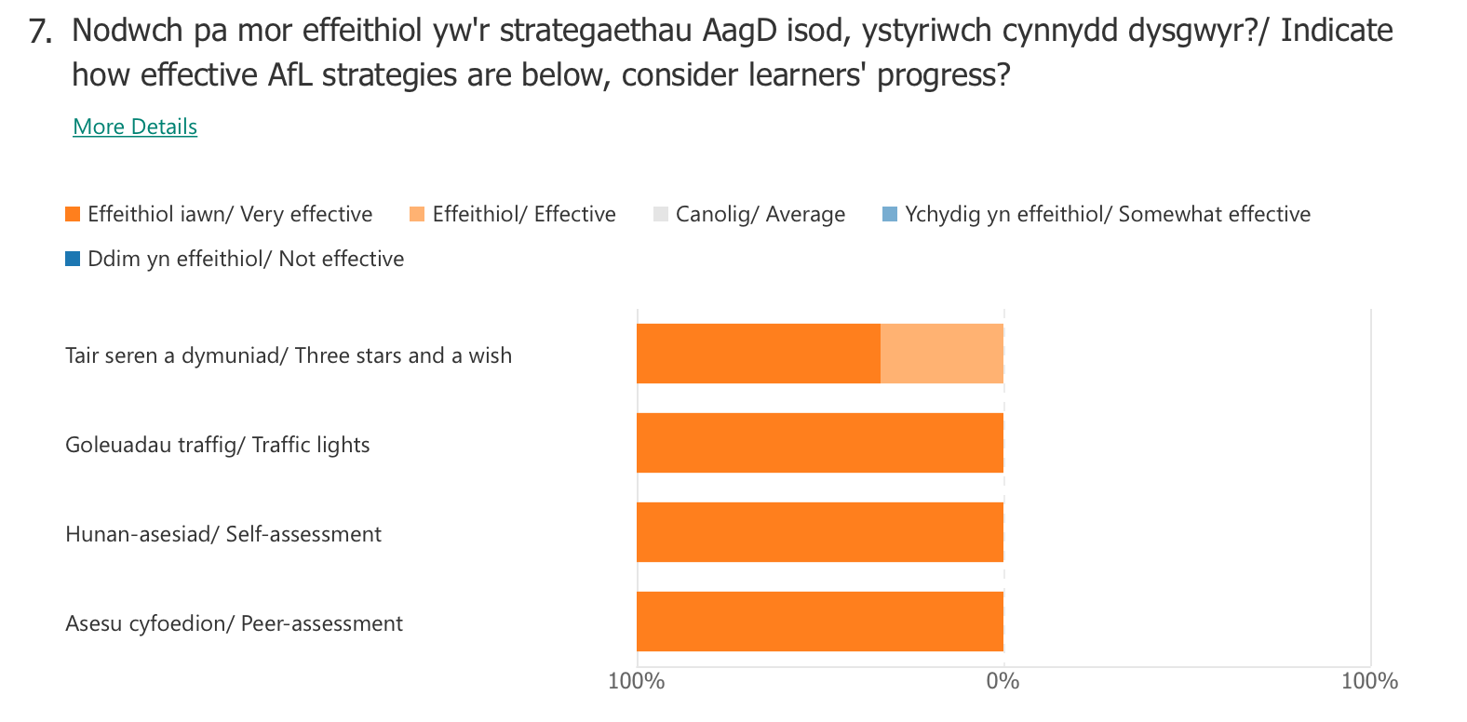

The findings shown in the graph above analyses the responses given when instructed the participants to indicate how effective Assessment for Learning strategies are when considering learners’ progress. The results provide a 100% ‘Very effective’ rate when implementing Assessment for Learning strategies into the lesson provisions; Traffic lights, self-assessment and peer-assessment. However, participants answered with a 66.7% rating of ‘very effective’ when considering the impact on learners’ progression, with 33.3% rating of effective remaining. This exemplifies that overall participants believe that by engaging pupils within their own learning using formative assessments there is a superior response in their progress.

To conclude to research tools used in the research, Interviews can be defined as a qualitative research technique which involves “conducting intensive individual interviews with a small number of respondents to explore their perspectives on a particular idea, program or situation.” (O’Leary, 2004). The author conducted a semi-structured interview to evaluate key topics in this research with a primary school teacher, that is at present teaching in Key Stage 2. The results shown in (Appendix F) identifies the response from the participant that initiates their views and implementations on feedback within their professional practice. Evidently, when asked in Question 3. ‘Do you think implementing Assessment for Learning strategies actively engage students in their own learning?’ the respondent answered strongly to the matter, ‘Yes definitely, it improves engagement and motivates learners to engage in their learning’ supporting Black and Wiliam (1998) theory. According to Black and Wiliam (1998) ‘students can achieve a learning goal only if they understand that goal and can assess what they need to do to reach it’, therefore, teachers hold a responsibility to imply this into their professional practice. This can have a significant impact on the learners’ recognition of their progression, it will encourage them to work towards their personal targets (Black et al. 2003).

The extensive results carried out by qualitive and quantitative research demonstrates the significant impact of Assessment for Learning strategies in practice, essentially on students’ progression. Contrary to the findings, in order for the research to be evaluate accurately, the author would need to produce the research at a larger-scale in order to see the impact of feedback on students’ progression in the educational system, exploring over an extensive period may influence on the research outcomes. Based on this small-scale research, evidently, feedback is an active part of the effective teacher-students feedback practice, developed as part of a daily routine in lessons. Feedback at the process level appears to be more effective than at a task level for enhancing deeper understanding. Hattie (2009) claimed that ‘using process feedback with goal setting appears to be a direct and powerful way of shaping an individual’s task strategy’ providing very specific information about the expectations needed to complete tasks successfully. The author collected data evidence showing that students react positively to assessment tasks provided by reflecting to their own progress and were able to identify to different feedback strategies performed in their lessons. This research and data collected supports the work of Black and William (1998) that demonstrates a key implementation of formative assessments being used as a form of effective feedback and assessment strategies made in a complex learning environment. Furthermore, the research emphasised the strategical inputs on professional practice, gaining in-depth dispositions of being a skilled researcher. Ethical principles are practiced and presented, following on ethical considerations and expressions of morals. The author was able to uphold essential attitudes when gaining insight of classroom practice in a current educational setting.

Reference:
Black, P. and Wiliam, B. (1998) Inside the Black Box: Raising Standards through Classroom Assessment. London: NferNelson
Black. P., Harrison. C., Lee, C., Marshal. B., and Wiliam. D. (2003) Assessment for Learning: Putting it into practice. Open University Press: Maindenhead.
Clarke, S. (2008) Active Learning through Formative Assessment. London: Hodder Education.
Cohen, L., Manion, L., and Morriston, K. (2007) Research Methods in Education. London: Routledge.
Hattie, J. (2009) Visible learning: A synthesis of over 800 meta-analyses relating to achievement. London: Routledge.
Hattie, J., and Timperley, H. (2007) The Power of Feedback. Review of Educational Research. Vol. 77(1), pp. 81-122.
O’Leary, Z. (2004) The Essential Guide to Doing Research. London: Sage Publications Ltd.
Seidman, I. (1998) Interviewing as qualitative research: A guide for research in education and the social sciences. New York: Teachers College Press.

Website Reference:
Blackburn, C. (2015) Researching with young and developmentally young children: Ethical considerations, dilemmas and compromises. Available at: https://www.bera.ac.uk/researching-with-young-and-developmentally-young-children-ethical-considerations-dilemmas-and-compromises (Accessed on: 3rd of March 2020).
British Educational Research Association [BERA] (2018) Ethical Guidelines for Educational Research, fourth edition, London. Available at: https://www.bera.ac.uk/researchers-resources/publications/ethical-guidelines-for-educational-research-2018 (Accessed on: 20th March 2020).
Estyn (2015) Improving marking and assessment through pupil participation. Available at: https://www.estyn.gov.wales/effective-practice/improving-marking-and-assessment-through-pupil-participation (Accessed on: 27th of March 2020).
National Foundation for Educational Research. An introduction to formative and summative assessment. Available at: https://www.nfer.ac.uk/for-schools/free-resources-advice/assessment-hub/introduction-to-assessment/an-introduction-to-formative-and-summative-assessment/ (Accessed on: 20th March 2020).
The Guardian (2018) Assessment too often fails to prioritise learning-let’s change that’ Available at: https://www.theguardian.com/teacher-network/2018/jan/23/assessment-too-often-fails-to-prioritise-learning-lets-change-that (Accessed on 27th March 2020).
The Welsh Government (2020) Supporting learner progression: assessment guidance. Available at: hhttps://hwb.gov.wales/curriculum-for-wales/supporting-learner-progression-assessment-guidance#the-purpose-of-assessment (Accessed on: 20th of March, 2020).
Griffiths, M. (2009) Critical approaches in qualitative educational research: The relation of some theoretical and methodological approaches to these ‘issues’ Available at: https://www.research.ed.ac.uk/portal/files/15324325/Critical_Approaches_in_Qualitative_ (Accessed on: 24th of March 2020).
Unicef United Kingdom (N.D) How we protect children’s rights with the UN Conventions on The Rights of the Child. Available at: https://www.unicef.org.uk/what-we-do/un-convention-child-rights/ (Accessed on: 24th March 2020).

