  Component One:  What are the key skills required when working in the housekeeping team? 750 words (+/- 10%)  Contribution to Overall Module Assessment: 25% | Student No: | 2127520
 | Module Title: | Operating hotel facility
 | Module Code: | BMIH4006
 | Lecturer: | Laurance Blake
Housekeeping is an essential element of any hotel or other lodging establishment. A trained housekeeper is crucial to the upkeep of a hotel's cleanliness and general look. All hotels depend on their housekeeping staff. Maintaining a clean environment is a must for every organization in the hospitality industry. Hotel rooms provide the bulk of income, therefore keeping them clean is a priority. Thus it can be assumed that the topic is important to the hospitality industry. The success of a hotel depends on its ability to keep guests coming back. This may be accomplished by maintaining a clean and aesthetically pleasing environment (Purwanti, 2019). Having a consistent theme across the rooms may improve the experience and encourage repeat visits from guests. A consistent theme can be created with the assistance of housekeeping services which inducted the importance of the topic in the hospitality industry. Guests may also be made to feel welcome by placing a vase of flowers on a table or desk in the room. It is crucial to make visitors feel appreciated and to go above and beyond their expectations.
Housekeepers in the hospitality sector often have to deal with a wide range of visitors regularly, so it's important for them to know how to connect with them professionally and courteously. While working as a housekeeper I should also be able to properly communicate with the rest of the team so that everyone is aware when someone is finished with their task or when they need assistance (Andrade et al., 2021). The ability to collaborate well with other professions and rapport-building
skills with customers are both assets for housekeepers. Housekeepers may be expected to exhibit soft skills including reliability, teamwork, and responsibility.
In my opinion, one can apply theoretical knowledge of housekeeping while working in the hospitality industry. Theoretical knowledge of housekeeping comprises communication and the ways of handling guests and clients in the hotel enterprise. During practical scenarios, I can use theoretical knowledge of communication for communicating with guests. Theoretical knowledge of cleaning and providing assistance to clients can be applied in the practical field (Bhatnagar and Dheeraj, 2019). With theoretical knowledge individuals in the hotel industry are able to apply ideas more effectively as they already have gained basic skills and ideas through theoretical studies.
I will be able to learn the fundamentals and beyond with the theoretical knowledge of housekeeping management.
This housekeeping will allow me to learn about the various cleaning supplies and equipment available, as well as how to properly utilize them. Theoretical knowledge of housekeeping allows individuals to learn everything from sorting clothes to doing each step of the laundry process (washing, drying, and ironing). I have assumed that individuals gain competence in key areas like time management and organization that makes them an asset to any job in the housekeeping industry. These are some of the ways through which theoretical knowledge can be applied in the hospitality industry.
In certain instances, I will be facing issues where a customer may not be satisfied with the services provided by housekeeping. In such a scenario I need to use my communication and interpersonal attitude and behavior to tackle the client and provide them with a service that may result in repetition of the client in the future. While working in the hospitality industry I need to focus on handling multiple tasks as this will allow me to execute each task within the deadline leading to satisfaction of the customers and my employers (Tiwari et al., 2022). Attention to detail is one of the skills that are taught as a part of theoretical knowledge. In certain scenarios, I will be needed to focus on details that will result in positive results for the clients. Hence, paying attention to details is one of the theoretical knowledge that I will be able to apply while working in the industry. For example, in my working in the hotel industry, I can use my customer service skills in serving customers effectively
I have learned a lot of skills and techniques of customer service in the hotel industry in the context of housekeeping. By gathering knowledge and ideas I will be able to use the technique while working in a housekeeping team (Andrade et al., 2021). The learning of the topic has also helped in learning various skills and expertise such as time management, interpersonal skills, and customer service skills. There are various tasks and activities included in housekeeping about which I have gained knowledge and ideas.

Word Count

Component Two:
Contribution to Overall Module Assessment: 25%
In this scenario – You have just been promoted to team leader for a floor within the hotel. A guest complains that on their arrival, their room had not been properly cleaned. Create an action plan and answer the following questions.

Problem | Why did it happen? | What are you going to do? | How will you prevent this from happening in the future? | What measures would you introduce to improve team effectiveness?
In a popular hotel, a particular poor situation occurs due to some probable incidents. Those are first maybe the previous guest was checkout their room, after the checkout time. As a result, the housekeeping staff does not take time to properly clean the room. Secondly, lack of employees in the housekeeping department, and as a result, the management manager does not allocate the job properly to an employee. On the other hand, due to conflict between employees, no staff may do not properly communicate with other employees, so the employees are not sure which rooms to clean and what time the next guest will arrive. | To become a team leader, it is necessary to manage all the problems regarding the hotel. A leadership strategy is a strategy that executives, managers, and so many other supervisors can use to handle, motivate, and inspire their groups. According to Andreu, et al (2020) improving focus on the growth of leadership skills enhances job readiness and marketability of employees. Leadership skills are a robust technique to manipulate and communicate with all employees. As opined by Cortellazzo, et al (2019) in the digital age, a leader's skills properly are enhanced by practicing virtual leadership techniques. Leadership skills that were previously recognised in the offline process should now be communicated to virtual leadership. My responsibilities is to mitigate all the problems faced by the new guest that properly manage without any hesitation or hampering anyone. A better way to learn to make more promising decisions as a leader is to study these strategies for consulting leadership techniques. | The hotel management enterprise has tremendous growth prospects in the upcoming future generations with the high demand for hotels in the UK. The need for skilled and smart specialists in this type of hotel industry is increasing rapidly, not only in the UK but also globally. There are critical need to retain and skill qualified professionals. There are several ways to control the problems | As a team leader, it is essential to evaluate all the problems and increase team effectiveness by adopting some useful strategies or techniques. In any customer-facing role, excellent customer service skills are essential. Dhyani and Dimri, (2019) have stated that through focusing on hospitality management, the manager can promote effective communication skills. There has been all the strategies analysis through the action plan. | - Communication skills are increased by communicating with all the employees and creating a positive environment for all the employees.  - Enhancing communication skills in the workplaces  - Participate in all events and try to actively listen to all the things.  Encourage all listeners
- Discuss all the technological advancements, used in future prospects.
- Adopting AI techniques in the hotel
- Practical work has been provided in this session
- Sometimes motivational speeches are also conducted by the company
- No interaction between the sender and receiver
- The work is also done without any open or paper
- It is a very hygienic process
- No chance to spread any contagious disease.

Component Three:
Contribution to Overall Module Assessment: 50%
Your task is to create and prepare a presentation following the detailed scenario provided below.

As the floor housekeeping manager and given the recent guest complaints you need to put together a basic training presentation for your colleagues within the housekeeping team to get the best out of them, ensure that brand standard is being achieved and that Health and Safety procedures are also being followed.

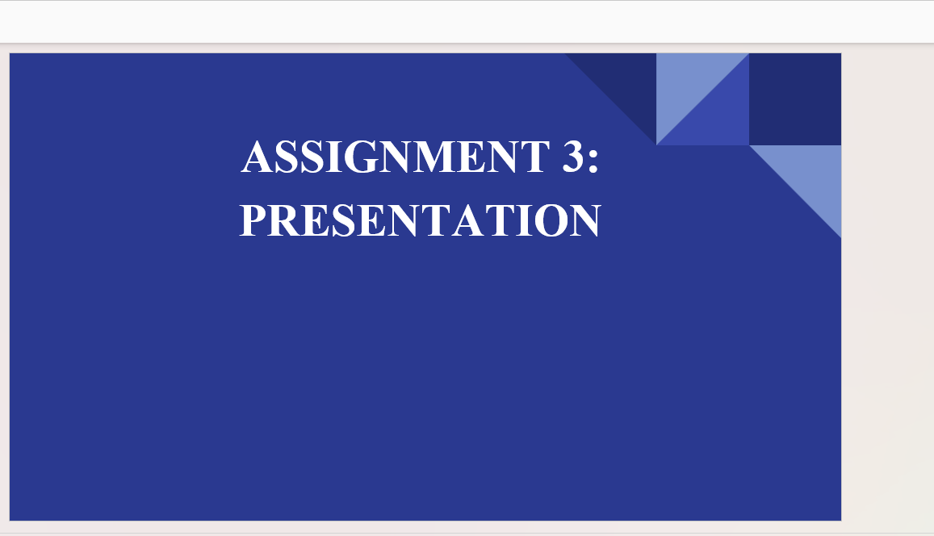
Training Notes: All the staff of the hotel needs to be very careful about the clean and hygienic premises, floor and restrooms. In a recent guests' review it can be found that guests are creating negative reviews towards the hotel related to the staff service. Therefore, it is advised to all the staff that the staff need to ensure that the rooms and the other surrounding rest of the hotel are properly cleaned and sanitized properly.
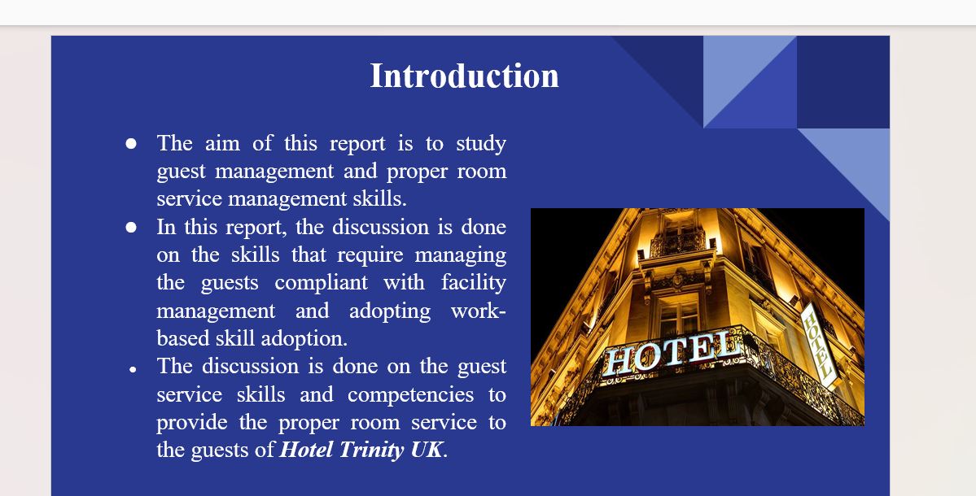
Training Notes: It is found that the guest booking numbers in the hotels are generally decreasing in the UK by 2022. It is most important for the staff to make the guests feel pleasant by presenting them with a smile and speaking very softly and politely to attract their attention toward the high standard of service of the hotel. The staff needs to have complete knowledge of the technology, industry standards, health and safety measures, appropriate attire and professionalism to welcome the guests. The staff that is in charge of the initial welcome or in the security department need to give a formal salute or addressed them in a proper manner with respect.
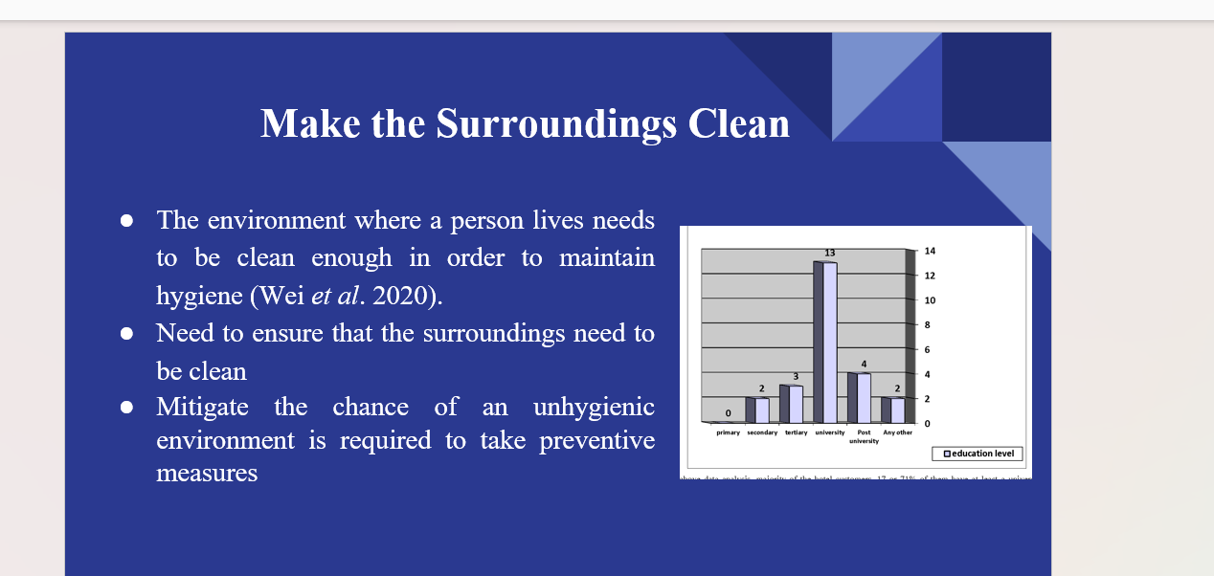The Maslow Model helps the staff to develop a sense of security and belonging in their work and gives a sense of security toward work. The staff need to follow the law in order to increase their self-esteem mad self-actualization which motivates them to work. The staff need to have knowledge of the company’s policies through the handbook given to all that helps them to increase the professional technique to attract the customer satisfactorily. The staff will be provided with rewards and recognition for their excellent professional performance. The staff is instructed to listen to the client's complaint carefully and sit above. The staff needs to combine technical skills and professional attitude and guest-serving experience to attract customers.
Training Notes:
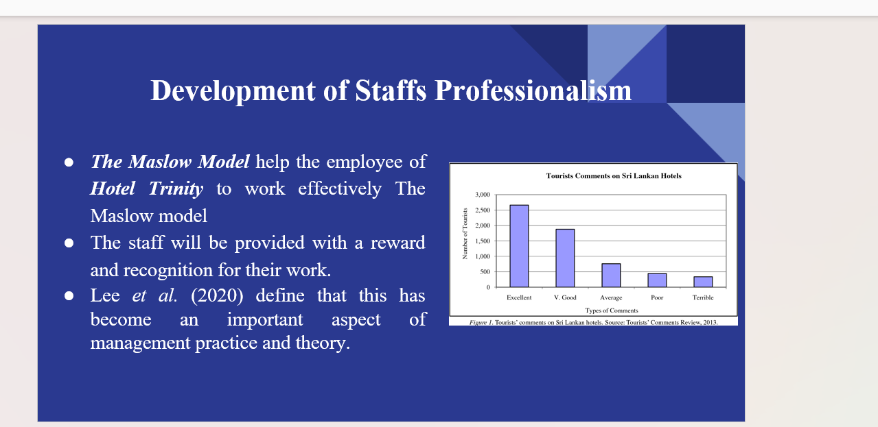The staff need to be very proficient and effective in their work and they need to work in a proper and coordinated manner in order to maintain Hotel Trinity's reputation to high standards. As per the hotel review, many guests have complained about the room service because they do not get the service on time. The hotel staff need to be communicative with the clients. The staff is being advised to have the potentially required information written with them. The reception department, housekeeping department, and maintenance department need to be available over the phone. The staff needs to be very active with the phones and they have to be very responsive and responsible towards the client service.
reputation and image among the customers.
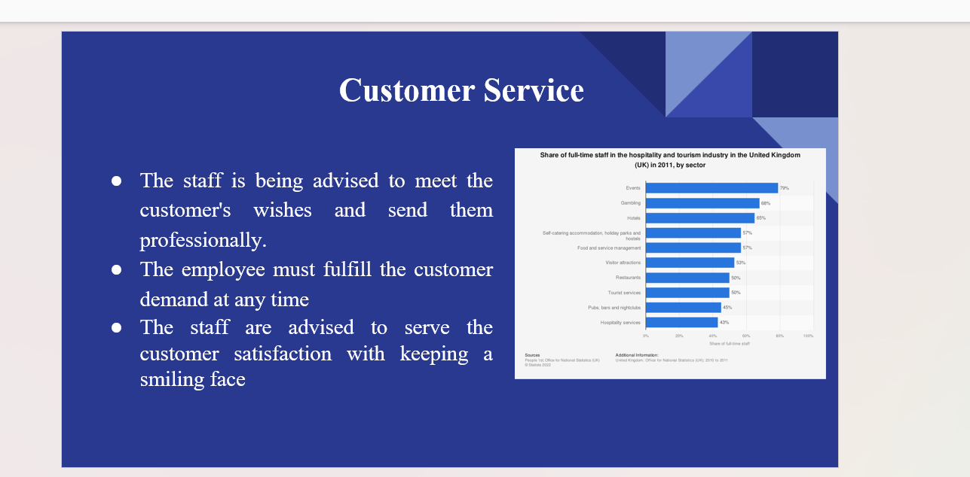Training Notes: The staff is being advised to have the guest service skills, like persuasive skills that help the staff to raise their sales skills and make them professionally confident enough so that they serve the customers and sell Hotel Trinity service so as to make them satisfied. In order to solve the query of the firm, the hotel staff need to become empathetic, which helps the staff to understand the clients or the guest 's emotions and points of view. It helps them to understand the query of the customer and find out the points of dissatisfaction and solve them. It is recommended it the staffs that they need to become very responsible le to manage the guest quietly by listening them properly. The kitchen department must know about the menu properly so that they can explain the dishes to the customers well and solve their queries related to the food. Moreover, the staff need to understand the client's query related to the housekeeping and health and hygiene issues and take the necessary and quick action to solve it. This will help the hotel to meet the organizational brand

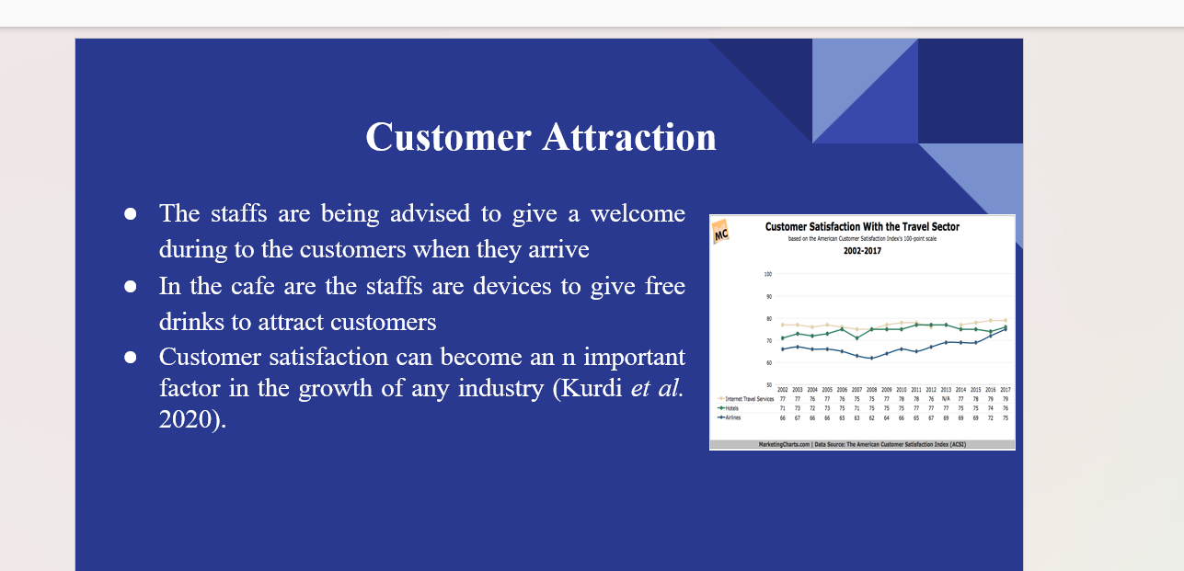Training Notes: The customers always need to be kept first in order to maintain the band image of Hotel Trinity. The staff is advised to serve the customer satisfaction by keeping a smiling face as it is shown as polite attire toward the customer. The staff must fulfill the customer demand at any time. The staff have to serve the customer with patience, be it any sort of work like being it of house cleaning service, food order service or any other.
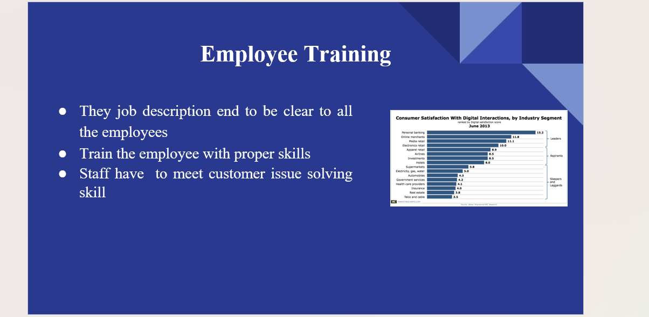The staff need to give the giveaway gifts to the customers on their departure and assist them with to their transport. The staff is advised to provide the amenities for the room and restrooms on time and, depending on the demand of the guest, they have to serve it as required. This will increase the image value if the Hotel Trinity among the customers. In the cafe the staff are devices to give free drinks to attract customers and provider chocolates to the kids and serve the food with a pleasant and appealing gesture in order or satisfy the customers.
Training Notes:
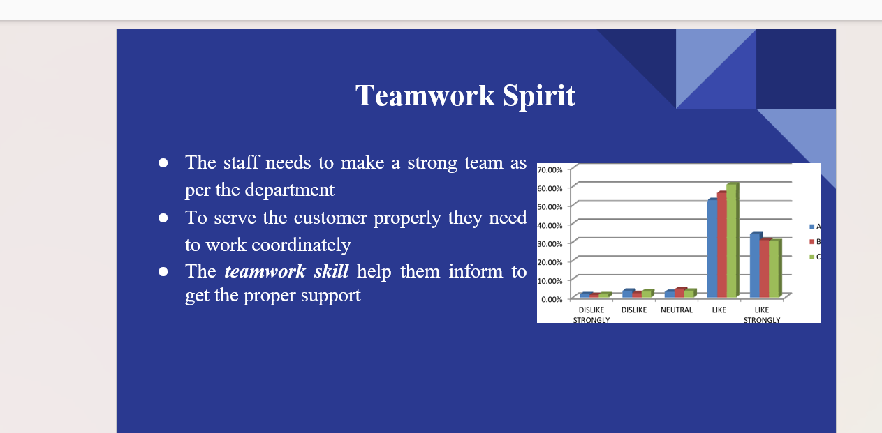The environment of the place where they live needs to be very clean and hygienic. The staffs need to maintain pleasing decor, clean and comfortable furniture, proper lighting and attractive service. Staff, need to meet customer issue solving skills.
Training Notes:
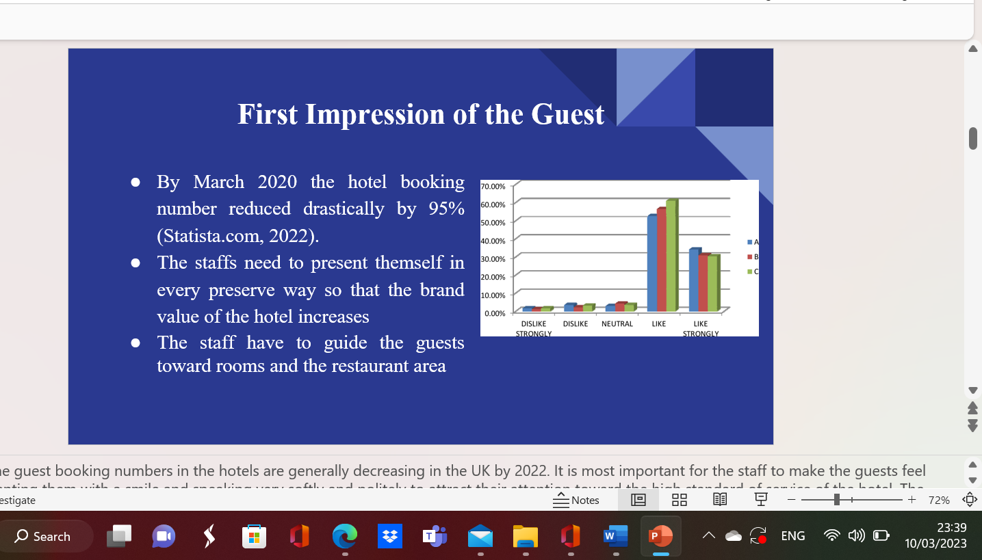The staff needs to make a strong team as per the department to serve the customer properly and help the service to become effective and fast. The teamwork skill helps them inform to get the proper support, replacement and benefits in the working ability gain among the staff. It will increase the staff coordination too.
Training Notes:
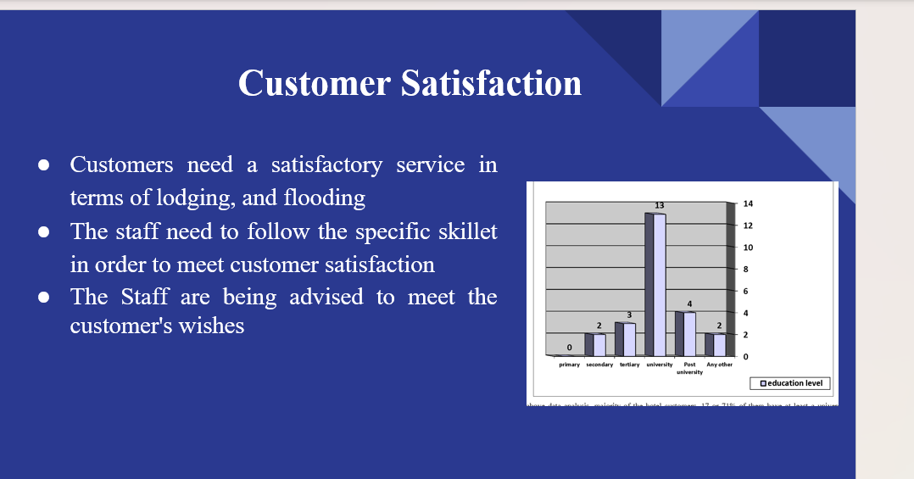
Customers need a satisfactory service in terms of lodging, and flooding according to their requirements. The staff needs to follow the specific skillet in order to meet customer satisfaction and trust. The staff is being advised to meet the customer's wishes and perform them professionally to meet the customer satisfaction.
Training Notes:

References

Andrade, M.S., Miller, D. and Westover, J.H., (2021). Job satisfaction factors for housekeepers in the hotel industry: a global comparative analysis. International Hospitality Review, 35(1), pp.90-108.
Bhatnagar, E. and Dheeraj, N., (2019). Impact of housekeeping services and practices on customer satisfaction and repeat business. Prabandhan: Indian Journal of Management, 12(8), pp.46-57.
Purwanti, A.R., (2019). Evaluation on an ESP course book: Get along with English for the hotel industry. JEES (Journal of English Educators Society), 4(2), pp.107-116.
Tiwari, A., Singh, M. and Dahiya, A., (2022), March. A study on the effect of Technological Innovation on Outsourcing in the Hotel Housekeeping Department. In 2022 International Mobile and Embedded Technology Conference (MECON) (pp. 37-40). IEEE.
Hulldailymail.co.uk, 2020.Trinity Hotel responds to 'fake news' of closure as panicking brides cancel weddings.Accessed from:https://www.hulldailymail.co.uk/news/hull-east-yorkshire-news/trinity-hotel-closure-cancel-weddings-4428843[Accesserd on: 4.3.2023]
Kurdi, B., Alshurideh, M. and Alnaser, A., 2020. The impact of employee satisfaction on customer satisfaction: Theoretical and empirical underpinning. Management Science Letters, 10(15), pp.3561-3570.http://dx.doi.org/10.5267/j.msl.2020.6.038
Lee, J.Y., Rocco, T.S. and Shuck, B., 2020. What is a resource: Toward a taxonomy of resources for employee engagement. Human Resource Development Review, 19(1), pp.5-38.https://doi.org/10.1177/1534484319853100
Lee, S.M. and Lee, D., 2020. “Untact”: a new customer service strategy in the digital age. Service Business, 14(1), pp.1-22. https://doi.org/10.1007/s11628-019-00408-2
Statista.com, 2022.Change in monthly number of hotel bookings in the UK 2020-2022.Accessed from:https://www.statista.com/statistics/1339613/change-in-monthly-number-of-hotel-bookings-in-the-uk/[Accesserd on: 4.3.2023]
Wei, L., Lin, J., Duan, X., Huang, W., Lu, X., Zhou, J. and Zong, Z., 2020. Asymptomatic COVID-19 patients can contaminate their surroundings: an environment sampling study. Msphere, 5(3), pp.e00442-20. https://doi.org/10.1128/mSphere.00442-20

