

The Influence of Perceived Price Value and Brand Sustainability Claims on UK Consumers' Purchase Intention Towards International Retail Brands
2026

MBA International Business
University of Wales Trinity Saint David
A thesis submitted by:
Cristian Stoleru
Under the guidance of:

Lecturer Dr Jia Miao

Declaration

This work has not in any previous form been accepted for any degree, nor is it being concurrently submitted in candidacy for any degree.
Except where identified as otherwise, I declare that the dissertation, the subject and title of which are: The Influence of Perceived Price Value and Brand Sustainability Claims on UK Consumers' Purchase Intention Towards International Retail Brands, is a work of my own independent research and investigation.
I confirm that I have expressed and referenced fully in the bibliography all the sources of information and literature used in formulating this study. I also verify that I have successfully gained ethical approval prior to data collection and that all research has adhered to University ethical guidelines.

Abstract
There is a significant paradox when talking about the current UK retail sector; that, on one hand, people are facing intense post-inflationary economic hurdles and, on the other, they have the highest ethical and sustainable expectations ever. Within the context of the economic climate, 2025-2026, this dissertation explores, through empirical research, the independent and relative effects of Perceived Price Value (PPV) and Brand Sustainability Claims (BSC) on Purchase Intention (PI) of the UK consumer towards international retail brands.
The research was guided by positivist philosophy in research and deductive approach, with the quantitative research method and cross-sectional approach. Primary data was gathered with a purposeful sample of 115 UK consumers who actively buy international brands. The data was subjected to rigorous statistical evaluation with SPSS, and the results were presented as a multiple linear regression analysis (R^2 = 0.546).
The empirical results validate that the order of magnitude PPV and BSC has a significant positive effect on Purchase Intention (β = 0.313, p<0.001) and (β = 0.564, p<0.001), respectively. The study, however, produced a critical result separating from current macro-economic consensus, which suggests that the relative impact of Brand Sustainability Claims on purchase intention is much greater than Perceived Price Value. In addition, the so-called “intention-action gap” caused by a typical trend of greenwashing unawareness was found to be very small, with surveyed consumers (mostly Millennials and Generation Z) demonstrating a high level of “Green Brand Trust”.
The study finds the sampled modern UK shoppers adopt an “eco-premium” approach to purchasing international premium, discretionary retail brands, forming intentions that incorporate authorised ethical contentions above recognised budgetary limitations. The dissertation offers strategic insights for international retailers targeting similar consumer segments, stating that a 'race to the bottom' on price might not be the best policy, and instead urging them to embrace transparent and authenticated for the purposes of sustainability marketing in order to gain brand loyalty and market share in the UK.

Acknowledgments
Writing this Master’s dissertation was a rewarding journey made possible by the support of many. I would like to thank my supervisor for their expert guidance, insightful comments and time. I also express my gratitude to the MBA International Business academic staff who gave me the base knowledge to shape this research. Thanks to the 115 anonymous survey participants who allowed me to collect primary data for this study. Finally, I would like to express my gratitude to my family and friends for their constant encouragement, understanding and emotional support to me during my Postgraduate studies.

Contents
Chapter 1: Introduction and Background 10
1.1 Background to the Study 10
1.2 Problem Statement 11
1.3 Research Aims and Objectives 12
1.4 Research Questions 12
1.5 Overview of Methodology 13
1.6 Significance of the Study 14
1.7 Structure of the Dissertation 14
Chapter 2: Literature Review 15
2.1 Introduction 15
2.2 Theoretical Foundation 15
2.3 Perceived Price Value (PPV) and Purchase Intention 16
2.4 Brand Sustainability Claims (BSC) and Purchase Intention 17
2.5 The Relative Influence: PPV vs. BSC 19
2.6 Conceptual Research Framework 21
2.7 Summary of Literature and Identification of the Research Gap 21
Chapter 3: Research Methodology 22
3.1 Introduction 22
3.2 Research Philosophy 23
3.3 Research Approach 23
3.4 Methodological Choice 24
3.5 Research Strategy 24
3.6 Time Horizon 25
3.7 Data Collection and Sampling Strategy 25
3.8 Questionnaire Design and Measurement 26
3.9 Data Analysis Procedures 26
3.10 Ethical Considerations 27
3.11 Chapter Summary 27
Chapter 4: Results and Discussion 28
4.1 Introduction 28
4.2 Frequencies 28
4.3 Mean, Median & Standard Deviation 47
4.4 Regression Results 52
4.5 Discussion of Findings 59
4.6 Chapter Summary 65
Chapter 5: Conclusion and Recommendations 66
5.1 Introduction 66
5.2 Overall Summary of the Research 66
5.3 Achievement of Research Objectives 67
5.4 Theoretical Implications 68
5.5 Managerial Implications and Strategic Recommendations 69
5.6 Limitations of the Study 70
5.7 Recommendations for Future Research 71
5.8 Final Conclusion 71
References 72
Appendix 80
Appendix A: Survey 80

List of Tables
Table 1: Age Frequency 30
Table 2: Gender Frequency 31
Table 3: Purchase Frequency 32
Table 4: PPV1 Frequency 33
Table 5: PPV2 Frequency 34
Table 6: PPV3 Frequency 35
Table 7: PPV4 Frequency 36
Table 8: PPV5 Frequency 37
Table 9: BSC1 Frequency 38
Table 10: BSC2 Frequency 39
Table 11: BSC3 Frequency 40
Table 12: BSC4 Frequency 41
Table 13: BSC5 Frequency 42
Table 14: PI1 Frequency 43
Table 15: PI2 Frequency 44
Table 16: PI3 Frequency 45
Table 17: PI4 Frequency 46
Table 18: PI5 Frequency 47
Table 19: Mean, Median & Standard Deviation PPV 48
Table 20: Mean, Median & Standard Deviation BSC 50
Table 21: Mean, Median & Standard Deviation PI 51
Table 22: Descriptive Statistics Regression Analysis 52
Table 23: Pearson Correlation 54
Table 24: Model Summary 54
Table 25: ANOVA 55
Table 26: Coefficients 56
Table 27: Residual Statistics 56

List of Figures

Figure 1: Research Onion Model 23
Figure 2: Age Frequency 29
Figure 3: Gender Frequency 30
Figure 4: Purchase Frequency 31
Figure 5: PPV1 Frequency 32
Figure 6: PPV2 Frequency 33
Figure 7: PPV3 Frequency 34
Figure 8: PPV4 Frequency 35
Figure 9: PPV5 Frequency 36
Figure 10: BSC1 Frequency 37
Figure 11: BSC2 Frequency 38
Figure 12: BSC3 Frequency 40
Figure 13: BSC4 Frequency 41
Figure 14: BSC5 Frequency 42
Figure 15: PI1 Frequency 43
Figure 16: PI2 Frequency 44
Figure 17: PI3 Frequency 45
Figure 18: PI4 Frequency 46
Figure 19: PI5 Frequency 47
Figure 20: Mean, Median & Standard Deviation PPV 48
Figure 21: Mean, Median & Standard Deviation BSC 49
Figure 22: Mean, Median & Standard Deviation PI 51
Figure 23: Descriptive Statistics Regression Analysis 52
Figure 24: Pearson Correlation 53
Figure 25: Coefficients 55
Figure 26: Normality Histogram 57
Figure 27: P-P Plot 58
Figure 28: Residual Scatterplot 59

List of Abbreviations
Abbreviation | Meaning
ANOVA | Analysis of Variance
BSC | Brand Sustainability Claims
CPV | Customer Perceived Value
CSR | Corporate Social Responsibility
FDA | Food Delivery Application
FMCG | Fast-Moving Consumer Goods
FSC | Forest Stewardship Council
GDPR | General Data Protection Regulation
MBA | Master of Business Administration
PI | Purchase Intention
PII | Personally Identifiable Information
PLS-SEM | Partial Least Squares Structural Equation Modeling
POS | Point of Sale
PPV | Perceived Price Value
SEM | Structural Equation Modeling
SPSS | Statistical Package for the Social Sciences
UK | United Kingdom
VAM | Value-Based Adoption Model
WTP | Willingness to Pay

Chapter 1: Introduction and Background

1.1 Background to the Study
The retail world in the United Kingdom is in a period of significant economic uncertainty and is radically redefining the everyday shopping experience with foreign brands. The overall inflationary pressures among different demographic groups have remained high, with the Household Costs Index increasing by 3.6% in the year to March 2026 (Office for National Statistics, 2026). As a result, consumer sentiment has plummeted from record levels this summer in 2022 to the level of an index score of -13 by April 2026, with almost 90% of consumers deeply concerned about the cost of living (PwC, 2026). This has led UK customers to adopt very price-sensitive behaviours in response. Recent empirical evidence suggests 78% of shoppers are actively more price-conscious than last year, leading to a widespread trading down; with 56% of consumers reported to have opted for own label products over brands (Pricer, 2026).
However, Perceived Price Value (PPV) is not limited by the cost that is currently available. According to the Simon-Kucher & Partners study (2026), the price is the biggest purchase motivation for 53% of consumers, whereas 49% think that “branded products” are often overpriced but not superior in tangible quality aspects. Today, 83% of consumers are more likely to think of their purchase as good value when they are happy and feel reassured, while 88% feel frustrated because brands are increasing prices but not in return delivering more value (Impact, 2025). Lumina Intelligence (2026) also notes that there's a shift from value only being defined based on price to the latest attributes being quality, health cues and fairness.
At the same time, "Brand Sustainability Claims (BSC)" have grown into an essential ingredient of consumer choice. Great levels of awareness with 78% of UK consumers aware of the environmental impact of their consumption (BearingPoint, 2026). In addition, two thirds of British consumers regard the environmental impact of products as very important (or somewhat important) in their purchasing decisions (Ipsos, 2025). But there is a deep divide between the ethics of sustainability and the economics of the 2026 retail world, creating a complicated situation for international brands looking to take a share of the UK market.

1.2 Problem Statement
Primarily, for international brands and retailers, getting the balance right between Perceived Price Value and Brand Sustainability Claims is a complex, and sometimes conflicting, challenge for them in the UK. Sustainability is seen as a competitive edge on one hand, with one in three consumers saying they would prefer a FSC certified product, there is a clear appetite for ethical retailing (Forest Stewardship Council UK, 2025).
However, a significant "intention-action gap" is prevalent on the market. 83% of consumers say they view sustainability as important to them, however, affordability is actually a massive issue with potential market size, as price is the biggest deterrent in the real consumption of sustainable products (Drapers, 2026). This massive effect of inflation is clearly demonstrated in studies which reveal that 81% of consumer demand for sustainable packaging products is currently hampered by the cost-of-living crisis, while 60% of UK consumers would actually purchase sustainable products if they cost as much as mainstream products (Packaging News, 2025). Some research points to a third of British consumers who could pay up to 10% more for sustainable products (Clear Channel UK, 2024), but across a range of data “sustainability fatigue” is everywhere in evidence. In 2024, a large number of consumers (61%) said that they wouldn't take a sustainable step because it is too costly (Deloitte, 2024) and 23% of consumers express a complete unwillingness to pay more for sustainable credentials (BearingPoint, 2026).
On top of the economic barrier there is also a general lack of trust in corporate green marketing. In recent years, consumers have grown extremely distrustful about companies taking action to carry out ‘greenwashing', with 62% of them stating that they feel companies are doing it in an alarming manner (Capgemini Research Institute, 2025). This mistrust is backed by the empirical evidence; in an evaluation of 1.000 environmental claims on products, 84% failed one or several tests of the Green Claims Code, primarily because they have words that are ambiguous, such as ‘eco’ and ‘environmentally friendly'', without substantiation (Which?, 2025). As a result, brands do not adequately reflect their sustainability efforts for 20% of global consumers and 17% of UK consumers (Blue Yonder, 2025). In fact, 57% of consumers say that companies make it clear that they intentionally hide their environmental and social footprint (Demos and GS1 UK, 2024) and 54% said they would boycott a brand if they were found to be making false claims about sustainability (KPMG, 2023).
Thus, it is critically uncertain how these Brand Sustainability Claims affect each other regarding their UK customer targeting, performance Sustainable Practices + Perceived Price Value = Purchase Intention. This study aims to fill this gap by conducting a test of these two independent variables on the consumer behavior relative to the present economic scenario.

1.3 Research Aims and Objectives
The primary aim of this research is to critically evaluate the influence of Perceived Price Value (PPV) and Brand Sustainability Claims (BSC) on UK consumers' Purchase Intention (PI) towards international retail brands.
To achieve this aim, the study will pursue the following specific objectives:
- To assess the current impact of Perceived Price Value on the Purchase Intention of UK consumers for international brands.
- To examine the effect of Brand Sustainability Claims on Purchase Intention, taking into account current levels of consumer skepticism and greenwashing concerns.
- To determine whether Perceived Price Value or Brand Sustainability Claims exerts a stronger relative influence on Purchase Intention in the 2026 economic climate.
- To provide data-driven, strategic recommendations for international retail brands to optimize their pricing and sustainability marketing in the UK.

1.4 Research Questions
- How does Perceived Price Value significantly influence UK consumers' Purchase Intention towards international retail brands?
- To what extent do Brand Sustainability Claims impact the Purchase Intention of UK consumers?
- Which independent variable—Perceived Price Value or Brand Sustainability Claims—demonstrates a stronger predictive relationship with Purchase Intention?

1.5 Overview of Methodology
This research is conducted with a positivist research philosophy and deductive approach which will be used systematically to address the research questions. Based on the Research Onion approach, the method will be quantitative, cross-sectional survey which will be used for data collection primary data from the target population mentioned above – the UK consumers who actively choose to purchase international retail brands/brands.
Structured online questionnaire with 18 different items to be used to collect data. The first part will contain 3 Control and Demographic questions (age, gender, etc.). The following sections will assess key constructs with 15 questions. Perceived Price Value will be measured with five questions (PPV1 to PPV5), Brand Sustainability Claims will be measured with five questions (BSC1 to BSC5) and Purchase Intention will be measured with five questions (PI1 to PI5). All items that vary will be assessed along a 5-point Likert scale (1=Strongly Disagree; 5=Strongly Agree).
Such methodological rigour and clarity of the instrument will be achieved by a pilot study on a small sample of 15 participants before the instrument is launched on a full scale. For the primary data collection, the minimum required sample size has been calculated using Green’s (1991) formula for multiple regression analysis (N≥104+m, where m is the number of independent variables). We have two independent variables in this study, so the required minimum is 106 respondents. To improve statistical power and address the possibility of missing responses, however, the study will try to solicit a strong sample of 150 responses using convenience sampling and purposive sampling.
After data collection all the data analysis will be conducted with software SPSS. The ordinal data in the Likert scale will be converted to continuous data by calculating the mean of the five sub-items of each variable construct, e.g., PPV will be the average of PPV1, PPV2, PPV3, PPV4, and PPV5. The first analytical approach will be descriptive statistics, which would include mean, median and standard deviation. Model reliability will be assured with Cronbach's alpha coefficient and initial bivariate relationships will be identified, as well as checking for possible multicollinearity through Pearson correlation analysis. Lastly, multiple linear regression analysis will be conducted to find the definitive predictions between PPV and BSC with regard to PI. A thorough regression protocol will be followed with critical assumption checks such as tests for heteroscedasticity performed.

1.6 Significance of the Study
From the academic perspective, this thesis makes a concrete contribution to the research on sustainable consumer behaviour, by empirically quantifying the conflict between consumers' ecologic attitudes towards buying and the cost-concerned attitudes in the post-inflationary context. Managerially, the results will be valuable to international retailers in terms of informing this positioning of the retailers' price models and sustainability communication strategies. Knowing if consumers in the United Kingdom are willing to pay a premium price for “green” products—or if they demand a price match as a condition to buying one to avoid what is known as “greenwashing”—will help international brands determine their value propositions, boost purchase intent and protect brand reputation from greenwashing.

1.7 Structure of the Dissertation
This dissertation has been organised in a systematic manner into 5 chapters. The research background, research problems and research objectives are presented in Chapter 1. Chapter 2 reviews the current academic literature and industry data related to PPV, BSC, and PI. The methodological framework, sampling strategy and analytical procedures are described in Chapter 3. The main data analysis and SPSS output of the study are presented in chapter 4 and followed by a thorough interpretation of findings. Finally, the overall findings, practical proposals for international retail brands, and the limitations of the study are presented in Chapter 5.

Chapter 2: Literature Review

2.1 Introduction
One of the most crucial paradigms in retail research today is harmonization of consumer economic constraints and escalating demand for ethical consumption. This chapter systematically undertakes a review of the current academic work and assesses these independently and comparatively against the effect on consumers' Purchase Intention (PI) in the domain of Perceived Price Value (PPV) and Brand Sustainability Claims (BSC). This review is based on latest empirical information collected from (2022-2026) with the purpose of stating the main hypotheses for the study and comprising a conceptualization framework that addresses the research objectives presented in Chapter 1.

2.2 Theoretical Foundation
This study draws on the Value Based Adoption Model (VAM) (Srivastava, 2023), a model that focuses on perceived value as the cognitive exchange between benefits and sacrifices. The traditional definition of consumer perceived value (CPV) is the mental comparison/cognitive process between benefits garnered by the offering and what is sacrificed by the customer (Blut et al., 2024). Blut et al. (2024) conducted a large meta-analysis of 687 articles and 357,247 customers and discovered the most integrative CPV model, which incorporates advantages, costs, and total value, is the strongest predictor of customer outcomes like satisfaction and repurchase intentions.
Building on this, Mason et al. (2023) did a psychometric meta-analysis of 82 studies revealing that functional value (expressed through price, quality, reliability) has a significant positive relationship with the attitude (rz = 0.10) and satisfaction (rz = 0.34) but did not have a significant positive relationship with the purchase intention (rz = −0.06). This functional dimension is absolutely vital in a number of retail industries. Rasoolimanesh et al. (2023) identified that the functional value (along with emotional value) is more crucial in terms of tourists satisfaction and revisit intention for traditional guesthouse, however, social value is more important for domestic tourists; Amirtha and Sivakumar (2022) showed that utilitarian value (price and utility) exerts a stronger influence on the repurchase intention and willingness to pay more among a sample of 827 e-shoppers. Likewise, Singh et al. (2022) conducted a survey on 648 respondents who are consumers of garments products and found that the perceived price had indirect effect on the satisfaction which in turn affects the brand loyalty.

2.3 Perceived Price Value (PPV) and Purchase Intention
Aligning with Objective 1
Perceived Price Value (PPV) in today's retail environment is about more than just low price; it's about perceived price fairness and affordability. Hamzah (2024) revealed that when it comes to purchase intention, perceived price fairness serves as a critical mediator between perceived brand value. This is complemented with research in the digital retail and food delivery app (FDA) industries. In a survey of 392 consumers in Hong Kong, Tavitiyaman et al. (2024) revealed that perceived value (PVA) positively affects consumers' satisfaction (SAT), which directly impacts consumer purchase intention (CPI). Likewise, Phan Tan and Le (2023) surveyed 791 consumers and concluded that perceived value (PV) has a strong direct relationship with perceived value of FDA (PVA), and that PVA has a strong direct relationship with consumer repeat purchase intention (CRI).

The Impact of Economic Uncertainty and Inflation
The recent cost-of-living crisis has actively reinforced consumer prices' sensitivity across the globe, as stated in recent literature. Using a comprehensive 36-month longitudinal study of 89 U.S. online retailers, Kwon and Hartley (2026) found that the aggregate price elasticity of demand increased from -1.21 to a highly sensitive, -1.52, in quarters where inflation rates rose above 8%. As a result, consumers moved down, with 18 percent of the market shifting to value segment shops.
Customers are more sensitive towards this price increase which directly limits the standard intentions to purchase and also influences the customer's brand orientation. The research conducted by Abdullah et al. (2023) focused on 341 retail consumers and found that a direct negative relation existed between price sensitivity and purchase intention which was mediated by the consumer emotional response. Likewise, Kaboor and Muthu (2026) analysed 620 Gen Z’s fashion consumers using Structural Equation Modeling (SEM) with a similar outcome; price sensitivity has a direct and negative influence on repeat purchase intention (β=-0.22<p<0.001), while ‘value-for-money' directly and positively influences it (β=0.48). In a study of 411 consumers, Magano et al. (2026) also found that, "heightened price sensitivity (β=-0.151, p=0.012) transcended cognitive self-control and pushed consumers toward discount and value purchases.

PPV as a Predictor of PI
From a quantitative perspective, PPV has been proven to be a sound predictor of Purchase Intention on a regular basis. Based on the Stimulus-Organism-Response model, Usman and Parlyna (2026) tested 115 consumers, and the findings indicate that price sensitivity positively influences perceived value (ß=0.717), which in turn has a positive effect on purchase intention (ß=0.762) and accounts for 58.1% of the variance (R²=0.581). Saraswati and Yulianti (2025) tested 191 consumers and obtained t-value of 10.967 with p-value < 0.001 in the context of purchasing decision created by perceived value. This was confirmed by the study conducted by Rakhmawati and Farisi 2024 (n=100) with the results of the test conducted showing that price value has a significant positive influence on purchase intention (O=0.318, p=0.002). In an alternative transport retail, Kırçova et al. (2026) (N=338) have also found that price sensitivity directly affects performance expectancy which in turn contributes to predicting purchase intention. This credible empirical research prompted the following hypothesis:
- H1: Perceived Price Value has a significant positive influence on UK consumers' Purchase Intention towards international retail brands.

2.4 Brand Sustainability Claims (BSC) and Purchase Intention
Aligning with Objective 2

The Intention-Action Gap
The awareness of the environment has grown steadily but there is a clear “Intention-Action Gap” as highlighted by the literature. A systematic review by Munro et al. (2023) found that there is a long-standing attitude-behavior gap with 50% of grocery shoppers globally expressing concerns over the environment, yet often these concerns do not translate into sustainable grocery shopping at the supermarket. Likewise, Göring-Lensing-Hebben et al. (2023) analyzed 1,045 scholarly journals, verifying that this attitude-behavior polarization is a result of multiple decision-making pathways and situational obstacles.
This is reflected in the empirical evidence. In a study conducted by Kálmán et al. (2026) with 389 consumers, the correlation between the environmental awareness and positive intentions was nearly perfect (rho=0.961,p<0.001); however, it did not lead to actual behavior because consumers were not sensitive to the price or they were not sufficiently informed about the product. On the other hand, Suresh and Sadanandan compared the responses of 1200 fast-fashion consumers, mentioning that 88% acknowledged the environmental consequences of fast fashion, however only 14% decided to adopt the sustainable option. For the organic food market, Liu et al. (2024) interviewed 480 people in China, and found a strong intention-behaviour disconnect that can be addressed by improving the cognitive understanding and through social information sharing. In the green housing sector, Zhang et al. (2026) confirmed a significant intention–behavior gap, where actual purchase behavior significantly lagged behind stated intentions. This difference was moderated positively by green trust. Azzopardi and van der Sluis (2024) describe this gap as an information seeking problem and state that the mean score on the ethical consumerism scale was fairly low (2.87 out of 5) and started to decrease as ethical search actions decreased as they correlated with intention (r=.300,p<.001). There is also a significant gap in the hospitality industry - people's willingness to pay higher prices for products that include green attributes and their willingness to pay for green products when they are perceived as higher in price (Borges-Tiago et al., 2024).

Greenwashing and Consumer Skepticism
One major driver that contributes to the intention-action gap is the practice of making a “greenwashing” Brand Sustainability Claim. When consumers notice claims that are unverifiable, they are extremely skeptical and it harms Purchase Intention. Di Pillo et al., (2025) employed PLS-SEM techniques for a sample of 400 respondents and discovered that the perception of greenwashing is the most negative predictor of green purchase intentions (β=-0.364, t=6.507). Yu et al. (2025) found this in the fast fashion industry (N=350), with an extremely significant negative relationship between perceived greenwashing and purchase intention (β=-0.43, p<0.01), with green skepticism as a mediational factor (β=-0.26).
Moreover, a survey of 467 consumers by Isac et al. (2025) revealed that greenwashing had a negative effect on purchase intention (B=-0.18,p<0.001), and the more consumers knew about environmental issues the stronger this negative relationship was (B=-0.34). In Vietnam, Nguyen Le Hoang Long and Mach Tran Huy (2026) found that greenwashing has a negative relationship with attitude (β=-0.196), and a significant negative indirect relationship with purchase intention (β=-0.134,p=0.002). The findings from Rahman et al., (2025) confirmed that the perceived issue of greenwashing concerns negatively influences on Green Brand Trust (β = −0.315), whereas Green Brand Trust has positive influence on green purchase intentions (β = 0.543). This was confirmed to be fully mediated between the two variables by Green Brand Trust.
However, Balaskas et al. (2025) conducted a survey among 690 respondents from Generation Z, revealing a complex mechanism that involved the direct positive effect of perceived greenwashing on purchase intention (β=0.151,p<0.001) yet was strongly mediated by the concept of advertising skepticism (β=0.285). Finally, a survey of 364 consumers validated the role of apprehensions concerning greenwashing in moderating the relationship between green attitudes and green purchasing actions (Margariti et al., 2024). Therefore, literature calls into question BSC as a driver of PI, and instills certainty instead of doubt:
- H2: Brand Sustainability Claims positively impact Purchase Intention, but this relationship is heavily moderated by consumer skepticism regarding greenwashing.

2.5 The Relative Influence: PPV vs. BSC

Aligning with Objective 3
The real challenge in assessing modern consumers is that it's not clear if the economic realities (PPV) are stronger or the ethical considerations (BSC) are stronger when they conflict. The literature available on the ‘eco-premium’s trade-off paints a complex picture.
Traditionally, certain groups have been willing to pay a Willingness to Pay (WTP) premium in the market for sustainable products. Khan et al. (2022) illustrated that older consumers and males are more inclined to pay premiums for socially responsible food. According to Chen et al. (2024), the emphasis on "green premiums" raises customers' perception of company efforts, which leads to self-accountability and a customers' preference for green products. Likewise, Shi, and Jiang (2023) found that reference groups and environmental awareness have a positive association with WTP a premium. Zhao Zhang (2026) discovered that corporate social responsibility (CSR) actions positively affect the perceived ethicality and aesthetics positively affect the perceived quality, both of which lead to premiums for perceived WTP for sustainable luxury. Nazarenko (2024) theorized how perceptions of a firm's sustainable innovation would indirectly affect WTP through its stakeholder orientation.
But, when it comes to recent inflationary pressures, it's very clear that Perceived Price Value trumps Sustainability. According to the study by Pourmahdi et al., 2026, consumers show sensitivity to “greenness” but this has a weak influence on behaviour (b=0.098,p=0.028). They demonstrated that attitude-intention-behaviour relationships are significantly reduced by price sensitivity (XZ=0.0076) while no significant reduction is shown by greenness sensitivity. They found that price is the main factor for their ultimate buying decisions with “affordability” as the main criterion.
This is supported by Cascavilla et al. (2025) who conducted an experiment (N=191) on sustainable fashion. Purchase intentions, which were originally linked to a corresponding rise in WTP for €10 (p<0.01), led to a stark intention-behaviour gap where the price sensitivity and aesthetics attributes completely overshadowed the sustainability attributes. In addition, Tan et al. (2025) demonstrated environmental concern is also of a rather negligible practical significance to moderate green purchase intentions as the consumers get more price sensitive. In the end, an experiment of Zaborek and Nowakowska's (2024) researched fast fashion in an experimental design (N=267) revealed a significant "ethical consumption gap". Their regression models generated the result that high CSR has a positive effect on intentions, both for wealthier customer segments and for lower-income segments. “Price remains a critical factor for lower-income customers, suggesting that the concepts of up ethically sound consumers are not in alignment with the concept of lower-income customers, where affordability is more prominent than any ethical considerations.” For this reason, in a post-inflationary retail world, price remain the main criterion over sustainability claims:
- H3: Perceived Price Value exerts a stronger relative influence on Purchase Intention than Brand Sustainability Claims in the current economic climate.

2.6 Conceptual Research Framework
A Conceptual Research Framework can be developed which posits two independent variables: Perceived Price Value (PPV) and Brand Sustainability Claims (BSC). The dependent variable is Purchase Intention (PI).
- Path 1 (H1) tests the direct positive relationship between PPV and PI, contextualized by post-inflationary price sensitivity.
- Path 2 (H2) tests the relationship between BSC and PI, accounting for the intention-action gap, the mediating role of green brand trust, and the moderating effects of greenwashing skepticism.
- Path 3 (H3) represents a comparative analysis of the standardized coefficients of PPV versus BSC to establish relative dominance in the UK consumer decision-making matrix.

2.7 Summary of Literature and Identification of the Research Gap
The literature reviewed confirms that value-for-money (functional value) and sustainable ethics are both important factors impacting consumer intention. The literature, however, also makes it clear that there is a significant “intention-action gap”, primarily due to inflation driven price sensitivity or to the effectiveness of greenwashing skepticism that is an active factor in reducing green brand trust. Although research has defined the trade-off between affordability and ethics as discussed by Pourmahdi et al. (2026) and Zaborek and Nowakowska (2024), there is still a clear lack of quantitative studies assessing this trade-off in terms of measurement in the United Kingdom's 2026 post-inflationary retail context. The dissertation aims to fill this gap by empirically testing two hypotheses: whether optimizing Perceived Price Value is more advantageous for an international retail brand aimed at consumers in the UK than amplifying the Brand Sustainability Claims in order to better understand factors influencing UK consumers' purchase intentions.

Chapter 3: Research Methodology

3.1 Introduction
This Chapter provides a methodological outline of the method used to examine the effect of Perceived Price Value and Brand Sustainability Claims on Purchase Intention. It systematically explains the selected research philosophy, approach, research strategy, mode of data collection, and analytical procedures used to test the hypotheses of the study as guided by Saunders' Research Onion.

Figure 1: Research Onion Model

3.2 Research Philosophy
The outermost circle of the Research Onion is about the philosophy of research—the way knowledge is constructed and understood. This study is based on Positivist philosophy. Positivism holds that the reality is real, that it exists as what it is and not as the researcher of the phenomenon imagine it, that it can only be known quantitatively, by observations that can be expressed in forms of statistics, and that the only aim of the researcher is to describe and predict relationships between variables in a definite manner. Positivism is the most rigorous and suitable paradigm for this dissertation, since it attempts to identify statistical relationships and predictive associations between the independent variables (PPV and BSC) and the dependent variable (PI).
The use of alternative philosophies was thoughtfully considered and rejected. Interpretivism was rejected because it emphasizes on the views of the individual on his experiences, their meanings, and social constructs, which are more appropriate for qualitative cases exploration than for testing specific, literature-based hypotheses. Also, Pragmatism suggested that the research question determines the philosophy of research, sometimes leading to mixed methods, was ignored, as the specific goals of this particular study (predictive strength essentially and relative influence) could be fully met with an objective, quantitative view, without resorting to a qualitative one.

3.3 Research Approach
The second layer of Research Onion is Research approach. The method used in this study is a Deductive method. Deduction is the construction of a theory, conceptual framework prior to its empirical substantiation. From a review of the vast literature and existing theories, as described in chapter two, three testable hypotheses were developed. This research will then gather empirical data to logically move from theory to confirmation as to these hypotheses.
The idea of an Inductive approach was rejected from the outset. Induction goes in the opposite direction, collecting data first, then developing theories based on patterns in the data. The constructs of Perceived Price Value, Brand Sustainability Claims and Purchase Intention have been well theorized and are already a well-accepted academic constructs, therefore it is inappropriate and unnecessary to construct a new theory from the scratch. Further, the use of an Abductive approach (iterative process of forming theories about the phenomena and gathering additional data of the same type) was discarded as it may become cumbersome for a rigid research paradigm that would address the specific research questions raised in the context of this present study.

3.4 Methodological Choice
The methodological choice for this study is Monomethod Quantitative, based on the positivist philosophy and deductive approach. This means using one quantitative data collection method and quantitative data analysis process. Using quantitative approaches captures large representative samples and utilizes inferential statistics to clearly define the precise amount of predictive power for variables.
A Mono-method Qualitative choice was eliminated because consumer feelings cannot be evaluated through interviews or focus groups to obtain the numerical β-coefficients or the p-value necessary to get the relative impact of PPV versus BSC as requested by Objective 3. In the same way, Mixed methods design (combining both quantitative and qualitative methodology) were too much to be accepted. Mixed methods can yield detailed contextual understandings, but they can be time consuming and labor intensive. A focused, well-done mono-quantitative method provides the statistical rigor that is essential in the context of a Master's dissertation, which is limited in scope and has a tight deadline to meet, compared to a spur-of-the-moment mixed method approach that is superficially presented.

3.5 Research Strategy
For this dissertation the selected research strategy is Survey strategy. The survey strategy is naturally associated with the deductive approach, and for researching business and management, it is a common procedure to gather standardized and huge data from large population in a very economical manner. Employing a structured questionnaire helps the researcher to measure consumer attitudes and to get purchase intention data in a continuous range, instead of an ordinal one.
Other strategies were evaluated and subsequently dismissed. An Experimental approach was discarded because it can create artificial behaviour when consumers are isolated in a controlled laboratory environment, affecting the external validity of the results obtained for the real market conditions of stores. Similarly, a Case Study approach was not adopted; although case studies offer insights into a single organization or incident, they have a problem as they are hard to generalize. A survey is used because it enables the collection of structured perceptual data across a defined cross-section of active retail consumers.

3.6 Time Horizon
This study has a cross-sectional time dimension which means that it focuses on one point at the time. This is an approach particularly well suited for the current buying intentions of UK consumers related to the conditions of the UK economy in 2026. Because of the time pressures and resource limitations of a master's dissertation, a longitudinal study (observing the same variables over an extensive time) was not accepted.

3.7 Data Collection and Sampling Strategy
Primary data will be gathered from the target market – UK consumers who are making conscious choices to buy international retail brands of goods. Since surveys of the whole population of the UK consumer base is not possible, it is necessary to sample this population.
The sampling method used in this study is non-probability sampling that is a combination between Convenience Sampling and Purposive Sampling. By using purposive sampling, only those who meet the criteria (UK residents who purchase international brands) are included but with convenience sampling, the survey can be rapidly, and cost effectively distributed through digital means to easily reach target groups or segments. There was a rejection of the use of probability sampling (e.g., simple random sampling), because the researcher does not have a complete sampling frame (e.g., registry of all consumers in the UK) from which to sample randomly.
To determine the appropriate sample size for statistical validity, Green’s (1991) formula for multiple linear regression analysis was applied: $N≥104+m$, where $m$ represents the number of independent variables. As this study utilizes two independent variables (PPV and BSC), the absolute minimum required sample size is 106 respondents. To provide more statistical power for the regression model, reduce margin of error in the regression, and cover possible response rates and non-responses, this study will target a sample size of 150 respondents.

3.8 Questionnaire Design and Measurement
Data will be gathered using a structured online questionnaire, to which participants will have easy access. The instrument will be composed of 18 items which will have two main sections for clarity and logical flow.
Section A will contain three control and demographic questions (e.g., age, gender, and purchasing frequency of international brands). It assures the sample reflecting the parameters of the target population.
Section B will assess the key psychological constructs using 15 specialized questions drawn and adapted from validated scales in the literature.
- Perceived Price Value (PPV) will be measured using five items (PPV1 to PPV5).
- Brand Sustainability Claims (BSC) will be measured using five items (BSC1 to BSC5).
- Purchase Intention (PI) will be measured using five items (PI1 to PI5).
All 15 of the constructs will be measured on a 5-point Likert scale ranging from 1 (Strongly Disagree) to 5 (Strongly Agree) to allow the same levels of quantification for every construct.
For methodological rigor the reliability, clarity and face validity of the instrument will be checked by a pilot study. Before launching, the questionnaire will be given to a small convenience sample of 15 participants. The pre-test will uncover ambiguous wording so that the format of the survey instrument can be modified prior to the main survey administration.

3.9 Data Analysis Procedures
After primary data collection, the raw data will be cleaned, coded, and entered into Statistical Package for the Social Sciences (SPSS) software for rigorous quantitative data analysis.
Since questions were asked using Likert scales, the data will first be turned into continuous data to facilitate parametric testing. This will be achieved by calculating the composite mean of the five sub-items for each variable construct (e.g., the PPV score will be the average of PPV1 through PPV5).
The analytical protocol will be systematic and multi-stage and follow this:
- Descriptive Statistics: Descriptive statistics will be measured such as mean, median to profile the sample and to learn about the general consumer sentiment level.
- Reliability Analysis: Cronbach’s alpha coefficient will be used to ensure the reliability of the models and the internal consistency of multi-item scales set at the threshold $α≥0.70$.
- Correlation Analysis: Initial bivariate relationships between PPV, BSC, and PI will be identified using Pearson correlation analysis. This step also will confirm if severe multicollinearity exists in the independent variables.
- Multiple Linear Regression: Finally, a multiple linear regression analysis will be performed to establish a model that allows one to draw a definite prediction. This will enable us to test the hypotheses, H1 and H2, and look at the standardized beta coefficients (β) to see which of the standardized predictors has a greater relationship or influence with the criterion, thus answering H3. A comprehensive regression protocol will be followed, including testing for important assumptions: heteroscedasticity and normality of residuals.

3.10 Ethical Considerations
This study is conducted with utmost ethical commitment. The online survey will be voluntary, and an informed consent form will be given on the opening page of the survey that describes the purpose of the study. Participants may pull out at any time before they turn into work without consequences. There will be no collection of personally identifiable information (PII) and will be complete anonymity and confidentiality. All digital data will adhere to current General Data Protection Regulation (GDPR) guidelines with regards to the secure keeping and processing of data.

3.11 Chapter Summary
To sum up, this chapter provided a solid methodological framework that is positivist, deductive and quantitative. The approach of the design is a cross-sectional survey design, which gives the opportunity to statistically test the hypothesized relationships between UK consumers' retail purchase intentions in a reliable and valid way using SPSS, with vigorous analytical procedures.

Chapter 4: Results and Discussion

4.1 Introduction
This chapter will discuss the empirical results obtained from quantitative analysis of the data collected from the surveys. It systematically presents the demographic profile of the respondents, provides the descriptive statistics for each of the variable measurements and reports the output of multiple linear regression analysis which was conducted to test the study hypotheses.

4.2 Frequencies

Responses at 115
The number of valid responses obtained was 115, exceeding Green's (1991) minimum sample size of 106 that was established in Chapter 3. This response rate is adequate to determine statistical significance of multiple linear regression analysis and to test the study's hypotheses in a reliable manner without small-sample bias.

Age Frequency
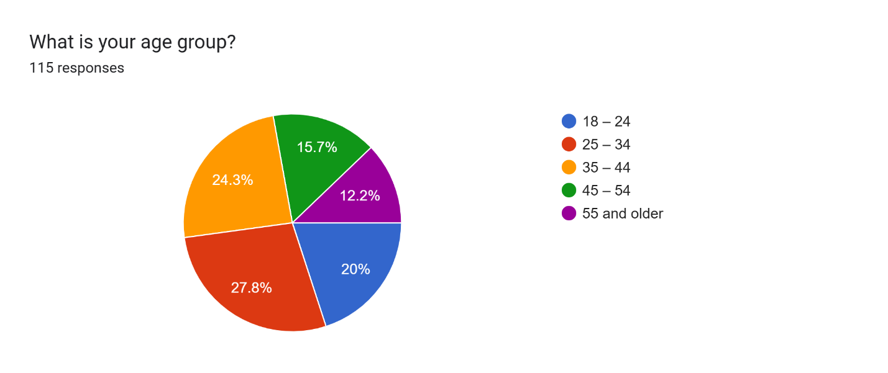
Figure 2: Age Frequency
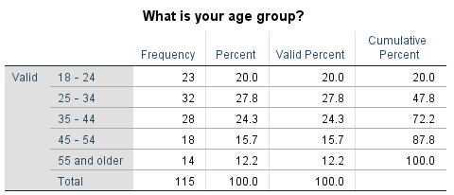
Table 1: Age Frequency
Table 1 shows that the largest age demographic among respondents was 25-34 years old ($n=32$
, 27.8%), followed closely by those aged 35-44 ($n=28$, 24.3%). That means that the sample is primarily composed of young to middle-aged adults, representing a core, economically active retail consumer base.

Gender Frequency
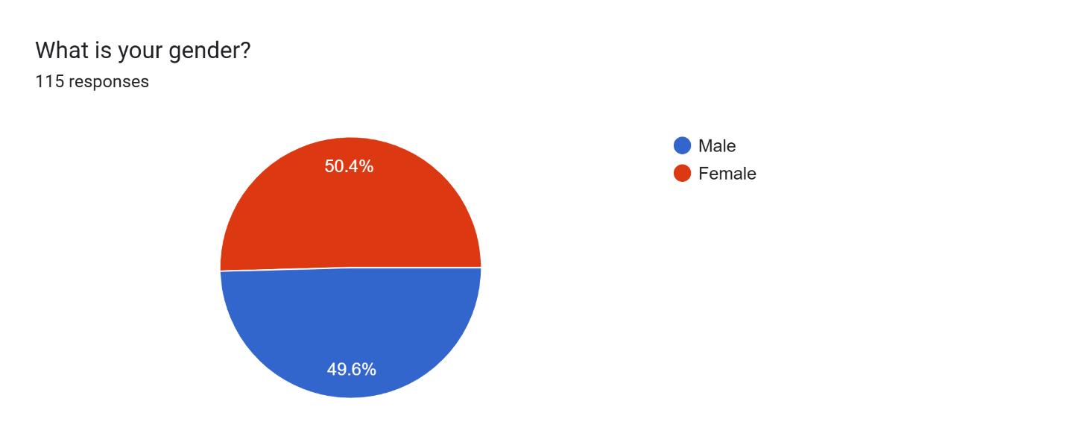
Figure 3: Gender Frequency
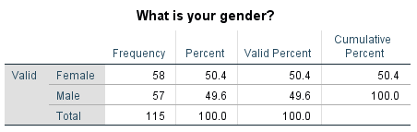
Table 2: Gender Frequency
Table 2 demonstrates a near-perfect gender parity within the sample, comprising 50.4% female ($n=58$) and 49.6% male ($n=57$) respondents. The high level of balance will help to minimize gender bias and provides a balanced perspective across genders within the surveyed sample.

Purchase Frequency
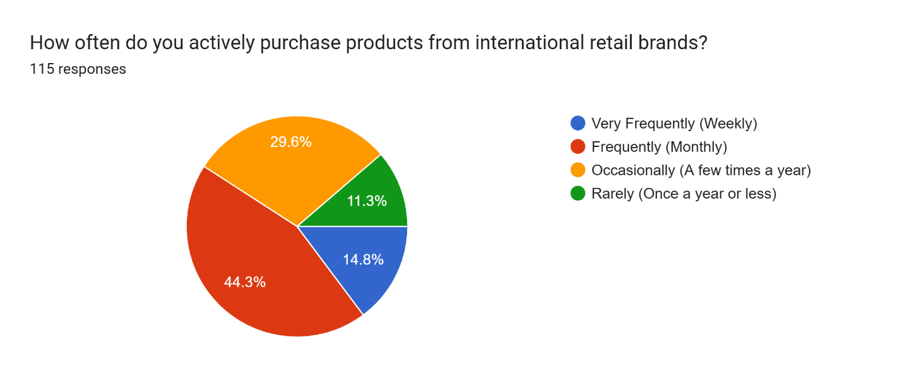
Figure 4: Purchase Frequency

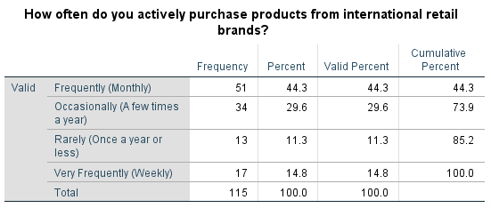
Table 3: Purchase Frequency
Table 3 indicates that the majority of respondents actively purchase from international retail brands on a "Frequently (Monthly)" basis ($n=51$, 44.3%), alongside 14.8% ($n=17$) who purchase "Very Frequently (Weekly)". This is an indication of the adequacy of the purposive sampling strategy in addressing the intended target population of active consumers or users of international brands.

PPV1 Frequency
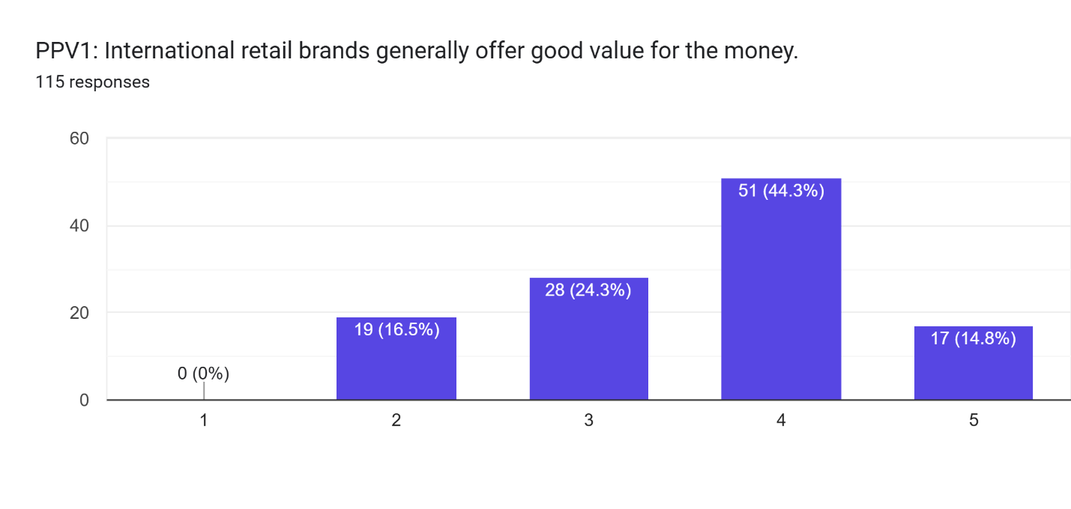
Figure 5: PPV1 Frequency
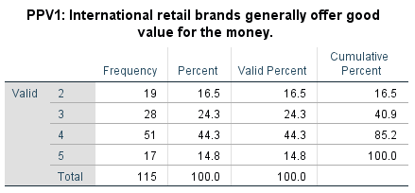
Table 4: PPV1 Frequency
Table 4 shows that the largest proportion of respondents agreed (44.3%, $n=51$) that international retail brands offer good value for money, with an additional 14.8% ($n=17$) strongly agreeing. This indicates that consumers have, overall, a positive starting point towards the financial benefit of purchasing these brands.

PPV2 Frequency
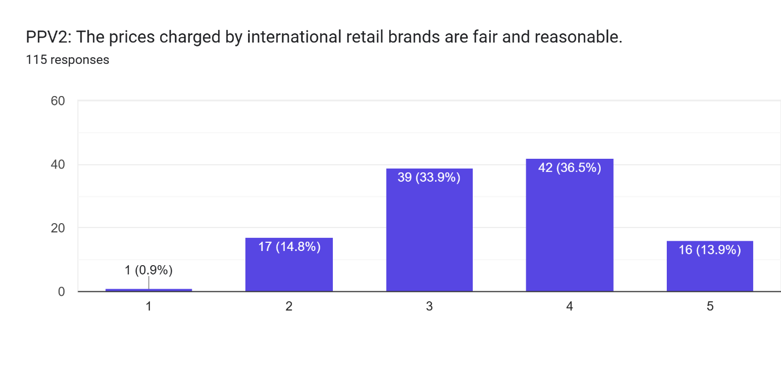
Figure 6: PPV2 Frequency

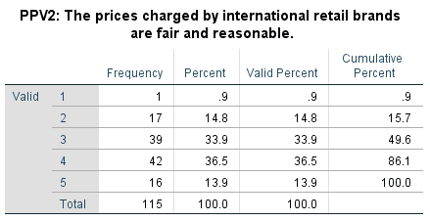
Table 5: PPV2 Frequency
Table 5: PPV2 (The prices charged by international retail brands are fair and reasonable)
Table 5 reveals that while 36.5% ($n=42$) of respondents agreed that the prices charged by these brands are fair, a substantial portion remained neutral (33.9%, $n=39$). It demonstrates how skeptical and probing consumers are of absolute fairness of international brand pricing models.

PPV3 Frequency
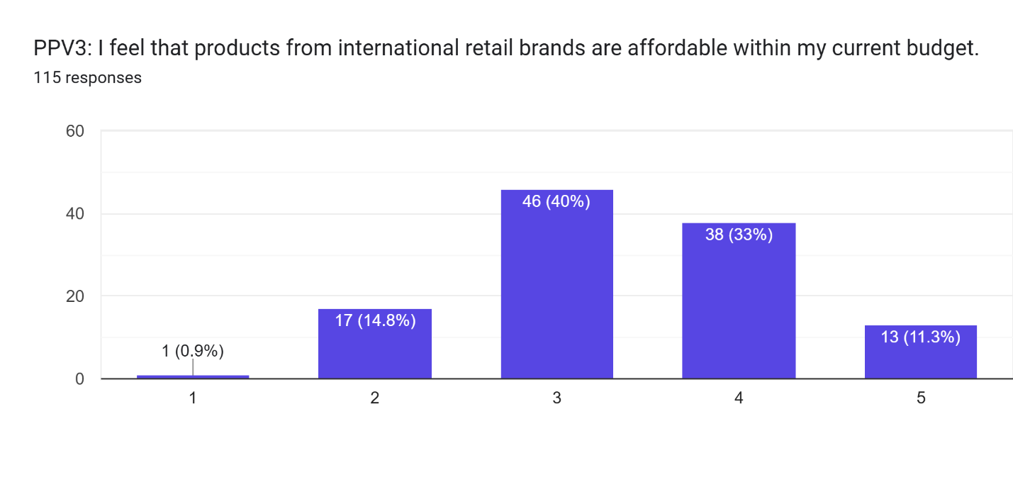
Figure 7: PPV3 Frequency
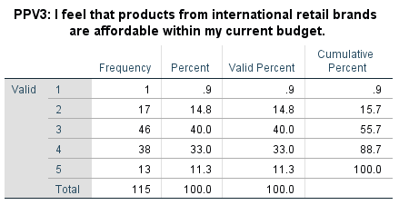
Table 6: PPV3 Frequency
Table 6 indicates that a plurality of respondents remained neutral regarding the affordability of international retail brands ($n=46$, 40.0%), while a combined 44.3% ($n=51$) agreed or strongly agreed. This indicates mixed consumer sentiment, with a large proportion of the market saying they don't think it is as affordable as it once was in the real world, owing to the cost-of-living crisis.

PPV4 Frequency
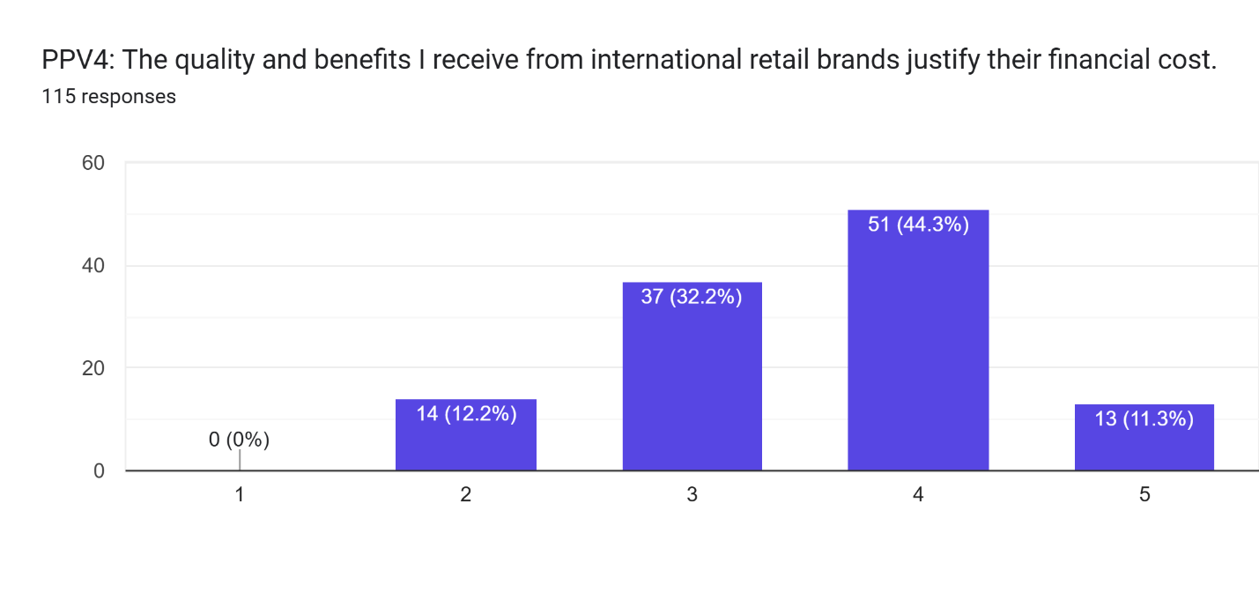
Figure 8: PPV4 Frequency
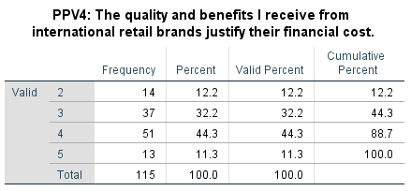
Table 7: PPV4 Frequency
Table 7 shows that the majority of respondents either agreed (44.3%, $n=51$) or strongly agreed (11.3%, $n=13$) that the quality and benefits received from these brands justify the financial cost. This indicates that even in the face of potential budget limitations, consumers remain very concerned with the functional value and quality of an international brand as an investment for their money.

PPV5 Frequency
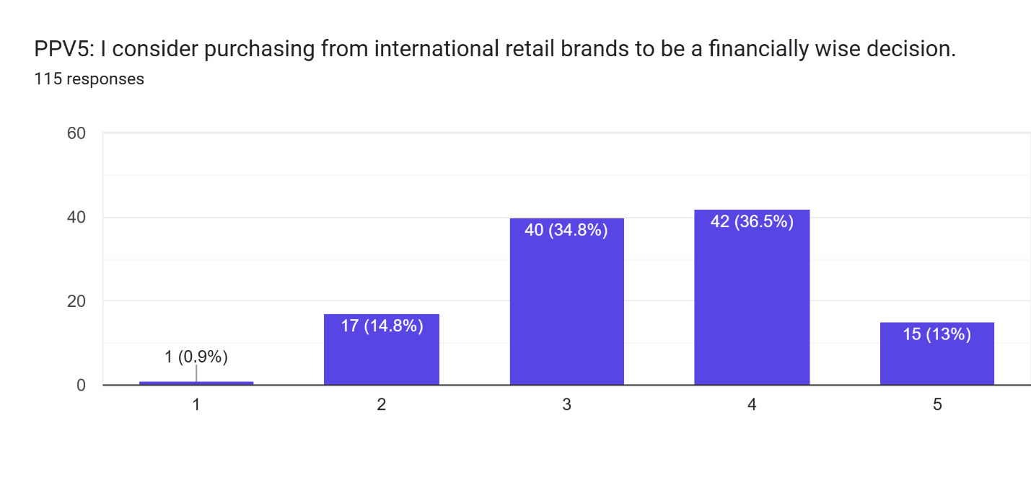
Figure 9: PPV5 Frequency
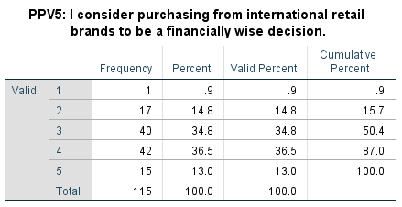
Table 8: PPV5 Frequency
Table 8 reveals that 36.5% ($n=42$) of respondents agreed and 13.0% ($n=15$) strongly agreed that purchasing from international brands is financially wise, though a large block of 34.8% ($n=40$) remained neutral. This indicates that although a lot of customers consider any of these purchases as wise expenditure, many consumers are undecided if the purchase is prudent in the current economic climate.

BSC1 Frequency
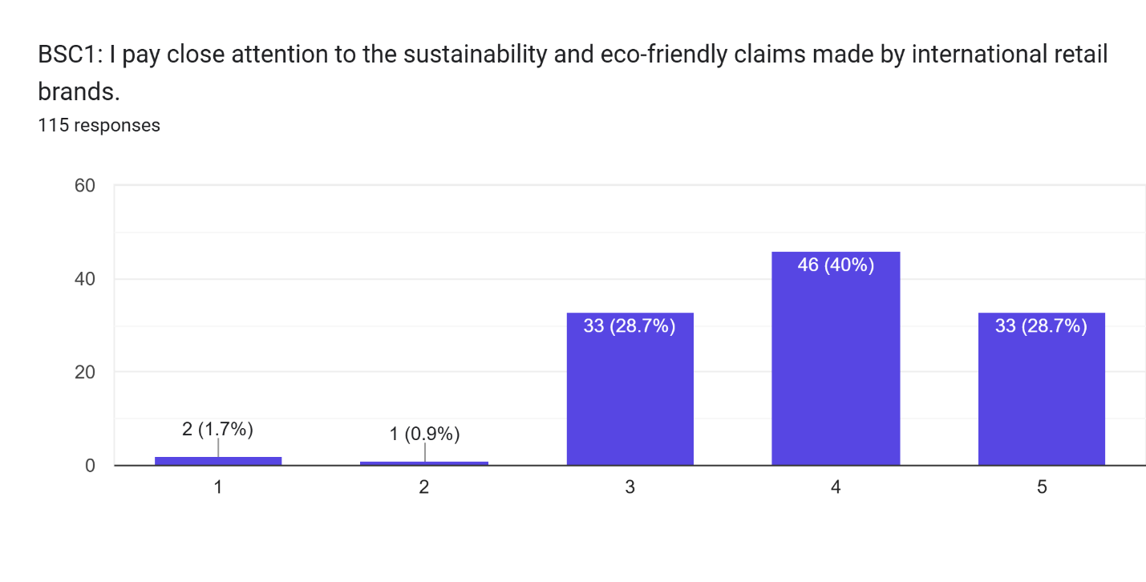
Figure 10: BSC1 Frequency
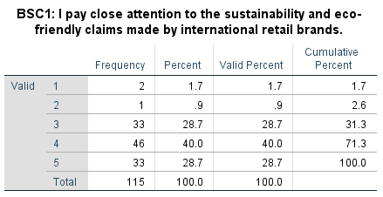
Table 9: BSC1 Frequency
Table 9 highlights a high level of environmental awareness, with 40.0% ($n=46$) agreeing and 28.7% ($n=33$) strongly agreeing that they pay close attention to brand sustainability claims. This suggests that the customer market is aware of and interested about eco marketing because it is very noticeable and has relevance to the customers, which shows that there is an increasing demand for ethical consumption.

BSC2 Frequency
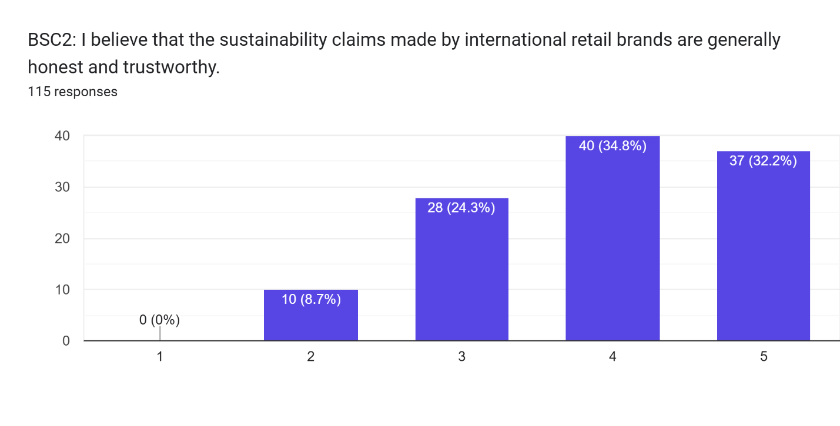
Figure 11: BSC2 Frequency
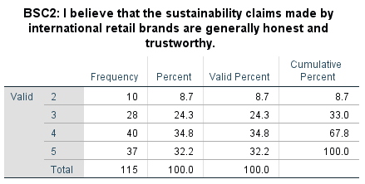
Table 10: BSC2 Frequency
Table 10 demonstrates that a significant majority of respondents trust these claims, with 34.8% ($n=40$) agreeing and 32.2% ($n=37$) strongly agreeing that international brands are honest about sustainability. This is a very important result, because it reveals a remarkably low number of brands that were skeptical about the practice of greenwashing within this specific sample, representing a high "Green Brand Trust" value.

BSC3 Frequency
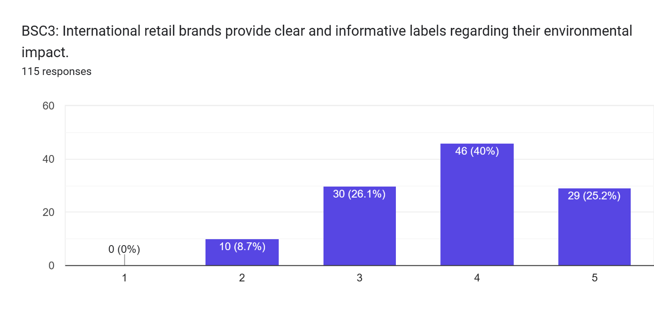
Figure 12: BSC3 Frequency
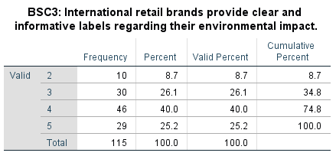
Table 11: BSC3 Frequency
Table 11 indicates that 40.0% ($n=46$) of respondents agreed and 25.2% ($n=29$) strongly agreed that international retail brands provide clear and informative environmental labels. This signals that, for the most part, consumers view these brands as honest and good at communicating with them on sustainability.

BSC4 Frequency
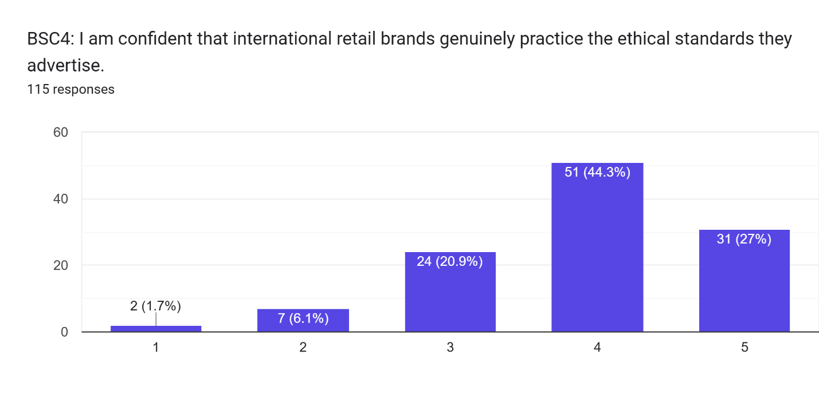
Figure 13: BSC4 Frequency
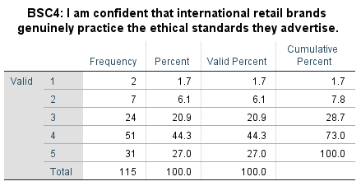
Table 12: BSC4 Frequency
Table 12 reveals that a combined 71.3% of the sample either agreed (44.3%, $n=51$) or strongly agreed (27.0%, $n=31$) that they are confident these brands genuinely practice their advertised ethical standards. This high level of confidence also runs counter to the broader uncertainty among consumers, suggesting a solid faith in the authenticity of this global brand operation.

BSC5 Frequency
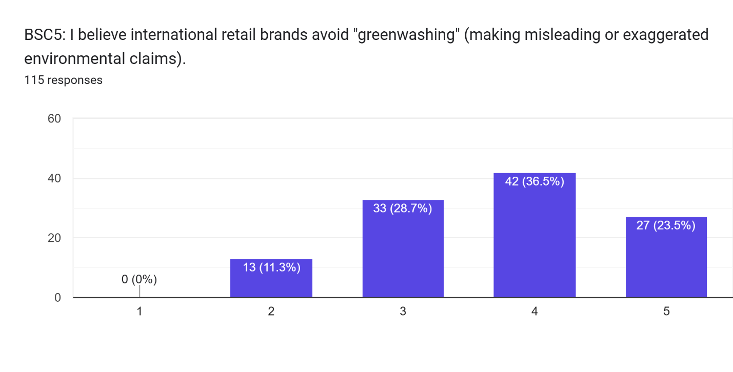
Figure 14: BSC5 Frequency
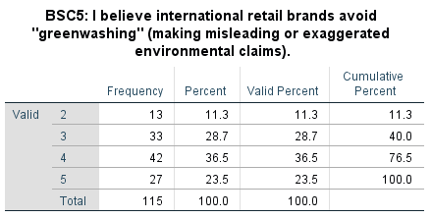
Table 13: BSC5 Frequency
Table 13 shows that 36.5% ($n=42$) agreed and 23.5% ($n=27$) strongly agreed that international brands avoid greenwashing, though a notable 28.7% ($n=33$) remained neutral. The majority is on the side of trust, but the large neutral group indicates that some caution is still present about possible strong claims in the environment.

PI1 Frequency
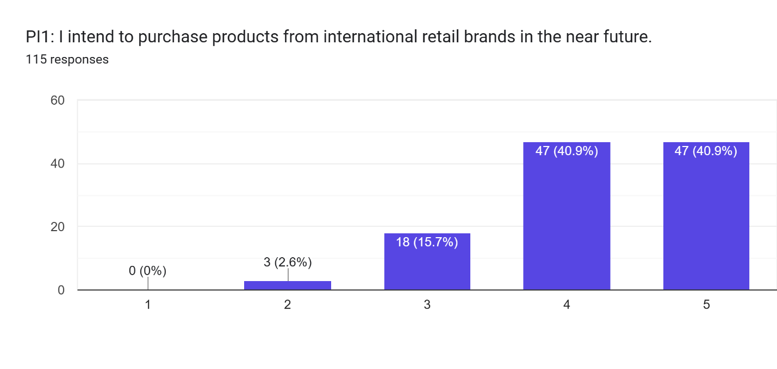
Figure 15: PI1 Frequency
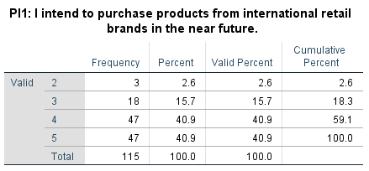
Table 14: PI1 Frequency
Table 14 demonstrates extraordinarily high purchase intention, with respondents equally split between agreeing (40.9%, $n=47$) and strongly agreeing (40.9%, $n=47$) that they intend to purchase from international brands in the near future. This is an overwhelming positive response giving clear evidence of robust short-term consumer demand despite macro-economic pressures.

PI2 Frequency
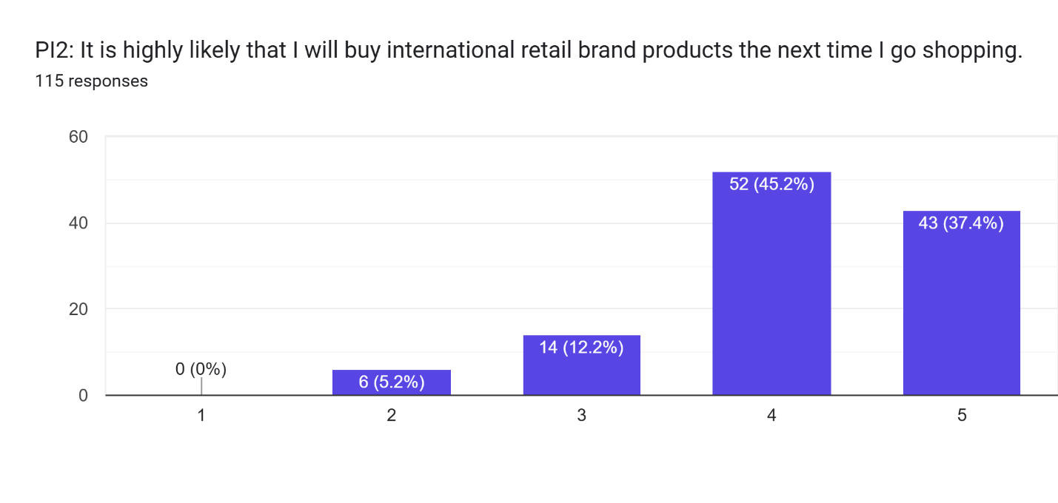
Figure 16: PI2 Frequency
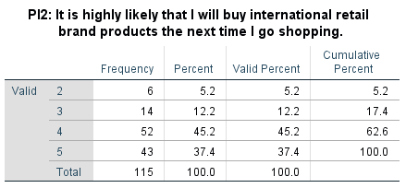
Table 15: PI2 Frequency
Table 15 indicates that 45.2% ($n=52$) agreed and 37.4% ($n=43$) strongly agreed that it is highly likely they will buy from these brands on their next shopping trip. This validates that general purchase intentions align with strong immediate likelihoods of future shopping behavior, although it does not measure actual behavioural conversion.

PI3 Frequency
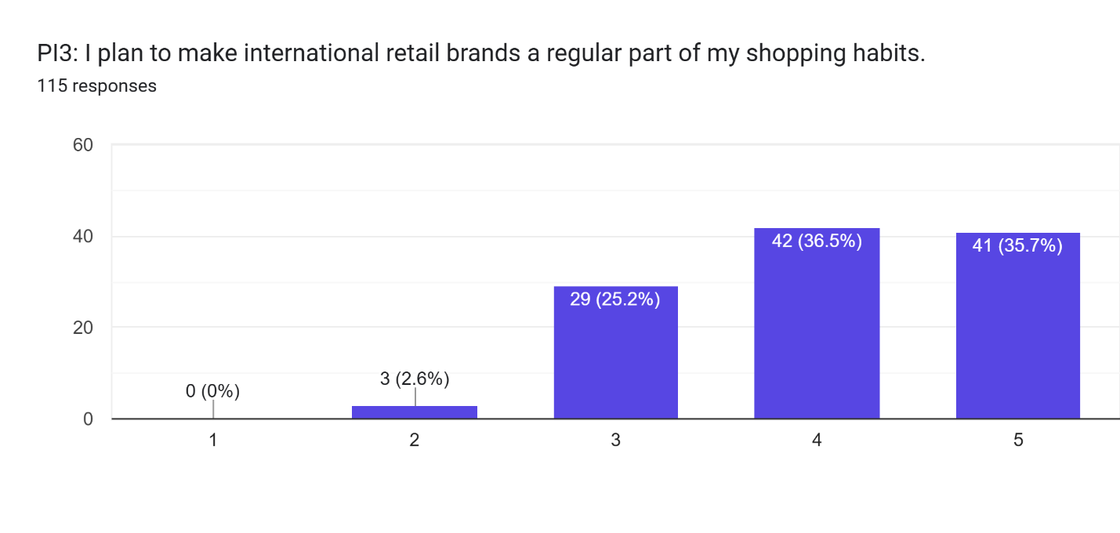
Figure 17: PI3 Frequency
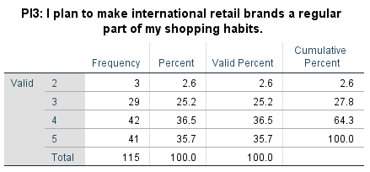
Table 16: PI3 Frequency
Table 16 reveals that 36.5% ($n=42$) agreed and 35.7% ($n=41$) strongly agreed with planning to make these brands a regular part of their shopping habits. This represents high levels of brand loyalty and long-term behavioural intentions to purchase among the sample of UK consumers.

PI4 Frequency
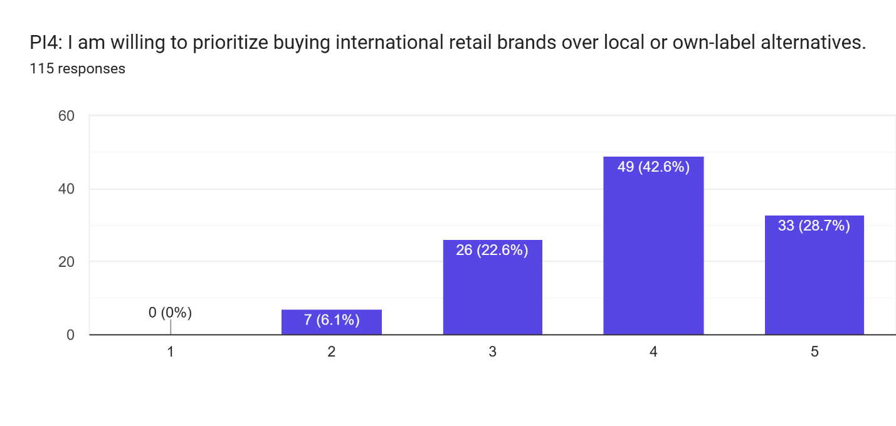
Figure 18: PI4 Frequency
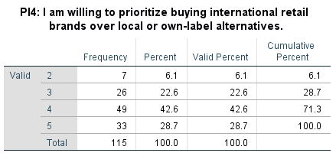
Table 17: PI4 Frequency
Table 17 shows that 42.6% ($n=49$) agreed and 28.7% ($n=33$) strongly agreed that they are willing to prioritize international brands over local or own-label alternatives. This is particularly revealing how international brands maintain their competitive edge in the UK market, in contrast to the wider economic pattern of consumers moving down to less expensive store brands.

PI5 Frequency
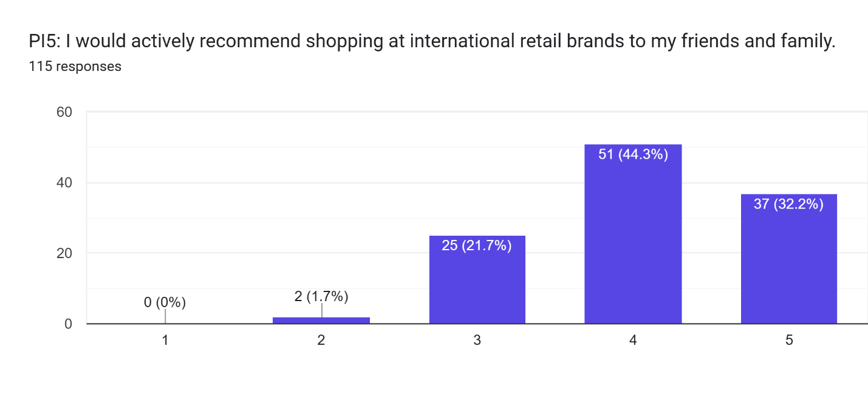
Figure 19: PI5 Frequency
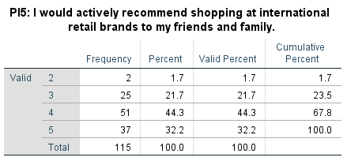
Table 18: PI5 Frequency
Table 18 highlights strong brand advocacy, with 44.3% ($n=51$) agreeing and 32.2% ($n=37$) strongly agreeing that they would recommend shopping at international retail brands to friends and family. This is a strong sense of advocacy which shows high satisfaction and positive brand resonance.

4.3 Mean, Median & Standard Deviation

PPV
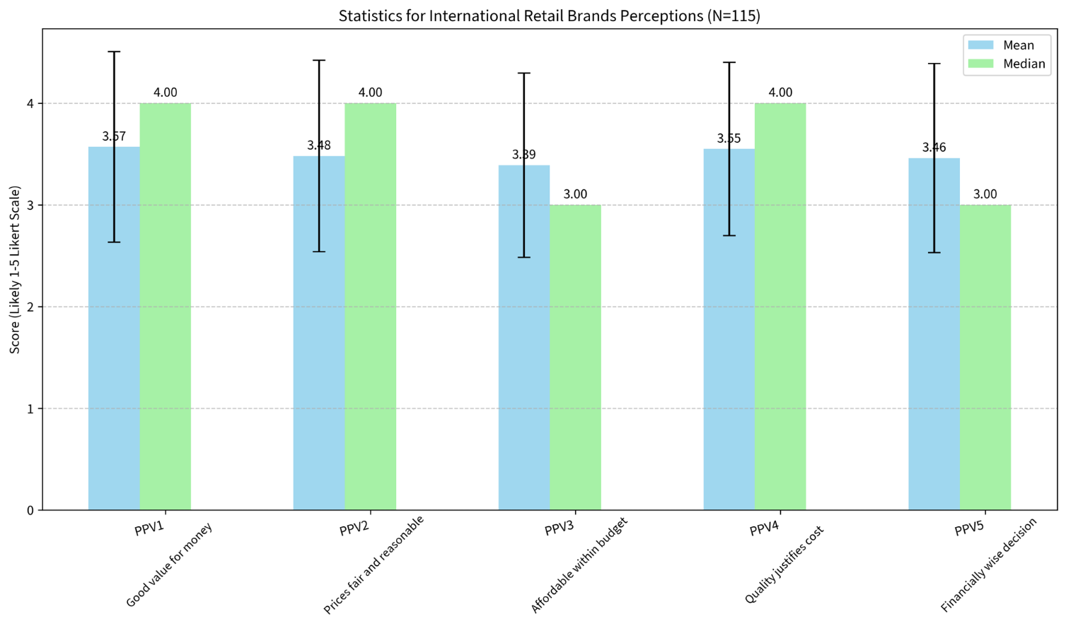
Figure 20: Mean, Median & Standard Deviation PPV
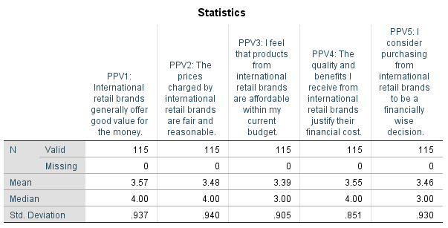
Table 19: Mean, Median & Standard Deviation PPV
Table 19 displays the item statistics for Perceived Price Value, revealing that PPV1 (good value for money) yielded the highest mean score ($M=3.57,SD=0.937$), while PPV3 (affordability) recorded the lowest ($M=3.39,SD=0.905$). This means consumers are aware of the overall value that is offered by an international brand, but the problem lies with their financial budget to receive that same value from it.

BSC
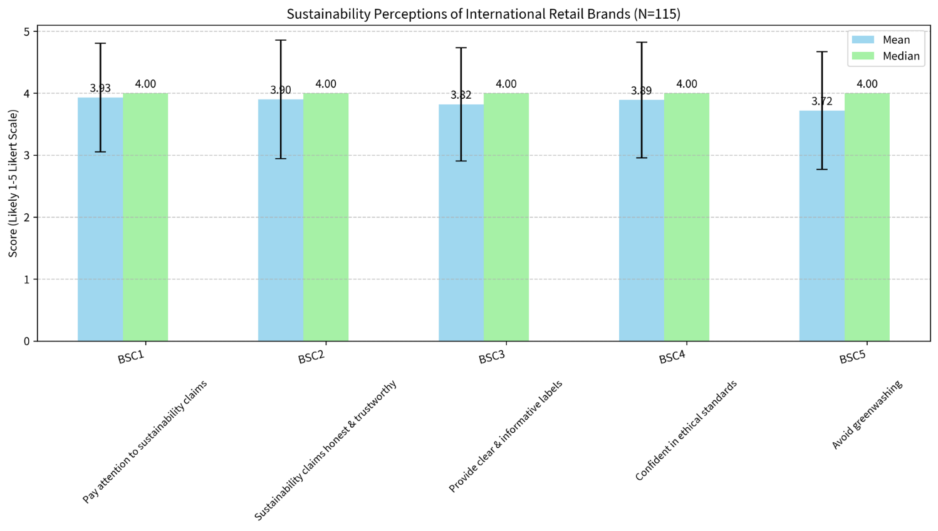
Figure 21: Mean, Median & Standard Deviation BSC
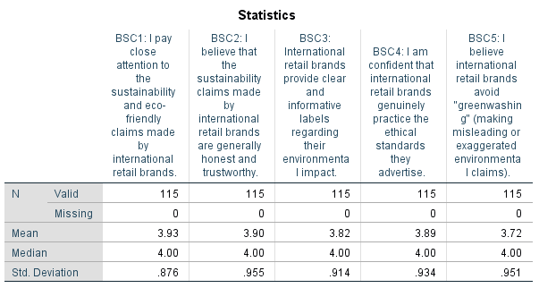
Table 20: Mean, Median & Standard Deviation BSC
Table 20 outlines the item statistics for Brand Sustainability Claims, showing the highest agreement for paying close attention to claims (BSC1, $M=3.93,SD=0.876$) and the lowest for believing brands completely avoid greenwashing (BSC5, $M=3.72,SD=0.951$). Here it appears that consumers are very sensitive to green marketing but also maintain some level of reservation about cases of greenwashing.

PI
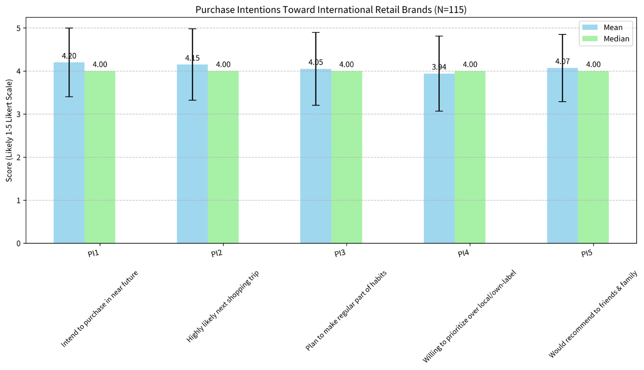
Figure 22: Mean, Median & Standard Deviation PI
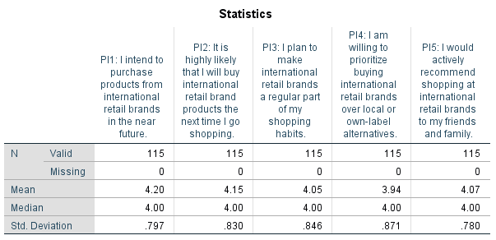
Table 21: Mean, Median & Standard Deviation PI
Table 21 presents the item statistics for Purchase Intention, with intention to purchase in the near future scoring the highest (PI1, $M=4.20,SD=0.797$) and willingness to prioritize over local brands scoring the lowest (PI4, $M=3.94,SD=0.871$). While a small percentage of consumers consider a local option at equal levels to the shop they are considering, it is a confirmation of strong overall short-term buying intent.

4.4 Regression Results

Descriptive Statistics
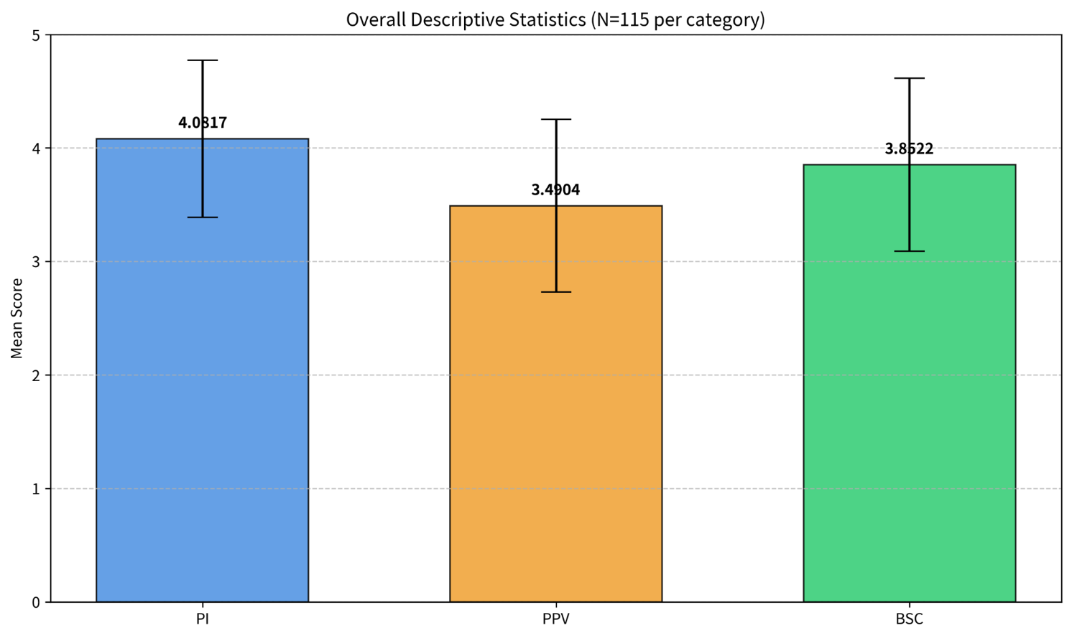
Figure 23: Descriptive Statistics Regression Analysis
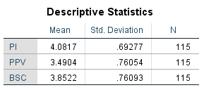
Table 22: Descriptive Statistics Regression Analysis
Table 22 displays the aggregated descriptive statistics for the core constructs, revealing that Purchase Intention has the highest overall mean ($M=4.08,SD=0.693$), followed by Brand Sustainability Claims ($M=3.85,SD=0.761$) and Perceived Price Value ($M=3.49,SD=0.761$). The composite scores show that consumer intentions to purchase are very high and they place strong importance on sustainability while their perception of price value is rather moderate with some distancing from it due to the current prevailing economic climate.

Pearson Correlation
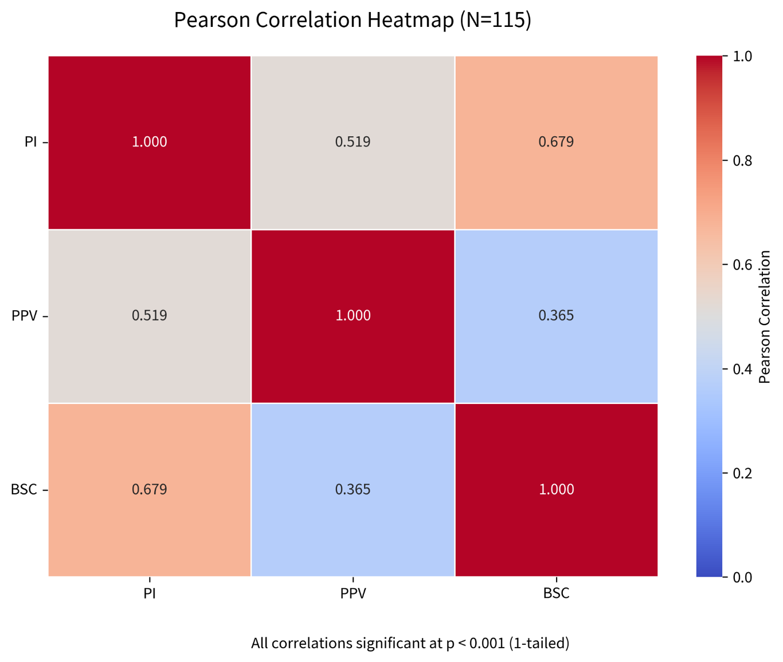
Figure 24: Pearson Correlation
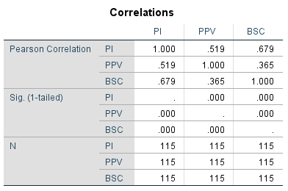
Table 23: Pearson Correlation
Table 23 presents the Pearson correlation analysis, indicating a strong positive correlation between Purchase Intention and BSC ($r=0.679,p<0.001$), a moderate positive correlation between Purchase Intention and PPV ($r=0.519,p<0.001$), and no severe multicollinearity between the independent variables ($r=0.365$). This indicates that both the independent variables are significantly related to the dependent variable and are also positively correlated; in this way, it is concluded that the independent variables measure different concepts to be used in a regression model.

Model Summary

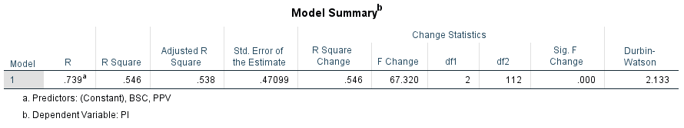
Table 24: Model Summary
Table 24 outlines the regression model summary, demonstrating an $R^{2}$ value of 0.546 alongside a Durbin-Watson statistic of 2.133. This signifies a robust predictive model where PPV and BSC together explain a substantial 54.6% of the variance in consumer Purchase Intention, with the Durbin-Watson value confirming the data is perfectly free from problematic autocorrelation.

ANOVA

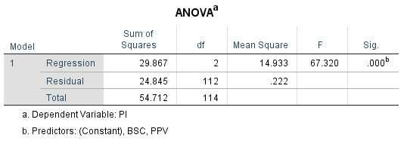
Table 25: ANOVA
Table 25 presents the ANOVA results, which indicate that the multiple regression model is highly significant ($F\left(2 , 112\right)=67.320,p<.001$). The finding not only demonstrates robustness of the Perceived Price Value and Brand Sustainability Claims combination to predict consumer Purchase Intention but also confirmed that this was a reliable and accurate prediction.

Coefficients
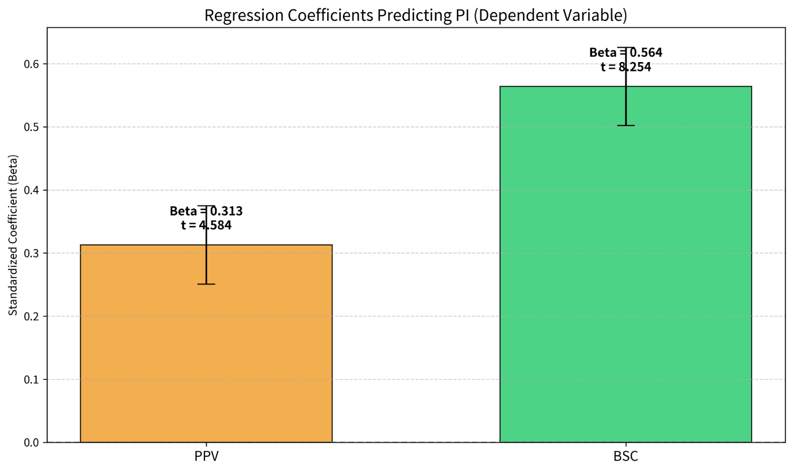
Figure 25: Coefficients
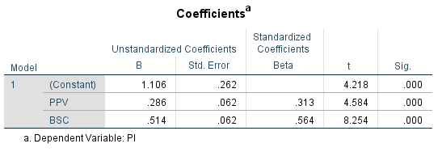
Table 26: Coefficients
Table 26 shows that both PPV ($β=0.313,t=4.584,p<.001$) and BSC ($β=0.564,t=8.254,p<.001$) have significant positive effects on Purchase Intention. This means that both independent variables effectively have a direct effect, whereas standardized beta weights indicate that while price value has an effect, the effect of sustainability is shown to be quite pronounced.

Residual Statistics
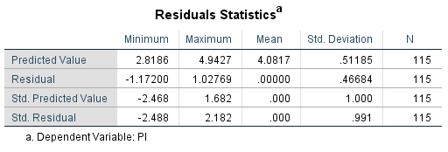
Table 27: Residual Statistics
Table 27 outlines the residuals statistics, highlighting that the standardized residuals fall well within the acceptable statistical threshold, ranging from a minimum of -2.488 to a maximum of 2.182. This means that the data set has no apparent extreme outliers that would have a dramatic effect on the regression analysis.

Normality Histogram
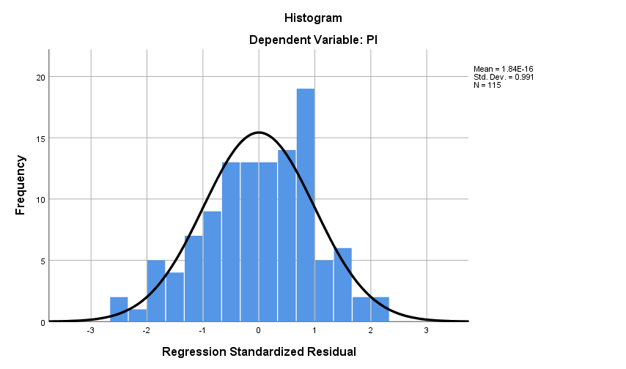
Figure 26: Normality Histogram
Standardized residuals from the regression are plotted in the histogram shown in Figure 26, which is a clear and symmetric bell curve. The critical regression assumption that the error terms within the model are normally distributed is met by this visual evidence.

P-P Plot
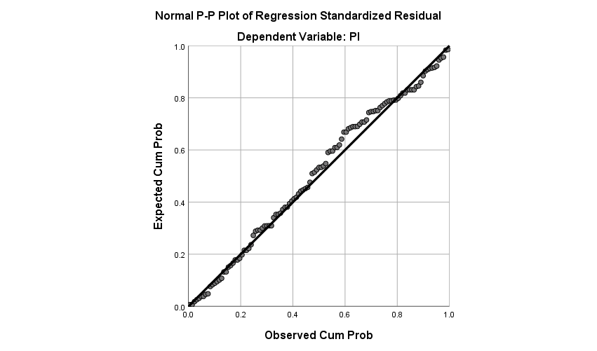
Figure 27: P-P Plot
Figure 27 presents the Normal P-P plot, showing the observed data points hugging the expected diagonal line very closely. This supports further the normality of the data as well as the strong statistical integrity of the predictive model.

Residual Scatterplot
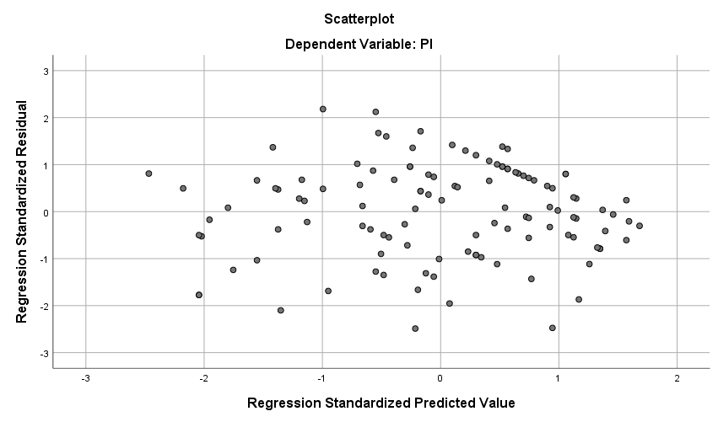
Figure 28: Residual Scatterplot
Figure 28 illustrates the scatterplot of standardized residuals against predicted values, displaying a random, unstructured dispersion of points without a funnel shape. This supports the assumption of homoscedasticity, indicating that the variance or errors of the model is constant and that the model is valid for all levels of the dependent variable.

4.5 Discussion of Findings
The primary purpose of this research was to empirically explore the independent and relative effects of Perceived Price Value (PPV) and Brand Sustainability Claims (BSC) on the Purchase Intention (PI) of a sample of UK consumers towards international retail brands. This study used a carefully designed questionnaire with 115 consumers to produce a strong sample of data which will help to explain the current attitude of these specific consumers and has many interesting differences from recent theoretical predictions.

Evaluating Model Viability and Statistical Assumptions
It is important to discuss viability of the regression model at the beginning before assessing the specific hypotheses. The predictive model built in this study has an excellent statistical health. The Model Summary (Table 24) shows a strong linear relationship between the predictor variables and Purchase Intention with the multiple correlation coefficient (R=0.739). But more important, the coefficient of determination, R², is 0.546. This indicates that the two variables of Perceived Price Value and Brand Sustainability Claims account for more than half (54.6%) of the total variance in consumer Purchase Intention for international brands. For research on consumer behavior, above 50% variance obtained is regarded as a very strong predictive model. The significance of this model is supported by the ANOVA results shown in Table 25, which shows a significant F-statistic of 67.320 (p<.001), meaning that that the predictive capacity of this model is not random chance.
In addition, regression assumptions were carefully followed, which validates the integrity of these inferential statistics. Durbin – Watson statistic is at 2.133 which is exactly in the acceptable range of (1.5 – 2.5) which proves the absence of first order linear Auto-correlation in the data. The Histogram of Standardized Residuals is very close to a bell curve, and the probabilities from the Normal P-P Plot align very closely with the expected diagonal line confirming that the assumption of normality is met. Lastly, the plot of the residuals shows a random and unstructured spread of data points, indicating that homoscedasticity holds. The constant variance of the errors from one level to another means that academy decisions to use the beta coefficients (β) discussed below are highly accurate.

Hypothesis 1: The Influence of Perceived Price Value on Purchase Intention
Hypothesis 1 posited that Perceived Price Value has a significant positive influence on UK consumers' Purchase Intention towards international retail brands. Based on the multiple regression analysis, H1 is strongly supported.
It can be seen from the results of the coefficient table (Table 26) that "Perceived Price Value" has a positive effect that is statistically significant when interacting with the variable "Purchase Intention" (β= 0.313; t= 4.584; p<.001). This number tells us that a one standard deviation rise in a consumer's favorability towards price and value is correlated with a .313 increase in the standard deviation in their intention to buy. In addition, the Pearson correlation matrix (Table 23) showed a very high and isolated positive correlation between PPV and PI (r=0.519, p<.001).
These statistical results coincide with the Value Based Adoption Model (VAM) used in the theory ground of this study (Srivastava, 2023). The results support both the meta-analysis of Blut et al. (2024), who found that price value is a key driver of purchasing decisions, and the conclusions of Mason et al. (2023), who concluded that the cognitive trade-off between price and quality is a key driver of retail outcomes. Hamzah's (2024) claim about the role of perceived price fairness as a key mediator of purchase intention is quantitatively supported as seen from the regression coefficient (β=0.313).
But a careful examination of the descriptive statistics shows the subtle truth of the present economic situation. The overall composite mean for PPV is 3.49 (Table 22), but an item-by-item breakdown reveals that there is a lot of consumer friction. In this case, the highest mean score for PPV1 (International brands offer good value for money) was obtained. Likewise, 55.6% agreed or strongly agreed (Table 7) the quality and benefits are worth the financial cost (PPV4). However, when considering the “affordability within my budget” question (PPV3, Table 6), the mean was lowered to 3.39, and a significant 40% of the sample moved to a “Neutral” stance.
This is the numerical divide between recognizing value and having an affordability problem, aptly encapsulating the microeconomic writing on the macroeconomic problem of the cost-of-living crisis. Inflation has aggressively increased consumers' sensitivity to price (Kwon and Hartley, 2026) and consumers are continually assessing their budgets. The observed indecision of PPV3 and PPV5 (34.8% neutral on purchasing being "financially wise") is the same as described by Abdullah et al. (2023) and Kaboor and Muthu (2026), which reported that higher price sensitivity negatively influences purchasing decisions. Ultimately, the data suggests that a consumer's wallet is being stretched by inflation but the fundamentals remain unchanged: If international brands can effectively substitute into the minds of consumers as functioning value-for-money, the intent to purchase increases markedly.

Hypothesis 2: The Impact of Brand Sustainability Claims on Purchase Intention
Hypothesis 2 posited that Brand Sustainability Claims positively impact Purchase Intention but anticipated that this relationship would be heavily moderated by consumer skepticism regarding greenwashing. Based on the data, H2 is supported regarding its positive impact, but the data sharply challenges the anticipated prevalence of consumer skepticism.
It should be noted methodologically that consumer skepticism was evaluated descriptively through specific survey items (BSC2, BSC4, BSC5) rather than as a formal statistical moderation analysis.
The evidence in the regression output (Table 26) of the predictive effect of Brand Sustainability Claims on consumer purchase intentions is clear and convincing. BSC yielded a highly significant, powerful positive beta coefficient (β=0.564,t=8.254,p<.001). This is further supported by Pearson correlation analysis (Table 23) which yielded a very strong positive correlation between BSC and PI (r=0.679,p<0.001).
The figures support the first half of their hypothesis, that ethical consumption is a primary concern for contemporary consumers, at least in numerical terms. This is supported by the descriptive data on which a composite mean for BSC was calculated, which is very impressive, coming to 3.85 (Table 22). In particular, a majority of the sample (68.7%) agreed or strongly agreed that they notice sustainability claims (BSC1; M=3.93) (Table 9). Continuing with this logic, it is certainly in line with the opening statements of Munro et al. (2023) and Göring-Lensing-Hebben et al. (2023), which highlights the record levels of environmental awareness among today's consumers.
What is most interesting about these results, however, is the consumer reaction to ‘green-washing'. In the literature, substantial focus was placed on the “Intention-Action Gap” correlated by the great consumer's doubt. Di Pillo et al. (2025) and Yu et al. (2025) found a significant empirical support showing how a negative perception to greenwashing significantly lowered the intention of buying from a green brand (e.g., Di Pillo β=-0.364). In the same way, Isac et al. (2025) and Nguyen Le Hoang Long and Mach Tran Huy (2026) reported that skepticism undermines sustainability marketing.
Contrary to the severity of this skepticism in international brands, it is curious that the key data from this sample is somewhat the reverse of that. The analysis of the item statistics (Table 20) showed that the consumers displayed remarkably high degrees of trust. An incredible 67% agreed or strongly agreed that sustainability claims of these brands were verifiable and open to scrutiny (BSC2, M=3.90). In addition, 71.3% were confident of the brands really practicing the ethics they claim (BSC4, M=3.89). As for brands that actively do not greenwash (BSC5, M=3.72, 28.7% neutral), the response was overwhelmingly favorable.
Rather than aligning with the skepticism literature (Margariti et al., 2024; Balaskas et al., 2025), these results strongly align with the framework proposed by Rahman et al. (2025). According to Rahman et al. green purchase intentions have full mediation and strengthening between the green brand trust (β=0.543). Given the size of the sample (N=115) and the high BSC2 and BSC4 frequencies that indicate the inherent trust the sample holds in international brands with which they conduct their shopping, the level of friction that would accompany the skeptical eye of the greenwashing is nearly non-existent. Due to this trust, the Brand Sustainability Claims are able to resonate directly and strongly to Purchase Intention which explains the large β=0.564 coefficient seen in its regression model.

Hypothesis 3: The Relative Influence - PPV vs. BSC in the Current Economic Climate
Hypothesis 3 posited that Perceived Price Value exerts a stronger relative influence on Purchase Intention than Brand Sustainability Claims in the current economic climate. Based on statistical evidence, H3 is definitively rejected.
This hypothesis can be tested by looking at the standardized beta-coefficients (β) of the two independent variables in the multiple regression model (Table 26). Standardized coefficients allow the researchers to get an accurate idea of which variable has a greater mathematical influence on the variables to be explained, since all variables are placed on the same scale.
- The standardized coefficient for PPV is $β=0.313$.
- The standardized coefficient for BSC is $β=0.564$.
Comparing the data very clearly, it can be seen that the Brand Sustainability Claims have a significantly more predictive effect on Purchase Intention than Perceived Price Value. The magnitude of this difference is further highlighted by the t-statistics: the t-value for BSC (t=8.254) is nearly double the t-value for PPV (t=4.584). Both are important at p<.001 level, however, BSC is definitely being the primary of all variables in consumer decision-making matrix.
The repulsion of this hypothesis is a very significant break with the latest macroeconomic literature examined in Chapter 2. As a consequence of the 2022-2026 inflation surge, major contemporary research works pointed out that economic survival had completely blanked out ethical consumption. Pourmahdi et al. (2026) used salience theory to claim that price sensitivity is a strong modulator of behavior while greenness sensitivity is a weak one (b=0.098). The work carried out by Cascavilla et al., (2025); Tan et al. (2025); Zaborek and Nowakowska (2024) also showed, similar to the study presented here, that affordability is more important than sustainability attributes, with regression analysis also showing that affordability supersedes ethical concerns for non-wealthy consumers, as they authored the term "ethical consumption gap". On this foundation of heavy consensus on academic opinion, post-inflationary, placed after the fact, hypothesis 3 was developed.
Why, then, does the primary data from this study (BSC $β=0.564$ > PPV $β=0.313$) vehemently contradict this established literature? The answer lies in a critical examination of the particular context and particular demographic data of the study.
Firstly, this study looked only at brands from abroad. International brands have a reputation for higher priced purchases, as well as discretionary items, compared to essential goods, or domestic goods. Consumers had high levels of overall Purchase Intention (4.08, Table 22) but found the affordability aspect challenging (PPV3 mean = 3.39). In addition, 71.3% of those who responded said they would prefer these international brands to other local or ‘own label' brands (PI4, Table 17).
The learning points from this behavioral phenomenon is that as consumers decide they're going to engage with brands from other countries, they're already making a conscious choice to give up searching for the cheapest options. If only the absolute affordability were enough, as Zaborek and Nowakowska (2024) have proposed, they would naturally turn to the less expensive own labels. They are choosing the premium (international) option and are conscious of their choice they are taking up the premium option therefore they have taken up premium attributes with sustainability as a topmost one which is a criteria of delivering the premium. This is consistent with previous “eco-premium” research, including Zhang (2026) and Nazarenko (2024), which found that the perceived ethic of a product influences willingness to pay a premium for luxury or high-end products.
Secondly, the demographic presentation of the sample is extremely important. Tables 1 and 2 show that the sample is heavily concentrated in the 25-34 (27.8%) and 35-44 (24.3%) age brackets. These not only represent the most ecologically conscious generational cohorts in history, they are the generational cohorts more likely to refuse our wastefulness. In the case of this small cohort, the “Intention-Action Gap” (Munro et al., 2023; Liu et al., 2024) may be narrowing, though it must be noted that this study measures expressed intentions rather than verified point-of-sale actions. Furthermore, they are not only discussing their environmental awareness, but on a statistically significant level, their sense of ethical responsibility is shaping the perception of whether or not to buy the product based on that awareness (PPV β=0.313, in contrast to β=0.564).
To close, the literature suggests that inflation conditions customers to think in terms of price, in this context, marketing international brands has shown that it is more about thinking about planet. While the baseline Purchase Intention requires excellent levels of Perceived Price Value to achieve, the Brand Sustainability Claims are key to motivate consumers to buy in today's UK.

4.6 Chapter Summary
This chapter showcased a statistical analysis of the main survey data that was carried out in a rigorous manner. To verify the engaging and ethical nature of the consumer sample, confirmatory procedure descriptive statistics were performed. The results of the multiple regression model were successful in indicating that both Perceived Price Value (H1) and Brand Sustainability Claims (H2) have a significant and positive predictive relationship with the R^2 value of 0.546. Most importantly, the relative strength of the influence of robust sustainability associations on purchasing intention for international brands was statistically larger than the relative strength of the influence of price value, as H3 was strongly rejected in the model analysis

Chapter 5: Conclusion and Recommendations

5.1 Introduction
This final chapter brings all the empirical results of the research together, finalizing the findings of the research and giving the concluding answer about the effects of Perceived Price Value (PPV) and Brand Sustainable Claims (BSC) on Purchase Intention (PI) of UK consumers for International retail brands. Following Chapter 4, which presents the statistics, this chapter assesses the achievement of the study's objectives. Moreover, it explains the important theoretical and management implications that the results bring, recognizes the methodological limitations of the study and makes specific suggestions for future academic study.

5.2 Overall Summary of the Research
This overarching aim for this dissertation was to explore an extremely contemporary retail paradox: the severest economic constraints of a postindustrial era and consumer demand for ethical, sustainable consumption. The literature reviewed indicated a general "intention-action gap," with higher price sensitivity and more entrenched greenwashing skepticism being described to lead to a reduction in sustainable purchasing.
In order to empirically test these theoretical assumptions a positivist, deductive methodology was used. A structured, cross-sectional survey online was successful as data was collected from 115 UK consumers who do actively purchase international retail brands. The data were statistically evaluated within a rigorous SPSS guideline up to multiple linear regression (R^2 = 0.546).
The empirical results led to a very predictive model, which came with a dramatic shift from recent macroeconomic expectations. Perceived Price Value came as a significant positive factor in determining Purchase Intention (β = 0.313), whereas Brand Sustainability Claims was the most dominant and overpowering factor in predicting consumer intentions within this sample (β = 0.564). Most important, there was no anticipated friction of a greenwashing doubt; the expected one was instead over the anticipated "Green Brand Trust”. The data ultimately revealed that when it comes to a premium discretionary investment, the targeted audience—newly arriving Millennials and Generation Zers—makes choices for international retailers based on their ethics as well as their affordability.

5.3 Achievement of Research Objectives
The empirical analysis comprehensively covered the four objectives of this study, which were implemented systematically and helped realize the success of this study.
Objective 1: To assess the current impact of Perceived Price Value on the Purchase Intention of UK consumers for international brands.
Hypothesis 1 was validated successfully to achieve this objective. The analysis of regression further increased the significance of PPV as having a significant positive effect on Purchase Intention (p < .001). But the descriptive data revealed a more complex picture as consumers strongly believed that international brands offer ‘good value for money' (Mean = 3.57), but at the same time that international products are ‘pushing our current budgets' (Mean = 3.39). The objective is thus met by indicating that this segment of consumers is very price-sensitive in this economic situation in 2026, but they also manage to see functional value and to perceive the price as fair, so that this consequence is still pertinent to actual purchase intent.
Objective 2: To examine the effect of Brand Sustainability Claims on Purchase Intention, taking into account current levels of consumer skepticism and greenwashing concerns.
This objective was fulfilled by testing Hypothesis 2. The data clearly showed the positive and powerful contribution of BSC to Purchase Intention. More important, this study directly assessed the expected influence of greenwashing scepticism through descriptive analysis, and this had surprisingly little effect in this situation. The majority of 67% of respondents believed that international brands were honest about their sustainability reporting and 71.3% felt that they actually observe the ethical practices they advertise. The study was finally able to successfully quantify this high level "Green Brand Trust", which in turn represented a direct flow of sustainability marketing into purchase intent without obstacle.
Objective 3: To determine whether Perceived Price Value or Brand Sustainability Claims exerts a stronger relative influence on Purchase Intention in the 2026 economic climate.
This objective was effectively achieved by comparing the standardised beta coefficients and dismissing Hypothesis 3. This study has shed light on the fact that affordability does not have a dominant effect compared to ethics during inflationary periods and that the relative effect of Brand Sustainability Claims (β = 0.564) is nearly twice of Perceived Price Value (β = 0.313). Brand Sustainability Claims demonstrated a comparatively stronger predictive relationship with purchase intention than perceived price value within this sample.
Objective 4: To provide data-driven, strategic recommendations for international retail brands to optimize their pricing and sustainability marketing in the UK.
This last objective is being met in Section 5.5 of this chapter involved in turning out the statistical results into actionable, strategic managerial suggestions.

5.4 Theoretical Implications
Academically the dissertation contributes to the broader stream of literature on sustainable consumer behaviour and/or the “intention-action gap” in the current literature. After the period of high inflation 2022-2025, leading experts suggested that price sensitivity has now superseded ecological consciousness, and invented phrases like the ‘ECG’—Ethical Consumption Gap.
In this study, this monolithic consensus is challenged, and a highly contextualized perspective on retail theory is offered. The results suggest that the “intention-action gap” may be closing when it comes to Millennials and Generation Z and premium international brands within the surveyed demographic. This divergence from broader macroeconomic surveys likely stems from this study's focus on discretionary, premium international brands among a self-selected younger demographic, rather than essential grocery shopping. These groups also do not assess goods simply on absolute economic feasibility since they think of international brands as discretionary as opposed to necessary. Rather they use an "eco-premium" approach. Theoretically, the study supports the claims of Rahman et al. (2025) that greenwashing anti-anticipation was neutralised when “Green Brand Trust” was created, which allowed the sustainability claims to be a primary measure in functional quality and appreciate higher prices. This implies that sustainability could be more deeply incorporated into – and not only along the side of – consumer value theories, particularly for this market segment.

5.5 Managerial Implications and Strategic Recommendations
This dissertation offers a number of actionable recommendations that might be implemented by international retail executives and marketers targeting similar segments of UK consumers that draw on this study's data and are of a very high actionable nature.
1. Lead with Authenticated Sustainability Marketing
The data clearly illustrates that the intent to purchase is most closely related to sustainability claims (β = 0.564). Based on this strong predictive relationship within the sample, the main focus of marketing messages for international brands targeting this demographic might benefit from shifting from price offers and discounts to environmental and ethical values. By contrast, 40% of consumers pay "close attention" to these claims, which means that the marketing must be transparent, verifiable and informative. Given that 65.2% of respondents agreed or strongly agreed that clear environmental labelling influences their trust (BSC3), international brands targeting younger UK demographics might consider providing substantiated, transparent on pack claims to continue to earn a high level of "Green Brand Trust" as outlined in this study.
2. Avoid the "Race to the Bottom" on Price
International brands targeting this specific consumer base may not need to make absolute low price offers as well as local or own brand to compete with other products for the consumers when they feel the pinch of the cost-of-living crisis. The data shows that 71.3% of consumers are already prepared to choose international brands over lower-priced domestic ones. Hence it is crucial for brands to work towards maintaining a high Perceived Price Value, ensuring that the high quality of the product and the good and lasting effects it has, are evidently commensurate with the price with which the customer needs to pay for them. Ethical production and a high-quality marketing strategy will also generate better purchase intentions in the short term, when compared to those of strategies assuming a low positioning and production costs.
3. Target Millennials and Gen Z as Ethical Brand Ambassadors
This demographic profile of the respondents to the survey indicated that the main age range of consumers is within the ages 25-44. This cohort was very brand loyal and had a very high willingness to promote the brand (PI5 Mean = 4.07). To maximize the impact on this socially conscious population, retailers would be wise to design their communications and marketing efforts for digital media and social platforms to reflect and resonate with them and also give them shareable sustainability content to use as an organic brand ambassador.

5.6 Limitations of the Study
This dissertation followed a strict methodological approach, but a number of its inherent limitations need to be recognized in order to place the findings in an accurate context.
First of all, the sample size (115) is adequate for performing a multiple linear regression analysis (as per Green's (1991) formula) and is relatively small. A larger number of respondents may have given more detailed analyses of this kind – for example, comparisons between levels of income.
Secondly, the study employed non-probability sampling methods (convenience sampling and purposive sampling). This meant that only consumers of international brands who were active were measured, which has reduced the overall generalisability of the results to the whole of the UK. Additionally, the shift towards younger and middle-aged people (25-44) may lead to an underrepresentation of the opinions of older adults (55+).
Third, the research design focused on the cross section of time and therefore examined consumer sentiment at one time in the 2026 economic climate. Consumer behaviour is a dynamic affair, and firmly attuned to macro-economic changes; thus, these findings are a snapshot in time and a not a law of consumer behaviour.
Lastly, the study was not conducted with purchasing behaviour measures but with Purchase Intention. Then as always, intentions predict behaviors in the developed consumer-based research models, but self-reported survey data is always prone to some degree of social desirability bias which means there's a tendency for respondents to overstate their dedication to sustainability.

5.7 Recommendations for Future Research
Based on the results of this dissertation, the following directions for further research in the academic field are suggested.
The current study suggests that future studies should use a longitudinal design to observe the dynamics of the influence of Perceived Price Value and Brand Sustainable Claims over the next 3-5 years as the UK economy moves out of the current cost-of-living crisis. Analyzing the variables over time would give more insight into the longevity of the "eco-premium" mentality.
Also, researchers could move beyond the use of survey-based intention measures to observational studies using actual point-of-sale (POS) data. The correlation of actual sales for popular international products with popular domestic substitute products, all with high green marketing presence, would be the best test ever of the closing of intention-action gap that this study has found.
Last but not least, a comparative analysis of these very factors between different industries (for example fast-moving consumer goods, or FMCG, and premium fashion) would be extremely useful. This would challenge the theories that suggest consumers' reactions in the aisle to sustainability content are just as strong as their responses to price-value content in the case of an international brand that consumers might want for their high-end food consumption.

5.8 Final Conclusion
Ultimately, for an international brand aiming to succeed with this demographic in the 2026 retail market, the key is to strike a balance between consumer price sensitivity and a retail market with heightened ethical awareness. This dissertation demonstrates that, although competitive and fair pricing is a baseline entry criterion to the market, it is not the ultimate criterion anymore. A growing cohort of younger consumers (such as Millennials and Generation Z) are using Brand Sustainability Claims as their main buying compass with inflation hitting them hard. International retail brands that adapt to building trust and honour the reality of Green Brand Trust by focusing on sustainable practices that can be proven will be able to overcome the macroeconomic price sensitivity and retain build-up purchasing intent and ongoing consumer loyalty.

References
Abdullah, H., Jan, M. F., Zeb, F., & Hassan, S. (2023). The Impact of Price Sensitivity on Purchase Intentions in Modern Retails: The Mediating Role of Consumer Emotional Response. International Journal of Business and Management Sciences, 4(4), 1–18. https://ijbmsjournal.com/index.php/jbmis/article/view/511
Amirtha, R., & Sivakumar, V. J. (2022). Building loyalty through perceived value in online shopping – Differences across family life cycle stages. The Service Industries Journal, 42(15-16), 1151-1189. https://doi.org/10.1080/02642069.2021.1960982
Azzopardi, L., & van der Sluis, F. (2024). Seeking Socially Responsible Consumers: Exploring the Intention-“Search”-Behaviour Gap. Proceedings of the 2024 ACM SIGIR Conference on Human Information Interaction and Retrieval (CHIIR ’24). https://ar5iv.labs.arxiv.org/html/2604.03694v1
Balaskas, S., Stamatiou, I., Komis, K., & Nikolopoulos, T. (2025). Perceptions of Greenwashing and Purchase Intentions: A Model of Gen Z Responses to ESG-Labeled Digital Advertising. Risks, 13(8), 157. https://www.mdpi.com/2227-9091/13/8/157
BearingPoint (2026) Paying sustainability premiums remains sticking point for UK consumers. Available at: https://www.consultancy.uk/news/43589/paying-sustainability-premiums-remains-sticking-point-for-uk-consumers
Blue Yonder (2025) 2025 survey results: only 20% of consumers believe brand sustainability claims. Blue Yonder. Available at: https://blueyonder.com/blog/2025/2025-survey-results-only-20-of-consumers-believe-brand-sustainability-claims
Blut, M., Chaney, D., Lunardo, R., Mencarelli, R., & Grewal, D. (2024). Customer Perceived Value: A Comprehensive Meta-analysis. Journal of Service Research, 27(4), 501-524. https://journals.sagepub.com/doi/10.1177/10946705231222295
Borges-Tiago, M. T., Almeida, A., Tiago, F. G. B., & Avelar, S. M. M. (2024). Bridging the innovative Attitude–Behavior Gap: A dual-level analysis. Journal of Innovation & Knowledge, 9(4), 100561. https://www.sciencedirect.com/science/article/pii/S2444569X24001008
Capgemini Research Institute (2025) A world in balance 2025: Unlocking resilience and long-term value through environmental action. Capgemini. Available at: https://www.capgemini.com/wp-content/uploads/2025/09/18_09_A-world-in-balance-2025_Press-Release.pdf
Cascavilla, A., Caferra, R., Morone, A., & Morone, P. (2025). Experimental evidence on consumers’ willingness to pay in the sustainable fashion industry. Scientific Reports, 15, 38752. https://www.nature.com/articles/s41598-025-23008-9
Chen, C., Zhang, D., Zhu, L., & Zhang, F. (2024). Promoting green choices: How price premium displays influence consumer preference for green products. Resources, Conservation and Recycling, 207, 107682. https://www.sciencedirect.com/science/article/pii/S0921344924002763
Clear Channel UK (2024) Some 30% Of UK Consumers Willing To Pay Up To 10% More For A Sustainable Product. Available at: https://www.esmmagazine.com/retail/30-of-uk-consumers-willing-to-pay-up-to-10-more-for-a-sustainable-product-276553
Deloitte (2024) Cost and sustainability fatigue stifle consumers’ efforts to adopt more sustainable lifestyles. Deloitte. Available at: https://www.deloitte.com/uk/en/about/press-room/cost-and-sustainability-fatigue-stifle-consumers-efforts-to-adopt-more-sustainable-lifestyles.html
Demos and GS1 UK (2024) Majority of consumers don’t trust companies to come clean about their environmental impact. GS1 UK. Available at: https://www.gs1uk.org/insights/press-releases/majority-of-consumers-don%E2%80%99t-trust-companies-to-come-clean-about-their-environmental-impact
Di Pillo, F., Palombi, G., & Strazzullo, S. (2025). Does Greenwashing Wash Away Gen Z's Green Purchase Intention? Business Strategy and the Environment, 34(7), 9081-9092. https://onlinelibrary.wiley.com/doi/10.1002/bse.70064
Drapers (2026) Sustainability and the Consumer 2026. Available at: https://www.drapersonline.com/guides/sustainability-and-the-consumer-2026
Forest Stewardship Council UK (2025) Results from the 2025 FSC UK Consumer Survey. FSC UK. Available at: https://uk.fsc.org/newsfeed/results-from-the-2025-fsc-uk-consumer-survey
Göring-Lensing-Hebben, K., Schmitz, A.-K., & Fassnacht, M. (2023). Understanding the attitude-behaviour gap in sustainable consumption – A systematic literature review. Proceedings of the European Marketing Academy, 52nd, (114102). https://proceedings.emac-online.org/pdfs/A2023-114102.pdf
Green, S. B. (1991) 'How many subjects does it take to do a regression analysis', Multivariate Behavioral Research, 26(3), pp. 499-510. Available at: https://doi.org/10.1207/s15327906mbr2603_7
Hamzah, M. I. (2024). What drives car buyers to accept a rejuvenated brand? the mediating effects of value and pricing in a consumer-brand relationship. Journal of Strategic Marketing, 32(2). https://www.tandfonline.com/doi/full/10.1080/0965254X.2022.2129749
Impact (2025) Who’s Getting Value Right? The Brands Winning (and Losing) in 2025. Available at: https://impactmr.com/2025/10/23/whos-getting-value-right-the-brands-winning-and-losing-in-2025/
Ipsos (2025) Price trumps planet? Britons want sustainable products, but on a budget. Ipsos. Available at: https://www.ipsos.com/en-uk/price-trumps-planet-britons-want-sustainable-products-budget
Isac, N., Javed, A., Radulescu, M., Cismasu, I. D. L., Yousaf, Z., & Serbu, R. S. (2025). Is greenwashing impacting on green brand trust and purchase intentions? Mediating role of environmental knowledge. Environment, Development and Sustainability, 27(9), 21329–21346. https://link.springer.com/article/10.1007/s10668-023-04352-0
Kaboor, A., & Muthu, T. (2026). Impact of Price Sensitivity and Value Perception on Gen Z’s Repeat Purchase Intention in Branded Fashion Textiles. International Journal of Innovative Research in Technology, 12(9). https://ijirt.org/publishedpaper/IJIRT192035_PAPER.pdf
Kálmán, B. G., Koltai, J. P., Bacsó, R., & Szeiner, Z. (2026). Green intention or green action? Bivariate studies on attitudes and purchase intentions towards sustainable packaging. Frontiers in Sustainable Food Systems, 10, 1778773. https://www.frontiersin.org/journals/sustainable-food-systems/articles/10.3389/fsufs.2026.1778773/full
Khan, W., Siddiquei, M. I., Muneeb, S. M., & Farhan, M. (2022). Factors affecting willingness to pay premium prices for socially responsible food products: Evidence from Indian consumers. Business and Society Review, 127(2), 423-436. https://onlinelibrary.wiley.com/doi/10.1111/basr.12270
Kırçova, İ., Sağlam, M. H., Enginkaya, E., & Konuk, A. (2026). Utility over novelty: How performance expectancy converts hedonic motivation, future expectations, and price sensitivity into private e-scooter purchase intention. PLOS ONE, 21(7), e0341194. https://journals.plos.org/plosone/article?id=10.1371/journal.pone.0341194
KPMG (2023) Over half of UK consumers prepared to boycott brands over misleading green claims. KPMG. Available at: https://kpmg.com/uk/en/media/press-releases/2023/09/over-half-of-uk-consumers-prepared-to-boycott-brands-over-misleading-green-claims.html
Kwon, J.-H., & Hartley, E. V. (2026). Pricing Strategies and Consumer Price Sensitivity in E-Commerce: Evidence From U.S. Online Retailers, 2022-2025. American Impact Review. https://americanimpactreview.com/articles/e2026015.pdf
Lin Zhang, Yanna Zhang, Youquan Zhang, Zhuyan Bai (2024). Bridging the Intention–Behavior Gap in Green Housing Purchasing Evidence from China: The Moderating Effect of Environmental Concerns and Green Trust. Buildings, 16(4), 837. https://www.mdpi.com/2075-5309/16/4/837
Liu, Y., Wang, P., Zhang, M., Chen, X., Li, K., & Qu, J. (2024). Bridging the Intention–Behavior Gap in Organic Food Consumption: Empirical Evidence from China. Foods, 13(14), 2239. https://www.mdpi.com/2304-8158/13/14/2239
Lumina Intelligence (2026) Consumer Value Perception in the UK: Why Price No Longer Drives Decisions in 2026. Available at: https://www.lumina-intelligence.com/blog/consumer-value-perception-uk-2026/
Magano, J., do Valle Lopes, I., & Durães Ferreira, L. (2026). Impulse Buying in Physical Fashion Retail and the Mediating Role of Self-Control. Sage Open. https://journals.sagepub.com/doi/10.1177/21582440261464251
Margariti, K., Hatzithomas, L. and Boutsouki, C. (2024) 'Elucidating the Gap between Green Attitudes, Intentions, and Behavior through the Prism of Greenwashing Concerns', Sustainability, 16(12), 5108. https://www.mdpi.com/2071-1050/16/12/5108
Mason, M. C., Oduro, S., Umar, R. M., & Zamparo, G. (2023). Effect of consumption values on consumer behavior: a Meta-analysis. Marketing Intelligence & Planning, 41(7), 923-944. https://www.emerald.com/insight/content/doi/10.1108/MIP-03-2023-0100/full/html
Munro, P., Kapitan, S., & Wooliscroft, B. (2023). The sustainable attitude-behavior gap dynamic when shopping at the supermarket: A systematic literature review and framework for future research. Journal of Cleaner Production, 426, Article 138740. https://doi.org/10.1016/j.jclepro.2023.138740
Nazarenko, E. and Saleh, M. I. (2024) 'A new conceptual model for consumer willingness to pay premium prices for sustainable products', Social Responsibility Journal, 20(8), pp. 1437-1458. https://doi.org/10.1108/SRJ-10-2023-0566
Nguyen Le Hoang Long, & Mach Tran Huy. (2026). Perceived Greenwashing and Sustainable Consumer Behavior: Evidence from Generation Z in Vietnam. Journal of Development and Integration, (87), 118-129. https://jdi.uef.edu.vn/article/files/BB1159_SXB87.pdf
Office for National Statistics (2026) Household Costs Indices for UK household groups: January to March 2026. Available at: https://www.ons.gov.uk/economy/inflationandpriceindices/bulletins/householdcostsindicesforukhouseholdgroups/januarytomarch2026
Packaging News (2025) Cost of living 'impacting the UK’s demand for sustainability'. Available at: https://www.packagingnews.co.uk/news/materials/cartonboard/cost-of-living-impacting-the-uks-demand-for-sustainability-16-06-2025
Phan Tan, L., & Le, T.-H. (2023). The influence of perceived price and quality of delivery on online repeat purchase intention: The evidence from Vietnamese purchasers. Cogent Business & Management, 10(1), 2173838. https://www.tandfonline.com/doi/full/10.1080/23311975.2023.2173838
Pourmahdi, K., Nyström, A.-G., & Gugenishvili, I. (2026). Influences on sustainable consumption behavior: A pairwise evaluation of price and greenness sensitivity. Sustainable Development, 34(S2), 811-827. https://onlinelibrary.wiley.com/doi/full/10.1002/sd.70362
Pricer (2026) A two-speed grocery market emerges. Modern Retail. Available at: https://modernretail.co.uk/a-two-speed-grocery-market-emerges/
PwC (2026) Consumer sentiment suffers biggest quarterly fall since summer 2022 as shoppers brace for rising costs. Available at: https://www.pwc.co.uk/press-room/press-releases/research-commentary/2026/consumer-sentiment-suffers-biggest-quarterly-fall-since-summer-2.html
Rahman, S. ur, Nguyen-Viet, B., Bhatti, W. A. and Salo, J. (2025). Greenwashing vs green branding: the role of non-deception and brand nature experiences in green brand trust formation. Asia-Pacific Journal of Business Administration, 18(3), 850. https://www.emerald.com/apjba/article/18/3/850/1303294/Greenwashing-vs-green-branding-the-role-of-non-deception-and-brand-nature-experiences-in-green-brand-trust-formation
Rakhmawati, N., & Farisi, H. (2024). The Influence of Price Value on Consumer Purchase Intention on the Food Delivery Application with the Attitude Variable as Mediation. Jurnal Akuntansi, Manajemen dan Ekonomi, 26(4), 27-34. https://jos.unsoed.ac.id/index.php/jame/article/view/13568
Rasoolimanesh, S. M., Iranmanesh, M., Seyfi, S., Ragavan, N. A., & Jaafar, M. (2023). Effects of perceived value on satisfaction and revisit intention: Domestic vs. international tourists. Journal of Travel Research. https://journals.sagepub.com/doi/10.1177/13567667221086326
Saraswati, P. D. P., & Yulianti, I. (2025). How Perceived Price and Value Affect Purchases in Ping Ping Thai Tea Business. Jurnal Manajemen Pemasaran dan Perilaku Konsumen, 4(4), 1-14. https://jmppk.ub.ac.id/index.php/jmppk/article/download/742/300
Saunders, M. N. K., Lewis, P., & Thornhill, A. (2019). Research methods for business students (8th ed.). Pearson.
Shi, J., & Jiang, Z. (2023). Willingness to pay a premium price for green products: does a reference group matter? Environment, Development and Sustainability, 25, 8699–8727. https://link.springer.com/article/10.1007/s10668-022-02419-y
Simon-Kucher & Partners (2026) More than half of UK consumers favour private label, study finds. Available at: https://news.cision.com/simon-kucher---partners/r/more-than-half-of-uk-consumers-favour-private-label--study-finds,c4343090
Singh, A. K., Patel, B. S., & Samuel, C. (2022). Understanding customer-perceived values for apparel retailing in India. International Journal of Retail & Distribution Management, 50(11), 1337-1357. https://doi.org/10.1108/IJRDM-08-2021-0347
Srivastava, A. (2023). Impact of perceived value on the online purchase intention of base of the pyramid consumers. International Journal of Consumer Studies, 47(4), 1291-1314. https://onlinelibrary.wiley.com/doi/10.1111/ijcs.12907
Suresh, S., & Sadanandan, S. (2025). Bridging the Awareness–Behavior Gap: Gen Z Fast Fashion Consumption and Its Environmental Consequences. International Journal For Multidisciplinary Research, 7(4). https://www.ijfmr.com/research-paper.php?id=50518
Tan, C. N.-L., Fauzi, M. A., & Harun, S. A. B. (2025). From perceived green product quality to purchase intention: the roles of price sensitivity and environmental concern. Marketing Intelligence & Planning, 43(7), 1329-1348. https://www.emerald.com/mip/article/43/7/1329/1256772/From-perceived-green-product-quality-to-purchase
Tavitiyaman, P., Tsang, W. S. L., & Lo, S. K. J. (2024). (2022/2024). Customers’ Perceived Values and Purchase Intention through Satisfaction: Differences Based on Food Delivery Application Platform and Buying Power. International Journal of Hospitality & Tourism Administration, 25(4), 709-737. https://www.tandfonline.com/doi/full/10.1080/15256480.2022.2153777
Usman, O., & Parlyna, R. (2026). Examining the Impact of Social Influence and Price Sensitivity on Purchase Intention. Journal of Strategic Marketing and Innovation, 2(1). https://www.researchgate.net/publication/401271862_Examining_the_Impact_of_Social_Influence_and_Price_Sensitivity_on_Purchase_Intention
Which? (2025) How green are green claims? An analysis of environmental claims on products. Which?. Available at: https://www.which.co.uk/policy-and-insight/article/how-green-are-green-claims-an-analysis-of-environmental-claims-on-products-arytT3b5PZ14
Yu, J., Yang, Y., & Wang, H. (2025). The influence of greenwashing perceptions on consumer purchase intentions in the Chinese fashion industry. Innovative Marketing, 21(1), 65–74. https://doi.org/10.21511/im.21(1).2025.06
Yu, J., Yang, Y., & Wang, H. (2025). The influence of greenwashing perceptions on consumer purchase intentions in the Chinese fashion industry. Innovative Marketing, 21(1). https://www.researchgate.net/publication/388662771_The_influence_of_greenwashing_perceptions_on_consumer_purchase_intentions_in_the_Chinese_fashion_industry
Zaborek, P., & Nowakowska, D. (2024). Can Corporate Social Responsibility Shift Consumer Behavior? Insights from Scenario-Based Experiment in the Fast Fashion Industry. Administrative Sciences, 14(11), 283. https://doi.org/10.3390/admsci14110283
Zhang, X., Aw, E. C.-X. and Phau, I. (2026) 'High Cost, High Cause: Understanding Willingness to Pay a Premium Price for Sustainable Luxury', Psychology & Marketing, 43(5), pp. 1060–1124. https://doi.org/10.1002/mar.70103

Appendix

Appendix A: Survey
Survey Link: https://docs.google.com/forms/d/1CfEnwmrJ11JaA_SefXcZV1BOWWnwmFBRXwjaT_b_gvs/prefill
Survey Questionnaire
Introduction & Informed Consent (For Google Forms Description)
Description: Thank you for participating in this academic study. This survey aims to understand your perceptions of international retail brands, specifically regarding their pricing and sustainability claims. The survey consists of 18 brief questions and will take approximately 3-5 minutes to complete. Your responses are entirely anonymous, confidential, and will be used solely for academic research purposes. By clicking "Next," you consent to participate in this study.
Section A: Demographics and Control
(Please select the option that best applies to you)
1. What is your age group?
- 18 – 24
- 25 – 34
- 35 – 44
- 45 – 54
- 55 and older
2. What is your gender?
- Male
- Female
3. How often do you actively purchase products from international retail brands?
- Very Frequently (Weekly)
- Frequently (Monthly)
- Occasionally (A few times a year)
- Rarely (Once a year or less)

Section B: Perceived Price Value (PPV)
Instruction: Please rate your level of agreement with the following statements regarding the pricing of international retail brands.
(Scale: 1 = Strongly Disagree, 2 = Disagree, 3 = Neutral, 4 = Agree, 5 = Strongly Agree)
- PPV1: International retail brands generally offer good value for the money.
- PPV2: The prices charged by international retail brands are fair and reasonable.
- PPV3: I feel that products from international retail brands are affordable within my current budget.
- PPV4: The quality and benefits I receive from international retail brands justify their financial cost.
- PPV5: I consider purchasing from international retail brands to be a financially wise decision.

Section C: Brand Sustainability Claims (BSC)
Instruction: Please rate your level of agreement with the following statements regarding the environmental and sustainability claims made by international retail brands.
(Scale: 1 = Strongly Disagree, 2 = Disagree, 3 = Neutral, 4 = Agree, 5 = Strongly Agree)
- BSC1: I pay close attention to the sustainability and eco-friendly claims made by international retail brands.
- BSC2: I believe that the sustainability claims made by international retail brands are generally honest and trustworthy.
- BSC3: International retail brands provide clear and informative labels regarding their environmental impact.
- BSC4: I am confident that international retail brands genuinely practice the ethical standards they advertise.
- BSC5: I believe international retail brands avoid "greenwashing" (making misleading or exaggerated environmental claims).

Section D: Purchase Intention (PI)
Instruction: Please rate your level of agreement with the following statements regarding your future shopping behavior towards international retail brands.
(Scale: 1 = Strongly Disagree, 2 = Disagree, 3 = Neutral, 4 = Agree, 5 = Strongly Agree)
- PI1: I intend to purchase products from international retail brands in the near future.
- PI2: It is highly likely that I will buy international retail brand products the next time I go shopping.
- PI3: I plan to make international retail brands a regular part of my shopping habits.
- PI4: I am willing to prioritize buying international retail brands over local or own-label alternatives.
- PI5: I would actively recommend shopping at international retail brands to my friends and family.

Appendix B: Data Analysis Files

Excel Data Sheet

SPSS Data

SPSS Results

Appendix C: Ethics Form

