

Programme: MSc/PgDip/PgCert Cybersecurity and Digital Forensics
Module: Data Security, Governance and Compliance
Module code: ACCA7028
Assignment Title: Apply the principles and practices of Data Security, Governance, and Compliance based on a given scenario
Internal Verifier: Dr. Suresh Shanmugasundaram
Student Name:
Student ID Number:

Executive Summary
This report examines the security, governance and compliance issues to which FinSure Bank (FSB) is prone and offers a solution to address the challenges in a unique manner. Since FSB is a user of cloud solutions and the BYOD policy, the report shows that implementing a multi-layered security system, such as data encryption, multi-factor authentication, and threat monitoring, is needed. It suggests the detailed governance framework which consists of the security control and compliance boards to cater to the regulatory demands. Another point mentioned in the report concerns the necessity of a powerful vendor risk management program and a continuous training program for employees so that the third-party integrations may be secure and human error minimized. Such measures will ensure that FSB maintains sensitive data integrity, compliance with regulations, and operational resilience.
Table of Contents
1. Introduction 4
1.1 Context 4
1.2 Purpose of the Report 4
1.3 Report Structure 4
2. Literature Review 4
2.1 Overview of Data Security, Governance, and Compliance Frameworks 4
2.2 Risk Management in Security Frameworks 6
2.3 Security Policies and Standards 6
2.4 Service Level Agreements (SLAs) 8
2.5 Literature Gap 8
3. Designing the Security Framework for FinSure Bank 8
3.1 Security Policies Design 8
3.2 Risk Management Strategy 9
3.3 Contingency Planning and Incident Response 10
3.4 Security Management Models and Practices 11
4. Critique and Analysis of Updated Regulations and Standards 12
4.1 Constantly Updating Regulations and Standards is Crucial 12
4.2 Case Study Analysis: Real-World Examples of Regulatory Changes 13
4.3 Impact of Regulation on FinSure Bank (FSB) 13
5. Application to FinSure Bank by Designing a Customized Approach 13
5.1 Designing the Security Framework for FSB 13
5.2 Governance Structure 14
5.3 Integration of Third-Party Services (BYOD, External Vendors) 14
6. Recommendations 14
7. Conclusion 15
References 16

1. Introduction

1.1 Context
FinSure Bank (FSB) is an emerging digital-first financial services provider that is virtually implemented in cloud-based structures only. As it continues to expand, the bank is grappling with growing security issues, especially in regard to the security of valuable customer information and adherence to emerging regulatory changes (Sanjay Shinde et al., 2023). Using personal equipment, the bank grants its employees, contractors and third parties on its list access to its internal systems, which casts doubt on data privacy and the possibility of successful cyberattacks (Gounari et al., 2024). To prevent these risks, protect the data and comply with regulations like GDPR, the bank urgently needs a strong security framework to deal with the external vendors and partners.

1.2 Purpose of the Report
This report aims at developing a complete information security framework of FinSure Bank (FSB) which covers its security, governance and compliance requirements. The purpose of the report is to assess the current security frameworks, challenges FSB experiences in ensuring data protection and what practical solutions can be offered to manage the risks, implement policy and stay regulatory.

1.3 Report Structure
The report starts with the introduction of the context and purpose of the study. This is followed by the literature review reviewing the pertinent security frameworks and models. The report then develops a tailor-made security framework to FSB covering governance, compliance and risk management.

2. Literature Review

2.1 Overview of Data Security, Governance, and Compliance Frameworks
The importance of data security, data governance, and data compliance frameworks are vital in ensuring that the sensitive information in the organisation is safeguarded, legal compliance, and management of risks. According to Shah, (2025), these frameworks offer systematic methods of data protection against unwarranted access, breaches, and cyberattacks. The best-known standards like ISO 27001 provide comprehensive instructions on how an information security management system (ISMS) should be established, maintained, and it should be improved. The governance of data security is the creation of policies, procedures and oversight mechanisms so as to make sure that the security provisions can be adjusted to meet the strategic objectives of the organisation (Oyeniyi and Oyeniran, 2025). ITIL (Information Technology Infrastructure Library) offers IT service management practices, so that the element of security is ingrained in IT functions.
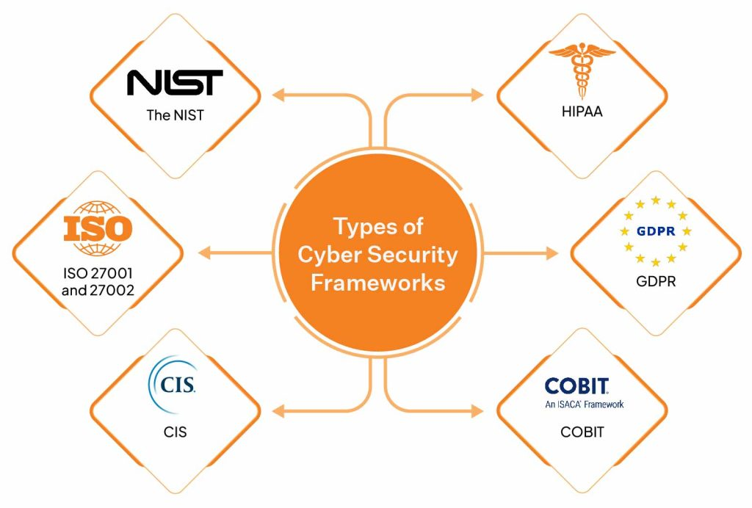
Figure 1: Cybersecurity Frameworks
(Source: Influenced by Oyeniyi and Oyeniran, 2025)
Regulatory frameworks, such as GDPR (General Data Protection Regulation) and PCI DSS (Payment Card Industry Data Security Standard), are important in the financial industry in terms of compliance. These systems are used to establish strict data protection measures to protect personal and financial information (Omolere, 2025). Also, data governance models guarantee an adequate data custodianship, control access privileges, and set a line of protocols of data utilization. Both compliance and governance frameworks are required to ensure that organizations address both legal and industry requirements and enable accountability and ongoing improvement (Pawar, 2022). In the case of an organization such as FinSure Bank (FSB), these structures are critical to reduce risks, retain customer confidence, and protect financial and personal information against risks and financial regulatory scrutiny.

2.2 Risk Management in Security Frameworks
Security risk management is a process of risk identification, evaluation, and alleviation of risks that may impact the information systems of an organization. Risk management as applied to the context of data security, entails the learning of threats, vulnerabilities and effects of sensitive data (Rajesh et al., 2024). An articulated risk management plan can also enable organizations to focus on high-risk areas and allocate resources without risking their assets.
As per the research of Mohamed, (2024), some essential elements of risk management within security systems are the risk assessment procedure, in which companies recognize and analyse possible dangers like cyberattacks, data breaches, or insider threats. Subsequently, risk mitigation measures are created to reduce the risk occurrence and threat, including additional measures like powerful encryption, firewalls, or multi-factor authentication (MFA) (Faruq, 2024). Security audits and vulnerability assessments are conducted regularly to be sure that systems are secure and that emerging risks are discovered soon.
Other models like the ISO 31000 are used to give guidelines to an organization on how to develop a strong risk management strategy that suits the requirements of the organization. Risk management should also ensure that security policies are updated and constantly monitored to meet new emerging and changing threats (Parker et al., 2023). FinSure Bank (FSB) has increased susceptibility to risks because it relies on cloud-based solutions and BYOD policy, making its approach more complex. To ensure that its financial data and customer information is not breached, fraudulent, and attacked by cyber-criminals, the bank must have a comprehensive risk management strategy.

2.3 Security Policies and Standards
Security policies and standards are two pillars of how an organization should protect, govern and comply with its data. A security policy is a document in which ideals, regulations and rules are defined to regulate the protection and management of information assets (Seetharamarao, 2023). Internationally-regulated standards of security controls implementation consist of standards, including ISO 27001 and NIST Cybersecurity Framework. These standards offer particular guidelines of putting up a system of information security management (ISMS), risk management, and regulation adherence (Pawar and Palivela, 2025). To illustrate, the ISO 27001 specifies the steps that should be followed to develop, implement, and sustain a long-term information security program.
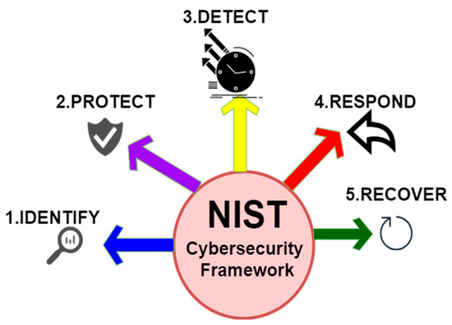
Figure 2: NIST Cybersecurity Framework
(Source: Influenced by Viegas and Kuyucu, 2022)
The significance of having sound security policies and standards cannot be overemphasized in a financial institution such as FinSure Bank (FSB). Security policies take care of employees, contractors, and third-party vendors who are supposed to be aware of their responsibilities and the measures put in place to protect sensitive data (Ekundayo and Ikumapayi, 2022). The policies are also beneficial in meeting the requirements such as GDPR that has strict guidelines to follow concerning data processing and protection. Policies need frequent revising and standards need to be followed in order to curb the developing threats and ensure a safe environment.

2.4 Service Level Agreements (SLAs)
Service Level Agreements (SLAs) are legal contracts between the service providers and its customers that specify the anticipated level of service. SLAs define performance metrics, services that are to be delivered and the roles of each party (Conceição et al., 2026). SLAs are necessary in data security and governance to guarantee that third-party service providers comply with the particular security standards and regulations. In the case of FinSure Bank (FSB), SLAs hold special significance because the company is a cloud-based service provider and depends on third-party services. The mutual understanding should also address the time frame time taken to report the incident, system downtime and data breach (Goswami and KHAN, 2025). The agreements assist in reducing risks that relate to third-party access to sensitive customer information.
Moreover, compliance with the standards introduced in the SLAs helps hold external service providers responsible to address the regulatory standards (e.g., GDPR). Considering the case on point, when a third-party cloud provider is negligent in terms of data protection practices, the SLA can be used to give penalties or enforcement tools to facilitate compliance (Stewart, 2022). SLAs as the elements of security governance by FSB are supposed to be periodically reviewed concerning the alignment with the new regulations and emergent security threats.

2.5 Literature Gap
Although numerous studies consider data security frameworks, risk management options, and compliant requirements, there is a gap in how these factors are integrated in a unified security model to fit the needs of digital-first financial institutions, in particular, FinSure Bank. To further improve real-time threat detection and compliance monitoring in the changing financial sector, future studies can look into the emergence of technologies like AI and machine learning, and their implication to the sector.

3. Designing the Security Framework for FinSure Bank

3.1 Security Policies Design
It is imperative that robust security policies are designed to protect sensitive data and to ensure compliance with the regulations. The initial phase in developing security policy in the FinSure Bank (FSB) is the definition of the main objectives, which will contain safeguarding customer data, ensuring confidentiality, integrity, and unauthorized access. Data retention policy also needs to be in place and the life cycle of financial and personal data should be managed so that data that is not required is safely destroyed (Jyoti, 2025). The people who should have access to sensitive information and the circumstances in which this should occur must be determined by access control policies, and multi-factor authentication (MFA) must be implemented on all outsourced access points to information resources.

3.2 Risk Management Strategy
Risk | Impact | Likelihood | Severity | Mitigation
Data Security | High | Medium | High | Implement strong encryption and access control mechanisms.
Cyberattack | High | High | High | Deploy advanced firewalls, intrusion detection systems, and conduct penetration testing regularly.
Insider Threat | Medium | Low | Medium | Regular audits, monitor user activity, implement least privilege access controls.
Data Loss | High | Medium | High | Backup critical data regularly and use data redundancy strategies.
Compliance Violation | High | Low | Medium | Regularly review and update policies to align with changing regulations (e.g., GDPR).
Table 1: Risk Management Plan
(Source: Self-Developed)
The risk management plan provides a list of different risks that an organization might encounter, the effects they can have, the possibility and the severity. Primary risks are Data Security, Cyberattacks, Insider Threats, Data Loss and Violation of Compliance. The risks are rated depending on their potential effect and probability, the severity being rated according to the potential effect of a risk. To address these risks the following mitigation measures are proposed such as encryption, periodic audits, data backups and compliance review to ensure that information systems in the organization are also secure and do not violate rules.

3.3 Contingency Planning and Incident Response
The development of contingency plans and two-step responses is needed to ensure the minimization of the consequences of security attacks and speed up the recovery. In the case of FinSure bank (FSB), there needs to be a contingency plan that enumerates what would be done in case of a data breach, system failure or a natural disaster. It must incorporate data recovery and system restoration procedures and communication with the stakeholders. The plan should also know the critical systems that need to be reinstated as soon as possible to continue running the business.
Step | Action | Responsible Party
Identification | Detect and confirm breach | IT Security Team
Containment | Isolate compromised systems | IT Operations
Eradication | Remove malware and vulnerabilities | Cybersecurity Team
Recovery | Restore systems from secure backups | IT Operations & Recovery
Communication | Inform stakeholders and regulators | Legal & Compliance Team
Table 3: Contingency Plan
(Source: Self-Developed)
Phase | Action Description | Responsible Party
Detection | Identify unusual activity and confirm the breach | Security Monitoring Team
Analysis | Evaluate the scope and impact of the breach | Incident Response Team
Containment | Isolate the affected systems to prevent spread | IT Support Team
Eradication | Eliminate the root cause and malicious software | Cybersecurity Response Team
Post-Incident Review | Analyse the incident and update protocols | Risk Management & Security
Table 3: Incident Response Process
(Source: Self-Developed)
Incident response entails identifying, containing, eliminating and reclaiming security threats. The contingency plan and the incident response protocols are supposed to be periodically checked with the help of tabletop exercises and corrected in case of new threats related to them.

3.4 Security Management Models and Practices
Security management models offer guidelines in the organization of security policies, practices, and strategies of risk management. The NIST Cybersecurity Framework is a popular framework that encompasses five main functions such as Identify, Protect, Detect, Respond, and Recover. There is also another helpful model named ISO 27001 that provides the recommendations on how to create, implement, maintain and enhance an information security management system (ISMS) (Agboola et al., 2023). This framework is centred on continual improvement and this means that the security practices created at FSB changes with the emergence of new threats to the organisation.
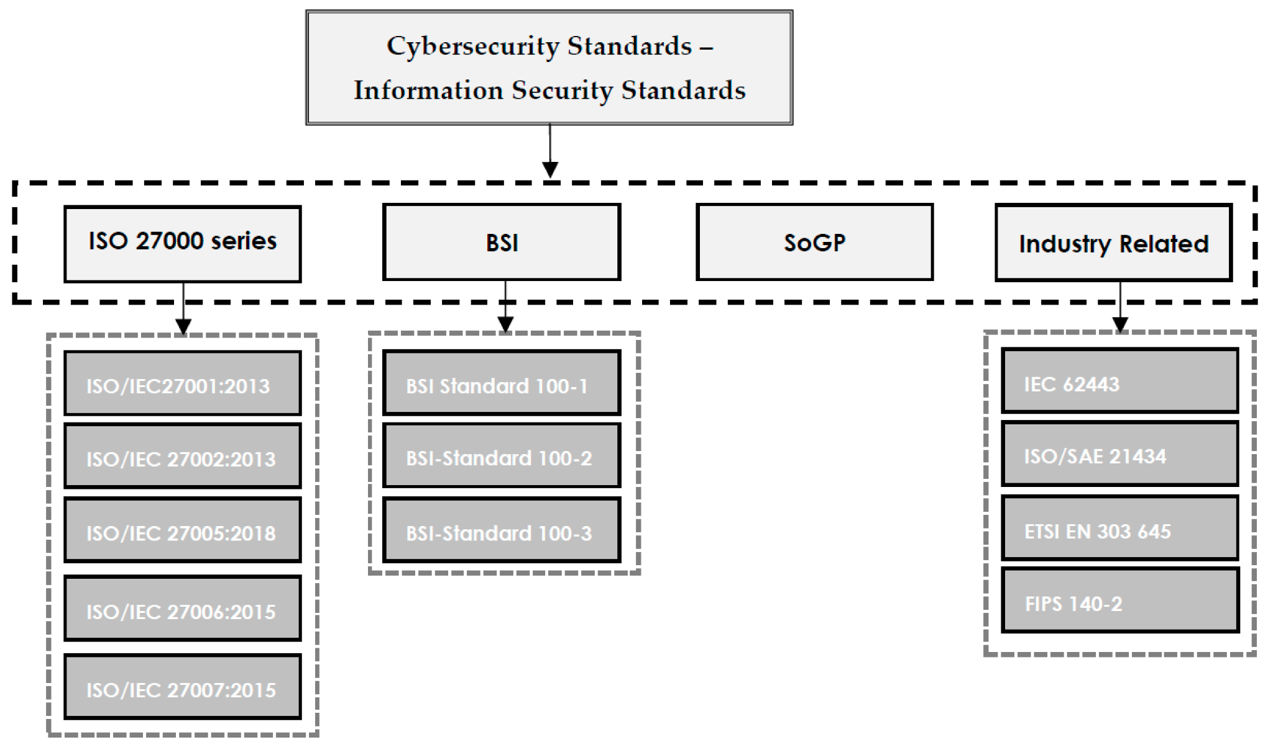
Figure 3: Cybersecurity Frameworks and Information Security Standards
(Source: Influenced by Agboola et al., 2023)
Ideal practices are frequent security tests, penetration testing as well as security information and event management (SIEM) systems to monitor in real-time (Rahi and Singh, 2026). Also, data encryption and role-based access controls (RBAC) are vital practices to guarantee that access to sensitive data is secure and that authorized staff may only access it. Such models and practices will assist FSB to reduce the risk and comply with the regulations such as GDPR.

4. Critique and Analysis of Updated Regulations and Standards

4.1 Constantly Updating Regulations and Standards is Crucial
The cyber threats landscape changes constantly, and it is essential that the regulations and standards undergo periodic changes. Due to technological development, cybercriminals also evolve and acquire new ways to attack including ransomware and advanced persistent threats (APTs), and data breaches of cloud-based services (Viegas and Kuyucu, 2022). Such regulations as GDPR, ISO 27001, and NIST might be considered the keywords to the protection of data and its compliance. However, they need to be updated and developed to solve the problem of emerging technologies, including artificial intelligence, cloud computing, and Internet of Things (IoT) (Sharma, 2026). These frameworks must be flexible enough to follow up with the growing complexity of threats, and emerging data privacy issues ensued as digital transformation progresses with renewed pace.

4.2 Case Study Analysis: Real-World Examples of Regulatory Changes
The enforcement of GDPR (General Data Protection Regulation) in the European Union is one of the brightest illustrations of regulatory changes over the last couple of years. A case in point is the example of the British Airways that was fined 20 million in 2020 due to data breach that resulted in the compromise of personal data of more than 400,000 customers, which illustrates the direct influence of the lack of adherence to the new regulations (BBC, 2020). This situation highlights the need to be proactive to regulatory changes in order to evade harsh monetary fines and negative bad publicity.

4.3 Impact of Regulation on FinSure Bank (FSB)
In the case of the FinSure Bank (FSB), the changing regulatory framework of the financial industry poses a major challenge, especially in respect of maintaining data protection laws such as the GDPR and ISO 27001. Failure to comply may lead to hefty fines, reputation, and customer loss (Demchenko et al., 2024). This involves the periodic auditing, compliance, and training of employees to make sure that the bank practices are subject to the utmost requirements of data security and privacy.

5. Application to FinSure Bank by Designing a Customized Approach

5.1 Designing the Security Framework for FSB
FinSure Bank (FSB) currently can only work on cloud-based premises and this offers both possibilities and threats to data security. To reduce the threat of unauthorized access, first, to sensitive data, encryption of data transfers and storage of all sensitive data must be compulsory (Shahzad, 2023). FSB should also adopt multi-factor authentication (MFA) to log in to internal systems and services, especially to employees and third-party vendors. A real-time detection of the vulnerability through continuous monitoring and the threat detection software, such as SIEM (Security Information and Event Management) is essential. Periodic penetration tests and security audits will also aid in proactive vulnerabilities fixing.

5.2 Governance Structure
FSB will be able to control its security and compliance duties with a strong governance model. A specific Information Security Officer (ISO) should also be a part of the governance model in charge of all the information security related matters. The Executive Committee ought to be keen in the establishment of strategic security goals and alignment to the business goals of the bank (Sharma et al., 2024). Security, compliance as well as risk committees at various levels within an organization should be adopted in order to facilitate full oversight by FSB. Moreover, FSB should define clear roles and responsibilities of each department and individual in its security policy.

5.3 Integration of Third-Party Services (BYOD, External Vendors)
As FSB uses third-party vendors as well as BYOD (Bring Your Own Device) policies, third-party risk management is essential to safeguard confidential customer data. In a bid to alleviate these risks, FSB ought to establish stringent Service Level Agreements (SLAs) which will delineate certain security requirements to all vendors and third-party partners (Ramaj et al., 2022). The use of FSB data protection standards, including encryption and controls, should be mandatory in SLA. Complete BYOD policy will also have to be adopted to limit the access to FSB systems where personal devices accessing the bank have to be encrypted and remotely wiped devices.

6. Recommendations
Strengthen Data Encryption and Access Controls
Encouraging FSB to focus on enhancing data encryption and access control is to provide defence against unauthorized customer data against unauthorised access. This will involve adopting full-end encryption of any communication channels and encryption of data in storage at cloud servers (Malik et al., 2024). Also, all users must be required to use MFA to gain access to internal systems on-site or remotely.
Establish a Comprehensive Vendor Risk Management Program
FSB needs to adopt an overarching vendor risk management program to review and oversee the security practices of the third parties. Third party vendor SLAs must have data protection criteria, breach notification, and incident reporting schedules clearly outlined (Demchenko et al., 2024).
Continuous Security Training and Awareness
FSB needs to invest in continuous security training and awareness to all employees and contractors. The training must also inform the personnel on the dangers of BYOD policies and the significance of using strong passwords (Parker et al., 2023). Regular phishing simulation drills as well as security awareness training will assist the staff to be aware of the possible risks and minimise human error as a cause of security breaches.

7. Conclusion
In conclusion, FinSure Bank (FSB) has a big dilemma in ensuring the digital-first infrastructure, especially as cloud services grow and BYOD policies are implemented. To prevent sensitive customer information leaking to these cyber threats, FSB can advance to developing a holistic security system which involves the use of encrypted data, multiple factor authentication and regular surveillance of the network. The adoption of a robust governance system by having committed security and compliance committees will help the bank not to lose track of the regulatory provisions and industry best practices. Also, the third-party risk management with the use of strict SLAs, vendor evaluation, and thorough BYOD policies is a key to avoid data breaches. By focusing on these major aspects, FSB will be able to enhance its security posture, ensure compliance, and protect its reputation within the financial sphere, the long-term resilience of its operations.

References
Agboola, O.A., Ogeawuchi, J.C., Gbenle, T.P., Abayomi, A.A. and Uzoka, A.C., (2023). ‘Advances in risk assessment and mitigation for complex cloud-based project environments’. Journal of Frontiers in Multidisciplinary Research, 6(1), pp.309-320. Available at: https://www.multidisciplinaryfrontiers.com/uploads/archives/20250530105925_FMR-2025-1-130.1.pdf (Accessed: 21 April 2026)
BBC, (2020). British Airways fined £20m over data breach. Available at: https://www.bbc.com/news/technology-54568784 (Accessed: 21 April 2026)
Conceição, F., Rocha, M. and Almeida, F., (2026). ‘Security Compliance as a Catalyst for Sustainable Partnerships: A Design Science Approach for SMEs’. Journal of Cybersecurity and Privacy, 6(2), p.53. Available at: https://www.mdpi.com/2624-800X/6/2/53 (Accessed: 21 April 2026)
Demchenko, Y., Cuadrado-Gallego, J.J., Chertov, O. and Aleksandrova, M., (2024). ‘Big Data Security and Compliance, Data Privacy Protection’. In Big Data Infrastructure Technologies for Data Analytics: Scaling Data Science Applications for Continuous Growth (pp. 349-415). Cham: Springer Nature Switzerland. Available at: https://link.springer.com/chapter/10.1007/978-3-031-69366-3_10 (Accessed: 21 April 2026)
Ekundayo, F. and Ikumapayi, O.J., (2022). ‘Leadership practices in overseeing data engineers developing compliant, highperformance REST APIs in regulated financial technology environments’. Int J Comput Appl Technol Res, 11(12), pp.566-577. Available at: https://www.researchgate.net/profile/Olumide-Ikumapayi/publication/392168505_Leadership_Practices_in_Overseeing_Data_Engineers_Developing_Compliant_High-Performance_REST_APIs_in_Regulated_Financial_Technology_Environments/links/6837d2486a754f72b58cc791/Leadership-Practices-in-Overseeing-Data-Engineers-Developing-Compliant-High-Performance-REST-APIs-in-Regulated-Financial-Technology-Environments.pdf (Accessed: 21 April 2026)
Faruq, M.O., (2024). ‘Vendor risk management in cloud-centric architectures: A systematic review of soc 2, Fedramp, and ISO 27001 practices’. International Journal of Business and Economics Insights, 4(1), pp.01-32. Available at: https://ijbei-journal.org/index.php/ijbei/article/view/2 (Accessed: 21 April 2026)
Goswami, D. and KHAN, M.N.I., (2025). ‘Cybercrime and Contractual Liability: A Systematic Review of Legal Precedents and Risk Mitigation Frameworks’. Journal of Sustainable Development and Policy, 1(01), pp.10-63125. Available at: https://papers.ssrn.com/sol3/papers.cfm?abstract_id=5279993 (Accessed: 21 April 2026)
Gounari, M., Stergiopoulos, G., Pipyros, K. and Gritzalis, D., (2024). ‘Harmonizing open banking in the European Union: an analysis of PSD2 compliance and interrelation with cybersecurity frameworks and standards’. International Cybersecurity Law Review, 5(1), pp.79-120. Available at: https://link.springer.com/article/10.1365/s43439-023-00108-8 (Accessed: 21 April 2026)
Jyoti, S.N., (2025). ‘ITSM based change management automation in cloud environments: A cross sector empirical study’. Review of Applied Science and Technology, 4(02), pp.440-472. Available at: https://rast-journal.org/index.php/RAST/article/view/29 (Accessed: 21 April 2026)
Malik, A.W., Bhatti, D.S., Park, T.J., Ishtiaq, H.U., Ryou, J.C. and Kim, K.I., (2024). ‘Cloud digital forensics: Beyond tools, techniques, and challenges’. Sensors, 24(2), p.433. Available at: https://www.mdpi.com/1424-8220/24/2/433 (Accessed: 21 April 2026)
Mohamed, I.A., (2024, May). ‘Cyber Risk Management of Third-Party Relationships: The Need for an Assessment Guidelines to Regulate Private Sectors in Libya’. In 2024 IEEE 4th International Maghreb Meeting of the Conference on Sciences and Techniques of Automatic Control and Computer Engineering (MI-STA) (pp. 7-12). IEEE. Available at: https://ieeexplore.ieee.org/abstract/document/10599763/ (Accessed: 21 April 2026)
Omolere, O., (2025). ‘Data Privacy and Cybersecurity Audits in the Era of Digital Transformation Studying Audit Challenges Related to Data Protection, Privacy Laws, and Emerging Cyber Threats’. Privacy Laws, and Emerging Cyber Threats (December 01, 2025). Available at: https://papers.ssrn.com/sol3/papers.cfm?abstract_id=5999675 (Accessed: 21 April 2026)
Oyeniyi, J.O. and Oyeniran, O.A., (2025). ‘Optimizing Information Security In Cloud Environments: A Risk Management Approach And Guide For Enterprise Cloud Security’. Journal of Cybersecurity Education, Research and Practice, 2025(1), p.8. Available at: https://digitalcommons.kennesaw.edu/jcerp/vol2025/iss1/8/ (Accessed: 21 April 2026)
Parker, M., Partridge, B., Svetcov, E. and Taylor, A.J., (2023). ‘Managing third-party risk: Framework details for risk management in medical technology’. In Advanced Health Technology (pp. 213-252). Productivity Press. Available at: https://api.taylorfrancis.com/content/chapters/edit/download?identifierName=doi&identifierValue=10.4324/9781003348603-13&type=chapterpdf (Accessed: 21 April 2026)
Pawar, S. and Palivela, H., (2025). ‘Need of paradigm shift in cybersecurity implementation for small and medium enterprises (SMEs)’. International Journal of Cybersecurity Intelligence & Cybercrime, 8(1), p.4. Available at: https://vc.bridgew.edu/ijcic/vol8/iss1/4/ (Accessed: 21 April 2026)
Pawar, S.A., (2022). ‘Business domain-specific least cybersecurity controls implementation (Bdslcci) framework for small and medium enterprises (SMES)’. Digital Repository of Theses. Available at: https://repository.learn-portal.org/index.php/rps/article/download/102/67 (Accessed: 21 April 2026)
Rahi, P. and Singh, R., (2026). ‘Modeling the Optimization Techniques of Distributed Denial of Service (DDoS) Attacks in Financial Management Systems’. In AI-Driven Intrusion Detection and Prevention for Business Cybersecurity (pp. 199-232). IGI Global Scientific Publishing. Available at: https://www.igi-global.com/chapter/modeling-the-optimization-techniques-of-distributed-denial-of-service-ddos-attacks-in-financial-management-systems/407727 (Accessed: 21 April 2026)
Rajesh, Y.S., Kumar, V.K. and Poojari, A., (2024). ‘A unified approach toward security audit and compliance in cloud computing’. Journal of The Institution of Engineers (India): Series B, 105(3), pp.733-750. Available at: https://link.springer.com/article/10.1007/s40031-024-01034-x (Accessed: 21 April 2026)
Ramaj, X., Sánchez-Gordón, M., Gkioulos, V., Chockalingam, S. and Colomo-Palacios, R., (2022). ‘Holding on to compliance while adopting DevSecOps: An SLR’. Electronics, 11(22), p.3707. Available at: https://www.mdpi.com/2079-9292/11/22/3707 (Accessed: 21 April 2026)
Sanjay Shinde, I.P.S., Patil, Y. and Wadkar, P., (2023). ‘Evolution of cybersecurity standards in financial sectors’. Madhya Bharti-Humanities and Social Sciences UGC Care Group I Journal, 84(29), pp.118-123. Available at: https://www.researchgate.net/profile/Prashant-Wadkar/publication/377064922_EVOLUTION_OF_CYBERSECURITY_STANDARDS_IN_FINANCIAL_SECTORS/links/6593bd7e3c472d2e8eaad792/EVOLUTION-OF-CYBERSECURITY-STANDARDS-IN-FINANCIAL-SECTORS.pdf (Accessed: 21 April 2026)
Seetharamarao, R.Y., (2023, December). ‘A unified approach towards security audit and compliance in cloud computing environment’. In 2023 16th International Conference on Developments in eSystems Engineering (DeSE) (pp. 623-629). IEEE. Available at: https://ieeexplore.ieee.org/abstract/document/10469536/ (Accessed: 21 April 2026)
Shah, K., (2025). ‘Auditing Cybersecurity Risks in the Digital Age: Evaluating Strategies and Protocols for Effective Risk Assessment and Mitigation in Cybersecurity Audits Within the Life Insurance Industry in India’. Digital Repository of Theses. Available at: https://repository.learn-portal.org/index.php/rps/article/view/1090 (Accessed: 21 April 2026)
Shahzad, A., (2023). ‘Cloud Security: Challenges and Best Practices in The Evolving Digital Landscape’. Computer Science Bulletin, 6(02), pp.235-246. Available at: https://csbulletin.com/index.php/csb/article/view/118 (Accessed: 21 April 2026)
Sharma, D.P., Lashkari, A.H. and Parizadeh, M., (2024). ‘Understanding cybersecurity management in healthcare’. Progress in IS. Available at: https://link.springer.com/content/pdf/10.1007/978-3-031-68034-2.pdf (Accessed: 21 April 2026)
Sharma, S., (2026). ‘Next Generation Emerging Technologies of Cloud Computing Driven E-Data Privacy, E-Security, and E-Governance’. In Practical Frameworks for New-Age Digitalization Business Strategy (pp. 1-38). IGI Global Scientific Publishing. Available at: https://www.igi-global.com/chapter/next-generation-emerging-technologies-of-cloud-computing-driven-e-data-privacy-e-security-and-e-governance/384673 (Accessed: 21 April 2026)
Stewart, H., (2022). ‘Why ISO27001 Certified Organizations Still Experience Data Leakage?’. Journal of Digital Information Management, 20(3), pp.90-103. Available at: https://www.dline.info/fpaper/jdim/v20i3/jdimv20i3_2.pdf (Accessed: 21 April 2026)
Viegas, V. and Kuyucu, O., (2022). ‘Information Security Frameworks’. In IT Security Controls: A Guide to Corporate Standards and Frameworks (pp. 67-102). Berkeley, CA: Apress. Available at: https://link.springer.com/chapter/10.1007/978-1-4842-7799-7_3 (Accessed: 21 April 2026)

