

Assessment 2

Programme:BA Business Management
Module : Data Handling & Business Intelligence
Module code : LCCB5000
Module Lecturer: Dr. Amitave Banik
Student : Zamsa Dan ( 2028094 )

Executive summary
The present report identifies the majority of product category and its quantity price that has been evaluated through the using of excel function. In such case it can be determined that the proper evaluation of PIVOT TABLE and IF function has been applied within the part I. similarly, it is found that Part 2 ha estimated the multiple source and category based on icecream flavour and its choice based on various respondent as per the interest and taste. Therefore, it needs more testing of data set and validation in a huge way to determine the performance of various category and preference of students.
Table of Contents
Introduction 4
Part 1 4
Part 2 13
Introduction 13
Conclusion 18
Reference list 19

Introduction
Data involves multiple cycles of obtaining data to ensure business accuracy and various integrations that help to keep the entire business data managed in an organised way. However, it is effective in terms of handling business and various purposes of intelligence. However, the main aim of the report is to identify the user's attention that draws specific data and information to keep the business more protective from outside threats and irrelevant patterns of forecast within the business.

Part 1
This part of the report contains the various use of excel functions to derive the reliable source and range from obtaining the accurate result of superstores sales and its product sales in the UK. However, it can be observed that the entire variables contain several categories of product and their unit price of sales as well as discount value based on category-wise products. It includes the order id, order quantity, order number, sum of sales, product category, category holder and many more (Allegri et al. 2020, p.8). Thus, the data set contains a huge source through the proper use of excel functions that can be understandable by the majority of participants in the UK. Moreover, the use of excel function mainly derives the overall determination of product category and its profit acquiring within the business. Moreover, business intelligence mainly includes multiple business analytics. It is part of integration that helps the business to keep on track and observation to protect against any threats or miss considerations (Anand et al. 2022, p.23). The function is IF, Charts and graphs, and PIVOT TABLE, as it provides the authentic source and data to manipulate the data and its various preferences for obtaining positive results from the computation. Therefore, the excel function is mainly performed to identify proper evaluation of superstore sales and overall profits.
Determine the category-wise product sales
The determination of product category and sales has been essential observed through making charts and tables based on stimulation of product category within excel. However, the product category is associated with multiple variables. Moreover, the data set contains 3 categories of product range and prices based on each category based on its selling price units (Asamoah, 2022, p.234). Hence, the overall calculations of product category and range are mainly done by using the pivot table and linear charts that have been illustrated below:
Using of PIVOT TABLE functions to evaluate the profit and per product category
Row Labels | Sum of Order Quantity | Sum of Sales | Sum of Unit Price | Sum of Profit
Furniture | 44324 | 5178590.542 | 209541.84 | 117433.03
Office Supplies | 118281 | 3752762.1 | 166268.39 | 518021.43
Technology | 52175 | 5984248.182 | 374609 | 886313.52
Grand Total | 214780 | 14915600.82 | 750419.23 | 1521767.98
Table 1: PIVOT TABLE
(Source: created by the learner)

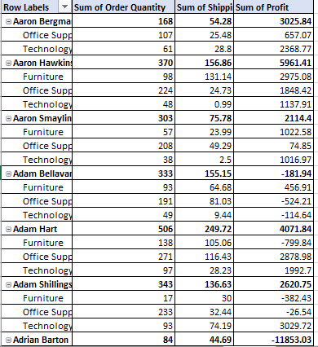

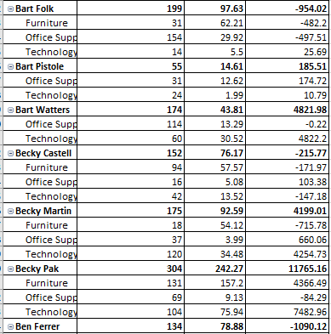
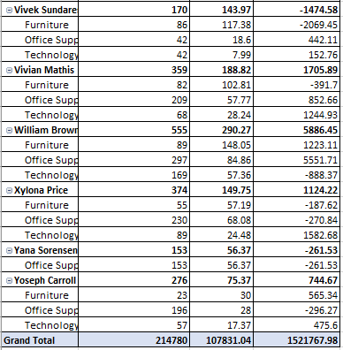
Figure 1: PIVOT TABLE
(Source: Created by the learner)

Figure 2: Category-wise product sales
(Source: created by learners)
Discussion
PIVOT TABLEis one of the most interactive ways to quickly summarise the amount of data. However, the use of a data set pivot table is mainly due to identifying the numerical data in depth to quickly anticipate the following questions. Moreover, the pivot table of the superstores and its product sales is mainly designed to gather a huge number of queries and data in a user-friendly way. Similarly, a pivot table is one interesting way that estimates the overall result of superstore products and various categories in the UK (Dai, 2022, p.22). In the above-mentioned data set, it can be observed that the PIVOT TABLE has been made by identifying the product category and range based on its selling price and unit price. Hence, it can be observed that the overview of the data set is based on various sources and product categories mainly due to enhanced profit and analysing of the overall performance based on High and low performance (He, 2022, p.22). Thus, the performance has been identified by using the proper excel function such as IF. through the use of the IF function the category and performance of the product can be determined through the above data test.
Additionally, it can be interpreted through the pivot table that illustrates the following functions and data based on identifying the category of the product in the UK. However, the results have been applicable on the basis of 3 product categories: Furniture, office supplies, and technology with its extinguished product selling profit such as 117433.03, 518021.43, 886313.52. It identifies the overall profit value through which the entire product category has been identified or estimated the entire data set and variable through the use of excel function of data validation has also been identified as with various categories of product based on input and output to exceed data (Jing et al, 2022, p.195). Moreover, it can be considered that the overall product category based on Office support and technology has been determined as 3025.84, as compared to the furniture which reflects 2975.08.
However, the selling price units has been determined as various changes as it does not exceed up the 76000 as per each product category.
Therefore, it can be clarified as the various changes of various inputs and the product category and price and hence, it identifies the other independent upon the various categories of product and its price.
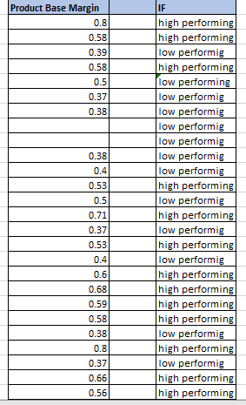
Figure 3: IF Functions based on product performance
(Source: created by the learner)
It is the most important function that has been used to identify the logical value that compares the difference between the actual value in terms of obtained true or false value as per the entire data set. However, it can be determined that the above table or data depicts the product range and performance such as high and low performance (Karam et al. 2022, p.38). Thus, the product base and margin that exceeds 50% have been determined as high performance of the product. As a result, those products have changed to gain enormous profit within the market as well as boost the demand for the product order high as earlier. Moreover, it can be identified that the supermarket product has been identified with respect to the following category of product and its multiple uses such as domestic and office. Therefore, it consists of shipping chargers and packaging costs. In addition, through the above data, it can be more determined that there are various units based on each product price and category in the UK supermarket and store selling products.
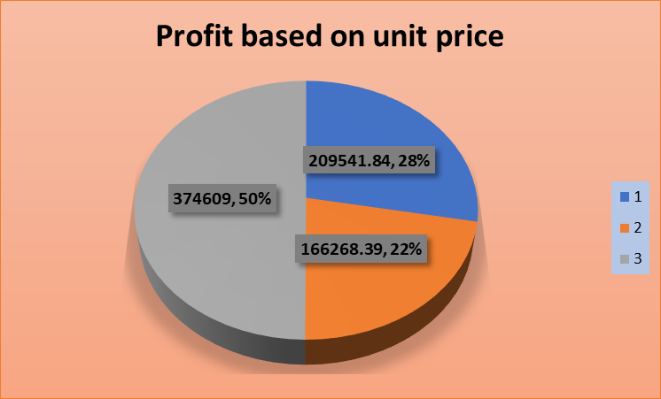
Figure 4: Chart based on profit price of the product.
(Source: created by the learner)
Discussion
It can be discussed through the above-mentioned charts and diagram that reflect the profit based on product price that is related to the variables. However, it depicts the difference between the product category and quantity in order to gain maximum product benefits through selling products (MacTavishet al. 2022, p.23). However, the range of products depicts the sum of product quantity. In such cases, it reflects the second product identifying its performance as 22% which is less than the overall performance of products 1 and 3 as 28 and 50%. Hence, it reflects the huge product performance.
Apart from this, it is validated to identify the product performance through several other medians. It can be observed that the product price and category evaluate the range and its scope to gain huge benefits for the future and its proper implication for the future.
Pre-processing the data
The Data as pre-processing is a data mining technique that mainly aims to transform the raw data for various use and efficiency within the business. However, the entire data has been procured based on the superstore product and its selling unit based on price. Thus, there are multiple tools to transform data and validation, as it is a technique to enhance the product quality and development tools to reduce the misrepresentation of the value of a range of products. However, the proper use of pivot tables is an efficient way to summarise the huge data performance as compared with smaller data to understand the facts and representation. Similarly, the product rate and quantity price of three product categories and their overall profit price are understood easily by evaluating the pre-processing techniques as mentioned in the above table and charts by the use of excel functions.
Here the pivot table and its related graph mainly provide to identify the overall product performance as it is one of the easy ways to represent the large quantity of product price based on a data set.
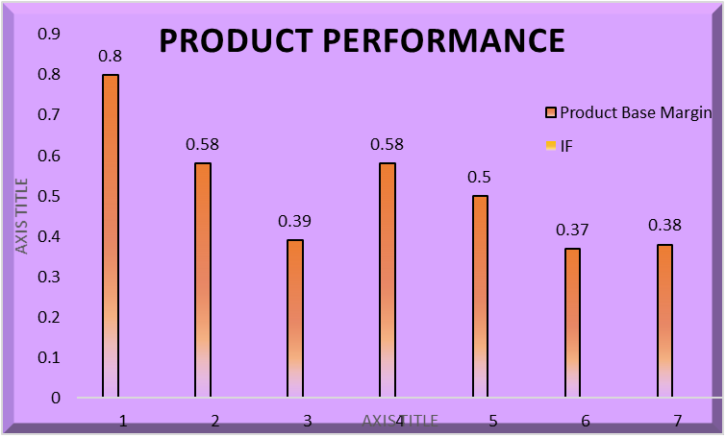
Figure 5: Product performance-based
(Source: Created by the learner)
It can be observed that the pre-processing of raw data in order to attain a better outcome or needs to analyse the data regarding every aspect of pre-processing data. However, it can be determined by the various representations of data visualisations and has involved several graphs and charts to understand the various sequences and trends of data. Moreover, it is the key to identifying every aspect of data in terms of identifying the product price and category. In such cases, the overall processing of data techniques and business intelligence has been identified by the data mining concept and applying the IF product performance (Quan, 2022, p.18). In such cases, there are several evaluations of data graphs to determine the p [product range and price to easily consider the number of price ranges as per the respective price consisting of millions of consumer ratings and demand towards the product.
Furthermore, the usage of data validation is mainly due to identifying the quantity and its price range based on UK supermarket sales. Hence, it requires more visualisations of data significantly to achieve valuable goals and outcomes regarding the data transformation.
Furthermore, through using both the excel functions which are helpful for identifying the market rate and product price to estimate a million consumers and their multiple demands regarding the products. However, it can be observed that the proper use of graphs and charts illustrated to represent the supermarket competition and quality items as per the consumer demand has basically changed as per the supermarkets and their associated variables.
Therefore, the research based on the market criteria has mainly been identified through the various effects of the product price and range as per the consumer perspectives. This is because of determining the profits through the marginal products and quantity that are allotted properly through the shipping and packaging before reaching the supermarkets' stores.
Conclusion
It can be concluded that the overall report can be identified the various product and their price range to evaluate the product guidance and its safety guidelines within the market of the UK. in such case it can be observed that there are multiple examinations of product performances based in graphs and data set including with PIVOT TABLE and IF function of excel. Therefore, the operational market leaders of the UK need to be more focused on determining its profit benefits and selling price units to be extended across the nation rather than the UK. Thus, it could be more affected to recognize more profit benefits and acquisition of data through business intelligence.

Part 2

Introduction
Discussion
Data analysis has been done on the basis of several surveys that need to be done to understand the majority of students. However, it can be observed that the survey has been done on the basis that the students can understand the fundamental approach of video games and puzzles. In addition, it can be considered as the flavoured ice cream has depend on the various responses of students who are performed through statistical software such as SPSS.
2.1 How many students like the vanilla flavour of ice cream?
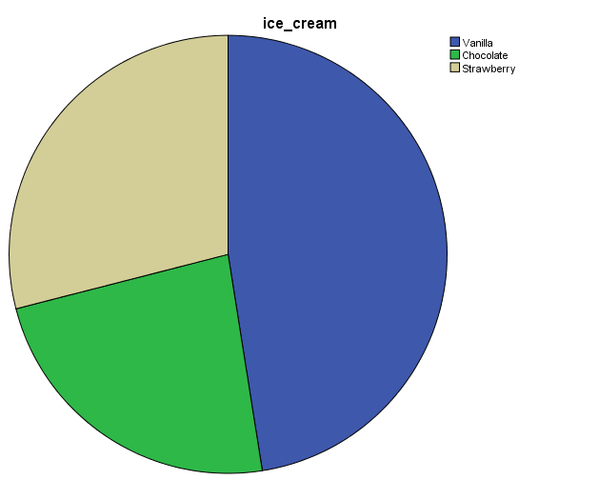
Figure 6: Number of people who likes vanilla flavoured ice cream
(Source: Self-created)
95 people like vanilla
The above figure depicts the majority of students who like to choose vanilla as per their interest. However, the histogram figure identifies that there are 95 students who like Vanilla flavoured ice cream among the entire flavoured. Since it can be observed that there are many other flavours with a variety of tastes and preferences, but the majority of vanilla flavour ice cream is high in terms of student majority (Roy, 2021, p.18).
2.2 How many students are Male and Female?
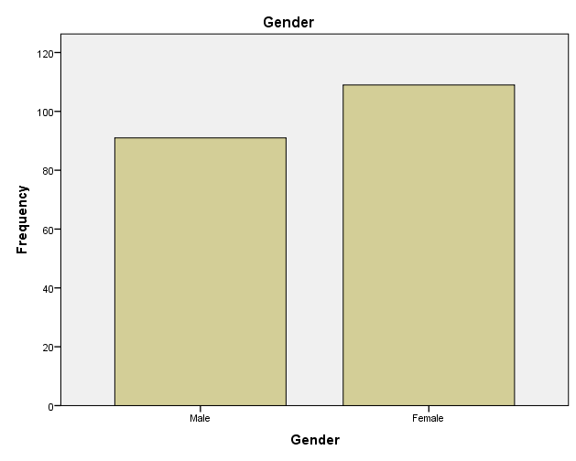
Figure 7: Gender participation
(Source: Created by the learner)
The above table depicts the majority of males and females in the survey that contains the majority of participants within the data. Hence, the table depicts that the number of female participants is higher than the male that reflecting 109 as compared to 91 males (Wang et al. 2022, p.47). This is also to identify that the percentage of males and females is not the same because they are not the same through the majority of tastes and preferences based on the survey.
2. 3 Mean and Median of the participants who like chocolates and strawberry flavour ice cream?

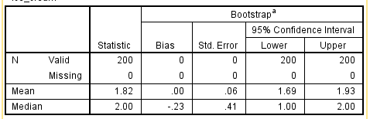
Figure 8: Number of participants who likes chocolate and strawberry
(Source: Self-created)
Discussion
The above table contains the information of various means and the median amount of the various flavours contains several ice creams flavours that have been determined through the help of SPSS. However, the valid percentage of the majority of members has been estimated as 200. In such a case the number of tables that have been illustrated through identifying the average value of chocolate flavours elaborated through frequencies that included almost 1.82 students who like to go with the chocolate flavour ice cream and 2.00 students is likely to eat strawberry flavour ice cream respectively (Daskalakis et al. 2022, p.39). Hence, it can be determined that approximately more than the 95% of students like to choose the chocolate and strawberry ice cream flavour as compared to the vanilla flavour. Apart from this, the middle series depicts the distribution regarding the lower and upper levels of confidence.
2.4 K- mean
Evaluation of data set clustering
ANOVA
 |  | Sum of Squares | df | Mean Square | F | Sig.
ice-creams | Between Groups | .027 | 1 | .027 | .037 | .847
ice-creams | Within Groups | 146.128 | 198 | .738
ice-creams | Total | 146.155 | 199
video | Between Groups | 318.337 | 1 | 318.337 | 3.285 | .071
video | Within Groups | 19189.163 | 198 | 96.915
video | Total | 19507.500 | 199
puzzle | Between Groups | 62.905 | 1 | 62.905 | .545 | .461
puzzle | Within Groups | 22873.290 | 198 | 115.522
puzzle | Total | 22936.195 | 199
Table 3: ANOVA Test
(Source: Created by the learner)
Discussion
In the context of the cluster table, it depicts as it can be done through the help of SPSS K-means of the data sets. However, the overall data have been gathered through the majority of 200 responses. Moreover, the K-means is important to determine through the above-mentioned table since it reflects the major constraints that have been identified by the overall response of participants. Therefore, the ANOVA test basically signifies the mean and median value to determine the significance and frequencies of the majority of responses of students. In such cases, the gender significance has been identified as it is closer to the value of 1, as well as it is higher than video games and puzzles. The significance of ice cream is .847 and puzzles as .461 and video games as .71. At last it can be illustrated as the difference between the different variables evaluate the degree of dependent variable who like to choose the ice cream flavour as per their own choice rather than the video games or puzzle.
2.5 Data mining methods
Data mining methods are appropriate in terms of identifying the various processes and understanding that identify the various patterns among the overall data set which is predictable to gain outcomes. However, on the other hand, the process of data or techniques has obtained quality information to predict multiple outcomes as per the survey results and findings. In addition, it can be observed various data mining techniques has been evaluated as
- Classification
- Clustering
- Regression
The above techniques and mining methods of data is an essential source that evaluate the large factors and terms of the business and maintain the positive relationship among the managers. Netflix is also an appropriate example of data mining for estimating consumer efficiency and service although it recommends various shows and web series. Amazon is also an essential source of data mining within the business for reliably enhancing its price based on service requirements.
2.6 Advantages and disadvantages of SPSS and Excel
Particulars | SPSS | Excel
Advantages | - It identifies the quick service and support regarding obtaining results as specific.  - It has the ability to handle or manage the amount of data and text simultaneously.  - It performs with the help of huge information and variable view based on data set | - It can perform through the help of strong data by gathering information regarding the company.  - It combines multiple calculations and graphs that can be done within the excel.  - The validation of data becomes easy through using excel.
Disadvantages | - The use of SPSS software is huge time consuming.  - It identifies as per the uncertainty level. | - It consists of huge risk and errors through the human capital  - The excel function cannot be designed through the various collaborative work and its formation regarding the data.
Table 5: Advantages and disadvantages of SPSS and Excel
(Source: created by learner)
However, the overall elaboration of excel and SPSS has been done through producing the proper data analyzation and validation through business intelligence. Though it is found that the proper use of computing the data set through applying the excel functions are largely extended to interpret the excellence of visualisation. However, it has been done through the help of graphs and charts to make it more effective.

Conclusion

Reference list
Allegri, S.A., Mccoy, K. And Mitchell, C.S., 2022. Compositeview: A Network-Based Visualization Tool. Big Data and Cognitive Computing, 6(2), pp. 66.
Anand, L. and Rodriguez Lopez, C., M., 2022. ChromoMap: An R package for interactive visualization of multi-omics data and annotation of chromosomes. BMC Bioinformatics, 23, pp. 1-9.
Asamoah, D., 2022. Improving Data Visualization Skills: A Curriculum Design. International Journal of Education and Development using Information and Communication Technology, 18(1), pp. 213-235.
Cardoso, E. and Su, X., 2022. Designing a Business Intelligence and Analytics Maturity Model for Higher Education: A Design Science Approach. Applied Sciences, 12(9), pp. 4625.
Dai, N., 2022. Analysis of Data Interaction Process Based on Data Mining and Neural Network Topology Visualization. Computational Intelligence and Neuroscience: CIN, 2022.
Daskalakis, E., Remoundou, K., Peppes, N., Alexakis, T., Demestichas, K., Adamopoulou, E. and SYKAS, E., 2022. Applications of Fusion Techniques in E-Commerce Environments: A Literature Review. Sensors, 22(11), pp. 3998.
He, M. and Li, Y., 2022. Application of Big Data Technology in News Media Scene Visualization Based on Internet of Things (IoTs). Mathematical Problems in Engineering, 2022.
Jing, C., Guo, S., Zhang, H., Lv, X. And Wang, D., 2022. Smartele: Smart Electricity Dashboard For Detecting Consumption Patterns: A Case Study at a University Campus. ISPRS International Journal of Geo-Information, 11(3), pp. 194.
Karam, S., Jaradat, R., Hamilton, M.A., Dayarathna, V.L., Jones, P. and BuchanaN, R.K., 2022. Exploration and Assessment of Interaction in an Immersive Analytics Module: A Software-Based Comparison. Applied Sciences, 12(8), pp. 3817.
Mactavish, M., Wecker, L. and Samavati, F., 2022. Perspective Charts in a Multi-Foci Globe-Based Visualization of COVID-19 Data. ISPRS International Journal of Geo-Information, 11(4), pp. 223.
Quan, J., 2022. Visualization and Analysis Model of Industrial Economy Status and Development Based on Knowledge Graph and Deep Neural Network. Computational Intelligence and Neuroscience : CIN, 2022.
Roy, P., Das, A., MondaL, I. and Maity, S., 2021. Data Visualization to solve COVID-19. Journal of Physics: Conference Series, 1797(1),.
Wang, P., Zhao, P. And LI, Y., 2022. Design of Education Information Platform on Education Big Data Visualization. Wireless Communications & Mobile Computing (Online), 2022.
Bibliogrpahy
Rodrigues, F., ANA, D.A. and MATOS, R., 2022. Construction Management Supported by BIM and a Business Intelligence Tool. Energies, 15(9), pp. 3412.
Stadnicka, D., Sęp, J., Amadio, R., Mazzei, D., Tyrovolas, M., Stylios, C., Carreras-Coch, A., Juan, A.M., Żabiński, T. And Navarro, J., 2022. Industrial Needs In The Fields Of Artificial Intelligence, Internet of Things and Edge Computing. Sensors, 22(12), pp. 4501.
VIOREL-COSTIN Banța, SÎNZIANA-MARIA Rîndașu, TĂNASIE, A. and Cojocaru, D., 2022. Artificial Intelligence in the Accounting of International Businesses: A Perception-Based Approach. Sustainability, 14(11), pp. 6632.

