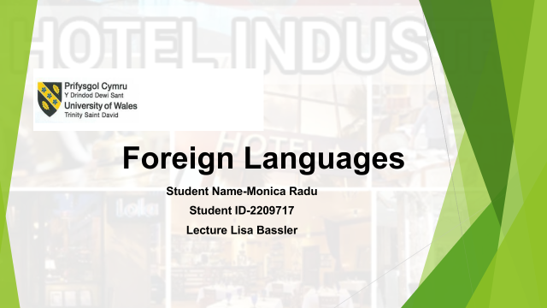
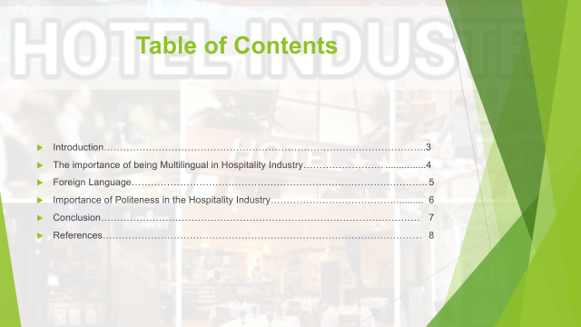



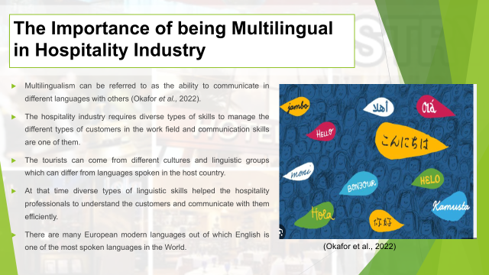

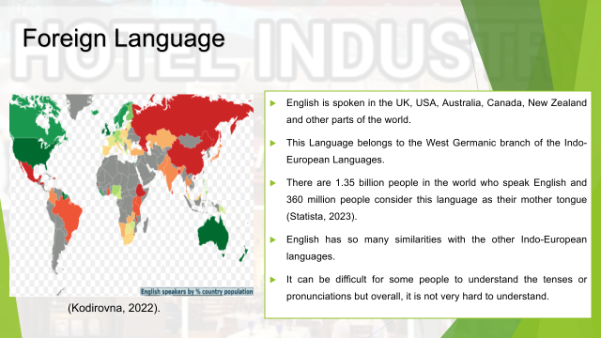

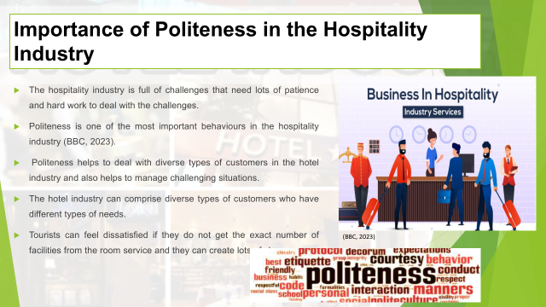

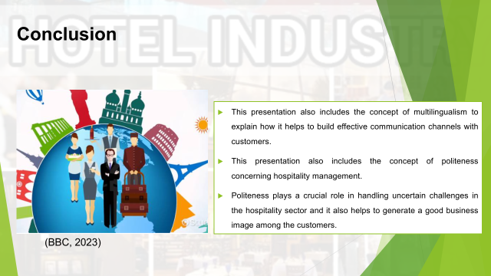

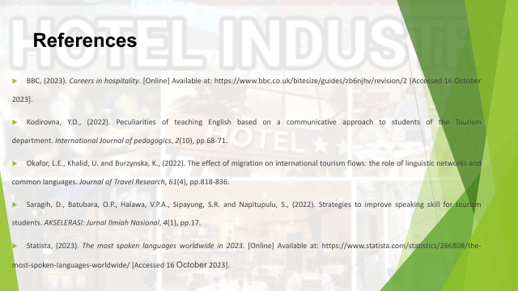

Introduction
Communication is an essential element of business and tourism management (Saragih et al., 2022). There are different languages which can help the hospitality professional to establish good relationships with the customers. This presentation explains the importance of multilingualism and politeness in managing a diverse group of people in the hospitality industry.

The importance of being Multilingual in Hospitality Industry
Multilingualism can be referred to as the ability to communicate in different languages with others (Okafor et al., 2022). The hospitality industry requires diverse types of skills to manage the different types of customers in the work field and communication skills are one of them. The tourists can come from different cultures and linguistic groups which can differ from languages spoken in the host country. At that time diverse types of linguistic skills helped the hospitality professionals to understand the customers and communicate with them efficiently. There are many European modern languages out of which English is one of the most spoken languages in the World.

Foreign Language
English is spoken in the UK, USA, Australia, Canada, New Zealand and other parts of the world. This Language belongs to the West Germanic branch of the Indo-European Languages. There are 1.35 billion people in the world who speak English and 360 million people consider this language as their mother tongue (Statista, 2023). English has so many similarities with the other Indo-European languages. The data clearly show that the majority of the global population can read or write in English so it is an easy language to learn to communicate with others (Kodirovna, 2022). It can be difficult for some people to understand the tenses or pronunciations but overall, it is not very hard to understand.

Importance of Politeness in the Hospitality Industry
The hospitality industry is full of challenges that need lots of patience and hard work to deal with the challenges. Politeness is one of the most important behaviours in the hospitality industry (BBC, 2023). Politeness helps to deal with diverse types of customers in the hotel industry and also helps to manage challenging situations. The hotel industry can comprise diverse types of customers who have different types of needs. Polite behaviour can create good impressions in the mind of a tourist which changes their perception about the destination. Satisfied tourist always recommends the hotel to their families and friends which helps them to gain new customers for the business. Tourists can feel dissatisfied if they do not get the exact number of facilities from the room service and they can create lots of chaos. The hotel staff can manage the situations with the help of polite behaviour. It is highly recommended for the managers of the Diversity Hotel and Spa to teach politeness to their staff so they can attend to the customers properly.

Conclusion
This presentation also includes the concept of multilingualism to explain how it helps to build effective communication channels with customers. This presentation also includes the concept of politeness concerning hospitality management. Politeness plays a crucial role in handling uncertain challenges in the hospitality sector and it also helps to generate a good business image among the customers.

