Ramada by Windham Bucharest Parc Hotel Consultancy Report
Emilia Ramona Sipos, 2211874

Exquisite Consultancy

EXQUISITE CONSULTANCY
11.11.2024

Content list

- Executive summary .……………………………………………..pg3
- Introduction.................................................................................................…pg 4
  - Exquisite Consultancy overview ………………………………………..…pg 4
  - Ramada by Wyndham Bucharest Parc hotel overview…………………pg 5
  - Correlation between Exquisite Consultancy and Ramada by Windham Bucharest Parc hotel………………………………………………………….pg 5
- Analysis....................................................................................................…pg 5-6
  - Identified issues description………………………………………………..pg 6
  - Identified issues impact…………………………………………………....pg 6-9
  - Customer satisfaction insights…………………………………………pg 9- 10
- PESTLE analysis………………………………………………………………….pg 10
  - Political factors…………………………………………………………...pg 10-11
  - Economic factors…………………………………………………………….pg 11
  - Sociological factors……………………………………………………...pg 11-12
  - Technological factors…………………………………………………...pg 12-13
  - Legal factors…………………………………………………………………..pg 13
  - Environmental factors……………………………………………………....pg 13
  - Ukraine conflict…………………………………………………………...pg 13-14
  - PESTLE advantages and disadvantages………………………………...pg 14
- SWOT analysis……………………………………………………………………pg 14
  - Strengths…………………………………………………………………..pg 14-15
  - Weaknesses…………………………………………………………………..pg 15
  - Opportunities………………………………………………………………....pg 15
  - Threats………………………………………………………………………....pg 15
- TOWS analysis…………………………………………………………………….pg 16
  - TOWS matrix Ramada by Wyndham example…………………………..pg 16
- Recommendations…………………………………………………………...pg 17-18
  - Action plan…………………………………………………………………….pg 18
- Conclusion…………………………………………………………………………pg 19
Bibliography……………………………………………………………….…..pg 20-23
Appendixes…………………………………………………………………….pg 24-30
- Executive summary

This report has been built in a manner that will ensure it can be an extremely useful tool for addressing the negative reviews expressed on various occasions by the guests regarding the several incidents that took place in Ramada by Wyndham Bucharest Parc Hotel via Tripadvisor, which lead to a significant decrease in customers rating. All the reviews have been carefully analysed by our consultants since 2018 to present, concluding that 70% of the negative reviews are regarding to the poor service, guests stating ‘a hotel to avoid’, ‘disinterest personnel’, ‘rude staff and thief’, ‘terrible communication and stolen values’ (Tripadvisor, 2024).
Tripadvisor is the number one tool that potential guests use prior to deciding which hotel they book; therefore, it is important to address the negative reviews, furthermore by doing so the hotel can gain not just an improved image but also attract more guests, thus increased revenues, which is ultimately every business goal.
During analysis, it was also noticed that the reviews did not receive a response from the hotel, the positive and negative both, which decreases the relationship between the hotel and its customers.
We strongly believe that any problem can be turned into an opportunity, as long as it is handled in a professional manner, therefore, we suggest a plan to improve service quality which will automatically attract positive reviews, which will follow in more customers and higher profits.
To conclude, this report has the aim to address negative reviews in a way that is beneficial for both the business and the guests and has well established steps that guarantee that if followed, the problem will not just be addressed, it will improve the entire service delivered aspect of the hotel.

- Introduction
2.1 Exquisite Consultancy overview
Exquisite Consultancy is a firm established in 2010, with a strong online presence, with hundreds of satisfied customers across United Kingdom, that targets businesses and offer expertise consultancy, efficient solutions, and bases its strategical plan on thorough analysis to identify the areas for improvement whilst combining the analysis with relevant theories in the field. At the same time, upon analysis and identifying the areas that need improvement, we offer a fresh perspective by tackling the identified issue or issues and offer optimal solutions that are proved to be efficient. Our dedicated team and experienced consultants will tackle all the obstacles and develop tailored solution to every client’s personal needs and resources. Furthermore, we don’t stop at addressing the issue/s identified, we offer integrated solutions for the hotel’s future, the solutions we offer are long-term and can be at any point with success.
Exquisite Consultancy appreciates that hospitality is a very challenging field, activating in a market that is volatile, for example COVID-19 pandemic and cost of living crisis are unpredictable events that can impact majorly hospitality. Other challenges that hospitality market players face are high operational costs, demanding customers, technological improvements, or sustainability practices. However, consultancy experts have solutions for all of these challenges, as they have a deep understanding of these implications and they are very efficient because they can save years of trying to find solutions that might not even be the most effective ones.
As stated, Exquisite Consultancy uses theory and relevant tools to identify a business strengths, opportunities, risks, weaknesses, internal and external challenges. Particularly for this case, there will be a combination of frameworks of SWOT, PESTEL, TOWS, with the purpose to gain a better understanding of the existing issue or issues, rather than restricting the analysis to just one of them, which could lead to omission of some aspects. We, as a company, pride ourselves with walking an extra mile when dealing with any customer, as a proper investigation can lead to a proper solution.

2.2 Ramada by Wyndham Bucharest Parc hotel overview
Ramada by Wyndham Bucharest Parc Hotel is known for its very well-placed location, near Bucharest town centre, just a few minutes away from the largest mall in the town, as well as the largest parc, and also close to the most popular tourist attraction from Bucharest, capital of Romania, which is the famous ‘Triumphal Arch’. All of the above give the hotel plenty of opportunities to attract a lot of guests. Other features that the hotel promotes are ‘comfortable accommodations at a great prices’ (Ramada, 2024), free Wi-fi, meeting rooms, relaxing lobby, restaurant and bar. Special treatment is offered to guests, ‘Vitality Wellness Club Spa is free of charge for the guests that are accommodated in Business Class rooms’, and also, all guests that are accommodated in Queen or Twin rooms benefit from special discounts (Booking, 2024).
2.3 Correlation between Exquisite Consultancy and Ramada by Windham Bucharest Parc hotel

It is true that hiring a consultant represents a cost, however, in return you receive a strategy that will be useful in your hospitality business future to come, therefore it is rather an investment than an expense. Consultancy offers unique and personalised guidance that enables growth within the field that was identified as problematic in a very short period of time, without having to spend years of trying to figure out how to sort out an issue. Specifically for Ramada by Wyndham Bucharest Parc, Exquisite Consultancy will offer personalised staff development, personalised training by our coach because we are aware that employee performance impact directly guests experience; a strong prove is the amount of the negative reviews towards staff, thus we plan to ensure that staff receive customer service training and leadership development.
- Analysis
According to Daoust (2021) guests experience represents the core of hospitality, and staff represent a reflection of the hotel and offer guest’s first impression, therefore, for an excellent customer experience staff must show a unique set of skills and behaviours- by doing so, the guests will be able to make a clear association between excellent customer service and the hotel and also, they might become loyal clients. However, excellent customer service is not easy to achieve, it requires constant work from the staff part, they need to be there for guests before booking, during booking, and after booking, and they need to show empathy, respect, and care at all times towards guests.
  - Identified issues description
The identified issue of several complaints against poor customer service can be addressed and solutioned, however, the first step is to analysis in depth this matter. Savage (2023) suggests that according to American Customer Satisfaction Index Report more and more guests leave bad reviews and complain about customer service and the outcome is a 5% decrease since 2018 (Appendix 1). This information is relevant for Ramada by Wyndham Bucharest Hotel Parc because it proves that when customer service suffers, the business suffers as well and many hotels face these challenges, therefore it requires special attention and proper solutions, which is exactly what our company delivers.
3.2 Identified issues impact
The impact of poor customer service is vast and can affect any business deeply, and on the opposite side, an excellent customer service attracts so many benefits for any business; that is the reason why it is crucial to address it properly. Ramada by Wyndham Bucharest Hotel Parc has negative feedback that repeats itself, which means it is not just casual customers having expectations too high, or perhaps they interacted with staff that had a bad day; thus, it is worth having a look at the impact that all these negative reviews have.
As Banerjee states, “poor customer service can not only impact the present/ future sales standard but can negatively impact a business in a variety of ways. This is especially true for businesses that rely on repeat business and positive word-of-mouth advertising for its success. In addition to running the risk of aliening current customers with sub-standard service levels, chronically poor service can impact the business potential for attracting new customers as well (Banerjee, LinkedIn, 2014).”

Point by point, the impacts of poor service are the following:
- Current customers loss. Customers are likely to be turned away by poor customer service, which can lead to offering competitors those clients, as they will seek same service offered elsewhere. Furthermore, once a customer was left with a bad impression, it is hard to win him back and make that client change his mind, which, if repeated with more customers, ultimately leads to a bad reputation, decrease in profits, and in more serious cases, it can lead to a business failure (Business advice, 2024). Surveys reveal that a significant percentage of 67% of customers admitted they abandoned a brand due to poor customer service, and 62% would not choose a service again or purchase a product if they are disappointed at the first attempt. On the opposite, 73% of the customers surveyed declared they stay loyal to brands because of helpful agents (LTV plus, 2024). These percentages illustrate the dimension of poor customer service, and how important it is to offer good customer service, especially in hospitality industry, where guests experience relies on the treatment they receive from the staff whilst their accommodation.
- Loss of potential customers. Potential customers can be very easily lost because of word mouth to mouth phenomenon; a single bad comment can turn away another few potential customers. There is data behind this fact, surveys showing that 54% of customers will talk about their experience with friends and families and they will form a negative opinion already without even entering the business premises (Schwartz, 2020).
- Brand image and loss of reputation. When customers talk about a bad service, they also talk about the brand that offered that poor service, so the brand image and business reputation are automatically affected at the same time. Research suggest that businesses that prioritize customer service can improve their brand image with 13% (LTV plus, 2024).
- Loss of competitive edge. Gunther McGrath (2013) talk about the concept of competitive edge and describes that ‘learning to thrive in a transient advantage economy’ is essential when a business is seeking success. Same author suggests that competitive business is a business that understands the importance of customer service and that excellent customer service demonstrates competitiveness, and at the other pole, a poor customer service represents the end of competitive advantage.
- High customer acquisition costs. Bishop (2023) highlights that customer acquisition implies a higher cost than customer retention, and that a damaged reputation can influence a business to invest in marketing with the goal to attract new clients that would replace the lost ones due to bad reputation; the important aspect is that this cycle can repeat itself continuously without having addressed the main root, which is poor service, and so, even more clients are lost in the process of trying to gain new customers. Thus, our company devise of investigating in depth until we reach the root cause of an issue becomes very useful and effective, saving Ramada by Wyndham Bucharest Parc hotel time, efforts and money.
- Legal issues. Poor customer service does not stop when a negative review is written, those unhappy guests can judge an honest mistake as an act of discrimination and decide to take matters to court, which can obviously damage seriously the hotel’s public image; a scandal is always highly mediatised in press and public nowadays is very up to date with every information due to popularity of technology. In Ramada by Wyndham Bucharest Parc Hotel the danger is represented by the accusations of theft made via TripAdvisor, where there are more than just one allegations of valuables going missing (TripAdvisor, 2024).
- Employee turnover. Surveys demonstrate that no less than 63% of employees experience burnout, which makes them even more vulnerable when dealing with customers. With the purpose of not being biased, two approaches have to be discussed:
- Sometimes customers have their own frustrations, and they would be unhappy regardless of the staff attitude, and they can even show a history of complaining about everything.
- Sometimes customers are right, and the staff are indeed the ones that create unpleasant situations due to being rude, unprofessional, careless, or non-cooperative due to being stressed and tired.
In both cases, businesses must stay on top of everything and handle situations with professionalism, clients cannot be told that they are not right, and staff cannot be told off for experiencing burnout. The solution is a proper customer service strategy that is easy for staff to access, however that will be lately detailed in this report.
- Loss of profits. Poor customer service has a domino effect on a business, as it leads to fewer customers both existing and potential ones, loss of reputation, loss of competitiveness, potential loss of employees, higher costs trying to improve the damage, which ultimately leads lower sales and to decreased profits.
3.3 Customer satisfaction insights
Theorists elaborated cause effect relationship models (Appendix 2 and appendix 3) that defines how customer expectations defines perceived quality, perceived value, then customer satisfaction determines complaint if not met or, on the contrary, customer loyalty if met. According to the same theorists, complaint handling plays an important role in the impact upon customer satisfaction, implying that if handled properly it can increase it, and on the other hand, if handled poorly or not addressed a more negative effect occurs (Johnson, Gustafsson, et al, 2001). This instance particularly applies to Ramada by Wyndham Bucharest Parc hotel, as it was noticed upon research that some online complaints did not receive any response from the managerial team (as stated earlier in this report).
Studies (Guido, 2014) indicate that customer satisfaction is a subjective topic, and the simple fruition of a service does not automatically generate the customer satisfaction level, it is the entire consumption experience that will contour their satisfaction or dissatisfaction. Tourists’ satisfaction can be defined as the result of the balance between expectations and the experience they perceive, where expectations can be influenced by emotional aspects, personal preferences, previous experiences, hopes and desires, or other subjective aspect that differ from one individual to another (Appendix 4). Furthermore, Addis and Holbrook (2001) suggest that there does not exist a common understanding in regards to consumer experience and what exactly it implies, however the process in between the customers anticipation of service use up to the remembrance of the experience is the point that a business can control, it is the step where the customer interacts with the business, thus representing a key element of the strategy we will later on recommend.
There are also studies (Anderson, 1973) that suggest that psychology plays a role in customer satisfaction, in a way that when an individual experiences are disconfirmed the perceived product or service performance will be influenced and will form the customer satisfaction level for that particular individual. Poor customer satisfaction arises when there is a significant gap between high consumer expectations and actual product or service performance, which is again controllable, if the interaction of the customer with the service is well managed, which is our proposal for this case.
Therefore, cultivating excellent customer service is a matter that has to take into consideration several aspects, and a deep understanding of this complexity is required, and that is why we thrive in elaborating solutions based on thorough research, relevant theories, and effective measures. Several studies, older and more recent have been cited so far in the desire to offer a non-biased perspective, to use various sources in order to gain different views expressed by different theorists, and no discrepancies were identified, all resources show that customer satisfaction, although is subjective, can impact any business. At this point, the report will focus on the most popular frameworks Pestel, Swot and Tows, with the aim to identify the strengths that Ramada by Wyndham Bucharest Parc hotel possess and the opportunities available, to bring some light upon this report.
- PESTLE analysis
There are six external factors that influence any business (Appendix 5), political, economic, social, technological, legal, environmental (PESTLE) and the analysis of these factors is important because it offers an insight into how the business analysed is performing from different angles (Makos, 2019).
4.1 Political factors
Pollical factors are represented by the government and politics external forces (Corporate Finance Institute), and applied to Ramada by Wyndham Bucharest Parc hotel the analysis of these factors can be described as:
The political climate of Romania, as described within the European Commission 2020 Country Report, illustrates a constant political shift, legislative instability, decision-making process that is unpredictable, a reduced institutional quality and a high corruption rate (US Department of state, 2023) (Appendix 8).
Careful assessment and consultations are required from investors in such a challenging political environment, as business climate can suffer rapidly complications due to frequent government changes. Furthermore, unfortunately, these external factors are out of any business control, the only measure that Ramada by Wyndham Bucharest Parc hotel can take regarding this challenge is caution, diligence, and the skill to adapt quickly to these changes.
4.2 Economic factors
Statista (2024) describes Romania’s financial situation as ‘showcasing its commitment to economic progress’ based on the fact that statistics freshly released, show that since 1990 Romania has evolved economically on different levels:
- new enterprises were created in Romania between 1995-2022, which supported gradually the economy (Appendix 6)
- the average net monthly salary has met a continuous growth between 2005-2023 (Appendix 7)
- rate of public consumption has registered significant growth between 2017-2024
- another significant growth is forecasted for the year 2025
- inflation rate has dropped down since 2022
- unemployment rate is looking positively between 2018-2023
A quick glance at all of the above statistics results highlight a positive economical environment which matters a lot for any business that is seeking to thrive internationally, without having a risk in a country’s economic state; and Ramada by Wyndham Bucharest Parc hotel does not make an exception. Inflation rate dropping down in tandem with unemployment rate decreasing and rate of public consumption growth illustrate a background than can be fructified by the hotel, activating in a market that experiences economic growth and a positive consumption rate (Wood, 2022). All of these aspects can be translated for the hotel into a favourable environment, with several advantages that the business can benefit from; activating in a country where citizens show potential for purchasing products or services and citizens that are employed can only mean that there is financial potential, there are people with money that are willing to spend those money, and all the businesses need to do is to activate efficiently. However, for Ramada, there is a slight question mark here, as some level of inefficiency is demonstrated by the poor customer service complaints, therefore focusing on improving this aspect is supported by the country’s economic picture.
4.3 Sociological factors
Demographics facts can be very useful in the analysis of sociological factors, as businesses can find out the climate where they activate and can gain an understanding of the customers they are targeting through their business.
Worldometer (2024) statistics show that Romania has at present a population median age of 42.9 years (Appendix 9), 54.9% of the population is urban (Appendix 10), and Bucharest, where Ramada by Wyndham is located has the highest population density, registering 1,877,155 citizens (Appendix 11). All of these dates reflect a positive aspect of the market, where the hotel has a vast market to target, the age group is beneficial as well, therefore the hotel can fructify this area.
Dumitrasca (2022) suggest that demographic changes, if they occur, will impact the economic development, which can further impact all the business. For example, if Bucharest average age changes, automatically the business for Ramada by Wyndham will be sensitively impacted; the targeted audience shifts, thus the sales strategy will have to adapt. A demographic change that has the potential to affect Ramada by Windham Bucharest Parc hotel is the emigration trend that is currently unfolding in Romanis and has intensified beginning with the 2020s’. This particular trend can directly affect Ramada hotel, as the population that emigrates is represented by the young ones that seek a better living in a foreign country, and these young people are potential customers; however, this is a phenomenon that is out of control and there aren’t any actions that the hotel can implement in order to avoid it, more than taking good care of existing customers and existing employees.
4.4 Technological factors
Technology is continuously changing and evolving, and the right path for any business is to adapt to the latest trends and embrace these changes in a manner that can turn this challenge into an opportunity.
According to McKinsey (2021) Romania is a little behind with technology trends, in comparison with other countries from Europe. For Ramada by Wyndham Bucharest Parc hotel, this information can be translated into a major cost saving, as implementing technological features such as digital key, guests self-check-in via an app, or any other technological features meant to make guests life easier involve very high costs, thus this not necessarily an external factor that should be a reason for worry.
4.5 Legal factors
Romanian law is currently going through changes in order to increase transparency and that slows down the decision-making process for the economic legislation. Furthermore, several investors have brough to light the fact that they were significantly challenged by the excessive time required in Romania for obtaining licences, approvals, permits and other juris dictionary matters that need to be completed prior to operating as a registered business.
Although the national legal regime does not illustrate necessarily a positive picture, there are also international implications. By being an EU member state since 2007, Romanian legislation must implement directives set by European Commission, therefore some positive legal actions are expected. The most relevant change in Ramada by Wyndham Bucharest Parc hotel case is revised competition regulation that was aligned with European commission criteria’s, which is beneficial because this approach supports business fairness. (US Department of state report, 2023).
4.6 Environmental factors
There are several natural disasters that are likely to occur in Romania (Appendix 12) from floods to earthquakes or high temperatures and heat waves (Climate change knowledge portal, 2023). Same all of the other external factors identified so far, it is out of control, therefore no solutions are to be recommended, the analysis has the purpose to highlight the external factors influencing the business in order to offer a greater understanding of the external environment, and at the same time, to help anticipate potential threats.
4.7 Ukraine conflict
The current conflict in Ukraine is also an external factor that can impact any business in Romania, and it was not mentioned under any of the PSTLE analysis because it can affect on several aspects rather than one. Romania shares a border with Ukraine, helped Ukrainians refugees, and, extremely important, if Russia would decide to disrupt oil and gas supply the entire country’s economy would be seriously threatened. Rainsford (2023) suggests that the Ukraine conflict is ‘a real danger for Romania’ and reportedly, parts of a Russian drone were found on Romania territory, leading to the Defence Minister and country President to initiate investigations.
For Ramanda by Wyndham Bucharest Parc hotel the risk is major, if the conflict would escalate the business is in serious danger, the implications would be several and it might even lead to hotel close down, therefore this matter is one that cannot be ignored.
4.8 PESTLE advantages and disadvantages
The main advantage of PESTLE analysis that it brings to light the opportunities on which the business can capitalize, which in Ramada by Wyndham Bucharest Parc hotel is represented by the economical growth and rising rate of public consumption. On the other hand, the main disadvantage is that although it is a great tool to identify the external environment and how it can affect the business, sometimes the data can impact the analysis by being insufficient. Also, the PESLE analysis does not address the internal influencing factors for the business, therefore the next step is to use a tool which addresses this part, and it is called SWOT analysis.
- SWOT analysis
Colos (2024) published an article where it was stated that SWOT analysis is a useful structure that companies can use to insights towards identifying the strengths and how to maximise them, identifying weaknesses and how to address them, recognising the threats and determining the opportunities which the business can exploit.
5.1 Strengths
- located in the business district of Bucharest, and near important tourist attractions
- various facilities for guests to indulge themselves, such as heated indoor pool, sauna, aerobics and fitness space, beauty centre, and gift shops
- 16 conferences rooms
- 2 restaurants providing Romanian and international dishes
- Strong brand identity
Insight: although so far, the report focused on using relevant theories and tools that brought to light a lot of negative aspects, it needs to be mentioned that Ramada by Wyndham Bucharest Parc hotel has remarkable strengths, well established operations, has exclusive offers for loyal guests, hosts celebrations and weddings, all of which demonstrate that the hotel has potential and business practices that brought the hotel success so far.
5.2 Weaknesses
- Several customer complaints in regard to poor customer service which can lead to loss of customers
- Allegations of theft which can develop to legal issues
- Negative customer feedback left without any response which reflect poor complaint management
Insight: the weaknesses identified are going to be addressed in recommendations sections
5.3 Opportunities
- Ascending overall country economy
- Arising public consumption national rate
- Population average age
- Positive employability rate
- High density population
- Decreasing inflation
Insight: all of these opportunities represent a foundation for the future possible strategies to attract more customers, to improve brand image, and to increase revenues in total.
5.4 Threats
- Ukraine conflict
- Political instability
- Corruption
- Natural disasters
- Competitors
Insight: the threats recognised are serious, however the hotel can keep being diligent and proactive, by being aware of the potential risks and predict the threats.
- TOWS analysis
At this point, after both internal and external factors have been recognised, now the report can focus on identifying the path to align Ramada by Wyndham Bucharest Parc hotel resources with the external environment. TOWS has the advantage of combining SWOT and PESTLE elements and can be a useful tool for developing future strategies that can increase the business competitiveness (Appendix 13).
6.1 TOWS matrix Ramada by Wyndham example
External factors\Internal factors | Strengths (s)  - Location  - Facilities  - Brand identity | Weaknesses (w)  - Customers complaints  - Theft allegations  - Unsolved complaints
Opportunities (o)  - Positive economy  - Positive consumption rate  - Favourable average age  - High density population | S-O strategies  - Re-invest profits in consultancy  - Use brand to increase potential customer’s trust  - Target young people that travel for businesses purposes  - Attract the business clients to return for personal holidays | W-O strategies  - Training staff to handle complaints with confidence  - Implementing strategies to enhance communication with customers  - Initiate a problem-solving team with clear actions to ensure complaints solving
Threats (t)  - Ukraine conflict  - Natural disasters  - Political instability  - Corruption  - Competition | S-T strategies  - Use the brand to attract new customers  - Seek partnerships with stakeholders to solidify the hotel’s market position | W-T strategies  - Develop rewarding programme for loyal customers  - Offer discounts to clients that were disappointed by the hotel (proved, not just the ones at allegations stage

- Recommendations

Recommendation | Why? How? | Benefit/ s | Cost
Customer service training | One of our coaches working closely to the hotel’s front desk department team with the purpose to ensure staff behaviours are aligned with the brand values, their skills are boosted whilst increasing their self-confidence. | preparing staff to interact with professionalism and confidence even with the most frustrating customers. | £2,000
Leadership development | A coach mentoring the hotel managers in order to strengthen their leadership skills | Motivates the entire team and is crucial for the business success, as all the directions start from the executives and managers, so if they are properly trained, they will deliver professionalism and efficiency, which is beneficial on three tiers: customers, team, business | £3,000
Digital marketing strategy | Our consultants can tailor social media strategies to the audience targeted by having a deep understanding of each group segmentation expectations, needs, hopes, and dislikes | A campaign specially designed and tailored for Ramada by Wyndham will ensure reaching the right audience and attract the right potential customers | £4,500
Customer experience | Our coaches can train staff and update them upon most recent protocols within hospitality whilst offering them new skills | A highly professional staff ensures a memorable experience which attracts repeat business and favourable online reviews (Alemar, 2024) | £2,000
Streamlined processes | Our consultants can carefully revise processes and offer improvement from housekeeping department, to front office or food and beverage departments | By implementing streamlined processes, staff gain coordination , costs can be cut down, time can be saved, service quality is improved. | £3,000
Reputation management | A coach can train staff how to handle complaints coming directly from customers, and also the managerial team how to handle online complaints | Nowadays online reviews are extremely important and can be a factor in deciding to book, therefore a coach mission is to learn team members how to turn negative feedback into a positive one | £2,000
Property management software | Our experts can revise the booking confirmations, reminders, automated emails sent to customers | This communication with customers is part of their experience with the hotel, and optimal communication can ensure the guest perceives the quality of the hotel (Yee Cui Choi, 2022) | £3,000

All of the above recommendations are proven to be efficient and as a prove stands also the fact that all of them can be measured. After implementation our experts can monitor the performance and measure the effects as it follows:
- Customer service training and leadership development can be measured in number of repeated businesses, number of total booking increase percentage
- Property management software, reputation management, streamlined processes, customer experience, and reputation management can be measured by the number of positive reviews and feedback and by calculating the decrease of negative reviews in percentage
- Digital marketing strategy efficiency can be easily measured by calculating the total number of new customers attracted
7.1 Action plan
Number | Problem | Solution | Desired outcome | Time scale | Competition date | Planned budget
1 | Customer complaints | Customer service training, leadership development | Empowered staff to treat guests with confidence, skilled managers to motivate teams | 3 months | 01.03.2025 | £4,000
2 | Theft allegations | Streamlined processes, reputation management | Each team will have clear coordination, and managerial team will have the appropriate skills to handle serious guests’ issues | 3 months | 01.03.2025 | £5,000
3 | Negative feedback and reviews | Digital marketing strategy, customer experience, property management software | Enhanced guest experience through excellent customer service, through smooth communication in tandem with a platform to target the right potential customers ensure more clients and higher profits | 3 months | 01.03.2025 | £9,500
TOTAL £18,500

- Conclusion
Hospitality is for certain a field that is driven by the guest’s experience, and this report focused on presenting external factors in tandem with internal ones in order to obtain a clear vision of the external and internal environment for Ramada by Wyndham Bucharest Parc hotel. The identified issues were addressed in a non-biased manner, and seven recommendations were outlined in correlation with the resources that the hotel poses, therefore our entire approach is a personalised one and tailored to the hotel’s current situation. It is important to outline that all the measures proposed are feasible, realistic, achievable and measurable.
Thank you for taking time to read this report, we are looking forward to hearing from you and hiring Exquisite Consultancy to take your hotel onto new pathways for success.

Bibliography

Addis, M., Holbrook, M. B. (2001) On the conceptual link between mass customisation and experiential consumption: an explosion of subjectivity. Journal of consumer behaviour, 1 (1), 50- 66. Available at: https://www.researchgate.net/publication/229545865_On_the_conceptual_link_between_mass_customisation_and_experiential_consumption_An_explosion_of_subjectivity (Accessed: 05.11.2024)
Alemar, S. (2024) Customer service in the hotel industry: nine ways to improve. Available at: https://www.canarytechnologies.com/post/customer-service-in-hotel-industry (Accessed: 12.11.2024)
Anderson, R., E. (1973) Consumer dissatisfaction: the effect of disconfirmed expectancy on perceived product performance. Journal of marketing research, 10 (February) 38-44. Available at: https://journals.sagepub.com/doi/10.1177/002224377301000106 (Accessed: 08.11.2024)
Banerjee, M (2014) How does poor customer service affect a business? Available at: How Does Poor Customer Service Affect a Business? (Accessed: 10.11.2024)
Bishop, C. (2023) Customer acquisition cost and tips to improve your CAC. Available at: Customer acquisition cost (CAC): How to calculate & improve it (Accessed: 08.11.2024)
Booking (2024) Ramada by Wyndham Bucharest Parc. Available at: https://www.booking.com/hotel/ro/bestwesternparchotel.en-gb.html (Accessed: 09.11.2024)
Business Advice (2024) Nine reasons businesses lose customers. Available at: 9 Reasons Businesses Lose Customers | Business Advice (Accessed: 09.11.2024)
Catala Consulting (2022) Why hiring consultants and coaches is the cheat sheet to success in hospitality industry. Available at: https://catalaconsulting.co.uk/consultants-coaches-hotel-industry-success/#:~:text=Consultants%20and%20coaches%20offer%20specialized,satisfaction%2C%20and%20achieve%20sustainable%20growth. (Accessed: 07.11.2024)
Climate Change Knowledge portal for development practitioners and policy makers (2023) Romania climate change overview. Available at: Romania - Vulnerability | Climate Change Knowledge Portal (Accessed: 10.11.2024)
Colos, L. (2024) Wyndham hotels and resorts: business model, SWOT analysis, and competitors. Available at: Wyndham Hotels & Resorts: Business Model, SWOT Analysis, and Competitors 2024 - PitchGrade (Accessed: 11.11.2024)
Corporate Finance Institute (2022) Pestel analysis. Overview, factors, analysis, and financial analysis. Available at: Bing Videos (Accessed: 11.11.2024)
Daoust, C. (2021) The importance of customer service in the hospitality industry. Available at: https://hotello.com/en/customer-service-hotels/#:~:text=Indeed%2C%20an%20excellent%20customer%20service,will%20become%20true%20brand%20ambassadors. (Accessed: 07.11.2024)
Dumitrascu, Trica, et al (2022) . Journal of sociology. Population of Romania- shapes and demographic trends. Available at: Microsoft Word - 04-VDumitrascu.....doc (Accessed: 10.11.2024)
Filip, Novak, et al (2022) Bridging the gap: Transversal technologies to boost Romania’s resilience. Available at: Securing Europe Romania (Accessed: 11.11.2024)
Guido, G. (2015) Customer Satisfaction. Available at: https://www.researchgate.net/publication/313966638_Customer_Satisfaction (Accessed: 09.11.2024)
Gunther McGrath, R., Harvard Business Review (2013) The end of competitive advantage. Available at: The End of Competitive Advantage (Accessed: 10.11.2024)
International hotel consulting services (2023) Why is it important to hire a hotel consulting company? Available at: https://www.ihcshotelconsulting.com/blog/why-is-it-important-to-hire-a-hotel-consulting-company/ (Accessed: 10.11.2024)
Johnson, Gustafsson, et al. Journal of economic psychology 22 (2001) 217-275. The evolution and future of customer satisfaction index models. Available at: https://www.researchgate.net/publication/237193148_The_evolution_and_future_of_national_customer_satisfaction_index_models (Accessed: 11.11.2024)
Makos, J. (2019) PESTLE analysis examples to better explain the framework. Available at: PESTLE Analysis Examples to Better Explain the Framework (Accessed: 11.11.2024)
MBO partners (2024) Nine effective marketing strategies for consultants and self-employed. Available at: https://www.mbopartners.com/blog/how-market-small-business/how-to-market-your-consulting-business-1/ (Accessed: 11.11.2024)
McKinsey (2021) Romania’s economic growth and tech challenges report. Available at: Romania’s economic growth and tech challenges | McKinsey (Accessed: 12.11.2024)
Ongkiko, R., LTV plus (2024) The domino effect: unravelling the damaging impact of bad customer service. Available at: The Domino Effect: Unraveling the Damaging Impact of Bad Customer Service - LTVplus (Accessed: 07.11.2024)
Rainsford, S. (2023) Ukraine war: Romania reveals Russian drone parts hit its territory. Available at: Ukraine war: Romania reveals Russian drone parts hit its territory - BBC News (Accessed: 10.11.2024)
Ramada by Wyndham (2024) Overview. Available at: https://www.wyndhamhotels.com/ramada/bucharest-romania/ramada-bucharest-parc/overview?CID=LC:wmcic5n98gs1g0r:18529&iata=00093796 (Accessed: 10.11.2024)
Savage, M. (2023) Hotel customer experience: service cuts make unhappy customers. Available at: https://www.the-future-of-commerce.com/2022/09/28/hotel-customer-experience-service/ (Accessed: 09.11.2024)
Schwartz, R. (2020) The power word-of-mouth has, and how to cultivate it. Available at: The Power Word-Of-Mouth Has In Marketing, And How To Cultivate It (Accessed: 10.11.2024)
Statista (2024) Economy of Romania. Statistics and facts. Available at: Economy of Romania - statistics & facts | Statista (Accessed: 08.11.2024)
Tripadivsor (2024) Ramada by Wyndham Bucharest Parc Hotel reviews. Available at: https://www.tripadvisor.co.uk/ShowUserReviews-g294458-d299347-r559459053-Ramada_by_Wyndham_Bucharest_Parc-Bucharest.html (Accessed: 08.11.2024)
Tripadvisor (2024) Reviews. Available at: https://www.tripadvisor.co.uk/Hotel_Review-g294458-d299347-Reviews-Ramada_by_Wyndham_Bucharest_Parc-Bucharest.html#REVIEWS (Accessed: 08.11.2024)
US Department of State (2023) 2022 Investment climate statements: Romania. Available at: Romania - United States Department of State (Accessed: 07.11.2024)
Visual paradigm online (2024) TOWS analysis: a comprehensive guide. Available at: TOWS Analysis: A Comprehensive Guide (Accessed: 12.11.2024)
Wood, A. (2022) What is a PESTLE analysis? A complete PESTLE analysis guide. Available at: Economy of Romania - statistics & facts | Statista (Accessed: 10.11.2024)
Worldometer (2024) Romania demographics. Romania Demographics 2024 (Population, Age, Sex, Trends) - Worldometer (Accessed: 09.11.2024)
Yee Cui Choi, L. (2022) The importance of client communication and how to improve it. Available at: https://hotello.com/en/importance-client-communication/ (Accessed: 12.11.2024)

Appendixes
Appendix 1
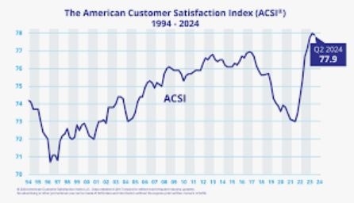
Appendix 2
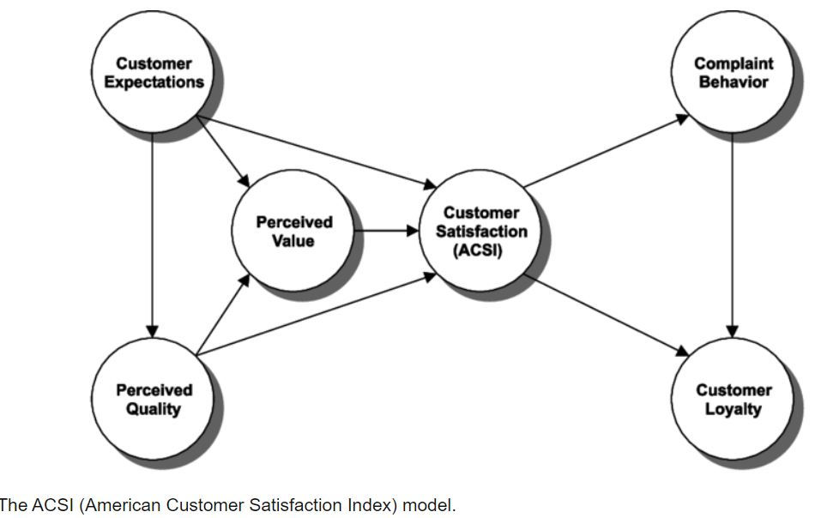

Appendix 3
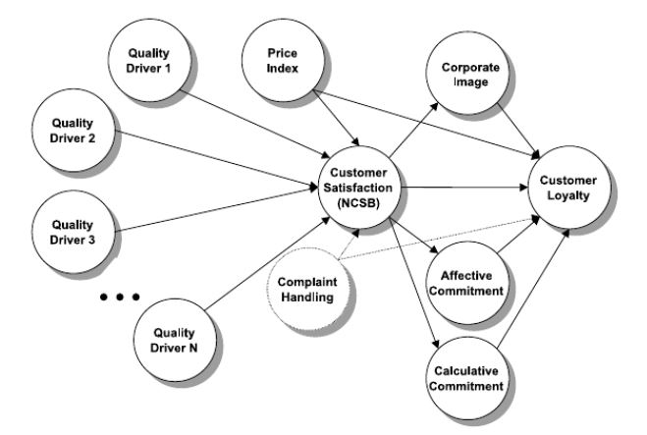
Appendix 4
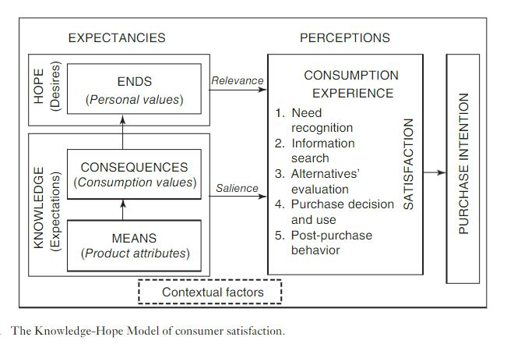

Appendix 5
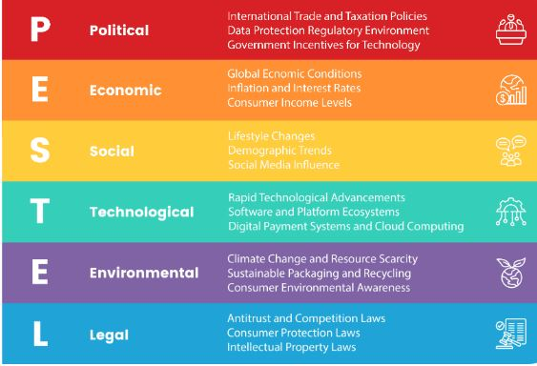
Appendix 6
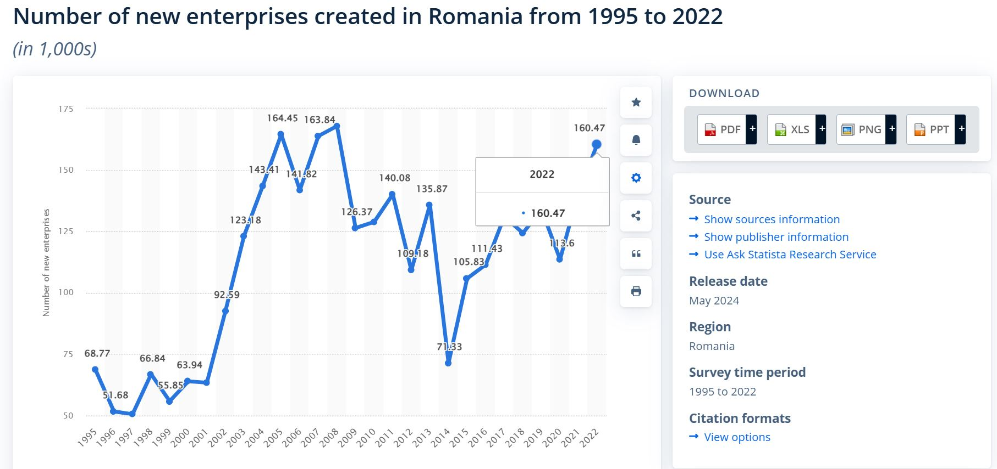

Appendix 7
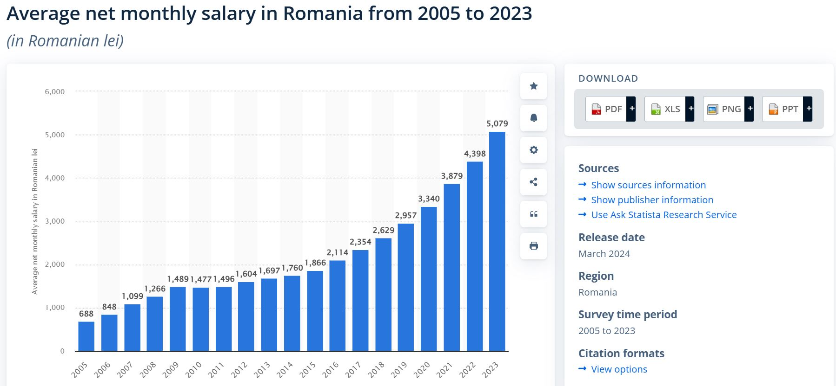

Appendix 8
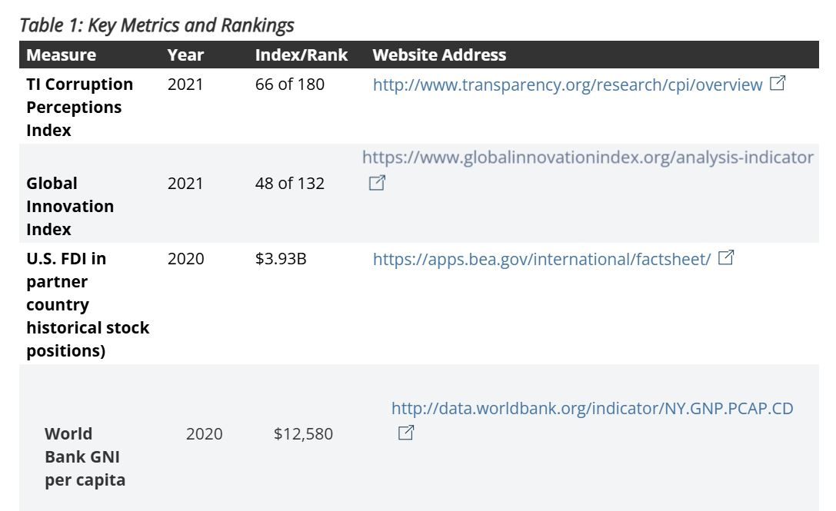

Appendix 9
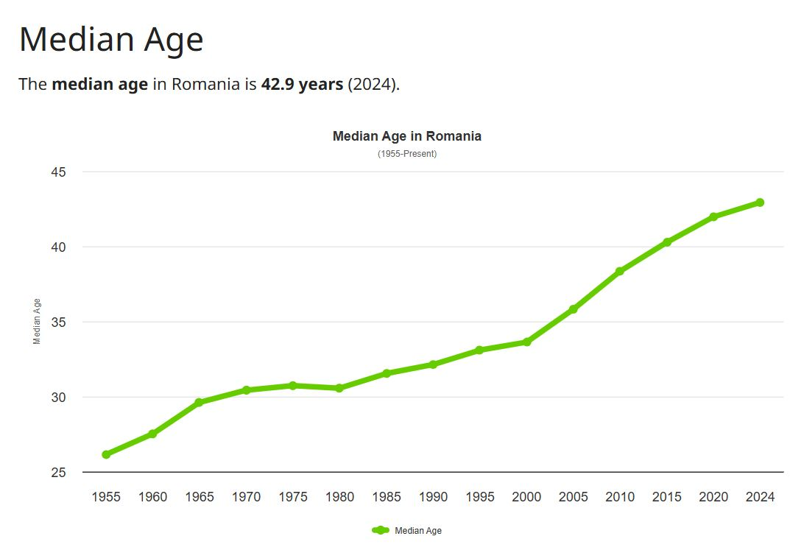
Appendix 10
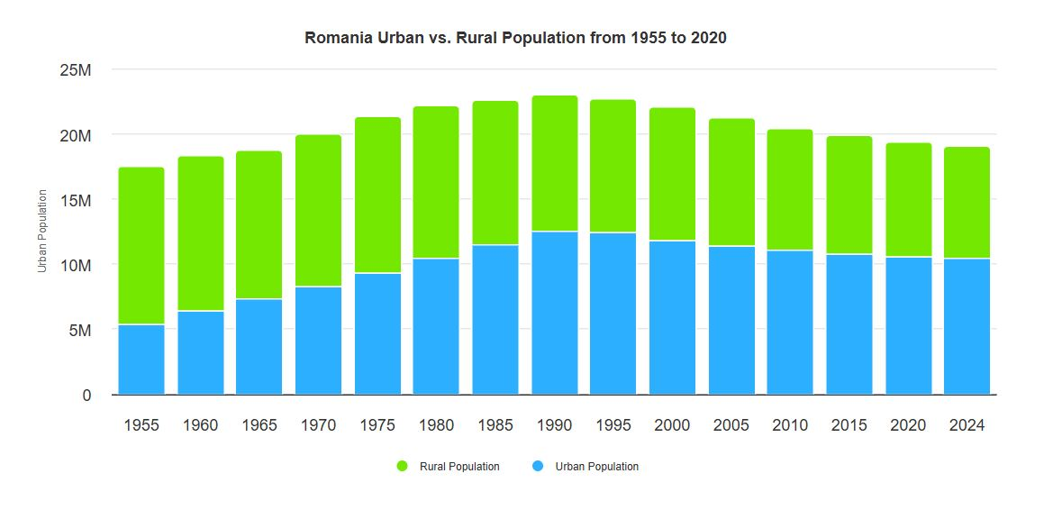

Appendix 11
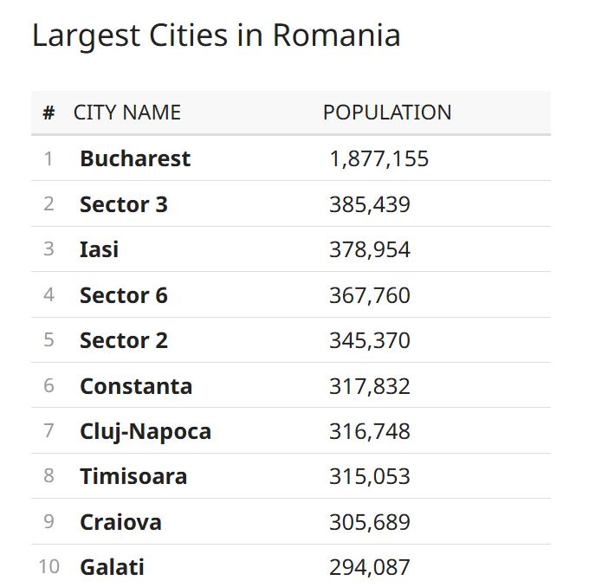
Appendix 12
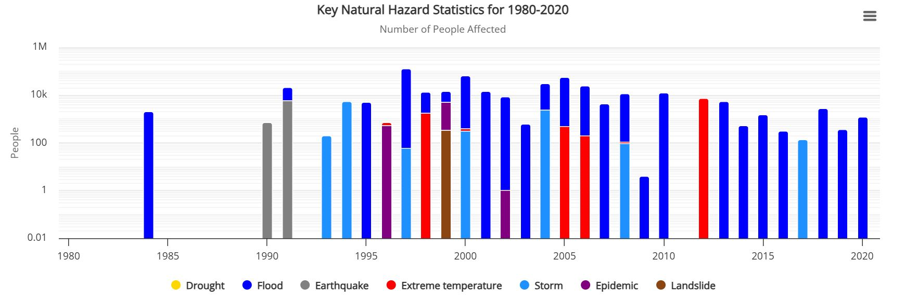

Appendix 13


