James Hunt (2215832)
2215832@student.uwtsd.ac.uk
Abstract
This assignment looks at the development of an intelligent traffic light control system using a PIC16F84A, evolving from a basic T-Junction setup to a more sophisticated system with pedestrian crossings, countdown displays, and an interrupt function. It then contemplates improving from this setup by exploring the potential for additional traffic light controls by adding main road traffic and turning movements, sensors to detect traffic and pedestrians before finally looking at the use of other hardware microcontrollers.
Electronics I
ACDA5002

Contents
Table of Figures 1
Introduction 1
Background research 2
Circuit design and simple diagram of road layout 3
Flowchart showing the system operation 3
Actual software listings 5
Screenshots of the simulation 5
Details of testing 7
Conclusion and recommendations on future work 8
References 9
Appendix 9

Table of Figures
Figure 1 - Circuit Diagram 3
Figure 2 - Flowchart of program 4
Figure 3 - Normal operation of the traffic lights 5
Figure 4 - Showing the interrupt function 6
Figure 5 - Showing the beginning of the pedestrian crossing function 6
Figure 6 - Counting down function showing remaining time to cross 7

Introduction

This assignment is focused on the development of an intelligent traffic light control system. The design of a system is tailored specifically for a T-Junction with a set of pedestrian crossings, a common but relatively complex traffic scenario. This report will look at the design for a computerised solution to controlling all of these induvial components. In this learning journey, the aim is to understand managing vehicular and pedestrian movements through precisely timed signal changes. The primary goal is to not only enhance traffic flow but also to prioritise safety for all users.
This system will need to be a reliable and efficient solution for T-Junctions, by using a microcontroller as the backbone to manage both the timings, lights and pedestrian signals.

Background research

The development of a traffic light control system is dependent on a foundational component, in this case the PIC microcontroller. Its simplicity, cost-effectiveness, common form factor, and wealth of documentation makes the PIC microcontroller stand out as a perfect choice for this task, catering to both novice and experienced developers alike.
At the heart of the PIC microcontroller's appeal is its inherent simplicity. Featuring a Harvard architecture, this microcontroller facilitates ease of programming and integration into diverse projects. This characteristic is particularly advantageous in the context of developing an intelligent traffic light control system, where clarity and simplicity in design contribute to the overall efficiency of the solution. The simplicity of the PIC microcontroller aligns well with the requirements of traffic management, offering a user-friendly platform for software development and ease of hardware integration.
Affordability is a crucial consideration in embedded systems development, where cost-effective solutions are paramount. The PIC microcontroller's cost-effectiveness makes it an attractive choice, ensuring that if the development of this traffic light control system so to be scaled up, it remains as an economically viable choice without compromising on functionality.
Additionally, the PIC microcontroller boasts a common form factor, ensuring compatibility and interchangeability across various projects. This uniformity simplifies the integration of the microcontroller into different hardware configurations, promoting flexibility in design. The ease with which the PIC microcontroller can be adapted to more complex scenarios which can still be managed by this system.

The setup of the PIC microcontroller plays a critical role in its effectiveness within a traffic management system. Whilst researching this assignment the realisation that most of the banks of pins would be needed for various hardware integration meant some careful thought would be needed for their optimisation. This involved the correct setup of PORT-B for the use of an interrupt and therefore using PORT-A for outputs. The research showed that some of the microcontroller pins have internal pull-up resistors which allows for a neater circuit. Where this not possible external pull-up resistors will have to be used. [1]

For this assignment various C compilers for PIC microcontrollers were considered however, two prominent choices emerged Mikro C and MPLAB XC8. The rationale behind the selection of MPLAB XC8 for this research lies in its easy integration with Proteus modelling software. However, Mikro C was considered as it can simplifies the development process by providing ready-made functions and modules, reducing the need for developers to create complex code from scratch. This feature is particularly advantageous when implementing hardware-specific functionalities, such as PWM timers. [2]
Overall MPLAB XC8’s compatibility with Proteus, a widely used virtual simulation software, is expected to be more convenient to the development cycle as edits and adjustments to the code can be achieved far quicker. This simulation capability aids in identifying potential issues, refining the system's performance, and ensuring a more robust and reliable final product. [3]

Circuit design and simple diagram of road layout

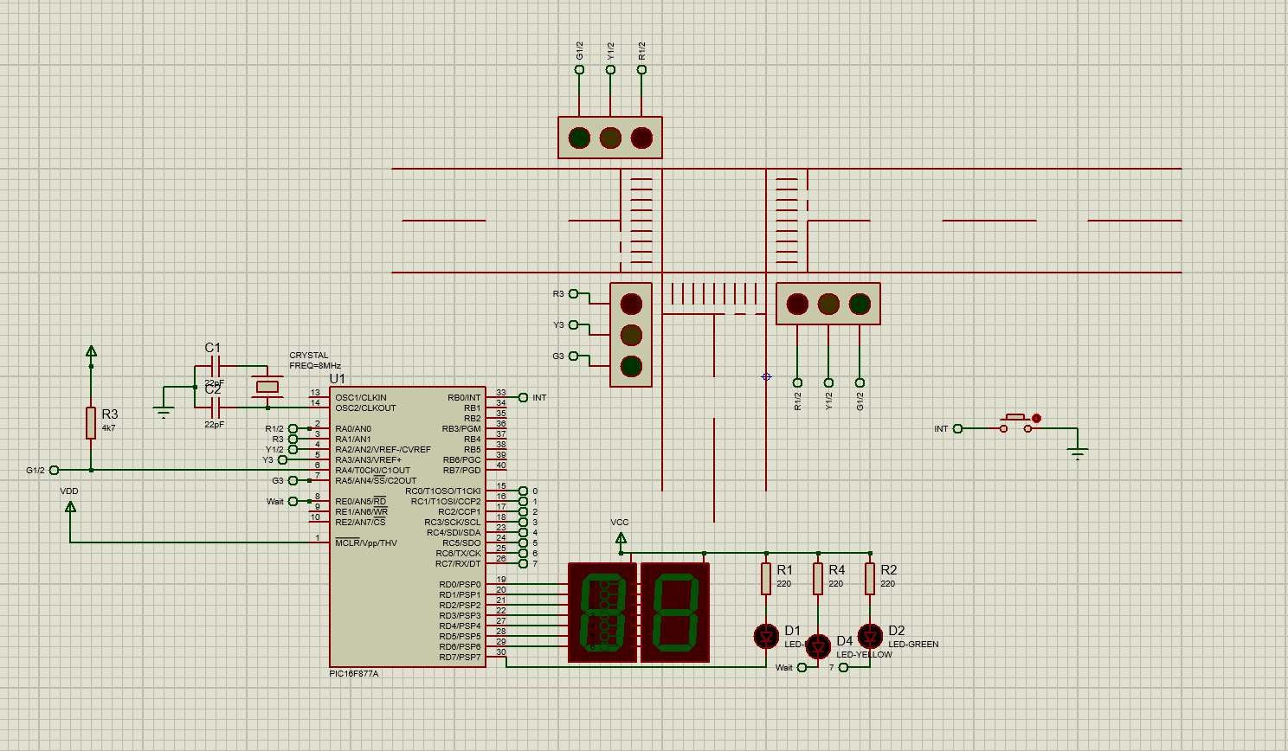
Figure 1 - Circuit Diagram
As seen in ‘Figure 1 - Circuit Diagram’ this is a simplified layout of a T-junction layout controlled by three traffic lights with a pedestrian crossing function. To keep the layout readable, only a single set of 7 segment displays with standalone LED’s to assist and a button push to control the pedestrian crossing. This can easily be adapted to include this set up to all points where the crossing points would be required by duplicating the layout and tying the controls to the same pins on the PIC microcontroller. As this is only a simulated setup there is also a few simplifications to the hardware layout, such as the lack of resistors to drop the voltage to required levels for the 7 segment displays and traffic lights requiring only a digital input to operate.

Flowchart showing the system operation

This flowchart details the overall functionality of the program created to control the traffic lights. Rather than producing a pseudo code to detail the controlling inputs and outputs, the code file is comprehensibly commented to explain each line of code. This has the advantage that anyone receiving this code can understand its purpose, without the need for further documentation.
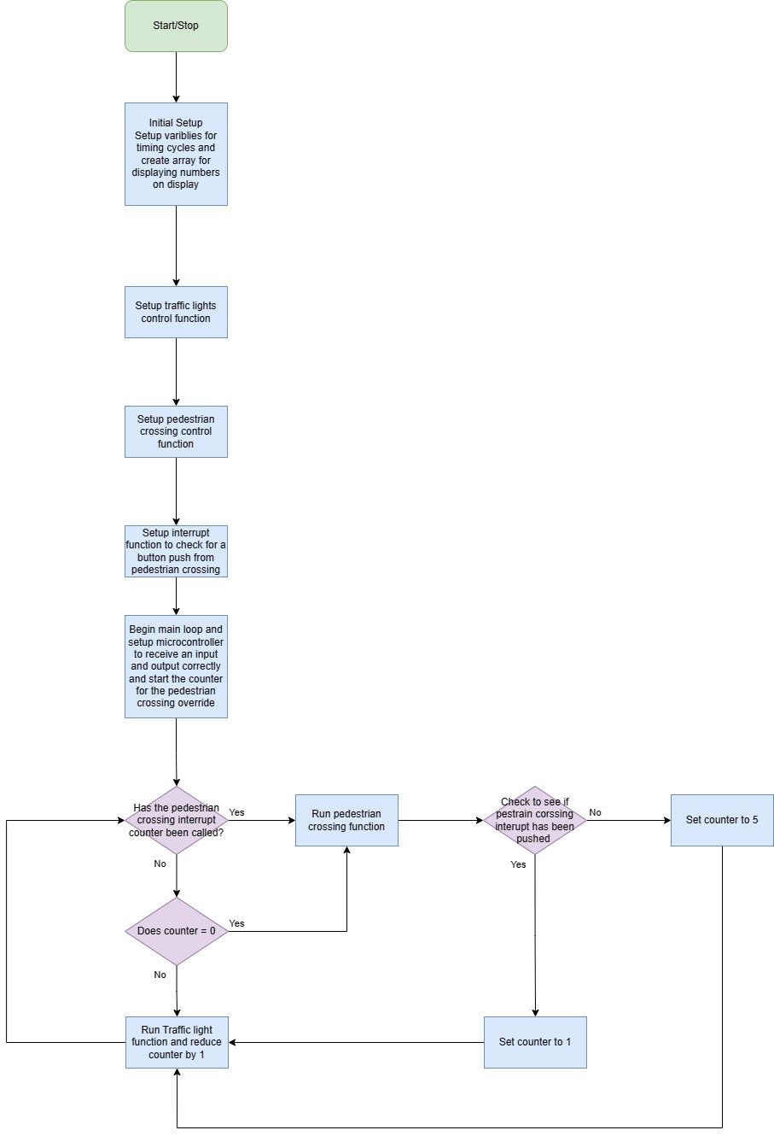
Figure 2 - Flowchart of program

Actual software listings

Attached below is a full print out of the main program as a pdf document. By attaching in this format the code is preserved including all comments. This is also included within the shared area of the appendix.

Screenshots of the simulation

In this section, various screenshots have been taken to illustrate the behaviour of the program through its cycles of operations.
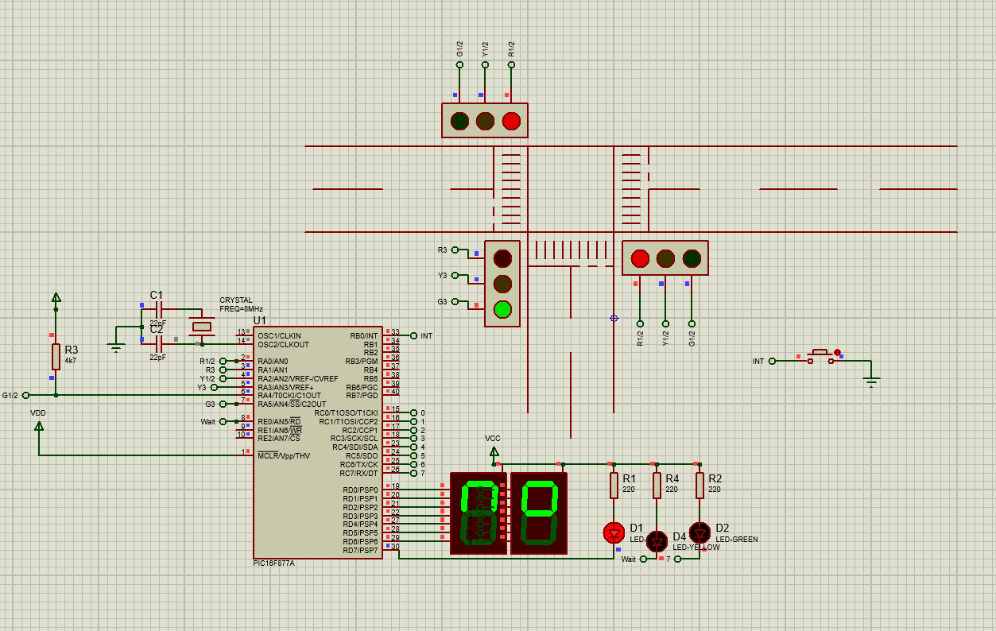
Figure 3 - Normal operation of the traffic lights
‘Figure 3 - Normal operation of the traffic lights’ demonstrates the normal operation of the traffic lights when no pedestrian crossing functions are required. A single red LED is illuminated and the word no is displayed on the 7-segment display for pedestrians arriving at the crossing.
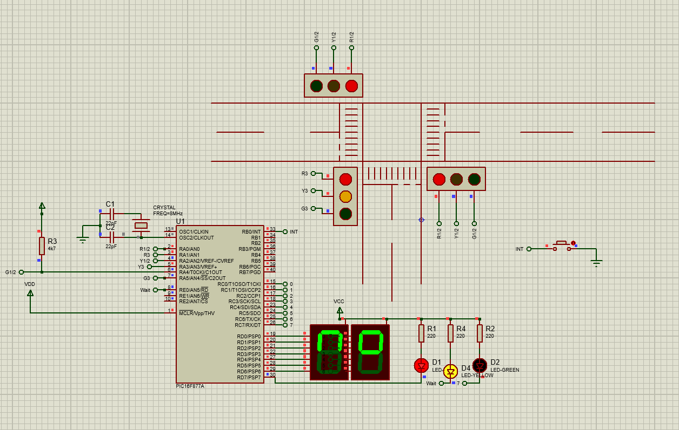
Figure 4 - Showing the interrupt function
‘Figure 4 - Showing the interrupt function’ demonstrates the stage where either the button push has been pressed or the counter controlling the timed interrupt has been activated. Note the yellow LED is now illuminated signalling the program has recognised the button press and informing pedestrians to wait.
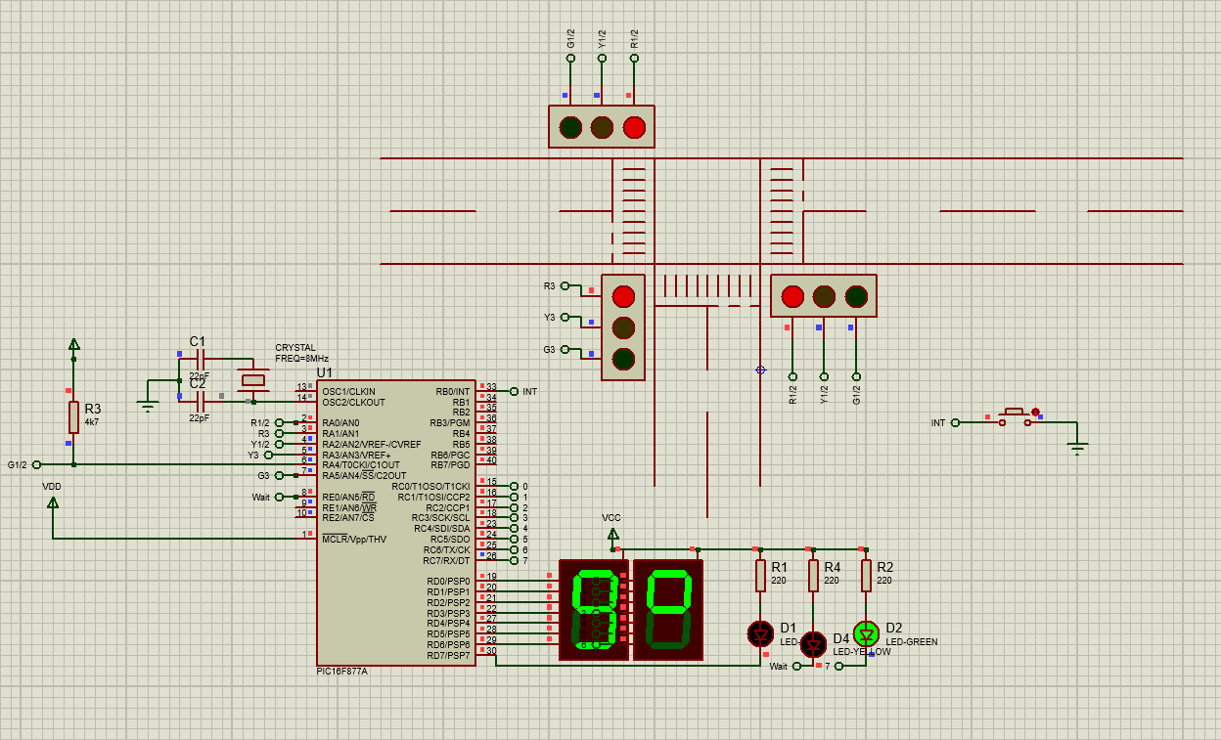
Figure 5 - Showing the beginning of the pedestrian crossing function
In Figure 5 - Showing the beginning of the pedestrian crossing function the pedestrian crossing function has now started and the traffic lights have finished their normal operations and are displaying red to any vehicles on the road. The pedestrian crossing now displays the word go for 2 seconds and the green LED is illuminated.
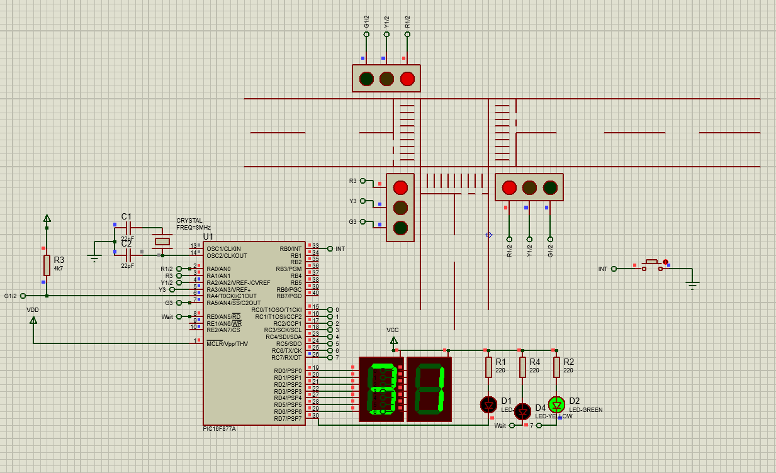
Figure 6 - Counting down function showing remaining time to cross
In Figure 6 - Counting down function showing remaining time to cross the program is now counting down from 40 and the green LED remains illuminated. Once this count reduces to 0, the program returns to the normal operation of the traffic lights as shown in Figure 3 - Normal operation of the traffic lights.
Although this is slightly different to how the assignment lays out the tasks, it feels like it demonstrates a more realistic variant on how traffic lights operate.

Details of testing

Details of the testing of this program have been documented throughout the development of this task, via both the comments within the code alongside a change log contained in the top comments of the main script.
This method has ensured any ideas have been captured as the code has developed alongside multiple date stamped save files with Proteus.
Throughout the development of this assignment various challenges have arisen in both software and hardware. One of the most notable examples came about when adding an interrupt function to control the pedestrian crossing. On the PIC microcontroller the pin assigned to receive an external interrupt is within PORT-B. [4] This meant that both the traffic lights controlled from this bank of ports would need to be relocated. As most of the other banks of I/O (Input/Output) pins were already used, the bank pins on PORT-A would need to be used. This therefore involved correctly coding the pins which can be used as Analog to Digital converters to only be used as digital outputs. Once this was achieved the next hurdle was understanding the hardware arrangement of how to interface the pins. Pin RA4 which can be used as a timer input which when configured as an output, is an open-drain which then requires an external pull up resistor to work correctly. [1]

Conclusion and recommendations on future work

In conclusion, this assignment has undertaken the challenging task of developing an intelligent traffic light control system. This began as a set of traffic lights for a simple T-Junction, but increased in complexity to have pedestrian crossings, count down displays and, an interrupt function to call stop the traffic when required. However, in the pursuit of creating this comprehensive solution, several other crucial considerations have emerged.

At the moment the traffic management at this T-Junctions is still a reasonably simplistic but functional approach, with the main road traffic lights linked together. This leads to exploring the possibility of splitting traffic light control on the main road or introducing a filter light for more convenient right turns. These considerations would aim to enhance the overall efficiency of the system, addressing specific traffic challenges associated with the main road and turning across lane movements.

Additionally, if a focus on safety features was to be developed further a consideration towards the use of Pulse Width Modulation (PWM) techniques could be explored. This would be used to generate signalling tones for the pedestrian crossing function. This is where the libraries within the MikroC complier would easily allow utilising the specialised embedded hardware on the PIC microcontroller for this purpose. Alongside this development, a move to replace the conventional 7-segment display with a Liquid Crystal Display (LCD) could be considered. This modification would enable the display of more comprehensive and easily read messages, contributing to improved communication with pedestrian users at the crossing. A version of code and proteus simulation beginning to explore this is contained with the Appendix.

Continuing the quest for heightened pedestrian safety and the smooth flow of traffic additional sensors, such as Passive Infrared (PIR) sensors at the pedestrian crossing points, and induction loops embedded within the road to detect vehicles. These sensors could be used to override the pedestrian function when no pedestrians are detected but vehicles are. This adaptive feature ensures an interrupt mechanism that would allow for pedestrian movement when required but with reduced interference to traffic, promoting positive experience for both sets of users.

The assignment encourages experimentation with hardware, and although promotes the use of the PIC16F/ PIC18F microcontrollers, many other microcontrollers exist including the Raspberry Pi Pico. This microcontroller is very similar to the PIC family however one of the main differences is the form factor. This has exposed the limitation of manually controlling pins for sections of code such as the traffic lights. The importance of good coding practices such as assigning pin names for ease of porting to different hardware if required is highlighted. A simple variant of this main script showing traffic light control has been created to run on this hardware environment, a short video of this is available via the Appendix. This could be continued to be developed, however the authors own lack of hardware interfaces (such as buttons and 7 segment LED displays) has curtailed this.

In essence, this assignment proposes an intelligent traffic light control system that not only optimises traffic flow and enhances safety but also can adapt to evolving needs through innovative features and hardware experimentation. This comprehensive approach aims to create a sophisticated and flexible solution for T-Junctions, paving the way for a safer and more efficient urban traffic landscape.
References
[1] Anonymous Anonymous PIC16F87XA datasheet. PIC16F87XA datasheet. Available: https://ww1.microchip.com/downloads/aemDocuments/documents/MCU08/ProductDocuments/DataSheets/39582C.pdf.
[2] M. Lab. (-03-31T17:58:00+00:00). PWM using Pic Microcontroller with Examples. Available: https://microcontrollerslab.com/pwm-using-pic16f877a-microcontroller/.
[3] Anonymous Anonymous MPLAB XC8 user guide. MPLAB XC8 user guide. Available: https://ww1.microchip.com/downloads/aemDocuments/documents/DEV/ProductDocuments/UserGuides/MPLAB-XC8-C-Compiler-Users-Guide-for-PIC-DS50002737.pdf.
[4] Anonymous (). How to Use Interrupts in PIC16F877A Microcontroller. Available: https://circuitdigest.com/microcontroller-projects/pic16f877a-interrupts-tutorial.

Appendix

Shared Appendices

