Student Name | Andrei Welkens Covaci
Student ID | 1818820
Module Title | Effective Team Working and Communication BMSW4002_LON
Assignment Title | Effective Team Working And Communication
Module Lecturer  Word Count | Dr. Gulnar Ali  2123

Contents
Introduction 3
Effective Team Working & Communication 3
Importance of Effective Communication 6
Purpose of Communication between Management and Employees 7
Conclusion 8
Recommendation 8
Action Plan 8
Reference List 9
Appendix A: The Professor and the Village People Exercise 11
Appendix B: Business Email Exercise 12
Appendix C: BMW Dealership Exercise 13
Appendix D: Maria and Pedro Exercise 14
Appendix E: Assessment 15

Introduction

Communication, in general, can be defined as the exchange or imparting of information through verbal, written or another medium between two or more parties involved. Sending and receiving information via telephone or computer can also be considered as communication. However, communication in context to this report is the organisational communication used by the management to exchange information, views and ideas within as well as outside of the communication (Fan et al., 2015).
In context to management within an organisation, effective communication is important for a number of reasons. It allows the management to implement their vision and strategy by communicating with the employees working under them. I worked as a diver assessor in one of my friend’s institution. Effective communication is required to develop better relations and increases productivity in the process. Effective communication also helps in a cross-cultural environment, which is prevalent in a globalised world and maintains multigenerational relations within the organisation (Shockley-Zalabak, 2014). Even problem-solving skills can be significantly improved through effective communication by organisation management.
In this report, I will show how communication can be made effective within a business organisation by linking them to scholarly and literary sources. Relevant theories related to group dynamics, team working, and communication will also be discussed in the report. To support my theoretical claims, practical examples of how communication is necessary for real-life scenarios will also be explained through the various in-class exercises that were performed by my friends and me. This would provide justification for the use of effective communication in my own or friend's workplace. Finally, an action plan will be provided in the recommendation section to improve my communication, team working and group dynamics skills.

Effective Team Working & Communication

There are multiple strategies and methods that business organisations use to make communication effective within the workplace. A few of these methods and strategies have been pointed out to better understand the significance of effective communication in a business organisation (Fleisher and Bensoussan, 2015). The first step for making communication effective is by developing a communication strategy that sets standards for employees and managers on the way they should communicate. This can de be developed by considering what information should be given to the employees, as well as when and how to deliver them. The next step is to build a communication process so that the employees and teams can have a modern communication experience. The best way for a consistent communication process is to develop a platform for the employees so that they communicate with each other and share views and ideas (Butchibabu et al. 2016). One of the mistakes that managers and leader do in an organisation is that develop new ideas, implement it by communicating with the employees but fail to explain to them the rationale behind the idea. Hence, it is important that employees understand what they are working for in the organisation. A major part of communication is listening, and people often fail to listen attentively and focus only on speaking. Both employers and employees should also develop a habit of listening to the other when engaging in a one on one conversation (Fleisher and Bensoussan, 2015). Additionally, one-way communication can often lead to disasters, and organisational leaders should be keen on this. Developing a forum for the employees so that they can offer feedback and ask relevant questions is essential for making communication effective within a business organisation. Apart from these methods, allowing open communication, making the planning process inclusive and focusing on result-driven communication in meetings further helps the process of developing effective communication in an organisation (Fan et al., 2015). Being a driver assessor, it was my duty to communicate with the driver of the car about the traffic situation ahead (Appendix E). This could help the driver in making comfortable driving. Thus, it is very important to communicate with the driver to make his driving more comfortable.
Relevant Theories of Communication
Shannon Weaver Model
The Shannon and Weaver model of communication, created by Claude Elwood Shannon and Warren Weaver in 1948 is a mathematical theory that explains effective communication better than all other linear models as it includes technological factors within the model (McQuail and Windahl, 2015). The model consists of several components like sender, encoder, channel, decoder, receiver and noise. This can be further explained through the in-class case study of Pedro and his wife, Maria. As Pedro works on a building site, the surrounding physical noises were interfering with the message and Pedro heard ‘chicken' as ‘kitchen' which created the miscommunication. For further details on the case study, refer to Appendix D at the end of the report.
Schramm’s Model
Another relevant theory is Schramm’s model of communication developed by Wilber Schramm in 1954 from the Shannon-Weaver model. According to this model, encoding and decoding of the message are an important part of the effective communication process (McQuail and Windahl, 2015). However, the model further states communication is incomplete if the receiver does not send any feedback to the sender based on the message. In context to the case study of Pedro and Maria, Schramm’s model could have explained why Pedro failed to receive the message accurately which might be language or educational differences between Pedro and Maria (Appendix D). However, this could have been easily avoided if Pedro being the receiver, would have provided feedback, and this could have cleared out any issues regarding their communication.
Berlo’s Model
Another major theory of communication is Berlo’s Sender-Message-Channel-Receiver (SMCR) theory, which was developed in 1960 by David Berlo based on the Shannon-Weaver model. Berlo's model does not consider the noise component in the message and focuses mainly on the source, message, channel and receiver (McQuail and Windahl, 2015). A set of factors might affect each of these components, which are same for the sender and receiver. The in-class case study of “The professor and the village” further explains the necessity of effective communication in context to Berlo’s communication model (Appendix A). In the case study, the professor from Welsh University had nothing in common with the people of a nearby village who were mostly uneducated. When the professor's house was on fire, he used sophisticated English words which the village people were unable to comprehend. For this reason, they did not help the professor in putting out the fire. Here the factors like knowledge, culture and social
skill of the sender and receiver were a problem which resulted in the failure of effective communication.

Importance of Effective Communication
The importance of effective communication in real-life scenarios can be better understood with the help of two in-class exercises, which involves my friend's and my own experience in a solo and a team project. In the solo exercise, I had to act as the Director of Communications at a company and write a business email to one of my employees, Jack Daniels asking him to join my communications training team due to his excellent communication skills and he would be an asset to our team (Appendix B). This exercise has helped me to identify the areas where I lack qualities of effective communication, and I plan to work on those areas to improve in the future. Refer to Appendix B for further details about the in-class exercise.
In a group exercise, the various teams acted as the various stakeholders in a huge BMW dealership in London, which later involved a Chinese electric car brand as well (Appendix C). Developing a communication strategy to interact with the other groups, help my friends and me to further evaluate our own skills for effective communication in a real-life scenario while acting as a driver assessor. Effective communication can help in completing the task much quicker (Appendix E). It also helps in the development of skills of the team members. This exercise identified the areas where I lack effective communication skills, and it will be included in the action plan at the end of the report.
The importance of effective communication can also be better understood with the help of a real-life scenario of my own workplace. As a driver assessor in a Driving Training School, I was once training another driver. During a test run on the road, I was guiding the trainee driver on which road to take. I asked him to take a left turn during the training session. However, there was too much traffic noise in the road and the trainee was not able to hear my direction. This led to miscommunication and we had to travel head to take the next turn in the right direction. This type of miscommunication that happened between me and the trainee is due to noise between the encoder and decoder mentioned in the Shannon-Weaver model. The traffic noise is mostly physical noise as mentioned in the theory. However, as the road was full of traffic, I should have used hand gestures to mark the proper direction. Non-verbal methods of communication like hand gestures can be used to avoid miscommunication due to physical noise in the environment. The issue could have been easily avoided if I had used non-verbal methods of communication in that noisy environment.
Methods of Communication
There are primarily four methods of communication comprising of verbal, non-verbal, written and visual methods. Verbal communication consists of transferring information by speaking directly to the audience (Kanki, 2019). This is done with the help of any language which all the parties involved can understand and can occur across various platforms like directly, over the phone or in video conferences. No-verbal methods include body language, facial expressions, gestures and even emotions. This method is used both intentionally and unintentionally between two or more parties (Berger, 2018). The written method is the transfer of information through a written form of language, symbols and numbers. This method is done through pamphlets, letters, books, blogs, etc. The visual method is the act of communication with the help of drawings, art, photographs, charts and graphs. This type of communication is mostly used as an aid to verbal communication to help the audience better understands the context of the information standard. In many cases, a combination of two or more of these methods is also used based on the requirement of the subject, situation and people involved.

Purpose of Communication between Management and Employees
The communication between organisation management and the employees are effective in a lot of purposes. The tone of communication, choice of language and the level of formality all contribute to the effectiveness of communication between management and employees. The main purpose that effective communication serves is that it encourages collaboration between the managers and their employees which results in a healthy work environment thus increasing the productivity of the organisation (Goetsch and Davis, 2014). Moreover, effective communication also allows proper motivation for the employees, and they are more engaged in their respective tasks and activities and perform with more efficiency. Furthermore, the problem-solving possibilities among the team members are further enhanced through effective communication. This makes communication such an essential aspect in various organisations and helps in productive output as well. Thus, in order to meet with the objectives of my organisation, I need to develop my communication skill.

Conclusion

The report provides a conclusive understanding of the various aspects and factors of effective communication within and outside of organisations, especially business companies. The relevant communication theories, along with in-class exercises, further evaluate the importance of communication as well as analyses my own communication skills. Each of the theories has been supported by authentic scholarly and literary sources and also highlights how communication can be made effective in business organisations. The various methods of communication, along with my own experience, determine the importance of effective communication in real-life scenarios. Therefore, it can be concluded that communication between the management and employees is the key to successful business operations due to its positive impact in the workplace.

Recommendation

The areas where I lack effective communication skills and ways to improve them have been provided in the action plan below.

Action Plan
Skills | How to Improve | Time Required
Vocabulary | I should improve my vocabulary skills by taking English lessons on how to better construct sentences. | 2-3 months
Team Work | Although I was a part of a group project, I was not a very good team player. I should participate in more team projects to become an effective team player. | 4 months
Language | I should increase my English vocabulary even more by reading novels and journals. | 6 months
Written Communication | Although my verbal communication skills are effective, I should practice more written exercises to improve my writing skills, which would help me in future real-life scenarios. | 1-2 months
Table 1: Action plan for my development Source: Created by author

Reference List
Berger, A.A., 2018. Media and communication research methods: An introduction to qualitative and quantitative approaches. Sage Publications.
Butchibabu, A., Sparano-Huiban, C., Sonenberg, L. and Shah, J., 2016. Implicit coordination strategies for effective team communication. Human factors, 58(4), pp.595-610.
Fan, S.P., Liberman, Z., Keysar, B. and Kinzler, K.D., 2015. The exposure advantage: Early exposure to a multilingual environment promotes effective communication. Psychological Science, 26(7), pp.1090-1097.
Fleisher, C.S. and Bensoussan, B.E., 2015. Business and competitive analysis: effective application of new and classic methods. FT Press.
Goetsch, D.L. and Davis, S., 2014. Quality management for organisational excellence: Introduction to total quality.
Greenberg, B.S. and Salwen, M.B., 2014. Mass communication theory and research: Concepts and models. In An integrated approach to communication theory and research(pp. 75-88). Routledge.
Kanki, B.G., 2019. Communication and crew resource management. In Crew resource management (pp. 103-137). Academic Press.
McQuail, D. and Windahl, S., 2015. Communication models for the study of mass communications. Routledge.
Shockley-Zalabak, P., 2014. Fundamentals of organisational communication. Upper Saddle River, NJ: Pearson.Watson, J. and Hill, A., 2015. Dictionary of media and communication studies. Bloomsbury Publishing USA.
Appendice:
Appendix A: The Professor and the Village People Exercise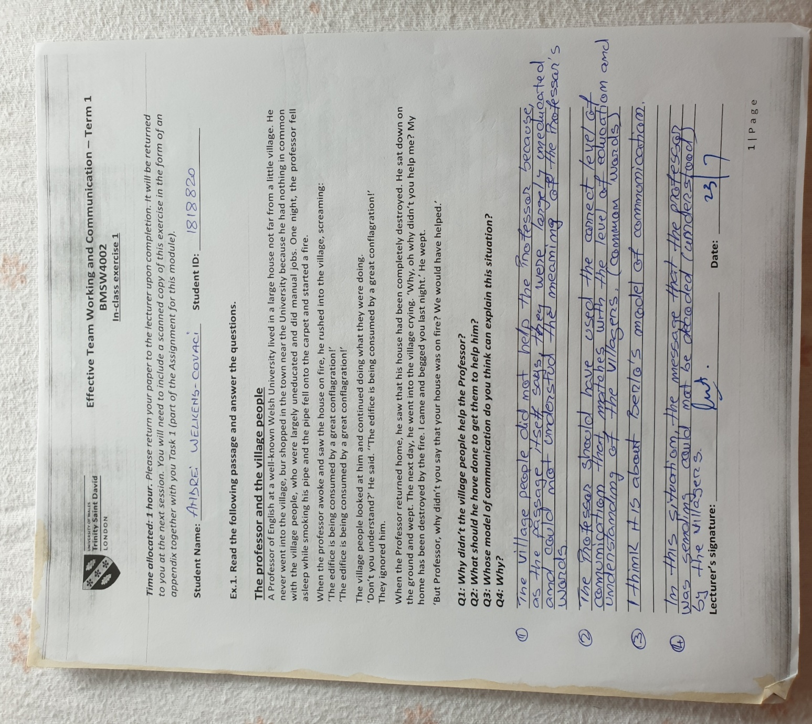

Appendix B: Business Email Exercise
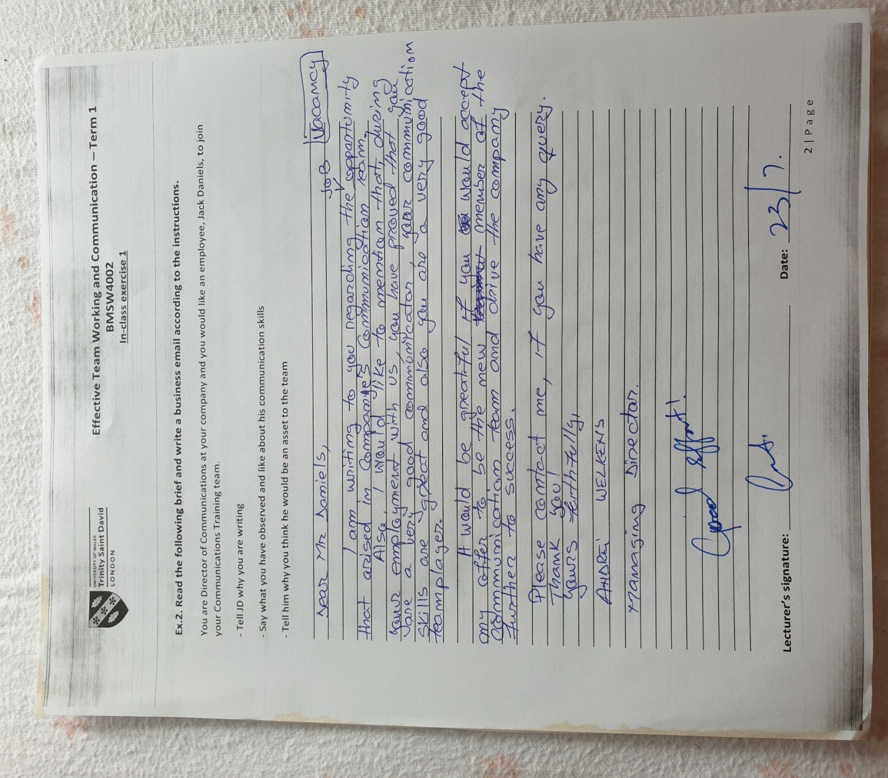

Appendix C: BMW Dealership Exercise
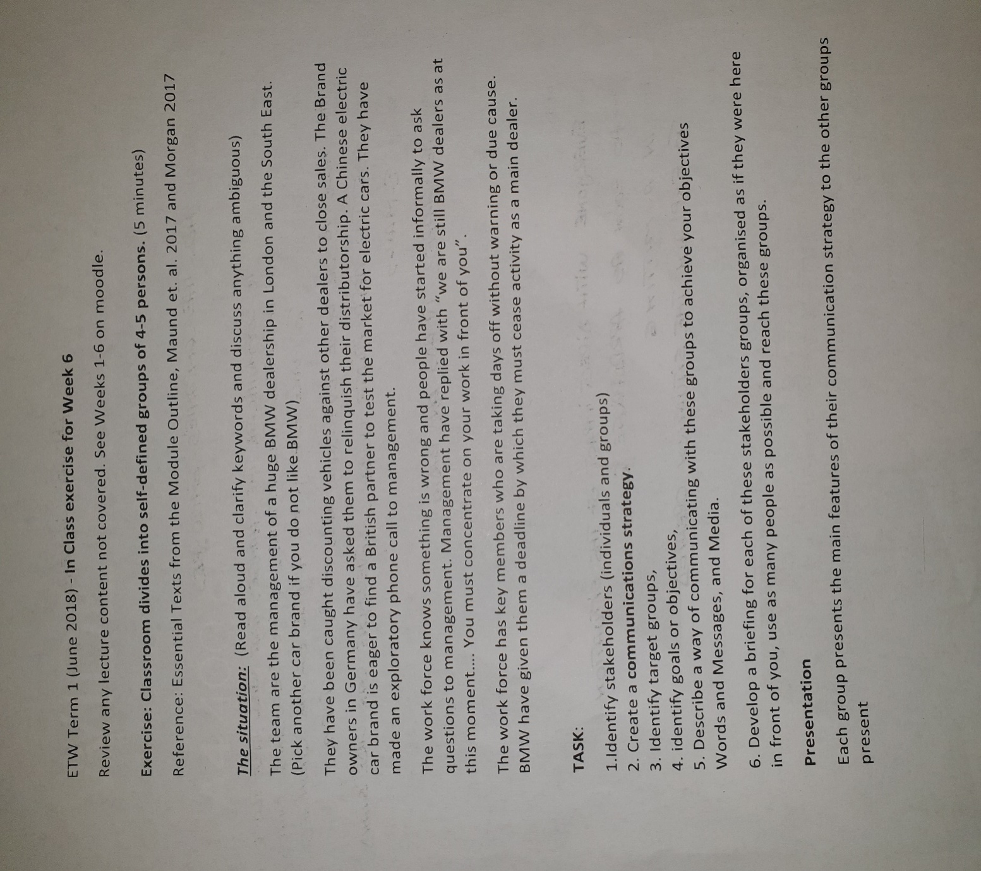

Appendix D: Maria and Pedro Exercise
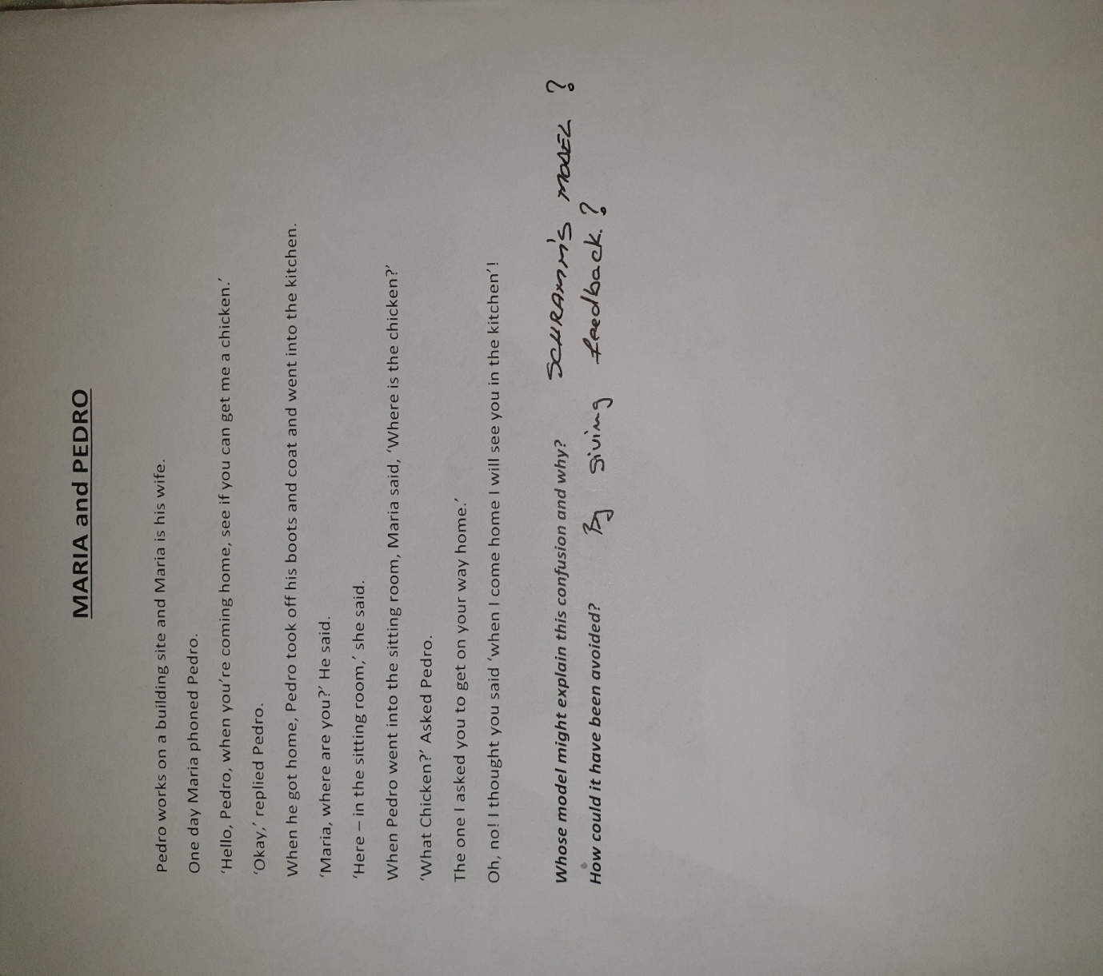

Appendix E: Assessment


