A comparative analysis of the adoption of Internet Banking between Generation Y and Baby Boomers.


Niswat Anjum Aniqa

1702530

University of Wales Trinity Saint David
BA (Hons) Business Management

A thesis submitted in Partial Fulfilment of the Requirements for the Degree of Bachelor of Arts in Business and Finance

May 2020

Declaration

I, Niswat Anjum Aniqa, declare that this work has not previously been accepted in substance for any degree and is not being concurrently submitted in candidature for any degree

Signed…………………………………………… Date………29/05/20………………………………

STATEMENT 1

This dissertation is being submitted in partial fulfilment of the requirements for the degree of BA.

Signed……………………………………………. Date………29/05/20…………………...…………

STATEMENT 2

This dissertation is the result of my own independent work/investigation, except where otherwise stated. Other sources are acknowledged by footnotes giving explicit references. A bibliography is appended.

Signed…………………………………………….Date………29/05/20……….……………...………

STATEMENT 3

I hereby give consent for my dissertation, if accepted, to be available for photocopying and interlibrary loan, and for the title and summary to be made available to outside organisations.

Signed……………………………………………... Date…….29/05/20……………………………..

STATEMENT 4

I hereby give consent for my dissertation, if accepted, to be available on the university's IT system to those who have consented to use the system.

Signed……………………………………………... Date…..…29/05/20……………………………

Acknowledgement

First and foremost, I would like to thank God Almighty for providing me with the capability, strength and the opportunity to undertake this research study.

The success of this thesis depends on the encouragement and guidelines of many others and I would like to express my gratitude to those who have been extremely helpful in the successful completion of this thesis.

I would like to show my greatest appreciation to Dr Gareth Hughes as the thesis supervisor. I cannot say thank you enough for his tremendous support, help and the continued guidance throughout my time at the university. Without his support, this thesis would not have materialized.

I take pride in acknowledging the insightful guidance of Dr Caroline Jawad, for sparing her valuable time whenever I approached her and showing me the way ahead.

It would be inappropriate if I omit to mention my dear parents for supporting me daily, my amazing sisters, friends and my partner, who have kept me going on my path to success, assisting me in whatever manner possible.

And lastly, I would like to thank every single person that assisted me in my dissertation research, who generously shared their time, experiences for this research; this would have not been possible without their support and participation.

Niswat Anjum Aniqa

May 2020

A comparative analysis of the adoption of Internet Banking between Generation Y and Baby Boomers.




Niswat Anjum Aniqa
1702530
Table of Contents
Acknowledgement ii
COVID-19 viii
Abstract ix
Roadmap to the thesis 0
1 Chapter 1- Introduction 1
1.1 Aims and Objectives 1
1.2 Background and Rationale 2
1.2.1 Internet Banking 3
2 Chapter 2- Literature review 5
2.1 Introduction 5
2.2 Diffusion of internet banking 6
2.2.1 Age-related factors and internet banking 7
2.2.2 Technology acceptance Model (TAM) 9
2.3 Online banking security 10
2.4 Adoption of internet banking among generations 11
2.4.1 Influences on Consumer Adoption of Internet Banking 11
2.4.2 Rogers’ theory of innovation diffusion (DOI) 13
2.5 Conclusion 15
3 Chapter 3- Methodology 17
3.1 Introduction 17
3.2 Research Methodology: Research Onion 18
3.2.1 Interpretivism 19
3.2.2 Inductive research 20
3.2.3 Case study 20
3.2.4 Mono-Method 21
3.2.5 Cross-sectional 21
3.2.6 Data Collection and Analysis 22
3.2.6.1 Qualitative Data 22
3.2.6.2 Purposive Sample 23
3.2.6.3 Interviews 23
3.2.6.3.1 Approach 24
3.2.6.3.2 Interview Design 25
3.2.6.3.3 Analysis 25
3.2.6.3.4 Interview Question Matrix 26
3.2.6.5 Credibility and Dependability 28
3.3 Reliability and Validity 28
3.4 Ethical Considerations 29
3.5 Potential Limitations 30
3.6 Conclusion 30
Chapter 4- Data analysis & findings and Discussion 31
4.1 Introduction 31
4.2 Background for findings 31
4.3 Main Findings 32
4.3.1 Participants 33
4.4 Security 33
4.4.1 Perception of ease of use and perceived usefulness 34
4.5 Trust 36
4.5.1 Convenience 38
4.6 Links between Security and Trust 39
4.6.1 Generation Y and Baby Boomers 40
4.7 Conclusion 44
Chapter 5- Conclusion and Recommendations 45
5.1 Introduction 45
5.2 The achievement of objectives; 45
5.3 Summary of findings 47
5.4 Recommendations 49
6.5 Limitations 51
5.6 Conclusions 52
6.6 Further research 53
Self-reflection 54
Final summary 54
References 55
Appendices 63

Table of Figures

Figure 1:A Roadmap to the Present Thesis 0
Figure 2 Technology acceptance Model (TAM) Davis (1989). 9
Figure 3 Rogers’ theory of innovation diffusion (Rogers, 1995). 13
Figure 4 Multivariate issue within Internet Banking (Literature Review Data, 2020). 15
Figure 5: The Research Onion (Saunders, et al., 2009). 18
Figure 6: Cross-sectional Study (Collins and Hussey, 2009). 21
Figure 7: Purposive Sampling (Saunders, et al., 2009). 23
Figure 8: Main findings between Gen Y and BB. 32
Figure 9:High-level word cloud of Security (Internet Banking Interview Data, 2020) 33
Figure 10:High-level word cloud of Trust (Internet Banking Interview Data, 2020) 36
Figure 11:Text query analysis on reasons for trust (Internet Banking Interview Data, 2020) 37
Figure 12: Word cloud of Internet banking, Gen Y (Internet Banking Interview Data, 2020) 40
Figure 13: Word cloud of Internet banking, BB (Internet Banking Interview Data, 2020) 40
Figure 14: Comparison diagram of Gen Y and BB, IB popularity (Internet Banking Interview Data, 2020) 42
Figure 15: Views of Gen Y and BB on Virtual Bank (Internet Banking Interview data, 2020). 43

List of Tables

Table 1: Questions from the interview relating to chapter two the literature review 27
Table 2: Demographic of participants 33

List of Appendices

Appendix a- Semi-structured Interview questions- Internet Banking users 63
Appendix b- Interview 1 Generation Y- Transcript 65
Appendix c- Interview 2 Baby Boomer- Transcript 70
Appendix d – Consent Form 74
Appendix e – Ethics form 77
Appendix f- Screenshot of Node Structure with NVivo 87
Appendix g- NVivo Security concerns Node References 88
Appendix h- Branch visits of Gen Y and BB Node References 89
Appendix i – Popularity of Internet Banking among Gen Y and BB Node Reference 90

Abbreviations and Acronyms

BB = Baby boomers

DOI = Diffusion of Innovation Theory

IB = Internet banking

PEOU = Perceived ease of use

PU = Perceived usefulness

TAM = Technology Acceptance Model

UWTSD = University of Wales Trinity Saint David



COVID-19

After the United Kingdom implemented a 24-hour curfew in March 2020, the University of Wales Trinity Saint David took steps to support the research student during the curfew and University building closures.
Supervision meetings continued via Microsoft Teams and documents were shared through emails. Projects required physical presence to undertake interviews, this has put the research into a greater risk to delays.
UWTSD understands that the projects of some students were planned to require in-person research and data collection which is not feasible in this period of remote learning. If it was no longer possible to continue with the existing plan then consideration to changes to the project plan should be considered to offset, wherever possible, undue future delays to the dissertation submission. All fieldwork conducted by students occurred remotely using electronic means wherever possible.
Students, with the help of their supervisors, are urged to document the extent of the disruption to their research.

Abstract

Recently the popularity of Internet Banking has increased among all users, younger and even with the elderly consumers. The main purpose of this study is to critically analyse the comparison between Generation Y and Baby Boomers on the adoption of Internet Banking and explore the key factors affecting their willingness to use Internet Banking. These two generations are completely different in terms of lifestyle, and this study has found that Generation Y uses this service for work and Baby Boomers use it because it is easily accessible from the comfort of their own homes.

It is noticeable that Internet Banking is more popular with the younger generation, Gen Y, than any other age group; however, additional research is needed to determine why there are generational differences. A total number of ten Internet Banking consumers were interviewed; the findings support much of the literature and themes outlined in chapter two. The results have demonstrated differences in the factors that organisations and customers adopted. However, further research is needed in order to explore this topic in more depth.

A quantitative study, for example, could determine whether banks can alter their business strategies and develop the customer’s willingness in internet banking usage. Howbeit, from this study, it has been concluded that the primary factor valued by the consumers is trust. Hence, to reduce risks and gain customers' trust, banks should carefully consider strengthening areas such as information security, liquidity monitoring and compliance with financial regulation.
Key words


Internet Banking, Banks, Age, Generation Y, Baby Boomers, Trust, Security, Technology, Customers, Acceptance, Usage.

Roadmap to the thesis
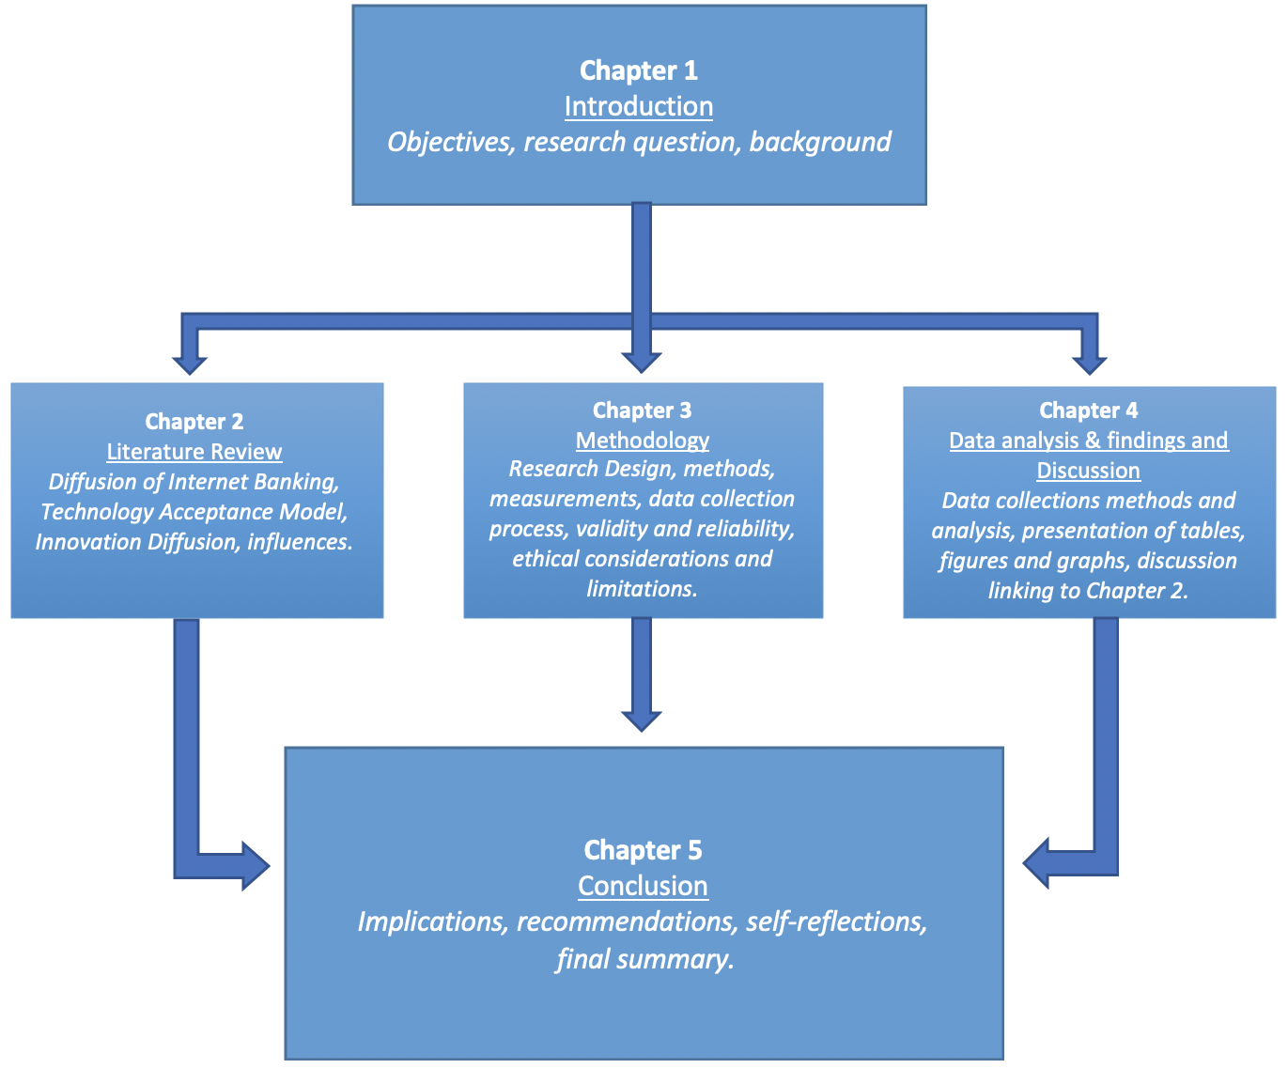

Figure 1:A Roadmap to the Present Thesis

The researcher has set out every chapter by creating an effective outline that reflects all logical details, the figure above (figure 1) is a guide of what the thesis intends to achieve on each chapter. All chapters, excluding Chapter one, have an objective that will be achieved throughout the research project. The thesis will conclude with recommendations for Internet Banking consumers and a personal reflection of the researcher. Some of the copies of interviews, consent and ethics forms, screenshots of the analysation of the data and all other supplementary material can be found on the appendices of the thesis.

1 Chapter 1- Introduction

Aims and Objectives

Technology has changed the whole pattern of life and it is still helping many people and organisations achieve goals with the help of its features (Feenberg, 2012). However, many individuals lack knowledge on how to use technology completely; older people, for example, have difficulties when using a mobile phone (Dede, 2010). On the contrary, younger people have more knowledge of this sector (Buckingham, 2013). Internet Banking has been a great addition that helped manage money more conveniently, but age can be a factor affecting some people to fully adopt Internet Banking (Tan and Teo, 2000).
The purpose of this dissertation is to critically analyse the comparison between Generation Y (Gen Y) and Baby Boomers (BB) on the adoption of Internet Banking (IB).
The primary objectives of the thesis are the following:

- To evaluate and analyse existing academic literature concerning the different motivations for the adoption of internet banking between Gen Y and BB;
- To collect and analyse qualitative data from respondents that are from Gen Y and BB category and have a relation to the thesis subject of internet banking;
- To examine the role of Gen Y and BB’s trust in data security and to the use of internet banking;
- Draw conclusions based on the discussions and offer recommendations for future research and to increase the use of Internet Banking among Generation Y and Baby Boomers.

1.2 Background and Rationale

This thesis will compare the factors affecting the adoption of IB between Gen Y along with BB and analyse the different motivations for the adoption of this service between these two generations. The researcher will interview individuals, of these two generations, that are both IB consumers. Using interview methods is seen as the appropriate data collection method for this thesis, as this has the possibility of gathering more data.
The researcher will expand on precedent studies into the subject area, (Tan and Teo, 2000; Laukkanen, 2007; Akinci, Aksoy, and Helsper, 2010) in preparation of factors affecting both generations towards the use of IB.
Alashban and Burney (2011) stated that age can be a limiting factor as the elderly consumer faces issues when dealing with technology and they fear the unknown. Therefore, IB can be daunting for them. On the contrary, the younger generation is used to this technology, and IB is convenient for them as it integrates with their lifestyle easily (Beccalli, 2007). Many children and teenagers today, in the technologically advanced world, are considered to be digital natives as they communicate and learn through social media and computers (Helsper, 2010). Digital natives are comfortable with technology at an early age as they consider the internet to be a part of their lives (Prensky, 2001; Helsper, 2010).
Conversely, both of these generations have similar aspects as well as views toward the adoption of IB, and this thesis shall compare these in detail. The growth of smartphones has initiated the rise in use of IB (Montazemi, 2015), and recently this has pushed many individuals to move to a cashless society; the majority of people have replaced their wallets with their smartphones thanks to ‘contactless payments’. Nowadays, using a contactless payment method is becoming incredibly popular among many young individuals as it is easily accessible and also time efficient (Montazemi, 2015). This has created social issues related to the adoption of IB, as Baby boomers are disadvantaged by not having enough knowledge in technology and they take longer to adopt IB services.
As such, the rationale underpinning this thesis study is to enhance on existing academic theories and conclusions that surround the topic of IB services by managing research on and compare the adoption of two different generations towards the use of IB. The researcher aims to find out how BB adopts IB differently to Gen Y.

1.2.1 Internet Banking

Internet Banking is a system that offers the facility to consumers to conduct financial transactions from her/his net bank account (Furst et al., 2002). The users can transfer funds from their account to other accounts using a website or an online application; the resource used might be an electronic device like a computer, a laptop or a mobile phone (Marakarkandy,2017). This service reduces the dependency on branches for banking transactions; users can do every transaction provided by their banks expect basic cash deposit and cash withdrawal (Thornton and White, 2001; Boateng 2016).
There are also a few disadvantages, such as not being able to access large amounts, vulnerability when it comes to hacking and connectivity issues as IB is dependent on a reliable internet connection (Lee et al., 2005). The use of the internet has risen in the past decade, providing everyone with more accessible means for gaining information and engaging in social exchanges.
However, age has been proven to be a dominant factor in user acceptance of IB (Laukkanen, 2007; Montazemi, 2015; Pikkarainen et al., 2004). Technology acceptance has become a major issue in the business world; hence, understanding the requirements of customers and meeting their demands regarding IB that has become a challenge for banks.

Considering the popularity of IB, this research will compare how Gen Y and BB adopt this service.
Gen Y is deemed to be consumption-oriented and sophisticated in terms of technology, and Baby boomers have minor knowledge on this subject (Boateng, 2016). The thesis shall identify and compare any similarities or differences that these two generations face towards the adoption of IB.

Chapter one has outlined the scope of the research as well as the rationale behind the topic. Chapter two shall explore in further detail the key themes which emerge from a variety of different published literature.

2 Chapter 2- Literature review

2.1 Introduction

The chapter shall be undertaken to complete the first objective of the thesis which is the following:
- To evaluate and analyse existing academic literature concerning the different motivations for the adoption of internet banking between Gen Y and BB

Several different sources shall be included to compose this chapter, some of these sources are academic theories and models, journals, relevant data accumulated from newspapers articles and websites. Definitions shall be given to research various models and after that, these will be applied and described to the primary objective. The chapter shall address IB, factors influencing Gen Y and BB’s behaviour towards IB supported through the academic theory.

Gen Y will represent the younger group of consumers, they are the demographic cohort following Generation X, researchers use the early 80s as starting birth years with 1981 to 1996 a widely accepted definition (McCrindle et al., 2010). They are called Generation Y because they follow on from Generation X (born 1965-1979) (McCrindle et al., 2010).
Meanwhile, Baby Boomers’ generations represent a matured group, born between the years of 1946 and 1964, BB were named for an uptick in the post-WWII birth rate (McCrindle et al., 2010).

2.2 Diffusion of internet banking
Internet banking is also known as e-banking or virtual banking (Furst et al., 2002), for this thesis these terms shall be considered synonymous with no meaningful distinction. IB refers to the usage of any computer or mobile devices to perform bank transactions and any banking-related services such as: checking on account balance, payment through smartphones, and any other electronic devices (Laukkanen, 2007). The internet has permitted financial services to be distributed through new channels, for instance, ATMs and IB. As a consequence, banks can offer services and products in the absence of human touch and at very low cost (Thornton and White, 2001).
IB is being adopted by consumers all around the globe since its first introduction in the ‘90s (Karjaluoto et al., 2003). This banking transactions channel gives the possibility to its users to access to bank services directly from anywhere in the world, this also lowers costs and eliminates the anxiety caused by carrying cash (Al-Somali et al., 2009).
The majority of people who use IB use this facility to inquire about their outstanding balances, to check their current or savings accounts as well as and details concerning their latest or last transactions (Lee et al., 2005). Having the possibility to check account’s balances from a computer or a phone has been easier, as a result, banks have diminished their operating costs and also work hours for employees at call centres and local branches with reference to frequently and repetitive questions (Jolly, 2016).
The impact of technology is quite intense as businesses need to keep it up with the fast changes; according to Moore’s law, the pace of technological progress speeds up rapidly over the time because there is a common force driving it forward (Schaller 1997). Banks are at all times adapting to new technological innovations which help perform in a highly competitive environment.
Hobe and Alas (2015) stated that innovation is considered to be one of the key profitability drivers of banks and it is becoming a principal factor in performance and competitiveness.
Beccalli (2007) has also noted that the performance of the banking sector is significantly impacted by means of investment in information technology and innovation. Consumers at all times look with reference to improvements which will satisfy their needs and IB has been a massive solution for banks and to their customers.

2.2.1 Age-related factors and internet banking

Studies have concluded that the effects of the customers’ demographic characteristics such as age on their attitude toward different banking technologies and individual adoption of new technology (Alashban and Burney, 2011; Akinci, Aksoy, and Atilgan, 2004; Czaja and Sharit, 1998).
This section shall now demonstrate how customers' demographic characteristics affect factors along the lines of banking and technology. A study in Turkey has found that age is a vital factor that influences the usage of IB; mid-aged people use more IB services than the younger and older population (Alashban and Burney, 2011).
According to Shine (2003), older people are less competent and less in control when it comes to using phones and any other devices correlated with technology; younger people adopt to new technologies faster and their involvement using technology will be influential on consecutive adoption of new technology (Boateng, 2016).
Meanwhile, Kleijnen, Wetzels, and Ruyter (2004) have found that the age of a person has a moderate effect on perceived ease of use and perceived usefulness (see figure 2).
Be that as it may, despite the agreement that age influences internet adoption, research in age and IB has also included some contradictory results. Rosen and Maguire (1990), for example, have argued that there was not enough evidence to validate the acceptance that younger users will have a much more decisive attitude and experience less anxiety toward the use of IB than older people; however, this research was studied in the 90s when IB was uncommon amongst users.
Prescott (1994) has also noted that age does not have a significant effect upon attitudes toward technology, which suggests any person of any age can learn to use computers, therefore IB services should be easily adaptable. Teenagers use fewer complex computer functions than adults, this is because adults were found to have a higher usage level of personal computers which explains why they use much more complex functions on their computers (Rosen and Weil, 1995). Times (1996) and Kerem (2002) have demonstrated that internet users are a usually young adult and that they would utilise innovative banking services, at the same time Ramayah and Koay (2002), have researched the contingency of the adaptation of IB decreases by means of the age of the family members.

Other research has revealed that the BB are less advantaged when learning to use technology, therefore being used to IB services (Spacey et al, 2004). Al-Jamal & Abu-Shanab (2015) has concluded that the age of a certain individual is a powerful predictor of the intention to use technology.
These studies have suggested that businesses will improve consumer attitudes to new internet service applications if they comprehend that such involvement implicates a process of adjustment as well as learning over time, and not merely the adoption of new technology.

Many models to investigate the individual acceptance behaviour on Information technology and Information systems were introduced, Technology acceptance model (TAM) (Davis et al, 1989) was considered to be the most useful as it examines the individual technology acceptance behaviour in different information systems constructs.

2.2.2 Technology acceptance Model (TAM)

The Technology Acceptance Model (TAM) was developed and introduced by Davis (1989), it is a popular research model that helps predict the use and acceptance of information systems and technology by users individually.

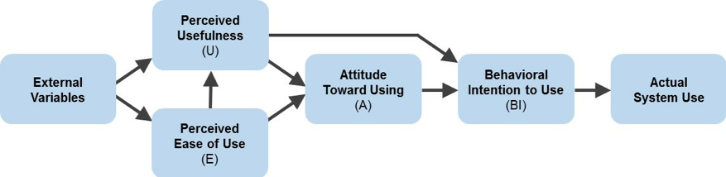

Figure 2 Technology acceptance Model (TAM) Davis (1989).

There are two principal factors in the TAM model which are the determinants of actual system use, these are perceived usefulness (PU) and perceived ease of use (PEOU). Perceived usefulness is defined by Davis as the prospective user’s subjective probability. In contrast, perceived ease of use is defined as the degree to which the prospective user expects the target system to be completely free of effort (Davis, 1989). Both factors are influenced by external variables: social, cultural and political factors.
The attitude to use involves the determination by mean of the consumer of the desirability of using a particular application of the information system. The measure of the likelihood of an individual adapting to reach the application is, as a matter of fact, behavioural intention (Davis, 1989).

2.3 Online banking security

Technology, age, gender or level of education are not the sole factors affecting people’s decision behind the use of IB services, people are cautious about this also because of different reasons (Amin, 20010). One of these reasons is online banking security.
Gelman (1998) stated that the information sent over the internet has a high chance to pass through dozens of different technological systems on the way to its destination. This does not feel safe and the consumer would not want to use things that may put at risk their bank account.
Some customers may feel safe because of the password which serves as protection and it is sent separately on their email address or post for various security purposes (Amin, 20010; Adams, 2005). Conversely, this is not helpful for organisations as many banks face danger as online banking can lead to fraudulent behaviour 80% of global phishing attacks in the past years have targeted the financial services sector (Martins et al., 2014; Roy & Bisht, 2012).
Different observations have led to very similar conclusions, according to Hain (2003) non-internet banking customers were more concerned concerning privacy issues than IB consumers. Regardless these characteristics, trust in IB services has gained trust through long-term internet use (Chu et al., 2012; Suh & Han, 2002).

2.4 Adoption of internet banking among generations

This section shall now elaborate certain attributes towards customer perspective on adoption or non-adoption of IB thus merely objective is to identify factors that affect the adoption of IB.
Referring to the views of Reisenwitz (2007), BB and those who are on lower incomes are the least to adopt IB, especially people from rural areas. Some of them also face problems such as difficulties to integrate with the banking system or learning the use of touchscreen devices.
On the contrary, Gen Y may have different issues such as lack of awareness of IB security. This may occur because of the lack of use of online banking apps, those with a lower education level might face these issues constantly (Aboelmaged & Gebba, 2013; Martins et al., 2014).

2.4.1 Influences on Consumer Adoption of Internet Banking

New technology adopters are usually the younger consumers, and they normally have a decent income, appropriate level of education and more reactive to innovation than the non-adopter (Nath 2003). According to Nath (2003), trust is related to consumer judgement on security and privacy issues therefore it is one of the main elements that influence the adoption of IB. However, few things are influencing the adoption of IB between Gen Y and even BB. Some of these are the following: Compatibility, Trialability and Social Influence.

2.4.1.1 Compatibility

Compatibility is defined as the innovation matching the existing values, experience and current needs of the potential adopter (Dauda et al., 2015). An individual’s job responsibilities and value system should all be matched with the innovation (Saloner et al., 1985). Internet, in this case, can be described as a delivery channel that is compatible with the modern-day banking customer, who is very likely to be familiar with the internet; therefore, more people utilise the internet and they also perceive that the internet is compatible with their lifestyle (Tan and Teo, 2000).

2.4.1.2 Trialability

Trialability has affected IB adoption. Trialability is the degree to which an invention may be a subject to minimal experimentation (Rogers, 1987). Those adopters that can experiment with and innovation are more likely to feel comfortable with the innovation and more likely to adopt it (Rogers, 1987). Therefore, in the event that the opportunity to try the innovation was given to the customers, certain fears of the unknown may be minimized (Tan and Teo, 000).

2.4.1.3 Social Influence

Social influences are the more likely to influence people and it can occur through face-to-face communication. The opinion of friends or the influence of the family are all considered to be social influences (Du Plessis and Rousseau, 1999; (Cheung, Chang and Lai, 2000). Majority of the researchers identified these factors are strongly influenced by the customer adoption of the IB system (Cheung, Chang and Lai, 2000).

Tan and Teo’s (2000) survey of internet users employed Ajzen’s (1985) theory of planned behaviour as well as Rogers’ theory of innovation diffusion (DOI) and determined the main influences which are the following: compatibility, the perceptions of relative advantage, risk and trialability.

2.4.2 Rogers’ theory of innovation diffusion (DOI)

Rogers’ theory of innovation diffusion (DOI) may help understand operative forces in consumer IB adoption (Rogers, 1995). DOI originated in communication to explain how a product achieves momentum and diffuses throughout a particular population or social system.
This diffusion concludes that people, as part of a social system, adopt a new idea, behaviour, or product (Rogers, 1995).
Understanding the aspects of the target population is crucial because of the fact that will support or block the adoption of the innovation; “there are five established adopter categories and there are different strategies used to appeal to the different adopter categories (Rogers, 1995).

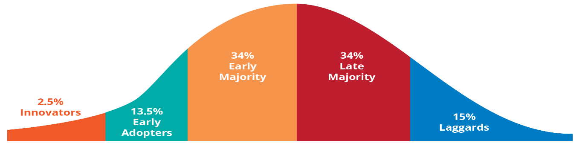

Figure 3 Rogers’ theory of innovation diffusion (Rogers, 1995).

- Innovators - These are people who want to be the first to try the innovation, these people are often the first to develop new ideas (Sahin et al., 2006).
- Early Adopters - These are people who represent opinion leaders, are already aware of the need to change and so are comfortable adopting new ideas. Procedures to appeal to this population include how-to manuals on implementation. They do not need any advice to persuade them to change (Sahin et al., 2006).
- Early Majority -These people adapt to new ideas before the average person. They are willing to adapt to innovation, but they need to see evidence which proves that the innovation will work (Rogers, 1995).
- Late Majority - These people are suspicious of change and will only adopt an innovation after it has been tried by the majority. Strategies to appeal to this population include concrete information on how others have tried the innovation and have adopted it successfully (Rogers, 1995).
- Laggards - These people are the hardest group to bring on board. Strategies to appeal to this population include statistics and pressure from people in the other adopter groups (Rogers, 1995).
Based on this model, it is theorised that product characteristics are crucial in the diffusion process.
The main concern of this innovation diffusion research is how innovations are adopted and why are they being adopted at different rates (Rogers, 1995).

Rogers (1995) stated that four major elements can influence new product diffusion: the innovation characteristics, social systems, communication, and time.
Gen Y and BB could fall into any of these five adopter categories depending on their situations because their behaviour towards innovation is highly influenced by social influences, which were all previously discussed.

2.5 Conclusion

There is a great deal of literature concerning the adoption of IB which illustrates that this is a multivariate issue (see diagram below). On the contrary, whilst age is a factor, there is insufficient work which compares intergenerational motivations for the adoption of IB. This study seeks to address this paucity of the research.
The diagram below will form the basis of the questions for this dissertation with a particular focus on how the individuals to either Gen Y or BB impacts this adoption.
Gen Y and BB are two types of consumers, both overtly different in comparison with one another in term of lifestyle as well as decision-based behaviour (Kumar & Lim, 2010). This research shall conduct to identify the differentiation perceptions between these two generations in adopting on IB.
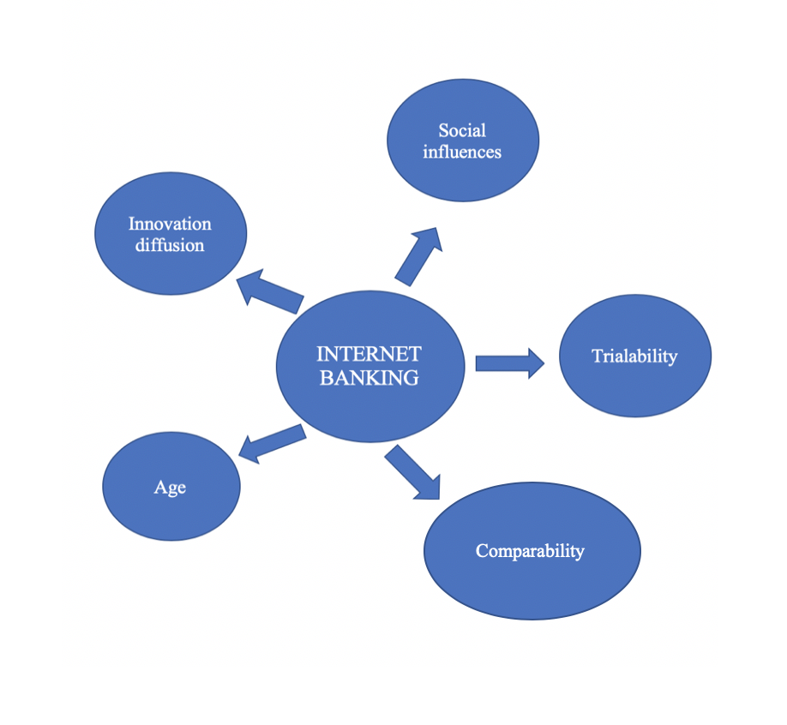

Figure 4 Multivariate issue within Internet Banking (Literature Review Data, 2020).
The chapter has revealed that the demographic characteristics have a major impact on the behaviour of Gen y and BB towards technology adoption and IB. However, with the internal nature of the theories and models, there is no specific conclusion behind the behaviour towards the adoption of IB.
Different theories have determined the reasons behind an individual adapting to IB services. Technology adoption is highly important because it is the transportation that allows people to rapidly adapt to the fast-changing world.
By gaining a better understanding of the factors affecting technology adoption, this suggests that IB, it will help this research predict and control who adopt, why and under what conditions. Further researches are needed to determine what factors have an influence on Gen Y and BB’s behaviour towards the use of IB.
The best practices for the methodology of data collection and analysis shall be discussed and evaluated on Chapter three, these will be utilised utilizing the researcher in gathering data on how two different generations, such as Gen Y and BB, adopts on the use of IB.

3 Chapter 3- Methodology

3.1 Introduction

This chapter includes the research methodology of the thesis. In this part, the researcher outlines various approaches including the research strategy, the method of data collection, the selection of the sample, type of data analysis, the ethical considerations and the research limitations of the project.

This chapter shall determine the methods of the research, data collection, the strategy, as well as analysis methods deployed to outreach the aims and objective of the research:

- To collect and analyse qualitative data from respondents that are from Gen Y and BB category and have a relation to the thesis subject of internet banking.

Qualitative research shall be held to satisfy the objectives of the thesis. The primary characteristic of qualitative research is that it is appropriate for small samples, while its outcomes are not measurable and quantifiable (Collins and Hussey, 2013). Qualitative research also makes it easier to gather rich data, details, and it takes an inductive approach that explores attentive as well (Collins and Hussey, 2013). This particular method offers a complete description and evaluation of a research subject, without limiting the scope of the research as well as the nature of participant’s responses (Collins and Hussey, 2013).

3.2 Research Methodology: Research Onion

There is not any particular consensus on how research should be defined due to the different meanings that it has to different people, howbeit from the many definitions being offered, it can be concluded that the research is a process of inquiry and investigation and it increases the knowledge of the researcher (Collins and Hussey, 2013).
The researcher shall adopt a methodical and efficient approach to research that can be referred to at any point for this a model shall be utilised to assemble the undertaking: The Research Onion (Saunders, et al., 2009).
The Research onion illustrates every stage that must be covered while developing research; its usefulness lies in its adaptability for almost any type of research methodology and can be used in a variety of contexts (Saunders, et al., 2009). In order to clarify the stages and methods of the project, the Research Onion shall be applied within this chapter.
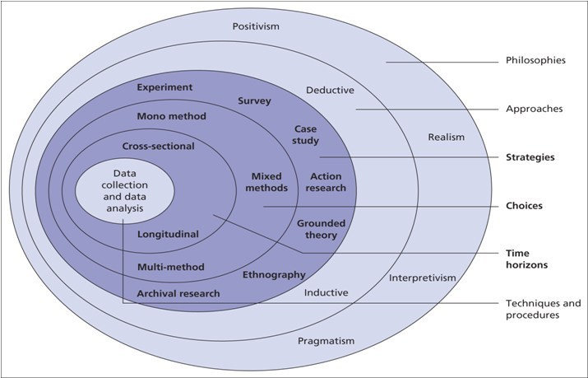

Figure 5: The Research Onion (Saunders, et al., 2009).

3.2.1 Interpretivism

The philosophy of study shall be interpretivism, this is because of the gathering of qualitative data. Interpretivism is where the researcher will take into consideration that there are several perceptions may overlap to one circumstance, matching with this the inductive approach will be used for analysis (Hudson & Ozanne, 1988).

The researcher has decided to use the Interpretivism epistemology because interpretivism studies focus on meaning, they are also helpful for theory constructions in the area with insufficient a priori theory, and it can understand what some people think and do, what kind of problems they are confronted to, and how they deal with them (Ozanne, 1988; Goldkuhl, 2012).

According to Hudson and Ozanne (1988), Interpretivists believe the reality is multiple and relative. The multiple realities also depend on other systems for meanings, this makes it more complex to interpret in terms of fixed realities, and the knowledge acquired in this discipline is socially rather than objectively determined and perceived (Lincoln and Guba,1990: Gergen, 2009; Berger and Luckman, 1967; Hudson and Ozanne, 1988).

Interpretivism incorporates actions which have had an effect on the candidate such as policies; with interpretive questioning, the responses gathered can be then explored further for elaboration and clarification (Gergen, 2009; O’donoghue, 2006). Saunders, et al. (2009) recognises that this structure of research is an optimal resource to business and management research studies, especially within organisational management because of the ever-fluctuating business environment as well as the human variable of the workplace. Behaviour and choices, making use of the paradigms lesser sampling size, and utilising the expert respondents for quicker data saturation (Weiss, 1995), all provide rich qualitative data which can be then analysed.

3.2.2 Inductive research

The inductive approach begins with the observations and theories are suggested towards the end of the research process as a result of observations (Hamilton et al., 2013). This particular approach involves the search of a pattern from observation as well as the development of explanations, for those patterns via a series of hypotheses (Hamilton et al., 2013; Thomas, 2003).

The inductive approach aims to generate meanings from the data that researcher sets to collect with the final goal to identify patterns and relationship to build a theory, howbeit, this particular approach does not impede the researcher from using a theory that already exists to formulate the question to be explored (Collins & Hussey, 2013; Hamilton et al., 2013).

The inductive approach will permit the researcher to establish understanding between Gen Y and BB and their choices and the influences behind those choices towards IB. The assessment of inductive findings than can be applied to various realities of situations because of the analysis’ subjective nature (Onwuegbuzie & Daniel, 2003).

3.2.3 Case study

The researcher decided to use this type of research design as it provides unique examples of real people in real situations (Baxter, 2008). Case studies are in-depth investigations of a group, the data is usually gathered from a variety of sources and different methods, the researcher for this thesis has decided to interview people (Tellis, 1997; Dul and Hak, 2007).

3.2.4 Mono-Method

Mono-Method will be used for the collection at primary data, which is interviews. This method allows for one type of data to be gathered in this research case is qualitative data; this maps with the aim of the study to evaluate interviewees' beliefs of a situation, on the contrary, cross-sectional approach benefits from being capable to view the comportment of a particular demographic within a corresponding situation (Spector, 2006; Teddlie, 2006).

3.2.5 Cross-sectional

The cross-sectional research design is a method where a study involves looking at data from a population at one specific point in time. These studies are known as descriptive research which means that the researcher cannot use them to regulate or control the cause of something. The cross-sectional method is used to make inferences about possible relationships or to gather preliminary data to support further research as well as experimentation (Lindell & Whitney, 2001; Mann, 2003; Levin, 2006).
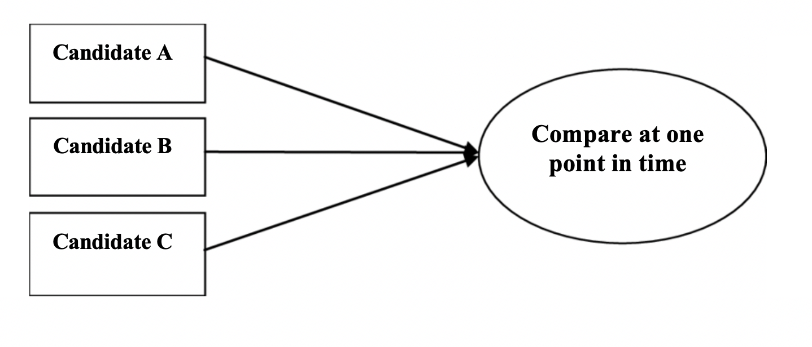
Figure 6: Cross-sectional Study (Collins and Hussey, 2009).

Cross-sectional and Mono-method approach shall be positioned with semi-structured interviews. The
rich data gathered will then provide the researcher with more depth to research permitting for behaviour and choices to be analysed and will allow the researcher to have a clear comparison of two different generations’ behaviour towards IB.
In its purpose, the dissertation is exploratory as it does not intend to finalise anything or find solutions rather is instead to explore the research question and provide correlations to establish a foundation for further study into this category of study (Hamilton et al., 2013).

3.2.6 Data Collection and Analysis

3.2.6.1 Qualitative Data

The accumulated data will be in the form of qualitative data. Qualitative data is more descriptive than numerical or statistical (Collins and Hussey, 2009). This particular data is used for comprehending the perceptions of the interviewees on a topic that was given to them; it creates an understanding for further research, to comprehend the human response to business agreements, and provides a rich set of data which consists of reasons to fundamental motivations, reactions and/or behaviour (Silverman, 2015).
The experience of the respondents can be easily understood by qualitative data; data given in this manner illustrates depth without having the need of numerical evaluation, which allows the researcher to determine factors which were not contemplated before the undertaking of the project (Miles et al., 1994; Mays, 2000; Atkinson, 1996; Fylan, 2005). The six-step method shall be utilised to form a narrative of the qualitative data collected from the semi-structured interviews, the program Nvivo will aid in the organisation of the data using codes for analysation of trends and patterns of theory within data (Braun & Clarke, 2006). The transcripts of the data will then be organised into nodes, then subcategories shall be used to evaluate further trends in order to form the calculation of the data (Mayer-Schönberger et al., 2013). This shall be presented in thematic narrative form, (Riessman, 2008), discussing current existing theory.

3.2.6.2 Purposive Sample

The researcher will use a purposive sample of interviewees in order to acquire primary data because of time restraints for statistics collection and analysis. This method allows for the simplest records to be gathered that has direct relevance to the challenge of the thesis (Lavrakas, 2008; Tongco, 2007).
The data accumulated from the sample can provide an overview of the analysis even though other perceptions may be visualised (Lavrakas, 2008).
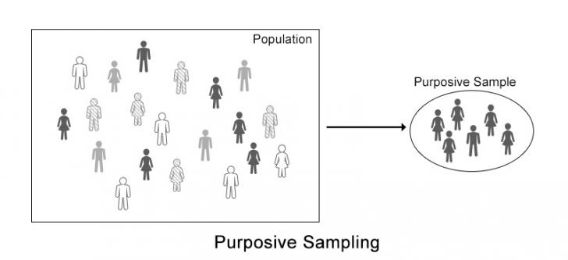

Figure 7: Purposive Sampling (Saunders, et al., 2009).

3.2.6.3 Interviews

Interviews may be face to face, voice to voice or screen to screen and it makes comparing answers much easier; it is either conducted with individuals or a group of individuals (Collins and Hussey, 2009). To accumulate data semi-structured interviews shall be used, this will allow the researcher to have questions correlating to the primary research, furthermore unstructured questions that arise as part of the conversation (Saunders, et al., 2009). The semi-structured format allows for personal interpretation as well as follow up questions, which allows the researcher to explore the personal experiences for the respondent (Saunders, et al., 2009).
Other advantages include:
- Overcoming low responses to questionnaires (Duncan, 1979; Dumay, 2011)
- Respondents can frame answers in own words for more complete accountability (Coombs, 1998; Holstein, 2002).
- Rapport can be built up within the interviews which allows trust to form as a result this encourages more truthful responses (DiCicco-Bloom & Crabtree, 2006)

Some questions were already prepared, which have guided the researcher in the interview towards the satisfaction of research objectives, however, additional questions were also made encountered during every interview.

3.2.6.3.1 Approach

The researcher shall guide each respondent through the subject chosen with few probing open-ended questions such as: What do you think about this? What would you do differently? (Hutchinson and Wilson,1999). These particular type of questions puts the respondent at ease because the interviewer has the opportunity to build a rapport within the interview which then help with recall of further information (Anderson et al., 2002). The researcher is aiming for a saturation of knowledge, where the researcher has enough data to have patterns in the experiences of the candidates (Bertaux, 1981; Strauss and Corbin, 1994).
The target for the number of interviews will be fourteen, these people all fall into the two categories, either Gen Y or BB, all of these participants use IB. By using this number of candidates, the researcher shall be able to collect enough amount of data that will draw patterns which can be evaluated (Dexter, 2006; Miller, 1992).
Depending on the respondent, each interview will aim to take between half an hour to an hour; the Interviewer will be polite and hold no time constraints on the process.
The questions will be reviewed by the dissertation supervisor which will help to see if the questions gather relevant information for the thesis.
In order to check the respondent’s consistency, at the midway point of the interview, a question shall be asked again, this will help the researcher to check if the reasoning still applies to the question once the rapport has been built between the researcher and the candidate (Patton, 1990; Groves et al., 2001).

3.2.6.3.2 Interview Design

Originally all interviews were set to be face-to-face interviews, however, due to Covid-19 (World Health Organization, 2020) interviews shall now be only via Skype, Teams and Messenger.
These interviews shall be recorded with a Phone only for back up purposes, this method of data collection negates human error in the note-taking processes (Myers & Newman, 2007). Once recorded, this data will be transcribed via talk to text software to eliminate human error in the typing of transcripts (McLellan et al., 2003; Britten 1995; Cassell, 2004).

3.2.6.3.3 Analysis

The data gathered shall be analysed with NVivo, which is a software package that categorises links in the data with coding (Nvivo, 2020). The data shall be open coded and then analysed for sub-category links. This method is called axial coding which allows the researcher to understand the correlations within the data for a more in-depth conclusion to the subject (Mentzer, 1997).
The researcher will be comparing the answers of the two different generations; the final stage is to merge these categories into concepts which then will be evaluated in order to produce a report on the findings.

3.2.6.3.4 Interview Question Matrix

These are the interview questions that shall be asked to the fourteen participants, among which seven of these are Gen Y and the other seven are BB. An interview is a powerful discussion between two or more people (Myers and Newman, 2007), and these questions shall help the researcher accumulate rich, valid and reliable data to complete Chapter four.

Questions in Interview | Reasoning and Source
Q1. How long have you been using internet banking services, and at what age did you start using it? | These are partly demographic questions that can provide the participant’s age group without asking them direct questions about their age, which may invade their privacy  (Alashban and Burney, 2011; Czaja and Sharit, 1998).
Q2. How did you find out about Internet banking?  Q4. How did you learn to use the service?  Q3. Do you ever visit the branch? Any reason for your trip? | Critically evaluate what are the main reasons behind the use of Internet Banking services of each different aged participant, these questions can help understand the behaviours of the respondent.  (Dauda et al., 2015; Tan and Teo, 2000).
Q5. How would you compare internet banking to traditional banking, and which one do you prefer? | To explore the views of different aged participants on traditional banking and then compare that to their views on Internet Banking (Kumar & Lim, 2010; Rogers, 1995).
Q6. What made you choose Internet Banking?  Q7. Has anything influenced your adoption of Internet Banking?  Q8. What do you primarily use Internet Banking for?  Q9. What do you think about safety? How safe is it to bank online? | Indirect questions to ger the participants own views based on their own experiences; these shall help the researcher gather enough data on how these different aged individuals think and what they would recommend to others. (Kumar & Lim, 2010; Rogers, 1995).
Q10. How would you benefit if Internet Banking removes the use of cash payments?  Q11. What makes Internet Banking easier?  Q12. How often do you think it is necessary to check your data, transactions etc, and why?  Q15. What are the main advantages that we have had since Internet banking was introduced?  Q14. What about the disadvantages?  Q18. Do you think internet banking is becoming increasingly popular? How would this affect you? | Probing questions to evaluate a participant's personal opinions and views regarding Internet Banking.  These questions would help the researcher explore how the different aged participants think in terms of online banking safety, how concerned they are regarding Internet banking in general and what the main advantages this service offers  (Kumar & Lim, 2010; Rogers, 1995; Dauda et al., 2015).
Q15. What do you think are the main characteristics of Internet Banking that need to be improved? And why?  Q16. What frustrates you the most when dealing with online banking services?  Q17. Based on the experience you have on Internet Banking, what recommendations would you make to anyone with no past knowledge/experience on this?  Q19. Would you ever go for a virtual bank ditching the physical one completely? | Following on from the previous questions, these are all linked and are open-ended questions that shall analyse the views of the participants (Dauda et al., 2015).
Q18. Do you think internet banking is becoming increasingly popular? Please explain why | The question to accumulate the views and thoughts of two different generations on internet banking.
Q20. Any questions or comments relating to the issues in this interview would be very welcome | This open-ended question will be analysed about any themes that have arisen, and it is hoped that it will contain qualitative answers.

Table 1: Questions from the interview relating to chapter two the literature review

3.2.6.5 Credibility and Dependability

The data gathered for analysis must demonstrate credibility and dependability to be worthwhile, but different qualities depend on the type of data collected and the methodology involved (Guba & Lincoln, 1981). Qualitative data is considered to be difficult to define in terms of what is credible and reliable, compared to quantitative statistical data; this is due to the subjective nature of the data gathered (Guba & Lincoln, 1981). According to Shenton (2004), the problems of replication of interviews in the same snapshot that was previously experienced by the researcher makes credibility and dependability complex for the qualitative researcher to access. The researcher must use standardised practices and competencies to support accuracy as well as validity since there are difficulties to measure the credibility of data collected from a qualitative method (Collis & Hussey, 2009).

The dependability of interviews can be low, howbeit the researcher has the capability to expand the dependability of data collected by using one-to-one interviews and using the same interviewer throughout the gathering of the data to provide similar bias to all the interviewees (Granheim and Lundman, 2004).

3.3 Reliability and Validity

The result tends to have high reliability but low validity, howbeit, this research has elements of the interpretivism which tends to build the reverse effect and having the merge of the two shall produce a study with enough reliability as well as validity (Collin & Hussey, 2009).
Interviews hold a low-reliability level because there are a variety of difficulties that could affect the conclusion of managing the interviews as well as the analysis of the interviews often to demonstrate to be a subjective process (Saunders, et al., 2009).

On the contrary, validity is concerned with the accuracy and trustworthiness of the data collected and its findings (Carmines et al., 1979; Creswell & Miller, 2000). Validity can be deteriorated by poor sampling and by misleading analysis outcomes; to avoid such skewing, the researcher will be interviewing fourteen participants that shall contribute to this research and provide enough amount of data to be then analysed on the following chapter.

3.4 Ethical Considerations

The research proposed may have one concern, which is the nature of the questions asked around the topic of online security (Denscombe, 2014). Many interviewees might not feel happy to share their thoughts and experiences on this particular subject. Respondents will be asked to sign a consent form and tick the boxes. Respondents will be given a consent form to keep in addition to the one signed and returned to the interviewer. The researcher shall act in a professional manner which will help minimise the stress of the subject area (Denscombe, 2014). The researcher will warn the participants before recording them. Before the interview commences, the researcher will reiterate the purpose of the interview is confidential and anonymous. The researcher will provide reassurance responses to the interviewees, as this will not put at risk their financial information and their views towards IB.

Saunders et al (2009) explained that no research should cause harm or risks to participants and careful consideration should be taken to ensure interviews do not cause the participant to feel stressed. Due to all the participants being over the age of eighteen and voluntary, the research should not raise any concern with ethical risk. At any stage of the interview, participants can withdraw if they wish to, all the data that gets collected will be kept confidential and all the participants will be kept anonymous.
To assure the participants that the data given will not be constructed by the researcher, a copy of the finished thesis will be available to every interviewee upon request through email.
Copies of the Ethics and the consent form are attached in the appendix D and E.

3.5 Potential Limitations

Limitations of this research collected at the bachelor's level are at the time restraints of the study to gather respondents and investigate the data provided. The overreaching limitation to the thesis can be authorized to the dependability of the procedure of the data collection and if the validity of the research can be corroborated with duplication by a second researcher (Miles et al., 1994).
Another limitation that needs to be highlighted is the Covid-19 outbreak in March 2020, which has put limitations onto the interview process as the researcher could not interview participants face-to-face but solely via Messenger and Skype.
The methodology is considered to be a standard practice which is used in the field of qualitative data collection, all backed by previous academic research. The methodology shall be used throughout data collection and analysis of semi-structured interviews (Guba & Lincoln, 1981).
To support further validation of the data analysis, the appendices shall include data and transcribe of all interview questions.

3.6 Conclusion

This chapter has analysed and elaborated the research methodology and the second objective was completed. The justification of the methods chosen, that will be used in this research, has been explained. In order to examine and discuss themes within the data collected, the next chapter shall use the methodology of data gathered outlined within the current chapter.

Chapter 4- Data analysis & findings and Discussion

4.1 Introduction

The Chapter is undertaken to analyse the data collected through the research method of semi-structured interviews. This chapter aims to accomplish the third and penultimate objective of the thesis:

- To examine the role of Gen Y and BB’s trust in data security and to the use of internet banking.

The following chapter contains data gathered from people of different ages and all IB consumers.
Ten participants were interviewed over 4 days period, between the 29th and 1st of April 2020, in order to provide the researcher with different types of consumers. This assessment shall be presented in thematic narrative form (Riessman, 1993), disputing current existing theory. The typed transcripts of two interviews can be located in the appendix (B and C) to this dissertation, one was an interview from a Gen Y respondent and the other a BB.

4.2 Background for findings

The researcher shall evaluate the transcripts of the data for any themes that are overlapping and establish if these correlate to the theory assessed within Chapter two or structure new links to the theory that was not previously appraised (Denscombe, 2014; Polkinghorne, 1995).
The evaluation shall be presented by using the narrative format corresponding to the principal points form the interviews and the use of graphical data taken from the NVivo analysis to allow for a fluent understanding of the qualitative data (Riessman, 1993; Braun and Clarke, 2006; Saldana, 2015).

4.3 Main Findings

The main findings have demonstrated the links between security and trust within IB, which shall be discussed and be split into three sections:
- Security;
- Trust;
- Links between security and trust.
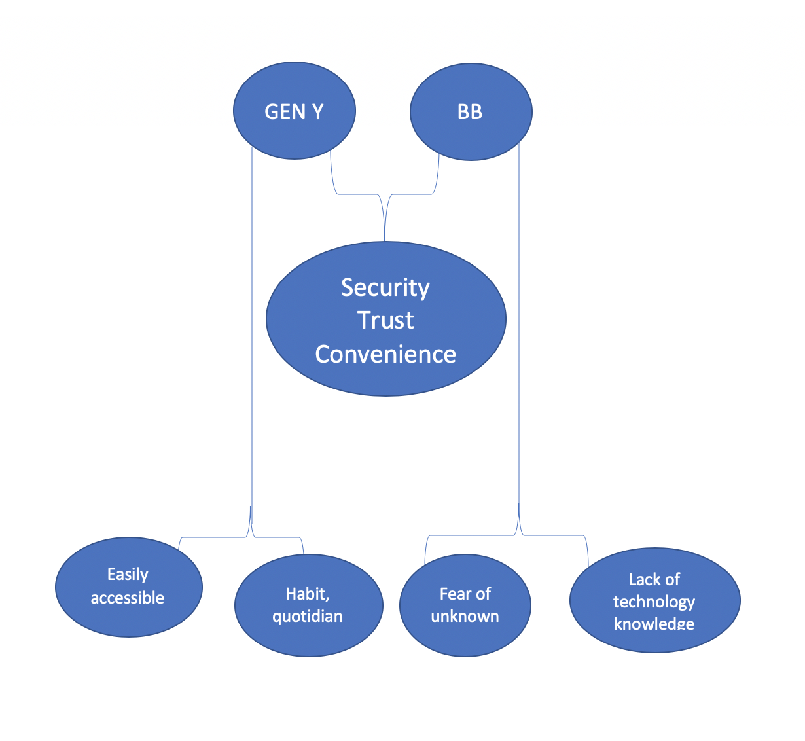
The analysis shall start by comparing the two generations and their views on banking security and trust and then move into deeper evaluation including word trees, diagrams differing perceptions to the topics. The analysis has illustrated that both generations use IB due to its convenience (see figure 8), both are concerned about the security features; conversely, the majority of the participants trust their bank as they would provide help in case problems arise. Other subjects such as, lack of technical knowledge or the fear of unknown are things that make the use of IB unpleasant to the BB. On the contrary, the younger generation uses IB as it is now a habit for them, and it integrates well with their daily life.

Figure 8: Main findings between Gen Y and BB.

4.3.1 Participants

The question was posed because the researcher wanted to compare the views and the adoption of IB between two different generations (Gen Y and BB). Table 2 illustrates a clear representation of every respondent that took part in the interview.

 | Demographic | Generation
Interviewees 1 to 5 | 48 - 59 | Baby Boomers
Interviewees 6 to 10 | 25 - 34 | Generation Y

Table 2: Demographic of participants

4.4 Security

All the interview data correlating to the theme of security were established by the researcher with the help of NVivo; this has created a word cloud.

Figure 9:High-level word cloud of Security (Internet Banking Interview Data, 2020)

A word cloud was created with the frequent words used by the interviewees whilst talking about the topic security. Referring to the data found from the research, most customers regardless of their age, view relationships with banking based mainly on trust and how they view security banking is equally important.

‘The bank always assures me that my money is safe with them,
I know them well and I trust their word’ (Interviewee BB4).

‘What I know is the bank is responsible for all my money,
so, I’m not really worried about that because I haven't really
had any experience with frauds but if I do the bank would help (Interviewee GY1).

Strong concern about security is one of the most common factors related to the unwillingness of customers to use IB services. The researcher aimed to investigate the relationships between the security and perceived usefulness and perceive ease of use (Davis et al, 1989); from the data collected it can be concluded that perceived usefulness and perceived ease of use positively affect the acceptance of IB.

4.4.1 Perception of ease of use and perceived usefulness

The technology acceptance model is defined as information theory which goal is only to predict and define user acceptance of information technology (Davis et al, 1989). Perception of ease of use is the level at which a consumer believes that using the IB system will free up mental and physical effort. Rogers (1995) affirmed that perceived ease of use is the term that constitutes the degree to which as ‘innovation’ is being perceived not to be difficult to operate or understand. He also added that the drivers of growth in IB are determined by the perceived ease of use, which is a merger of convenience provided, the availability of secure and the necessity of banking services (Rogers, 1995).

‘Among the benefits of using internet banking is the speed of transactions, the convenience of doing everything only through a simple device’. (Interviewee BB3)

‘The fact that is very convenient, it's very easy you can access it from your tablet, from your computer from all your devices from the comfort of your own home, is very easy to use that Is the main advantage’. (Interviewee GY4)

‘I'd say my friends and my colleagues had it and I felt like it was something I needed as I said before, and yeah it was a little more like a necessity for me. So easier to manage your money to pay bills or make payments to others’. (Interviewee GY1)

Results have demonstrated that even though the participants appreciated the benefits of the IB as perceived usefulness factor apply the biggest direct effect, they would prefer to use the clearer and easier websites, this means that the use of IB is highly influenced by the surrounding people’s views and prior experience. Both generations believe IB services are highly convenient and Gen Y says that is also a ‘necessity’ as they need it for work and educational purposes. Both generations have security concerns but most of them trust their bank (see appendix g).

‘I know the local branch would provide help if I do face scams’ (Interviewee BB2).

The banking industry is linked to high levels of trust such as privacy issues and security; without trust (Balaji, 2015), the use of online banking services would not survive.

4.5 Trust

Regardless of the level of trust between the consumers and the banks, some BB customers still have the lack of trust which has a major influence on their willingness or intention to use IB fully. Trust has been an obstacle that stops a person from adopting technology, due to identity theft and activities of hacking (Pearson, 2007). Luding (2003) also noted that trust issues are crucial drivers of IB adoption.

Figure 10:High-level word cloud of Trust (Internet Banking Interview Data, 2020)

Gen Y trusts the bank as they are digital natives, however, BB still prefers to visit the traditional branch as they fear to make the ‘wrong click’ due to the lack of knowledge and not being used to technology.

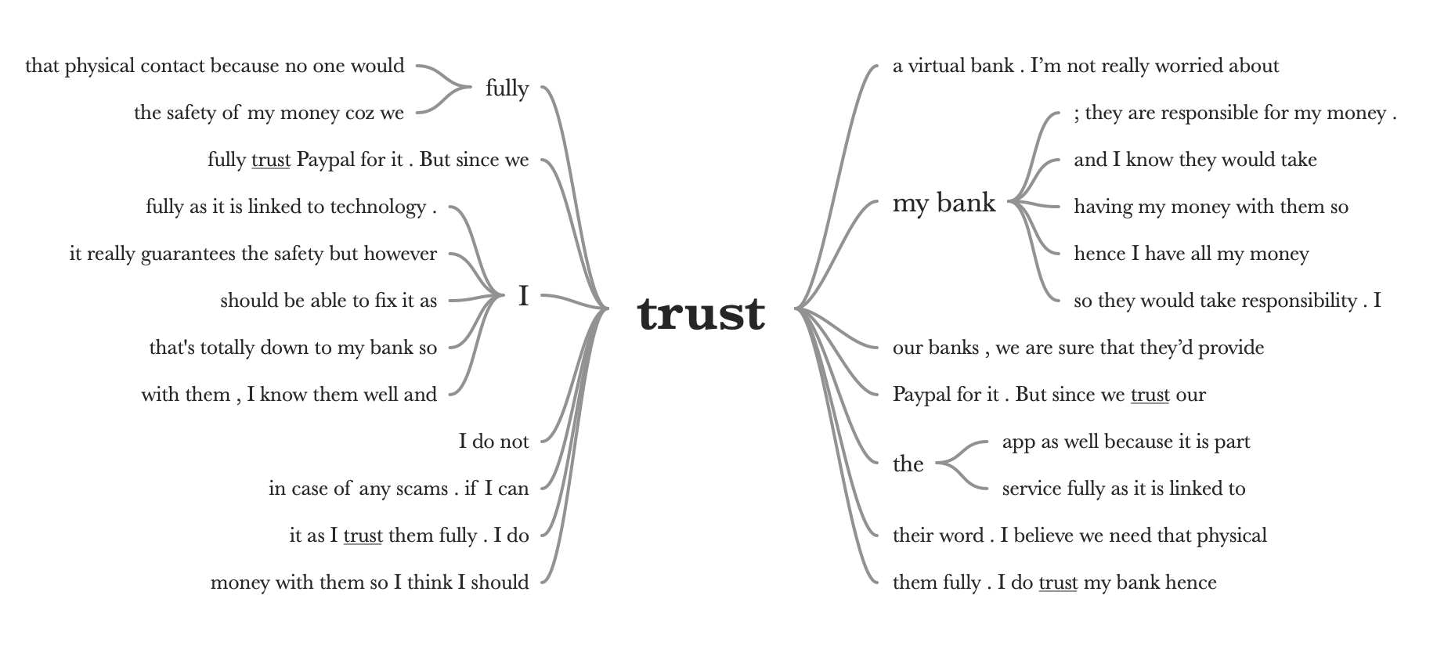

Figure 11:Text query analysis on reasons for trust (Internet Banking Interview Data, 2020)

The researcher created a word cloud with all the most frequent words used by the interviewees whilst talking about the topic of trust. Security and safety are surely linked to trust as they are clearly shown in the word cloud. The researcher also wanted to view reasons for their trust, with the use of NVivo text search query; the researcher has identified that the most common reasons are because they fully believe the bank would help, some have also mentioned that they are at peace as they use PayPal for managing money online. The importance of security for the acceptance of IB has been previously noted in many studies (Hernandez and Mazzon, 2007; Tan and Teo, 2000; Sathye, 1999; Chen and Barnes, 2007). The lack of privacy and security were described as obstacles to the adoption of IB (Sathye, 1999). Referring to the views of Roboff and Charles (1998) people have a weak understanding of the security risk of IB; Furthermore, Howcroft (2002) has noted that although customer’s confidence in their bank was robust, their confidence in technology was weak. Privacy issues have been barriers to the use of online services.

4.5.1 Convenience

Results have demonstrated that both generations are overly similar when it comes to security and trust and they both use this service as it is convenient for them. The features of this service have made it easier to manage people’s finances; from the interviews, it can be concluded that not making regular visits to the branch is the greatest advantage of IB services for both Gen Y and BB.
‘I chose it for convenience, low costs are also another reason, and because my bank is not open 24/7 so having access to this tool was a great advantage’. (Interviewee BB3)

‘we don't have to go to your bank that often, it is very useful for me as I am quite busy and always in a hurry between work and university.’. (Interviewee GY3)

People will adopt IB when they perceive it to be useful, convenient; in this case, both generations find the use of this service highly convenient due to its advantages (Lee, 2009; Martins et al., 2014; Chan, 2004). People used to choose their bank based on where they live but IB made this simple as the location is no longer a concern (Martins et al., 2014). The researcher has found that convenience is individual to each consumer. IB is more popular with Gen Y for every aspect, whilst some BB respondent mentioned they only use this as it is convenient for them for certain things. Few BB respondents, for instance, said that they only visit the branch when they need to make an important change in their bank:
‘I only go to my local bank if I need to make a significant change in my personal account such as loan applications, this is only due to the great help provided from the staff.’ (Interviewee BB4).

Other BB respondents have added that they only visit the branch for personal interaction with the staff, something that was not mentioned by any of the Gen Y participants.

‘I visit the bank regularly to take cash out and I also like to have a chat with the manager’ (Interviewee BB2).

4.6 Links between Security and Trust

Through the interview the researcher has found similar threads of Security, Trust and Convenience that flowed through; both generations have strong concerns regarding security. According to a PwC report (2017), only 10% feel like they have complete control over their personal information; this demonstrates that the majority of IB consumers do not have that trust yet and banks need to assure their consumers that their online banking system security is safe enough. From the data collected the researcher has moreover found that face-to-face communication is preferred for the trust for the older generation.
‘I still prefer the traditional branch because of the service, and the face-to-face communication.’ (Interviewee BB3)

‘I personally do not have much time to visit the branch and I find less time consuming to access my money directly from my devices and I still prefer to visit the branch because of the face-to-face communication’. (Interviewee BB1)

The data gathered proves that trust is linked to direct communication such as face-to-face communication, this transmits security to the consumers as this enhances security, credibility, it can gather feedback and it gives the consumer a chance to address sensitive issues. Banks are failing to gain trust among all its users due to its lack of direct communication with customers as the older generation prefers face-to-face communication (Ball, 2004; Ratnasingham 1998).

The researcher asked few questions, other than security or trust-related, to both generations to compare; their experiences, thoughts regarding the use of IB.
The next section shall now focus on comparing the views of each generation.

4.6.1 Generation Y and Baby Boomers


The researcher has created a word cloud with all the most frequent words used by the younger generations whilst discussing IB.

Figure 12: Word cloud of Internet banking, Gen Y (Internet Banking Interview Data, 2020)

The younger generation finds this service to be more flexible, faster and mainly timesaving.

‘The fact that is very convenient, it's very easy you can access it from your tablet from your computer from all your devices from the comfort of your own home, is very easy to use that Is the main advantage.’ (Interviewee GY4)

On the other hand, BB thinks that IB is helpful and is more of a ‘necessity’ for them; some said they find it complicated because of all the features it has within the website, and some mentioned ‘scams’ as they do not fully trust the service because technology is involved.



Figure 13: Word cloud of Internet banking, BB (Internet Banking Interview Data, 2020)

‘I believe that no service is 100% secure so I always check my data, but the bank always assures me that my money is safe with them, I know them well and I trust their word’. (Interviewee BB4)

‘I found out about the service through my workplace, so I needed to use this tool as it is required to manage the money and to make payments. It was necessary to have this app in order to keep it up with my finances’. (Interviewee BB5)

Previous studies concluded that those consumers who use IB for the longest period of time find online banking services to be reliable (Dauda et al., 2015; Tan and Teo, 2000).
Lee (2005) has added that the intention to adopt IB is affected by factors like efficiency, responses time from the providers and reliability. The researcher asked both age groups what things frustrates them the most when dealing with IB services, both generations have given various answers;

‘The thing that annoys me is when you use internet banking to make payments and they are not successful, and it takes a lot of times to get answers and one FAQ isn’t really enough, so again it comes to security.’ (Interviewee BB4)

‘Remembering the login credentials usually stresses me and not everyone has the devices that can remember it for you, sometimes you do not get all your questions answered in the FAQ section and this is something they should work on.’ (Interviewee BB1)
‘Sometimes remembering my password or my login details and sometimes when I have to type everything over the security stuff just for a single transaction it's pretty much time consuming’. (Interviewee GY1)

‘So, if you have a fault in your account for some reason you can't fix that directly from your devices but you have to go to the office or bank so there should be a sole service online to fix the online issues. I know my one doesn’t I am not sure about others.’ (Interviewee GY3)

This illustrates that IB services are affected by a lack of communication as a ‘FAQ is not enough’, and some security features should be quickly accessible to make the whole adoption easier for every age group, BB in particular.

4.6.1.2 Internet Banking Popularity
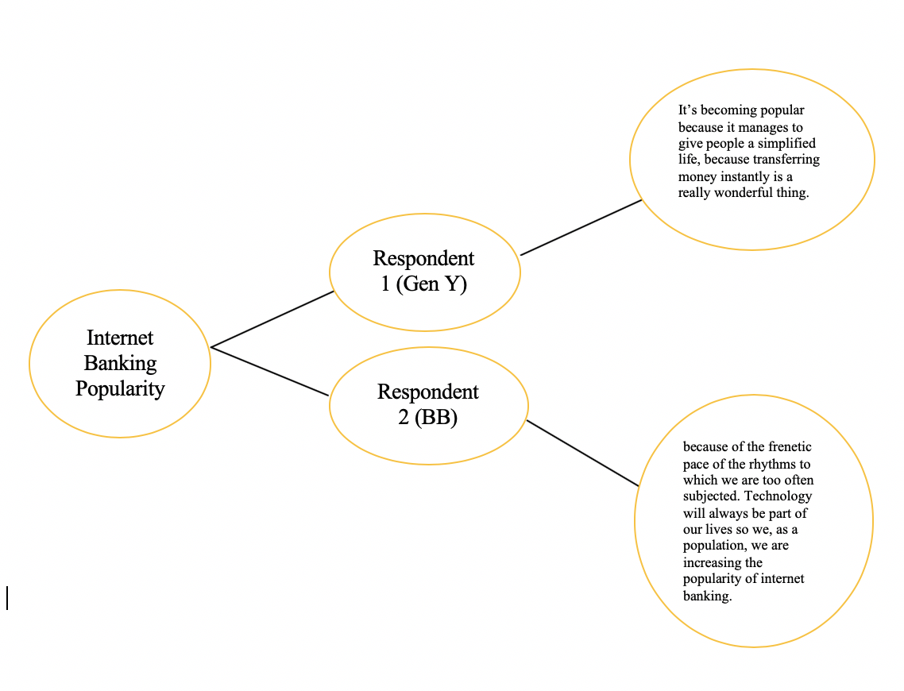
Figure 14: Comparison diagram of Gen Y and BB, IB popularity (Internet Banking Interview Data, 2020)

Another question the researcher wanted to ask was about IB popularity.
The younger interviewee describes the popularity of the service to be a ‘wonderful thing’ (see figure 14), because of how quickly people can transfer money; the older interviewee mentions how everyone is surrounded by technology, hence this has become part of everyone’s life and as a population, we are what is making this service popular. The popularity of the service is linked to the users, the majority of IB consumers only use it once they fully understand its usefulness, however, BB assumes certain risks because of lack of competence and they value the influence over younger family members, who are more used to the use of online services.
‘The service was quite simple to learn, however, I needed help from my son to fully understand this. The bank also provided great help in answering my security-related questions’. (Interviewee BB2)

4.6.1.3 Virtual Banks

The researcher questioned both groups if they would stop banking with a physical branch and upgrade to a virtual bank, all of them answered that they would not switch to an only virtual branch due to various reasons. The responses were the following:

BB | GEN Y
I do need that assistance from the bank workers that a virtual bank wouldn’t be able to offer. | I cannot deposit cash or withdraw money
The face-to-face communication is crucial as you might not get your all questions answered through a virtual bank. | I actually think that would be a great idea as people nowadays do not visit the branches anyways so I would definitely switch it.
Imagine if you have no fast internet connection or no electricity? And if my money gets stolen I would much prefer to solve it by talking to the bank directly and not through the phone or an automated system. | I think is not secure enough so I will need the security from my actual physical bank because the virtual one isn’t safe enough in my opinion.
I am not really able to learn the use of technology so having a virtual bank would just really cause me problems. | I would rather have that physical contact with my physical bank who can provide extra help in case of scams
I need a visual security as an only online bank wouldn’t be able to give me, we are humans and I believe we need that physical contact because no one would fully trust a robot. | I prefer traditional banks because they provide more help than a virtual bank would.

Figure 15: Views of Gen Y and BB on Virtual Bank (Internet Banking Interview data, 2020).

The majority answered ‘no’ because of security issues, they feel like a virtual bank would not be secure enough due to different factors, such as no face-to-face communication. The older generation is more concerned about hacking and the lack of direct communication with the bank, meanwhile, the younger generation believes the traditional branch would be more helpful than a virtual bank as there is human contact hence reliability and trust can be easily built.

4.7 Conclusion

The most occurring factors affecting the adoption of IB services found from the qualitative research are the lack of knowledge, no people to help, fear of doing things wrong, fear of the unknown, not being able to use technologies and lastly ethical hacking.

By analysing the data collected from this qualitative research and presenting the findings, the researcher has attained the objective of this chapter has been successful. The next chapter shall illustrate a summary of the findings, make recommendations based on the results found in the current chapter, discuss any implications and provide reasons for further research.

Chapter 5- Conclusion and Recommendations

5.1 Introduction

The data gathered was investigated in chapter four, which was the achievement of the objective three. The outcomes of the findings have materialised three themes: security, trust, and convenience.
This chapter will now achieve the final objective of the dissertation:

- Draw conclusions based on the discussions and offer recommendations for future research and to increase the use of Internet Banking among Generation Y and Baby Boomers.

Additionally, this chapter will offer recommendations for future research and state the conclusions and limitations of this study. The recommendations will be established on the research undertaken and the findings from the data gathered.

The achievement of objectives;

- To evaluate and analyse existing academic literature concerning the different motivations for the adoption of internet banking between Gen Y and BB.
To analyse previous academic research, a large amount of research was being conducted in Chapter two. Previous studies have indicated that age is a factor affecting the adoption of IB services as older people have less knowledge in technology and the internet; the technology acceptance model (Davis et al, 1989) was the most appropriate way to check how the participants adopt and use the IB.

- To collect and analyse qualitative data from respondents that are from Gen Y and BB category and have a relation to the thesis subject of internet banking:
This was achieved in Chapter three by identifying the right methodology concerning the findings in Chapter two. This has conducted primary data to get a better understanding.
With the help of the Research Onion, the researcher was able to create a better-organised methodology in writing the thesis.

- To examine the role of Gen Y and BB’s trust in data security and to the use of internet banking:
Objective three was achieved in Chapter four by evaluating the primary data collected using NVivo and presenting the findings. The researcher was able to find the differences between Gen Y and BB and their adoption towards IB. Gen Y has more background knowledge on this field as most of them are ‘digital natives’. On the contrary, BB had to get used to the IB services as the technology was ‘unknown’ for them. Both generations have mentioned security often as their main concern and all the participants have added that convenience was the main reason why they use this service.

5.3 Summary of findings

Data analysed in the previous chapter discussed and put into context the adoption of IB between Gen Y and BB. Participants in this study were between the age of 25 and 59. The results of this study have demonstrated that both generations have strong concerns regarding the security of their accounts however they all have a robust relationship in trust with their banks. Based on the findings the key items in facilitating the adoption of IB were ‘time-saving’ and ‘reliability’ as to access the app/website.

Factors like the ‘fear of the unknown’ and ‘lack of knowledge were found to be the key discouragement items for BB considering in term of adopting IB. People today are busier; their hurried lifestyle is the reason why IB is gaining popularity. This can be also seen from the increase in the adoption of mobile phones and the Internet generally due to its speed and convenience. IB is free, available 24 hours per day, 7 days per week; this attracts those who are time-poor. This to say, instead of physically going to a bank branch, customers who use IB can manage their time more effectively.
The following themes were materialised by the outcomes of the findings:

- Security: both generations believe security is low as IB requires technology. Gen Y believes that banks need to safeguard customer data as they fear identity theft;
- Trust: this refers mainly to the banks’ reputation; all the participants have added how they trust their bank when it comes to risks or privacy; this is due to the relationship they have with their banks.
- Convenience: rather than visiting the branch for managing their finances, customers can conduct their transactions in their own time wherever they are. With advantaged technology consumers can order cheque books online, manage each payment, and even arrange their payments in advance by weeks.
The study has also found that a positive attitude about IB should occur before the technology can be accepted. Findings of the research indicate that BB and Gen Y appear to make their IB adoption decisions based on its compatibility, complexity and trialability. The findings are similar in what (Tan and Teo, 2000) have found, which have demonstrated that the more complex an innovation is to use, and the greater the skills needed to adopt it; the less likely it is that the innovation will be adopted.
To build a positive attitude towards IB, banks should advertise the benefits linked with the technology, few examples include faster and convenient execution of transactions and lower cost.
IB coordinates well with the current lifestyle where work or communications are all done online via a device. Banks may need to arrange opportunities for their customers to test-drive the technology by providing the possibility for potential consumers to use IB.
By identifying factors and comprehending the relationship between them and their impact on intentions behaviour could help banks to create adequate websites to encourage their customers, BB or Gen Y, to fully utilise IB services. In this study, the researcher has found two issues that help to augment the intention of Gen Y and BB towards the use of IB.
These issues are:
- The need to recognise that IB should be managed with the intention of creating a useful service rather than just producing ease of use. Banks should reinvent their websites with no promotions, out-of-ordinary features as some BB have mentioned in the interviews that they want simplicity. Banks should keep it simple by making clear what actions are needed with familiar terms and by avoiding jargons.
- The majority of the participants have added how the FAQ section is not helpful, hence banks should add quick links, helpful tools and other useful resources that could help to change the whole online banking experience. Providing consumers with immediate access to these utilities can help saving time and keep them happy.
The researcher has found that Gen Y and BB are similar because the main concern of both is security and they use this service due to its convenience. However, the issues outlined above should be minimised by banks to develop strategies and build adequate IB websites and platforms for BB and Gen Y.

5.4 Recommendations

Based on the findings, the following recommendations are made to increase the use of IB among Generation Y and Baby Boomers:

- Adding new online features: giving the customers direct interaction with the bank agents in solving their problems. Some interviewees have suggested to include several links that connect with tutorial instructions, either in the form of e-books or videos; these were mentioned by both Gen Y and BB as they both feel like IB apps do not include enough answers on their FAQ section.

- Highlight new IB features once introduced: new features would need to be implemented so that it can be in line with the consumer expectations. The ease in navigating the new features can boost customer perceptions, BB in particular, of the overall IB performance and speed. Once customers understand how to use these features, their perception of IB speed will increase.

- Adding extra security features: BB customers are concerned about security as hacking activities are regular. Banks should encourage their customers to have stronger passwords and change it regularly, have a two-factor authentication before they log in and finally to avoid the use of public Wi-Fi. As many participants from this research have mentioned security to be an issue, the need for more secure and easier authentication for login is recommended.

- Survey the consumers: the greatest way to find out what BB and Gen Y would want is to ask for feedback and question them. Surveying customers regularly could improve the service and banks can be aware of what their consumer wants therefore, providing a useful service would be easier.
- Be aware of scams: Banks should strictly advise their customers to use PayPal when shopping online as identify theft and hacking can happen whilst making purchases online. When customers of any age experience such events, chances of them using IB again are low. Some BB respondents have admitted that they would not manage money online if they face issues during their IB experience as they find this risky.

- Simple websites: IB websites should be straight forward to motivate dormant users to fully utilise their features and raise their perception of system usefulness. Banks should know that when consumers face difficulties in using IB websites, this has a chance to stop them using this service and may not acknowledge the usefulness of it.

Limitations

A chief limitation of this research is that it has been carried out by an individual at the undergraduate level; for this reason, to reduce any error or bias during the research process, the progress was inspected by an experienced dissertation supervisor.

The limitation to the dissertation can be assigned to the dependability of the method of data collection; to aid further validity of the data analysis, the appendices will include the transcript of two interviews questions and answers.

The use of NVivo for codifying the data can consume some of the subjective nature of coding the data. During the interview, to build rapport and trust for ease of communication, all interviewees’ details were kept anonymous.

Research bias, time scale and sample size were the limitations that the researcher found during the collection and analysis of the data. The researcher wanted to interview five people from each age group however, including other age groups such as Generation Z would have given a better possibility to acquire further data to then compare. If more IB users had been interviewed, further measures might have been identified which may have created secondary adoption characteristics.

Lastly, due to Covid-19, it was not possible to run the interviews face-to-face with the participants; this has complicated the situation as the researcher had to interview people via Messenger and Skype. This has been difficult for the researcher as it was hard to find Baby Boomers that could use these platforms; the researcher felt that the rapport could not be built, thus less reliability in the data collected.

5.6 Conclusions

Research has been conducted to gain a better understanding of Gen Y and BB’s behaviour regarding the use of IB and to determine the factors that influence their intentions to use this service. With the use of the technology acceptance model, the researcher has analysed certain facts such as; the age is not a factor that has a direct influence on a consumer, every participant interviewed felt like using IB services is straight forward and free of effort, Perceived Ease of Use.
Perceived Ease of Use influences Perceived Usefulness; everyone interviewed mentioned how they use IB as it is required from their jobs, or it is needed as they use this service to manage their finances regularly from their mobile phones. This has suggested that they believed using IB would enhance his or her job performance, Perceived Usefulness.
Furthermore, the researcher has also found that IB eliminates anxiety, which is caused by physical cash handling, hence the majority of the participants mentioned how relieved they are and how easy it is to manage money online.
The interviewees have also added that lower transaction costs were a massive advantage and the fact that it saves them time and provides direct access anytime, from any location. The researcher found that the majority of BB consumers are feared to use this service completely as they lack knowledge of technology and some of them have no support from family members to entirely learn this. Lack of knowledge, information and fear of unknown are the highest critical barriers to IB adoption for BB. Other barriers that also hinder accepting IB for both generations are risk of hacking, lack of security, no trust, high financial risk, fear of incomplete transactions.
Results concluded that Perceived Usefulness and service visibility directly influence the intentions of a consumer to use IB. Perceived Ease of Use is indirectly important on the behavioural intentions through Perceived Usefulness. Furthermore, results have revealed that trust is linked to security, and both generations need to build that trust more with their banks. Further study is required to increase the explanatory on this particular subject area and also to better understand the behaviour of consumers, regardless of their age, regarding accepting Internet technologies.

Further research

Research needs to regulate the extent to which the results of this study can be generalized to include other technologies. For example, by using the conceptual model (TAM) of the present thesis, the factors influencing different aged consumers’ behaviour towards online shopping can be examined.
Another interesting addition of the present thesis would also be to analyse the perceptions of prospective adopters, persistent non-adopters and heavy users and dormant users. A comparison of the perceptions of these regarding IB should provide greater insight into online consumer behaviour research.
There would be some great benefits to interview non-users to identify barriers that are slowing down the adoption of IB or what would encourage non-users to become IB consumers. Besides, future research could reproduce this particular one in other countries; understanding cross-cultural effects on the acceptance of IB services among consumers would be great for this area of study.

Additional research is encouraged and including different age groups, different types of users in different settings such as online shopping could contribute to developing knowledge in this field. Furthermore, more accuracy into measuring could be used to better understand whether bank consumers are dormant or heavy users of IB. Successive researches could aim to run quantitative research which would be beneficial to determine if there are any other measures affecting the adoption of IB.

Self-reflection

The researcher wanted to obtain a better understanding of the correlation within trust and security that has impacts on the adoption of Internet Banking. This thesis has been difficult at times, howbeit, the researcher has developed her knowledge in the use of the software NVivo. The dissertation has been extremely rewarding and has taught the researcher the independent process of self-learning.

The researcher was able to gain a rich understanding of the importance of security, privacy, lack of trust towards the adoption of online banking services.
Convenience; being able to proceed with something without any difficulty, has been outlined as the most common reason why both generations, regardless the age, use Internet Banking. However, the researcher has also found that the lack of knowledge regarding security risks is one of the principal causes why some people fail to adopt online banking services.

Final summary

The dissertation has contributed to a better understanding of the various motivational factors affecting the adoption of Internet Banking between two different generations. It has also identified different areas for further research such as online banking security, how trust issues are crucial drivers of Internet Banking adoption and finally the need for easier authentication for login that is more secure.

References

Aboelmaged, M. and Gebba, T.R., 2013. Mobile banking adoption: an examination of the technology acceptance model and the theory of planned behaviour. International Journal of Business Research and Development, 2(1).
ACNielsen (2019). Consumer Insights on What People Watch, listen to and Buy | Nielsen. [online] Nielsen.com. Available at: https://www.nielsen.com/uk/en/ [Accessed 21 Jan. 2020].
Ajzen, I., 1985. From intentions to actions: A theory of planned behaviour. Action control (pp. 11-39). Springer, Berlin, Heidelberg.
Akinci, S., Aksoy, Ş. and Atilgan, E., 2004. Adoption of internet banking among sophisticated consumer segments in an advanced developing country. International journal of bank marketing, 22(3), pp.212-232.
Al-Jamal, N. and Abu-Shanab, E., 2015. E-Government Adoption in Jordan: The Influence of Age. ICIT 2015 the 7th International Conference on Information Technology, Amman, Jordan, pp. 345-350.
Al-Somali, S., Gholami, R. and Clegg, B. (2009). An investigation into the acceptance of online banking in Saudi Arabia. Technovation, 29(2), pp.130-141.
Al‐Ashban, A. and Burney, M. (2001). Customer adoption of telebanking technology: the case of Saudi Arabia. International Journal of Bank Marketing, 19(5), pp.191-201.
Amin, H. and Ramayah, T., 2010. SMS banking: Explaining the effects of attitude, social norms and perceived security and privacy. The Electronic Journal of Information Systems in Developing Countries, 41(1), pp.1-15.
Anderson, K. and Jack, D.C., 2002. Learning to listen: Interview techniques and analyses. The oral history reader (pp. 171-185). Routledge.
Ball, D., Coelho, P.S. and Machás, A., 2004. The role of communication and trust in explaining customer loyalty. European journal of marketing.
Baxter, P. and Jack, S., 2008. Qualitative case study methodology: Study design and implementation for novice researchers. The qualitative report, 13(4), pp.544-559.
Beccalli, E., 2007. Does IT investment improve bank performance? Evidence from Europe. Journal of banking & finance, 31(7), pp.2205-2230.
Berger, P.L., Luckmann, T. and Zifonun, D., 1967. The social construction of reality.
Bertaux, D., 1981. From the life-history approach to the transformation of sociological practice. Biography and society: The life history approach in the social sciences, pp.29-45
Boateng, H., Adam, D.R., Okoe, A.F. and Anning-Dorson, T., 2016. Assessing the determinants of internet banking adoption intentions: A social cognitive theory perspective. Computers in Human Behavior, 65, pp.468-478.
Braun, V. and Clarke, V., 2006. Using thematic analysis in psychology. Qualitative research in psychology, 3(2), pp.77-101.
Britten, N., 1995. Qualitative research: qualitative interviews in medical research. Bmj, 311(6999), pp.251-253.
Brooks, S.P. and Gelman, A., 1998. General methods for monitoring convergence of iterative simulations. Journal of computational and graphical statistics, 7(4), pp.434-455.
Buckingham, D. and Willett, R. eds., 2013. Digital generations: Children, young people, and the new media. Routledge.
Cassell, C. and Symon, G. eds., 2004. Essential guide to qualitative methods in organizational research. Sage
Chan, S.C., 2004. Understanding internet banking adoption and use behavior: A Hong Kong perspective. Journal of Global Information Management (JGIM), 12(3), pp.21-43.
Chen, Y.H. and Barnes, S., 2007. Initial trust and online buyer behaviour. Industrial management & data systems.
Cheung, W., Chang, M.K. and Lai, V.S., 2000. Prediction of the Internet and World Wide Web usage at work: a test of an extended Triandis model. Decision support systems, 30(1), pp.83-100.
Chia, N.Y., Chan, Y.S., Feng, B., Lu, X., Orlov, Y.L., Moreau, D., Kumar, P., Yang, L., Jiang, J., Lau, M.S. and Huss, M., 2010. A genome-wide RNAi screen reveals determinants of human embryonic stem cell identity. Nature, 468(7321), pp.316-320.
Chu, P.Y., Lee, G.Y. and Chao, Y., 2012. Service quality, customer satisfaction, customer trust, and loyalty in an e-banking context. Social Behavior and Personality: an international journal, 40(8), pp.1271-1283.
Coffey, A. and Atkinson, P., 1996. Making sense of qualitative data: complementary research strategies. Sage Publications, Inc.
Collis, J. and Hussey, R., 2013. Business research: A practical guide for undergraduate and postgraduate students. Macmillan International Higher Education.
Coombs, W.T., 1998. An analytic framework for crisis situations: Better responses from a better understanding of the situation. Journal of public relations research, 10(3), pp.177-191.
Crabtree, B.F. and Miller, W.L., 1992. Doing qualitative research. In Annual North American Primary Care Research Group Meeting, 19th, May, 1989, Quebec, PQ, Canada. Sage Publications, Inc.
Czaja, S.J. and Sharit, J., 1998. Age differences in attitudes toward computers. The Journals of Gerontology Series B: Psychological Sciences and Social Sciences, 53(5), pp. 329-340.
DALCHER, I. and SHINE, J. (2003). Extending the New Technology Acceptance Model to Measure the End User Information Systems Satisfaction in a Mandatory Environment: A Bank's Treasury. Technology Analysis & Strategic Management, 15(4), pp.441-455.
Dede, C., 2010. Comparing frameworks for 21st century skills. 21st century skills: Rethinking how students learn, 20(2010), pp.51-76.
Denscombe, M., 2014. The good research guide: for small-scale social research projects. McGraw-Hill Education (UK).
Denscombe, M., 2014. The good research guide: for small-scale social research projects. McGraw-Hill Education (UK).
Dexter, L.A., 2006. Elite and specialized interviewing. Ecpr Press.
DiCicco‐Bloom, B. and Crabtree, B.F., 2006. The qualitative research interviews. Medical education, 40(4), pp.314-321.
Du Plessis, P.J. and Rousseau, G.G., 1999. Buyer behaviour. a multicultural approach. Halfway House. International Thomson.
Dul, J. and Hak, T., 2007. Case study methodology in business research. Routledge.
Duncan, W.J., 1979. Mail questionnaires in survey research: A review of response inducement techniques. Journal of Management, 5(1), pp.39-55.
Farrell, J. and Saloner, G., 1985. Standardization, compatibility, and innovation. the RAND Journal of Economics, pp.70-83.
Feenberg, A., 2012. Questioning technology. Routledge.
Furst, K., Lang, W.W. and Nolle, D.E., 2002. Internet banking. Journal of Financial Services Research, 22(1-2), pp.95-117.
Fylan, F., 2005. Semi-structured interviewing. A handbook of research methods for clinical and health psychology, 5(2), pp.65-78.
Gergen, K.J., 2009. Realities and relationships: Soundings in social construction. Harvard university press.
Gioia, D.A., Corley, K.G. and Hamilton, A.L., 2013. Seeking qualitative rigour in inductive research: Notes on the Gioia methodology. Organizational research methods, 16(1), pp.15-31
Goldkuhl, G., 2012. Pragmatism vs interpretivism in qualitative information systems research. European journal of information systems, 21(2), pp.135-146.
Graneheim, U.H. and Lundman, B., 2004. Qualitative content analysis in nursing research: concepts, procedures and measures to achieve trustworthiness. Nurse education today, 24(2), pp.105-112.
Groves, R.M. and McGonagle, K.A., 2001. A Theory-Guided Interviewer Training Protocol Regarding' survey Participation. Journal of Official Statistics, 17(2), p.249.
Guba, E.G. and Lincoln, Y.S., 1981. Effective evaluation: Improving the usefulness of evaluation results through responsive and naturalistic approaches. Jossey-Bass.
Gubrium, J.F. and Holstein, J.A., 2002. From the individual interview to the interview society. Handbook of interview research: Context and method, pp.3-32.
Helsper, E.J. and Eynon, R., 2010. Digital natives: where is the evidence?. British educational research journal, 36(3), pp.503-520.
Hernandez, J.M.C. and Mazzon, J.A., 2007. Adoption of internet banking: proposition and implementation of an integrated methodology approach. International journal of bank marketing.
Hõbe, L. and Alas, R., 2015, February. Management Challenges for the Financial Services Sector. In International Conference on Management, Leadership & Governance (p. 103). Academic Conferences International Limited.
Homans, G.C., 1949. The strategy of industrial sociology. American Journal of Sociology, 54(4), p 27.
Howcroft, B., Hamilton, R. and Hewer, P., 2002. Consumer attitude and the usage and adoption of home‐based banking in the United Kingdom. International journal of bank marketing.
Hudson, L.A. and Ozanne, J.L., 1988. Alternative ways of seeking knowledge in consumer research. Journal of consumer research, 14(4), pp.508-521.
Igbaria, M., Pavri, F.N. and Huff, S.L., 1989. Microcomputer applications: an empirical look at usage. Information & Management, 16(4), pp.187-196.
Jolly, V. (2016). The Influence of Internet Banking on the Efficiency and Cost Savings for Banks’ Customers. International Journal of Social Sciences and Management, 3(3), pp.163-170.
Kerem, K., 2002. Adoption of electronic banking: underlying consumer behaviour and critical success factors. Case of Estonia [Internet] Tallinn Technical University Available from: http://www. ise. ac. u k/[Accessed 23 January 2020].
Kleijnen, M., Wetzels, M. and De Ruyter, K., 2004. Consumer acceptance of wireless finance. Journal of financial services marketing, 8(3), pp.206-217.
Kumbhar, V., 2011. Service quality perception and customers’ satisfaction in internet banking
Lassar, W.M., Manolis, C. and Lassar, S.S. (2005). The relationship between consumer innovativeness, personal characteristics, and online banking adoption. International Journal of Bank Marketing. Vol. 23 (2),176–199
Lavrakas, P.J., 2008. Encyclopedia of survey research methods. Sage Publications.
Lee, E.J., Kwon, K.N. and Schumann, D.W., 2005. Segmenting the non-adopter category in the diffusion of internet banking. International Journal of Bank Marketing, 23(5), pp.414-437.
Lee, M.C., 2009. Factors influencing the adoption of internet banking: An integration of TAM and TPB with perceived risk and perceived benefit. Electronic commerce research and applications, 8(3), pp.130-141.
Levesque, T. and McDougall, G.H., 1996. Determinants of customer satisfaction in retail banking. International journal of bank marketing.
Levin, K.A., 2006. Study design III: Cross-sectional studies. Evidence-based dentistry, 7(1), pp.24-25.
Lincoln, Y.S. and Guba, E.G., 1990. Judging the quality of case study reports. Internation Journal of Qualitative Studies in Education, 3(1), pp.53-59.
Lindell, M.K. and Whitney, D.J., 2001. Accounting for common method variance in cross-sectional research designs. Journal of applied psychology, 86(1), p.114.
Mann, C.J., 2003. Observational research methods. Research design II: cohort, cross sectional, and case-control studies. Emergency medicine journal, 20(1), pp.54-60.
Marakarkandy, B., Yajnik, N. and Dasgupta, C., 2017. Enabling internet banking adoption. Journal of Enterprise Information Management.
Martins, C., Oliveira, T. and Popovič, A., 2014. Understanding the Internet banking adoption: A unified theory of acceptance and use of technology and perceived risk application. International Journal of Information Management, 34(1), pp.1-13.
Martins, C., Oliveira, T. and Popovič, A., 2014. Understanding the Internet banking adoption: A unified theory of acceptance and use of technology and perceived risk application. International Journal of Information Management, 34(1), pp.1-13.
Martins, C., Oliveira, T. and Popovič, A., 2014. Understanding the Internet banking adoption: A unified theory of acceptance and use of technology and perceived risk application. International Journal of Information Management, 34(1), pp.1-13.
Mattila, M., Karjaluoto, H. and Pento, T., 2003. Internet banking adoption among mature customers: early majority or laggards? Journal of services marketing.
Mayer-Schönberger, V. and Cukier, K., 2013. Big data: A revolution that will transform how we live, work, and think. Houghton Mifflin Harcourt.
McLellan, E., MacQueen, K.M. and Neidig, J.L., 2003. Beyond the qualitative interview: Data preparation and transcription. Field methods, 15(1), pp.63-84.
Mentzer, J.T. and Flint, D.J., 1997. Validity in logistics research. Journal of business logistics, 18(1), p.199.
Miles, M.B., Huberman, A.M., Huberman, M.A. and Huberman, M., 1994. Qualitative data analysis: An expanded sourcebook. sage.
Montazemi, A.R. and Qahri-Saremi, H., 2015. Factors affecting adoption of online banking: A meta-analytic structural equation modeling study. Information & Management, 52(2), pp.210-226.
Mukherjee, A. and Nath, P., 2003. A model of trust in online relationship banking. International journal of bank marketing.
Myers, M.D. and Newman, M., 2007. The qualitative interview in IS research: Examining the craft. Information and organization, 17(1), pp.2-26.
Nilsson, M., Adams, A. and Herd, S., 2005, April. Building security and trust in online banking. In CHI'05 Extended Abstracts on Human Factors in Computing Systems (pp. 1701-1704).
Nor, K.M. and Pearson, J.M., 2007. The influence of trust on internet banking acceptance. Journal of Internet Banking and Commerce, 12(2), p.10.
Nvivo, 2020. Qualitative Data Analysis Software | Nvivo. [online] Qsrinternational.com. Available at: <https://www.qsrinternational.com/nvivo-qualitative-data-analysis-software/home> [Accessed 21 March 2020].
O'donoghue, T., 2006. Planning your qualitative research project: An introduction to interpretivist research in education. Routledge.
Onwuegbuzie, A.J. and Daniel, L.G., 2003. Typology of analytical and interpretational errors in quantitative and qualitative educational research. Current issues in Education, 6.
Page, C. and Luding, Y., 2003. Bank managers’ direct marketing dilemmas–customers’ attitudes and purchase intention. International Journal of Bank Marketing.
Parente, S.L. and Prescott, E.C., 1994. Barriers to technology adoption and development. Journal of political Economy, 102(2), pp.298-321.
Patton, M.Q., 1990. Qualitative evaluation and research methods. SAGE Publications, inc.
Pikkarainen, T., Pikkarainen, K., Karjaluoto, H. and Pahnila, S., 2004. Consumer acceptance of online banking: an extension of the technology acceptance model. Internet research.
Polkinghorne, D.E., 1995. Narrative configuration in qualitative analysis. International journal of qualitative studies in education, 8(1), pp.5-23.
Pope, C., Ziebland, S. and Mays, N., 2000. Analysing qualitative data. Bmj, 320(7227), pp.114-116.
Prensky, M., 2001. Digital Natives, Digital Immigrants Part 1. On the Horizon, 9(5), pp.1-6.
PwC, 2017. Consumer Intelligence Series: Protect.Me. [online] PwC. Available at: <https://www.pwc.com/us/en/services/consulting/library/consumer-intelligence-series/cybersecurity-protect-me.html> [Accessed 11 May 2020].
Qu, S.Q. and Dumay, J., 2011. The qualitative research interviews. Qualitative research in accounting & management.
Ramayah, T. and Ling, K.P., 2002, October. An exploratory study of Internet banking in Malaysia. In Proceedings of the 3rd International Conference on Management of Innovation and Technology (pp. 25-27).
Ratnasingham, P., 1998. The importance of trust in electronic commerce. Internet research.
Reisenwitz, T. and Iyer, R., 2007. A comparison of younger and older baby boomers: investigating the viability of cohort segmentation. Journal of Consumer Marketing.
Riessman, C.K., 1993. Narrative analysis (Vol. 30). Sage.
Riessman, C.K., 2008. Narrative methods for the human sciences. Sage.
Roboff, G. and Charles, C., 1998. Privacy of financial information in cyberspace: banks addressing what consumers want. Journal of Retail Banking Services, 20(3), pp.51-57.
Rogers Jr, H., 1987. Theory of recursive functions and effective computability.
Rosen, L.D. and Maguire, P., 1990. Myths and realities of computerphobia: A meta-analysis. Anxiety research, 3(3), pp.175-191.
Rosen, L.D. and Weil, M.M., 1995. Computer anxiety: A cross-cultural comparison of university students in ten countries. Computers in Human Behavior, 11(1), pp.45-64.
Roy, S.K., Kesharwani, A. and Bisht, S.S., 2012. The impact of trust and perceived risk on internet banking adoption in India. International Journal of Bank Marketing.
Sahin, I., 2006. Detailed review of Rogers' diffusion of innovations theory and educational technology-related studies based on Rogers' theory. Turkish Online Journal of Educational Technology-TOJET, 5(2), pp.14-23.
Saldaña, J., 2015. The coding manual for qualitative researchers. Sage.
Sathye, M., 1999. Adoption of Internet banking by Australian consumers: an empirical investigation. International Journal of bank marketing
Schaller, R.R., 1997. Moore's law: past, present and future. IEEE spectrum, 34(6), pp.52-59.
Schierholz, R. and Laukkanen, T., 2007. Internet vs mobile banking: comparing customer value perceptions. Business process management journal.
service: a case study of public and private sector banks.
Shenton, A.K., 2004. Strategies for ensuring trustworthiness in qualitative research projects. Education for information, 22(2), pp.63-75.
Silverman, D., 2015. Interpreting qualitative data. Sage.
Spacey, R. et al, 2004. The power of influence: what affects public library staff's attitudes to the Internet? Library Management, 25(6/7), pp.270-276.
Spector, P.E., 2006. Method variance in organizational research: truth or urban legend? Organizational research methods, 9(2), pp.221-232.
Strauss, A. and Corbin, J., 1994. Grounded theory methodology. Handbook of qualitative research, 17, pp.273-85.
Suh, B. and Han, I., 2002. Effect of trust on customer acceptance of Internet banking. Electronic Commerce research and applications, 1(3-4), pp.247-263.
Tan, M. and Teo, T.S., 2000. Factors influencing the adoption of Internet banking. Journal of the Association for information Systems, 1(1), p.5.
Teddlie, C. and Tashakkori, A., 2006. A general typology of research designs featuring mixed methods. Research in the Schools, 13(1), pp.12-28.
Tellis, W., 1997. Application of a case study methodology. The qualitative report, 3(3), pp.1-19.
Thomas, D.R., 2003. A general inductive approach for qualitative data analysis
Thornhill, A., Saunders, M. and Lewis, P., 2009. Research methods for business students. Prentice Hall: London.
Thornton, J. and White, L. (2001). Customer orientations and usage of financial distribution channels. Journal of Services Marketing, 15(3), pp.168-185.
Times, S., 1996. Finding out who surfs the Internet is their business. November 12th.
Tongco, M.D.C., 2007. Purposive sampling as a tool for informant selection. Ethnobotany Research and applications, 5, pp.147-158.
Venkatesh, V. and Davis, F.D., 2000. A theor5etical extension of the technology acceptance model: Four longitudinal field studies. Management science, 46(2), pp.186-204.
Weiss, R.S., 1995. Learning from strangers: The art and method of qualitative interview studies. Simon and Schuster.
World Health Organization, 2020. Coronavirus Disease 2019 (COVID-19). [online] Who.int. Available at: <https://www.who.int/docs/default-source/coronaviruse/situation-reports/20200313-sitrep-53-covid-19.pdf?sfvrsn=adb3f72_2> [Accessed 25 March 2020
Yu, P.L., Balaji, M.S. and Khong, K.W., 2015. Building trust in internet banking: a trustworthiness perspective. Industrial Management & Data Systems.

Appendices

Appendix a- Semi-structured Interview questions- Internet Banking users

Q1. How long have you been using internet banking services for, what age did you start using it?

Q2. How did you find out about Internet banking?

Q3. Do you ever visit the branch? Any reason for your trip?

Q4. How did you learn to use the service?

Q5. How would you compare internet banking to traditional banking, and which one do you prefer?

Q6. What made you choose Internet Banking?

Q7. Has anything influenced your adoption of Internet Banking?

Q8. What do you primarily use Internet Banking for?

Q9. What do you think about the safety of online banking services? How safe is it to bank online?

Q10. How would you benefit if Internet Banking removes the use of cash payments?

Q11. What do you think that makes Internet Banking easier?

Q12. How often do you think it is necessary to check your data, transactions etc, and why?

Q13. What are the main advantages that we have had since Internet banking was introduced?

Q14. What about the disadvantages?

Q15. What do you think are the main characteristics of Internet Banking that need to be improved? And why?

Q16. What frustrates you the most when dealing with online banking services?

Q17. Based on the experience you have on Internet Banking, what recommendations would you make to anyone with no past knowledge/experience on this?

Q18. Do you think internet banking is becoming increasingly popular? How would this affect you?

Q19. Would you ever go for a virtual bank by ditching the physical one completely?

Appendix b- Interview 1 Generation Y- Transcript

AA- Aniqa Anjum (Interviewer)
GY2- GEN Y participant 2 (respondent)

31/03/20 14:30

AA: Hello, my name is Aniqa Anjum and I am a Business and Finance student at UWTSD Business School. I will be interviewing you today regarding yours view on Internet Banking. Your responses will be documented in written format and later a copy of this interview will be stored in the university archives. Do you consent to take part in an interview today?

GY2: yes, that is absolutely fine.

AA: Brilliant, may I begin by asking how long have you been using internet banking services for, and at what age did you start using it?

GY2: Since the beginning of 2019 so pretty recently, but I've been using Internet banking back from back home as well, so it's been a couple of three years and I was around 27.

AA: How did you find out about Internet banking?

GY2: Well it was through an advertisement or I cannot recall but think I found a text on my phone from my bank which was advertising internet banking and then I have also downloaded it on my device.

AA: Do you ever visit the branch? Any reason for your trip?

GY2: not even once in a week, probably once a month if I really have to. Because I manage my money directly from my phone.

AA: How did you learn to use the service?

GY2: When I came to UK the bank executive told me when I went there to open my account they showed me how to use it and when I downloaded the app back home there was a tutorial video and they were showing all the options, how I'm going to do everything so yeah.

AA: How would you compare internet banking to traditional banking, so the main differences, how habits have changed etc., and which one do you prefer?

GY2: First of all if it was a traditional banking, so for example if I want to transfer money to you, I have to literally like travel to the bank and then I have to transfer the money in your account and all that stuff so I have to go through a long queue and hassle. I would say Internet banking makes life easier as it is better cause I can just literally home and transfer money to anyone I want. To be honest with you I prefer Internet banking that's only because I don't really have the time to visit a branch i'm a busy person

AA: What exactly made you choose Internet Banking? (special offers from the bank, for quick transactions, for convenience etc.)

GY2: Not really, not a special offer but it just I thought it was easier for me, so more convenient to me as I am very much used to using my phones or technical devices

AA: Has anything influenced your adoption of Internet Banking?

GY2: It was more like a necessity for me as it is very convenient, I would say the bank, the fact that people around me were using it.

AA: What do you primarily use Internet Banking for?
GY2: I don't like maths except I don't like numbers or my money matters, I like the fact that I can check my account anytime I want, like how much money do I have in my account so it's a piece of mind really. You know what actually I think it helps you, for example in the traditional way you have to go to the ATM , put your card in and then you see your balance meanwhile with Internet banking you can literally check that from your phone so you don't have to travel all the way to the ATM. One of the main reasons I use my app is just to see how much I'm spending how much I'm saving.
AA: What do you think about the safety? How safe is it to bank online?

GY2: Okay that it's a trust with my bank right, if I can trust my bank having my money with them so I think I should trust the app as well because it is part of the bank so it’s mainly me trusting my bank regarding this matter. But I stay careful when it comes to transferring my money and protecting my bank or personal details.

AA: Do you think that Internet banking will totally remove the use of cash payments? If yes, how would you benefit from it.

GY2: To some extent yeah, like for example their bitcoins right now it's literally not near to Internet banking but what I feel like there will be a virtual currency to some extent just the way we believe that in near future electric cars are going to be the mainstream thing about rather than oil driven cars, right? So I think in the near future there will be this thing that will come out where just a virtual money will be there, no cash, but I feel like having cash is also necessary coz you know doesn't matter how dependent you are on digital thing it's always easy to write something on a paper. So, no Internet banking will not remove the use of cash payments.

AA: Do you think that Internet banking is easier, what does makes it easier?

GY2: Yeah so for example if I want to transfer money to my friend who is in need right now in the middle of the night when I'm sleeping in my bed I can just directly transfer the money; but one thing the bank should do as well , one thing I struggle a lot and for example, if I want your account I have to ask you to send me your account number all this stuff what they can do just create a keyword code and send it to me I can scan it over my phone and I just directly have your account right away because I hate typing numbers and the fact that I have to go through all the security procedures it is also time consuming.

AA: How often do you think it is necessary to check your data, transactions etc, and why?

GY2: well I personally check it like 7 times a day i like to see my numbers growing.

AA: What are the main advantages that we have had since Internet banking was introduced?

GY2: So, the main advantage is that I can stay home instead of going out for a simple transaction which is 10 times easier

AA: What about the disadvantages?
GY2: Disadvantages umm, can't really think of any apart from improving connections with the customers.

AA: What do you think are the main characteristics of Internet Banking that need to be improved? And why?

GY2: That thing I have mentioned the keyword thing, they should introduce this keyword code so that I can have someone's account very easily like for example Monzo , I think they are one of the best Internet banking right now in the market, like even if you spend 1P on anything it directly gives you a notification on your phone. I have my other account in Barclays and Lloyds, and Lloyds gives me notification how much money do I have or how much money I have spent but Monzo is very active about it so I think all other banks should actually follow this tradition; If I keep on getting notifications from the bank like that, I will feel more connected to my bank that's what I feel. For example, if spend £1 or something the bank should notify me yeah like this is just a small pop up on my phone that you spend 1 pound on that place so I would feel like I am keeping a better track of money.

AA: What frustrates you the most when dealing with online banking services?

GY2: it's a very contradictive question but I feel like it's very easy it's nothing really annoys me about their services.

AA: Based on the experience you have on Internet Banking, what recommendations would you make to anyone with no past knowledge/experience on this?

GY2: Yeah and that is for banks, they should brag about their Internet banking literally apart from bragging about their interest rates or mortgages they should brag about Internet banking coz it's a digital world; so I think they should put up advertisements and a lot of lot of commercials on the TV maybe the newspaper whatever about the Internet banking so then people can become closer to Internet banking; they should put up more advertisement commercials on TVs and all the portals on all the media's and one thing they need to add from my personal views, they should come up with the keyword thing coz I hate typing and going through security questions and I’m sure many people are like me.
AA: Do you think internet banking is becoming increasingly popular? How would this affect you?

GY2: It is becoming very popular even among the older generation because they don't want to go out they want to do it faster coz I'll tell you if I go to the physical bank branches and if I want to transfer money to someone in traditional way it usually takes time 48 hours within a couple of seconds you can literally send money and one of the best things that for example I have 3 bank accounts, right, so one is like my saving and another is like my daily use another is my online payments and stuff so to be very honest my Lloyds account is actually like I have all my main money over there and my Barclays is for the month expenses or maybe like week expenses and I keep zero money in Monzo specially I use it when I'm paying something online because of trust issues I have haha I don't want my money to just go up to some wrong places when I'm being. And this would not affect me as I am pretty confident with technology.
AA: And finally, would you ever go for a virtual bank ditching the physical one completely?

GY2: I actually think that would be a great idea as people nowadays do not visit the branches anyways so I would definitely switch it.
AA: thanks for that, do you have any comments or questions you would like to ask regarding this?

GY2: wish you all the best with your studies and thanks for the interview, I have enjoyed answering your questions

AA: And that terminates our interview, thank you for assisting me in my dissertation research and hope you have a good day.

Appendix c- Interview 2 Baby Boomer- Transcript

AA- Aniqa Anjum (Interviewer)
BB4: Baby Boomer participant 4 (respondent)

30/03/20 12:00

AA: Hello, my name is Aniqa Anjum and I am a Business and Finance student at UWTSD Business School. I will be interviewing you today regarding yours view on Internet Banking. Your responses will be documented in written format and later a copy of this interview will be stored in the university archives. Do you consent to take part in an interview today?

BB4: Yeah of course

AA: Brilliant, may I begin by asking how long have you been using internet banking services for, and at what age did you start using it?

BB4: I have been using internet banking for 3 years now, and I was about 48 when I started using it.

AA: How did you find out about Internet banking?

BB4: I got to know internet banking through my kids, since they are more active with the modern world and they are up to date with all the newest technologies.

AA: Do you ever visit the branch? Any reason for your trip?

BB4: Well I still make quite a few visits every week because I need to manage my money and I prefer to see someone and to talk to someone instead of doing the on my own completely via a mobile device.

AA: How did you learn to use the service?

BB4: I was helped by my eldest son and also by my granddaughter, we spent the evenings to learn it well, which for me are very complicated things, I am not someone who knows a
lot about computers in fact I rarely use it.

AA: How would you compare internet banking to traditional banking, so the main differences, how habits have changed, and which one do you prefer?

BB4: I think internet banking is the world of the future, because it facilitated the way I manage money in a crazy way, the fact that I have maximum control of my money from home is truly amazing. but if I have to compare with the traditional bank I should necessarily say that I am still used to going to the bank that I have been going there for the past 20 years so I have friends I meet, but times have changed now no one likes to queue for one transition, me personally I prefer the bank.

AA: What exactly made you choose Internet Banking? (special offers from the bank, for quick transactions, for convenience)

BB4: well the way to manage my time has definitely made me choose this service, moreover I live far from the bank and I am not always able to reach it, therefore I find comfort in using this service, and in addition I had special offers from my bank, that is that I don't have to spend any money on my payments, bills, I make orders in the blink of an eye is at no cost

AA: Has anything influenced your adoption of Internet Banking?

BB4: I was influenced by my family mainly and it was also a personal necessity because I have learnt to manage my money by myself from my phone.

AA: What do you primarily use Internet Banking for?

BB4: I mainly use internet banking to make payments to my employees and to pay bills and it is to transfer money to some of my family members who live abroad so it was nice to have this type of service.

AA: What do you think about the safety? How safe is it to bank online?

BB4: I believe that no service is 100% secure so I always check my data, but the bank always assures me that my money is safe with them, I know them well and I trust their word

AA: Do you think that Internet banking will totally remove the use of cash payments? If yes, how would you benefit from it.

BB4: I believe that one day the traditional way of paying banknotes will certainly cease to exist. and there will only be payments with the devices, it will surely be an advantage for everyone, we will be much more connected and hopefully there will be more security

AA: Do you think that Internet banking is easier, what does makes it easier?

BB4: the thing that makes internet banking easy is definitely the fact that you can manage money with more speed, you can make payments from any place, also once you learn to use the app things seems to be easier.

AA: How often do you think it is necessary to check your data, transactions etc, and why?

BB4: I Think you have to check your data every day, after all it only takes a few minutes, it is always better to be cautious when it comes to money.

AA: What are the main advantages that we have had since Internet banking was introduced?

BB4: since internet banking was introduced, life has become easier, I can do all my procedures regarding money from home with confidence, and I don't have to go to the bank to queue for hours and lose half a day

AA: What about the disadvantages?

BB4: mm the disadvantages…I think it is only in fact that you lose contact with people slowly, since I am a man of a certain age I find that sometimes it is pleasant to go to the bank and have a chat, but apart from that I do not find other disadvantages.

AA: What do you think are the main characteristics of Internet Banking that need to be improved? And why?

BB4: the main features that I think need to be improved is to give more transparency and maybe change some ways that for us elderly is complicated, so as to be within everyone's reach.

AA: What frustrates you the most when dealing with online banking services?

BB4: The thing that annoys me is when you use internet banking to make payments and they are not successful, and it takes a lot of times to get answers and one FAQ isn’t really enough, so again it comes to security.

AA: Based on the experience you have on Internet Banking, what recommendations would you make to anyone with no past knowledge/experience on this?

BB4: For those who have no experience on this I would like to say that it is indeed a very useful service, it facilitates the way you manage your money you can do a lot of things without having to go to the bank, and once you learn to use the app you will be very happy to use it

AA: Do you think internet banking is becoming increasingly popular? How would this affect you?

BB4: I think internet banking is becoming popular because it is able to provide a very good service to everyone, and also because in today's world we are all very busy, so in this way people learn to manage their time in the way they want, also it gives a safe way to control your currencies.

AA: And finally, would you ever go for a virtual bank ditching the physical one completely?

BB4: No because I need a visual security as an only online bank wouldn’t be able to give me. We are humans and I believe we need that physical contact because no one would fully trust a virtual bank.

AA: thanks for that, do you have any comments or questions you would like to ask regarding this?

BB4: thank you for interviewing me and good luck with your project!

AA: Marvellous, thank you very much for assisting me in my dissertation research.

Appendix d – Consent Form

A comparative analysis of the adoption of Internet Banking between Generation Y and Baby Boomers.

Invitation

You are being invited to consider taking part in the research study on Internet Banking. This project is being undertaken by Aniqa Niswat Anjum.

Before you decide whether or not you wish to take part, it is important for you to understand why this research is being done and what it will involve. Please take time to read this information carefully and ask us if there is anything that is unclear or if you would like more information.

You are free to decide whether you wish to take part or not. If you do decide to take part you will be asked to sign two consent forms, one is for you to keep and the other is for our records. You are free to withdraw from this study at any time and without giving reasons.

Consent to take part in research

- I understand that even if I agree to participate now, I can withdraw at any time or refuse to answer any question without any consequences of any kind.

- I understand that I can withdraw permission to use data from my interview within two weeks after the interview, in which case the material will be deleted.

- I have had the purpose and nature of the study explained to me in writing and I have had the opportunity to ask questions about the study.

- I understand that I will not benefit directly from participating in this research.

- I agree with my interview being audio-recorded and transcribed by the researcher. Only the researcher will hear the audio recording of the interview in full and it will be retained in Swansea on a password protected device until 1st of June 2020.

- I understand that all information I provide for this study will be treated confidentially.

- I understand that in any report on the results of this research my identity will remain anonymous. This will be done by disguising any details of my interview which may reveal my identity or the identity of people I speak about.

- I understand that disguised extracts from my interview may be quoted in the researcher’s dissertation

- I understand that under freedom of information legalisation I am entitled to access the information I have provided at any time while it is in storage by contacting the researcher directly.

- I understand that I am free to contact any of the people involved in the research to seek further clarification and information.

What if there is a problem?

If you have a concern about any aspect of this study, you may wish to speak to the researcher, who will do their best to answer your questions. You should contact Aniqa Anjum on 1702530@student.uwtsd.ac.uk

Alternatively, if you do not wish to contact the researcher you may contact Dr Caroline Jawad on caroline.jawad@uwtsd.ac.uk.

If you remain unhappy about the research and/or wish to raise a complaint about any aspect of the way that you have been approached or treated during the course of the study, please write to Dr Caroline Jawad who is the University’s contact for complaints regarding research.



CONSENT FORM

Name and contact details of researcher: Aniqa Niswat Anjum 1702530@student.uwtsd.ac.uk

Please tick box if you
agree with the statement

1 |  | I confirm that I have read and understand the information sheet for the above study and have had the opportunity to ask questions. |  |  |  | □
2 |  | I understand that my participation is voluntary and that I am free to withdraw at any time. |  |  |  | □
3 |  | I agree to take part in this study. |  |  |  | □
4 |  | I understand that data collected about me during this study will be anonymised before it is submitted for publication. |  |  |  | □
5 |  | I agree to the interview |  |  |  | □
6 |  | I agree to allow the dataset collected to be used for future research projects |  |  |  | □
7 |  | I agree to be contacted about possible participation in future research projects. |  |  |  | □
 | ________________________  Researcher |  | ___________________  Date | _____________________  Signature

Appendix e – Ethics form

APPLICATION FOR ETHICAL APPROVAL

SECTION A:

Full Name: |  |  | Niswat Anjum Aniqa
Tick all boxes which apply:
Member of staff: | ☐ | Student: |  | ☒ | Honorary research fellow: | ☐

Faculty/School/Centre: | University of Wales Trinity saint David
Campus: | Swansea Business Campus
E-mail address: | anikaniswat@hotmail.co.uk
Contact Telephone Number: | 07384719473
For students:
Student Number: | 1702530 | Undergraduate | ☒
Programme of Study: | Business and Finance | Taught Postgraduate | ☐
Director of Studies/Supervisor: | Gareth Hughes | Research | ☐

SECTION B: Approval for Research Activity

Has the research activity received approval in principle?  (please check the Guidance Notes as to the appropriate approval process for different levels of research by different categories of individual) |  | YES | ☒ | NO | ☐
 |  |  |  | Date
If Yes, please indicate source of approval (and date where known): | Research Degrees Committee |  | ☐
 | Faculty Research Committee |  | ☐
 | Other (write in) |  | ☐ | supervsior
Approval in principle must be obtained from the relevant source prior to seeking ethical approval.

SECTION C: External Ethical Guidance Materials

Please list the core ethical guidance documents that have been referred to during the completion of this form (including any discipline-specific codes of research ethics, and also any specific ethical guidance relating to the proposed methodology). Please tick to confirm that your research proposal adheres to these codes and guidelines.
Dissertation handbook | ☒
advice from supervisor | ☒
 | ☐

SECTION D: External Collaborative Research Activity

Does the research activity involve collaborators outside of the University? |  | YES | ☐ | NO | ☒
If Yes, please provide the name of the external organisation and name and contact details for the main contact person:
Institution
Contact person name
Contact person e-mail address

Where research activity is carried out in collaboration with an external organisation
Does this organisation have its own ethics approval system? | YES | ☐ | NO | ☒
If Yes, please attach a copy of any final approval (or interim approval) from the organisation

SECTION E: Details of Research Activity

Indicative title: | A comparative analysis of the adoption of Internet Banking between Generation Y and Baby Boomers.
Proposed start date: | 01/10/19 | Proposed end date: | 18/11/2020
Purpose of research activity (including aims and objectives)
Outline the purpose, aims and objectives of the research activity, including key research questions. Show briefly how existing research has informed the proposed activity and explain what the research activity will add and how it addresses an area of importance.
Purpose of this research is to evaluate how internet banking has gained higher approval from millennials and compare that with how baby boomers are unable to adapt into this.
Few of the objectives are to critically analyse and review existent academic literature and to synthesis research with existing work to enhance customer experience of both demographics.
The primary and secondary data inquired into the results shall be processed and appraised into creating suggestions or improving perceptions within the argument which is proposed by the thesis.
Proposed methods
Provide a brief summary of all the methods that may be used in the research activity, making it clear what specific techniques may be used. If methods other than those listed in this section are deemed appropriate later, additional ethical approval for those methods will be needed.
Interviews

Location of research activity
Identify all locations where research activity will take place.
Swansea, United Kingdom
(this box should expand as you type)
Research activity outside of the UK
If research activity will take place overseas, you are responsible for ensuring that local ethical considerations are complied with and that the relevant permissions are sought. Specify any local guidelines (e.g. from local professional associations/learned societies/universities) that exist and whether these involve any ethical stipulations beyond those usual in the UK (provide details of any licenses or permissions required). Also specify whether there are any specific ethical issues raised by the local context in which the research activity is taking place, for example, particular cultural sensitivities or vulnerabilities of participants.
n/a

SECTION F: Scope of Research Activity

Will the research activity include: | YES | NO
Use of a questionnaire or similar research instrument? | ☐ | ☒
Use of interviews? | ☒ | ☐
Use of diaries? | ☐ | ☒
Participant observation with their knowledge? | ☐ | ☒
Participant observation without their knowledge? | ☐ | ☒
Use of video or audio recording? | ☒ | ☐
Access to personal or confidential information without the participants’ specific consent? | ☐ | ☒
Administration of any questions, test stimuli, presentation that may be experienced as physically, mentally or emotionally harmful / offensive? | ☐ | ☒
Performance of any acts which may cause embarrassment or affect self-esteem? | ☐ | ☒
Investigation of participants involved in illegal activities? | ☐ | ☒
Use of procedures that involve deception? | ☐ | ☒
Administration of any substance, agent or placebo? | ☐ | ☒
Working with live vertebrate animals? | ☐ | ☒
Other primary data collection methods, please explain in this box | ☐ | ☐

If NO to every question, then the research activity is (ethically) low risk and may be exempt from some of the following sections (please refer to Guidance Notes).

If YES to any question, then no research activity should be undertaken until full ethical approval has been obtained.

SECTION G: Intended Participants

Who are the intended participants: | YES | NO
Students or staff at the University? | ☒ | ☐
Adults (over the age of 18 and competent to give consent)? | ☒ | ☐
Vulnerable adults? | ☐ | ☒
Children under 18? | ☐ | ☒
Prisoners? | ☐ | ☒
Young offenders? | ☐ | ☒
Those who could be considered to have a particularly dependent relationship with the investigator or a gatekeeper? | ☐ | ☒
People engaged in illegal activities? | ☐ | ☒
Others (please identify): | ☐ | ☒

Participant numbers and source
Provide an estimate of the expected number of participants. How will you identify participants and how will they be recruited?
15 People to be interviewed.
The researcher will be interviewing people of different ages, the number of participants may vary depending on the data that will be collected throughout each interview.
Participants could be neighbours, friends, staff and students at the university or strangers.

this box should expand as you type)

Information for participants: | YES | NO | N/A
Will you describe the main research procedures to participants in advance, so that they are informed about what to expect? | ☒ | ☐ | ☐
Will you tell participants that their participation is voluntary? | ☒ | ☐ | ☐
Will you obtain written consent for participation? | ☒ | ☐ | ☐
Will you explain to participants that refusal to participate in the research will not affect their treatment or education (if relevant)? | ☒ | ☐ | ☐
If the research is observational, will you ask participants for their consent to being observed? | ☒ | ☐ | ☐
Will you tell participants that they may withdraw from the research at any time and for any reason? | ☒ | ☐ | ☐
With questionnaires, will you give participants the option of omitting questions they do not want to answer? | ☒ | ☐ | ☐
Will you tell participants that their data will be treated with full confidentiality and that, if published, it will not be identifiable as theirs? | ☒ | ☐ | ☐
Will you debrief participants at the end of their participation, in a way appropriate to the type of research undertaken? | ☒ | ☐ | ☐
If NO to any of above questions, please give an explanation
(this box should expand as you type)

Information for participants: | YES | NO | N/A
Will participants be paid? | ☐ | ☒ | ☐
Is specialist electrical or other equipment to be used with participants? | ☒ | ☐ | ☐
Are there any financial or other interests to the investigator or University arising from this study? | ☐ | ☒ | ☐
Will the research activity involve deliberately misleading participants in any way, or the partial or full concealment of the specific study aims? | ☐ | ☒ | ☐
If YES to any question, please provide full details
A mobile phone, which will record the interviews.

This will only be used to gather data.

During this research, respondents’ confidentiality will be protected, and they will all remain anonymous.

(this box should expand as you type)

SECTION H: Anticipated Risks

Outline any anticipated risks that may adversely affect any of the participants, the researchers and/or the University, and the steps that will be taken to address them.

If you have completed a full risk assessment (for example as required by a laboratory, or external research collaborator) you may append that to this form.
Full risk assessment completed and appended?

Yes ☐
No ☒

Risks to participants
For example: emotional distress, financial disclosure, physical harm, transfer of personal data, sensitive organisational information
None
(this box should expand as you type)
If research activity may include sensitive, embarrassing or upsetting topics (e.g. sexual activity, drug use) or issues likely to disclose information requiring further action (e.g. criminal activity), give details of the procedures to deal with these issues, including any support/advice (e.g. helpline numbers) to be offered to participants. Note that where applicable, consent procedures should make it clear that if something potentially or actually illegal is discovered in the course of a project, it may need to be disclosed to the proper authorities
NONE
(this box should expand as you type)
Risks to investigator
For example: personal safety, physical harm, emotional distress, risk of accusation of harm/impropriety, conflict of interest
NONE
(this box should expand as you type)
University/institutional risks
For example: adverse publicity, financial loss, data protection
NO RISKS
(this box should expand as you type)
Adverse outcomes
List measures put in place to limit any adverse effects or outcomes of research activity where appropriate. Include any emergency protocols.
All information will be stored securely and confidentially, the data gathered will be kept on password protected devices and only the researcher will have access.
(this box should expand as you type)

Disclosure and Barring Service
If the research activity involves children or vulnerable adults, a Disclosure and Barring Service (DBS) certificate must be obtained before any contact with such participants. | YES | NO | N/A
Has a DBS certificate been obtained? | ☐ | ☐ | ☒

SECTION I: Feedback, Consent and Confidentiality

Feedback
What feedback will be provided to participants, how will this be done and when?
The dissertation will be available to all participants by email request.

(this box should expand as you type)
Informed consent
Describe the arrangements to inform potential participants, before providing consent, of what is involved in participating. Describe the arrangements for participants to provide full consent before data collection begins. If gaining consent in this way is inappropriate, explain how consent will be obtained and recorded.
Participants will be formally asked by a invite letter/email, they have the choice to whether take part or not.

(this box should expand as you type)
Confidentiality / Anonymity
Set out how anonymity of participants and confidentiality will be ensured in any outputs. If anonymity is not being offered, explain why this is the case.
No participant will be identified, confidentiality and anonymity will be guaranteed.

(this box should expand as you type)

SECTION J: Data Protection and Storage

In completing this section refer to the University’s Research Data Management Policy and the extensive resources on the University’s Research Data Management web pages (http://uwtsd.ac.uk/library/research-data-management/).
 | YES | NO
Does the research activity involve personal data (as defined by the Data Protection Act)?  “personal data” means data which relate to a living individual who can be identified—  (a) from those data, or  (b) from those data and other information which is in the possession of, or is likely to come into the possession of, the data controller, and includes any expression of opinion about the individual and any indication of the intentions of the data controller or any other person in respect of the individual. | ☐ | ☒
If YES, provide a description of the data and explain why this data needs to be collected:
(this box should expand as you type)
Does it involve sensitive personal data (as defined by the Data Protection Act)?  “Sensitive personal data” means personal data consisting of information as to –  (a) the racial or ethnic origin of the data subject,  (b) his political opinions,  (c ) his religious beliefs or other beliefs of a similar nature,  (d) whether he is a member of a trade union (within the meaning of the Trade Union and Labour Relations (Consolidation) Act 1992),  (e) his physical or mental health or condition,  (f) his sexual life,  (g) the commission or alleged commission by him of any offence, or  (h) any proceedings for any offence committed or alleged to have been committed by him, the disposal of such proceedings or the sentence of any court in such proceedings. | ☐ | ☒
If YES, provide a description of the data and explain why this data needs to be collected:
(this box should expand as you type)

Will the research activity involve storing personal data on one of the following: | YES | NO
Manual files (i.e. in paper form)? | ☐ | ☒
University computers? | ☒ | ☐
Private company computers? | ☐ | ☒
Home or other personal computers? | ☒ | ☐
Laptop computers/ CDs/ Portable disk-drives/ memory sticks? | ☒ | ☐
“Cloud” storage or websites? | ☒ | ☐
Other – specify: | ☐ | ☐
For all stored data, explain the measures in place to ensure data confidentiality, including details of password protection, encryption and anonymisation:
Password Protected files and full anonymisation for participants

Will the research activity involve any of the following activities: | YES | NO
Electronic transfer of data in any form? | ☐ | ☒
Sharing of data with others at the University? | ☐ | ☒
Sharing of data with other organisations? | ☐ | ☒
Export of data outside the European Union or importing of data from outside the UK? | ☐ | ☒
Use of personal addresses, postcodes, faxes, emails or telephone numbers? | ☐ | ☒
Publication of data that might allow identification of individuals? | ☐ | ☒
Use of data management system? | ☐ | ☒
Data archiving? | ☒ | ☐
If YES to any question, please provide full details, explaining how this will be conducted in accordance with the Data Protection Act (and/or any international equivalent):
Data will be kept in a password protected server. All participants will remain anonymous,

(this box should expand as you type)

List all who will have access to the data generated by the research activity:
Aniqa N. Anjum

(this box should expand as you type)
List who will have control of, and act as custodian(s) for, data generated by the research activity:
Aniqa N. Anjum

(this box should expand as you type)
Give details of data storage arrangements, including where data will be stored, how long for, and in what form. Will data be archived – if so how and if not why not.
Researcher’s personal MacBook.

Everything will be password protected.

No specific duration limits.

SECTION K: Declaration

The information which I have provided is correct and complete to the best of my knowledge. I have attempted to identify any risks and issues related to the research activity and acknowledge my obligations and the rights of the participants.

In submitting this application I hereby confirm that I undertake to ensure that the above named research activity will meet the University’s Research Ethics and Integrity Code of Practice
Signature of applicant: |  | Date: | 17.11.19

For students:
Director of Studies/Supervisor: | Dr Gareth Hughes
Signature:
Date: | 03/04/2020

Appendix f- Screenshot of Node Structure with NVivo

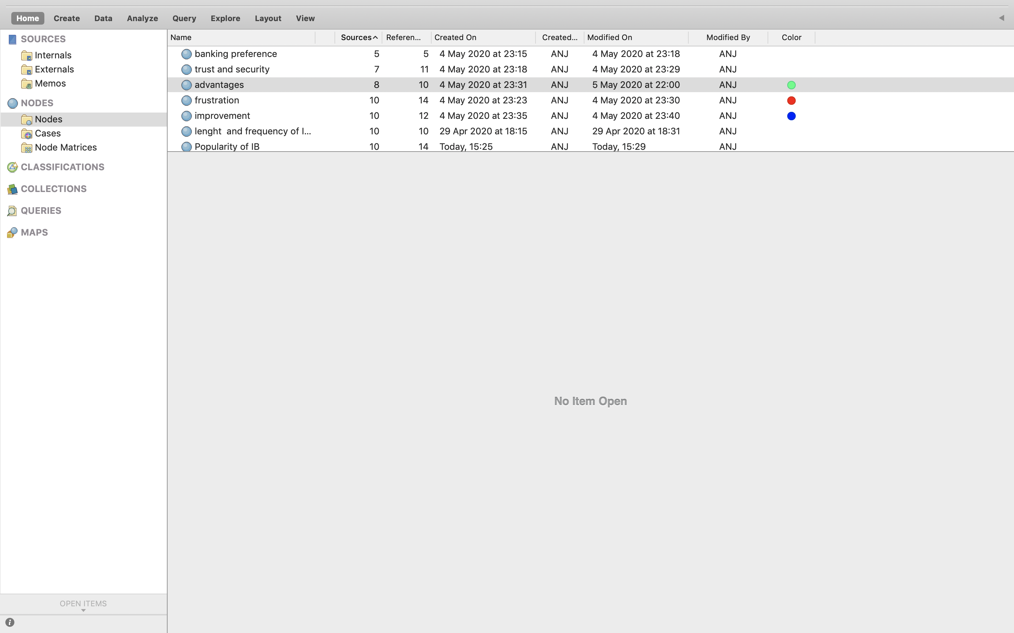

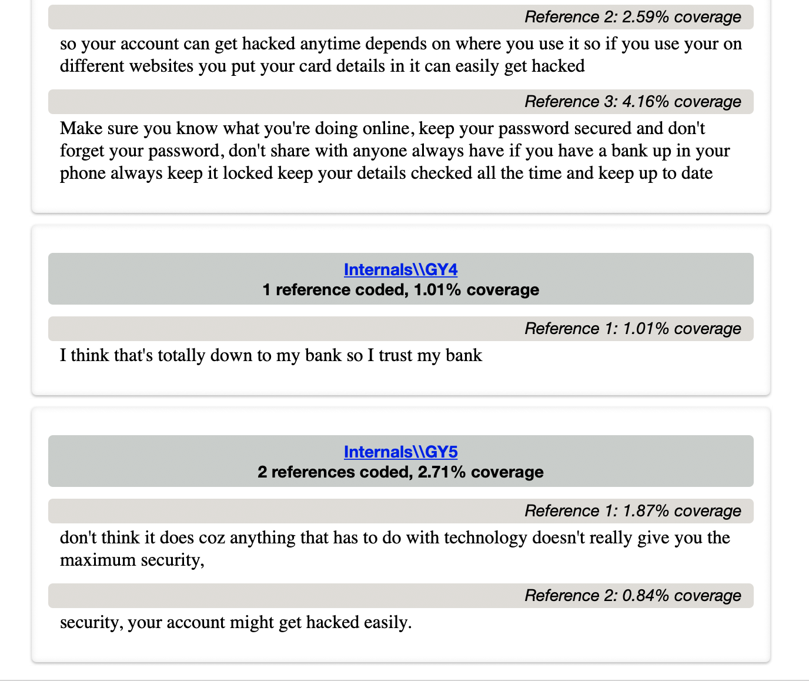
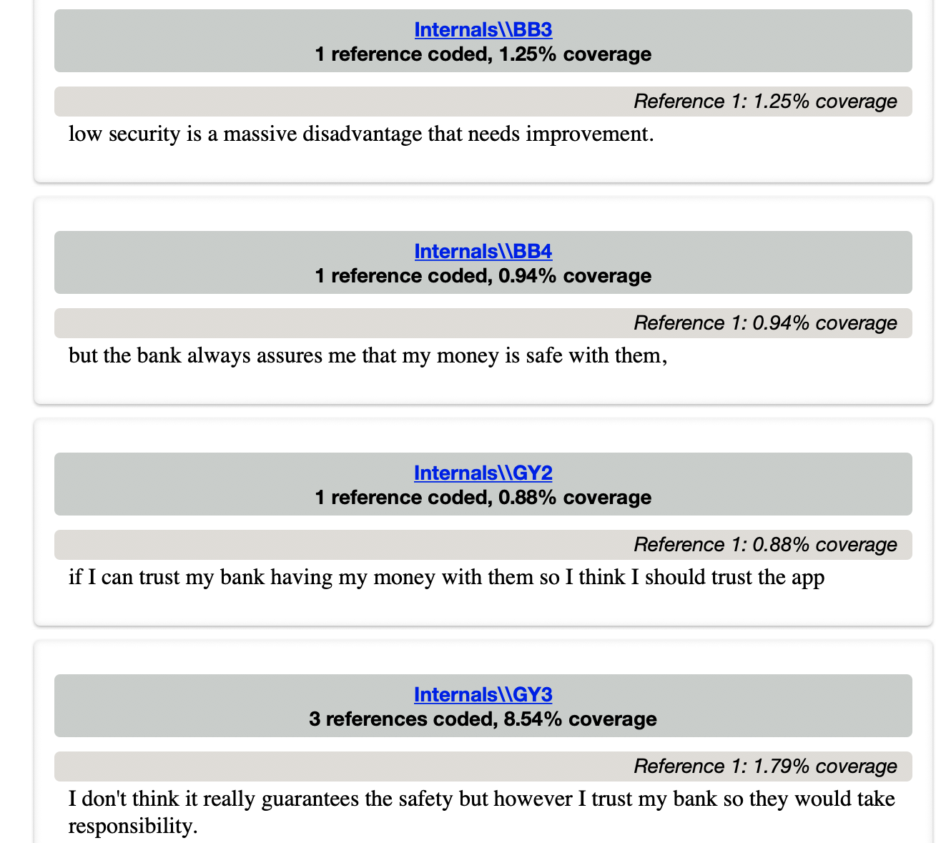
Appendix g- NVivo Security concerns Node References

Appendix h- Branch visits of Gen Y and BB Node References

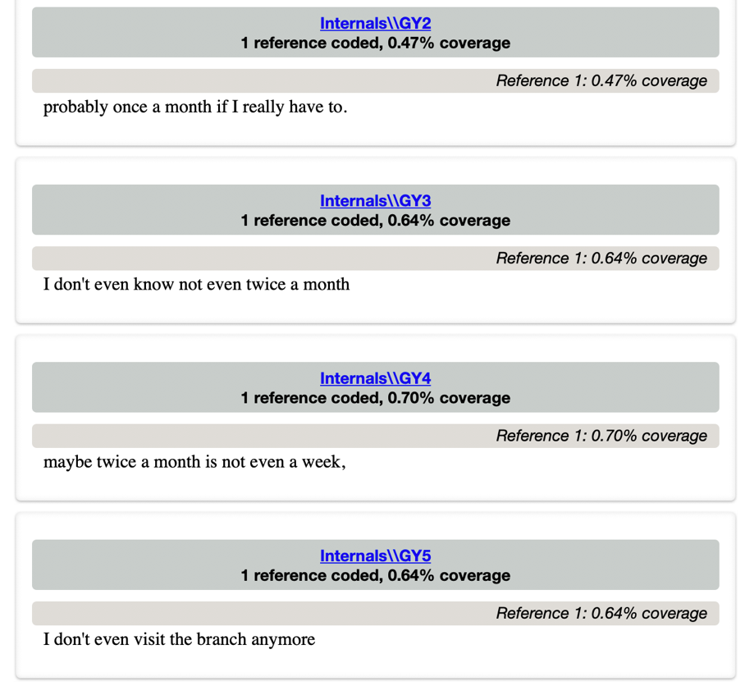

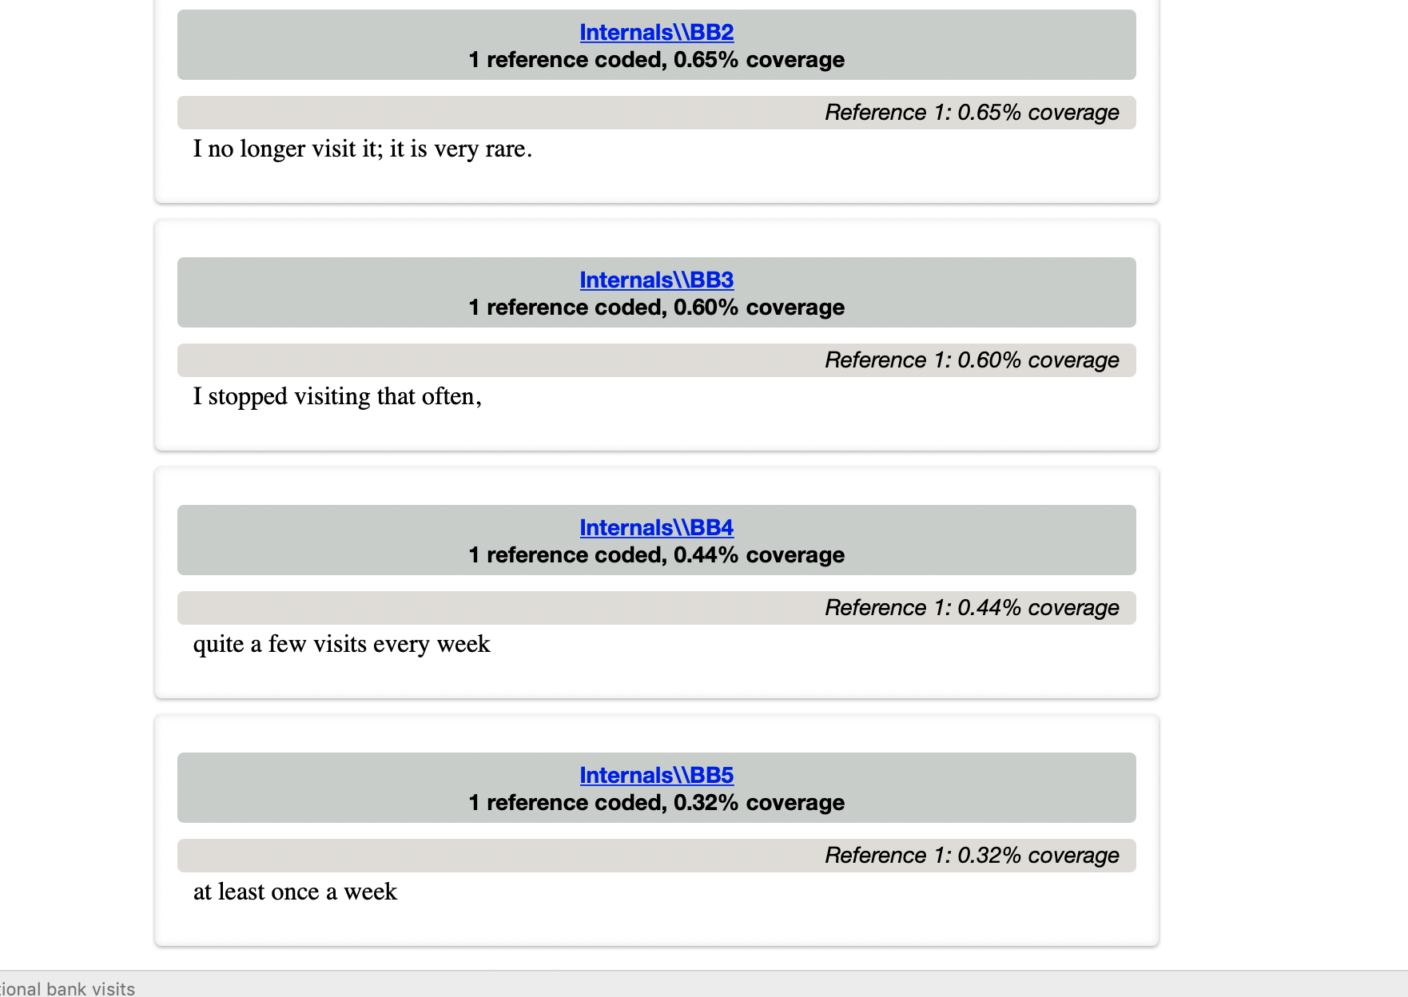

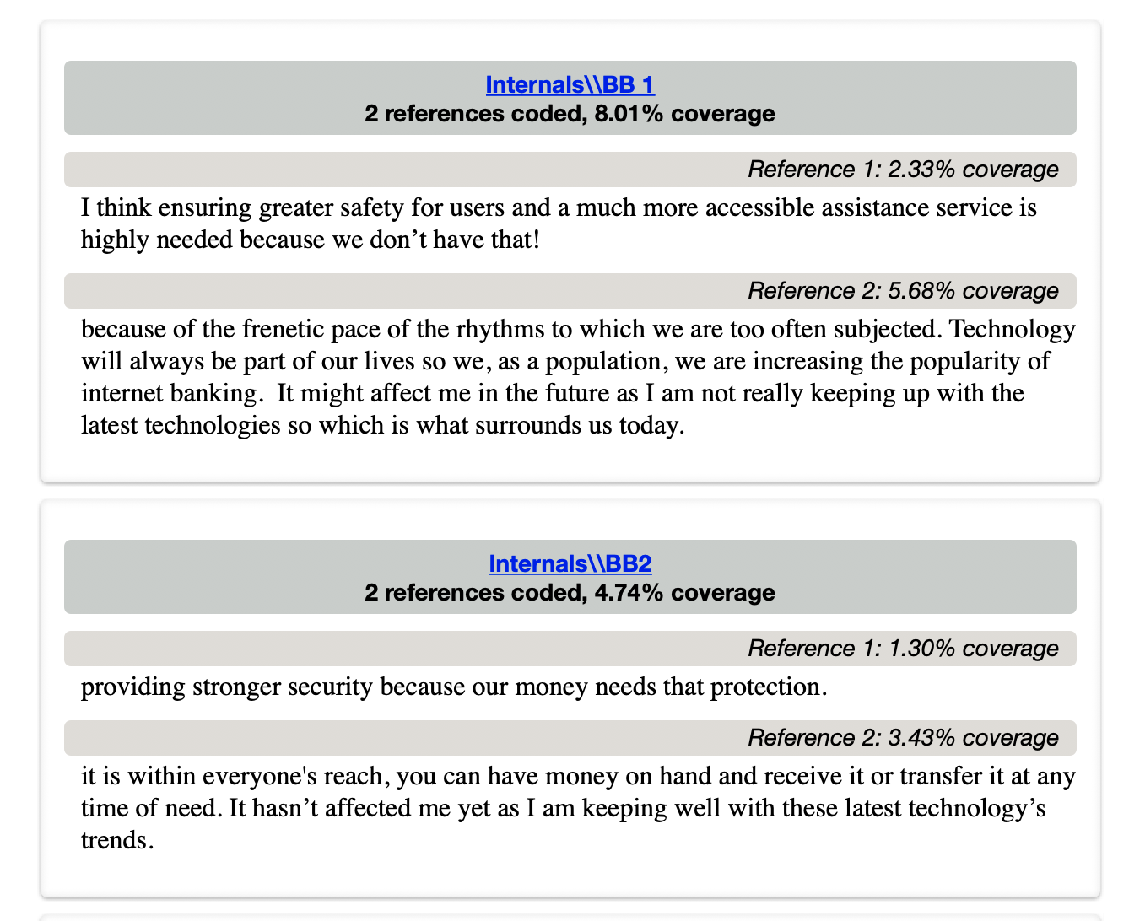
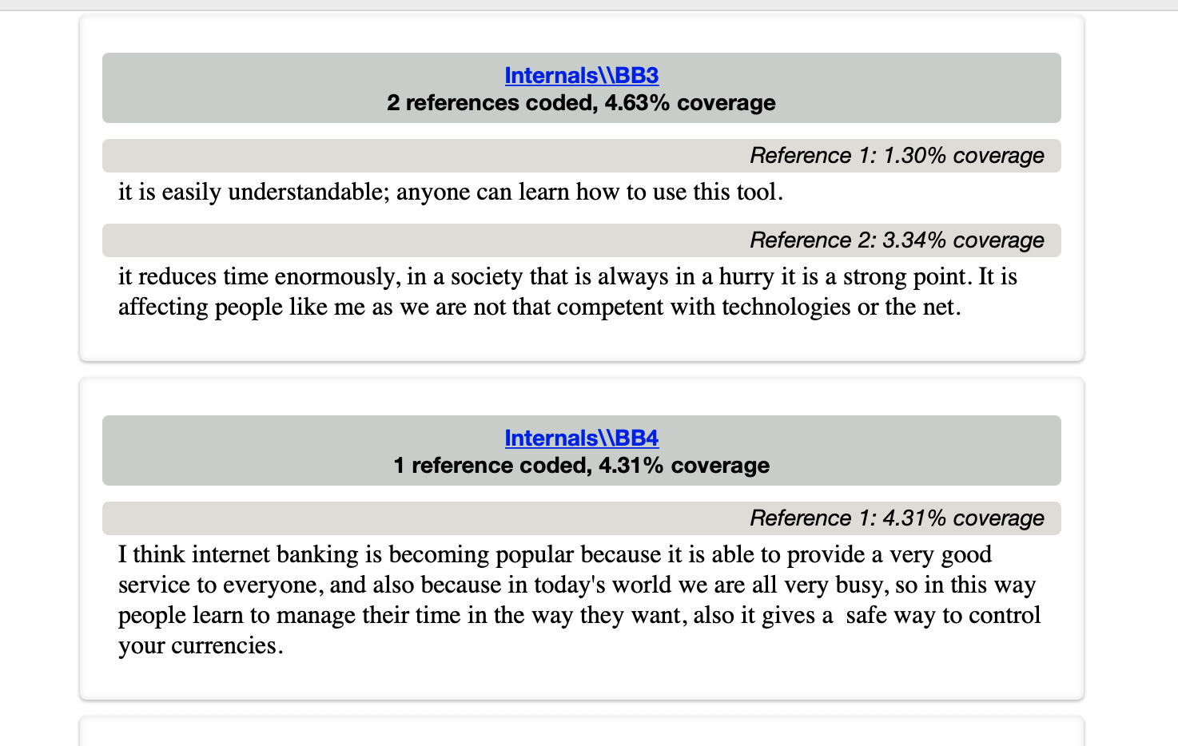
Appendix i – Popularity of Internet Banking among Gen Y and BB Node Reference



