Title page:
Name: Mohammed Moqbul Ali | Student number: 1713426
Module: Understanding and engaging in the customer experience, BMSW 5103
Assignment title: Ethical trading
Lecturer: Vajira Balasuriya | Date: 24th July 2020

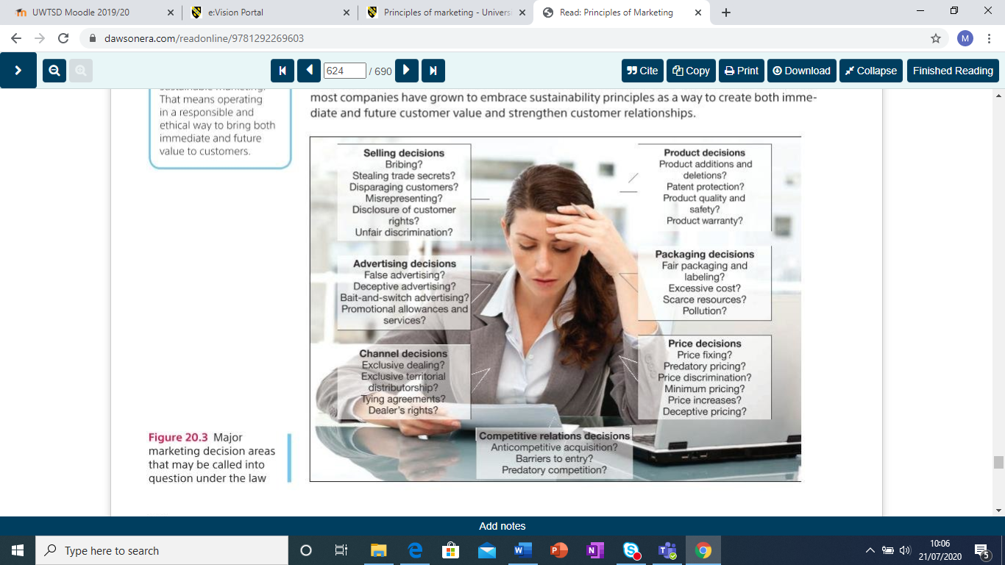Source: Kotler, (2020) P 624

Cover page
Title of the report
Benefits of engaging in ethical trading and building sustainable resources to the customer relationship and impact of quality in product and service.
Purpose of the report
“This report has been written from a student at the University of Wales Trinity Saint David to ‘customer relations’ online journal’ Editor.”
Executive summery
This report investigates the benefit of engaging ethical and sustainable business and producing quality product and service by utilising various quality models. The report is written from a student of UWTSD to customer relations editor of online journal.
The report investigates three different sectors organisation namely Tesco, McDonalds and Primark to find each and individual organisation’s ethical policies, sustainability process and utilising quality model as a tool to improve product and service quality in term of customer experience. The report writer uses various online journals including Principle of Marketing book by Philip Kotler to demonstrate the various tactics of successful business.
Report discovered that all of them practice a vast amount ethical policies from improving their own staff looking after their wellbeing, supporting and monitoring partners organisations worldwide, participating to tackle global environmental issues and constantly improving quality product and service to meet customer demand and requirements.
Reports discussed three quality models namely Deming, Juran and Crosby’s quality model, their construction, comparison and evaluations to show how these models are improving customer relationship management in various business organisations.
Report concluded with impact of ethical and sustainability practices in the business organisation and finally provided some recommendations for future improvement.

Contents page number
Title page………………………………………………………………………………………1
Cover page……………………………………………………………………………………..2
Title of the report………………………………………………………………………………2
Purpose of the report…………………………………………………………………………..2
Executive summery……………………………………………………………………………2
1.Part One: Business ethics and sustainability policies in term of Customer Relation Management (CRM)………………………………………………………………………..5
1.1 Definitions……………………………………………………………………………..5
Figure 1: Sustainable marketing concept…………………………………………………..6
1.2 Ethical policies of TESCO in relation to customer experience…………………………..6
1.2.1 Ethical business policies of Tesco……………………………………………………..6
1.2.2 Sustainability policies of Tesco…………………………………………………………7
Picture 1: Promoting human right…………………………………………………………..8
1.3 Ethical and sustainability policies of McDonalds in relation to customer experience…9
1.4 Ethical and sustainability policies of Primark in relation to customer experience…….10
2. Part Two: Quality model in marketing in terms of CRM…………………………………….11
2.1 Definition of Quality Model………………………………………………………………….11
2.2 Quality models………………………………………………………………………………12
2.2.1 Critical discussion of Deming’s Quality Model in terms of CRM…………………12
2.2.1.1 Deming’s Quality Model………………………………………………………..12
Figure 2: Shewhart Plan – Do – Check/Study – Act (PDCA/PDSA) model……..12
2.2.1.2 The summary of Deming 14 points are as follows………………………….13
Figure 3: Deming 14 points plan for TQM…………………………………………..13
2.2.1.3 Deming seven deadly diseases are………………………………………….14
2.2.1.4 Deming 14 points attribute and examples of business organisation……..14
2.2.1.5 Advantages and disadvantages of Deming quality model………………...15
Table 1: Advantages and disadvantages of Deming quality model………………15
2.2.2 Critical discussion of Juran’s Quality Model in terms of CRM………………….…..15
2.2.2.1 Juran Trilogy quality model……………………………………………………...15
Figure 4: Juran Trilogy………………………………………………………………..16
2.2.2.2 Quality planning roadmap………………………………………………………..16
Figure 5: Juran quality planning road map…………………………………………..17
2.2.2.3 Juran quality Trilogy and examples of business organisation…………………17
2.2.2.4 Advantages and disadvantages of Juran quality model……………………….18
Table 2: Advantages and disadvantages of Juran quality model…………………..18
2.2.3 Critical discussion of Crosby’s Quality Model in terms of CRM………………………18
2.2.3.1 Crosby’s Quality Model……………………………………………………………18
2.2.3.2 Crosb’y 4 quality absolutes and examples of business organisation………...19
2.2.3.3 Advantages and disadvantages of crosby’s quality model…………………….19
Table 3: Advantages and disadvantages of Crosby’s quality model…………………19
2.2.4 Comparison table of Deming, Juran and Crosby’s quality model……………………19
Table 4: Comparison of Deming, Juran and Crosby’s quality model………………………20
3. Part Three: evaluation of ethical trading and sustainability policies in terms of CRM….20
3.1 Impact of ethical and sustainability trading in business………………………….…..20
3.2 Recommendations……………………………………………………………………….22
3.3 Limitation of this report…………………………………………………………………..22
3.5 Conclusion………………………………………………………………………………..22
4. References…………………………………………………………………………………….24

- Part One: Business ethics and sustainability policies in term of Customer Relation Management (CRM)
  - Definitions:
Definition of Customer Relation Management (CRM): according to Ellis (2011) “CRM is considered as a core customer- focused business strategy that keeps customer data for the purpose of satisfying customers’ requirements and profitable customer”.
Armstrong et al, (2017) described as “CRM is the continuous customer relationship on marketing and its management”.
Definition of ethics in business: according to CIM (2016) Marketing ethics is about continued standards of conduct, not a singular goal or fixed set of principles.
Longman Business Dictionary (2017) defines ethics as “moral rules or principles of behaviour that should guide members of a profession or organization and make them deal honestly and fairly with each other and with their customers”.
AMA (America Marketing Association) code of practice says, “Marketers shall uphold and advance the integrity, honour and dignity of the marketing profession, by being honest in serving consumers, clients, employees, suppliers, distributors, and the public.”
AMA (2020) states that: “As marketers, we recognize that we not only serve our organizations but also act as stewards of society in creating, facilitating and executing the transactions that are part of the greater economy.
In this role, marketers are expected to embrace the highest professional ethical norms and the ethical values implied by our responsibility toward multiple stakeholders.”
Ethisphere (2017) stated the core for ethics consider on five criteria, namely: ethics and compliance program; corporate citizenship and responsibility; culture of ethics; governance; leadership, innovation and reputation.
Definition of Sustainability: Corporations worldwide are being challenged to create new, environmentally sustainable, and socially responsive organizations, while enhancing company value and remaining customer oriented (Closs et al. 2011).
“The sustainable marketing goals of long-term consumer and business welfare can be achieved only through ethical marketing conduct. Thus, ethical marketing is the cornerstone of sustainable Marketing (Kotler, et al, 2017)”
“Sustainable marketing means meeting current needs in a way that preserves the rights and options of future generation of consumers and business (Kotler, 2020, P 611).” In figure 1 below, Kotler (2020) stated that a business must be socially and environmentally responsible to be sustainable to meet customers and organisations current and future needs.
Needs of consumers

Now | Marketing concept | Strategic planning concept
Future | Societal marketing concept | Sustainable marketing concept
Needs of business | Now | Future
Figure 1: Sustainable marketing concept. Source: (Kotler, 2020 P 611)

1.2 Ethical policies of TESCO in relation to customer experience:
1.2.1 Ethical business policies of Tesco: Tesco is a grocery and general merchandising retail chain supermarket founded in 1919 (The Guardian, 2010)
Tescoplc.com(2020) clearly stated that they are committed to uphold human rights, treat people fairly in line with UN human rights universal declaration guiding principle and the international Labour organisation core conventions and standard are uphold on issues like as: working hours, health and safety, no child or forced labour take place. In addition to that Tesco monitor all its supplier to follow standards which is set out in the Ethical Trading Initiative code of practice. For example, promoting gender equality in Assam, India, Cocoa and coffee programs and certification of labour conditions audits in rainforest alliance. Tesco plays an important role on environmental issue in climate change by reducing carbon labelling (Bhardwaj, 2012).
According to ethics and sustainability policies of Tesco PLC (2020) mentioned that they strict on their anti-bribery policy, does not encourage to give or receive gift and entertainment apart from modest in nature and only in occasional activity which must be approved in compliance policy. Tesco conduct charity event on behalf of the organisation and does not involve supplier or other parties under pressure on sponsoring. They are not affiliated by any political or charitable organisation and does not make any political donations to gain benefit in return.
Tesco claims that they are a responsible taxpayer and zero tolerance on tax evasion by employee or business partners.
All employees at Tesco must follow conflict of interest process as identify – avoid – mitigate rule and any breaches of conflict of interest may face disciplinary action. Whistleblowing is part of code of business conduct and honest, value-based culture and any concern raised are taken very seriously, which gives customer confidence.
Tesco strictly follow cyber security rules and data protection or GDPR to protect its customer, worker and stakeholder, does not disclose to unauthorised party and regularly test and install ‘pathes’ which increases customer and other stakeholder trust on Tesco.
Tesco offers price match to save customer money promising to match price with other store, however, some of the ethical customer raised question why not the price tag not changed at the first place on the shelf rather than giving discount on the till. Is Tesco doing enough on social corporate responsibility for example, no priority services for the elderly citizen.
However, is Tesco doing enough for ethical trading? ethicalconsurer.org (2020) published that Tesco marked down on ethics for many reason including people, environment, animal and politics. According to them although Tesco published their Modern Slavery Statement 2018/2019 and code of conduct, at the same time a slave labour was used by one of his supplier, use of toxic chemicals in its electronic product, toxic chemical Phthalates used for clothing, non-free-range eggs and still performing animal testing on their own brand product and a large amount of £4.13 m in bonuses and salary paid to CEO Dave Lewis to avoid government tax. Tesco horsemeat scandal 2013 was a great customer concern damaged its reputation (BBC 2013, and Lawrence, The guardian, 2013). Tesco criticised for not paying plastic bag charges to government charity fund (The Guardian, 2017)
1.2.2 Sustainability policies of Tesco: Tescoplc.com, (2020) mentioned their sustainability based on 4 pillars; people, product, planet and places.
People: they treat the people how they should be treated as a human being including employees and supply chain. Tesco support their employees on health, safety and wellbeing issues, empowering on employment skills, supporting young people on career development e.g. graduate apprenticeship and princes trust, giving opportunity for flexible working condition, welcome diversity and inclusion and protecting and promoting human rights by ensuring there is decent, fair, safe work for all, which will eventually promote employees motivation and will increase customer satisfaction.
Product: they keep the product affordable to everyone by using from farm to fork policy. Supporting animal welfare, healthier product choice, clearer labelling. Tesco committed to food waste for that reason removed 2 for 1 offer and end date from fresh fruit with the of no good food can go to bin, halving all waste by 2030 in-store, on farms and at home, also regular testing for product highest safety. Tesco introduced closed loop packaging where reuse or recycle to protect environment damage and cutting use of plastic, stop using plastic bags for delivery from mid-2019 (Independent, 2019 and BBC, 2019) to reduce pollution, however using paper bags instead, where is the paper comes from, is it not damaging environment again.
Planet: they tackle the threat from global climate change by protecting ecosystem and initiating sustainable practices on agriculture like as working with farmers to protect climate and soil health, reducing emission, achieving zero-net deforestations and promoting healthy fish stocks. Tesco became the first corporate to set a 1.5degree Paris agreement target (edie.net, 2020)
Places: they are helping the communities to thrive by employing local people, work with local businesses and supporting local causes. Supporting charities, local projects and donating foods to local charities e.g., food bank which giving customer a humane satisfaction.

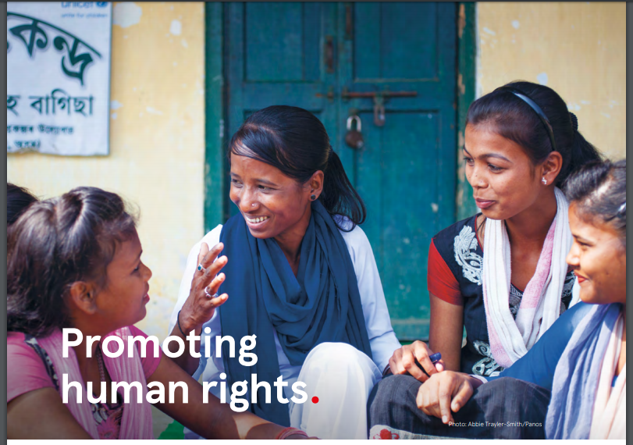
Picture 1: Promoting human right. Source: Tescoplc.com (2020). Available at: https://www.tescoplc.com/sustainability/people/human-rights/
1.3 Ethical and sustainability policies of McDonalds in relation to customer experience
According to Kotler, (2017) as part of the ethical and sustainability strategy McDonalds changes into salads, fruits, grilled chicken, low fat milk and other healthy options on the menu and Sponsored major education campaigned like “you are what you eat” to help customer to understand better about the effect of unhealthy foods. Offered improved nutritional balance menu, commitment to children well-being, increased access to consumer and employee to nutrition information which increase new customer, retain existing customer and satisfy their need.
Kotler (2017) also stated that McDonalds also considered environmental issues like food-supply sustainability, environmentally friendly packaging reusable and recyclable, however according to ethical consumer (2020) these are even worse as they contain inner layer waterproof plastic which is hard to separate for recycling, instead of this why not use paper only or leave it to customer responsibility.
Blasio, (2008) Stated that McDonalds animal welfare contribution policy, farm produce and contribution to employees as human resources placed it into world’s most ethical organisation category. They monitor supplier’s performances for example in water use, energy use and waste management areas which provide greater customer satisfaction.
Corporate.McDonalds.com (2017 - 2019) company website claimed that they respect human right, animal welfare and good health, founder member of Global Roundtable Sustainable Beef, foster business and community relationship which increase customer retention. However, Independent, (2016) news reported that they refused to recognise trade union and poor level of employee satisfaction, zero-hour contract, not enough apprenticeship, no opportunity for promotion which damage customer service productivity.
McDonalds encourage viable farming and high-quality production, actively take part on reducing greenhouse gas emissions, maintain soil health and healthy ecosystem. However, according to ethical consumer (2020) around 70% amazon rainforest clearing due to beef farming, unless McDonalds make some remedy for this will lose customer gradually.
To tackle global climate issue McDonalds introduced targeted to use 100% guest packaging from renewable or recycle sources by 2025 expect to reduce 150 million metric tons of CO2 by 2030.
McDonalds uses more recycled materials in packaging to close the loop and introduced eco-friendly paper straws in place of plastic from 2019, however, paper comes from plant, many critics says why not move to reusable glasses as like restaurant instead.
Despite of these, ethical consumer (2020) complains that McDonalds potato chips contain fats which is not suitable for vegetarian or vegan. Still adverts on “Happy Meals” to attract children with toys, which sometimes pose health risk will diver customer to somewhere else.

1.4 Ethical and sustainability policies of Primark in relation to customer experience
Primark described their ethical and sustainability policies in three different area as follows and published on organisation website primark.com as follows:
People and Production: Primark has been a member of Ethical Trading Initiative (ETI) organisation since 2006 and follows international recognised standard det out on primark codes of conduct which set by International labour Organisation (ILO).
Primark suppliers and factories are committed to treat their workers with decent and fair pay, good working conditions and maintaining health and safety policies in their workplace, no child labour or force labour. For example. In India partner with NGO Women win and Naz foundation to recruit and empower women worker. Providing HR training to factory workers. However, Independent (2018) claimed that Primark supply chain could be using child labour at the age of 14 in Indian sub-continent.
In Bangladesh after the incident at Rana Plaza in 2013, Primark took initiative to partnership with Accord and Sheva to inspect building safety and fire hazard in all of their supply factories which will increase safety for the worker.
Planet: The Primark’s Environmental Sustainability also covers how raw materials such as source of cotton from minimum amount of using chemical pesticide and fertilizer, manufacturing process impact on environmental in factories such as water used to clean finished clothes not to pollute environment, the energy used in Primark stores are minimum and reduction of waste and recycle when possible or donate to charity for example in U. S partner with non-profit organisation Delivering Good and redistributes unsold clothes to needy people which will increase ethical customer.
Setting High Standard – codes of conduct – ethical policies statement: Primark anti-social bribery policy and whistleblowing policy protect people malpractice and wrongdoing against public interest.
Regarding fair and ethical treatment of animals Primark prohibited material contains Real fur, Duck or Goose down, Exotic skins, Mohir and Angora fibre, this will be encouraged by the animal lover customer.
However, Primark has not mentioning anything about sustainable initiative like ‘closing the gap’ still using paper bags which is better than plastic but still comes from plant, better not to use anything, why not leave the carrying responsibility to customer?
- Part Two: Quality model in marketing in terms of CRM
2.1 Definition of Quality Model:
The improve standard or outcome of a process is called quality. Quality is the ultimate degree of standard on a service or product or both which satisfy customer expectation. The higher score on the scale of standard is the high quality and vice versa.
There are many definitions of quality provided by quality gurus and various scholar in the literature.
According to Kotler, et al, (2017, p. 231): “Quality can be defined as ‘no defects’”
According to Pryor, et al, (1998, p. 23): “Quality refers to the extent to which processes, products, services, and relationships are free from defects, constraints.”
Quality guru William Edwards Deming defined quality as “customers predictable and acceptable standards”, Crosby mentioned “Quality is conformance to requirements” and Dr. Juran stated “Quality is fitness for use”.
Chartered Quality Institute (2020) stated quality is customer satisfaction according to their needs and expectation.
Therefore, the underlying philosophy of the term quality means a constant high standard faultless product and service which satisfies customers’ needs and expectation continuously.
Harvey, (1998) stated that customer satisfaction depends on quality, means that how well customer expectation is met. Nilsson, Johnson, and Gustafsson (2001) mentioned that quality influences customer satisfaction, whereas, Anderson, Fornell, and Lehmann (1994a) found that customer satisfaction influences organisation’s profitability.

2.2 Quality models:
Several theories and models have been invented on quality models which often adopted by business organisation to enhance the better quality on product and services. In this report a critical assessment has been made for the following three quality models:

2.2.1 Critical discussion of Deming’s Quality Model in terms of CRM
2.2.1.1 Deming’s Quality Model: Dr. W. Edwards Deming (1900 -1993) an American statistician, manufacturing engineer formulated techniques to improve quality which proven successful in the modern word and especially in Japan after second world word to rebuild their economy.
The Deming philosophy is described in his well-known popular work “Out of the Crisis” book. (Deming, 1986)
Deming quality model comprises on Deming theory, the philosophy of Total Quality Model (TQM) articulated in 14 management points (Deming, 2000) along with seven deadly disease and the model includes Shewhart concept of ; Plan – Do – Check – Act (PDCA) cyclic invention (Anderson, et. Al., 1994 and Khan, 2010).

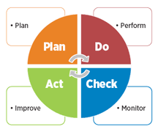
Figure 2: Plan – Do – Check – Act (PDCA) cycle. Source: https://asq.org/quality-resources/pdca-cycle

2.2.1.2 The summary of Deming 14 points are as follows: The business firm should consider the following points as figure 3 below:
- Create a constant and continuous purpose of improvement
- Adopt new philosophy to improve quality
- Cease dependency and do first time right
- Price tag is not enough
- Only criteria to measure and reward but look for loyalty
- Enhance institutional training facility
- Encourage leadership
- Drive out fear from workforce
- Make them self-motivated and self-improved;
- Remove interdepartmental barriers and
- Introduce an organisational culture on top management to accomplish to set transformation process.

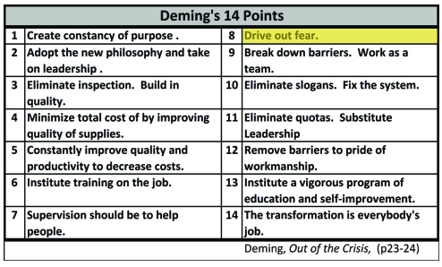
Figure 3: Deming 14 points plan for TQM. Source: Out of the Crisis, available at:
https://in.kaizen.com/blog/post/2013/10/15/dr-edward-demings-14-points-on-the-organizational-culture-of-continuous-process-improvement.html

2.2.1.3 Deming seven deadly diseases are:
- lack of making consistent improvement plan,
- emphasises only on short term profits,
- appraisal on quantity only not quality,
- no consideration of intangible data apart from visual only and
- considering paying out excessive medical and liability claim cost.
Deming 14 points are suggestions of remedy for the seven deadly diseases which helps organisation to remove barriers and achieve performance in making quality in products and services.
Deming believe that most problems are systematic and it is management responsibility to overcome from this situation by improving system, so that the people who works for the organisation can do their duties effectively and create quality in their product and services to fulfil customer demand and satisfaction.
Improvement in quality ultimately resulted in high quality and low cost due to intelligent use of time and materials, less mistakes, fewer rework, minimum delays and fault in outcome. Nilsson, Johnson, and Gustafsson (2001) stated that “the quality practices create customer satisfaction”. Therefore, in long term provide competitive strength, grater market share and increased opportunities for business sustainability, increase job opportunity. Deming suggested that when things are done first time right it cost less in the long-run and hence companies reputation and customer experiences increased. Rust, Zahorik, and Keiningham (1995) mentioned “increased customer satisfaction benefits customer retention”. Anderson, Fornell, and Lehmann (1994a) concluded “customer satisfaction inﬂuences a ﬁrm’s proﬁtability.” As a result of these increase customer retention, revisit and recommendation which means grated market share and increased profitability.
2.2.1.4 Deming 14 points attribute and examples of business organisation: as described on section 2.2.1.3 above for example train and educate employee, which will enhance employee’s customer service skill and skill for making better quality product which will satisfy customer and their expectation. Again, constancy of purpose and adopting new philosophy will boast innovation which will meet customer needs. For example, the following organisations are performing well by practicing this quality model: Dyson, British Petroleum, Marks and Spencer, Virgin Atlantic and John Lewis.

2.2.1.5 Advantages and disadvantages of Deming quality model:
Advantages | Disadvantages
Improve customer satisfaction | Lack of planning in advance
Meeting customer expectation | Not thinking about current needs of customer
Minimise mistakes | Does not prevent waste of resources
Less time return to accomplished work | Does not encourage individual responsibility for quality maintenance
Minimise work delays and fault | Due to regular educate and train staff less chances for innovative idea for employee
Low production for manufacturer and less product price for customer | Initial cost is high due to staff training
Increase competitive strength | Eliminating slogans demotivate staff on local value
Increase business sustainability

Profitable business

Strengthened organisation leadership

Foster mutual respect and teamwork

Built skilled, trained and motivated workforce

Table 1: Advantages and disadvantages of Deming quality model

2.2.2 Critical discussion of Juran’s Quality Model in terms of CRM:

2.2.2.1 Juran Trilogy quality model: Juran Trilogy quality model invented by Joseph Moses Juran (1904 – 2008) an American engineer and management consultant. Juran trilogy philosophy consists of quality planning, quality control and quality improvement and quality planning roadmap. Juran (1989) mentioned in his “Juran on leadership for quality” handbook.
- Quality planning: is the planning activity to develop quality products and processes to satisfy customers requirement which involves determination of customer, their needs and product features to meet organisations goal.
- Quality control: is a process to develop methods to test products quality during operation which contains evaluation of quality performances and comparing differences between planned and achieve quality.
- Quality improvement: is the process of constantly rising quality which consists of establishing quality improvement framework and resource, motivation, training required by the project team.

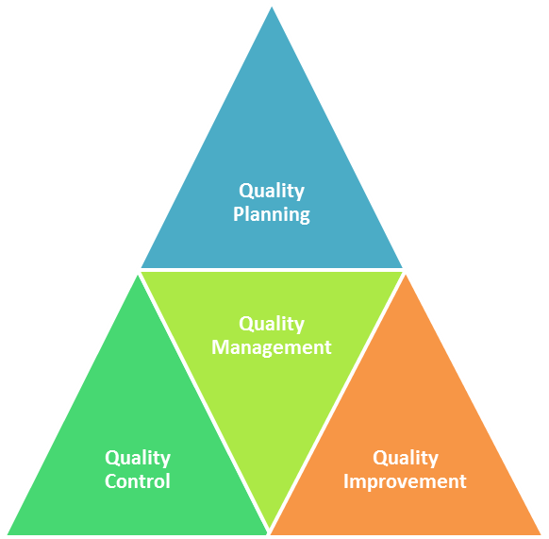
Figure 4: Juran Trilogy. Saurce: https://www.whatissixsigma.net/jurans-quality-trilogy/

2.2.2.2 Quality planning roadmap: is the universal series of input-output steps between multiple organisational level and existing goods, services and operational processes. These steps are
- to identify customer,
- determine their needs,
- translate those needs,
- develop product features and production process and
- transform these into operation (Juran, 1989 p. 87).
Juran also develop a thought of the Pareto 80-20 principle where “80% of the problems are created by 20% of the causes (Chandrupatla, 2009).”

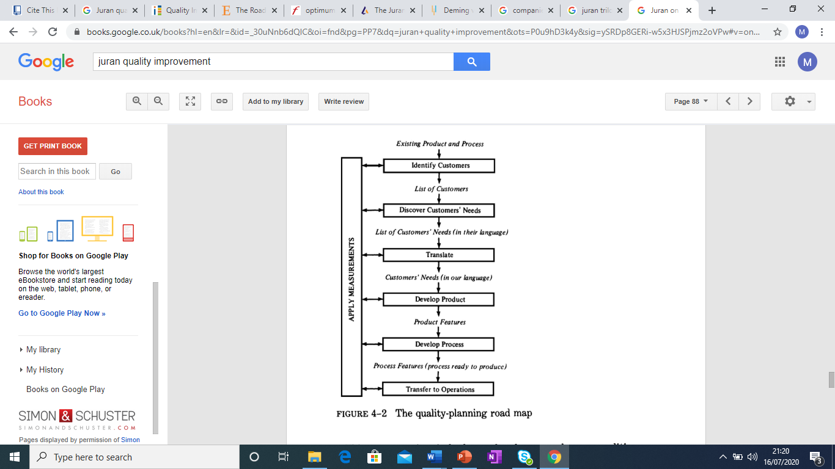

Figure 5: Juran quality planning road map (Source: Juran, 1989 p.88)

2.2.2.3 Juran quality Trilogy and examples of business organisation: by pacticing Juran trilogy and roadmap organisation learn who are their customer and what are their demand to serve them better. For example, the following organisations are practicing Jurans model to perform better customer care: GlaxoSmithKline, British airways, Rolls Royce, Wilmot Dixon, Netflix and Amazon.

2.2.2.4 Advantages and disadvantages of Juran quality model:
Meets customer needs and satisfaction | High commitment sometimes difficult to achieve
Increase efficiency and productivity | Resistance to change due to organisational culture and setting
Increase profitability | Organisation profitability suffer due to high implementation cost
improved efficiency less work | Discourage creativity and innovation
Better understanding by knowing customer and their needs | Require very high commitment by management and employee
Consistent control of business process

Emphasis market need

Table 2: Advantages and disadvantages of Juran quality model

2.2.3 Critical discussion of Crosby’s Quality Model in terms of CRM

2.2.3.1 Crosby’s Quality Model: Crosby 1926 -2001) was an author and businessman who suggested a new form of quality model of theory. The philosophy of his theory is based on doing things “first time right” and “zero defective” (Crosby, 1984 and Bendel, et. al. 1995) to make a quality product and service.
Crosby’s quality model consists of four absolutes;
- quality is conformance to requirements
- the management system for causing quality is prevention
- The performance standard must be zero defects and
- the quality measurement is the price of non – conformities (Crosby, 1984).
Crosby also proposes 14 steps of improvements. Some of these are:
- management commitment,
- cross departmental quality improvement team,
- identify potential problems, measuring cost,
- improve awareness and employee commitment to the goal,
- take rapid action for correction,
- eliminate cause of errors,
- design system for creating zero defect product and service and
- staff training and improvement (Crosby, 1984).
He also suggested some vaccination for prevention of poor quality on the following field: integrity, communication, operation and policies (Monnappa, 2019)
2.2.3.2 Crosb’y four quality absolutes and examples of business organisation: Crosby quality model emphasises to create the product and service with no defect as repeat work cost more and make the customer unhappy. For example, Aston Martin recall mini car and Whirlpool recall Hotpoint washing machine which cost them Hughes penalty and created anxiety for customer.

2.2.3.3 Advantages and disadvantages of crosby’s quality model:
Meets customer needs and satisfaction | High commitment sometimes difficult to achieve
Increase efficiency and productivity | Zero fault and improvement can not go together as no room after zero fault
Increase profitability | Organisation profitability suffer due to high implementation cost
Requirement is the target | Difficult to obtain zero fault
Brings management and workforce together and work from one platform | Require very high commitment by management and employee

Table 3: Advantages and disadvantages of Crosby’s quality model

2.2.4 Comparison table of Deming, Juran and Crosby’s quality model:
 | Deming’s quality model | Juran’s quality model | Crosby’s quality model
Known for | 14 points TQM and 7 deadly diseases. | Trilogy planning, control, improvement and quality road map. | Zero defect philosophy plus 14 steps of improvements.
Work Repetitions | Plan-Do-Study-Act repeat cycle to improve quality. | Plan first, implement and improve the quality. | first-time right no scope for repetition
Business example | Birmingham City Council benefited uses most of the attributes, like as staff training and development, encourages self-improvement, creating constant purpose and adopting new philosophy to provide quality service for citizen. | Unilever follows all three philosophy, planning, control and improvement plus apply roadmaps like identify customer, their needs, develop product and its feature for customer satisfaction. | Jaguar Land Rover motto is the best quality, zero defect or faultless cars, follows most of Crosby’s 14 steps like as identify problems, rapid correction, eliminate cause of error design system to create zero defect cars to attract customer.

Table 4: Comparison of Deming, Juran and Crosby’s quality model:

- Part Three: evaluation of ethical trading and sustainability policies in terms of CRM.
3.1 Impact of ethical and sustainability trading in business:
There is a wide range of advantages inherent in running a business in an ethical manner. Businesses which strongly committing to ethical practices, ultimately gain a good reputation, in other words a high level of ‘reputational capital’. Bulog and Grančić (2017) argue a positive reputation helps the business forge better relationships with stakeholders (workforce, suppliers, investors and customers). Leading to high revenues and lower costs, meaning an increase in profits. In addition to keeping existing stakeholders satisfied, businesses attract new shareholders who share these ethical values.
There is a significant impact of ethical trading on consumers. Greater customer satisfaction leads to greater customer retention as customers. The business will also attract new customers through their lasting positive reputation. By committing to ethical values, the business fosters an environment of trust and integrity, which in turn creates a good image of the business. The positive reputation improves customer confidence and improves the brand image thereby giving the business a competitive advantage.
By adopting ethical values, businesses build a culture of openness and promote fairness in the workplace. In addition, making ethical choices lowers the stress levels of managers and employees and enhances leadership (Ferrel et al, 2005). This attracts more employees and leads to greater employee retention. If employees are treated well, they are more productive which increases profits. There are other stakeholders who if treated ethically are more likely to help the business grow. For instance, if suppliers are treated well, they are more likely to provide favourable prices and long-term contracts. If investors are treated ethically, they are more likely to buy more stock and lend more money to the business at lower interest rates.
Following ethical business practice involves stopping business malpractice and following the law and standards set out by governmental regulatory bodies. If businesses adopt this type of behaviour, this will lead to a better relationship between businesses and governmental regulatory bodies. This in turn may mean governments make more favourable decisions regarding regulation (Bulog and Grančić, 2017).
Moreover, the positive environmental impact is undeniable. Implementation of ethical values minimises carbon output, reduces waste and improves energy efficiency, leading to reduced energy costs.
Albu et al (2017) argue that a business that does not incorporate ethical practice may cause harm to the “employees’ performance, employee work relations, company’s image and credibility”. The added effect of this will be that the profit will suffer over time (Bulog and Grančić, 2017). This is because, having a bad reputation has led to reduced revenue and higher costs. Avoiding this demanding and costly negative outcome is an incentive for some businesses to adopt ethical values.
However, there are many disadvantages to adopting ethical values, the additive effect of which leads to a fall in profits. There is a restriction to maximise profits due to added costs. For example, switching to more ethical supplies such as fair-trade is more costly. Inevitably the price of the product will need to be increased to maintain profit margins. This may lead to decreased revenue for the product as the higher price may deter existing customers. As a result, there is a limit to how much profit can be generated, and the business may even see a fall in profits. In addition, for a workforce to feel comfortable working for the business and confident in their role, training costs must be considered.
If employees are treated badly, this may lead to poor employee performance, high employee turnover (as workers are unsatisfied) and decreased productivity. The latter of which translates into falling profits. There may be detrimental consequences if stakeholders are treated unethically. For instance, customers will no longer buy the business’s products and if severely unsatisfied with the product or service may file lawsuits against the business. If there is a poor relationship with investors, they may refuse to sell or buy stock or increase capital lending rate to the business.
Furthermore, in trying to mitigate the impact on the environment, businesses are exposing themselves to a security risk by going paperless. These documents are at higher risk of data loss or theft.
3.2 Recommendations: this report recommends the following steps for the above three organisations namely Tesco, McDonalds and Primark.
Tesco:
- Introduce and implement bagless delivery system to become more environ friendly.
- abolish Large unethical pay and bonus payment to big bosses including chief executive.
- Publish comparison data from similar organisation and provide ratio of profit and contribution towards the ethical and sustainability programme cost.
McDonalds:
- Implement and utilise reusable cups or glasses for sitting customer instead of recyclable.
- Abolish zero-hour contract and provide more opportunity for job apprenticeship and promotion.
- Set and publish separate clear business ethics and sustainability document instead of with the business conduct document.
Primark:
- Publish data between ethical and sustainability investment and business profit ratio for the stakeholder.
- Change fast fashion business tactics to long lasting sustainable fashion to reduce waste and environmental effect.
- Overall, for every organisation there is an urgent need of government legislation to investment a particular amount of money towards the maintenance of ethical and sustainability issue.
3.3 Limitation of this report:
- Due to Covid19 it was not possible to carry out any empirical research work to make the report more realistic.
- Most of the description had to make concise due to limitation of word limit.
3.5 Conclusion: in conclusion, organisation is for consumer and consumer need business organisation, one cannot survive without other. However, future sustainability we need to protect our business environment. Ethics and sustainability relate to each other and ethical business is more sustainable. Although initially these cost organisations but in the long run it is more profitable. However, to make a business profitable not only ethical process is enough but along with other aspect of business one of the most important and essential thing a business must adhere to is the quality of product and service. Paul Polman CEO of Unilever concluded that when the organisation merge with customer and environmental needs, and take responsibilities of social impact, then the stakeholders will be rewarded (Kotler, 2020 P. 624).

- References:
- Albu, Ruxandra & Mandru, Lidia & Suciu, Titus. (2017). IMPACT OF ETHICS UPON BUSINESS SUCCESS.
- AMA (2020). Codes of Conduct | AMA Statement of Ethics, available @:
https://www.ama.org/codes-of-conduct/, (01/07/2020)
- Anderson, J. C., Rungtusanatham, M., & Schroeder, R. G. (1994). A theory of quality management underlying the Deming management method. Academy of Management Review, 19(3), 472–509.
- Anderson, E. W., Fornell, C., & Lehmann, D. R. (1994a). Customer satisfaction, market share and proﬁtability: Journal of Marketing, 58, 53–66.
- Armstrong, G. Kotler, P. and Opresnik M. O. (2017). Marketing: An Introduction, 13th Edition, Pearson.
- Bandel, T., Penson, R., & Carr, S. (1995). The quality gurus – their approaches described and considered. Managing Service Quality, 5(6) 44 – 48.
- BBC News. 2013. Tesco Value Bolognese 60% Horsemeat. [online] Available at: <https://www.bbc.co.uk/news/uk-21418342> [Accessed 18 July 2020].
- Bhardwaj, N. (2012). CONSUMER BUYING BEHAVIOUR TOWARD CARBON LABELLING (FMCG) IN TESCO SUPERMARKET.
- Blasio, G. (2008). Understanding McDonald’s Among the “World’s Most Ethical Companies “. EJBO Electronic Journal of Business Ethics and Organization Studies
- Bulog, I. and Grančić, I., (2017). The Benefits of Business Ethics - Ethical Behavior of Decision Makers: the Empirical Findings from Croatia. Mediterranean Journal of Social Sciences, 8(4-1), pp.9-14. Cited on: Burton, B. and Goldsby, M., 2009. The Moral Floor: A Philosophical Examination of the Connection Between Ethics and Business. Journal of Business Ethics, 91(1), pp.145-154.
- Chandrupatla, T., 2009. Quality And Reliability In Engineering. Cambridge: Cambridge Univ. Press.
- Chartered Quality Institute. 2020. Available at: www.thecqi.org (Accessed 23 July 2020)
- CIM (2016). What is ethical marketing? available at:
https://exchange.cim.co.uk/blog/what-is-ethical-marketing/, (accessed on 21 July 2020)
- Closs DJ, Speier C, Meacham N (2011) Sustainability to support end-to-end value chains: the role of supply chain management. J Acad Mark Sci 39(1):101–116 Cited On MÜLLER, A., 2014. Sustainability and customer relationship management: current state of research and future research opportunities. Management Review Quarterly, 64(4), pp. 201-224.
- Crosby, P. (1984). Quality without tears. New York: McGraw-Hill.
- Corporate.macdonalds.com (2017 - 2019). Codes of conduct. Available at: https://corporate.mcdonalds.com/corpmcd/investors-relations/codes-of-conduct.html (Retrieved on 23 July 2020)
- Deming, W. E. (1986). Out of the crisis. Cambridge, MA: Massachusetts Institute of Technology, Center for Advanced Engineering Study.
- Deming, W., 2000. The New Economics. Cambridge, Mass.: MIT Press.

Edie.net (2020). How Tesco became the first corporate in the world to set a 1.5-degree science-based target. Available at:
https://www.edie.net/68298/case-studies/How-Tesco-became-the-first-corporate-in- the- world-to-set-a-15-degree-science-based-target/14086 [Accessed 18 July 2020].
- Ellis, N. (2011). Business-to-Business Marketing: Relationships, Networks & Strategies, Oxford University Press
- Ethical Consumer. 2020. How Ethical Is Tesco Plc? | Ethical Consumer. [online] Available at: <https://www.ethicalconsumer.org/company-profile/tesco-plc> [Accessed 18 July 2020].
- Ethisphere Institute (2017). “2016 World’s Most Ethical Companies List”, Scottsdale, Arizona, USA, Available at http://worldsmostethicalcompanies.ethisphere.com/, accessed on the 22nd of July 2020.
- Ferrell, O. C., Fraedrich, J. and Ferrell, L. (2005). Business Ethics, Ethical decision making and cases. Houghton Mifflin Company, Boston, New York.
- Harvey, J. (1998). Service quality: A tutorial. Journal of Operations Management, 16, 583–597.
- Independent, (2016). How bad is McDonalds is it unhealthy. Max Benwell, 18 April 2016. Available at: https://www.independent.co.uk/news/uk/how-bad-is-mcdonalds-is-it-unhealthy-was-labour-right-to-ban-it-from-its-conference-a6990116.html (Retrieved on 18 July 2020)
- Independent (2018). Primark and Topshop could be using child labour at the age of 14 in their supply chain. Published on 27 November 2018. Available at:https://www.independent.co.uk/life-style/fashion/child-labour-primark-topshop-sustainable-fashion-industry-m-and-s-select-committee-parliament-a8654026.html ( retrieved on 20 July 2020)
- Independent, (2019). TESCO BECOMES LATEST SUPERMARKET TO STOP USING PLASTIC BAGS FOR ONLINE DELIVERY. Available at:https://www.independent.co.uk/life-style/tesco-plastic-bags-online-delivery-iceland-asda-environment-a9019851.html (Retrieved on 22 July 2020)
- Juran, J., 1989. Juran On Leadership For Quality. Free Press: New York, p.20-88.
- Khan, M. (2010). Evaluating the Deming Management Model of Total Quality in Telecommunication Industry in Pakistan – An Empirical Study. International Journal of Business and Management, 5(9).
- Kotler, P. Armstrong, G. Harris, L. C. and Piercy, N. (2017). Principles of
Marketing, 7th European Edition, Pearson.
- Kotler, P. Armstrong, G. Harris, L. C. and Piercy, N. (2020). Principles of
Marketing, 8th European Edition, Pearson.
- Lawrence, F., 2013. Horsemeat Scandal: The Essential Guide. [online] the Guardian. Available at: <https://www.theguardian.com/uk/2013/feb/15/horsemeat-scandal-the-essential-guide> [Accessed 18 July 2020].
- Longman Business Dictionary (2017). Pearson, London, UK. Cited on: Albu, Ruxandra & Mandru, Lidia & Suciu, Titus. (2017). IMPACT OF ETHICS UPON BUSINESS SUCCESS.
- McDonalds.com (2019). Available at:https://corporate.mcdonalds.com/content/dam/gwscorp/nfl/corporate-governance-content/codes-of-conduct/UK-English_Standards_of_Business_Conduct_December_2019.pdf
- Monnappa, A. (2019). Pioneers of project management; Deming vs Juran vs Crosby. Available at: https://www.simplilearn.com/deming-vs-juran-vs-crosby-comparison-article ( Retrieved on 17 July 2020)
- Nilsson, L., Johnson, M. D., & Gustafsson, A. (2001). The impact of quality practices on customer satisfaction and business results: Product versus service organizations. Journal of Quality Management, 6, 5–27.
- Pryor, M. G., White, J. C., & Toombs, L. A. (1998). Strategic Quality Management: A Strategic, Systems Approach to Quality. Thomson Learning.
- Primark.com (2020). Available at: https://www.primark.com/en/primark-cares/setting-high-standards/our-policies (accessed on 23 July 2020)
- Rust, R., Zahorik, A. J., & Keiningham, T. L. (1995). Return on quality (ROQ): Making service quality ﬁnancially accountable. Journal of Marketing,59(2), 58–70.
- the Guardian. 2010. Company Profile For Tesco. [online] Available at: <https://www.theguardian.com/sustainable-business/profile-tesco> [Accessed 18 July 2020].
- the Guardian (2017). Tesco criticised for deducting £3.4m from plastic bag tax charity donations. Available at: https://www.theguardian.com/environment/2017/sep/07/tesco-criticised-for-deducting-34m-from-plastic-bag-tax-charity-donations [Accessed 20 July 2020]
- Tesco PLC. Com (2020). Ethics And Compliance Policies. [online] Available at: <https://www.tescoplc.com/about/how-we-do-business/ethics-and-compliance-policies/> [Accessed 18 July 2020].

- Websites:
https://www.whatissixsigma.net/jurans-quality-trilogy/
https://asq.org/quality-resources/pdca-cycle
https://in.kaizen.com/blog/post/2013/10/15/dr-edward-demings-14-points-on-the-organizational-culture-of-continuous-process-improvement.html
Tescoplc.com:

https://www.tescoplc.com/about/how-we-do-business/

https://www.tescoplc.com/about/how-we-do-business/#

https://www.tescoplc.com/about/how-we-do-business/ethics-and-compliance-policies/
https://www.ethicalconsumer.org/company-profile/tesco-plc
https://ukdiss.com/examples/tesco-ethical-operations-stakeholders.php
https://dq7j3ns0e24fe.cloudfront.net/uploads/02394234.pdf
https://www.tescoplc.com/sustainability/publications/policies/downloads/our-approach-to-human-rights/
https://www.tescoplc.com/sustainability/
Mcdonalds.com
https://corporate.mcdonalds.com/corpmcd/scale-for-good/packaging-and-recycling.html
https://corporate.mcdonalds.com/corpmcd/scale-for-good/beef-sustainability.html
https://corporate.mcdonalds.com/corpmcd/scale-for-good/climate-action.html
https://mcdonaldsethics.weebly.com/mcdonalds-ethical-issues.html
https://www.independent.co.uk/news/uk/how-bad-is-mcdonalds-is-it-unhealthy-was-labour-right-to-ban-it-from-its-conference-a6990116.html
https://www.ethicalconsumer.org/food-drink/shopping-guide/fast-food-chains
https://corporate.mcdonalds.com/content/dam/gwscorp/nfl/corporate-governance-content/codes-of-conduct/UK-English_Standards_of_Business_Conduct_December_2019.pdf
sustainable packaging, restaurant recycling,
Primark.com
https://primark.a.bigcontent.io/v1/static/Environmental-Policy
https://www.primark.com/en/primark-cares/setting-high-standards/our-policies

