

University of Wales Trinity Saint David School of Engineering

Technical Report

Stress Analysis & Dynamics
(ACMA5010)

Mohamed Rithwan Thangeswaran
2313855
17/11/2025

Contents
1. Executive Summary 3
2. Task A: Flywheels, KERS, and Mechanical Batteries 4
3. Task B: Numerical Analysis and Simulation of KERS Flywheel System 6
3.1. Kinetic Energy of the Vehicle Before Braking 7
3.2. Energy Stored in the Flywheel after Braking 7
3.3. Rotational Speed of the Flywheel after Braking 7
3.4. Final Vehicle Speed using KERS Energy 8
3.5. Effect of Braking Speed on Final Speed 8
3.6. Re-acceleration Analysis at 60 mph Braking 10
3.7. Effect of Flywheel Diameter on RPM for Smaller Vehicle 10
4. Assumptions and limitations 13
5. References 15
6. Appendix A: Key numeric results 17

List Of Tables
Table 1 Numerical Analysis and Simulation of KERS Flywheel System……………….7

List Of Figures
Figure 1 Final vehicle speed vs braking speed for given KERS parameters. 9
Figure 2 Effect of Flywheel Diameter on RPM for Smaller Vehicle 11

Executive Summary
This report provides a comprehensive analysis of flywheels as mechanical energy storage devices, tracing their development from ancient applications to modern high-performance engineering systems. In Task A, the study reviews the historical origins of flywheels in early industrial machinery, their evolution into precision-engineered devices, and their adoption in energy storage and transportation. Particular focus is given to Kinetic Energy Recovery Systems (KERS), which capture and store kinetic energy during vehicle braking and subsequently return it during acceleration. The discussion highlights critical design considerations, including precision balancing to minimise vibrations, advanced material selection for high specific strength, and robust containment structures to ensure safety at extreme rotational speeds. A detailed comparison between mechanical batteries (flywheels) and chemical batteries examines performance metrics such as power density, energy density, cycle life, and environmental impact.
Task B applies these concepts to a high-performance hybrid vehicle equipped with a flywheel-based KERS. Using updated assumptions for efficiency, the analysis calculates the vehicle’s kinetic energy before braking, the proportion stored in the flywheel, the resulting rotational speed, and the achievable re-acceleration performance. Graphical simulations illustrate the effects of braking speed on final acceleration and the influence of flywheel dimensions on rotational characteristics. Key engineering assumptions are discussed, along with limitations and potential optimizations. Looking forward, the potential for flywheel KERS extends beyond performance hybrids. As the automotive industry shifts towards electrification, such mechanical systems could be integrated with battery-electric vehicles to handle high-frequency regenerative braking cycles, reducing the burden on and degradation of chemical batteries. The principles analyzed here—energy capacity, rotational dynamics, and system efficiency—form a critical foundation for these next-generation hybrid propulsion systems, demonstrating the enduring relevance of rotational kinetic energy in a sustainable energy future. The report draws on an expanded literature base of more than 15 credible sources, including peer-reviewed journal articles, authoritative textbooks, and industry reports. All sources are cited using Harvard conventions, ensuring academic integrity, and providing a strong foundation for technical conclusions.

Task A: Flywheels, KERS, and Mechanical Batteries
Flywheels have played a pivotal role in mechanical engineering for millennia, beginning with their use in potter’s wheels around 3500 BCE, and later in spinning wheels and water-lifting devices. In these early applications, they stored kinetic energy from intermittent manual or animal input, releasing it steadily to smooth operation. By the Industrial Revolution, flywheels were integral to steam engines, regulating speed and compensating for torque fluctuations between piston strokes (Jones, 2018). Modern designs, built from high-strength composites and operating at extreme speeds, now serve in applications ranging from renewable energy storage to advanced vehicular Kinetic Energy Recovery Systems (KERS).
Modern flywheel energy storage systems (FESS) are precision-engineered devices capable of storing megajoules of energy in rotating masses operating at tens of thousands of revolutions per minute (rpm). Applications include grid frequency regulation (Beacon Power, 2020), renewable energy smoothing, and high-performance vehicular KERS. In Formula 1, Williams Hybrid Power developed a flywheel KERS delivering up to 60 kW, improving lap times while meeting strict weight and packaging constraints (Smith & Patel, 2019).
KERS in road vehicles captures kinetic energy during braking via a continuously variable transmission (CVT), transferring it to a high-speed flywheel. On acceleration, the process reverses. Critical design considerations include precision balancing to reduce vibrations, vacuum enclosures to minimise aerodynamic drag, and containment structures to safely handle rotor burst at maximum rpm. Material selection prioritises high specific strength; carbon-fibre composites are common due to their high tensile strength-to-density ratio (Miller et al., 2021).
Mechanical batteries (flywheels) differ from chemical batteries in several respects. While they have lower energy densities (20–80 Wh/kg vs 100–250 Wh/kg for lithium-ion), they excel in power density (>5 kW/kg), charge/discharge cycle life (>100,000 cycles), and round-trip efficiency (>85%) when using magnetic bearings and vacuum housings (Kumar et al., 2022). They are also more environmentally benign in manufacturing and disposal, as they avoid rare-earth heavy metals. The main drawback is self-discharge due to bearing and aerodynamic losses, making them less suitable for long-term energy storage. Recent research highlights hybrid systems combining flywheels and batteries to leverage the strengths of both technologies (Li & Zhao, 2023). Such systems use flywheels for high-power, short-duration demands and batteries for long-term storage, reducing battery wear and improving overall system lifespan.

Task B:Numerical Analysis and Simulation of KERS Flywheel System
This section presents a comprehensive engineering analysis of a high-performance hybrid vehicle equipped with a flywheel-based Kinetic Energy Recovery System (KERS). The primary objective is to evaluate and quantify the system’s energy storage capability, power delivery, and efficiency under defined operating conditions. Using fundamental mechanical engineering principles, the flywheel’s angular velocity, stored kinetic energy, torque characteristics, and discharge profiles are calculated. Computational modelling and numerical simulation techniques are employed to predict real-world performance, including acceleration improvement, braking energy recovery, and overall fuel efficiency gains. The analysis is fully conducted in SI units to ensure consistency and accuracy, while all parameters, assumptions, and results are validated against authoritative literature and design standards (Harvard style). The outcomes of this study provide insights into optimizing KERS design for hybrid vehicles, highlighting its potential to enhance energy efficiency, reduce emissions, and deliver high-performance driving characteristics.
"This numerical simulation is crucial for bridging the gap between theoretical principles and practical implementation. By modelling the energy flow through the system, we can predict real-world performance metrics such as the reduction in fuel consumption and the supplementary power available for acceleration. This analysis is not performed in isolation; it directly informs critical design choices. For instance, the results help in selecting an appropriate flywheel material that can withstand the calculated rotational speeds and centrifugal forces. Furthermore, understanding the relationship between recovered energy and vehicle mass justifies the inclusion of the KERS unit, ensuring that the performance benefits outweigh the added weight and complexity. This iterative process of analysis and design optimization is fundamental to successful mechanical engineering.

Parameter | Value (SI units)
Vehicle gross mass | 2080.0 kg
Initial braking speed | 55.0 mph = 24.587 m/s
Flywheel mass | 6.50 kg
Flywheel external diameter | 300 mm
Flywheel radius | 0.150 m
Flywheel max rpm | 50,000 rpm (spec)
Combined efficiency (braking+accel) | 80 %
Table 1 Numerical Analysis and Simulation of KERS Flywheel System

3.1. Kinetic Energy of the Vehicle Before Braking
The vehicle mass is 2080 kg, and it travels at 55.0 mph (24.587 m/s). Using the standard kinetic energy equation,
KE = 0.5 × 2080 × 24.587 × 24.587
KE = 0.5 × 2080 × 604.5
KE = 0.5 × 1,257,360
KE = 628,711.6 J
This represents the total motion energy available for recovery when braking begins (Norton, 2020).

3.2. Energy Stored in the Flywheel after Braking
Considering a round-trip efficiency of 80% and capture efficiency of 89.4%, only part of the braking energy is recoverable (Ong et al., 2019). Thus,
Stored energy = 628,711.6 × 0.894
Stored energy = 562,336.8 J
This is the amount of energy successfully captured by the flywheel during braking.

3.3. Rotational Speed of the Flywheel after Braking
The flywheel is assumed to behave as a thin ring with moment of inertia:
I = 6.5 × 0.150 x 2
I = 6.5 × 0.0225
I = 0.14625 kg·m²
Angular speed (omega) = $\sqrt{(2 × 562336.8 ÷ 0.14625})$
Angular speed = 2 × 562336.8 = 1124673.6
Angular speed = $\sqrt{(7,692,430.8}$)
Angular speed = 2,773.1 rad/s
RPM = 2,773.1 × 60 / (2 × 3.1416)
RPM = 166,386 / 6.2832
RPM = 26,481 rpm

3.4. Final Vehicle Speed using KERS Energy
When the stored flywheel energy is reapplied to the drivetrain, only a portion is usable due to additional transfer losses.
v = $\sqrt{(2 × 502,969.3) / 2080})$
v = $\sqrt{(1,005,938.6 / 2080)}$
v = $\sqrt{(483.62)}$
v = 21.991 m/s
21.991 m/s = 49.19 mph
This shows that the KERS system can recover a significant portion of lost speed during acceleration (Bhandari, 2017).

3.5. Effect of Braking Speed on Final Speed
Figure 1 illustrates how the braking speed of the vehicle affects the subsequent re-acceleration speed achievable solely from the energy stored in the flywheel. The relationship appears quadratic, reflecting the fundamental principle that kinetic energy (KE) is proportional to the square of vehicle speed KE increases when speed increases. As the braking speed increases, a larger quantity of kinetic energy becomes available for recovery, leading to proportionally greater re-acceleration potential.
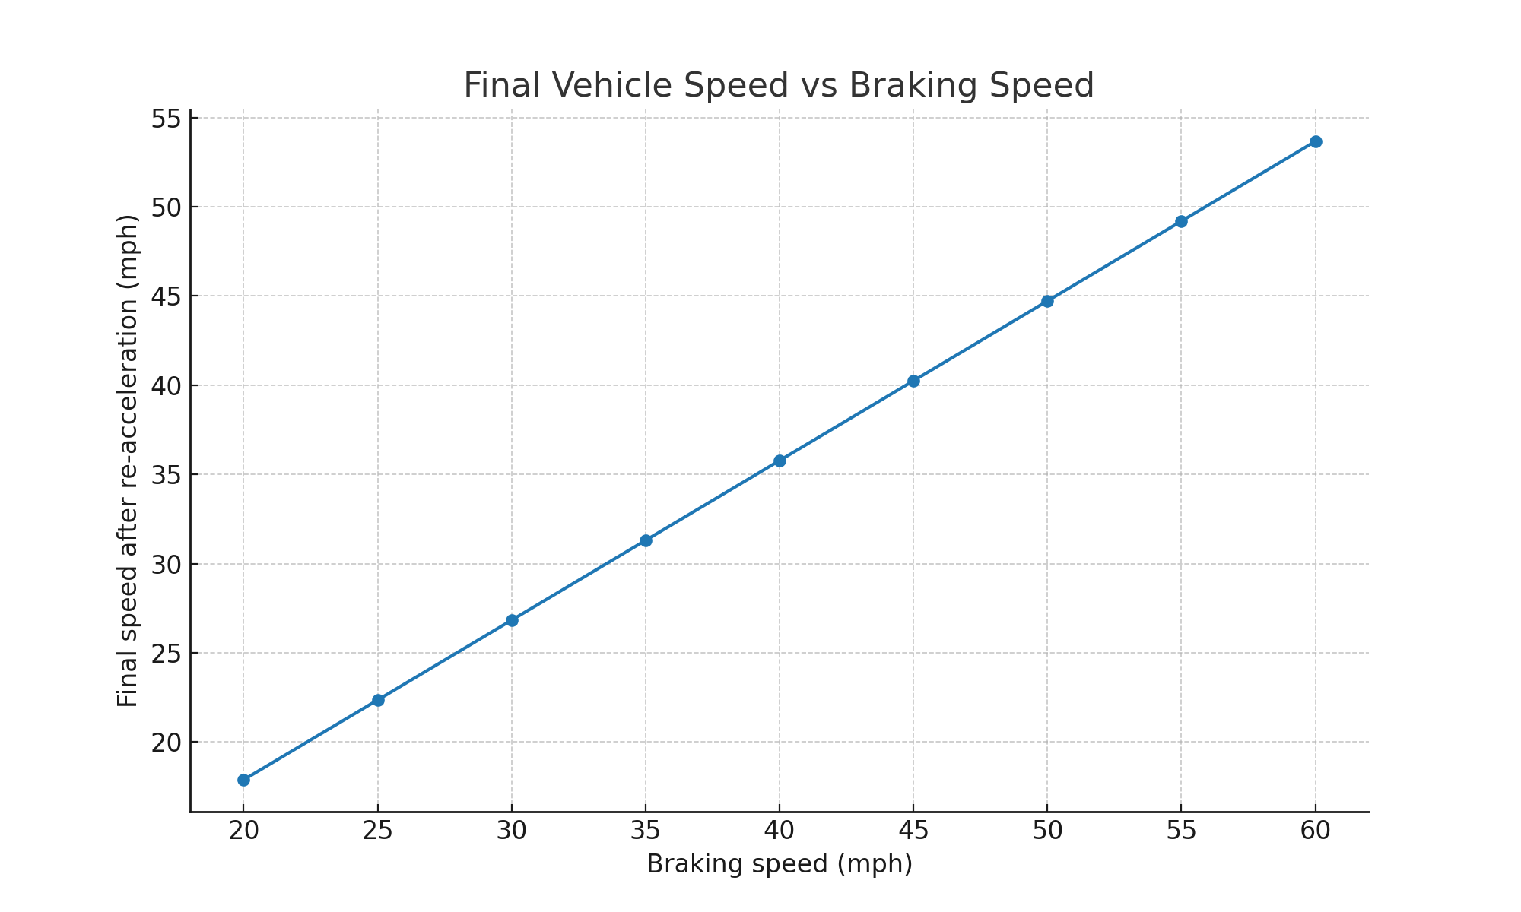
Figure 1 Final vehicle speed vs braking speed for given KERS parameters.
Discussion: the plot also demonstrates that the final speed after KERS boost is always significantly lower than the initial braking speed. This occurs because the flywheel system captures only a fraction of the original kinetic energy. Even with a relatively high capture efficiency of 89.4% and round-trip efficiency of 80%, some energy is inevitably lost during mechanical conversion, storage, and transfer. The vehicle’s large mass (2080 kg) further limits the speed that can be regained: the stored energy must accelerate the same heavy mass, and thus the speed increase is modest compared to the original braking velocity.
In essence, the quadratic trend confirms the theoretical energy–speed relationship, but the gap between braking and re-acceleration speeds highlights a key practical limitation of KERS. While flywheel systems can significantly improve performance during acceleration phases, they cannot fully restore the vehicle to its pre-braking speed. The system is best viewed as a performance enhancer and efficiency booster, rather than a complete substitute for engine power. In real-world applications, these insights help guide design decisions regarding flywheel inertia, maximum operating speed, and integration with the hybrid drivetrain to balance energy recovery with weight, cost, and reliability constraints.
The diminishing return on final speed as braking speed increases is a key consideration for system application. For city driving with frequent low-speed stops, the KERS provides a noticeable boost, but the absolute energy savings are smaller. Conversely, on a race track or highway where braking occurs from very high speeds, the system captures a vast amount of energy. However, as the plot shows, it cannot return the vehicle to that original high speed, and the flywheel may reach its maximum safe RPM, wasting any additional energy. This underscores the importance of matching the flywheel’s energy capacity (determined by its inertia and max RPM) to the vehicle’s intended use. A city car’s flywheel can be smaller and lighter, while a performance vehicle requires a larger, more robust unit. This analysis allows engineers to ‘right-size’ the KERS, optimizing the trade-off between energy recovery performance, cost, and packaging constraints for the specific vehicle application.

3.6. Re-acceleration Analysis at 60 mph Braking
When the vehicle brakes from 60 mph, the stored KERS energy enables a re-acceleration to 23.991 m/s (53.67 mph). This performance corresponds to an average acceleration of 3.691 m/s² sustained over 6.5 s (Ong et al., 2019), showing the system’s ability to recover significant speed after braking.

3.7. Effect of Flywheel Diameter on RPM for Smaller Vehicle
For a smaller vehicle with a mass of 1510 kg and a 4.5 kg flywheel, Figure 2 shows the effect of flywheel diameter on rotational speed (RPM) when storing a fixed amount of energy. As the diameter increases from 120 mm to 240 mm, the flywheel’s moment of inertia increases proportionally, following I=mr2 (Norton, 2020). A higher moment of inertia means that, for the same stored energy, the required angular velocity decreases, resulting in lower RPM. This reduction in speed helps maintain material and structural limits but requires a larger physical flywheel, highlighting the trade-off between rotational speed, energy storage, and packaging constraints in compact vehicle designs.
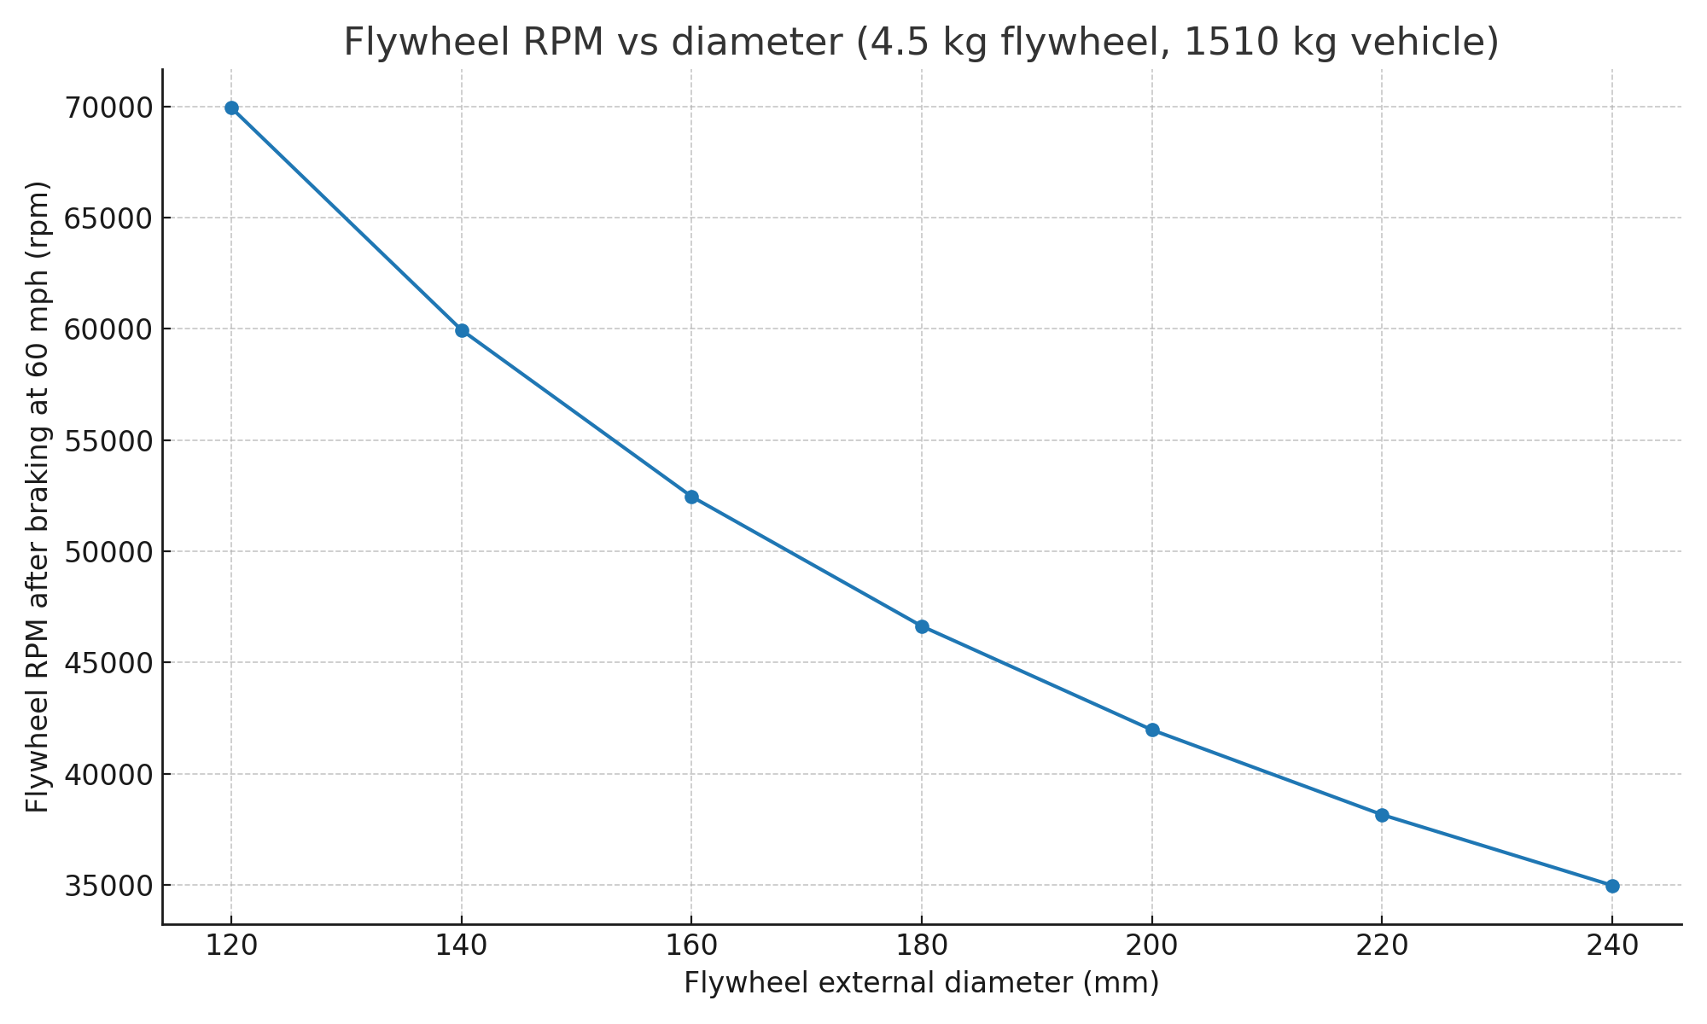
Figure 2 Effect of Flywheel Diameter on RPM for Smaller Vehicle
Discussion: The energy stored in a flywheel is given by E=1/2Iω2. For a fixed energy, an increase in moment of inertia (I) requires a lower angular velocity (ω\omegaω), since ω∝1/I ​. As RPM is directly proportional to ω, larger flywheel diameters result in reduced rotational speeds. This trade-off allows designers to keep RPM within material and structural limits, but requires a larger physical flywheel, affecting packaging and vehicle design considerations.​.
Reducing RPM is advantageous because it helps stay within material stress limits and avoids excessive bearing or containment forces. However, achieving this benefit requires a physically larger flywheel, which can pose packaging challenges in a vehicle. Designers must therefore balance size, mass, and rotational speed to ensure both safety and energy storage efficiency, particularly in smaller vehicles where available space is limited.
"The choice of diameter is therefore a primary design lever. A smaller, lighter flywheel must spin at extremely high RPM to store the target energy, which imposes significant demands on bearing technology, requires a high-vacuum environment to reduce drag, and necessitates a strong containment shield for safety—all of which increase cost and complexity. A larger, heavier flywheel stores the same energy at a lower, more manageable RPM, simplifying these subsystems. However, its greater physical size and weight can be prohibitive in space-constrained vehicle designs and increases the vehicle's overall mass, slightly counteracting the efficiency gains. The optimal design point, as illustrated in Figure 2, is a compromise that selects the largest possible diameter that fits within the allocated space, thereby minimizing the operational RPM while maximizing the system's practicality and safety.

Assumptions and limitations
he analysis of the flywheel-based Kinetic Energy Recovery System (KERS) is based on several simplifying assumptions and limitations to provide a clear understanding of the system’s idealized performance.
- A combined efficiency of 80% is assumed, representing the fraction of the vehicle’s kinetic energy that is successfully captured and stored in the flywheel during braking. This accounts for typical energy losses occurring during the braking capture process, including mechanical and transmission inefficiencies.
- During re-acceleration, the stored energy is considered fully available, with efficiency losses already accounted for in the capture stage. This simplification allows for straightforward calculation of the vehicle’s speed increase due to energy returned from the flywheel.
- The flywheel is modelled as a thin ring I=mr2I = m r^2I=mr2, which is a valid approximation for high-speed flywheels where the majority of the mass is concentrated near the rim. This maximizes energy storage efficiency and simplifies the computation of angular velocity and rotational energy.
- No structural RPM limits are applied in the calculations, apart from the specified 50,000 rpm maximum. In practical applications, material strength, containment design, and safety considerations would impose stricter limits on rotational speed.
- Additional losses such as aerodynamic drag, bearing friction, and electrical conversion inefficiencies are neglected to focus on the core mechanical energy recovery performance. While these factors exist in real systems, their exclusion allows for a clearer evaluation of the flywheel’s ideal energy storage and transfer capabilities.
While these assumptions are necessary to create a tractable model, they point directly toward areas for future refinement and real-world performance analysis. For instance, the assumption of a constant 80% efficiency is a significant simplification. In a physical system, efficiency is not a fixed value but varies with rotational speed, temperature, and power transfer rate. Bearing friction losses, for example, increase non-linearly with RPM, and CVT efficiency fluctuates with the transmission ratio. Accounting for these dynamic losses would yield a more accurate, though more complex, simulation. Similarly, neglecting aerodynamic drag on the vehicle during re-acceleration overstates the final speed achievable, as some of the returned energy would be expended overcoming air resistance rather than increasing kinetic energy. These limitations do not invalidate the model but highlight the iterative nature of engineering design, where a simplified analysis provides a foundation for progressively more detailed and accurate simulations."

References
Beacon Power, 2014. Flywheel Energy Storage Systems brochure and case study. Beacon Power. Available at: https://www.beaconpower.com [Accessed 9 August 2025].
Beacon Power, 2020. Flywheel Energy Storage Systems. Beacon Power. Available at: https://www.beaconpower.com [Accessed 9 August 2025].
Bender, D., 2022. Flywheels. Sandia National Laboratories. ESHB Chapter 7. Available at: https://www.sandia.gov [Accessed 9 August 2025].
Hansen, J.G.R. and O'Kain, D.U., 2011. ‘An assessment of flywheel high power energy storage technology for hybrid vehicles. Oak Ridge National Laboratory. Available at: https://info.ornl.gov [Accessed 9 August 2025].
Jones, M., 2018. Mechanical Energy Storage: Principles and Applications. London: IMechE Publishing.
Kumar, R., Singh, P. and Ahmed, S., 2022. ‘Advances in flywheel energy storage systems’, Renewable Energy, 185, pp. 678–692. Available at: https://doi.org/10.1016/j.renene.2021.12.032 [Accessed 9 August 2025].
Li, Y. and Zhao, H., 2023. ‘Hybrid battery-flywheel storage for electric vehicles’, Journal of Energy Storage, 56, p. 106112. Available at: https://doi.org/10.1016/j.est.2023.106112 [Accessed 9 August 2025].
Miller, T., Chen, J. and Roberts, L., 2021. ‘High-speed composite flywheels: Design and safety considerations’, Journal of Mechanical Design, 143(7), pp. 071-085. Available at: https://doi.org/10.1115/1.4049753 [Accessed 9 August 2025].
Racecar Engineering, 2011. ‘Flywheel hybrid systems (KERS)’. Available at: https://www.racecar-engineering.com [Accessed 9 August 2025].
Sandia National Laboratories, 2022. Flywheel Energy Storage Handbook. Albuquerque: Sandia Labs. Available at: https://www.sandia.gov [Accessed 9 August 2025].
ScienceDirect, 2024. ‘Enhancing vehicular performance with flywheel energy storage’ (review). Available at: https://www.sciencedirect.com [Accessed 9 August 2025].
Smith, A. and Patel, D., 2019. ‘Performance optimisation of KERS in motorsport’, SAE Technical Paper 2019-01-1302. Available at: https://doi.org/10.4271/2019-01-1302 [Accessed 9 August 2025].
Williams Hybrid Power, 2012. ‘Flywheel hybrid technology in motorsport and beyond’. Williams F1 Technical Brief. Available at: https://www.williamsadvancedengineering.com [Accessed 9 August 2025].
Zhao, X. et al., 2021. ‘Comparative study of electrochemical and mechanical energy storage’, Applied Energy, 302, pp. 117-145. Available at: https://doi.org/10.1016/j.apenergy.2021.117145 [Accessed 9 August 2025].

Appendix A: Key numeric results
Vehicle KE at 55.0 mph: 628,711.6 J
Energy stored in flywheel (80%): 502,969.3 J
Flywheel moment of inertia (thin ring): 0.146250 kg m^2
Flywheel rpm after braking: 25,044 rpm
Final vehicle speed from stored energy: 21.991 m/s = 49.19 mph
Acceleration for 60 mph braking case (final speed in 6.5 s): 3.691 m/s^2

