Assignment 2
Professional Development Plan (PDP)
Module Name | Learning in the Digital Era
Module Code | ACCA4025
Student Name | Makawe Alsir
Student ID | 2513347
Lecturer | Fernando
Group | 2
University | University of Wales Trinity Saint David
Video Link | https://youtu.be/TmKme9D-g74
UNIVERSITY OF WALES TRINITY SAINT DAVID
LONDON CAMPUS

Table of Contents
Introduction ............................................................ 3
Main Body ............................................................... 3
Gibbs' Reflective Model ................................................. 5
Task 1: Self-Evaluation ................................................. 7
Task 2: Professional Development Plan ................................... 9
Task 3: Unit 4 Topic Summary ............................................ 10
Conclusion .............................................................. 13
References .............................................................. 15

Introduction
This report presents the content of my Learning in the Digital Era Assignment 2 presentation. It focuses on self-reflection and self-evaluation, the development of a Professional Development Plan (PDP) with SMART goals, and a summary of Unit 4 Topic 2, 'Bouncing Forward'. The report also considers resilience, stress and anxiety, and well-being for learning.

Main Body
The main body follows the order of my completed PowerPoint presentation. Each slide is included as evidence, and the main task slides are followed by a brief explanation of what I learned and how the content relates to my personal and professional development.
Video Link: https://youtu.be/TmKme9D-g74

Slide 1 - Cover Page
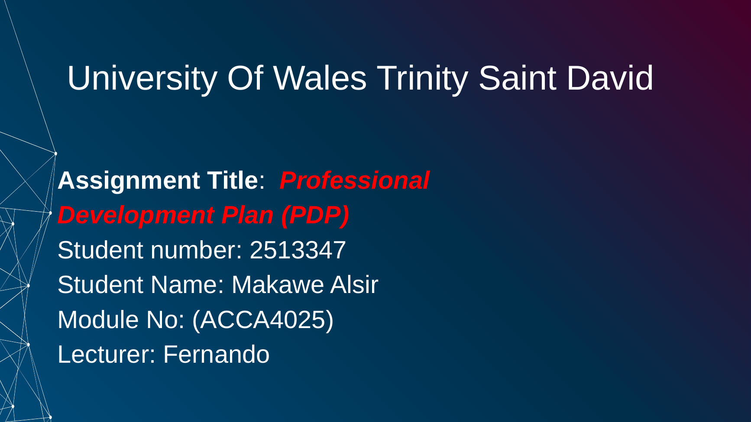

Figure 1. Slide 1 - Cover Page

Slide 2 - Introduction
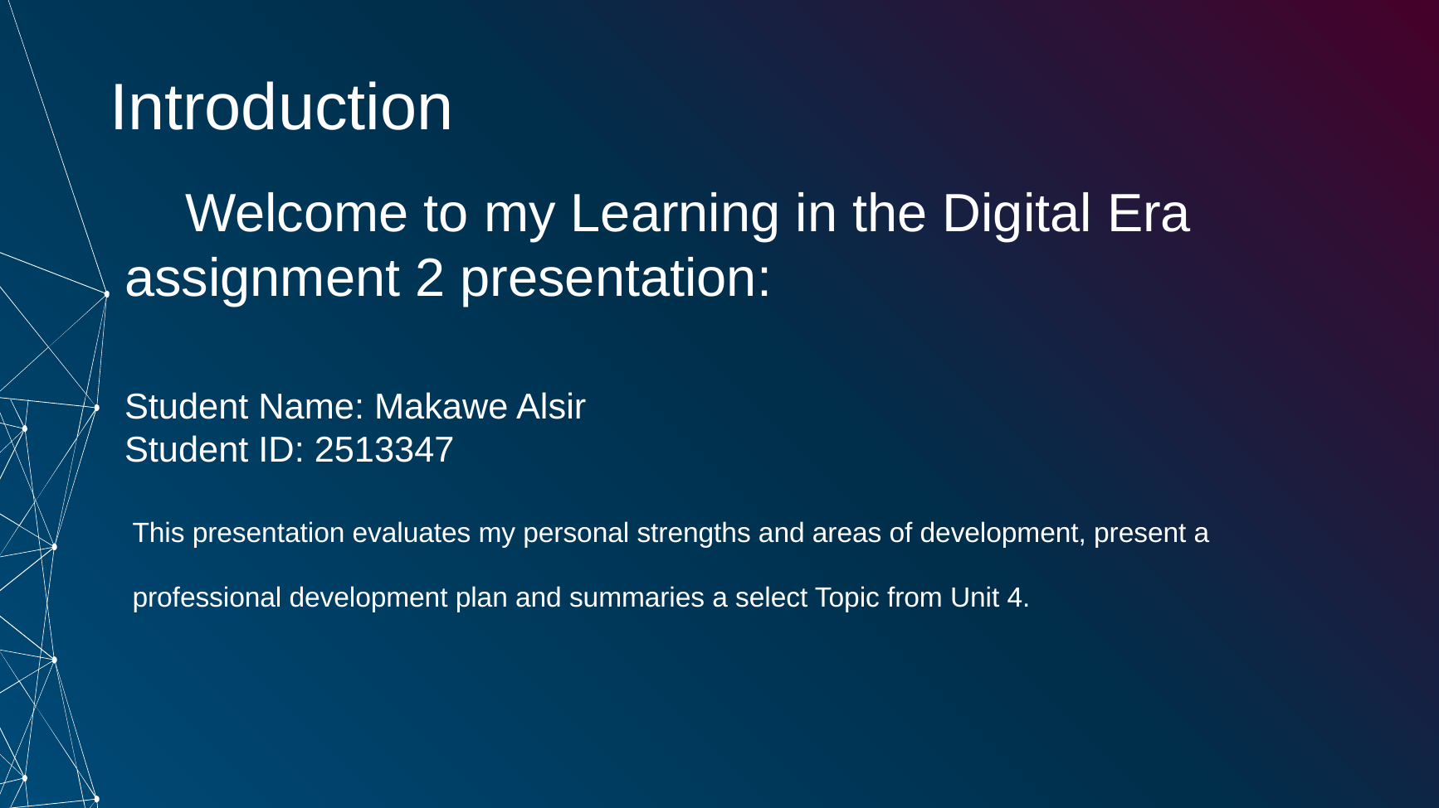
Figure 2. Slide 2 - Introduction

Slide 3 - Self-Reflection, Personal Development and Professional Learning
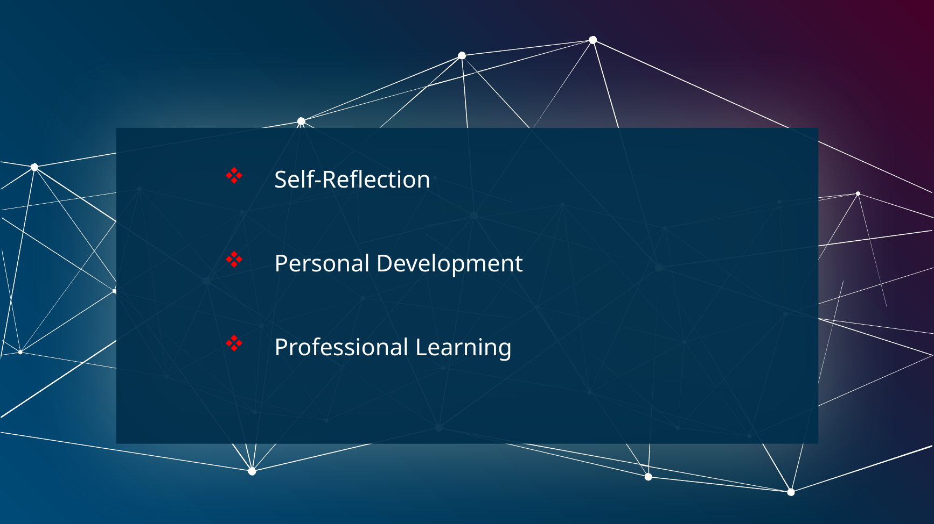
Figure 3. Slide 3 - Self-Reflection, Personal Development and Professional Learning

Slide 4 - Reflective Model Diagram
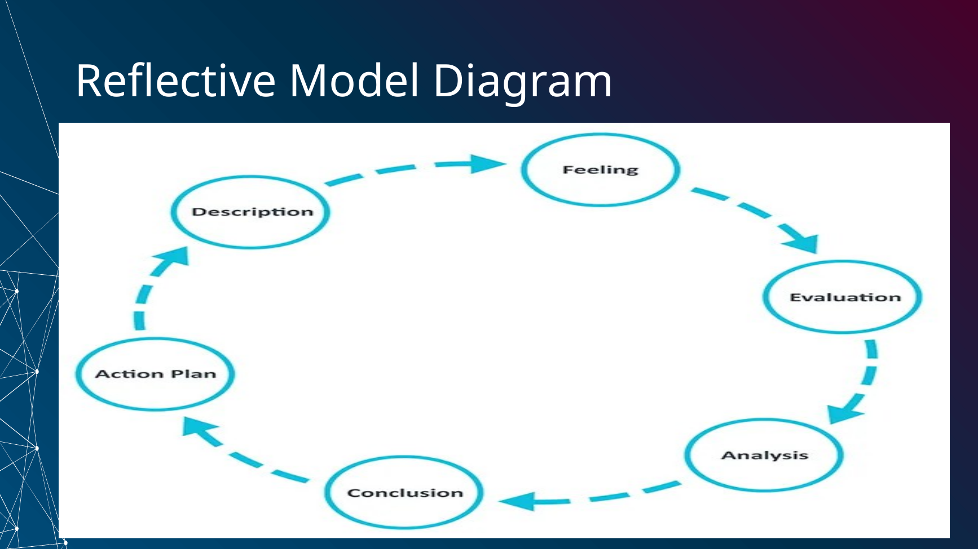
Figure 4. Slide 4 - Reflective Model Diagram
Brief explanation: The diagram presents the six stages of Gibbs' Reflective Cycle: Description, Feelings, Evaluation, Analysis, Conclusion and Action Plan [1]. The cycle provides a clear sequence for thinking about an experience, understanding what happened, identifying what was learned, and deciding how to respond more effectively in the future.

Slide 5 - Gibbs' Reflective Cycle
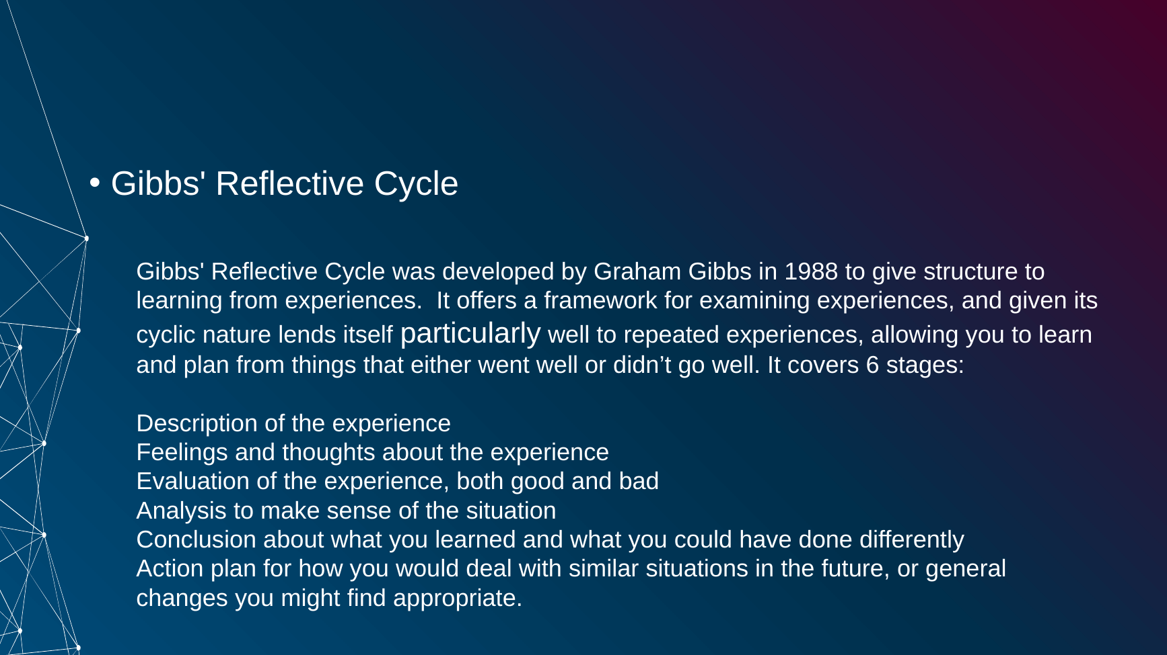
Figure 5. Slide 5 - Gibbs' Reflective Cycle
Brief explanation: Gibbs' Reflective Cycle gives structure to learning from experience. In this assignment, I apply the model by describing my abilities and experiences, considering my feelings about my performance, evaluating what I do well and what I need to improve, analyzing the reasons behind these areas, drawing conclusions about my development needs, and creating an action plan for future improvement [1].

Task 1: Self-Evaluation

Slide 6 - Strengths and Areas for Improvement
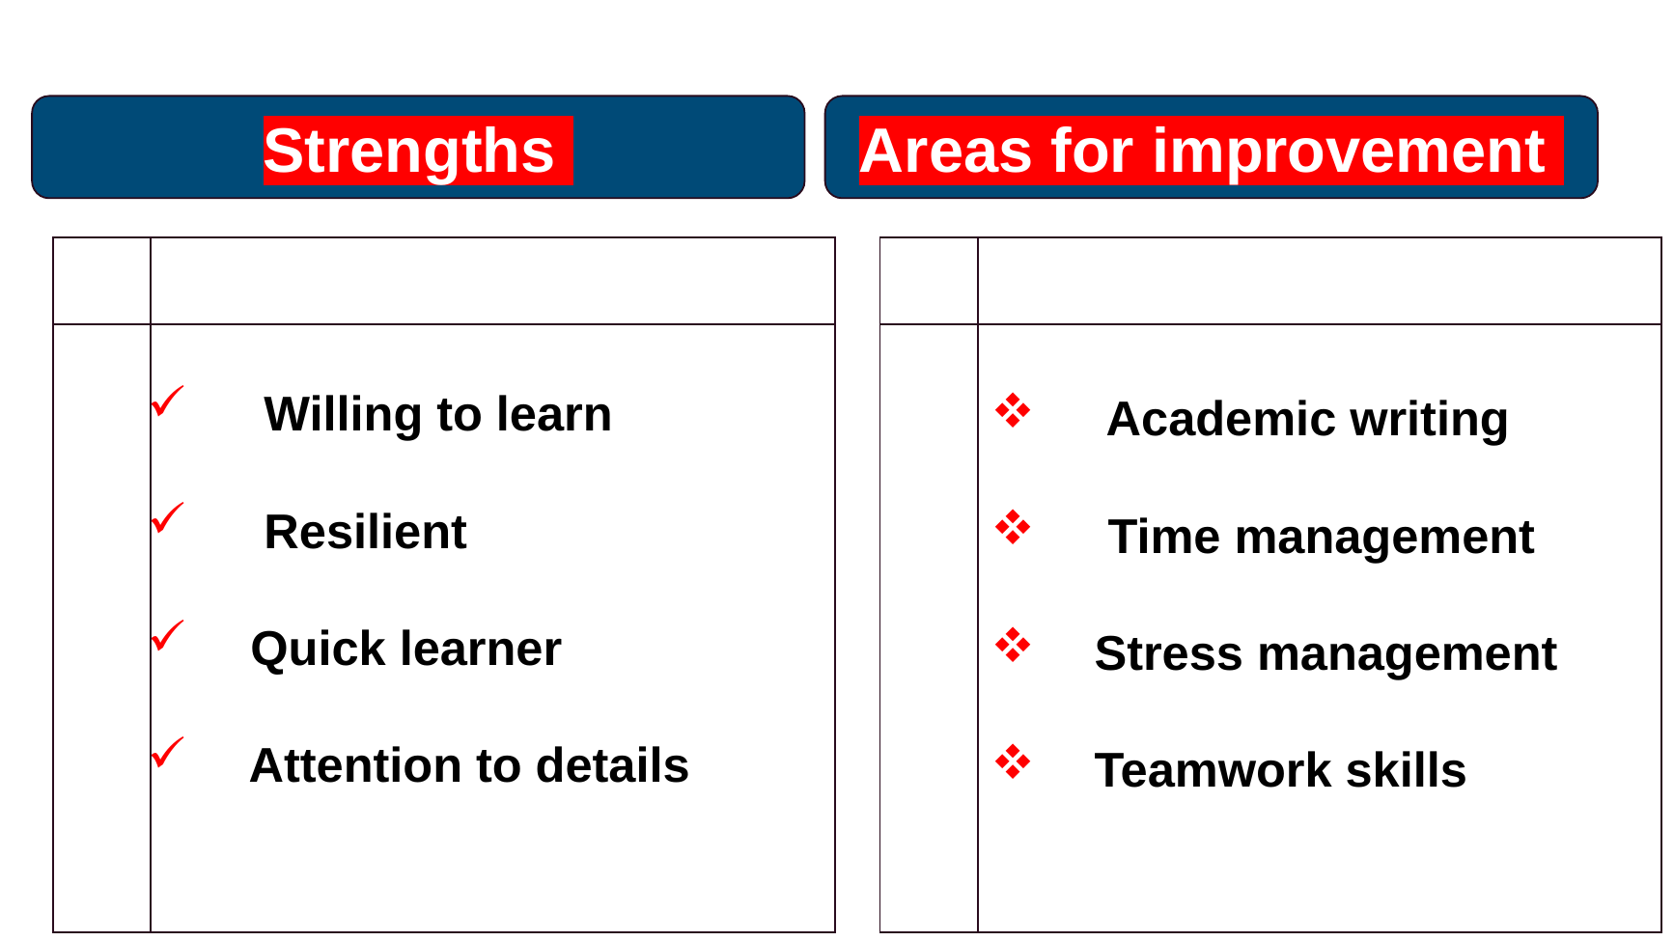
Figure 6. Slide 6 - Strengths and Areas for Improvement
Brief explanation: My self-evaluation identified four main strengths: willingness to learn, resilience, being a quick learner, and attention to detail. These strengths support my academic development because they help me remain open to new knowledge, continue working when I face difficulties, understand new tasks, and check my work carefully. I also identified four areas for improvement: academic writing, time management, stress management, and teamwork skills. Recognizing these areas gives me clear priorities for future development.

Slide 7 - Traits Gained from the Self-Reflection
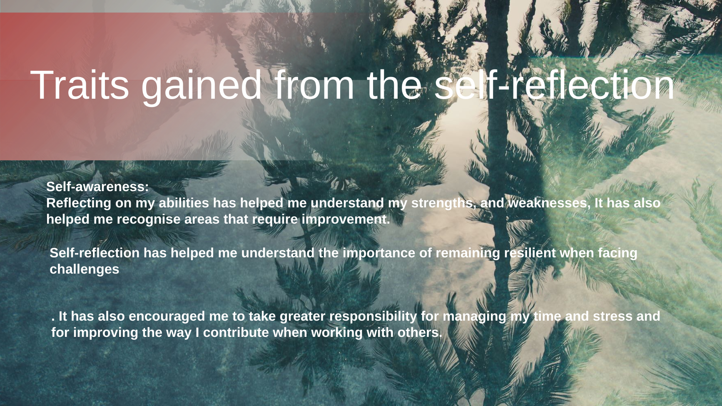
Figure 7. Slide 7 - Traits Gained from the Self-Reflection
Brief explanation: The self-reflection process has increased my self-awareness because I now have a clearer understanding of my strengths and weaknesses. It has also shown me the importance of remaining resilient when facing challenges. In addition, reflection has encouraged me to take greater responsibility for managing my time and stress and for improving how I contribute when working with other people.

Task 2: Professional Development Plan

Slide 8 - Professional Development Plan with SMART Goals
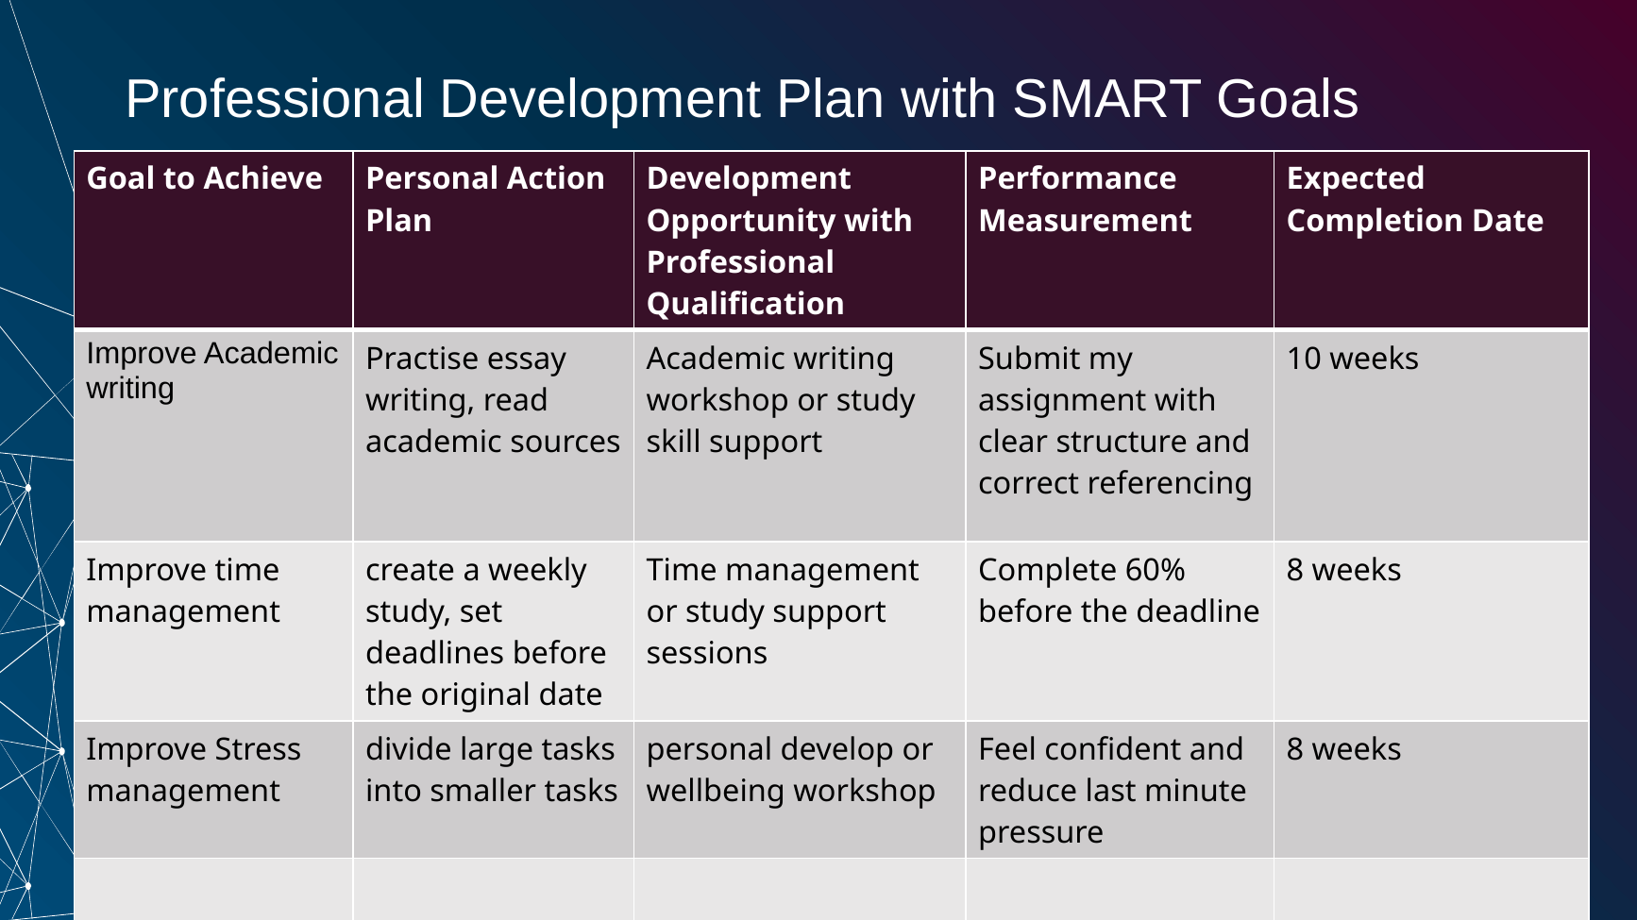
Figure 8. Slide 8 - Professional Development Plan with SMART Goals
Brief explanation: My Professional Development Plan turns the main areas for improvement into practical goals. I plan to improve my academic writing by practicing essay writing, reading academic sources, and using academic writing or study-skills support, with a target of 10 weeks. I will improve time management by creating a weekly study plan and setting earlier personal deadlines, with a target of 8 weeks. I will also improve stress management by dividing larger tasks into smaller tasks and using personal development or well-being support, with a target of 8 weeks. The performance measures in the plan will help me review whether I am making progress.

Task 3: Unit 4 Topic Summary

Slide 9 - Bouncing Forward - Developing Resilience
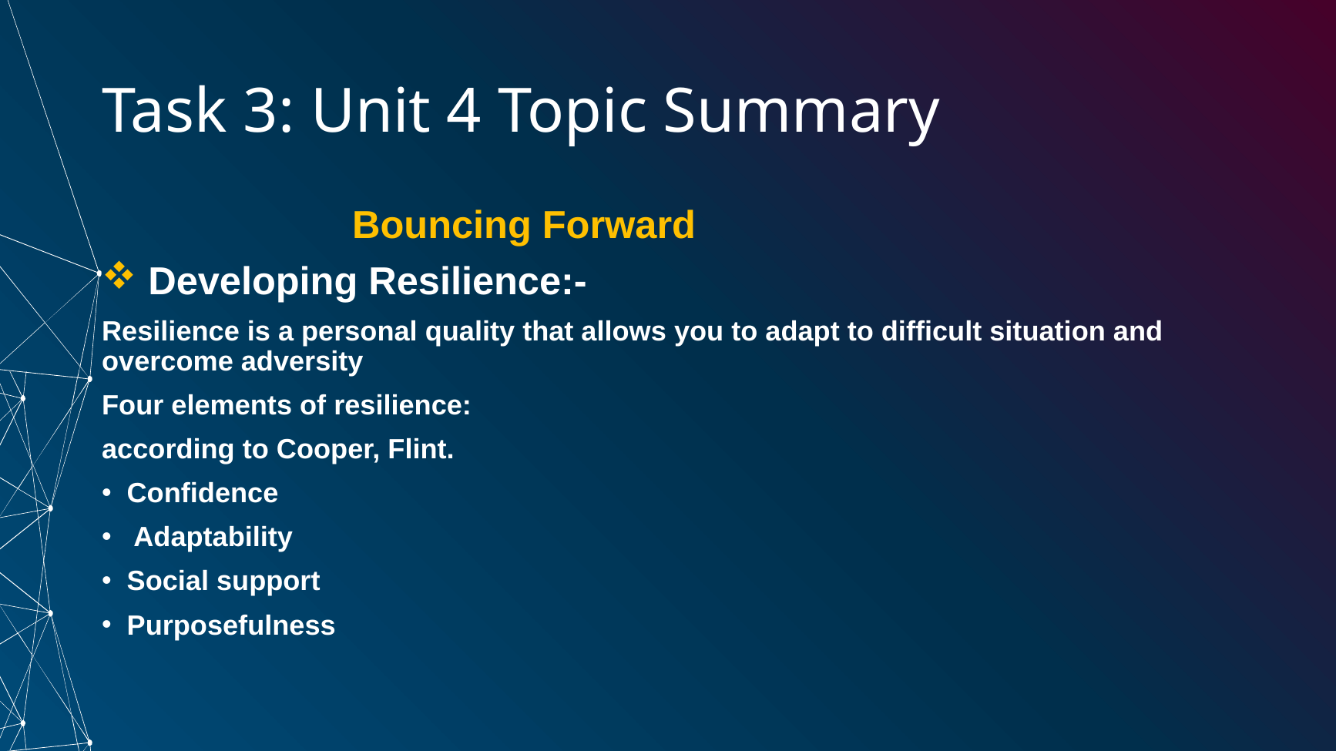
Figure 9. Slide 9 - Bouncing Forward - Developing Resilience
Brief explanation: The Unit 4 topic I selected is 'Bouncing Forward'. The first section focuses on developing resilience. In my presentation, resilience is described as a personal quality that helps a person adapt to difficult situations and overcome adversity. The topic identifies four elements of resilience: confidence, adaptability, social support, and purposefulness [3]. These elements show that resilience involves both personal abilities and support from other people.

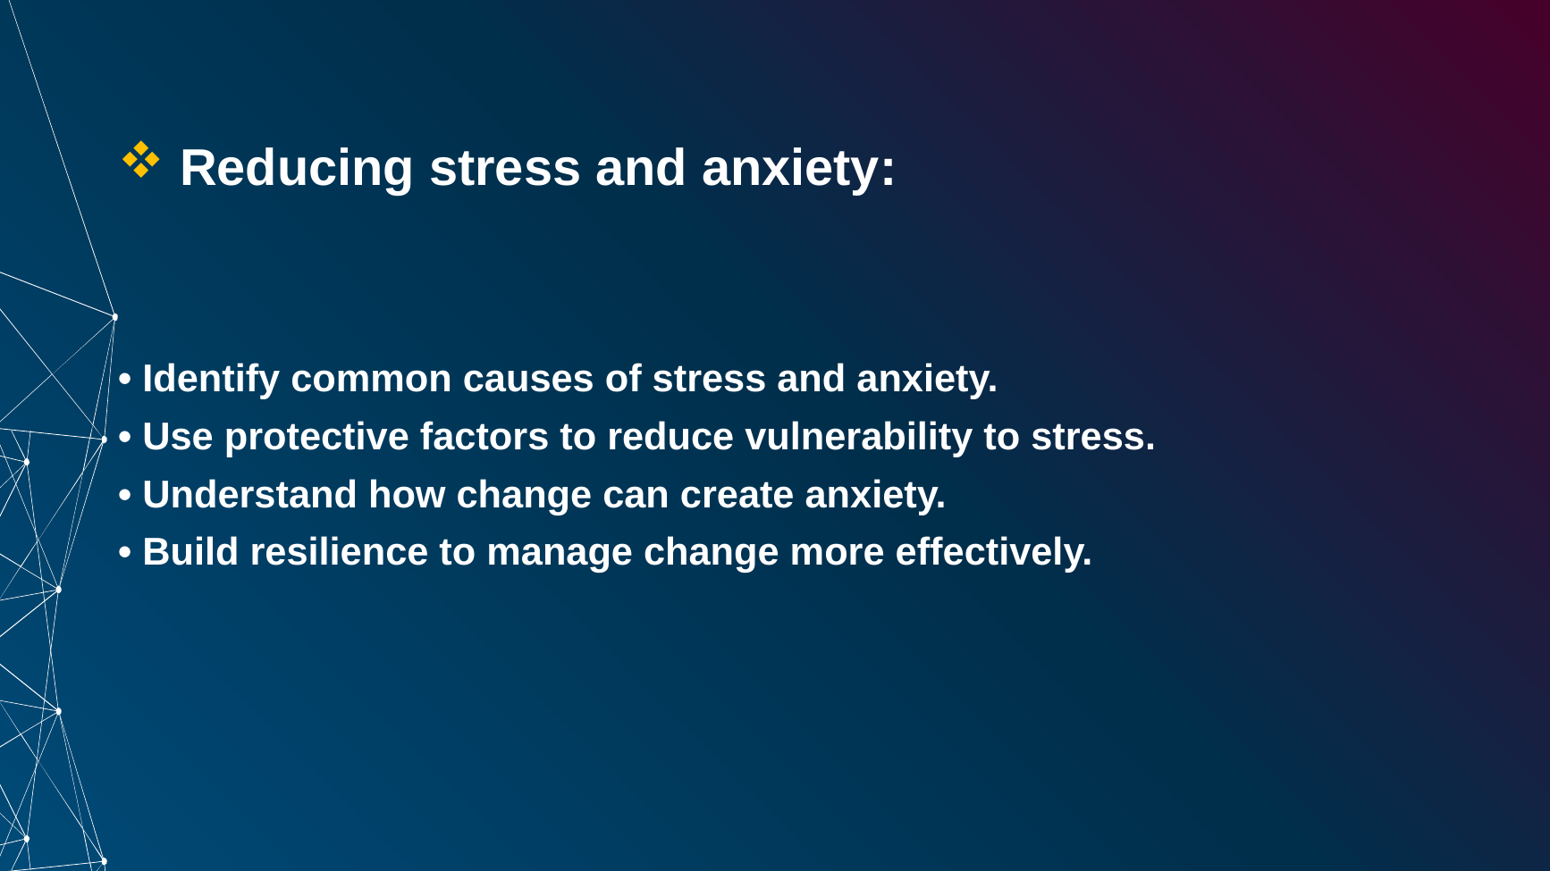
Figure 10. Slide 10 - Bouncing Forward - Reducing Stress and Anxiety
Brief explanation: The second section focuses on reducing stress and anxiety. It highlights the importance of identifying common causes of stress and anxiety, using protective factors to reduce vulnerability to stress, understanding how change can create anxiety, and building resilience to manage change more effectively [3]. This section is especially relevant to my self-evaluation because I identified stress management as one of my areas for improvement.

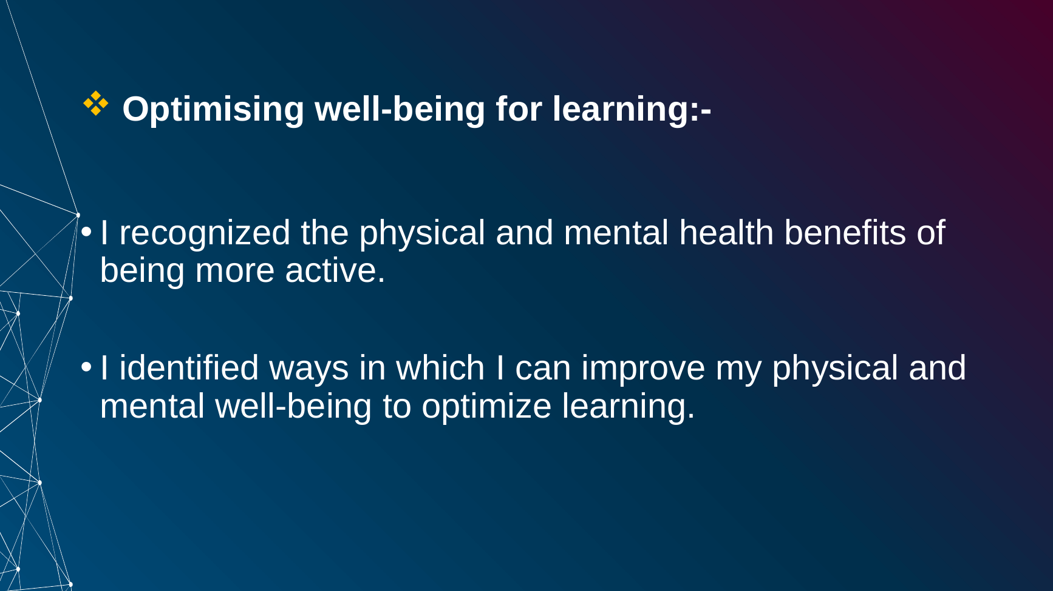
Figure 11. Slide 11 - Bouncing Forward - Optimizing Well-being for Learning
Brief explanation: The final section focuses on optimizing well-being for learning. I recognized that being more physically active can support both physical and mental health, and I identified ways in which I can improve my well-being to support learning. The presentation source by Wendy Suzuki also discusses how exercise can support the brain and mental functioning [2]. Maintaining healthier routines can therefore contribute to my learning and personal development.

Conclusion

Slide 12 - Conclusion
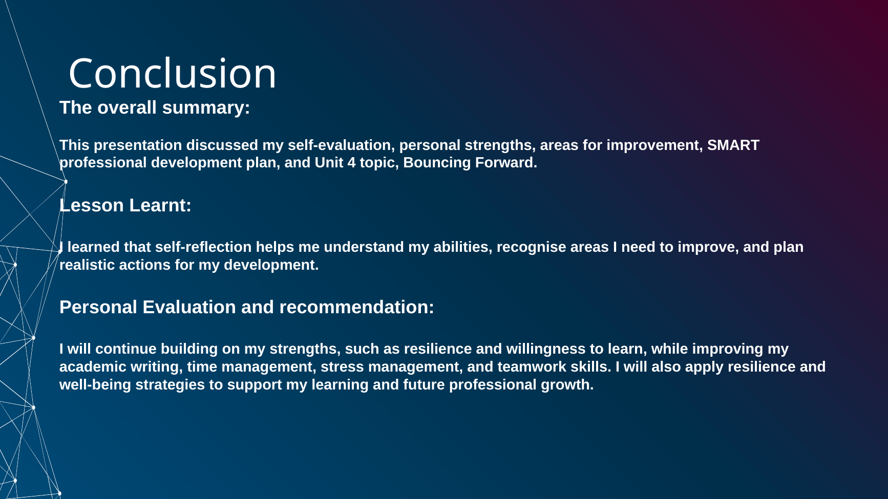
Figure 12. Slide 12 - Conclusion
Brief explanation: The presentation brought together my self-evaluation, personal strengths, areas for improvement, SMART professional development plan and the Unit 4 topic 'Bouncing Forward'. The main lesson I learned is that self-reflection can help me understand my abilities, identify development needs, and plan realistic actions for improvement. I will continue building on strengths such as resilience and willingness to learn while improving academic writing, time management, stress management, and teamwork skills. I will also use resilience and well-being strategies to support my future learning and professional growth.

Slide 13 - References
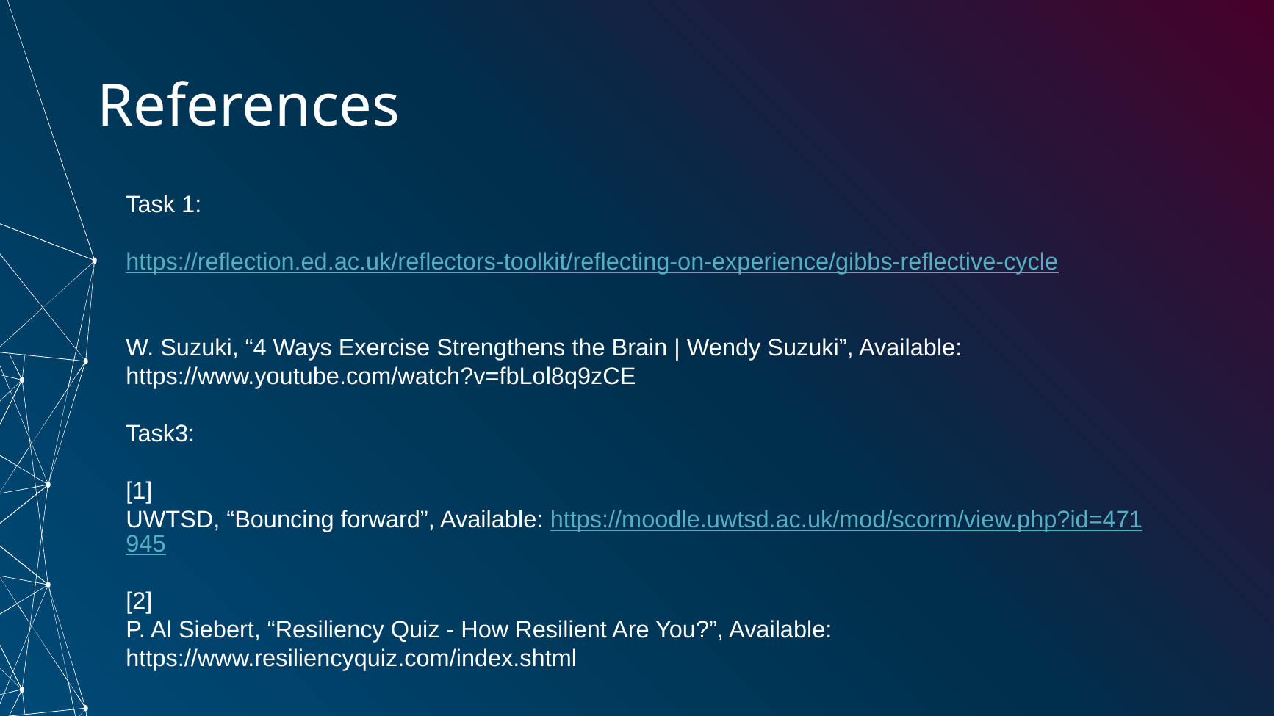
Figure 13. Slide 13 - References

General Conclusion
In conclusion, this assignment has helped me evaluate my current abilities and identify realistic areas for personal and professional development. Gibbs' Reflective Cycle provided a structured way to think about my experiences and future actions, while the Professional Development Plan converted my development needs into clear goals. The Unit 4 topic 'Bouncing Forward' also strengthened my understanding of resilience, stress management and well-being for learning. I can use these ideas to improve my academic performance and continue developing skills that will be useful in my future professional life.

References
The following sources are taken from the reference slide in the completed PowerPoint and are presented in the IEEE style.
[1] University of Edinburgh, “Gibbs’ Reflective Cycle,” Reflectors’ Toolkit. [Online]. Available: https://reflection.ed.ac.uk/reflectors-toolkit/reflecting-on-experience/gibbs-reflective-cycle. [Accessed: Aug. 13, 2026].
[2] W. Suzuki, “4 Ways Exercise Strengthens the Brain | Wendy Suzuki,” YouTube. [Online]. Available: https://www.youtube.com/watch?v=fbLol8q9zCE. [Accessed: Aug. 13, 2026].
[3] University of Wales Trinity Saint David, “Bouncing forward,” Moodle. Online. Available: https://moodle.uwtsd.ac.uk/mod/scorm/view.php?id=471945. [Accessed: Aug. 13, 2026].

