Events Plan
By Grace Davies

2220599

Live Events Project
BMTP5021
Deborah Jenkins

Contents

Introduction…………..……………………………………………………………………....3
My Roles and Responsibilities …………………………………………………………….3
Aims and Objectives ………………………………………………………………………..3

Market Research and Target Market ………………...…………………………………...3
Venue selection ……………………………………………………………………………..4
Talent Selection ……………………………………………………………………………..5
Itinerary planning ……………………………………………………………………………5
Marketing Plan and Materials ……………………………………………………………..6
Expected finances …………………………………………………………………………..6
Risk management plan …………………………………………………………………….7
Contingency planning ………………………………………………………………………7
Evaluation strategy …………………………………………………………………………8
Profits and Finance …………………………………………………………………………8

Appendix ……………………………………………………………………………………..9
Bibliography ………………………………………………………………………………..15

Event Plan
This document contains a detailed explanation of the event planning process including the personal contributions involved in its success.

Introduction
A group of 4 events and tourism students including myself worked together to plan and execute a live music event in Swansea. These students are myself, Kirsty Cook, Savannah Kitching and Ben Williams. The event is classed as a live music event and consists of 3 bands playing consecutively in one space.

My Roles and Responsibilities
As a team we devised and delegated roles to ensure that each aspect of the event would be thought out and completed thoroughly. Belbin (2010) highlights the importance of role allocation in a team and discusses the importance of having a diverse team that utilises its strengths for the best outcomes. Belbin identifies 9 different roles, these are the plant, resource investigator, co-ordinator, shaper, monitor evaluator, team worker, implementer, completer and specialist. Belbin found that everyone fits at least one of these roles, some roles work better with others and the more variety in the team the better the outcome. There is a test online that allows you to access which team role best fits your personality, each of our team members completed this test and devised our team roles accordingly.

After assessing my personal strengths and weaknesses as a group we decided that I would be the co-ordinator, shaper and implementer. These roles are most fitted towards the usual name of team manager or organiser. I have the challenging personality that thrives under pressure. I am practical, reliable, and efficient however I also have the ability to delegate when necessary. With this information we allocated tasks to each team member, although we worked collaboratively in lots of areas, we were all allocated areas in which we would thrive. I took on the role of project manager as this best suited my personality type.

Aims and Objectives
The main aim of this project was to provide an enjoyable and memorable experience for our attendees through the live musical performances and overall atmosphere of this event. It was also important to us that we allowed the musical artists to showcase their talent, we purposefully chose newer artists so that they could perform in front of an audience and gain recognition and popularity from our event. We also prioritise social connections allowing time for socialising and networking between acts as well as before and after the show.

Market Research and Target Market
This event is catered towards students living in Swansea. This is an audience that is easily accessible to my group and are most willing to enjoy an event of this kind. As we are students ourselves, we are able to identify the needs of this target group and meet them to ensure the events success. Knowing that students enjoy partying and spending time with friends it was important that this event gave attendees time to socialise with each other while listen to good music.

The date chosen for this event lines up with student night in Swansea increasing the number of attendees. The genre of music for this event was crucial when assessing the target market, after agreeing previously that this event would be an indie-rock concert it was vital that we were marketing towards the right group of people. Greenheld (2015) suggests that indie-rock music is mostly aimed at people between the ages of 16 and 25 who attend higher education and university. This fits the target market perfectly and means that our event will be highly attended.

Venue selection
Picking the right venue sets the tone for the whole event, it is important that the space chosen is consistent with the theme of the evening. Locations direct (2024) highlight the key aspects that are necessary when looking for a place to host. They state that assessing the location, capacity, layout, accessibility, amenities and technical services of the venue are the key aspects of event planning.

When deciding on a venue for this event, it was important that it was close to the city centre so that parking and public transport is highly accessible. Knowing that Swansea is a student hub, it was also important that the location of the venue is close to popular places with students in Swansea.

After looking at different venues and what they had to offer there was a standout venue that was popular with students. The Bunkhouse Swansea is a Live music venue in the city centre that hosts a wide range of musical events all through the week. As they are a live music venue, they would already have the technical equipment and amenities that are necessary. After accessing their website, we reached to find out more information. As a part of team role allocation, Kirsty decided to be the key communicator between stakeholders, this included the management team at Bunkhouse and the bands chosen for the event. Although this was her allocated role, we all participated in the communication as it made it easier for us all to stay informed of what was happening.

After emailing Bunkhouse, a meeting was arranged for the 9th of February with the venue manager Jordan McGuire to discuss things such as venue hire prices and availability for the main stage and bars. Jordan informed us that the price of venue hire would be £100 for the evening. This included the use of the staff and security that is already existing at the venue. We were informed that any profits made from bar sales would cover the costs of employment for the staff the event. My group would work the event for free as us earning a wage was not a priority. It was a quick process of finding a date that worked with both our university schedule, the dates of which students would most likely attend and the dates where the venue was available. After settling on the 20th of March, a student night we went ahead and booked the venue. Jordan sent over all of our documentation, including proof of venue hire and contracts. All written forms of communication can be seen in the appendix at the end of this document.

The Bunkhouse has a capacity of 235 people with both the staging area and bar area. This number includes member of staff and attendees of the events. This is more than enough space for our event, we are not expecting to fill this space. After a conversation with Jordan, it was clear that mid-week gigs have a lower attendance rate than if we were to put it on the weekend. We estimate that we will sell around 50 tickets for this event which is enough to pay for the bands and cover the costs of the venue. The age restriction on entrance to the venue is 16, this is because there is alcohol sold on the property and the health and safety regulations set out by the venue, therefor it is important that IDs are checked upon entry.

Talent Selection
Now that we had chosen our venue we could continue with the next stage of the process and find bands that would fit the interests of our target market and were available for our selected date. With some social media research and the help of Jordan at The Bunkhouse, we found 3 bands that were very eager to come down and perform for us. Communication with the bands was a part of my role as project manager. I liaised with several members of each band to ensure that we were all on the same page regarding the itinerary for the event. The bands were informed that this event was non-profit and any proceeds from ticket sales would be going directly to them. This was the best option financially as there is no way of accurately knowing how much money we would generate before tickets were released. The bands agreed to this, and we booked them for our event. The bands selected were CODA, The False IDLES and Stone Deaf. As Stone Deaf have a larger following, we decided that it was best if they headlined the event and played a longer set than the other bands as a way of increasing attendance to this event.

Itinerary planning
Before the event begins, we came up with a strict schedule of when each of our tasks must be completed by. Savanah completed a Gantt chart to show these timings so that we could work as a group to meet the deadlines efficiently.

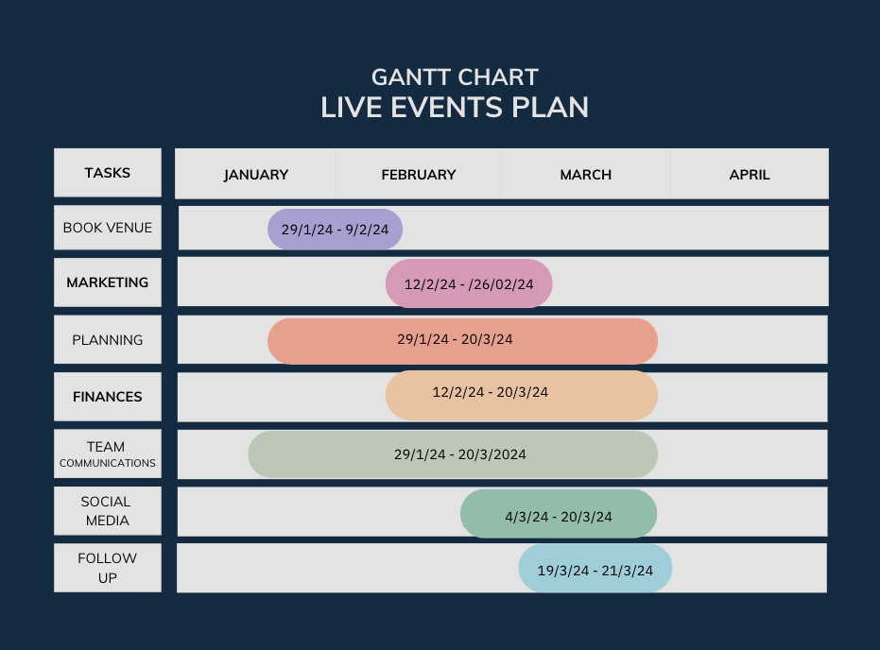
On the Night itinerary
As this event is aimed at students, we wanted to put the event on later in the evening.

Prior to the doors opening, it is important that all of the bands do a sound check to make sure that their equipment is working properly to ensure the smooth running of the event. Sound check will start at 5pm as soon as the bands arrive. Doors of the bunkhouse will open at 6pm allowing people time to socialise and have a few drinks by the bar before the first band starts. At 8pm, The False Idles will take the stage performing for approximately 30 minutes, after this a quick 15-minute break for people to get more drinks and use the toilets before the next band begins. At 8:45pm, CODA will perform a 30-minute set and again a 15-minute break will happen afterwards. Finally, at 9:30pm Stone Deaf will perform for approximately 1 hour. Afterwards there will be time for more socialising at the bar area until the venue closes at 11pm. This 11pm curfew is in line with the 2012 Live Music licencing act that states “amplified live music to be played to an audience of less than 500 people between the hours of 8am and 11pm” (Hospitality law, 2024).

Marketing Plan and Materials
The target market selected for this event is 16–25-year-olds, according to Zhou (2024) “those between the ages of 19 and 29 are the most active on social media, around 87% of them have an account”. After reviewing this information we thought that it would be vital to make social media marketing our main priority. We created eye-catching and informative posters and videos to post on social media. we decided that using Instagram, TikTok and Facebook would be our best option when trying to reach a wide audience.

According to Duncan and Toplis (2023) “4.89 billion people are using social media worldwide” meaning that opportunities to reach potential customers is endless. Social media marketing is very cost effective way of reaching thousands of people almost instantly. As our event is going to be on the smaller scale, there is no expenses to be paid in the promotion of our event on social media. we are trying to reach local people meaning that it is not necessary to pay for our advertisement to be promoted in other countries.

Social media marketing also enables us to use multiple different forms of media to optimise efficiency. This includes pictures, videos, posters and music and considering we are putting on a live music event, these materials are extremely important. All of the marketing materials used can be seen in the appendix at the bottom of this document.

Expected finances
Another role allocated to me as project manager was to manage our finances and ensure that we were staying in budget. The only expected upfront cost of our event was the £100 venue hire that was stated previously. This meant that each member of the group contributed £25 to the event, this is a cost that we are willing to waver depending on the amount of tickets that we sell leading up to the event.

We estimate to sell 50 tickets for this event. We will be charging £5 for online sales and £6 upon entry. This means that overall ticket revenue will be approximately £250. This money will be split 30/30/40 between the bands giving the headliners the largest sum. This works out at £70 each for the support acts and £100 for the headliners.

As mentioned previously security and staff is provided by the venue as a part of the £100 hire fee.

Risk management plan
This section will revise all health and safety risks that may arise during the event.

It is important that our event abides to certain laws that may affect the safety of our event. The Health and Safety at Work act 1999 ensures that “provisions of risk assessments must be followed” (Croner-I, 2021). Risk assessments are a vital part of any event they ensure the safety of both staff and attendees. Risk assessments are dependent on the scale, type and scope of the event, the size of the audience, the location and the duration of the event. These are all mitigating factors that can change the outcome of an incident. It is important that all risks are identified and analysed and that procedures are in place to either prevent them or solve them. It is important to consider even the most unlikely of events so that we are fully prepared to deal with them if they occur. The purple guide is an unofficial piece of documentation that advises event holders on the health and safety of their events. “It highlights legal responsibilities as well as non-legislative practices that ensure the smooth running of an event” (The Purple Guide, 2023).

As a team we did research on the health and safety that would be advised to have in place. For our event, Ben has created a risk assessment for us to use. This can be found in the appendix at the bottom of this document.

On our first visit in the Bunkhouse, we were given a health and safety walk through and were shown where all fire and emergency exits were. We were advised on the best courses of action that we could take when we were managing the venue on event day.

Some of the bands performing are under the age of 18, therefore it is important not to provide them with alcohol on the night of the event. Usual concert protocol involves providing the bands with a rider, this includes providing them with anything that they want in the green room before a show, this can include anything but usually is just food and drinks. Due to the bands being underage it is a risk to provide alcohol in the room as it puts the venue at risk of losing their licence. As a result, band member that are over the age of 18 must get their alcohol at the bar instead of having them in the room ready for them.

Contingency planning
Planning for the unexpected is vitally important, although not everything can be predicted it is important that the most common incidents are highlighted. Contingency plans are action plans that are in place to help employees and attendees respond to potential risks (Needle, 2023). This includes unexpected weather conditions, technical issues and medical emergencies. To my knowledge the bunkhouse has a first aid kit available on cite for any minor injuries, any major injuries must be reported to the ambulance service so that they can deal with it appropriately. This event is not large enough to require emergency services on cite. Whether related issues include the cancellation of the event due to extreme weather conditions, this would mean that our £100 deposit is non-refundable if the event was not to take place. Other plans in place include door mats to prevent slipping on wet floors and avoiding injuries. Technical contingency plans include having backup equipment available in case of damage or loss.

Post event evaluations are vital to review the effectiveness of these contingency plans and identify any mistakes that can be avoided in the future.

Evaluation strategy
After the event on March 20th, 2024, we asked our attendees for verbal feedback, the general information we received was extremely positive. On the day after we received messages from management at bunkhouse and from the bands thanking us for putting on such a successful event. The bands asked us to inform them of any future events that we put on because they would love to be involved.

Personally, I think that the event was a huge success, despite this it was not without its faults. We had a few issues that were quick to be resolved. On arrival one of the bands had realised that they had left some of their equipment at home. They were quick to inform me so that I could source the equipment from elsewhere, luckily one of the bands happened to have the correct equipment with them and were able to lend it to them so we could do our sound check. This was a high stress situation that was quickly resolved. Apart from this and a few broken glasses that had to be cleaned up there were very few accidents that happened at the event.

If I was to run this event again, I would start sound check earlier to make sure that all of the bands have time to themselves before the show. On the night everyone was feeling a bit rushed of their feet as we had not given enough time for errors. Apart from this there is not much that I would change, and I am very happy with the outcome.

Profits and Finance

We had sold 75 tickets overall which is more than we were expecting meaning that we were able to pay the bands more than originally stated. Between sales online and tickets bought at the door we made £396. We decided that it was best to divide the money between the bands as previously mentioned as 30/30/40. Meaning that the support acts received £118 each and the headliners received £158.

Between us in our group we were happy to waver the £25 deposit for the venue as we had a successful event and wanted the bands to receive a higher pay.

Appendix
Written forms of communication

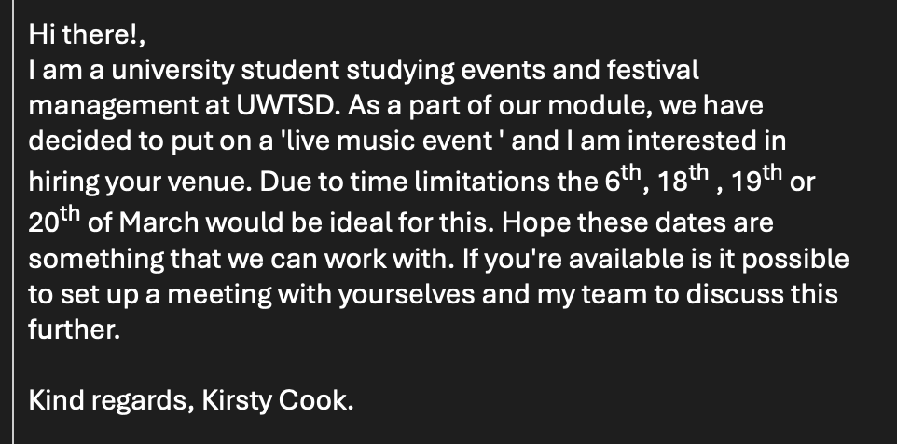
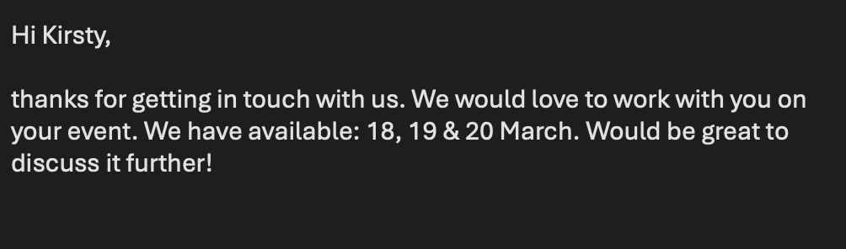
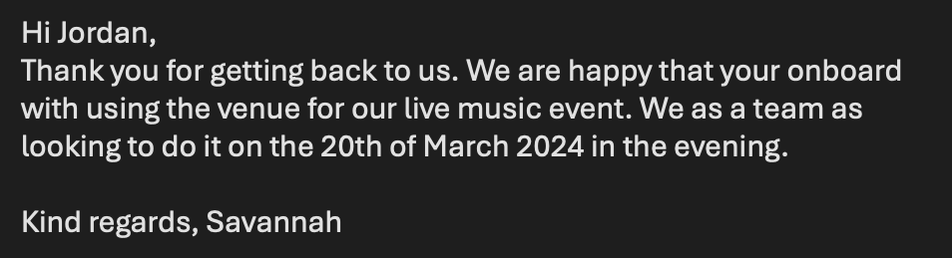

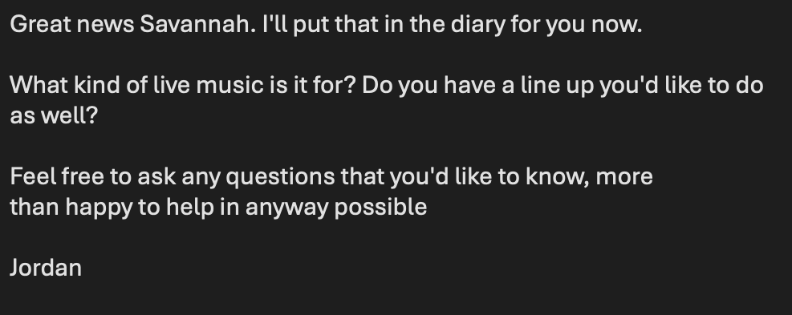
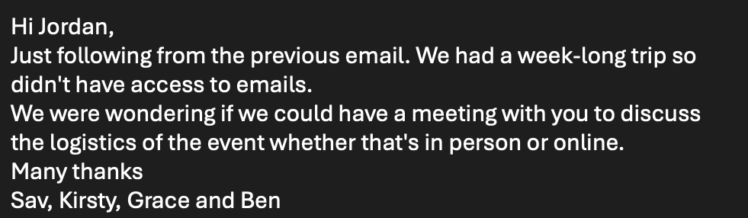
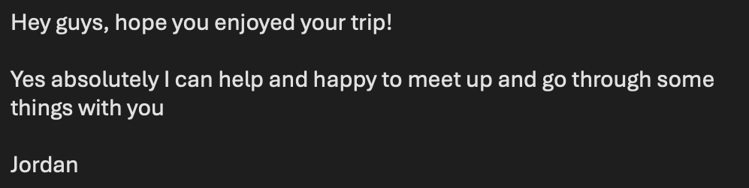
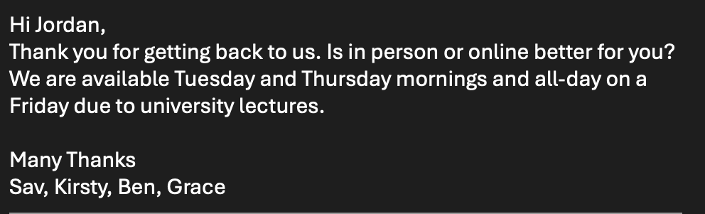
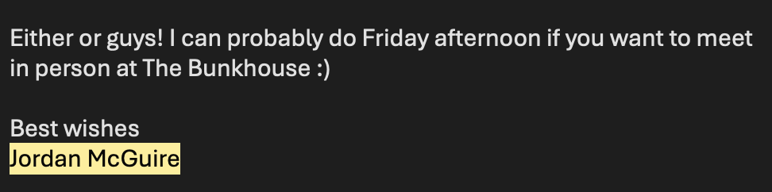



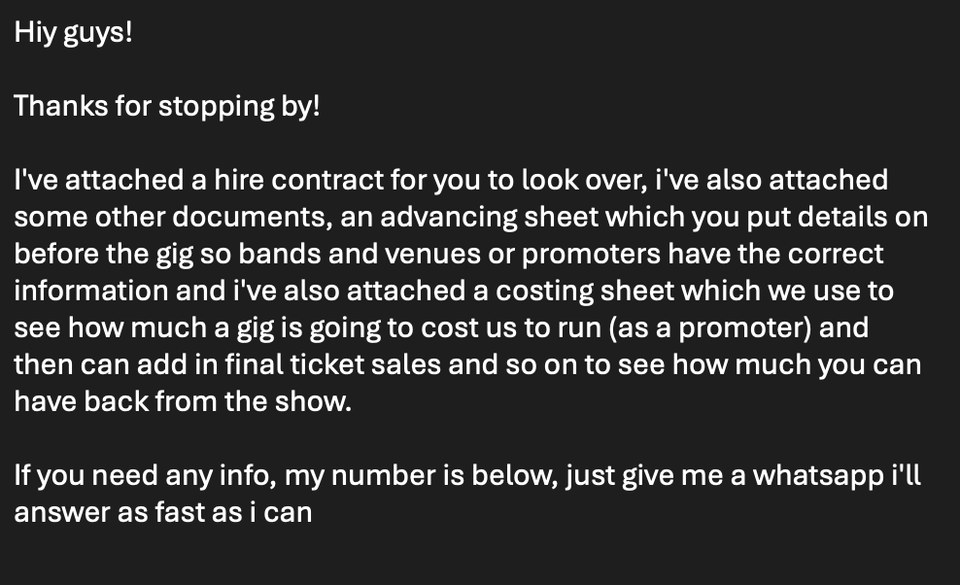


Marketing materials

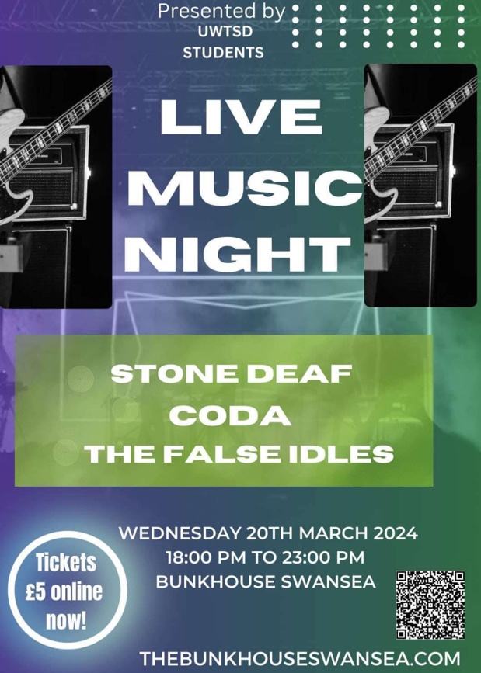

Documentation provided by bunkhouse.

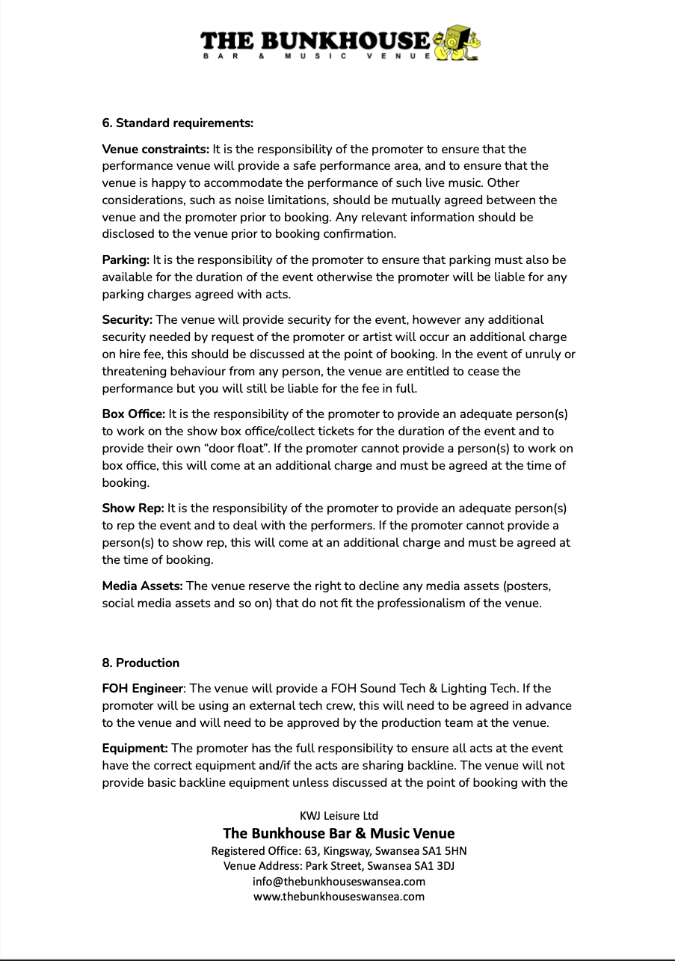
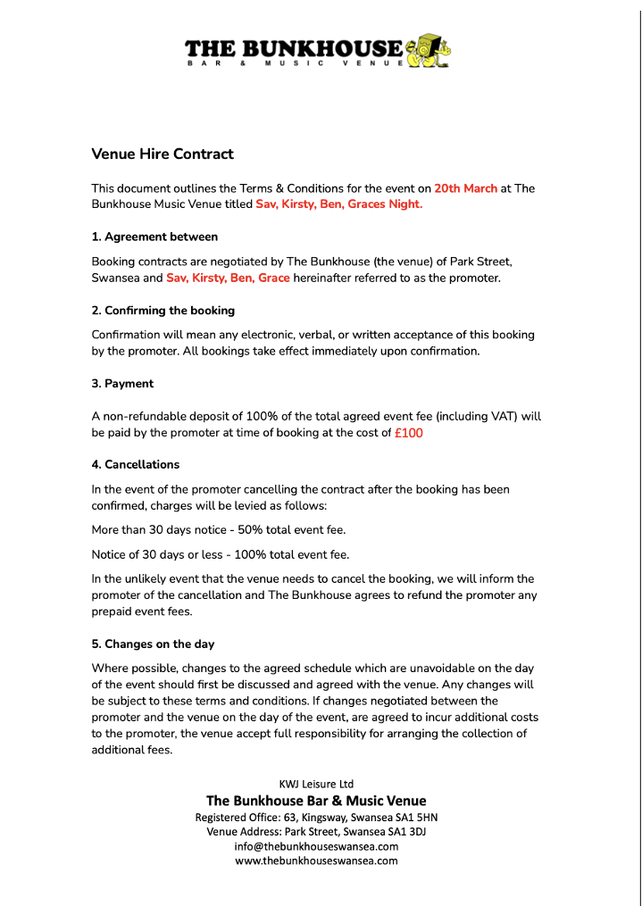
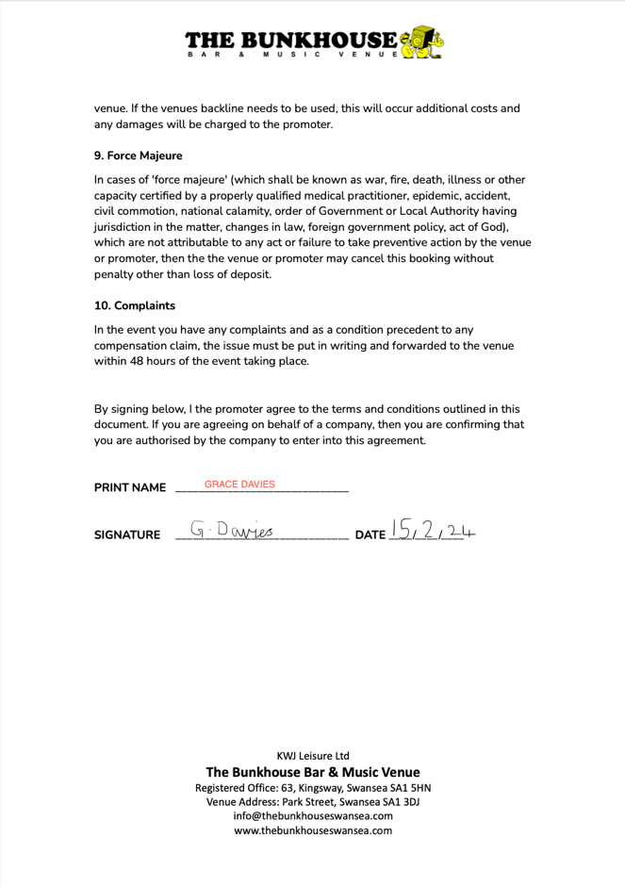

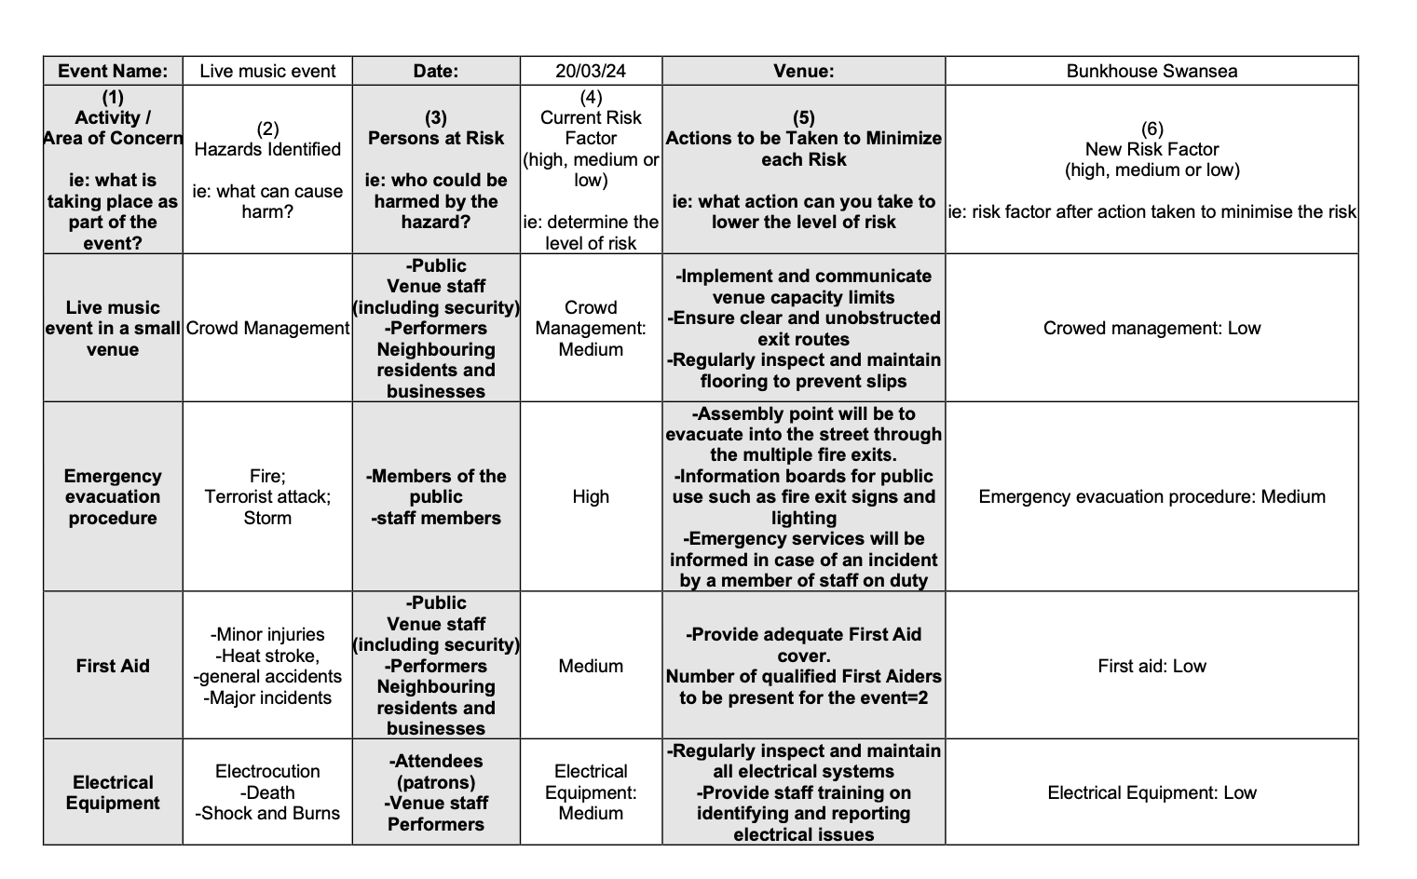
risk assessments.

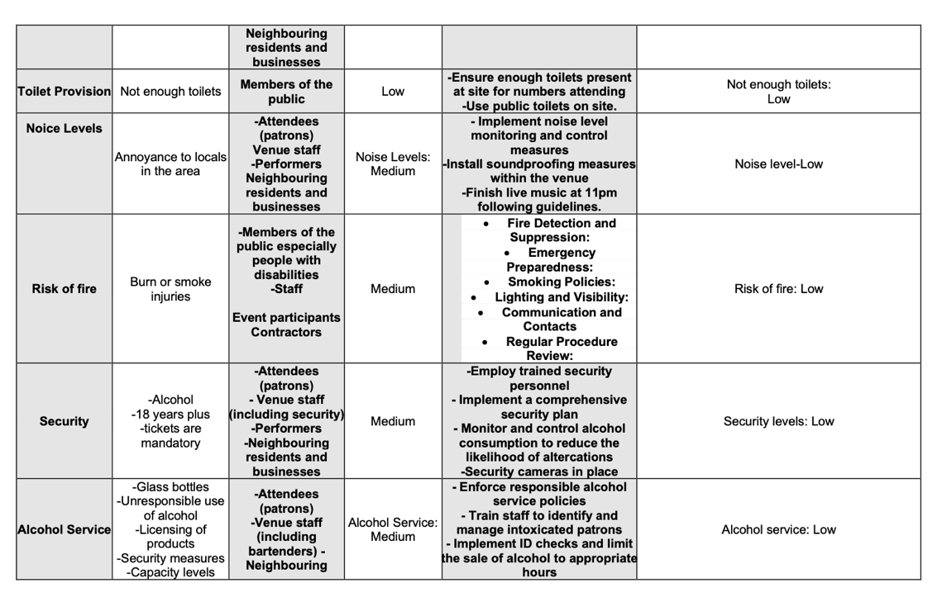

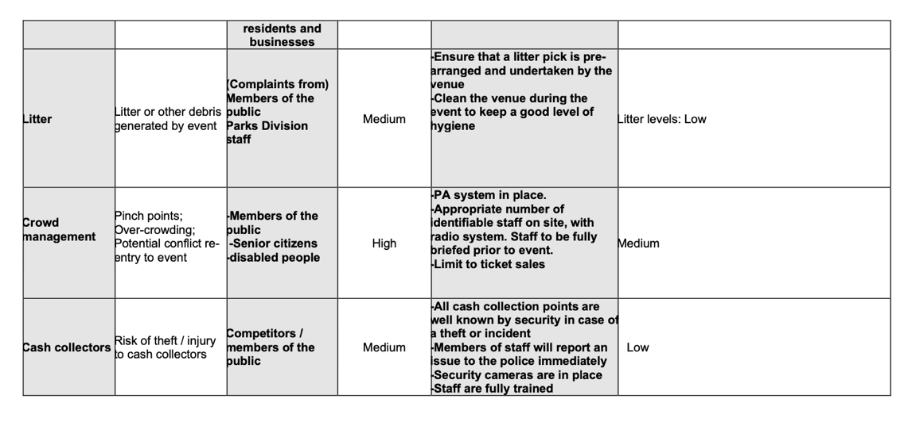

Bibliography

Belbin, R, M. (2010) Management Teams why they succeed or fail. (3rd ed.). Butterworth-Heinemann. (accessed: 21/03/2024).

Croner-I (2021) Don’t spoil the party: risk assessment in event management. Available at: https://app.croneri.co.uk/feature-articles/don-t-spoil-party-risk-assessment-event-management (accessed: 21/03/2024).

Duncan and Toplis (2023) Benefits of social media marketing. Available at: https://duncantoplis.co.uk/news/benefits-of-social-media-marketing/ (accessed: 22/03/2024).

Greenheld, J (2015) Indie Rock Target Audience. Available at: https://prezi.com/iicqoofdj6zd/indie-rock-target-audience/#:~:text=Target%20audience-,Social%20demographic,you%20have%20a%20favourite%20artist%3F&text=What%20are%20maps%20and%20why%20are%20they%20useful%3F (accessed: 21/03/2024).

Hospitality law (2024) Pubs, bars & restaurants – keep the volume down on your Summer events. Available at: https://www.hospitalitylaw.co.uk/pubs-bars-restaurants-keep-the-volume-down-on-your-summer-events/#:~:text=The%20Live%20Music%20Act%202012,11pm%20to%20an%20unlimited%20audience (accessed: 21/03/2024).

Journal of Management Studies (2007) Belbin’s Team Role Model: Development, Validity and Application for Team Building. Available at: https://www.researchgate.net/publication/4771221_Belbin's_Team_Role_Model_Development_Validity_and_Applications_for_Team_Building (accessed: 21/03/2024).

Locations Direct (2024) Importance of Venue Selection in Events. Available at: https://www.locationsdirect.co/news/importance-of-venue-selection-in-event/ (accessed: 21/03/2024).

Needle, F. (2023) What is contingency planning? Available at: https://blog.hubspot.com/service/contingency-planning (accessed: 22/03/2024).

The Purple Guide (2023) Introduction. Available at: https://www.thepurpleguide.co.uk/index.php/the-purple-guide/78-introduction (accessed: 21/03/2024).

Zhou, L. (2024) Social Media Demographics: The Definitive Guide in 2024. Available at: https://www.luisazhou.com/blog/social-media-demographics/#:~:text=72%25%20of%20US%20adults%20use%20social%20media&text=Those%20between%20the%20ages%20of,84%25%20have%20an%20account). (accessed: 21/03/2024).

