Student Name: Rafeen Akram
Student Number: 2407472
Student Name: Rafeen Akram
Module Code: BMHP5023
Assignment: Case Study Report
Lecturer: Robert Nartowski

Table of Contents
a) Introduction: Understanding Asthma and Its Risk Factors 3
b) Structure of the Respiratory System 4
c) The Mechanical Respiration process 5
d) Gas Exchange in the Lungs 5
e) The way Irritants Enlarge and influence breathing. 6
g) Data Recording and Monitoring of the respiratory data 8
g) Lifestyle Lifestyle Evidence-Based Recommendations 8
h) Conclusion 9
References 10

a) Introduction: Understanding Asthma and Its Risk Factors
Asthma is a chronic inflammatory disorder that affects the airways of the lungs, making them swollen, narrow, and filled with mucus. Such inflammation causes difficulty in the free passage of air, leading to coughing, wheezing, chest tightness, and shortness of breath (Buist et al., 2006). Asthma is a changeable disease, i.e. its symptoms may vary with time or deteriorate abruptly in reaction to some stimuli. It is among the prevalent chronic diseases among the youth and may have a great effect on their physical and emotional health should it not be managed well.
During adolescence, control of asthma is usually harder due to the change in lifestyle and behavior. Teenagers will be more tempted to smoke, use vaping, spend time in the smoke in bars or clubs, or be exposed to other air pollutants and infections in overcrowded places. These exercises may aggravate the lungs and make it easier to get asthma attacks (Gibson and Powell, 2000). Lack of knowledge regarding the working mechanism of asthma and poor compliance with medications is another factor that leads to worsening control. Other risk factors involve contact with allergens such as pollen, dust mites and pet danger; cold or rainy weather; obesity; stress; and the family history of asthma. Certain symptoms can also be exacerbated by emotional stress and poor sleeping patterns. The encouraging aspect is that through adequate education and change in lifestyle, the majority of adolescents could control asthma and lead healthy lives. Knowing the functioning of the lungs and the way in which the process of asthma makes breathing difficult is an important initial step towards self-management.

b) Structure of the Respiratory System
The respiratory system brings oxygen to the body and eliminates the product of metabolism and carbon dioxide. It consists of two principal segments: the upper and lower respiratory tracts. The upper tract consists of the nose, mouth, pharynx, and larynx whereas the lower tract consists of the trachea, bronchi, bronchioles, and alveoli. Collectively, these buildings guarantee the movement of air to the lungs (Buist et al., 2006).
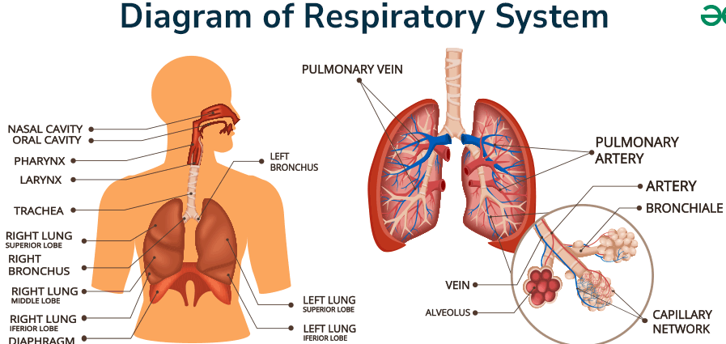
As we inhale, we get air in the form of air intake by the mouth or nose, which is channeled down the throat and the voice box into the windpipe. The trachea is split into two great bronchi which run to the two lungs (Gibson and Powell, 2000). These bronchi then divide into smaller
bronchioles within the lungs just the way the branches of a tree do. Clusters of alveoli (small air sacs containing networks of capillaries (very small blood vessels)) occur at the terminus of the bronchioles.
Oxygen and carbon dioxide exchange takes place in the alveoli. They are very thin walled where the gases can flow through the air and blood easily. The lungs are also spongy organs that are supported by ribs and coated by two-layered membranes known as pleura which permit free movement during breathing. A diaphragm is a dome-shaped muscle located at the bottom of the chest which is crucial as it contracts and relaxes to inhale air and expel it during the process of breathing.
In asthma, bronchi and bronchioles, airways of smaller sizes, play the most significant role in inflammation. Their walls become thicker, the muscles that surround them become tight, and there is the accumulation of mucus that is inside them. This blockage isolates airflow particularly during exhalation, causing the sensation of breathlessness experienced by patients of asthma conditions.

c) The Mechanical Respiration process
The physical process of breathing is known as mechanical respiration, and this helps in exchanging fresh air in the lungs and waste gases out of the body. It is divided into two major stages: inhalation (inspiration) and exhalation (expiration).
As a person inhales, the diaphragm shrinks and draws downwards, and the intercostal muscles that are located between the ribs raise the chest up and outwards. This contraction makes the chest cavity bigger, reducing the pressure of air within the lungs. Since air passes through high pressure to low pressure areas, it is sucked into the lungs via mouth and nose (Stoodley et al., 2019).
As one exhales, the diaphragm relaxes and shifts back to a dome's shape, and the ribs separate downwards. This causes the chest cavity to be smaller so that the pressure within the lungs is magnified forcing the air to exit. This is painless and easy in the normal lungs. In asthma, however, inflammation and narrowing of airways make it more difficult to expel the air, and air is trapped within the lungs and breathing becomes painful (Buist et al., 2006).
Mechanical respiration is essential as it supplies an incessant source of oxygen and an elimination of carbon dioxide so that the body cells can properly perform their functions. In case asthma interferes with this process, it may cause fatigue, dizziness, and decline physical performance.

d) Gas Exchange in the Lungs
The exchange of gases takes place in the alveoli -the minute-sized tubes of the respiratory tract. The alveoli walls are just a single cell thick and are immediately close to capillaries which transport deoxygenated blood supplied by the heart (Stoodley et al., 2019).
As air enters the alveoli, oxygen diffuses across their thin walls into the blood, and in the process, oxygen moves to an area where there is a greater concentration of oxygen (alveoli) to the area that has a lower concentration of oxygen (blood). Oxygen once in the blood is released to bind hemoglobin in red blood cells which are transported to the tissues around the body.
Meanwhile, the opposite happens to carbon dioxide, which is also produced by body cells as a waste. It is brought out of the blood, of which it is more concentrated, into the alveoli, in which it is exhaled. This process keeps the blood gas levels normal, providing energy to the body and avoiding accumulation of carbon dioxide.
Airways and obstructions of mucus make the airflow to the alveoli harder in individuals having asthma. This reduces the rate of exchange of gases and leads to low oxygen levels and shortness of breath. The imbalance can be dangerous in case of serious asthma attacks, which is the reason why it is crucial to control and monitor them (Gibson and Powell, 2000).

e) The way Irritants Enlarge and influence breathing.
The lungs of asthmatic people have very sensitive airways. The immune system reacts to the presence of irritants like smoke of cigarettes, vaping aerosols, air pollution, or even viral infections by releasing such inflammatory chemicals, including histamine, cytokines, and leukotrienes. These lead to the swelling of airways lining, constriction of the airways space, and excessive production of mucus (Grant et al., 2022).
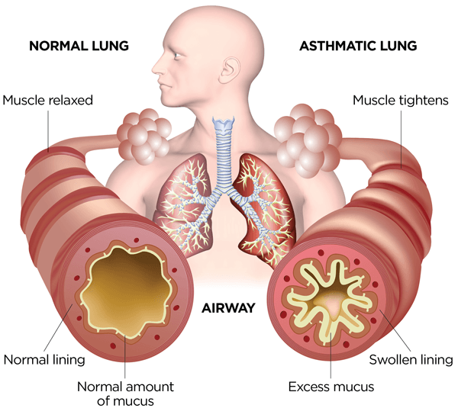

It is known as bronchial inflammation and results in bronchoconstriction or narrowing of smooth muscles surrounding the airways. The narrowing of the airway space causes the airflow to become more difficult and harder to breathe. That is why patients usually face greater difficulty with exhalation in which the airways constrict naturally (Stoodley et al., 2019).
In extreme situations, the inflammation coupled with the accumulation of mucus and tightening of the muscles may almost entirely block the airways leading to an asthma attack. Long term chronic inflammation may cause airway remodeling, whereby structural alterations result in a permanent decrease in the elasticity and an increase in the responsiveness of the lungs (Hmaid and Tulic, 2009). The greatest triggers of this inflammation are smoking and vaping. Cigarette smoke has more than 7,000 chemicals, most of which destroy cilia (hair-like structure) which clears off the mucus hence mucus is able to settle easily (Thomson, 2022). Nicotine and flavoring substances are present in vaping liquids also and may irritate the lungs. It has been demonstrated that adolescent vapers and smokers have more frequent and severe asthma symptoms (Gibson and Powell, 2000).
Likewise, due to contact with infections in enclosed areas, particularly the respiratory viruses such as influenza, there is inflammation and, in most cases, causes asthma attacks. This is an indication of interaction between external irritants and infections and asthma resulting in severe breathing complications.

g) Data Recording and Monitoring of the respiratory data
Asthma self-management requires one to monitor it regularly. One such device is the peak flow meter, a handheld device for this purpose that measures the speed with which one can blow away the air in their lungs. The reading, which is referred to as the Peak Expiratory Flow (PEF), reveals the airways openness or narrowness (Li et al., 2022).
Patients with asthma should be advised to do daily readings (preferably in the morning and evening) and write these numbers in a diary or a mobile application. Monitoring outcomes helps them to remove tendencies and notice the first signs of deteriorating asthma. As an example, when the reading falls below 80 per cent. Of what the person uses to have, it could be a sign of airway constriction or an asthma attack (Jaakkola et al., 2019).
Such monitoring will give the patients more power to respond promptly because they have an asthma action plan. They are able to make medication changes, prevent known triggers, or consult their doctor. Frequent monitoring also assists the health care providers in personalization of treatment during visits (Buist et al., 2006).
It has been found that daily peak flow measurement may be used to reduce hospitalization due to worsening symptoms spotted in the initial stages (Buist et al., 2006). It also makes the patient realize that lifestyle patterns such as smoking or even being exposed to pollution directly influence breathing. Readings should, however, be taken in a consistent and good technique to be reliable. The usefulness of the device requires correct and frequent use (Agache et al., 2021).

g) Lifestyle Evidence-Based Recommendations
Lifestyle management contributes significantly to a better lifestyle in asthma management and general health.
- The greatest measure is not to smoke and vape. The cigarettes smoke has harmful chemicals which irritate the lungs and worsen the symptoms of asthma. By quitting smoking, lung functions increase, inflammation decreases, and the number of attacks decreases (Thomson, 2022). Vaping can be perceived as less harmful, yet it has been proven that vapor of e-cigarettes can inflame airways as well as promote cough and wheezing.
- Most patients with asthma benefit from regular exercise. Swimming, walking, or cycling strengthens the lungs and increases endurance. It has been demonstrated that exercise positively impacts asthma and anxiety and boosts self-confidence (Jaakkola et al., 2019). But patients are advised to warm-up, take a reliever inhaler, exercise prior to a strenuous activity, should there be a necessity, and avoid exercising in cold or polluted air.
- Another important consideration is to maintain a healthy weight. Obesity causes inflammation of airways and places undue burden on lungs. It has been found that even a thin layer of weight loss can bring benefits to the breathing system and lessen medication intake (Stoodley et al., 2019). Diets that are high in fruits, vegetables and whole grains have antioxidants that preserve the lung tissues and lower sugary and processed foods to assist in weight management.
- It is also necessary for environmental control. Patients are advised to keep the contact with allergens to a minimum, washing bedding on a regular basis, vacuuming with HEPA filters, closing the windows during high-pollen days, and staying away from strong perfumes or cleaning sprays.
- Vaccinations are an important measure of prevention. Flu and pneumococcal vaccines help avoid infection annually which is one of the leading causes of asthma exacerbations. Viral infections can also be prevented by good hygiene, hand washing, and close contact with sick individuals (Sockrider and Fussner, 2020).
- Sleep and stress are not given due attention but important. Stress causes hormones that tighten airways whereas sleep deprivation suppresses the immune system. Mindfulness, yoga, and deep breathing are techniques that can help de-stress and enhance control of lungs (Jaakkola et al., 2019).
- Lastly, proper inhaler use and medication compliance are very vital. Lots of patients do not use inhalers properly, which minimizes the effects of medications. Frequent meetings with a nurse or a doctor will check the adequate utilization. Triggers, warning signs and correct use of inhalers educational programmers that educate teenagers on how to do it have been shown to increase confidence and lower emergency care.

h) Conclusion
With knowledge, education, and healthy living, asthma can be controlled as it is a chronic illness. During the age of adolescence, when lifestyle habits are developed, asthma understanding is even given more significance. The major worsening factors include smoking, vaping, and bad medication regimes. Education on the mechanism of the respiratory system and asthma and subsequent interference with breathing will enable patients to gain control. Irritants lead to inflammation and constriction and make it difficult to breathe, and oxygen supply remains limited, but proper monitoring through peak flow meters can allow seeing the early signs of changes and avoiding severe attacks. Uncomplicated yet effective lifestyle changes, including such practices as stopping smoking, staying physically active, keeping healthy weight, avoiding irritants, vaccination, and stress management, have been found to minimize symptoms and the number of visits to a hospital. Education, healthcare professionals, and self-monitoring could help adolescents develop long-term habits that would defend their lungs and enable them to live healthy and independent lives.

References
- Agache, I., Eguiluz‐Gracia, I., Cojanu, C., Laculiceanu, A., Del Giacco, S., Zemelka‐Wiacek, M., Kosowska, A., Akdis, C.A. and Jutel, M., 2021. Advances and highlights in asthma in 2021. Allergy, 76(11), pp.3390-3407.
- Buist, A.S., Vollmer, W.M., McBurnie, M.A. and Jenkins, C.R. (2006) A Randomized Clinical Trial of Peak Flow versus Symptom Monitoring in Asthma. Available at: https://www.ncbi.nlm.nih.gov/pmc/articles/PMC2648108/ (Accessed: 11 October 2025).
- Gibson, P.G. and Powell, H. (2000) Monitoring the Patient with Asthma: An Evidence-Based Approach. Journal of Allergy and Clinical Immunology. Available at: https://www.jacionline.org/article/S0091-6749%2800%2987372-8/fulltext (Accessed: 11 October 2025).
- Grant, T., Croce, E. and Matsui, E.C., 2022. Asthma and the social determinants of health. Annals of Allergy, Asthma & Immunology, 128(1), pp.5-11.
- Hamid, Q. and Tulic, M., 2009. Immunobiology of asthma. Annual review of physiology, 71(1), pp.489-507.
- Jaakkola, J.J.K., et al. (2019) Regular Exercise Improves Asthma Control: A Randomized Controlled Trial. Scientific Reports. Available at: https://www.nature.com/articles/s41598-019-48484-8 (Accessed: 11 October 2025).
- Li, X., Zhang, Y., Zhang, R., Chen, F., Shao, L. and Zhang, L., 2022. Association between e-cigarettes and asthma in adolescents: a systematic review and meta-analysis. American journal of preventive medicine, 62(6), pp.953-960.
- Sockrider, M. and Fussner, L., 2020. What is asthma?. American journal of respiratory and critical care medicine, 202(9), pp.P25-P26.
- Stoodley, I., et al. (2019) Evidence for Lifestyle Interventions in Asthma: A Systematic Review. BMC Pulmonary Medicine. Available at: https://www.ncbi.nlm.nih.gov/pmc/articles/PMC6876140/ (Accessed: 11 October 2025).
- Thomson, N.C. (2022) Cigarette Smoking and Asthma: Pathophysiology and Management. The Lancet Respiratory Medicine. Available at: https://www.sciencedirect.com/science/article/pii/S2213219822004780 (Accessed: 11 October 2025).

