Programme: Master of Business Administration

Module: Marketing Management

Student Name: Shreman Bhushanbhai Mankad

Student No. 2537843

Professor Name: Taonga Kaonga

Module code: LCMB7024

SUSTAINABLE BRAND EXTENSION AND MARKETING STRATEGY FOR NUDIE FOODS
TABLE OF CONTENTS
Element 1: Sustainable Brand Extension Poster 3
Introduction 3
The Extension 3
Why Now? 3
Sustainability Alignment 4
Element 2: STDP Analysis 5
2.1 Segmentation 5
2.2 Target Audience 6
2.3 Differentiation 7
2.4 Positioning 7
Element 3: Marketing Mix (4Ps) 8
3.1 Product 8
3.2 Price 8
3.3 Place 9
3.4 Promotion 9
Element 4: Reflection 11
Description 11
Feeling 11
Evaluation 11
Analysis 11
Action Table 12
Conclusion 12
Reference List 13

Element 1: Sustainable Brand Extension Poster
Brand Extension Proposal: Nudie Kids NourishSip- A plant-based, functional hydration range for children aged 2-10

Introduction
Nudie Foods is Australia’s leading chilled juice brand, established in 2003 with headquarters in Eastgardens, NSW and 100% free from concentrates, preservatives and artificial additives (Nudie, 2024). Since 2014, under the ownership of Monde Nissin (Philippines) (Australian Beverages, 2025), and with the vision to “create good” by making food and beverage choices with honesty.

Figure 1: Nudie Foods
(Source: Nudie, 2024)

The Extension
NourishSip Kids Range is a line of fully compostable 180ml cartons of low-sugar, fortified fruit and vegetable blends. For school canteen, lunchboxes, and on-the-go.

Why Now?
Market Demand
- Approximately 64% of parents select products with additional vitamins and minerals, while nearly 72% prefer beverages with less sugar (Global Growth Insights, 2026)
- Sustainable packaging is now a top-3 purchase driver in FMCG
- The juice segment is predicted to maintain a CAGR of 4.2% through 2034, while the kids’ beverages sub-segment expanded at a CAGR of 8.3% between 2019 and 2025 (Dataintelo and More, 2025).
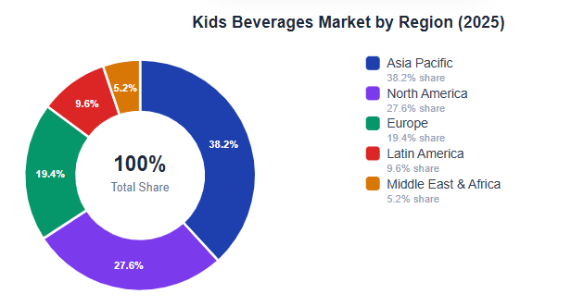
Figure 2: Kids Beverage Market
(Source: Dataintelo and More, 2025)

Sustainability Alignment
SDG 3: Good health and wellbeing- no added sugar, vitamin-fortified
SDG 12: Responsible consumption- 100% compostable cartons
SDG 13: Climate action - reduced carbon footprint vs. plastic bottles
Investor & customer value proposition
NourishSip has secured Nudie’s dominant position in a new adjacent, rapidly expanding retail segment - without cannibalisation of the adult product. It must meet the UN SDGs 3, 12 and 13, and it has to meet the investor ESG requirements and the conscious parent market. With Nudie’s brand dominance and trust, NourishSip taps into a new adjacent, high-growth category of children’s beverages ($200.95 billion in 2024) (Zion Market Research, 2024), which is expected to be significantly less cannibalised by the existing adult juice category. Transparency in labelling and verification of sustainability and school-friendly nutrition is on trend and in response to parental demand.

Element 2: STDP Analysis

2.1 Segmentation
Effective market segmentation enables companies to target different consumer segments more accurately (OLANIPON et al., 2025). The NourishSip extension is analysed based on four segmentation variables:
Geographic
The main target market consists of the metro and inner suburbs of Australia, with a population income level above the national average, and the highest density of primary schools and supermarket chains (Woolworths and Coles). The market for fruit and vegetable juice was estimated to be worth USD 295.49 billion in 2024 and is projected to increase at a compound annual growth rate (CAGR) of 6.3% from 2025 to 2033, reaching USD 512.81 billion (Grandviewresearch, 2026), indicating a structurally large market that the children’s functional sub-segment can be carved out of.
Demographic
The main target market is parents, primarily mothers (aged 28-45) who have children between 2 and 10 years of age, and who have a dual income of AU$47,900+ per year. The data from the Australian Bureau of Statistics (2023) indicate that the early childhood window of opportunity is key for NourishSip to successfully shift soft drink consumption, with only 3.9% of children aged 2–4 consuming soft drinks, and a much higher proportion (32.2%) for those aged 12–17.
Psychographic
Three clusters emerge. These are the preferences of The Conscious Parent, The Convenience-Driven Parent, and The Eco-Activist Parent. Indeed, 73% of consumers consider recyclable packaging an “essential” or “nice to have” when buying products (Sustainability Online 2025), and purchasing with sustainability and convenience in mind is a crucial paradigm shift — and a fact, packaging is the No.1 differentiator factor for consumers.
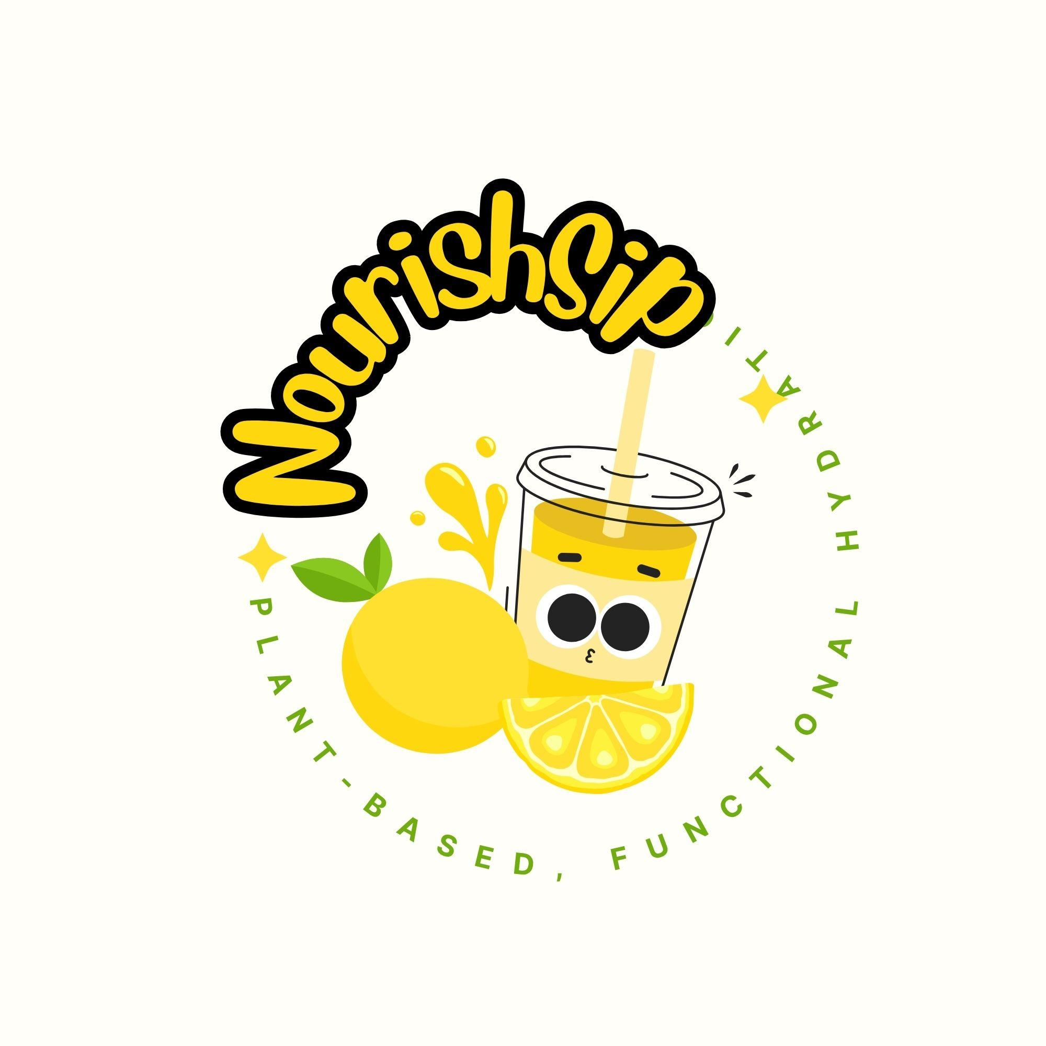
Figure 3: Nudie Kids NourishSip
(Source: Self-Created)
Behavioural
Talati et al. (2024) examined beverage choices among 1,611 Australian children and parents and identified that beverage choices were most strongly driven by the parent’s beverage consumption pattern compared to views and preferences of children on their drinks. The results showed that parents were an important factor in influencing dietary habits and food choices in home settings. Thus, the target audience for marketing NourishSip will focus mainly on parents, especially those who are health-conscious, nutrition-oriented and are concerned with sustainability when choosing food and beverage products for their kids.

2.2 Target Audience
NourishSip goes for a concentrated targeting strategy, targeting the Conscious Parent. Rising parents’ demand for nutritious, functional and clean-label foods and beverages will fuel At a CAGR of 6.3%, the global market for children’s food and beverages is projected to increase from USD 148.2 billion in 2025 to USD 273.6 billion by 2035 (Future Market Insights, 2025) led by millennials and younger parents who value and act upon health-conscious attitudes, and are pushing for convenience in their beverage choices. NourishSip’s 180ml compostable lunchbox format has been crafted to appeal to the secondary Convenience-Driven Parent with its school canteen placement.

2.3 Differentiation
NourishSip differentiates on three interdependent pillars:
Pillar | NourishSip Offer | Competitor Gap
Functional Nutrition | Vitamin C, D and Iron, as well as no added sugar | Golden Circle and Berri are largely unfortified
Verified Sustainability | 100% compostable carton | Competitors depend on conventional plastic
Brand Equity | Nudie's #1 chilled juice retail position | No challenger brand holds the same trust
Table 1: Three interdependent pillars
(Source: Self-created)
Many Australian consumers are increasingly interested in sustainable packaging, creating a significant opportunity for brands to make their sustainability efforts known to consumers. The study found that 70% of consumers think about sustainable packaging when they shop for it, and 20% are more loyal to brands that include biodegradable or recyclable materials. Apart from the environmental advantage, NourishSip designees who use fully compostable cartons in their workplace have a distinct competitive edge in the children's beverage industry. Ensuring sustainability also drives brand differentiation from competition, increases trust and fosters lasting consumer loyalty of environment-conscious parents.

2.4 Positioning
Sitting on the nexus of functional kids’ nutrition and authentic sustainability, NourishSip is positioned as “Australia’s first school-trusted planet-kind kids’ juice”. The AU$1.50–AU$1.70 per 180ml unit is a premium price that’s good value for money given the functional ingredients and sustainability aspects. The personality, using the Brand Identity Prism by Kapferer (Nasiri et al., 2025), is warm, honest and purposeful, which is consistent with the parent brand of Nudie. Two-thirds of Australians place value on nutrition, which is more important than anything else (excluding taste and price) in their food, and almost half believe that sustainable food is a major consideration when they purchase food.

Element 3: Marketing Mix (4Ps)
The 4Ps model by McCarthy (1960) is a framework that offers operational scaffolding to help implement the brand’s strategy in the market (Jirayuwattana and Pomsuwan, 2026). For NourishSip, every P is a touch and pivot that must be critically aligned both to Nudie’s sustainable brand identity and the behaviours of the conscious Australian parent consumer.

3.1 Product
NourishSip, a low-sugar, vitamin-fortified fruit and vegetable juice in a fully compostable carton for kids aged 2-10. NourishSip builds on Nudie’s underlying brand equity and functional differentiation, using Vitamin C, Vitamin D and Iron fortification, which address the key nutrient deficiencies seen in Australian primary school-aged children. The product strategy is based on the principle of brand extension theory (Deng and Messinger, 2021, which states that an extended brand product should build on parent brand associations and be in a neighbouring but meaningful category. The 180ml single-serve compostable carton is designed to be “lunchbox size” for everyday snacking during the school day. Packaging is one of the most critical product attributes; over half (51%) of Australian shoppers (Atto, 2023) consider sustainability a key factor when buying products at retail stores, making compostable packaging a product attribute, not cosmetic CSR. Four SKUs are expected to be launched: Apple & Carrot, Mango & Pineapple, Strawberry & Beetroot, Orange & Sweet Potato – a mix of kids’ favourites and hidden vegetable goodness.

3.2 Price
NourishSip’s value-based pricing strategy (Andriania et al., 2025) is grounded in the health and sustainability value rather than the cost-plus approach. NourishSip is priced at AU$0.96–AU$1.07 per carton, which puts it above conventional juice poppers (AU$0.27–AU$0.43) but below premium imported kids’ drinks. This is an observation that premiumisation has been the primary source of revenue and margin growth in FMCG innovation – with the caveat that sub-branding has to be used properly to avoid cannibalisation of the parent brand.
Format | RRP | Retail Channel
6-packk multipack | AU$ 11.99 | Stores
Single 180 ml carton | AU$ 2.00 | School canteen
10-pack value multipack | AU$ 17.99 | Online
Table 2: Pricing Format
(Source: Self-created)

However, with the current cost of living climate in Australia, price sensitivity is also a significant concern, especially with FMCG inflation in Australia at 3.5% in 2024 (Consult Group, 2024). Yet despite all of these pressures, consumers are willing to pay a higher price for a product if it seems to impact their health and their environment directly and significantly. We sell our NourishSip by value with a 6 pack sale at AU$6.40 or approx. AU$1.06 per serve. The price spectrum targets the “conscious premium” appeal offering access to product for the “double income household” and the coupled nutritional strength based on the fortified product and compostable packaging fibre. The strategy is affordable, profitable and competitive.

3.3 Place
Distribution is based on the omnichannel retail strategy (Zhang et al., 2025), with the existing #1 distribution chilled juice position in grocery retail. The primary point of placement will be in the “children” beverage area (as opposed to adult beverage) within the chilled beverage aisle of Woolworths and Coles, which represent over 67% of the grocery store market share in Australia (ACCC, 2025).
Secondary channels include:
- Modern practices in school canteens: A high credibility placement signal, which reinforces the positioning of “school trusted” and speeds up the trial momentum for the target consumption occasion.
- Pharmacy and health retail (Chemist Warehouse, Priceline): Walks with parents, purchasing child nutrition products.
- Online DTC: 10-packs are available at Nudie's website and Amazon AU for regulars
According to 72% of Australian marketers, digital and electronic commerce must be launched together with traditional (physical) retail and over the next several years will redistribute their marketing resources primarily to Digital Channels, Digital/e-commerce will be the new marketing channel (Whitting, 2023).

3.4 Promotion
The promotion strategy of the NourishSip practice is built on the principles of a consistent and coordinated message presentation across various communication channels, as expressed by the Integrated Marketing Communications (IMC) concept (Goldmanová, 2025). The strategy is a combination of paid, owned and earned media that effectively serves the primary target user of its service: Conscious Parent itself. These digital tactics all contribute to the brand's mission of health, nutrition, and sustainability. Having a consistent image with one another, NourishSip can generate awareness, drive credibility, spur product trial, and cultivate customer loyalty.
Channel | Activity | Objective
Instagram and Facebook Meta ads | Targeted ads to the parents who are around 28-45 | Awarness
Influencer marketing | Almost 15-20 micro-influencers who have around 50K to 200K followers | Authenticity and reach
In-store activation | Everyday rewards, shelf talkers and end-cap displays | Purchase conversion
School canteen sampling program | Some free sample launches across 200 metro primary schools | Placement and Trial
PR, Digital content and SEO | Blog, some parenting media pitching, nutrition endorsement | Loyalty, retention and credibility
Table 3: Promotion Strategy
(Source: Self-created)
The key message in all channels is one that is a testable proposition: “Real fruit. Real veg. Nothing your kids don’t need”. It is a direct response to Nudie’s parent brand tone with a child-specific functional layer.

Element 4: Reflection
For writing this reflection part, I am using Gibbs’ Reflective Cycle (Praveena et al., 2025). The following phases make up the cycle.

Description
In this assignment, I created a sustainable brand extension strategy for Nudie Foods by suggesting a new line of the brand: ‘NourishSip’, a plant-based functional beverage for kids. I also created a poster presentation which included STDP analysis and the marketing mix to highlight the market potential and sustainability benefits of the extension.

Feeling
I felt that I had a lot of confidence about this project because I had a basic knowledge of the marketing principles. But I also felt the challenge of implementing sustainability-ambitions, consumers' needs and business-related targets in a realistic manner. The critical thinking and evaluation of selecting market data and applying the marketing frameworks, such as STDP and the 4Ps were important aspects of the considerations. As the project developed, I felt increasingly competent in my knowledge and understanding of the importance and potential for evidence-based research to support strategic thinking and effective marketing proposal that is align with current sustainability trends.

Evaluation
One of the areas where my work was strong was bringing sustainability into the mix with business goals. Has managed to connect consumer trends, environmental and brand equity to form a realistic market opportunity. However, it was difficult to fit in all the research into such an attractive poster, and I was also struggling to remember to include enough detail in the presentation.

Analysis
This project was crucial to understand the concept of sustainable marketing and brand extension techniques in a competitive FMCG sector. I also learned hands-on how to use marketing frameworks like STDP and the 4Ps in support of strategic decisions through the development of NourishSip. In addition, the project improved my ability to analyze consumer behavior, how issues around sustainability would develop and how market opportunities would come about when I was launching a new product idea. In addition, I understood how crucial it was to making sound decisions based on evidence, with the application of market research and industry data making my recommendations more credible, thus strengthening the credibility of my strategy and marketing mix in every decision I made. The knowledge I gained will help me to practice marketing in the future.

Action Table
SMART Element | Action
Specific | Strengthen some competitor analysis and provide design skills in the presentation
Measurable | Complete almost two design courses and a professional meeting course
Achievable | Organise almost 2 hours every week for practice and learning
Relevant | Need to support some future marketing strategy as well as presentation projects
Time bound | Need to complete all the tasks within 3 months
Table 4: SMART Action Plan
(Source: Self-created)

Conclusion
This experience enhanced my research, analytical and communication skills and boosted my confidence in creating sustainable marketing strategies. The project has helped me gain academically and has made me more prepared for future marketing career opportunities.

Reference List
ACCC (2025). Supermarkets Inquiry Final Report. [online] Available at: https://www.accc.gov.au/system/files/supermarkets-inquiry_1.pdf [Accessed 6 Jun. 2026].
Andriania, L., Anitasarib, R., Putic, H.M., Rohimatd, M. and Yuliantie, A., 2025. Pricing Strategy And Value Based Marketing: Strategi Harga Dan Persepsi Nilai Konsumen. Jurnal Ilmu Manajemen dan Pendidikan| E-ISSN: 3062-7788, 2(3), pp.1108-1113. Available at: https://jurnal.kopusindo.com/index.php/jimp/article/download/1452/1258 [Accessed 6 Jun. 2026].
Atto, S. (2023). Sustainability attitudes and behaviours of Australian shoppers – Monash Lens. [online] Monash Lens. Available at: https://lens.monash.edu/sustainability-attitudes-and-behaviours-of-australian-shoppers/ [Accessed 6 Jun. 2026]..
Australian Beverages. (2025). Monde Nissin (Aust) Pty Ltd (Nudie) - Australian Beverages. [online] Available at: https://www.australianbeverages.org/member/monde-nissin/ [Accessed 6 Jun. 2026].
Consult Group (2024). Top FMCG statistics you need to know for 2025 - Consult Group. [online] Consult Group. Available at: https://consultgroup.co/top-fmcg-statistics-you-need-to-know-for-2025/ [Accessed 6 Jun. 2026]..
Dataintelo and More, A.B. (2025). Kids Beverages Market Research Report 2034. [online] Dataintelo.com. Available at: https://dataintelo.com/report/kids-beverages-market [Accessed 6 Jun. 2026].
Deng, Q.C. and Messinger, P.R. (2021). Dimensions of brand-extension fit. International Journal of Research in Marketing, [online] 39(3). doi:https://doi.org/10.1016/j.ijresmar.2021.09.013 [Accessed 6 Jun. 2026]..
Future Market Insights (2025). Kids’ Food and Beverages Market. [online] www.futuremarketinsights.com. Available at: https://www.futuremarketinsights.com/reports/kids-food-and-beverages-market [Accessed 6 Jun. 2026].
Global Growth Insights (2026). Kids Beverages Market Trends | Forecast & Strategic Outlook. [online] Globalgrowthinsights.com. Available at: https://www.globalgrowthinsights.com/market-reports/kids-beverages-market-127361 [Accessed 6 Jun. 2026].
Goldmanová, V., 2025. Integrated marketing communication, synergy: a systematic literature review. Studia Commercialia Bratislavensia, 18(63). Available at: https://scb.euba.sk/archiv_scb/scb0225_vfinal.pdf#page=19 [Accessed 6 Jun. 2026].
Grandviewresearch (2026). Global Fruit and Vegetable Juice Market Research Report, 2018-2025. [online] www.grandviewresearch.com. Available at: https://www.grandviewresearch.com/industry-analysis/fruit-vegetable-juice-market [Accessed 6 Jun. 2026].
Jirayuwattana, N. and Pomsuwan, S., 2026, March. THE STUDY OF MARKETING MIXES (4Ps), CUSTOMER SERVICE AND PRODUCT QUALITY FACTORS TOWARD PURCHASE INTENTION IN STREAMING PLATFORM IN BANGKOK. In Proceedings National & International Conference (Vol. 21, No. 1, p. 329). Available at: http://journalgrad.ssru.ac.th/index.php/8thconference/article/view/5847/4422 [Accessed 6 Jun. 2026].
Nasiri, A., Richards Carpenter, N. and Ghasemi, M., 2025, June. Applicability of Kapferer’s brand identity prism to SMEs. In 3rd National Conference on Modern Management and Startups. Available at: https://repository.londonmet.ac.uk/10820/1/Applicability%20of%20Kapferer%E2%80%99s%20Brand%20Identity%20Prism%20to%20SMEs.pdf [Accessed 6 Jun. 2026].
Nudie (2024). about us | nudie, creators of good. [online] nudie - nothing but fruit. Available at: https://www.nudie.com.au/our-story/ [Accessed 6 Jun. 2026].
OLANIPON, O.O., EMEGWARA, C.P., OGUNRO, O.V., OLOKOR, C. and WILLIAM, V.T., 2025. MARKET SEGMENTATION AND TARGET MARKET ANALYSIS ON THE NEW PRODUCT LAUNCH IN EKITI STATE. FUOYE Journal of Management, Innovation and Entrepreneurship, 4(1), pp.72-89. Available at: https://fjmie.fuoye.edu.ng/index.php/public_html/article/download/110/103 [Accessed 6 Jun. 2026].
Praveena, K.S., Juslin F, Patil, C.M. and Bhargavi K (2025). Using Gibb’s Reflective Model Approach for Enhancing Project-Based Learning Among Students Through Reflective Assessment. Journal of Engineering Education Transformations, [online] 38(2), pp.148–155. Available at: https://journaleet.in/index.php/jeet/article/view/2071 [Accessed 6 Jun. 2026].
Sustainability Online (2025). 73% of consumers consider recyclable packaging an important purchase decision - Sustainability Online. [online] Sustainability Online - A business news platform with a sustainable focus. Featuring the latest sustainability news and ESG insight, viewed through a business lens. Available at: https://sustainabilityonline.net/news/73-of-consumers-consider-recyclable-packaging-an-important-purchase-decision/ [Accessed 6 Jun. 2026].
Talati, Z., Charlesworth, J., Mackenzie, K., McAlpine, T., Myers, G., Miller, C., Dana, L.M., O’Connor, M., Mullan, B.A. and Dixon, H.G. (2024). Exploring Sugary Drink Consumption and Perceptions among Primary-School-Aged Children and Parents in Australia. Nutrients, [online] 16(19), pp.3320–3320. doi:https://doi.org/10.3390/nu16193320 [Accessed 6 Jun. 2026].
Whitting, E. (2023). The 7 Marketing Priorities for FMCG Brands in 2023. [online] Miller Leith. Available at: https://www.millerleith.com.au/the-7-marketing-priorities-for-fmcg-brands-in-2023/ [Accessed 6 Jun. 2026].
Zhang, L., Wu, L., Huang, L. and Zhang, Y., 2025. Wield the power of omni-channel retailing strategy: a capability and supply chain resilience perspective. Journal of Strategic Marketing, 33(3), pp.416-440. Available at: https://www.tandfonline.com/doi/pdf/10.1080/0965254X.2021.1972440 [Accessed 6 Jun. 2026].
Zion Market Research (2024). Children’s Beverages Market Size, Share, Growth, Demand, Trends 2030. [online] Zion Market Research. Available at: https://www.zionmarketresearch.com/report/childrens-beverages-market [Accessed 6 Jun. 2026].

