Module: Digital Skills and Research Methods
"The impact of Virtual Learning Environment-Moodle on students learning experience at the University of Wales Trinity Saint David London Campus”

Student: Sorin Petrut Marica
Student ID: 2014041

Table of Contents
Introduction 3
Rationale 4
Objectives 4
Literature Review 5
Methodology 6
Primary Data Analysis 7
Secondary Data Analysis 13
Conclusion 14
References 15
Appendix 17
Class activities 19

Introduction
The virtual learning environment (VLE) is an online-based platform for the digital aspect of courses to study, mostly used by educational institutions. This virtual learning environment has brought dramatic changes in the field of education because it has created opportunities for students to attend classes regularly and learn new things by staying at their home (Keller, 2016). Due to the current pandemic situation, it is noticed that the virtual learning platform is highly used by the educational institution to continue their classes. This research will be highly focused that whether the students think that these learning environments are effective for them or not. For this reason, this research has been conducted on the students of UWTSD who are currently continuing their classes in this online platform.

Rationale
In the educational institution, the concept of Virtual learning is not a new concept but the use of this platform has been raised during this pandemic situation. The government regulations and safety measures have made the use of this online learning platform a worthy and timely solution for the students and teachers. But there are some positive and negatives impacts of this virtual platform on the learning methods of students (Chen and Kinshuk, 2020). This research study will be a significant one because students will be able to share and evaluate their online learning experiences and the authority of the University will be able to know about the opinions of students for more improvements in their virtual education system.

Objectives
This study has both primary & secondary objectives. The primary objective of the study is to evaluate the impact of the virtual learning environment among the current students of the University of Wales Trinity Saint David, London Campus. And the secondary objectives are:
- To know about online learning experiences of students.
- To know about the problems the students face during their online classes.
- To know about the benefits that students get by continuing online classes.
- To know about the effectiveness of learning through the virtual platform.

Literature Review
Digital technology has introduced a new environment for learning in educational institutions which are called the virtual learning environment (Mort, 2015). The virtual learning environment has been experiencing a very upward trend in this pandemic situation, because social distancing, as a part of safety measures, is made compulsory by the governments of every country in the world (Chen and Kinshuk, 2020).
According to (Weiss and Trifonas, 2016), The use of digital technology in the educational sectors was first observed in the late 19th century, when several universities in the United Kingdom has started to introduce new and different ways of learning environments for the students of University. Earlier, this online-based platform was used to take classes of senior students but now it is used for the students of every class.
Although, Online learning platform is in practice for a long period the effect of this environment on student's learning process is a subject matter of research for several scholars and educationists. The learning experiences of students are an aggregation of several activities that are conducted under any learning platforms if it is traditional or digital (Dieker and Hardin, 2014). Both positive and negative impact of online learning platform has been observed by several articles, books, and other materials.
The positive impact of VLE:
A virtual learning environment has been arranged with the prime objective of enabling online education services for both teachers and students with the help of the internet. This learning environment has many positive impacts on the learning experiences of University students like the flexibility of attending the class, it increases the facilities of communication among teachers and students, it provides effective time management facilities, it ensures real-time learning, etc. (Hay and Drago, 2017). Moreover, the introverted students, now, are being comfortable and more involved in this learning environment and also share their opinions compared to the face-to-face classes that happened in educational institutions (Keller, 2016).

Negative impacts of VLE:
According to (Annetta and Klesath, 2017), The E-learning environment has negative effects on learning experiences of the students such as students does not concentrate on the lectures properly and the teacher is unable to monitor these situations, students are not attending their classes regularly, and also are not present in time, etc. According to the study of (Dyson and Campello, 2018), it is observed that only 57% of students are reading the study material which is provided in the VLE, only 52% of students are downloading links provided in the online platform but it is a shocking matter that only 14% of students are going into the links that have been attached in the Google classroom for the advanced learning. There are some other cases too, where the students are not being able to attend the classes regularly due to poor network connection or lack of technical knowledge (Tobarra and Caminero, 2017).

Methodology
For conducting a research study, the research design, the research philosophy, data collection methods are discussed in detail in this part of the Methodology.
Research Design: The research design that will be used in this study is the “Exploratory” research design of Virtual learning environment because this design will help to have detail and correct information regarding any specific research topic. It helps to work on the objectives of the research for getting the fruitful conclusion of the research study (Goddard and Melville, 2014).
Research Philosophy: The research philosophy that has been chosen for this study is “Positivism”. This philosophy helps get the exact and realistic information regarding any subject matter while conducting a study (Gomm, 2016).
Data Collection Method: The data of this research will be collected from both primary and secondary sources. For this research, Primary data will be collected from the students of UWTSD of London campus. On the other hand, secondary data will be collected from the previous articles, books, a journal that was published regarding the related subject matter of research. Both the Quantitative & Qualitative approach will be applied in conducting this research.
The quantitative approach will be used for the analysis of primary data and the qualitative approach will be used for the analysis of secondary data which will make the research study more logical for all types of researchers (Goddard and Melville, 2014). There are more than a thousand students in the UWTSD, London Campus; the sample size that has been taken for this study is 20 students because this study will be based on non-probability sampling.

Primary Data Analysis
For collecting primary data, a questionnaire has been prepared and collects responses from the students through the online method. This questionnaire contains 10 questions. The sample size of this survey was 20 students. The summary of the responses to each question are shown through the pie-chart below:
Q.1
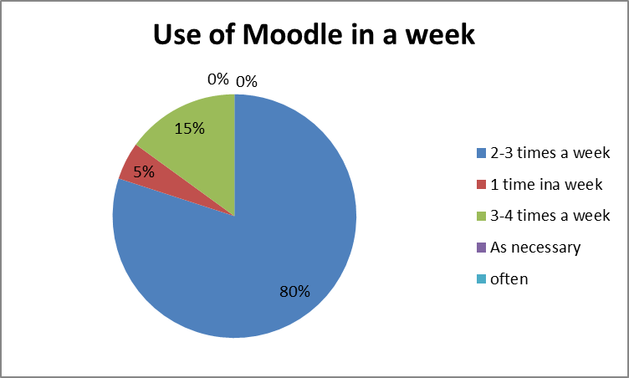
Fig 1: Use of Moodle in a week
Analysis: It is seen that 80% of students use moodle 2-3 times in a week, whereas 15% use moodle 3-4 times in a week and 5% use moodle 1 time in a week. So, it can be said that most of the students of UWSTD are using moodle 2-3 times a week.

Q2.
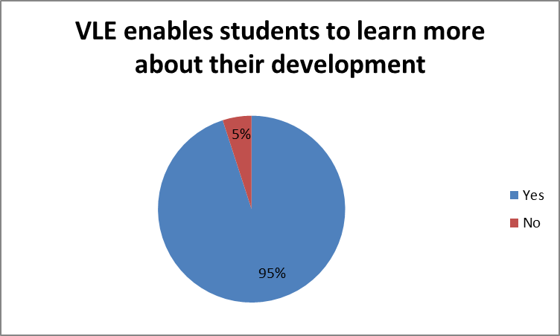
Fig 2: VLE enables the student to learn more about their development
Analysis: In the above pie-chart, it is observed that 95% of students think that a Virtual learning environment helps them to learn more about their development. And, 5% of students opine that VLE doesn't enable them to learn about their development.
Q3.
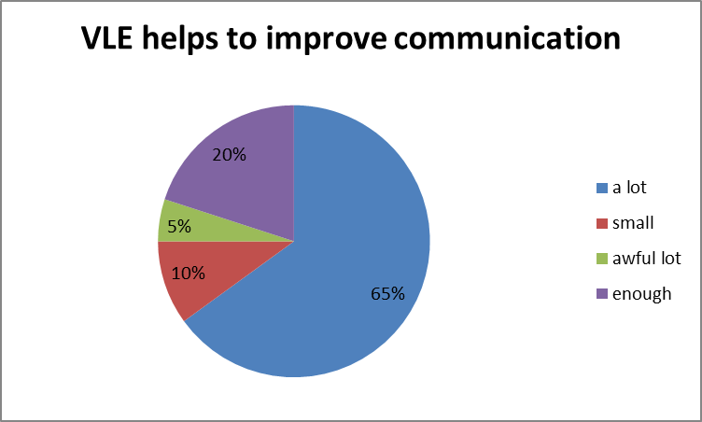
Fig:3 VLE helps to improve communication
Analysis: It is seen in the above pie-chart that 65% of student thinks that VLE helps to improve communication a lot. 20% of student thinks that VLE helps to improve enough communication facilities. 10% of student thinks that VLE doesn't help that much in improving communication. Only, 5% student thinks that VLE helps to improve communication awful lot.
Q4.

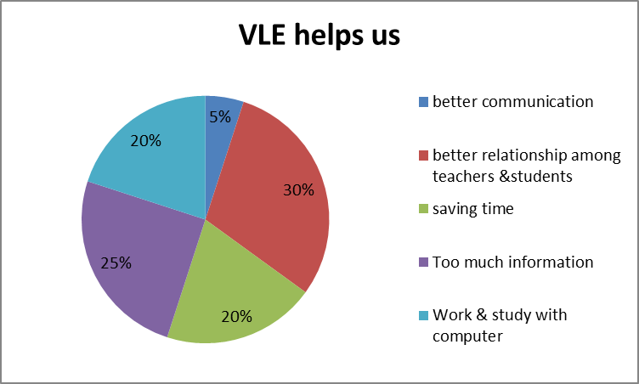
Fig 4: Virtual Learning helps us
Analysis: 30% of students think that a Virtual learning environment helps us in building better relationships among teachers and students. 25% of students think that VLE helps us by providing too much information. 20% of student thinks that VLE helps us to work and study with the computer. And, other 20% student thinks that that VLE helps us in saving time. Only, 5% student thinks that VLE helps us in better communication.

Q5.
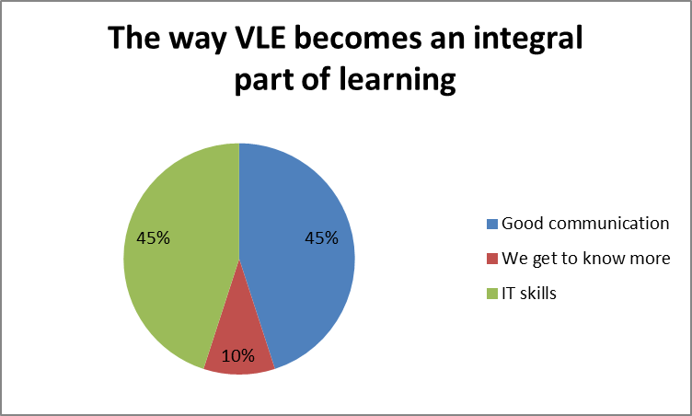
Figure 5: The way VLE becomes an integral part of learning
Analysis: It is seen that 45% of student thinks that VLE becomes an integral part of learning through better communication. On the other hand, 45% of student thinks that VLE helps us to know more about our development. Only 10% of student opines that VLE becomes an integral part of learning by enhancing IT skills.
Q6.
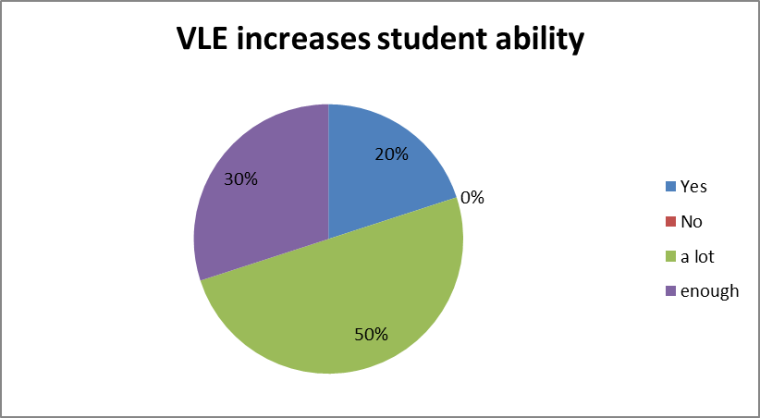
Figure 6: VLE increases student ability
Analysis: It is seen that 50% of student thinks that VLE increases a student's ability a lot. 30% of students that VLE has enough contribution to increasing students ability. 20% of the student agrees with the above-mentioned statement. No student has disagreed with the above-mentioned statement.
Q7.
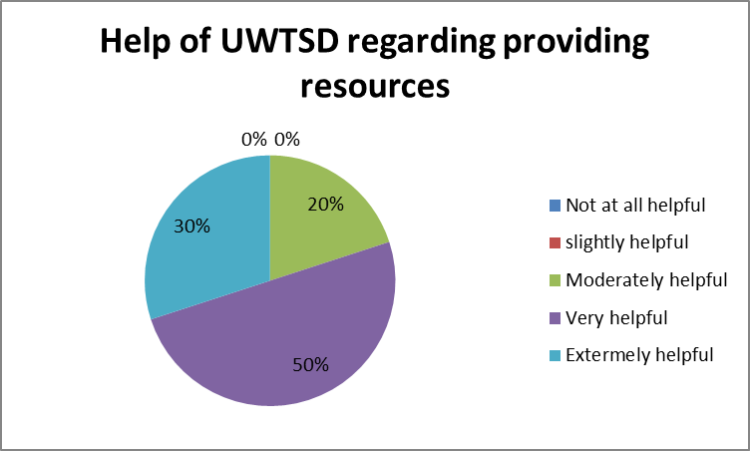
Figure 7: Help of UWSTD regarding providing resources
Analysis: It is seen in the above pie-chart, 50% student opines that their University was very helpful in providing resources to learn from home. 30% of students opine that University was extremely helpful and 20% of students opine that their University was moderately helpful in providing resources to learn from home. No student has denied the helpful activities of their institution.

Q8.
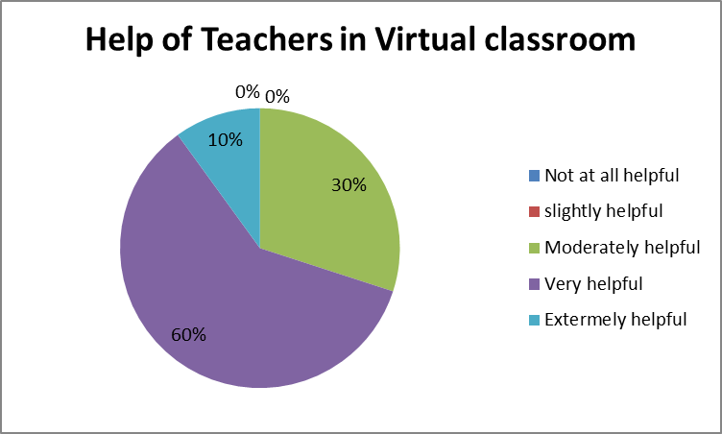
Figure 8: Help of Teachers in Virtual classroom
Analysis: It is observed that 60% of student thinks that Teachers are very helpful in the online classroom. On the other hand, 30% of student thinks that the Teachers are moderately helpful and 10% of student thinks that Teachers are extremely helpful in the online classroom. No student has denied the helpful nature of their Teachers on the online platform.
Q9.
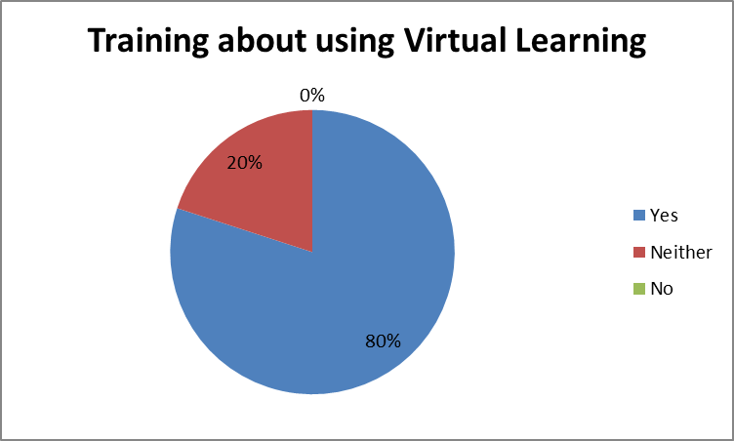
Figure 9: Training about using Virtual Learning
Analysis: In the above chart, it is seen that 80% of student opines that they have training about using Virtual learning. 20% of students didn't express any exact opinion regarding the training about using Virtual learning.
Q10.
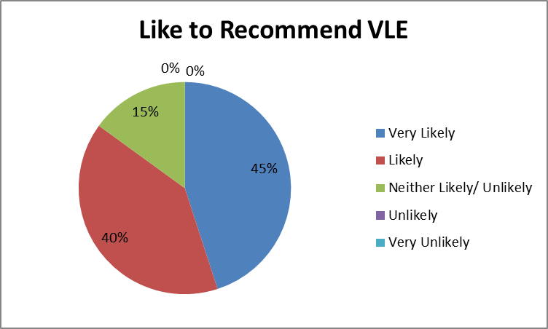
Figure 10: Like to Recommend VLE
Analysis: It is seen that 45% of student opines that they would be very likely to recommend VLE. On the other hand, 40% of student opines that they are likely to recommend VLE. And, 15% of student didn't provide their opinion regarding recommending a virtual learning environment.

Secondary Data Analysis
It is found from different research articles, publications, and books regarding the effect of online learning on students that virtual learning has been recognized as the most effective distant learning for the students. The virtual learning environment empowers the student with more confidence than before and helps to get wider knowledge regarding any specific topics (Fowler, 2015). Students get the opportunity to surf on Google to collect their necessary information and students also get acquired with the professional skill (Kerimbayey, 2016). But it is also found that students face problems like lack of technical gadgets and failure of network connection that affect their learning experiences negatively.

Conclusion
It is found from the research study that, students of UWTSD are well equipped with the technical gadgets, have proper training and guidance from their teachers which results in a positive impact on their online learning experiences. It is also observed from this research study, that students are getting the necessary support from the university and the students have easy access to the Moodle, Library, and other online platforms. This facility contributes to enhancing their online learning experiences positively. It is observed that the online learning environment has made the students of University more confident and enthusiastic (Kerimbayey, 2016). Therefore, it can be said that VLE is having a positive effect on the learning experiences of students at UWTSD, London campus.

References
Annetta, L.A., Folta, E. and Klesath, M., (2017), V-Learning: Distance education in the 21st
Century through 3D virtual learning environments, Springer Science & Business Media.
Chen, I.Y., Chen, N.S., and Kinshuk, (2020). Examining the factors influencing participants'
Knowledge sharing behavior in virtual learning communities. Journal of Educational Technology & Society, 12(1), pp.134-148.
Dieker, L.A., Hynes, M.C., and Hardin, S., (2014). Learning from virtual students. Educational
Leadership, 71(8), pp.254-278.
Dyson, M.C., and Campello, S.B., (2018). Evaluating Virtual Learning Environments: What Are
We Measuring. Electronic Journal of E-learning, 1(1), pp.111-120.
Fowler, C., (2015). Virtual reality and learning: Where is the pedagogy? British Journal of
Educational technology, 46(2), pp.412-422.
Goddard, W., and Melville, S., (2014). Research methodology: An introduction. Juta and Company Ltd.

Gomm, R., (2016). Social research methodology: A critical introduction. Macmillan International Higher Education.

Hay, A., Peltier, J.W. and Drago, W.A., (2017). Interaction and virtual learning. Strategic change, 13(4), p.193-223.

Keller, C., (2016). Virtual learning environments: three implementation perspectives. Learning, media, and technology, 30(3), pp.299-311.

Kerimbayey, N., (2016). Virtual learning: Possibilities and realization. Education and Information Technologies, 21(6), pp.1521-1533.

Mort, L., (2015). Learning & Development: ICT - Virtual learning. Nursery World, 201(3),
Pp. 221-290.
Tobarra, L., Hernández, R. and Caminero, A.C., (2017). Analyzing the students' behavior and
Relevant topics in virtual learning communities. Computers in Human Behaviour, 31, pp.659-669.
Weiss, J., Hunsinger, J., and Trifonas, P. eds., (2016). The international handbook of virtual
Learning environments (Vol. 14). Dordrecht, Netherlands: Springer.

Appendix
Questionnaire on "The impact of Virtual Learning Environment-Moodle on students
learning experience at the University of Wales Trinity Saint David London Campus”
(Sample size: 20 students)
- How many times a week do you use the Moodle?
- 2-3 times in a week
- 1 time in a week
- 3-4 times in a week
- As necessary
- Often
- Does VLE enable students to learn more about their development?
- No
- Yes
- Microsoft team allows everyone to join their own team. Does this help improve communication?
- A lot
- Small
- Awful lot
- Enough
- In what VLE helps us?
- Better communication
- Better relationship between teachers and students
- Saving time
- Too much information
- Work and study with a computer
- How the E- learning environment becomes the integral part of learning?
- Good Communication
- We get to know more
- IT skills
- Does it increase the student’s ability to deepen their knowledge?
- Yes
- No
- A lot
- Enough
- How helpful did University of Wales Trinity Saint David Campus has been with giving you the resources to learn from home?
- Not at all helpful
- Slightly helpful
- Moderately helpful
- Very helpful
- Extremely helpful
- How helpful are your teachers while studying virtually?
- Not at all helpful
- Slightly helpful
- Moderately helpful
- Very helpful
- Extremely helpful
- Did you feel you had adequate training and guidance about using Virtual Learning?
- Yes
- Neither
- No
- How likely are you to recommend Virtual Learning?
- Very Likely
- Likely
- Neither Likely/Unlikely
- Unlikely
- Very Unlikely

Class activities


