Dissertation proposal

Introduction
This dissertation proposal outlines the three key words and their definitions that will be used as part of my dissertation question next year. Research will be undertaken in order to find images that are related to the three chosen key words. This will enable the completion of my dissertation using the chosen question of my choice.
My 3 key words are:
- Mediocre
- Monolith
- Advertising
I will ascertain how these words are used on a daily basis, as well as the history behind them. This will ensure a full understanding of the chosen words ready for completion of my dissertation.

Mediocre
The first of the chosen words is mediocre because it has a lot of meaning with my current topic; how football advertising has changed. The use of the word mediocre is on the decline, its definition a great example of how to describe previous advertising in football.
Before modern technology, more mediocre methods to compete basic tasks were the norm. Mediocre is a synonym for basicness. Mediocre is never good enough.
Gordon B. Hinckley
“Mediocrity will never do; you are capable of something better”.
Gordon B. Hinckley. (2003). Quotes. Available: https://www.goodreads.com/quotes/24571-mediocrity-will-never-do-you-are-capable-of-something-better. Last accessed March.
This quote is fascinating; it could relate to numerous situations, including personal growth, businesses, designs etc. If somebody decides to start up a business, they would start at the bottom and aim improve their products and/or services, not accepting mediocrity. Often businesses start with very basic ideas, improvements to brand recognition and an increase in quality of output will ensure satisfaction and a uniqueness.
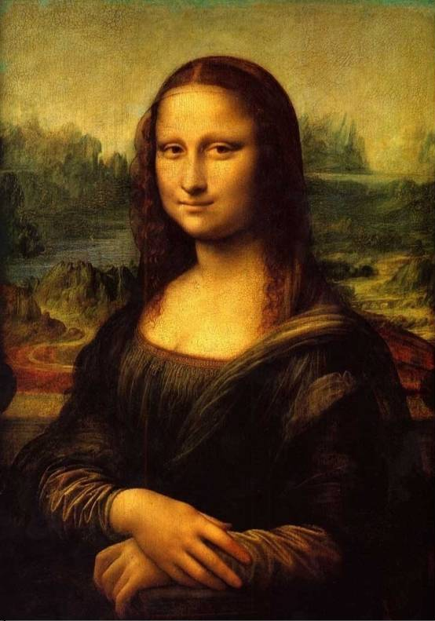
Da Vinci, L (1503). Mona Lisa. (Oil). Paris: Louvre
My image: Mona Lisa
I have chosen the Mona Lisa painting as one of my key images because my research has found that people believe this painting that relates to my key word, mediocre. One of the most recognisable paintings of today, this work is merely portrait of a woman no one really knows.
This painting attracts thousands of spectators each day, which is fascinating considering it is simply a portrait of an unidentified women, wearing dark, unappealing robes. There is a lack of jewellery, or anything that makes her stand out like other paintings dating from the same period. Research suggests that the identity of this lady is unknown.
Compared to the Mona Lisa, there are an unfathomable amount of paintings existing around the world, that are brilliant pieces of detailed, intricate artwork that are completely unknown. The creators of these paintings may have taken far longer and put in much more effort than Da Vinci, yet the status of him ensures his work is more recognisable. I believe that this is an example of a mediocre painting, which has an added attractiveness because of the mysteriousness of the sitter.
Albert Einstein once said, “Great opposition have always encountered violent opposition from mediocre minds”, highlighting how uneducated people may use violence to attack intelligent people because their mediocre minds do not possess the power to debate a situation correctly. Mediocre minds don’t succeed in life because they aren’t open to new experiences/ideas and will never develop or improve themselves, therefore may not be able to develop or proceed further in life because of their narrow mindedness.

Monolith
The second of my chosen key words is monolith. Another word that’s is less prolific these days, monolith can describe various things that surround us in the modern day. As time has progressed, material objects have changed in size and this is because of consumer demands.
The most recognisable object is the mobile phone. When mobile phones were first introduced, they were roughly the side of a brick. Having a big telephone, with an external aerial one would have to pull out to get signal, made it difficult to transport because it was so large in size that it would not fit in your trouser pocket and this would have required a sizeable bag to fit it in.
As technology improved and phones started developing at a greater rate, phones started greatly reducing in size so that they were more practical and that you were able to fit them in your pocket without any hassle, so that you were able to take them anywhere with you, hence why they were known as mobile phones. The small stature of a mobile phone was the next line of the mobile generation and its technology amazed everyone.
At first, having a small mobile phone was better to the public because it enabled consumers, who normally used large portable telephones, to carry around a phone with a great deal of ease; it could fit into a pocket or bag with little amount of fuss.
Some of the most notable mobile phones include the range of the Nokia mobile phones. Known for being the size of the palm of your hand, people were very happy with the size of the gadgets.
Since the start of the early 2000’s, mobile phones have started to get bigger and bigger up until today where the new phones are now the size of your whole hand if not bigger. Greater technological advances and a desire for increased mobile phone capabilities and bigger, clearer, easier to read screens have seen the mobile phone move away from being the size of one’s palm, almost going backwards in terms of size. However, these newer phones are still far smaller than the original editions, yet it is comical to see how having the smallest mobile phone was, at one point, the most expensive and desirable, whereas now the bigger the phone, the more expensive.
Social media and a need for recognition these days, based on one’s tangible assets has made consumers far more likely to show off what materials items they have; the bigger the and more expensive the phone, the more acceptable in society and in turn the more you tend to be known and liked because people then look up at you and want to have the same to try and get higher up the market.
In life it is known that “the bigger, the better: in everything” quoted by FREDDIE MERCURY.
If you have a big house, a big car, a big phone etc. you are labelled as wealthy, because the bigger the size of materials objects, the higher the standard.
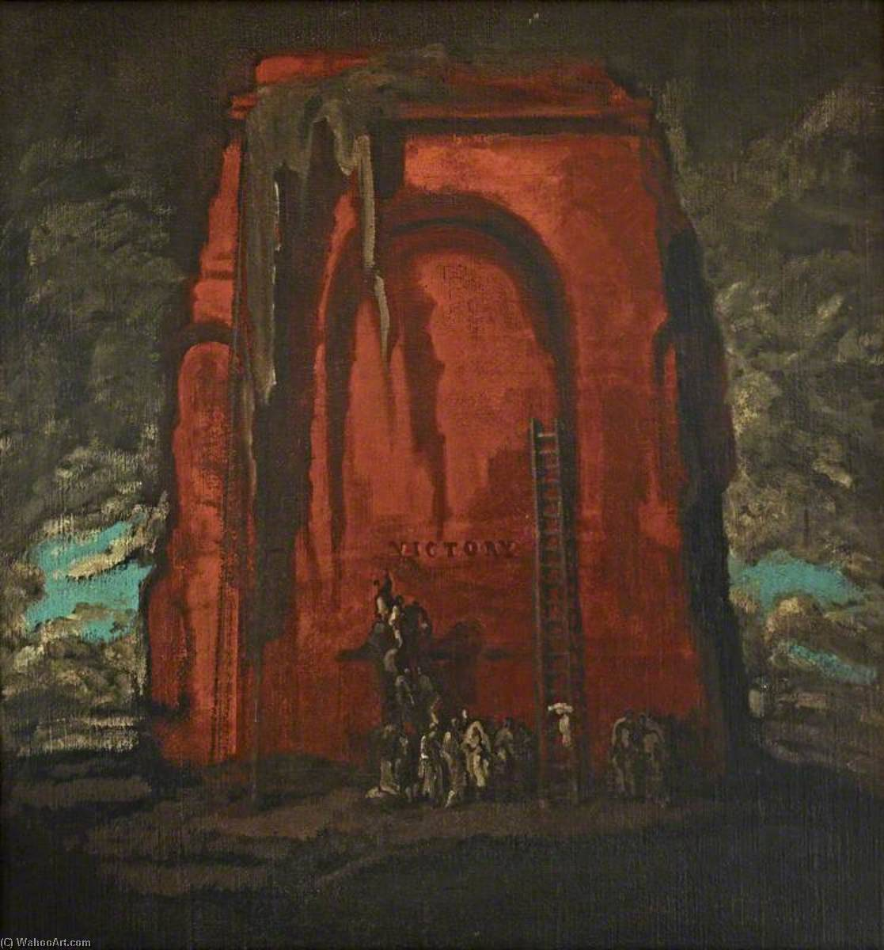
Pryde, J. (1912). Allegory: The Victory Monolith, (oil) National trust: Anglesey Abbey

My image: Allegory: The Victory monolith
The picture of the victory monolith is a showing that whoever is at the bottom of the monolith, wants to be at the top of it because that is what is more desirable to them. It also relates to everyday actions. If you are at the bottom of the class, you want to get to the top. If you’re at the bottom of the list, then you want to get to the top of the list. This concept can be applied to a number of situations these days.
Everyone has someone or something they look up to and aspire to be like. Monolith is a great word to use in this situation because it literally means something big, whether one is looking up at it physically or admirably. This could apply to looking up at your parents, older siblings or people in the public eye such as celebrities as everyone aspires to be better.
Tony Hiseh
“whatever you think, think bigger”
Mike. (2017). Whatever you're thinking, think bigger. Available: http://mrinsidesales.com/whatever-youre-thinking-think-bigger/. Last accessed March.
In people’s eyes the bigger means the better which is why growth is something important in life because the more you grow the more you tend to achieve because growth is the best way to move forward and growth is a big or even a monolithic step forward in your life.

Advertising
My third keyword is advertising. The reason I have chosen this as one of my key words is because it has a lot of meaning to me as it is the course I am currently studying, plus it also has so much to do with the world these days because advertising is literally everywhere you look and can show off something in a certain way.
These days advertising is absolutely integral to promote your product or service out to people around the world. Without advertising, exposure would be low and in turn the success of the entity would suffer. Sometimes, even if at first something doesn’t appear to be a form of advertising, it always is. It can be also seen as brainwashing because through advertising businesses try and convince the general public something that may not be true by using their product to try and get as many sales as possible.
There are currently many different ways of advertising and that can include digital, print, guerrilla, TV, radio and social media. Advertising a product or a brand has become a massive part of life with everyone watching the advertisements to see if the product or brand is someone they like and that they want to purchase, whether they know it or not.
Businesses use advertising to promote their brand, especially if they are releasing a new product. By doing this they promote the features of this new product and why you should use their brand over other brands. I think that if you have a business and you are to compete in today’s world you, must have very good advertising and that you should pay what it takes to correctly market your brand to the correct target demographic.
There are some products out there that didn’t sell at all at some point, but as soon as there were adverts launched to try and help sell the product, it then started flying off the shelves because it makes people believe they need it even if they don’t actually need it.
Some businesses would go to great strengths to afford the funds to be able to correctly promote their products. On average, about 10% of gross revenue will be spend on advertising because it’s such an important element in promoting a product or service and there are so many varying methods of doing so.
William Bernbach
“good advertising does not just circulate information. It penetrates the public’s mind with desires and beliefs”
AZ Quotes. (2018). William Bernbach. Available: https://www.azquotes.com/quote/684042. Last accessed March.

I quite like this quote from William Bernbach because it shows that if you advertise well then it gets embedded into the consumers’ minds that they actually want and need the product that you are trying to sell, which results in a purchase.
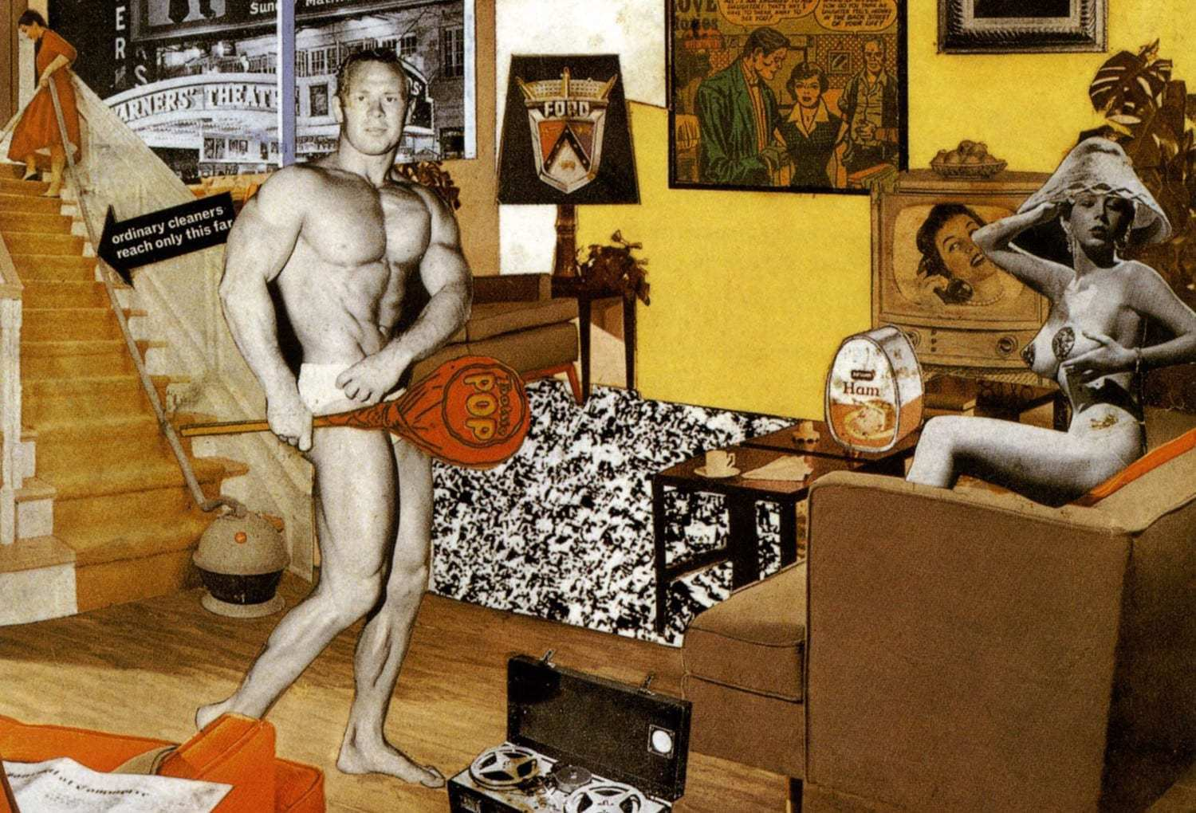
Hamilton, R. (1956). Just what is it that makes today’s homes so different so appealing. (collage) Tubingen: Germany.

My image: Just what is it that makes today’s homes so different, so appealing?
This picture shows the everyday of consumer wants, needs and demands. In this picture, Richard Hamilton wanted to show the public what everyone wants their homes to look like. He did this by cutting out products and people from different magazines and binding them into one piece of art which creates this piece.
For his piece of artwork, he wanted to show consumers what everyone wants their houses to look like because he included all of the latest material objects in the collage. This creates an element of desirability. This includes a bodybuilder, which people see as the perfect body for a man. He also includes a female whose job is as a model, which is a highly desirable career because it promotes one’s beauty.
Also in the collage it includes a vacuum cleaner which, at the time, was the latest in the line of vacuum cleaners out, showing how it’s able to go further than other standard vacuum cleaners. It also has the latest tape-recorder, a classical rug, a painting on the wall and then in the background the outside of a cinema and what they used to look like. The reason as to why he created this piece of art, was to show the rise of consumer society. It attempts to portray that the perfect house has all of the latest products inside it, but in fact hardly any houses are indeed like that, merely just a clever form of advertising and trying to sell a business’ new range of products.

Conclusion
To conclude, the three keywords that I have chosen, and the research that I have conducted has enabled me to compose a question that I am going to use for my year three dissertation. The reason for these three keywords are that they relate to what my question is going to be. The three keywords greatly relate to everyday life and it can also be applied to anything, but mainly my question which is specifically why I chose them.
Relating to my question, I can see how much football has changed throughout the years and how it’s become very advertising based compared to what it previously used to be like. Highlighting the importance of enabling advertising to be placed everywhere the customer looks, always stimulating consumer interest. It can have such a massive impact, such as how the football kit looks, or even what the person thinks of the brand because of the related team the sponsor is in partnership with. The influence of sponsors in football can influence whether consumers want to actually make a purchase from their business because their favourite team adheres the sponsor.
Football uses different platforms to advertise these days and it’s a very clever way of making as much money as possible, even off little things such as advertising. Football clubs use football tops, shorts, advertising boards, flags, boots etc. to advertise a brand that have paid them to advertise their logo. This is why I have chosen my question because football has changed from an untapped sport where thousands congregate to enjoy the game, to a place where multimillions are invested because the market is so lucrative and association with the sport can result in massive export and in turn massive profits for both the football clubs receiving the investment from businesses as well as the businesses that are investing in the football club.
Research question
In the last 20 years, how has football gone from a mediocre sport, to a monolith, advertising platform?

