

Acca6020

Wondrous Labyrinths: Teaching tool for demonstrating pathfinding algorithms

By
Rebecca Ryall
1705433

Supervisor: Michael Dacey
Second Marker: Gaynor Thomas

Project submitted as part of the requirements for the award of BSc inc Foundation: Computing (Games Development) with Foundation Year
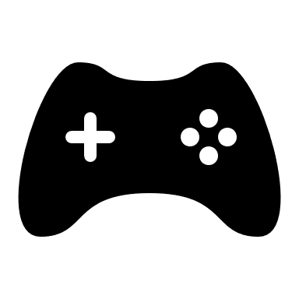
Table of Contents
Introduction 4
The objectives of this project are 4
Literature Review 5
How to Define a pathfinding Algorithm 5
What is pathfinding? 5
Pathfinding Explained with the using of a grid maze 5
what is an algorithm? 6
What are pathfinding Algorithms used for? 6
What kind of mazes are there? 6
Search Methods & Pathfinding algorithms 8
Introduction 8
Dijkstra’s algorithm 8
A* (A star) Algorithm 9
Aldous-Broder Algorithm 9
Wilson’s Algorithm 9
Eller's Algorithm 9
Andragogy 10
There are four main learning types below is a breakdown of these four types: 10
Read/Write Learners 10
Visual Learners 10
Auditory Learners 10
Kinaesthetic Learners 10
Semiotics? 12
Research Methodology 12
Resources 12
Research Overview 13
Research Process 13
Design Methodology 13
Development Methodology 13
Conclusion 13
Design & Implementation 14
Design 14
Implementation 14
Testing 15
Results 15
Conclusions and Future Work 16
Summary 16
Conclusion 16
Recommendations for Further Research 16
Reflection 16
References 17

Table of Figures
Figure 1 4 by 4 grid [3] 5
Figure 2 Squared true maze[4] 7
Figure 3 imperfect maze / not a true maze[5] 7
Figure 4 Learning Styles[11] 11
Figure 5 Program output 15
Figure 6 unsolvable 15

Introduction
This report contains a breakdown of different maze[1] building algorithms and pathfinding solutions to be used in a individual teaching form. Because there being a variety of different learning styles and teaching approaches, the author will be focusing on visual learning. To show their findings the use of two specific learning styles and two different algorithms will be used within this report.
Two different learning styles will be used to solve two different pathfinding algorithms. To be able to create a comparison of the difference between using the application for visual learners and not using the program for visual learners. The first learning style will being read/write and the second learning style will be visual, when it comes to the pathfinding algorithms the visual learners will be learning the A* search method and the read/write learners will be using Aldous-Broder Algorithm. To keep the result true the search methods will swap halfway through testing to prevent the chance of one algorithm being easier to learn then the other. Using these various ways to learn a topic the author plans to create a program to help teach and explain how pathfinding algorithms work. And how they are used to solve different type of maze, this report is named Wondrous Labyrinths and aims to evaluate difference approaches to make understanding pathfinding algorithms easier for visual learners.
The objectives of this project are:
- Analyse algorithms and Andragogical approaches to determine the best approach for visual learners to understand applications of pathfinding.
- Evaluate the learning benefits by implementing a teaching tool that can be used by visual learners to study how pathfinding solves different mazes.
- Critically evaluate the Andragogical benefits of a tool for simulating and then presenting the solution steps taken by a pathfinding algorithm.
The author plans to create a program that will solve non identical mazes visually, to be used as a teaching tool to help demonstrate how pathfinding is used in a visual form. By showing the maze being solved in real-time and explaining why and how the algorithm chooses the path it takes to reach the end of the maze. To accomplish this the author plans to create a C++ program to generate random true mazes with a unique maze layout, to be drawn on to the screen for the user to see as its being created. Once the maze has been drawn to the screen the program will proceed to solve the maze, using the A* pathfinding algorithm to do so. Showing the decision making and the process of how the algorithm is used to navigate through the maze to then eventually solve it. To accomplished this the use of tables or graphs will be used to show the nodes in tree form, shown next to the maze or to have arrows displayed on the maze to indicate the direction it wishes to go. the use of different colour cues on the maze to show different stages of where the algorithm is, such as what the algorithm is thinking and when a decision of what direction the algorithm plans to travel in and why it chose the root. The time duration will be slowed or even paused at stages of the maze being solved allowing the user time to take in the information. There will be a table form used to give the user more information on what has been visited and which ones will be next to be visited.
The author plans to expand the program in the future, to allow for multiple pathfinding algorithms and search methods to be included in the program. To include a lot more variety of different learning styles and to have more creative shaped mazes to be show being solved. So, more people can learner and better understand the different types of pathfinding algorithms and enjoy learning without being intimidated by the math.

Literature Review

How to Define a pathfinding Algorithm
Within this section of this report the author hopes to answer the important questions about pathfinding such as What is Path Finding and why is it important? And where are mazes used in computing, as well as a comparing and explain the compassion of the different path finding algorithms.

What is pathfinding?
Pathfinding is when a computer program plots a route from two points well the program is traveling between these points it searches through to find the shortest path from the two basically solving mazes. This is done by the use of mathematical formulars known as algorithms being a list of instructions of how the program will go about searching through the grid like maze until it reaches its second point which would be its end goal.

Pathfinding Explained with the using of a grid maze

To begin first let’s picture a grid with four boxes across and four boxes down this will be our maze to help explain pathfinding. Now think of two points on our square grid, one being the S point being the start position and we shall locate that at the top left corner of the grid and the second one being the E point to represent the end goal and this one will be in the bottom right corner.
These two points can be anywhere within our grid but to make it simpler we shall place them in opposite corners. Using pathfinding we start from the s point and work our way through the grid visiting each square until we have either worked our way through and visited every square or either until we find the E point. We use different pathfinding algorithm for different types of search methods, majority of them focus on finding a good path between these two points. In this document we will be focusing on the type that look or the shortest and best path between the two points.
To help test to see if the algorithm has indeed found the best route, we use obstacles between these points these obstacles are like walls prevent the algorithm from using the same path over and over. Allowing us to see which algorithm found the best and shortest path. [2]
Figure 1 4 by 4 grid [3]

what is an algorithm?
What is an algorithm? It sounds so complicated, but it need not be. In simple terms it is just a description of a process. Thinking of it like a how to book like a form of instruction, like a manual leaflet that shows a how to assemble flat packed furniture or even a recipe handed down to family members on how to bake grandmother’s famous cookies. It tells the user a step-by-step guide on how to achieve a specified task, algorithms exist for everything. If you want to make a cup of tea and that is your aim, then the series of steps you take to make the tea is your algorithm. An algorithm can either be used to solving a problem by using a set of instructions or to achieve a set goal. [3]
The pathfinding algorithm has the duty to find the shortest path from two coordinates.

What are pathfinding Algorithms used for?

Pathfinding is used for multiple different things, one being satellite navigation these maps show the users the shortest path or route to take to their desired destination. Second place these algorithms are used is in video games, one use could be to allowing the play to have NPC (Non-Player Character) follow them thought the game world. or even have enemy NPC (Non- Player Character) find and attack them within the game and follow them when they walk or run away. Giving the play a more immersive game play.

What kind of mazes are there?
A perfect maze which can also be known as a true maze is a maze that has been create with a single path from the start point of the maze to the end point. meaning these is only one solution and the rest of the paths in the maze are dead ends and can only be solved using the correct path. Like shown in figure 4.
An imperfect maze or can also be called a untrue maze is the opposite of a true maze it not only has more than one single solution, they can have multiple solution to one maze, or have no solutions at all making it impossible to be solved this is shown in figure 5.
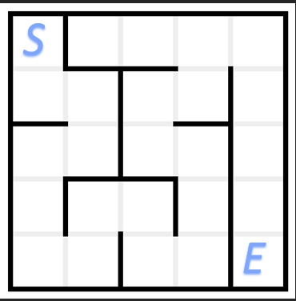
Figure 2 Squared true maze[4]

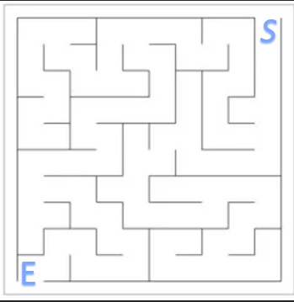
Figure 3 imperfect maze / not a true maze[5]

Search Methods & Pathfinding algorithms

- What they are?
- Why they are used?
- Where they are used?

Introduction
The project will be focusing on the A*(A star) algorithm to help demonstrate the maze solving aspect of the visual learning program. To have some data to compare the wondrous labyrinths program too, the author plans to use a secondary algorithm to be used as a comparison. To show how effective the wondrous labyrinths program is for visual learners. By having the second algorithm explained in a written text form with no images or tables to explain how it works. The program will be tested on other types of learners, such as the most common learning type read/ write. The program will use the A*(Star) algorithm with in the C++ program to visually explain how it works and the Aldous-Broder Algorithm will be given in a written text form explained using text only. The author plans to provide surveys to both test learners containing question on there understanding of how the algorithm functions and a rating their experience from 1 to 5.
The author plans to expand the program to more algorithms in the future, below is a breakdown of various pathfinding solutions and an explanation of how each algorithm goes about solving different mazes and why and how they chose their specified path to accomplish this.

Dijkstra’s algorithm
What is Dijkstra’s algorithm[6] or also known as Dijkstra’s shortest path when it comes to Dijkstra’s algorithm the short the route the best. This algorithm works by flooding the maze, it first makes a note of its start location and its end goal. It will visit’s every square and will set a number to all making start square 0. next squares over as 2 and so on forth until it reaches the end goal square. It will storge this information in a queuing list, placing the squares that are the shortest distance from start point at the top and furthest away at the bottom of the queue it will used the information to solves the maze. Then it goes down the list and finds the one at the very top, which is the one closest to the start point. will make that the next square to go to, it will then go through all the square in the list again looking for the closest to the square its on. Which being nearest to the top of the queue list, it will repeat this process until the end goal square becomes at the top of the queue list then it has reached its end goal square.

A* (A star) Algorithm
A* is simpler to Dijkstra’s algorithm[7] as it is an extension but with Important difference like for intents A* is much smarter because it works out how far it needs to travel till the end point. It does this by having an added heuristic method the heuristic is the estimated distance between the two points so not only having the added the distance between each square or nodes needed to be visited but, also includes the estimated distance to the end goal.
This information is then place in a stack like queuing system, it uses the information of the furthest estimated distance from goal plus the distance to the next square to be visited combined together to make up the combined heuristic. it then uses this combined heuristic value to orders the stack like queue, making the high heuristic values at the bottom of the stack and bring the low value to the very top of the list these being the shortest combined distance. Once it goes down the list visiting the square with the lowers combined heuristic value, the program will reach the end point leaving unvisited square in the queue that didn’t need to be explored. It does this so the next square to be visited in the maze is the one closes to the goal, rather than aimlessly searching through the maze to find the end point like other algorithms. making it the faster and more efficient than the others and better than its predecessor.

Aldous-Broder Algorithm
Aldous-Broder is a very nice and simple Algorithm because it does not need any additional memory like other types of algorithms making it easier to implement, it does generate a consistent maze’s it begins by cycling through all unvisited sections at random quickly. Sadly, as the algorithm continues each unvisited section becomes few and far between making the end point drawn out, taking its time to reach the end. [8]

Wilson’s Algorithm
starts slowly but faster at the end[9] to solve the maze Wilson’s Algorithm picks a random begin point say square 1 and then pick another random position within the maze. It then goes through all unvisited square like shown in figure 1. Until it finds square 1 then draws the route to that point and then continues but instead of just looking for square 1 any visited square that joins to square 1 it will draw the route to it until all squares are visited. But what makes it different is that if it hits a wall when picking its random direction, it will teleport to a random point and continue to search through until it finds the end.

Eller's Algorithm
When it comes to Eller's Algorithm it works great but can be difficult to implement and complex to comprehend but it is faster than most other algorithm also most memory efficient it goes through the first row and assigns each square a random number, once they all have a number it moves down to the next row and does the same. but there is a change, any above number that matches the ones below are group together to make a route through the maze. it does this left to right, across the row until the end of the row then moves down a column and continue till the end of the maze. [8]

Andragogy

- Mental models
- Visual learners
- Simulations in learning

There are four main learning types below is a breakdown of these four types:
Read/Write Learners
These learners whom find it easier to understand a subject better when it is giving in either write form such as from books, or having the information well they make notes and write about the topic.

Visual Learners
Visual learners do not learn in the stereotypical way, they take in knowledge better when it is show to them using table charts and PowerPoint to demonstrate the subject. When it is show using images and then explained in more detail after the learner have a better grasp the topic.

Auditory Learners

Kinaesthetic Learners

[10]

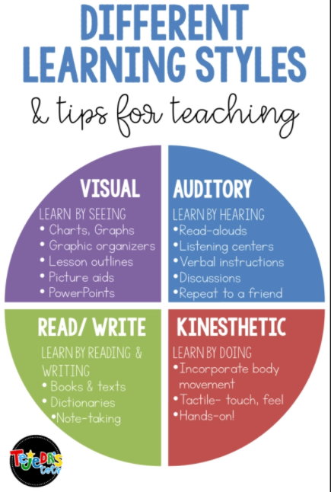
Figure 4 Learning Styles[11]

Semiotics?
- Semiotics is an investigation into how meaning is created and how meaning is communicated. Its origins lie in the academic study of how signs and symbols (visual and linguistic) create meaning.
- Methods for visualising interactive activities e.g. HUD, game GUI

Research Methodology
- Discuss different research methods e.g. research onion, positivism, etc. Then argue for the methods you think are the most appropriate for your project.
- Open vs closed questions
- Qualitative vs Quantitative or both

Resources
- Visual Studio 2019[12]
- OpenGL [13]
- Books and articles
- Internet
- SFML (Simple and Fast Multimedia Library)[14]

Research Overview

Research Process
How you are use those research methods e.g. surveys, questionnaires, interviews, etc.
What were the steps you applied to this project.
- Interview
- Based on answers implement software
- Test usability
- Statistical analysis of results e.g. t-test. DON’T HAVE TO DO THIS
Demonstrate that our results are valid and verifiable.!!

Design Methodology

- Waterfall model
- Compare and contrast different design methods …methodologies e.g. Agile
- Select requirements analysis approach e.g. user stories, use case documents, numbered list…argue why but with a valid argument (reference)
- But agile is for teams so I can’t use it but I can steal some methods from it e.g. user stories.
- RUP is complicated but I can use class diagrams….
- …. Prototype approach ..if you do then you need to demo that you built prototypes.

Development Methodology

Conclusion

Design & Implementation

Design
- Describe your requirements e.g. as user stories is that is what you chose above.
- Show class diagrams for you code if that is what you chose above.
- Design should reflect the requirements.

Implementation
- What are the main problems you experienced and how did you overcome them.
- What are the main features and how did you implement them?
- How does you implementation match the requirements and the design?
- How does the implementation help you obtain the results you required? If applicable.

The author created a Diagram using Microsoft Visio to show the logic of how the program will run and how they plan on creating the visual aspects the program.
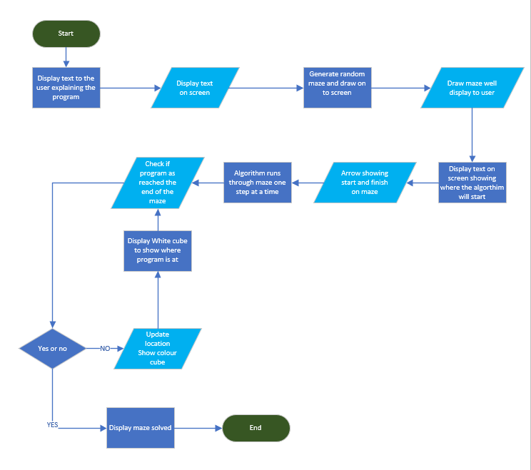

Testing

At the begin of creating the A*(Star) algorithm within the program, the author tested to make sure the program was taking the most direct route.
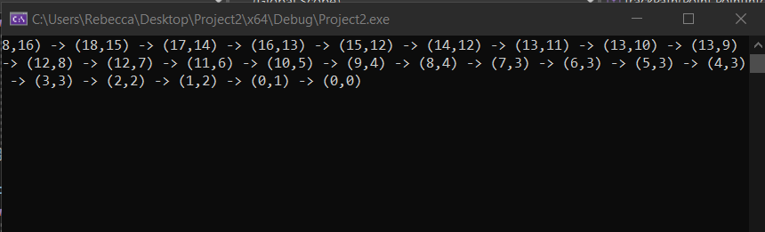
Figure 5 Program output
Well testing the program, it creates a maze that wasn’t able to be solved, this happened because the mazes are created using a random maze generator. So, each time the program is ran it will generate a brand-new maze each time. the program will create an imperfect maze like the one shown in figure 5 every now and then that are unable to be solved.
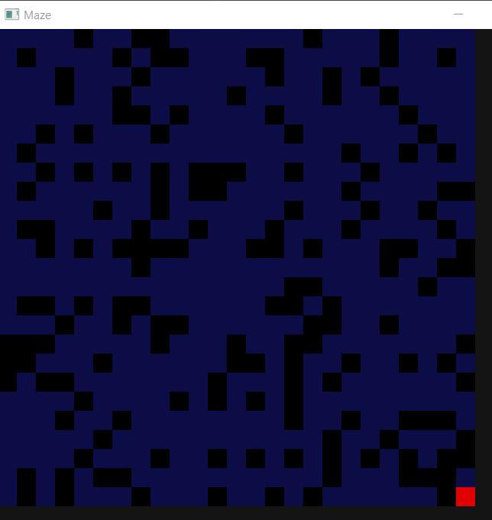
Figure 6 unsolvable

Results
- Present your results
- Tables/figures would be great.
- Analyse your results

Conclusions and Future Work
Review ALL your results and reflect on what they mean overall. Discuss what you could do next.

Summary

The author hoped to create a working program the allowed user to learner different search algorithms in a visual format, the author hoped to prove that have things shown and tort in a visual form would not only help visual learners better understand how each algorithm solved and works its way through he mazes. But would also help other learning types.

Conclusion

Recommendations for Further Research

Reflection
How did you find your own learning process. You may use “I” in this section.

References
[1] J. Xu and C. S. Kaplan, ‘Image-guided maze construction’, ACM Trans. Graph., vol. 26, no. 3, Jul. 2007, doi: 10.1145/1276377.1276414.
[2] P. Lester, ‘A* Pathfinding for Beginners’, 2005, Accessed: Aug. 29, 2022. [Online]. Available: http://www.policyalmanac.org/games/aStarTutorial.htm.
[3] J. Buck, ‘Mazes for Programmers Code Your Own Twisty Little Passages’. http://mazesforprogrammers.com/ (accessed Oct. 14, 2021).
[4] ‘Maze generator with Fable | Red, Green, Rewrite’. https://red-green-rewrite.github.io/2016/09/14/Maze-generator-with-Fable/ (accessed Dec. 13, 2021).
[5] ‘Networks, mazes, and R (Rmaze) | R-bloggers’. https://www.r-bloggers.com/2016/07/networks-mazes-and-r-rmaze/ (accessed Aug. 30, 2022).
[6] H. Ortega-Arranz, D. R. Llanos, and A. Gonzalez-Escribano, ‘The shortest-path problem : analysis and comparison of methods PDF’, Morgan & Claypool. https://ieeexplore.ieee.org/xpl/ebooks/bookPdfWithBanner.jsp?fileName=6813003.pdf&bkn=6813002&pdfType=book (accessed Oct. 15, 2021).
[7] ‘A* (A Star) Search Algorithm - Computerphile - YouTube’. https://www.youtube.com/watch?v=ySN5Wnu88nE (accessed Dec. 17, 2021).
[8] ‘Think Labyrinth: Maze Algorithms’. http://www.astrolog.org/labyrnth/algrithm.htm#perfect (accessed Oct. 10, 2021).
[9] ‘“Algorithm” is Not a Four-Letter Word’. http://www.jamisbuck.org/presentations/rubyconf2011/index.html#ellers-merge-sets (accessed Dec. 17, 2021).
[10] M. Murphy, S. Redding, and J. Twyman, ‘Handbook on Innovations in Learning’, Accessed: Aug. 30, 2022. [Online]. Available: www.centeril.org.
[11] ‘Unit 1: What are learning styles? How are they identified? - KNILT’. https://knilt.arcc.albany.edu/Unit_1:_What_are_learning_styles%3F_How_are_they_identified%3F (accessed Aug. 30, 2022).
[12] ‘Getting started with Visual Studio’. https://visualstudio.microsoft.com/vs/getting-started/ (accessed Oct. 10, 2021).
[13] ‘OpenGL - The Industry Standard for High Performance Graphics’. https://www.khronos.org/api/opengl (accessed Dec. 13, 2021).
[14] ‘SFML’. https://www.sfml-dev.org/ (accessed Feb. 24, 2022).

