Module code: BMIH5005
Module title: Research Project Proposal

Topic- What are the current challenges that the hospitality industry is facing that are affecting business performance: a case study of Hotel Premier Inn
Student name: Alin-Daniel Chiteala
Lecturer’s Names: Emma Roberts
Executive Summary
The research proposal is based on the current challenges faced by the hospitality industry in the United Kingdom. To research this topic, Hotel Premier Inn has been taken for the case study. Several other Hotel companies like the Marriot, Hilton Plc., and IHC have been taken for the comparison on strategies applied for mitigation of the issues. The first section includes an overview of the topic and a brief description of the company. The literature review of this report deals with the key factors and challenges of the industry. The methodology section explains the overall research process and data analysis method.

Table of Contents
1. Introduction 4
1.1 Topic Background 4
1.2 Hotel Overview 4
1.3 Aims 5
1.4 Objectives 5
1.5 Rationale 5
1.6 Research questions 6
2. Literature Review 6
2.1 Introduction 6
2.2 Theories Relating to business management in the hospitality industry 6
2.3 Obstacles that the industry faced in operations 8
2.4 Outline the risk management strategy benefits in the industry 8
2.5 Impact of COVID-19 and Brexit on the hospitality industry 9
2.6 Factors Leading to a Change in the retention process 9
2.7 Literature Summary 10
2.8 Literature Gap 10
2.9 Conceptual Framework 11
3. Research Methodology 11
3.1 Research Philosophy 11
3.2 Research Approach 11
3.3 Research Strategy 12
3.4 Research design 12
3.5 Data collection method 12
3.6 Data Analysis Method 12
4. Ethical Consideration 12
5. Timeline 13
6. Conclusion 13
7. References 14

1. Introduction

1.1 Topic Background
As opined by Bowen and Morosan, (2018, p.726), the hospitality sector of the UK especially the Hotel industry is a sophisticated industry that involves a huge number of people. As the number of people engaged in this industry is huge, there should be a chance of workplace inequality (Murton et al., 2010). The hospitality industry has been facing many challenges that affect business performance. For this research, the case study has been done for the Hotel Premier Inn. The current challenges may include employee unfairness, inequality, discrimination, communication gap and many more.

Figure 1: Oficial logo of the Hotel Premier Inn
(Source: Premierinn.com, 2023)

1.2 Hotel Overview
As coined by French, (2018, p.23), the Hotel Premier Inn is a British limited-service hotel chain and is also considered the UK’s largest hotel brand. Hotel Premier Inn has more than 800 Hotels and over 72,000 rooms. The hotel was founded in 1987 by Whitbread. The headquarters has been situated in Dunstable, UK. The current CEO of this hotel chain is Dominic Paul. Golden Tulip, The Bay Hotel, Comfort Inn Kensington, and The Purple Hotel are some well-known subsidiary companies of the Hotel Premier Inn. There have been 40,000 employees working for the company (Uk.linkedin.com, 2023). The total annual revenue of the company is estimated at 1.7 billion British pounds in 2022 (Statista.com, 2023).
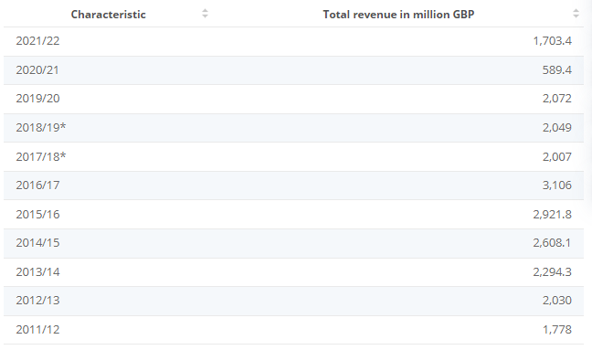
Figure 2: Year-wise company revenue statistics
(Source: Statista.com, 2023)

1.3 Aims
The aim of this research is to provide a brief idea of the challenges faced by the hospitality industry in the UK and the mitigation strategies.

1.4 Objectives
- To identify the key challenges that are affecting the UK’s hospitality industry.
- To evaluate the mitigation strategies that could resolve the issues.
- To analyse the effectiveness of the strategies that have been taken to meet the issues.
- To find out the factors that drive the issues in the hospitality industry of the Uk.

1.5 Rationale
The issues that are affecting the industry are identified as unfairness, inequality, discrimination, and communication gap. The main reason behind this problem is considered the poor leadership quality and insufficient training of the employees. The problem could be resolved by employing new and powerful leadership qualities.

1.6 Research questions
Q.1 What are the challenges that are faced by the hospitality industry of the Uk?
Q.2 How to mitigate the challenges faced by Hotel Premier Inn in relation to the issues?
Q.3 What strategies could be implemented to meet the issues?
Q.4 What are the key elements that render the industry to face the challenges?

2. Literature Review

2.1 Introduction
The hospitality industry has been contributing a significant amount of GDP to the United Kingdom. As coined by French, (2018, p.23), there are certain challenges which have been entailed due to the impacts of changes in the business environment. Those challenges have made the conduct of operations for the industry quite difficult. These also have a connection with the sustainability requirements by which the hospitality sector shall abide. Also, the operational costs are rising day by day along with technology advancements. These are the major sources in listing down the challenges being faced by the industry. The external market has become dynamic in approach with changing demands and supply. Hotels such as Premier Inn are also facing challenges regarding the same (Uk.linkedin.com, 2023).

2.2 Theories Relating to business management in the hospitality industry
To bring betterment to the current working conditions, the industry has been practising business management techniques. The ideology of theories has also been adopted to suffice the need for change. In the present case, the adopted theories are bureaucratic theory and system management theory.
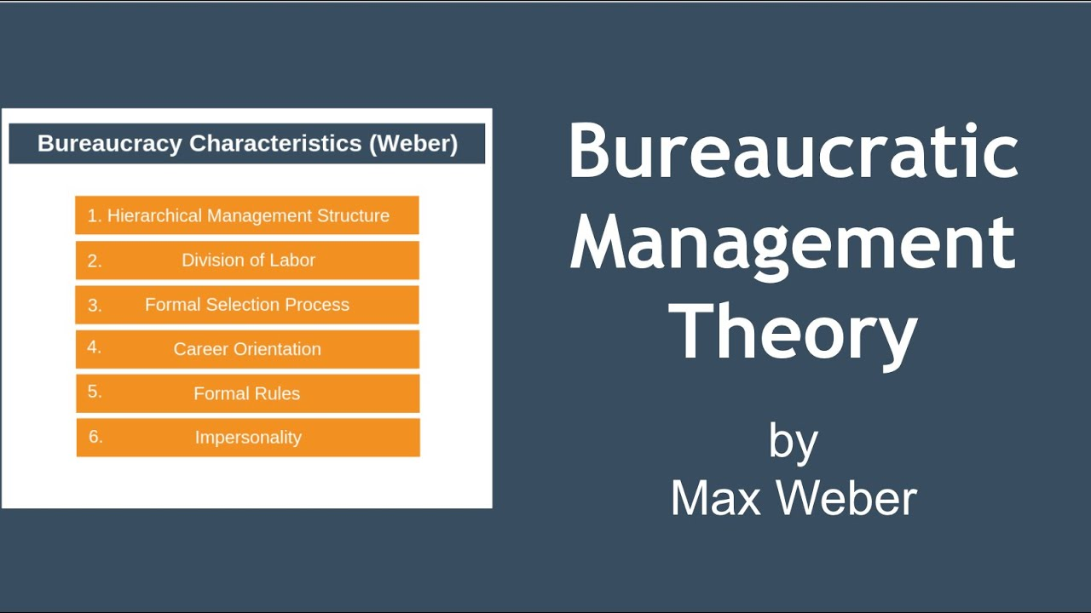
Figure 3: Bureaucratic management theory
(Source: I.ytimg.com, 2023)
Bureaucratic management theory is an approach which has two essential elements-hierarchy and clearly defined roles. As described by Filimonau and Mika, (2019, p.357), the theory suggests that any organisation shall have a hierarchical way of substituting commands which present it in a dignified way. Additionally, the goals and objectives must be defined precisely to attain a better understanding of relative figures. Clearly defined roles help in the division of tasks among the employees.
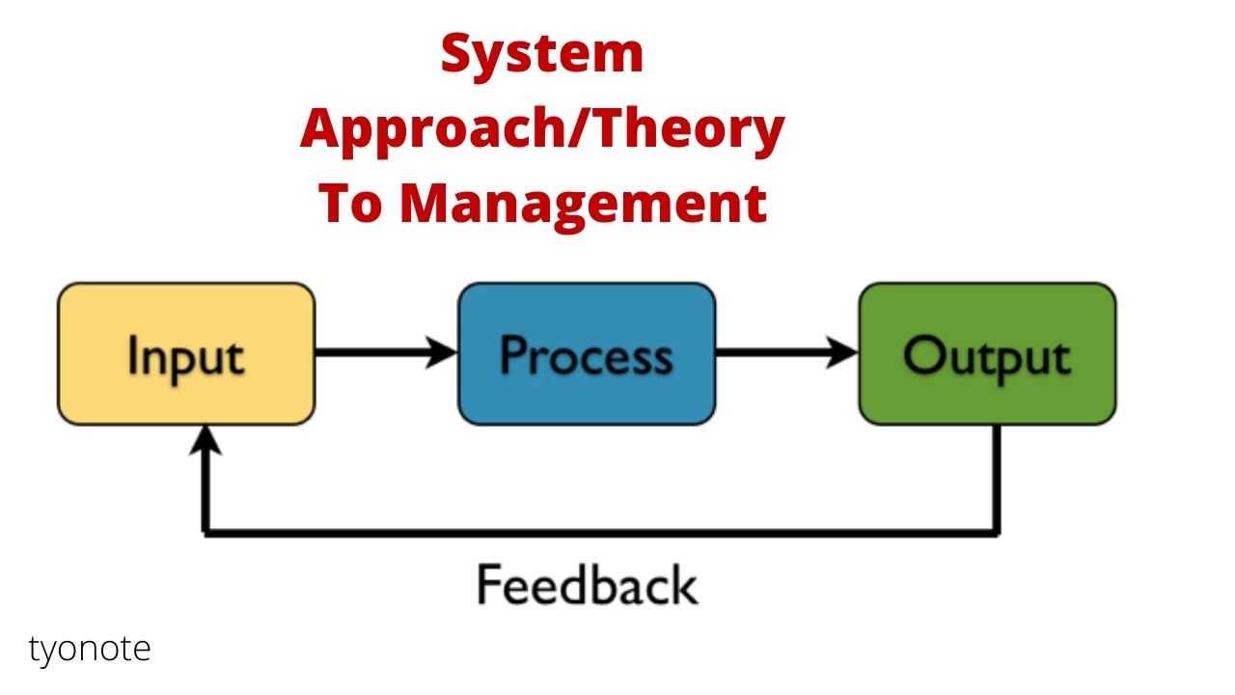
Figure 4: System management theory
(Source: Tyonote.com, 2023)
System management theory states that any organisation is a single operating system with a unified structure of subsystems. As opined by Alexakis and Jiang, (2019, p.210), each function is dependent on one another. The functions act optimally if conducted properly. The hospitality industry is looking into this theory so that it could manage resources and capital formation effectively. Also, the management and activities could be channelised in an efficient way.

2.3 Obstacles that the industry faced in operations
Increased operational costs: The foremost obstacle in the path of the hospitality industry is the hike in operational costs. The initial costs along with working costs have increased to such a level that it has raised the overall incurrence of the organisation towards the settling expenses.
Shortage in the number of workers: As discussed earlier that workers are not ready to work in the current pay scale. Hence, they are needing an increase in their pay which the industry should consider as a measure of inflation. Therefore, they have been leaving their jobs.
Communication between teams: As stated by Bowen and Morosan, (2018, p.726), communication between teams has become quite difficult due to diverse functions. The flow of information is experiencing blockage in the system because of the number of obligatory positions.
Labour and utilities cost rising: As stated by Ram, (2018, p.760), as a result of inflation, labour and utility costs have risen up. This has resulted in increased demands for the workers to raise salaries. Also, the utilities which are necessary for daily life have suffered a hike in price as well.

2.4 Outline the risk management strategy benefits in the industry
Increased range of opportunities: The risk management strategy entails an increase in opportunities for the business and workers. The resultant increase has been due to identified sources of potential risks.
Recognition and management of risk entity-wise: As depicted by Chervoni-Knapp, (2022, p.74) risk assessment takes place which helps in recognising the strategical approach to be applied. The entity could identify risks potently with the tools used and this further helps in managing change in the organisation.
Better quality data for decision-making: The assessed risk further is a criterion for taking better decisions. Since the risks are priorly identified, the necessary steps to deal with them are taken and hence, the procedure for taking a decision becomes easier (Johnston et al., 2012).
Teams remain focused: The teams remain focused because of clearly assigned tasks. It is stated that these could lead to the benefit of effective functions and increased productivity (Uk.linkedin.com, 2023).

2.5 Impact of COVID-19 and Brexit on the hospitality industry
Staff switching to other sectors: The pandemic brought fear for jobs and a decline in employment opportunities as well. As a result, the staff were encouraged to switch to other sectors. This created a condition decrease in staff numbers and slower work processes.
High price for hotel guests: Since the industry has been dealing with the problem of staff shortage, the hotels are paying higher salaries so that they could attract more of them. This has led to an increase in the prices charged to guests staying on hotel premises.
Increased expenses on wages and salaries: To employ workers, the industry has witnessed that most hotels are offering higher salaries and wages to staff and workers. This has increased the overall expenses of the organisations on wages and salaries.
Debt repayments: As stated by Ram, (2018, p.760), another impact states the debt payment procedures of the organisation in the hospitality industry. The stringent business during COVID-19 made the profit endowment lower and the industry is facing an acute shortage of funds for repayment.

2.6 Factors Leading to a Change in the retention process
Onboarding and training: To retain employees, the industry shall focus on providing onboard training to the workforce. This would further entail the benefit of increased information and knowledge about the job process. As described by Filimonau and Mika, (2019, p.357), it creates effectiveness and efficiency in operations as well.
People and culture: As opined by Alexakis and Jiang, (2019, p.210), the culture shall be protected at all costs. People belong to different cultures and backgrounds but work together in a collaborative place. Here distinct cultures shall be respected. The employees must be treated with a sense of respect.
Work-life balance: Most employees find a work-life balance which totally depends on the time duration. The organisations shall provide workers with proper time schedules so that they could manage other work and requirements.
Recognition of smaller achievements: The achievement of targets shall be recognised irrespective of the fact that they are small or big. These recognitions make the employees feel valued and justified.

2.7 Literature Summary
The provided literature review is a descriptive statement depicting the needs and changes in the hospitality industry which has taken place till now. The framed approaches and requirements by the organisations are discussed briefly to give a generalised idea of the said fact (Gallagher, 2016). The relevancy of the topic is shown with a proper listing of factors affecting the industry along with measurable benefits and transition steps.

2.8 Literature Gap
The research is based on purely secondary analysis. The secondary analysis deals with the idea of various authors, articles, journals, books, and literature reviews. The study lacks information about the factors that trigger the issues faced in the hospitality industry and eventually highlights the scope for future research.

2.9 Conceptual Framework
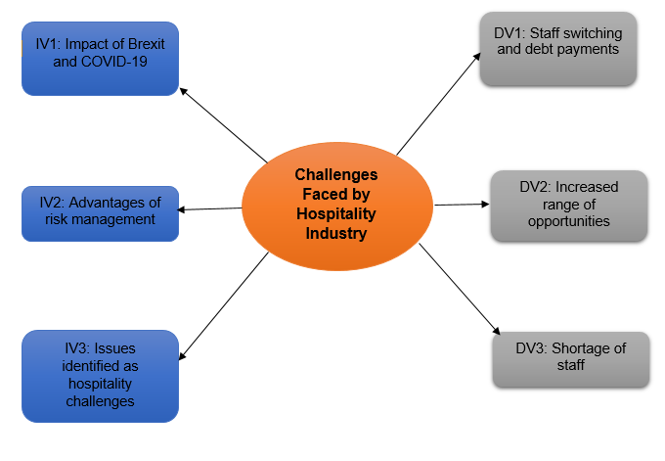
Figure 5: Conceptual Framework
(Source: Developed by the Learner)

3. Research Methodology

3.1 Research Philosophy
Research philosophy refers to the set of basic elements that guide the research design and the execution of the research process (Johnston et al., 2012). There are four types of research processes including interpretivism, realism, pragmatism and positivism. In this research process, the Interpretivism and Positivism process would be applied.

3.2 Research Approach
The research approach is the process of researchers collecting data and analysing the data (Torrington et al., 2020). The research approach is divided into three segments. Inductive, Deductive, and Abductive. In this research, the Deductive and Inductive approaches would be applied.

3.3 Research Strategy
Research strategy refers to the overall plan to conduct the research. It helps to monitor the research progress. Research strategy could be of two types. Qualitative and Quantitative (I.ytimg.com, 2023). In this research, both Quantitative and Qualitative research strategies would be implemented.

3.4 Research design
The research design is the overall strategy that has been chosen to integrate different components of the research. For this study, both Explanatory and Exploratory research designs would be applied (Torrington et al., 2020).

3.5 Data collection method
As the research would be based on both primary and secondary analysis. The Primary data collection method depends on primary sources like interviews, sampling and surveys. Where the secondary data collection method depends on the secondary sources which lie in articles, journals, case studies and ethical books regarding the research topic (Gallagher, 2016).

3.6 Data Analysis Method
As the research would be based on both primary and secondary methods, the data analysis would be both descriptive and thematic.

4. Ethical Consideration
This research is depending on authentic and validating data which are collected from trusted and genuine sources. The collected data are reliable and maintained by the Data Protection Act 2018 (Uk.linkedin.com, 2023), maintained by the UK government. The data collection process is free from any kind of unwanted interference and maintains all the legal data protection formality. This data collection process is verified and authentic with the genuine contribution of people.

5. Timeline
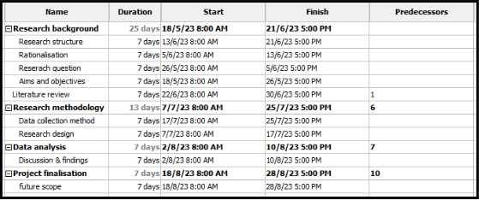

Figure 4: Gantt chart
(Source: Developed by the Learner)

6. Conclusion
In this context, the conclusion has been made on the challenges faced by the hospitality industry of the United Kingdom and a conclusion has also been made on the implication factors that have been applied to mitigate the challenges. Hotel Premier Inn has found loopholes in its strategies and made specific strategies to overcome the situation.

7. References
Websites
I.ytimg.com, 2023 Available at: https://i.ytimg.com/vi/zmKZoIHwCw4/maxresdefault.jpg (Accessed on May 10th 2023)
Premierinn.com, 2023, Available at: https://www.premierinn.com/gb/en/why.html (Accessed on May 10th 2023)
Statista.com, 2023, Available at: https://www.statista.com/statistics/511372/total-revenue-whitbread-united-kingdom-uk/ (Accessed on May 10th 2023)
Tyonote.com, 2023 Available at: https://tyonote.com/wp-content/uploads/2021/01/system_theory_of_management.jpg (Accessed on May 10th 2023)
Uk.linkedin.com, 2023, Available at: https://uk.linkedin.com/company/premier-inn (Accessed on May 10th 2023)
Journals
Alexakis, G. and Jiang, L., 2019. Industry competencies and the optimal hospitality management curriculum: An empirical study. Journal of Hospitality & Tourism Education, 31(4), pp.210-220. https://doi.org/10.1080/10963758.2019.1575748
Bowen, J. and Morosan, C., 2018. Beware the hospitality industry: the robots are coming. Worldwide Hospitality and Tourism Themes, 10(6), pp.726-733. https://doi.org/10.1108/WHATT-07-2018-0045
Chervoni-Knapp, T., 2022. The Staffing Shortage Pandemic. Journal of radiology nursing, 41(2), pp.74-75. https://www.sciencedirect.com/science/article/pii/S1546084322000311/pdf?md5=9a376cb0cd83994dabb796ef3f25a36c&pid=1-s2.0-S1546084322000311-main.pdf
Filimonau, V. and Mika, M., 2019. Return labour migration: an exploratory study of Polish migrant workers from the UK hospitality industry. Current Issues in Tourism, 22(3), pp.357-378. https://doi.org/10.1080/13683500.2017.1280778
French, S., 2018. Between globalisation and Brexit: Migration, pay and the road to modern slavery in the UK hospitality industry. Research in Hospitality Management, 8(1), pp.23-31. https://doi.org/10.1080/22243534.2018.1501185
Ram, Y., 2018. Hostility or hospitality? A review on violence, bullying and sexual harassment in the tourism and hospitality industry. Current Issues in Tourism, 21(7), pp.760-774. https://doi.org/10.1080/13683500.2015.1064364
Books
Gallagher, K. (2016) Essential study and employment skills for business and management students. Oxford: Oxford University Press. https://books.google.com/books?hl=en&lr=&id=eB_4CwAAQBAJ&oi=fnd&pg=PP1&dq=Gallagher,+K.+(2016)+Essential+study+and+employment+skills+for+business+and+management+students.+Oxford:+Oxford+University+Press.&ots=3LYtwOYd9Q&sig=2lhtRZZzm8J2Hf3VB3PqScjXkR4
Johnston, R. Clark, G. Shulver, M (2012). Service Operations Management, Pearson, London
Murton, A,. Inman, M., O’Sullivan, N. (2010) Unlocking Human Resource Management, Hodder Education http://rguir.inflibnet.ac.in/handle/123456789/8436
Torrington, D, Hall, L, Atkinson, C, & Taylor, S 2020, Human Resource Management PDF EBook, Pearson Education, Limited, Harlow. Available from: ProQuest Ebook Central.

