
Master of Business Administration
Module: Financial Management
Module code: LCMB7002
LEVEL 7 ASSESSMENT
Student Name: Shravan Nalumasu
Student ID:2432622
Lecture’s Name: Isaiah Oino
Term 1

Assessment component: Financial performance and management

Table of Contents
Introduction 5
1. Financial Health Check of General Electric 5
1.1 Introduction to Financial Analysis 5
1.2 Profitability Analysis 5
1.3 Liquidity Analysis 6
1.4 Efficiency and working capital ratios 6
1.5 Leverage and solvency analysis 7
1.6 Investment and market ratios 8
1.7 Cash flow Analysis 8
1.9 Summary 9
2. Working Capital Management Analysis 9
2.1 Introduction to Working Capital 9
2.2 Evaluation of Cash Operating Cycle 10
2.3 Assessment of Current Liquidity Position 11
2.4 Strategies for Improving Liquidity 11
2.5 Financing of Working Capital 11
3. Strategic Financial Restructuring Plan 12
3.1 Introduction to Financial Restructuring 12
3.2 Identification of Strategic Challenges 12
3.3 Recommended Restructuring Options 13
3.4 Impact Assessment 14
3.5 International and Ethical Considerations 15
3.6 Summary of strategic recommendations 15
4. Investment Appraisal and Capital Budgeting 16
4.1 Introduction to Investment Appraisal 16
4.2 Project Overview 16
4.3 Evaluation Using Quantitative Techniques 16
4.4 Risk Analysis 19
4.5 Capital Rationing, Final Investment Decision. 20
4.6 Strategic Justification 20
4.7 Final Investment Appraisal Conclusion. 20
5. Overall Conclusion 20
Reference List 22
Appendices 27
Appendix 1: Profitability ratio 27
Appendix 2: Liquidity Ratio 27
Appendix 3: Efficiency and working capital ratios 28
Appendix 4: Leverage and solvency ratios 28
Appendix 5: Investment and market ratios 29
Appendix 6: Cash flow analysis 29
Appendix 7 : Cash Conversion Cycle 30
Appendix 8: Investment Appraisal of Project A 31
Appendix 9: Investment Appraisal of Project B 31
Appendix 10: Investment Appraisal of Project C 31

Introduction
The following report will have an in-depth analysis of the overall financial health of the company, its working capital management, and the possibility of restructuring it. It looks at the key performance indicators used in evaluating the stability and growth potential of operations including profitability, liquidity, solvency, and efficiency. The analysis also examines the effectiveness of the company to use its current assets and liabilities to sustain both liquidity and operation balance. Moreover, it is also suggested that the organisational financial sustainability can be improved, investor confidence will be increased, and the future financial strategies need to be aligned with long-term business objectives.

1. Financial Health Check of General Electric

1.1 Introduction to Financial Analysis
The paper gives a thorough analysis of the five-year performance and stability of General Electric (GE) between 2020 and 2024 regarding their financial performance. GE is a foreign industrial conglomerate that trades in aviation, energy, healthcare, and renewable sectors (GE, 2025). The company has experienced massive reorganization in the process, disposing non-core business and re-strategic on high value industries. The main aim of the present financial analysis is to evaluate the profitability, liquidity, efficiency, solvency, attractiveness to investment and financial sustainability of GE.

1.2 Profitability Analysis
Profitability ratios will show how well GE has been able to make use of its revenue and capital base to make profits.
Gross Profit Margin (GPM) was 29 in 2024, 23 in 2023, 28 in 2022, 32 in 2021, and 29 in 2020. The fall in 2023 showed the cost pressure and reorganization cost, but the 29 percent recovery in 2024 shows the cost control and pricing strategy was improved. Nevertheless, the margin is still lower than pre-pandemic efficiency, which indicates the existence of unresolved inefficiencies in the production cost or the limitation of the supply chain.
Net Profit Margin (NPM) is also very unstable with net profit margin of -6% in 2024, -23% in 2023, 0% in 2022, 1% in 2021 and 6% in 2020. Continued net losses in the form of interest, restructuring costs and lower post-divestment revenues suggest continued negative margins in 2023-2024 [Refer to Appendix 1].
The trend of Return on Assets (ROA) and Return on Equity (ROE) is also similar. The negative net income had a drastic impact on the ROA, which reflected the low efficiency of the total assets used in generating returns. Similarly, the ROE became negative because the equity of shareholders had reduced through the losses (El-Chaarani and Abraham, 2022). These values show that the profitability position of the firm is still weak even though the gross margins have shown signs of recovery.

1.3 Liquidity Analysis
The liquidity analysis is used to determine how GE can pay for its short-term liabilities using its current assets.
The Current Ratio was 1.53-1.61 over the 5 years period, whereas the Quick Ratio was 1.03-1.15. Both ratios reveal the average but prudent liquidity position, i.e., GE has slightly higher current assets as compared with current liabilities. Current ratio of 1.5 and above is good short-term solvency, which means that the obligations will be paid without overreliance on any outside funds [Refer to Appendix 2].
The Quick Ratio without the inventory remained above 1.0 also demonstrated that the company has sufficient liquid reserves. Even though industry standards tend to indicate a 2:1 optimal current ratio, the fact that GE has always had stability in the 1.5 band indicates a balanced working capital strategy, which can be attributed to its large-scale industrial nature. The company seems to be able to handle short term liabilities effectively as the current assets are periodically varying.

1.4 Efficiency and working capital ratios
The efficiency ratios assess how GE uses its resources and liquidity to manage working capital.
Inventory Turnover Ratio was between -3.54 in 2024 and -3.19 in 2021 and the inventory days were between 99 to 131 days. These values are signs of low inventories movement which is an indication of traditionality of longer production cycle which is characteristic of industries that are capital intensive. Even though there are negative indicators in calculation that are reflected on the style of presentation, the underlying tendency is to point to a consistent, yet slow process of inventory conversion.
The Receivable Turnover Ratio decreased to 3.46 in 2024, which represents the growth of receivable collections days, previously being around 67 days (2020) and currently being around 105 days (2024). This decline is an indication that customers are paying after a long time, and it may limit liquidity given that it is not carefully handled.
Payable Period has gone up by decreasing the time to pay by a factor of 99 days in 2020 to 66 days in 2024, i.e. GE is paying off with more speed. Although it can improve the relationship with suppliers, it decreases the cash reserves within the short-term perspective [Refer to Appendix 3].
The most important efficiency indicator is Cash Conversion Cycle (CCC), which stood at approximately 68-76 days, which means that GE spends more than two months to turn its investments in inventory and receivables into cash. The length of the cycle is stable but indicates that the working capital efficiency has not improved much.

1.5 Leverage and solvency analysis
Solvency ratios measure the ability of GE to cover its long-term financial obligations and debt.
The Debt-to-Equity Ratio rose in 2022 (0.7) to 2024 (1.1), which means that, on each dollar of equity, GE has a debt amount of about 1.10. On the same note, Debt Ratio (Debt/Total Assets) increased in 2024 to 0.53 compared to 2023, which is a reaffirmation that more than half of the assets of GE are financed using debt [Refer to Appendix 4].
This increase in leverage indicates increased dependence on borrowed funds by the company and could be an indication of the restructuring or the need to maintain operations when profitability is low. On the other hand, the Equity Ratio decreased in 2024 by 0.47 as compared to 0.54 in 2021 indicating a reduced equity base because of accruing losses.

1.6 Investment and market ratios
Investment ratios bring to the fore investor perception and attractiveness of the company in the capital market.
Since 2023, the value of Earnings per Share (EPS) has been negative (22.6 in 2024, -75.1 in 2023) following a positive value in 2021-2022. This shows that its shareholders are losing value because of net losses. The Price/Earnings (P/E) Ratio became negative as well during these years and this is the indication of the lack of real earnings to be used in valuation (Sam, 2025) [Refer to Appendix 5].
EPS fluctuations and P/E indicate low investor confidence, and the share price performance of GE is highly volatile in the market. The negative earnings will discourage the dividend payments, as well as the ability to reinvest. The P/E ratios were on the one hand relatively stable in the years before (2020-2021), whereas the current decline indicates that the market is not optimistic about profitability in the near-term perspective.

1.7 Cash flow Analysis
Cash flow ratios help to know how sustainability of liquidity goes beyond accounting profits.
Mobility between Operating Cash Flow (OCF) and Current Liabilities was 0.09 to 0.18 and Operating Cash Flow to Debt Ratio was very low (approximately 0.0006-0.0046). These values show that although GE is still having a positive cash flow after operations, the value is not enough to pay off all its debt easily.
However, the company has been operating with a positive operating cash flow although it has negative net income, and this indicates that non-cash expenses (such as depreciation) and working capital modifications have cushioned its liquidity. The increasing trend of the OCF/CL ratio indicates that the company is managing its cash well in 2024 than it was managing it before in previous years.
The Altman Z-Score Model could be used to determine the possible risk of default by using the working capital, retained earnings, EBIT, equity, and sales of GE. Since GE has a moderate leverage level and a history of net losses, the hypothetical Z-score of the company would most likely fall in the so-called grey zone (1.81-2.99), which implies that this firm is not close to financial health, but the situation is not critical [Refer to Appendix 6].

1.9 Summary
The financial analysis shows that it is very profitable, its liquidity is steady, and it manages its assets well. A balance between financing is supported with moderate gearing, whereas operational sustainability is supported through consistent cash flow. There are however threats such as possible pressure on the profit margin, slacken receivable turnover, and increasing debt dependency which might pose threats to financial stability in the future unless it is competently handled.

2. Working Capital Management Analysis

2.1 Introduction to Working Capital
Efficient working capital management can be defined as effective management of current assets and current liabilities so that a business has a sufficient amount of liquidity so as to pay current liabilities and at the same time use its resources in the most economical way. It is concerned with cash, inventories, and receivables management to maintain a smooth operation of the company and prevent liquidity crisis. Working capital management ensures that idle money is minimized, the cost of financing is low as well as profitability as working capital increases the efficiency of conversion of resources into cash. There must be a proper balance between profitability and liquidity where a large amount of working capital results to inefficiency whereas a small amount of working capital can lead to havoc. It is also important in enhancing cash, as well as operational resilience in times of market fluctuations. The role of the working capital management in terms of liquidity restoration and operational performance enhancement is crucial in the situation of General Electronics to address the financial issues and help the company to survive in a competitive world.

2.2 Evaluation of Cash Operating Cycle
Cash Conversion Cycle (CCC) Analysis Calculation
The Cash Conversion Cycle (CCC) is the efficiency or ability of the company to transform its investments in inventory and receivables into a cash flow (Ishikawa, GEMBA and Oda, 2024).
- General Electronics has indicated CCC of about 68.78 days in 2024 which is slightly higher than 68.55 days in 2023 indicating some slight worsening in liquidity efficiency.
- Inventory Days was showing negative values that showed that there might be overestimation of inventory or something was wrong with the production and turnover control.
- The Receivable Days improved at a gradual pace, as in the previous 97.7 days it had been 105.5 days indicating that the company was receiving slow payment in turn, limiting cash inflows.
- Payable Days went down a bit to 66.36 and this is an indication that the company is releasing its money to the suppliers sooner, which is putting a strain on the cash reserves.
In general, the CCC trend suggests longer cash conversion times, i.e. the funds remain longer in activities, resulting in the lack of access to the short-term liquidity, and influences the working capital efficiency. [Referred to Appendix 7]
Evaluation of Existing Liquidity Position
The change in liquidity position of General Electronics shows that it is under stress and the trend shows increased receivables and decreased payable days prove the situation is not good any longer and needs urgent actions to improve liquidity through efficient collection methods, access of supplier payments and inventory optimization. The liquidity position has not been only tense but also shows that the firm is unable to increase its liquidity in terms of cash receivables and reduction in days payable as indicated by supplier payment and increasing working cash days (Karim, Shetu and Razia, 2021). To improve the liquidity position, the company must adopt efficient collection processes, changes to supplier payment terms and optimization Enhanced cash forecast and working capital discipline are paramount in making sure that there is sustainable liquidity recovery and continuity in operations.

2.3 Assessment of Current Liquidity Position
The working capital position of the company is an indication of the capacity to pay the short-term bills and enables the company to continue with its operations. Current ratio and quick ratio give the general account of solvency within a short period, and both the values are above 1.0, which depicts that it has sufficient liquidity (Blessing and Sakouvogui, 2023). This will show that the company has enough current assets including cash, receivables, and inventories to meet the immediate liabilities. The fact that the quick ratio, less the inventories, narrates that the liquidity of the firm is backed by liquid assets and not stockpiles indicates that there is wise management of cash flows (Ugwu et al., 2021). The efficiency indicators including the receivables collection period, inventory turnover and cash conversion cycle indicate that though the company manages its short-term resources in an efficient manner, there is still some room to be improved.

2.4 Strategies for Improving Liquidity
The firm can employ both financial and operational strategies to increase its liquidity. Cash inflows can be increased by reducing the period of the collection of receivables by means of tightening credit policy, providing early payment discounts, or the introduction of electronic invoicing systems. Just-in-time (JIT) or demand forecasting systems should be used to keep a close eye on the inventory to minimize overstocking and lower the cost of storage (Ogunyankinnu et al., 2024). Lengthening of the payables period through negotiations of longer credit terms with the suppliers can be used to save the short-term cash. Responsiveness to changes in cash flow can also be enhanced by enhancing internal cash controls such as automated payment scheduling and real time liquidity tracking.

2.5 Financing of Working Capital
The working capital financing approach used by the company should provide a balance between the cost, flexibility, and risk. Other short-term sources of finance, including overdrafts, trade credit, and invoice factoring, are flexible and simple to obtain cash but when abused it can be very expensive. Supplier trade credit offers a cheap source of finance, although excessive use might put pressure on relations (Ahsan et al., 2023). On the other hand, long-term sources of finance such as term loans, retained earnings or debentures are more stable in meeting larger working capital requirements but come with higher interest and repayment requirements. The current moderate gearing of this firm would indicate that it would be wise to depend on internal funding and short-term facilities to provide more seasonal liquidity requirements, as opposed to long-term borrowing.

3. Strategic Financial Restructuring Plan

3.1 Introduction to Financial Restructuring
The brand of GE needs to be restructured through the consideration of the financial landscape in order to get itself back on track in regard for profitability as well as excessive leverage and liquidity. The most important goal in this context would be to stabilise the structure of capital, restore confidence of investors and establish a long-term global competitiveness along with an ethical financial growth base.

3.2 Identification of Strategic Challenges
It can be noted and identified that GE is in a dire financial state, as seen by failures in revenues and the drop in efficiency of its assets. The factor in this case of severe profitability loss is also illustrated by the fact that net income fell to £ 98,238 million and more than £24 million in 2023 and 2024, respectively. In this case, the operating income also worsened by a loss of £15,297 million in 2024 compared to £37,267 million in 2020 as the sales decreased in a considerable manner and the operating expenses thereby increased.
Liquidity has further deteriorated in a drastic manner, and it is now £26,783 million, as compared to £66,740 million which was present in 2022, indicating poor cash burn and weak working capital management. On the other hand, over-reliance on short-term funding, such as £36,960 million of lines of credit in 2024, is indicative of over-leverage and a lack of flexibility in funding.
Inventory, though less than it was in 2022, is still high, and it is holding up the cash and restricting cash flow. These trends, together with aspects such as inflation in the global landscape, fluctuations in exchange rates and the fall in consumer demand highlight unsustainable operations (Arkadeva, Berezina and Arkadev, 2022). General Electronics is facing the risk of surviving pressure, investor loss and strategy loss unless radical restructuring is undertaken.

3.3 Recommended Restructuring Options
Restructuring Option | Description | Feasibility | Long-Term Implications
Divestiture | Disposal of non-core or underperforming assets to free up cash and streamline operations. | Highly feasible in the short term if assets have market demand; may face valuation or buyer constraints. | Improves liquidity and focus on core business but may reduce diversification and future revenue potential (Xie et al., 2022).
Merger or Acquisition (M&A) | Combining with or acquiring another firm to achieve economies of scale and market expansion (Blessing and Sakouvogui, 2023). | Moderately feasible; depends on regulatory approval, cultural compatibility, and financing capacity. | Can create synergies and competitive advantage, but integration risk and cultural mismatch may reduce effectiveness.
Equity Injection or Debt Refinancing | Raising capital through new equity or restructuring existing debt to reduce interest burden. | Feasible if investor confidence and market conditions are favourable. | Strengthens balance sheet and solvency, though equity dilution or extended debt maturity may affect returns (Oyeyipo et al., 2023).
The restructuring strategy which would be the most feasible are required to strike a balance between the requirements based on short-term liquidity and long-term development and also involves the refocus strategy (Moridu and Abidin, 2023). This has the ability to be achieved by a quick sale of assets; however, over-selling assets might result in undermining future operational potential. A merger or acquisition has the prospect of strategic expansion and cost-effectiveness and required to be diligence towards discourage issues of integration and regulatory hurdles. This is because equity injection or debt refinancing is a way of increasing stability in financial aspects by improving adequacy of capital and reducing risks of financial distress (Han, 2025).
However, new equity will reduce the value of the existing shareholders whereas refinancing will focus on pushing the obligations into future. The best reorganization strategy might be considered to be a combination of selective divestiture for the purpose of achieving liquidity in a better manner, and debt refinancing for achieving better solvency (Akinsola and Kingsley Onu, 2025). This combined strategy focuses on ensuring the short-term relief and competitiveness based on long-term aspects and the preservation of investor confidence and promoting the principles of sustainable financial management.

3.4 Impact Assessment
Criteria for Initiative | Shareholder Value | Debt Structure | Operational Flexibility | Strategic/Brand Impact | Regulatory & Ethical Compliance
Divestiture of Non-Core Assets | Medium | High | High | Medium | Medium
Merger or Acquisition | High | High | Medium | High | High
Equity Injection | Medium | Medium | High | High | Medium
Debt Refinancing | Medium | High | Medium | Medium | High
Working Capital Reforms | High | Medium | High | Medium | Medium
Cost Efficiency Programs | High | High | High | Medium | Medium
The analysis of impact, which has been done, in this case, indicates that the restructuring efforts will help create resiliency through the financial area and operational agility to a large degree. Immediate liquidity is offered by the dispossession as well as the cost-efficiency programs, and leverage is minimised, which enhances the debt ratios and the confidence of shareholders (Kingsley, 2023). Acquisitions or mergers bring about strategic scale benefits, but integrating with and complying with them is risky.
On the other hand, equity injections and refinancings help increase solvency and capital flexibility, but at the expense of shareholder value in the short run (Friewald, Nagler and Wagner, 2022). Liquidity and efficiency gains can also be sustainable through the working reforms of capital. On the whole, the joint actions can help GE under a balanced profitability as well as solvency, and ethical compliance, which allows the company to recover, to regain the trust of investors, and to be more competitive in unstable international markets.

3.5 International and Ethical Considerations
Financial restructuring of international role has to reflect the provisions of cross-border taxation, transfer prices, and profit re-patriation, while these issues affect the cash flows which is following the restructuring along with the overall profitability. The currency issue is one of the most important issues where commitments of revenue and debt are based on various currencies (Coppola, Krishnamurthy and Xu, 2023). Through proper hedging and using forward contract, the volatility can be resolved. Also the real value of returns, cost of capital, and purchasing power is impacted by the sensitivity of inflation which helps in necessitating the adaptive pricing and cost-control systems.
Ethically and following CSR, transparency and fair treatment of employees and creditors are required to be the foremost priority of restructuring, and it should not be aligned with exploitative cost-cutting (Akinsola, 2025). Accountable borrowing, fair interaction of stakeholders and compliance with the goals of sustainability will focus on ensuring that financial restructuring (Efunniyi et al., 2024). This will not only recover fiscal stability along with the methods of corporate integrity and social aspects in the long-term aspects.

3.6 Summary of strategic recommendations
The financial restructuring proposed will help to build a strong liquidity position, efficiency of capital and increases profitability in the long run. The company will be able to maintain financial stability by maximising the working capital, decreasing the reliance on short-term debt, and digitalizing cash flow management. It will also be ensured that short-term actions are aligned to long-term growth goals through strategic cost control, reinvestment in high-return projects and an optimum capital structure. Moreover, improved supplier and customer relations will help in increasing the resilience of operations (Faruquee et al., 2021). Taken together, these efforts will put the company in a sustainable growth, higher shareholder value and increased flexibility in a dynamic business environment.

4. Investment Appraisal and Capital Budgeting

4.1 Introduction to Investment Appraisal
Investment appraisal can alternatively be referred to as capital budgeting which is a vital task in finances in which the profitability and feasibility of long-term investments are put into consideration (Kraus, Kappl and Schlegel, 2024). Its main aim is to assist the organizations in the allocation of capital so that the resources are invested in the project that are likely to maximize the shareholder values. Through Net Present Value (NPV), Internal rate of return (IRR), Payback Period (PBP) and Accounting rate of return (ARR), firms are able to evaluate risk, timing of cash flow and returns potential. In the case of General Electronics, the investment appraisal is fundamental in bringing back strategic recovery, to make the most out of the little capital, and to build financial sustainability in the long term.

4.2 Project Overview
Under capital rationing, General Electronics has considered three suggested investment projects, namely A, B and C.
- Project A is an initial investment of £40 million which will bring an annual inflow of between 10 million to 8 million in the next five years.
- Project B entails an investment of 30 million, which has a steady inflow of 6 million every year over a span of five years.
- Project C requires the largest investment of 50 million pounds, and its inflows will be rising slowly between 5 million and 25 million.
The scale, profitability, and risk of these projects are different and thus will need to be analyzed using Payback Period, ARR, NPV, PI, and IRR to come up with the best combination of investments to be undertaken with given budget of £60 million.

4.3 Evaluation Using Quantitative Techniques
Project A: Moderate-Return and High-Investment Project
Payback Period (PBP):
Project A, which has a start-up capital investment of £40 million, takes a payback period of four years. This fairly moderate payback is a sign that the project can restore its investment in the period within which the project is operating and as a result the project is fairly liquid in comparison to other projects (Karda, Nagy-György and Boros, 2023).
Accounting rate of Return (ARR):
The ARR of Project A indicates a reasonable profitability ratio as evidenced by the average profit of the accounting of annual growths of the stable inflows of the project at around £810 million. Even though it is not the best, it implies fair operational efficiency and yielding returns.
Net Present Value (NPV):
The NPV of Project A indicates that the discounted cash inflows of the project are better than the initial outlay. This supports its ability to provide shareholders with value albeit the overall magnitude of NPV is medium with minimal excess returns.
Profitability Index (PI):
Any PI of slightly over 1.0 confirms that Project A will produce slightly more value than it will cost, and hence a viable, but not a very profitable alternative the capital constraints.
Internal Rate of Return (IRR):
Project A will be profitable, as its IRR is relatively high and above the cost of capital of the company. Nevertheless, the incremental value of the project is relatively low, which implies the low risk but low aggressiveness of development. [Referred to Appendix 8].
Project B: Low-Investment, Steady-Return Project
Payback Period (PBP):
The payback period of project B is around 5 years which is congruent with the total period. This implies that it promotes low liquidity and retards quicker capital recovery in that even at the expiry of its operating life it has recovered the initial £ 30 million.
Accounting Rate of Return (ARR):
Project B has a relatively low ARR which means that its profitability is low. Although the inflows remain constant at to 6 million each year, the project does not have high earnings leverage and has low accounting returns.
Net Present Value (NPV):
Project B has a slight NPV which is at or near break-even. Despite the fact that this will result in minimal shareholder value addition, the fact that the discount adjusted surplus is low means that to the overall profitability of the company, it might not be a significant contribution (Standaert and Ethgen, 2023).
Profitability Index (PI):
The PI of nearly 1.0 indicates that the Project B would barely be viable with capital rationing. The returns are just enough to cover the investment and this explains the conservative yet low risk project structure.
Internal Rate of Return (IRR):
IRR is 0% to the cost of capital of the firm that implies that the project just covers the required minimum return. It shows a sense of security and stability but does not have the strategic edge required to overcome the financial transformation (Kulakov and Blaset, 2020). [Referred to Appendix 9].
Project C: Project in investor with high growth
Payback Period (PBP):
The payback period of project C is elongated because it has a 50 million initial cost and will not receive an inflow quickly. The returns increase rapidly in late years, which shows that it is slow in profitability and original risk.
Accounting rate of Return (ARR):
The ARR of Project C enhances as time goes by, which is in line with growing inflows between 5 million pound and 25 million pounds. This is an indication of good long-term earning capacity even though it has been slower to start.
Net Present Value (NPV):
Project C is the one that presents the greatest NPV which is 4.23 of all, and it is, therefore, quite good value creating. This has been pushed by increasing cash flows which bring high discounted returns thus it is the most financially appealing project in the long-term growth circumstances (Le, 2021).
Profitability Index (PI):
A PI which is much greater than 1.0 is one which shows high investment efficiency. Project C (being highly risky) has much higher returns than others per £1 invested, and warrants strategic importance.
Internal Rate of Return (IRR):
Project C has a significant IRR in comparison with the cost of capital of the company, indicating that it is profitable and stable. Nonetheless, it means that the volatility of cash flows is higher, which also assumes that the financial and operational risk is also elevated. [Referred to Appendix 10].

4.4 Risk Analysis
There is a difference in the extent of cash flow volatility and sensitivity of the market as indicated by the three-risk assessment of the projects. It is not a high-risk Project A whose inflows are relatively stable and deviation of returns projected by the project are punched thus robust to minor modifications in the markets. Project B is unstable but low profitability nature which means that any minor unfavourable changes in discount rates would make it unestablished. The project C, however, is very sensitive concerning the changes in discount rate because the initial outlay is enormous and deferred carry, which has inflows (Kulakov and Blaset, 2020). It however counters such risks with its long term returns that makes it a high-reward maybe high project even during good economic times. With higher discount rate assumptions meaning greater reliability as observed in scenario testing, projects A and C have a positive NPV.

4.5 Capital Rationing, Final Investment Decision.
This is due to the fact that according to the evaluation imposed by the constraint of budget of 60 million, investment is crucial in terms of priority. Using the NPV and PI rankings, Projects A and C have been rated higher than Project B on the basis of the value creation of the project. The average returns and religious recovery of Project A complements the profitability and strategic growth opportunities of the Project C, which is high. Their team investment is (40 20) million and this can easily live within the budget and has a better aggregate NPV and profitability that any single project choice. By so doing, the Projects A and C would ensure the best option of capital and long-term financial gain.

4.6 Strategic Justification
General Electronics will currently be trying to regain profitability and liquidity efficiency. The combination of both Projects A and C is in accordance with this objective: Project A will contribute to boosting the liquidity level in the short-term perspective since the inflows will be stable, and Project C will boost long-term profitability and shareholder value. This is a risk mix combined with a period to cash flow and a high likelihood of returns that makes its operations a resilient and financially sustainable entity.

4.7 Final Investment Appraisal Conclusion.
In general, the comparative analysis confirms the fact that the combination of the most suitable strategic and financial options is found in Projects A and C. This will ensure that NPV and IRR is maximized and exposures to risk are at manageable levels to ensure that General Electronics can obtain liquidity stability and sustainable profitability within its capital limits.

5. Overall Conclusion
The firm has a good financial standing with equally stable profitability, effective use of assets, and moderate leverage. The management of working capital is satisfactory, which facilitates the operation of the company and maintenance of liquidity. It has been suggested that the financial restructuring can be viable, and it is also strategic because of its increased flexibility and long-term stability. The potential of investment is enhanced by the stable trend of cash flow and profitable results, but there are external risks that must be monitored including the fluctuation of the market and debts.

Reference List
Ahsan, T., Mirza, S.S., Gull, A.A. and Majeed, M.A., (2023). How to deal with customer and supplier concentration to attain sustainable financial growth? The role of business strategy. Business Strategy and the Environment, 32(7), pp.4600-4619. https://onlinelibrary.wiley.com/doi/pdfdirect/10.1002/bse.3383
Akinsola, K., (2025). The Influence of Legal Counsel in Shaping Corporate Governance and Ethical Financial Reporting Practices. Available at SSRN 5125893. https://papers.ssrn.com/sol3/Delivery.cfm?abstractid=5125893
Akinsola, O.K. and Kingsley Onu, D.Y.O., (2025). Legal Implications of Corporate Spin-Offs, Divestitures, and Corporate Restructuring: Key Considerations for Business Leaders and Legal Counsel. https://www.researchgate.net/profile/Beauden-John/publication/388659649_Legal_Implications_of_Corporate_Spin-Offs_Divestitures_and_Corporate_Restructuring_Key_Considerations_for_Business_Leaders_and_Legal_Counsel/links/67a19499645ef274a4664f72/Legal-Implications-of-Corporate-Spin-Offs-Divestitures-and-Corporate-Restructuring-Key-Considerations-for-Business-Leaders-and-Legal-Counsel.pdf
Arkadeva, O., Berezina, N. and Arkadev, M., (2022). Inflation Targeting under Global Trends Exposure. In Proceedings of the International Scientific-Practical Conference" Ensuring the Stability and Security of Socio-Economic Systems: Overcoming the Threats of the Crisis Space"–SES (pp. 33-37).https://www.scitepress.org/Papers/2021/106820/106820.pdf
Blessing, H. and Sakouvogui, G., (2023). Impact of liquidity and solvency ratios on financial performance: a comprehensive analysis. Indonesia Auditing Research Journal, 12(3), pp.102-115. http://journals.iarn.or.id/index.php/ARJ/article/download/208/141
Blessing, H. and Sakouvogui, G., (2023). Impact of liquidity and solvency ratios on financial performance: a comprehensive analysis. Indonesia Auditing Research Journal, 12(3), pp.102-115. http://journals.iarn.or.id/index.php/ARJ/article/download/208/141
Coppola, A., Krishnamurthy, A. and Xu, C., (2023). Liquidity, debt denomination, and currency dominance (No. w30984). National Bureau of Economic Research. https://www.aeaweb.org/conference/2024/program/paper/rzTY657n
Efunniyi, C.P., Abhulimen, A.O., Obiki-Osafiele, A.N., Osundare, O.S., Agu, E.E. and Adeniran, I.A., (2024). Strengthening corporate governance and financial compliance: Enhancing accountability and transparency. Finance & Accounting Research Journal, 6(8), pp.1597-1616. https://www.researchgate.net/profile/Angela-Abhulimen/publication/383860258_1597-1616_4_Nigeria_Inter-bank_Settlement_System_Plc_NIBSS_5_Zenith_General_Insurance_Company_Limited_Nigeria_6_International_Association_of_Computer_Analysts_and_Researchers/links/66ddaa822390e50b2c769a8e/1597-1616-4-Nigeria-Inter-bank-Settlement-System-Plc-NIBSS-5-Zenith-General-Insurance-Company-Limited-Nigeria-6-International-Association-of-Computer-Analysts-and-Researchers.pdf
El-Chaarani, H. and Abraham, R., (2022). The impact of corporate governance and political connectedness on the financial performance of Lebanese banks during the financial crisis of 2019–2021. Journal of Risk and Financial Management, 15(5), p.203. https://www.mdpi.com/1911-8074/15/5/203/pdf
Faruquee, M., Paulraj, A. and Irawan, C.A., (2021). Strategic supplier relationships and supply chain resilience: is digital transformation that precludes trust beneficial?. International Journal of Operations & Production Management, 41(7), pp.1192-1219. https://sussex.figshare.com/articles/journal_contribution/Strategic_supplier_relationships_and_supply_chain_resilience_is_digital_transformation_that_precludes_trust_beneficial_/23492213/1/files/41200427.pdf
Friewald, N., Nagler, F. and Wagner, C., (2022). Debt refinancing and equity returns. The Journal of Finance, 77(4), pp.2287-2329.https://onlinelibrary.wiley.com/doi/pdfdirect/10.1111/jofi.13162
Han, W., (2025). The Practice and Strategy of Capital Structure Optimization under the Background of the Financial Crisis. European Journal of Business, Economics & Management, 1(2), pp.8-14. https://pinnaclepubs.com/index.php/EJBEM/article/download/145/147
Ishikawa, T., GEMBA, K. and Oda, T. (2024). The influence of cash conversion cycle on profitability: a quantitative analysis of Japanese software firms. Access Journal - Access to Science, Business, Innovation in the digital economy, [online] 6(1), pp.84–102. https://journal.access-bg.org/journalfiles/journal/issue-6-1-2025/the_influence_of_cash_conversion_cycle_on_profitability.pdf.
Karda, S., Nagy-György, T. and Boros, I. (2023). Evolution of the Payback Period for Energy-Efficient Residential Buildings in Romania in the Last Decade. 15(11), pp.8986–8986. https://doi.org/10.3390/su15118986.
Karim, Md.R., Shetu, S.A. and Razia, S. (2021). COVID-19, liquidity and financial health: empirical evidence from South Asian economy. Asian Journal of Economics and Banking, [online] ahead-of-print(ahead-of-print). https://www.emerald.com/insight/content/doi/10.1108/AJEB-03-2021-0033/full/html.
Kingsley, P.K.M., (2023). Analysing the Efficiency of Private Placements and Capital Markets in Terms of Cost Comparing the Cost Efficiency of Private Placements and the Capital Markets. https://papers.ssrn.com/sol3/Delivery.cfm?abstractid=4905535
Kraus, P., Kappl, J. and Schlegel, D. (2024). To invest or not to invest in digital initiatives? An exploratory examination of procedures, evaluation criteria and barriers. Digital transformation and society. [online] https://www.emerald.com/insight/content/doi/10.1108/DTS-02-2024-0004/full/html.
Kulakov, N. and Blaset, A. (2020). Rehabilitation of the Internal Rate of Return. SSRN Electronic Journal. [online] https://papers.ssrn.com/sol3/Delivery.cfm/SSRN_ID3593173_code2221094.pdf?abstractid=3593173&mirid=1.
Le, S. (2021). The Applications of NPV in Different Types of Markets. [online] www.atlantis-press.com. https://doi.org/10.2991/assehr.k.211209.171.
Moridu, I. and Abidin, Z., (2023). Adapting financial management strategies amidst economic turmoil: a case study of gama corporate's liquidity and restructuring initiative. The Eastasouth Management and Business, 2(01), pp.34-42. https://esj.eastasouth-institute.com/index.php/esmb/article/download/137/109
Ogunyankinnu, T., Osunkanmibi, A.A., Onotole, E.F., Ukatu, C.E., Ajayi, O.A. and Adeoye, Y., (2024). AI-Powered Demand Forecasting for Enhancing JIT Inventory Models. https://www.researchgate.net/profile/Anfo-Pub-2/publication/391628002_AI-Powered_Demand_Forecasting_for_Enhancing_JIT_Inventory_Models/links/681f2fd5d1054b0207edf490/AI-Powered-Demand-Forecasting-for-Enhancing-JIT-Inventory-Models.pdf
Oyeyipo, I., Attipoe, V., Mayienga, B.A., Onwuzulike, O.C., Ayodeji, D.C., Nwaozomudoh, M.O., Isibor, N.J. and Ahmadu, J., (2023). A conceptual framework for transforming corporate finance through strategic growth, profitability, and risk optimization. International Journal of Advanced Multidisciplinary Research and Studies, 3(5), pp.1527-1538. https://www.multiresearchjournal.com/admin/uploads/archives/archive-1742807323.pdf
Sam, R., (2025). How to Adjust the P/E Ratio for Earnings Growth in Equity Valuation: PEG or PPP?. E Ratio for Earnings Growth in Equity Valuation: PEG or PPP. https://papers.ssrn.com/sol3/Delivery.cfm?abstractid=5241650
Standaert, B. and Ethgen, O. (2023). Discounting health gain: a different view. Journal of Market Access & Health Policy, [online] 11(1). https://pmc.ncbi.nlm.nih.gov/articles/PMC10627044/.
Ugwu, I.V., Ekwochi, E.A. and Ogbu, C.G., (2021). Logical consequence of liquidity management on firm profitability. IJAMSR, 5, pp.265-279. https://www.researchgate.net/profile/Ekwochi-Adaeze/publication/352065048_Logical_Consequence_Of_Liquidity_Management_On_Firm_Profitability/links/60b7f6dba6fdccb96f4d81ef/Logical-Consequence-Of-Liquidity-Management-On-Firm-Profitability.pdf
Xie, Z., Liu, X., Najam, H., Fu, Q., Abbas, J., Comite, U., Cismas, L.M. and Miculescu, A., (2022). Achieving financial sustainability through revenue diversification: A green pathway for financial institutions in Asia. Sustainability, 14(6), p.3512. https://www.mdpi.com/2071-1050/14/6/3512

Appendices

Appendix 1: Profitability ratio
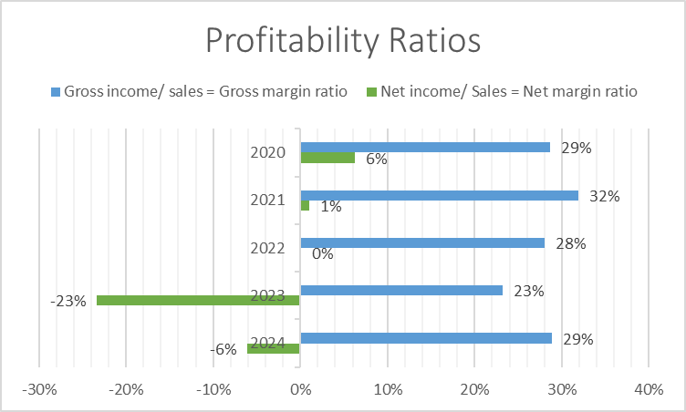

Appendix 2: Liquidity Ratio
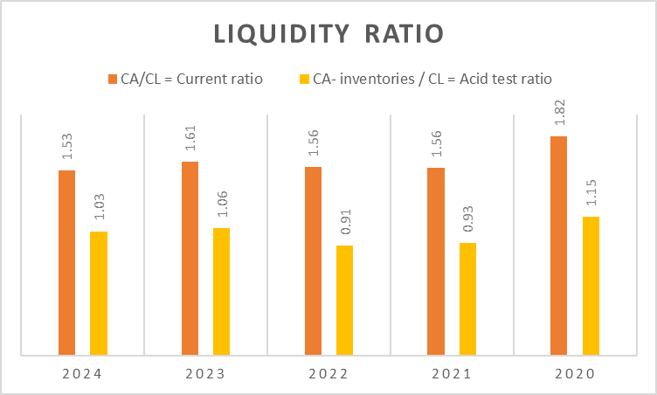

Appendix 3: Efficiency and working capital ratios
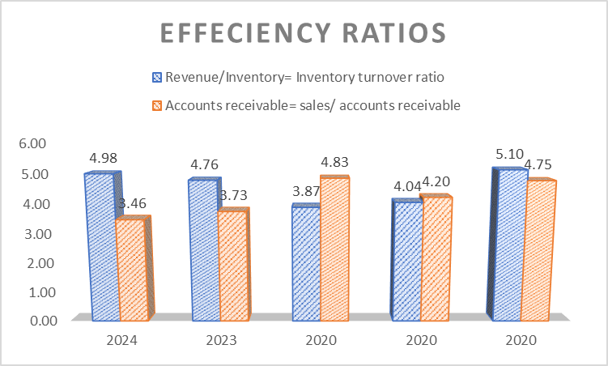

Appendix 4: Leverage and solvency ratios
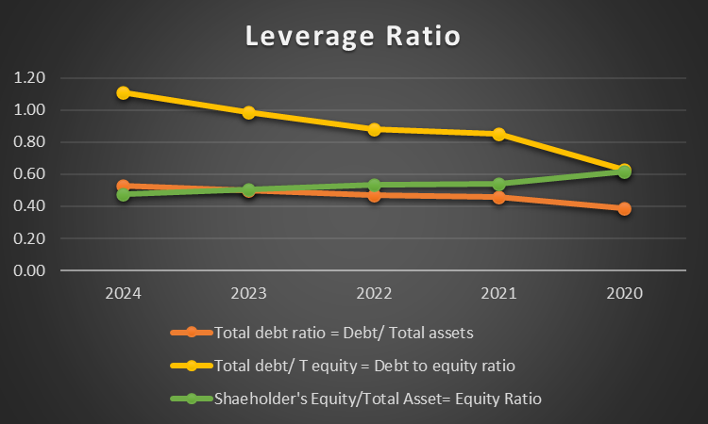

Appendix 5: Investment and market ratios
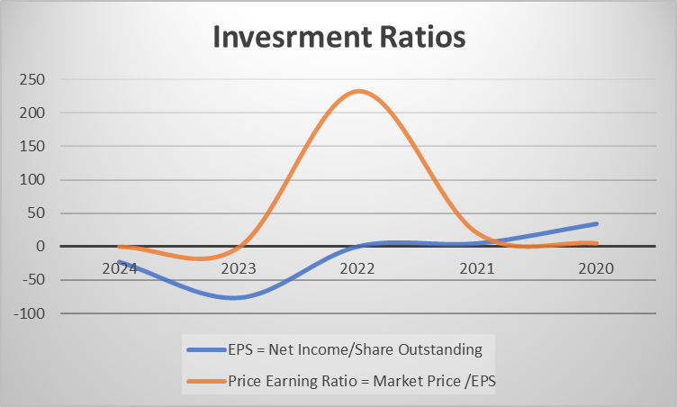

Appendix 6: Cash flow analysis
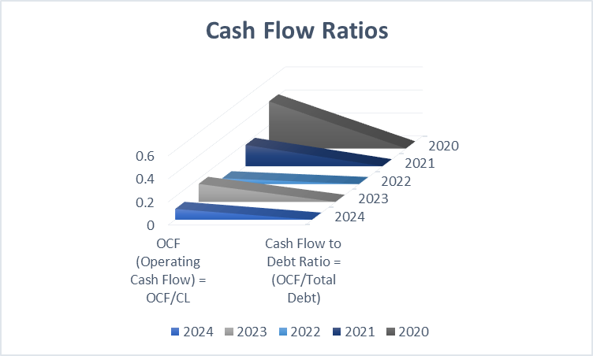

Appendix 7 : Cash Conversion Cycle
Ratio | 2024 | 2023 | 2022 | 2021 | 2020
Cost of Sales | -2,80,885 | -3,22,897 | -3,90,459 | -4,28,586 | -4,38,424
Average Inventory | 79,355 | 88,273 | 1,40,181 | 1,34,469 | 1,20,430
Sales | 3,94,879 | 4,20,457 | 5,42,751 | 5,42,751 | 6,14,680
Accounts Receivable | 1,14,182 | 1,12,596 | 1,12,346 | 1,29,215 | 1,29,433
Inventory Turnover = Cost of Sales / Average Inventory | -3.54 | -3.66 | -2.79 | -3.19 | -3.64
Receivable Turnover = Sales / Accounts Receivable | 3.46 | 3.73 | 4.83 | 4.20 | 4.75
Ratio | 2024 | 2023 | 2022 | 2021 | 2020
Inventory Days | -103.1189811 | -99.78304 | -131.0408135 | -114.5188714 | -100.2612768
Receivable Days | 105.54228 | 97.74493 | 75.55267517 | 86.89707619 | 76.85795048
Payble Days | 66.36 | 70.59 | 82.33 | 92.48 | 99.53
 | 2024 | 2023 | 2022 | 2021 | 2020
Cash Conversion Cycle (Inventory Days+Receivable Days+Payble Days) | 68.78329896 | 68.551888 | 26.84186166 | 64.85820483 | 76.12667372

Appendix 8: Investment Appraisal of Project A
Project A - Investment Appeaisals
Year | Cash Flow | Cumilative CashFlow
0 | -£ 40.00 | -£ 40.00
1 | £ 10.00 | -£ 30.00
2 | £ 12.00 | -£ 18.00
3 | £ 14.00 | -£ 4.00
4 | £ 10.00 | £ 6.00
5 | £ 8.00 | £ 14.00
Total Cash Flow | £ 54.00
Average Annual Profit | £ 10.80
Payback Period | 4
ARR | -27%
NPV | £ 1.32
Profitability Index (PI) | £ 0.97
IRR | 11%

Appendix 9: Investment Appraisal of Project B
Project B - Investment Appeaisals
Year | Cash Flow | Cumilative CashFlow
0 | -£ 30.00 | -£ 30.00
1 | £ 6.00 | -£ 24.00
2 | £ 6.00 | -£ 18.00
3 | £ 6.00 | -£ 12.00
4 | £ 6.00 | -£ 6.00
5 | £ 6.00 | £ -
Total Cash Flow | £ 30.00
Average Annual Profit | £ 6.00
Payback Period | 6
ARR | -20%
NPV | -£ 7.26
Profitability Index (PI) | £ 1.24
IRR | 0%

Appendix 10: Investment Appraisal of Project C
Project C - Investment Appeaisals
Year | Cash Flow | Cumilative CashFlow
0 | -£ 50.00 | -£ 50.00
1 | £ 5.00 | -£ 45.00
2 | £ 10.00 | -£ 35.00
3 | £ 20.00 | -£ 15.00
4 | £ 25.00 | £ 10.00
5 | £ 15.00 | £ 25.00
Total Cash Flow | £ 75.00
Average Annual Profit | £ 15.00
Payback Period | 4
ARR | -30%
NPV | £ 4.23
Profitability Index (PI) | £ 0.92
IRR | 30%

