
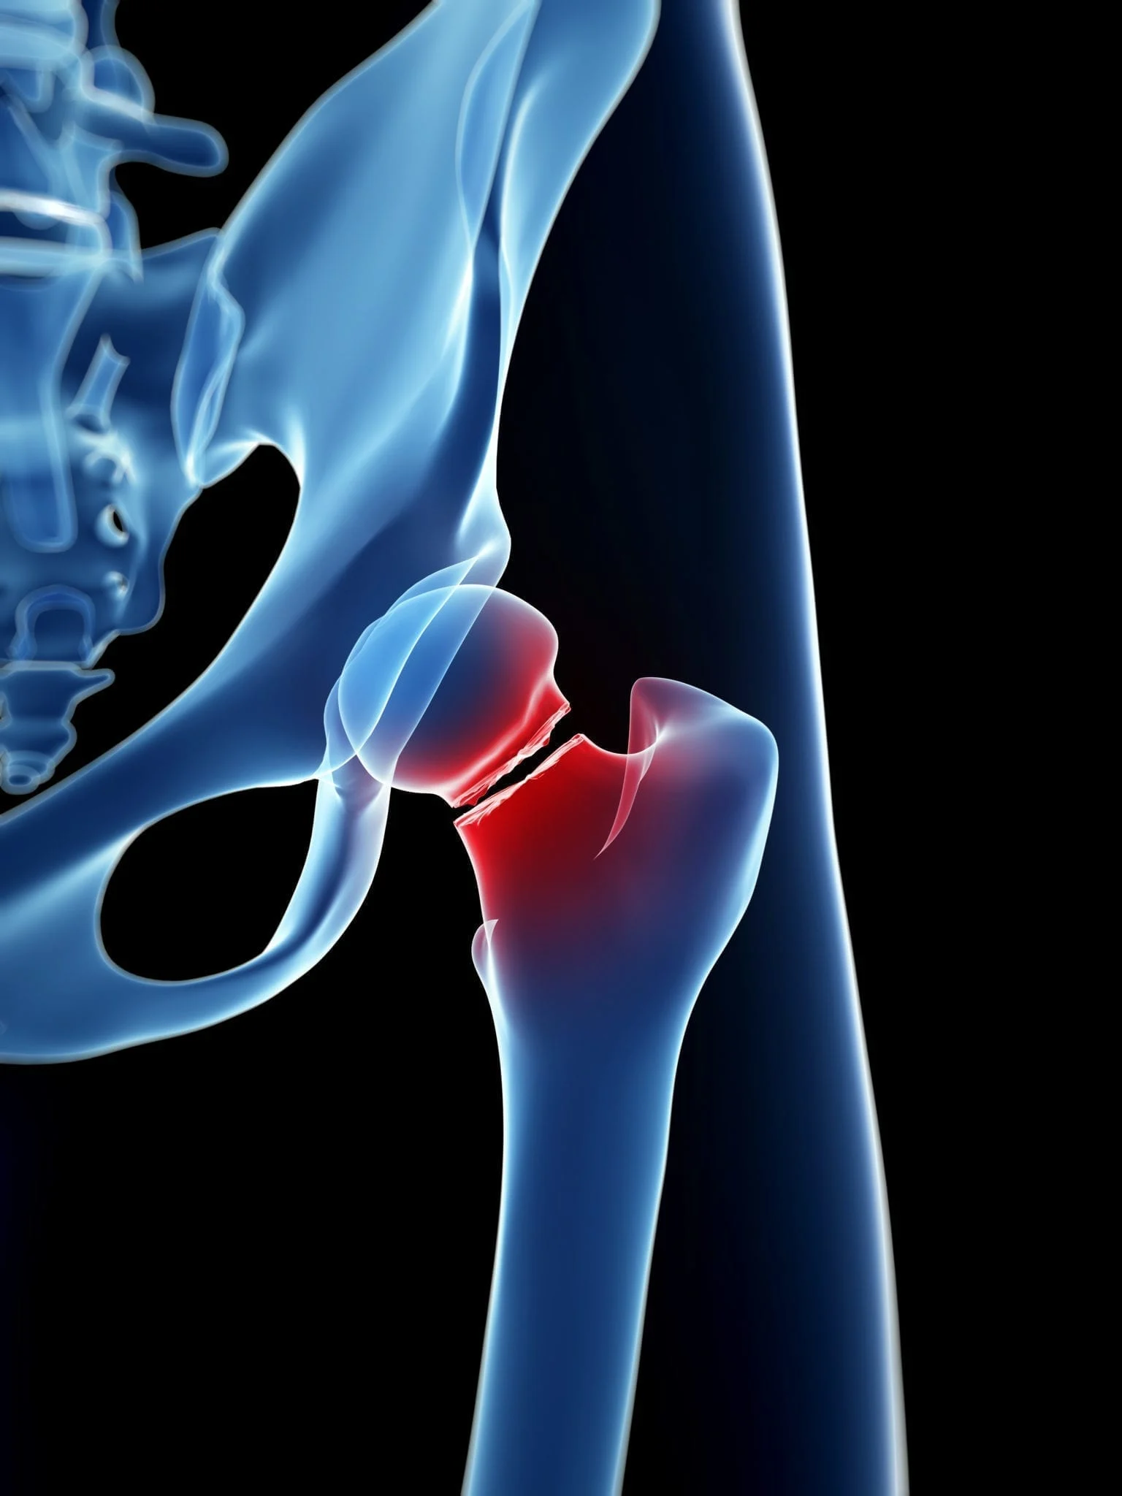  health, age and FALLS  March, 2021 | How age and health increase the risk of falls, and how research helps in prevention.  Agnieszka Sewkani  (Introduction to Health Research, BMNS4005)

CONTENTS PAGE

Index of statistics …………………………………………………..2

Introduction …………………………………………………………3

How serious a fall can be? …………..……………………..…….4

What are the risk factors of a fall? …..…………………..……….5

How can it be prevented? ……………………………….………..8

Conclusions and what more
need to be done to prevent falls …………..………………..11

Reference list …………………………………………….……….12

INDEX OF STATISTICS

- Figure 1 Real First Aid (2020) Statistics - UK Injury Mortality, Available at: https://www.realfirstaid.co.uk/injury-statistics

- Figure 2 Medscape (2021) Falls in the Elderly: Causes, Injuries, and Management. Available at: https://login.medscape.com/login/sso/getlogin?wcode=102&client=205502&urlCache=aHR0cHM6Ly9yZWZlcmVuY2UubWVkc2NhcGUuY29tL3NsaWRlc2hvdy9mYWxscy1pbi10aGUtZWxkZXJseS02MDEyMzk1&sc=ng&scode=msp

- Figure 3 Canadian Deprescribing Network (2018) Medications and falls. Available at: https://www.deprescribingnetwork.ca/medications-and-falls

- Figure 4 Royal College of Nursing (2021) Osteoporosis. Available at: https://www.rcn.org.uk/clinical-topics/womens-health/osteoporosis

INTRODUCTION

People with mobility issues and those aged 60 and over are at a higher risk of sustaining a serious injury due to a fall, and in some cases, this may lead to death. It is a second, after traffic accidents, of the World's unintended “cause of death”, taking around 700 000 lives each year (WHO, 2021). It is estimated that about 30% of all elderly deaths are caused by a fall injury (Coutinho, et al, 2012). The National Health Service (NHS, 2021) evaluated that, in people aged 65 and over, 1 in 3 will have a minimum of one fall a year, and half of those over the 80s. The results of a fall in an elderly person, in many cases, may also lead to physical and/or mental complications, affecting their day-to-day lives. Many elderly people become far more cautious of the fear of falling over and sustaining an injury. With age, the fear increases, subsequently leading to a decrease in physical activity, which has a negative impact on their health and wellbeing and will also increase the probability of a fall by 40% (Lavedan, et al, 2018).
The UK Government (2022) stated that in 2017-2018 hospital admissions due to falls, in the elderly population, were more than 220 000. According to the Aging Well in Wales (2022), the approximate cost to the NHS to deal with falls is more than 2 000 000 pounds a year.
Scientific evidence shows that many of those falls may be prevented if the right steps and actions were in place. A great number of organisations, all around the world, are constantly providing data and statistics based on close monitoring of individual injury reports, health records, and claims data. Their findings and information are necessary to assess the scale of the problem and to provide the best possible solution and prevention. This report will evaluate some of the risk factors and present the importance of research studies to lower the risk of sustaining a serious injury as a consequence of a fall.

HOW SERIOUS A FALL CAN BE?

Falls in an older population does not always result in a fracture, but in the majority, it undeniably affects their mental state. Their confidence and ability to stay independent are diminished and for many, the recovery is prolonged and painful bringing uncertainty for the future and fear of having another accident. The negative feeling of their current situation slows down their recovery and preventing from regaining their physical strength and stamina. Many older people are too proud to ask for help and support for fear of losing control of their lives. That unfortunately may lead to a decline in their health, increasing the risk of another fall (Shoene, 2019).
A hip fracture is the most common and serious outcome of a fall in an elderly person. The death rate in the first year after a hip fracture is around 26% (UK Government, 2022). Depending on an individual health condition and age, this type of fracture may lead to death. In other cases, it is frequently a lengthy and painful recuperation without the assurance of complete recovery. There is evidence to say that approximately 50% who do suffer from this kind of injury will have to rely on others to help them in everyday life, losing confidence and some ability to be independent (Hudson, 2018).
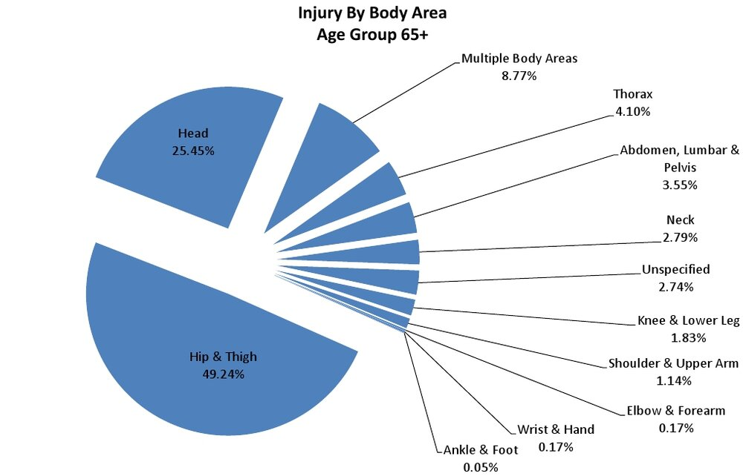
Figure 1 (Real First Aid, 2020)
WHAT ARE THE RISK FACTORS OF A FALL?

There are many factors that influence the chances of a fall and also the seriousness of the injuries incurred, especially in people over 60 years of age.
The conditions in which people are living are not always optimum. There is a connection between the home environment and accidental falls, especially among people with mobility issues and those aged 60 and over. The structure and design of the house, the surrounding environment like the accessibility, hazards, or even the social behaviour may have a negative impact on health (Lette, et al, 2020).

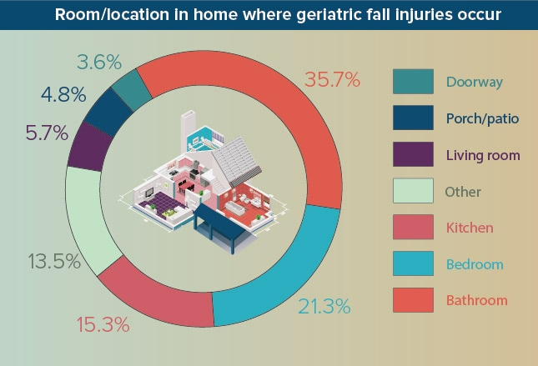 Figure 2 (Medscape, 2021)

A low level of serum sodium concentration can cause hyponatraemia. This electrolyte disorder can often occur in elderly people due to dehydration, kidney, liver problems, heart failure, or hormonal changes (Daw, et al, 2019). Additionally, some the medications, like thiazides diuretics and antidepressants, can as well result in decreasing serum sodium in the body. Some studies are indicating that there is a connection between body weakness due to mild hyponatremia and falls among elderly people. Furthermore, as sodium affects the bones it may also lead to osteoporosis (Boyer, et al, 2019) (Kwak, et al, 2015).
Osteoporosis, a weakening of the bones due to calcium insufficiency, is one of the major concerns in elderly people especially in the female population because 1 in 3 is more likely to develop this condition, compared to 1 in 12 in men. The effect that osteoporosis has on the bone makes them extremely susceptible to fracture (Department of Health, 2001).
Alcohol consumption by people over 60 can significantly increase the risk of having a fall. The older generation is much more likely to experience intoxication side effects much faster than those in their 30s or 40s. Balance problems, dizziness, and confusion can occur even by drinking a reasonably small amount of alcohol (Bareham, et al, 2021). A decline in health along with medication intake may add to the seriousness of the injuries due to a fall (Holton, et al, 2019).
Older people are more likely to be prescribed many kinds of medications. Certain pharmacological drugs' side effects may increase the possibility of a fall. Many of them on their own or in a combination may cause dizziness, confusion, visual disturbance, sleepiness, and/or muscle weaknesses. Those people who are underweight, with dementia, Parkinson’s disease, had a stroke, suffer from frequent urinary tract infections, or have a problem with bladder control are at higher risk of sustaining a fall due to prescribed medication intake (Coutinho, 2008). Thus, it can also occur when a person forgets to take the medication or take them irregularly (Division of Aging and Seniors, 2005).

Medications whose side effects increase the risk of a fall are:
- Psychoactive drugs – those kinds of pharmacological drugs affect mostly the brain and nervous system. They may cause confusion and drowsiness (Sterke, et al, 2008);
- Medications for diabetic people – elderly people are more likely to be affected by those kinds of medication as it increases the risk of having low blood sugar known as hypoglycaemia (Berlie and Garwood, 2010);
- pharmaceuticals that may lower the blood pressure – a rapid decrease in blood pressure (Odden, et al, 2015);
- Muscle relaxation drugs – should be avoided in older people, because of the likelihood of causing dizziness, confusion, weakness, and fatigue (Spence, et al, 2013).

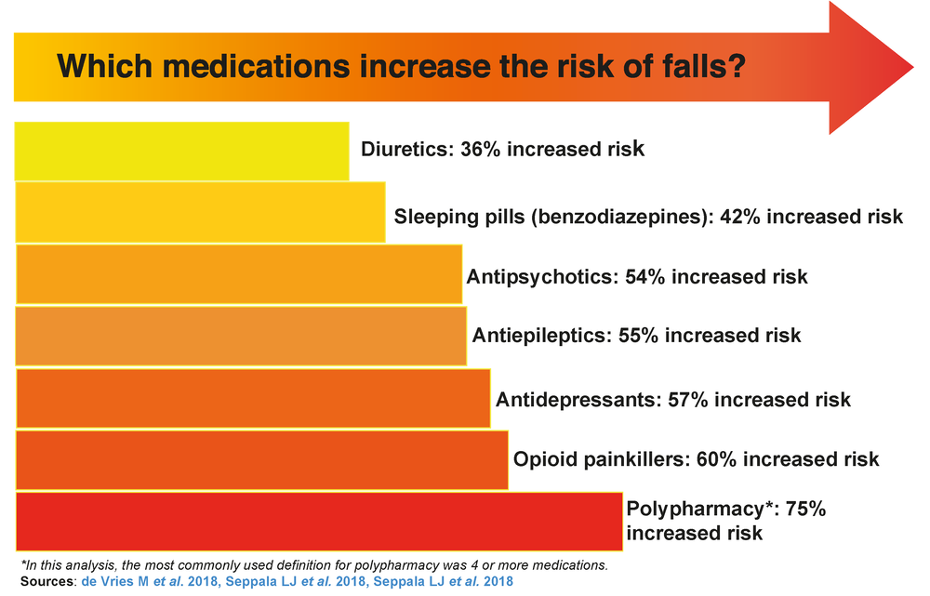 Figure 3 (Canadian Deprescribing Network, 2018)

HOW CAN IT BE PREVENTED?

Every elderly person admitted to the hospital is assessed by a healthcare professional to evaluate the risk factor of a fall during patient hospitalization. Nurses collect fully detailed information from patients' medical histories, mobility assessments, mental states, but also from observation and a conversation with a patient and in some cases with their relatives (Aimee, Kuo-Wei, and Khang, 2013).
Those who are discharged from a hospital without having an adequate plan and support at home are more likely to have another fall and be hospitalised again. Adequately done risk assessment and safeguarding allows to make the right action plan to protect those vulnerable adults. Making sure that they have the support and help that they need lower the risk of a fall and/or sustaining a serious injury (Age UK, 2016).
Improving the home environment and surrounding area can also significantly reduce the risk of a fall. Studies produce evidence that removing hazardous objects, like rugs and electrical wires, and adding some adjustments, like handrails or a stairlift, can enhance mobility and coordination. Together with those home modifications, it is important to check them regularly for safety reasons (Tiefenbachová and Zeleníková, 2019).
One of the prospective cohort studies, on a group of people aged 65 plus, shows that inadequate lighting at home can increase the risk of a fall. Make sure that the light at home in places like corridors, stairs, restroom, and bedroom should work properly and the switches easily accessible. Only 31%, of those who were introduced to “the light path”, had a fall in contrast to 50% of those who were not (Tchalla, et al, 2012).
Falls due to alcohol intoxication are difficult to prevent, because due to the fact that the reasons for people drinking may vary. Adequate support, recommendation, and treatment should be provided for those who got an alcohol-related problem which will not only improve their health and wellbeing but reduce the risk of having a fall. (Bye, Bogstrand and Rossow, 2022).
A study was done in Australia in 2020 (Naseri, et al), indicated that fall prevention education together with physical activities or physiotherapy, among those who had a recent or previous fall, may be an efficient and effective way of preventing those kinds of accidents from occurring again. Those who participated in this study shows significant improvement in mobility and balance, plus it brought a positive attitude during this form of rehabilitation, especially in the first six months, but also, they become more aware and less afraid of having another fall. Similar studies indicated that introducing exercise brought a positive outcome, especially in reducing the serious consequences of further falls (Daly, 2019). The percentage provided by one of the studies shows that the total number of falls was reduced by 37%, the number of serious trauma due to a fall went down by 43%, and a reduction of 61% in bone fractures. These kinds of activities should be very carefully planned and tailored to individual abilities (El-Khoury, et al, 2013).
A Health Belief Model (HBM) is a programme designed for women over 60 years of age who are diagnosed with osteoporosis. A study based on HBM combines a few aspects like exercise, the right diet, education about their condition, and routine health checks as a fall preventable plan. The results show a great improvement in women's lifestyles and health (Ahn and Oh, 2021). Research shows that taking regularly vitamin D, especially vitamin D3, together with calcium notably reduces the risk of a fall accident by 26% and by 29% reduction in bone fraction (Thanapluetiwong, et al, 2020) (Annweiler, et al, 2010).
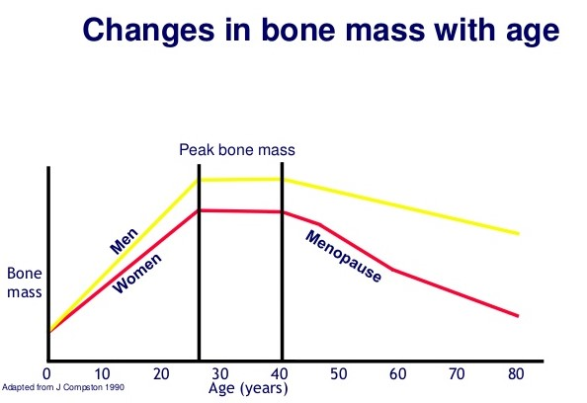
Figure 4 (RCN, 2021)
Not many people are realising that taking vitamin K helps to bind the calcium to the bone and take part in bone metabolism to maintain their health. For the past two decades, scientists are gathering evidence to prove that there is a link between vitamin K, osteoporosis, and bone fracture. Unfortunately, currently, the studies are not conclusive, with a mix of opinions, which is why further research is required (Fusaro, M. et al, 2020) (Mott, A. et al, 2019).

CONCLUSION AND
WHAT MORE NEED TO BE DONE
Overall, the majority of falls in people over 60 years of age can be preventable which is why it is incredibly important to raise awareness of the possibilities to improve their physical and mental health. That will improve their confidence, help them to maintain independence, and encourage them to stay safely active. If people understand the risk associated with their health conditions there is a better chance that they become more positively active and less fearful (Francis-Coad, et al, 2019). That is why research studies become a crucial part of prevention. Given all that it could considerably reduce the number of hospitalisations, lower the mortality rate, and reduce the NHS spending costs. What is more, it proves that having the right support and information allows elderly people to maintain control over their life.
Without a doubt research, statistics and reports are crucial in providing information to prevent falls and minimise the risk of a serious injury. However, the lack of research that would include the thoughts and opinions of the older generation, what they would like to do to improve their health and mobility, to make them happier and comfortable. What is more, the reality of helping and assisting elderly people to live fulfilling healthy life is far from ideal. There is a massive shortage of adequate houses for the older generation of people, but also a lack of financial support, for those on a low income, who would benefit from their homes being adjusted to their needs. The prevention programmes and closely monitoring is lacking in continuity over a longer period of time. The Royal College of Physicians (2016) indicated that around 50% of those elderly people who are enrolled in those programmes are satisfied and can see the improvement in their mobility and balance, though only 73% of those activities are a short-term solution, they usually take no longer than three months.
More local organisations, services, and healthcare professionals should work together to promote and support a healthy lifestyle and independence. As well as providing the right care and assistance for those who are at the highest risk of having a fall. They should also assure of the continuation of those evidence-based prevention programmes, along with providing an adequately trained staff (Welsh Assembly Government, 2006).
REFERENCE LIST

- Age UK (2016) Behind the Headlines, Are older people and their families really to blame when their hospital discharges are delayed?
Available at: https://www.ageuk.org.uk/globalassets/age-uk/documents/reports-and-publications/reports-and-briefings/care--support/rb_march16_behind_the_headlines_hospital_discharge.pdf (Accessed on 18 March 2022).
- Aging Well in Wales (2022) Falls prevention. Available at: https://ageingwellinwales.com/en/themes/falls-prevention (Accessed on 18 March 2022).
- Ahn, S. and Oh, J. (2021) ‘Effects of a health-belief-model-based osteoporosis- and fall-prevention program on women at early old age’, Applied Nursing Research, 59, Article 151430.
- Aimee, L., Kuo-Wei, L. and Khang, P. (2013) ‘Preventing Falls in the Geriatric Population’, Permanente Journal, 17(4), pp 37–39.
- Annweiler, C. et al (2010) ‘Fall prevention and vitamin D in the elderly: an overview of the key role of the non-bone effects’, Journal Neuroengineering Rehabilitation, Volume 7, p 50. doi: 10.1186/1743-0003-7-50
- Bareham, B.K. et al (2021) ‘Factors affecting primary care practitioners’ alcohol-related discussions with older adults: a qualitative study’, British Journal of General Practice, 71(711), pp 762-771.
- Berlie and Garwood, C.L. (2010) ‘Diabetes Medications Related to an Increased Risk of Falls and Fall-Related Morbidity in the Elderly’, The Annals of Pharmacotherapy, 44(4), pp 712–717.
- Boyer, S. et al (2019) ‘Prevalence of mild hyponatremia and its association with falls in older adults admitted to an emergency geriatric medicine unit (the MUPA unit)’, BMC Geriatrics, Volume 19, Article 265. doi: 10.1186/s12877-019-1282-0
- Bye, E.K., Bogstrand, S.T. and Rossow, I. (2022) ‘The importance of alcohol in elderly’s hospital admissions for fall injuries: a population case-control study’, Nordisk Alkohol- & Narkotikatidskrift, 39(1), pp 38–49.
- Coutinho, E.S.F. et al (2008) ‘Risk factors for falls with severe fracture in elderly people living in a middle-income country: a case control study’, BMC Geriatrics, Aug 26, 8:21. doi: 10.1186/1471-2318-8-21.
- Coutinho, E.S.F. et al (2012) One-‘year mortality among elderly people after hospitalization due to fall-related fractures: comparison with a control group of matched elderly’, Publica, 28(4), pp 801-5.
- Daly, R.M. et al (2019) ‘Exercise for the prevention of osteoporosis in postmenopausal women: an evidence-based guide to the optimal prescription’, Brazilian Journal of Physical Therapy, 23(2), pp 170-180.
- Department of Health (2001) National Service Framework for Older People. Available at: https://assets.publishing.service.gov.uk/government/uploads/system/uploads/attachment_data/file/198033/National_Service_Framework_for_Older_People.pdf (Accessed on 19 March 2022).
- Division of Aging and Seniors (2005) Report on senior's fall in Canada. Ontario: Public Health Agency of Canada.
- Dow, C. et al (2019) ‘Hyponatraemia in primary care’, BMJ (Online). Available at: https://doi.org/10.1136/bmj.l1774 (Accessed on 25 March 2022).
- El-Khoury, F. et al (2013) ‘The effect of fall prevention exercise programmes on fall induced injuries in community dwelling older adults: systematic review and meta-analysis of randomised controlled trials’, The BMJ, 49(20), p 347. doi: 10.1136/
- Francis-Coad, J. et al (2019) ‘Evaluation of older people's knowledge, awareness and perceptions about falls and falls prevention in residential aged care homes: a tale of two cities’, Ageing and Society, 39(11), pp 2541-2559.
- Fusaro, M. et al (2020) ‘Vitamin K and osteoporosis’, Nutrients, 12(12), p 3625.
- Holton, A. et al (2019) ‘Potentially serious alcohol-medication interactions and falls in community-dwelling older adults: a prospective cohort study’, Age Ageing, 48(6), pp 824-831.
- Hudson, L. (2018) ‘The cost of falls in the UK’, Yorkshire Care Equipment. Available at: https://www.yorkshirecareequipment.com/advice-tips/the-cost-of-falls-in-the-uk-with-infographic/ (Accessed on 18 March 2022).
- Kwak, M.K. et al (2015) ‘Relationship between Decrease in Serum Sodium Level and Bone Mineral Density in Osteoporotic Fracture Patients’, Journal of Bone Metabolism, 22(1), pp 9–15.
- Lavedán, A. (2018) ‘Fear of falling in community-dwelling older adults: A cause of falls, a consequence, or both?’, PLoS ONE, 13(3). doi: 10.1371.
- Lette, M. et al (2020) ‘Addressing safety risks in integrated care programs for older people living at home: a scoping review’, BMC geriatrics, 20(1), pp 1-13.
- Mott, A. et al (2019) ‘Effect of vitamin K on bone mineral density and fractures in adults: an updated systematic review and meta-analysis of randomised controlled trials’, Osteoporosis International, 30(8), pp 1543-1559.
- Naseri, C. et al (2020) ‘Perspectives of older adults regarding barriers and enablers to engaging in fall prevention activities after hospital discharge’, Health and Social Care in the Community, 28(5), pp 1710-1722.
- National Health Service (2021) Falls. Available at: https://www.nhs.uk/conditions/falls/ (Accessed on 18 March 2022).
- Odden, Beilby, P.R. and Peralta, C.A. (2015) ‘Blood Pressure in Older Adults: the Importance of Frailty’, Current Hypertension Reports, 17(7), pp 1–8.
- Royal College of Physicians (2016) Older people's experience of therapeutic exercise as part of a falls prevention service. Available at: https://www.rcplondon.ac.uk/projects/outputs/older-peoples-experience-therapeutic-exercise-part-falls-prevention-service (Accessed on 19 March 2022).
- Schoene, D. et al (2019) ‘A systematic review on the influence of fear of falling on quality of life in older people: is there a role for falls?’, Clinical Interventions in Aging, 14, pp 701–719. doi: 10.2147/CIA.S197857
- Spence, M.M. et al (2013) ‘Risk of injury associated with skeletal muscle relaxant use in older adults’, Pharmacother, 47(7-8), pp 993-8.
- Sterke, C.S. et al (2008) ‘The influence of drug use on fall incidents among nursing home residents: a systematic review’, International Psychogeriatrics, 20(5), pp 890–910.
- Tchalla, A.E. et al (2012) ‘Efficacy of simple home-based technologies combined with a monitoring assistive center in decreasing falls in a frail elderly population (results of the Esoppe study)’, Archives of Gerontology & Geriatrics, 55(3), pp 683−689.
- Thanapluetiwong, S. et al (2020) ‘Vitamin D supplement on prevention of fall and fracture’, Medicine (Baltimore), 99(34), Article e21506. doi: 10.1097/MD.0000000000021506
- Tiefenbachová, P. and Zeleníková, R., (2019) ‘The effect of educational intervention by nurses on home environmental risk factors for falls’, Central European Journal of Nursing and Midwifery, 10(2), pp 1019-1025.
- United Kingdom Government (2022) ‘Guidance Falls: applying All Our Health’, Office for Health Improvement & Disparities. Available at: https://www.gov.uk/government/publications/falls-applying-all-our-health/falls-applying-all-our-health (Accessed on 18 March 2022).
- Welsh Assembly Government (2006) National Service Framework for Older People in Wales. Available at: https://www.housinglin.org.uk/_assets/Resources/Housing/Wales/NSF_for_Wales.pdf (Accessed on 19 March 2022).
- World Health Organization (2021) Falls. Available at: https://www.who.int/news-room/fact-sheets/detail/falls (Accessed on 18 March 2022).

