Impact of VLE on the students learning experience

Name: Akos Ludovic Ioan Molnar
Student Number: 2030659
Programme: Certificate of Higher Education in Skills for the Workplace
Module: Digital Skills And Research Methods
Module Code: BMSW4003
DSR Assessment 2 individual Report:
  - Impact of VLE on the students learning experience.

Table of Contents
Introduction 3
Background 3
Literature review 3
Aims and Objectives 5
Methodology 6
Results and Discussion 6
Conclusion 13
References 15
Appendix 1 16
Appendix 2 17

Introduction
Virtual learning is a form of education that revolutionizes today's manner of learning. The teacher uses online resources in a virtual learning environment to teach students classes rather than to teach in an individual classroom setting. Due to current technology, kids may learn from home in a regular classroom and attain knowledge just like on a normal physical class (Jain, 2015). In educational institutions, virtual learning environments (VLE) is an efficient way of delivering knowledge to students. Nevertheless, the students hard work and determination is a key factor in his/her success. At the University of Wales Trinity Saint David London Campus, students use an online platform called Moodle to learn online. COVID-19 restrictions limit the physical engagement of students hence making Moodle the ideal platform to carry on classroom work. This research report will look at the effects of Moodle on the students learning experience.

Literature review
The formal teaching and interactions between instructors and students in Moodle have involved virtual learning environments. During this period of COVID crises, VLE has been an important aspect of learning. This is because through VLE, learners were able to continue learning without risking their lives by social gathering. VLE also provides a chance for one to review some of the previously taught lessons. This is because some platforms provide an option for recording lecturers which can then be used for later revision. There is growing interest in Internet-supported virtual learning environments, particularly between students and teachers. As a result, VLE is gradually replacing the traditional physical learning method. Through VLE some of the students who shy to ask questions in a physical class get a better chance to interact with the lecturer. Moodle played a major role in the virtual learning by giving learners a chance to continue with their studies at such a time when physical classes were almost impossible to take place. The students got a chance to learn, do their assignments and get tested on this platform.
Due to the continuous development of digital technology, its characteristics and potentials and the value of such environments within learning processes, the VLE idea may be seen as a dynamic concept (Simkova, and Stepanek, 2013). This has made this platform to be of importance since it is being developed as time goes by. New inventions are making it more efficient to use the VLE hence more people are appreciating the online platforms. A rising number of institutions are using web-based educational systems to enhance their online classes. These systems store large amounts of data that is useful for the student's analysis of the courses. Although computers have been used for learning at the Open University in the United Kingdom since the 1970s, the business VLE "Board" was protected in 2000. In 2010, Board programming was utilized by more than 3700 instructive establishments in more than 60 nations. In 2001, the second most famous VLE, 'Moodle' was delivered. Moodle was created to help instructors develop online courses with an emphasis on connection and cooperative substance creation, and it had 212 nations and 49,365 dynamic destinations in more than 75 dialects by 2011. Because formal education institutions are where each country's educational norms and curriculum are applied, virtual learning environments have played a significant role in supporting and promoting formal education. VLEs, on the other hand, may play a critical role in facilitating learning in non-formal and informal settings when seen through the lens of change and innovation (Vaganova, et al., 2017).
In University of Wales Trinity Saint David London Campus, VLE learning is implemented by use of the Moodle. From the platform, students access numerous modules which are consolidated to form courses. It is created in a student friendly manner that enables easy operation for any student in the institution. For some students who may experience difficulties operating the platform, an online support tool is available to assist them solve their issue.
In today's culture, the term "innovation" connotes a need for change or renovation, as well as a desire to try something new. VLE is a mode of teaching different from the normal physical teaching which has proven to be of essence since most students using it appreciate its efficiency. The relationship of data about students' actions in a VLE with students' performance is influenced by the teaching settings. According to Barker, and Gossman, (2013), the same researchers used a regression model to connect data from nine-degree courses at a university. Their findings revealed that only the variables number of logs, number of operations performed in forums, and resources were important markers of students' success, accounting for 21% of the variance in students' achievement. Moodle has put this research into use by incorporating several resources such as the library resources in the platform. These resources provide adequate knowledge to learners who utilize such features.
Virtual computers are used to monitor students' activities, and data-driven machine learning algorithms are applied to students' profiles and log files from Learning Management Systems (LMS) databases to identify students who are at risk early. The data on how a student interacts with their course and institution may be a good predictor of how interested they are and, as a result, how likely they are to drop out of school (Stricker, Weibel, and Wissmath, 2011).
Despite several VLE advantages, it’s not fully efficient since its faced by some disadvantages. Some of the impacts that negatively affect it include; social isolation of the students, poor technology may affect the implementation of the programs and some students may fail to concentrate during lectures. Students may not be able to mingle and create friends when the classes are fully offered using online platforms. This denies them a chance to exchange ideas which would later develop to become innovations.

Methodology
This research, like many others in the field of e-learning, employed a mix of quantitative and qualitative techniques. In the online questionnaire, both closed and open questions were employed. The quantitative study was conducted using an e-questionnaire (Survey Monkey) that could be analyzed in Excel. The link to the questionnaires was shared via WhatsApp, survey created with google forms . The survey was distributed in this manner because it was the most convenient. The questionnaire was given to 12 University of Wales Trinity Saint David London Campus students. The review was pushed during bunch instructional exercises, and scholars involved were encouraged to finish it individually. All review results were kept hidden, and undergraduates were educated regarding this preceding finishing the overview. The survey's data was considered as informed consent for the study's results to be used. Before the final data collection in one and a half weeks, certain reminder notifications were sent out. The majority of the analysis is descriptive in nature. Because there are only a few open questions, descriptive statistics are supplied for the issue questions, but the responses to the open questions are left in their original form for description.

Results and Discussion
I use Moodle every day when studying

The results in the study showed that most of the students at the university use Moodle every day when studying while just a 10% use it less often. This is because they enable contact and interrelation in an on-going communication process, thereby increasing knowledge and meaning building and reconstruction, as well as habits and behaviors, in a context that is united to everyone who are participating in the educational process (Alves, Miranda, and Morais, 2017).

Moodle is user friendly

50% of the respondents strongly agreed and 40% agreed that Moodle is user friendly. 10% of the participants were neutral. Moodle was made to help teachers in creating on the web courses with an attention on connection and synergistic material creation (Vaganova, et al., 2017).

I gain a lot with Moodle than without it

30% of the respondents strongly agreed and 50% agreed that gain a lot with Moodle than without it. 20% of the respondents disagreed with this statement. VLEs, on the other hand, may play a critical role in facilitating learning in non-formal and informal settings when seen through the lens of change and innovation (Vaganova, et al., 2017).

I get information from every topic from Moodle

However, according to these results, it is clear that some students do not prefer VLEs. 40% of the respondents strongly agreed and 30% agreed that get information from every topic from Moodle. 20%v of the respondents disagreed with the statement while 10% were neutral. These results portrayed a mixed reaction nature between students.

Moodle has enhanced my learning experience

50% of the respondents strongly agreed and 30% agreed that Moodle has enhanced their learning experience. 15 % of the respondents were neutral but 5% of them strongly disagreed with the statement. The data on how a student interacts with their course and institution may be a good predictor of how interested they are and, as a result, how likely they are to drop out of school (Stricker, Weibel, and Wissmath, 2011).

Moodle has had a good effect on my productivity as a student

20% of the respondents strongly agreed and 70% agreed that Moodle has positively affected their usefulness as an understudy. 10% of the understudy could not help contradicting the assertion. According to a survey by Demian, and Morrice, (2012), students' motivation was enhanced as a result of other students seeing their submitted remarks, and they felt more keen on playing an active job in the course as a result of collaborative tools like forums. Online courses are also seen as more convenient by students.

I can access Moodle anytime I want to study

Moodle encourages me to learn independently
90% of the respondents strongly agreed that can access Moodle anytime they want to study. 10% of the respondents were neutral. 20% of the respondents strongly agreed and 70% agreed that Moodle encourages them to learn independently.

Moodle is a valuable help in my studies

From the question presented,10% of the respondents disagreed with the statement. 50% of the respondents strongly agreed and 20% agreed that Moodle is a valuable help in their studies. 30% of the students were neutral. This depicted how most of the students were happy to have Moodle has a way of learning.

Conclusion
The research questions are supported by empirical study in the literature, which leads to the formulation of hypotheses. This study shows that utilizing a VLE upholds self-governing learning by permitting understudies to adapt casually at their own time, area, and speed, permitting them to fit course work around their rushed timetables. The writing concentrate likewise shows that utilizing a VLE works on understudies' ability to learn, cultivates correspondence and synergistic learning, and gives profoundly spurring quick criticism. While this examination shows that the utilization of Moodle beneficially affects understudy learning, it is interesting to see whether branches of knowledge affect learning. It would also be fascinating to investigate, for instance, which tools in the VLE have the most influence on student education: forums, quizes and course handouts. However, the statistical analysis has produced substantial results but cannot and cannot give depth owing to the time available and the positive strategy adopted.

References
- Alves, P., Miranda, L. and Morais, C., 2017. The influence of virtual learning environments in students’ performance. Universal Journal of Educational Research, 5(3), pp.517-527.
- Barker, J. and Gossman, P., 2013. The learning impact of a virtual learning environment: students’ views. Teacher education advancement network journal (TEAN), 5(2), pp.19-38.
- Demian, P. and Morrice, J., 2012. The use of virtual learning environments and their impact on academic performance. Engineering Education, 7(1), pp.11-19.
- Jain, P., 2015. Virtual learning environment. International Journal in IT & Engineering, 3(5), pp.75-84.
- Kumar, G. and Suneja, A., 2011. Using Moodle-an open source virtual learning environment in the academia. International Journal of Enterprise Computing and Business Systems, 1(1), pp.1-10.
- McComas, W.F., 2014. Virtual learning environment. In the language of science education (pp. 110-110). SensePublishers, Rotterdam.
- Simkova, M. and Stepanek, J., 2013. Effective use of virtual learning environment and LMS. Procedia-Social and Behavioral Sciences, 83, pp.497-500.
- Stricker, D., Weibel, D. and Wissmath, B., 2011. Efficient learning using a virtual learning environment in a university class. Computers & education, 56(2), pp.495-504.
- Sneha, J.M. and Nagaraja, G.S., 2014. Virtual Learning Environments-A Survey. arXiv preprint arXiv:1402.2404.
- Vaganova, O.I., Smirnova, Z.V., Mukhina, M.V., Kutepov, M.M., Kutepova, L.I. and Chernysheva, T.L., 2017. THE ORGANIZATION OF THE TEST CONTROL OF STUDENTS'KNOWLEDGE IN A VIRTUAL LEARNING ENVIRONMENT MOODLE. Journal of Entrepreneurship Education, 20(3), pp.1-4.

Appendix 1
QUESTIONNAIRE

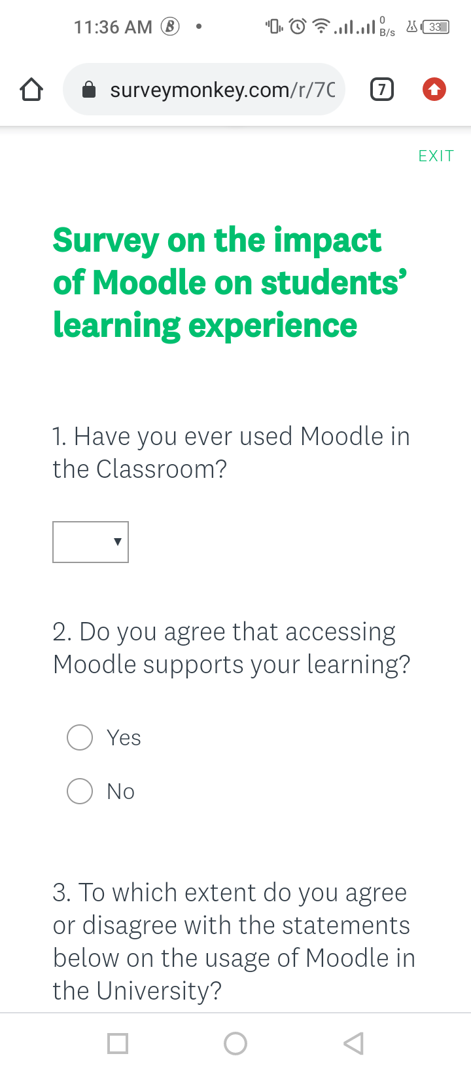
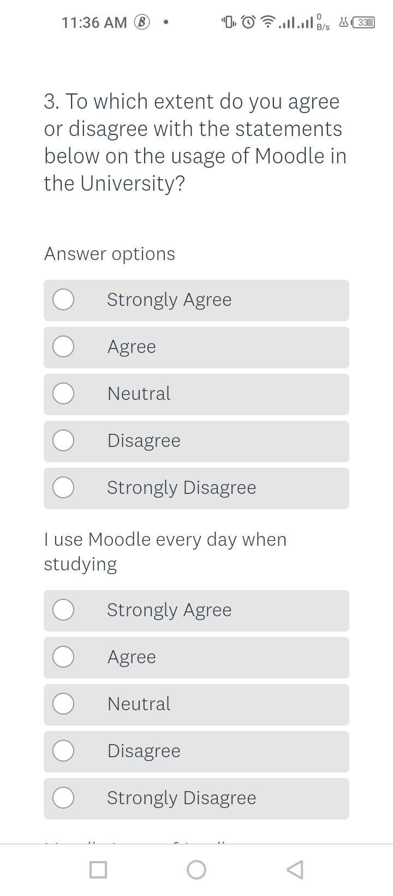
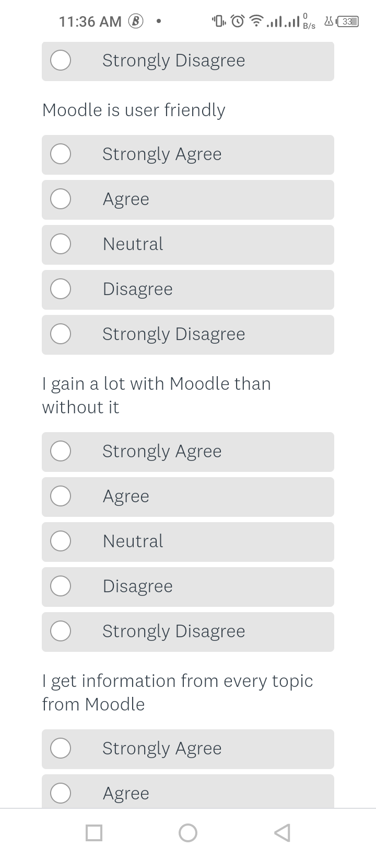
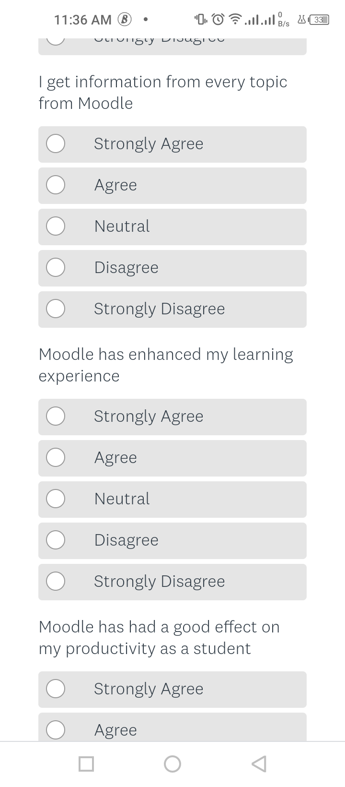
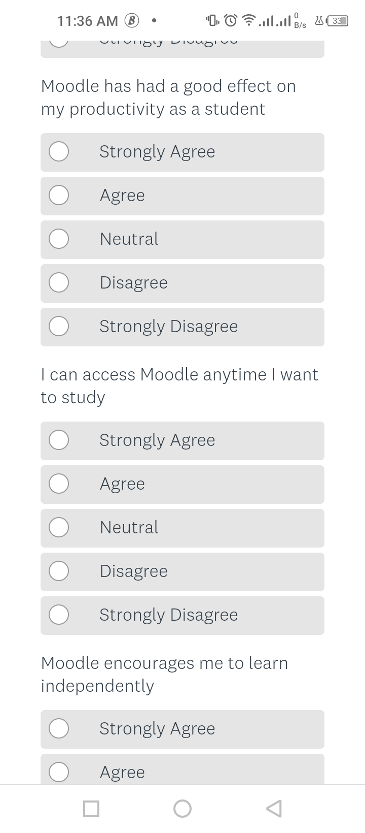
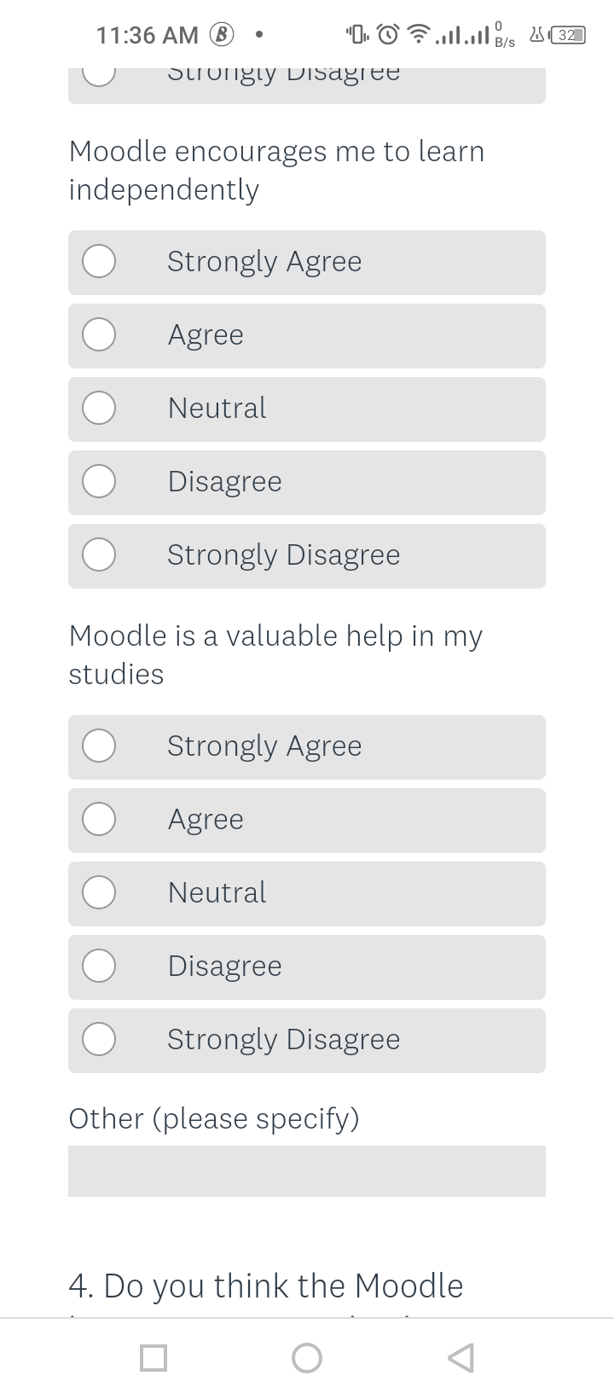
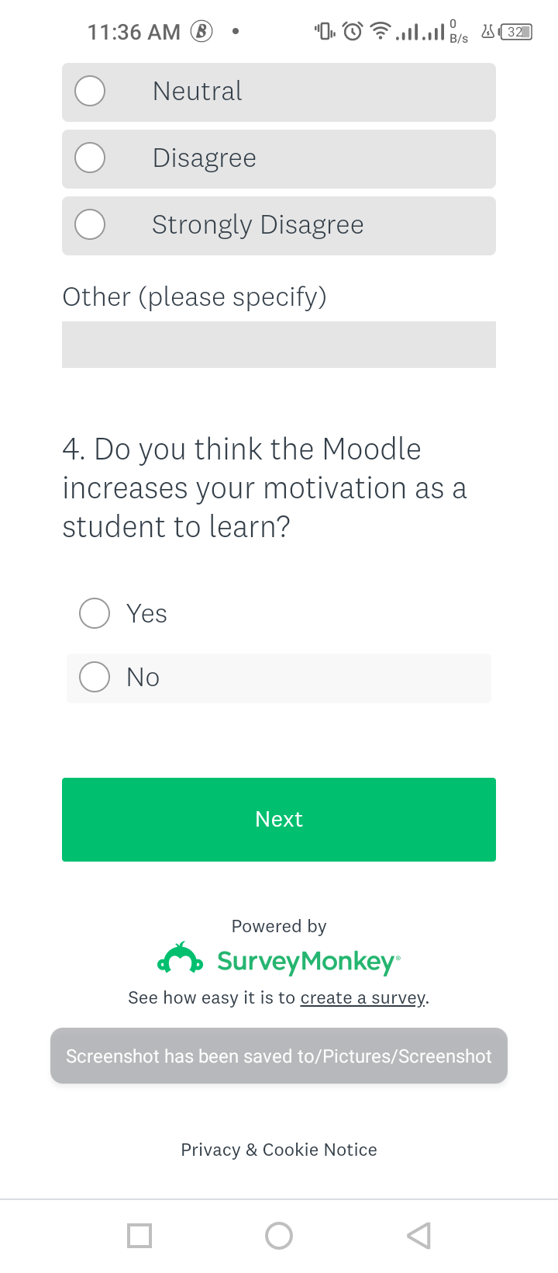

Appendix 2

Questionnaire Results
 | Strongly Agree | Agree | Neutral | Disagree | Strongly Disagree
I use Moodle every day when studying | 90% |  |  | 10%
Moodle is user friendly | 50% | 40% | 10%
I gain a lot with Moodle than without it | 30% | 50% |  | 20%
I get information from every topic from Moodle | 40% | 30% | 10% | 20%
Moodle has enhanced my learning experience | 50% | 30% | 15% |  | 5%
Moodle has had a good effect on my productivity as a student | 20% | 70% |  | 10%
I can access Moodle anytime I want to study | 90% |  | 10%
Moodle encourages me to learn independently | 20% | 70% |  | 10%
Moodle is a valuable help in my studies | 50% | 20% | 30%

